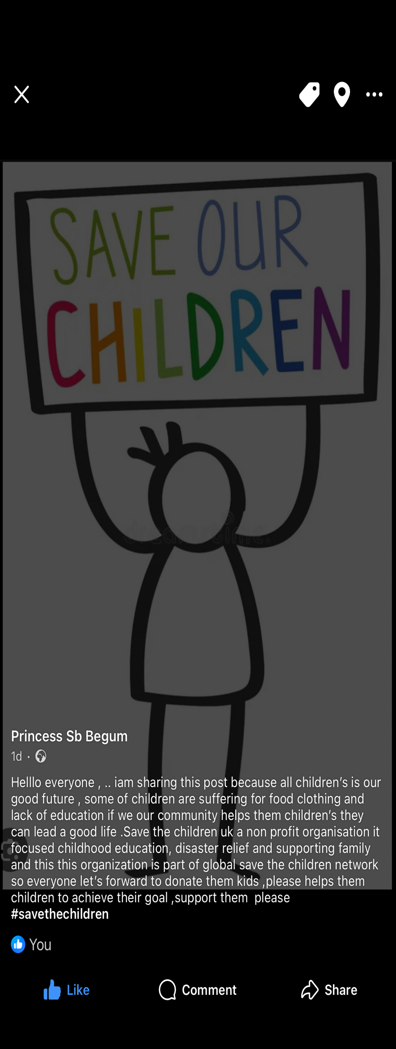
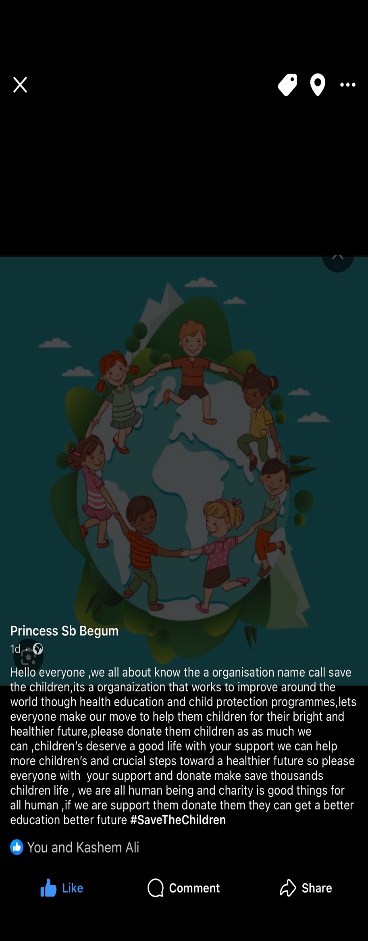
Sathi Begum
2521691
Group
Sathi Begum (me)
Pinky Begum
Abdul Miah
Marketing in practice (tactical communication) blog/Social media posts.
Link to individual blog/social media site. Princess sb Begum
Save the children’s is my chosen blog.
Save the children uk is a non an international non governmental organisation around the world through program ,they provide children in need ,children rights and they provides health nutrition education protection emergency response .The purpose of the organisation is ensure every child get a healthy start in life and go to school safely and protect from violence .the organisation raises money to improve children’s lives creating by better educational opportunities All our community please help them donate this organisation for those children’s who suffering for food education clothes shelter so they can lead a better life .our little help can change their life. These children’s need to have better life and be looked after they need food they need water. They need clothes they need shelter and they need love if we do not help and children who will help them. I will save the children organisation we will promote on Facebook YouTube TikTok everywhere in the social media for people to donate for the future of the children they need better life maybe they come from bad background dangerous background maybe those children have no mom no dad no family maybe those children have no Home nobody to care for them. They might have had life they might have had memory them children’s need caring they need support they need people to donate on social media TikTok Facebook YouTube everybody uses it so Who will not see if you post a blog on our social media there are so many celebrities so many business organisations so many students working in class people wealthy people everybody’s using social media. Somebody will see even if somebody is giving £5 that £5 will help these children’s get books clean freshwater clothing food £5 is not much but £5 will help those children’s life turn around. One donation from from one person will make big difference so please help donate please a help these children’s future to be better. Growing up we even never had anything we can see the hard shape our parents our family been through and it’s not easy. That is the reason we have this organisation to help children’s not have hard life and help them in every way as possible, children’s across the world come from different background does not matter which religion they still are children. In our save the children organisation if anyone donate to our social media our blog, we will be giving out free food free samples free discount voucher two different food festival. Life is short donate for the future of the children they are future and do not let them ruin their life help their life give what you can. we will share all over social media all over blogging bringing our save the children organisation so everybody can see and we will make more friends on social media and post more so they can see everybody can see it can be so globally and everybody will know everybody can donate even friends families people from all over the world they can help every little health and make big change big impact. We will make daily video daily post daily blog we will make the children right cards to every donated that year and writing thank you. Back there are so many competitions there are so many charity groups out. There is very hard to pick to choose which to donate on which group to donate in for this is a challenge in marketing because not just I was everybody has organisation and everybody is on the same goal same process same structure but sometimes different way of marketing The donators should realise this children’s need better future than a better future The future they deserve and we need to help them because they have no other way of getting help so please I hear everybody and encourage everybody in my blog and my post. Please donate little bit but much they can. Different children come from different parts of the world some might be suffering with food some might be suffering with Money some might be suffering with they have not good parents. Some might be coming from countries that come out of war every children should be same. we will make different videos every day post different blogs every day on social media on Facebook make our friends and family posted as well to help us advertise the organisation so it will be eye-catching to other people and make our organisation will be more successful marketing is I think the cheapest way because you don’t have to spend any money on social media just open up an account and start advertising making best videos best way possible to find the best buyers Facebook YouTube they don’t cost much money to spend on that advertise you just type it or make video on everybody uses social media so definitely somebody will see and they will be happy to donate because those kids need the donations and they need the donations from everybody when I was young. I used to see my family always donating every time my family they go shops when they go shopping they see children’s outside they donate to their children’s that is what got me into their donations because after all it’s like from the heart we do. I am a mother being a mother. I look at my children’s and I don’t want to see my children suffer and I don’t want to see any other children suffer when I look at any other children they remind me of my own children and as a mother I think the best charity organisation is for anything to well-being for children’s these children’s are the next future they might do the same when they grow up they might help others through charity organisation there are so many types of charity so many kind of charity in so many topics in so many element there are too many organisation of charity. I chose this charity because it’s to do with children’s should mine not chance but we can give them the chance they when they grew up they can be successful and doing good for people is a good thing. Marketing is getting harder day by day because times are changing New computer is coming no technology everything getting fast so it’s very hard to market but making video and posting blog on social media could be the best way for gaining donators who will donate towards this children’s little bit close little bit food some money to donate so they can get best life as possible because we can’t do it alone. We need everybody support and support is the main thing. me myself being a mother of two myself my children’s clothes when he gets small rather than throwing it away I gave it to charity my children’s every time when they get big and they always get new clothes or clothes all toys every time I never wasted it, but I always give it to divorce others to use so I always give it in charity knowing it will be going to good use and other children’s that never had the chance will get the chance to be happy. Charity is always a good thing is always going towards good cause, but you need a formidable team. Good team good successful team team is dreaming work. All we have to do is market continue posting blogging and marketing and spending time and we will make this organisation successful bringing more donators make more people to donate towards the children’s and that’s the only way we will get the best for the children all these children want is to be careful and be loved and not feel scared and being grown-ups we have to knowing they are children and giving them the best. We need profit we need to bring in High people with money people from big business because we need to bring the organisation big spending money on these children’s is good beneficial because somebody else will get good life rather than spending money on bad spend it on somebody that will get good life in return because if we don’t donate for them children those children’s will choose different life maybe might be bad for them and get them away from these, but we need to bring them to good and donate help them give them better life life they deserve. Every time people look at my videos of social media I would like if they could donate at least £.50 so even if somebody don’t need 50p if hundred people watch you will times by 100 and that is still enough to the children every every penny counts to give us the children you can give big small it’s okay it goes towards them but why sometimes we need to target big big is because we need the big sauce because not just for the children even to get the funding is for equipment for everything sometimes we need to buy you the children’s build them maybe a small shelter so we need the funding from the big company to build helpers to building them completing the shelter for them so they have Home to sleep and stay away from the cold weather.

Reference

Childlawadvice.com
Homeless link 07 September 2023
BBC childreninneed.com
Wikipedia.org
Children trust.com

