Intercultural Competence and Leadership: An Opening in Italy

Module: Foreign Languages & Cultural Awareness
Module Code: BMIH5003

Student Name: A K M Amdadul Hoque
Student ID:2107424
Lecturer Name: Giulia Chifari

Words: 1032

Executive Summary
The intended fact of this writing is to uncover the necessary insights that a manager needs to plan and develop a program for its staff to have a good start as well as continuous improvement. This writing mainly focuses on the cultural background of Italy as the manager has decided to open a new branch in this developed country. For this, a cultural overview of the Italian community has been illustrated first, followed by a GLOBE Project analysis from the cultural perspective of Italy. It was found interesting and encouraging to have a decision for a grand opening in Italy. Some advisory recommendations have been added in the later part of the study to make the manager easy and comprehensive.

Introduction
It is necessary to conduct a cultural analysis of a place before starting up a business because cultural insights into a place provide many crucial findings that help a businessperson reach his utmost goal and earn higher benefits. This study involves assisting the manager of Diversity Hotel & Spa, located in London, United Kingdom, to identify the key points he needs to point out and the challenges he needs to address.

Cultural Background
The culture of a country plays a significant role in opening and continuing a successful business initiative. Any type of business is influenced by the culture and customs of the country in which it is intended to be run in terms of customer demand, customer satisfaction, supply chain, and many others. Italy, a country in Southern Europe, has a rich and incredibly diverse background that spans thousands of years. Italian culture is deeply rooted in history, art, music, and culinary traditions (Borin and Donato, 2015). Italians are well known for their passion, warm celebration, and strong family values. Here are some key aspects of Italian culture and customs:

Figure 1: Cultural Overview of Italy; (Source: Own)
Italians are fond of family bonding and love to celebrate together. They take meals seriously which include multiple courses and wine. They love to have meals with families that make them emotional and lovelier. They have a rich cultural heritage reflecting deep appraisement for creativity and history. Italians are mainly followers of Roman Catholicism and a number of festivals and traditions are based on religious events (Burke, 2014). They enjoy music and opera and possess a sophisticated instinct for fashion. They take pride in their language expressing their feelings loudly while in the conversation. The people of this land have a deep passion for soccer and football.

GLOBE Study: An analysis of culture
GLOBE study is an unconventional technique for evaluating cross-cultural norms and leadership styles that span over 150 countries in collaboration with hundreds of researchers. Robert I. House, the founder of GLOBE Project shows an analytical view of organizational behaviors, norms, values, and leadership methods in divergent societies. According to GLOBE societal clusters, Italy falls under the Latin Europe cluster with few other neighboring countries that have similar sets of values, cultures, beliefs, social norms, and practices.
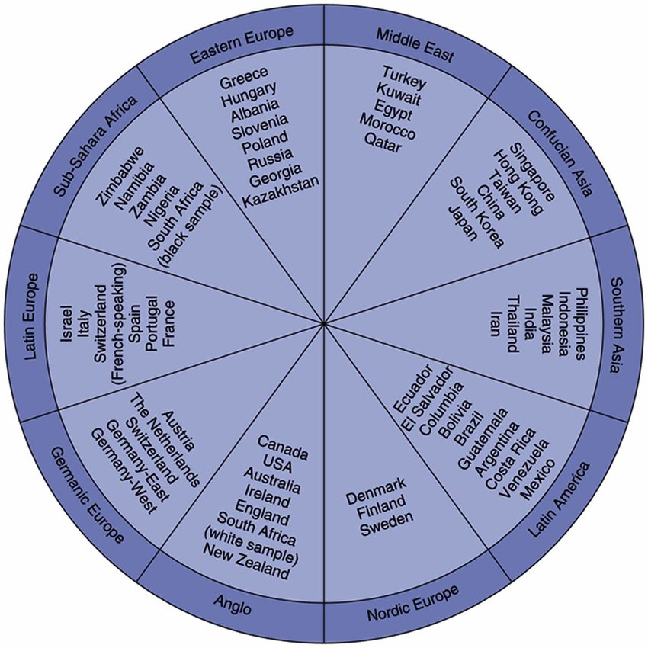
Figure 2: GLOBE Societal Culture; (Source: Bozkurt, 2018)
The GLOBE study finds that leader effectiveness is based on social and organizational processes, practices, norms, values, and beliefs (Latka, 2022). This project empirically introduced nine different cultural dimensions based on the cultural differences in values, beliefs, customs, and practices that a leadership strategy may follow (Clark et. al., 2016). These can be illustrated as follows:
Power Distance: It reflects how far the partners of a group look for the power to become centralized or decentralized. Italians maintain a moderate power distribution in their society, organization, and states (Berezin, 2018). They distribute more or less equal authority to both upper levels and lower levels.
Uncertainty Avoidance: It is a measure that reflects how much a group, society, or organization safeguards itself from unpredictable future contingencies following and depending on the societal processes, norms, beliefs, values, and practices.
Humane Orientation: It is the dimension by which it can be found that how much a group, encourages and rewards an individual to be kind, generous, ethical, honest, altruistic, caring, kind, and emotional with others (Martin, 2023). Italians are highly respectful and they observe this kind of behavior as a natural instinct of human beings. They appreciate those people who feel for others and do for others.
Collectivism I (Institutional): It is the magnitude to which an organization, society, or institution allows the collective distribution of resources and responsibilities with appropriate rewards. Italians are fond of groups and so they nourish such a cultural practice that distributes resources among all the members of their groups.
Collectivism II (In-Group): It measures the dimension that how far individuals are allowed to express their emotions, feelings, pride, and cohesiveness in their groups including families, societies, etc. Italians maintain a deep familial and social bonding that encourage them to share their experience and feelings with their mates (Lingiardi et. al., 2016).
Assertiveness: It refers to the status of the relationship with others as to how much individuals are conservative or aggressive to other members of a collective. Italians interact with their relatives in a quiet manner and rarely behave aggressively.
Gender Egalitarianism: It is the magnitude to which a group of people maintains equality in every sort of situation. As per Nimb et. al. (2019), Italians are sophisticated and ethical, so they establish equity in their actions.
Future Orientation: It refers to the degree to which people take actions evaluating future contingencies, proper planning, future benefits, etc. Italians, like most other citizens, do plan for the future and take action accordingly but they are more realistic than others.
Performance Orientation: It defines the magnitude to which a society allows its members to improve their performance and rewards for their excellence (Cervi, 2020). Italians do encourage their teammates to develop their expertise and reward them for their performance.

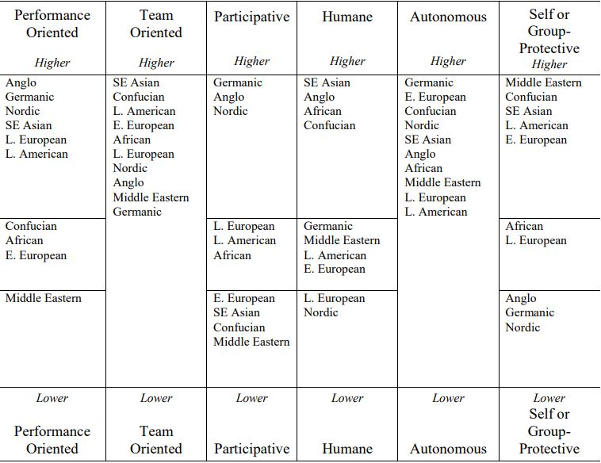
Figure 3:Societal segments and Leadership styles; (Source: Latka, 2022)
GLOBE project study analyzed leader characteristics of a number of countries and classified them into 21 leadership scales, condensed to six leadership styles: task-oriented, people-oriented, engaging, soft-hearted, self-ruled, and self or group-defensive. As per Burke (2014), Italians follow soft-hearted, self-ruled, and self or group-defensive leadership styles highly.

Recommendations
To manage a hotel in a Latin European country like Italy, a manager needs to understand and appreciate their culture emphasizing values, beliefs, emotions, and traditions (Fissi et. al., 2020). The following are some suggestions that a manager should pursue:
- Practice warm hospitality
- Use Italian phrases like Buongiorno" (Good morning)
- Welcome local hard drinks i.e., wines
- Celebrate national and cultural festivals
- Provide Concierge facilities i.e., tour guides
- Collaborate with local artists to decorate native offerings

Conclusion
European countries are appropriate to start a new hotel business since they love to eat meals with their relatives in an attractive environment and they love to stay, visit, and enjoy the outside beauty. Italy is one of the highly accessible places in this regard for a new grand opening. However, it is necessary to have a thorough evaluation of the socio-cultural environment of the country to fulfill the main purpose of the manager.

References
Berezin, M., 2018. Making the fascist self: The political culture of interwar Italy. Cornell University Press.
Borin, E. and Donato, F., 2015. Unlocking the potential of IC in Italian cultural ecosystems. Journal of Intellectual Capital, 16(2), pp.285-304.
Burke, P., 2014. The Italian Renaissance: culture and society in Italy. Princeton University Press.
Cervi, L., 2020. Exclusionary Populism and Islamophobia: A comparative analysis of Italy and Spain. Religions, 11(10), p.516.
Clark, J.M., Quast, L.N., Jang, S., Wohkittel, J., Center, B., Edwards, K. and Bovornusvakool, W., 2016. GLOBE Study culture clusters: Can they be found in Importance ratings of managerial competencies?. European Journal of Training and Development, 40(7), pp.534-553.
Fissi, S., Romolini, A. and Gori, E., 2020. Building a business model for a new form of hospitality: the albergo diffuso. International Journal of Contemporary Hospitality Management, 32(1), pp.307-323.
Latka, R., 2022. GLOBE: is the research still relevant after almost 20 years?: Insights in the case of Germany (Bachelor's thesis, University of Twente).
Lingiardi, V., Nardelli, N., Ioverno, S., Falanga, S., Di Chiacchio, C., Tanzilli, A. and Baiocco, R., 2016. Homonegativity in Italy: Cultural issues, personality characteristics, and demographic correlates with negative attitudes toward lesbians and gay men. Sexuality Research and Social Policy, 13, pp.95-108.
Martin, J., 2023. Venice's hidden enemies: Italian heretics in a Renaissance city (Vol. 16). Univ of California Press.
Nimbi, F.M., Tripodi, F., Simonelli, C. and Nobre, P., 2019. Sexual Dysfunctional Beliefs Questionnaire (SDBQ): Translation and psychometric properties of the Italian version. Sexologies, 28(2), pp.e11-e27.

