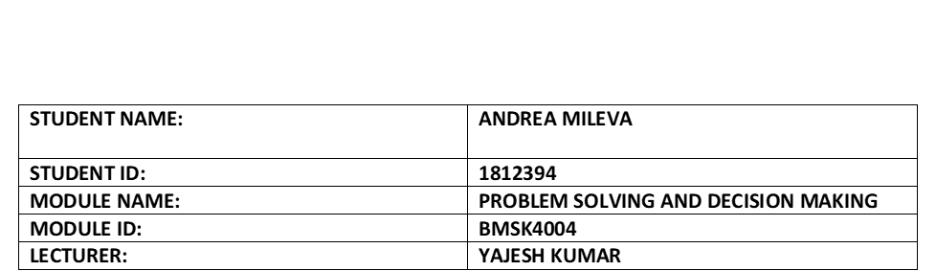

PROBLEM SOLVING TOOLS AND TECHNIQUES WHICH HELPS FOR DECISION MAKING WITHIN THE WORKFORCE

HONEYPOT MEDICAL CENTRE

Table of Contents
INTRODUCTION 3
HONEYPOT MEDICAL CENTRE 3
SHARING EXPERIENCE WITH ORGANIZATION 4
PROBLEMS WITHIN HONEYPOT MEDICAL CENTRE 4
LITERATURE RELATED TO THE CHOSEN PROBLEM 5
SEARCH 6
PROBLEM SOLVING TOOLS AND TECHNIQUES 6
ALTERNATIVE SOLUTIONS 11
EVALUATING BOTH OF YOUR PROSED SOLUTIONS 13
DISCUSSING IMPLEMENTATION OF THE PROPOSED SOLUTION 13
COMMUNICATE THE PLAN TO STAKEHOLDERS 14
PMI 15
CONCLUSION 15
REFERENCES 17

INTRODUCTION
.
Problem solving and decision making are effective and important skills which in turn helps in improving the quality of the decision making. This helps in fixing various set of issues which helps in finding the best solution to the problem. Use of effective problem-solving tools like PESTLE Analysis, SWOT Analysis, Brainstorming, etc. in order to solve various specific problem within the organization. In this report I will explain what the problems within the Honeypot Medical Centre which are was taken by interviewing some of the staff and seen by my personal experience. Also, will try to apply Problem solving tools and techniques to solve these problems. The problem-solving tools and techniques will be explained (when is possible), some suggestion is given plus what are the benefits if those problems will be solved.

HONEYPOT MEDICAL CENTRE
Honeypot Medical Centre is small GP surgery and NHS organization with 8GP’s, nurse, health care assistant, pharmacist, receptionist. There works an 8 General Practices, 1 Nurse, 1 health care 1 assistant, 1 pharmacist.
Honeypot Medical Centre is located at Queensbury, Stanmore and is one of local GP surgeries in Harrow Council. Honeypot Medical Centre provide also same day appointment which is one of the issues mentioned in this report.
(Honeypotmc.co.uk)
The location of Medical Centre is at the Hight Street in Queensbury and the local busses 114 and 79 stop near by the surgery, therefore is easy for visiting.
The technology which is using it in the Honeypot Medical Centre is modernistic, but the software’s are much more complicated for the computers that the surgery work with. Like example: The appointment booking system is need much larger processor that the one which the surgery computers works with.
The Honeypot Centre work together with few local clinics where can be booked appointment if the Honeypot Medical Centre run out of day appointment availability. This is clinics are open from 8:00 am until 20:00pm.
(Honeypotmc.co.uk)

SHARING EXPERIENCE WITH ORGANIZATION
Like a patient with Honeypot Medical Centre I can share my experience with the waiting time. Most of the time there is a need to book appointment for my son- he is born 15 weeks premature and in every 3 months we must go to his GP for health check. Always there is a delate for our appointment, sometime the delate is 20 minutes, other time is more than 40 minutes. Never seen it the GP on time.

PROBLEMS WITHIN HONEYPOT MEDICAL CENTRE
From primary research was found that in this surgery have a couple of complex problems. In first time the patients complain about waiting time. The key problem associated with the Honeypot medical centre is that, they do not have an effective management system to lower the queue in order to provide better are results within the stipulated time frame. The doctors delay for shifts and the appointments time delaying automatically. Usually there is limit of the appointments for the working day that is why every appointment should take not more than 10 minutes inside the room. The staff remember every time to the patients they should explain one problem in one appointment, if they have more than one should book a double appointment.
The receptionist dealing every day with test result delays complain. There are not enough train persons to read a test results (only one of the General Practices could do this). The waiting time for test results could increase to few months. This could cost life’s and late treatments which will be the worst scenario for Honeypot Medical Centre specially if is a Cancer and is getting worst. Not enough trained persons for examining test results in turn increases the waiting time to attain test results. This in turn also increases the risk of the worst scenarios associated with the late delivery of care treatments.
Apart from this problem is coming another which is about the computers which are using it for booking appointment system. The staff mentioned that the computers are slowly and the system not enough strong for the software for the booking system.
Another problem from personal experience is lack of communication. The staff does not ask for repeating if they do not hear something. When you book appointment and they do not hear properly the date of birth or the name somebody else gets appointment instead of you. This in turn largely affects the way care is delivered to each patient in Honeypot Medical Centre.
Some staff come with the point that they are working with old and functional examination beds. This is another problem within the Honeypot Medical Centre. Some of the beds are not changed for years and still there to be in use.
The Medical Centre refurbished the building, but not change the facility to build more examination rooms, not change the furniture’s, not thinking for Information Technology process or to provide any easy way to help with the appointment bookings.

LITERATURE RELATED TO THE CHOSEN PROBLEM
Kuziemsky, (2016, January) sought to determine the fact that, problem solving in turn is an effective technique as it helps in examining a difficult matter which in turn requires a specific solution. Problem solving helps in ensuring that the individual deals with the specific real problems. Decision making in turn helps in finding the best solution to the problem which in turn eventually leads to higher efficiency. Problem solving and decision making helps in improving the quality of the decision making. It is useful in fixing various set of issues which helps in finding the best solution to the problem. Patel & Dave, (2019) argued that, the rational decision-making process mainly comprise of problem identification, criteria definition, alternative generation and evaluation and effective implementation of the plan. Monitoring and seeking feedback in turn is an effective measure which in turn eventually helps in delivering the best results and outcomes. Miller, Singh, Arnold & Klein, (2020) investigated that, use of effective problem solving tools and techniques such as PESTLE Analysis, SWOT Analysis, Brainstorming, fish bone, Porter's five force model, PMI, etc. in turn are considered to be very useful in analysing the solving the various set of problems associated with the medical centre. This in turn helps in providing better care results and outcomes. Lack of proper trained staff, lack of communication, old equipment’s, long waiting time, lack of quality staff, etc. are the key problems of the medical centre.

SEARCH
This report will use primary research which has been done by interviewing some of the staff at Honeypot Medical Centre. The problems are explained and used different problem-solving tools and techniques. The research has been carried out and it has been analysed that, Honeypot medical centre requires funds from the NHS and government in order to improve the reasons associated with the complaint time.
Like every NHS organization the Honeypot Medical Centre need more finance for changing the operative system, to change the facility, for refurbishment etc. For all those changes there need to come money from the Government and NHS, which is happened not very often.
The common reasons for complaints are:
- The appointment time taking long and is some happens mistakes from the system;
- Lack of quality staff;
- Lack of training;
- Lack of Communication;
- Old furniture’s
These in turn are one of the key problems which in turn has to be resolved in order to provide the best quality care services and attain better care results and outcomes.
All this information was taken by private discussions within the Honeypot Medical Centre General Practice’s, Nurses, some patients and was given the personal experience.

PROBLEM SOLVING TOOLS AND TECHNIQUES
The Honeypot Medical Centre tends to focus on effectively applying range of problem-solving techniques in order to provide the best quality care services and attain better care results and outcomes within the health care sector.
PESTLE ANALYSIS- Know it also like PEST analysis, is an idea in trading rules. Besides, these rules are used as an implement by companies and factories to check the productivity and profits. (PESTLE Analysis,2019)
Political factors which play role for the normal function of Honeypot Centre are Brexit, tax increasing, Government decision, NHS restrictions, Small budget. The key factors such as government laws and legislations, tax policy, funding grants and initiative from NHS and government, political stability, etc. influences the operations of the Honeypot Medical Centre.
From Ecological side there are: Cuts form NHS, Small salaries, poor facility. These factors comprise of increase in interest rate, higher inflation rate, lower disposable income of the individuals, poor economic conditions, etc. influences the operations of the Honeypot Medical Centre.
Social factor: The key factors such as age population, improvements in healthcare service, increase in the growth of the population, health consciousness, demographics, etc. in turn largely influence the operations of the Honeypot Medical Centre.
Technology: New software for the computers or for the appointment booking system, examination by the phone or phone appointments, proper communication within the target markets, increase number of training because of integration of innovative technology etc. in turn largely influence the operations of the Honeypot Medical Centre (Laukkanen, Suhonen, & Leino-Kilpi, (2016)).
Environmental factor: The key factors such as ethics and suitability, climate change, environmental pollution, reduction in the carbon footprint, accessibility to the medical care, etc. in turn are considered to be the most influencing factors which in turn largely influence the operations of the Honeypot Medical Centre.
Legal factor: The key factors such as various legal laws and legislations associated with employment law, health and safety law, safety standards, competitive legislations, equal opportunities, consumer laws, etc. are considered to be the most influencing factors which in turn largely influence the operations of the Honeypot Medical Centre.
The expression PEST is routinely practised for long time and is not easy to organize. Primitively has been remark to instrument and styles for checking the trade conditions. Aquilar (1976) talk about ETPS- the four areas important for circumstances- Ecological, Technology, Political and Social. Upon the time was recognize just a PEST accompanying of extra lines-Ecological and Legislative for commerce investigation (Aguilar,1976)
PESTEL is also call a business investigation. The outside elements of order could be value via go it to pieces and seeing the changes through all five positions (Political, Economic, Social, Technology, Environment and legal).
Similar inspect list could take place within the company (Health Knowledge,2017)
SWOT ANALYSIS- Swot Analysis is a business investigation system that assures the fairs for purpose are fully explain and all the points communicates to the assure are rightly named.
Swot Analysis investigation signifies four areas:
Strength, Weaknesses, Opportunities and Treats.
The Inward and outward ingredients reflect to the Swot Analysis when is in action and both plays important role for triumph of the purpose. (Notredameonline.com,2017)
SWOT ANALYSIS FOR HONEYPOT LANE

The strengths of the Honeypot Medical Centre are: The good location-easy for access, is free for NSH users, they have computers and operative systems, using telephones to contact patients and patients can use the telephones to contact the surgery. The major strength associated with the Honeypot Medical Centre is that it is in a good location which is very accessible for the patient to visit the medical centre. They also offer wide range of medical services to the patients in order to attain better care results and outcomes.
Weaknesses is coming: There not good communication between the staff and between staffs to patients; There are not enough General Practice’s, but and in the building does not have much space for extra examination rooms, there are not enough budget for refurbishment. The major weakness associated with the Honeypot Medical Centre is that, they tend to have lack of finances and funds in order to carry out business operations (Arocha & Patel, (2017)). Deficit of GP's and lack of communication in turn are one of the major weakness for Honeypot Medical Centre.
Opportunities: Train the staff, New booking system, more employees, extension to the building for update the room examinations. The key opportunity with the Honeypot Medical Centre is to hire trained and specialized staff which in turn helps in properly examining the working of the company. Integration of the effective online booking system and software in turn helps in effectively managing the various business operations. Creating more examination rooms and creating more general practice in turn helps in creating wider set of opportunity for the business.
The threats which can be taken are providing a training to the staff, updating the software systems and change the technical, employing more General practice’s, build more examination rooms. The major threat associated with the Honeypot Medical Centre is associated with more staff meeting and proper training to the health care practitioners in turn leads to higher cost to the business. Building extension for more rooms and employing more general practice in turn are considered to be the major threat to the Honeypot Medical Centre.
This analysis show that the Honeypot Medical Centre is not in perfect condition comparing with the other Medical Centres within the Harrow council.
There need to be make a huge change within the surgery. The staff need to be change as well, need people with strong leadership skills to solve the problems.
This analysis showing that the Honeypot Medical Centre is connecting to the Government and Harrow Council and if both reduce the budget for the local Medical Centres there not will be possible to improving the quality and the way of communication.
BRAINSTORMING- Brainstorming blends a reduced simple way to problem solving among indirect believing. Stimulate humans to suggest conceptions along with abstractions which can be difficult for understanding. These conceptions could be clever designed and can be original answer for dilemma, when separates could stimulate extra conceptions. This lend a hand to the humans and motivate them to produce more conceptions.
whence, over a brainstorming sitting the humans escape with disapproving or return the conceptions.
Arbitration and investigation in this level exploits the concept originality and extend the imaginability.
All the staff in Honeypot Medical Centre could make meeting every weeks or every two weeks to discuss what going wrong and how could be resolve. Everybody will have a chance to say what will be better to be change and how, what must be removed from the service list and together to think about budget and new staff.
The meetings will help to arrange a training for the untrained personal, to discuss with the manager the day complains and what is the reasons for them.
FISHBONE DIAGRAM-This source investigation instrument related to one of seven primary characteristic instruments.
The Fishbone diagram recognize numerous imaginable sources for outcomes or difficulty. (Asq.org,2020)
Fishbone analysis stock a span table to split additional classificatory potential reasons for a trouble along authorizing groups ability to point the dilemma. It is advantageous within the search breakdown which is practised within well-being attention status.
The triumphant manner to practice the fish bone investigation is to comfort the teams within the organization to operate in collective and to recognize the potential sources of the dilemma. Those sources are ranked in clusters like a circumstances, process, humans and tools. To finish the work out, the answer will come and operations which have to be taken in the next step will showing up.
(Contributor,2013)

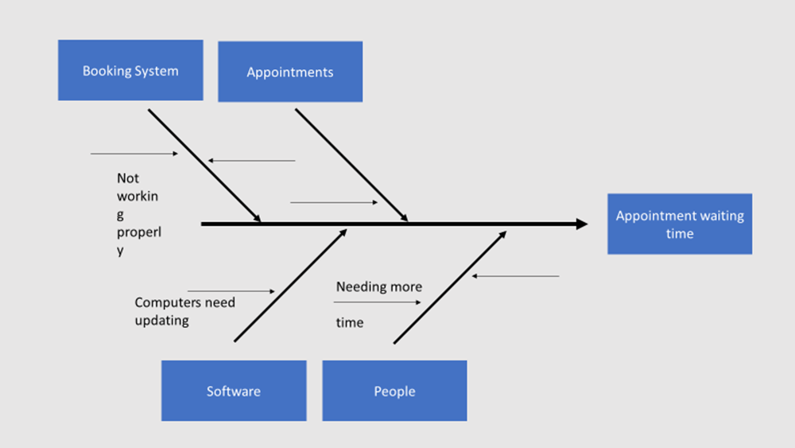 This analysis shows that the Honeypot Medical Centre need have problem with the rules of the examination appointments and there must be explained that one appointment should take not more than 10 minutes. If the patients need more time or coming with more than one issue, they must book a double appointment.
There coming an option for building extra examination rooms and employs more General Practice’s.

PORTERS FIVE FORCES-Porter’s Five Forces is an easy, however strong instrument for considerate the competitiveness of trade circumstances also for recognizing tactics. (Chappelow,2019)

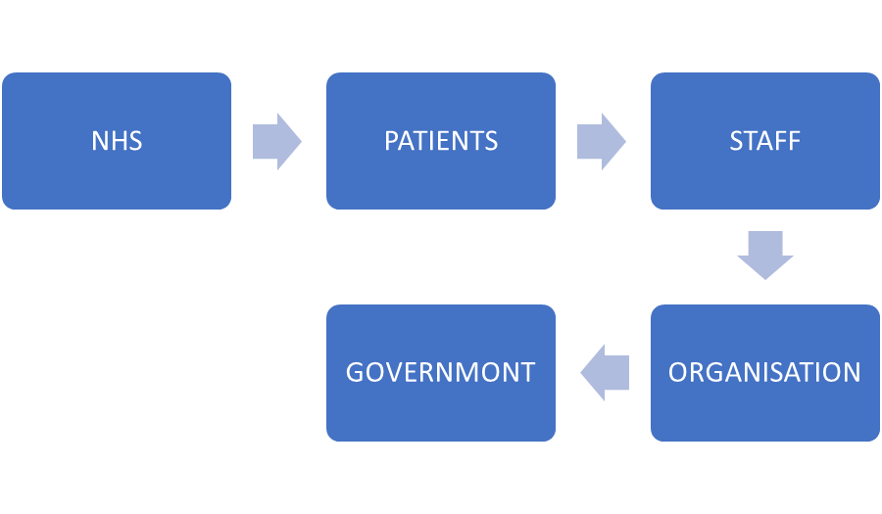
This tool is used to be analyses the ability to be employed more GP’s. If this happened the complains will stop about there are delating with the appointments time. Every patient will be seeing when that is needing and will receive treatment if there have any needs for.
Not really clear how this tool is used to analyse problem, but the idea is that there are several factors which influenced to the Honeypot Medical Centre improvement.
The patients are a factor which plays role for the organization feedback. When they complaining there is coming signal that the organization doing something wrong and this must fix. From the patient’s complaints the management will be clear what must be change and what action must be taken for improvement.

ALTERNATIVE SOLUTIONS
Every problem within Honeypot Medical Centre can be solve by logical way.
The lack of communication can be solved by team buildings. Need to be arrange some holidays or just day travel time to take the staff out of the city, to be provide some food and drinks. The staff will start to communicate each other and will start to know their characters and interests. This step makes everyone to relax and stop thinking about the stress during the shift and is helping to build teams within the organisation and they will work to achieve the same goals- No complaints and better care. Another way to solve the lack of communication problem is by integrating subordinates to participate in the decision-making process. This in turn eventually helps in making better care decision in order to attain the best results and outcomes.
Research also could be useful for solution about complaints. Managers could search and collecting data what the other Medical Centres improve their facility and care service.
The problem with the waiting time is coming for not clear policy how long is the duration of one appointment. There should be remained to every patient that the appointment time is 10 minute per patients and if they need more time for discussion or just to chat about their condition, they need to book double appointment (20minutes). Also, there can be putted a leaflet which explain about the duration of the appointment.
The other way of solving this problem is to employ more GP’s and to build extra examination rooms. This will reduce the waiting time in drastic way, there will be perfect if this happened soon. If this step is taken many people will be able to use daytime appointments and is not will need to wait extra half an hour or more
The problem with the technology system will be resolved if the manager ask the IT (Information Technology) department could change the operative system of the computers and the booking appointments start to functional normal. The new operative system of the computer will be facing the exact need of appointment booking system and not will meeting any more the same mistakes and delays.
About the test result delays there will be need a training and time to teach a some of the staff. The better solution is to Employ the qualitative GP’s which are already trained to read a blood or urine test. Sometime delays in the results could be fatal and the Medical Centre must close the doors forever (opinion).
Another solution could be if the laboratory sending the results with explanation. This is will safe time for patients and money for the surgery.
The furniture will be change if the Honeypot Medical Centre have finances for it or the NHS is prepared to invest in them.

EVALUATING BOTH OF YOUR PROSED SOLUTIONS
Problem associated with the lack of communication: team building capability is more beneficial in order to resolve problem associated with the lack of communication. This helps in collaborating people and helps in better decision making associated with certain care problem.
The problem associated with the waiting time: Building extra examination room and employing more general practice in turn helps in reducing the waiting time drastically. This in turn helps in checking more patients within a day which helps in better care results and outcomes within the Honeypot Medical Centre.
The problem associated with the technology system: The best solution associated with the problem is to integrate effective operative system and integrated technology which in turn helps in assessing mistakes and delays associated with booking of appointment. The new operative system of the computer will be facing the exact need of appointment booking system which helps in delivering effective services.
Problem associated with the test results delay: Giving effective and proper training to the health care practitioners in the Honeypot Medical Centre such as staff, doctors, nurses, etc. to read a blood or urine test. This helps in solving problem associated with the delay in the test results of the patients. This in turn helps to provide timely care to the patient without any delay.
Old furniture: Raising funds from the NHS and government in turn helps in changing the beds in the building. This also helps in refurbishing the building which in turn helps in better care results and outcomes with positive care environment.

DISCUSSING IMPLEMENTATION OF THE PROPOSED SOLUTION
Implementation plan in turn is an effective strategy which in turn helps in turning strategies into the desired action. This in turn helps in accomplishing strategic goals and objectives.
Implementation plan for lack of communication: The management team of the Honeypot Medical Centre must focus on creating a team and must focus on carrying out group meeting activities like holidays, hangouts, etc. which helps in better collaboration of the team members. This helps them in better interaction and helps them know each other.
Implementation plan for reducing waiting time: Raising fund from the government and NHS in order to build extra number of examination room and hiring number of specialized staff helps in reducing waiting time and results in better care outcomes within stipulated time frame.
Implementation plan for integrating technology system: Selecting an appropriate IT team in order to create a software and develop an effective website which help in integrating the online booking system.
Implementation plan for test result delay: Selecting the group of health care practitioners who need to specialize their skills associated with the test results. This helps in timely examining the test results of the patients.
Implementation plan for changing old furniture and beds: Raising fund from the government and NHS of around £2600 in order to change the old furniture and beds of the Honeypot Medical Centre.

COMMUNICATE THE PLAN TO STAKEHOLDERS
A stakeholder communication plan in turn is very crucial because it helps in outlining the plan and discuss the plan to the stakeholders. This in turn eventually leads to long term sustainable growth and efficiency within the health care sector and medical centre.
This implementation plan associated with the medical centre problem can be effectively communicated to the stakeholders by scheduling a meeting or a conference call. This in turn helps in effectively addressing all the problems associated with the Honeypot Medical Centre. Project summary report must be sent to the key stakeholders of the organization in order to make them aware about the various changes which in turn has been carried out within the Honeypot Medical Centre.
The which can be taken Is one step for improvement.
The manager of Honeypot Medical Centre is responsible to write action plan and to putt this plan in action.
Goals:
The goals of Honeypot Medical Centre are to refurbish the building, to build more examination rooms, updating the operative systems, reducing the waiting time.

PMI
+ | - | Interesting
Updating of the technology will help for time delating (+5) | New Cost (-2) | Waiting time will be not issue (+5)
Quality staff will help with test results (+5) | More money for salaries (-3) | The Cancer treatments will be on time (+5)
More examination room will help the complaints to be reduced (+5) | More money for refurbishment (-5) | 10 minutes per appointment (+5)
Total: +15 | Total: -10 | Total: +15

From the PMI tool is seeing it that the updating of operational computer system will reducing the waiting time to be seen the GP, train staff will help to reduce the test results time and not will be issue and will cost money. Also showing that the Honeypot Medical Centre will be able to meet patients’ needs without long waiting time for. More General Practice’s will be able to see more patients on same day appointment without any rush or complaining about waiting time. Yes, they need bigger budget to do all those steps, but the complaints and bad feedbacks will be reducing to the minimum.
The Honeypot Medical Centre can employ quality staff, which is already trained, those staff could be General Practice’s, nurses, receptionist, pharmacists etc. This step could save money from training and the health care within the Honeypot Medical Centre will be improved.

CONCLUSION
There are some factors which are barriers for Honeypot medical Centre to achieve all the planning changing for improving the quality of care that they provide.
In conclusion can be said that the Honeypot Medical Centre must identify the problems, break them to peace’s, found out what cost this problem and after that to thinking for solutions to these problems.
Honeypot Medical Centre must employ more quality and experienced staff to reduce the complaints and bad feedbacks. Building new examination room will be helpful to be reduced the appointment waiting time.

REFERENCES
Bibliography

Aguilar, F. (1976). Scanning the business environment. Johannesburg: Macmillan.
Arocha, J. F., & Patel, V. L. (2017). Making Sense of Health Problems: Folk Cognition and Healthcare Decisions. In Cognitive Informatics in Health and Biomedicine (pp. 45-64). Springer, Cham.
Croskerry, P. (2017). A model for clinical decision-making in medicine. Medical Science Educator.27(1). 9-13.
Kuziemsky, C. (2016, January). Decision-making in healthcare as a complex adaptive system. In Healthcare Management Forum (Vol. 29, No. 1, pp. 4-7). Sage CA: Los Angeles, CA: SAGE Publications.
Laukkanen, L., Suhonen, R., & Leino-Kilpi, H. (2016). Solving work-related ethical problems: The activities of nurse managers. Nursing ethics. 23(8). 838-850.
Miller, K. E., Singh, H., Arnold, R., & Klein, G. (2020). Clinical decision-making in complex healthcare delivery systems. In Clinical Engineering Handbook (pp. 858-864). Academic Press.
Patel, B., & Dave, G. (2019). OPERATIONS RESEARCH TECHNIQUES AND ITS’APPLICATION IN HEALTHCARE SERVICE DELIVERY DECISION MAKING: A REVIEW OF EVOLUTION. Journal of Management (JOM), 6(2).
Online
Asq.org. (2020). What is a Fishbone Diagram? Ishikawa Cause & Effective Diagram | ASQ. [online] Available at: https://asq.org/quality-resources/fishbone[Accessed 7 Jan. 2020]
Chappelow, J. (2019). Porter’s 5 Forces Definition. [online] Investopedia. Available at: https://www.investopedia.com/terms/p/porter.asp[Accessed 5 Jan. 2020]
Contributor, N. (2013). Change the management tools part 1: Using fishbone analysis to investigate problem| Nursing Times. [online] Available at: https://www.nursingtimes.net/roles/nurse-managers/change-management-tools-part-1-using-fishbone-analysiss-to-investigate-problems-12-04-2013[Accessed at 10 Jan. 2020]
Health Knowledge. (2017). The impact of political, economic, socio-cultural, environmental and other external influences. [online] Available at: https://www.healthknowledge.org.uk/public-health-textbook/organisation-management/5b-understanding-ofs/assessing-impact-external-influencess[ [Accessed 8 Jan.2020]
Honeypotmc.co.uk. (n.d.). Practice services | Honeypot Medical Centre. [Online] Available at: https://www.honeypotmc.co.uk/practice-services/[Accessed 5 Jan. 2020]
Notredameonline.com (2017). [online] Available at: https://www.notredameonline.com/resources/business-administration/what-is-swot-analysis/Accessed [ 2 Jan. 2020]
PESTLE Analysis. (2019). What is PESTLE Analysis? A Tool for Business Analysis. [online] available at: https://www.google.com/amp/s/pestleanalysis.com/what-is-pestle-analysis/
[Accessed 6 Jan. 2020]

