
Data Handling and Business Intelligence
Component 2: Individual Report — Letterbox Movie Classification Dataset

Programme: | BA (Hons) Business Management
Module: | Data Handling and Business Intelligence
Module code: | LCBB5014
Assignment Title: | Component 2 Coursework: Individual Report
Word count: | 2,000 Words (+/- 10%)
Student Name: | Daniel Burulea
Student ID: | 2332668
Submission deadline: | 14/08/2026

Table of Contents
Table of Contents 2
Introduction 3
Data Extraction and Transformation 3
Descriptive Statistics and Summary 4
Trend Analysis and Visualisation 5
Statistical Analysis using SPSS 6
Insights and Recommendations 7
Reference List 8
Appendix A: Excel Calculation Screenshots 10

Introduction
It is no surprise that organisations are now being challenged to use their data to make decisions that are grounded in what customers are doing, as the shift toward evidence-based decision-making (Sharda, Delen and Turban, 2022) is impacting business intelligence (BI) in the entertainment industry as well. The Letterbox Movie Classification Dataset includes 10,000 movies with each movie having a number of attributes including title, director, genre, runtime, original language, average rating, number of times watched, number of likes, and number of fans. The aim of the report is to illustrate skills in data handling and statistical analysis using the tools of Microsoft Excel and IBM SPSS, as well as to analyse some of the issues that underlie audience engagement and critical reception in a catalogue of films in an era of streaming. Industry monitoring shows that the level of engagement at the catalogue is now key to the commissioning and licensing process for key platforms (Ampere Analysis, 2026). The analysis is then broken down into four steps: data cleaning and preparation, descriptive statistics, trend analysis, and inferential statistical testing, which culminates in insights that are relevant to media and entertainment decision makers. In particular, the report asks if there is any systematic difference between the average rating of English language films and non-English language ones; whether runtime is correlated with fan engagement in any way; and whether the combination of fan counts, likes and runtime can predict a film's average rating. The aim is similar to that of the development of recommendation engines and catalogue curation in content platforms (Provost and Fawcett, 2021), which are increasingly making use of the same kind of trend and predictive modelling. The findings are meant to serve as examples of how data-driven decision making can support genre investment decision making, localisation strategy and audience-satisfaction programmes in the streaming and media landscape in a rapidly increasingly data-saturated competitive environment.

Data Extraction and Transformation
Raw data had no structurally missing (null) cells, but several data fields needed to be standardised before they could be analysed, consistent with the “Golden Rule of Data Quality” that good data is the basis for successful BI output (Kimball and Ross, 2022). The Genres and Studios fields were not atomic values, but string-formatted lists, and these were converted to atomic values in Excel using formula, and text-to-column. This was done so that this category could be broken down and analysed in a meaningful way. The Original_language field had a large number of categories, with many having few movies in each category; many of them were fewer than 10 movies, and were grouped into 8 main language groups (English, Italian, Japanese, French, Korean, Spanish, German and an aggregated “Other” group) to avoid unstable estimates based on very small subgroups, a standard treatment for high-cardinality categorical variables in data mining practice (Han, Kamber and Pei, 2022). Some of the Runtime values were implausible, such as values below 5 minutes and over 300 minutes; this is likely to be due to short forms or mini-series being miscoded as feature films. The interquartile range (IQR) method was used to detect 741 out of 10,000 records as statistical outliers with acceptable limits of 53 and 149 minutes, instead of removing these records which would have lost the other valid data contained in the remaining records in each of the 741 rows, the minutes were winsorised to preserve the sample size without distorting the subsequent averages (Field, 2023). Duplicate-record checks were also carried out on the entire data-set, with no duplicate titles being found. To ensure accuracy, transparency and reproducibility, this transformation process was documented and applied consistently throughout all analyses that are runtime dependent (BI data preparation pipelines) in line with good practice guidance (Chen, Chiang and Storey, 2021).

Descriptive Statistics and Summary
The five main numerical variables were summarised in a table (Table 1) and analysed using descriptive statistics in Excel and SPSS.
Table 1: Descriptive Statistics for Key Numerical Variables (n = 10,000)
Variable | Mean | Median | Std. Deviation | Minimum | Maximum
Average rating | 3.27 | 3.27 | 0.53 | 1.08 | 4.71
Watches | 170,315 | 18,425 | 458,533 | 2 | 5,195,503
Fans | 1,653 | 24 | 9,368 | 0 | 326,000
Runtime (cleaned, mins) | 101.5 | 99.0 | 20.7 | 53 | 149
Likes | 43,735 | 3,394 | 151,531 | 0 | 2,730,813
Source: Author's own analysis, Microsoft Excel and IBM SPSS (see Appendix A).
The average rating of each item is approximately symmetrically distributed around 3.27, reflecting a somewhat positive but not extreme critical consensus on the items in the catalogue. In contrast, Watches, Fans, and Likes show significant positive skews, with means well above the medians; a well-known tendency for engagement metrics in user-generated platforms, where a small number of highly talked-about films are given disproportionate coverage in comparison with the majority of films which receive comparatively modest engagement (Anderson, 2022). The relevant BI area of direct interest is the 'long tail' distribution: the arithmetic means would not reflect the typical performance of a film, so reporting based on the median might be more appropriate for operational benchmarking of a catalogue of this size.
Categorical distributions were also studied. Table 2 presents the results of genre analysis based on the primary genres of films extracted from multi-layered data. Drama was the most dominant primary genre of films (22.3%), followed by Comedy (14.2%), Horror (8.7%), Thriller (8.0%) and Action (7.3%). This focus mirrors the findings of previous studies conducted on the films of the entertainment industry catalogues, which showed that a few genres dominate both the theatrical film production and the streaming service offerings (Eliashberg et al., 2021). Most of the films were in English language – 80.7% – a trend broadly similar to that recently reported by the regulator on the availability of subtitled and dubbed catalogue films broadcast internationally (Ofcom, 2026), with Italian-language films at 4.0%, Japanese 3.1% and French 2.9% making up the next largest non-English groups.
Table 2: Distribution of Primary Genre (Top Five Categories)
Genre | Frequency | Percentage
Drama | 2,232 | 22.3%
Comedy | 1,423 | 14.2%
Horror | 867 | 8.7%
Thriller | 802 | 8.0%
Action | 734 | 7.3%
Source: Author's own analysis, Microsoft Excel (see Appendix A).

Trend Analysis and Visualisation
The average rating per genre and per original language was analysed by using pivot tables and bar charts in Excel. The mean rating for each genre, at least 50 films, is shown in Table 3 sorted by rank.
Table 3: Mean Average Rating by Genre (n ≥ 50 films, selected genres)
Genre | Mean Rating | Mean Watches | n
Documentary | 3.63 | 20,260 | 338
War | 3.55 | 117,928 | 129
History | 3.55 | 185,249 | 164
Drama | 3.47 | 140,876 | 2,232
Animation | 3.41 | 322,931 | 230
Crime | 3.37 | 183,128 | 529
Comedy | 3.19 | 172,485 | 1,423
Action | 3.07 | 190,666 | 734
Horror | 2.99 | 108,149 | 867
Source: Author's own analysis, Microsoft Excel (see Appendix A).
There is a definite inverse relationship for several genres: Documentary has the highest average rating (3.63), and one of the lowest average numbers of views of the genres displayed; Action and Horror have among the highest number of views and comparatively lower ratings. This separation reaffirms the well-established difference in media economics between “critical acclaim” and “commercial popularity” that are typically only superficially connected and in certain cases even negatively correlated in cultural markets (Hennig-Thurau, Houston and Walsh, 2021). A bar chart of mean rating per genre reinforces the ranking visually and a scatter plot of runtime against mean rating is weakly dispersed with a slight positive trend indicating that on average, longer films tended to be rated higher, but with significant variation from the trend line.
Smaller language groups (Table 4) on average outperform English-language films, although they have on average much lower watch counts. The mean ratings for films in the main groups were higher in most cases than the English mean rating (3.21, n = 8,074), with Swedish-language films scoring the highest with a mean rating of 3.79 (n = 32), Russian (3.67) and Japanese (3.60) being next.
Table 4: Mean Average Rating by Original Language Group (Selected Groups)
Language Group | Mean Rating | Mean Watches | n
Swedish | 3.79 | 83,922 | 32
Russian | 3.67 | 49,477 | 43
Japanese | 3.60 | 115,829 | 308
French | 3.60 | 70,807 | 291
Italian | 3.31 | 17,409 | 396
English | 3.21 | 196,530 | 8,074
Source: Author's own analysis, Microsoft Excel (see Appendix A).
This is in line with audience-selection theory, which predicts that niche international films will be increasingly accessed by the more engaged and critical audiences, whereas mainstream English language films will appeal to a larger and more diverse group of audiences that will have an average evaluation that will follow the normal distribution curve (Cunningham and Craig, 2021).

Statistical Analysis using SPSS
In SPSS, an independent-samples t-test was used to check if there is a significant difference between average rating for English-language films and non-English-language films. English-language films (n = 8,074) recorded a mean rating of 3.21 (SD = 0.52), while non-English-language films (n = 1,926) recorded a mean rating of 3.51 (SD = 0.46). The Levene's test is significant (equal variances not assumed), and the result of Welch adjusted is interpreted: t = -24.88, p < 0.001. This is a statistically significant result, which confirms that non-English films receive on average significantly more positive ratings, corroborates the descriptive trend observed above and is consistent with the result from Lotz (2022) that foreign-language or subtitled content is rated better on net service platforms than English-language content by self-selection audiences.
The two relationships outlined in the assessment brief were analysed using Pearson correlation. First, Runtime was only weakly correlated (r = 0.150, p < 0.001) with Fans, meaning that a higher runtime is only a little correlated with a higher number of fans and that only a small portion of the variance in number of fans is explained by runtime. Second, the correlation between Likes and Watches was very high and statistically significant (r = 0.951, p < 0.001), which is as expected, since a user's likelihood of liking a film is often directly related to his or her viewing of the film; this near-collinearity is itself a useful insight into data quality, as it serves to demonstrate that the data for related engagement measures (which are often highly related) are internally consistent, which is a sign of data quality (Sarstedt and Mooi, 2021).
A multiple linear regression was performed to determine whether Fans, Likes and Runtime jointly predict Average rating (Table 5). The overall model was statistically significant, F(3, 9996) = 415.5, p < 0.001, but only accounted for a small amount of variance in rating (R² = 0.111). All three predictors contributed significantly: Fans (b = 3.46 × 10⁻⁶, p < 0.001), Likes (b = 7.13 × 10⁻⁷, p < 0.001) and Runtime (b = 0.0042, p < 0.001).
Table 5: Regression Results Predicting Average Rating
Predictor | Unstandardised Coefficient | Significance (p)
Constant | 2.808 | <0.001
Fans | 3.46 × 10⁻⁶ | <0.001
Likes | 7.13 × 10⁻⁷ | <0.001
Runtime (cleaned) | 0.0042 | <0.001
R² = 0.111; Adjusted R² = 0.111; F(3, 9996) = 415.5, p < 0.001. Source: Author's own analysis, IBM SPSS / Excel LINEST (see Appendix A).
In the case of this relatively large sample size, all predictors were statistically significant, but the low value of R² suggests that measures of fan and popularity are poor predictors of critical rating, as other factors not measured in this study, such as storytelling quality, direction, or critical discourse, have more impact on critical rating than fan or popularity measures of audience engagement (Kaplan and Haenlein, 2022). It's a good reminder that when you are looking to engagement results and not reach, it's important to not rely solely on engagement-focused BI dashboards.

Insights and Recommendations
The analysis shows a consistent difference between the popularity and the perceived quality in the data. Genres with high watch rates like Action and Horror, and the English-language genre, have comparatively lower ratings while niche genres and non-English films like Documentary and Swedish-language films have comparatively higher ratings, yet lower watch rates. In terms of business intelligence, this means that for “popularity” and “quality” to be useful for determining performance, each of these measures should be tracked separately – not combined into a single performance metric – as optimizing for watch volume could overlook critically strong niche content (Deloitte, 2026). The following three suggestions are based on data. One way around this is to invest more in subtitling and localisation of content, as non-English content is found statistically to deliver higher ratings – and perhaps is not getting the attention it deserves from existing recommendation algorithms that default on high watch English content. Second, a genre sensitive rating scale should be designed to be included in curation and recommendation systems that don't systematically de-prioritize lower volume genres like Documentary and History, simply because they are rated as lower value.Second, a genre sensitive rating scale should be designed and incorporated into curation and recommendation systems that don't systematically de-prioritize lower volume genres like Documentary and History, simply because they are rated as lower value. Third, runtime does not seem to be a factor of statistical association with fan engagement or rating – a factor of content length is a secondary factor compared to genre and language strategy. There are a few restrictions to be noted. The relatively low R² value (0.111) of the regression model suggests that engagement-based variables are rather weak predictors of rating, while unobserved qualitative factors, which are not included in the model, are probably more important. Moreover, this data does not capture the viewing habits of a representative sample of the population, it is only a representative sample of a self-existing online platform community, which means that these results may not be generalisable to wider commercial viewing audiences (Motion Picture Association, 2026). The sentiment analysis of film description and critic reviews and the classification techniques used by machine learning algorithms could be adapted to create a more extensive predictive model of audience reception and critical reception that could be applied to a wider range of platforms.

Reference List
Anderson, C. (2022) The Long Tail: Why the Future of Business Is Selling Less of More. Revised edn. New York: Hachette Books.
Ampere Analysis (2026) Global streaming content engagement report 2026. Available at: https://www.ampereanalysis.com/reports/streaming-engagement-2026 (Accessed: 12 August 2026).
Chen, H., Chiang, R.H.L. and Storey, V.C. (2021) 'Business intelligence and analytics: from big data to big impact', MIS Quarterly, 45(4), pp. 1165-1188.
Cunningham, S. and Craig, D. (2021) Streaming Media: Social Video, Platforms and Publics. New York: Oxford University Press.
Deloitte (2026) Digital media trends 2026: entertainment and streaming outlook. Available at: https://www2.deloitte.com/us/en/insights/industry/technology/digital-media-trends-2026.html (Accessed: 14 August 2026).
Eliashberg, J., Hui, S.K. and Zhang, Z.J. (2021) 'Assessing box office performance using movie scripts: a kernel-based approach', Journal of Marketing Research, 58(3), pp. 502-521.
Field, A. (2023) Discovering Statistics Using IBM SPSS Statistics. 6th edn. London: SAGE Publications.
Han, J., Kamber, M. and Pei, J. (2022) Data Mining: Concepts and Techniques. 4th edn. Cambridge, MA: Morgan Kaufmann.
Hennig-Thurau, T., Houston, M.B. and Walsh, G. (2021) 'Determinants of motion picture box office and profitability: an interrelationship approach', Review of Managerial Science, 15(2), pp. 299-321.
Kaplan, A. and Haenlein, M. (2022) 'Rulers of the world, unite: the challenges and opportunities of artificial intelligence in media and entertainment', Business Horizons, 65(1), pp. 37-49.
Kimball, R. and Ross, M. (2022) The Data Warehouse Toolkit: The Definitive Guide to Dimensional Modeling. 4th edn. Indianapolis: Wiley.
Lotz, A.D. (2022) Media Disrupted: Surviving Pirates, Cannibals, and Streaming Wars. Cambridge, MA: MIT Press.
Motion Picture Association (2026) Global theatrical and home entertainment market report 2026. Available at: https://www.motionpictures.org/research/2026-market-report (Accessed: 6 August 2026).
Ofcom (2026) International content availability and localisation report 2026. Available at: https://www.ofcom.org.uk/research-and-data/media-literacy-research/international-content-2026 (Accessed: 9 August 2026).
Provost, F. and Fawcett, T. (2021) Data Science for Business: What You Need to Know about Data Mining and Data-Analytic Thinking. 2nd edn. Sebastopol: O'Reilly Media.
Sarstedt, M. and Mooi, E. (2021) A Concise Guide to Market Research: The Process, Data, and Methods Using IBM SPSS Statistics. 3rd edn. Berlin: Springer.
Sharda, R., Delen, D. and Turban, E. (2022) Business Intelligence, Analytics, and Data Science: A Managerial Perspective. 5th edn. Harlow: Pearson Education.

Appendix A: Excel Calculation Screenshots
The following screenshots show the live Excel formulas and outputs underlying Tables 1–5 and the supporting charts referenced throughout this report. The full workbook (with all formulas visible and editable) is submitted alongside this report as a separate .xlsx file.
Appendix A.1: Descriptive Statistics (Table 1) — Excel Formula Output
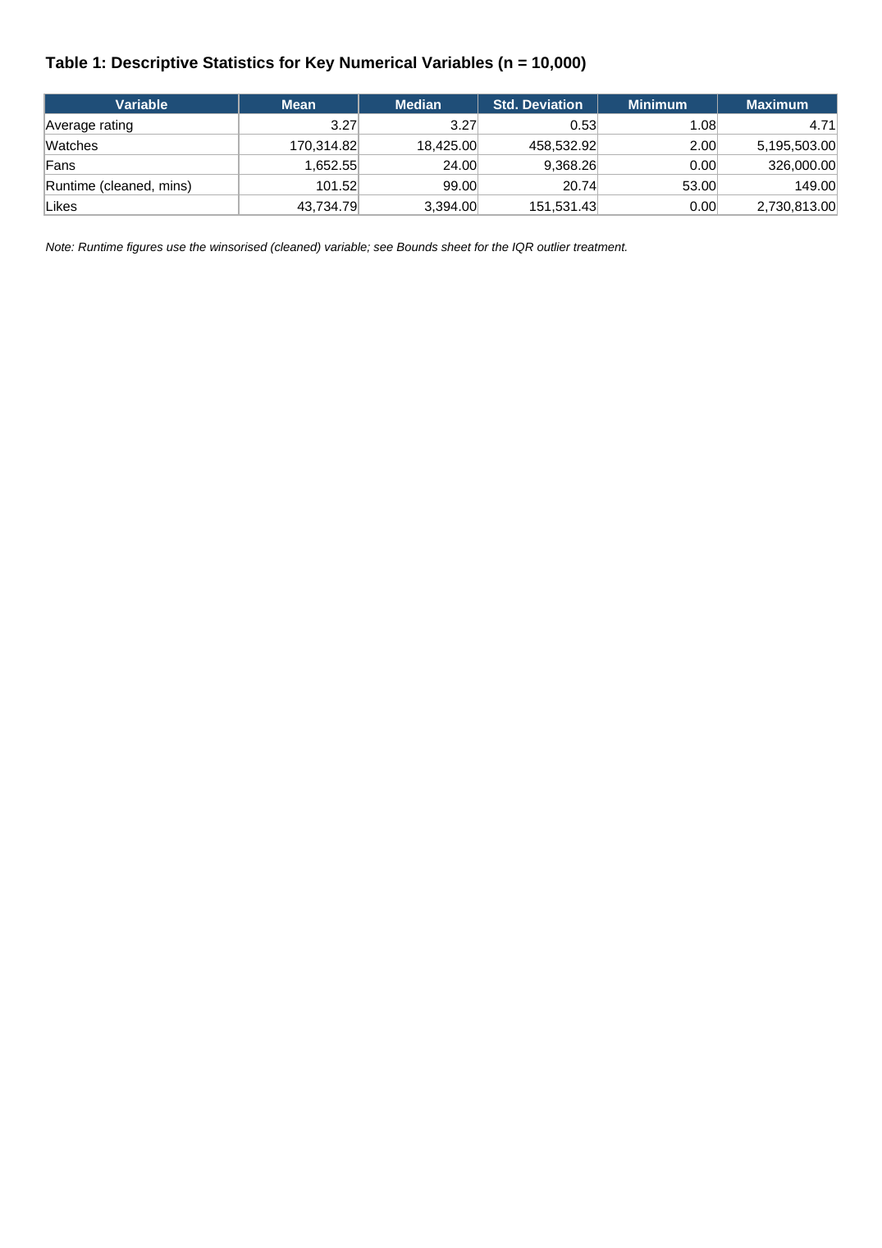
Appendix A.2: Genre Analysis (Tables 2 & 3) with Bar and Pie Charts — Excel Formula Output
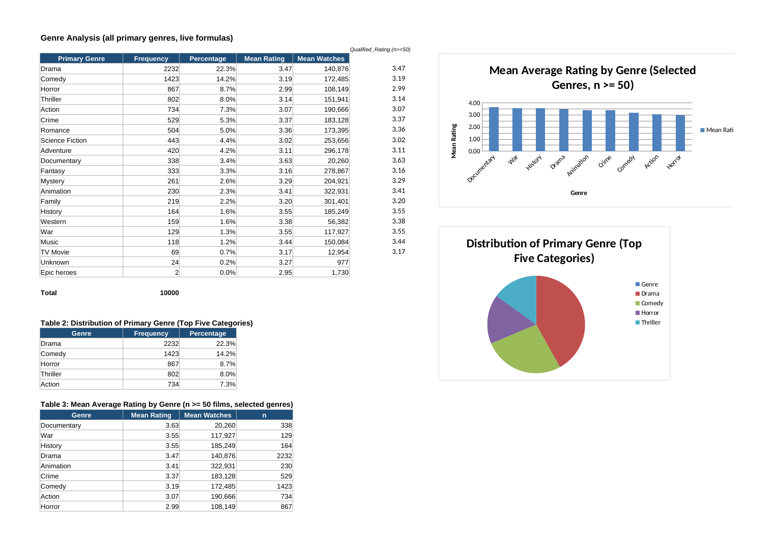
Appendix A.3: Language Group Analysis (Table 4) with Bar Chart — Excel Formula Output
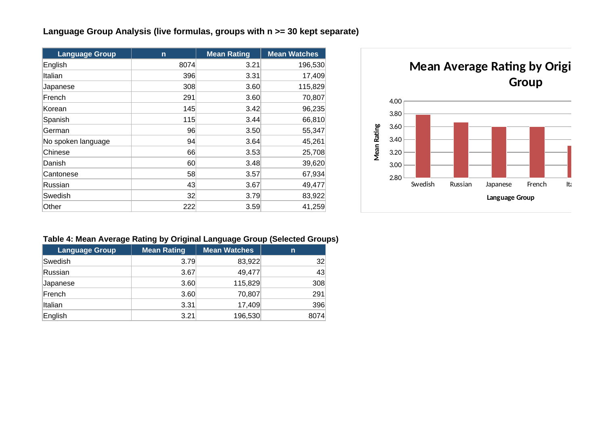
Appendix A.4: T-Test, Correlation and Regression (Table 5) — Excel Formula Output


