

Title- Marketing management- Assessment 1
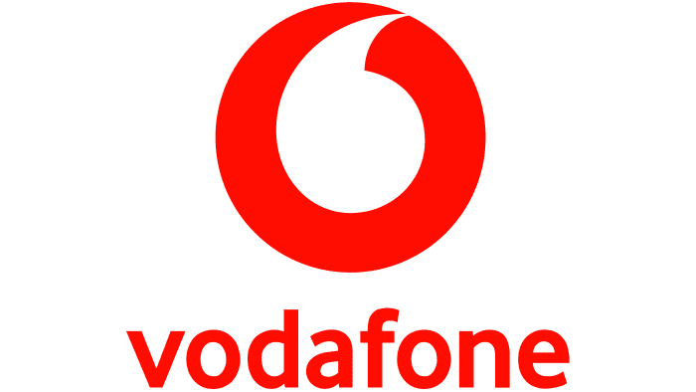

Student name : Aditya Pratap Gurjar

Student ID : 2239855

Programme : MBA – Masters in Business Administration

Module Name: Marketing Management

Module code : LCMB7001

Lecturer name : Tushara Balendran

Date : 30 / August/ 2023
Table of content

1.Introduction……………………………………………………………………3
2.Communication ……………………………………………………………….4
2.1Types of Communication ……….…………………………………5
3.Shannon weaver model……………………………………………………..6
4. Integrated Marketing Communication ………………………………9
5. New Promotional Techniques for
Vodafone Group…………………………………………………………….10
6.Branding & Brand Equity…………………………………………………13
7.Keller’s Brand equity model………………………………………………14
7.1Advantages of keller’s model for Vodafone ……………………18
7.2Disadvantages of keller’s model for Vodafone ………………19
8.Customer journey …………………………………………………………..20
9.Customer touchpoints ……………………………………………………..22
10.Customer Journey Map…………………………………………………..25
11.Total Engagement model…………………………………………………28
12.Recommendations …………………………………………………………31
13.conclusion…………………………………………………………………….32
14.References ……………………………………………………………………33

1.Introduction

This marketing report attempts to evaluate the effectiveness of the marketing tactics and activities used by Vodafone Group PLC to reach and engage its target audience. The research will evaluate Vodafone's marketing mix, competitor analysis, customer journey, and touchpoints. It will also critically evaluate Vodafone's strengths and weaknesses and suggest new marketing tactics that the company may implement to promote sustained industry growth.
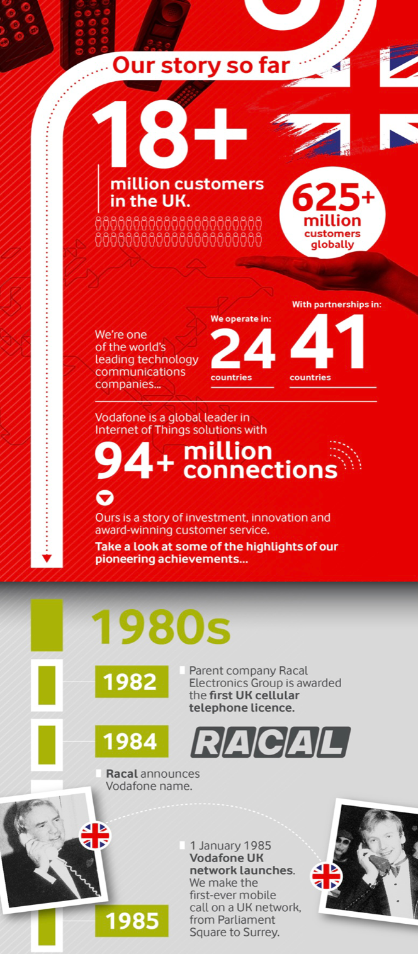
HISTORY :

Vodafone is a British-based telecommunications firm having operations in both Europe and the US. It was first a component of Racal, a 1950-founded British radar and electronics company. Racal established its Vodafone subsidiary in 1983 and obtained the rights to create the first mobile phone network in Britain, which went live in 1985. Early in the 1990s, Vodafone began making acquisitions and forming global network alliances.

20% of the Company's stock, which was then known as Racal Telecom Limited, was made available to the public in October 1988. In September 1991, it formally separated from Racal Electronics Plc to become a separate business.

The Company resumed using its previous name, Vodafone Group plc, on July 28, 2000.

The largest wireless communications provider in Ireland, Eircell, was purchased by the Company in 2001 from eircom. Then, Vodafone Ireland was rebranded from Eircell. The third-largest mobile operator in Japan, J-Phone, which had pioneered the introduction of camera phones there, was later acquired by Vodafone.

2.Communication

In a business environment, communication refers to the intentional flow of information, ideas, data, and insights among individuals, teams, and departments within an organization, as well as with external stakeholders. It acts as a crucial channel for communicating the company's goals, plans, expectations, and development. Collaboration, effort alignment, and decision-making are all aided by effective corporate communication, which ultimately boosts an organizations’s overall effectiveness, productivity, and success. It includes a range of formal and informal platforms, channels, and techniques that are suited to the structure, culture, and objectives of the business.
(Principles of Management - Communication in Organizations, by Vinod B. Singh, Himalaya Publishing House, 2013 ).

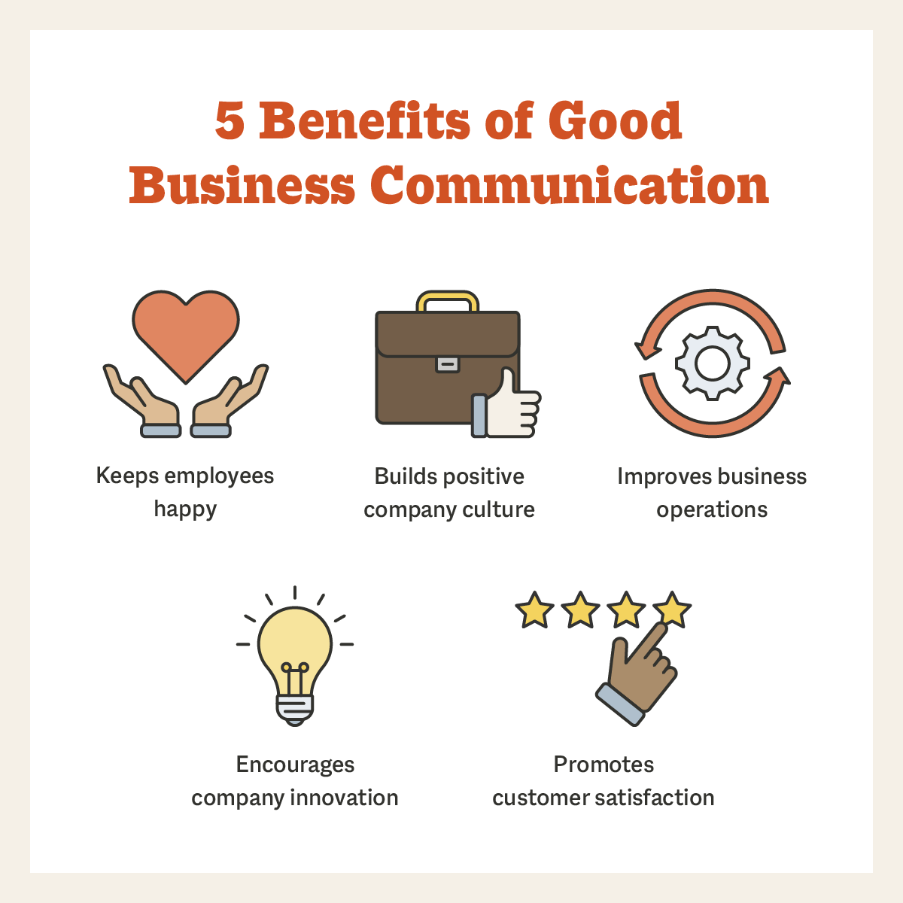

Types of Communication:-

- Verbal Communication:

verbal communication is the use of spoken words to deliver information, ideas, directions, and feedback. This can happen in a variety of ways, including in-person interactions, phone calls, video conferences, meetings, formal speeches, and presentations. In the business sector, strong interpersonal ties must be built while presenting complex topics, negotiating transactions, giving instructions, and other verbal tasks.

- Nonverbal Communication

Nonverbal communication in business is the sharing of information through nonverbal indicators like body language, tone of voice, gestures, and facial expressions. These cues can communicate feelings, attitudes, and intentions that either support or occasionally detract from the stated words. In business, nonverbal communication is crucial for deciphering underlying signals, fostering rapport, and developing trust.

During business contacts, for instance, a firm handshake, maintaining eye contact, and employing the appropriate facial expressions can all help to make a good impression.

3. Shannon weaver model

The most well-known and significant formal model of communication, created in 1949 by Warren Weaver and Claude Shannon (see communication models). It is a transmission model made up of five components: an information source that generates a message; a transmitter that turns the message into signals; a channel that the signals are adapted for transmission through; a receiver that decodes (reconstructs) the message from the signal; and a destination where the message is received. Additionally, by making information measurable, it gave rise to the mathematical discipline of information theory, which has since produced a great deal of important work on redundancy in language. Since Shannon and Weaver's model is information-centered rather than meaning-centered, it should come as no surprise that it has some shortcomings as a generic representation of human communication.
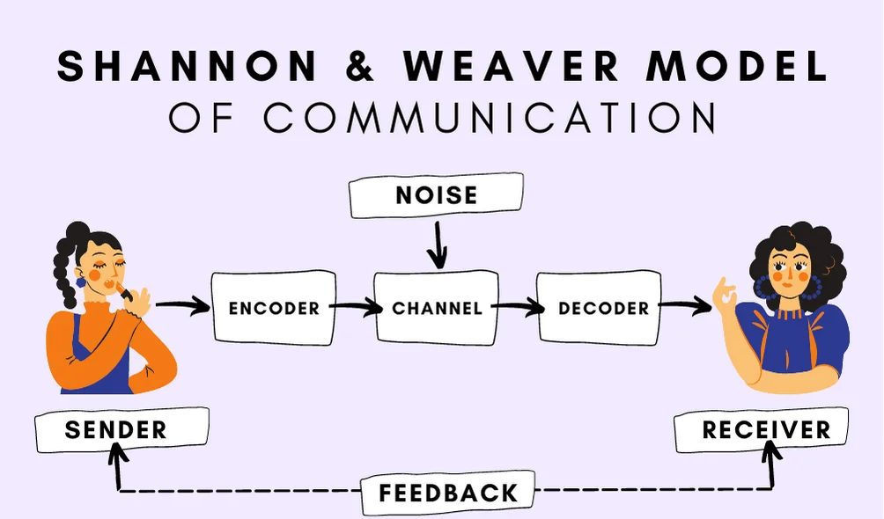

The Shannon-Weaver model consists of seven essential elements. These elements include:

Sender :- The sender, or information source, is where the model starts. This is the individual who possesses the information that needs to be shared. The message, the receiver, and the delivery method are all made available by the sender. The message can be conveyed orally, in writing, visually, through body language, or through music. A radio newscaster is one illustration. Before the program starts, the newscaster will decide on the message to deliver.

Encoder :- is this individual or device that transforms the message into a signal that may be transmitted from the sender to the receiver. The model was initially developed to describe how binary numbers and radio waves are used in computers and telephones to communicate. However, by converting the intended message into words that can be read or heard, a person can likewise act as the encoder. A radio station is an example of a transmitter since it converts voice into radio waves that are then sent through a radio.

Channel :- is the medium or apparatus that transmits data from the source to the decoder and receiver. For instance, a landline phone uses cables as the channel.

Noise :- As a communication travels from a sender to a receiver, interruptions are referred to as noise. Physical examples include a person being on the phone as a nearby child screams. Additionally, it could be psychological, such when a long-ago event causes a mental diversion.

Decoder: A decoder is a device that receives signals and transforms them into understandable messages. Equipment, software, machines, and people are examples of decoders. The opposite of encoding is this.

Receiver - The destination is another name for the receiver. The process of communication comes to a close at this point. Here, a person receives the message after taking into account the noise.


The Shannon-Weaver model gives Vodafone UK employees a fundamental foundation for understanding communication, but it's critical to remember that in real life, communication is frequently more dynamic and engaging. The communication strategy used by Vodafone UK constantly adapts based on client interactions to make sure that messages are understood and accepted positively.

Vodafone UK acts as the information provider by sending messages to its clients about special offers, service upgrades, and other topics.The information that Vodafone UK wants to share, such as special offers, service alerts, and updates.
Vodafone UK uses a variety of platforms to communicate with its clients, including mobile apps, text messaging, emails, and social media.
Customers are the ones that decode the information and offers from Vodafone UK in the messages they receive.
Both internal and external variables, such as language obstacles and network problems, can produce noise that interferes with communication.

Vodafone UK can determine the success of their communication and if messages are being comprehended and taken action upon based on customer replies, activities, and direct feedback.

- Integrated marketing communications

Integrated marketing is a strategic approach that integrates communications and interactive experiences targeting specific markets and individuals and unifies all facets of a brand's marketing, such as:

paid media (online display, programmatic, direct marketing, and offline advertising);
Earned media (Organic search supported by content marketing, public relations, and outreach to online influencers)
In order to achieve consistent messaging tailored where possible by channel that presents a unified and seamless experience to consumers across the customer lifecycle or path to purchase, owned media (including social media, on-site UX, customer service, and direct messaging through email and mobile) must be used.

The goal of integrated marketing is to increase brand knowledge, familiarity, favourability, and buy intent. When communications are coordinated across channels, the outcomes are much greater than when using a less integrated strategy that does not coordinate.

The integration of marketing channels has never been more challenging or more crucial due to the emergence of a variety of new digital marketing channels during the past ten years.

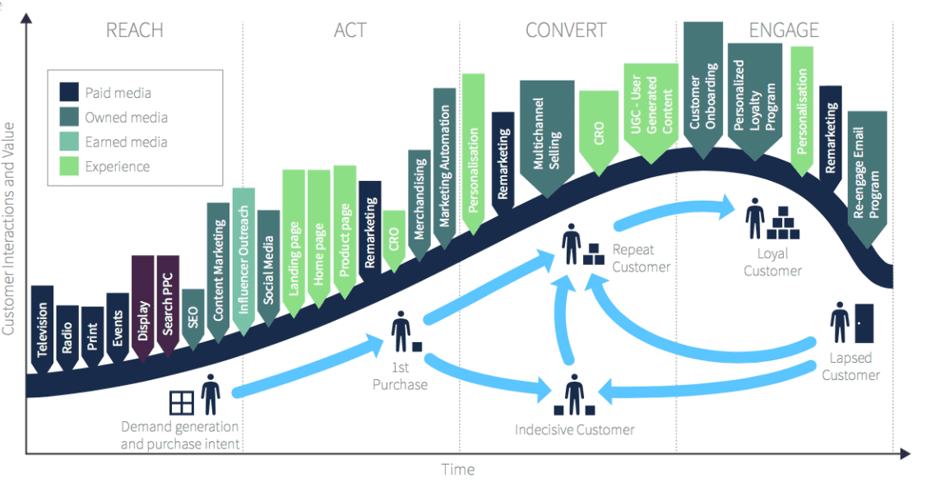

- New Promotional Techniques for
Vodafone Group

Vodafone's strong branding, multi-channel approach, individualised messaging, strategic alliances, and dedication to innovation are all factors in the company's marketing strategy's success. However, in order to remain competitive and relevant, Vodafone must implement new marketing tactics.

  - Online Promotional Techniques

Vodafone can get a step forward by using various online strategies :-

- Smart Device Bundles : Create packages that include popular smart home gadgets like smart speakers, smart thermostats, security cameras, and smart lighting with Vodafone UK's mobile plans.

- Customizable Bundles : Give clients the option to create their own bundles by selecting the smart devices of their choice from a well chosen list. This gives them the ability to customize the bundle to meet their own needs

- Exclusive Discounts : Provide exclusive rates and discounts to customers who decide to buy smart technology bundles. Draw attention to the cost reductions over buying the equipment separately.

- User feedback : Display user feedback and endorsements from clients who have purchased and profited from the smart tech packages. Other people may be persuaded to buy something by social proof

.
- Cross-Promotion : Work with makers of smart devices to jointly advertise the bundles. Co-branded material and collaborative marketing initiatives may be included.

- Online Community Engagement : Create a forum where users can give advice on how to get the most out of their smart gadgets and talk about their experiences using them.

- Upgrade Options : Offer clients who already own some smart devices the chance to upgrade. To entice clients to upgrade their smart home setup, provide discounts on extra devices.

Therefore,Vodafone UK may capitalize on the linked home trend by providing "Smart Tech Bundles," which add value-added services to clients beyond what is typically offered by cell subscriptions. This tactic not only boosts revenue but also improves client retention and establishes Vodafone UK as a provider of all-inclusive digital solutions.

  - Offline Promotional Techniques

- Tech Fairs: Hold tech fairs showing the most recent mobile gadgets, smart home technology, and digital services in well-known public areas. Allow participants to explore the features of the gadgets and interact with them.

- Seminars & Talks: Invite technology professionals to present on cutting-edge developments, trends, and technologies. These presentations can promote Vodafone UK as a tech-savvy brand and offer participants insightful information.

- Mobile Clinics : Provide mobile clinics where clients can receive individualized help with their equipment and subscriptions. Address technical problems, make plan suggestions, and give advice on how to maintain devices.

- Customer Appreciation Days : Host exclusive special events for current Vodafone UK clients. As a token of thanks, give out freebies, discounts, and entertainment.

- Workshops and fairs : Hold events where customers can trade in their outdated devices in exchange for discounts on new ones. Encourage device updates while supporting appropriate e-waste management.

- Collaborative Art Projects : Initiate neighbourhood art initiatives with participation from locals and artists. The community may feel a sense of pride and ownership as a result.

"Community Connection Events" give Vodafone UK the chance to meet with customers personally while also showcasing the company's dedication to enhancing the communities in which it operates. Vodafone UK can strengthen customer relationships and improve its reputation as a caring and engaged company by providing educational and enjoyable experiences offline.

6.Branding and Brand Equity

  - Branding

“A brand is a name, term, design, symbol, or any other feature that identifies one seller’s good or service as distinct from those of other sellers” (American Marketing Association)

Therefore, a brand is not merely defined by its external attributes but also by the feelings that customers have for a business or its goods. When exposed to a name, a logo, a visual identity, or even a message, a combination of physical and emotional cues are released.

“Branding is endowing products and services with the power of a brand” (Kotler & Keller, 2015)

By developing and forming a brand in consumers' thoughts, branding is the process of giving a specific organization, company, products, or services a meaning. It is a method used by businesses to make it easier for customers to recognize and experience their brand, as well as to give them a reason to prefer their goods over those of the competition.

  - Brand Equity

“A set of assets or liabilities in the form of brand visibility, brand associations and customer loyalty that add or subtract from the value of a current or potential product or service driven by the brand.” (Aacker, 1991)

Put simply, brand equity represents the value of a brand. It is the simple difference between the value of a branded product, and the value of that product without that brand name attached to it (Rosenbaum-Elliott, 2015).

Understanding brand equity, despite being a multifaceted and difficult notion, is essential to a brand's ability to compete. Numerous perceived interpretations and definitions that have been made by academics and professionals alike highlight how complex it is.

7.) Keller’s Brand Equity Model
Lane Keller, a marketing professor, first created the Customer-Based Brand Equity (CBBE) Model, which is also known as Keller's Brand Equity Model, in his widely-used textbook, "Strategic Brand Management."
The Brand Equity Model's basic premise is that you must influence customers' attitudes toward your goods if you want to develop a powerful brand. In order for customers to have specific, favourable thoughts, feelings, beliefs, attitudes, and perceptions about your brand, you must create the appropriate types of experiences surrounding it.

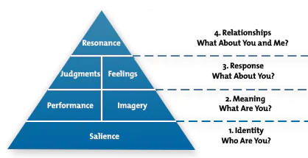
KELLER, KEVIN, STRATEGIC BRAND MANAGEMENT: GLOBAL EDITION, 4th, © 1901. Reprinted by permission of Pearson Education, Inc., New York.

let's examine each component of Keller's Brand Equity Model in more detail and use it to analyze Vodafone UK:

- Brand Identity
In the case of Vodafone UK, brand identity includes the name, logo, slogan, and visual components of the business. To help clients quickly recognize and remember the brand, these components should be distinctive and memorable. Vodafone should be able to communicate its dedication to technical advancement, connection, and seamless communication through its visual identity.
The brand's basic principles should be reflected in the logo and slogan, which should represent the company as a dependable and progressive telecom provider.

- Brand Meaning
Vodafone UK must create distinct brand connotations in customers' thoughts. These links may be made with characteristics including network dependability,technological development, and customer-centred solutions. Vodafone UK has to explain how its superior network coverage, cutting-edge products, or first-rate customer service set it apart from the competition. These characteristics provide Vodafone UK's brand a distinctive and differentiating meaning that separates it from its rivals.
- Brand Response
Customers' emotional and behavioral responses to the brand are indicators of a successful brand. Vodafone UK may do this by routinely surpassing or fulfilling consumer expectations. Customers should experience happiness and trust every time they connect with Vodafone's services, whether it is through customer service, purchasing products, or utilizing network services. For a brand to elicit favorable emotions and foster consumer loyalty, timely resolution of customer complaints, clear communication, and fulfillment of promises are essential.
- Brand Resonance
Customers' intense emotional bond with a brand is referred to as brand resonance. Vodafone UK has to develop an atmosphere that fosters high customer involvement and loyalty if it wants to increase brand resonance. Customers and brands may become more closely bonded through community-building efforts, unique content, and loyalty programs that reward devoted patrons. Customers are more inclined to stick with Vodafone UK and spread the word about the company when they experience a feeling of attachment and belonging.
Vodafone UK can strategically alter consumer perceptions, increase brand loyalty, and build a powerful and enduring brand presence in the cutthroat telecommunications market by addressing each of the four dimensions ofKeller's Brand Equity Model: brand identity, brand meaning, brand responses, and brand resonance.
Advantages of Keller’s Model:-
• Good for strategy formulation :
The approach offers precise direction for creating powerful brand strategies. It encourages companies to think about things like brand associations, client experiences, and emotional connections while developing their marketing strategies.

• Measurable Metrics:
Keller's methodology supports gauging brand equity using metrics including client loyalty, brand awareness, and resonance. This makes it simpler for businesses to monitor the effectiveness of their brands and modify their strategy as necessary.
- Long-Term Focus:
The strategy encourages long-term brand-building efforts by emphasizing establishing brand resonance and emotional ties. In order to develop long-lasting relationships with clients and keep a brand relevant over time, this is essential.

- Differentiation:
The model assists in forging in customers' minds strong and distinctive brand connections. It fosters distinctive qualities and value propositions that help businesses stand out in crowded markets.

- Communication Advice:

Keller's approach offers communication advice for businesses on how to convey their worth to consumers. It promotes consistent visual cues and messages that strengthen the ideal brand connections.

Disadvantage of keller’s model :-

- Subjective views:

The model mainly relies on the views and feelings of the consumer, which are extremely subjective and sensitive to a variety of outside influences. It is difficult to precisely assess and forecast changes in brand equity because of this subjectivity.

- Measurement Difficulty:

Using the model's dimensions to calculate brand equity might be difficult. The complete worth of a brand may not be fully captured by metrics like awareness and loyalty.

- Ignoring Competitive considerations:

Although the model largely focuses on consumer perceptions, it may not pay enough attention to the competitive considerations, market dynamics, and industry trends that also affect brand equity.

- Incomplete View of Customer Behaviour:

The model emphasizes customers' emotional responses more so than behavioral components like purchase decisions, which are also very important for building brand equity.Internal

- Factors Ignored:

The approach places a strong emphasis on external perceptions while ignoring internal elements that have an influence on brand equity, such as employee engagement, corporate culture, and internal brand alignment.

8.Customer Journey

The process of improving the interaction your consumers have with your brand is known as customer journey management. As consumers progress through your sales funnel, it leverages technology and behavioral research to create encounters that are compelling to them.

Customer journey management may also be referred to as journey mapping or experience optimization. That's not quite correct, though. These procedures are crucial for your company, but trip management goes much beyond what they cover.

Let's examine the customer journey notion and put it into practice using Vodafone UK:

- Awareness :

At this phase, prospective consumers learn about Vodafone UK via a variety of sources, including advertisements, social media, word-of-mouth, or web searches. This might entail coming across Vodafone UK's television advertisements, social media posts, or word-of-mouth referrals.

- Consideration :

Customers carefully examine Vodafone UK's offers throughout this phase of the buying process. To research cellphone plans, contrast costs, and read client testimonials, they can go to the Vodafone website. For users to make educated decisions, Vodafone UK's website must offer clear and pertinent information.

- Decision:

Customers are prepared to make a purchase at the decision stage. They could select a certain mobile service, product, or plan based on what best suits their need. The website for Vodafone UK should make the purchasing process simple, including straightforward navigation, safe payment methods, and detailed instructions.

- Purchase Stage:

At this stage, the consumer has finished paying for the cell plan or device of their choice. Customers should receive a confirmation of their purchase along with any necessary information, and the transaction should go smoothly.

- Post purchase:

After the sale, Vodafone UK's responsibility turns to guaranteeing customer pleasure. This covers answering any queries or resolving any post-purchase issues, as well as assistance with configuring devices and activating services.

- Usage and Experience:

As users begin utilizing Vodafone UK's services, their impressions of the company will be shaped by their interactions. Their total happiness will be influenced by elements including network quality, customer service, and billing accuracy.

- Loyalty and Advocacy:

Customers are more likely to remain loyal to Vodafone UK if they had a good experience. They could upgrade their plans, tell others about the company, and participate in Vodafone's reward programs or neighbourhood activities.

9.Customer Touchpoints :

Customer touchpoint can understand as Any time a customer connects with your brand, whether it's through an employee, website, advertisement, or app, it's considered a customer touchpoint. Additionally, how customers interact with those touchpoints might affect how they perceive your business.

- Pre – Purchase:-

- Website & Online Platform: For customers in the pre-purchase phase, Vodafone UK's website is a crucial touchpoint. Visitors can look for different mobile plans, gadgets, pricing information, and network coverage diagrams.

- Search Engines: Vodafone UK's visibility in search engine results acts as a touchpoint, leading users to the website when they are looking for mobile plans or network providers online.

- Social Media: Vodafone UK uses social media posts and advertisements to engage potential consumers and entice them to learn more about mobile plans, device features, and time-limited incentives.

- Comparison Websites: Customers may use comparison websites to compare Vodafone UK's plans to those of rival providers, making these platforms crucial points of contact.

Effective management of these pre-purchase touchpoints is crucial for influencing potential customers to make wise choices. To improve the customer experience and promote conversions, Vodafone UK should make sure that there is consistent message, accurate information, and simple navigation throughout these touchpoints.

- Purchase :-

- In-Store Purchase Experience: The in-store experience, which includes contacts with staff, payment, and device activation, is a significant touchpoint for customers who make purchases in actual Vodafone UK stores.

- Mobile App Purchases: For customers who prefer a mobile-centric experience, Vodafone UK's in-app purchasing process is a crucial touchpoint.

- Website Checkout procedure: When clients complete their purchase of a Vodafone UK mobile plan or device, the website checkout procedure is a crucial touchpoint. It ought to be simple to use, safe, and include a variety of payment methods.

- Payment Confirmation: Customers receive a payment confirmation email or message after completing a purchase, which solidifies the choice to make a purchase and gives crucial transaction information.

A seamless and satisfying experience for customers as they make their purchasing decisions depends on optimizing these purchase-related touchpoints. To increase consumer pleasure and loyalty, Vodafone UK needs to put transparency, ease of use, and assistance first throughout the purchasing process

- Post – Purchase:-

- Assistance with activation and setup: Giving customers step-by-step instructions, videos, or interactive lessons on how to activate and set up the services they have purchased can improve their initial experience.

- First Use Communication: After the consumer uses the gadget for the first time, a follow-up message can be a touchpoint where information, troubleshooting suggestions, and tips are provided to help them get the most out of their new purchase.

- Customer Support for Issues: Post-purchase customer support touchpoints via phone, chat, or email should be easily accessible in case customers run into any problems with their new plan or gadget.

- Feedback Surveys: Sending post-purchase feedback surveys to clients is a touchpoint that enables them to share their views and offers Vodafone UK useful information for improving its goods and services.

Vodafone UK can make sure that customers have a satisfying and helpful experience long after they make their original purchase by efficiently managing these post-purchase touchpoints. Customer satisfaction can be raised and repeat business promoted by consistent communication, helpful resources, and proactive customer care.

10.Customer Journey Map

A customer journey map depicts the customer journey (also known as the buyer journey or user journey). It enables you to describe the consumer journey across all touchpoints and express the brand's story. No customer will fall through the cracks if the customer journey is visually mapped out, whether your consumers contact with you through social media, email, live chat, or other methods.

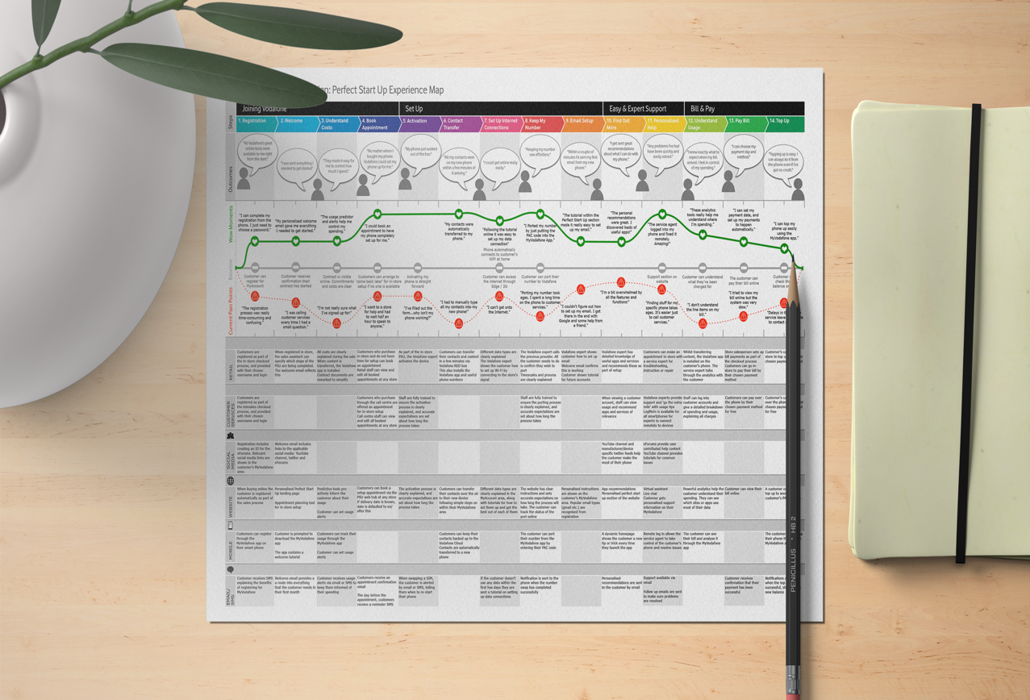

Stage 1: Being Aware

- Touchpoints include social media posts, TV commercials, online advertisements, and search engine outcomes.

  - emotions :Curiosity and interest in something.

  - action: learning about Vodafone's offerings and examining social media accounts.

Stage 2 . consideration

  - Touchpoints include comparison websites, online reviews, and the Vodafone UK website.

- Emotions: weighing alternatives and looking for information.

- Actions :Researching mobile plans, reading reviews, and evaluating costs .

Stage 3: Buying

- Touchpoints :include the Vodafone UK website (checkout), real-world locations, and mobile apps.

- emotions: anticipation and excitement.

- actions: Choosing a mobile plan, getting a device, and finishing the checkout process.

Stage 4 : onboarding

- Touchpoints: Setup instructions for devices and confirmation emails.

- Emotions: A desire to begin utilizing the services.

- Actions :include turning on the gadget, configuring the plan, and investigating features.

Phase 5: Use

- Touchpoints: Using the Vodafone app, customer service, and mobile plans.

- Actions: Making calls, using data, and controlling account settings.

- Emotions: Engagement and satisfaction.

Strength in Vodafone’s Customer Journey Map :-

- Detailed Visualization: The customer journey map offers a detailed and organized representation of the interactions, feelings, and actions of the client at each point of the journey.

- Holistic Perspective: By taking into account every step of the customer journey, from awareness to loyalty, the map enables Vodafone UK to comprehend the full customer experience.

- Identification of Pain Points: The map assists in identifying pain points and places where customers may experience difficulties or frustrations by emphasizing customer emotions and actions.

- Opportunity Identification: The map identifies touchpoints where Vodafone UK may improve customer satisfaction and possibly create chances for upselling or cross-selling.

Weakness in Vodafone’s Customer Journey Map :-

- Assumption of linear progression : The map implies a linear navigation through the phases, but in practice, consumers may loop back or skip stages depending on their needs.

- Lack of Depth: The map may not adequately depict the complexity of feelings and behaviour’s at each step, possibly overlooking subtleties in consumer behaviour.

- Difficulty in Setting Priorities: Without a more thorough understanding, it can be difficult to set priorities for which touchpoints or stages need the most urgent attention.

- Absence of Real-Time Updates: If the map is not frequently updated with the most recent client insights and feedback, it may become out of date.

11. Total Engagement Model

The phrase "Total Engagement Model" often denotes a thorough and integrated strategy that includes a variety of touchpoints, methods, and techniques to effectively engage stakeholders and customers. To forge deep connections and establish enduring relationships, it entails leveraging a variety of channels, individualized interactions, and constant messaging. A whole engagement approach in marketing strives to involve customers fully, improve their experience, and provide beneficial results for both the brand and its audience. Every touchpoint, from initial awareness through post-purchase contacts, is focused on in order to maximize engagement.

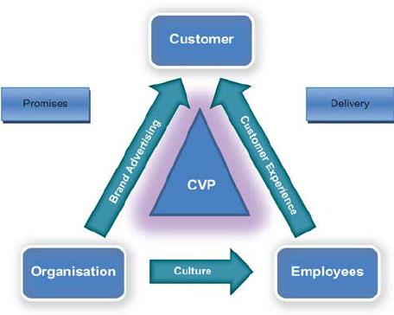

- Culture

Refers to the common principles, attitudes, customs, and practices that influence how people interact and view a brand whether inside an organization or among its clientele. The collective identity and personality of a group of individuals have an impact on how they interact with a company's goods, services, and messaging. Building genuine and resonant relationships, boosting engagement, and cultivating a feeling of community and loyalty all depend on an organisation’s ability to recognize and align with the cultural features of both its target audience and its organization. By ensuring that marketing activities are pertinent, relatable, and appealing to the target audience, this cultural alignment promotes more fruitful and significant connections.

- Customer Experience

refers to a customer's overall experience and interactions with a brand across time, from first becoming aware of it to engaging with it after making a purchase. Every interaction is included, including those that take place online, in stores, over the phone with customers, while using products, and more.

A strong customer experience is essential to establishing trust and promoting brand loyalty. It entails making certain that each interaction is seamless, tailored, and consistent with the promises and values of the brand. Businesses may forge emotional bonds with their clients, raise client satisfaction, and inspire brand evangelists by offering extraordinary customer experiences.

- Brand Advertising

refers to the strategic communication initiatives made to advance and improve a brand's personality, principles, and reputation. It entails developing and distributing pictures and statements that capture the core of the brand, its distinctive value proposition, and its commitment to the target market.

Brand advertising is crucial in influencing the perceptions and feelings people have about the brand. It tries to create a distinct and unforgettable identity in the target audience's minds, encouraging loyalty and recognition. This kind of advertising aims to establish a strong brand presence and cultivate a close relationship with consumers rather than just marketing particular goods or services.

12. Recommendations

Vodafone needs to put in place a tailored loyalty program that fits the Keller Model and improves the customer experience. This program will make use of the promotion strategies of personalised offers and gamification, as well as the communication model's combination of conventional and digital channels.

Vodafone may strengthen its emotional bond with its clients by providing customized discounts, prizes, and special offers based on unique tastes and usage patterns. The Keller Model is in line with this strategy because it strengthens brand equity and brand identification.

In addition, gamification components in the loyalty program, including challenges and interactive games pertaining to Vodafone's services, can spark interest and engagement, enticing users to engage with the brand and actively participate.

Vodafone should provide consistent messaging that promotes the advantages of the loyalty program and stresses the exclusive value proposition it offers throughout the consumer experience, from awareness to post-purchase.

Vodafone may effectively increase customer engagement, fortify brand loyalty, and ultimately enhance customer happiness and retention by heeding these advice.

13. Conclusion

A planned and customer-centric marketing approach is essential for forging a distinct niche in the ever-evolving realm of telecommunications. The suggested improvements offer a clear road map for advancing Vodafone's ascent in the face of tough competition.

Vodafone's target audience is effectively connected to via the seamless integration of a comprehensive marketing model. This intentional fusion of conventional and digital channels enables a broad appeal, boosting engagement. Customized rewards, gamification elements, and a specialized loyalty program all work together to rekindle customer interest and foster enduring bonds that flawlessly align with Vodafone's unwavering dedication to excellence.

The Keller Model's guiding principles, which highlight the value of brand equity, enable Vodafone to define its corporate identity. Vodafone strengthens its grasp on the customer's mind by continually communicating a consistent brand narrative across a variety of touchpoints, hence fostering affinity and trust.

A crucial cornerstone that emphasizes the need of complete client experiences is the customer journey framework. Vodafone carefully cultivates a satisfied clientele that organically develops into passionate advocates through precision-targeted awareness activities, open product insights, streamlined purchasing methods, and unmatched post-purchase support mechanisms.

In conclusion, incorporating these painstakingly developed suggestions into Vodafone's marketing strategy not only makes it easier to navigate the competitive landscape, but also helps it advance into uncharted territory. This tactical planning puts Vodafone in a position to reshape the communications industry and steer it inexorably toward enduring preeminence.
14. References

• Kitchen, P.J. and Burgmann, I. (2015), "Integrated marketing communication: making it work at a strategic level", Journal of Business Strategy, Vol. 36 No. 4, pp. 34-39.
https://doi.org/10.1108/JBS-05-2014-0052

• Keller, K.L. (2001) ‘Building Customer-Based Brand Equity: Creating Brand Resonance Requires Carefully Sequenced Brand Building Efforts,’ Marketing Science Institue, 1-107, July/August 2001. http://anandahussein.lecture.ub.ac.id/files/2015/09/article-4.pdf

• Durrant, C. (Publication Year). Vodafone Case Study: Innovation. Available at: https://clairedurrant.com/case-studies/vodafone-innovation/

• Shannon, C. E. (1948). A Mathematical Theory of Communication. Bell System Technical Journal, 27(3), 379-423. http://cm.bell-labs.com/cm/ms/what/shannonday/paper.html A Mathematical Theory of Communication

• Study.com. (Year, Month Day of publication or last update). Shannon-Weaver Model of Communication: Definition, Features & Example. https://study.com/learn/lesson/shannon-weaver-model-communication-theory-parts-transmission-model.html

• The Branding Journal. (2021). Brand Equity: Definition, Components, Measurement, and Importance. Available at: https://www.thebrandingjournal.com/2021/02/brand-equity/

• The Branding Journal. (Year, Month Day of publication or last update). What is Branding? Definition and Meaning. URL: https://www.thebrandingjournal.com/2015/10/what-is-branding-definition/

• The SERP Wire. (Publication Year). Advantages and Disadvantages of Brand Equity. Available at: https://theserpwire.com/advantages-and-disadvantages-of-brand-equity/

• Zendesk. (Publication Year). The Ultimate Guide to Customer Touchpoints. Available at: https://www.zendesk.co.uk/blog/customer-touchpoints/

