University of Wales Trinity Saint David

Richard Hankey
P151406

ACCA5017
Games Architecture and Mechanics

Assignment 1

Title:
Part 1a: Games Physics

Task 1:
Part 1a: Short description of Euler’s Method:
Euler’s method uses numerical integration by Intervals of validity[1]meaning incremental values using an algorithm with a timestep. Although refinement of the timestep is often required to enhance approximations.[2] Euler’s method is often considered the starting point of most numerical integration to achieve a starting point in the polygonal curve, allowing more accurate numerical integration methods to be implemented. There are some disadvantageous outcomes to using this method, one being the tendency to stray off and inaccurate readings, but the essential aforementioned problem with Euler’s is in its inaccuracy.[3]
Using numerical integration in game development, Euler methods are commonly used as the First Order Integrators.[4] The one explored later in the C++ program is Explicit Euler, being the simplest, most game developers start with this method. Other Euler methods used by game developers are Implicit and Symplectic Euler. Each with their own merits and drawbacks[4], [5].As mentioned, Explicit Euler is inaccurate but it’s the simplest, Implicit Euler is quicker and stable meaning its extremely accurate but its computationally expensive. Symplectic Euler is the middle ground of the two, it’s still more accurate than explicit and less expensive than implicit and is the favoured First Order Integrator amongst game developers.[5]
The Second Order Integrators such as Second Order Runge-Kutta and Verlet methods are viable options for the next stage of game development as these are favoured by game developers.[4] The Higher Order Integrator for example Forth Order Runge-Kutta bring accuracy and expenses closer to desired outcome although these are not explored in this report.
Euler’s Explicit Method
As described earlier this method is the simplest and a starting point for most game developers.
V_{n+1} = V_{n} + (A_{n} * dt)
X_{n+1} = X_{n} + (V_{n} * dt)

Euler’s Symplectic Method
Semi-implicit Euler method as it commonly known uses the implicit part of Position and explicit part of Velocity.
Explicit part: V_{n+1} = V_{n} + (A_{n} * dt)
Implicit part: X_{n+1} = X_{n} + (V_{n+1} * dt)

Verlet method
The Verlet method is another fast method and is in the Second Order integration profile[4], meaning this would be next step of numerical integration for developers. This type of integration uses the acceleration to calculate a position, the small drawback which could be detrimental to some development process as that this assumes that time steps are constant , meaning abrupt changes such as a momentary stop[4], for example a car braking would not be suitable for this type of method.
Another issue is that the calculation requires two steps[6] to get started which has proven difficult to work around within the algorithms on the plotting software, (see Appendix Folder: Excel file: “Numerical Integrations Plotting”).

X_{n+1} = 2*X_{n}-X_{n-1+} (A_{n} * dt^2)
V_{n+1} = X_{n} – X_{n-1/} dt [7]
Time Corrected Verlet;
Upon research of Verlet Integration Methods, a variant provided by J, Dummer writes about a time correction scheme, unfortunately, repeated attempts to replicate this only breaks the formula inside the plotting software.

Dummer’s formula:
x_{i+1} = x_{i} + (x_{i} - x_{i-1}) * (dt_{i} / dt_{i-1}) + a * dt_{i} * dt_{i}[6]
Where x = distance, a=Acceleration and dt=Delta Time
What can be ascertained from this algorithm is that the next position will be determined by the current position, adding the subtraction from the previous position, multiplying the result of the division of current delta time by the previous delta time and adding the acceleration multiplied by current delta time squared.
Dummer’s findings are included in the plotting software. (See Appendix Folder: Excel File: “TimeCorrectedVerlet”)[8]

Task 1:
Part 1b: Implementation into C++ Console Application

Implementing the previously mentioned methods into a C++ console application, has replicated the results inside the plotting software. The results match using both of Euler’s methods described in part 1a but using the Verlet integration method has proven fruitless in the console application. Further testing and/or research is required to determine the problem.
In regard to improving the simulation algorithms, some variables had to be considered for appropriate calculations for example, initial tension calculation was that of Hooke’s Law [9]. The calculations of inertia are debatable of whether it shows the correct outcome, though the implementation and theory behind this is rough.[10], [11], [12], [13]
Further algorithms showed that, calculations for the n+1 have been possible, and this allows further accuracy, paving the way for 2nd, 3rd and 4th order numerical integration.

Task 2: Vector Class for Games Engine

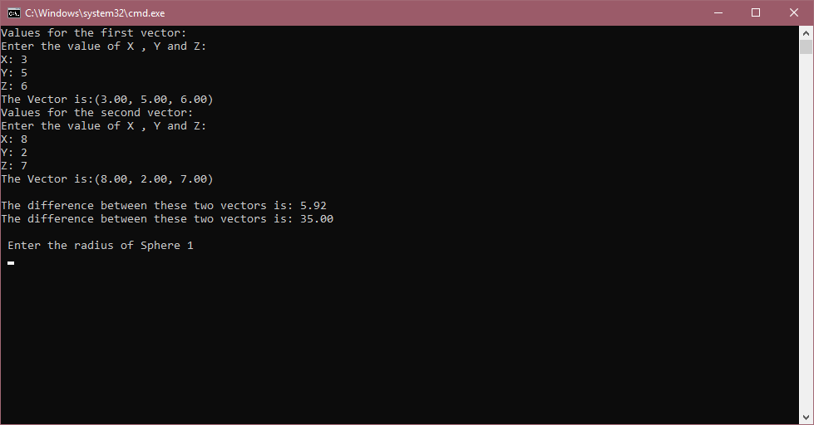
Screenshot of the Vector class, showing the distance and the distance squared using Pythagoras theorem.[14], [15]

Vector.h
#ifndef VECTOR_H
#define VECTOR_H

class vector
{
private:
float x;
float y;
float z;
public:

//construct
vector(float, float, float);
vector(void);
void Scale(float s);
void Add(vector & v1);
void Add(vector & v1, vector & v2);
vector getVector();

//void setVector(float setX, float setY, float zsetZ);
void printVectors(void);

float distB2points(vector v1);

float distB2pointsSqrd(vector v1);

vector projection(vector);

};
#endif

Vector.cpp
#include "libraries.h"

//construct
vector::vector(void) {};
vector::vector(float myx, float myy, float myz)
{
x = myx;
y = myy;
z = myz;
}
void vector::Scale(float s)
{
x = s*x;
y = s*y;
z = s*z;
}
void vector::Add(vector & v1, vector & v2)
{
v1.x = v2.x + v1.x;
v1.y = v2.y + v1.y;
v1.z = v2.z + v1.z;
}
vector vector::getVector()
{
return vector(x, y, z);
}
//void vector::setVector(float setX, float setY , float setZ)
//{
// vector(x=setX, y=setY, z=setZ);
//}
//probably no need for this now.
void vector::Add(vector & v1)
{
x = x + v1.x;
y = y + v1.y;
z = z + v1.z;
}
void vector::printVectors()
{
printf("The Vector is:(%.2f, %.2f, %.2f)\n", x, y, z);
}

float vector::distB2points(vector v1)
{

//v1.x = pow(x - v1.x,2);
//v1.y = pow(y - v1.y,2);
//v1.z = pow(z - v1.z,2);
float dist = sqrt(pow(x - v1.x, 2) + pow(y - v1.y, 2) + pow(z - v1.z, 2));//Pythagoras Distance.

return dist;
}

float vector::distB2pointsSqrd(vector v1)
{
float dist = pow(sqrt(pow(x - v1.x, 2) + pow(y - v1.y, 2) + pow(z - v1.z, 2)),2);//Pythagoras Distance squared
return dist;
}

vector vector::projection(vector v1)
{
sqrt(pow(v1.x, 2) + pow(v1.y, 2) + (v1.z, 2)); // finds the magnitude of v1;

return v1;

}

Plane Class
The plane class constructor creates a vector plane with a point and a normal vector using the vector class to demonstrate an attempt at polymorphism.

The two methods chosen:
- Distance from a point on the plane would allow vectors to be always orthogonal to the plane.
- Intersecting a plane to create a line.[16]–[18]

#pragma once
class plane
{

private:
vector normal;
vector p0;

public:
plane();
plane(vector normal, vector p0);
float distanceFromPoint(vector v1);
vector intersectPlane(vector v1);

~plane();
};

#include "libraries.h"

plane::plane()
{
}

plane::plane(vector normal, vector p0)
{

}

float plane::distanceFromPoint(vector v1)
{
return 0.0f;
}

vector plane::intersectPlane(vector v1)
{
return vector();
}

plane::~plane()
{
}

Projecting a vector onto another
The method(as seen above) unfortunately is unfinished due to a lack of understanding of the calculus required for vector projection.[19], [20]

Task 3: Sphere to Sphere Collision detection.

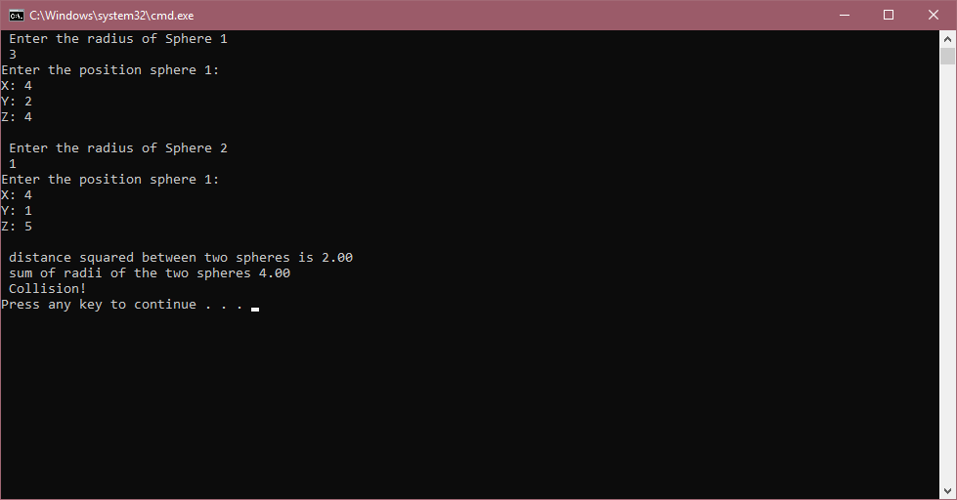
Screenshot showing collision detection between to spheres; this screen shows a collision.

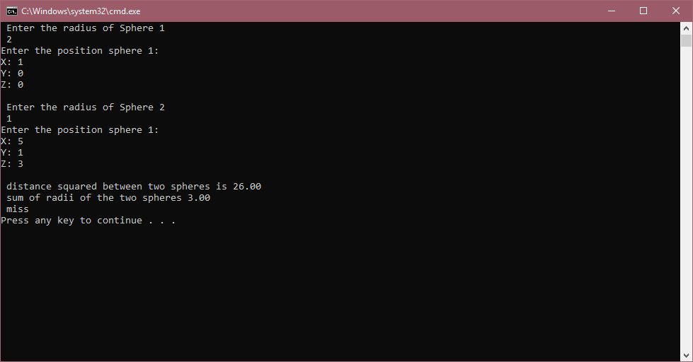
Screenshot showing collision detection between to spheres; this screen shows a miss.

[21]–[23]

References
[1] P. Dawkins, “Differential Equations - Intervals of Validity.” [Online]. Available: http://tutorial.math.lamar.edu/Classes/DE/IoV.aspx. [Accessed: 02-Feb-2019].
[2] P. Dawkins, “Differential Equations - Euler’s Method.” [Online]. Available: http://tutorial.math.lamar.edu/Classes/DE/EulersMethod.aspx. [Accessed: 02-Feb-2019].
[3] A. Geletu, “Lecture 3 Introduction to Numerical Methods for Differential and Differential Algebraic Equations Lecture 3 Introduction to Numerical Methods for Differential and Differential Algebraic Equations TU Ilmenau.”
[4] J. Dickonson, “Numerical Integration in Games Development | Understanding Games Development.” [Online]. Available: https://jdickinsongames.wordpress.com/2015/01/22/numerical-integration-in-games-development-2/. [Accessed: 03-Feb-2019].
[5] G. Fiedler, “Gaffer on Games | Integration Basics,” 2016. [Online]. Available: http://gafferongames.com/game-physics/integration-basics/. [Accessed: 03-Feb-2019].
[6] J. Dummer, “A Simple Time-Corrected Verlet Integration Method.” [Online]. Available: http://lonesock.net/article/verlet.html. [Accessed: 13-Feb-2019].
[7] “Verlet integration,” pp. 1–7, 1967.
[8] J. Dummer, “TimeCorrectedVerlet.” .
[9] S. Khan, “(27) What is Hooke’s Law? (article) | Khan Academy.” [Online]. Available: https://www.khanacademy.org/science/physics/work-and-energy/hookes-law/a/what-is-hookes-law. [Accessed: 21-Mar-2019].
[10] “Torque Formula (Moment of Inertia and Angular Acceleration).” [Online]. Available: http://www.softschools.com/formulas/physics/torque_formula/59/. [Accessed: 21-Mar-2019].
[11] “Physics - Mechanis: Application of Moment of Inertia and Angular Acceleration (1 of 2) Rolling Wheel - YouTube.” [Online]. Available: https://www.youtube.com/watch?time_continue=37&v=4BGrnBc124w. [Accessed: 21-Mar-2019].
[12] “(27) More on moment of inertia (video) | Khan Academy.” [Online]. Available: https://www.khanacademy.org/science/physics/torque-angular-momentum/torque-tutorial/v/more-on-moment-of-inertia. [Accessed: 21-Mar-2019].
[13] “Tangential Acceleration Formula.” [Online]. Available: http://www.softschools.com/formulas/physics/tangential_acceleration_formula/33/. [Accessed: 21-Mar-2019].
[14] Simon, “Pythagorean theorem - How to use Pythagoras theorem with examples.” [Online]. Available: http://pythagoras.nu/. [Accessed: 22-Mar-2019].
[15] M. Ferguson, “National 5 Mathematics Assessment Practice 5 : The Theorem of Pythagoras and vectors ( Topics 16-17 ) Authored by :”
[16] P. Dawkins, “Calculus III - Equations of Planes.” [Online]. Available: http://tutorial.math.lamar.edu/Classes/CalcIII/EqnsOfPlanes.aspx. [Accessed: 09-Feb-2019].
[17] S. Khan, “(26) Defining a plane in R3 with a point and normal vector (video) | Khan Academy.” [Online]. Available: https://www.khanacademy.org/math/linear-algebra/vectors-and-spaces/dot-cross-products/v/defining-a-plane-in-r3-with-a-point-and-normal-vector. [Accessed: 18-Mar-2019].
[18] “Plane Equation.” [Online]. Available: http://www.songho.ca/math/plane/plane.html#distance_origin. [Accessed: 21-Mar-2019].
[19] “Vector Projection Calculator - Symbolab.” [Online]. Available: https://www.symbolab.com/solver/vector-projection-calculator/projection %5Cbegin%7Bpmatrix%7D1%260%263%5Cend%7Bpmatrix%7D%2C %5Cbegin%7Bpmatrix%7D-1%264%262%5Cend%7Bpmatrix%7D?or=ex. [Accessed: 18-Mar-2019].
[20] “Scalar and Vector Projections | CK-12 Foundation.” [Online]. Available: https://www.ck12.org/book/CK-12-College-Precalculus/section/9.6/. [Accessed: 18-Mar-2019].
[21] D. H. Eberly, “3D Game Engine Design : a Practical Approach to Real-Time Computer Graphics.,” p. 1008, 2006.
[22] C. Ericson, Real-time collision detection, vol. 1. 2005.
[23] NeHe Productions, “NeHe Productions: Collision Detection.” [Online]. Available: http://nehe.gamedev.net/tutorial/collision_detection/17005/. [Accessed: 26-Mar-2018].

Further Reading

- “Numerical Methods for Differential Equations 1 2 NUMERICAL METHODS FOR DIFFERENTIAL EQUATIONS.”
- “Numerical Integration Problem sheet 1 Newton-Raphson Method,” pp. 4–6, 2009.
- J. C. Butcher, “The Euler method,” 1999.
- “Idézet egy cikkbl: The Verlet algorithm.”
- M. McDunnigan, “How to Make a Chart From Two Different Sheets in Excel | Your Business.” [Online]. Available: https://yourbusiness.azcentral.com/make-chart-two-different-sheets-excel-8304.html. [Accessed: 13-Feb-2019].
- P. V Johnson, “Review Improved Finite Difference Methods Exotic options Summary FINITE DIFFERENCE-CRANK NICOLSON.”
- “Euler ’ s Method , Taylor Series Method , Runge Kutta Methods , Multi-Step Methods and Stability .,” no. 0, pp. 1–6.
- P. F. Batcho and T. Schlick, “Special stability advantages of position-Verlet over velocity-Verlet in multiple-time step integration,” 2001.
- Ingo Berg, “A Comparison of Numeric Integration Schemes.” [Online]. Available: http://beltoforion.de/article.php?a=runge-kutta_vs_euler&hl=en&s=idPageTop#idPageTop. [Accessed: 13-Feb-2019].
- L. Evans, “Limitations of euler’s method for numerical integration,” pp. 1–5, 2007.
- E. Hairer, “Numerical Geometric Integration,” 1999.
- D. Lee, “Numerical methods for solving ODEs,” vol. 4, no. 1974, 1978.
- “Excel Lab 1 : Euler ’ s Method.”
- E. Cheever, “Euler’s Method (First Order Runge-Kutta).” [Online]. Available: http://lpsa.swarthmore.edu/NumInt/NumIntFirst.html. [Accessed: 17-Mar-2019].
- H. Serrano, “Visualizing the Runge-Kutta Method — Harold Serrano.” [Online]. Available: https://www.haroldserrano.com/blog/visualizing-the-runge-kutta-method. [Accessed: 17-Mar-2019].
- G. Fieldler, “Fix Your Timestep! | Gaffer On Games.” [Online]. Available: https://gafferongames.com/post/fix_your_timestep/. [Accessed: 17-Mar-2019].
- “Crank Nicolson method.” [Online]. Available: https://mat.iitm.ac.in/home/sryedida/public_html/caimna/pde/fifth/5.html. [Accessed: 17-Mar-2019].
- C. Barker, “Numerical Methods--Euler’s Method.” [Online]. Available: http://calculuslab.deltacollege.edu/ODE/7-C-1/7-C-1-h-c.html. [Accessed: 17-Mar-2019].
- Z. Kalogiratou, T. Monovasilis, and T. E. Simos, “New modified Runge–Kutta–Nyström methods for the numerical integration of the Schrödinger equation,” Comput. Math. with Appl., vol. 60, no. 6, pp. 1639–1647, Sep. 2010.
- J. Lambers, “Three-Dimensional Coordinate Systems,” pp. 1–5, 2009.
- “There are two main ways to introduce the dot product The dot product of two vectors is a scalar Definition.”
- “10.1. Lining Up Text Output - C++ Cookbook [Book].” [Online]. Available: https://www.oreilly.com/library/view/c-cookbook/0596007612/ch10s02.html. [Accessed: 18-Mar-2019].
- “Vector Projection Calculator | Calculator@TutorVista.com.” [Online]. Available: https://calculator.tutorvista.com/vector-projection-calculator.html. [Accessed: 18-Mar-2019].
- E. Furey, “3D Distance Calculator.” [Online]. Available: https://www.calculatorsoup.com/calculators/geometry-solids/distance-two-points.php. [Accessed: 18-Mar-2019].
- S. K. DUBEY, “Program to calculate distance between two points - GeeksforGeeks.” [Online]. Available: https://www.geeksforgeeks.org/program-calculate-distance-two-points/. [Accessed: 18-Mar-2019].
- “Dot Products and Projections.” [Online]. Available: https://math.oregonstate.edu/home/programs/undergrad/CalculusQuestStudyGuides/vcalc/dotprod/dotprod.html. [Accessed: 18-Mar-2019].
- “Distance Between Two Points Calculator.” [Online]. Available: https://www.easycalculation.com/analytical/distance.php. [Accessed: 18-Mar-2019].
- “The Distance Between Two Vectors - Mathonline.” [Online]. Available: http://mathonline.wikidot.com/the-distance-between-two-vectors. [Accessed: 18-Mar-2019].
- K. H. Michaelian, “Numerical methods 5.1.,” vol. 159, pp. 81–100, 2003.

