MARKETING FUNDAMENTALS

ASSESSMENT 2

Analysis and Evaluation
HARVEY NICHOLS

by Anca Ghizela Hotca
(2021006/BABM Level4T1G2/20.04.2021)

Tutor’s name: Tushara Balendran

Introduction
Marketing is one of the most crucial department and element of any organisation in the current days. Marketing helps in reaching to wide customer base. The present easy would be delving into the company Harvey Nichols and the marketing strategies that are used to integrate different stakeholders of the organisation. Harvey Nichols, is a British luxury department store chain was founded in the year 1831. The company sells fashion collections for men and women, beauty products, fashion accessories, wine and food of various range (Harveynichols.com. 2021).
The role of marketing in creating value for customers can be seen with by sharing this information with the customers over phone or any E-mail. The value is created by educating the customers on the new product by assessing the need.
Definition of marketing
Marketing can be defined as the concept in which the organisations try to achieve the organisational goals depending on the target market. The wants and the demands of the customers are assessed in the same so that customers are satisfied with the products or services (Kotler, 2018).
Advantages of marketing to consumers
Harvey Nichols being a luxury brand tries to sells collection in fashion and luxury products that are as per the demand of the customers. in this marketing is one of the bases that helps in gaining customer loyalty for the brand. the advantages that are received by Harvey Nichols due to marketing includes the following:
Informing and educating consumers –

(Harveynichols.com. 2021)
the company website of Harvey Nichols is the method through which the products are reached. In the fashion industry the trends are changing continuously and, in this regard, it can be seen that engaging content and information is required. This is offered through internet marketing or traditional marketing by the company. Keeping customers up-to-date engages them to the company (Baines et al., 2017).
Convenience and quick service – through marketing the services and the information are passed quickly like in a traditional marketing like television the information is reached to the desired customers through advertisements whereas in e-mail marketing the information is passed with few clicks. In Harvey Nichols brand exposure is gained through these processes (Harveynichols.com. 2021).
Managing customer expectations –

(Harveynichols.com. 2021)
trust is one of the most important aspects that is grown with marketing. Customers of Harvey Nichols can access to the information by the marketing details and the information that are often posted by the company online that is social media sites, website and e-mails. Customer experiences is enhanced with this initiative (Harvey Nichols. 2021).
Personalised experience –
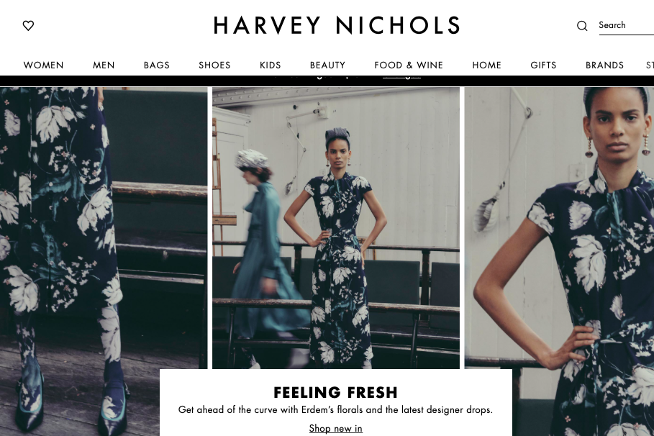
(Harveynichols.com. 2021)
for any customer getting the value as customers is one of the pivotal aspects and they do not like wasting time. Marketing in the current trends delves into personalised experiences that align to the expectations of the customers. Harvey Nichols offers tailored experiences that are more likely to engage customers to the brand (Harvey Nichols. 2021).
Branding and it’s advantages
Branding can be defined as the method in which the name, design, term or symbol is used to create distinction between two or more companies. The advantages of branding can be mentioned as following:
Brands provide peace of mind – Consumers want comfort, happiness, and satisfaction in their buying experiences and this is the reason that they want to buy from companies that are consistent. This consistency is based on the brand becoming trustworthy. The advantage is that customers become loyal to brands that offers the value of the trust they are showing (Baines et al., 2017).
Brands save decision making time – branding is necessary as the positioning and the selection of the brands are based on the idea of offering the specific features that are delivered. The development of brand and aligning the same to customer wants and demands save the time of the customers. they automatically receive their requirements from the brands without further searching (Kotler, 2017).
Brands provide safety – brand safety measures are used by the brands so that the risk is minimalised. Third party verification providers are often used in this case and technology is used so that quality is maintained. Customer bank of such initiatives as the products and services are standardised through the process. Branding helps in mitigating risks like fraudulent e-commerce ads, illegal download ads and invalid traffic (Kotler, 2018).
As per the recent strategic changes that have been brought by Harvey Nichols it has been found that transformation of the brand for customer experience would be essential. The shopping experience of the brand has been 79% in the year 2017 and branding has been essential for the company to create value of customer experiences (Harvey Nichols. 2021). 360 degree service proposition is one of the essential part of branding and that Harvey Nichols is trying to offer something extra. Offering fearless styles to the customers is essential and there should be uniqueness in the proposition. Hence, the introduction of Style Academy, a two-day training programme by Harvey Nichols has been advantageous for the company to satisfy customers. the mentioned measures of branding have been useful for Harvey Nichols for unique experiences that stand out (Harveynichols.com. 2021).
Ansoff Matrix
Ansoff Matrix can be mentioned to be a strategic planning tool that is used by companies for devising the market tactics that would be used in the future. Harvey Nichols can use the matrix in the following ways:
Market penetration – providing class and premium value to the customers is the method through which Harvey Nichols intends to penetrate market. The company has been effective in providing world class elite fashion products along with food and wine. Engaging communication through website and social media increases the consumer base of the company (Kotler, 2017).
Product development – the development of the product includes range of products that are for men, women to beauty ranges. Based on trends there is continuous modification that ae brought in the existing range and through research and development new products are brought in the market. Innovation and creativity is used by Harvey Nichols so that there is new products and standardisation that is maintained (Kotler, 2018).
Market development – the company believes in going international and hence geographically different markets are used by the company. Harvey Nichols believes in creating customer base in the international market based on value based products that meet the expectations of the customers. focusing on increasing the segmentation of the customers has been one of the prime strategies of the company (Kotler, 2017).
Diversification – Harvey Nichols uses both vertical diversification and horizontal diversification. New products are developed and used in the market through vertical diversification. Based on the trends and the customer satisfaction introducing new products is necessary and this is used by Harvey Nichols as part of horizontal diversification. As part of diversification standardisation of the products and services is used (Deepak and Jeyakumar, 2019).
The overall advantages and disadvantages of the Ansoff Matrix model includes the following:
Advantages – Ansoff Matrix can be used for analysing different product scenarios that can be two of more. This tool is useful for analysing high level strategies for a company. Easy assessment can be utilised by Ansoff Matrix and complex scenarios can be evaluated (Kotler, 2017).
Disadvantages – at times the tool is over simplistic and real world markets are not analysed. Detailed market, customer and product assessment is not used by Ansoff Matrix (Deepak and Jeyakumar, 2019).
Relationship marketing of Harvey Nichols
Relationship marketing is a strategy that is used in marketing to create long term engagement with the customers and to create loyalty and interaction. Strong connections are developed and retained through the process and customers are offered services based on needs. Communication plays a dominant role in the process (Baines et al., 2017).
Harvey Nichols is necessary for creating customer based value of the products and enriching experiences that the customer expect from the premium brand. business marketing is used by the company for aligning the brand with marketing, content, digital, loyalty and visual merchandising. The loyalty app has been one of the methods through which relationship is grown with the customers. in a recent advertisement of Harvey Nichols it has been found that an endangered species that is Northen Bald Ibis was seen to wear a £200,000 necklace. The new loyalty app by the company shows CCTV footage of shoplifters to ensure safety and security (Harveynichols.com. 2021). The idea of creating something new with the endangered species has been to show customers that they are also valued that uniqueness of the brand is its key strategy to impress the customers. the loyalty app as per the company officials is the relationship enhancer that help in offering value to customers once they are loyal to the brand. hence, there is a strong bond that is grown by the company (Qualtrough, 2021).
Stakeholder engagement and their impact on the marketing activities of an organisation includes improving communication and re-working on the operations and the marketing strategies that would offer long term benefits. There is first mover advantage that is received by a brand and process helps in sustainable communication with the stakeholders. The brand image is enhanced (Kotler, 2017).
Definition of a stakeholder
A stakeholder is a person of part of group that have their legitimate interest in the operations or the actions of a company. They are part of any organisation with the power to affect the operations of a company or vice versa (Kotler, 2017).
Definition of internal and external stakeholders
Internal stakeholders are the ones who are part of internal operations of an organisation. they are person or groups who participate in the management of the company and have the power to influence an organisation. they have vested interest in organisation and also are influenced with the success or failures. Internal stakeholders are also mentioned as primary stakeholders. They are the employees, owners, managers and board of directors in an organisation (Kotler, 2018).
External stakeholders are the people and groups in organisations that are an integral part of the management and they are affected by the managerial decision making process. They are outside the business environment. External stakeholders and known are secondary stakeholders. The secondary stakeholders of an organisation include customers, suppliers, creditors, intermediaries, society, government, competitors (Deepak and Jeyakumar, 2019).
Internal and external stakeholders of Harvey Nichols
The internal stakeholders of Harvey Nichols include the following:
Employees – the employee base of Harvey Nichols is nearly 1900 and the company has some of the key offerings that cater to the needs of the employees. As employees are an integral part of the organisation resource it can be seen that generous staff discount is given along with additional cards are given for the near ones of the staffs. Family friendly policies in the company include extra day’s holiday, a pension scheme childcare vouchers and management life insurance and healthcare (Harvey Nichols. 2021).
Owners – Harvey Nichols is owned by Dickson Concepts that is a Hong Kong luxury brands. Manju Malhotra is the CEO of the company and the company is integrated in offering premium products (Qualtrough, 2021).
Managers – the managers of the company take most of the required decisions as part of team management. They are also entitled for all the staff policies and this includes applying for a bicycle from the company so that it is easier to reach to work (Kimball, 2019).
Board of directors – the board of directors of the company include Julie Holdaway who is the Group HR & People Development Director, Alison Nieuwoudt who is the Director of Finance and Laura Larbalestier who is the Group Fashion Buying Director. Gail Shuman is the Group Ecommerce Director and Marcel Borlin as the Group IT Director. The work of the directors is to create exclusive value intensive services that creates perfect sourcing and experience for the customers (Harvey Nichols. 2021).
The external stakeholders of Harvey Nichols include the following:
Customers – the company has been serving end number of customers since it was opened as linen shop in 1813. The company is currently present in 8 locations. Apart from the physical stores the company is also offering value oriented service through website that is E-commerce ordering process. Customers tend to receive the information from the website and the social media handles of the company (Harvey Nichols. 2021).
Suppliers – the suppliers of the company are ensured to be ethical so that the sourcing is genuine and reliable. This ensures long term relationship of the suppliers with the company and the loyalty of Harvey Nichols towards the suppliers (Kimball, 2019).
Competitors – some of the companies that are competitors to Harvey Nichols are Harrods, Liberty, Fenwick, Selfridges, Topshop, Farfetch, Modern Luxury, NET-A-PORTER, Matchesfashion and Tobi. The company follows the policies and the product development that are used by these companies to ensure that create something better and unique for attracting and retaining customers (Qualtrough, 2021).
Communication of Harvey Nichols with stakeholders
Harvey Nichols has adopted the idea of implementing an effective communication plan with the stakeholders. In case of the internal stakeholders the company follows a transparent top down communication method. this ensures that decisions and ideas are followed throughout the structure of the company. Harvey Nichols uses the idea of press releases, brochures, websites and trade show presentations for the external stakeholders (Qualtrough, 2021). As part of the marketing communication plan for the external stakeholders is planning to the needs and preferences. This is mostly for the customers and this is created in line with the government policies and the regulations that the company is bound to follow. The policies or the new product development would be also be for gaining competitive advantage (Deepak and Jeyakumar, 2019). Hence, the objectives that are ensured in the communication plan include the first to facilitate the ability of the organisation and secondly, interacting with the stakeholders that is both internal and external for products, consumers, and regions. Finally, the communication plan would help in integrated communications mechanisms for meeting the profit initiative in each financial year. The communication plan for the internal and external stakeholders is used to enhance the reputation of the company for increasing the market coverage and consumer base (Kimball, 2019).
However, with reference to communication with the stakeholders Harvey Nichols Director of Technology and Innovation, Fatima Zada initiated the use of innovative technology as part of the merging communication plan. The organisation culture has been changed and technology has been made the base of communication for standardised operations that are fast and reliable. The use of artificial intelligence in the organisation has been developed with IBM Watson and SAP HANA that would be effective in collecting data, generating the results and the management can take the necessary decisions for the welfare of the stakeholders based on this data (Qualtrough, 2021).
The impact of internal stakeholders on Harvey Nichols includes the changes in employee programs and employee engagement policies that are created based on the needs of the employees. The company needs to create and enhance employee and manager relationship as failing this conflict would arise. This can impact the productivity of the organisation (Deepak and Jeyakumar, 2019).
The impact of external stakeholders on Harvey Nichols includes bearing the cost of raw materials and change of the prices as failing this the relationship with the suppliers might be affected. This can impact the quality of service and meeting demands of the customers. With the changing market requirements and customer demand the company must formulate products failing which customer base can be reduced (Kotler, 2017).
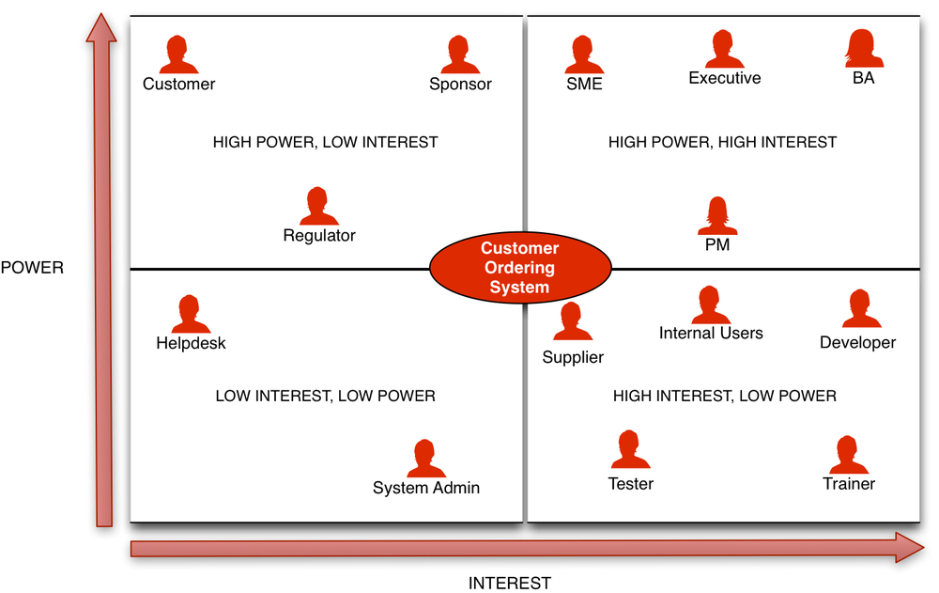
(Qualtrough, 2021)
The Power/Interest matrix for Harvey Nichols for various stakeholders is provided above in the diagram. The power of internal stakeholders like employees that include executive and managers is high power and high interest that includes owners as well. The external stakeholders like suppliers include high interest but low power however, for customers high power and low interest is seen in the company.
Conclusion
As found, Harvey Nichols has been a company that has been effective in delivery customer value by meeting the needs and expectations of the customers. However, there are certain recommendations that can be provided to the company so that it can develop further and target a larger market. The company has been efficient in connecting with the customers through website and social media sites, however, the positioning of the brand image in the international market is not strong as the company operations are limited globally. This is to be improved by Harvey Nichols succinctly.
Recommendations
Diversification can be brought through better product innovation by Harvey Nichols. The company is delivering products are range that most of the ecommerce companies are delivering like Amazon and eBay. However, with innovation of products like company based premium lines of apparels the company can bring the necessary change. Harvey Nichols can also try to bring product innovation like brining personal line of gadgets (Deepak and Jeyakumar, 2019).
The next step that should be considered by Harvey Nichols is increasing the international locations. The company is present in only 8 locations globally and this should be increased by Harvey Nichols. The company should start penetrating with their categorised products in different parts of the globe. This should also include considering the merging economies of the world. The business profit would be more and the company would be gaining more loyal customers (Kimball, 2019).
The final recommendation would be to consider using customer relationship managers for after sales service. These executives would be given the work to follow up with the customers, post purchase and to ensure customer expectations are fulfilled.

References
Baines, P., Fill, C., Rosengren, S. and Antonetti, P., 2017. Fundamentals of marketing. Oxford University Press.
Deepak, R.K.A. and Jeyakumar, S., 2019. Marketing management. Educreation Publishing.
Harvey Nichols. 2021. All The Extras, Our Rewards And Benefits From Harvey Nichols Careers, UK. [online] Available at: <https://careers.harveynichols.com/rewards-and-benefits> [Accessed 13 April 2021].
Harveynichols.com. 2021. Harvey Nichols - Designer Fashion, Beauty, Food & Wine. [online] Available at: <https://www.harveynichols.com/> [Accessed 13 April 2021].
Kimball, B., 2019. The Enhancement of Learning Outcomes in a Marketing Fundamentals Course Through Innovations in Coursework Content and Delivery Mode. Business Education Innovation Journal VOLUME 11 NUMBER, p.171.
Kotler, P., 2017. Philip Kotler: some of my adventures in marketing. Journal of Historical Research in Marketing.
Kotler, P., 2018. Why broadened marketing has enriched marketing. AMS Review, 8(1), pp.20-22.
Qualtrough, E., 2021. Harvey Nichols Director of Technology and Innovation Fatima Zada Q&A - Innovation and emerging technologies. [online] CIO. Available at: <https://www.cio.com/article/3524316/harvey-nichols-director-of-technology-and-innovation-fatima-zada-q-a-innovation-and-emerging-technol.html> [Accessed 13 April 2021].

