Personal Development Plan
No | Improvement and Development Goals | Success Criteria  (How I will know when I have made this change) | The actions I will take to achieve the goal | Timelines | What will this help me to achieve? | Achievements  (3 monthly review)
1 | To become more confident speaking Welsh | When I am more comfortable using Welsh in my everyday life. For example, in my setting during placement or small conversations in University or Work. | I can add more Welsh words/phrases into my vocabulary. For instance, saying good morning/good evening in Welsh.  Once I am more comfortable saying smaller phrases I can move onto sentences and slowly build up the amount of Welsh spoken throughout the day.  I can listen to a podcast about gaining confidence when public speaking or learning a new language. This could give me more tips to help me get used to talking Welsh in public.  The podcast called ‘The Language Confidence Project’ by Emily Richardson will be very helpful for me to gain confidence and learn new tips to help me learn Welsh more confidently. https://open.spotify.com/show/5nM0fRi9tUDvl2XNHhsuqt?si=07604351f13b4d18 | I would like to complete this by the time I go into Teaching after I graduate. This gives me 2 – 3 years to complete. | Having a second language in teaching is helpful to communicate with a larger community. Welsh as a second language will be very helpful for me to talk to Welsh speakers in school and work.
2 | Complete my PGCE after my undergraduate degree. | Once I graduate and gain my PGCE qualification. | Ensure I gain at least a 2.2 or higher in my undergraduate degree in Early years education.  Ensure I have experience working in a setting with children. I need work experience with children for entry requirements into the PGCE.  Have a minimum of C or above in English, Mathematics and Welsh.  Here is a link I have been reading up on do gain more knowledge and understanding of the entry requirements and the modules included in the Primary PGCE. https://digital.ucas.com/coursedisplay/courses/35c1696d-5af9-49b2-97c5-6923fc672a20?academicYearId=2025#entry-requirements | I would like to apply for my PGCE in the September 2026 after I graduate from my undergraduate degree. This gives me just over2 years to prepare. | Help me gain the qualification to go into working my dream career as a Primary education teacher in early years.
3 | Spend a second summer in Canada working at a summer camp. | Once I complete a full summer in Canada looking after children at a summer camp. | I will need to apply to a camp and go through the interview process to secure my place.  Ensure I apply for the correct position. I would like to be a camp counsellor or unit head next summer to work with children for the summer and give the children the best experience possible.  Book flights and make sure I have all the correct documents like my DBS and Work permit to work abroad.  Last year I worked at Camp Northland and would like to reapply to join them for next summer as a Cabin Counsellor. Camp Northland is a Jewish camp in Ontario Canada. Their vision is to give every child an amazing Jewish camp experience and their mission is to ensure all campers and staff grow, thrive, and have fun at camp whilst focusing on innovative programming and Jewish identity building. https://www.campnbb.com/why-camp-northland.html | I would like to complete this by summer 2025. | This will give me more experience working with different children from different cultures and countries.  Overseeing large groups of children will give me good experience dealing with large numbers for when I become a teacher.  It will be a good addition to my CV for when I apply for teaching jobs in the future.

The first step of Gibbs (1988) reflective cycle is description, this means what is the challenge or topic you will be reflecting about. It then moves onto the second step which is feelings, the point of this step is to think about what the individual was thinking and feeling during the challenges they faced. This step is important because Gibbs reflective cycle is one of the few that focuses on feelings during reflective practice. According to Bassot (2016) reflecting on emotions and feelings is important for professional practitioners as it helps individuals process how their feeling about their work and ensure they are supporting the children efficiently. Bassot (2016) stated that professional practitioners not dealing with their negative feelings towards work could result in low motivation, fatigue anxiety and anger which can lead to have a negative impact on other staff and children in the environment. This shows that reflecting on your feelings and processing how you feel is important to ensure you can complete your role efficiently. There are a few ways you can reflect on your feelings effectively, Bassot (2016) recommended writing in a journal or talking to a trusted colleague/friend about your feelings and worries to help find solutions. The third step is evaluation, this is a focus on the experience and what went well and what could have gone better to improve the experience. Next is the Analysis step which includes the individual make sense of the situation and ensuring they know why certain areas of the situation went well and why other areas could have gone better. Then we have the conclusion, which is step five, this investigates what the individual learnt from the situation and what skills can be used in the future to help everyone gain a positive engagement from the situation. Lastly is the action plan, this final step studies how the individual would do the activity again but change certain areas or handle it differently to see any improvement compared to the previous time (University of Edinburgh, 2024).

According to Brock (2015) reflection and reflective practice are a core value used by professional practitioners in early years used in training for education and social care.
Another outlook of reflective practice stated by Pacey (2016) is that reflective practice is a method used to help challenge, modify, and develop ideas that can improve your practice. Pacey (2016) believe that reflection should be an ongoing cycle to help keep the practice at a continuous progress.

Gibbs (1998) reflective cycle is highly detailed and can give individuals an in-depth reflection with a lot of detail. However, if a practitioner is looking for a simpler reflection cycle Kolb’s (1984) experimental learning cycle is useful as it has four steps to help practitioners reflect efficiently but also is not as time consuming as Gibbs reflective cycle. Kolb (1984) stated that with this reflective model practitioners can start from any step they would like. However, majority of people start from the most common step which is concrete experience. This is where the practitioner will explain what the experience their reflecting on is. Secondly, there is the reflective observation, this is where the practitioner will reflect on their experience and see what went well or what went wrong. Next, there is the abstract conceptualisation which is the step where the practitioner can learn from the experience and see what they could have done differently. Lastly, the active experimentation which is where the practitioner will plan for the next time they try the activity and make any changes that could help improve the experience next time (Thompson,2021).

Zwozdiak-Myers (2024) stated that reflective thinking in practice is important because it is the practitioner’s obligation to analyse and evaluate the activities, environment, and lessons during school to act upon any challenges that could be stopping the children from gaining the most holistic care and education in school. Reasons for reflective thinking in practice could be to ensure all staff are meeting the correct professional standards of the setting. Secondly, it can help teachers or other professionals improve their own teaching techniques to ensure they provide an efficient quality provision and create fun and enjoyable activities for the children. Lastly, efficient reflective thinking can lead to higher qualifications and promotions in work, due to the individual always looking on ways to improve themselves and their work. Bradbury et al (2014) stated that having the ability to reflect urgently and think back on previous ideas ensures the individual understands the complexity and importance of the workplace and the challenges that they have dealt with during the day. The atmosphere in the classroom can have a large effect on the way children act during school.
Stated by Sullivan et al (2014) having a positive atmosphere in the classroom enables the children to stay more engaged and focused when learning. This was found by Sullivan et al (2014) reflective thinking practices, they found that children’s behaviour and management was improved when they were in a more positive environment. This shows that reflection used as a method in teaching can help professional practitioners understand their students’ feelings, reactions, and attitudes.

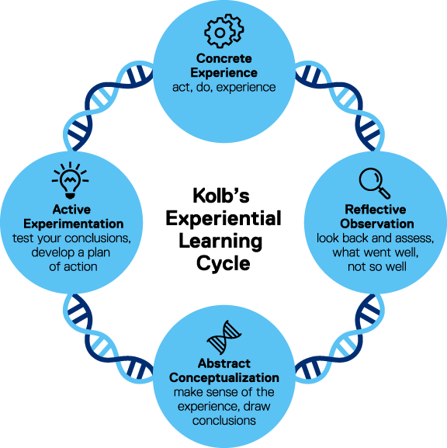

Toronto metropolitan University (no date)
Lindon and Trodd (2016) suggest that early year’s practitioners can use reflection to assess the quality of various teaching strategies and techniques. They can identify what works well and what needs to be improved, resulting in the alteration of teaching methods. This process enables teachers to adjust their approaches to the various requirements of young children.
Reflective practice promotes a routine of continuous learning and professional development among early years practitioners. Teachers can stay up to date on best practices and new research in early childhood education by reflecting on their experiences on a regular basis and seeking feedback from colleagues, mentors, or professional development opportunities. This shows that the practitioners are constantly trying to improve their skills and knowledge to ensure the early years children are gaining the most efficient learning (Lindon and Trodd, 2016). It is important that early childhood educators can engage with colleagues and families in important discussions about children's progress and development by using reflective practice says Brock (2015). As a result of sharing insights and experiences, Brock (2015) believes practitioners can learn from each other and improve their collective ability to support children's learning and well-being.

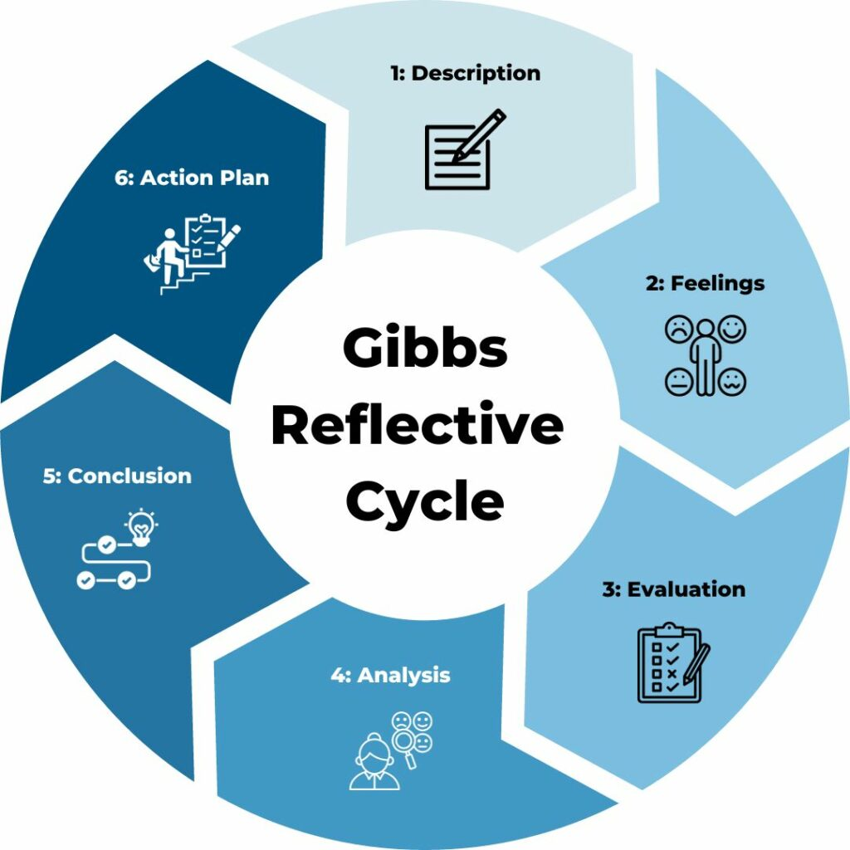

TSW TRAINING (No date)

Professional practice in early years setting is working with young children, families, and co-workers to ensure the children gain effective care, safety and support during their early learning stages and transitions. They should be observed, listened to, and ensured that their health and well-being is a priority (Leeds Trinity University, 2023).

Values are ‘the beliefs people have, especially about what is right and wrong and what is most important in life, that control their behaviour’ (Cambridge University Press and Assessment,2024).
To be a professional practitioner in an early year’s settings there are certain values an individual must carry to be successful at the career. For instance, Powell (2010) believed that a professional practitioner should have a genuine liking for children, good communication skills, confidence, patience, and sense of fun. These are just some of the core values stated by Powell (2010), even though these qualities may not be an explicit requirement to become an early year’s practitioner, Powell (2010) believed these were important to ensure children welfare and holistic development was a priority to all professional practitioners working with young children. In addition to this the Scottish Government (2012) stated that professional practitioners should have certain qualities such as promoting the well-being of individual children and young people, putting the child at the centre of decisions, taking a whole child approach, supporting informed choice, and working in partnership with families. According to Scottish Government (2012) these types of skills and qualities ensure that young children gain the highest standards of care in early years settings.
According to University of Oxford (n.d) effective communication is the act of sharing information but also knowing the importance to understand the reasons and emotions that underlie the information, meaning that to ensure individuals are communicating effectively with each other they need to understand the feelings and emotions that go along with the conversation. In addition to having the ability to communicate ideas clearly, individuals must also be able to listen so that the other person feels heard and understood.

Stated by Early Learning HQ (no date) effective communication is essential for building strong bonds with young children and their families as well as with co-workers and other professionals in any kind of setting. It not only paves the way for a happy workplace, but it is also an essential field of study for many young people's workforce qualifications.

Following this point Early learning HQ (no date) described some ways to ensure your communication is effective. For instance, giving full attention to the individual you’re talking to, being aware of body language as 70% of communication is non-verbal, being confident and role modelling good communication skills and lastly listening to the person you are talking to, to make sure you understand what they are trying to share with you.

In agreement with Early Years HQ (no date) the Department of Education (2021) believe that effective communication with children and their families is highly important as it helps creates trusted bonds. The Department of Education (2021) suggested on collaborating with parents and carers and give them the chance to visit the setting to start the relationship. This will assist in determining how to gently settle the child, learn about their personal histories, family history, and community culture.

The Department of education (2021) also stated that finding out what the parents/carers anticipate from early years practitioners and from the childcare setting will help the practitioners understand what is expected from then but also give the parents the chance to participate in their child's entire journey in the setting.

After parents/carers witness how the staff tailor their child's education and respond to them, they will be able to put their trust in the setting and the practitioners that work there. It involves collaborating to exchange knowledge, ascertain children's areas of interest, and determine the most effective ways to assist their learning (Department of Education, 2021).

According to Whalley (2019) effective relationship-building and maintenance skills are essential for leadership. Early childhood professionals establish relationships with children, families, members of their immediate and extended staff teams, and professionals from other disciplines. Early childhood leaders aim to collaborate with others instead of imposing their power on them.

Every child should have the opportunity to safety from harm and should feel protected and safe in all environments. To keep children safe, all organisations I the UK that work with children need to follow and adhere to safeguarding policies and procedures. This is to ensure that children are protected from not only adults but other children who could be causing risk or harm to other children (NSPCC, no date).

The Early years alliance (2019) stated that the Working Together to Safeguard Children (2023) is the most recent government guideline that defines safeguarding, which includes preventing child maltreatment, ensuring that children grow up in environments that support the provision of safe and effective care, protecting children from abuse, and taking action to ensure that all children have the best outcomes.

There are many key principles in safeguarding to keep children safe and protected and a few main ones are, a child's needs should always come first, it is important to ensure that children have support and assistance as soon as possible, to guarantee that difficulties do not worsen and/or escalate. Everyone in a setting has a responsibility to safeguard children, and all staff have the knowledge to respond to any worries about a child’s safety as soon as they recognise any signs of harm/ unsafety (Early Years Alliance, 2019).

The Early Years Foundation Stage has set a curriculum for early childhood educators to adhere to, to ensure safety in their settings. There are four different concepts which help Early years settings adhere to safeguarding policies correctly, these are, Children learn and grow most effectively in supportive environments, children are unique and can learn new things all the time which gives them the opportunity to grow up to be strong, competent, self-assured, and confident individuals. Positive relationships teach children strength and independence and lastly, children learn and develop best in many different ways and at different rates so no child should be rushed or held back in accordance to any other children (Early Years Alliance,2019).
The United Nations Convention on the Rights of the Child (UNCRC) is an international agreement setting out the rights of children and has created a rationale which outlines all the specific rights and needs of a child for them to stay protected and safe. According to Children’s rights (2022) All children and young people have the rights listed in the UNCRC, regardless of where they live in the world. Young people and children have the right to play, safety, health, education, and happiness. There are four main articles stated by the UNCRC these are Right to non-discrimination (article 2), Commitment to the best interests of the child (article 3), Right to life, survival, and development (article 6) and right to be heard (article 12).
Families and Childcare Trust (no date) stated that parents and families are frequently contacted by a variety of agencies, including employees of children's centres, schools, the Citizens Advice Bureau, and medical professionals. In addition, a variety of unofficial networks and community-based organisations can serve as gatekeepers for the community. Forming alliances with these organisations and services can help provide information to families in more efficient ways and open more networks for communication.

Some advantages of successful multi agency working according to Families and childcare trust (no date) are sharing money or resources, this is a widely recognised strategy for conquering obstacles. Agencies can combine funds, offer cooperative financing, or find new or additional revenue streams. Also, recognising roles and responsibilities as all parties involved should be aware of their responsibilities and the limitations placed on them by other agencies. It is simple for agencies to work on different agendas, to believe that someone else was responsible for a task, for misunderstandings to arise, or for clients to receive contradictory information when roles and responsibilities are not clearly defined.

Similarly, the NSPCC (2023) stated that effective safeguarding and child protection depend on multi-agency collaboration. The NSPCC (20023) also state that throughout their lives, children and their families will make use of a variety of services and be contacted by many different professionals and agencies. To obtain a comprehensive picture of a child's circumstances and develop a coordinated support plan, practitioners must collaborate.

To ensure the needs of children are met effectively in settings observation needs to take place to fully understand what the children acquire to be cared for appropriately, stated by West Sussex County Council (2021) This can be done through Planning, assessment, and observation. These are all helpful in a child's growth and education. Observing children is the first step in planning because it helps practitioners understand and consider their current interests, development, and learning.

According to West Susses County Council (2021) Observation should be both formal and informal and carried out while working with the children. Without observation, overall planning would be based solely on what we thought was important, fun, or interesting (or all three), which may not necessarily meet the needs of the children in our care. Regular observations are necessary to ensure that the child is at the centre of the practice.

In conclusion there are many factors that contribute to the care of young children in early years settings, such as reflection, safeguarding and communication. All these aspects have similar importance and should all be carried out effectively in early years settings to ensure children have the most holistic and safe development in their educational journey during the early stages of their life.

References

Bassot, B. (2016) ‘The reflective practice guide: an interdisciplinary approach to critical reflection’ Abingdon, Oxon; Routledge.

Brock. A. (2015) ‘The early years reflective practice handbook’ New York: Routledge.

Cambridge University Press and academy (2023) Values. Available at: https://dictionary.cambridge.org/dictionary/english/values#google_vignette (Accessed: 10 May 2024).

Department of Education (2021) Working in partnership with parents and carers. Available at: https://help-for-early-years-providers.education.gov.uk/get-help-to-improve-your-practice/working-in-partnership-with-parents-and-carers (Accessed: 12 May 2024).

Early Learning HQ (no date) Effective communication in early years settings. Available at: https://www.earlylearninghq.org.uk/earlylearninghq-blog/effective-communication-in-early-years-settings/ (Accessed: 12 May 2024).

Early Years Alliance (2019) Safeguarding in the early years. Available at: https://www.eyalliance.org.uk/safeguarding-early-years (Accessed: 15 May 2024).

Family and childcare trust (no date) multi-agency working. Available at: https://www.familyandchildcaretrust.org (Accessed: 18 May 2024).

Leeds Trinity University (2023) Professional practice: early childhood studies. Available at:
https://www.leedstrinity.ac.uk/courses/undergraduate/professional-practice-early-childhood-studies/#:~:text=Working%20directly%20with%20young%20children,early%20learning%2C%20progression%20and%20transitions (Accessed 10 May 2024).

NSPCC (2023) Multi- Agency Working. Available at: https://learning.nspcc.org.uk/child-protection-system/multi-agency-working-child-protection (Accessed: 16 May 2024).

NSPCC (no date) Safeguarding and child protection. Available at: https://learning.nspcc.org.uk/safeguarding-child-protection (Accessed: 15 May 2024).
PACEY (2016) Developing self-reflecting practice. Available at: https://www.pacey.org.uk/Pacey/media/Website-files/PACEY%20member%20practice%20guides%20(PDFs)/PG04-self-reflective-practice.pdf (Accessed: 1st May 2024).

Powell, S. (2010) ‘hide and seek: values in early childhood education and care’. British journal of educational studies, 58(2). Pp.213-229. Available at: https://www.tandfonline.com/doi/citedby/10.1080/00071001003752195?scroll=top&needAccess=true

Scottish Government (2012). Common Core of Skills, Knowledge & Understanding and Values for the "Children's Workforce" in Scotland. Available at: https://www.gov.scot/publications/common-core-skills-knowledge-understanding-values-childrens-workforce-scotland/pages/5/ (Accessed: 12 May 2024).

The University of Edinburgh (2024) ‘Reflection tool kit’ Gibbs reflective cycle. Available at: https://www.ed.ac.uk/reflection/reflectors-toolkit/reflecting-on-experience/gibbs-reflective-cycle#:~:text=It%20offers%20a%20framework%20for,or%20didn't%20go%20well. (Accessed: 1st May 2024).

Thompson, C. (2021) Reflective Practice for Professional Development. ‘A guide for teachers’ London: Routledge.

University of Oxford (no date) Communicating Effectively. Available at: https://pod.admin.ox.ac.uk/communication-effectively (Accessed: 12 May 2024).

Welsh Government (2022) Children rights in Wales. Available at: https://www.gov.wales/childrens-rights-in-wales (Accessed: 15 May 2024).

West Sussex County Council (2021) Effective practice: observation, assessment, and planning. Available at: https://www.westsussex.gov.uk/media/5555/effective_poa_and_planning.pdf (Accessed: 16 May 2024).

Zwozdiak-Myers, P. (2024) Teachers reflective practice handbook: becoming an extended professional through enacting evidence – informed practice. New York: Routledge.
Lindon and Trodd (2016) suggest that early year’s practitioners can use reflection to assess the quality of various teaching strategies and techniques. They can identify what works well and what needs to be improved, resulting in the alteration of teaching methods. This process enables teachers to adjust their approaches to the various requirements of young children.
Reflective practice promotes a routine of continuous learning and professional development among early years practitioners. Teachers can stay up to date on best practices and new research in early childhood education by reflecting on their experiences on a regular basis and seeking feedback from colleagues, mentors, or professional development opportunities. This shows that the practitioners are constantly trying to improve their skills and knowledge to ensure the early years children are gaining the most efficient learning (Lindon and Trodd, 2016). It is important that early childhood educators can engage with colleagues and families in important discussions about children's progress and development by using reflective practice says Brock (2015). As a result of sharing insights and experiences, Brock (2015) believes practitioners can learn from each other and improve their collective ability to support children's learning and well-being.

