Learning In The Digital Era
Component 1: E-portfolio

Submitted by:
Henry Ogunde
Student number: 2522133

Date: 9 March 2026

Table of contents
Contents
E-portfolio link 3
Screenshot of e-portfolio cover page/ welcome page 3
Task 1 4
Screenshot of ‘Essential Skills’ 4
Screenshot of ‘Reflection’ 5
Task 2 6
Screenshot of mind map 6
Link to mind map 6
Screenshot of the academic poster 7
Link to the academic poster 7
Task 3 8
Screenshot of automatic referencing tool 8
Task 4 9

E-portfolio link

https://sites.google.com/view/henro-e-portfolio/home

Screenshot of e-portfolio cover page/ welcome page

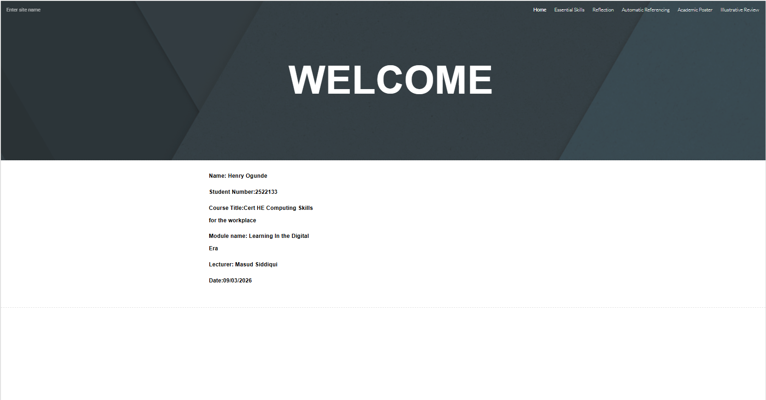

Task 1

Screenshot of ‘Essential Skills’

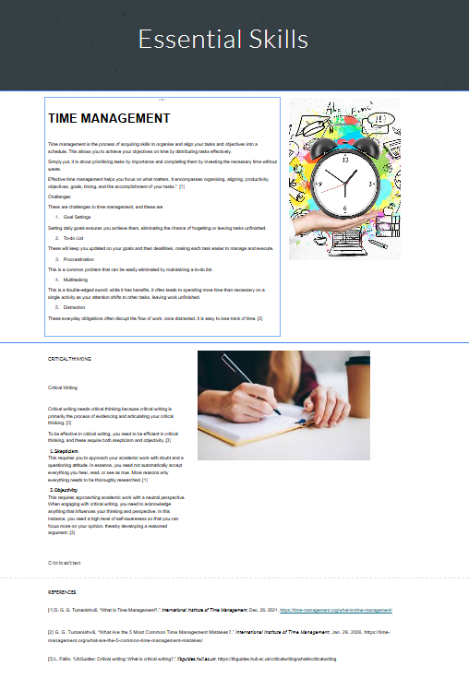

Screenshot of ‘Reflection’

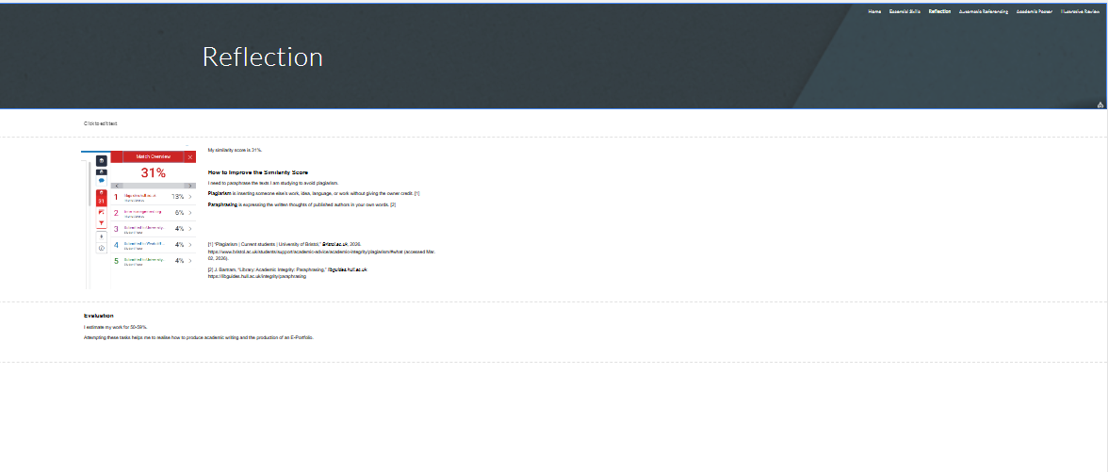

Task 2

Screenshot of mind map

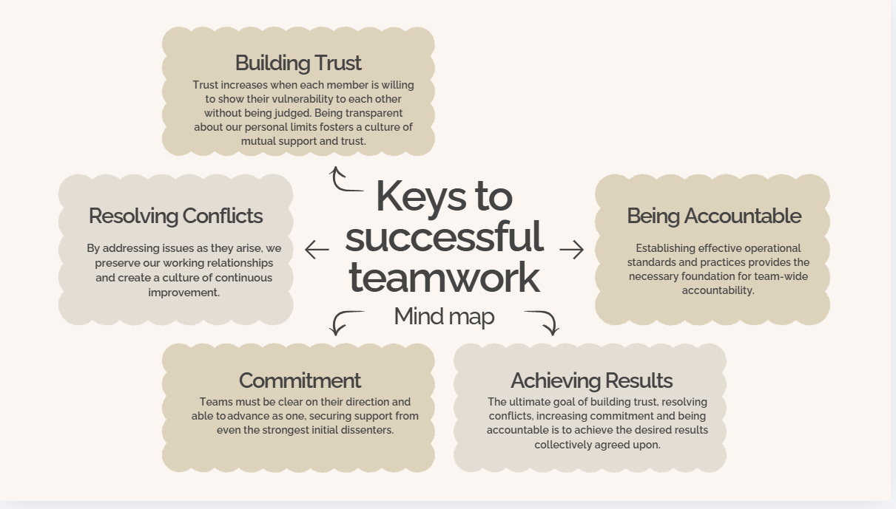

Link to mind map

https://www.canva.com/design/DAHDcmboNmA/8j7b8thJX86ThvdVyu3-_Q/edit

Screenshot of the academic poster

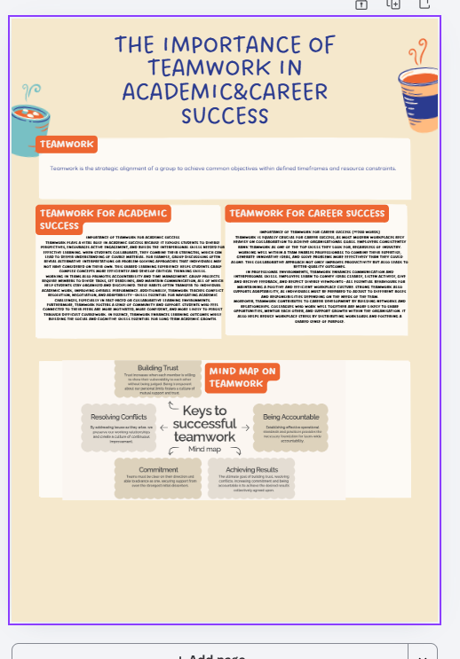

Link to the academic poster
https://www.canva.com/design/DAHDc1QDo6s/k1PwtZVv8Oo8VLKdEbqoHA/edit?ui=eyJBIjp7fX0

Task 3

Screenshot of automatic referencing tool

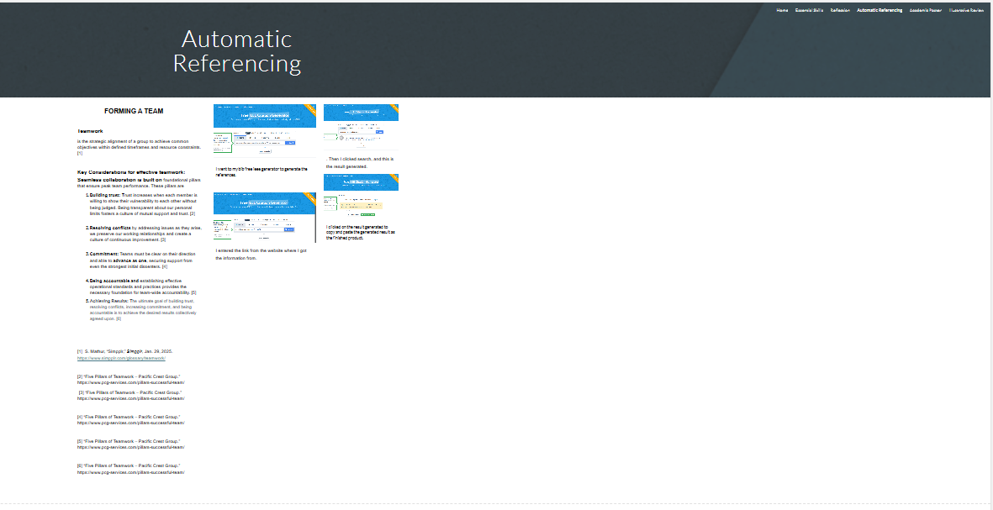

Task 4


