

Level 5

BMSK5003: UNDERSTANDING AND ENGAGING IN THE CUSTOMER EXPERIENCE

Student Name: Mohammad Zakir Hossain
Student ID: 1713069

Table of Contents
1.0 INTRODUCTION 4
2.0 Critically analyze the factors that influence your organizations ability to maximize customer value 4
2.1 A Successful CRM (Customer Relationship Management) 4
2.2 How Tesco is maintaining its CRM in Business 8
2.3 CRM Technologies 9
2.3 CRM – Corporation Perspectives 11
2.4 Impact of Existing CRM practices in Tesco 11
2.5 Touch Points 12
2.6 Understanding the wants or needs of the customers 13
2.7 Core competency 13
2.8 Staff satisfaction 14
2.9 Innovation 14
3.0 Provide a critical understanding of your organizations quality processes and its effectiveness in meeting customer requirements 14
3.1 Customer perceptions, expectations of the quality and customer satisfaction 14
3.2 How Tesco meets the Customer Expectation 16
3.3 Quality Management Process 16
3.4 Competitive Priorities 18
3.5 Service Quality 18
3.6 Quality programs 18
3.7 Training and Development Programs 19
3.8 Supply Chain Labor Standards 19
3.9 Benchmarking 20
3.10 Customer feedback 20
4.0 Conclusion 20
References 21

INTRODUCTION
According to Pennington (2016), customer experience is the key term in business that is usually used to explain relationship that customers has with any business organizations. In other words, customer experience means the experiences of the customers that has with a business by depending on the thoughts as well as interactions of that business organization. In addition, customer experience is the key factor to fulfil the expectations of the customers. This is the important factor for a business to sustain the business growth. Bordeaux (2019) said that positive customer experience not only makes the customers feel happy but also increases the business revenue.
Tesco is the chosen organization to conduct this assignment. Tesco is the leading and 3rd largest grocery retailer around the world which headquarters is in Hertfordshire, UK. This grocery retailer was first founded by Jack Cohen in 1919 but this has expanded internationally since 1990s. This retail organization is successfully doing its business operations in the 11 countries around the world (Tesco Annual Report, 2018). As Tesco is the leading grocery retailer offers varieties of products and services to its customers including foods, clothing, furniture, books, toys, electronic items, software and others.

2.0 Critically analyze the factors that influence your organizations ability to maximize customer value

2.1 A Successful CRM (Customer Relationship Management)
CRM (Customer Relationship Management) is the key approach for a business because this manages the interaction of an organization with its both existing and potential customers. Kumar (2017) said that CRM focuses on the data analysis regarding the customer history to improve the business relation with the customers that helps the business organization to increase the sales. A business organization’s successful CRM helps to recruit right people by motivating them through different training and motivational tools that make them able to give better services to the customers (William, 2016).

Recruit and Keep Right People

In a business organization, the frontline staffs must be given proper training as well as motivated them with different motivational tools to make them motivated so they can be able to give better services to the customers. In addition, the staffs must be trained like a way that they become capable to answer most of the questions that are come from the customers without any hesitation and support of their managers (Mathew, 2016). Thus, it is essential for any kind of business organization to recruit the skilled and right person for the right position at the workplace. In this case, interview or staff selection process has to be suitable and proper that helps to recruit the right person. For example, if an interview any person say that he or she is not good at managing, then for the customer service section he or she must not be recruited. Moreover, if any person is not able to be friendly with other people, then he or she is also not be recruited in the customer service section. According to Mukerjee (2017), the right and skilled employees are able to manage the good relations with the customers. On the other hand, staffs’ attitudes and behaviour towards the customers can be developed when they cooperate and interact with the customers while giving services to them. However, a business organization may recruit both part time and full time employees for conducting different organizational activities. But it is essential to recruit the right employees for any position of the organization so employees are able to successfully fulfil their responsibilities. Thus, it is essential to recruit the right person for the right position to make the CRM successful that brings benefits for the business organization in an effective way. In terms of Tesco, this retailer must focus on the proper and legal recruitment and selection process to recruit the right people for the right position.

Frontline CRM
William (2016) said that the frontline CRM has a way to cooperate with customer experiences. This is not so much important for a business to focus on the experienced employees who can easily maintain the business strategies. In addition, a business can concentrate on the supplementary investment that is not necessary if the staffs of that business organization are able to manage the customer services properly (William, 2016). Tesco is the largest grocery retailer around the world that tries to offer good salaries to the employees that helps to make them motivated and help the customers by giving them good services in a n effective way (Tesco Annual Report, 2018).

Tools
Employee empowerment, feedback from the customers, analyses the information of the customers and other are the key tools to identify the customers’ expectations that make the feel valued (Gitomer, 2017). In a business organization, it is the key responsibility of the employees of customer service section to give correct information about products/services and give proper answers about any queries of the customers. If any of the employees of an organization do not give answers of the customers’ questions and do not manage the customers properly, then the customers become demotivated and never come again to that organization in the next time. So, in this case the employees of an organization must be given proper training about customer service that they can be expert how to handle the customers and make them motivated and feel valued. Tesco must give proper training to its employees by fulfilling their requirements that they feel motivated at the workplace to make the customers feel valued by giving them good customer services.

Empower the Employees to Act Properly
Employees of an organization must be trained and prepared like a way that they become able to make the customers feel valued though their good customer service. If any staffs become incapable to sort out different problems of the customers, then it is necessary to consult with his/her senior manager of the organization to make the employee understand how they give proper customer services to the customers feel valued (Mills, 2018). So, it is necessary for the employees to act properly with the customers in a good way. Moreover, a business organization must offer effective training to the employees that can motivate them to make the customers feel valued with good services. Tesco is the largest grocery retailer around the world that tries to offer good salaries to the employees that helps to make them motivated and help the customers by giving them good services in a n effective way (Tesco Annual Report, 2018).

Training
Effective training for the employees of a business organization is crucial to make the CRM (customer relationship management) successful. There is the great importance of effective training as it helps an organization’s employees to be motivated at the workplace and only the motivated employees are able to make the customers feel valued (Gitomer, 2016). In addition, motivated employees are able to target potential customers through their good services towards the customers. However, not every of the employees are not motivated at the workplace so in this case training plays a significant role to develop the knowledge or skills of the demotivated employees to make them feel motivated. Business organizations have to give training to the employees about the key products and services, customers’ requirement and how to give answer properly to their questions. Moreover, an organization must train its employees about how to develop their soft skills at workplace to work successfully (Beebe and Roach, 2017). Different soft skills of the employees are crucial to make CRM successful. On the other hand, educative training helps to make the CRM successful for a business organization. However, if there is poor customer service, then business organizations become incapable value the customers properly that can destroy the brand image of the businesses. Tesco must make its CRM successful to increase its brand image to the customers.

Staff motivation
Staff motivation is the key factor for a business organization as it helps to make the CRM successful. To motivate the employees successfully business organizations must offer high compensation, effective training, different facilities and good management behaviour. Kruse (2017) said that if the employees are not motivated at the workplace, then they will not show good performance.
High compensation is crucial to make the staffs motivated to create CRM successful for a business. Tesco must give better compensation to make the staffs motivated at the workplace to do work successfully to create CRM.
Then, good management behaviour is also crucial to motivate the employees that can reduce the staff turnover (Kruse, 2017). Tesco has to maintain a good relation between the managers and employees and give training to both managers and employees about how managers can make friendly attitude to the employees and how employees can obey heir managers.
After that, effective training is crucial for the staff motivation that can create the CRM successful (Kruse, 2017). Tesco is very much concern to give proper training to its customers to make them satisfied in the workplace by identifying their needs, demands and expectations (Tesco Annual Report, 2018).

Capturing Matrix and Feedback Channels

Observation and Listening to Quality Supervisor: employees’ calls can be assessed properly to understand the observation of the managers properly in an organization
Surveys of the Customers: different surveys can be carried properly through emails, calls and instant messaging to understand the satisfaction level of the customers.
Employee Feedback: feedback of the employees can be collected properly through weekly survey, observation and meetings.

2.2 How Tesco is maintaining its CRM in Business
Hansen (2016) said that relationship marketing means creating relation between customers and business organization. Relationship marketing of a business’s main aim is to make good relationship with the potential customers. Tesco is the leading grocery retailer which is successful to make good relationship with the customers by focusing on the needs, demands or requirements of the customers (Tesco Annual Report, 2018). The relationship marketing of Tesco includes a number of activities. Getting feedback from the customers through the social media sites and customer survey can help Tesco to make good relationship with the customers. Tesco is always concern to make its customers feel valued through their better services.
After that, Tesco also focuses on different key activities to make their customers pleased and support to retain them for the long time period. On the other hand, Tesco has focused on number of methods in its business to achieve the requirement of the customers and make them feel valued.
Then, Tesco always make effort to assess the key information of its customers. So, Tesco always tries to keep the proper information of the customers in their customer database. According to Tesco Annual Report (2018), it has the ability to increase the sales revenue by attracting the customers towards its brand by offering quality products and services. Furthermore, Tesco must try its best to gain the loyalty of its customers by taking their position as the first largest grocery retailer in the world.
Moreover, Tesco not only serve its customers though in store but also maintains its online marketing to make good relation with the customers. This supports Tesco to easily identify the customers’ demands, needs and requirements by sorting out different problems.
In addition, as Tesco is the leading business organization so it offers quality products with good services to the customers. Tesco is the well-known grocery retailer for its quality products with affordable prices. As Tesco is offering its products in different countries including China, EU and US, so has become able to make good relationship with the customers of different countries by fulfilling their demands successfully (Tesco Annual Report, 2018).
Finally, the leading grocery retailer Tesco offers different promotional activities and discounts to its customers through different products to attract them. In this case, Tesco has to focus on different promotional campaigns to make its customers feel valued. In addition, Tesco Clubcard offers several programs to make the customers loyal towards them (Tesco Annual Report, 2018).

2.3 CRM Technologies

Components of CRM
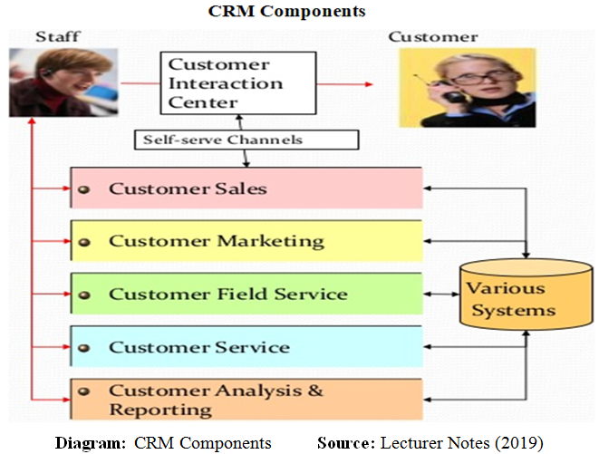

CRM Technologies

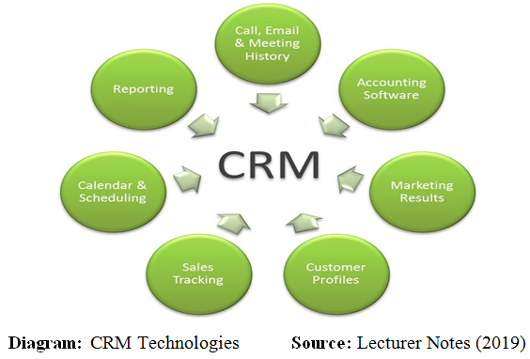
CRM is a technological process as it is involved with a number of technical factors including computers, electronics, telephone connection, social media, and others (William, 2016). Tesco make call and send email to its customers for know any query or get feedback from them. In this case, Tesco makes customer profiles and make schedule to make connection with the customers and good relation. Thus, this needs different technologies to maintain the CRM successfully.

Why Technology should be Effective
Technology is the key facto as it helps both the customers and business organizations. As today is the day of advanced technology so this helps both the business organizations and customers to make good relationship with each other in an effective way. Technology helps a business and customers in different ways including boarding pass printing, money withdrawal through ATM and others. Thus, it can be said that technology is very effective as it make the business process and customer buying process easy within short period of time (Dyche, 2016).

Types of Technologies
Websites: In the modern time, most of the business has its online platform thus an attractive and informative website. In the website, business organizations can share their product details, the offer details, the advertising about their latest products and others to attract the customers. Website can help to make good relationship with the customers easily by getting their feedback from them about any product and answering their questions for any issue (William, 2016). Tesco has the attractive website that can easily target the potential customers. In addition, Tesco is able to maintain good relationship with its customers.
Interactive Voice Response: To make the good relationship with the customers it is essential for the business organizations to give proper information to the questions answers of its consumers where the customers’ questions can be related to shipment date, receipt, product information, payment date, credit cards and others (William, 2016).
Mobile Communication: Some of the business organizations focus on smartphone or mobile phone to make communication with the customers easily. Business organizations including Tesco can focus on telephone to give answers or solutions of any questions or problems of the customers (Dyche, 2016).
Emails and Chats: As most of the business organizations are now online or internet based so e-mail or chats through social media can be the best source of making good relationship with the customers through proper and effective communication related to business and its services (William, 2016).

2.3 CRM – Corporation Perspectives
A corporation or a business organization must create positive relationship with the customers that can help the customers feel valued and increase the sales of that organization. A business organization can offer discounts on seasonal products to attract many customers to the business. Mullick (2015) stated that the customer value only creates if there is a good customer experience.

2.4 Impact of Existing CRM practices in Tesco
The relationship marketing of Tesco has helped this grocery retailer in a number of ways. First of all, relationship marketing is increased business sales about 55% by maintain the good relationship with the customers. After that, relationship marketing also has helped Tesco to properly give the services to the customers. This has supported Tesco to fulfill the demands of the customers in an effective way. However, Tesco is able to understand the market trends and customer requirements about its products and services (Tesco Annual Report, 2018).
As Tesco has the high market trend and customers’ demands of its products so it can focus on effective strategies to make its products price affordable. Moreover, Tesco is able to gain the loyalty of its customers through its different types of marketing strategies and facilities including Tesco Clubcard (Tesco Annual Report, 2018).

2.5 Touch Points
In the present days, most of the business organizations focus on the touch points to collect the information of the customers to make the good relationship with them and also communicate with them when necessary. Different information including customer age, mobile number, product purchase date and others can be easily gathered because of the touchpoints as well as easily store on the customer database. On the other hand, customers also can achieve satisfaction, loyalty and value while they communicate with the business organizations through the touchpoints. If business organizations are able to collect the information of the customers through touchpoints then they become able to identify the needs of the customers, buying intention of the customers, customer lifecycle, customer profile, complaints or inquiries of the customers and others (William, 2016).

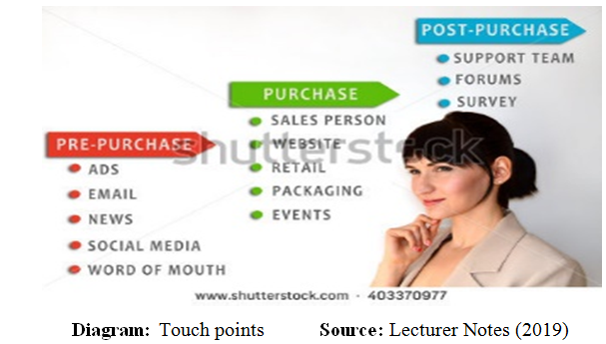

2.6 Understanding the wants or needs of the customers
Businesses organizations always maintain good relationship with the customers by focusing on their needs and wants effectively. Business organizations in this case give proper training to the employees to make them understand about the needs and wants of the customers (Buttle, 2018).
According to Tesco, it makes the customer profile in its customer database to identify the needs or demands of the customers easily. In this case, to make the profile Tesco focuses on demographic information including name, address, mobile number, purchase history and others. Moreover, they also gather the information related to marital status, income level, education, religion and others. Thus, this supports the business organization including Tesco to make effective decision by fulfilling the needs or demands of the customers. On the other hand, Tesco also states customers’ lifecycle. When customer’s lifecycle is estimated effectively, then business organization is able to provide proper goods and services (Dyche, 2016). Moreover, business organizations tries to understand the demands or needs of the customers as it helps to deal with different problems that are come from the customers.

2.7 Core competency
Core competency is the key term in the business. Business organizations always try to focus on the core competencies. Such as, as Tesco is the large grocery retailer so it must make sure the fresh and quality products to its customers by focusing on the needs or wants.

2.8 Staff satisfaction
Staff satisfaction is the key factor for a business organization as it helps to make the CRM successful. To satisfy the employees successfully business organizations must offer high compensation, effective training, different facilities and good management behaviour. Kruse (2017) said that if the employees are not satisfied at the workplace, then they will not show good performance. High compensation is crucial to make the staffs satisfied to create CRM successful for a business. Tesco must give better compensation to make the staffs satisfied at the workplace to do work successfully to create CRM. Then, good management behaviour is also crucial to satisfy the employees that can reduce the staff turnover (Kruse, 2017). Tesco has to maintain a good relation between the managers and employees and give training to both managers and employees about how managers can make friendly attitude to the employees and how employees can obey heir managers. After that, effective training is crucial for the staff satisfaction that can create the CRM successful (Kruse, 2017). Tesco is very much concern to give proper training to its customers to make them satisfied in the workplace by identifying their needs, demands and expectations (Tesco Annual Report, 2018).

2.9 Innovation
Customers always focus on the innovative products as the demands or needs of the customers vary from time to time. The expectations of the customers are increasing if the organization is innovative and tries to bring innovation in the products. However, this is not so easy for every business organization to bring innovation in the business or customer services. According to Tesco, it has developed the packaging system for its customers that help to maintain good relation with customers by increasing the sales (William, 2016).

3.0 Provide a critical understanding of your organizations quality processes and its effectiveness in meeting customer requirements

3.1 Customer perceptions, expectations of the quality and customer satisfaction
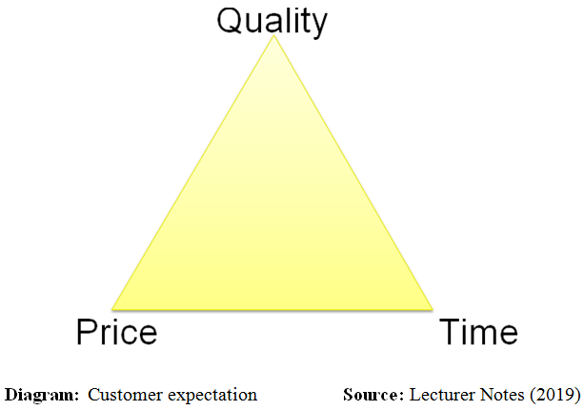
Customers of a business organization always want quality products with an affordable time within short delivery time. Business organizations always face competition with each other in terms of quality, price and time (Dyche, 2016). Thus, it is essential for the leading organizations to maintain these three issues properly to make the good relationship with the customers in an effective way.
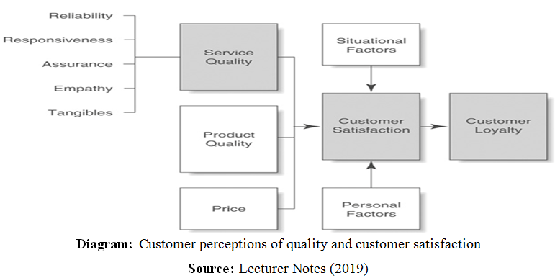
There are a number of factors that can have great impact on the customers’ satisfaction including product quality, service quality, price of the products, features of the products, buying intention of the customers, situational factors, customer satisfaction and others (Scott, 2015).

3.2 How Tesco meets the Customer Expectation
Expectations of the customers are the key factor for any kind of business organization. Business organizations tries to understand the demands or needs of the customers as it helps to deal with different problems that are come from the customers. Tesco can easily meet the experiences of the customers by focusing on the following issues which are explained as follows:
Safety: organization must ensure the products and services that are safe for fulfilling the customers’ satisfaction easily
Quality: organization must offer quality products with affordable price to fulfill the customers’ expectations
Legality: Business organization must ensure the legality of the products labeling, packaging and other standard issues that help to fulfill the expectations of the customers.
Customer focus: organization must sell the products and give the services that may be able to fulfill the expectations of the customers, in a word must be customer focused.
Tesco also make connection with the organizational environment maintenance experts and product safety maintenance experts to its environment safe for both staffs and customers and ensure the safety of the products to fulfill the expectations of the customers. Tesco can collect information from the suppliers related to the production issue to maintain the standards of the products (Tesco Annual Report, 2018). This also helps to fulfill the customers’ expectations easily

3.3 Quality Management Process
Kiran (2017) said that the term quality management process is significant to develop the product and service quality of a business organization. Most of the business organizations are concern about the quality issue of the products effectively. On the other hand, quality management process is a formal procedure that focuses on different effective processes or tasks to make sure the products’ quality.

Approaches to Quality Management at Tesco
Tesco is the key grocery retailer which key focus is to give the quality products with affordable price to the customers (Tesco Annual Report, 2018). On the other hand, Tesco can evaluate its products quality through the effective supply chain. The operational management system is responsible for the great production of a business organization where the production system is crucial to make the quality products and services in an effective way.
Quality management process is the crucial factor for a business organization including Tesco. If Tesco is not able to produce the quality products and better services for the customers, then it cannot be able to make the good relationship with the customers (Tesco Annual Report, 2018). Customers are the most important part for a business organization so Tesco manages its customers’ expectations or wants. Tesco focuses on the following approaches to ensure the total quality management:
Prevention: Tesco always tries to reduce the defect form its products to make the customers feel satisfied towards the business
Zero defects: Key objective of Tesco is to bring innovation in its products by reducing defects near to zero to target more potential customers (Tesco Annual Report, 2018).
Getting things right: Tesco tries to focus on the right things to make the products quality at the top level to satisfy the customers.
Continuous Improvement: Tesco brings improvement in its products and services by focusing on the market trends and the demands of the customers effectively.
Employee involvement: Tesco always engages its employees towards its business and make them motivated to share their ideas, thought and expectations to make effective decision for the business. Therefore, Tesco has continuously improve its business strategies to remain in the market stable (Tesco Annual Report, 2018).

3.4 Competitive Priorities
There are the key six priorities including low cost, quality, delivery time, flexibility, speed and dependability (Porter, 2016). Tesco has to focus on these competitive priorities to gain competitive advantage by fulfilling the demands of the customers.
Low Cost: Tesco must make its products’ price low as the products can be afforded by the customers easily.
Quality: Tesco is the key grocery retailer which key focus is to give the quality products with affordable price to the customers (Tesco Annual Report, 2018). On the other hand, Tesco can evaluate its products quality through the effective supply chain.
Speed and Delivery Time: Tesco not only sells its products through in store but also sells its products through online. In this case, Tesco must make its delivery process speed and on time to make the customers feel satisfied towards them.
Dependability: Tesco focuses on the differentiation strategy and focuses on different promotional activities to get the dependability of the customers to their products. Tesco can also focus on the innovative things in its business that is completely unique from its competitors.
Flexibility: Tesco offers a flexible working environment to its employees that helps the employees to feel motivated towards their work and this ultimately help to give better services to the customers (Tesco Annual Report, 2018).

3.5 Service Quality
There are five key aspects of service quality that is crucial for a business organization to gain the competitive advantage in the market where the five aspects including reliability, assurance, tangibles, responsiveness and empathy. Every the business organization must offer the quality products to its customers in a reasonable price. Assurance means the knowledge of the employees that make them feel confident. Tangibles mean the physical resources that are offered by a business organization. In addition, empathy means the care or services that are provided to the customers. Furthermore, responsiveness means giving the support to customers through fast and speed services. Tesco always tries to maintain these aspects to successfully run its business.

3.6 Quality programs
Tesco is the key grocery retailer which key focus is to give the quality products with affordable price to the customers (Tesco Annual Report, 2018). On the other hand, Tesco can evaluate its products quality through the effective supply chain. The operational management system is responsible for the great production of a business organization where the production system is crucial to make the quality products and services in an effective way. Quality management process is the crucial factor for a business organization including Tesco. If Tesco is not able to produce the quality products and better services for the customers, then it cannot be able to make the good relationship with the customers (Tesco Annual Report, 2018). Customers are the most important part for a business organization so Tesco manages its customers’ expectations or wants.

3.7 Training and Development Programs
There is the great importance of effective training as it helps an organization’s employees to be motivated at the workplace and only the motivated employees are able to make the customers feel valued (Gitomer, 2016). In addition, motivated employees are able to target potential customers through their good services towards the customers. Moreover, an organization must train its employees about how to develop their soft skills at workplace to work successfully (Beebe and Roach, 2017). However, if there is poor customer service, then business organizations become incapable value the customers properly that can destroy the brand image of the businesses. Tesco must make its CRM successful to increase its brand image to the customers.

3.8 Supply Chain Labor Standards
McDonald’s safety or welfare of the staffs is the important factor. McDonald expects the suppliers to encompass the honest or fair contact to its staffs and to all the persons they conduct the business. Then, McDonald has developed the new strategy for its technical managers to increase ethical issues’ awareness and welfare of the employees in the supply chain. After that, it will train every of its technical managers continually like this (McDonald Annual Report, 2017). McDonald is managing its several labor standards to do its business successfully around the world.

3.9 Benchmarking
Camp (2016) said that benchmarking means the maintenance of quality products, business strategies or programs of an organization, and difference or similarities between the different factors of the competitors. In terms of Tesco, it focuses on benchmarking process to manage its different products; quality, business strategies and policies to compare different issues with its competitors such as Sainsbury’s, ASDA, Morrison and others. So, this is beneficial for Tesco to maintain its position successfully in the market by fulfilling the demands of the customers (Tesco Annual Report, 2018).

3.10 Customer feedback
Customer is the eye of any kind of business organizations because without the customers a business cannot go long. So, success of depends on the customers so it is necessary to get feedback from the customers. Gitomer (2015) stated that there are both positive and negatives feedbacks that are come from the customers. Business organizations can accept the positive feedback as opportunity and the negative feedback as their weaknesses and try to sort out their weaknesses like a way that can help to fulfil the expectations of the customers. In terms of Tesco, it can get feedback from the customers through social media sites, website and survey.

4.0 Conclusion
Customer experience is the key factor to fulfil the expectations of the customers. This is the important factor for a business to sustain the business growth. Positive customer experience not only makes the customers feel happy but also increases the business revenue. Tesco is the chosen organization to conduct this assignment. Tesco is the leading and 3rd largest grocery retailer around the world which headquarters is in Hertfordshire, UK. This grocery retailer was first founded by Jack Cohen in 1919 but this has expanded internationally since 1990s. This retail organization is successfully doing its business operations in the 11 countries around the world. Tesco tries its best to fulfil the demands and expectations of its customers by remaining its position at the top.

References
Kiran, D. (2017) Total Quality Management: Key Concepts and Case Studies. 2nd Ed. London: Macmillan.
Dyche, C. (2016) The CRM Handbook: A Business Guide to Customer Relationship Management. 4th Ed. Boston: Oxford University Press

Buttle, K. (2018) Customer Relationship Management. 4th Ed. Harlow: Oxford University Press

Pennington, A. (2016) The Customer Experience Book: How to design, measure and improve customer experience in your business. 2nd Ed. London: Sage Publication.
Bordeaux, J. (2019) What Is Customer Experience? (And Why It's So Important). Available at: https://blog.hubspot.com/service/what-is-customer-experience. [Accessed on: 22 August 2019]
Tesco Annual Report (2018) Annual Report and Financial Statements 2018. Available at: https://www.tescoplc.com/media/474793/tesco_ar_2018.pdf. [Accessed on: 22 August 2019]
Kumar, V. (2017) Customer Relationship Management: Concept, Strategy, and Tools. 3rd Ed. Boston: Prentice Hall Publication.
William, D. (2016) Connected CRM: Implementing a Data-driven, Customer-centric Business Strategy. 3rd Ed. London: Pac McMillan.
Mukerjee, K. (2017) Customer Relationship Management: A strategic approach. 3rd Ed. Harlow: John Wiley and Sons.
William, D. (2016) Connected CRM: Implementing a Data-driven, Customer-centric Business Strategy. 2nd Ed. London: Oxford University press.
Mills, Q. (2018) Collaborative Customer Relationship Management: Taking CRM to the Next Level. 3rd Ed. Boston: Prentice Hall.
Beebe, S. and Roach, D. (2017) Training and Development: Enhancing communication and leadership skill. 3rd Ed. London: Sage Publication.
Mullick, N. H. (2015) Customer Relationship Management. 3rd Ed. Milan: Penguin Books.

