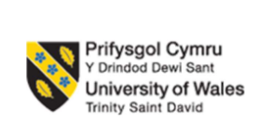

LCMB7026

INTERNATIONAL MARKETING: PRINCIPLES AND PRACTICES

Assessment component 1: Individual report

Topic: A Report on the International Market Entry Strategy and Marketing Mix of Toyota in India and Japan

Student ID: 2519666
Student Name: Godhani Hevin Ashvinbhai

Word Count: 5491

RESEARCH | For this assessment, you can use Generative AI to support you in research and data analysis. | Yes ☒  No ☐
STRUCTURE | For this assessment, you can use Generative AI to support you in structuring your submission, including creating a draft argument structure, identifying parts  and headings, etc. | Yes ☐  No ☒
PROOFREADING | For this assessment, you can use Generative AI to check your own text/creation for grammatical and syntactical mistakes, including getting suggestions to  rephrase your work. | Yes ☒  No ☐
WRITING | For this assessment, you can use Generative AI to create text for submission. | Yes ☐  No ☒
CREATIVE | For this assessment, you can use Generative AI to create creative materials, such as images. | Yes ☒  No ☐
PROGRAMING | For this assessment, you can use Generative AI to create and check code. | Yes ☐  No ☒
NONE | For this assessment, you are not allowed to use any type of Generative AI support. This includes research support, structure support, writing/proofreading  support and creative support. | ☐

Table of Contents
Section 1: Report on the International Market Entry Strategy and Marketing Mix 3
1.1 Introduction 3
1.2 A comparative analysis of the market in India and Japan 3
1.3 Hofstede Analysis 13
1.4 A comparative analysis of STP and Marketing Mix 16
1.4.1 STP 16
1.4.2 Marketing Mix 20
1.5 Analysis of Market Entry Strategy in India 31
1.6 Evaluation of ethical issues for marketing mix in Japan 33
1.7 Recommendations 33
1.8 Conclusion 35
Section 2: Reflective Account 36
2.1 Description 36
2.2 Feelings 36
2.3 Evaluation 37
2.4 Analysis 37
2.5 Conclusion 38
2.6 Action Plan 38
Reference List 40

Section 1: Report on the International Market Entry Strategy and Marketing Mix

1.1 Introduction
The automobile industry is now increasingly globalized, and multinational companies have to adapt their marketing to the economic, cultural, and regulatory environment. Toyota Motor Corporation is one of the leading automobile companies in the world and their product marketing is successful in both developed and emerging markets and has localised strategies. The present report looks into the performance of Toyota in its home country in the Japanese market and one of the most vibrant markets, the Indian market. The report provides analytical lenses such as PESTLE, Hofstede's Cultural Dimensions, STP and 7Ps Marketing Mix, which contrasts the conditions of the market and the marketing strategies in both countries.

1.2 A comparative analysis of the market in India and Japan
PESTLE
PESTLE is part of business’ external factors, as well as it is a business strategy which is useful for businesses to determine the strategy by analysing their internal environment factors including political, economic, social, technological, legal, and environmental impact of.
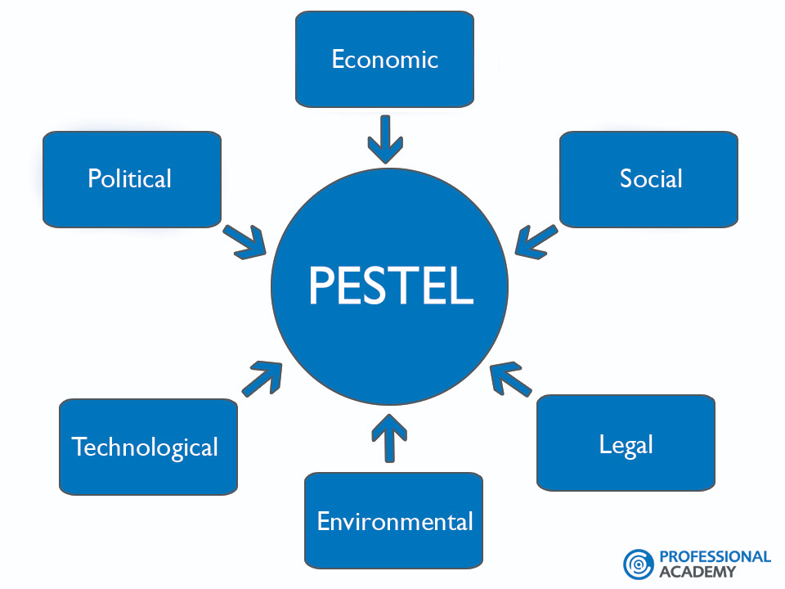
Figure 1: PESTLE
(Source: professionalacademy.com. 2026)
Definition of all PESTLE factors
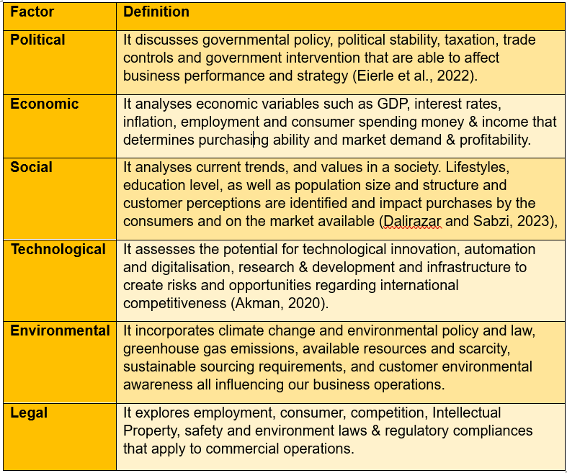
Political Environment
India (Favourable)
The government of India enjoys one of the world's most stable and democratic governments that is generally welcoming to foreign investment in the automotive sector (Bathla, Awasthi and Ahuja, 2022). Various schemes like Make in India, Production Linked Incentive (PLI) Scheme for Automobile and Auto Components (25,938 crore Rs) are provided to manufacturers to promote domestic value addition and production spurs in the country (pib.gov.in. 2026).
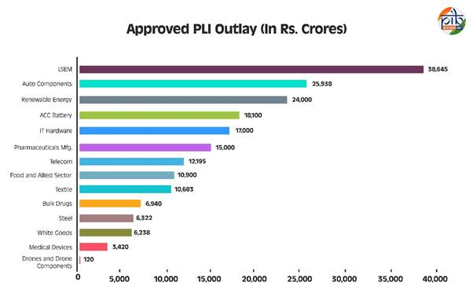
Figure 2: Approved PLI Outplay
(Source: pib.gov.in. 2026)
Japan (Favourable)
The Japanese political system is one of the world's most stable and well-governed political systems and has a clear and transparent regulatory structure (Nottage and Teramura, 2024). The Government is actively fostering innovation and industrial competitiveness, and export manufacturing, especially by offering research funding and technology collaboration programs.
Comparative Evaluation
The political situation is relatively stable with relative importance in both countries. India's key policy measures are geared towards manufacturing and Japan's are geared towards regulatory stability for innovation and technological leadership.

Economic Environment
India (Favourable)
India is one of the fastest growing world economies with the impact of rapid urbanisation, increasing levels of disposable income and an expanding middle class. According to Statista (2025), India accounted for the sales of approximately 5.06 million passenger vehicles in 2025, making it a top automotive market worldwide (Sasu, 2025). The liberal Foreign Direct Investment (FDI) policy has also helped in the growth of the manufacturing base as offered by the Multinational manufacturers.
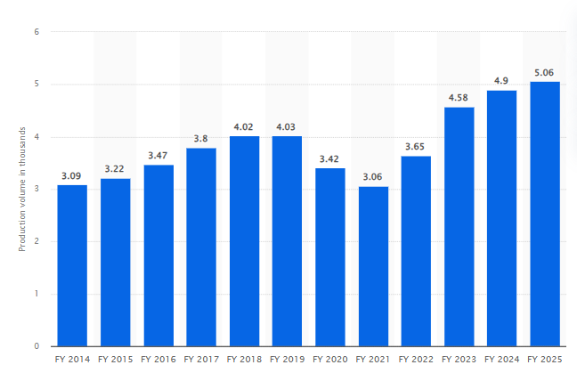
Figure 3: Production volume of passenger vehicles in India (2014 to 2025)
(Source: Sasu, 2025)
Japan (Favourable)
Japan is a highly developed and high-income economy, and its purchasing power is excellent, the industrial infrastructure is advanced. There is also increased competition from other overseas manufacturers which are competing in the market, such as Honda, Nissan, and Mazda, therefore the production volume of passenger car in Japan has increased to 7.21 million units in 2025 (Sasu, 2026).
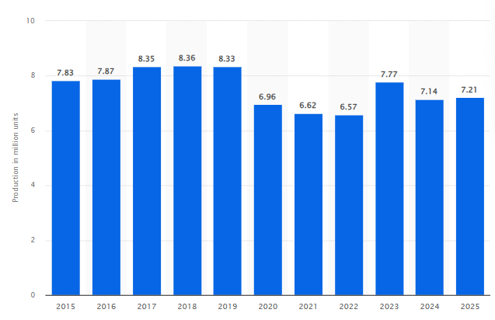
Figure 4: Production volume of passenger vehicles in Japan (2015 to 2025)
(Source: Sasu, 2026)
Comparative Evaluation
In terms of growth potential, India has the growing consumer demand, but Japan has the potential of margin per customer but relatively low growth in terms of market. In 2026, India is projected to grow 6.4% with 4.7% inflation, compared with Japan's 0.6% growth and 2.2% inflation (IMF, 2026). Hence, Toyota views the Indian market as a growth market and Japan as an established market with a thrust towards innovation and premium value creation (toyotabharat.com. 2026)
Social Environment
India (Favourable)
India's youth population has a huge impact on the demand for automobiles. India's population is projected to comprise 13.9% aged 0–14, 50.0% aged 15–59, and 36.1% aged 60+ which indicates rapid population ageing by 2100 (voronoiapp.com. 2025). As well as the rapid urbanisation in many cities, a lack of investment in public transport systems results in a high level of dependence on private transport.
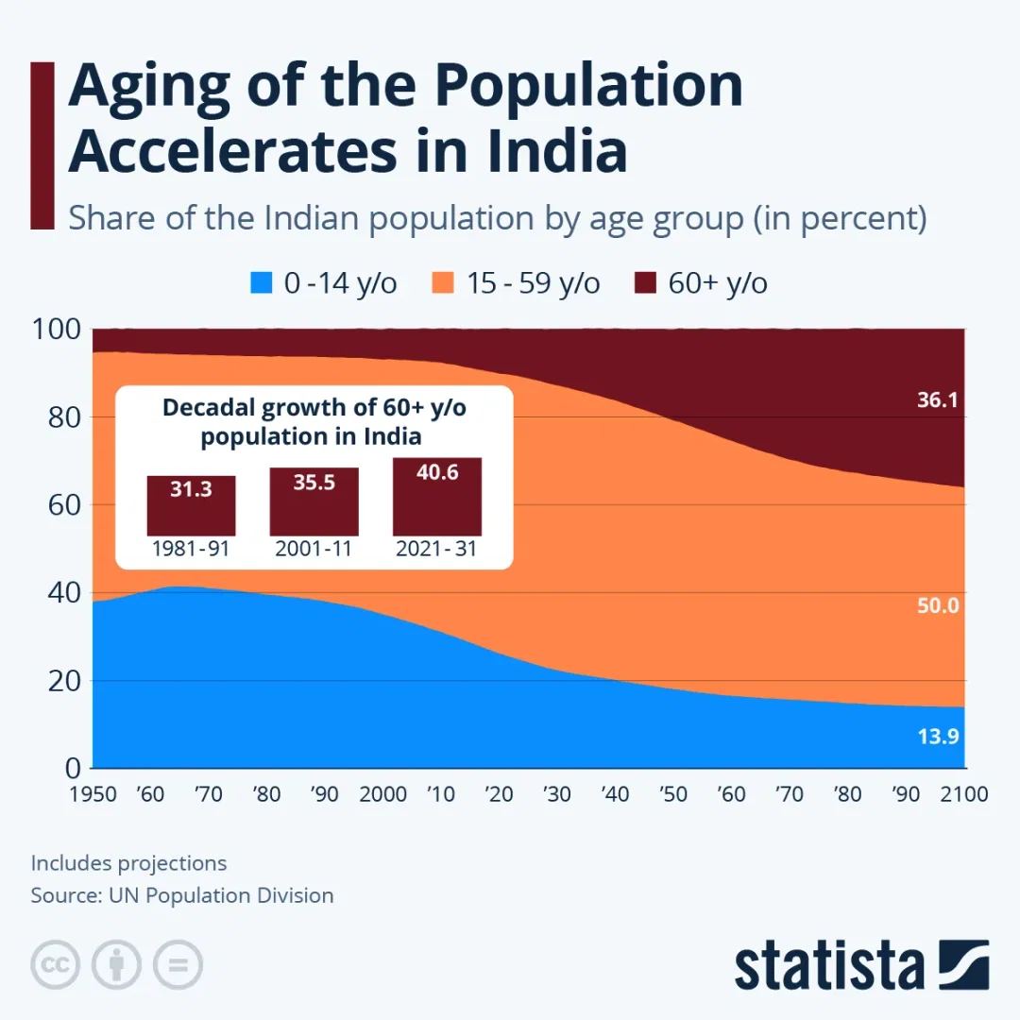
Figure 5: Aging of the Population Accelerates in India
(Source: voronoiapp.com. 2025)
Japan (Unfavourable)
29.8% of Japan's population was aged 65 years or over which highlights one of the world's oldest demographic profiles in 2021 (weforum.org. 2023). Consumers are more concerned about product quality, safety, advanced technology, and environmental sustainability, than affordability.
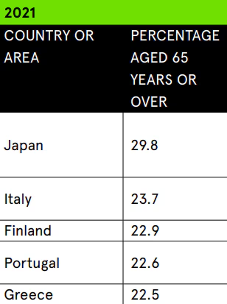
Figure 6: Higher percentage of 65 years age population in Japan
(Source: weforum.org. 2023)
Comparative Evaluation
The two markets have large differences in terms of their demographics and purchasing habits. Japan is an ageing society with the demand for technologically advanced, safe, and quality mobility; India as a young country has the demand of cheap and convenient means of transport. India has a young population that are asking for less expensive and convenient mobility solutions, while Japan is an ageing population asking for technologically advanced, safe, and high-quality mobility solutions (voronoiapp.com. 2025).
Cultural Environment
India and Japan have a strong emphasis, quality, and long-term relationships in automobile purchasing, however Indian buyers have collectivist approach and Japanese has individualistic approach (theculturefactor.com. 2026). Indian consumers are more value oriented as well as flexible, on the contrary, Japanese emphasised on reliability, technological performance, build quality along with long-term quality. These differences have an influence on marketing of Toyota, product positioning along with customer expectations in both countries.
Technological Environment
India (Favourable)
Government efforts and investments in digital infrastructure, and the promotion of electric vehicles, are expected to usher in a technological revolution in the Indian automotive industry (Kumar et al., 2020). The national initiatives for support of EV manufacturing and battery production and charging infrastructure are driving technology adoption.
Japan (Favourable)
Japan is still one of the biggest hubs for R&D in the automotive sector (Yun et al., 2025). The country continues to invest in autonomous driving and smart manufacturing, AI and robotics, and this further boosts the nation's technical capabilities.
Comparative Evaluation
Both countries have technological advances, but from very different perspectives. In India, manufacturing is getting promoted and in Japan, the bulk of technology is being used to enhance Toyota's technological innovation in Japan and elsewhere (Global.toyota. 2026).
Environmental Environment
India (Favourable)
The automotive industry in India is becoming increasingly sustainable with environmental issues. Adoption of Bharat 6 emission norms has sparked consumer interest in HEV and EVs and government incentives are encouraging people to opt for greener transportation (Sathiyan et al., 2022).
Japan (Favourable)
The Code of Environmental Code is one of the most comprehensive environmental laws in the world, especially in the field of carbon neutral/sustainable transportation in Japan (Washizu, Akao and Liu, 2025). The Government policies are well advanced to promote the use of low emission vehicles, renewable energy, circular manufacturing etc.
Comparative Evaluation
The degree of maturity of the two regulatory systems varies greatly and both countries include environmentally friendly transport in their regulations. While environmental governance and consumer awareness are high in Japan, it is a developing sustainability market with a high potential in India.
Legal Environment
India (Favourable)
The auto regulatory framework in India has undergone a complete transformation which is useful to make strict car safety regulations, new emissions standards, and a more positive foreign investment policy (Borkhade, Bhat and Mahesha, 2022) The regulations have been changed making it easier to invest and international manufacturers have set up manufacturing facilities.
Japan (Favourable)
Japan's legal system is one of the oldest in the world for several reasons such as the wide-ranging IP protection, the very strict labour, and environmental laws (Tilt, 2022).
Comparative Evaluation
Liberalisation policies in India give preference to investment and expansion of manufacturing and high standards of regulation in Japan protect innovation. Japan has a higher cost of compliance, but higher protection of IP means that Toyota can have more confidence in the protection of advanced technology and investments in research (Tilt, 2022).

1.3 Hofstede Analysis
Definition of all Hofstede factors
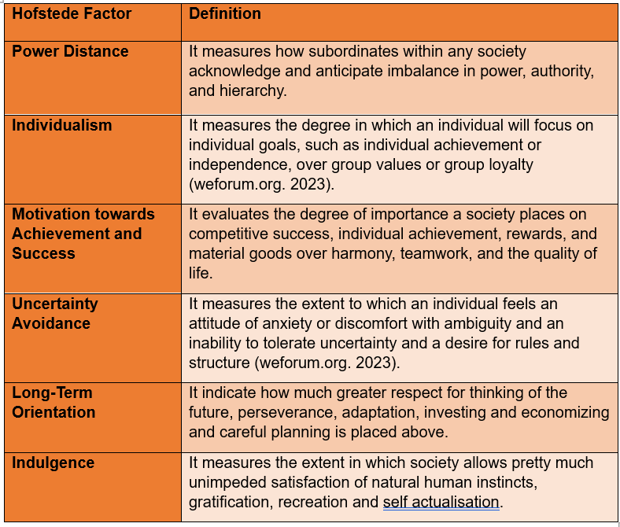
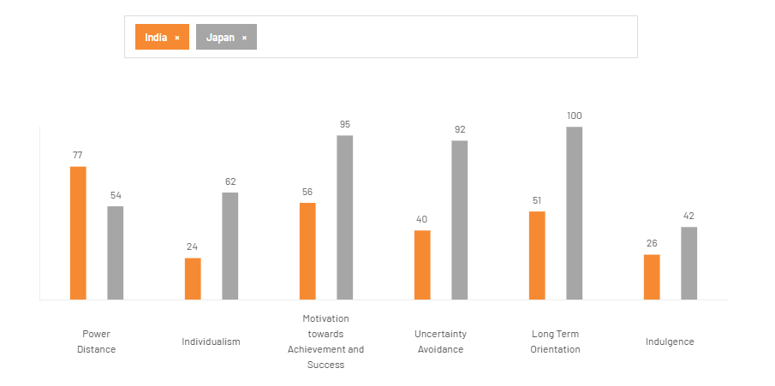
Figure 7: Hofstede Country comparison between India and Japan
(Source: weforum.org. 2023)
Power Distance (India: 77 | Japan: 54)
Indian society is more accepting of hierarchical arrangements and unequal power distribution (higher Power Distance score of 77 is considered as disadvantage than Japan 54 is considered as advantage) (theculturefactor.com. 2026). Consumers are more likely to put faith in familiar brands or company reputations, and Toyota's reputation is a large competitive advantage. The relatively consensual and collaborative organisational relationships, on the other hand, are more appreciated in Japan, as reflected in its lower score.
Individualism (India: 24 | Japan: 62)
This score is 24 indicating that the Indians are highly collectivistic and as such, family values and group decision making are an important part of their culture which also affects their purchasing behaviour which is an advantage (theculturefactor.com. 2026). Japan scores 62 in the individualism context which indicates low family values and high individual values which seems to be a moderate disadvantage.
Motivation towards Achievement and Success (India: 56 | Japan: 95)
Japan's score for Motivation towards success is 95, which acts as advantage and for India is 56, which acts as disadvantage (theculturefactor.com. 2026). This indicates that the Japanese society is much more focused on accomplishment, competition, technical skills, and performance. In this way, Toyota helps to promote high level engineering, innovation, and quality among the Japanese.
Uncertainty Avoidance (India: 40 | Japan: 92)
The Indian Uncertainty Avoidance score was medium (40) indicating that the consumers were not too disturbed by uncertainty and uncertainty in the market which is an advantage (theculturefactor.com. 2026). The extreme high end (92) implies that the Japanese are demanding a lot of stability, detailed planning, product reliability and risk reduction which is a disadvantage.
Long-Term Orientation (India: 51 | Japan: 100)
Both countries have exhibited LT orientation, but Japan's score is 100 (advantage) which is much higher than India's score of 51 (disadvantage) (theculturefactor.com. 2026).
Indulgence (India: 26 | Japan: 42)
In terms of culture, India (26) has a relatively low level of indulgence, and Japan is slightly more indulgent (42) (theculturefactor.com. 2026). Whereas in both countries consumers tend to think more about what they're getting out of their purchases than they are about going overboard. But Japanese consumers are slightly more advantageous as compared to India to pay for high tech and driving experience, whereas Indian consumers are slightly more price conscious and value driven.

1.4 A comparative analysis of STP and Marketing Mix

1.4.1 STP
STP is a set of customer-driven actions that may serve as foundation for marketing strategy aimed at finding target segments, targeting target customers in order to reach an adequate brand strategy (Ramachandran and Chandramohan, 2024).
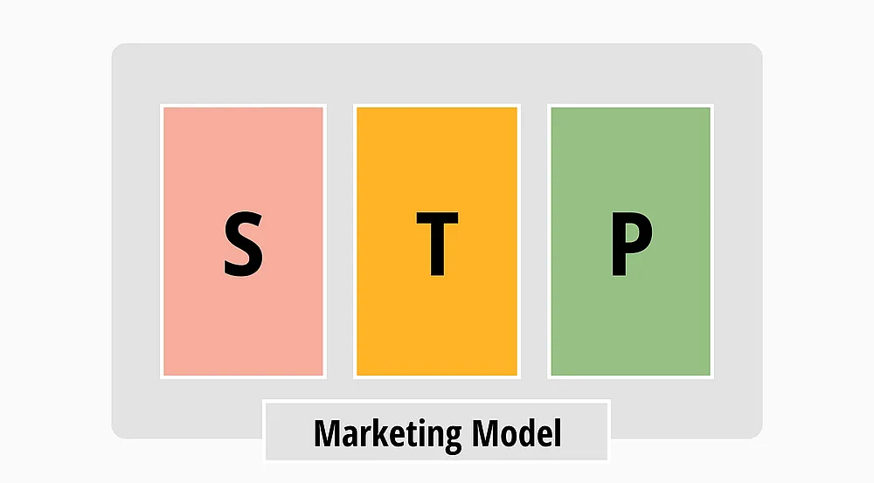
Figure 8: STP Model
(Source: Forms.app. 2024)
Segmentation
Segmentation refers to dividing customers into distinct groups based on demographics, geography, psychographics, and behaviour to identify valuable market opportunities.
India (Favourable)
Demographically, the company is focused on middle and upper middle-income consumers, families and business professionals who are looking for reliable vehicles. For example, Toyota considers metropolitan centres such as Delhi, Mumbai, Bengaluru, and Hyderabad to be relatively affluent and has its sights on them (Ramachandran and Chandramohan, 2024). The company, thus, serves the different customer groups in the mass premium segment like Glanza, Urban Cruiser Hyryder and Innova Hycross.
Japan (Favourable)
The advanced auto industry in Japan makes Toyota's market segmentations more advanced. According to lifestyle, technological preferences and eco-awareness, the customer segments are divided (Takeuchi, Ohmae and Ichijo, 2023). For example, there are several luxury models of the Lexus brand, a variety of hybrid and hydrogen powered Mirai models, in addition to the compact cars, which address the needs of city dwellers, older consumers, luxury car buyers and eco-conscious consumers. Innovation, safety, and product quality are more important than affordability when it comes to consumer demand.
Comparative Evaluation
In both countries Toyota has several segmentations variables and is highly focussed on other variables. In the Japanese market technology adoption and sustainability and lifestyle preferences are key factors, whereas in India income is one of the key factors. So, Japanese segmentation is more towards maturity and diversification in the market, whereas Indian segmentation is growth oriented.
Targeting
Targeting refers to selecting attractive customer segments to serve; Toyota can use differentiated or concentrated targeting according to market.
India (Favourable)
The selective targeting strategy is characteristic of Toyota, which targets middle income family members, fleet operators, urban professionals, and premium buyers of SUVs (Tinwala, Singh and Vidani, 2025). The company isn't operating on a low-cost competitive basis; instead, it's targeting customers who want high-quality vehicles that have acceptable fuel economy and price.
Japan (Favourable)
Toyota has a more comprehensive targeting approach that satisfies different customer segments at the same time in Japan. The ones that are young, urban, green consumers, Seniors, Commercial vehicle drivers and luxury car buyers. As the hybrid and hydrogen models are selling out quickly, Toyota can now focus on innovation and environmentally conscious consumers without compromising on quality (Takeuchi, Ohmae and Ichijo, 2023).
Comparative Evaluation
Toyota's target strategy is based on the differences in the maturity of markets. The company will be more inclined to pursue high value and high mix customers in India than in Japan where they will be more inclined to pursue customers on a different price spectrum.
Positioning
Positioning is the process of establishing a distinctive as well as desirable brand image in consumers' minds relative to competition.
India (Favourable)
Toyota is a brand that is considered to be a provider of high quality, reliable and fuel-efficient cars, proved to be good value for long-term use (Morgan and Liker, 2020). With fuel consumption becoming more significant and modern technology gaining in popularity, hybrid versions are starting to appear to meet the demand of an eco-friendly car and thus reinforcing Toyota's image as high quality and functional.
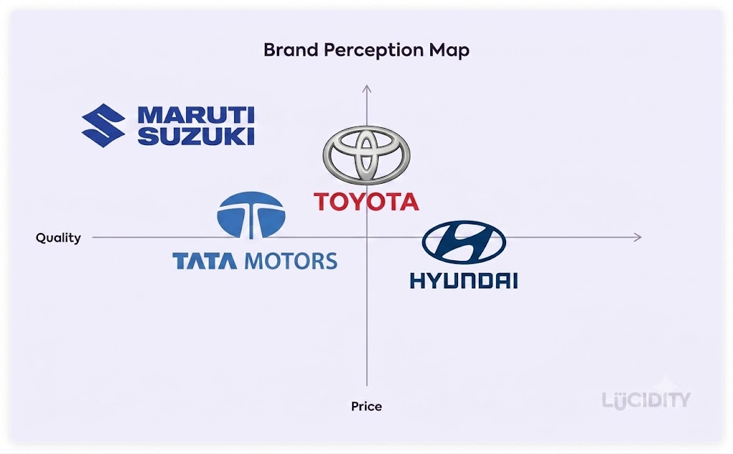
Figure 9: Positioning map of Toyota in India
(Source: self-developed)
Japan (Favourable)
Toyota has a reputation for automotive technology, innovation and sustainable transportation around the globe and the Toyota Motor Corp. is a leader in this field in Japan as well (Blahová et al., 2022).
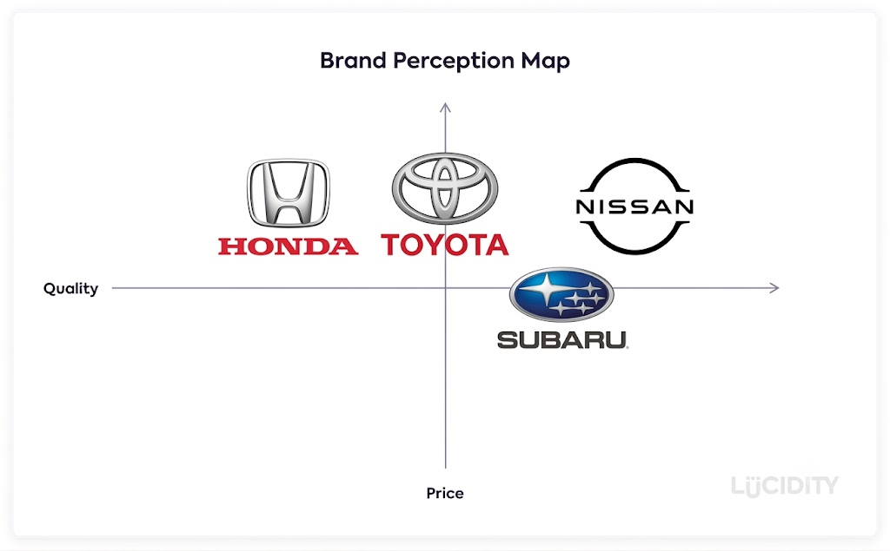
Figure 10: Positioning map of Toyota in Japan
(Source: self-developed)
Comparative Evaluation
The quality and reliability of Toyota's worldwide presence is uniform but meets expectations of local markets. While the Indian positioning is based on affordability, reliability and usefulness, the positioning in Japan is based on innovation, cutting edge technology and environmental stewardship.

1.4.2 Marketing Mix
The marketing mix is a strategic framework comprising 7Ps such as Product, Price, Place, Promotion, People, Process and Physical Evidence, these are used to develop effective customer-focused marketing strategies (Sathiyan et al., 2022).
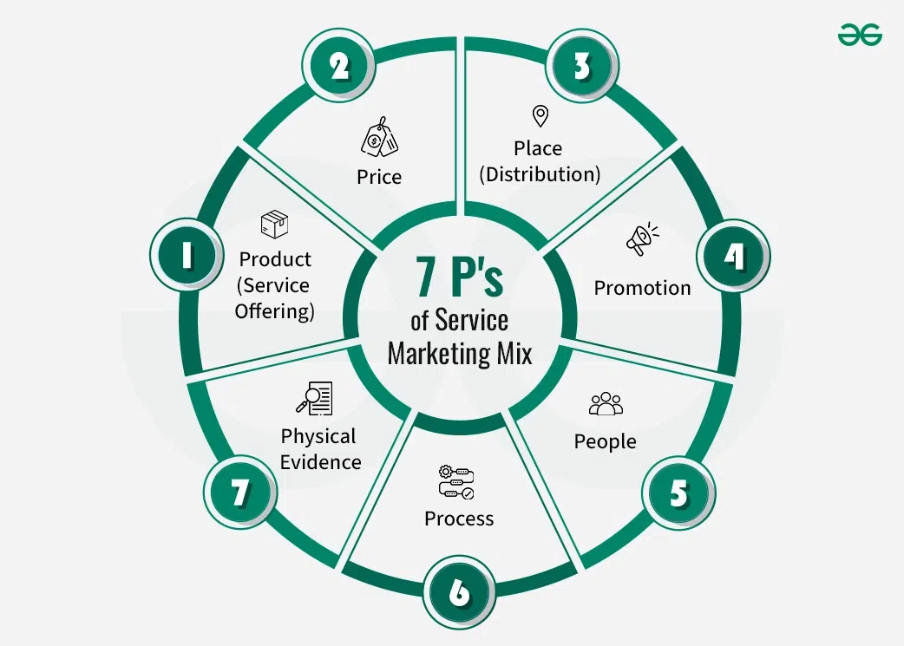
Figure 11: 7ps of Marketing Mix
(Source: GeeksforGeeks. 2024)

The table below covers the definition of 7ps-
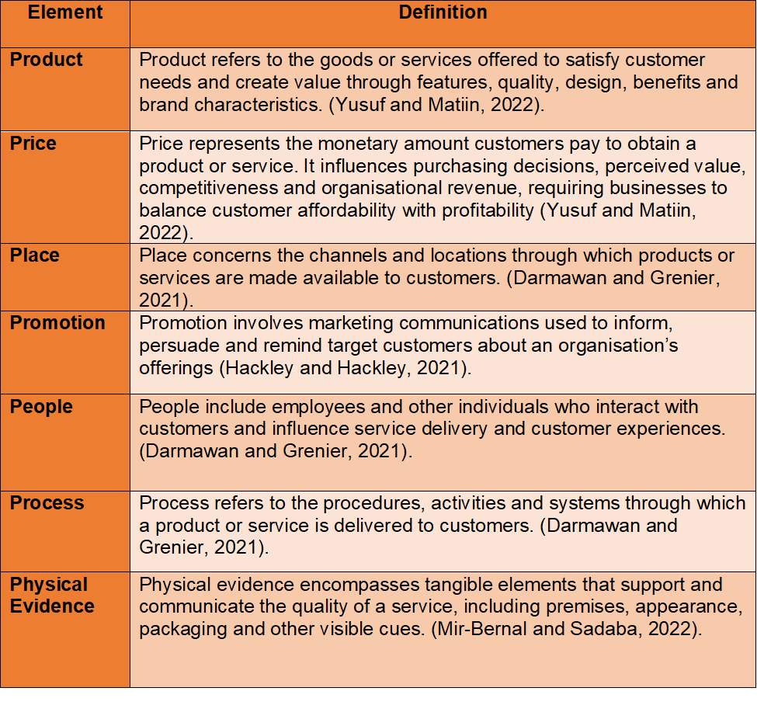
Product
India
Toyota's product strategy is focused on assuring safety, efficiency, and affordability of cars for budget-conscious consumers (Sathiyan et al., 2022). The company produces small hatchbacks, sport utility vehicles (SUVs) and multi-purpose vehicles (MPVs) as well as hybrid versions like the Glanza, Urban Cruiser Hyryder, Fortuner and Innova Hycross (toyotabharat.com. 2026).
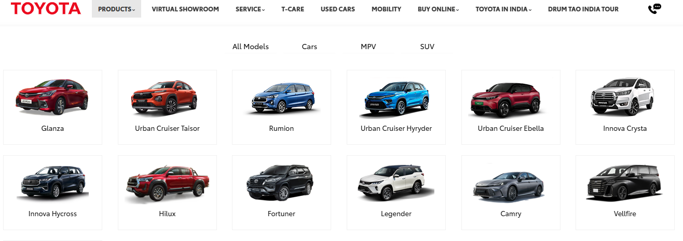
Figure 12: Toyota Products in India
(Source: toyotabharat.com. 2026)
Japan
The range of Toyota's vehicles in Japan includes small city cars, hybrid, plug-in hybrid, and hydrogen fuel-cell vehicles (like the Mirai) alongside luxury versions of the Lexus (Global.toyota. 2026). Technological innovations, safety systems, self-driving technologies and environment-friendly solutions are the features characterizing the product development.
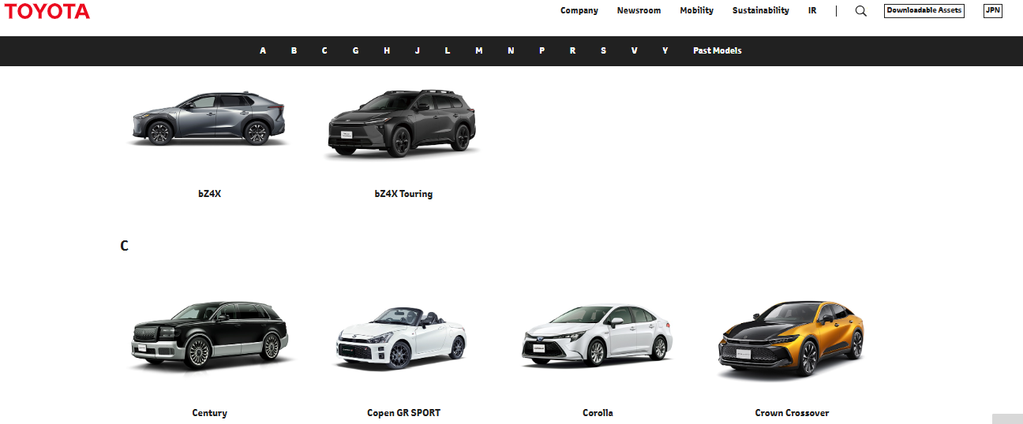
Figure 13: Toyota Products in Japan
(Source: Global.toyota. 2026)
Similarities and Difference
Toyota's product approach is on course to be very close to the market. India is looking for functional cars, affordable cars, and durable and fuel-efficient cars, while Japan is looking for technologically advanced and environment friendly cars (Sathiyan et al., 2022).
Price
India
Toyota has adopted the competition value-based pricing in India. Its vehicles are not as cost-efficient as local brands but as they are of good quality, reliable and require less maintenance, the customer feels that they are of high value.
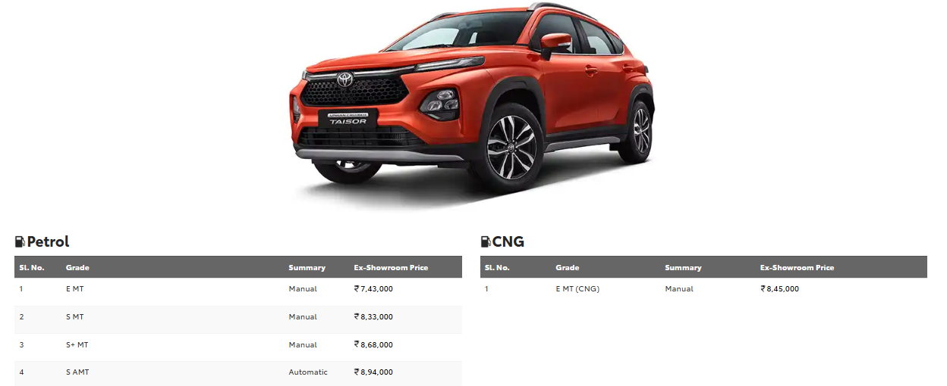
Figure 14: Urban Cruiser Taisor price in India
(Source: toyotabharat.com. 2026)
Japan
Differentiated pricing, for example at Toyota, is offered according to the amount of technology and quality of products (Takeuchi, Ohmae and Ichijo, 2023). Compacts are still competitively priced, and hybrid, premium and Lexus are premium-priced advanced features and innovation.
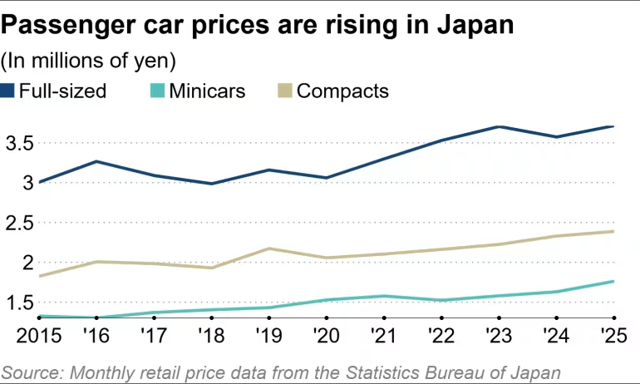
Figure 15: Car prices rise in Japan in 2025
(Source: nikkei.com, 2026)
Similarities and Difference
Consumers' buying habits are reflected in Toyota's pricing strategy. In India, competition is key as it is more sensitive to the market; in Japan, it's an opportunity for Toyota to command a premium on the basis of its technical innovation.
Place
India
Toyota offers its cars via a broad dealer network in both Tier-2 and Tier-3 markets, and the major metropolitan areas (Loponen, 2025). Toyota Kirloskar Motor not only does the dealership thing because it integrates both the dealership experience and digital marketing, but customers can also browse through the options, schedule test drives and even pursue financing online.
Japan
Toyota is one of the most advanced dealership and distribution networks in Japan. Customers have access to dedicated Toyota, Toyota Corolla and Lexus dealerships and have powerful digital platforms and built-in after-sales service (Loponen, 2025).
Similarities and Difference
It is distributed in both countries, Physical & Online. On the other hand, the Indian strategy will be to penetrate new markets, and Japanese will be on the service quality, operational efficiency, and customer experience in the existing distribution network.
Promotion
India
In the Integrated Marketing Communication (IMC) campaign media used by Toyota are as follows: TV Advertising, Digital Marketing, Social Media Marketing, Influencer Marketing and Sponsorship. Some of the promotional messages include fuel efficiency, reliability, safety, and family mobility. For example, dealer events, test-drive campaigns, festive offers, as well as customer referral programmes strengthen Toyota's promotional reach and engagement.
Japan
For Japan, the emphasis of promotion is on innovation, cutting edge technology, environment, and customer confidence (Ramachandran and Chandramohan, 2024). Toyota shines a light on the benefits of hybrid leadership, hydrogen technology and intelligent mobility solutions on TV, via digital media, corporate branding, and experiential marketing. For example, auto exhibitions, technology demonstrations, sustainability campaigns, as well as loyalty programmes reinforce Toyota's innovative and environmentally responsible brand image.
Similarities and Differences
The promotion by Toyota is an example of a good localisation strategy. India's growth is on affordable, practical, and family values, whereas Japan's growth is on innovation, sustainability, and technological leadership.
People
India
Toyota has a number of programmes in place to train employees, develop dealerships and the development of good customer management skills. Staff have knowledge about the product, funding and customer care which enables them to enhance the buying process (Ramachandran and Chandramohan, 2024).
Japan
The management of employees is in line with Toyota's long-term philosophy of management: Continuous improvement (Kaizen) and respect for people (Rode, Huang, and Schroeder, 2022). Technical and customer service training is provided for staff, and they are involved in ongoing quality improvement programs. The average number of union members of the company in Japan in 2024 has been observed to be 96.4.
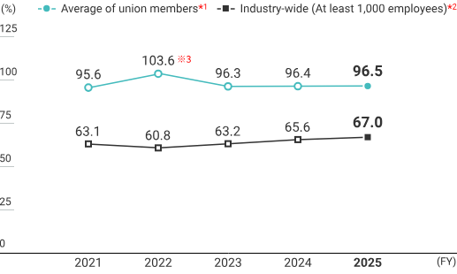
Figure 16: Employment details of Toyota
(Source: toyota-boshoku.com, 2025)
Similarities and Difference
Human resources in both countries are still a very strong competitive advantage. In India, they are interested in the continuous improvement, technical skills, organisational excellence while in Japan they are interested in improving the quality of services and developing the skills of the workforce to ensure business growth (Rode, Huang, and Schroeder, 2022).
Process
India
Toyota is constantly refining customer processes and leveraging digital to make improvements to the car buying and after sales processes (Helmold et al., 2022). Online shopping, financing/online scheduling, customer service/servicing appointments are some of the features available online for customers. Customers submit complaints through dealerships, Toyota support channels, service centres, as well as online platforms for resolution.
Japan
The Toyota Production System (TPS), which has been made well known, is a Japanese system following lean manufacturing, Just-in-Time (JIT) and continuous process improvement. Customers contact dealerships or Toyota support, followed by investigation, communication, and timely resolution. Manufacturing systems tend to be highly efficient, providing better-quality control, lower waste, and shorter innovation cycles. Toyota has gathered a revenue of 298.3 billion in 2024 (Figure 12).
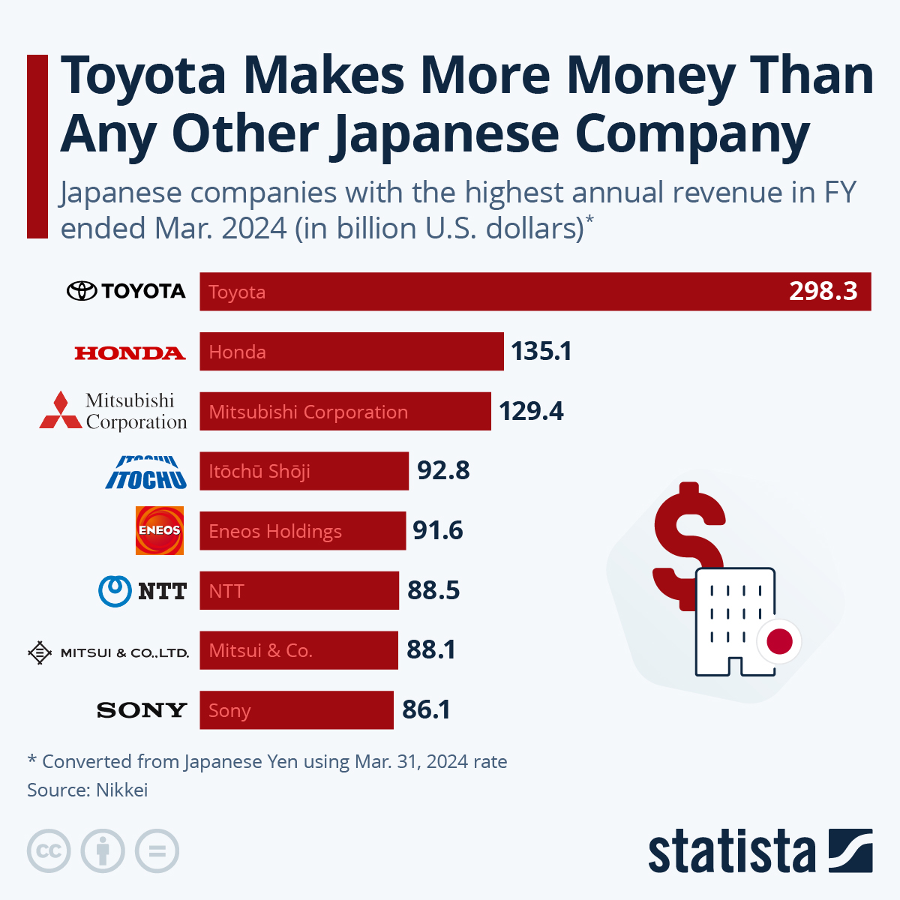
Figure 17: Toyota presence in Japan
(Source: Zandt, 2024)
Similarities and Difference
Processes in both countries are very effective. In India the focus is to expand the market, make the customer more convenient and make the manufacturing system more efficient, but in Japan, the advanced manufacturing system is perceived as good practice in the world (Helmold et al., 2022).
Physical Evidence
India
Modern dealerships, well serviced centres, professional layouts of showrooms and uniformity of corporate branding are what Toyota provides. Toyota offers physical proof in the form of up-to-the-minute dealerships, service centres with adequate equipment, showroom layouts that are professional, and uniform corporate branding.
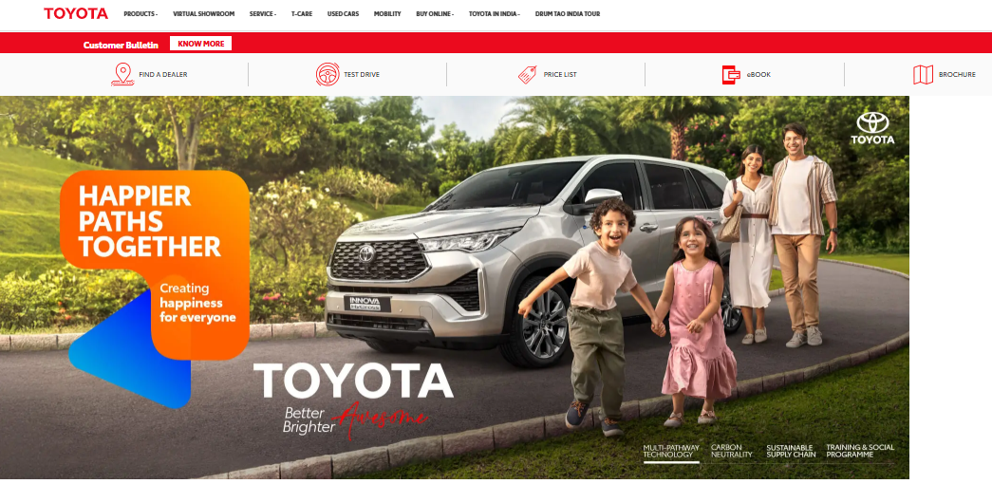
Figure 18: Toyota India Website
(Source: toyotabharat.com. 2026)
Japan
Toyota's showrooms are liberally outfitted with the latest technology, such as digital product presentations, interactive displays, and high-tech customer lounges, at its dealerships in Japan (DESIGN, 2024).
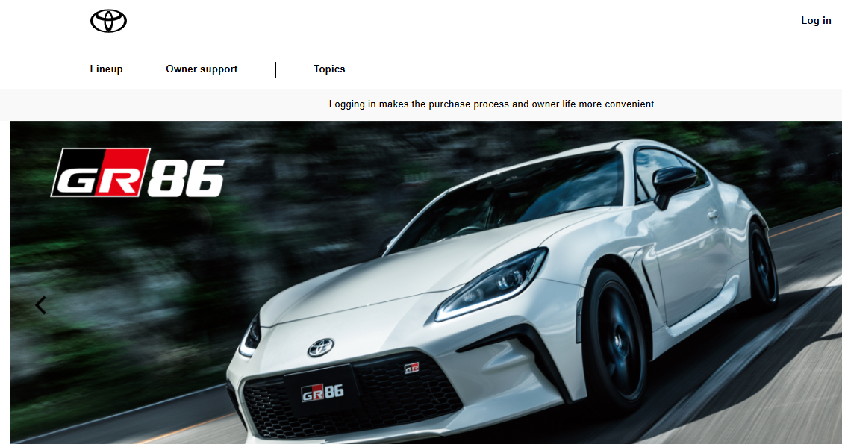
Figure 19: Toyota Japan Website
(Source: toyota.jp. 2026)
Similarities and Difference
The car's image is extremely significant in terms of the brand's reputation in both nations and a lot of this is owing to physical evidence. The Japanese dealerships are more focused on the technology and customer experience, whereas the Indian dealerships are more focused on convenience and the quality of service they can provide to attract new customers.

1.5 Analysis of Market Entry Strategy in India
Toyota came to India in 1997 by forming a joint venture with Kirloskar Group to form a company called Toyota Kirloskar Motor (TKM). This approach was useful for Toyota to lower the investment risk, as well as to gain an understanding of the local market, distribution system and also of regulation within India by Kirloskar (RRadhika and SuryaKar, 2023). The joint venture also facilitated the government policy of foreign investment, localisation, and home industries, which has been a major advantage. However, after some time, Toyota increased its production at Bidadi in Karnataka to enhance its procurement of raw materials from the local market and to improve the cost-effectiveness.
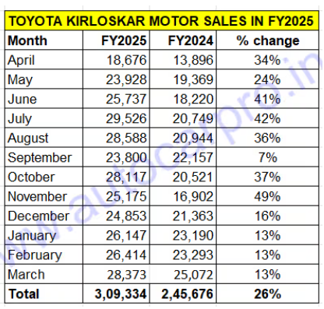
Figure 20: Toyota growth in India
(Source: autocarpro.in, 2025)
Figure 13 demonstrates the sales growth of around 34% in the year 2025 to that of 2024 in April. Moreover, with the localization of components this has reduced the manufacturing cost which has further helped in making the Indian market competitive (Mohapatra et al., 2026). Despite its benefits, the domestic carmakers like Maruti Suzuki, Tata Motors and Mahindra, which have significant market share and established dealer networks in the entry level are posing a threat to the market share of Toyota, this acted as a major disadvantage. Overall, the joint venture entry strategy has proved to be successful as the company has brought together the knowledge and expertise of both the local partner and that of Toyota and has been successful in gaining a long-term foothold in India and getting over the hurdle of an extremely rapidly growing automotive market.

1.6 Evaluation of ethical issues for marketing mix in Japan
Ethical Practices
Toyota has a good ethical standing in Japan, but some ethical issues with the quality of the product, and with the communication (promotions) and transparency of the company. For example, Toyota’s Japan Eco-Vehicle Tax Incentive communications clearly explain eligible models and environmental benefits, supporting transparent and responsible customer information. Furthermore, Toyota’s KINTO subscription service provides transparent pricing and contract information, helping Japanese customers understand costs before purchasing (Waseem et al., 2024). The incident did not immediately impact consumers but had instead brought to light consumer trust and transparency and accountability issues that the company is worried about.
Unethical Practices
Toyota's marketing always has been about quality, safety, and reliability; it appears that they have surpassed the mark (Haris, 2022). For example, Toyota ensures truthful advertising, transparent pricing, and culturally respectful marketing practices when promoting vehicles in Japan. In addition, Japanese culture is extremely conservative, and ethical and legal standards and quality control are of paramount importance (Rayhan, 2023). On a price/customer basis, responsible business practices are implemented with warranty, recall and after-sales service to reduce the impact on the customer, etc. One of the biggest issues was the certification and inconsistencies in testing undertaken in 2024, which were uncovered, whereby some Toyota vehicles had been tested using substandard testing methods during the testing process (Waseem et al., 2024).

1.7 Recommendations
Accelerate Sustainable Mobility
India
Global sustainable mobility leadership should continue to be enhanced through further investments in hybrid, battery electric and hydrogen fuel-cell vehicles by Toyota. The company should be expediting the launch of the fully electric vehicle, the markets in India where the provision of charging stations is not as advanced.
Japan
For Japan, hybrid technology will still be relevant. Increased collaboration with the government and energy provider to increase the number of charging network partnership projects will contribute to further market acceptance and Toyota's sustainability commitments.
Strengthening Localised Marketing Strategies
India
Toyota must adapt its marketing strategy to meet the tastes and preferences of the country and not go with a ‘one size fits all' philosophy. Pricing, range, product safety, long product value and awareness of the product in Tier-2 and Tier-3 cities should be the focus of marketing communication, and in India, digital marketing and retail outlet presence in Tier-2 and Tier-3 cities (Duarte and Vardasca, 2023).
Japan
The promotion should also be continued, with emphasis on technological innovation and autonomous mobility, and the environment to please highly sophisticated consumers in Japan, who are heavily concerned with environmental issues.
Enhance Ethical Governance and Brand Transparency
India
For Toyota to attract new customers and retain their loyal, use of ethical marketing in the product lifecycle will enhance the brand and image of the company as reliable and responsible.
Japan
Toyota have to get their quality control systems sorted and give greater visibility to their processes across the globe, as a number of problems were discovered in Japan after certification (Duarte and Vardasca, 2023). An improvement of the internal control system, public communications about Product safety and compliance audit by third parties every 3 years would improve the consumer's confidence on the product.
Expand Strategic Partnerships and Digital Innovation
India
At the same time, digital sales channels will be the ones to dominate, virtual showrooms will be offered, artificial intelligence will make customer service even more efficient and omnichannel retail will improve both customer experience as well as the competition in the existing and new international markets.
Japan
Toyota still needs to be creative and continues to diversify its growth prospects in electric vehicles, connectivity, and autonomous vehicles, and looking for strategic partnerships with tech vendors and carmakers (Pérez-Moure et al., 2023).

1.8 Conclusion
The comparative analysis shows that both the companies have been successful in certain measure as they were able to tailor their international marketing strategies according to the contrasting attributes of India and Japan. India has great growth potential because of the positive demographic, there are many cars, Government support, but on the other hand, there is innovative leadership, absence of cost fluctuations and technological leadership in Japan.

Section 2: Reflective Account
A reflective account critically examines personal experiences, learning, decisions as well as outcomes, identifying strengths, challenges, and improvements for the enhancement of future academic and professional practice (Rajagopal and Zlatev, 2025).

2.1 Description
In the course of this report, I have applied systematic and structured approach which consist of research and analysis of international marketing strategy of Toyota in India and Japan. Firstly, the assessment requirements were reviewed to understand the desired outcome of the assessment and the key analytical frameworks used; PESTLE, Hofstede's Cultural Dimensions, STP, the 7Ps Marketing Mix, market entry strategy and ethical issues. Once that, I conducted detailed research from many academically published journals, books, industry reports and other credible sources like Toyota, Statista, JETRO, Invest India, Government published and other sources to get accurate and up-to-date information. In the research process I ensured that I didn't describe each market, instead I took into account the difference in macro-environmental, cultural, and marketing level between the two countries (Rajagopal and Zlatev, 2025). The collected information was divided into logical themes, which allowed to consider Toyota's international marketing strategies in a critical way both theoretically and practically. Also, I ensured that there are sufficient number of references to support arguments and that there is market current data so that the report is more academic. I used an academic style during all stages of the writing process, had a logical structure, and ensured that each paragraph was linked to the assessment tasks. Finally, I read through the report several times to improve the clarity, logic, and consistency in the report (properly referenced and following academic integrity guidelines.

2.2 Feelings
For this assignment I had no difficulty in analysing international marketing as I had some idea about what to do as I have studied some concepts of marketing in my other assignments. But I did have some doubt about balancing two countries, giving a variety of analytical frameworks, and maintaining a balanced discussion and some uncertainty about that. Due to my research work, my confidence gradually increasing as I gained knowledge about various factors having influence on international business decisions like macro-environmental, cultural, and marketing factors (Gini and Agala, 2023). The concept of executing campaigns in a similar fashion with an equal brand name but different markets was what caught my eye in particular, in Toyota's case, India versus Japan. Identifying the best information, which was often very out-of-date and came from a variety of academic and industry sources and assessing evidence could sometimes be challenging. But, after completing each portion of the work, I was feeling good and confident in analysing and comparing the concepts. Overall, it was a great inspiration to develop my research, analytic and academic writing skills in the future assignments.

2.3 Evaluation
I believe the research and preparation of the report was successful as it enabled me to broaden my knowledge of the two markets that I decided to market in internationally and the strategies Toyota uses to do so. The positive one was there where I'm able to apply a number of business theories to real world business scenarios like PESTLE, Hofstede's cultural dimensions, STP and the 7Ps marketing mix. These frameworks have aided me in the logical planning of my analysis and making a critical comparison between opportunities and challenges of Toyota in India and Japan (Hyland, 2023). I was also able to find and access academic journal articles, government reports, industry reports and my arguments were now credible. But I had some problems in the research process. There was lots of data from various sources, but it was hard to find the most pertinent and reputable evidence. Also, there had to be planning and organizing comparisons between two countries which were not repeated.

2.4 Analysis
It gave me the opportunity to explore the application of theory in analysing the international marketing practices. For example, I knew that international marketing entails adapting marketing strategies to the political, economic, cultural and consumer environment, and using the PESTLE and Hofstede's Cultural Dimensions, STP and 7Ps Marketing Mix. The comparisons with India and Japan also revealed that it is impossible to have a ‘one size fits all' solution for companies in the global markets (Dagsberg and Persson, 2025). I found critical analysis to be a process of realization of the evidence, to compare various points of view and to link theory and business practice. Additionally, throughout the research process I learned about the reliability of different research sources from academic and business, and I was able to use that knowledge in my discussion (Passarelli and Kolb, 2023). Besides, I knew about the value of ethics, transparency, and corporate responsibility issues to maintain a good name around the world.

2.5 Conclusion
This reflection on this assignment has been useful for me to identify the skills that I have developed in preparing the research, analytical and academic writing skills. I have enthusiastically used Gibbs' Reflective Cycle to see how it is applied to my learning journey and been encouraged to reflect on the learning process, and I consider my learning and learning product (Passarelli and Kolb, 2023). I have gained knowledge and understanding of the application of theory in international marketing in the real business world and the importance of evidence that is credible when analysing.

2.6 Action Plan
Area for Development | Action to be Taken | Expected Outcome | Timeline
Improve research skills | Read more peer-reviewed journal articles and industry reports for future assignments. | Stronger evidence base and improved academic credibility. | Next 1 month
Enhance critical analysis | Practise evaluating and comparing theories instead of relying on descriptive discussion (Fife and Gossner, 2024). | More critical and analytical academic writing. | Throughout the next semester
Develop time management | Prepare a study schedule with milestones for research, drafting and proofreading. | Better organisation, reduced stress, and timely submission of assignments. | Before each assignment
Strengthen referencing and proofreading | Allocate dedicated time to review grammar, formatting and Harvard referencing before submission. | Higher academic quality, fewer errors, and improved presentation. | Final 2–3 days before submission

Reference List
Akman, M.K., (2020). Defence management and PESTLE analysis. Ante Portas-Security Studies, 1(14), pp.93-102.http://anteportas.pl/wp-content/uploads/2020/10/AP.XIV_.pdf#page=93
autocarpro.in (2025). Autocar Professional. Available at: https://www.autocarpro.in/analysis-sales/toyota-india-sales-hit-record-levels-in-fy2025-309000-units-125680 (Accessed: 27 July 2026).
Bathla, D., Awasthi, S. and Ahuja, R., (2022). PESTEL Analysis of the Automotive Industry. In Applying Metalytics to Measure Customer Experience in the Metaverse (pp. 143-160). IGI Global Scientific Publishing. https://www.researchgate.net/profile/Rohit-Markan/publication/362591143_Factors_Influencing_Imbursements_Study_on_Payment_Preference_Among_Cash_MW_and_NFC/links/668777372aa57f3b826edc56/Factors-Influencing-Imbursements-Study-on-Payment-Preference-Among-Cash-MW-and-NFC.pdf#page=164
Blahová, M., Haghirian, P., Pálka, P. and Urbánek, T., (2022). Global performance strategies in leading Japanese automotive organisations. Journal of International Studies, 15(4). https://www.jois.eu/files/6_1298_Blahova%20et%20al.pdf
Borkhade, R., Bhat K, S. and Mahesha, G.T., (2022). Implementation of sustainable reforms in the Indian automotive industry: from vehicle emissions perspective. Cogent Engineering, 9(1), p.2014024.https://www.tandfonline.com/doi/pdf/10.1080/23311916.2021.2014024
Dagsberg, M. and Persson, F., (2025). One Size Fits All? A review of how multinational companies adapt their business model to enter emerging markets in Asia successfully. https://lup.lub.lu.se/luur/download?func=downloadFile&recordOId=9207684&fileOId=9207685
Dalirazar, S. and Sabzi, Z., (2023). Strategic analysis of barriers and solutions to development of sustainable buildings using PESTLE technique. International Journal of Construction Management, 23(1), pp.167-181. https://www.academia.edu/download/102976620/15623599.2020.185493120230603-1-cqyvib.pdf
Darmawan, D. and Grenier, E., (2021). Competitive advantage and service marketing mix. Journal of Social Science Studies, 1(2), pp.75-80.https://jos3journals.id/index.php/jos3/article/download/14/14
DESIGN, S.P., (2024). Towards More Meaningful And Superior Digital Experiences in Luxury Automotive. https://repository.tudelft.nl/file/File_5f264232-0e8b-4e65-8a99-2cae5dd65d80
Duarte, N. and Vardasca, R., (2023). Literature review of accreditation systems in higher education. Education Sciences, 13(6), p.582. https://www.mdpi.com/2227-7102/13/6/582
Eierle, B., Hartlieb, S., Hay, D.C., Niemi, L. and Ojala, H., (2022). External factors and the pricing of audit services: A systematic review of the archival literature using a PESTLE analysis. Auditing: A Journal of Practice & Theory, 41(3), pp.95-119. https://papers.ssrn.com/sol3/Delivery.cfm?abstractid=3816385
Fife, S.T. and Gossner, J.D., (2024). Deductive qualitative analysis: Evaluating, expanding, and refining theory. International Journal of Qualitative Methods, 23, p.16094069241244856. https://journals.sagepub.com/doi/pdf/10.1177/16094069241244856
Forms.app. (2024). A comprehensive guide to the STP marketing model. forms.app. Available at: https://forms.app/en/blog/stp-marketing-model (Accessed: 12 August 2026).
GeeksforGeeks. (2024). 7 P’s of Service Marketing Mix. In GeeksforGeeks. https://www.geeksforgeeks.org/marketing/7-ps-of-service-marketing-mix/ (Accessed: 12 August 2026).
Gini, K.B. and Agala, H.O., (2023). The Impact of Macro-Environmental Factors on Business Performance. International Journal of Research and Innovation in Social Science, 7(11), pp.1837-1843. https://www.researchgate.net/profile/Kiyentei-Gini/publication/376792903_The_Impact_of_Macro-Environmental_Factors_on_Business_Performance/links/6588b2f30bb2c7472b09d265/The-Impact-of-Macro-Environmental-Factors-on-Business-Performance.pdf
Global.toyota. (2026). Vehicle Gallery: Toyota Brand: Mobility, Toyota Motor Corporation Official Global Website. Available at: https://global.toyota/en/mobility/toyota-brand/gallery/ (Accessed: 27 July 2026)
Hackley, C. and Hackley, R.A., (2021). Advertising and promotion. SAGE Publications Ltd.https://www.academia.edu/download/55416095/88231_Chapter_3___Hackley__Brands_and_Promotion_Communication.pdf
Haris, A., (2022). Marketing Strategy on Purchase Decisions for Toyota All New Veloz Cars. Jurnal Economic Resource, 5(2), pp.377-388. https://jurnal.feb-umi.id/index.php/JER/article/download/550/387
Helmold, M., Küçük Yılmaz, A., Flouris, T., Winner, T., Cvetkoska, V. and Dathe, T., (2022). Lean management in the automotive industry. In Lean Management, Kaizen, Kata and Keiretsu: Best-Practice Examples and Industry Insights from Japanese Concepts (pp. 183-195). Cham: Springer International Publishing. https://link.springer.com/chapter/10.1007/978-3-031-10104-5_13
Hyland, K., (2023). Academic publishing and the attention economy. Journal of English for Academic Purposes, 64, p.101253. https://www.sciencedirect.com/science/article/pii/S1475158523000395
IMF. (2026). [online] IMF. Available at: https://www.imf.org/en/Countries/IND? [Accessed 12 Aug. 2026].
Kumar, R., Jha, A., Damodaran, A., Bangwal, D. and Dwivedi, A., (2020). Addressing the challenges to electric vehicle adoption via sharing economy: an Indian perspective. Management of Environmental Quality: An International Journal, 32(1), pp.82-99.https://www.researchgate.net/profile/Deepak-Bangwal/publication/343497798_Addressing_the_challenges_to_electric_vehicle_adoption_via_sharing_economy_an_Indian_perspective/links/5f36a55e458515b7291f3d54/Addressing-the-challenges-to-electric-vehicle-adoption-via-sharing-economy-an-Indian-perspective.pdf
Loponen, L.N., (2025). Key Sales and Persuasion Methods for Car Dealership Success. https://www.theseus.fi/bitstream/handle/10024/890685/THESIS%20%28Correct%20version%29.pdf?sequence=2
Mir-Bernal, P. and Sadaba, T., (2022). The ultimate theory of the marketing mix: A proposal for marketers and managers. International Journal of Entrepreneurship, 26(1), pp.1-22.https://www.academia.edu/download/82018688/the_ultimate_theory_of_the_marketing_mix_a_proposal_for_marketers_and_managers.pdf
Mohapatra, J.K., Guttena, R.K. and Jonnalagadda, K.C., (2026). Maruti Suzuki’s strategic foray into the Indian light commercial vehicle market. The CASE Journal, 22(1), pp.180-188. https://www.emerald.com/tcj/article/doi/10.1108/TCJ-07-2024-0198/1264786
Morgan, J. and Liker, J.K., (2020). The Toyota product development system: integrating people, process, and technology. Productivity press.https://www.academia.edu/download/44446924/06-22-4-BR_Toyota_Prod_Dev_Sys.pdf
nikkei.com (2026) Japan car prices keep climbing, with Toyota Corolla up 60% over 10 years, Nikkei Asia. Nikkei Asia. Available at: https://asia.nikkei.com/business/automobiles/japan-car-prices-keep-climbing-with-toyota-corolla-up-60-over-10-years (Accessed: 12 August 2026).
Nottage, L. and Teramura, N., (2024). Foreign Investment, Treaties, Arbitration and Corruption: Comparing Japan. In Corruption and Illegality in Asian Investment Arbitration (pp. 285-310). Singapore: Springer Nature Singapore.https://link.springer.com/content/pdf/10.1007/978-981-99-9303-1_11.pdf
Passarelli, A.M. and Kolb, D.A., (2023). Using experiential learning theory to promote student learning and development in programs of education abroad. In Student learning abroad (pp. 137-161). Routledge. https://learningfromexperience.com/downloads/research-library/using-experiential-learning-theory-to-promote-student-learning-and-development-in-programs-of-education-abroad.pdf
Pérez-Moure, H., Lampón, J.F., Velando-Rodriguez, M.E. and Rodríguez-Comesaña, L., (2023). Revolutionizing the road: How sustainable, autonomous, and connected vehicles are changing digital mobility business models. European Research on Management and Business Economics, 29(3), p.100230. https://www.sciencedirect.com/science/article/pii/S2444883423000177
pib.gov.in. (2026). Available at: https://www.pib.gov.in/PressNoteDetails.aspx?NoteId=153454&ModuleId=3&reg=48&lang=2 (Accessed: 27 July 2026).
professionalacademy.com. (2026). Marketing Theories – PESTEL Analysis Terms and Conditions. Available at: https://www.professionalacademy.com/blogs/marketing-theories-pestel-analysis/ (Accessed: 12 August 2026).
Rajagopal and Zlatev, V., (2025). Economic and Cultural Factors. In Decisions in International Trade and Logistics: Corporate Diplomacy, Strategies, and Operations (pp. 67-95). Cham: Springer Nature Switzerland. https://link.springer.com/chapter/10.1007/978-3-031-83375-5_3
Ramachandran, S. and Chandramohan, B.P., (2024). Oligopoly in the Passenger Vehicle Segment of The Indian Automobile Sector–A Meta-Analysis. European Economic Letters, 14(4), pp.2160-2173. https://www.academia.edu/download/124192715/Oligopoly_in_the_Passenger_Vehicle_Segment_of_The_Indian_Automobile_Sector_A_Meta_Analysis.pdf
Rayhan, A., (2023). Living with honor: Exploring the ethical values of Japanese society and education. Research Gate. https://www.researchgate.net/profile/Abu-Rayhan-11/publication/373328817_LIVING_WITH_HONOR_EXPLORING_THE_ETHICAL_VALUES_OF_JAPANESE_SOCIETY_AND_EDUCATION/links/64e6188940289f7a0faeee7b/LIVING-WITH-HONOR-EXPLORING-THE-ETHICAL-VALUES-OF-JAPANESE-SOCIETY-AND-EDUCATION.pdf
Rode, J.C., Huang, X. and Schroeder, R.G., (2022). Human resources practices and continuous improvement and learning across cultures. Journal of International Management, 28(4), p.100972. https://www.sciencedirect.com/science/article/pii/S1075425322000473
RRadhika, K. and SuryaKar, P., (2023). Toyota Kirloskar Motors: Labor Unrest and Crisis Management. SAGE Publications: SAGE Business Cases Originals. https://sk.sagepub.com/cases/toyota-kirloskar-motors-labor-unrest-crisis-management
Sasu, D. D. (2025) India: volume of passenger car production 2025, Statista. Available at: https://www.statista.com/statistics/606519/passenger-car-production-volume-india/?srsltid=AfmBOopGackA-pduPCqAI1Xb43eerdV3uZE_oN5NOqXVatjV0bC4sINK (Accessed: 27 July 2026).
Sasu, D. D. (2026) Passenger car production volume Japan 2025, Statista. Available at: https://www.statista.com/statistics/348344/passenger-vehicle-production-in-japan/?srsltid=AfmBOoo2BiNaeO5nM9Lgw95yXoF-ZS-h8H3GaJoE4zTGPBCtk8k8BY9m (Accessed: 27 July 2026).
Sathiyan, S.P., Pratap, C.B., Stonier, A.A., Peter, G., Sherine, A., Praghash, K. and Ganji, V., (2022). Comprehensive assessment of electric vehicle development, deployment, and policy initiatives to reduce GHG emissions: opportunities and challenges. IEEE Access, 10, pp.53614-53639.https://ieeexplore.ieee.org/iel7/6287639/6514899/09775727.pdf
Takeuchi, I.Y., Ohmae, H.T. and Ichijo, K.K., (2023). Navigating Competition through Alliances: An Analysis of Toyota's Strategy in the Japanese Auto Industry. Journal of Strategic Management, 7(6), pp.1-12.https://stratfordjournalpublishers.org/journals/index.php/journal-of-strategic-management/article/download/1733/2251
theculturefactor.com. (2026). Country comparison tool. Available at: https://www.theculturefactor.com/country-comparison-tool?countries=india%2Cjapan (Accessed: 27 July 2026).
Tilt, D., (2022). Intellectual property and commercialising university research in Japan: Comparative perspectives from the US. Austl. J. Asian L., 23, p.93.https://papers.ssrn.com/sol3/Delivery.cfm?abstractid=4263185
Tinwala, M., Singh, V. and Vidani, J., (2025). A Comparative Study on Urban Cruiser of Toyota V/S Harrier of Tata Engine, Mileage and Safety Among Consumers in Ahmedabad City.https://www.academia.edu/download/122959698/283.pdf
toyota.jp. (2026). トヨタ自動車WEBサイト. Available at: https://toyota.jp/index.html (Accessed: 12 August 2026).
toyotabharat.com. (2026). PRICE LIST. Toyota India | Price List. Available at: https://www.toyotabharat.com/pricelist/ (Accessed: 12 August 2026).
toyotabharat.com. (2026). Toyota India: Official Website. Toyotabharat. Available at: https://www.toyotabharat.com/?gad_source=1&gad_campaignid=24057945507&gbraid=0AAAAACR3f3xkl0_hyYYRnrLGvXCYkjVe9&gclid=Cj0KCQjwg5zTBhCLARIsAP2AFU5_Hp1W6EJ3jGNlEGxO77-9EyvSQyVrIsm9V0FqHikvLscyNWDPIjkaAvkoEALw_wcB (Accessed: 27 July 2026).
toyota-boshoku.com. (2025) Home, Job Satisfaction and Employment｜Social｜Sustainability｜Toyota Boshoku Corporation. Available at: https://www.toyota-boshoku.com/global/sustainability/social/employees/ (Accessed: 27 July 2026).
voronoiapp.com. (2025). Aging of the Population Accelerates in India, Voronoi. Available at: https://www.voronoiapp.com/demographics/Aging-of-the-Population-Accelerates-in-India-5411 (Accessed: 27 July 2026).
Waseem, D., Chen, S., Xia, Z., Rana, N.P., Potdar, B. and Tran, K.T., (2024). Consumer vulnerability: understanding transparency and control in the online environment. Internet Research, 34(6), pp.1992-2030. https://kar.kent.ac.uk/105076/1/Internet%20Research_Accepted%20Version.pdf
Washizu, A., Akao, K.I. and Liu, Y., (2025). Transition to a Carbon-Neutral and Sustainable Society. In Climate Change Issues and Social Sciences: Towards a Carbon Neutral Society (pp. 205-211). Singapore: Springer Nature Singapore. https://link.springer.com/content/pdf/10.1007/978-981-96-8951-4_15.pdf
weforum.org. (2023). More than 1 in 10 people in #Japan are aged 80 or over. Here’s how its ageing population is reshaping the country World Economic Forum. Available at: https://www.weforum.org/stories/2023/09/elderly-oldest-population-world-japan/ (Accessed: 27 July 2026).
Yun, J.J., Zhao, X., Koo, I., Sadoi, Y. and Pyka, A., (2025). Open innovation and digital transformation in the automotive industry: a comparative analysis of South Korea, Japan and Germany. European Journal of Innovation Management, 28(9), pp.4284-4304.https://www.openinnovationtmc.org/storage/upfs/board/2025/10/20251023015429193148.PDF
Yusuf, M. and Matiin, N., (2022). Analysis of the effect of the marketing mix on purchasing decisions. International Journal of Economics and Management Research, 1(3), pp.177-182. https://pdfs.semanticscholar.org/6861/d9fae39d1470ec6f0ce28f6b43db503127fe.pdf
Zandt, F. (2024). Toyota Makes More Money Than Any Other Japanese Company. [online] Statista Daily Data. Available at: https://www.statista.com/chart/33445/japanese-companies-with-the-highest-annual-revenue-per-fiscal-year/?srsltid=afmbooo9zz9aygawo8pejnowpajdfvxnynz6cxhmjnzwkg4sprpcn8a8 [Accessed 27 July 2026].

