
Assessment 1
Supporting Paper
Student Name: Oluwaseun Akran
Student ID: 1908389
Lecturer Name: Bianca Sanfilipo
Module Name: Mental Disorders and Psychopathology
Module Code: BMHP 6006
Date: 14/04/2022

Contents……………………………………………………………………………………….Page
Introduction…………………………………………………………………………………….2
Brief Overview of the history of mental health and general treatment…………………..3
Discussion and Analysis……………………………………………………………………...4
Depression……………………………………………………………………………………..5
Types and causes of depression…………………………………………………………….5
Symptoms of depression……………………………………………………………………..6
Diagnosis………………………………………………………………………………………10
Historical and Contemporary treatment of Depression…………………………………..11
Practical support of depression………………………………………………………….....14
Issues of professional support for depression treatment…………………………………14
Conclusion…………………………………………………………………………………….15
References…………………………………………………………………………………….15-16
Appendix: Power point presentation debate……………………………………………….17-25

Introduction
Mental Health is the same as physical health because it is part of every person health. Several organisations, including the Pan American Health Organization, the European Union Council of Ministers, the World Federation of Mental Health as well as Royal college of Psychiatrists have publicly endorsed this (Turner et al., 2017).
Mental health disorder affects a person way of thinking, feeling or behavior which reflects a problem in mental functions; (Turner et al., 2017). For example, in 2005, report of WHO revealed that a sizeable proportion of people (31.7%) lived with neuropsychiatric illnesses such as unipolar depression (11.8%), alcohol use disorder (3.3%), schizophrenia (2.8%), bipolar depression (2.4%), and dementia (2.4%). (1.6 percent).
This supporting paper view depression as a class classification of ICD-10 as against those who oppose it.
Brief Overview of the history of mental health and general treatment
Mental health illness is not new because abnormal behavior has been part of human existence. Conflicting ideas about demonic possession, divine punishment for a bad act, and the recurrence of brain disorders extend back to ancient times (Turner et al., 2017). In the ancient times, there have been attempt by ancient people to treat people with mental disorders by making hole in the person skull to drive away demons even before doctors had full knowledge of mental disorders. In the religious believe the method of treating a person with mental disorder is by exorcism. (Turner et al., 2017)
Undoubtedly, ancient culture and religion play a role in mental health and early therapies focused on brain surgery by using trephining in putting hole into the skull of the mental ill person to drive away the evil spirit. Baker (2021) indicates that trephining was used to treat epilepsy, infantile, convulsions as well as headache. This method was not totally treating the disease but provided a relief to the disorder.
In the United Kingdom (UK), history of mental health treatment remained unchanged and people having mental health issues were tagged with stigma. In the early times, mental health people were treated inside austere Victoria asylum far away from their communities. In 1959, the UK Parliament passed the Mental Health Act where patients with mental health issues are admitted in hospitals based on mental health and in 1983, the Mental Health Act was revised where the consent of the patients is allowed for treatment, but on cases where the patient is at risk of themselves or to others, they can be detained under the Mental Health Act.
Discussion and Analysis
Mental health disorder is a person way of thinking, feeling or behavior which reflects a problem in mental functions; There are different types e.g., depression and anxiety, panic disorder, phobias, as well as obsessive compulsory disorder. Baker (2021) contends that one in six people of 16 years and over in the UK has symptoms of common mental health disorder. See chart for age and gender breakdown for common mental health disorder.
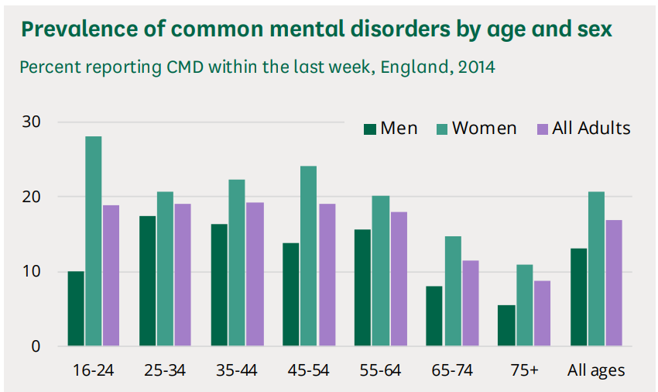

Source: Baker (2021) adapted by Student (2022)
The chart shows that women are more affected with common mental health disorder than men and it is more common among 16 and 24 age bracket.
However in 2014, anxiety disorder is rated the most common mental disorder followed by depressive episodes phobias, obsessive compulsive disorder, panic disorder and others. See chart for the prevalence of common mental health disorder.
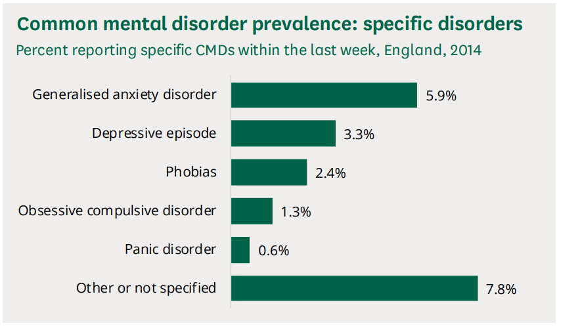
Source: Baker (2021) Adapted by Student (2022)
Given this interest, this supportive paper selects depression as a mental disorder from the ICD-10 manual chapter v classification.
Depression (Mental Health Disorder)
Depression as broader mental health problems with loss of interest and enjoyment in ordinary things and experience, low mood, and a range of related emotional, cognitive, physical as well as behavioral symptoms for long time and reoccur regularly with work activities (NICE, 2020: NHS 2021). Depression is a serious mental health disorder and effort to reduce the prevalence may help workplace productivity and increase mortality rate. Thus, early identification and treatment of depressive symptom may contribute to reduction.
However, major depressive symptom is diagnosed with regular low mood and absence of positive effect. (NICE, 2020). A person who demonstrates atypical presentation with reactive mood, increased appetite, weigh gain, and excessive sleepiness and this atypical depression is no longer recognized by ICD-10. For example, there are some people with typical presentation of physical slowness, complete lack of reactivity of mood to positive event, several somatic symptoms, weight loss, and reduced sleep. This presentation has melancholic features in DSM-IV and depressive episode with somatic symptom in ICD-10, WHO, 2010, DSM-IV, APA, 2010)

Types and Causes of depression
Depression is associated with mild depressive episode (impact), moderate depressive episode (significant impact), psychotic depression in form of hallucination and the postnatal depression. (NHS 2021), these highlighted types of depression are characterized by some causes e.g., individual cases like post partam depression, loss of loved one and change in life of heartbreak. See table for causes of depression.
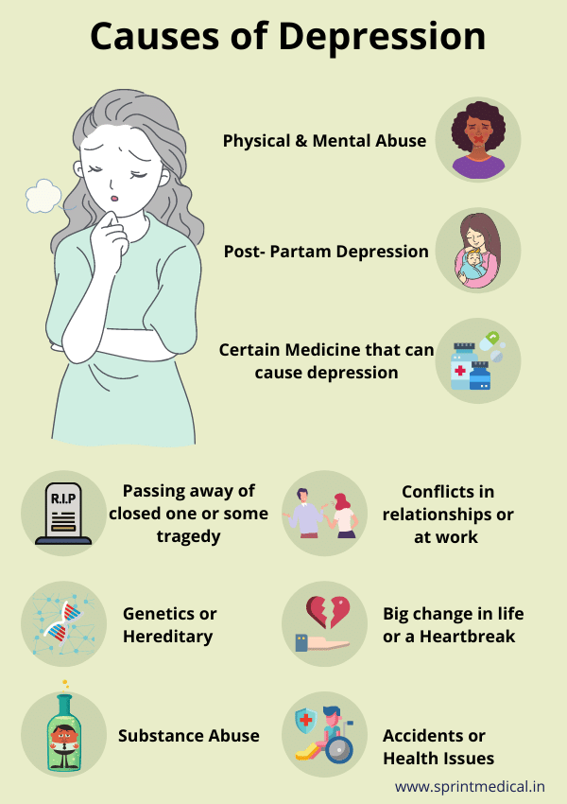
Source: Eduindex (2019) adapted by Student (2022)

Symptoms of depression
There are many signs of depression symptoms, but each person’s experience will be different because depression is different for everyone. Psychological depression is associated with low mood, feeling hopeless, tearful, and worrisome.
Physical depression is linked with tired of walking, constipation loss of appetite and social symptom concerns with avoiding friend’s lack of socializing and neglect hobbies. (Mind 2021) See table for symptoms of depression
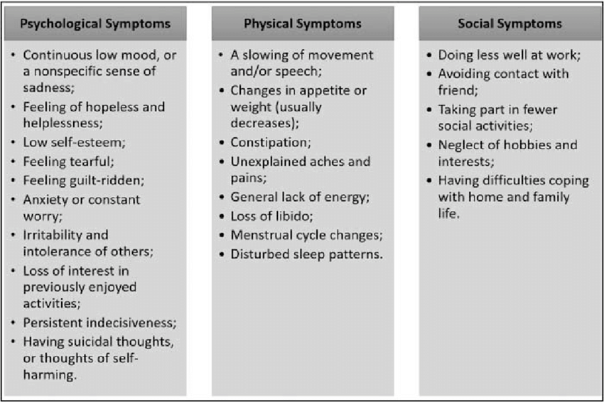
Source (NHS, 2021) adapted by Student (2022)
In the UK, before the COVID 19 pandemic, there was sign of increase in self-reported work-related stress, depression, or anxiety. See graph for work related stress, depression, or anxiety per 100,000 workers in 2020/2021 (HSE, 2021)
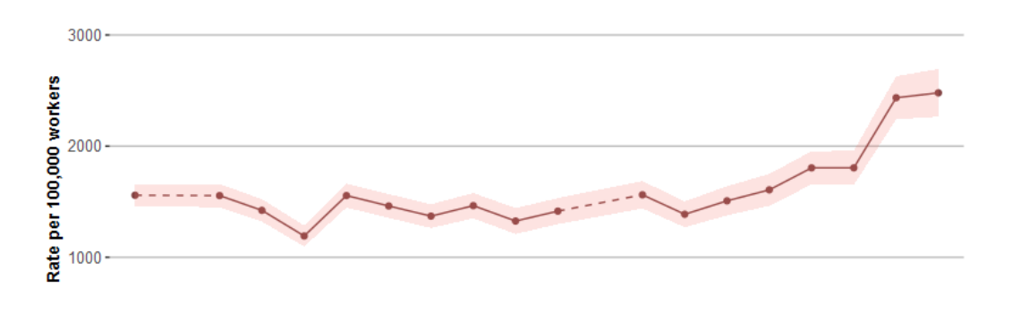
Source: HSE (2021) adapted by Student (2022)
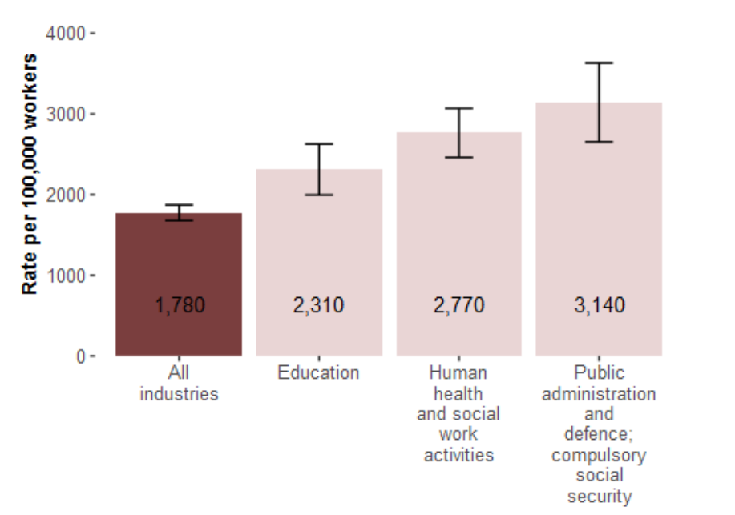
Further in 2018/2019, and 2020/2021, the reported work-related stress, depression, or anxiety across all industries was 1780 cases per 100,000. See graph for prevalence rate of work-related stress, depression, or anxiety in Great Britain.
HSE (2021) indicate in 2018 to 2021 there was work-related stress, depression, or anxiety for professional occupation of 2,530 cases per 100,000. See graph for prevalence rate of work-related stress, depression, or anxiety in Great Britain by occupational category per 100,000 workers in 2018-2021.
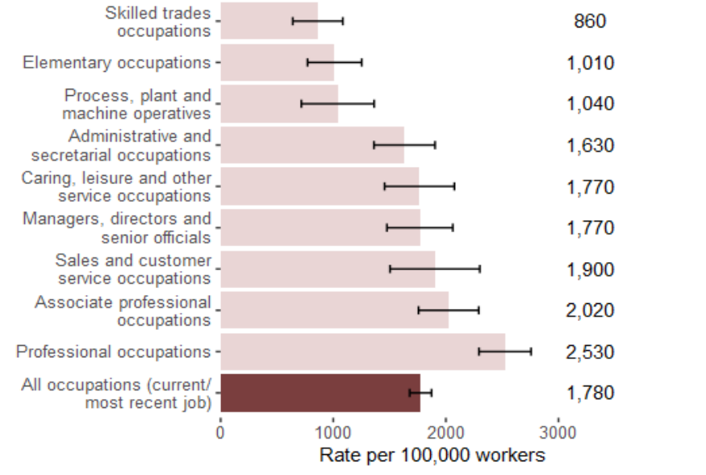
HSE (2021) adapted by Student (2022)
Without any doubt, depression is now recognized as one of the most common mental health issue globally. Office of National Statistics (2021) contends that a sizeable proportion (21%) of adults in the UK during COVID 19 pandemic is affected with depression. In addition, Age UK (2021) indicates that 55 years adults in the UK are also affected with depression. Depression may reduce workforce and reduce productivity See graph of depression in UK.
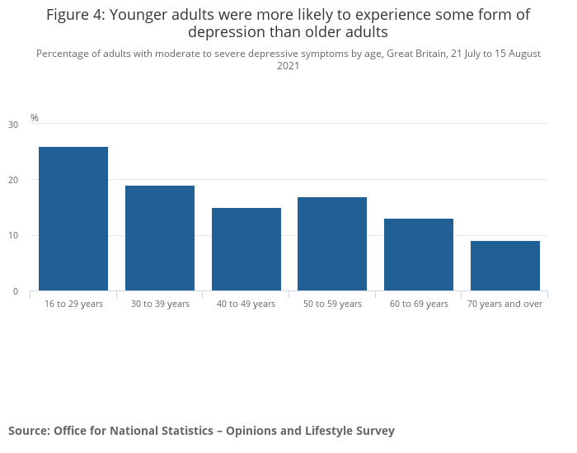
Source: ONS (2021) adapted by Student (2022)
Diagnosis of depression
Depression symptoms manifest themselves in various ways. Nation Health Services (2019) indicate that if you have depression symptoms for more than two weeks, you should contact your doctor, especially if your symptoms aren’t improving, if your mood is interfering with your work or other hobbies, or if you have surgical or self- harming ideas. It can be tough to believe that treatment can help when depressed. However, the sooner you get treatment, the sooner you will recover from your depression. There are no physical tests for depression, but your doctor may examine you and perform certain urine or blood tests, for example if you have an infection to rule out order disorders that have similar symptoms such as an underactive thyroid, which produces insufficient hormones and causes fatigue. The G.P will detect depression by asking you questions about your general health and how you are feeling emotionally or
Physically and you must be honest. Your response will decide whether or not you have depression and the severity of your symptoms. Any conversation you have with the G.P will be kept private. See below image for depression symptoms.

Historical and contemporary treatment of Depression
Historical treatment of depression is different from today’s contemporary period. In the last 19th and 20th century, treatment of depression was not enough to help depressed people. In fact, lobotomies surgery was used to destroy brain prefrontal lobe. According to Schimelpfening (2020), lobotomies treatment as a calm effect but often caused personality changes on the patient’s inability to make decisions and poor judgment and death. Also, depression was seen as spiritual condition associated with demons or evil spirits instead of physical condition which effect results to beating or starvation (Very Well Mind, 2021). This implies that people possessed with depression were isolated and suffer from inhuman treatment. See below image for historical account of depression.
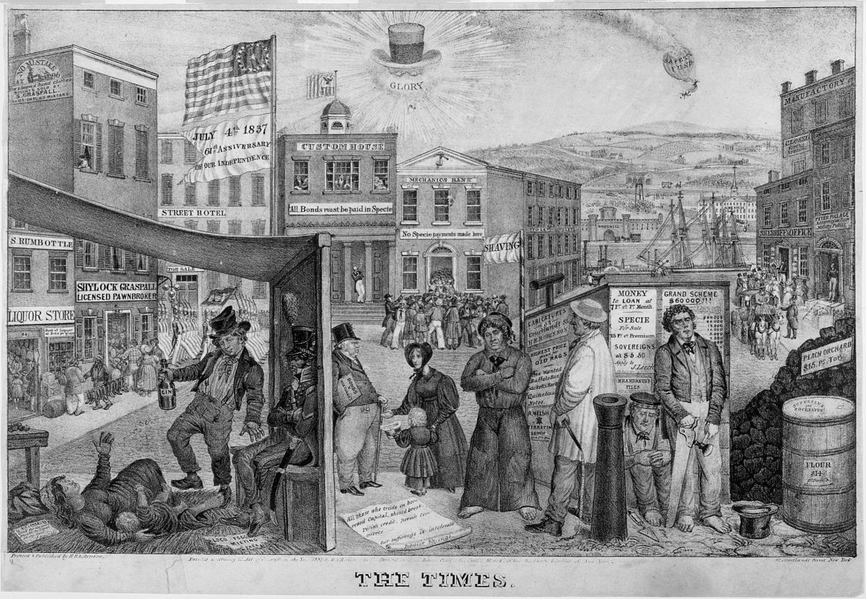
Source: (LOC) Library of Congress (2021) adapted by Student (2022)
However, contemporary treatment is effective with antidepressants and have response rate of about 65-70%. For example, Very Well Mind (2021) indicates that interpersonal therapy is used to address depression. This shows that interaction allows depressed people to forget things and relief pressure. But his may be short time. See figure for contemporary treatment for depression
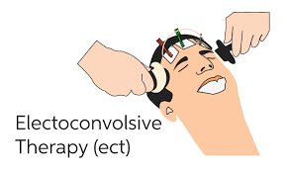

Source: (Healthline2021) adapted by student (2022)
Further drugs used to treat depression are associated with some form of serious side effect like weight gain, tiredness and overdose. Schimelpfening (2020) indicate that these antidepressants drugs are classified as selective serotonin reuptake inhibitors, serotonin norepinephrine reuptake inhibitors, and other antidepressants medications which target serotonin levels in the human brain with fewer side effects.

Practical support for depression
Diet: A depressed individual may reduce depression with rich diet containing vitamins and minerals. The British Psychological Society (2020) indicate that a poor diet can be restored with vitamins and minerals which can restore health
Sleep: Sleep repairs and restores the body and brain; hence, depressed people must have regular sleep routine. The British Psychological Society (2020) argues that sleep is important for good mental health; hence, people should have regular sleep routine that is comfortable and relaxing.
Exercise: Depressed individual requires regular physical exercise to help reduce depression. This is well echoed by the work of National Institute for Health and Clinical Excellence (NICE) guidelines which recommended structured physical activity program to assist people who are experiencing mind and severe depression. Gentle exercise and daily walking may be beneficial for individual wellbeing. A lack of any form of exercise may contribute to level of depressions.
Mindfulness: The British Psychological Society (2020) indicates that practice of mindfulness is sure to help people bring about calmness of the body and mind and prevent depression. This implies that individual with depression may use mindfulness to regularly pay attention on purpose to prevent reoccurrence.
Yoga: This may also support depressed persons to have a wider knowledge of their body and mind. With this, depressed person must free his mind and focus on things that can be beneficial to their mental health and wellbeing.
Issues of professional support for depression treatment
Depression is a common human experience, when an individual depression last for more than two weeks and interfering with social and work life, it is crucial to know the point of depression and seek professional help. There are various professional help and some of these include talking to health specialists, family doctor, and community mental health centers, clergy, local hospital. However, despite the professional help highlighted there are some issues or barriers which depressed person faces in seeking help such as difficulty in accessing support, concerns about confidentiality and distrust of mental health professionals and treatment, negative attitude towards mental help seeking having experienced previous poor help seeking experience, preferred to handle depression themselves and unwillingness to disclose problem.
Again, cultural issues is also associated with depression support from professional and some of this include fear of discrimination, self-stigma, public stigma and seeking alternative treatment. Third, trying to handle the depressive disorder themselves and ignoring the seriousness of the depressive disorder and finally, limited information about depression, lack of information on psychological health, cost, and appointment availability.
Conclusion
Depression is a common mental health experience as every individual experience one form of depression or the other every day. In the UK, in 2020 the rate of depression was 10%, but there was an increase in early 2021, of COVID 19 pandemic when one in five adults experienced one form of depression which represents an increase of 19% (ONS, 2021). However, there has been contemporary treatment for depression using various antidepressants drugs with severe or fewer side effects. This supportive paper provides an understanding about depression as a class classification of ICD-10 as against those who oppose it.

Reference
Baker, C. (2021) Mental Health Statistics England: House of Common Library (online) Available at: https://researchbriefings.files.parliament.uk/documents/SN06988/SN06988.pdf (Accessed 3 April 2022).
HSE (2021) Work-Related Stress, Anxiety or Depression Statistics in Great Britain 2021 (online) Available at: https://www.hse.gov.uk/statistics/causdis/stress.pdf (Accessed: 4 April 2022).
Mind (2021) Depression Symptom [Online] Available at: https: //www.mind.org.uk /information-support/type-of-mental-health-problems/depression / symptoms. (Accessed: 26 March 2022).
NHS (2019) Diagnosis and treatment –clinical depression [Online] Available at: https://www.nhs.uk/mental-health/conitions/clinical-depression/diagnosis// (Accessed: 14 April 2022).
NICE (2020) The NICE Guidelines on the Treatment and Management of Depression in Adults Available at: (online) https://www.nice.org.uk/guidance/cg90/evidence/full-guideline-pdf-4840934509 (Accessed 4 April 2022).
ONS (2021) Corona virus and Depression in Adults, Great Britain: January to March 2021 (online) Available at: https://www.ons.gov.uk/peoplepopulationandcommunity/wellbeing/articles/coronavirusanddepressioninadultsgreatbritain/januarytomarch2021 (Accessed 4 April 2022).
Schimelpfening N. (2020) The History of Depression: Account, Treatments and Beliefs through the Ages (online) Available at: https://www.verywellmind.com/who-discovered-depression-1066770 (Accessed: 3 April 2022).
Turner, J., Hayward, R., Angel, K., Fulford, B., Hall, J, Milard, C and Thomson, M. (2017) ‘The History of Mental Health Services in Modern England’: Practitioner Memories and the Direction of Future Research’, Medical History, Vol.58, (4): pp. 599 - 624.
The British Psychological Society (2020) Understanding Depression: Why Adults Experience Depression and what can help: Division of Clinical Psychology (online) Available at: https://www.bps.org.uk/sites/www.bps.org.uk/files/Member%20Networks/Divisions/DCP/Understanding%20depression.pdf Accessed 3 April 2022).
WHO-World Health Organization (2010) ICD-10-International Statistical Classification of Diseases and Related Health Problems10th Revision (online).Available at: https://icd.who.int/browse10/2010/en#/V(Accessed at: 4 April 2022).

Appendix: Power Point Presentation- Debate




Image source: NIH>National Institute of Mental Health

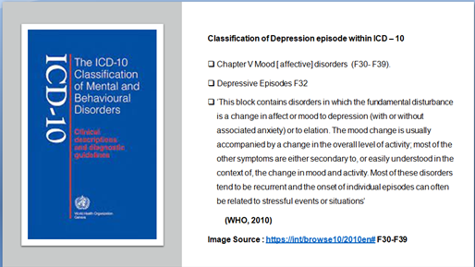
Image Source: WHO, 2010

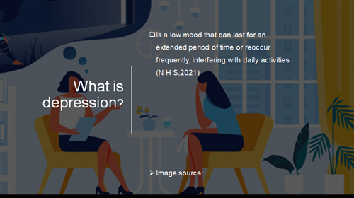

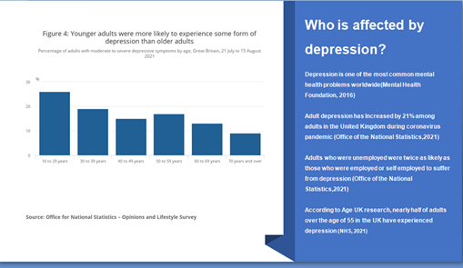
Image source: Office of the National Statistics- Opinions and Lifestyle

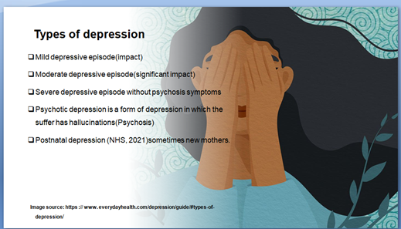
Source:https://www.everydayhealth.com/depression/guide/#types-of-depression/

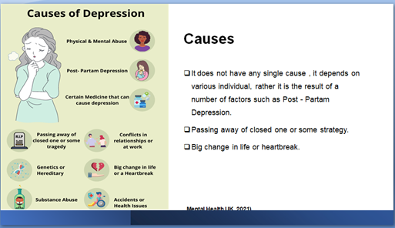

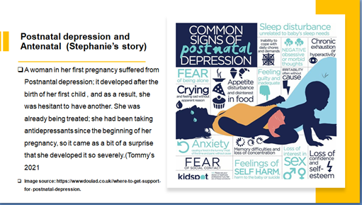

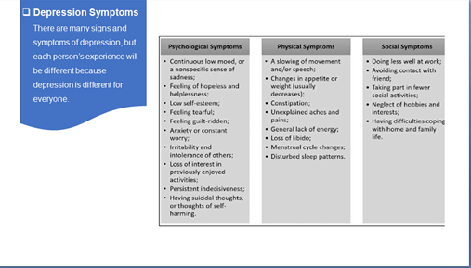
Image source:https://www.researchgate.net/figure/UK-NHS-Summary-of-depression-symptomps fig-1-316651493

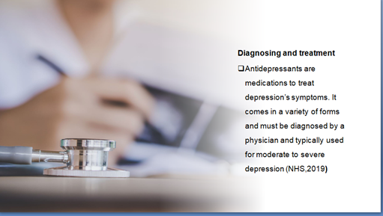

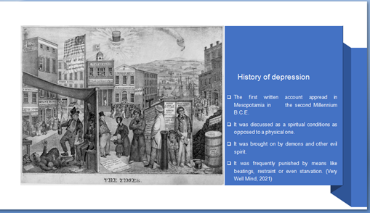
Image source: The times/ Library of Congress

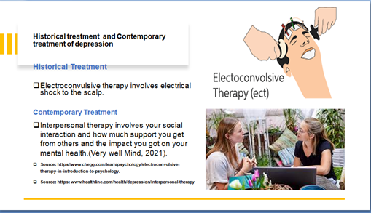
Source: https://www.healthline.com/healthline.com/health/depression/interperonal- therapy

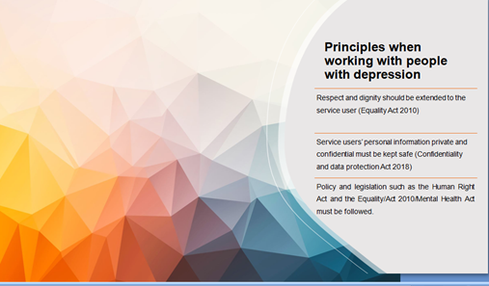

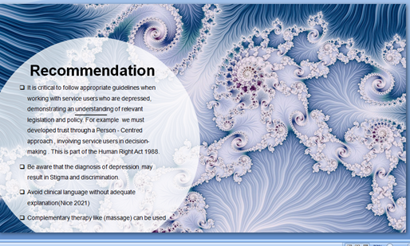

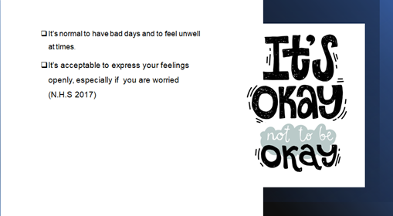
Source: Blog- Clay Behavioral Health… ccbhc.org.uk

