Programming 2
Programming 2 - ACCA4006- Dr TIM BASHFORD, MIKE DACEY
Matthew Dickinson (1708355) - 1708355

Contents
Part A – Understanding 2
Part B – Testing 2
Entering text into the options menu 2
Entering variations of “YES” into quit menu. 3
The result window displaying more than one digit at a time. 4
Part C – Implementation 7
Exercise 1 – Identifying Problems 7
Identifying problems 7
Exercise 2 – Mapping Problem Space to Code 8
Exercise 3 – Connect Four 8
Solutions 8
References 10
Appendix 10
Appendix A1 – Part B – Fixed code 10
Application.cpp 10
Appendix A2 – Part C – Exercise 1 code 12
Source.cpp 12
} 13
Appendix A3 – Part C – Exercise 3 code 13
Source.cpp 13
Game.h 14
Game.cpp 15
Player.h 17
Player.cpp 18

Part A – Understanding
Problem solving techniques allow someone to find solutions to difficult or complex problems by approaching parts of the larger problem differently. A problem can be approached using existing knowledge, be rearranged or reframed for an alternative approach, generalized into as basic a concept as possible and rebuilt as the problem is solved, or the easiest parts of the problem can be targeted first allowing more difficult areas to become more manageable later on. [1]
The favored approach of the author would be to divide the problem into its simpler, more manageable parts and piece them together to reach the final completed design. An example of this would be an approach taken towards the connect4 game from part C exercise 3, found in the appendix A3. Here one of the problems relating to checking for matches in the grid along rows, columns and diagonals was separated and approached using pseudocode and diagrams on paper before returning to writing the code itself.
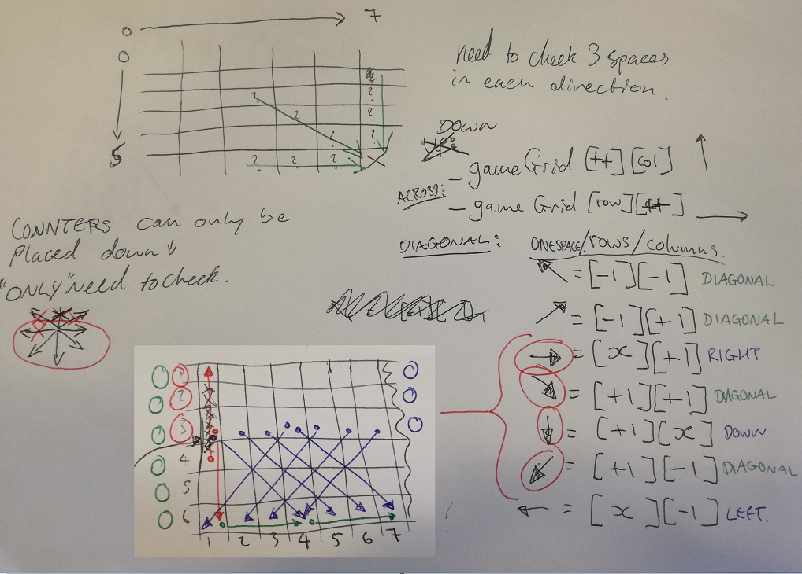
This approach to solving the problem allowed far better visualization of what was needed to solve the problem. It also aided in the design of the solution by demonstrating the most efficient way to scan for matches.

Part B – Testing
The source code of an application containing some errors was provided in the assignment appendix. The application was designed to allow the user to enter an amount of numbers into a calculator which would display the result. The amount of numbers the user could enter was an option that could be selected from a menu, alongside an enter numbers option and a quit option.
There were 3 main problems highlighted with the application:
- Entering text into the options menu.
- Entering variations of “YES” into the quit menu.
- The result window breaking when displaying more than one digit at a time.
These problems were tested, and the results written into test reports.

Entering text into the options menu
1 | Entering text into options menu
Description |  | The user enters a line of text instead of a valid option number.
 |  | Test Steps:
1 | Options 1-3 are displayed on-screen.
2 | User is asked to enter a number.
3 | User enters text.

Response |  | Program should move to the default case in the switch statement and print “Unknown option value entered”. The option loop should then repeat as quit == false and the menu will print again.
Status |  |  | Date |  |  | Description
Pass |  |  | 28/03/18 14:15 |  |  | Passed

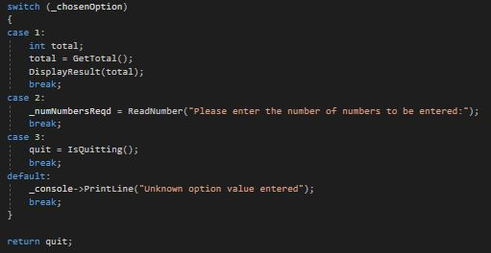
Here the switch statement allows the program to use the default case option if the user enters a value that is not 1, 2, or 3. Therefore entering text will only cause the “Unknown option” case to be chosen.

Entering variations of “YES” into quit menu.
Here if the user enters “YES” then the code will set quit to true and the loop will end, causing the program to close.

1 | Entering “YES” when trying to quit.
Description |  | The user types “YES” when asked if they want to quit.
 |  | Test Steps:
1 | Options 1-3 are displayed on-screen.
2 | User is asked to enter a number.
3 | User enters the number 3 to quit.
4 | User is asked if they would like to quit.
5 | “YES” is entered.

Response |  | Program should print “Quitting” and should then close as quit == true and the loop should be exited.
Status |  |  | Date |  |  | Description
Pass |  |  | 28/03/18 14:40 |  |  | Passed

2 | Entering “Yes”, “yes”, “Y” or “y” when trying to quit.
Description |  | The user types “Yes”, “yes”, “Y” or “y” when asked if they want to quit.
 |  | Test Steps:
1 | Options 1-3 are displayed on-screen.
2 | User is asked to enter a number.
3 | User enters the number 3 to quit.
4 | User is asked if they would like to quit.
5 | “Yes”, “yes”, “Y” or “y” is entered.

Response |  | Program should print “Quitting” and should then close as  quit == true and the loop should be exited.
Status |  |  | Date |  |  | Description
Fail |  |  | 28/03/18 14:45 |  |  | Loop continued and displayed the option menu on screen, meaning quit == false.
Passed |  |  | 28/03/18 14:58 |  |  | Passed.

Here the way the code is written means that only if “YES” typed the program will close. This was fixed by changing the condition to include more inputs that also mean “YES”.
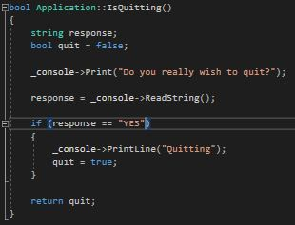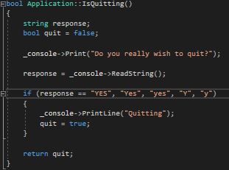

The result window displaying more than one digit at a time.
1 | Displaying a result with two digits
Description |  | The user enters 5 numbers that add together to equal a two-digit result.
 |  | Test Steps:
1 | Options 1-3 are displayed on-screen.
2 | User is asked to enter a number.
3 | User enters the number 1 to add 5 numbers.
4 | User enters 5 numbers that equal a two-digit number.

Response |  | Program should add the numbers and display the result in the centre of the printed ‘display’.
Status |  |  | Date |  |  | Description
Fail |  |  | 28/03/18 15:12 |  |  | The display row containing the result is shifted to the right of the result by one space for the extra digit.
Fail |  |  | 28/03/18 15:28 |  |  | The display row containing the result is pulled inwards toward the result by one space.
Pass |  |  | 28/03/18 15:47 |  |  | Passed

2 | Displaying a result with three digits
Description |  | The user enters 5 numbers that add together to equal a three-digit result.
 |  | Test Steps:
1 | Options 1-3 are displayed on-screen.
2 | User is asked to enter a number.
3 | User enters the number 1 to add 5 numbers.
4 | User enters 5 numbers that equal a three-digit number.

Response |  | Program should add the numbers and display the result in the centre of the printed ‘display’.
Status |  |  | Date |  |  | Description
Fail |  |  | 28/03/18 15:16 |  |  | The display row containing the result is shifted to the right of the result by two spaces for the extra digits.
Pass |  |  | 28/03/18 15:21 |  |  | Passed

In this case, any digit length longer than one meant the printed display window containing the result had its right column shifted to the right by however many digits over one there were.
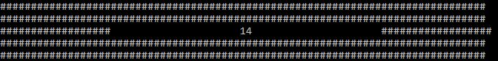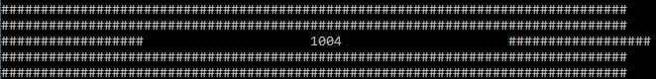
A solution was made which would take the blank space where the result was displayed and shorten the number of blank spaces based on the size of the result. This used the size of the empty space in the result window minus the length of the result, divided by 2. This could then be used either side of the result for its position to be central.
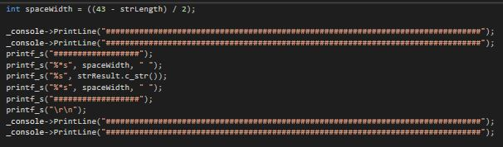
However, this solution only solved test 2 as it only worked for odd numbered digit lengths.
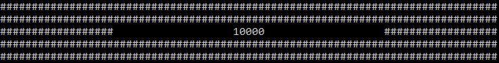
For test 1 the column shifting was still present, although now the column was being pulled inward to the result. 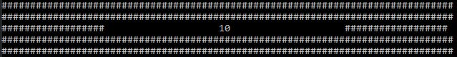 This indicated a problem with the spaceWidth value as the window space was an odd number, 43, meaning that for even numbers there would always be one space missing.
To fix this, an extra factor was added to the second spaceWidth on the right side of the result.
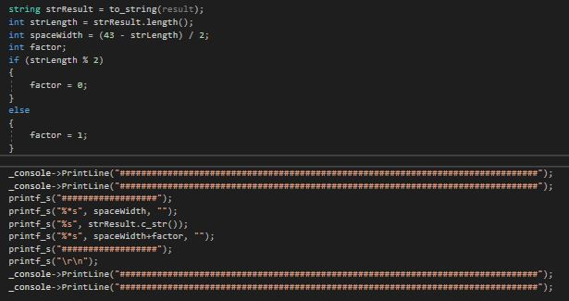
The factor would have no value if the digit length was odd and would have a value of 1 if the value was even. This would balance out the spaces on the display.
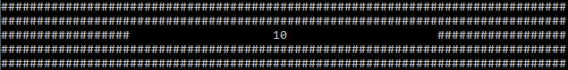

Part C – Implementation

Exercise 1 – Identifying Problems

Identifying problems
Exercise 1 required a console game to be created that would ask a player to guess a number between -20 and +20 which the program has randomly generated. The player was allowed 5 attempts to guess the number otherwise the game ends and they lose.
The player was to be given hints based on how close they were to the correct answer on each guess. These hints were to be given when the player is negative/positive or within 10, 5, or 2 of the random number.
Ranked in terms of increasing difficulty, the main problems in creating this program and their potential solutions are listed below.

- Displaying messages to the user | Using the printf() function.
- Scanning User input. | Using the scanf() function.
- Checking user input is in range. | Using a while loop based on a Boolean variable returning true or false if in or out of range.
- Counting the number of attempts. | Using a for loop to only allow a maximum of 5 attempts.
- Checking user input matches the random number. | Using an if statement that checks if the input “==” the random number.
- Creating the random number between -20 and 20. | Using the rand() function from the standard library.
- Checks that the input is within +/-2 | An if statement checking the number is under the target+2 and over the target-2.
- Checks that the input is within +/-5 | An if statement checking the number is under the target+5 and over the target-5.
- Checks that the input is within +/-10 | An if statement checking the number is under the target+10 and over the target-10.
The solutions to these problems have been written into the code I appendix A2

Exercise 2 – Mapping Problem Space to Code
In this exercise code was supplied which was used to convert a string containing numbers separated by dash characters into numbers that could be extracted into an integer array. The code required some changes in order to function properly.
The problems involved were:
- Function doesn’t scan entire string. | Add the string length into the function arguments.
- Function doesn’t correctly scan numbers separated by two dashes. | Add ‘--’ to the FindChar function called into the SplitNumbers function.

Exercise 3 – Connect Four
Exercise 3 required a connect 4 game be built. The game would allow 2 users to take alternating turns selecting columns to drop their individual counters. These counters would automatically be assigned to the lowest free space in the selected column.
A player would be declared the winner if four matching counters were detected in a row, column or diagonal line.
The problems and their solutions have been ranked according to increasing difficulty below.

- Creation of individual player counters. | A player class with specific player objects.
- Creation of a game board to keep track of counters. | Use a 2D array and assign the array addresses to player counters.
- Display the game board. | Use two for loops to print a set number of columns for a set number of rows.
- Allowing players to enter choices | Use a scanf function to change the column attribute of each player object
- Checking rows | An if statement in a for loop checking across throughout the grid.
- Checking columns | An if statement in a for loop checking downwards throughout the grid/.
- Checking diagonals | Two for loops each containing an if statement checking diagonally downward in different directions throughout the grid.
- Checking the game has been won | Required all match checks to contain a GameOver function to end the game early.

Solutions
Individual counters were made for each player by creating two player objects from the Player class and initializing them with different properties.
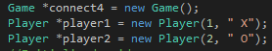
The game board was created using a 2D array kept in the Game class, which would have different array addresses ‘set’ to different values from the player objects.
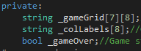
The game board was displayed using for loops for printing rows of columns.
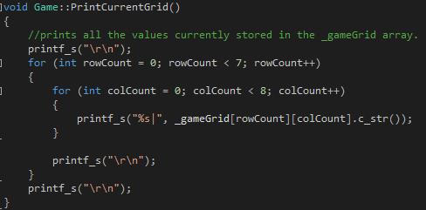
Player choices were kept using scanf() functions, assigning the inputted value to the player attributes after certain checks had been performed.
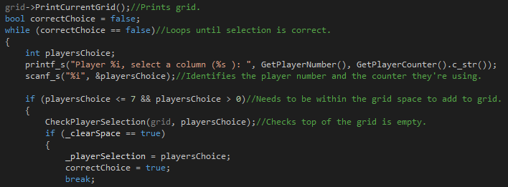
These choices were then set to the grid array.
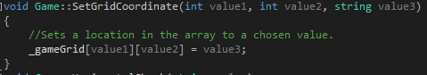
The rows, columns and diagonals were then checked for winning matches.
Rows
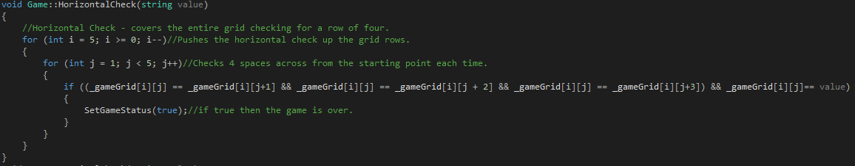
Columns
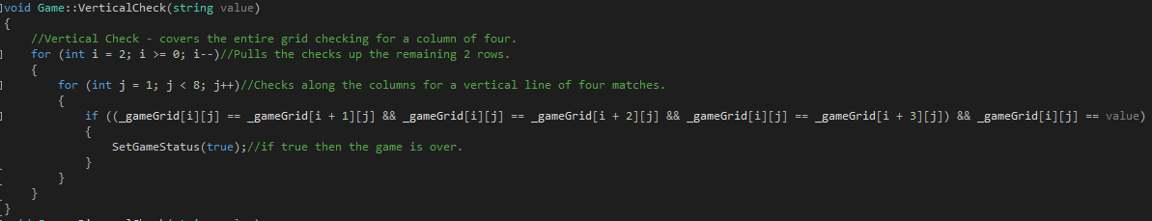
Diagonals
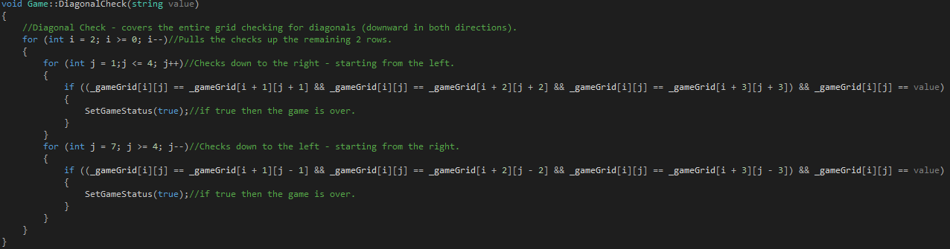
These checks contained a function to change the game status of the game to ‘over’ and meant the while loop containing the game would end.
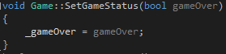

References

[1] | M. Tools, "What is Problem Solving," Mind Tools, [Online]. Available: https://www.mindtools.com/pages/article/newTMC_00.htm. [Accessed 29 03 2018].

Appendix

Appendix A1 – Part B – Fixed code

Application.cpp
…
void Application::DisplayResult(int result)
{

string strResult = to_string(result);
int strLength = strResult.length();
int spaceWidth = ((43 - strLength) / 2);
int factor;
if (strLength % 2)
{
factor = 0;
}
else
{
factor = 1;
}

_console->PrintLine("###############################################################################");
_console->PrintLine("###############################################################################");
printf_s("##################");
printf_s("%*s", spaceWidth, " ");
printf_s("%s", strResult.c_str());
printf_s("%*s", spaceWidth + factor, " ");
printf_s("##################");
printf_s("\r\n");
_console->PrintLine("###############################################################################");
_console->PrintLine("###############################################################################");

}

bool Application::IsQuitting()
{
string response;
bool quit = false;

_console->Print("Do you really wish to quit?");

response = _console->ReadString();

if (response == "YES", "Yes", "yes", "Y", "y")
{
_console->PrintLine("Quitting");
quit = true;
}

return quit;
}
…

Appendix A2 – Part C – Exercise 1 code

Source.cpp

#define _CRT_SECURE_NO_WARNINGS
#include <string>
#include <stdlib.h>
#include <time.h>

using namespace std;

int RandomValue(int maxValue)
{
return rand() % 40 + (-maxValue);
}

int InputUserValue()
{
int userValue;
bool userValueCorrect = false;

while (userValueCorrect == false)
{
printf_s("Enter a guess between -20 and 20: ");
scanf_s("%i", &userValue);
if ((userValue > 20 || userValue < -20))//Input not in range.
{
userValueCorrect = false;
printf_s("Incorrect value entered!\r\n");
}
else
{
userValueCorrect = true;
}
}
return userValue;
}

int main()
{
time_t theTime;
srand((unsigned)time(&theTime));

int x = RandomValue(20);
int attempts = 5;
int y;

for (int i = 0; i < attempts; i++)
{
y = InputUserValue();
if (y == x)
{
printf_s("Congratulations! You guessed correctly! \r\n");
break;
}
else
if (y >= x - 2 && y <= x + 2)
{
printf_s("Close! (+/- 2) \r\n");
}
else
if (y >= x - 5 && y <= x + 5)
{
printf_s("Warmer! (+/- 5) \r\n");
}
else
if (y >= x - 10 && y <= x + 10)
{
printf_s("Cold (+/- 10) \r\n");
}
else
if (x < 0)
{
printf_s("Try again! \r\n");
printf_s("The number is negative\r\n");
}
else
{
printf_s("Try again! \r\n");
printf_s("The number is positive\r\n");
}
if (i == 4)
{
printf_s("You lose! \r\n");
}
}

system("pause");
return 0;

}

Appendix A3 – Part C – Exercise 3 code

Source.cpp
#define _CRT_SECURE_NO_WARNINGS

#include <string>
#include <stdlib.h>
#include "Game.h"
#include "Player.h"
using namespace std;
int main()
{
//Object creation.
Game *connect4 = new Game();
Player *player1 = new Player(1, " X");
Player *player2 = new Player(2, " O");
//Initialised grid array.
connect4->GameStart();
//Game loop.
while (connect4->GetGameStatus() == false)
{
//Player1 turn.
player1->AddSelection(connect4);//Sets and Adds Player1's " X" Counter.
player1->WinCheck(connect4);//Checks for a set of four touching " X"'s.
if (connect4->GetGameStatus() == true)//Checks if the game is over to break the loop BEFORE player 2 makes a turn after they've already lost.
{
break;
}
//Player2 turn.
player2->AddSelection(connect4);//Sets and Adds Player2's " O" Counter.
player2->WinCheck(connect4);//Checks for a set of four touching " O"'s.
}
//Object deletion
delete player2;
delete player1;
delete connect4;
return 0;
}

Game.h
#pragma once
#include <string>
using namespace std;
class Game
{
#pragma region Attributes
private:
string _gameGrid[7][8];//Allows space for a 7x6 grid space + axes labels.
string _colLabels[8];//Column labels.
bool _gameOver;//Game status.
#pragma endregion
#pragma region Constructors
public:
Game();//Sets initial game over status.
~Game();
#pragma endregion
#pragma region Properties
public:
void SetStartingGrid();//Initialises Grid for the start of the game.
void SetGameStatus(bool gameOver);//Sets the game status to true(over) or false(running).
bool GetGameStatus();//Gets the game status for the while loop and other checks.
#pragma endregion
#pragma region Methods
public:
void GameStart();//Prints a message and uses the SetStartingGrid function.
void PrintCurrentGrid();//Prints the current state of the game grid.
void SetGridCoordinate(int value1, int value2, string value3);//Allows the chosen grid coordinate to be set to a chosen value.
string GetGridCoordinate(int value1, int value2);//Gets the selected grid coordinate for checks.
void HorizontalCheck(string value);//Checks for four of the same player counters horizontally.
void VerticalCheck(string value);//Checks for four of the same player counters vertically.
void DiagonalCheck(string value);//Checks for four of the same player counters diagonally.
#pragma endregion
};

Game.cpp
#include "Game.h"
#pragma region Constructors
Game::Game()
{
_gameOver = false;//Sets the game to 'not over' for the while loop.
}
Game::~Game()
{
}
#pragma endregion

#pragma region Properties
void Game::SetStartingGrid()
{
//column labels
_colLabels[0] = " ";
_colLabels[1] = "^1";
_colLabels[2] = "^2";
_colLabels[3] = "^3";
_colLabels[4] = "^4";
_colLabels[5] = "^5";
_colLabels[6] = "^6";
_colLabels[7] = "^7";

for (int rowCount = 0; rowCount < 7; rowCount++)//assigns bottom row some labels, everything else is blank.
{
for (int colCount = 0; colCount < 8; colCount++)
{
_gameGrid[rowCount][colCount] = " ";
_gameGrid[6][colCount] = _colLabels[colCount];
}
}
}
void Game::SetGameStatus(bool gameOver)
{
_gameOver = gameOver;
}
bool Game::GetGameStatus()
{
return _gameOver;
}
#pragma endregion

#pragma region Methods
void Game::GameStart()
{
printf_s("Welcome to connect4!\r\n");
system("pause");
system("cls");
SetStartingGrid();//Sets the starting grid
}
void Game::PrintCurrentGrid()
{
//prints all the values currently stored in the _gameGrid array.
printf_s("\r\n");
for (int rowCount = 0; rowCount < 7; rowCount++)
{
for (int colCount = 0; colCount < 8; colCount++)
{
printf_s("%s|", _gameGrid[rowCount][colCount].c_str());
}

printf_s("\r\n");
}
printf_s("\r\n");
}
string Game::GetGridCoordinate(int value1, int value2)
{
//Gets a specific array location
return _gameGrid[value1][value2];
}
void Game::SetGridCoordinate(int value1, int value2, string value3)
{
//Sets a location in the array to a chosen value.
_gameGrid[value1][value2] = value3;
}
void Game::HorizontalCheck(string value)
{
//Horizontal Check - covers the entire grid checking for a row of four.
for (int i = 5; i >= 0; i--)//Pushes the horizontal check up the grid rows.
{
for (int j = 1; j < 5; j++)//Checks 4 spaces across from the starting point each time.
{
if ((_gameGrid[i][j] == _gameGrid[i][j+1] && _gameGrid[i][j] == _gameGrid[i][j + 2] && _gameGrid[i][j] == _gameGrid[i][j+3]) && _gameGrid[i][j]== value)
{
SetGameStatus(true);//if true then the game is over.
}
}
}
}
void Game::VerticalCheck(string value)
{
//Vertical Check - covers the entire grid checking for a column of four.
for (int i = 2; i >= 0; i--)//Pulls the checks up the remaining 2 rows.
{
for (int j = 1; j < 8; j++)//Checks along the columns for a vertical line of four matches.
{
if ((_gameGrid[i][j] == _gameGrid[i + 1][j] && _gameGrid[i][j] == _gameGrid[i + 2][j] && _gameGrid[i][j] == _gameGrid[i + 3][j]) && _gameGrid[i][j] == value)
{
SetGameStatus(true);//if true then the game is over.
}
}
}
}
void Game::DiagonalCheck(string value)
{
//Diagonal Check - covers the entire grid checking for diagonals (downward in both directions).
for (int i = 2; i >= 0; i--)//Pulls the checks up the remaining 2 rows.
{
for (int j = 1;j <= 4; j++)//Checks down to the right - starting from the left.
{
if ((_gameGrid[i][j] == _gameGrid[i + 1][j + 1] && _gameGrid[i][j] == _gameGrid[i + 2][j + 2] && _gameGrid[i][j] == _gameGrid[i + 3][j + 3]) && _gameGrid[i][j] == value)
{
SetGameStatus(true);//if true then the game is over.
}
}
for (int j = 7; j >= 4; j--)//Checks down to the left - starting from the right.
{
if ((_gameGrid[i][j] == _gameGrid[i + 1][j - 1] && _gameGrid[i][j] == _gameGrid[i + 2][j - 2] && _gameGrid[i][j] == _gameGrid[i + 3][j - 3]) && _gameGrid[i][j] == value)
{
SetGameStatus(true);//if true then the game is over.
}
}
}
}
#pragma endregion

Player.h
#pragma once
#include <string>
#include "Game.h"
using namespace std;
class Player
{
#pragma region Attributes
private:
int _playerNumber;//Players number.
string _playerCounter;//Players counter on the grid.
int _playerSelection;//Players column choice.
bool _clearSpace;//The result of a clear space check.
#pragma endregion
#pragma region Constructors
public:
Player(int playerNum, string playerCounter);//Sets player number and counter.
~Player();
#pragma endregion
#pragma region Properties
public:
int GetPlayerNumber();//Gets the players number.
string GetPlayerCounter();//Gets the players counter.
#pragma endregion
#pragma region Methods
public:
void SetPlayerSelection(Game *grid);//Player choice is
bool CheckPlayerSelection(Game *grid, int value);//Checks that the players selection is within the grid.
void AddSelection(Game *grid);//Adds the users selection to the grid.
bool ClearSpaceCheck(Game *grid);//Checks the top of the chosen column is empty.
int CounterHeight(Game *grid);//Calculates the lowest free coordinate in the chosen column.
void WinCheck(Game *grid);//Checks the entire grid for four matching counters in all directions.
#pragma endregion
};

Player.cpp
#include "Player.h"
#pragma region Contructors
Player::Player(int playerNum, string playerCounter)
{
_playerNumber = playerNum;//Initialises the player number.
_playerCounter = playerCounter;//Initialises the player counter.
}
Player::~Player()
{
}
#pragma endregion

#pragma region Properties
int Player::GetPlayerNumber()
{
return _playerNumber;//Gets the player number.
}
string Player::GetPlayerCounter()
{
return _playerCounter;//Gets the player counter.
}
void Player::SetPlayerSelection(Game *grid)
{
grid->PrintCurrentGrid();//Prints grid.
bool correctChoice = false;
while (correctChoice == false)//Loops until selection is correct.
{
int playersChoice;
printf_s("Player %i, select a column (%s ): ", GetPlayerNumber(), GetPlayerCounter().c_str());
scanf_s("%i", &playersChoice);//Identifies the player number and the counter they're using.

if (playersChoice <= 7 && playersChoice > 0)//Needs to be within the grid space to add to grid.
{
CheckPlayerSelection(grid, playersChoice);//Checks top of the grid is empty.
if (_clearSpace == true)
{
_playerSelection = playersChoice;
correctChoice = true;
break;
}
else
{
printf_s("Column is Full!\r\n");
}
}
else
{
printf_s("Invalid column entered!\r\n");
}
}
}
#pragma endregion

#pragma region Methods
bool Player::CheckPlayerSelection(Game *grid, int value)
{
if (grid->GetGridCoordinate(0, value) == " ")//checks the top of the column is empty.
{
return _clearSpace = true;
}
else
{
return _clearSpace = false;
}
}
void Player::AddSelection(Game *grid)
{
SetPlayerSelection(grid);//Sets the column choice.
grid->SetGridCoordinate(CounterHeight(grid), _playerSelection, GetPlayerCounter());//Assigns the choice to the grid
system("cls");
}
bool Player::ClearSpaceCheck(Game *grid)
{
for (int i = 5; i >= 0; i--)//Checks that the column selected by the player has space to place the counter.
{
if (grid->GetGridCoordinate(i, _playerSelection) == " ")
{
return true;
break;
}
}
return false;
}
int Player::CounterHeight(Game *grid)
{
for (int i = 5; i > 0; i--)//Checks the height of the board (6 spaces) for a clear space and returns the location when found.
if (grid->GetGridCoordinate(i, _playerSelection) == " ")
{
return i;
break;
}
}
void Player::WinCheck(Game *grid)
{
grid->PrintCurrentGrid();//Prints the grid.
grid->HorizontalCheck(GetPlayerCounter());
grid->VerticalCheck(GetPlayerCounter());
grid->DiagonalCheck(GetPlayerCounter());

if (grid->GetGameStatus() == true)//Checks if the game is over and prints a message if true.
{
printf_s("Congratulations Player %i\r\n", GetPlayerNumber());
system("pause");
}
else//Else clears the screen for the next turn.
{
system("cls");
}
}
#pragma endregion

