

RESULT

BACHELORS DEGREE ASSIGNMENT SPECIFICATION

Student name: | Anthony Williams-Lloyd | Student P number: | 2014403
Programme: | Built Environment Programmes – Level 5. BSc (Hons) Construction Management; BSc (Hons) Civil Engineering and HND pathways.
Module: | Project Planning for Construction | Module Level (4, 5, 6): | 5
Module code: | ACBA5001 | Contribution to Overall  Module Assessment (%): | 60%
Lecturer: | Dr Deborah Hughes | Internal Verifier: | Allan Nantel
Assignment Title: | Programmes | Assignment No (x of x): | 1 of 2
Hand Out Date: | Week Commencing 2/11/21 | Submission deadline: | 4/1/22

Referencing: | In the main body of your submission you must give credit to authors on whose research your work is based. Append to your submission a reference list that indicates the books, articles, etc. that you have read or quoted in order to complete this assignment (e.g. for books: surname of author and initials, year of publication, title of book, edition, publisher: place of publication).
Disclosure: | I declare that this assignment is all my own work and that I have acknowledged all materials used from the published or unpublished works of other people. All references have been duly cited.
Student’s Signature: | Assignments will not be accepted without a signature here | Date:

Turnitin: Lecturer to tick to indicate if an electronic version of the assignment must be submitted to Turnitin. Note: the Turnitin version is the primary submission and acts as a receipt for the student. Both electronic and paper versions MUST be submitted by the same deadline. No marks will be released until both submissions are received. Late submission of either the electronic or paper version will result in a late penalty mark. Penalties for late submission: Up to one week late, maximum mark of 40%. Over one week late, Refer. Only Year Tutors and the Programme Director may grant an extension. | YES | √
 | NO

Learning Outcomes tested  (from module syllabus) | Assessment Criteria. To achieve each outcome a student must demonstrate the ability to:
Determine and assess the principles and application of effective project planning and programming.  Produce method statements and programme of works, analysing time, cost and resources needed for the project construction. | Using appropriate software produce a programme of works. Using this software analyse time cost and resources needed for the construction project.
- Please submit the assignment parts in a suitable report folder– not in poly-pockets.
- This form (ALL PAGES) MUST be at the front of the paper submission. Assignments will not be accepted without this form as it is a requirement that you sign the disclosure regarding referencing convention.
- DO NOT put this form into Turnitin or it will match many similarities with other students’ submissions.

TASK DESCRIPTION

Coursework

Please note this is an academic assessment that relates specifically to the module studied. It is a fictional proposal.
You will need to choose ONE of the following scenarios to address.

- You are to assume that a local housing developer has received planning consent for FOGs on a new development on SA1. [See attached floor plans and elevations].
The construction is described in the drawings provided on Teams.
Work is proposed to start on 8th February 2022.
- You are to assume that a local housing developer has received planning consent for an adoptable highway for a housing estate on SA1. [See attached drawings. Further drawings available on Teams].
Work is proposed to start on 8th February 2022.
The following tasks are allocated a percentage to emphasise the suggested time you should spend on each individual task. Marks will be allocated against the set Marking Criteria indicated on page 6.

- Produce a detailed work breakdown structure for all the major activities related to the construction of this project – from start until completion. (25%)
- Produce Construction Method Statements for three of the major activities related to this project. (25%)
- Produce a Gantt chart utilising suitable software showing the critical path. (25%)
- Develop, evaluate and produce site specific reports for time, cost and resources of the work activities. (25%)

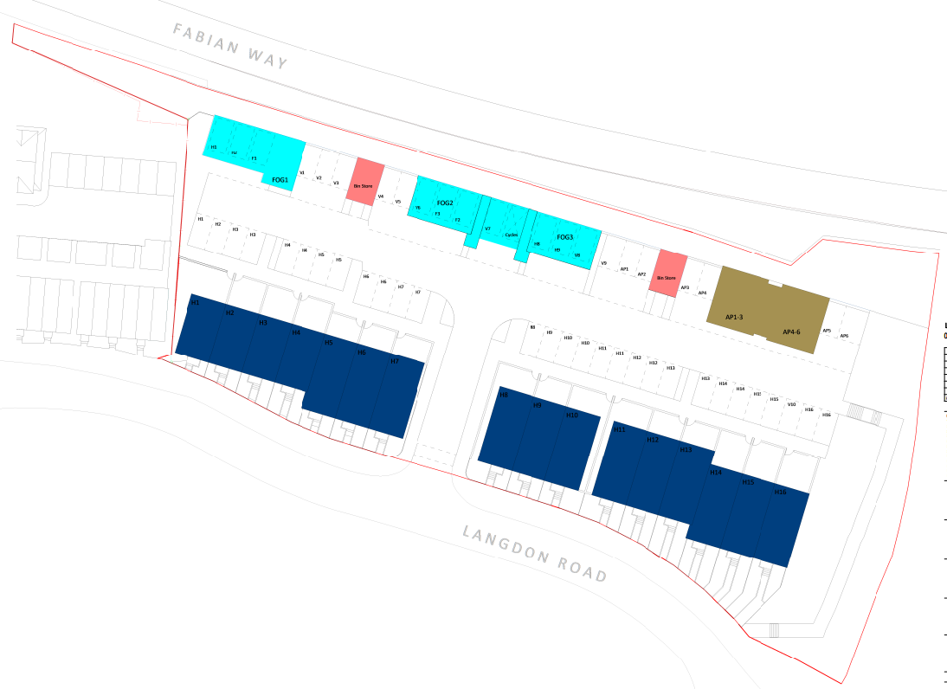

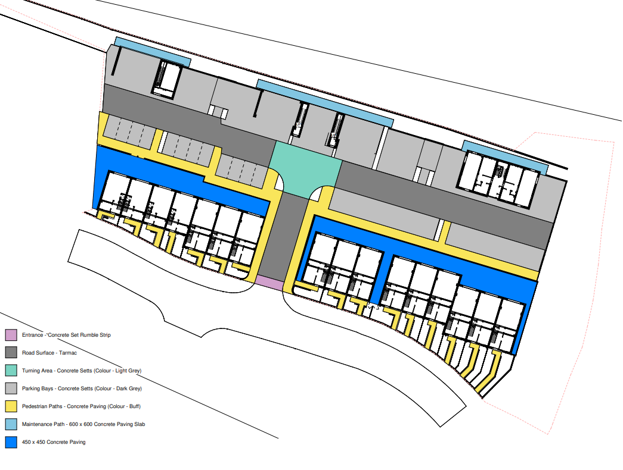
Table Of Contents

Introduction 6

Work Breakdown Structure 7

Gantt Chart/Programme of Works 9

Time Report 12

Cost Report 13

Resource Report 14

Conclusion 15

References 15

Appendices 16

Electrical Installation Method Statement (AWL/01) 16

Concrete Slab Installation Method Statement (AWL/02) 23

Mechanical Installation Method Statement (AWL/03) 29

Introduction

Throughout this assignment I am going to be researching and developing my own construction documents for a set of 3 FOG based down in SA1. One FOG will consist of a single dwelling & two FOGs will consist of double dwellings. The construction documents I will be producing are as follows:
- A Detailed work breakdown structure for all the major activities
- Construction Method statements for three of the major activities
- A Gantt chart/Construction programme showing the critical path
- Site specific reports for time, cost & resources

To Complete this part of the assignment I will be developing a detailed Work Breakdown Structure which will be linked to the Detailed Gantt chart I will be producing. I will be creating three detailed method statements for activities be carried out during the project. These activities will be:
- Electrical Installation
- Concrete Slab Installation
- Mechanical Installation

Once the Gantt chart is completed, I can gather all the information I require to create reports in relation to Time, Cost & Resources.

3No FOGs
External Works
Planning
Project
Manager
Client
Requirements
Architect
Quantity
Surveyor
Design
Project
Manager
Structural
Engineer
Architect
Quantity
Surveyor
Site Plan
Site Location
General
Arrangement
Elevations
External
Finishes
Electrical
Drawing
Details
Mechanical
Drawings
Floor
Finishes
Wall Finishes
Roof
Drawing
Pre Construction
Project
Manager
Quantity
Surveyor
Tender
Hand-in
Tender
Consultation
Period
Contractor
Lead-in
Pre Planning &
Sign Off
Enabling Works
Site
Manager
Site Setup
Site
Clearance &
Reduce Dig
Pilling Matt
Installation
Pilling Works
Formation Works
Install FW &
SW Drainage
Install
Temporary
Access Road
Base Course
Access Road
Site
Manager
Setting Out
Engineer
Substructure
Drainage &
Services
Concrete
Pour
Block &
Brickwork
Site
Manager
Ring Beam
Installation
Window, Door
Installation
Clean &
Mastic
Scaffold
Roof Works
& Finishes
Internals
Carpentry
1st & 2nd Fix
Mechanical
1st & 2nd Fix
Electrical
1st & 2nd Fix
Site
Manager
Stair
Installation
Decoration
Snag & Clean
Tilling
Mastic Works
Bike Rack
Install
Back Fill
Level Ground
Install
Footpaths
Site
Manager
Setting Out
Engineer

White Lining
Road Sweep
Tarmac
Site Clearance
Inspection
Mechanical
Manager
Quantity
Surveyor
Site
Manager
Project
Manager
Electrical
Manager
Client
Handover
Mechanical
Manager
Quantity
Surveyor
Site
Manager
Project
Manager
Electrical
Manager
Client

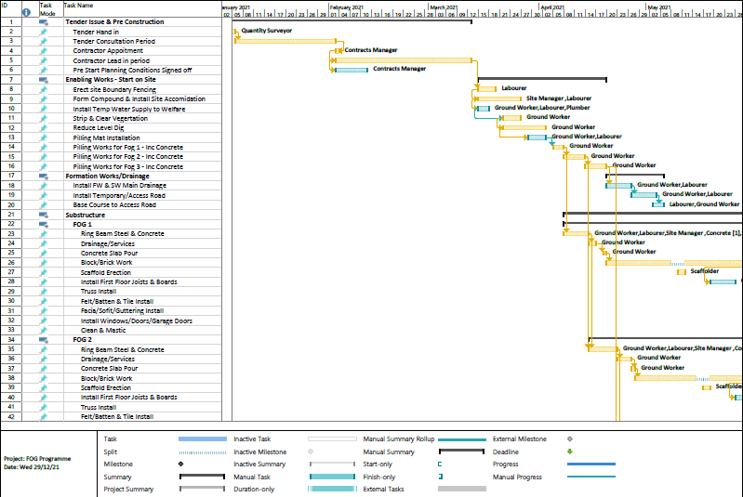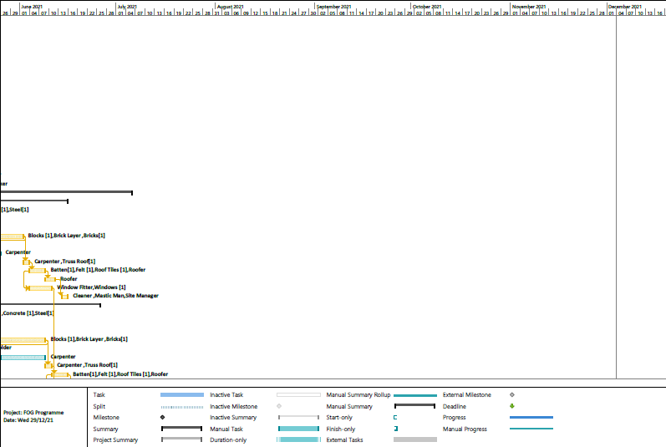

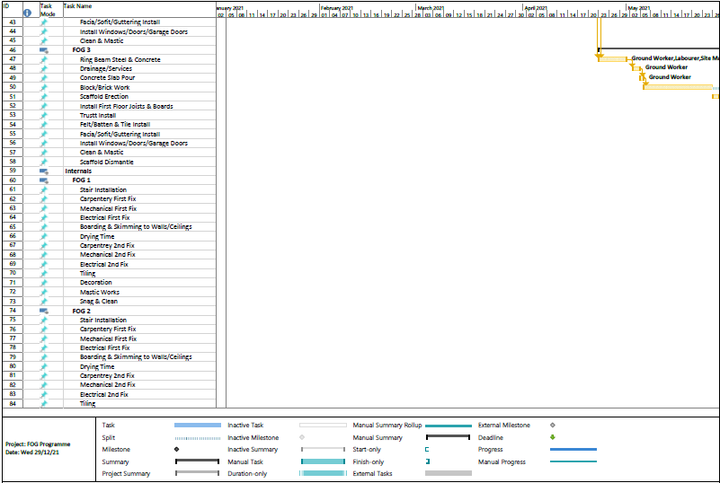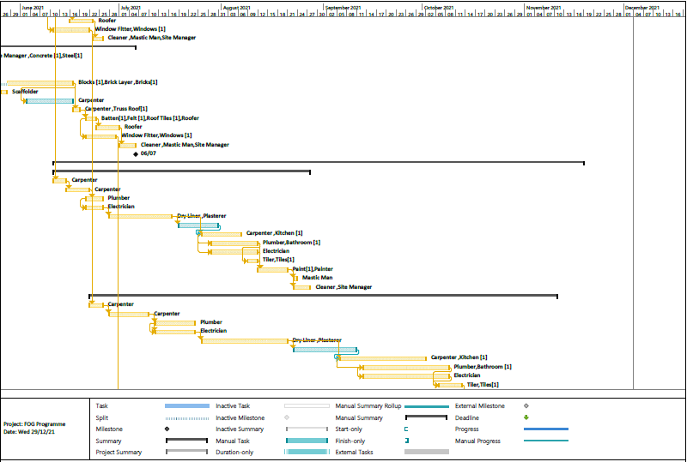

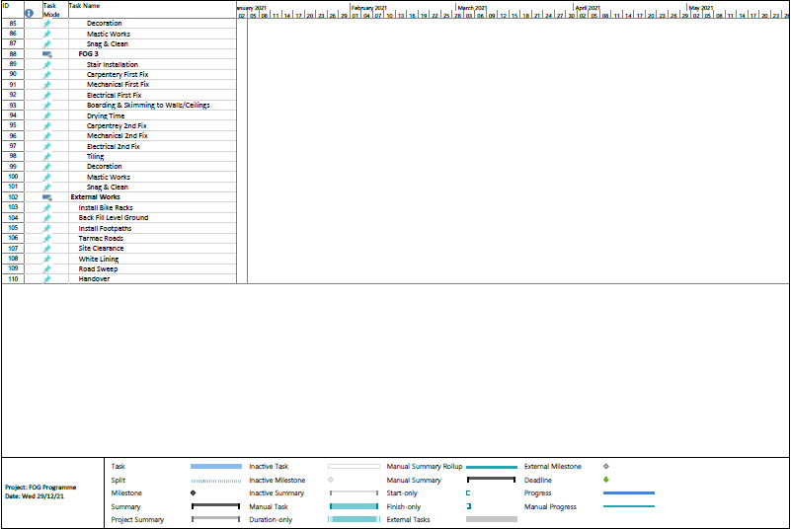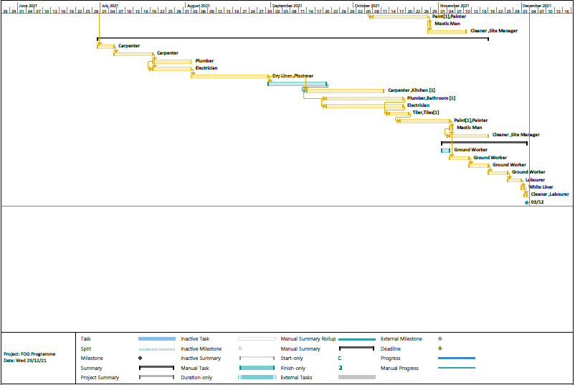

Time Report

As you can see from the project overview, we are 27% completed on this project. We are still on programme as works stand and there are no major concerns or issues that will affect handover. All leading items have been pre-ordered and will be delivered to site before needed to make sure we stay on track. We are still on target to achieve the first milestone on 06/07/2021.

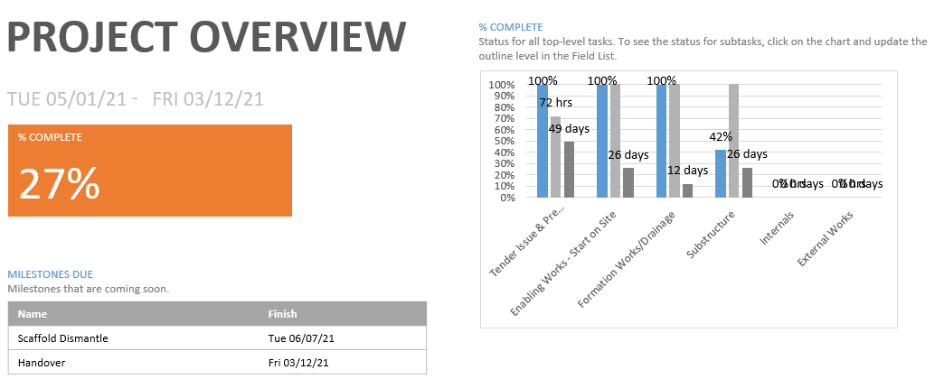

Cost Report

As you can see on the cost overview, we have spent a total of £144988.86 to complete 27% of the project. This leaves us a remaining to spend £234204.14 to spend to get this project completed on budget. We have a remaining £114652.14 to spend on materials & a further £119552 to spend on resources to get this project completed. If you compare cost to work completed, we are exactly where we need to be to completed this project within budget.

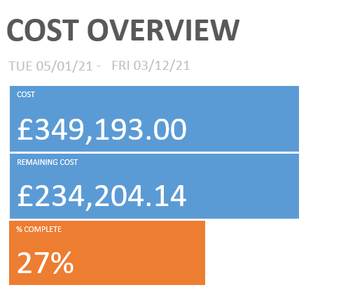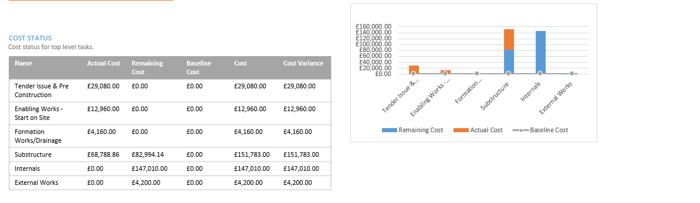



Resource Report

We have used the allocated resources affectively on this project to get the works completed in conjunction with the programme. As you can see below, we can see how many hours each resource has worked alongside how many we have budgeted for. We can also cross reference this information alongside the costs spent to see if we have budgeted correctly and still on budget/time
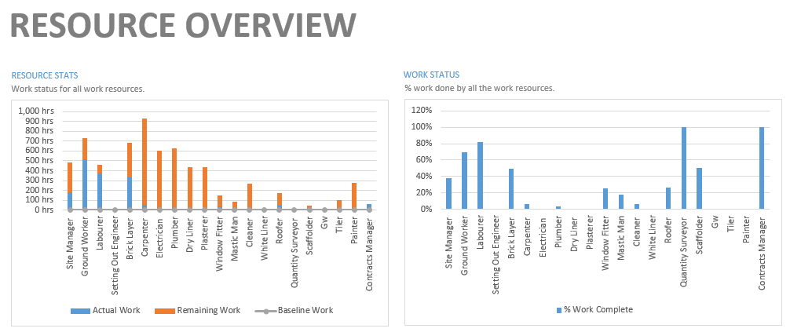

Conclusion

In Conclusion having a good Gantt Chart is a vital part of any project. Having a good Gantt chart full of the relevant information can be the difference between having a successful project and an unsuccessful project. The Gantt chart will be used throughout the project from initial design stage all the way through to handover. With all the right information imputed you can not only use the Gantt chart to manage the project successfully you can use it to track labour, costs, materials and compile accurate reports. Using the Gantt chart to its full potential you can also order leading materials in advance to minimise delays on the project. If used correctly and managed correctly you can use it to catch delays early so you can be proactive on this rather than reactive which will be too late.

Methos statements are used alongside Risk assessments and are hugely important in the construction industry when it comes to carrying out high-risk activities safely. Not only are they used as a guide to complete a task safely & correctly they are a key H&S document which are mandatory on all projects. The key information needed in Method statements are: (CHAS2021)
- Control Risks
- Safety precautions
- Equipment used
- PPE
- Step by Step Guide
- Waste material control
- Reporting instructions
- Control instructions
- COSHH

References

CHAS 2013 - https://www.chas.co.uk/blog/what-is-a-method-statement/

Appendices

Method Statement AWL/01

Method Statement Title: Electrical Installation of 3no FOGs
Method Statement Number: AWL/01
Name: Anthony Williams-Lloyd
Job Title: H&S Manager
Date: 03/02/2021
Start Date: As per construction Programme
Client: Swansea City Council
Site Address: SA1 Fabian Way
Works to be carried out by: Qualified & competent persons
The purpose of this Method Statement is to describe the measures and ways of completing Electrical installation on this project. The works shall be carried out in compliance with the drawings and project specification.
Index
- Monitoring Arrangements
- Hazards
- Risk Assessment
- Materials, Plant & Equipment
- Training Requirements
- Sequence of Work
- Method of Work
- Reference Documents
- Personal Protective Equipment (PPE)
- Working at Height
- Permits of Work
- Access & Lighting
- Manual Handling
- House Keeping
- Noise/Vibration
- Traffic Management
- Protection of Others
- Health & Welfare Arrangements
- Emergency Arrangements
- First Aid
- Control of Hazardous Substances (COSHH)

Activity/Event |  | Action/Control
1. | Monitoring arrangements | Induction procedures  Review of training  Daily or new erection of access equipment inspections.  Weekly safety inspections of plant and equipment to be recorded  Reviews of Risk assessments on site  Site supervisors will be monitoring all site works throughout the working shift, which will include site safety arrangements  All works are to be inspected by Site Supervisor and offered to the Client for inspection when ready to hand over. Completion or section handovers to be issued to PC for sing off  Exclusion zones and signage  Material Storage
2. | Hazards | Access and Egress  Working at Height  Electrocution  Manual Handling  COSHH  Noise  VWF, HAV  Poor House Keeping  Other workers.
3. | Risk assessments | Risk Assessment RA G01-RA-GO8 RA-E01 to RA-E07  Manual Handling risk assessment MH01-MH10
4. | Materials, Plant and equipment | Range of bracketry including 40mm x 40mm/20mm x 6m unistrut, with supplementary screwed rod, nuts, bolts washers.  Wiring range from 1mm singles to 50mm x 4core SWA  Electrical components fittings and accessories.  Site storage as agreed to ensure storage areas are kept neat and tidy.  Mobile Tower.  Small hand-held power tools  Chop saw  Small hand tools  Step Ladders in confined areas
5. | Training requirements | Method statement briefing.  CSCS card  Site induction  Manual Handling  Mobile Tower (PASMA)  Familiarity of site  Familiarity of all plant of equipment
6. | Sequence of work | Method Statement Briefings  Site Induction  Site familiarisation (site tour)  Delivery of plant, equipment, materials to work  Exclusion zones and signage  Familiarisation of plant and equipment  Installation process, undertake the works.  Testing and commissioning  Removal of any site waste  Demobilise plant and equipment.
7. | Method of work | - All person involved in the works will receive a briefing on the approved method statement and Risk assessments and will sign the method statement briefing register stating that they have received, understood and agree to follow this described method of work.  - All operatives will attend site induction they will take with them signed method statement briefing register, CSCS card and copies of their training certificates. Site manager will provide details of the site risks, welfare arrangements and emergency procedures.  - Electrical supervisor will arrange for a site tour so each operative is aware of the site layout and access and egress arrangements, storage areas and other works.  - Access and egress to the site work area will be as designated walkways which are clearly marked. If changes to any routes are made the new routes shall be identified.  - Delivery of materials and storage areas will be as logistics plan.  - Materials, access equipment if required and tools will be carried to the workface care to be taken loads are comfortable to carry and access routes are clear of debris or trip hazard and other operatives working are aware of your movements. Heavy or long objects shall require a team lift for safe awareness and control of the load.  - A work station local to the installation will be set up to facilitate bracket containment fabrication. All equipment used shall be proprietary tools for the work all plant shall be used as the manufacturer’s instructions. Work areas shall be kept clean and tidy with end of shift clearance of rubbish and waste products to the appropriate skip. If waste becomes unmanageable it shall be removed at each break. Note offcuts of materials likely to cause injury if stood on shall be placed in a waste receptacle immediately.  - Electrical services will be installed in a methodical manner according to the project drawings, containment shall be installed onto brackets securely fixed with suitable and sufficient fixings and shall fully support the section of containment and cables installed at each stage of installation. During drilling it is important not to exceed the safe limits of trigger operation HAV calculations have identified no  more than 20min use.
7. | Method of Work | - On completion of the brackets and containment to an extent that will allow installation of wiring to commence. All wiring left for final fix shall be coiled neat and tidy as where possible not cause a head or trip hazard.  - Distribution boards accessories and fittings shall be installed and wired as per the construction drawings and manufacturer’s instructions.  - When required scaffold access will be taken to the workface and erected and used as per the manufacturer’s instructions. (note only PASMA trained operatives to use) A scaff tag will be fixed and signed off only when scaffold is complete and safe to work on. Scaff tag shall be removed when scaffold not in use. Steps shall only be used under a permit to work and procedures shall be read understood and control measures followed.  - On completion of each day’s work the area shall be cleared of debris and waste. Plant /Scaffold and any materials left in a safe tidy manner. Scaff tags shall be removed.  - When starting a new day’s work plant /scaffold shall be checked for damage or removal of sections once satisfied attach scaff tag and sign off.  - On completion of each section of works testing will be undertaken. Arrangements shall be made to ensure other workers are informed of the test procedure. Live testing and commissioning will be undertaken under a separate RA and MS  - On completion of the works the systems shall be tested, commissioned and handed to the client in safe condition to operate.  - Site shall be cleared of all waste materials recycled, if possible, unused goods returned. Plant and equipment storage shall be cleared.
8. | Reference Documents | - Construction Issue Drawings  - Risk Assessment  - COSHH Assessment  - Construction Programme  - Risk Assessment
9. | Personal Protective Equipment (P.P.E.) | Mandatory PPE.  Hard Hat to EN397  High visibility clothing to EN471  Steel toe capped boots with mid sole protection to EN345  Eye Protection to BS EN166  Gloves to EN388  Additional protection during drilling  Ear defenders helmet type to EN352  Impact safety goggles to EN166  Dust Mask to EN149
10. | Work at height | Tower Scaffold hired from HSS operating and safety guide 509 shall be followed and a copy affixed to each scaffold for easy reference. Tower scaffold to be scaff tagged during use and signed off daily or after each erection procedure. Only PASMA trained operatives shall erect or use scaffolds.  Steps may be required for specific areas this shall be undertaken with a permit to work.
11. | Permits to work | Permit to work in DB Boards as a duty of care on electrical services is under electrical supervisor until handover all works within DB Board that have power shall be under a permit to work.  Permit to provide power; before any circuit is energised a permit to provide power must be completed.  Permit to use steps some areas within the site may require the use of steps before steps are used a separate RA and MS is required and a permit issued. All steps if taken on site will be removed from site as soon as works are complete and demobilised during breaks.
12. | Access and lighting | Access and egress to the workface shall be by clearly defined walkways, these will be checked daily by the supervisor for any changes or hazard if identified operatives shall be informed via the start right procedure.  Access lighting shall be provided by client task lighting shall be provided by electrician. Operatives shall ensure they have adequate lighting to carry out the works.
13. | Manual handling | See manual handling assessments.  When unloading and carrying materials to the workface good manual handling techniques as identified in training. Loads shall be manageable comfortable and all routes clear of obstructions and trip hazards. Team lifts for heavy or difficult to control items
14. | Housekeeping | Site to be kept clean and tidy at all times. Waste likely to cause a puncture or slip injury shall be placed in a receptacle immediately.  Waste shall be kept to a manageable level if mounting waste shall be removed at each break.  Waste to be removed as site waste plan and recycled wherever possible.  Particular attention shall be taken in storage areas.
15. | Noise/Vibration | A vibration calculation shall be carried out for each item of plant and shall be made available before each task is undertaken to ensure safe trigger times are not exceeded.
16. | Traffic management | All deliveries shall be as site logistics plan.  A banks man shall be provided for all reversing vehicles.
17. | Protection of others | Exclusion zones will be set up around site boundary. When manual handling procedures are undertaken clear routes shall be established.  No authorised access to members of the public, however visitors may be escorted around site it is important to be vigilant and be aware of new faces and attire which may alert you to a person who may not be site wise or aware of their surroundings. If in doubt stop work and ask the person if they need assistance.
18. | Health & welfare arrangements | Site manager will arrange all welfare facilities. Toilet area, eating and drying room shall be identified at induction and site tour.
19. | Emergency Arrangements | In case of an emergency PC emergency procedures shall be followed.  The site Supervisors shall be informed immediately.  All accidents and near misses shall be reported to Electrical supervisors and an incident form completed and returned to office. PC shall also be informed and the incident recorded.  All operatives MUST assist with any investigations into the incident.
20. | First aid | PC have provided facilities for first aid and first aiders.
21. | Control of hazardous substances (C.O.S.H.H.) | Hazardous substances shall be reduced and alternatives considered. Those that are deemed to be vital shall have a COSHH assessment carried out and control measures identified and followed.

Method Statement AWL/02

Method Statement Title: Concrete Slab Installation of 3no FOGs
Method Statement Number: AWL/02
Name: Anthony Williams-Lloyd
Job Title: H&S Manager
Date: 03/02/2021
Start Date: As per construction Programme
Client: Swansea City Council
Site Address: SA1 Fabian Way
Works to be carried out by: Qualified & competent persons
The purpose of this Method Statement is to describe the measures and ways of completing Concrete Slab Installation on this project. The works shall be carried out in compliance with the drawings and project specification.
Index
- Monitoring Arrangements
- Hazards
- Risk Assessment
- Materials, Plant & Equipment
- Training Requirements
- Sequence of Work
- Method of Work
- Reference Documents
- Personal Protective Equipment (PPE)
- Working at Height
- Permits of Work
- Access & Lighting
- Manual Handling
- House Keeping
- Noise/Vibration
- Traffic Management
- Protection of Others
- Health & Welfare Arrangements
- Emergency Arrangements
- First Aid
- Control of Hazardous Substances (COSHH)

Activity/Event |  | Action/Control
1. | Monitoring arrangements | Induction procedures  Review of training  Weekly safety inspections of plant and equipment to be recorded  Reviews of Risk assessments on site  Site supervisors will be monitoring all site works throughout the working shift, which will include site safety arrangements  All works are to be inspected by Site Supervisor and offered to the Client for inspection when ready to hand over. Completion or section handovers to be issued to PC for sing off  Exclusion zones and signage  Material Storage
2. | Hazards | Access and Egress  Manual Handling  COSHH  Noise  VWF, HAV  Poor House Keeping  Other workers.
3. | Risk assessments | Risk Assessment RA G01-RA-GO8 RA-E01 to RA-E07  Manual Handling risk assessment MH01-MH10
4. | Materials, Plant and equipment | Plywood and timber  Concrete  Blocks as per structural engineers’ specifications  Mortar  Steel  Mortar mixer  Concrete pump  Electrical tools  Hand tools
5. | Training requirements | Method statement briefing.  CSCS card  Site induction  Manual Handling  Familiarity of site  Familiarity of all plant of equipment
6. | Sequence of work | Method Statement Briefings  Site Induction  Site familiarisation (site tour)  Delivery of plant, equipment, materials to work  Exclusion zones and signage  Familiarisation of plant and equipment  Installation process, undertake the works.  Removal of any site waste  Demobilise plant and equipment.
7. | Method of work | - All person involved in the works will receive a briefing on the approved method statement and Risk assessments and will sign the method statement briefing register stating that they have received, understood and agree to follow this described method of work.  - All operatives will attend site induction they will take with them signed method statement briefing register, CSCS card and copies of their training certificates. Site manager will provide details of the site risks, welfare arrangements and emergency procedures.  - Groundworker supervisor will arrange for a site tour so each operative is aware of the site layout and access and egress arrangements, storage areas and other works.  - Access and egress to the site work area will be as designated walkways which are clearly marked. If changes to any routes are made the new routes shall be identified.  - Delivery of materials and storage areas will be as logistics plan.  - Materials, access equipment if required and tools will be carried to the workface care to be taken loads are comfortable to carry and access routes are clear of debris or trip hazard and other operatives working are aware of your movements. Heavy or long objects shall require a team lift for safe awareness and control of the load.  - A work station local to the installation will be set up to facilitate bracket containment fabrication. All equipment used shall be proprietary tools for the work all plant shall be used as the manufacturer’s instructions. Work areas shall be kept clean and tidy with end of shift clearance of rubbish and waste products to the appropriate skip. If waste becomes unmanageable it shall be removed at each break. Note offcuts of materials likely to cause injury if stood on shall be placed in a waste receptacle immediately.  - Reinforcement - It is important to make sure that rebar on site as per the bar bending schedules. Some Bases are composed of top and bottom reinforcement, the bottom bars shall be supported with concrete block or spacer of correct thickness.
7. | Method of Work | - Make sure that the area within the shutter to be poured with concrete is cleaned. Remove all rubbish, dirt, and any other deleterious material via air compressor.  - Inspection Request can be submitted to the Site Manager for approval of fixed steel reinforcement and installed forms, if casting shall not take place on the same day.  - Readymade concrete shall be provided from batching plant.  - If require the concrete pump will be ordered to place concrete  - Concrete vibrators shall be ready to use at time of receiving concrete. Number of vibrators shall be depending on concreted area to improve well compaction for concrete pump.  - Computerized delivery ticket shall be checked for conformity as per the approved design mix.  - Slump shall not more than 150mm and not less than 100mm as per Engineers instruction and approval. Temperature of fresh concrete shall not more than 30 deg. Celsius as per BS Standard.  - Concrete at truck mixer shall not exceed more than 90 minutes from leaving batching plant.  - On acceptance, mix shall be directly unloaded in the bases. Care shall be taken to make sure that concrete mix is not dropping from more than a height of 2 meter.  - Concrete when introduced to the footing at first level of 300mm shall then be vibrated, the same shall be done for the succeeding layer of concrete until Base top level is reached.  - When concrete reach proposed level; hand trowelling should carry out to get a smooth surface according to the top footing level.  - On completion of the works the systems shall be handed to the client in safe condition to operate.  - Site shall be cleared of all waste materials recycled, if possible, unused goods returned. Plant and equipment storage shall be cleared.
8. | Reference Documents | - Construction Issue Drawings  - Risk Assessment  - COSHH Assessment  - Construction Programme  - Risk Assessment
9. | Personal Protective Equipment (P.P.E.) | Mandatory PPE.  Hard Hat to EN397  High visibility clothing to EN471  Steel toe capped boots with mid sole protection to EN345  Eye Protection to BS EN166  Gloves to EN388  Additional protection during drilling  Ear defenders helmet type to EN352  Impact safety goggles to EN166  Dust Mask to EN149
10. | Work at height | N/A
11. | Permits to work | Supervisor will comply with PC permit system, all necessary permits to be issued by PC Site manager
12. | Access and lighting | Access and egress to the workface shall be by clearly defined walkways, these will be checked daily by the supervisor for any changes or hazard if identified operatives shall be informed via the start right procedure.  Access lighting shall be provided by client task lighting shall be provided by electrician. Operatives shall ensure they have adequate lighting to carry out the works.
13. | Manual handling | See manual handling assessments.  When unloading and carrying materials to the workface good manual handling techniques as identified in training. Loads shall be manageable comfortable and all routes clear of obstructions and trip hazards. Team lifts for heavy or difficult to control items
14. | Housekeeping | Site to be kept clean and tidy at all times. Waste likely to cause a puncture or slip injury shall be placed in a receptacle immediately.  Waste shall be kept to a manageable level if mounting waste shall be removed at each break.  Waste to be removed as site waste plan and recycled wherever possible.  Particular attention shall be taken in storage areas.
15. | Noise/Vibration | A vibration calculation shall be carried out for each item of plant and shall be made available before each task is undertaken to ensure safe trigger times are not exceeded.
16. | Traffic management | All deliveries shall be as site logistics plan.  A banks man shall be provided for all reversing vehicles.
17. | Protection of others | Exclusion zones will be set up around site boundary. When manual handling procedures are undertaken clear routes shall be established.  No authorised access to members of the public, however visitors may be escorted around site it is important to be vigilant and be aware of new faces and attire which may alert you to a person who may not be site wise or aware of their surroundings. If in doubt stop work and ask the person if they need assistance.
18. | Health & welfare arrangements | Site manager will arrange all welfare facilities. Toilet area, eating and drying room shall be identified at induction and site tour.
19. | Emergency Arrangements | In case of an emergency PC emergency procedures shall be followed.  The site Supervisors shall be informed immediately.  All accidents and near misses shall be reported to supervisors and an incident form completed and returned to office. PC shall also be informed and the incident recorded.  All operatives MUST assist with any investigations into the incident.
20. | First aid | PC have provided facilities for first aid and first aiders.
21. | Control of hazardous substances (C.O.S.H.H.) | Hazardous substances shall be reduced and alternatives considered. Those that are deemed to be vital shall have a COSHH assessment carried out and control measures identified and followed.

Method Statement AWL/03

Method Statement Title: Mechanical Installation of 3no FOGs
Method Statement Number: AWL/03
Name: Anthony Williams-Lloyd
Job Title: H&S Manager
Date: 03/02/2021
Start Date: As per construction Programme
Client: Swansea City Council
Site Address: SA1 Fabian Way
Works to be carried out by: Qualified & competent persons
The purpose of this Method Statement is to describe the measures and ways of completing Mechanical Installation on this project. The works shall be carried out in compliance with the drawings and project specification.
Index
- Monitoring Arrangements
- Hazards
- Risk Assessment
- Materials, Plant & Equipment
- Training Requirements
- Sequence of Work
- Method of Work
- Reference Documents
- Personal Protective Equipment (PPE)
- Working at Height
- Permits of Work
- Access & Lighting
- Manual Handling
- House Keeping
- Noise/Vibration
- Traffic Management
- Protection of Others
- Health & Welfare Arrangements
- Emergency Arrangements
- First Aid
- Control of Hazardous Substances (COSHH)

Activity/Event |  | Action/Control
1. | Monitoring arrangements | Induction procedures  Review of training  Daily or new erection of access equipment inspections.  Weekly safety inspections of plant and equipment to be recorded  Reviews of Risk assessments on site  Site supervisors will be monitoring all site works throughout the working shift, which will include site safety arrangements  All works are to be inspected by Site Supervisor and offered to the Client for inspection when ready to hand over. Completion or section handovers to be issued to PC for sing off  Exclusion zones and signage  Material Storage
2. | Hazards | Access and Egress  Working at Height  Electrocution  Manual Handling  COSHH  Noise  VWF, HAV  Poor House Keeping  Other workers.
3. | Risk assessments | Risk assessment GA01-6 M01, M02  Mechanical Manual Handling risk assessment 090315
4. | Materials, Plant and equipment | Range of bracketry including 40mm x 40mm/20mm x 6m unistrut, 50mm x 50mm x 5mm x 6m angle 100mm x 50mm channel with supplementary screwed rod, nuts, bolts washers.  Copper pipe range from 15mm dia to 65mm dia associated solder, crimped or compression fittings  Plastic drainage pipework range from 32mm to 100mm using appropriate gluing or compression fittings  Plant items, pumps  Site storage as agreed at site induction. Operatives to keep area tidy and safe  Mobile Tower.  Podium  Small handheld power tools  Crimper  Small hand tools
5. | Training requirements | Method statement briefing.  CSCS card  Site induction  Manual Handling  Mobile Tower (PASMA)  Familiarity of site  Familiarity of all plant of equipment
6. | Sequence of work | Method Statement Briefings  Site Induction  Site familiarisation (site tour)  Delivery of plant, equipment, materials to work  Exclusion zones and signage  Installation process, undertake the works.  Pressure Testing  Removal of any site waste  Demobilise plant and equipment.  Final test and commission
7. | Method of work | - All person involved in the works will receive a briefing on the approved method statement and will sign the method statement briefing register stating that they have received, understood and agree to follow this described method of work.  - All operatives will attend site induction they will take with them signed method statement briefing register, CSCS card and copies of their training certificates. Site manager will provide details of the site risks, welfare arrangements and emergency procedures.  - Mechanical supervisor will arrange for a site tour so each operative is aware of the site layout and access and egress arrangements, storage areas and other works.  - Access and egress to the site work area will be as designated walkways which are clearly marked. If changes to any routes are made the new routes shall be identified by site manager  - Delivery of materials and storage areas will be as PC logistics plan. A Banks man will be provided for any reversing vehicles.  - An exclusion zone will be set up at the work face for any noisy, high-level work or lifting operation  - Materials, access equipment if required and tools will be carried to the workface care to be taken loads are comfortable to carry and access routes are clear of debris or trip hazard and other operatives working are aware of your movements. Long sections of bracketry or pipe shall require a team lift for safe awareness and control of the load.  - A work station local to the installation will be set up to facilitate pipe and bracket fabrication. All equipment used shall be proprietary tools for the work all plant shall be used as the manufacturer’s instructions. Work areas shall be kept clean and tidy with end of shift clearance of rubbish and waste products to the appropriate skip.  - Piped services will be installed in a methodical manner according to the project drawings, pipe shall be installed onto brackets securely fixed with suitable and sufficient fixings and shall fully support the section of pipe installed at each stage of installation. During drilling it is important not to exceed the safe limits of trigger operation HAV calculations have identified no more than 20min use.  - Pipes will be jointed using traditional methods and include welded, soldered which will require a hot work permit which must be followed. Plastic Drainage pipe will be glued.
7. | Method of Work | - Jointing compounds shall be used and stored as manufacturer’s instructions and COSHH assessments read understood and control procedures followed.  - When required a Tower scaffold it will be taken to the workface and erected and used as per the manufacturer’s instructions. A scaff tag will be fixed and signed off only when scaffold is complete and safe to work on. Scaff tag shall be removed when scaffold not in use only operatives who have undertaken PASMA training will erect or use scaffolds. Pop Ups maybe used as an alternative to Scaffolds, all personnel using pop ups will be appropriately trained and hold the correct licence.  Steps shall only be used under a permit to work and procedures shall be read understood and control measures followed.  - On completion of each day the work area shall be cleared of debris and waste. Plant /Scaffold and any materials left in a safe tidy manner. Scaff tags shall be removed.  - When starting a new day’s work plant /scaffold shall be checked for damage or removal of sections once satisfied attach scaff tag and sign off.  - On completion of each section of works testing will be undertaken. Arrangements shall be made to ensure other workers are informed of the test procedure and valves are locked off and clearly marked. Pipe ends shall be sealed and water shall be introduced pressurised in steady increments until test pressure level attained. Test shall not be left unattended and pressure shall be reduced as soon as practicable.  - On completion of the works the systems shall be tested, commissioned and handed to the client in safe condition to operate.  - Site shall be cleared of all waste materials recycled, if possible, unused goods returned. Plant and equipment storage shall be cleared.
8. | Reference Documents | - Construction Issue Drawings  - Risk Assessment  - COSHH Assessment  - Construction Programme  - Risk Assessment
9. | Personal Protective Equipment (P.P.E.) | Mandatory PPE.  Hard Hat to EN397  High visibility clothing to EN471  Steel toe capped boots with mid sole protection to EN345  Eye Protection to BS EN166  Gloves to EN388  Additional protection during drilling  Ear defenders helmet type to EN352  Impact safety goggles to EN166  Dust Mask to EN149
10. | Work at height | Tower Scaffold hired from HSS operating and safety guide 509 shall be followed and a copy affixed to each scaffold for easy reference. Tower scaffold to be scaff tagged during use and signed off daily or after each erection procedure. Only PASMA trained operatives shall erect or use scaffolds.  Steps may be required for specific areas this shall be undertaken with a permit to work.
11. | Permits to work | Hot work permit  Permit to work on steps when used are required for this task  Permit to Pressure Test
12. | Access and lighting | Access and egress to the workface shall be by clearly defined walkways, these will be checked daily by the supervisor for any changes or hazard if identified operatives shall be informed via the start right procedure.  Access lighting shall be provided by client task lighting shall be provided by electrician. Operatives shall ensure they have adequate lighting to carry out the works.
13. | Manual handling | See manual handling assessments.  When unloading and carrying materials to the workface good manual handling techniques as identified in training. Loads shall be manageable comfortable and all routes clear of obstructions and trip hazards. Team lifts for heavy or difficult to control items
14. | Housekeeping | Site to be kept clean and tidy at all times. Waste likely to cause a puncture or slip injury shall be placed in a receptacle immediately.  Waste shall be kept to a manageable level if mounting waste shall be removed at each break.  Waste to be removed as site waste plan and recycled wherever possible.  Particular attention shall be taken in storage areas.
15. | Noise/Vibration | A vibration calculation shall be carried out for each item of plant and shall be made available before each task is undertaken to ensure safe trigger times are not exceeded.
16. | Traffic management | All deliveries shall be as site logistics plan.  A banks man shall be provided for all reversing vehicles.
17. | Protection of others | Exclusion zones will be set up around site boundary. When manual handling procedures are undertaken clear routes shall be established.  No authorised access to members of the public, however visitors may be escorted around site it is important to be vigilant and be aware of new faces and attire which may alert you to a person who may not be site wise or aware of their surroundings. If in doubt stop work and ask the person if they need assistance.
18. | Health & welfare arrangements | Site manager will arrange all welfare facilities. Toilet area, eating and drying room shall be identified at induction and site tour.
19. | Emergency Arrangements | In case of an emergency PC emergency procedures shall be followed.  The site Supervisors shall be informed immediately.  All accidents and near misses shall be reported to Electrical supervisors and an incident form completed and returned to office. PC shall also be informed and the incident recorded.  All operatives MUST assist with any investigations into the incident.
20. | First aid | PC have provided facilities for first aid and first aiders.
21. | Control of hazardous substances (C.O.S.H.H.) | Hazardous substances shall be reduced and alternatives considered. Those that are deemed to be vital shall have a COSHH assessment carried out and control measures identified and followed.

