

MODULE CODE: BMIH5007

MODULE: FINANCIAL MANAGEMENT FOR THE HOTEL INDUSTRY

2: Report on The City Hotel

Student Name: Ana Ivascu
Student ID: 2239390
Word Count: 2159
Module leader:Tristan Hawkins

Table of Contents

Assessment 2 2
1.0 Introduction 2
2.0 The City Hotel's financial performance during the last three years, broken down by trend 2
2.1 Trends of earnings and costs 2
2.2 Profitability Trends 3
2.3 Patterns of Liquidity 4
2.4 Trends of solvency 5
3. Main reasons regarding the decrease in profit focusing on real-world events and the contemporary economy 6
3.1 Soaring labour costs and post-Brexit staff shortage 6
3.2 Cost of living crisis due to high inflation 7
3.3 Changing consumer behaviour 8
4.0 Strategy that can improve the financial health of the City Hotel 9
4.1 Inculcation of modernising technologies in the services and product offer enables 9
4.2 Maximizing profit by controlling operational costs 9
4.3 Providing lucrative discounts and offers to attract customers and deal with the rising cost of living 9
5.0 Conclusion 9
References 11
Appendices 14
Appendix 1: Calculation of ratios 14

Assessment 2

1.0 Introduction
Financial management is a practice that involves overseeing the financial resources and documenting the transactions that are made by the organisation to structure its operations to optimise profitability and enhance its competitive position within the industry it operates. Considering the significance of financial management, the purpose of the report is to assess the financial management capabilities of The City Hotel during the fiscal years 2021-23. Furthermore, evaluating the hotel’s financial performance by examining aspects such as the company’s profitability, liquidity, solvency and other relevant metrics to the current economic landscape facilitates devising an effective plan for enhancing the company’s performance.

2.0 The City Hotel's financial performance during the last three years, broken down by trend

2.1 Trends of earnings and costs
The City Hotel has witnessed significant fluctuation in experiences and revenue over the past three years from 2021 to 2023. These fluctuations have affected the overall financial state of the company. For the company, the income is generated through the day-to-day operations that the company undertakes, while, costs include the money that is going out of the company either through direct or indirect means (Răducanu, 2022). In the case of The City Hotel, it can be observed that the company has witnessed little growth in terms of revenue during 2021-22 that it has been able to generate through its operations. However, in 2023, the company had witnessed significant loss in terms of revenue resulting in uncertainty in financial performance. For the fiscal year 2021, the company generated a revenue of 5,248,290 GBP. Subsequently in 2022 and 2023, the company was able to generate a revenue of 3,307,480 and 2,325,440 GBP respectively.
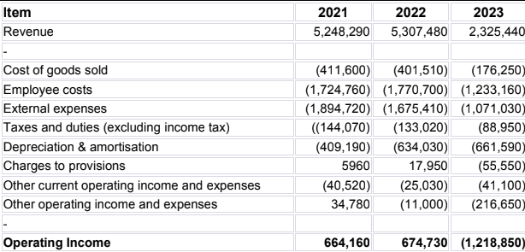
Figure 6: The City Hotel revenue and expenses
The reason behind poor revenue generation in 2023, can be stated due to the fluctuations that the industry has faced in terms of consumer demand, economic uncertainty, increase in operational expenses and intense competition. This has impacted the occupancy rates as well as customer satisfaction of the company impacting the overall financial position. The relationship between hotel occupancy and revenue and profit is well-established (Gogele, 2024) in the hospitality industry. From the presented table it can be noted that while the cost of goods sold has been reducing in 2023 when compared to the past two years, depreciation & amortisation have been increasing over the years. The same can also be observed in terms of charges to provisions as in 2021 it was 5960 GBP, during 2022 it was 17,950 GBP and in 2023 it had reached 55,550 GBP. These are the reasons and trends that the company has witnessed resulting in decreasing profits and increased expenses.

2.2 Profitability Trends
A profitability trend is the evolution of profit within a business. Profitability trends show the variations that the company witnesses in terms of profit levels over the different accounting years through an effective assessment of the income that the company has been able to earn through the operations that it performs (Kliestik et al., 2020). Taking this into consideration, it can be noted that in the case of The City Hotel, the company has experienced a significant decrease in earnings that is attributed to the unfavourable charges from the guests. According to Lacalle (2023), A room rate in a hotel is one of the most crucial decisions for a hotelier as it could positively or negatively affect the profits of the company. Therefore, to maintain competitiveness within the industry the company needs to control expenses while establishing competitive room rates that would allow the company to increase occupancy rates and profits.
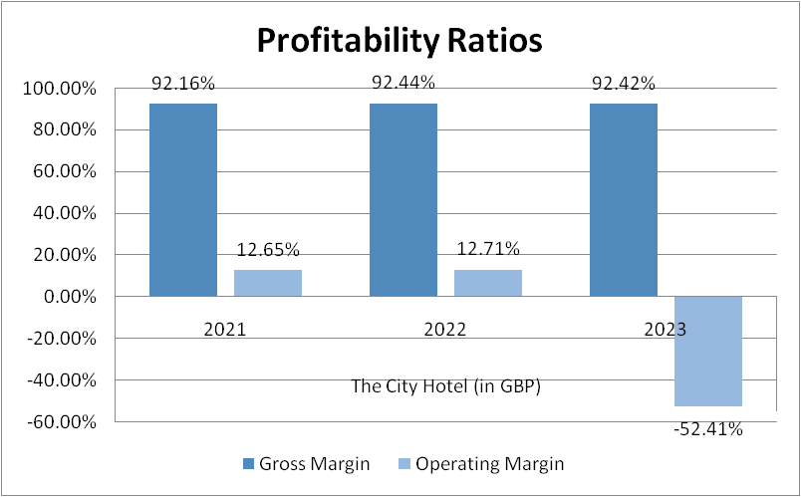
Figure 7: Profitability ratio
(Source: Created by the learner)
Based on the above-presented graph, it can be noted that while the company has been able to maintain the gross margin over the three years prior, the operating margin in 2023, witnessed a negative 52.41%. Operating margin is expressed in percentage and it is the ratio of operating income to the net sales revenue (Beaver, 2021). According to Zhang et al. (2021), a negative operating margin in a hotel indicates that the operating experience of the hotel is higher than its operating profits. Henceforth, The City Hotel needs to handle the demand of customers while also gathering feedback from them to enhance its service delivery and increase its profits.

2.3 Patterns of Liquidity
The changes in cash flow levels at The City Hotel are determined by the fluctuations that the company has witnessed in terms of liquidity patterns. The alterations in the financial strategies for upholding ideal cash reserves impact the company's liquidity status (Musiita et al., 2023). In the presented scenario, it can be noted that The City Hotel has experienced a significant decrease in profits and revenue which impacted the cash flow levels which are needed for addressing the obligations of the company. Henceforth, maintaining the perfect amount of cash reserved in the hotel would help the company improve liquidity and enhance financial results.
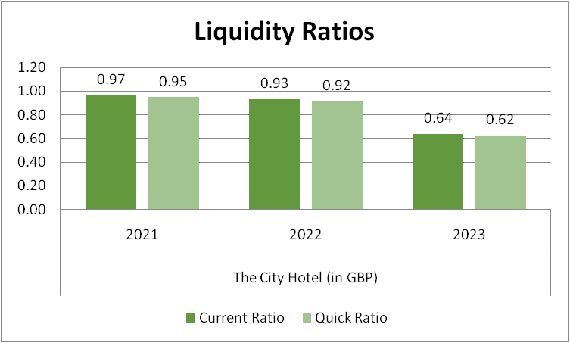
Figure 8: Liquidity ratio
(Source: Created by the learner)
According to Djohan (2023), liquidity ratios are relevant to cash flow as they help in determining the company's ability to cover the short-term obligations and cash flow of the company. Based on the presented graph it can be noted that from 2021 to 2023, the company has poised decreasing trends due to the availability of insufficient current liabilities for covering the liabilities of short term. The low occupancy rates in the hotels reduced the cash flow resulting in difficulty in meeting the financial constraints. Therefore, the sudden decrease in current and quick ratio from 0.93 and 0.92 to 0.64 and 0.62, indicates that the company has decreased the ability to generate cash. Therefore, the company could make use of the short-term assets to liquidate the company.

2.4 Trends of solvency
The solvency trends are important for the business as it helps the organisation in the management of long-term financial obligations of the firms and reduction in the financial risk of the company. Based on the debt-to-equity ratio of The City Hotel, it can be seen that the debt/equity ratio of the company has been increasing over the years. In 2021, the debt-to-equity ratio was about 3.60, which increased to 8.25. A higher debt-to-equity ratio means a company has been relying on debt for their operation heavily (Saputri and Naryono, 2024). It needs to be taken into account that further continuation of the trend can lead to the company facing bankruptcy in its business process.

Figure 9: Solvency ratios
On the other hand, the company's debt-to-asset ratio has steadily increased over the years. In 2021, the company's debt-to-asset ratio was approximately 0.63, which climbed to 0.74 in 2023. It signifies that the company's financial health is not good. (Source: Created by the learner)

3. Main reasons regarding the decrease in profit focusing on real-world events and the contemporary economy

3.1 Soaring labour costs and post-Brexit staff shortage
It needs to be taken into account that there have been real-world events that have been able to result in decrement of the profit of the company. One of the core problems that can be identified is that there has been an increment in the labour cost and a shortage of labour.
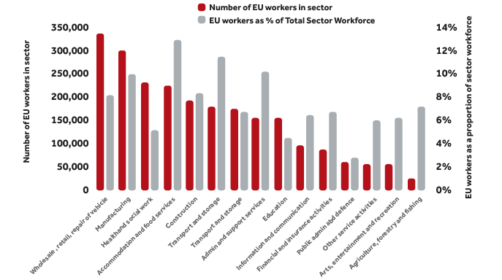
Figure 10: Number of UK workers in different industries of UK
(Source: Taylor et al., 2020)
The event of Brexit has created a labour shortage issue in UK hospitality. Taylor et al. (2020), in their study, mentioned that post-Brexit, UK hospitality has faced staff shortages due to restrictions on migrant labour. The study highlighted that more than 300,000 EU workers used to work in the accommodation and food services sector and they accounted for about 13% of the overall workforce (Taylor et al., 2020). Thus, the event of Brexit created challenges related to accessibility of the migrant labours in UK hotels and created staff shortage. On the other hand, the report of ONS (2024), highlights that in quarter 4 of 2021, there was a 0.9% increment in labour which was 9.6% more than the 2019 figures. These elements have been able to influence City Hotel's financial performance.

3.2 Cost of living crisis due to high inflation
Another major problem that has been able to impact the business of the organisation is the cost-of-living crisis. It needs to be taken into account as the living cost of the people, they have reduced their spending.
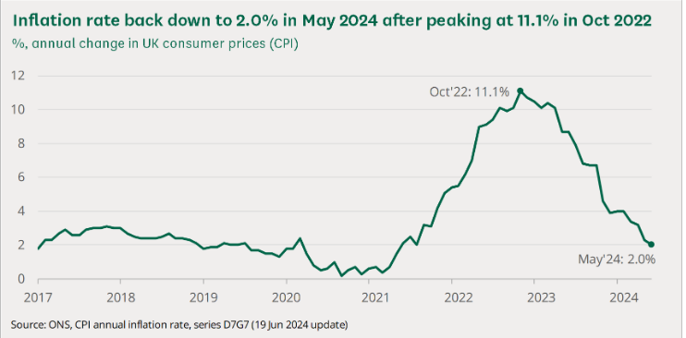
Figure 11: Inflation rate in the UK
(Source: Commonslibrary, 2024)
During the times of 2022, there has been an increment in the cost-of-living crisis in the UK. It can be understood from the report of Commonslibrary (2024), which highlights that the inflation rate reached 11.1% in October in 2022. It had been able to increase the overall operational cost of the City Hotel which led to the company facing issues related to their profitability. In November of 2022, the hotel bookings in the UK dropped by 35%, and in November of 2023, the hotel bookings had dropped by 37% (Statista, 2024). This had been able to make a significant impact on the financial performance of City Hotel, which reflected on their financial performance as well.

3.3 Changing consumer behaviour
It needs to be taken into account that there has been a change in consumer behaviour that has been able to make a negative impact on the financial performance of the companies. The report of Vanguardcleaning (2023), is able to highlight that 77% of holidaymakers have been searching for hygiene before booking a hotel. This change in consumer behaviour has been able to increase the hygiene cost of The City Hotel which has made an impact on the overall profitability of the company in a significant manner. Overall, it can be said that these elements have been able to make a significant impact on the profitability of The City Hotel.

4.0 Strategy that can improve the financial health of the City Hotel

4.1 Inculcation of modernising technologies in the services and product offer enables
It has been noted that the revenue of the City Hotel has seen a slump along with lowered customer satisfaction levels, it would become viable for the hotel firm to inculcate modernising technologies to enhance customer satisfaction. Integrated hotel technologies aided by IoT technologies, AI networks and many others significantly help in improving customer services. A seamless hotel technology integration speeds up the check-in and check-out processes for guests, making customers not obliged to wait at the front desk for check-in formalities ,all they need is a smartphone to check into their room contactless pattern.

4.2 Maximizing profit by controlling operational costs
With the ability to optimise the financial performance and ensure that the City Hotel is able to sustain for longer terms in the operational markets, the company can focus on controlling its operational costs. The focus on inculcating systems which would demand a limited role of people and mostly the operations conducted by hardware and software would significantly help the City Hotel to generate more revenue by spending less on the operational parameters.

4.3 Providing lucrative discounts and offers to attract customers and deal with the rising cost of living
As the cost of living is rising in the UK, the City Hotel can focus on curating lucrative offers for several seasons that can attract customers without hurting their pockets. As per the article of The Access group, it has been noted that hospitality companies such as the City Group can reduce the VAT. This would help hotel businesses to offer accommodation and rooms at a more attractive and affordable price (Theaccessgroup, 2024).

5.0 Conclusion
In order to conclude this section of the study, it has been noted that The City Group has experienced a declining revenue over the time of 3 years, from 2021 to 2023. The second also noted that the reasons that lead to the decrease in the profit of the City Hotel in relation to real-world events are the rising cost of labour and staff shortages, rising cost of living and changes in consumer behaviours. With regard to this, The City Hotel can focus on integrating modern technologies, such as the Integrated Hotel technologies aided by AI and IoT, which can be done along with maximising the profit by controlling the operational costs and providing lucrative discounts and offers to attract customers and deal with the rising cost of living.

References
Beaver, (2021) What Is Operating Margin? How to Calculate Your Business Operating Margin Available at: https://www.netsuite.com/portal/resource/articles/financial-management/operating-margins.shtml [Accessed on: 15 October 2024]
Commonslibrary, (2024) Rising cost of living in the UK. Available at https://www.ons.gov.uk/economy/economicoutputandproductivity/productivitymeasures/bulletins/labourcostsandlabourincomeuk/2022 [Accessed on: 15 October 2024]
Djohan, D., (2023). The Analysis of Liquidity Ratio as Tool to Measure Financial Position in PT. Iplug Indonesia at Medan. International Journal of Health, Economics, and Social Sciences (IJHESS), 5(3), pp.322-327. DOI:0.56338/ijhess.v5i3.3934
Gogele, (2024) Low Hotel Occupancy: Causes and Innovative Solutions to Overcome the Occupancy Crisis Available at: https://www.additive.eu/en/articles/low-hotel-occupancy-causes-and-innovative-solutions-to-overcome-the-occupancy-crisis.html#en-online-marketing-3 [Accessed on: 15 October 2024]
Kliestik, T., Valaskova, K., Nica, E., Kovacova, M. and Lazaroiu, G., (2020). Advanced methods of earnings management: Monotonic trends and change-points under spotlight in the Visegrad countries. Oeconomia Copernicana, 11(2), pp.371-400. https://doi.org/10.24136/oc.2020.016
Lacalle, (2023) 10 hotel rate types to maximize the revenue of your property Available at: https://www.mews.com/en/blog/hotel-rate-types [Accessed on: 15 October 2024]
Musiita, B., Boyi, B., Kisaalita, T., Mutungi, W. and Mbabazize, R., (2023). Liquidity Management and Financial Performance of SACCOs in Bushenyi District. Journal of Economics and Behavioral Studies, 15(3 (J)), pp.55-69. Retrieved from: https://ojs.amhinternational.com/index.php/jebs/article/view/3289[Accessed on: 15 October 2024]
ONS, (2024) Labour costs and labour income, UK: 2022. Available at https://www.ons.gov.uk/economy/economicoutputandproductivity/productivitymeasures/bulletins/labourcostsandlabourincomeuk/2022 [Accessed on: 15 October 2024]
Răducanu, F., (2022). Model the Diagnosis of Profitability of the Enterprise. Romanian Review of Statistics-Supplement, (5), p.155. http://www.revistadestatistica.ro/supliment/wp-content/uploads/2022/07/rrss06_2022_08_en.pdf[Accessed on: 15 October 2024]
Saputri, A.F. and Naryono, E., (2024). The effect of debt to equity ratio and current ratio on return on equity: Case study at PT. Duta Pertiwi Tbk, on the Indonesia Stock Exchange for the 2016-2023 Period. Jurnal Ekonomi, Manajemen Dan Akuntansi, 2(04), pp.699-710. doi: https://ip2i.org/jip/index.php/ema/article/view/168
Statista, (2024) Year-over-year monthly change in number of hotel bookings in the United Kingdom from January 2020 to October 2023. Available at https://www.statista.com/statistics/1339613/change-in-monthly-number-of-hotel-bookings-in-the-uk/ [Accessed on 15 October 2024]
Taylor, H., Florisson, R. and Wilkes, M., (2020). Post-Brexit Labour Supply and Workforce Planning. Work Foundation. Doi: https://www.lancaster.ac.uk/media/lancaster-university/content-assets/documents/lums/work-foundation/7097-LUni-WorkFoundation-Brexitv4.pdf
Theaccessgroup. (2024). How Hospitality Will Survive The Cost of Living Crisis. [online] Available at: https://www.theaccessgroup.com/en-gb/blog/hos-how-the-cost-of-living-is-impacting-hospitality/.[Accessed on: 15 October 2024]
Vanguardcleaning, (2023) Behind The Fresh Sheets: Decoding The Hygiene Standards Of Hotel Rooms. Available at https://www.statista.com/statistics/1339613/change-in-monthly-number-of-hotel-bookings-in-the-uk/ [Accessed on 15 October 2024]
Zhang, D., Xie, J. and Sikveland, M., (2021). Tourism seasonality and hotel firms’ financial performance: Evidence from Norway. Current Issues in Tourism, 24(21), pp.3021-3039. Available at: https://www.tandfonline.com/doi/abs/10.1080/13683500.2020.1857714[Accessed on: 15 October 2024]

Appendices

Appendix 1: Calculation of ratios

