Mikolaj Michalski (1900885)


By
Mikolaj Michalski
Project submitted as part of the requirements for the award of BSc (Hons) Computing (Computer Networks and Cybersecurity)
April 2022

Securing a Home Network Against Denial-of-Service Attacks
SUPERVISOR: DR KAPILAN RADHAKRISHNAN SECONDARY MARKER: DR CARLENE CAMBELL

Declaration of Originality

I, Mikolaj Michalski declare that I am the sole author of this Project; that all references cited have been consulted; that I have conducted all work of which this is a record, and that the finished work lies within the prescribed word limits.

This work has not previously been accepted as part of any other degree submission.

Signed : Mikolaj Michalski

Date : 01/04/2022

FORM OF CONSENT

I Mikolaj Michalski hereby consent that my Project, submitted in candidature for the B.Sc.(Hons) Computer Networks degree, if successful, may be made available for inter-library loan or photocopying (subject to the law of copyright), and that the title and abstract may be made available to outside organisations.

Signed : Mikolaj Michalski

Date : 01/04/2022

Abstract
This research has been made to investigate the security of home networks against denial-of-service attacks. Within this area, there are several existing research papers and conferences that covered similar aspects of the project. These papers have been used as research for this project and used within the literature to build up better knowledge into the fields that have been covered. Some of the articles provide a deeper insight into the way that DDoS attacks affect home networks while also providing a solution to detecting them and protecting the network from other attacks in the same manner. Those related works that are covered assisted in the completion of the project while also giving a deeper understanding into home network security and the attacks covered. An experiment has been conducted that includes a simulation of a home network through the simulation software called packet tracer. As well as the implementation of the home network was done into a virtual environment using VMware. The experiment covered different denial of service attacks on the network. These attacks consist of a DoS attack, DDoS attack, and a Botnet DDoS attack. The attacks that were conducted on the network were successful which required a security solution to combat these attacks. The solutions for the attack consisted of a well configured firewall, antiviruses as well as training for the users to not click malicious emails. The security methods have been suggested alongside additional changes or additions that can be made to secure the network even more. The methodology that was chosen for this report is the research onion framework. This method provides a clear guide in which way the research is to be gathered and using the framework allowed for better explanation and understanding of where, how, and why the information was gathered. The report uses several different data sources ranging from books, journal articles, conference proceedings etc. While the main source of data came from the experiment that was conducted. Using the information gathered from the literature review, analysis of related works, and the results from the experiment it covers all the objectives and deliverables that have been set.

Contents
Acknowledgements 5
Copyright Acknowledgement 5
Chapter 1 6
1.1. Introduction 6
1.2. Aim 6
1.3. Objectives 7
1.4. Structure of the project 8
Chapter 2 – Literature Review 9
2.1. What is a Network 9
2.2. Standard network communication models 10
2.2.1. OSI Model 10
2.2.2. TCP/IP Model 12
2.3. What is a home network? 13
2.4. Network security 15
2.5. Securing a home network 16
2.6. Mitigating security issues / preventing attacks 17
2.7. Botnets 19
Chapter 3 – Research Methodology 22
3.1. Introduction 22
3.2. Overview of research 22
3.2.1. Onion layer 1: Research Philosophy 22
3.2.2. Onion layer 2: Research Approach 23
3.2.3. Onion layer 4: Choices 23
3.2.4. Onion layer 3: Research Strategy 23
3.2.5. Onion layer 5: Time horizon 24
3.2.6. Onion layer 6: Techniques and Procedures 24
3.3. Data Collection 25
3.4. Gantt Chart 26
3.5. Risk and limitation 27
3.6. Deliverables 28
3.7. Conclusion 28
Chapter 4 - Design & Implementation 29
4.1. Introduction 29
4.2. Problem formulation 29
4.3. Design 30
4.4. Implementation 34
4.5. Conclusion 43
Chapter 5 – Evaluation 44
Chapter 6 – Conclusion and Recommendations 47
6.1. Conclusion 47
6.2. Recommendations for future research 49
Chapter 7 – Reflections 50
References 52

Table of Figures
Figure 1: OSI Model [3] 9
Figure 2: TCP/IP Model [5] 11
Figure 3: Example of home network [8] 12
Figure 4: proposed framework for quantitative information [17] 15
Figure 5: Onion research [30] 19
Figure 6: Old Gantt Chart [31] 22
Figure 7: New Gantt Chart [32] 22
Figure 8: Picture of topology created in Cisco Packet Tracer 25
Figure 9: Website opened through PC in PT software 26
Figure 10: Showing additions to network topology 27
Figure 11: Launching a flood attack in PT 27
Figure 12: Result of flood attack 28
Figure 13: VMware set up for the project 28
Figure 14: Victims computer using a search engine 29
Figure 15: Attacker scanning network 29
Figure 16: Attacker scanning for ports 30
Figure 17: Attacker setting up and launching attack 30
Figure 18: Wireshark result on victims computer 31
Figure 19: Setting up a DDoS attack 32
Figure 20: Victims computer unable to load the website 33
Figure 21: Wireshark crash during attack 34
Figure 22: Attacker opening a port and listening on it 35
Figure 23: Victim opened malicious link running a PowerShell script connecting to the attackers open port 35
Figure 24: Attacker has access of victim’s computer 36
Figure 25: Attacker launches a flood attack from victims PC 36
Figure 26: Attacker launches additional attacks to create a botnet DDoS 36

Acknowledgements

Copyright Acknowledgement

I acknowledge that the copyright of this project report, and any product developed as part of the project, belong to University of Wales Trinity Saint David, Swansea.

Chapter 1

Introduction
Networks allow everyone to communicate together to what seems like a limitless scale. With more technological advancements, security is in serious demand to maintain the privacy that is held in networks. The problem that is going to be covered in this report is the current security of home networks and to see how well they handle different types of denial-of-service attacks. This has been decided because after some research it was found that most internet users buy their home routers and don’t configure any network security for the newly generated network. because of this it allows for easy access for several hackers and through this report and testing it will be clear whether the networks need improved security or if the users need to have instructions on setting up security to ensure their own online safety. To do this the implementation will create a virtual home network that will then have different types of DDoS attacks launched at it to test the security.
This chapter covers the overall aim of the project. The aim will help deliver a solution to the project scenario which is broken down into more manageable steps through the objectives. Finally, the first chapter of the structure of the project helps show the approach that will be applied to the literature review as well as the research and practical project. The second chapter of the document covers the literature review which is the section that covers the research for this document. This covers the OSI model which is a standard that was made for computer systems to interact with each other. Following that is the model for TCP/IP, which is the communications model that started being used as a standard due to its efficiency and accuracy. It helps divide the duties into levels by using CP/IP. The literature review covers the difference between a home network and a company network due to the strong differences between the two in terms of design and security. While later covering the mitigation of security issues, preventing attacks, and covering botnets. The botnet section covers how they work as well as a more in-depth look at how they can group in a DDoS attack.
The project will investigate security measures that can be set up to protect a home network from a botnet attack. This will first be demonstrated in a simulation and then attempted to be recreated in VM software for safety and legal reasons. This project will help show how to secure the home network to be protected against DDoS attacks. The purpose of this attack is to also see how a botnet attack will affect the typical home network. Seeing if the normal configurations can protect the users from getting booted offline.

Aim
This project aims to see how secure a home network is against different types of DDoS attacks. The results will be compared to a direct security approach against DDoS attacks to see how well it competes at securing a network.

Objectives
The objectives for this project are:
- Create a critical literature review of the research conducted to demonstrate the knowledge gained.
- Document and cover different types of research that can be used for the project. Create a project plan to show the time management over the course of the project.
- Utilise the knowledge gained from the review to recreate a network and experiment with different security measures to successfully protect and secure the network.
- Testing the security implemented in the network to see if it will protect it from a DDoS attack.
- Creating methods that will resolve any of the vulnerabilities found during the tests, (if it’s possible to secure in the timeframe). These methods would then be retested to ensure the new network improvements have made it more secure.
- To evaluate whether the security issues in the network are caused by the users or by out-of-date security.

Structure of the project
The project is split up into different parts. The start is the theoretical work that has already been done and helps pin the project. This relates to the way the theory has been learnt either inside or outside the classroom. The second part goes over the project itself and the research that was done. The research for the network will have to undergo an analysis to cover what was done. Another analysis will have to be done on the network itself. Finally, the third part covers what was found after the network was constructed. This can cover any issues along the way as well as security that had to be added to improve the network.
Chapter 1 covers the introduction to the review and what it is going to be about. This also contains the aims and objectives which inform the reader on what was initially planned when going into creating this project. This also covers the way that the report is written to help break down the information.
Chapter 2 covers the research and review of the literature that is used. It contains an introduction that summarised what the chapter covers, followed by a methodology. This will then contain all the images and references that were used to help inspire and produce the network.
Chapter 3 covers the research methodology. The introduction covers the chapter quickly to get a better understanding. It contains a research overview that goes over the philosophy, process and methodologies that have been used when doing the research. It also covers the data collection over time, research design and the research deliverables. It contains a conclusion at the end to finalise what is to be delivered and expected after the research is made.
Chapter 4 covers the design and implementation of the network. It starts with another introduction which moves over to the problem formulation. It then contains the design of the network and how it will be implemented. Finishing off with another conclusion to the chapter.
Chapter 5 covers the testing and evaluation of the tests that will be conducted on the network. this will cover the changes made and potential improvements to the network.
Chapter 6 is the conclusion which summarises what happened throughout the project. It gives a conclusion and recommendations on how to further the research that was made during the project.
Chapter 7 is the reflections page.
Chapter 8 is the section for the references used.
Chapter 9 is the bibliography containing all the used materials through the project.

Chapter 2 – Literature Review

2.1. What is a Network
A computer network is something that is used on a day-to-day basis. To go into detail a computer network is a collection of computers that share resources shared by network nodes. To interact with one another, the computers employ standard communication protocols across digital linkages. There are several benefits to having a computer network. not only does it act as a basic form of communication in computing. But it also enables the sharing of information as well as several different resources that would improve work efficiency. The connected devices are usually connected either by a wired or wireless communication link allowing them to then share the data through the data communication system. There has been research done into computer networks and the impact they have on development from as far as 1996. [1] In this article by Larry Press he explained how computer networks are being used for many different sectors for communication as well as improving efficiency, quality and even equity. In comparison, [2] this conference by Xiaoling Sun that was done in 2011, further proved the point that was made by Larry Press, In this conference, he mentions how with the information age where the networks are used in several different fields of society, they have promoted the rapid development in techniques and culture while making great economic and social benefits.
However, with networks, there are several different protocols that should be in use to help the network run without issues, as well as run more efficiently or even be more organised. Protocols help characterise and provide standards in networks making them far more manageable for the network technicians.

2.2. Standard network communication models

2.2.1. OSI Model
The International Organization for Standardization (ISO) developed the open systems interconnection (OSI) model, which allows different communication systems to communicate via standard protocols. In layman's terms, the OSI establishes a standard for computer systems to interact with one another. The OSI Model may be thought of as a universal computer networking language. It's based on the idea of breaking down a communication system into seven abstract layers that are piled on top of each other.

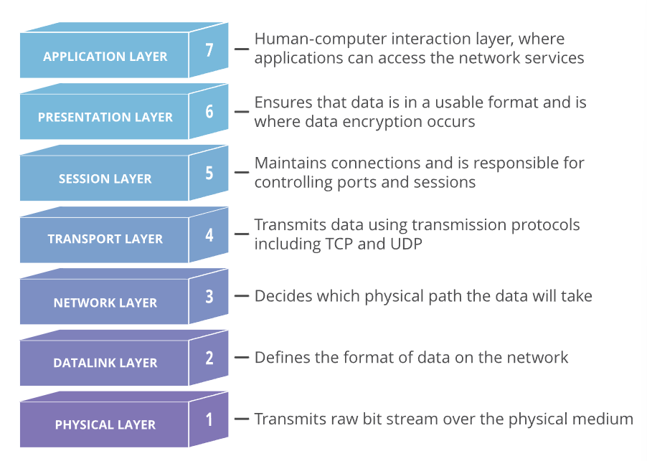
Figure 1: OSI Model [3]
Layer 7 Application layer
When a user — human or software — chooses to receive messages, transfer files, or conduct other network-related tasks, the application layer allows them to engage with the application or network. Layer 7 application protocols are used by web browsers and other internet-connected programmes like Outlook and Skype.
Layer 6 Presentation layer
Based on the semantics or syntax that the application accepts, the presentation layer converts or prepares data for the application layer. This layer also manages the application layer's encryption and decryption requirements.
Layer 5 Session layer
Conversations between apps are set up, coordinated, and terminated via the session layer. Authentication and reconnection after an interruption are among the functions it offers. This layer specifies how long a system will wait for a response from another programme. X.225 and Zone Information Protocol are two examples of session layer protocols (ZIP).
Layer 4 Transport layer
The transport layer is in charge of moving data over a network while also providing error-checking and data flow management techniques. It decides how much data to send, where it should go, and at what speed. TCP, which is part of the TCP/IP suite, is the most well-known transport layer example. This is where TCP port numbers are assigned to categorise and arrange data flow over a network.
Layer 3 Network layer
The network layer's principal job is to transport data into and out of other networks. This is accomplished by network layer protocols packaging data with the right network address information, identifying appropriate network routes, and passing the packaged data up the stack to the transport layer. From the standpoint of TCP/IP, this is where IP addresses are used for routing.
Layer 2 Data-Link layer
A program's data link, or protocol layer, is responsible for transporting data into and out of a network's physical link. This layer deals with issues that arise from bit transmission defects. It makes sure that the data flow isn't too fast for the transmitting and receiving devices. Data can also be sent from this layer to Layer 3, the network layer, where it is addressed and routed.
The data-link layer is further broken down into two sublayers. Multiplexing, flow control, acknowledgement, and warning upper layers if transmit/receive (TX/RX) faults occur are all handled by the higher layer, which is known as logical link control (LLC).
The media access control sublayer is in charge of tracking data frames using the transmitting and receiving hardware's MAC addresses. It's also in charge of structuring each frame, including identifying the beginning and ending bits and determining when each frame may be delivered via the physical layer media.
Layer 1 Physical layer
Data is transported through the physical layer via electrical, mechanical, and procedural interfaces. This layer is in charge of transmitting computer bits over the network from one device to the next. It controls how physical network connections are established, as well as how bits are converted into predictable signals and transferred through electrical, optical, or radio waves. [4]

2.2.2. TCP/IP Model
The US Department of Defence created TCP/IP to define how computers communicate data from one device to another. TCP/IP places a high value on precision, and it takes numerous steps to verify that data is delivered accurately between the two machines. The diverse communications duties are divided into levels by CP/IP. Each layer has a distinct purpose. Before being received on the other end, data passes through four levels. TCP/IP then reassembles the data and presents it to the receiver by going through these levels in reverse order. The layers' objective is to keep things standardised so that several hardware and software providers don't have to deal with communication on their own. It's like driving a vehicle: all the manufacturers agree on where the pedals go, so we know what to expect from one car to the next. It also implies that particular layers may be upgraded without having to change the entire system, such as to increase performance or security.

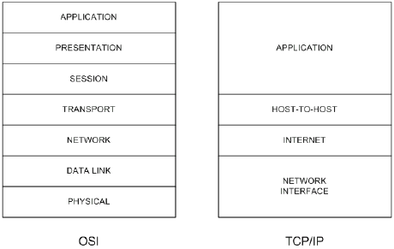
Figure 2: TCP/IP Model [5]
The TCP/IP model's four levels. TCP/IP stands for Transmission Control Protocol/Internet Protocol. It is a data link protocol that is used on the internet. It has four unique layers in its model. They can also be referred to as a protocol suite when used together.
Datalink layer
The data link layer (also known as the link layer, network interface layer, or physical layer) is responsible for the physical aspects of data transmission and reception via Ethernet cables, wireless networks, network interface cards, computer device drivers, and so on.
Internet layer
The internet layer (also known as the network layer) is in charge of packet flow throughout the network.
Transport layer
The transport layer is responsible for establishing a secure data connection between two devices. It breaks data into packets, acknowledges packets received from the other device, and ensures that the other device recognises packets received.
Application layer
The application layer is a collection of apps that need to communicate through a network. This is where the user interacts most frequently, such as through email and messaging. The apps don't have to worry about communication intricacies because the lower layers take care of it.
[6]

2.3. What is a home network?
A home network is a collection of devices that link to the Internet and each other, such as computers, gaming systems, printers, and mobile devices. There are a few ways for home networks to connect. One of these ways is through A wired network is one that uses wires to link devices such as printers and scanners. While another way is done through wireless, which wirelessly links gadgets such as tablets and e-readers. On top of this, there is another option which is very widely used as of now. This is a mix of both. As home network routers are advanced usually providing both a Wi-Fi and wired connection allows the network to be more accessible to different devices.
There are several reasons why having a home network is important [7]. Connecting to the Internet via a variety of devices, including PCs, game consoles, mobile phones, and more. All devices linked to the network may access files and directories. On a single printer, you may print from several PCs. All networked devices' security settings may be managed in one spot. All of these help make working at home as well as doing a lot of day-to-day things more efficient.
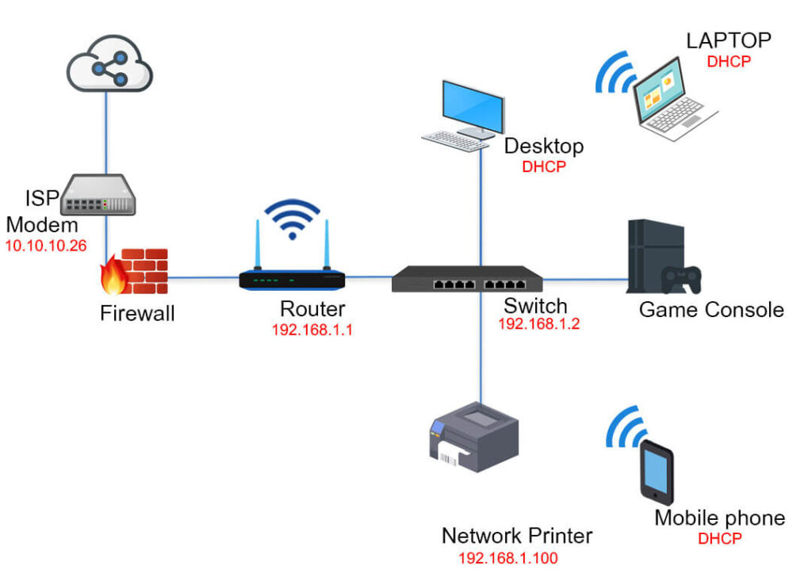
Figure 3: Example of home network [8]
The figure above is an example of a home network. There is the use of both wired and wireless devices. As visible there is a wide array of devices connected to the network. However, not every home network uses a switch. Due to the improvement in technology, it’s more common for important devices such as a personal computer to be connected directly to a router while the rest of the network including the printer would be all connected wirelessly. This is because wireless connections are now much stronger as well as faster than they ever used to be. A wired connection will be used for the important device to have a more secure connection to the network.

2.4. Network security
There has been similar research conducted in the same field of study. The research can be used to compare and find out what might need to be done to get a correctly working and secure network.
This article by Ning Zhang states that: [9]
“The requirements for security are best assessed by examining the various security threats faced by an organization.”
This shows that security requirements may heavily differ from organisation to organisation. Having a good team to break down security threats is also important as without this the changes would not be found and implemented to improve everything. To further support this point this is a quote from the “Network Security Evaluation and Threat Assessments in Enterprise Systems” book: [10]
“Research that includes Literature Survey and Face-to-Face interviews regarding the issues and concepts on Enterprise systems network.”
This suggests that finding security issues and any potential threats will involve several different measures. In this scenario, the individuals decided to use surveys as well as interviews with the people who know of some of these issues. To compare, the project security will be implemented based on the average network. Which will then be improved upon by testing the security and eliminating any threats.
While there are plenty of ways in which you can find threats within a network. There can already be several things done to reduce the threats in the network. Mitigating potential security issues can help in the long run as you are simply providing a small layer of protection beforehand that could deter some less advanced hackers from their attempts of attack. There are several different types of attacks that can be done. After some research has been done into these attacks it has been found that 85% of breaches are done through the use of a human element [11]. What this means is that the attack involved some sort of human usage, something as simple as clicking a link that prompts a download. This would then sneakily infect the computer with dangerous files. This can be easily mitigated. With the correct training provided to staff, this issue would happen less. Having a set rule on making sure a link is safe before opening it from an email is also important. This would hopefully deter people from opening random emails that have been sent. [12] On top of this 36% of breaches have been done through phishing, which is an increase of 11% from last year. This shows how important correct explanation and training of employees is. Finally, another statistic involving breaches shows that 10% of the found breaches involved the usage of some ransomware, this doubles the frequency that was last year [13]. What can be gathered from these statistics is that the threats keep evolving and it is important to keep track of them and be updated on everything. Its common knowledge that staff might be trained to avoid these issues. however, with new technologies and threats on the rise, there are some new tactics and ways in which hackers succeed with these breaches. The best way to avoid this is through something like weekly meetings. These meetings can include any new threats on the rise and what must be avoided. Another way can be forcing the spam emails involving any obscure links to either be directly refused or just sent straight to trash/deleted.

2.5. Securing a home network
The research done into home network security was done simply because of the differences between the threats of a company network and a home network. as said previously the attacks on company networks are usually a bit more sophisticated.
With a home network security differs a lot. Because everything is linked to one router it’s important to ensure the password is changed from the default one that is given. While this seems like an obvious thing to do for security research it found that only [14] 10% of UK adults change their home router passwords once a month. And only around 22% do this less than every 2 years. This research also found that 55% of the users will never change their passwords. With something like this in mind it's extremely important to change the password as just the default security measure for the home network.
However, some of the attacks that can still happen are DDOS attacks. There are ways to prevent these attacks from happening and usually, these attacks can happen from internet trolls that want to mess with people. as someone who has personally had this happen due to playing certain games. Users will pull IPs through in-game lobbies. As everyone is connected to the same hosted game when the troll decides to pull IPs it will display everyone within the lobby. Luckily with new security measures implemented in games, this is a less common action. But even in some video calling applications such as Omegle where users meet random people online with usually the intention for a quick conversation or to make friends. Users have found ways to take IPs and locations directly from the calls. With this information, some people like to show a display of power by doing a simple volumetric attack on the network. The high flood packets this can sometimes cause the network to shut off to avoid damage.
To stop these from happening there are a few ways that can be done. [15] One of the ways to prevent this is through continuous monitoring of network traffic. Real-time monitoring alongside the use of looking for early warning signs such as a slower network speed is a great way to notice a DDOS attack happening. Another way is setting up high levels of network security such as ensuring the firewall will block out an excessive amount of network traffic coming from an unknown source.
There are different solutions to solving DDoS attacks within home networks. In a conference from 2020 by Utkarsh Saxena, JS Sodhi and Yaduveer Singh [16] they provide a framework for the approach against DDoS attacks aimed at home networks. This approach covers network traffic capture, different types of data collection using software such as Wireshark, setting up a choking node which selects the maximum amount of input connections and finally an algorithm that identifies the shortest path for packet transmission to help identify and mitigate attacks such as the DDoS attack. This is a great approach to mitigating and protecting the network from issues.

2.6. Mitigating security issues / preventing attacks
When mitigating security-related issues in a network it is important to identify the cause of the issues as well as where the issue occurs. This can be found by using a security risk assessment which helps identify any weak points that are in the network. Here is a great example of a good security risk assessment process in a network:
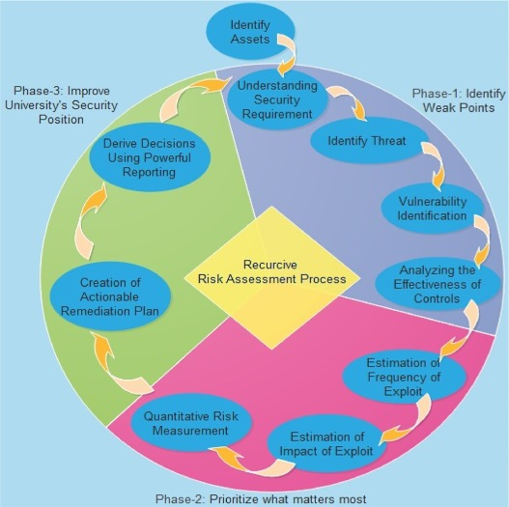
Figure 4: proposed framework for quantitative information [17]
In this process, there is a clear strategy to mitigate all if not most of the issues within the network. This starts by identifying the network assets, this being the devices within the network as well as the connections. Forwarding that comes identifying the threats that appear in the network, followed by any vulnerabilities that can be found. The last step of identifying weak points is left with analysing the effectiveness of the current controls in the network. this would be done to see how well they can be dealt with in the current state of the network to prioritise the issues from urgent to mild. The second phase of this process is where the prioritization of the issues begins. To start this process, you simply begin with looking into and estimating how often an exploit that has been found can be done. This can be checked in several ways, whether this is a backdoor or some sort of easy access into the network. After discovering how frequent the exploit can be done you then move on to the impact of the exploit. This is a very important step as it helps determine the scale of the exploit whether it would affect a single PC, a section of the network or even the whole network. The final step in phase 2 is the quantitative risk measurement. This is the calculated risk based on the frequency and impact of the exploit. This then gives the measurement of the security risk level, ranging from low to high. The final phase of the process is improving the security of the network. To be this you use the information gathered from the tests and research of the previous phases, doing so you then create an actionable remediation plan to help act upon the issues. This plan would cover the highest risks that were calculated previously and then use the remediations to help secure and cover the issues in the network. Finally, the last step is reporting the results of the risk assessment on official report format. This report will be sent to the senior management which will make decisions based of several fields such as budgets and policies. The final report of the risk assessment will then be used as part of phase 1 in a future cycle of risk assessment procedures.
This framework can help cover the majority of the issues that can appear in the network. However, when it comes to certain network attacks, they could still find ways to go through the security. using botnets as an example. They are versatile as they can conduct several different attacks, with the most common one being a DDoS attack.

2.7. Botnets
A botnet is a collection of linked devices that individually operate one or more bots. Botnets may be used to launch DDoS assaults, steal data, send spam, and give the attacker access to the device and its connection. To look a little more in-depth looking at how botnets work. When using a botnet to conduct a DDoS attack it uses the machines that are infected. A botnet is a group of malware-infected machines known as zombies that are managed by a criminal entity known as the botmaster. The zombies are controlled remotely by a botmaster who issues commands to them. How the bots are controlled will depend on what control mechanisms are used as well as the architecture of the botnet. It is now common knowledge that approximately 80% of all email traffic is spam and most of the messages are sent through botnets. [18]
Work has been done to stop botnets from being able to DDoS certain things. As an example, in this conference [19], Qaisar Shafi and Abdul Basit cover the prevention of botnets using SDN and blockchain architecture. It mentioned that SecPoliMod(SecurityPolicyModule) is used to prevent the entire IoT network from becoming a botnet, by implementing security regulations and designating a list of permitted IoT devices that meet basic security requirements. The overall application and administration module for the entire IoT DDoS botnet protection network is this module. It also serves as a user interface for the control programme.
In a random DDoS attack bots attempt to hide the malicious activity by disguising the patterns as normal traffic patterns. Two strategies that can be used to detect a botnet attack. The first is based on cluster expurgation, whereas the second is based on a union rule. Both methods are tested for consistency under ideal settings, as well as their performance on real network traces [20].
In this conference by Kashif Naveed and Hui Wu [21], it is said that Botnet assaults on IoT devices are a serious worry these days and detecting them is a hot topic of research. Artificial Neural Networks (ANNs) have demonstrated their effectiveness in detecting botnets. However, the process of selecting and training ANN structures has been iterative and exploratory, with a random number of layers holding an arbitrary number of neurons as a starting point. The experimental results show that our work outperforms the manually designed network architectures in terms of computational efficiency. The solution that was found from the conference was a framework that learns over time that detects attacks. The results also help prove the overall efficiency of the solution that was provided by the speed and accuracy of the framework. While the whole solution couldn’t work within this project some parts of the framework could still be used to secure the network from such attacks.

2.8. Related works
Real-time detection of DDoS assaults is a challenging task due to the growing sophistication of attack patterns. There are many ways in which a DDoS attack can be approached. M Robinson, J, Mirkovic, M, Schnaider, Michel and Reiher [22] suggest that 5 issues can occur and therefore should be considered when creating a good DDoS defence system.
- Since DDoS attack detection is fundamentally a distributed problem, an effective distributed solution is excellent for detecting DDoS attacks.
- The actions of legitimate users should not be harmed by a DDoS defensive system.
- A defensive strategy must have proper security mechanisms not just against exterior threats, but also against internal dangers that might assist DDoS assaults from within a network.
- A defensive system should be scalable, with strong economic incentives for deployment.
- The defence should be created in such a way that it may be a component of a larger solution that can be built over time, rather than being a comprehensive answer for all issues.
When looking at the article and the reasoning behind the issues it was found to be relative to this project. It’s important to make sure that these issues will not occur so that within the network everyone can have the same experience without being affected.
There has been quite a lot of research done into finding a successful security approach against DDoS attacks whether they’re normal DDoS attacks or larger scale botnet DDoS attacks. [23], [24], [25], [26]. The security systems and methods have been covered in-depth with different approaches being tested and used to find the more efficient security approach. The research conducted has been done using similar and, in some cases, the same approaches as in other pieces of work. Because of this it is thought that some approaches are far more efficient and popular than others.
One of the approaches that can be taken to stop DDoS attacks is using a source-end DDoS defence system. [27] in a solution by Nazrul Hoque, Dhruba K. Bhattacharyya and Juigal K. Kalita it is said that source-end DDoS defence systems are very good at stopping the attacks closest to the source. This means several things. One of them is that it reduces the congestion within the network traffic and saves resources in the network as it stops the attack closer to its point rather than it is travelling further down the network. Another one of the reasons is that it helps reduce the chance of filtering traffic compared to the attack traffic in the network as well as reduces the chance of collision between those two separate traffic flows. Finally, it’s said that this is an easy way to trace back to the location while also providing a very high accuracy due to the low traffic flow in the network. When comparing this to the project it was found that this method could be used to help detect an incoming DDoS attack. Furthermore, if the network was to be set up within a switch all the traffic flow could be split into separate streams making incoming traffic even easier to scan through and therefore detect any incoming attacks on the network.
The second related work was conference papers [28] that are in the same field of study. This was very helpful as a source of information regarding the project. It covers several Distributed Denial of Service (DDoS) attack information that furthered the knowledge and helped get a greater understanding of the topic. It covers an approach to DDoS attack detection within a smart home networking using the shortest path algorithm. This conference suggests that the DDoS attacks make the network more vulnerable than normal DoS attacks due to there being more than one origin of the attack. It covers that a remedy must be taken to counter-affect the DDoS attack that will be sent to a home network. it also covers the different types of attacks that can occur on the network those being passive attacks and active attacks, it covers the different defensive schemes that can be used against DDoS attacks including the topological Sequential Defence Scheme, and the Game Theory and Fusion Defence scheme and the Topological Defence Scheme.
The third article [29] covered securing a home network. This article helped further expand the understanding of home network security when going through this project. This is because the article covered several different areas of in-home network security. The source covered the upcoming 5G in era which the networks are said to be powered by mobility management meaning that the users will be able to have a lot of remote access to control the in-home Internet of Things (IoT) sensors and appliances no matter where they go. It also covered a large-scale solution to this issue which would be “Distributed IP Mobility Management” (DMM). This would be considered as it addresses the limitation of the centralized approaches as well as their architecture as it is suitable for 5G networks. This article also covered how the home networks without the correct protection would be extremely vulnerable to various security threats. Especially, as it’s important to protect the data traffic that is transmitted between the in-home IoT devices as they may include very sensitive and private user information. Because of this the article also informs that it is necessary to support secure route optimization. This allows the devices in the network to establish communication directly in a secure method while reducing the possibility of information leaks during the communication. The source also states that because there has been no previous secure route optimization for DMM networks they have proposed a protocol for DMM-based smart home systems. This article also mentions that the proposed security protocol that was created, is composed of route optimization initialization and handover phases. It also said that because of this it’s designed to provide a key exchange, mutual authentication, privacy protection and perfect forward secrecy. Finally, the source also covers that the security is thoroughly verified through two security analysis tools which are Automated Validation of Internet Security Protocols and Applications (AVISPA) and BAN-logic.

Chapter 3 – Research Methodology

3.1. Introduction
This chapter covers the methodology that was chosen for the project. The methodology that was chosen was onion research. As the chapter progresses it covers the different layers of the research followed by the data collection methods used throughout the report. It shows the difference in the Gantt chart over time with any changes that have been made. Finally, it covers the risks and limitations of the project and the conclusion of the chapter with some of the deliverables that are expected.

3.2. Overview of research
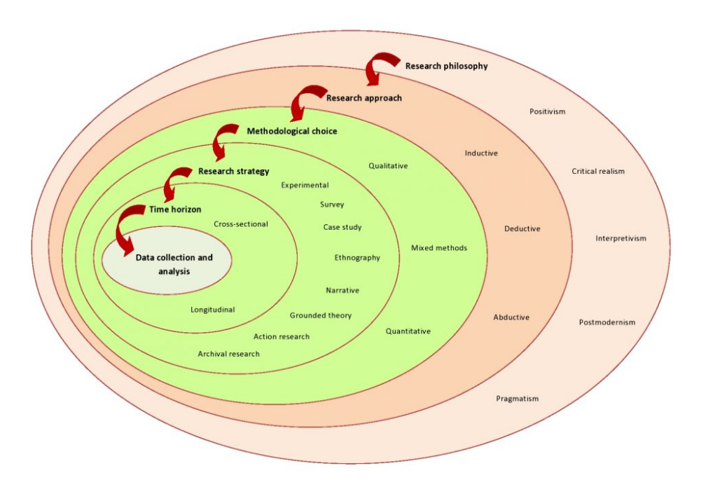
Figure 5: Onion research [30]
The research that was conducted was taken in several different steps to get a wide range of different findings. There were several topics covered throughout the research with more research being done in the more relevant fields such as network security mitigation. The data that was collected was taken from different types of experiments and studies that have previously been done in this field, while some were similar enough to be compared to each other as well as compared to the project itself. To carry out the research the onion research method will be used. Using the layers as a guide to gather information for the research design.

3.2.1. Onion layer 1: Research Philosophy
Starting with research Philosophy. Research philosophy is a set of beliefs about how to collect, analyse, and apply evidence on phenomena. For this layer, it was decided that Pragmatism was going to be the best to use. Pragmatism is approaching research from a practical point of view. A scenario that is constantly questioned or changed. Because of this, it’s believed that this is the best option for the project. This is because many different things that can change the scenario of the project. The attacks on this project could happen in different ways. However, has been chosen to be a DDoS attack specifically through a botnet during this time. This all can change depending on the outcome of the tests and simulations that will be conducted as well as the time constraint.

3.2.2. Onion layer 2: Research Approach
The research approach is the 2nd layer of the onion method. This is where the broader method is chosen for the research chosen between inductive, deductive, or abductive. For this research, the inductive approach will be used due to the link with qualitative research. The use of qualitative data is preferred over quantitative data. Qualitative data is data that is non-numeric, such as diaries, and surveys. Rather than being used in their entirety, have been combined at various stages. Whereas quantitative data is data that is in form of counts or numbers, data sets that have their association with them are a type of quantitative data. While this information is valuable and useful in several cases, it still will differ depending on the scenarios. Because the data can vary, qualitative data is easier to understand and is better suited for comparing it to related or similar data.

3.2.3. Onion layer 4: Choices
Another layer of the onion method is choices. This is about choosing how many types of data will be used within the research that is going to be conducted. There are 3 possible options mono, mixed and multi-method. For the mono method, this means only one data type will be selected for all the research, for example choosing qualitative data only will mean you’re only able to gather that type of information as research. There is the mixed method option which covers the approach of using both the quantitative and qualitative data. finally, the multi-method approach is made through a wider range of approaches. Which requires the use of more than one quantitative and one qualitative approach. For this project, the method that is going to be used is going to be the mixed method. This is because the data will be gathered from watching the attack happen and then analysing it.

3.2.4. Onion layer 3: Research Strategy
Research strategy is another layer in the onion method. This layer covers how the research can be conducted and what approaches can be taken to conduct said research. For this approach, it would be inaccurate to assume that this study integrated Case Study, Ethnography, and Action Research in their entirety. The following approaches have been altered for this study. As mentioned above one of the methodologies that are used is Qualitative data. There is some quantitative data used as some statistics helped build a picture for some of the mentioned pieces of work. Finally, some applied, descriptive, and analytical research will also be used. These assist in critical evaluation and help visualise everything. The simulation will be used to replicate the attack virtually in a safe contained area, also allowing a visual guide to how the network will be set up when setting it up through the virtual machines.

3.2.5. Onion layer 5: Time horizon
Then another layer of the onion method is the time horizon. This describes how many times will data be collected, and at which points in time will that data be collected. There are two options for this cross-sectional or longitudinal. When collecting data based on a longitudinal time horizon, means collecting data over a long period. The other option is the cross-sectional time horizon which is where the data is collected at one point in time rather than over a long period. The time of time horizon that will be used in this research is the cross-sectional time horizon due to this being conducted only twice within a short period.

3.2.6. Onion layer 6: Techniques and Procedures
Finally, the last layer of the onion method is the Techniques and Procedures. This is where the practical choices of the research are made. Defining what type of data will be collected using what types of data collection methods. How long will the sampling happen for the data? the type of data analysis that will be used within the project research to answer the questions. And lastly, to set up the materials that will be used for the project.

3.3. Data Collection
This study employs a Multiple Method collection of data, as can be seen in Figure 1. This might include everything from interviews to documentation. Each method's justification and application will be explained in full in the Methodology section at the start of each chapter.
Table 1: Different types of data collection, shows what data gathering methods were employed.
Component | Type of Research
Literature Review  Chapter 2 | Archival research – Using peer reviewed papers, conferences, and reports.  Exploratory research – Covering what is already known about the topic.
Design and Implementation  Chapter 4 | Qualitative research – Covered by the observations made in the results of the project.  Action research – Reflection of the conducted attacks and how they effected the network.
Evaluation  Chapter 5 | Cross-sectional research – cross referencing the literature review research  Mixed research – Mixture of both qualitative and quantitative research gathered over time.
Conclusion and Recommendation  Chapter 6 | Mixed research – This covers all the information gathered through the report during the conclusion.  Applied research - This is covered by the solutions in the conclusion.
Reflections  Chapter 7 | Action research – Reflection of the findings after completion of the project.  Exploratory research – Covering the additions that could be made to the project.
The use of data gathering techniques in triangulating findings and the final design of the training model is an essential feature of the data collection methods. The topic of triangulation will be covered in greater depth later in this chapter.

3.4. Gantt Chart

Figure 6: Old Gantt Chart [31]
Here is a previous Gantt chart that was depicting the way the workflow would go through the duration of the project.

Figure 7: New Gantt Chart [32]
The new updated version of the Gantt chart. The update was made as some of the time frames changed as the project was worked upon. Some sections of the project were completed before others allowing more time to be given to other sections of the work.

3.5. Risk and limitation
After the methodology and research, it is important to cover the potential risks and limitations that come with the project. There are a few risks and limitations that come with the project and because of that, there are solutions and backup plans in place to avoid as many issues as possible. One of the risks that can come with the project is that the test of the simulation may not give a valid result. As the test is being done in the simulation software for networks there is a chance that the DDoS attack may not appear as if it has happened. There is a backup plan for this in case of this situation. Firstly, a webserver will be created that will allow the network to connect to some default websites. Once the attack is launched there will be an attempt to view the website from the affected PC to show that the website can’t be loaded due to the network traffic. If this doesn’t work then the backup plan will be to show how the flood looks like, through the virtual machine software, this is because the attack will slow down and make several services stop working for the computer that is being targeted.
Another potential risk for the project is the security of the network after the attack. The security may not make a difference at all in defending the network. while this will still give a valuable result as an answer for the network it is important to have some backup that can provide a result. The backup for this is using additional methods to counter the attack aimed at the network.
For the limitations of the project, there are a few other things to consider. Firstly, this network was unable to be conducted physically and therefore will be conducted using virtual machines. This is due to the cost of the project. The virtual machines are a replacement for this as they will mimic the physical construction and connections of the networks to the best of their ability. Another limitation of the project is the type of attack used. As this is a DDoS attack there are only so many variations of this attack that all are similar in use. Because of this, there could be the need to use additional attacks to display a better result in the project.
Risks and limitations manage the backup plan and workarounds that might need to happen with the project. It’s important to go over the risks as there are things that can go wrong and/or might not work when conducting the practical part of the project.

3.6. Deliverables
There are a few deliverables for this project. For the implementation of the project the deliverables are:
D1: Setting up a virtual network
D1.1: Launching attack 1
D1.2: Launching attack 2
D1.3: Launching attack 3
D1.4: Covering solutions for the attacks
These deliverables help work out what are the steps required to get to the end of the project. Allowing for a better visual understanding of the project through the report.

3.7. Conclusion
In conclusion, the methodology covers several research methods that can be taken for the project. Covering the separate layers of the research onion allowed to create a good guide for gathering research. Creating a linear flow makes the whole process more efficient and easier to gather. Covering of the data collection methods is recorded and explained as data gathering techniques can help make the project better or even move the project further along. While also helping with creating backup plans for if the project won’t be able to be conducted properly due to any limitations.

Chapter 4 - Design & Implementation

4.1. Introduction
This chapter of the report covers the creation and execution of the project. Covering what the problem is which for this scenario is the home networks protection against DDoS attacks. After this the design of the network is covered by showing the topology created to run the test simulation of the network before recreating it on the virtual machines. Finally, the end of chapter 4 covers the implementation of the project into a virtual network.

4.2. Problem formulation
The problem that needs to be solved is that home networks are not secure enough against DDoS attacks and this project aims to hopefully find a successful and efficient way to stop them. This is because users do not realise the threat that DDoS attacks are. Especially with how easy it is to replicate these attacks. The test will first be done in Cisco Packet Tracer to show a network topology in the simulation software. Once the network is made, an example will be shown of how the attack will look like from the simulation view in packet tracer showing the packets flowing through the network created.
The practical aspect of the network will be completed using VMware as it allows recreation of real machines as virtual machines in a safe and controlled area. This is needed as the attacks conducted will be dangerous and it is important to make sure that everything stays safe. There will be different types of software and machines used in this chapter:
  - Kali Linux (Attacking computer)
  - Nmap (Network scanning tool)
  - Metasploit (Used as an attacking tool)
  - Hping3 (Used as an attacking tool)
  - Reverse shell script
  - Windows OS
  - Wireshark
  - VMware
  - Antivirus (Post attack protection)
  - Firewall (Post attack protection)

4.3. Design
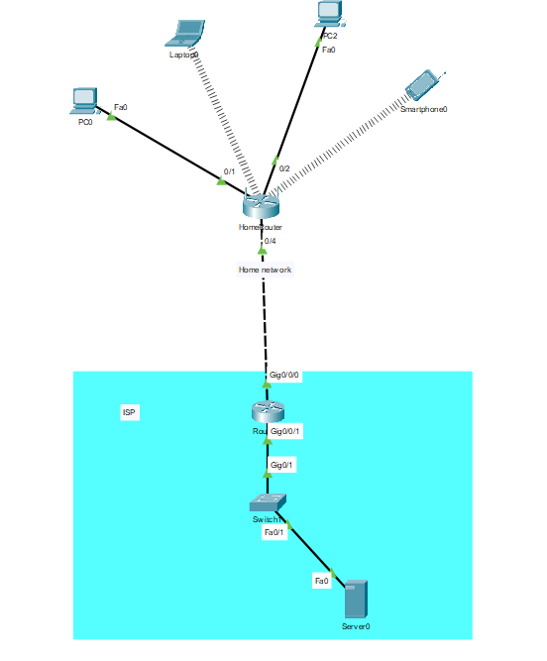
Figure 8: Picture of topology created in Cisco Packet Tracer
The Topology above has been made on packet tracer which is a network simulation software. This topology was made to recreate what a home network looks like. While there can be additional devices on the network such as consoles and printers. For simplicity of the network test, the devices have been left out of this network design. This works by the wireless router having the main connection to its devices through a wireless connection. The computer that is being used the most has a connection made through the ethernet cable as its priority in the home network. The wireless router is configured with DHCP for the devices to have an easy connection as it’s usually done in-home networks. The topology also mimics the connection with the ISP which then reaches the internet server. The webserver will host websites for the home network users. doing this can assist in displaying the network attack that will be done on the network as the websites may not be reachable during the attack.
This design was chosen specifically due to how home networks are currently being used. Most devices are now usually connected through a wireless router in the home network, this is because most people now own smartphones as well as tablets meaning that a wireless connection is needed for any internet access. The main computer in the household has a wired connection due to priority. This is because a lot of home networks have a main computer where people may do most of the important work and therefore would like to have a more stable and secure connection to the internet. The webserver and ISP connection of the network is added to give website access that will provide evidence when an attack happens during testing. This would work by the website not being active during the attack due to the traffic flow inside the network.
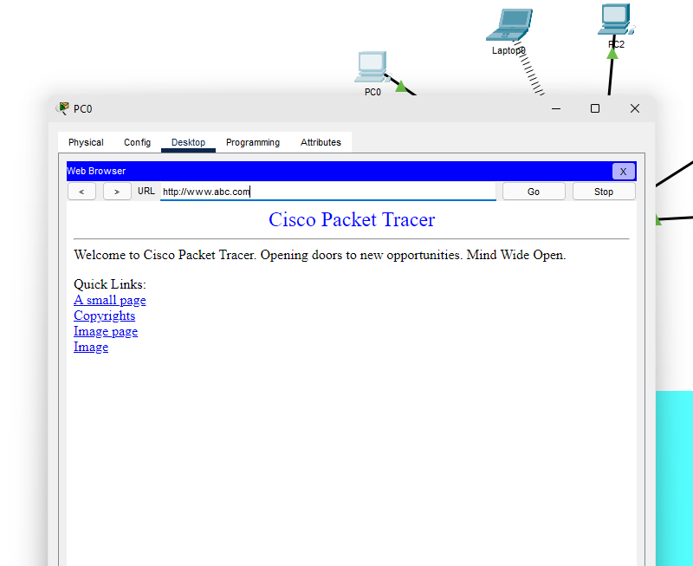
Figure 9: Website opened through PC in PT software
PC0 is easily able to connect to the webservers website that was created. This was done to see if the connection between the networks was done correctly and if everything was in working condition. This was checked before the attack was done to be able to see how the attack affects the attacked individual.

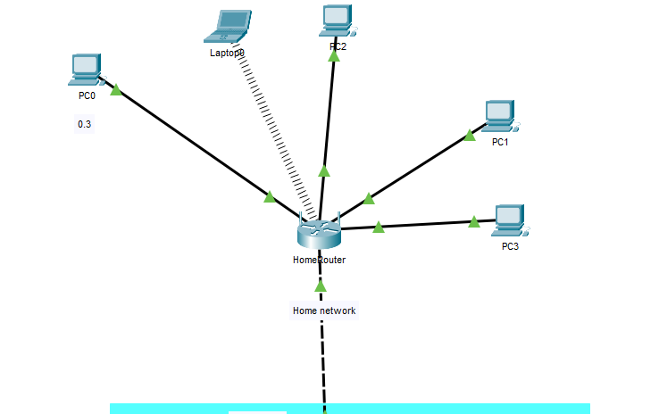
Figure 10: Showing additions to network topology
To be able to conduct this test 2 more computers were added to the home network to simulate the hackers connecting to the network itself. This was also done because after testing 1 computer attack it didn’t show any effect on the victim’s computer as there wasn’t enough strain on the network that the victim was using.

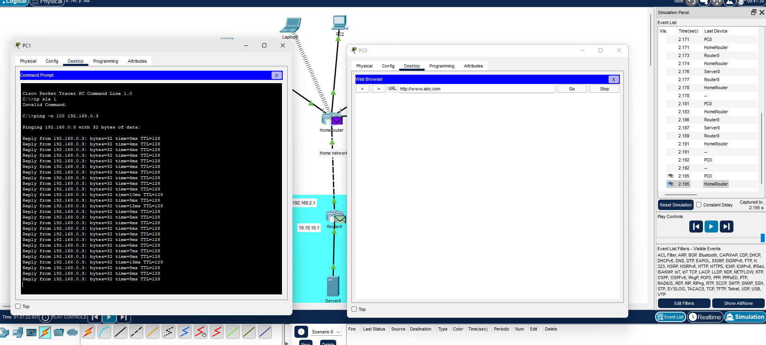
Figure 11: Launching a flood attack in PT
After using the computer to launch a simple flood attack and checking this attack through the simulation tab it was clear that the attack that was launched caused the computer to load the website much slower. After a short period, the website loaded. This test was done on a smaller scale there would be many more factors in place. Such as a bandwidth limit and many more attacking computers. However, this small attack already showed results proving how insecure the network is.
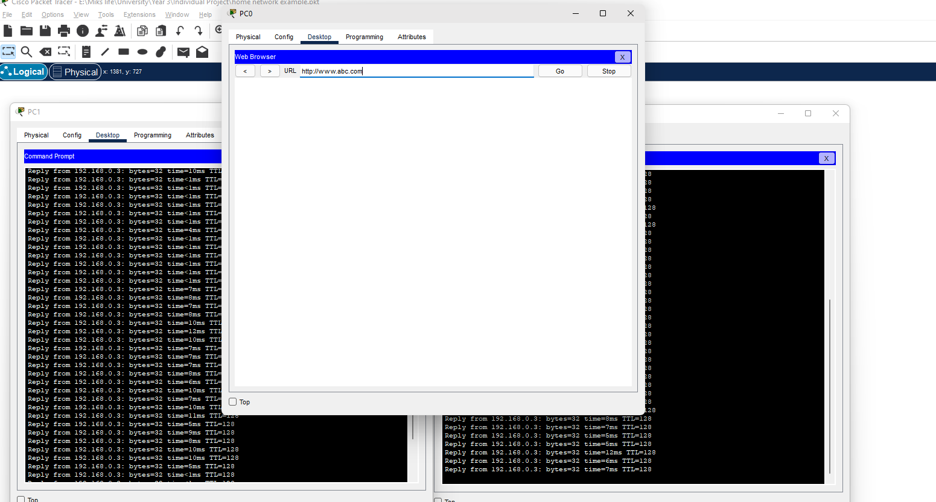
Figure 12: Result of flood attack
Following up the attack with a single computer the next test on the simulation software was done using multiple attacking computers. Because of this, it took even longer for the website to load on the victim side and initially wouldn’t load the website unless it was refreshed. If there were additional parameters in place such as the bandwidth limiting would’ve meant the victim’s PC wouldn’t gain any access to the website during the attack.

4.4. Implementation
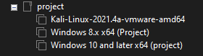
Figure 13: VMware set up for the project
For the implementation of the project, VMware was used. The machines that were used for the project are the Linux machine. Windows 8 and a windows 10 machine. These were all set up to be on the same connected network to allow for communication and internet access. The Linux machine is the attacking machine as it has all the tools required to conduct the attack on the network. The windows machines are simply user machines on the network.


Figure 14: Victims computer using a search engine
This is the victim’s computer on the network browsing the internet. This was done to show the computer is online and able to use the internet connection while everything is still working.

DoS attack
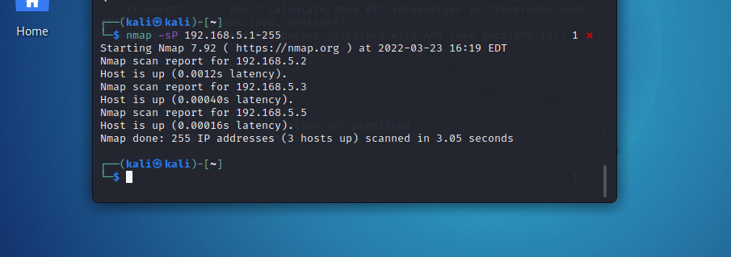
Figure 15: Attacker scanning network
The attacking computer (Linux) conducts a scan of the network to see if there are any available IPs on the network. After the scan has been done it informs the attacker that there are currently 3 IPs active on the network. Allowing the attacker to pick which target they want to attack.
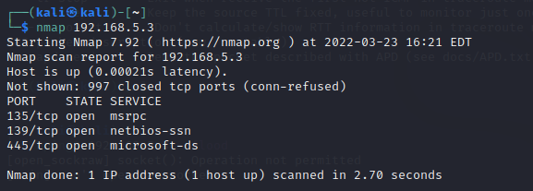
Figure 16: Attacker scanning for ports
After the network has been scanned and the attacker has picked an IP the IP is then scanned to check for available ports on the address. The scan showed that 3 open ports that can be attacked all with different services. This is the part where the attacker will decide which port is best to attack.

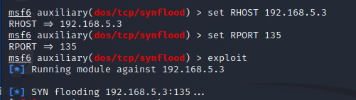
Figure 17: Attacker setting up and launching attack
Using a tool called Metasploit the attacker selects which attack they would like to conduct. Which in this case is the SYNflood attack. This attack floods the server with several SYN packets and the target will reply with open ports. This attack works well as eventually, the router runs out of open ports causing massive strain on the network traffic. The attacker set the IP and port to aim the attack and launched the DoS attack on the Windows 10 user.

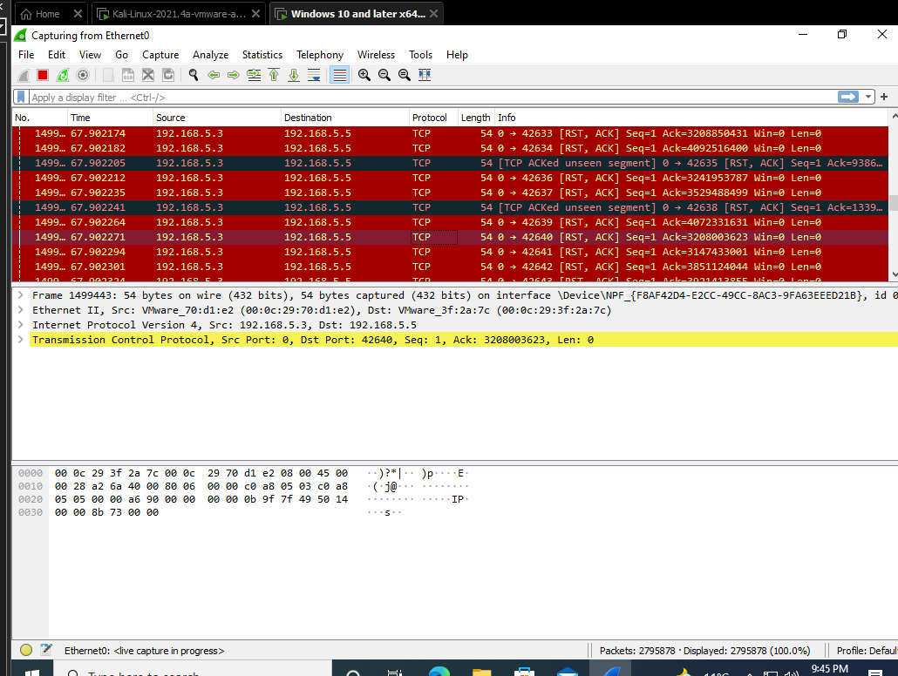
Figure 18: Wireshark result on victims’ computer
When the attack got launched, you can see a slow performance on the victim’s computer. This happened when connecting to websites and generally scrolling. Because of this Wireshark was downloaded to see how the computer network was being affected. Upon opening Wireshark and scanning the network, it was clear the network was being heavily attacked. The computer slowed down a bit more over time the more packets came through. DoS attacks already affect the target computer. For a better result, it was decided to conduct a DDoS attack to see how the computer would handle the stress from the attack.
There are many ways in which the network can be secured against this attack. One of the things that prevented the attack was the firewall. After the first few pings, the network stopped accepting the large number of packets from the same source. This is because firewalls are made to prevent an entity at a time. Therefore, if only 1 person is conducting an attack that’s a DoS the firewall is great protection against it.
DDoS attack
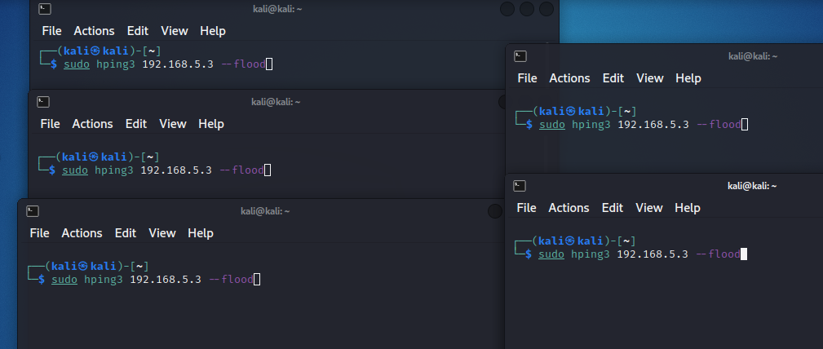
Figure 19: Setting up a DDoS attack
When setting up for the DDoS attack there were several attack links open. This is done to impersonate the way a DDoS attack is done. A DDoS attack is run off multiple devices sending packets onto the victim’s computer. Flooding the traffic and often causing several issues on the victim’s computer.

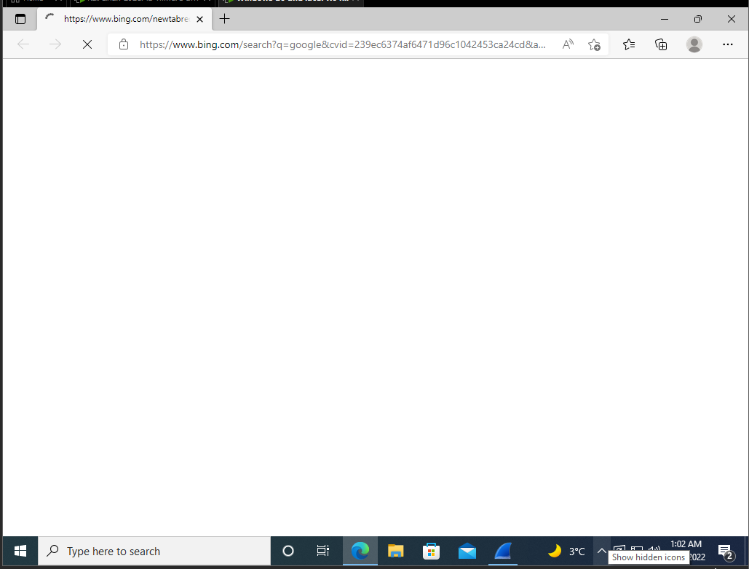
Figure 20: Victims computer unable to load the website
Immediately after launching the DDoS attack, you can see a performance drop. When opening the internet browser a website wouldn’t load. Overall, the victim’s PC was performing much slower.


Figure 21: Wireshark crash during attack
After checking with Wireshark to see how the network traffic is handling the attack. The software started slow. The computer began to freeze up and after only a few seconds the application crashed, and it wasn’t possible to display the number of packets getting launched at the network. This almost rendered the victim’s computer unusable during the attack.
Securing against a DDoS becomes significantly harder compared to a DoS attack. As a firewall is no longer enough to stop a DDoS it is important to have more security. One of the ways that this can be prevented is by configuration changes. Configuring the firewall to block UDP port 53 helps block DNS responses and drop incoming ICMP packets from the outside of the network. Due to the nature of this attack, it would still be very important to have someone in charge when this attack is detected that could follow a procedure to stop the attack.

Botnet attack
A botnet attack is an attack that uses other computers without the user’s knowledge to launch attacks. This is done on several computers to launch a large-scale attack. Due to the nature of the attack and the sophistication of current security. For this attack to work, it requires the victim to get into some sort of contact with the attacker. This can be done by malicious emails, links and even files. For this scenario, the victim opens an email that contained the malicious link. Upon opening it, it ran a script that opened PowerShell in the background and connected to the attacker’s port. This is because the network already blocks most malicious connections and wouldn’t allow the attacker to connect directly, to work around this the attacker hosts an open port and makes the victim connect to their port without them noticing giving them access to their computer. This is called the reverse shell method.

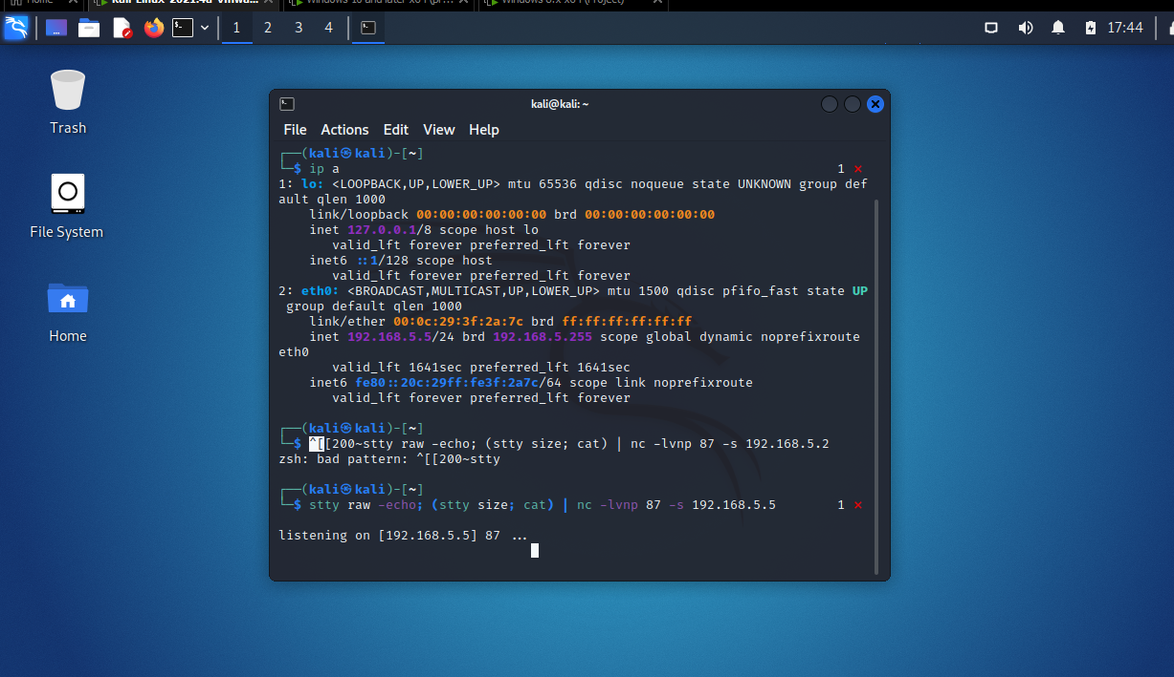
Figure 22: Attacker opening a port and listening on it
This is an echo command that the attacker uses to open a port and then listen in on it to get reverse shell access to any PCs connecting through the mail sent.
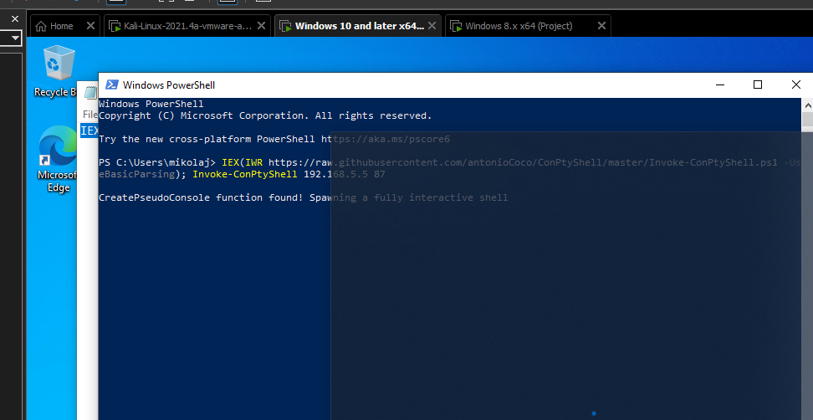
Figure 23: Victim opened malicious link running a PowerShell script connecting to the attackers open port
Upon clicking the link that the victim received, a script gets launched. This script causes windows PowerShell to open and immediately connect to the port that the attacker is listening on. Allowing the attacker to bypass the network security.
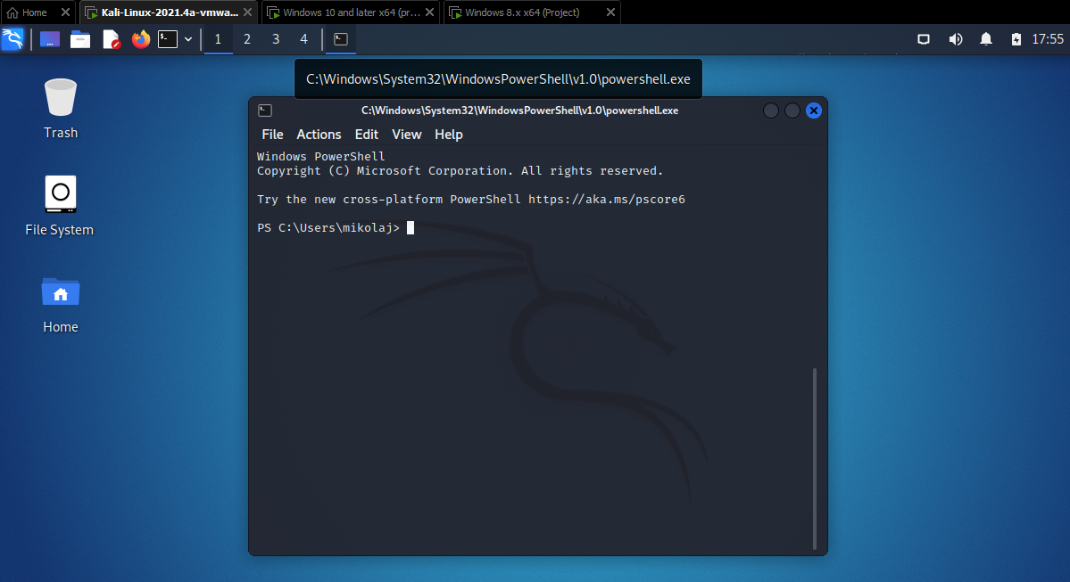
Figure 24: Attacker has access of victim’s computer
The moment that PowerShell launches the command connecting to the attackers port it immediately grants the attacker’s access to the user’s PC using its command line.
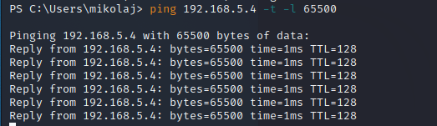
Figure 25: Attacker launches a flood attack from victims PC
After this connection, the attacker uses the victim’s PC to launch a DOS flood attack onto a selected PC.
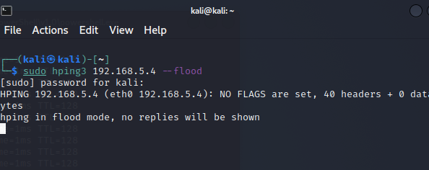
Figure 26: Attacker launches additional attacks to create a botnet DDoS
This would be followed by other PCs launching flood attacks potentially including the attacker’s PC. Sending millions of packets directed exactly where the attacker wants them to be sent. Following this attack, the victim’s computer was severely struggling to run due to the stress of the network.
Stopping a botnet DDoS attack can be much more difficult. This is because the nature of the attack requires different PCs that would be used without the victim’s knowledge. One method to stop this is to teach people about malware and clicking links that could be malicious. However, even after some information people may not understand and it could still happen. To stop some of these would require monitoring of the network to find unusual activities. Another way to prevent this would be to make sure everything is up to date to not have any backdoors or vulnerabilities. Finally, having antivirus software as well as scanning all downloaded files could help from any reverse shell access that can occur.

4.5. Conclusion
In conclusion to this chapter, the findings of the attacks show that it’s relatively easy to launch attacks on a home network. in this implementation scanning of the networks and ports was covered. Attacking a victim’s computer with a DoS, DDoS and botnet DDoS was also done in this chapter. Using a reverse shell hacking method was used to take control of a victim’s computer to launch a DoS attack as part of a DDoS. Each method proved to be strong against the home network, to improve this sufficient security was added to prevent these attacks. Finally, this chapter also covered the potential security that can be implemented which would stop the attacks from successfully taking down some of the machines or networks.

Chapter 5 – Evaluation
The results from this project show that the home network needs much more improvement to security features to be correctly protected from incoming attacks. The results were able to show that the problems that occur in the home network are also very user sided. This is because some of the attacks succeeded due to simple human error. Because of these results it was decided to compare them to the literature review findings that were done before the experiment was conducted to see how it correlates to the research done with similar findings in this field.
The first attack that was conducted was a DDoS attack on the network simulation software. This was shown in the implementation of the project and worked by creating a webpage server that the computers were connected to then running the attack and seeing if the connection was going to work between the server and the computer that was being attacked. The screenshots show how the PC in the network simulation software was unable to reach the website the first few attempts due to the network traffic. This could’ve been further improved upon by adding a limit to the bandwidth within the network to show how much strain the computer is going through with the attack. This test covered one of the objectives that were listed in chapter one which was a simulation test on a home network to see if this could even be possible in a virtual network scenario. As the test was run and the attack was conducted the objective was complete.
The second attack was the DoS attack in the virtual network that was created following the simulation software topology. The purpose of this attack was to see how vulnerable the network would be to a Denial of Service (DoS) attack. The attacker first made a scan of the network to determine which device is available to target. The attacker then scanned for the ports using a tool called Nmap. It gave a clear result of the victim’s PC. With evidence from the conducted attack, the DoS attack managed to disrupt the flow of work for the user. The websites took longer to load as the network began to get strained from the flood of packets received. The tool that was used for the attack came from the Linux attacking device and was called Metasploit. This tool used the IP and port number given to launch a flood attack on the target. The literature review relates to this attack as it covered different types of Denial of Service (DoS) attacks that are conducted against smart home networks [29]. Comparing this to the objectives that were set at the beginning of the report, shows that the outcome of the test was successful by the user having a slowed experience on their device because of the attack which covered one of the goals in the objectives. This was also proven by using Wireshark to display the number of packets that were hitting the victim’s computer during the attack. There is security that gets put in place explaining how it would protect the network from the attack that was conducted which also covers part of the objectives that were set.
Another attack that was conducted on the network was the Distributed Denial of Service attack (DDoS). The goal of this attack was to see disrupt the victim’s PC by booting them offline due to the flood of packets from several different PCs. The tool that was used for this attack demonstration was a tool called Hping3. The screenshots are evidence that the attack conducted on the PC caused the victim’s PC to become unresponsive after receiving the packets. This could be seen as when Wireshark was opened the number of packets received caused the application to crash and the computer was unable to open any websites. This attack was related to several parts of the literature review that covered the DDoS attacks on home networks as well as mitigation against them (2.8. Related works). The outcome of the attack successfully covered the objective that was set, as the attack showed the vulnerability of the network to the DDoS attack. The security against these attacks is also listed below the attack which covered additional parts of the literature review and objectives. The security requirements for this attack consisted of configuring the firewall to disable a port that blocks all unknown incoming packets. The section also covers other security methods that would allow for better detection of the attack.
The last attack that was conducted for the project was the Botnet Distributed Denial of Service (DDoS) attack. While this attack is similar to the DDoS attack it differs from it as it infects other hosts that then conduct the attack for the attacker. The attacker first sets up a reverse PowerShell attack script to conduct this attack. Following the opening of the attacker’s port, the attacker sends malicious mail to the victim containing malware that then gets opened. Upon opening the mail, the victim causes the malware to launch the script in the background causing the PC to connect to the attack’s open port. This gives the attacker access to the PC and allows them to launch further attacks. Upon access to the computer, the attack opens CMD and launched a flood attack on the target. At the same time, the same flood attack was launched several times coming from the attacker’s PC. The tool that was used for the flood attack this time was Hping3. The attack relates to the literature review that covered the DDoS attacks as well as botnet attacks on networks (2.7. Botnets). The attack followed the objective that was set in chapter 1 and was successfully conducted the attack. This is also supported by the screenshots and the suggested security against the type of attack.
In these results, it is clearly shown how easy it can be to attack some computers on a network. while not all networks are as vulnerable as the ones in the attacks that were conducted, it still shows how important it is to ensure enough is done to protect the home network. In the research that was done, it covered the solution that was created by [23] Nazrul Hoque, Dhruba K. Bhattacharyya and Juigal K. Kalita. The solution had several points which were covered during this project. One of these was stopping the attack closer to its attack point. This is done by shutting down port 53 which is the UDP port which could potentially block the attacks coming from as close to the source as possible. Another method that was used that can compare to this is making sure to use antiviruses and not clicking malicious links. This is because one of the main ways in which a reverse shell hack can occur and cause the hacker to gain access to a home PC is through the victim accessing some malicious link or file download.
To further compare this research, it was found that the suggestions that were made by M, Schnaider, Michel and Rehier [22] were followed very similarly in the project. For example, it states that the actions of users in the network should not be harmed by the defensive system that is in place. In this case, the security implemented wouldn’t cause harm to the users. It also follows the point of protecting the network from interior threats as it would have taught the users to not use malicious links as well as there being antivirus and firewalls to prevent the links from downloading malware onto the computer once pressed. Finally, another comparison that can be made to this research was the point of creating the security solution to be part of a bigger solution over time. For the home network created having the firewall and antivirus installed would be similar as there can be additions and changes made over time to improve and provide better security for the network.

Chapter 6 – Conclusion and Recommendations

6.1. Conclusion
The research that was conducted at the start of this project was to visualise what kind of results this experiment could provide. Attacking the home network wasn’t done often and therefore a lot of research was taken from experiments that were conducted on bigger networks. While this made some comparisons hard it allowed to compare how differently a home network and a network may be.
My results from the experiments show how easy it is for a hacker to attack or infiltrate a home network. Because most home networks don’t have much higher security that’s where the base of the tests was conducted. The results of the simple DoS attack showed that it can slow the home network without causing too much of an issue for the victim. This is because of the bandwidth that the network has between itself and the victim’s computer. In a scenario where there would be less bandwidth or even compared to a normal network where the bandwidth is monitored and changed, the attack would be much more impactful. While it slowed the victim’s computer slightly it didn’t cause any outstanding issues that could stem directly from the attack. The security that was then used to prevent this attack was a simple firewall. This was because the firewall can prevent 1 entity at a time and therefore an attack from 1 computer can be easily prevented depending on its size.
The DDoS attack was conducted differently. Because this is done in VMware having multiple attacking machines was difficult to run. To mimic the machines the Linux attacking machine had several CMD panels open that would be launching the attack. While this doesn’t identically show a DDoS attack it was part of the limitations that came with doing this experiment. The attack still showed similar results as once the attack was launched the victim’s PC was running significantly slower and it had issues loading the websites. When opening Wireshark on the victim’s computer it was clear that the attacks were working and causing a disruption within the network. to mitigate this attack, it is suggested to use a well-configured firewall and antivirus software. the configured firewall would be blocking the UDP port which would stop most packets coming from outside the network.
The botnet attack that was conducted was also done differently. However, to make it as close to the real scenario as possible the acquisition of the victim’s computer is shown. The attacker conducts a reverse shell attack that is possible due to the victim opening a link that contained malware that would run a PowerShell script in the background. Usually, a botnet attacker will have access like this to several computers before launching an attack on a victim. Due to the limitations of this experiment, the attack was conducted from the attacker’s PC and the single infected PC compared to normally where the attacker would have access to many more. The attack results showed that the victim’s PC immediately began to slow in speed to which it was difficult to load any application. Once opening Wireshark, the attack was so heavy on the victim’s PC that the application crashed, and it wasn’t possible to get a clear screenshot of the software working during the attack. Security against this type of attack against a home network requires the same security as the previous attack. A firewall and antivirus. The antivirus would prevent malware from downloading. While there are direct approaches that can be taken to secure the home network against botnets specifically it would be very inefficient to do so on a home network as it’s mainly an issue for company networks.
The aims and objectives that were set in chapter 1 were adequately met and this is proven by the report and the tests themselves. The overall aim was to secure a home network against different types of DDoS attacks. This was done exactly as it was stated and is shown within the implementation stage of the report. The tests showed that the firewall can block some of the basic denials of service (DoS) attacks. While the stronger attacks required a different configuration with the firewall as well as some additional work. Additional methods of security are spoken about in the recommendations section that would further improve the results of these tests. The objectives are covered through the report and as part of the project. The first cover the understanding of DDoS attacks and home network security which have been covered through the literature review. The later objectives were to create a home network and experiment with the attacks and security measures to protect the network. This is shown in the implementation section with the tests that were conducted in the virtual network. it was covered by launching the attacks and showing their effect on the network while also giving the security methods required to protect the network. There is 1 objective that was unable to be met due to the time constraints of the project. This was the creation of methods that could resolve the vulnerabilities in the networks. This was mentioned within the limitations and risks section of the report as a potential failure due to how little time there was left to conduct the project. The tests conducted show that the home networks require some security to avoid getting easily taken down by simple attacks. The tests proved this as they managed to stop the user from being able to use the internet as well as in some cases crash some of the applications the user was using. As this was a small-scale attack it was unable to show what a full-scale DDoS attack could do to the network. However, it still managed to show the impact of the attacks. Suggestions have been made in the recommendations that cover what can be added in the future to make the tests show a more accurate result.
Finally, there are recommendations that have been made for the project. To cover the DoS attacks its recommended to use a firewall to stop the attack from being able to keep sending packets at the network. However, the recommendation for the DDoS is to configure the firewall to block the UDP port 53 to stop all incoming packets from an unknown source. As an overall recommendation its best to configure the firewall in that way to prevent both of those attacks. Another recommendation is to use other security methods that can detect the attacks on the network allowing the attack to be stopped before the network gets overwhelmed. For the botnet DDoS attack its recommended that the users don’t click on malicious mails and make sure to have an antivirus or extension that will protect them from malicious page activity.

6.2. Recommendations for future research
After conducting this project there are several places in which the project can be improved on. While there are quite a few areas in which this could’ve been expanded on. One of these areas is the security methods to prevent these attacks. There were more efficient security methods that would guarantee protection for the home network. However, due to the time constraint as well as the way this experiment was done it would’ve been too much to do for the time being. In the future aspect, the security could’ve been significantly improved by using more professional methods as listed in some of the research found in the literature review.
Another recommendation for future research would be the attacks. Due to the limitations in VM, it would be better to conduct this test in a physical field rather than a virtual field. While also using the attacks that were conducted correctly. for example, a DDoS attack should be conducted by several computers rather than using 1 to launch multiple attacks. The same goes with the botnet attack. That attack should be conducted using several zombies rather than just the single zombie created during this experiment.

Chapter 7 – Reflections
Looking back to the start of the project I believe that the aim and objectives that are set have been mostly hit. While some of them can be improved upon for them to be checked off correctly. The aim was to see how secure a home network is against different types of DDoS attacks. I believe that this part of the aim was met as several different types of DoS attacks were conducted. One of the objectives was to demonstrate an understanding of the current security measures that are most used in the home network. This is covered not only the coverage of the literature review but also the methodology as it explains how it is planned to be done.
Another objective is to establish a deeper understanding of network security. I believe that I have developed a deeper understanding of network security after this project. Searching up different methods of security against these types of attacks has improved my general knowledge of network security and networks.
Additionally, another objective was to create a critical literature review of the research that was conducted to demonstrate the knowledge that was gained. This was completed in chapter 2 as there is an in-depth literature review covering several different aspects of the project. from networking protocols to home network security. While making sure there are research projects relating to my project.
To continue, another objective was to utilise the knowledge that was gained to recreate the network and experiment. This was also successfully done as this project was able to reach its end following the finished experiments. However, the security measures were harder to implement as the more sophisticated security methods are designed around bigger company networks.
Finally, the last objective was to see if it can be protected from a DDoS attack. While the network was able to be protected against some DDoS attacks, I still believe there is room for improvement. With better security implementation and blocking of the UDP port, a lot of DDoS related attacks will be getting blocked from entering the network.
During the implementation stage of the experiment, it became clear that the replication of the DDoS and botnet was going to be close to impossible due to my equipment. Therefore, I believe that this was the only significant shortcoming of my experiment. The attacks were still conducted and showed results. However, it would be better if this test was conducted in a physical scenario using an actual home network. the results could then be more precise while also having better examples of how it affects the home network.
Throughout the project, I believe that the project went very well. The only issue that I ran into when doing this project was happening during the implementation of the botnet attack. I struggled to find a way to hack into the victim’s computer to launch an attack targeting another PC. After some more research, I found that conducting a reverse shell attack would be the best possible potion for the attack. To do this I made the scenario that the victim opened a malicious link that he received in which he would get malware that would run a PowerShell script connecting to the open port of the attacker. This was a very important point in the experiment as once it managed to connect it felt like a breakthrough into something new. Because of this, a flood attack was able to be launched from the victim’s computer targeting another individual on the network.

References

[1] | L. Press, “The Role of Computer Networks: In Development,” Communications of the ACM, vol. 39, no. 2, pp. 23-29, 02 1996.
[2] | X. Sun, “The study on computer network security and precaution,” in Proceedings of 2011 International Conference on Computer Science and Network Technology, Harbin, 2011.
[3] | “What is the OSI Model?,” cloudfare, [Online]. Available: https://www.cloudflare.com/en-gb/learning/ddos/glossary/open-systems-interconnection-model-osi/. [Accessed 15 December 2021].
[4] | A. Fraihat, “Computer Networking Layers Based on the OSI Model,” Test Engineering and Management, vol. 83, pp. 6485 - 6495, January 2021.
[5] | “TCP/IP Overview,” Cisco, 10 August 2005. [Online]. Available: https://www.cisco.com/c/en/us/support/docs/ip/routing-information-protocol-rip/13769-5.html. [Accessed 2021].
[6] | S. Fisher, “What is TCP/IP and How Does it Work?,” Avast, 30 July 2019. [Online]. Available: https://www.avast.com/c-what-is-tcp-ip#gref.
[7] | W. K. E. M. C. E. S. P. Rebecca E. Grinter, “The Ins and Outs of Home Networking: The Case for Useful and Usable Domestic Networking,” ACM Transactions on Computer-Human Interaction, vol. 2, no. 16, p. 8, 2009.
[8] | “8 Effective Home Network Setup Diagram For Your House In 2022,” Smart Network Geek, [Online]. Available: https://smartnetworkgeek.com/home-network-setup-diagram/. [Accessed 10 January 2022].
[9] | Z. Zhang, “An Introduction to Computer & Network Security Threats,” An Introduction to Computer & Network Security Threats, April 2020.
[10] | S. Goundar, A. C. Chonkit, S. Kumar and A. Bhardwaj, “Network Security Evaluation and Threat Assessments in Enterprise Systems,” Impact of Digital Transformation on Security Policies and Standards, pp. 145-168, 2020.
[11] | “DBIR 2021 Data Breach Investigations Report,” DBIR, 2021. [Online]. Available: https://www.verizon.com/business/resources/reports/dbir/. [Accessed 12 December 2021].
[12] | “2021 Data Breach Investigations Report,” DBIR, 2021. [Online]. Available: https://www.verizon.com/business/resources/reports/dbir/. [Accessed 15 December 2021].
[13] | “2021 Data Breach Investigations Report,” DBIR, 2021. [Online]. Available: https://www.verizon.com/business/resources/reports/dbir/. [Accessed 15 December 2021].
[14] | “Over half of UK adults NEVER change their WiFi password,” reichelt elektronik magazine, [Online]. Available: https://www.reichelt.com/magazin/en/uk-adults-wifi-password/.
[15] | N. G. D. S. .. P. G. r. Niranchana, “Securing internet by eliminating DDOS attacks,” IOP Conference Series Materials Science and Engineering, vol. 263, no. 4, 2017.
[16] | U. Saxena, J. Sodhi and Y. Singh, “An Analysis of DDoS Attacks in a Smart Home Networks,” in International Conference on Confluence The Next Generation Information Technology Summit (Confluence), Noida, 2020.
[17] | C. Joshi and U. K. Singh, “Information security risks management framework – A step towards mitigating security risks in university network,” Journal of information security and applications, vol. 35, no. 1, pp. 128-137, 2017.
[18] | N. Hoque, D. K. Bhattacharyya and J. K. Kalita, “Botnet in DDoS Attacks: Trends and Challenges,” IEEE communications Surveys & Tutorials, vol. 17, no. 4, pp. 2242-2270, 16 July 2015.
[19] | A. B. Qaisar Shafi, “DDoS Botnet Prevention using Blockchain in Software Defined Internet of Things,” in 2019 16th International Bhurban Conference on Applied Sciences and Technology (IBCAST), Islamabad, 2019.
[20] | V. Matta, M. D. Mauro and M. Longo, “Botnet identification in multi-clustered DDoS attacks,” in 2017 25th European Signal Processing Conference (EUSIPCO), Kos, 2017.
[21] | K. Naveed and H. Wu, “Poster: Automated Neural Network Structure Selection for IoT Botnet Detection,” in 2021 IFIP Networking Conference (IFIP Networking), Espoo, 2021.
[22] | J. M. M. S. S. M. a. P. R. M. Robinson, “Challenges and principles of DDoS defense,” ACM SIGCOMM, pp. 1-8, 2003.
[23] | N. Hoque, D. K. Bhattacharyya and J. K. Kalita, “Botnet in DDoS Attacks: Trends and Challenges,” IEEE Communications Surveys & Tutorials, vol. 17, no. 4, 2015.
[24] | S. M. Sajjad, M. Yousaf, H. Afzal and M. R. Mufti, “eMUD: Enhanced Manufacturer Usage Description for IoT Botnets Prevention on Home WiFi Routers,” IEEE Access, vol. 8, 2020.
[25] | S. T. Zargar, J. Joshi and D. Tipper, “A Survey of Defense Mechanisms Against Distributed Denial of Service (DDoS) Flooding Attacks,” IEEE Communications Surveys & Tutorials, vol. 15, no. 4, 2013.
[26] | J. Francois, I. Aib and R. Boutaba, “FireCol: A Collaborative Protection Network for the Detection of Flooding DDoS Attacks,” IEEE/ACM Transactions on Networking, vol. 20, no. 6, 2012.
[27] | N. Hoque, D. K. Bhattacharyya and J. K. Kalita, “Botnet in DDoS Attacks: Trends and Challenges,” in IEEE Communications Surveys & Tutorials, vol. 17, no. 4, pp. 2242-2270, 2015.
[28] | U. Saxena, J. Sodhi and Y. Singh, “A Comprehensive Approach for DDoS Attack Detection in Smart Home Network Using Shortest Path Algorithm,” in 2020 5th International Conference on Mechanical, Control and Computer Engineering (ICMCCE), 2020.
[29] | D. Shin, K. Yun, J. Kim, P. V. Astillo and J.-N. Kim, “A Security Protocol for Route Optimization in DMM-Based Smart Home IoT Networks,” "A Security Protocol for Route Optimization in DMM-Based Smart Home IoT Networks, vol. 7, pp. 142531-142550, 2019.
[30] | D. G. R, “Research Proposal-Flow Chat-New Research Scholars-Reg,” 27 August 2020. [Online]. Available: https://www.aesanetwork.org/research-onion-a-systematic-approach-to-designing-research-methodology/. [Accessed December 2021].
[31] | Mikolaj. [Online]. Available: https://www.teamgantt.com/. [Accessed December 2021].
[32] | Mikolaj. [Online]. Available: https://www.teamgantt.com/. [Accessed March 2022].

