LCHS7006 – Quality Assurance and Service Improvements
Component 2: Service Improvement Report
Quality Assurance Failures in Southern Health NHS Foundation Trust:
A Critical Analysis of Learning from Deaths and a Service Improvement Proposal

Student Name: Fahmidah Faruk patel
Student ID: 2519425
Programme: MSc Public Health and Social Care in Practice
Module Leader: Dr Fahad Khan
Submission Date: 29 July 2026

Table of Contents
1. Introduction 3
2. Root Cause Analysis of Quality Assurance Failures 4
2.1 Donabedian Model Application 4
2.2 Fishbone Diagram Analysis 5
2.3 Strategic Analysis – SWOT 7
2.4 Kotter’s Eight-Step Change Model 8
2.5 The Plan-Do-Study-Act (PDSA) Cycle 9
3. Recommendations 10
4. Conclusion 12
References 14

1. Introduction
Acute deficiencies in the process of identifying, investigating and learning from patient deaths continue to be one of the most enduring hazards in patient safety in the National Health Service (NHS). The Southern Health NHS Foundation Trust scandal emphasised by the Independent Review of Deaths from April 2011 to March 2015 conducted by Mazars is a red flag case of systemic failure in quality assurance (Mazars, 2015). The review looked at 10,306 deaths of people with mental health and learning disabilities, and identified 722 sudden deaths. Importantly, only about 1% of deaths of people with learning disabilities were formally investigated, highlighting stark inequalities in the investigation of deaths of vulnerable groups (Mazars, 2015; Pascoe, 2020).
Follow-up investigations revealed that inadequate death-investigation frameworks and governance oversight, late management accountability, and a lack of organisational learning had prevented risks from being known for several years (Pascoe, 2020; Pascoe, 2021). These several organisational weaknesses support Reason's Swiss Cheese Model of accident causation where latent conditions and active failures allow successively defensive layers to fail, allowing hazards to reach harm (Reason, 1997; Wiegmann et al., 2022).
Although the national Learning from Deaths framework (National Quality Board, 2017) and Patient Safety Incident Response Framework (PSIRF) (NHS England, 2022/2023) have now been introduced, considerable variation in implementation and organisational learning is reported (Brummell et al., 2023; Lalani et al., 2022; HSSIB, 2025). Although many trusts are reviewing all relevant deaths in a systematic way and are endeavouring to find ways to translate learning into sustained improvement, this does not always happen, especially for those with learning disabilities and mental health conditions (Brummell et al., 2021; Schönfeld et al., 2024).
The present service improvement report investigated the reason of the non-satisfaction of the quality of service in the Southern Health according to the Donabedian's model, Fish bone analysis, and SWOT analysis with a critical approach. It then outlines a step-by-step implementation plan based on the Plan-Do-Study-Act (PDSA) methodology and the eight steps of change proposed by Kotter. The goal is to create evidence-based recommendations that enhance cultural conditions necessary for real organisational learning and increase the reliability of the technical process (Vincent, 2010; Langley et al., 2009; Kotter, 2012).

2. Root Cause Analysis of Quality Assurance Failures

2.1 Donabedian Model Application
The Donabedian model offers an integrated framework in which the areas of structure, process and outcome are interlinked and essential in the assessment of the quality of healthcare (Donabedian, 2003). At Southern Health, weaknesses in structure included a lack of effective standardised systems for reviewing deaths, poor information technology systems for death notifications, and an inadequate allocation of resources to carry out the critical review of unexpected deaths (Mazars, 2015; Pascoe, 2020).
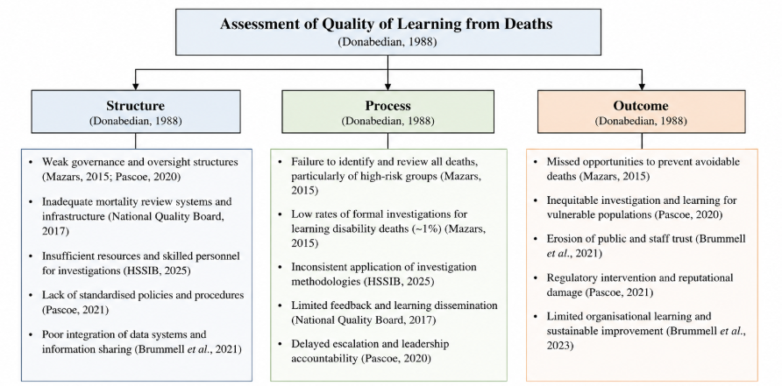
Figure 1: Donabedian Model Applied to learning from deaths
(Source: Adopted from Donabedian, 1988)
Governance arrangements did not ensure consistent monitoring of mortality data at board level and did not ensure learning from death was being consistently used in quality improvement programmes (Pascoe, 2021). Limited availability to specialist MRNs, and the absence of real-time electronic MRNs also undermined the structural basis for timely and reliable identification (Schönfeld et al., 2024; Mendu et al., 2020).
These structural shortcomings were exacerbated by process deficiencies. A proportion of these unexpected deaths were not formally investigated or reviewed using a structured case note review, especially those of individuals with learning disabilities (Mazars, 2015). Escalation pathways were not consistent and there was little evidence of discussion at multidisciplinary level or of thematic analysis of issues arising where safety concerns cropped up repeatedly (Brummell et al., 2023). Leadership accountability systems were not robust enough to "call out" underperformance and to prompt timely action. Similarly, analysis of morbidity and mortality conferences has demonstrated that just as without process design and psychological safety, learning remains superficial and individual, rather than organisational (Batthish et al., 2024; Jeffs et al., 2024; Campos et al., 2025).
The consequences of these structural and process weaknesses were contexts of unresolved risks of patient harm, missed opportunities for organisational learning and differential rates of investigation that highlighted a concern for equity of care for vulnerable populations (Mazars, 2015; Brummell et al., 2021). There was external scrutiny about the Trust's performance of mental-health and learning-disability services, and a loss of public trust was experienced (Pascoe, 2021). The Donabedian analysis shows that doing action on outcomes only is not enough; you need to attend to the enabling structures and the reliable processes that produce the outcomes as well (Donabedian, 2003; Schönfeld et al., 2024; Vincent, 2010). The critical use of the model also shows that without complementary process and structure measures, outcome measures (crude mortality rate or percentage of deaths reviewed) fail to capture the full picture and organisation may appear to be compliant with the model without addressing the system vulnerabilities (Donabedian, 2003; Schönfeld et al., 2024; Mendu et al., 2020).

2.2 Fishbone Diagram Analysis
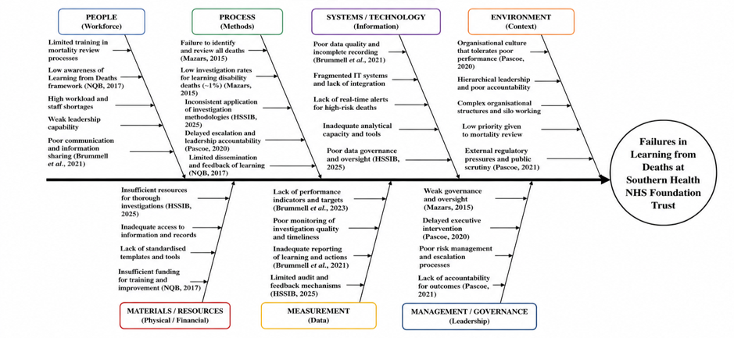
Figure 2: Fishbone (Ishikawa) Diagram of Causes of Quality Assurance Failures in Learning from Deaths at Southern Health NHS Foundation Trust
(Source: Self-developed based on literature)
The Fishbone (Ishikawa) diagram is a structured approach to explain the multifactorial causes for delayed recognition and inadequate management of deaths. Six major causal domains arise when the tool is connected to the Southern Health context. In the People domain, non-specialist clinicians lacked knowledge about the expectations for mortality reviews, they had high workload and limited training in the domain and did not complete the review (Schönfeld et al., 2024; Jeffs et al., 2024). Established professional silos and fear of social exclusion/embarrassment also pose challenges in ensuring full and frank discussion of adverse outcomes in morbidity and mortality conference settings (Campos et al., 2025; de Vos et al., 2023).
Processes: structured approaches to judgement review were not applied consistently, notification was not always done in a protocolised manner and there were no standardised method of escalating concerns that arose from mortality data (Mendu et al., 2020; National Quality Board, 2017). Technological challenges included lack of robust electronic systems to capture unanticipated deaths and enable real-time risk stratification (Schönfeld et al., 2024). There was not enough time for a comprehensive review of the cases due to environmental restrictions, such as high bed occupancy and competing operational priorities (Brummell et al., 2023). Some of the materials and resource factors were; the non-availability of evidence-based instruments for systematic MRT and inadequate administrative support for collation and thematic analysis of data (Mendu et al., 2020).
Furthermore, Management factors played a prominent role: there was weak organisational learning systems, delay in response from the executive to known issues, and lack of accountability at Board-level on mortality metrics which facilitated systemic weaknesses (Pascoe, 2020; Pascoe, 2021; HSSIB, 2025). The Fishbone analysis reinforces the notion that interventions focused in just one domain are unlikely to yield lasting organizational change, and a multi-domain approach is needed (Vincent, 2010; Reason, 1997; Torres-Landa and Farrell, 2026). In the same vein, the Swiss Cheese Model has gained more popularity in modern contexts, propagating this finding: Active failures and latent conditions must be dealt with together for the defensive layers to remain intact (Khosla et al., 2026; Mendoza et al., 2025; Wiegmann et al., 2022). The combination of these six domains can lead to the classic conditions outlined by Reason by which hazards can reach patients, due to latent weaknesses in the organisation and active failures by those in frontline roles (Reason, 1997; Wiegmann et al., 2022). Correcting just the most obvious active failures – for example, gaps in individual understanding – without simultaneously improving management systems or technology, is therefore unlikely to yield lasting safety improvements (Khosla et al., 2026; Mendoza et al., 2025).

2.3 Strategic Analysis – SWOT
Strengths | Weaknesses
- National Learning from Deaths Framework (NQB, 2017)  - PSIRF promotes systems-based learning  - Strong national patient safety policies  - Increasing organisational awareness of mortality review | - Weak governance and board oversight  - Low investigation rates for learning disability deaths  - Inconsistent mortality review processes  - Fragmented IT systems and limited organisational learning
Opportunities | Threats
- Full implementation of PSIRF  - Digital mortality dashboards and real-time reporting  - National benchmarking and peer review  - Enhanced multidisciplinary learning culture | - Workforce shortages and competing priorities  - Resistance to organisational change  - Continued variation in implementation across NHS trusts  - Loss of public confidence following repeated safety failures
A SWOT analysis was done for current Learning from Deaths arrangements, identifying both unaddressed issues and strategic opportunities. Strengths are the availability of two national policy frameworks supporting the work: Learning from Deaths guidance (National Quality Board, 2017) and PSIRF (NHS England, 2022/2023), as well as a greater awareness of the need for systematic organisational learning (Brummell et al., 2021; Lalani et al., 2021). This shift to systems investigation is a marked improvement in thinking compared to the previous serious incident regimes (NHS England, 2022/2023 and HSSIB, 2025).
Weaknesses remain including that the local implementation can be inconsistent with quality of investigations varying, assessment of impact of learning actions is limited and inequities in the investigation of deaths amongst people with learning disabilities continues (Brummell et al., 2023; Mazars, 2015). Learning from Deaths is still largely being treated by many trusts as a duty to report and is not being used to ensure continuous improvement (Brummell et al., 2021; Lalani et al., 2022). Opportunities include progressive embedding of PSIRF; potential of digital systems of mortality surveillance to support real-time tracking; and national benchmarking/ external peer review (Schönfeld et al., 2024; HSSIB, 2025; Fakih et al., 2025).
Based on the SWOT findings, therefore, it is strongly felt that while technical standardisation is important, specific, deliberate cultural and leadership actions are needed to achieve sustainable improvement (Kotter, 2012; Vincent, 2010). Specifically, the promise for PSIRF will only be realised through investments by organisations in capacity, time and psychological safety needed for systems-based investigation—otherwise, PSIRF will likely be used primarily as a compliance tool instead of a learning system (HSSIB, 2025; Campos et al., 2025; Lalani et al., 2022). Even more recent evidence in the fields of morbidity and mortality conference redesign highlights that conferences are most productive when they are centered around a theme, shift from an individual focus of the case to a systems focus of the conference, and are supported by clear governance and follow-up (Batthish et al., 2024; Dickinson et al., 2025; Torres-Landa and Farrell, 2026).

2.4 Kotter’s Eight-Step Change Model
In achieving sustainable change in organisations, it is necessary to work on the technical aspects of interventions and on the processes of change itself, which is human and cultural based (Kotter, 2012; Vincent, 2010). The eight-step model sets out by Kotter is a structured framework which is relevant to the complex governance and cultural failures described at Southern Health NHS Foundation Trust for leading large-scale transformation.
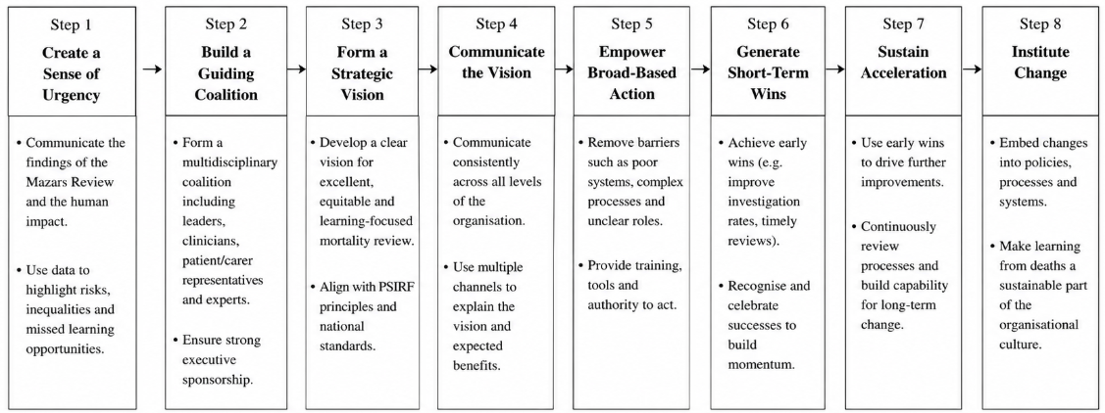
Figure 3: Kotter’s Eight-Step Change Model
(Source: Self-Developed)
The first one of these steps – creating a sense of urgency – can be secured by providing local/ national statistics on the numbers of preventable harms, the mortuary equities gap relating to mortality investigations, and the fact that deaths of people with learning disabilities are not investigated (Mazars, 2015; Brummell et al., 2023). A powerful guiding coalition is imperative – and can be achieved via a multidisciplinary Learning-from-Death improvement team with visible executive sponsorship and representation from clinical, governance, digital and family perspectives (Pascoe, 2021; HSSIB, 2025).
A clear strategic vision, based on secure detection, uniform investigation and substantive post-death management helps to unite staff in a common goal. The vision should be reinforced by compulsory simulation training as well as regular safety huddles and open board reporting (Campos et al., 2025; Jeffs et al., 2024; Dickinson et al., 2025). Facilitating action and breaking down barriers involves financing integrated information technology systems, creating opportunities to review cases and give them psychological safety to raise concerns without fear (Campos et al., 2025). By achieving short-term gains in pilot wards or pilot services, momentum can be generated and initial evidence of possible and good change provided (Kotter, 2012).
Embedding mortality indicators in board performance management structures, in annual benchmarking and appraisal exercises, ensures gains are consolidated and new approaches become part of the culture of the organisation (Schönfeld et al., 2024; National Quality Board, 2017). Large-scale quality-improvement programmes have shown that organisations that integrate structured quality improvement approaches with transparent leadership dedication are more likely to sustain reductions in mortality and harm (Fakih et al., 2025; Schönfeld et al., 2024). On the other hand, projects that overlook cultural aspects are often found to have brought only temporary compliance but no change in behavior (Lalani et al., 2022; Brummell et al., 2023).

2.5 The Plan-Do-Study-Act (PDSA) Cycle
Kotter's model covers strategic and cultural aspects of change, while the Plan-Do-Study-Act (PDSA) cycle provides the operational method for experimenting and learning from specific interventions in real time (Langley et al., 2009). PDSA is very appropriate for the continuous improvement of processes such as mortality-review or electronic alert or learning-response systems.
The Plan phase includes a collection of baseline data on current review completion figures, time spent in investigations and equity of review as well as a development of a standardised care bundle / structured judgement review that can be included in the electronic patient record (EPR) (Mendu et al., 2020; National Quality Board, 2017). Do phase is a controlled roll-out of pilots across designated high-risk wards/services with staff training and live assistance provided. Study Phase: quantitative measures and staff and family qualitative feedback is analysed to see if the change brings about the anticipated improvement (Langley et al., 2009; Fakih et al., 2025). The Act phase then involves fine-tuning the intervention and/or roll out successful elements to the whole organisation or discarding those that were ineffective.
The PDSA cycles can be continued in practice so that the organisation can get momentum and have opportunity to change in response to new evidence and local context. The power of PDSA, coupled with Kotter's focus on leadership, communication and cultural anchoring mechanisms, means that technical process improvements will not only be made, but sustained and continuously improved (Kotter, 2012; Vincent, 2010; Batthish et al., 2024). When used together, both models offer a comprehensive approach to ensure that national policy directives like Learning from Deaths and PSIRF, are translated and effectively put into practice at the local level, with a focus on reducing preventable harm and improving organisational learning.

3. Recommendations
Based on the preceding root causes and strategic analysis five evidence based recommendations are put forward to enhance the arrangements for Learning from Deaths and for services to be in a position of continual improvement under PSIRF. For each recommendation, there is a reference to the analysis findings and a practical implementation outline, based on the PDSA cycle.
Recommendation 1: Standardize Real-time Mortality Alerting and Structured review. Timely structured judgement review of all relevant deaths, including laboratory and clinical external quality assurance programme (Mendu et al., 2020 and National Quality Board, 2017). In an Fishbone analysis, lack of up-to-date procedures and communication were identified as key obstacles to recognition. Implementation should be done in a PDSA format: Plan (Months 1–3) – end of period audit of current review rates and design of the care bundle which should be standardised and made available on the electronic patient record (EPR); Do (Months 4–6) – implement on high risk wards with full staff training; Study (Months 7–9) – audit and review rates of compliance merged with timeto-review and feedback from staff including with qualitative focus groups; Act (Months 10–12) – Refine the care bundle and scale-up to the rest of the organisation with audit cycle monthly and feedback.
Recommendation 2: Implement mandatory competency training of all relevant professionals that are based on simulation. A major "People Factor" identified in the Fishbone analysis was knowledge gaps on non-specialists (Jeffs et al., 2024; Campos et al., 2025). Both simulations that teach technical skills to review and review and reflect, simulations that involve both non-technical skills and teamwork and escalation patterns, have shown to be valuable in the promotion of safety culture and psychological safety (Vincent, 2010; Campos et al., 2025; de Vos et al., 2023). All medical, nursing and governance employees should attend training and then regularly (annually) refresh this training, they should be tied to the consideration of revalidation and appraisal. PDSA can be used to prototype and test training content and delivery to revise before roll-out.
Recommendation 3: Create a stand-alone Learning-from-Deaths improvement team with strong executive sponsorship. In the study of the SWOT analysis, repeated findings were the weaknesses of weak governance and limited organisational learning, also identified by Donabedian (2020; 2021) and the HSSIB (2025). Rapid-cycle improvement of process and outcome measures should be led by a multidisciplinary team that includes people from mental health and learning-disability services, specialists in patient-safety concerns and informaticians, with quarterly reporting to the board and monthly audit meetings to update the board on progress (Brummell et al., 2023; Schönfeld et al., 2024; Batthish et al., 2024). Getting executives' backing to overcome organisational barriers and to ensure the desired endorsement and signify that learning from death is a strategic priority (Kotter, 2012).
Recommendation 4: Full implementation of PSIRF (with learning based investigation, systems-based). PSIRF moves from blame and finger pointing towards learning in the system, proportionate response (NHS England, 2022/2023). Organisations should make AARs, thematic analysis of incidents and meaningful involvement with patients and families a routine and utilise accredited human factors and systems-analysis training (Campos et al., 2025; HSSIB, 2025; Dickinson et al., 2025). Monitoring of progress should be against the four PSIRF aims and be shared in a quality account publicly. PDSA methodology can be used to pilot a learning-response tool before roll out to the organisation.
Recommendation 5: Incorporate continuous audit, KPIs at a Board level and external benchmarking. Recognizing delays, review completion rates, and escalation times and equities of investigation pre and post intervention is crucial for demonstrating impact and responsible for accountability (Brummell et al., 2021; Fakih et al., 2025; Schönfeld et al., 2024). The mortality metrics should be a permanently placed agenda item of board quality meetings and an external peer review need to be conducted on an annual basis based on the national standards (National Quality Board, 2017). More measurable external accountability will be gained with the public reporting of quantitative data as well as qualitative learning themes (Brummell et al., 2023).

4. Conclusion
The Southern Health NHS Foundation Trust scandal revealed numerous and significant governance failures, relating to mortality review, leadership accountability and organisational learning which allowed preventable harm, or inequitable investigation of preventable deaths, to continue over the years. Just a small number of deaths of those with learning disabilities had been formally investigated between 2011 and 2015, showing significant inequalities in the investigation of vulnerable patient groups, the independent review of the deaths found. Known risks were not addressed and families were not given the chance to learn and hold accountable due to these systemic failures.
Analysis using the Donabedian model, Fishbone analysis and SWOT framework has revealed that these failures were related to structural, process and cultural weaknesses, and the shortcomings were complexly intertwined. Poor governance frameworks, lack of a consistent review process, deficiencies in staff knowledge, siloed information systems, and inadequate executive ownership contributed to enabling hazards to flourish. This type of system failure is in line with the Swiss Cheese Model of accident causation, which suggests a model where successive layers of defence may contain holes or weak elements which when layered may allow harm to come to patients.
If improvement has to be and remain sustainable, both the technical processes and the cultural and leadership dimensions that facilitate the learning of the whole organisation must be addressed. Standardised real time alert systems, structured mortality review, complete use of learning focused investigation approaches, building workforce capacity and holding executives fully accountable are all key. These technical changes can only be successfully embedded through having a clear strategic vision, through developing a guiding coalition of clinicians and leaders, by removing organisational barriers, and through constant reflection and assessment of process fidelity and impact on outcome.
This combination of iterative testing through Plan-Do-Study-Act and a structured model of organisational change lends a logical approach to being able to nationalise a policy and replicate it at local level in a replicable fashion. A combination of improved mortality avoidance processes, staff training, boards to take responsibility and transparent benchmarking of performance to flow and demonstrate impact, can help health care organisations to alleviate the burden of preventable harms, resolve historically problematic equity issues, and restore confidence in the ability of the NHS to learn from deaths. The recommendations found in this report provide a concrete, evidence-based course of action toward achieving that objective.

References
Batthish, M., Kuper, A., Fine, C., Laxer, R.M. and Baker, G.R. (2024) ‘Organizational learning in the morbidity and mortality conference’, Journal for Healthcare Quality, 46(2), pp. 100–108. Available at: https://journals.lww.com/jhqonline/fulltext/2024/04000/organizational_learning_in_the_morbidity_and.5.aspx
Brummell, Z. et al. (2021) ‘NHS “Learning from Deaths” reports: a qualitative and quantitative document analysis of the first year of a countrywide patient safety programme’, BMJ Open, 11(7), e046619. Available at: https://bmjopen.bmj.com/content/11/7/e046619 (Accessed: 20 June 2026).
Brummell, Z. et al. (2023) ‘Is anybody “Learning” from deaths? Sequential content and reflexive thematic analysis of national statutory reporting within the NHS in England 2017–2020’, BMJ Open Quality, 12(1), e002093. Available at: https://bmjopenquality.bmj.com/content/12/1/e002093 (Accessed: 20 June 2026).
Brummell, Z. and Walker, D. (2026) ‘Learning from deaths’, Advances in Perioperative Care, 1(1). doi: 10.14324/111.444/apoc.3511. Available at: https://journals.uclpress.co.uk/apoc/article/id/3511/ (Accessed: 20 June 2026).
Campos, B.A., Brindle, M.E., Cummins, E., Hannenberg, A., Salley, D., Sonnay, Y. and Samost-Williams, A. (2025) ‘Overcoming professional silos and threats to psychological safety: a conceptual framework for successful team-based morbidity and mortality conferences’, The Joint Commission Journal on Quality and Patient Safety, 51(6), pp. 415–422. Available at: https://www.jointcommissionjournal.com/article/S1553-7250(25)00087-X/abstract
de Vos, M.S., Hamming, J.F. and Marang-van de Mheen, P.J. (2023) ‘The morbidity and mortality conference: a century-old practice with ongoing potential for future improvement’, European Journal of Pediatric Surgery, 33(2), pp. 114–119. Available at: https://pmc.ncbi.nlm.nih.gov/articles/PMC10023258/
Denecke, K. (2026) ‘Safeguarding AI-driven digital health – an adaptation of the Swiss cheese model for safety’, Digital Health, 12. Available at: https://pubmed.ncbi.nlm.nih.gov/42282245/
Dickinson, J., Placide, S. et al. (2025) ‘The morbidity, mortality, and improvement conference: an innovative, action-oriented learning space’, The Joint Commission Journal on Quality and Patient Safety, 51(11), pp. 719–726. Available at: https://www.sciencedirect.com/science/article/abs/pii/S1553725025001515
Donabedian, A. (2003) An Introduction to Quality Assurance in Health Care. New York: Oxford University Press.
Fakih, M.G. et al. (2025) ‘Optimizing and sustaining clinical outcomes in 88 US hospitals post-pandemic: a quality improvement initiative’, The Joint Commission Journal on Quality and Patient Safety, 51(2), pp. 86–94. Available at: https://www.jointcommissionjournal.com/article/S1553-7250(24)00367-2/fulltext
Health Services Safety Investigations Body (HSSIB) (2025) Mental health inpatient settings: Creating conditions for learning from deaths in mental health inpatient services and when patients die within 30 days of discharge. Available at: https://www.hssib.org.uk/patient-safety-investigations/mental-health-inpatient-settings/fourth-investigation-report/ (Accessed: 20 June 2026).
Jeffs, E.L., Delany, C., Newall, F. and Kinney, S. (2024) ‘Goals of the morbidity and mortality meeting in acute care: a scoping review’, Australian Critical Care, 37(1), pp. 185–192. Available at: https://www.sciencedirect.com/science/article/abs/pii/S1036731423001601
Khosla, A.S., Zona, E.E., Quach, M.P., LaLiberte, C.J. and Poore, S.O. (2026) ‘Blocking the holes: a systems-based approach to error prevention in the operating room using the Swiss Cheese Model’, Plastic and Reconstructive Surgery, 157(5), pp. 815e–816e. Available at: https://pubmed.ncbi.nlm.nih.gov/41129820/
Kotter, J.P. (2012) Leading Change. With a new preface by the author. Boston, MA: Harvard Business Review Press.
Lalani, M. et al. (2021) ‘A narrative account of the key drivers in the development of the Learning from Deaths policy’, Journal of Health Services Research & Policy, 26(4), pp. 263–271. Available at: https://pmc.ncbi.nlm.nih.gov/articles/PMC8564247/
Lalani, M., Morgan, S., Basu, A. and Hogan, H. (2022) ‘Understanding the factors influencing implementation of a new national patient safety policy in England: lessons from “learning from deaths”’, Journal of Health Services Research & Policy. Available at: https://journals.sagepub.com/doi/10.1177/13558196221096921
Langley, G.J., Moen, R.D., Nolan, K.M., Nolan, T.W., Norman, C.L. and Provost, L.P. (2009) The Improvement Guide: A Practical Approach to Enhancing Organizational Performance. 2nd edn. San Francisco: Jossey-Bass.
Mazars (2015) Independent review into the deaths of people with a learning disability or mental health problem in contact with Southern Health NHS Foundation Trust April 2011 to March 2015. Available at: https://www.england.nhs.uk/south/wp-content/uploads/sites/6/2015/12/mazars-er-rep.pdf (Accessed: 20 June 2026).
Mendoza, M.G., Logrono, K.J., Sarmiento, D. and Capinig, J. (2025) ‘“Slices of Swiss cheese”: a recipe to taste improvement from medication errors – right drug, right route, wrong patient case study’, BMJ Open Quality, 14(Suppl 2), A10. Available at: https://bmjopenquality.bmj.com/content/14/Suppl_2/A10
Mendu, M.L., Lu, Y., Petersen, A., Gomez Tellez, M., Beloff, J., Fiumara, K. and Kachalia, A. (2020) ‘Reflections on implementing a hospital-wide provider-based electronic inpatient mortality review system: lessons learnt’, BMJ Quality & Safety, 29(4), pp. 304–312. Available at: https://qualitysafety.bmj.com/content/29/4/304
National Quality Board (2017) Learning from Deaths: A framework for NHS trusts and NHS foundation trusts on identifying, reporting, investigating and learning from deaths in care. Available at: https://www.england.nhs.uk/wp-content/uploads/2017/03/nqb-national-guidance-learning-from-deaths.pdf (Accessed: 20 June 2026).
NHS England (2022/2023) Patient Safety Incident Response Framework (PSIRF). Available at: https://www.england.nhs.uk/patient-safety/patient-safety-insight/learning-from-patient-safety-events/learn-from-patient-safety-events-service/ (Accessed: 20 June 2026).
Pascoe, N. (2020) Stage 1 Report into Southern Health NHS Foundation Trust. Available at: https://www.england.nhs.uk/south-east/wp-content/uploads/sites/45/2020/02/060220-Report-pdf2.pdf (Accessed: 20 June 2026).
Pascoe, N. (2021) ‘Right First Time’ – Stage 2 Independent Investigation into Southern Health NHS Foundation Trust. Available at: https://www.england.nhs.uk/south-east/wp-content/uploads/sites/45/2021/09/Southern-Health-NHSFT-Stage-2-Final-Report-Right-First-Time-1-1.pdf (Accessed: 20 June 2026).
Reason, J. (1997) Managing the Risks of Organizational Accidents. Aldershot: Ashgate.
Schönfeld, M.S., Härter, M., Schröder, A.S., Kokartis, K., Bartz, H.-J. and Kriston, L. (2024) ‘Implementation of hospital mortality reviews: a systematic review’, Journal of Patient Safety, 20(2), pp. 138–146. Available at: https://journals.lww.com/journalpatientsafety/fulltext/2024/03000/implementation_of_hospital_mortality_reviews__a.10.aspx
Torres-Landa, S. and Farrell, T.M. (2026) ‘Evolution of the morbidity and mortality conference in surgery: from Codman to contemporary practice’, The American Surgeon. Available at: https://journals.sagepub.com/doi/10.1177/00031348261448909
Vincent, C. (2010) Patient Safety. 2nd edn. Chichester: Wiley-Blackwell.
Wiegmann, D.A., Wood, L.J., Cohen, T.N. and Shappell, S.A. (2022) ‘Understanding the “Swiss Cheese Model” and its application to patient safety’, Journal of Patient Safety, 18(2), pp. 119–123. doi: 10.1097/PTS.0000000000000810. Available at: https://journals.lww.com/journalpatientsafety/Abstract/9000/Understanding_the__Swiss_Cheese_Model__and_Its.99027.aspx (Accessed: 20 June 2026).

