
APPENDIX GA36d

LEVEL 7 ASSESSMENT SPECIFICATION

Student name: | ARYA MARTIN | Student ID number: | 2220294
Programme: | MSC
Module: | Data Security, Governance and Compliance
Module code: | ACCA7028 | Contribution to Overall Module Assessment (%): | 50%
Lecturer: | Assoc. Prof. Carlene  Campbell | Internal Verifier: | Munyaradzi N  Murira
Assignment Title: | Apply the principles and practices of Data security, Governance and Compliance based on a given scenario. | Word count (or equivalent): | 3000
Submission deadline: | 9/01/2024 | Return date of provisional marks & written feedback:
Submission method: | All written assessments, where practical and possible, must be submitted via Turnitin unless otherwise instructed by the Lecturer. (Please DO NOT put this assessment specification into Turnitin or it will match many similarities with other students’ submissions.)  Alternative submission method (if applicable):  Late submission of the assessment will result in a late penalty mark. Penalties for late submission: Up to one week late, maximum mark of 50%. Over one week late, 0%. Only the Extenuating Circumstances Panel may approve a change to submission dates.
Academic honesty / referening: | Academic honesty is required. In the main body of your submission you must give credit to authors on whose research and ideas your work is based. Append to your submission a reference list that indicates the books, articles, etc. that you have used, cited or quoted in order to complete this assessment.

Apply the principles and practices of Data security, Governance and Compliance based on a given scenario.

Introduction
In today's interconnected digital world, the protection of sensitive information and the assurance of data governance and compliance have become important for organizations worldwide [1]. This report aims to address the critical aspects of information system security, governance, and compliance within the context of NatureGarden (NG), a globally recognized brand in the business of promoting healthy living. As NatureGarden (NG) expands its online presence, adopts cloud services, and grapples with the integration of personal devices for business operations, the necessity for a robust and customized approach to information security becomes increasingly evident. This report seeks to provide a comprehensive understanding of the security frameworks and models, with a specific focus on GDPR and ISO standards, to formulate a strategic approach that aligns with the company's unique requirements. By examining the principles of compliance, governance, risk management, and protection mechanisms, this report aims to offer practical insights and recommendations to strengthen NG's information system security while ensuring adherence to legal and ethical standards [2]. The report will first investigate into an exploration of key security frameworks and models, including ITIL, ISO 27001, and GDPR, providing clear and accessible explanations of their relevance and application. Also, the report will critically analyze the importance of continually updating regulations and standards in the dynamic landscape of information security, offering a nuanced perspective on the necessity of adaptability and vigilance in safeguarding organizational assets and maintaining regulatory compliance.

Background of the Company
NatureGarden (NG) is a prominent global brand focused on promoting healthy living, has established itself as a leader in the industry with a robust presence worldwide. The company strategically leverages cloud services for day-to-day operations, highlighting its commitment to modern technology by operating almost entirely on wireless networks. Engaging actively in online and social media marketing to connect with its audience, NG faces the evolving challenge of allowing both staff and customers to use personal devices for business operations. This shift, while enhancing flexibility, has raised concerns about the security of sensitive data and the protection of NG's invaluable intellectual properties, estimated to be worth billions. Notably, NG currently lacks established security policies, highlighting the critical need for comprehensive measures to ensure information system security, governance, and compliance as it navigates the dynamic landscape of the digital world.

Assumptions
Assumption 1: Online Presence and E-commerce Operations
In the rapidly evolving landscape of business, NatureGarden (NG) holds a robust online presence, leveraging an advanced e-commerce platform for sales, purchase transactions, and streamlined inventory management. This assumption acknowledges NG's strategic utilization of digital channels, enabling the company to conduct efficient e-commerce operations. Engaging in online sales, purchase activities, and thorough inventory management represents a significant facet of NG's business model, necessitating a comprehensive approach to information security, governance, and compliance. This assumption places the foundation for addressing the potential security challenges associated with e-commerce, such as secure payment processing, safeguarding customer financial data, and ensuring compliance with data protection regulations, notably the General Data Protection Regulation (GDPR).
Assumption 2: Utilization of Cloud Services, Including Public and Hybrid Cloud Models
NatureGarden (NG) strategically utilizes the power of cloud services, positioning itself at the head of technological advancement. Embracing a cloud-centric approach, NG hosts all its web applications on the cloud infrastructure. This assumption recognizes the organization's dynamic IT landscape, including both public cloud services and a hybrid cloud model, where a combination of private and public cloud resources optimally caters to specific operational needs. The deployment of web applications on the cloud signifies NG's commitment to scalability, flexibility, and operational efficiency. Nevertheless, it also introduces cybersecurity considerations related to data privacy, access control, and adherence to industry standards and regulations, including ISO 27001 and GDPR. As NG operates in a global context, ensuring the security and integrity of data stored and processed in the cloud becomes crucial, making this assumption a crucial foundation for addressing cloud-related security challenges.
Assumption 3: Mostly Wi-Fi-Based Operations with Basic Security Measures
NatureGarden (NG) relies significantly on wireless connectivity, with approximately 95% of its operations conducted over Wi-Fi networks. The company's importance on wireless communication highlights its commitment to modern, flexible, and mobile-friendly business practices. Nevertheless, the assumption acknowledges that the Wi-Fi infrastructure primarily relies on password protection without additional layers of security such as firewalls or advanced access controls. While password protection serves as a basic security measure, it may not provide comprehensive defense against sophisticated cyber threats. This assumption highlights the potential vulnerability in NG's Wi-Fi infrastructure, signaling the need for a more robust security posture, including the implementation of advanced security measures, regular security audits, and the adoption of industry best practices. As NG navigates the digital landscape, ensuring the confidentiality and integrity of data transmitted over Wi-Fi networks becomes imperative for safeguarding against unauthorized access and potential security breaches.
Assumption 4: Absence of Comprehensive Organizational Policies
NatureGarden (NG) currently lacks established basic policies, including those related to data control and human resources. The absence of a structured framework for data control raises concerns about the company's ability to effectively manage and secure sensitive information. Specifically, the assumption points out the lack of policies governing password updates when an employee leaves the organization. This gap in human resource policies poses a potential security risk, as former employees may still retain access to certain systems or data. To address this, NG should consider implementing comprehensive organizational policies that cover data control, access management, and human resource procedures. These policies would not only enhance the overall security posture but also contribute to effective governance, risk management, and compliance. By establishing clear guidelines for data handling, access control, and employee departures, NG can mitigate the risk of unauthorized access, data breaches, and other security-related incidents.

Framework
In order to develop a robust approach to information system security, governance, and compliance for NatureGarden (NG), it is essential to conduct research into various security frameworks and models [5]. This research will provide valuable insights into industry best practices and standards, enabling NG to align its security measures with recognized frameworks and regulations. Two key frameworks that will be explored in this section are the Information Technology Infrastructure Library (ITIL) and the International Organization for Standardization (ISO) 27000 series, with a specific focus on GDPR compliance.
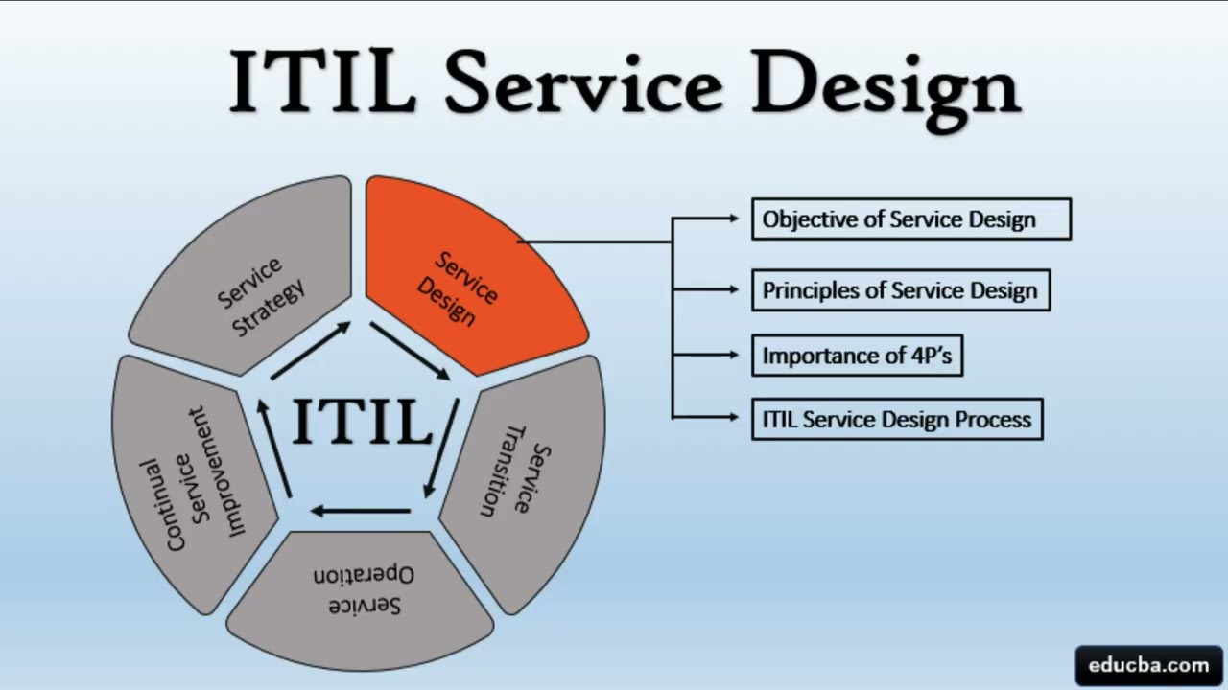
ITIL Service Design
The Information Technology Infrastructure Library (ITIL) is a widely recognized framework that offers a set of best practices for IT service management. It provides guidance on aligning IT services with the needs of the business, emphasizing the importance of security, risk management, and compliance within the IT service delivery process. By incorporating ITIL principles into its operations, NG can establish a structured approach to managing its IT services while ensuring that security considerations are integrated into every aspect of service delivery.
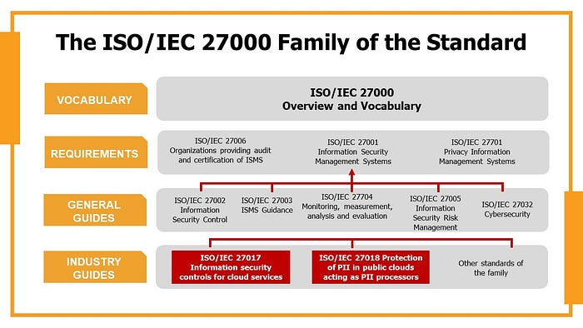
ISO 27000 Family of the Standard
The ISO 27000 series, particularly ISO 27001, is a globally acknowledged standard for information security management systems (ISMS). This standard outlines the requirements for establishing, implementing, maintaining, and continually improving an ISMS within the context of the organization's overall business risks. By adhering to ISO 27001, NG can systematically identify, assess, and mitigate information security risks, thereby enhancing the confidentiality, integrity, and availability of its data and information assets. In addition, ISO 27001 compliance demonstrates NG's commitment to maintaining a robust information security posture, which is crucial for building trust with customers and business partners. In the context of NG's operations, compliance with the General Data Protection Regulation (GDPR) is of most importance. GDPR sets out rigorous requirements for the protection of personal data and the privacy rights of individuals within the European Union (EU). As NG operates internationally and likely processes personal data of EU residents, it must ensure that its data processing activities align with GDPR's principles and requirements. This involves implementing appropriate technical and organizational measures to safeguard personal data, obtaining explicit consent for data processing, and establishing procedures for responding to data breaches and data subject requests. By integrating GDPR compliance into its security framework, NG can demonstrate its commitment to upholding data protection standards and fostering a culture of privacy and trust.

Assets
Tangible Assets:
- Physical Infrastructure: NG's physical buildings, offices, and warehouses.
- IT Hardware: Computers, servers, networking equipment.
Intangible Assets:
- Customer Information: Personal details (name, address, contact information), purchase history.
- Research and Development (R&D) Data: Ongoing projects, experimental results, innovative ideas.
- Brand and Reputation: NG's brand image, public perception.
- Intellectual Property: Trademarks, patents, copyrights.
- Online Presence: NG's website, social media accounts.
- Cloud-Based Infrastructure: Data storage, applications in the cloud.
- Employee Knowledge and Skills: Collective knowledge, skills, and expertise of NG's workforce.
- Partnerships and Alliances: Collaborative agreements with other organizations.
Financial Assets:
- Cash Reserves: NG's available cash for operations, investments.
- Investments: NG's financial investments, stocks, bonds.
Data Assets:
- Employee Data: Personal and professional information of staff and employees.
- Financial Data: Records of financial transactions, budgets, and financial reports.
- Products & Inventory Data: Information related to NG's products, current inventory levels, and sales data.
IT Assets:
- Hardware: Physical IT equipment such as servers, computers, and networking devices.
- Software: Applications, programs, and operating systems used by NG.
Legal and Compliance Assets:
- Compliance Frameworks: Adherence to legal and compliance frameworks (GDPR, ISO standards).
- Contracts and Agreements: Legal contracts, agreements, partnerships.
Human Capital:
- Employee Information: Personal and professional details of NG's employees.
- Employee Training Programs: Training programs, educational initiatives.
Product Assets:
- Products: Physical goods offered by NG for sale.

Compliance (Laws and Ethics) | GDPR Standards:  - As NatureGarden operates in the European market and handles personal data of its customers, GDPR compliance is crucial for the company. NG must ensure that its data processing activities, especially those involving customer information, align with GDPR's requirements for lawful and transparent data processing. NatureGarden's GDPR compliance is based on key articles and provisions. Notably, the company aligns with Articles 5(1)(a) on Lawfulness, Fairness, and Transparency, 6 for Lawful Basis of Processing, and 13-14 to ensure clear data processing. Moreover, NG prioritizes clear consent in line with Articles 4(11), 6, and 7. The company is committed to upholding data subject rights, as outlined in Articles 12-23, ensuring customers can access, rectify, or erase their data. Additionally, NG's consideration of a Data Protection Officer aligns with Article 37, demonstrating a proactive approach to GDPR compliance.  - NG's marketing activities, particularly those involving customer data, must adhere to GDPR's consent requirements (Article 6 and Article 7). This means that NG needs to obtain explicit consent from individuals before using their personal data for marketing purposes and provide clear information about how their data will be used.  - NG's data management practices must align with GDPR's provisions for data subjects' rights, emphasizing accessibility, rectification, and erasure upon request (Articles 12 to 23). As well, NG is obligated to inform customers about any data breaches affecting their privacy (Article 34).  - NG, considering its potential large-scale processing of personal data, may need to appoint a Data Protection Officer (DPO) to oversee data processing activities in compliance with GDPR requirements, particularly as outlined in Article 37.  ISO Standards (ISO/IEC 27001):  - Given NG's reliance on cloud services and wireless networks for its global operations, ISO/IEC 27001's focus on information security management systems is highly relevant. NG can benefit from aligning its information security practices with ISO/IEC 27001 to ensure the confidentiality, integrity, and availability of its information assets.  - NG's R&D data, intellectual properties, and network infrastructure are critical assets that require robust information security measures. Aligning with ISO/IEC 27001 can help NG identify security risks and implement appropriate controls to protect these assets from potential threats and vulnerabilities.  - By establishing a framework for risk assessment and developing an information security management system tailored to its specific needs, NG can demonstrate its commitment to information security best practices, which is essential for safeguarding its operations and maintaining the trust of its customers and stakeholders.
Governance and Strategic Planning for Security | Governance and Strategic Planning for Security at NatureGarden (NG):  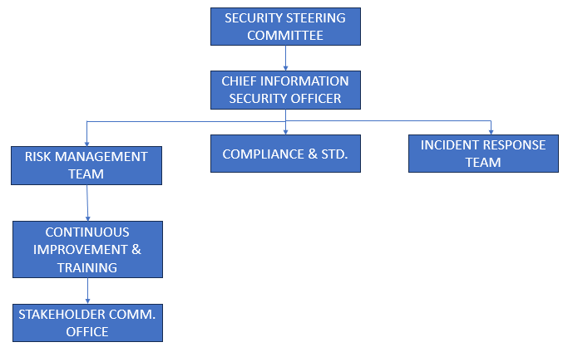Governance Structure  - Risk Assessment and Mitigation: NG will regularly assess potential security risks to its valuable intellectual properties and customer data. By identifying these risks, NG can implement specific measures to mitigate them, ensuring the protection of its assets.  - Compliance Alignment: NG will align its security strategies with GDPR and ISO/IEC 27001 standards to ensure that its security practices meet legal and industry requirements, fostering trust and confidence among its customers and stakeholders.  - Incident Response Planning: NG will develop a comprehensive incident response plan to effectively address and mitigate security breaches or data incidents, minimizing potential damages and ensuring a swift and coordinated response.  - Continuous Improvement: NG will establish a culture of continuous improvement in security practices, regularly reviewing and updating its security measures to adapt to evolving threats and regulatory changes, ensuring that its security posture remains robust and up-to-date.  - Stakeholder Communication: NG will prioritize clear and transparent communication with its stakeholders regarding security measures and practices, promoting trust and demonstrating its commitment to safeguarding sensitive information and intellectual properties.
Risk Management | Risk Management at NatureGarden (NG)  - Data Security  - Potential Risks:  - Data Breaches  - Exposure of sensitive customer information  - Damage to reputation and legal repercussions  - Mitigation:  - Encryption techniques for sensitive data  - Regular vulnerability assessments  - Robust intrusion detection systems  - Swift identification and response to breaches  - Access Control  - Potential Risks:  - Unauthorized Access to Customer Data  - Risk of data breaches and compromised privacy  - Mitigation:  - Strict access controls  - Multi-factor authentication  - Regular security audits and monitoring  - Social Engineering  - Potential Risks:  - Social Engineering Attacks  - Risk of unauthorized access to sensitive info  - Mitigation:  - Comprehensive training on social engineering  - Security awareness programs for employees to recognize and counter social engineering  - Cloud Security  - Potential Risks:  - Cloud-based Risks  - Data breaches, data loss, or service outage due to inadequate cloud security measures  - Mitigation:  - Robust encryption for data in the cloud  - Regular security assessments for cloud service providers  - Network Security  - Potential Risks:  - Network-based Risks  - Unauthorized access, data interception, or denial of service attacks on the network  - Mitigation:  - Firewalls, intrusion detection systems, and regular network security audits  - Physical Security  - Potential Risks:  - Physical Access Risks  - Unauthorized access to physical infrastructure (buildings, data centers)  - Mitigation:  - Access controls, surveillance systems, and security personnel

Policies
Security Policies for NatureGarden (NG)
Network Usage Policy
- Access to NG's network and sensitive data must be restricted to authorized personnel only [6].
- All users must undergo a robust user authentication process before accessing any sensitive information or network resources.
- Access privileges must be assigned based on job roles and responsibilities to ensure that employees can only access information necessary for their specific roles.
- Regular monitoring of network and data access must be conducted to detect and prevent unauthorized attempts to access sensitive information.
- Access privileges must be promptly revoked for employees who no longer require access due to role changes or employment termination to maintain data security and integrity.
BYOD policy
- Employees may use personal devices for work, subject to compliance with company guidelines and security measures [7].
- Personal devices accessing company resources must have up-to-date security software and adhere to access control measures.
- Employees using personal devices for work must ensure data encryption and secure access controls to protect sensitive information.
- Personal device usage for work must align with company standards and not compromise security.
- Employees using personal devices for work must adhere to all relevant company policies and procedures to ensure data security and protection [8].
- Wi-Fi access for personal devices used for work must comply with company policies and security standards.
- Employees must connect only to secure and authorized Wi-Fi networks designated for business use.
- Personal devices must not be used on public or unsecured Wi-Fi networks for work-related tasks.
Incident Response Policy
- All employees are responsible for promptly reporting any suspected security incidents or data breaches to the designated IT or security personnel.
- Clear procedures for identifying, containing, eradicating, and recovering from security incidents are outlined to guide employees in their response to potential threats.
- Specific roles and responsibilities are defined for employees involved in incident response to ensure a coordinated and effective approach to managing security incidents [9].
- Employees are instructed on the proper channels and protocols for communicating security incidents to relevant stakeholders within the organization.
- Regular training and awareness programs are conducted to educate employees about their roles in incident response and to ensure they are prepared to respond effectively to security incidents.

Data Encryption Policy
- All sensitive data transmitted over the network and stored in databases must be encrypted using industry-standard encryption algorithms like Advanced Encryption Standard (AES) to prevent unauthorized access.
- Customer information, including personal and financial data, must be encrypted to ensure its confidentiality and integrity [10].
- Encryption measures must be applied to protect NG's valuable intellectual property from unauthorized access and data breaches.
- All encryption practices must adhere to industry standards and best practices to ensure the effectiveness of data protection measures.

Cloud Policy
- NG's reliance on cloud services must adhere to industry best practices and comply with security standards.
- Cloud service providers must be selected based on their ability to meet security, compliance, and service level agreement (SLA) requirements.
- All cloud-based data must be encrypted, both in transit and at rest, to ensure data confidentiality.
- Regular security assessments for cloud service providers must be conducted to evaluate and mitigate potential risks.

Password Policy
- Employees must create strong and unique passwords for accessing company systems and accounts.
- Passwords must be changed regularly, and employees should not reuse passwords across multiple accounts.
- Multi-factor authentication is mandatory for accessing sensitive systems and data.
- Passwords must not be shared or disclosed to unauthorized individuals.

Access Control [Account Privileges Policy]
- Access to company systems and data must be granted based on job roles and responsibilities.
- Employees must have the minimum level of access necessary to perform their job functions.
- Regular reviews of account privileges must be conducted to ensure alignment with current job roles.
- Any changes in job roles or responsibilities must trigger a review and adjustment of account privileges to maintain the principle of least privilege.

Why it is good practice to constantly have new or updated regulations and standards
It is essential for NatureGarden (NG) to constantly adhere to new or updated regulations and standards for several reasons. Firstly, new regulations often reflect the evolving landscape of data security, governance, and compliance, addressing emerging threats and vulnerabilities. By aligning with these updated standards, NG can better protect its sensitive data, intellectual property, and it’s customer information, ensuring that its security measures remain robust and up essential for companies like-to-date. In addition, updated regulations often incorporate best practices and lessons learned from past security incidents, enabling NG to learn from industry-wide experiences and enhance its own security posture. By staying current with the latest standards, NG can demonstrate its commitment to maintaining high security and compliance standards, fostering trust among its customers, partners, and NatureGarden (NG) to constantly adopt new or updated regulations and standards to ensure the security and integrity of their operations. Furthermore, aligning with new or updated regulations and standards can help NG avoid potential legal and financial repercussions. By proactively adapting to regulatory changes, NG can mitigate the risk of non-compliance penalties and reputational damage, safeguarding its operations and brand data and intellectual properties, from evolving cyber threats. Also, adhering to new regulations and standards demonstrates NG's commitment to ethical and integrity.

References
[1] H. Hassani and S. MacFeely, “Driving excellence in official statistics: Unleashing the potential of comprehensive digital data governance,” Big Data and Cognitive Computing, vol. 7, no. 3, p. 134, Jul. 2023, doi: 10.3390/bdcc7030134.
[2] A. Papazafeiropoulou and K. Spanaki, “Understanding governance, risk and compliance information systems (GRC IS): The experts view,” Information Systems Frontiers, vol. 18, no. 6, pp. 1251–1263, Jun. 2015, doi: 10.1007/s10796-015-9572-3.
[3] E. Marsh, E. P. Vallejos, and A. Spence, “The digital workplace and its dark side: An integrative review,” Computers in Human Behavior, vol. 128, p. 107118, Mar. 2022, doi: 10.1016/j.chb.2021.107118.
[4] “ScienceDirect.com | Science, health and medical journals, full text articles and books.,” Sciencedirect, 2023. https://pdf.sciencedirectassets.com/306234/1-s2.0-S2351978915X00047/1-s2.0-S2351978915001821/main.pdf
[5] H. Taherdoost, “Understanding Cybersecurity Frameworks and Information Security Standards—A Review and Comprehensive Overview,” Electronics, vol. 11, no. 14, p. 2181, Jul. 2022, doi: 10.3390/electronics11142181.
[6] Y. S. Abdulsalam and M. Hedabou, “Security and Privacy in Cloud Computing: Technical review,” Future Internet, vol. 14, no. 1, p. 11, Dec. 2021, doi: 10.3390/fi14010011.
[7] R. Palanisamy, A. A. Norman, and L. M. Kiah, “BYOD Policy Compliance: Risks and strategies in organizations,” Journal of Computer Information Systems, vol. 62, no. 1, pp. 61–72, Feb. 2020, doi: 10.1080/08874417.2019.1703225.
[8] F. Annansingh, “Bring your own device to work: how serious is the risk?,” Journal of Business Strategy, vol. 42, no. 6, pp. 392–398, Sep. 2020, doi: 10.1108/jbs-04-2020-0069.
[9] N. Shinde and P. Kulkarni, “Cyber incident response and planning: a flexible approach,” Computer Fraud & Security, vol. 2021, no. 1, pp. 14–19, Jan. 2021, doi: 10.1016/s1361-3723(21)00009-9.
[10] O. L. Van Daalen, “The right to encryption: Privacy as preventing unlawful access,” Computer Law & Security Review, vol. 49, p. 105804, Jul. 2023, doi: 10.1016/j.clsr.2023.105804.

