

Certificate of Higher Education in Employability Skills
LEVEL 4
Module Lead: : Philippa Fitzgerald
Email: p.fitzgerald@uwtsd.ac.uk

BMSW4008 Digital Skills for Personal and Professional Growth
e-Portfolio
Business Selected: EcoVibe Apparel
Student ID: 2325709
MICHAELA STOEAN-CRISTEA

Table of Contents
Task 1: Questionnaire analysis 3
Task 2: Website building 11
Task 3: Excel 17
Task 4: Advertising brand: EcoVibe Apparel 22
Reference List 23

Task 1: Questionnaire analysis
The development of questionnaire assists in the collection of first hand data that assists in the better analysis regarding the preferences of customers. The purpose of the questionnaire analysis is to gather valuable insights from the targeted audiences that helps the brand in the better manufacturing of the products.
https://forms.office.com/r/Uss8BSzBJd
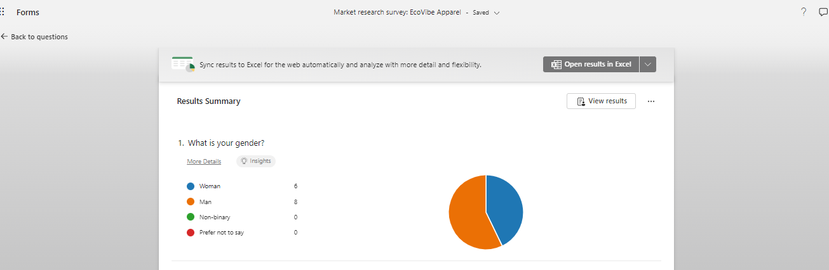
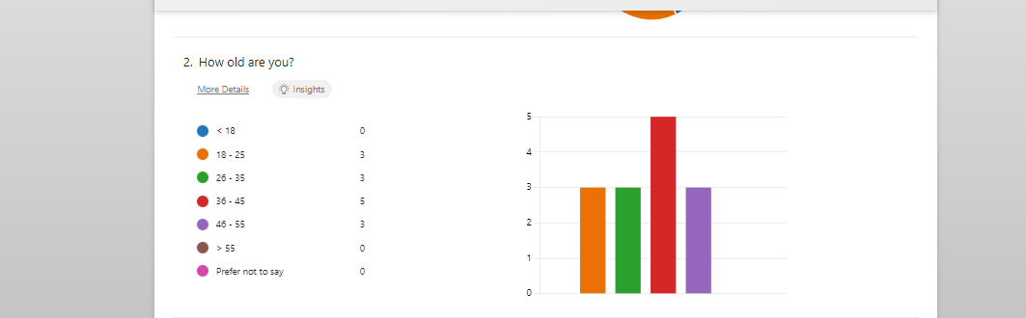
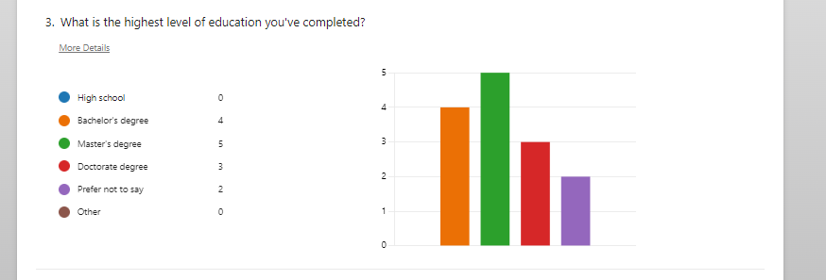
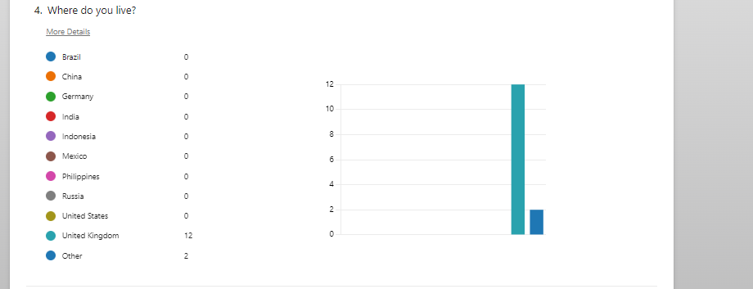
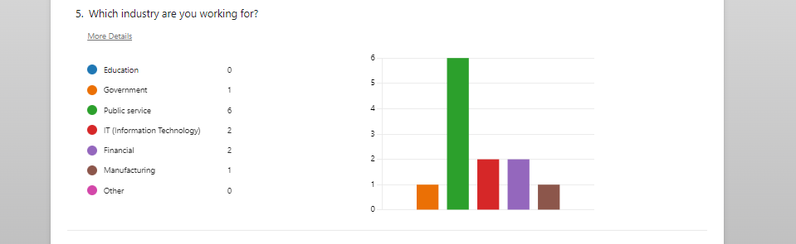
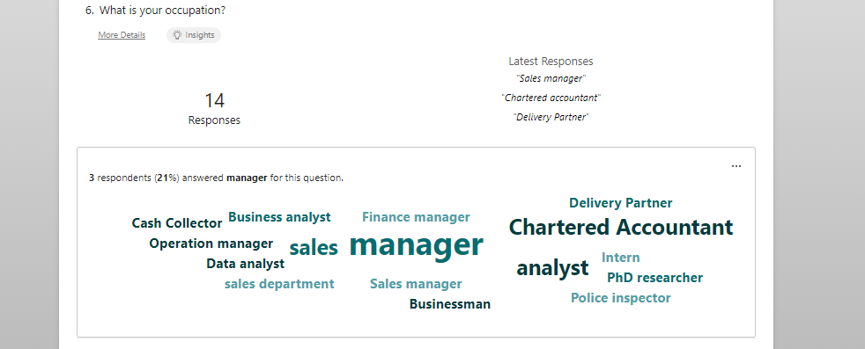
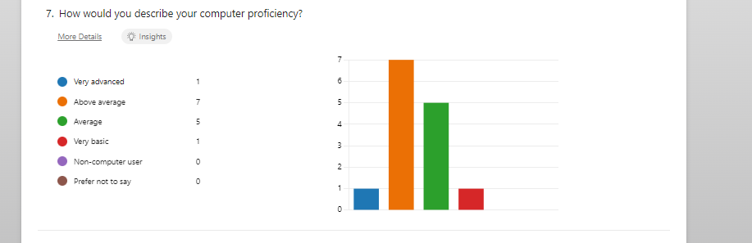
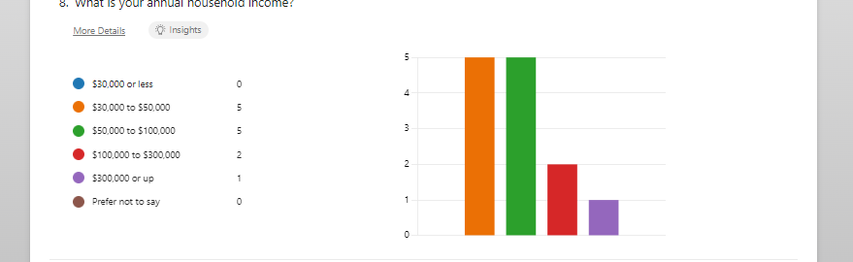
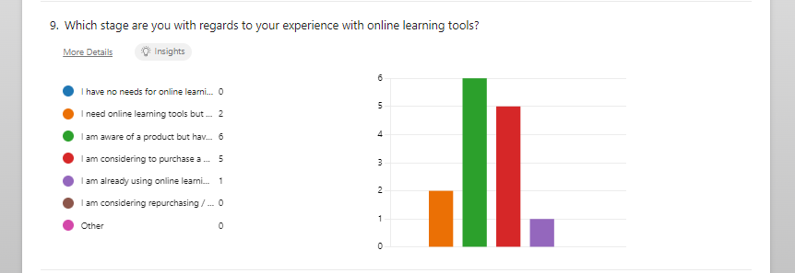
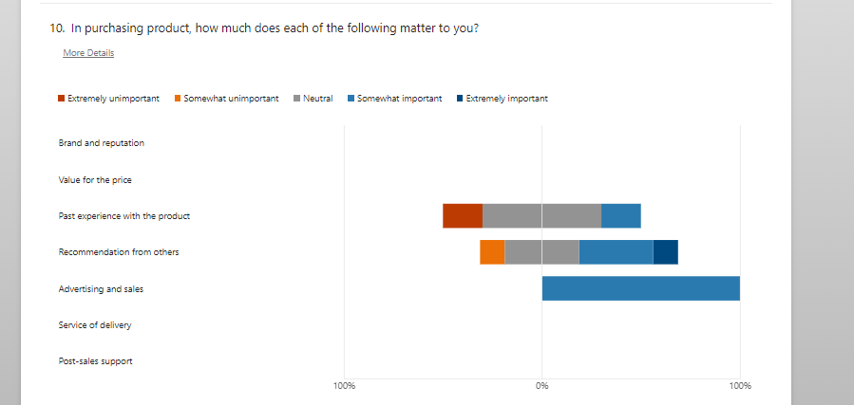
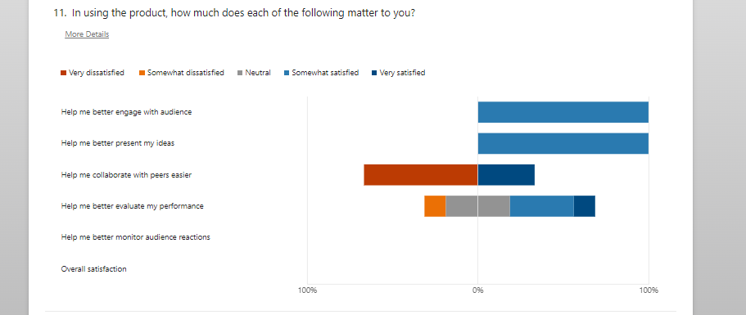

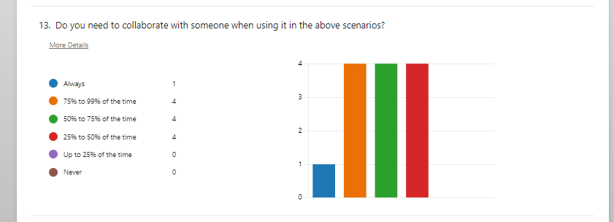
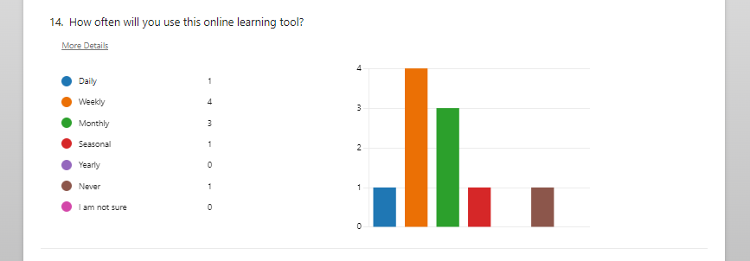
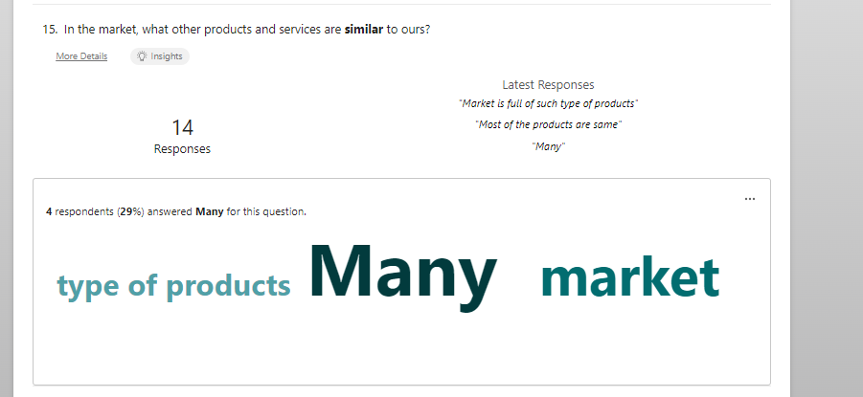
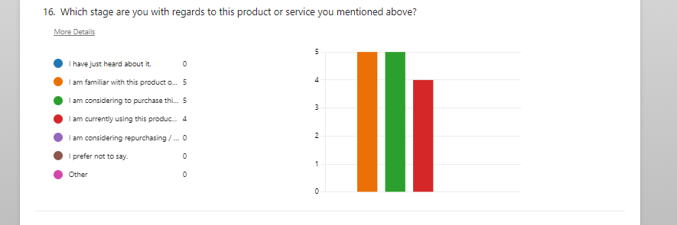
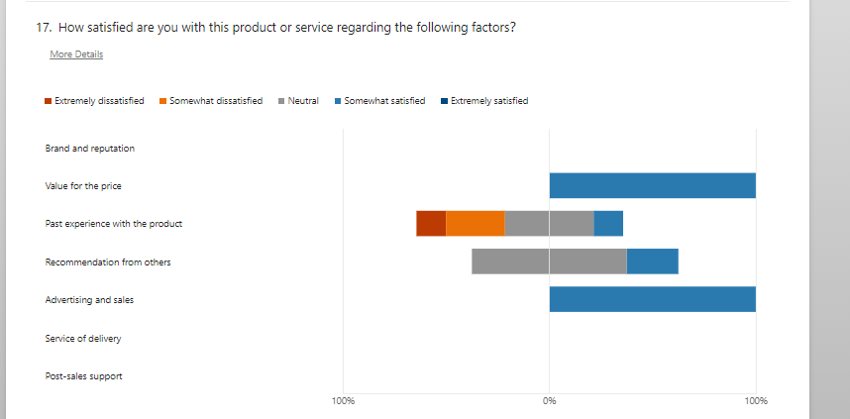
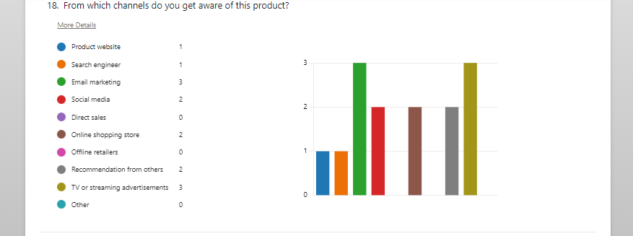

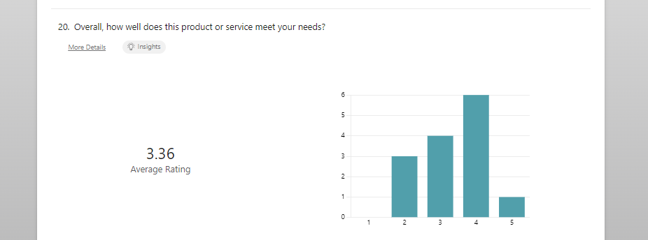
The survey is divided into three main sections: About You, About Your Expectation and Competitive Analysis. As mentioned above, each section is developed purposely to gather the data of the respondent’s background, and the specific requirements and knowledge of the online learning products and services and other related products in the market (Xu et al., 2022).
Section 1: About You
This section is devoted to data gathering on clients’ demographic characteristics. The questions asked are those concerning the respondent’s gender, age group, education level, place of residence, industry of employment, occupational status, and computer literacy, income. These responses are useful for audience division and revealing the socio-economic status of the consumers that may buy EcoVibe Apparel.
For example, the gender and age field allows to determine, to which segments, the brand can be mired or allow to indicate, what trends might be crucial in segments. Education levels provide information about the professional progress and expertise of respondents; whereas computer skills represent the technological literacy of the authors’ audience (Rehman et al., 2022). Also, by using annual household income, it is easy to understand the factor of purchasing power of the consumers that may be in the market.
Section 2: About Your Expectation
This part focuses on the respondents’ practice and perception related to online learning tools, their awareness of them and potential applications. The survey first asks the respondent about their current standing with regard to the tools being offered by online learning solutions –whether the respondent has no need for such tools at the moment, is in a planning stage of purchasing such tools or is already a user of such tools.
One of the questions is to arrange some factors according to the importance of choosing a product: price, features, usability and other. This would then supply important information on which features consumers might find most important, which EcoVibe Apparel can use to adjust its product offering or its strategy to reach new customers (Prakash et al., 2023).
Another question relates to collaboration requirements of online applications, perhaps necessary for consumers who are applying blended modes of delivery, training or virtual classes. Knowledge of this assists the brand to create or advertise attributes that promotes group work or distance learning, with focus on the top user trends.
Section 3: Competitive Analysis
The information of this section looks for other competitors; respondents are required to provide other similar products or services to the ones that EcoVibe Apparel sells. It gets information about whether the respondents are acquainted with these competing commodities, which phase of acquiring them they are currently, and their overall satisfaction level with the others (Tekin and Kanat, 2023). This feedback is useful to EcoVibe Apparel for benchmarking in the market and positioning itself to know its competitors better. Another query put to respondents is one concerning the media through which they encountered the information about these products. These are website, social media, recommendations, adverts, online shops among others.
The Importance of the Questionnaire
The current market research survey covers all the necessary aspects, and it offers EcoVibe Apparel valuable information about the potential customers’ traits and expectations. Regarding the company, demographic data indicate potential users and preferences for online learning tools and competitors as the target audience for a company that helps consumers to choose the necessary services (Hasan et al, 2022).
For instance, demographic questions enable the company to categorise its target market according to age, income and the level of education. This information is crucial in designing proper marketing strategies because of the revealed segments. The expectations towards online learning tools helps the brand to filter features that are most important to the consumers, so that its products can continue to be relevant and competitive in the market (Nurjaman, 2022). The competitive analysis gives a valuable insight of how EcoVibe Apparel compares with its competitors and which marketing communication is most fruitful.

Task 2: Website building
Website designating and marketing materials is one of the crucial element in the business as it helps in attracting targeted customers and reflecting the positive attributes of the business. The purpose of website building and marketing materials based on the questionnaire analysis is to establish the presence of brand on the digital platforms.
Website link - https://ecovibeapparel.durablesites.com/?pt=NjcwOTY2NTFmODc3NDNjZWI0Njc4ODg3OjE3Mjg2NzAyMTIuMzQyOnByZXZpZXc=


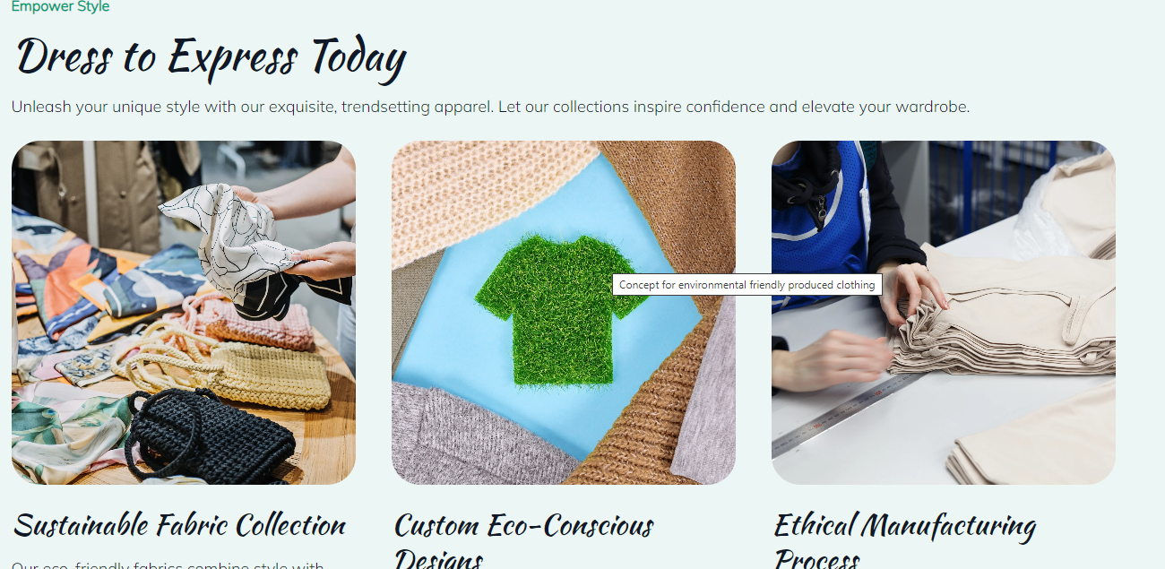

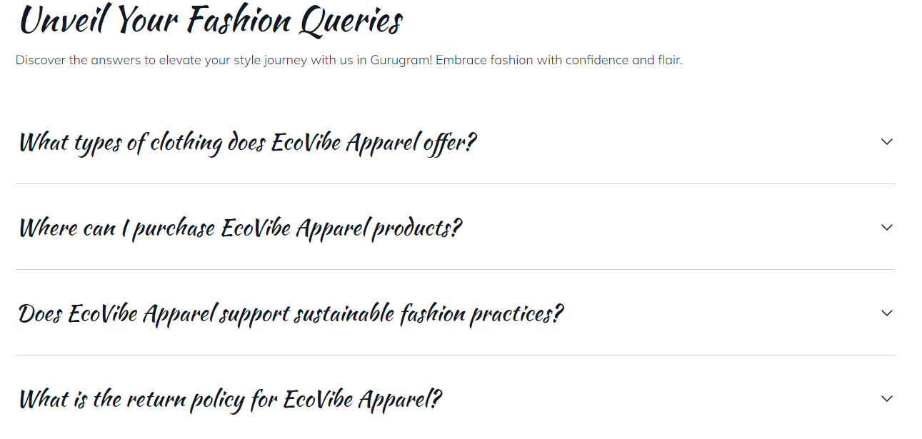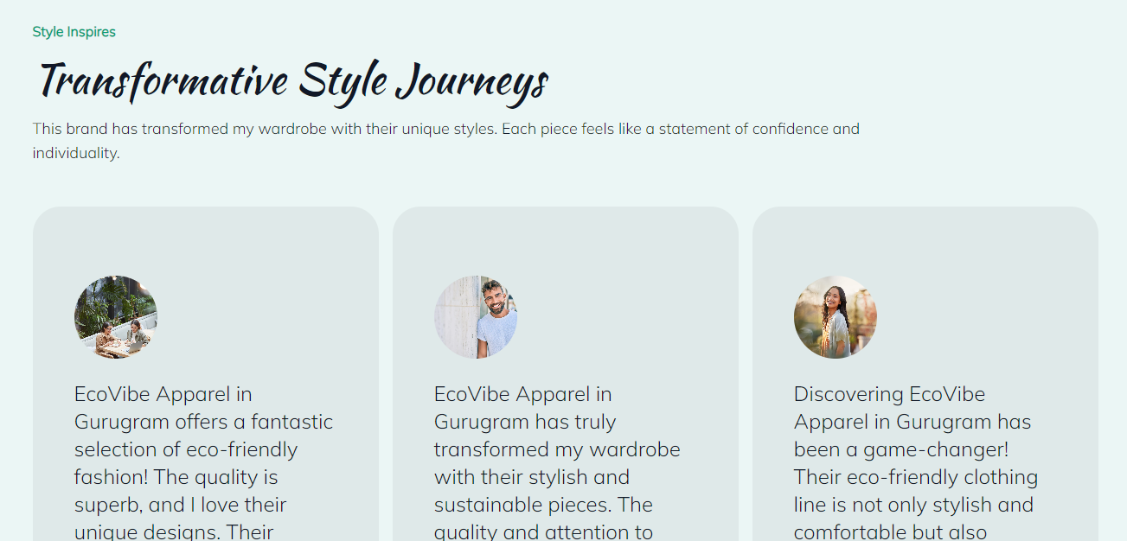

EcoVibe Apparel is a brand that is specialty branded for environment-friendly clothes to consumers who are a sensitive to the issue. The materials that were used to design its website and its promotional literature were developed based on market research questionnaire that was designed to fill in the gaps in understanding about the needs, trends, and characteristics of the target market. The questionnaire data helped to inform the website design and content as well as the marketing message contained within the website and other online ivy marketing material.
Analysing the Questionnaire data
1. Demographic Data - Regarding the profile of potential customers, the respondents were asked for their age, gender, income and education level. Out of the total respondents 38% were in the age group of 18 to 35 years, thus reaffirming that the target group for the brand consists of the youth who are more fashion conscious (Asiri et al., 2022). The gender split was fairly even but women outnumbered men so the website needed to attract both sexes but particularly those interested in products young women would be interested in.
2. Behavioural Data - The questionnaire also gathered self-reported behavioural biomarkers – for example, shopping behaviour, and preferred online marketplaces. One of the specific conclusions was that the majority of the respondents was not strangers to the world of internet and would more willingly chose to shop online than go to a ‘real’ physical store (Soegoto et al., 2022). This realization called for an accessible, hassle free to use website that incorporated the relative shopping convenience across devices and especially the mobile phones.
Segmentation: Identifying and targeting audience
According to the results of the questionnaire, concrete target audiences were established in order to direct the project. With segmentation you could target the specific segments with certain messages and design elements that would meet their needs and wants.
1. Age and Gender Segmentation - The main target market for EcoVibe Apparel consists of the people between the ages of 18-35, and most of the traffic is generated from the female users. To cover this niche, the website’s design remained eye-catching and rather contemporary with an accent on the usage of visuals. The page was designed very attractively and most noticeable it exposed new collection and there was male and female models (Petrović et al., 2023).
2. Income and Pricing Strategy - Noting that a vast majority of the respondents earned middle incomes, the website targeted ably priced services that were sustainable to offer. The descriptions of products focused on the quality and longevity which underlined sensible purchase of clothes that will last, because sustainable fashion is a responsible approach.
Search Engine Optimization (SEO)
1. Keywords search and installation - The questionnaire allowed to determine the specific terms the audience used when searching for the SFPs. The notion of ‘green clothing,’ ‘sustainable clothing,’ ‘biological fiber,’ ‘responsible clothing’ were often used by respondents. All these particular keywords were incorporated to individual product pages to enhance the online site’s rank on the SERPs (Dimitrijevic et al., 2023). For instance, instead of such vague names of products as “T-shirt,” such names as “Organic Cotton T-Shirt for Women – Eco-Friendly Clothing” were used, which include the mentioned keywords.
2. On-Page SEO - Besides, the following on-site SEO were also employed for efficient search engine result on the site: Title tags and meta descriptions were written using the primary and secondary keywords to guarantee every man’s page returned relevant searches (Prakash et al, 2023).
3. Content Marketing - In addition to that, to enhance the SEO the website had blog section and it was engaged in posting articles on topics such as sustainable fashion, eco-friendly choices, and environmentally friendly shopping. The articles for example, “The Benefits of Choosing Organic Cotton” and “Why Sustainable Fashion is the Future,” were developed as per the trends as preferred by the target market (Afwan and Lupiyoadi, 2023). This content was useful for increasing further the organic traffic and at the same time reminded consumers about the company’s sustainable practices.
Creating Marketing Materials
1. Visual Consistency - To achieve brand identity the style of all marketing collateral including the colours used, the typeface, and the logo were the same as the website. Organic and soil colours were most used in the designs, which marked good portrayal of the company’s environmental maximalism. The approach of using consistent logos across the website and marketing materials served the purpose of brand familiarisation and perspective from the consumers (Prakash et al., 2023).
2. Social Media Campaigns - The findings of the questionnaire suggest that the majorities of the target consumers level engagement in social media, especially the Instagram and face –book. Hence, visually appealing post on social media platforms was created using Canva so that EcoVibe Apparel’s products look elegant and contemporary. The notes underscored the environmental-friendly angle alongside pumping up the already fashion-oriented consumer base (Pllashniku, 2023).
3. Email Campaigns - The use of email marketing was the other relevant part of the marketing mix. For the purpose of creating the templates of the emails that will come straight to the customers’ boxes, containing information about the new arrivals, special offers, and initiatives related to the company’s focus on the environmental issues (Boardman, 2023). Analysing the results of the questionnaire we identified that the respondents appreciate clarity and conciseness, therefore, the emails were spare visually with brief, invitational text and large CTAs.
Reflection: Using the Driscoll Model
Knowledge in Action: The Driscoll Model of Reflection “What?”, “So What?”, & “Now What?” Applying the Driscoll Model of Reflection to the creation of my e-portfolio for EcoVibe Apparel.
What?
The task meant to create a website for the company called EcoVibe Apparel, which is a manufacturer of environmentally friendly clothes, and use data from a questionnaire that will be conducted on customers. Based on the gathered data I segmented and grouped them according to the audience preferences to inform developing the website design and content (Ryder and Downs, 2022). Moreover, I employed narrative elements learned in the module, and have made the presentation in the form of video that tellbrand story.
So What?
In this project, I learned how logical and objective data are useful in marketing and designing one’s website. I used the demographics and preferences of the audiences to deliver content which would appeal to specific niche markets. Engagement was used through storytelling as a method for the conveyance of sustainable values adopted by the brand.
Now What?
I'll use these lessons in my next initiatives, giving data analysis and storytelling first priority in order to produce relevant, interesting material (Soundiraraj and Babu, 2022). My goal is to further develop my abilities in user experience (UX) design and keep using storytelling to create genuine brand narratives. As reflection has shown to be crucial for professional development, I'll keep using it to evaluate my work critically and promote ongoing progress.

Task 3: Excel
The purpose of this task is to reflect the financial projections of small business over a three-month period in order to analyse the total income expense and profit margin. Financial projects can be helpful for new business to project the required budget for each operation of business.
Monthly projections
Month | Sales Revenue |  | Cost of Goods Sold (COGS) |  | Gross Profit | Operating Expenses |  | Net Profit
October | 10000 |  | 4000 |  | 6000 | 3000 |  | 3000
November | 12000 |  | 4500 |  | 7500 | 3200 |  | 4300
December | 14000 |  | 5000 |  | 9000 | 3500 |  | 5500
Row Labels |  | Sum of Month 1 |  | Sum of Month 2 |  |  | Sum of Month 3
Marketing |  | 800 |  | 900 |  |  | 850
Other Income |  | 500 |  | 700 |  |  | 600
Profit/Loss |  | 12300 |  | 16750 |  |  | 14280
Rent |  | 1500 |  | 1500 |  |  | 1600
Salaries |  | 4000 |  | 4000 |  |  | 4200
Sales Revenue |  | 10000 |  | 12000 |  |  | 11000
Service Income |  | 2000 |  | 2500 |  |  | 2300
Total Expenses |  | 6600 |  | 6750 |  |  | 6970
Total Income |  | 12500 |  | 15200 |  |  | 13900
Utilities |  | 300 |  | 350 |  |  | 320
Grand Total |  | 50500 |  | 60650 |  |  | 56020

Monthly Breakdown
Category | Month 1 | Month 2 | Month 3
Sales Revenue | 10000 | 12000 | 11000
Service Income | 2000 | 2500 | 2300
Other Income | 500 | 700 | 600
Total Income | 12500 | 15200 | 13900
Rent | 1500 | 1500 | 1600
Salaries | 3000 | 3500 | 3200
Utilities | 500 | 600 | 550
Marketing | 800 | 900 | 850
Miscellaneous | 300 | 400 | 350
Total Expenses | 6100 | 6900 | 6550
Profit/Loss | 6400 | 8300 | 7350
Month 1 Breakdown
Category | Month 1
Sales Revenue | 10000
Service Income | 2000
Other Income | 500
Total Income | 12500
Rent | 1500
Salaries | 3000
Utilities | 500
Marketing | 800
Miscellaneous | 300
Total Expenses | 6100
Profit/Loss | 6400
Month 2 Breakdown
Category | Month 2
Sales Revenue | 12000
Service Income | 2500
Other Income | 700
Total Income | 15200
Rent | 1500
Salaries | 3500
Utilities | 600
Marketing | 900
Miscellaneous | 400
Total Expenses | 6900
Profit/Loss | 8300
Month 3 Breakdown
Category | Month 3
Sales Revenue | 11000
Service Income | 2300
Other Income | 600
Total Income | 13900
Rent | 1600
Salaries | 3200
Utilities | 550
Marketing | 850
Miscellaneous | 350
Total Expenses | 6550
Profit/Loss | 7350
Profit and Loss details
Row Labels | Sum of Month 1 | Sum of Month 2 | Sum of Month 3
Profit/Loss | 6400 | 8450 | 6930
Total Expenses | 6100 | 6750 | 6970
Total Income | 12500 | 15200 | 13900
Grand Total | 25000 | 30400 | 27800
The formula that is used in excel for calculating profit and loss is subtracting total income and total expenses. For instance, in month 1, total income (12500) - total expense (6100) that is 6400.
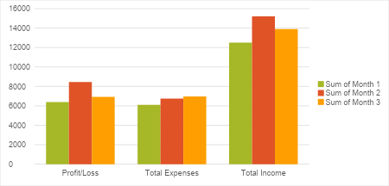
Description
The Importance of Excel in the Digital Era
During the age of technological advancement, Microsoft Excel has stayed as one of the most vital necessities to the functioning of business companies, big and small, complex and simple, in every industry. Nonetheless, due to the numerous entries of professional software tools, Excel remains an effective tool for managing and processing data, making financial forecasts and deciding on business development strategies (Bunea, 2022). For its versatility, easy usage and strong functions integration it becomes crucial for everyone regardless the field of the activity. Now, let’s focus on the particular fields that are still profiting from and Anchoring Excel in today’s digital world.
1. Maintaining and warehousing data – Data management and organization is perhaps one of the core or one of the best strengths of Excel since it involves storing large volumes of data. Companies, corporations and organizations carry out a colossal volume of data consisting of; their clients, stock of products and services, cash transactions among others. Excel has a well-organized type of document titled as spreadsheet that has rows and column, hence one can input data in a well arranged manner as well as analyse it properly (Visconti, 2022).
2. Again, in this process, Excel is magnificent to apply because it offers the formulas and functions that are relevant to financial forecasting as well as budget preparing with high efficiency and effectiveness. Irrespective of the sizes of these companies, excel is an important tool in business planning, financial planning and cash flow planning. Forecasting is a tool in finance where a business predicts the future sources of income and expenditure as well as the future profits earned from the business using assumptions and formulae placed in changeable excel sheets (Jamal, 2023). Managers are able to enter different future sosario/economic/financial scenario and examine the sensitivity of the business’s performance on potential changes in any given parameter such as growth rate, operating expenses, or inte2st rates.
3. Data Visualization and Reporting – The idea of raw data complicates its examination when it is not well presented. Among the most touted aspects of Excel is its capacity to analyse data and convert it into easily understandable charts, graphs, and other visual displays we refer to as dashboards. Proper usage of tools and methods of information visualizations allows businesses to make sense of great amounts of information and come up with insights in a timely manner which is crucial if business is to rely on data (Stuebs et al., 2022). For instance, pie charts can be used to present market share while line graph can be used to depict the trend of sales performance and bar graph can be used to indicate the performance of a product.
4. Automation with Macros – Macros, despite being one a range of features that makes Excel very functional, is among the least employed resources in a range of Offices applications. Macros are saved sequences of operations that can be repeated by a single mouse click; it might be used to format data, to generate particular reports, or to perform the sequence of calculations.
5. Interactivity and Access – especially given that more and more organizations employ remote or hybrid work modes, collaboration applications have never been more important. Excel, if linked with the compulsory online services like, OneDrive or share point allows two or more people to edit the same document at a time (Fei et al., 2023). Cross-functional teams can share information and work on documents in real-time and make comments for others and/or update documents, and so forth instead of having to continue using multiple emails or learn which version is the latest.
6. Data Analysis and Decision–making – Present day business environments demand data analytic thinking and excel has many functions related with it. They include formulas, functions and its statistical features offer users the ability to analyse data in detail and achieve insight. For instance, Excel can craft trends to predict future demand given past consumption, execute financial ratio analysis to determine profitability or solvency, and work out forecasts that may enable organizations to make positive strategic decisions (Minenko, 2022).
These aspects will help businesses make better decisions or choose which strategies they should use in marketing, operations or even the inventions of new products. The data analysis capabilities of Excel enable users to delve deeply into the data and extract insights that have a direct bearing on the success of businesses (Cao, 2023).
The amalgamation of Microsoft Excel's versatility, efficiency, and user-friendliness accounts for its continued significance in the digital age. Excel has established itself as a vital tool for company operations, with uses ranging from managing massive information to producing financial estimates and producing insights (Salmi and Kaipia, 2022). Excel's ability to integrate with other digital tools, facilitate collaboration, and analyse data guarantees that businesses can keep using it to make well-informed decisions, automate tasks, and spur growth.

Task 4: Advertising brand: EcoVibe Apparel
The purpose of this task is to reflect the story telling techniques that are used for the creation of video regarding the EcoVibe Apparel brand.
https://studio.youtube.com/video/WY25hzFBM1s/edit
The video is designed as a story, which tells people about the existence of EcoVibe Apparel and the goals they pursue. Whereas the approach that is taken is by using The Hero’s Journey framework where the brand takes the role of the hero that is combating effects of fast fashion. It is built by the use of real customers’ experience and the connection of going for sustainable fashion to environmental conservation. Visuals and spoken word support each other, and as a result, guarantee true to life representation of the brand. The conflict is created with the help of the problem of fast fashion, and by presenting EcoVibe Apparel as its solution. Behind the scenes shots in making the product and nature are used as supplementary visuals to support the brand. The call to action at the end of the above slogans tells the audience to sign up hence building an everlasting association. These techniques in synergy therefore build a compelling story and an emotional connect that helps brand recall.

Reference List
Afwan, I. and Lupiyoadi, R., 2023. PULL STRATEGY AND DIGITAL MARKETING OPTIMIZATION FOR HOUSE OF GARMENT MSMES AS BRAND IDENTITY ENHANCEMENT BY LEGALITY MANAGEMENT, COMPANY PROFILE AND WEBSITE MAKING. Eduvest: Journal Of Universal Studies, 3(7).
Arindaputri, N.B. and Santoso, S., 2023. Analysis of the influence of digital marketing, brand image, and price perception on purchase intention and brand loyalty in Uniqlo apparel products.
Asiri, A., Isyanto, P. and Yani, D., 2022. DIGITAL MARKETING IN PROMOTION CLOTHING" COTTONSTYLES". Jurnal Ekonomi, 11(02), pp.670-681.
Bernat Gaya, P.L., 2022. Marketing plan of Ecoalf.
Boardman, R., 2023. E-commerce is king: creating effective fashion retail website designs. In Pioneering new perspectives in the fashion industry: disruption, diversity and sustainable innovation (pp. 245-254). Emerald Publishing Limited.
Bunea, L., 2022. Business plan for a clothing store.
Cao, J.M., 2023. A STUDY OF DIGITAL TRANSFORMATION STRATEGIES OF AT CLOTHING COMPANY. The EUrASEANs: journal on global socio-economic dynamics, (5 (42)), pp.276-288.
Dimitrijevic, D., Dimitrijevic, N. and Adamović, Ž., 2023. Digital marketing from the perspective of the producer/seller in the SMEs of textile and clothing industry. Naučni i stručni časopis tekstilne industrije UDK 677+ 687 ISSN 0040-2389 eISSN 2683-5665, 72(3), p.52.
Etuk, A., Anyadighibe, J.A., James, E.E. and Ukpe, M.U., 2022. Sociological factors and consumer buying behaviour towards fashion clothing. International Journal of Applied Research in Social Sciences, 4(2), pp.21-34.
Fei, T., Wang, Y. and Ma, Y., 2023. Cash Flow Analysis of Clothing Company—Take Shengye Clothing Company as an Example. Statistics & Quantitative Economics, 3(1), pp.1-14.
Hasan, M.M., Cai, L., Ji, X. and Ocran, F.M., 2022. Eco-friendly clothing market: a study of willingness to purchase organic cotton clothing in Bangladesh. Sustainability, 14(8), p.4827.
Jamal, A.N., 2023. Business plan for a clothing and artificial jewellery business in Central Ostrobothnia, Finland.
Minenko, M., 2022. Sustainable and Customizable clothes: a business plan for Bramd.
Nuñez, M.A., Villanueva, E., Giraldo, L., Gomez, L. and Castaño, Y., 2023. Risk governance in the textile/clothing industry: A case study in medium enterprises. Dutch Journal of Finance and Management, 6.
Nurjaman, K., 2022. Analysis of the Effect of External Environment and Marketing Strategy on the Marketing Performance of MSME Fashion. International Journal of Demos (IJD), 4(2), pp.665-675.
Petrović, M., Pačavar, S., Petrović, V., Đorđić, D., Milosavljević, A. and Pecev, P., 2023. THE INFLUENCE OF SOCIAL MEDIA ON PROMOTIONAL ACTIVITIES OF CLOTHING PRODUCERS. UNION OF ENGINEERS AND TEXTILE TECHNICIANS OF SERBIA.
Pllashniku, G., 2023. A Digital Marketing Strategy for Fashion For You.
Prakash, K.C., Arun, R., Mayi, K., Kavitha, K., Sivaperumal, K. and Shivaratri, C., 2023. Clothing Products Purchases through Social Media Advertisements and the Problems Involved. Remittances Review, 8(4).
Prakash, K.C., Arun, R., Mayi, K., Kavitha, K., Sivaperumal, K. and Shivaratri, C., 2023. Clothing Products Purchases through Social Media Advertisements and the Problems Involved. Remittances Review, 8(4).
Rehman, F.U. and Ghazali, B.M., 2022. Evaluating the influence of social advertising, individual factors, and brand image on the buying behavior toward fashion clothing brands. Sage Open, 12(1), p.21582440221088858.
Ryder, M. and Downs, C., 2022. Rethinking reflective practice: John Boyd’s OODA loop as an alternative to Kolb. The International Journal of Management Education, 20(3), p.100703.
Salmi, A. and Kaipia, R., 2022. Implementing circular business models in the textile and clothing industry. Journal of Cleaner Production, 378, p.134492.
Soegoto, E., Ananta Hafidz, M., Febiananda, R. and Maruli, D., 2022. Design of a customizable preview feature on clothing website. International Journal of Research and Applied Technology (INJURATECH), 2(1).
Soundiraraj, S. and Babu, B.A., 2022. Reflective Practice for Teachers in the Post-Method Era. In Contemporary ELT Strategies in Engineering Pedagogy (pp. 271-282). Routledge India.
Stuebs, M., Bryant, S.M., Edison, C. and Stanley, C., 2022. Brittney’s Boutique: Tailoring financial statements for function as well as fashion. Journal of Accounting Education, 58, p.100768.
Tekin, S. and Kanat, S., 2023. The effects of sensory marketing on clothing-buying behavior. Autex Research Journal, 23(3), pp.315-322.
Visconti, R., 2022. The Valuation of FashionTech and Digital Clothing. In Augmented Corporate Valuation: From Digital Networking to ESG Compliance (pp. 629-657). Cham: Springer International Publishing.
Xu, Z., Zhu, G., Metawa, N. and Zhou, Q., 2022. Machine learning based customer meta-combination brand equity analysis for marketing behavior evaluation. Information Processing & Management, 59(1), p.102800.

