
Global Business Challenges Report on HSBC


University of Wales Trinity Saint David



Programme: MBA

Module: Global Business Challenges

Module code: BMMB7006

Lecturer: Rebecca Francis-Davies

Assignment Title: Global Business Challenges

Student name: Manna Barua

Student ID number: 2428346

Word Count: 5000

Executive Summary
This research looks at how HSBC can deal with the dangers and challenges that come with using artificial intelligence (AI) in all of its operations around the world. AI makes things more efficient in areas like fraud detection, credit scoring, and customer service, but it also creates big problems with rules, ethics, and operations.
The main problem is that the UK has a flexible, principles-based approach, while the EU has a rigorous, rules-based AI Act. This makes it harder to follow the rules and costs more; HSBC has to build a global governance system that is in line with the toughest criteria. Good data governance is also very important since problems with data quality, openness, and compliance across borders raise both regulatory and reputational issues.
Ethical issues include algorithmic prejudice, not being able to explain decisions, and relying too much on automated decisions, which need to be managed proactively through ethics-by-design and human monitoring. At the same time, trust from customers is becoming an important business asset; AI-driven judgments need to be fair and open.
The research suggests a three-phase implementation plan (Foundation, Build, Lead) over 24 months to improve governance, make sure compliance, and make HSBC the leader in responsible AI. Overall, good AI governance is seen as more than just a way to follow the rules; it's also seen as a long-term way to go ahead of the competition.

Table of Contents
Executive Summary 1
1. Introduction 3
2. Main Findings 4
2.1 Strategic Analysis of AI Risk Management in Global Banking 4
2.1.1 Regulatory Analysis: UK vs EU 4
2.1.2 Data Governance 6
2.1.3 Ethical AI 8
2.1.4 Customer Trust 10
2.1.5 Macroeconomic Context 11
2.2 Implementation Plan 13
2.2.1 AI Implementation Timeline 13
2.2.2 Phase 1: Foundation (0–6 Months) 14
2.2.3 Phase 2: Build (6–18 Months) 16
2.2.4 Phase 3: Lead (18–24 Months) 18
2.3 Overall Strategic Value of the Implementation Plan 21
3. Conclusion 23
Bibliography 25

1. Introduction
AI's rapid rise is transforming the global banking industry by changing how banks function, manage risk, and provide value. Machine learning, natural language processing, and predictive analytics are being used in basic banking operations, such as fraud detection, credit scoring, AML, and customer relationship management (McKinsey, 2023). These technologies can boost efficiency and provide companies with a competitive edge. However, they pose complex regulatory, ethical, and operational risks that must be controlled (WEF, 2024).
A global systemically significant bank, HSBC operates in over 60 countries. It must deal with several international rules and pressures (HSBC, 2024). AI operations raise data governance, algorithmic bias, rule-following, and consumer trust problems. Regulators, investors, and society are scrutinising responsible AI practises, increasing these dangers (Edelman, 2023).
HSBC can strategically manage AI risks and use AI to establish a long-term competitive edge, according to this senior advisory paper. The UK and EU have flexible, principles-based regulatory frameworks and rigid, rules-based frameworks, respectively (UK DSIT, 2023).
The paper analyses and makes recommendations using key academic frameworks. The Resource-Based View (RBV) views AI governance skills as strategic assets (Barney, 1991). Stakeholder Theory is used to reconcile conflicting stakeholder interests in AI implementation (Freeman, 1984). Institutional Theory explains regulatory compliance pressures across countries (DiMaggio and Powell, 1983). EU laws also affect the world through the Brussels Effect (Bradford, 2020). The paper combines these frameworks to achieve regulatory and strategic aims to provide lasting recommendations.

2. Main Findings

2.1 Strategic Analysis of AI Risk Management in Global Banking

2.1.1 Regulatory Analysis: UK vs EU
Global AI laws are developing swiftly, fragmenting, and affecting more countries. These shifts pose dangers and opportunities for HSBC, a global bank. The UK's principles-based regulatory regime and the EU's rules-based system should be compared (European Commission, 2024).
The Department of Science, Innovation, and Technology (DSIT) White Paper, which is part of the United Kingdom's artificial intelligence strategy, places more of a focus on flexibility, innovation, and sector-specific supervision than it does on a single set of regulations (DSIT, 2023). The idea behind this paradigm is that safety, openness, justice, accountability, and contestability are all important. In the present day, these requirements are enforced by authorities like as the FCA and the ICO (FCA, 2023). In the near term, this decentralised system decreases the amount of regulation that is imposed, but also causes confusion for businesses who operate in several industries or jurisdictions (CMA, 2023).
A horizontal artificial intelligence law known as the AI Act (law (EU) 2024/1689) was approved in the European Union. The Act classifies uses of artificial intelligence as inadmissible, high-risk, limited-risk, and low-risk respectively. Credit scoring, fraud detection, and anti-money laundering are all services that HSBC regards to be "high-risk" functions. In order to do this, exhaustive documentation, human control, and compliance testing are required.
This difference tenses the structure. The UK model has flexible yet unclear guidelines. The EU model is straightforward and predictable yet has tight rules (Veale & Borgesius, 2021). HSBC's compliance infrastructure is harder to manage strategically due to this imbalance. The EU AI Act extends to any company that provides AI-enabled services in the EU market, regardless of location (Bradford, 2020).
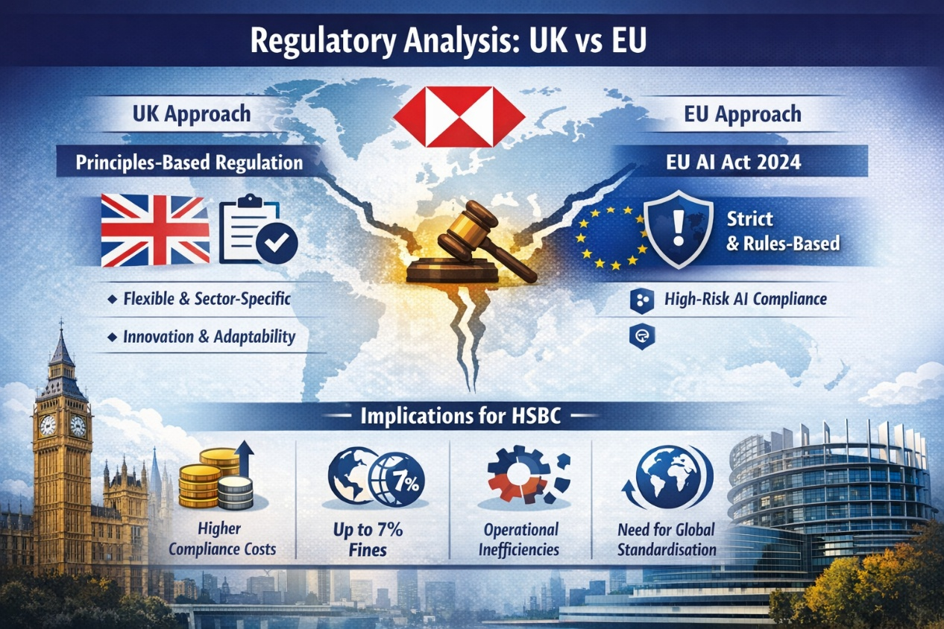
Figure 1: Regulatory Analysis: UK vs EU. [Source: (European Parliament, 2024)]
Multinational corporations standardise their operations to satisfy the tightest EU laws; the Brussels Effect suggests that EU rules will become the global norm. To prevent regulatory arbitrage and ensure consistency, HSBC must unify compliance globally.
Macroeconomic and geopolitical issues worsen regulatory disparity. Data sovereignty, digital protectionism, and systemic financial stability are driving governments to tighten AI deployment controls (OECD, 2023). Financial institutions are vulnerable since they handle sensitive customer data and are vital to the global economy (BIS, 2023).
Institutional Theory states that HSBC faces three sorts of isomorphic pressure: coercive (following the EU AI Act), normative (matching industry standards and professional expectations), and mimetic (following competitors' best practices) (DiMaggio & Powell, 1983). A proactive and uniform regulatory policy is even more vital under these challenges.
Implications for HSBC
- Increased compliance costs due to dual regulatory regimes
- Risk of regulatory penalties under EU law (up to 7% of global turnover)
- Operational inefficiencies arising from fragmented compliance systems
- Strategic pressure to standardise AI governance globally

2.1.2 Data Governance
Data governance is crucial to AI risk management, especially in banking, where data drives choices (OECD, 2022). HSBC's global activities make data management across systems, jurisdictions, and regulations difficult.
AI systems need organised and unstructured data such as client financial records, transaction histories, and behavioural data. Data privacy, quality, integrity, and compliance are at risk from this dependence (Kuner et al., 2017). The General Data Protection Regulation (GDPR) requires enterprises to process data legally, limit its use, keep it minimal, and be responsible for it (Voigt & Von dem Bussche, 2017).
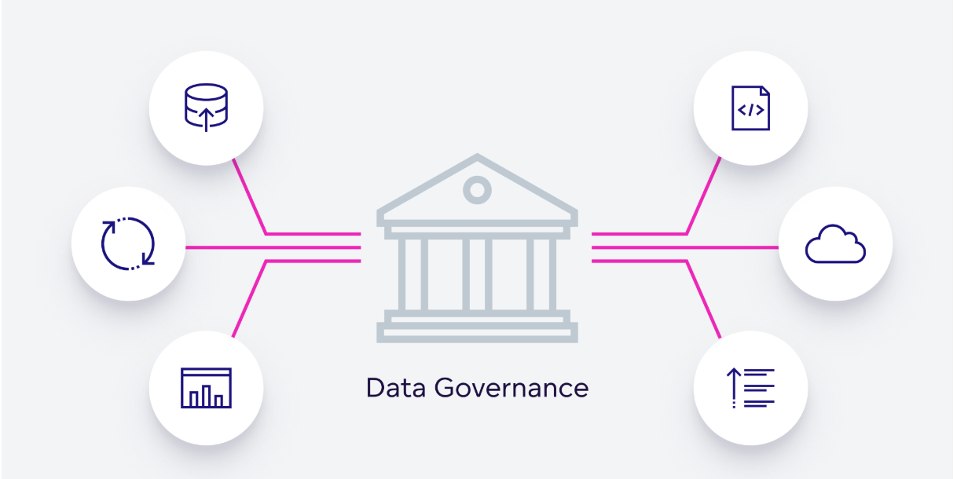
Figure 2: Data Governance. [Source: (Floridi, 2019)]
HSBC struggles to send data internationally, especially between countries with different laws. The complexity of data localisation and international data flow constraints may hinder AI system growth (UNCTAD, 2022). Different data laws in different jurisdictions might create compliance gaps and leave organisations more vulnerable to authorities.
A major issue is data lineage and traceability. AI systems are generally "black boxes," making data collection, processing, and decision-making difficult to view (OECD, 2021). Lack of transparency makes it tougher to follow rules and damages customer trust and internal responsibility.
The management of consent is still another concern. Systems that are powered by artificial intelligence and that utilise data for many purposes make it more difficult to verify that consumer data is used with the user's express and informed permission (ICO, 2020). Inappropriate management of consent may lead to legal consequences as well as harm to one's reputation.
According to the principles of information ethics, data governance ought to be equitable, transparent, and respectful of the informational rights of personal persons. As a result of the fact that choices made by banks based on data may have an impact on people's financial options and social mobility, this is very important.
Additionally, HSBC's data infrastructures are fragmented, which presents additional risk. According to McKinsey (2023), Artificial Intelligence models may be less reliable, vulnerable, and error-prone if they are based on outdated systems, regional silos, and uneven data standards. Strong governance frameworks are unable to keep up with the fast development in the deployment of artificial intelligence, which makes these problems even more severe.
According to Barney (1991), a Resource-Based View (RBV) believes excellent data governance to be a strategic asset that is uncommon, valuable, and difficult to replicate. Companies that have strong governance systems are able to make better choices, decrease risk, and build customer trust, which gives them an edge over their competitors over the long run.
Table 1: Data Governance Challenges and Strategic Recommendations for HSBC
Key Issues | Description | Strategic Recommendations
Regulatory complexity in cross-border data transfers | Different jurisdictions impose varying data protection and localisation requirements, increasing compliance burden | Establish clear global standards for data transfer aligned with GDPR and international regulations
Lack of transparency in AI data usage | Difficulty in tracking how data is collected, processed, and used in AI systems reduces accountability | Implement monitoring tools to track data lineage, usage, and compliance in real time
Inconsistent data governance across regions | Fragmented systems and regional silos create inefficiencies and compliance gaps | Develop a unified global framework ensuring consistent standards, policies, and controls
Risk of non-compliance with GDPR and related frameworks | Failure to meet regulatory requirements can result in penalties and reputational damage | Align all data practices with GDPR and emerging global standards
Ethical concerns regarding data fairness and usage | Potential bias and unfair use of data in AI decision-making processes | Embed fairness, transparency, and accountability into all AI data processes
Strategic underutilisation of data governance | Data governance often treated as compliance rather than strategic asset | Invest in technology, talent, and governance to leverage data as a competitive advantage

2.1.3 Ethical AI
Along with operational concerns, ethical AI in banking produces systemic and long-term strategic issues that must be controlled at the organisational level. HSBC's massive AI deployment implies even modest ethical missteps can affect global markets.
AI feedback loops are more concerning. Machine learning models can institutionalise inequality by reinforcing biases (Mehrabi et al., 2021). For instance, if a credit scoring algorithm continually discriminates against certain client segments, future training data would reflect similar biases, making the system unjust and harder to fix. Moral difficulties and long-term legal and reputational risks arise.
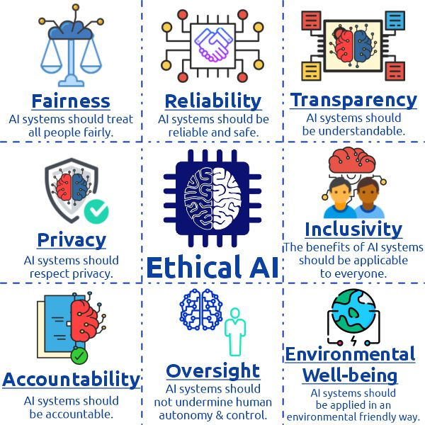
Figure 3: Ethical AI. [Source: (Leslie, 2019)]
Automation bias in enterprises, where decision-makers rely too much on AI outputs without proper critical scrutiny, is another developing issue (Skitka et al., 2000). This could mean HSBC staff accept faulty fraud alerts or credit judgements, increasing risk. This illustrates that ethical AI is a behavioural and organisational issue as well as a technical one.
Ethical AI must be integrated into model design, development, deployment, and monitoring for governance. Research demonstrates that many organisations focus on controls after deployment and disregard hazards like biased data and model assumptions. These issues make HSBC more vulnerable, and audits alone can't fix them.
Generative AI and advanced prediction models pose additional ethical issues like incorrect information, model hallucination, and improper synthetic data use (Bommasani et al., 2021). While these technologies can improve efficiency, they can also make things less certain and harder to govern, especially in customer-facing applications.
Strategic Insight
Ethical AI is becoming more than just a legal requirement in the financial services industry; it's also becoming a competitive advantage. Banks that show leadership in ethical AI are more likely to win over regulators, get investors who care about ESG, and improve their brand reputation.
Additional Recommendations
- Integrate Ethics-by-Design Principles: Ensure ethical considerations are embedded at the design stage of AI systems, not added retrospectively.
- Develop Human-in-the-Loop Systems: Keep meaningful human oversight over high-risk decisions, especially those involving credit and fraud.
- Establish Ethical KPIs: Introduce measurable indicators such as bias reduction rates and explainability scores to monitor ethical performance.

2.1.4 Customer Trust
Trust has always been based on reliability and financial stability. AI introduces algorithmic trust. Customers must trust both businesses and decision-making technologies.
HSBC struggles to trust individuals. AI can speed up and personalise services, making customers happier. However, greater automation reduces human interaction, which may damage trust and responsibility (Luhmann, 2018).
Trust depends heavily on perceived fairness. Research shows that customers are more likely to accept unfair outcomes like loan denials when they believe the process is fair and open (Kim and Mauborgne, 1998). This illustrates the importance of explainable and discussable AI-driven judgements.
Another emerging issue is digital trust imbalance. Customers don't understand AI systems, but firms have lots of data and analytical tools (Zuboff, 2019). This mismatch can make people feel exploited or out of control, especially when it comes to data consumption.
Data stewardship is also gaining trust. Customers want firms to use their data safely, privately, and ethically (Martin, 2018). Any data misuse or AI error that violates this expectation may have immediate and lasting reputational consequences.
Trust affects client lifetime value, cross-selling, and market share. Trusted companies retain clients and make more money than their competitors (Morgan and Hunt, 1994).
Strategic Insight
Trust should be treated as a quantifiable and manageable asset, integrated into HSBC’s overall performance framework rather than viewed as an abstract concept.
Additional Recommendations
- Introduce Explainability Interfaces for Customers: Provide user-friendly explanations of AI decisions through digital banking platforms.
- Develop Trust Recovery Mechanisms: Establish rapid response systems to address AI-related errors, including compensation and transparent communication.
- Leverage Trust as a Competitive Advantage: Position HSBC as a leader in responsible AI through branding and marketing strategies.

2.1.5 Macroeconomic Context
The global macroeconomic environment is transforming how banks employ AI and compete. HSBC must grasp these factors to align its AI approach with its long-term aims.
Technology competition is increasing worldwide, especially between major economies like the US, the EU, and China. Competition produces diverse regulatory approaches and making cross-border commerce tougher (Baldwin, 2019). HSBC faces uncertainty, but it may leverage its worldwide reach to its advantage.
Another crucial point is rising compliance and governance costs. As restrictions tighten, AI system implementation costs rise, especially for high-risk applications (KPMG, 2023). These charges should be considered investments in risk reduction and longevity, not short-term costs.
ESG factors are also gaining relevance. Investors increasingly scrutinise technological governance, including AI ethics and data management (Eccles and Klimenko, 2019). HSBC's AI governance affects capital access and investor trust, adding another layer of accountability.
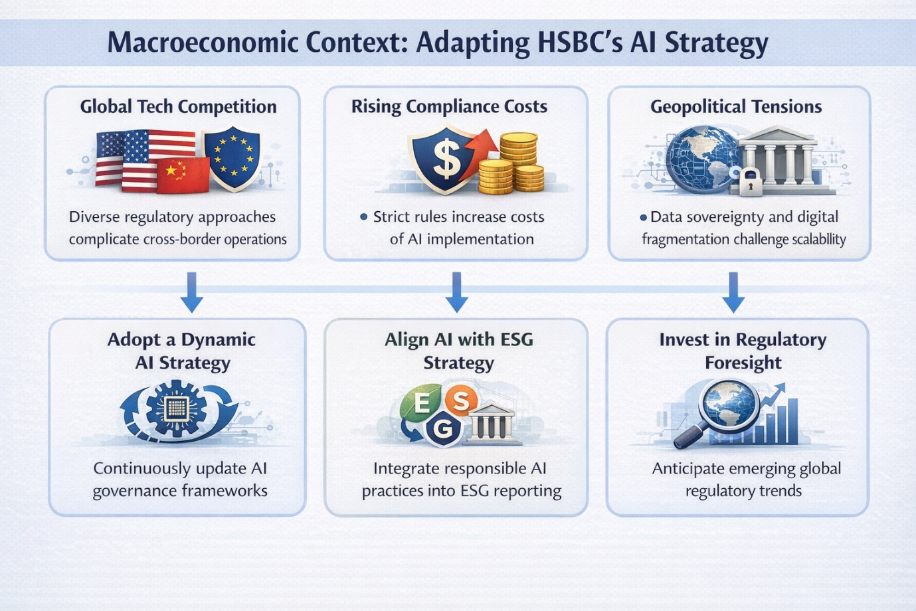
Figure 4: Macroeconomic Context. [Source: (Aaronson, 2021)]
Geopolitical changes worsen data fragmentation and digital sovereignty. Countries are restricting data flow, making AI models less scalable and operations more complicated. HSBC, with branches worldwide, needs a more flexible and decentralised data approach.
AI investment decisions can also be affected by macroeconomic instability, including interest rate increases, inflation, and economic uncertainty. Long-term strategic lag and competitive disadvantage might result from not investing in AI skills, despite short-term cost concerns. HSBC must adapt its AI strategy to changing external conditions to stay adaptable and resilient (Teece et al., 1997).
Recommendations
- Adopt a Dynamic AI Strategy: Continuously update AI governance frameworks in response to regulatory and economic changes.
- Align AI with ESG Strategy: Integrate responsible AI practices into ESG reporting and investor communications.
- Invest in Regulatory Foresight: Develop internal capabilities to anticipate and respond to emerging regulatory trends globally.

2.2 Implementation Plan
A strong implementation plan is necessary to turn strategic suggestions into results that can be measured. HSBC needs to make a phased, organisation-wide change that includes following the rules, following ethical standards, and making operations more efficient in order to have good AI governance.

2.2.1 AI Implementation Timeline
The timeline chart shows a planned, step-by-step way to put AI governance into place over the course of 24 months. The steps from Foundation (0–6 months) to Build (6–18 months) to Lead (18–24 months) show a logical order of tasks. First, governance and visibility are set up, then capabilities are built, and finally, strategic leadership is reached.

Figure 5: AI Implementation Timeline. [Source: Author]
The long length of the Build phase shows how hard it is to combine explainable AI systems, regulatory compliance tools, and training for the organisation. This is in line with what the industry says: putting AI governance into practice is the most resource-intensive step. The shorter Lead phase means that once governance capabilities are in place, the organisation can focus on optimisation, engaging with others, and creating value.

2.2.2 Phase 1: Foundation (0–6 Months)
Objective
The main goal of this phase is to build a strong organisational base for AI governance at HSBC. This means making clear oversight structures, making sure that all AI systems are fully visible, and making sure that they follow all relevant rules. By creating this baseline, HSBC can better handle the risks that come with using AI and help with the next steps in the implementation process.
Key Actions
1. Establish AI Governance Committee
HSBC should set up a central AI Governance Committee made up of senior people from the risk, compliance, data, technology, and legal departments. This committee will be in charge of overseeing AI-related decisions, making sure that they are in line with regulations, and making sure that everyone in the organisation is held accountable. More and more, people are realising that these kinds of governance structures are necessary for managing AI risks in banks and other financial institutions (Financial Stability Board, 2023).
2. Conduct AI System Inventory
A complete list of all AI systems used by HSBC around the world needs to be made. This should include a lot of information about each system's purpose, the data sources it uses, how it classifies risk, and where it is used. Making this inventory more open and easier to keep an eye on is in line with regulatory expectations for traceability and accountability (European Banking Authority, 2021).
3. Perform Regulatory Gap Analysis
HSBC should carefully compare its current AI practices to important regulatory frameworks, such as the EU AI Act, UK regulatory principles, and relevant international standards. This gap analysis will find places where rules aren't being followed and help decide which fixes should be made first. This will lower the risk of breaking the law (IOSCO, 2021).
4. Conduct Data Audit Across Regions
A global data audit should be done to check the quality of the data, the rules that govern it, and the flow of data across borders. This process is very important for making sure that AI systems follow data protection laws and are more reliable and trustworthy. Good data governance also helps people make better choices and lowers the risk of running a business (Basel Committee on Banking Supervision, 2023).
Responsibility
The successful execution of this phase requires a clear allocation of responsibilities:
Role | Key Responsibility
Chief Risk Officer (CRO) | Overall accountability for AI risk management and regulatory compliance
Chief Data Officer (CDO) | Oversight of data governance, data quality, and data infrastructure
Chief Technology Officer (CTO) | Technical support for AI system identification, integration, and infrastructure
Head of Compliance | Ensuring alignment with regulatory frameworks and managing compliance reporting

Key Performance Indicators (KPIs)
KPI Area | Performance Indicator | Target
AI System Visibility | Identification and documentation of AI systems across all business units | 100% coverage
Regulatory Compliance | Completion of regulatory gap analysis across major operating regions | Fully completed
Data Governance | Coverage of data audit across critical datasets | ≥ 95%
Governance Structure | Establishment of AI Governance Committee with defined roles and reporting lines | Fully operational
Estimated Cost
This phase is expected to need a medium amount of money, mostly for allocating internal resources, getting help from consultants, and getting audit tools. Costs stay relatively low while providing a lot of strategic value because the focus is on governance and assessment instead of technology deployment.

2.2.3 Phase 2: Build (6–18 Months)
Objective
In this phase, HSBC creates and implements AI governance tools to ensure ethical, compliant, and growing AI systems. This stage builds on Phase 1's core infrastructure and applies governance ideas daily. HSBC can better control risks and use AI strategically.
Key Actions
1. Implement Explainable AI (XAI) Systems
HSBC should use Explainable AI (XAI) tools to make AI-driven decisions clearer and easier to understand. This is especially important for applications that are very risky, like credit scoring, fraud detection, and systems that stop money laundering. XAI helps people follow the rules and builds trust by making it easier for stakeholders like regulators, employees, and customers to understand how decisions are made (Arrieta et al., 2020).
2. Develop an AI Ethics Review Framework
Before AI systems are put into use, there should be a formal AI ethics review framework in place to evaluate them. Fairness, accountability, openness, and human oversight are some of the important ideas that should be included in this framework. The review process should be a part of the AI development lifecycle so that ethical issues are dealt with before they happen, not after they happen (IEEE, 2019).
3. Staff Training and Capability Building
HSBC should set up a full training program for more than 500 employees in risk, compliance, technology, and business functions. The program should focus on the rules for AI governance, the rules that must be followed, ethical issues, and how to manage risks in the real world. To make sure that AI governance is implemented consistently and effectively across the organisation, it is important to build internal capabilities (Bughin et al., 2018).
4. Compliance Alignment with EU AI Act
HSBC needs to put in place processes that make sure they follow the EU AI Act, especially for high-risk AI systems that are high-risk. This includes doing conformity assessments, keeping detailed records, and making sure there is enough human oversight. Following these rules not only lowers the risk of getting in trouble with the law, but it also sets a global standard for compliance (European Banking Authority, 2023).
Responsibility
The successful execution of this phase requires coordinated efforts across multiple functions:
Role | Key Responsibility
Chief Technology Officer (CTO) | Leads implementation of AI systems, including Explainable AI (XAI) tools and supporting technical infrastructure
Chief Compliance Officer (CCO) | Ensures alignment with regulatory frameworks, oversees compliance processes, and manages reporting obligations
Head of AI/Analytics | Responsible for AI model development, validation, and integration of ethical and governance standards

Key Performance Indicators (KPIs)
The effectiveness of Phase 2 will be evaluated using the following measurable indicators:

KPI Area | Performance Indicator | Target
Regulatory Compliance | Proportion of AI systems compliant with EU AI Act standards | ≥ 90%
Ethical AI Performance | Reduction in identified bias incidents | ≥ 30% reduction
Capability Building | Completion of AI governance training among relevant employees | ≥ 80%
Explainability Implementation | Deployment of Explainable AI (XAI) in high-risk AI applications | 100% coverage

Estimated Cost
This phase requires a high level of investment, reflecting the complexity of implementing AI governance capabilities at scale. Key cost components include:
- Acquisition and integration of XAI tools and monitoring systems
- Development and delivery of training programmes
- Engagement of external consultants for compliance and ethical validation
- Implementation of documentation and reporting systems
Although the financial investment is significant, it is necessary to ensure robust governance and long-term sustainability.

2.2.4 Phase 3: Lead (18–24 Months)
Objective
This phase aims to make HSBC the world's leading responsible artificial intelligence firm by using its governance expertise to achieve a competitive edge, establish stakeholder trust, and shape new regulatory norms. Artificial intelligence governance has evolved beyond compliance to a strategic advantage that creates long-term value.
Key Actions
1. Publish Responsible AI Report
HSBC should write a full Responsible AI Report every year that explains its AI governance framework, risk management practices, ethical standards, and performance results. To make sure that it is clear and easy to compare, this report should follow well-known ESG reporting frameworks. Public disclosure not only makes companies more accountable, but it also makes investors and regulators more confident (Global Reporting Initiative, 2021).
2. Launch Customer Trust Campaigns
HSBC should create targeted communication campaigns to teach customers about how the bank uses AI in its services. These campaigns should stress openness, fairness, and data protection to help people feel more confident about AI-based decisions. Effective communication is very important for getting customers to trust and engage with digital banking (Capgemini, 2022).
3. Conduct External AI Audits
HSBC should hire outside auditors to look at its AI systems, governance structures, and compliance practices. External audits check that internal processes are working correctly, which makes them more credible and shows that the company is committed to being accountable and always improving (PwC, 2022).
4. Strengthen Regulatory Engagement and Leadership
HSBC should take part in regulatory consultations, industry forums, and global efforts to improve AI governance. The organisation can help shape new standards and stay ahead of changes in the law by working with policymakers and industry groups. This proactive approach helps with strategic positioning and makes it less likely that rules will change (World Economic Forum, 2022).
Responsibility
The leadership phase requires strong executive involvement and cross-functional coordination:
Role | Key Responsibility
Chief Executive Officer (CEO) | Provides overall strategic direction and leads stakeholder engagement at the global level
Chief Sustainability Officer (CSO) | Oversees ESG integration and Responsible AI reporting across the organisation
Public Affairs & Regulatory Affairs Teams | Manage external engagement, policy advocacy, and relationships with regulators and industry bodies

Key Performance Indicators (KPIs)
The success of this phase will be measured through the following indicators:
KPI Area | Performance Indicator | Target
Customer Trust | Increase in customer trust index | ≥ 15% increase
Regulatory Compliance | Number of major AI-related regulatory breaches | 0 (zero breaches)
ESG Performance | Improvement in ESG ratings linked to AI governance | Positive upward trend
Audit & Assurance | Completion of independent AI audits with no critical findings | 100% successful audits

Estimated Cost
This phase involves a medium to high level of investment, primarily associated with:
- Development and publication of Responsible AI reports
- Customer communication and marketing campaigns
- External audit and assurance services
- Participation in global regulatory and industry initiatives
While these costs are high, they are strategically justified by the reputational, regulatory, and competitive benefits achieved.

2.3 Overall Strategic Value of the Implementation Plan
This makes sure that AI governance is built into the highest levels of the organisation, both in terms of day-to-day operations and long-term planning.

Figure 6: Compliance Performance. [Source: Author]
This KPI chart illustrates that AI governance performance has improved in all three phases of implementation. Foundation sets the visibility baseline, completely identifying AI systems. Compliance and bias reduction enhance 90% and 30% during construction.
Governance has matured, with higher compliance and 15% consumer trust in the Lead phase. This trajectory indicates that early governance and infrastructure investments increase performance later on. This chart shows that trust and compliance improvements are trailing indicators that appear after basic and operational capabilities are in place. This emphasises the need for a long-term AI governance framework.

Figure 7: Estimated Cost by Phase. [Source: Author]
The AI implementation cost chart shows the investment distributed over three periods. Technology installation, staff training, and regulation enforcement make the Build phase the most expensive. However, the Foundation phase only requires minor funding for governance and audits. However, reporting, external audits, and stakeholder engagement cost medium to high in the Lead phase.
AI governance requires substantial upfront investments to establish capabilities, but these costs reduce long-term regulatory, operational, and reputational risks. The trend also suggests that AI governance should be a long-term investment rather than a business cost.
Key Outcomes
- Progression from Visibility, Capability and leadership: The staged strategy simplifies and streamlines the transfer, reducing risks and improving efficiency.
- Alignment with Global Regulatory Expectations: International standards help HSBC reduce compliance risks and ensure jurisdictional consistency.
- Embedding Ethical AI into Organisational Culture: Governance is not treated as a standalone function but is integrated into everyday operations and decision-making processes.
- Conversion of Compliance into Competitive Advantage: HSBC doesn't see governance as a cost; instead, it uses it as a strategic asset to improve trust, reputation, and market position.

3. Conclusion
The rapid expansion of AI gives HSBC both a chance and a risk. AI might boost productivity, improve decision-making, and customise customer experiences. It also raises difficult concerns with compliance, data management, ethics, and stakeholder confidence.
This report shows that global regulatory guidelines are unclear. This is especially true for the principles-based UK and rules-based EU. Multinational organisations need a proactive, united strategy because this disparity makes it tougher to follow the rules. Following EU regulations gives HSBC a secure and future-oriented framework for addressing AI-related risks across countries.
The investigation also suggests that AI systems need effective data governance. Without good data quality, transparency, and compliance systems across borders, AI applications could become unreliable and non-compliant. To protect the company's reputation and provide fair results, the AI lifecycle must address ethical challenges like algorithmic bias, explainability, and responsibility.
This change elevates customer trust to strategic value. To maintain long-term connections and brand value as AI influences customer interactions and decisions, be upfront, fair, and accountable. Companies that don't address these issues face regulator fines and customer distrust.
The execution plan in this paper gives HSBC a clear and organised solution. Through Foundation, Build, and Lead, the business may establish control and visibility, build operational skills, and become a strategic leader in responsible AI.

Bibliography
Aaronson, S.A. (2021). Data Is Different: Why the World Needs a New Approach to Governing Cross-Border Data Flows. Washington DC: CIGI.
Arrieta, A.B. et al. (2020) ‘Explainable Artificial Intelligence (XAI): Concepts, taxonomies, opportunities and challenges’, Information Fusion, 58, pp. 82–115.
Baldwin, R. (2019). The Globotics Upheaval: Globalisation, Robotics, and the Future of Work. Oxford: Oxford University Press.
Bank for International Settlements (BIS) (2023) Artificial Intelligence and Machine Learning in Financial Services. Basel: BIS.
Barney, J. (1991) ‘Firm resources and sustained competitive advantage’, Journal of Management, 17(1), pp. 99–120.
Basel Committee on Banking Supervision (BCBS) (2023) Principles for the Sound Management of Operational Risk. Basel: BIS.
Bommasani, R. et al. (2021). On the Opportunities and Risks of Foundation Models. Stanford: Stanford University.
Bradford, A. (2020). The Brussels Effect: How the European Union Rules the World. Oxford: Oxford University Press.
Bughin, J. et al. (2018) Notes from the AI Frontier: Modelling the Impact of AI on the World Economy. McKinsey Global Institute.
Capgemini (2022). Why Consumers Love AI—And What They Expect Next. Paris: Capgemini Research Institute.
Competition and Markets Authority (CMA) (2023) AI Foundation Models: Initial Report. London: CMA.
DiMaggio, P.J. and Powell, W.W. (1983) ‘The iron cage revisited: Institutional isomorphism and collective rationality’, American Sociological Review, 48(2), pp. 147–160.
Eccles, R.G. and Klimenko, S. (2019) ‘The investor revolution’, Harvard Business Review, 97(3), pp. 106–116.
Edelman (2023). Edelman Trust Barometer 2023. New York: Edelman.
European Banking Authority (EBA) (2021) Guidelines on Loan Origination and Monitoring. Paris: EBA.
European Banking Authority (EBA) (2023) Report on Machine Learning in Banking. Paris: EBA.
European Commission (2024) Artificial Intelligence Act (Regulation (EU) 2024/1689). Brussels: European Commission.
European Parliament (2024) Artificial Intelligence Act: Legislative Resolution. Brussels: European Parliament.
Financial Conduct Authority (FCA) (2023) AI and Machine Learning in Financial Services. London: FCA.
Financial Stability Board (FSB) (2023) The Financial Stability Implications of Artificial Intelligence. Basel: FSB.
Floridi, L. (2019). The Ethics of Information. Oxford: Oxford University Press.
Freeman, R.E. (1984). Strategic Management: A Stakeholder Approach. Boston: Pitman.
Global Reporting Initiative (GRI) (2021) GRI Standards. Amsterdam: GRI.
HSBC (2024) Annual Report and Accounts 2024. London: HSBC Holdings plc.
Information Commissioner’s Office (ICO) (2020) Guidance on AI and Data Protection. London: ICO.
International Organisation of Securities Commissions (IOSCO) (2021) Artificial Intelligence in Capital Markets. Madrid: IOSCO.
Janssen, M. et al. (2020) ‘Data governance: Organising data for trustworthy AI’, Government Information Quarterly, 37(3), pp. 101493.
Kim, W.C. and Mauborgne, R. (1998) ‘Fair process: Managing in the knowledge economy’, Harvard Business Review, 76(4), pp. 127–136.
KPMG (2023) AI in Financial Services: Managing Risk and Compliance. London: KPMG.
Kuner, C. et al. (2017). The EU General Data Protection Regulation (GDPR): A Commentary. Oxford: Oxford University Press.
Leslie, D. (2019). Understanding Artificial Intelligence Ethics and Safety. London: Alan Turing Institute.
Luhmann, N. (2018). Trust and Power. Cambridge: Polity Press.
Makridakis, S. (2017) ‘The forthcoming Artificial Intelligence (AI) revolution’, Futures, 90, pp. 46–60.
Martin, K. (2018) ‘Ethical implications and accountability of algorithms’, Journal of Business Ethics, 160(4), pp. 835–850.
McKinsey & Company (2023). The State of AI in 2023. New York: McKinsey.
Mehrabi, N. et al. (2021) ‘A survey on bias and fairness in machine learning’, ACM Computing Surveys, 54(6), pp. 1–35.
Morgan, R.M. and Hunt, S.D. (1994) ‘The commitment-trust theory of relationship marketing’, Journal of Marketing, 58(3), pp. 20–38.
OECD (2021) AI Systems and Data Governance. Paris: OECD.
OECD (2022) OECD Digital Economy Outlook. Paris: OECD.
OECD (2023) Regulatory Frameworks for Artificial Intelligence. Paris: OECD.
PwC (2022) Responsible AI: Building Trust in AI Systems. London: PwC.
Rudin, C. (2019) ‘Stop explaining black box machine learning models’, Nature Machine Intelligence, 1(5), pp. 206–215.
Skitka, L.J. et al. (2000) ‘Automation bias and errors’, International Journal of Human-Computer Studies, 52(4), pp. 701–719.
Teece, D.J., Pisano, G. and Shuen, A. (1997) ‘Dynamic capabilities and strategic management’, Strategic Management Journal, 18(7), pp. 509–533.
UK Department for Science, Innovation and Technology (DSIT) (2023) AI Regulation White Paper. London: UK Government.
UNCTAD (2022) Digital Economy Report. Geneva: United Nations.
Veale, M. and Borgesius, F.Z. (2021) ‘Demystifying the draft EU AI Act’, Computer Law Review International, 22(4), pp. 97–112.
Voigt, P. and von dem Bussche, A. (2017) The EU General Data Protection Regulation (GDPR): A Practical Guide. Cham: Springer.
World Economic Forum (WEF) (2022) Global AI Governance Framework. Geneva: WEF.
World Economic Forum (WEF) (2024) AI Governance and Risk Report. Geneva: WEF.
Zuboff, S. (2019). The Age of Surveillance Capitalism. London: Profile Books.

