ECAD7004

Professional and Pedagogic Studies: Researching the Learning: what, how, and why am I teaching?

Jayne Libby
Student Number 2306506
Word Count - 4932

The study investigates a class of Year 7 students' perceptions of Class Charts as a reward system, focusing on its influence on behaviour, engagement, and academic performance. The research aims to evaluate how Class Charts align with motivational theories and it’s impact on classroom dynamics. School X's extensive use of Class Charts highlights the importance of assessing its efficacy within the educational setting.

Welsh Government guidance documents (Welsh Government, 2016; Welsh Government, 2023c) have shaped the research question, emphasising the importance of reward systems in cultivating positive behaviour and attendance. These guidelines advocate for a supportive environment that addresses both intrinsic and extrinsic motivational factors. The pressing need to enhance pupil achievement in Welsh schools, underscored by the 2022 disappointing PISA results (Welsh Government, 2023b), has led to the formulation of a comprehensive roadmap for education reform titled "Our national mission: High standards and aspirations for all" (Welsh Government, 2023a). The roadmap outlines objectives focused on ensuring high-quality learning experiences, dismantling barriers to achievement, supporting student and staff wellbeing, providing professional development for educators, fostering community engagement, and promoting the Welsh language. It also endeavours to enhance pupils' intrinsic motivation by making learning more relevant and engaging, guided by the four purposes of the curriculum (Donaldson, 2015).

Understanding students' perspectives on Class Charts holds implications for the professional development of student teachers, providing insights into the dynamics of student motivation and engagement. This enables educators to tailor their instructional strategies effectively while fostering a positive learning atmosphere. The research took place within a 3-16 co-educational school in South Wales, focusing on a Year 7 registration class to which the student teacher was assigned, providing valuable opportunities to gather firsthand insights into students' perceptions and experiences with Class Charts.

Literature Review
The literature review serves not only to inform the research question but also to identify key debates and theoretical foundations relevant to investigating the effectiveness of Class Charts as a reward system. By delving into the distinction between intrinsic and extrinsic motivation, the literature illuminates how different reward systems can influence pupil engagement and academic outcomes. The study aims to assess whether Class Charts rewards have the potential to bolster or hinder intrinsic motivation, whilst also acknowledging the potential drawbacks of extrinsic rewards. Furthermore, the integration of diverse learning theories provides a framework for examining the alignment of Class Charts with various pupils' perspectives on learning and motivation.

The debate between the effectiveness of intrinsic and extrinsic motivation has been a central theme in learning theories, with different perspectives offering unique insights into the interplay between internal and external factors in shaping learning and behaviour. Behaviourism, as exemplified by the works of Skinner (1965) and Thorndike (2023), focuses on observable behaviours and the role of external stimuli, such as rewards and punishments, in shaping learning. Thorndike's "law of effect" posits that actions leading to favourable outcomes are reinforced, whilst those resulting in unfavourable outcomes are less likely to be repeated (Thorndike, 2023). This perspective aligns with the use of extrinsic motivation, where external factors drive learning and behaviour. The literature review conducted by O'Leary and Drabman (1971) on token reinforcement programmes in classrooms portrays token reinforcement as a powerful tool, but also emphasises the complexity of its implementation and the need for careful design to achieve fairness and lasting behaviour change.

In contrast, constructivist theories, as articulated by Piaget (1953), Vygotsky (1978), and Bruner (2006), emphasise the active role of learners in constructing their own understanding through interaction with the environment and social interactions. Piaget's theory highlights the importance of intrinsic motivation, driven by an individual's curiosity to explore and understand their surroundings. However, Vygotsky's sociocultural theory asserts that extrinsic factors, such as praise and rewards, are more powerful motivators for children's learning (Vygotsky, 1978).

Bandura's Social Learning Theory (SLT) (1971) bridges the gap between behaviourism and cognitive approaches, emphasising the interplay between internal cognitive processes and external influences in learning and behaviour. SLT addresses both intrinsic and extrinsic motivation, suggesting that individuals are motivated to imitate rewarding behaviours (intrinsic) whilst also highlighting the role of reinforcement in shaping behaviour (extrinsic) (Bandura, 1971).Connectivism, introduced by Siemens (2005), offers a unique perspective on motivation in the digital age, suggesting that motivation can be shaped by individuals' perceptions of the relevance and usefulness of information. Learners might feel intrinsically driven to interact with content that aligns with their interests, whilst external incentives such as badges or certificates can also impact participation and learning achievements in digital learning settings. Maslow's Humanistic Learning Theory (1970) emphasises self-directed learning, personal growth, and the fulfilment of individual potential. Intrinsic motivation is central in humanistic approaches, as learners are encouraged to pursue personally meaningful activities. Extrinsic motivators such as rewards or grades are less emphasised, with the focus instead on fostering autonomy, intrinsic interest, and personal growth.

Recent publications, such as Daniel H. Pink's "Drive: The Surprising Truth About What Motivates Us" (2010), challenge traditional views on motivation by highlighting the importance of intrinsic motivation over extrinsic rewards. Pink argues that intrinsic motivation, driven by autonomy, mastery, and purpose, leads to higher levels of engagement and creativity compared to extrinsic rewards (Pink, 2010). This perspective aligns with research in self-determination theory, which suggests that extrinsic rewards can be beneficial when they support individuals' psychological needs for autonomy, competence, and relatedness (Ryan & Deci, 2000).

However, critics argue that rewarding expected behaviours might backfire (Wheldall et al., 1989) and that extrinsic rewards can undermine intrinsic motivation and lead to superficial compliance rather than genuine engagement or learning (Kohn, 1999). Cameron & Pierce (1996) argue that relying on external incentives may diminish pupils' inherent curiosity and passion for learning, ultimately undermining their long-term growth and self-regulation. To ensure equitable and impactful extrinsic rewards for all pupils, educators must align them with culturally relevant pedagogy, as outlined by Ladson-Billings (1995). This involves recognising pupils' cultural backgrounds and values, incorporating diverse forms of excellence, and promoting collaboration alongside individual achievement. By doing so, educators create a more inclusive classroom environment where all pupils' cultural identities are valued and celebrated within the reward system.

Class Charts integrates with various learning theories, particularly aligning with behaviourist perspectives such as classical behaviourism as founded by Watson in 1913, by reinforcing positive behaviours through its reward system, echoing Skinner's behaviourist theory (Skinner, 1965). However, it also elicits concerns from constructivist viewpoints, where some argue that external rewards facilitated by ClassCharts might impede natural learning processes. Constructivists stress the significance of intrinsic motivation and self-directed learning, suggesting that reliance on external rewards could detract from pupils' innate drive to learn autonomously (Piaget, 1953; Vygotsky, 1978; Bruner, 2006). Moreover, Class Charts intersects with contemporary discussions on motivation, emphasising intrinsic and extrinsic factors. Daniel Pink underscores the importance of intrinsic motivation, proposing that tools like Class Charts should foster pupils' autonomy, mastery, and purpose (Pink, 2010). Conversely, Alfie Kohn critiques the reliance on extrinsic rewards, warning that they may undermine intrinsic motivation and genuine engagement with learning tasks (Kohn, 1999).

Other theories offer support for the integration of Class Charts. Social learning theory, proposed by Bandura (1971), suggests that Class Charts can serve as a model for pupils, encouraging positive behaviours through observation and emulation. Additionally, self-determination theory, proposed by Ryan and Deci (2000), highlights Class Charts' potential to foster autonomy and competence in pupils by allowing them to track their progress. Operant conditioning principles also support Class Charts' reward system, aligning with Skinner's theory of behaviour modification (Skinner, 1965). Moreover, positive psychology principles, advocated by Seligman (2002), suggest that Class Charts' emphasis on positive behaviours can contribute to a positive classroom environment and enhance pupils' well-being.

The literature review highlights the complex interplay between intrinsic and extrinsic motivation in shaping learning and behaviour. Class Charts aligns with behaviourist perspectives, reinforcing positive behaviours, but raises concerns from constructivist viewpoints regarding the impact of external rewards on intrinsic motivation. The effectiveness of Class Charts depends on its implementation, considering fairness, cultural relevance, autonomy, mastery, and purpose. The study contributes to this debate by investigating Class Charts' impact on pupil motivation and academic outcomes, considering diverse perspectives from various learning theories.

Explanation of Case Study
Case study research is a widely used method in education that investigates specific phenomena within their natural contexts (Yin, 2018). The National Strategy for Educational Research and Enquiry's (NSERE) vision document, outlined by the Welsh Government (2021), emphasises the importance of integrating research evidence into educational policy and practice in Wales. Evaluative case studies are crucial for assessing the effectiveness of interventions or systems in educational settings and determining their practical implications (Yazan, 2015). Yin (2018) highlights the significance of considering context and the interplay of variables in case study methodology, facilitating the exploration of complex educational phenomena and contributing to both theory-building and practical applications.

Sharan B. Merriam (2018) underscores the significance of case studies in educational research, suggesting that they enable researchers to delve deeply into specific educational cases, providing rich insights into teaching and learning processes, student experiences, and educational practices. This aligns with Joseph A. Maxwell's (2013) discussion of the iterative nature of case study research, emphasising its purpose in providing detailed, contextually rich descriptions of educational phenomena, which fosters deeper comprehension and theory development. Simons (2009), Adelman et al. (1980), and Tight (2010) define case study research as a comprehensive examination of specific projects, policies, or systems within real-life contexts, aiming to generate comprehensive insights and understand the complexities of the phenomenon under scrutiny. Robson (1993) and Yin (2018) emphasise the empirical nature of case study research, highlighting the reliance on multiple sources of evidence for analysis. Thomas (2021), Stake (1995), Gall, Gall, and Borg (2005), and Schutt (2006) underscore the holistic perspective and significance of case study research in educational inquiry.

Case study research offers several strengths in educational inquiry, such as allowing researchers to delve deeply into complex phenomena within real-life contexts, facilitating contextualisation, enabling holistic analysis, and contributing to theory development (Merriam, 2018; Yin, 2018; Maxwell, 2013; NSERE, 2021). However, it also presents limitations, including potential lack of generalisability, subjectivity in interpretation, and demands on time, resources, and expertise (Yin, 2018; Stake, 1995; Eisenhardt, 1989; Gall, Gall, & Borg, 2005). Despite these limitations, case study research remains a valuable tool in educational inquiry. By leveraging its strengths while being mindful of its limitations, researchers can effectively employ this method to advance educational research and inform evidence-based practice and policy decisions (Berger, 2015). The holistic nature of case studies allows for a comprehensive understanding of the complexities and interrelationships within educational phenomena (Schutt, 2006).

In the context of this research document, which focuses on a Year 7 registration class at School X, the case study approach is particularly suitable. The diverse composition of the class, comprising pupils from various socioeconomic backgrounds, religious affiliations, and cultural identities, ensures that a wide range of perspectives and experiences are captured, allowing for a more comprehensive and representative understanding of the researched phenomenon (Stake, 1995; Gall, Gall, & Borg, 2005). By conducting a case study on this specific class, researchers can delve deeply into the complex dynamics and factors influencing the educational experiences and outcomes of these pupils. The rich, contextualised insights gained from this case study can contribute to the development of theories and inform evidence-based practices and policies tailored to the unique needs and circumstances of diverse student populations (Maxwell, 2013; NSERE, 2021).

In conclusion, while case study research provides valuable insights into educational phenomena, researchers must carefully balance its strengths and limitations in educational contexts (Berger, 2015). By leveraging its strengths while mitigating limitations, case study research can effectively inform evidence-based practice and policy decisions. The case study of the Year 7 registration class at School X offers an opportunity to deeply understand educational complexities, ultimately enhancing teaching, learning, and educational outcomes for all students.

Research methods
Positivism, interpretivism, and critical theory are three philosophical paradigms that guide social science research, each offering a unique perspective on the nature of knowledge and the methods used to acquire it (Cohen, et al. 2007). Positivism, rooted in the work of Auguste Comte and Émile Durkheim, emphasises the importance of empirical observation and quantitative techniques to study social phenomena objectively (Comte, 2009; Durkheim, 1982). Whilst critiqued for oversimplifying human experiences, positivism remains an important paradigm in social science research, allowing researchers to test hypotheses and contribute to the development of scientific knowledge (Cohen, et al. 2007).

In contrast, interpretivism, influenced by Max Weber's social action theory, prioritises the understanding of subjective meanings and contextual understanding in social science research (Parkin, 2002). Interpretivist researchers often use qualitative methods, such as interviews and participant observation, or mixed-methods approaches to gain a comprehensive understanding of social phenomena (Becker, H. 1998). Critical theory, originating at the Frankfurt Institute and influenced by Horkheimer, Adorno, and Habermas, offers a third paradigm that challenges traditional forms of knowledge and seeks to uncover the ways in which they perpetuate social inequalities (Abromeit, J. 2011). Critical researchers recognise that social reality is shaped by historical processes and that research should engage in social critique to promote social change (Bronner 2017; Cohen, L. et al. 2007).

The choice between these paradigms depends on the research questions, objectives, and desired understanding. Positivism establishes causal relationships but may overlook distinctions, whilst interpretivism explores subjective meanings but may lack generalisability. Critical theories highlight subjective values but can lead to conflicts. Researchers often combine elements of these paradigms for comprehensive understanding, although this may not always be feasible due to resource constraints or methodological incompatibility (Cohen, L. et al. 2007).

Given the time constraints and the nature of this research (a questionnaire with closed questions), positivism emerges as the most suitable philosophical paradigm, allowing for quantifiable responses that can be analysed using statistical methods to draw objective conclusions (Cohen, L. et al. 2007). Quantitative data, which encompasses numerical information acquired through the research process, can be statistically understood, represented, and analysed, with widespread recognition of the value of these methods (Divan et al., 2017; Rosenthal, 2016). In this research, quantitative data analysis will be employed to examine the data collected through the questionnaires, aligning with the positivist paradigm and the structured nature of the closed-ended questions, allowing for statistical analysis and objective conclusions that address the research objectives (Cohen et al., 2007).

Designing an effective questionnaire is a critical component of survey research that demands meticulous planning and consideration. A well-crafted questionnaire should exhibit key characteristics such as validity, reliability, clarity, and conciseness (Brace, I. 2008; Dikko, 2016). Validity ensures that the questionnaire precisely measures its intended target (Saunders et al, 2003), necessitating careful attention to question wording and structure to align with research objectives and facilitate respondent comprehension (Cohen, L., et al 2007). To achieve clarity and conciseness, researchers should employ plain language, organise questions logically, and include only essential questions that directly address research objectives, thereby reducing confusion and respondent fatigue (Brace, I. 2008).

The questionnaire, which encompassed 18 closed-ended questions, was designed with simpler or less complicated questions appearing at the beginning to acclimatise respondents to the survey process (Creswell, J. 2012). The Likert scale, introduced by American psychologist Rensis Likert in 1932, was selected as the preferred method for the responses. This psychometric scale is commonly used to gauge attitudes or opinions by presenting respondents with a series of statements and prompting them to indicate their level of agreement or disagreement on a symmetric scale (Cohen et al. in 2007). To ensure the effectiveness of the questionnaire, the researcher conducted a pilot test prior to finalising it. This pilot test aimed to identify and rectify any issues related to content, wording, or formatting by soliciting feedback from a small sample of respondents, ultimately enhancing the clarity, validity, and overall quality of the questionnaire (Kvale, 2007; Ahmed, 2024). By adhering to these principles, the researcher developed questions that effectively gathered the necessary data to address the research question and yield meaningful insights (Brace, I. 2008).

The Likert scale provides a structured framework for data collection, enabling participants to express their opinions along a continuum, which facilitates systematic analysis and nuanced interpretation of the gathered data. Questionnaires offer several advantages, including cost-effectiveness, efficiency in gathering information from a large number of respondents within a relatively short timeframe, consistency across responses through standardisation, and a degree of anonymity and confidentiality that encourages candid answers (Stern, M., et al. 2014). This approach aims to yield rich and insightful information that can inform evidence-based decision-making and enhance the effectiveness of the Class Charts reward system.

However, it is crucial to recognise the potential limitations associated with closed-ended questions and the Likert scale, such as response bias, where participants may be inclined to select socially desirable or neutral responses rather than expressing their genuine opinions (Brace, I. 2008). Interpreting neutral responses can also be problematic, as they may reflect indifference, uncertainty, or a lack of comprehension of the question (Brace, I. 2008). Furthermore, questionnaires may yield superficial data, lacking the depth necessary for a comprehensive understanding of complex phenomena (Fowler, F. 2009). Despite these limitations, questionnaires remain a valuable tool for researchers when used thoughtfully (Creswell, J. 2012; Stern, M., et al. 2014). The researcher carefully considered these limitations during data analysis and interpretation, making efforts to mitigate their impact on the findings. In designing the methodology, the researcher also considered the demographic characteristics of the pupil participants, particularly their age and attainment levels. The questions were tailored to be age-appropriate and comprehensible to all pupils, regardless of their developmental stage (Creswell, J. 2012), and measures were taken to accommodate varying levels of proficiency, such as adjusting language complexity and providing clear instructions (Cohen, L., et al 2007).

In conclusion, the positivist paradigm, coupled with a well-designed questionnaire and the Likert scale, provides a suitable framework for this research, given the time constraints and the nature of the study. By carefully considering the strengths and limitations of the chosen methodology, the researcher has developed an approach that effectively addresses the research objectives and contributes to the understanding of the Class Charts reward system's effectiveness. The quantitative data analysis, aligned with the positivist paradigm, will allow for objective conclusions that can inform evidence-based decision-making and enhance the system's efficacy.

Data Presentation and Analysis Method
The researcher employed ordinal scale analysis to examine the Likert scale responses. By utilising ordinal scale techniques, the researcher analysed the ordered nature of the Likert scale, which allowed for the exploration of trends, patterns, and levels of agreement within the dataset (Creswell & Poth 2018). The researcher chose to employ basic descriptive statistics as the primary method for analysing the closed-question questionnaire administered to a class of Year 7 pupils. This decision is founded on the appropriateness of descriptive statistics for summarising the quantitative data generated from closed questions, which predominantly consist of agree/strongly agree/disagree etc. responses and Likert scale ratings (Cohen et al. 2007). By utilising descriptive statistics the researcher provided a clear and concise summary of the responses gathered from the pupils. These statistical measures enabled the researcher to understand the distribution of responses among the participants, identify prevailing opinions or preferences, and gauge the variability of attitudes toward different statements. Additionally, presenting the findings in column and bar charts facilitated visual interpretation and enhanced accessibility in the analysis process. (Clark et al. 2021).

To ensure the validity and reliability of the data analysis, several steps were taken. Firstly, the closed-question questionnaire was carefully designed to include clear and unambiguous questions, ensuring that respondents could easily understand and provide accurate responses. Secondly, efforts were made to minimise response bias by ensuring anonymity and confidentiality in the data collection process, allowing participants to respond truthfully without fear of judgment or repercussion (Stern, M., et al. 2014; Brace 2008). Thirdly, any anomalies in the data were carefully examined to determine their impact on the overall analysis and interpretation of results (Saunders et al. 2003). The data gathered from the questionnaire was presented using bar charts and column charts, these provide a visual representation of response distributions, (Cohen et al. 2007).

Ethical considerations
The University of Wales Trinity St David Ethics Committee granted ethical clearance for the study upon submission of a detailed ethics form, which provided a comprehensive overview of the research project, including researcher details, project overview, adherence to ethical guidelines, participant recruitment and consent procedures, risk assessment, data protection measures, and a declaration of the researcher's commitment to ethical conduct (University of Wales Trinity St David, 2023). The researcher's completion of the ethics application demonstrated their understanding of the ethical implications and commitment to upholding the highest standards of ethical practice throughout the study (BERA, 2018; ESRC, 2015).

Participants in the study were provided with thorough briefings on the research's objectives and procedures to ensure informed consent. The researcher obtained signed consent forms from all participants, prioritising students' autonomy in decision-making while securing parental consent for those under 18 (BERA, 2018; ESRC, 2015). Participants were informed of their rights, including the option to withdraw and decline answering any questions. Debriefing sessions were offered following data collection, and electronic and paper-based data were securely stored to safeguard confidentiality (UWTSD, 2022).

The researcher implemented measures to mitigate potential risks, including compliance with child protection and safeguarding regulations, and appropriate support resources were readily available if needed (BERA, 2018; ESRC, 2015). Adherence to ethical frameworks, such as the University of Wales Trinity St David Research Ethics & Integrity Code of Practice (UWTSD, 2022), BERA's (2018) ethics and guidance documents, and GDPR guidance, ensured the integrity and ethical soundness of the study.

Analysis of Class Charts Questionnaire:
The following analysis presents the findings of a research study conducted to assess students' perceptions of Class Charts, a digital tool used for tracking behaviour and academic progress in the classroom. The questionnaire consisted of 5 categories containing 18 statements in total, each rated on a Likert scale ranging from "Strongly Disagree" to "Strongly Agree." The responses were collected from a sample of 23 Year 7 students.
Overall Perception:
Overall, the responses indicate a positive perception of Class Charts among Year 7 students. The majority of students expressed agreement or strong agreement with the statements related to the effectiveness, ease of use, and motivational aspects of Class Charts.

Key Findings:
Understanding Progress and Motivation:
The majority of students agreed that Class Charts helped them understand their progress in class and motivated them to participate in class activities (see Figure 1). This suggests that students perceive Class Charts as a valuable tool for tracking their academic and behavioural performance.
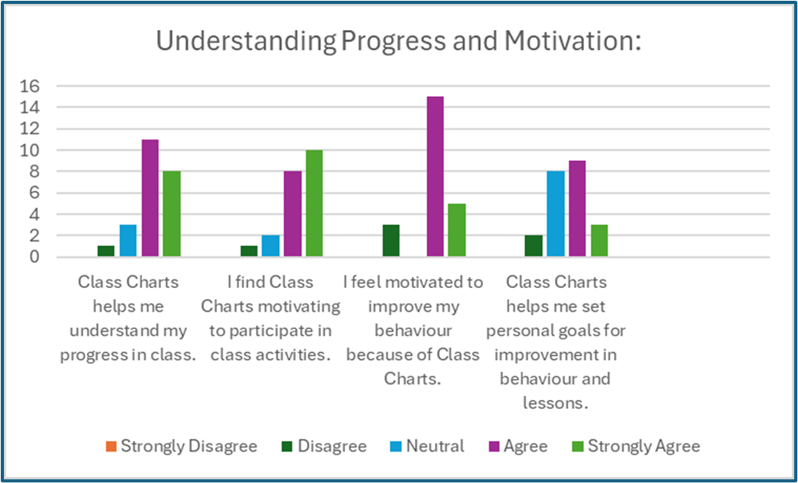
(Figure 1)

Encouragement and Recognition:
Students generally agreed that Class Charts encouraged them to complete their work on time and made them feel recognised for their efforts in class (see Figure 2). This indicates that students value the positive reinforcement provided by Class Charts in terms of rewarding achievements and promoting a positive classroom environment.
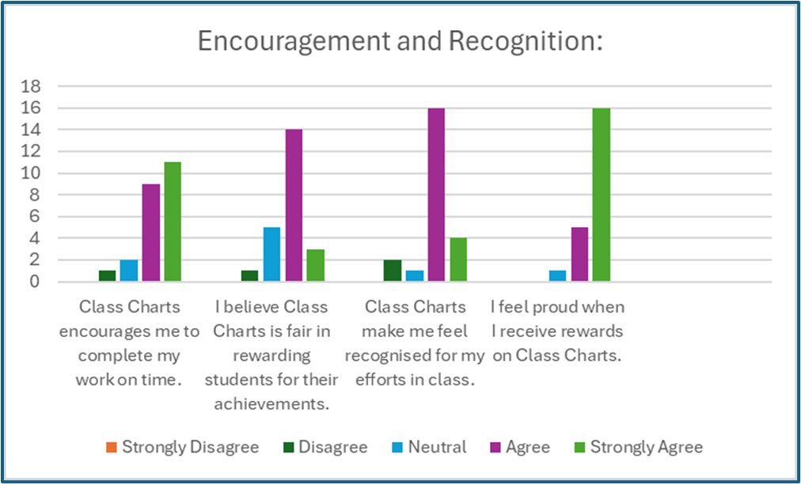
(Figure 2)

Ease of Use and Organisation:
The majority of students found Class Charts easy to understand and use, indicating that the interface is user-friendly and accessible to students. Additionally, students agreed that Class Charts helped them stay organised with their tasks and responsibilities, suggesting that the tool supports effective time management and task prioritisation, (see Figure 3).
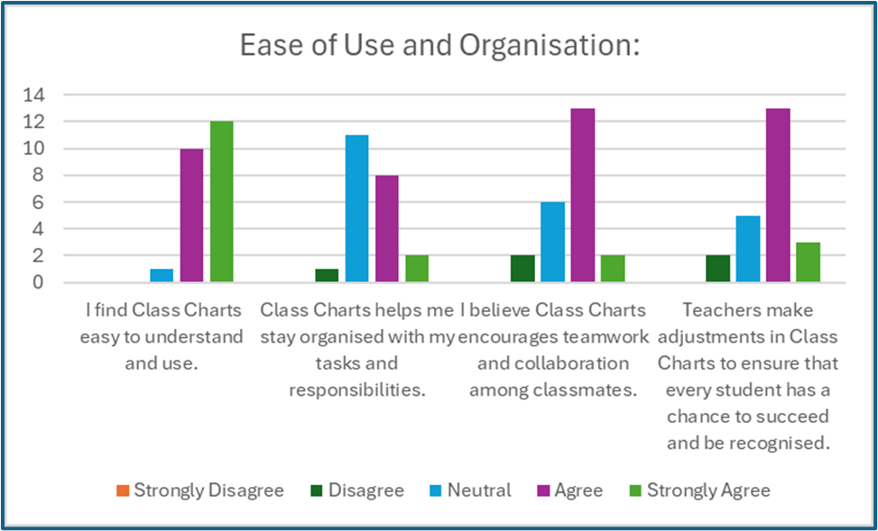
(Figure 3)

Effective Classroom Management:
Students expressed agreement that Class Charts are an effective way for teachers to manage classroom behaviour and encourage healthy competition among students. This suggests that students perceive Class Charts as a fair and transparent system for promoting positive behaviour and academic achievement, (see Figure 4).

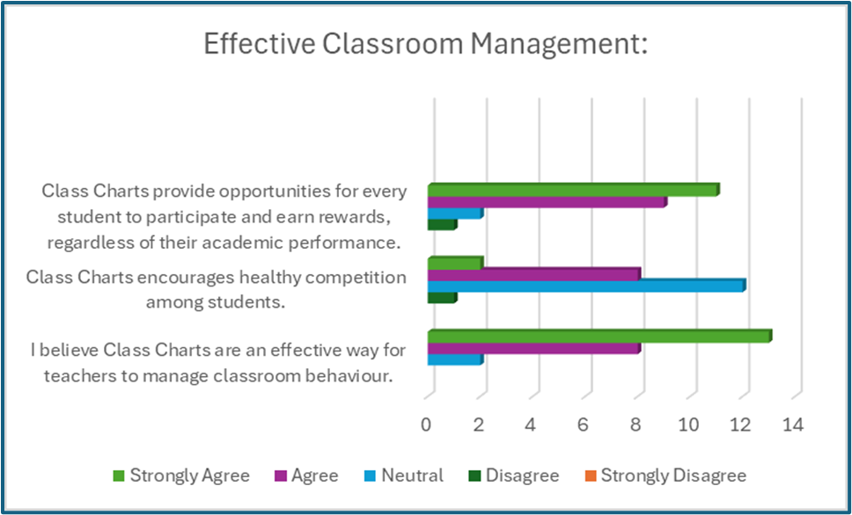
(Figure 4)

Inclusivity and Fairness:
Overall, students agreed that Class Charts treated all students fairly, regardless of their background or abilities. They also agreed that Class Charts provided equal opportunities for every student to participate and earn rewards, regardless of their academic performance. This indicates that students perceive Class Charts as an inclusive and equitable system that values diversity and individual circumstances, (see Figure 5).

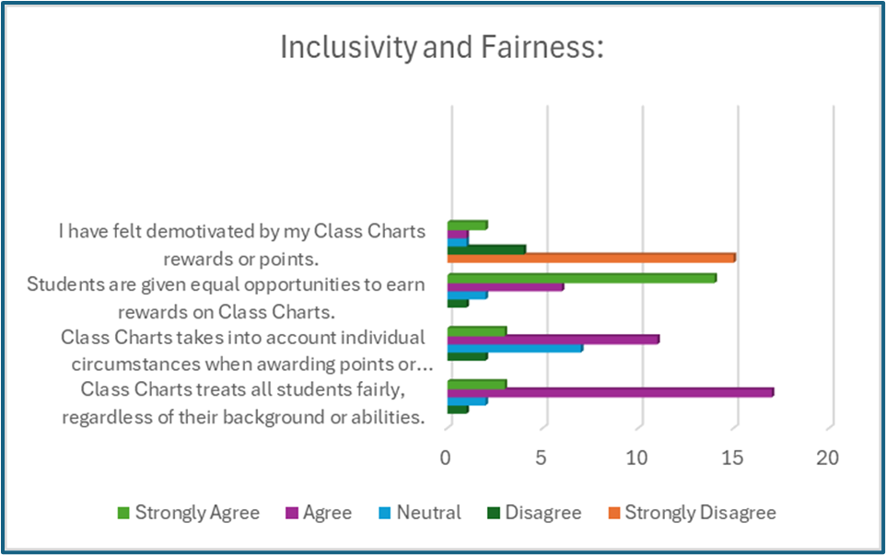
(Figure 5)

The positive reception of Class Charts among Year 7 students holds significant implications for both the classroom environment and the individuals involved. Students' favourable attitudes toward Class Charts indicate that they view the tool as advantageous for monitoring progress, cultivating motivation, and fostering positive behaviour and academic achievement. This has the potential to invigorate classroom dynamics by enhancing student engagement and participation. Moreover, the findings underscore the efficacy of digital tools in education, emphasising the role of Class Charts in bolstering student engagement and organisational skills. Additionally, the emphasis on positive reinforcement resonates with research highlighting the significance of such strategies in moulding student behaviour. Overall, the findings underscore the potential of Class Charts to foster a positive learning environment and bolster student success in school.

A review of the literature reveals that the efficacy of Class Charts as a reward system intersects with various theoretical perspectives on motivation and learning. Referencing seminal works in behaviourism, such as Skinner's operant conditioning principles (Skinner, 1965), Class Charts align with the notion of reinforcing positive behaviours through external rewards. However, constructivist theories, as exemplified by Piaget and Vygotsky, caution against excessive reliance on extrinsic rewards, emphasising the importance of intrinsic motivation and self-directed learning (Piaget, 1953; Vygotsky, 1978). Contemporary discussions by Pink and Kohn further underscore the delicate balance between intrinsic and extrinsic motivation, with Pink advocating for autonomy, mastery, and purpose (Pink, 2010), while Kohn warns against the potential dilution of intrinsic motivation by extrinsic rewards (Kohn, 1999).

Furthermore, Class Charts intersects with social learning theory, suggesting that it can serve as a model for students to observe and emulate positive behaviours. Additionally, self-determination theory underscores Class Charts' potential to nurture autonomy and competence in students by enabling them to monitor their progress (Ryan & Deci, 2000). Operant conditioning principles further support Class Charts' reward system, aligning with Skinner's behaviour modification theory (Skinner, 1965). Positive psychology principles, as advocated by Seligman, propose that Class Charts' emphasis on positive behaviours can contribute to a conducive classroom environment and bolster student well-being (Seligman, 2002). 699

Conclusions & recommendations

The study encounters limitations due to the quantitative questionnaire format, which constrained respondents from providing detailed insights. This inherent limitation in quantitative questionnaires, characterised by closed-ended questions with predefined response options, is well-documented (Cohen et al., 2007). Moreover, the research method lacks established metrics to assess its reliability and validity. While the study offers some understanding of how pupils utilise and perceive Class Charts as a reward system, additional qualitative and quantitative research would facilitate a more comprehensive gathering of responses and provide deeper insights into classroom interventions. Exploring a mixed methods approach integrating quantitative surveys alongside qualitative interviews or observations could yield richer insights into teachers' perceptions and practices concerning reward systems in classrooms (Cohen et al., 2007).

Understanding the positive and negative impacts of rewards is essential for educators. As learning theories evolve, recognising the significance of intrinsic and extrinsic motivation is crucial for developing effective strategies to support learners' growth. Some argue that extrinsic rewards might undermine intrinsic motivation (Kohn, 1999; Cameron & Pierce, 1996), while others suggest that they can be beneficial when aligned with individuals' psychological needs (Ryan & Deci, 2000). A nuanced understanding of motivation acknowledges that intrinsic and extrinsic behaviours are not always mutually exclusive, and students' actions may be influenced by a combination of factors (Ryan & Deci, 2000).

Proponents of Class Charts argue that it aligns with behaviourist and social learning theories, as external rewards can reinforce desired behaviours and serve as a model for positive behaviour (Skinner, 1965; Thorndike, 2023; Bandura, 1971). Additionally, Class Charts can be seen as compatible with connectivism in the digital learning environment, as real-time visual feedback and rewards can enhance students' perceptions of the relevance and usefulness of their academic efforts (Siemens, 2005). However, critics argue that relying solely on extrinsic rewards may have unintended consequences and fail to address the complexities of student motivation (Kohn, 1999; Cameron & Pierce, 1996). Concerns about equity and fairness also arise, as not all students may respond positively to external rewards, potentially exacerbating existing achievement gaps (O'Leary & Drabman, 1971; Wheldall et al., 1995; Ladson-Billings, 1995).

While ClassCharts offers a visually engaging method to reward students, its effectiveness in promoting long-term engagement and intrinsic motivation remains subject to debate. Educators must critically evaluate the balance between extrinsic rewards and intrinsic motivation, considering the potential benefits and drawbacks of platforms like Class Charts. Ultimately, fostering a holistic approach to student motivation that encompasses both internal and external factors is crucial for creating an inclusive and supportive learning environment.

Furthermore, it's important to acknowledge that the effectiveness of Class Charts as a reward system can vary among different age groups of students. While younger students may find visual rewards and immediate feedback more motivating, older students may have different preferences and motivations. Adolescents, for example, may place greater emphasis on autonomy, peer recognition, and intrinsic fulfilment in their learning experiences (Deci & Ryan, 2000). Consequently, educators should consider adapting reward systems like Class Charts to suit the developmental stages and unique needs of older students, ensuring they remain pertinent and meaningful in fostering engagement and motivation across various age groups.

This study intersects with various dimensions delineated in the Professional Teaching Standards for Teaching and Learning. Investigating the impact of these reward systems on student behaviour and academic performance resonates with standards associated with managing the learning environment and listening to learners. Through the critical evaluation of the equilibrium between intrinsic and extrinsic motivators, this research contributes to ongoing professional development, as outlined in standards related to professional learning.

In conclusion, the literature review underscores the multifaceted nature of motivation in education and underscores the necessity for a balanced approach to reward systems like Class Charts. While Class Charts offers potential benefits in reinforcing positive behaviours and fostering student engagement, it’s effectiveness hinges on factors such as implementation, fairness, cultural relevance, and the promotion of autonomy and intrinsic motivation. By leveraging insights from various learning theories, educators can better comprehend the intricacies of motivation and tailor reward systems to effectively support student learning and well-being.

Appendices

Appendices A - Survey questionnaire
Appendices B - Survey results
Appendices C - Application for ethical approval
Appendices D - Parental Consent letter & information sheet
Appendices E - Information sheet for year 7 pupils

Appendices A - Survey questionnaire

YEAR 7 Survey Questionnaire
The effectiveness of Class Charts

Please indicate your level of agreement with the following statements by highlighting the appropriate response:
Strongly Disagree
Disagree
Neutral
Agree
Strongly Agree

Understanding Progress and Motivation:
Class Charts helps me understand my progress in class.
Strongly Disagree
Disagree
Neutral
Agree
Strongly Agree

I find Class Charts motivating to participate in class activities.
Strongly Disagree
Disagree
Neutral
Agree
Strongly Agree

I feel motivated to improve my behaviour because of Class Charts.
Strongly Disagree
Disagree
Neutral
Agree
Strongly Agree

Class Charts helps me set personal goals for improvement in behaviour and lessons.
Strongly Disagree
Disagree
Neutral
Agree
Strongly Agree
Encouragement and Recognition:
Class Charts encourages me to complete my work on time.
Strongly Disagree
Disagree
Neutral
Agree
Strongly Agree

I believe Class Charts is fair in rewarding students for their achievements.
Strongly Disagree
Disagree
Neutral
Agree
Strongly Agree

Class Charts make me feel recognised for my efforts in class.
Strongly Disagree
Disagree
Neutral
Agree
Strongly Agree

I feel proud when I receive rewards on Class Charts.
Strongly Disagree
Disagree
Neutral
Agree
Strongly Agree

.Ease of Use and Organisation:
I find Class Charts easy to understand and use.
Strongly Disagree
Disagree
Neutral
Agree
Strongly Agree

Class Charts helps me stay organised with my tasks and responsibilities.
Strongly Disagree
Disagree
Neutral
Agree
Strongly Agree

I believe Class Charts encourages teamwork and collaboration among classmates.
Strongly Disagree
Disagree
Neutral
Agree
Strongly Agree

Teachers make adjustments in Class Charts to ensure that every student has a chance to succeed and be recognised.
Strongly Disagree
Disagree
Neutral
Agree
Strongly Agree
Effective Classroom Management:
I believe Class Charts are an effective way for teachers to manage classroom behaviour.
Strongly Disagree
Disagree
Neutral
Agree
Strongly Agree

Class Charts encourages healthy competition among students.
Strongly Disagree
Disagree
Neutral
Agree
Strongly Agree

Class Charts provide opportunities for every student to participate and earn rewards, regardless of their academic performance.
Strongly Disagree
Disagree
Neutral
Agree
Strongly Agree

Inclusivity and Fairness:
Class Charts treats all students fairly, regardless of their background or abilities.
Strongly Disagree
Disagree
Neutral
Agree
Strongly Agree

Class Charts takes into account individual circumstances when awarding points or rewards.
Strongly Disagree
Disagree
Neutral
Agree
Strongly Agree

Students are given equal opportunities to earn rewards on Class Charts.
Strongly Disagree
Disagree
Neutral
Agree
Strongly Agree

I have felt demotivated by my Class Charts rewards or points.
Strongly Disagree
Disagree
Neutral
Agree
Strongly Agree
Appendices B - Survey results
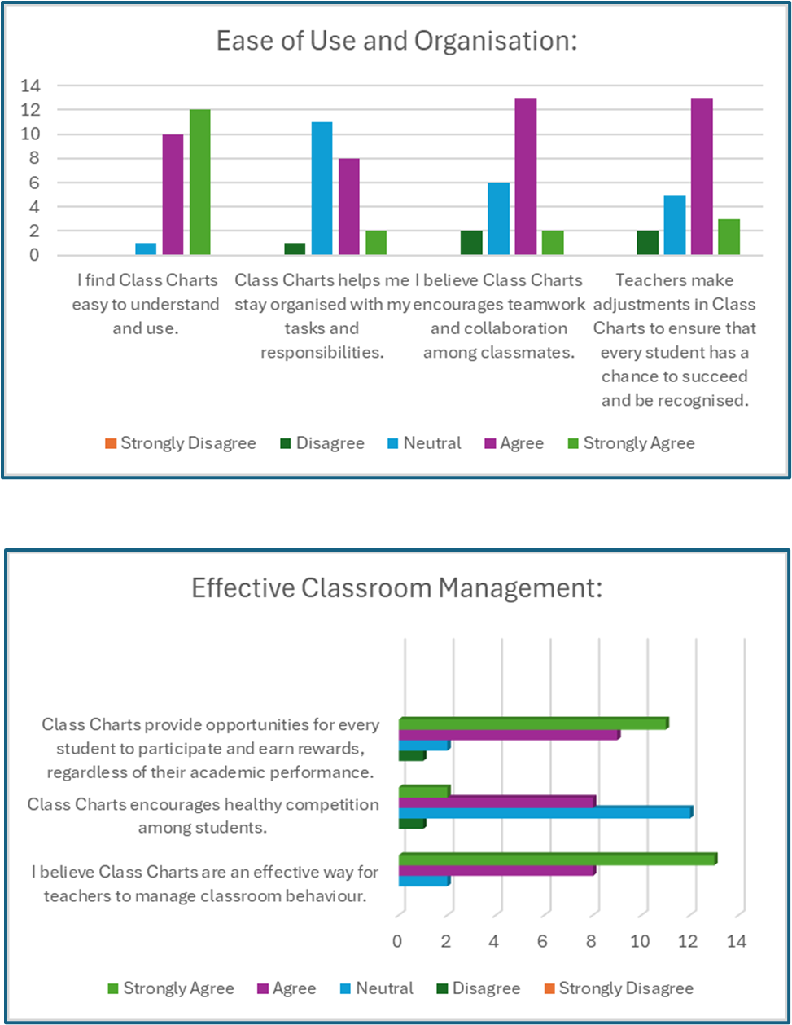
(Figure 3)
(Figure 4)

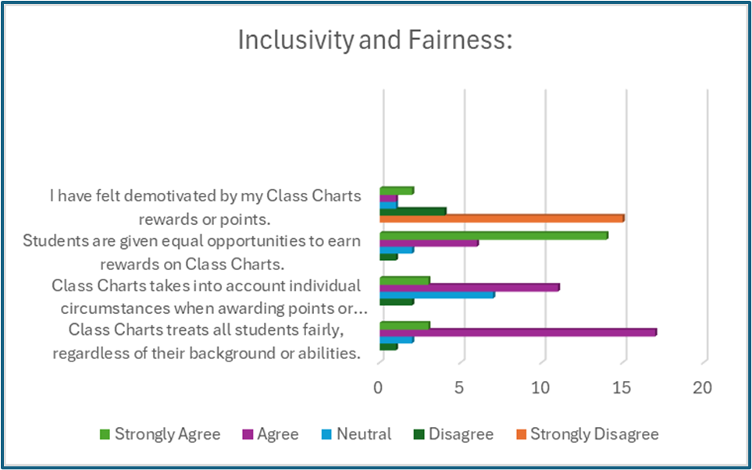
(Figure 5)

Appendices C
APPLICATION FOR ETHICAL APPROVAL

RESEARCH STUDENTS
This form is to be completed by the student within SIX months for full-time students and TWELVE months for part time students, after the commencement of the research degree or following progression to Part Two of your course.

Once complete, submit this form via the MyTSD Doctoral College Portal at (https://mytsd.uwtsd.ac.uk).

This document is also available in Welsh.

RESEARCH STAFF ONLY
All communications relating to this application during its processing must be in writing and emailed to pgresearch@uwtsd.ac.uk , with the title ‘Ethical Approval’ followed by your name.

STUDENTS ON UNDERGRADUATE OR TAUGHT MASTERS PROGRAMMES should submit this form (and receive the outcome) via systems explained to you by the supervisor/module leader.

In order for research to result in benefit and minimise risk of harm, it must be conducted ethically. A researcher may not be covered by the University’s insurance if ethical approval has not been obtained prior to commencement.

The University follows the OECD Frascati manual definition of research activity: “creative work undertaken on a systematic basis in order to increase the stock of knowledge, including knowledge of man, culture and society, and the use of this stock of knowledge to devise new applications”. As such this covers activities undertaken by members of staff, postgraduate research students, and both taught postgraduate and undergraduate students working on dissertations/projects.

The individual undertaking the research activity is known as the “principal researcher”.

Ethical approval is not required for routine audits, performance reviews, quality assurance studies, testing within normal educational requirements, and literary or artistic criticism.

Please read the notes for guidance before completing ALL sections of the form.

This form must be completed and approved prior to undertaking any research activity. Please see Checklist for details of process for different categories of application.

SECTION A: About You (Principal Researcher)
1 | Full Name: |  | Jayne Libby
2 | Tick all boxes that apply: |  | Member of staff: | ☐ | Honorary research fellow: | ☐
 | Undergraduate Student | ☐ | Taught Postgraduate Student | ☒ | Postgraduate Research Student | ☐

3 | Institute/Academic Discipline/Centre: | UWTSD
4 | Campus: | SA1 Waterfront, Swansea Campus
5 | E-mail address: | 2306506@student.uwtsd.ac.uk
6 | Contact Telephone Number: | 07936581937
 | For students:
7 | Student Number: | 2306506
8 | Programme of Study: | PGCE Secondary with QTS
9 | Director of Studies/Supervisor: | Ishmael Lewis

SECTION B: Approval for Research Activity
1 | Has the research activity received approval in principle?  (please check the Guidance Notes as to the appropriate approval process for different levels of research by different categories of individual) |  | YES | ☒ | NO | ☐
 |  |  |  |  | Date
2 | If Yes, please indicate source of approval (and date where known): Approval in principle must be obtained from the relevant source prior to seeking ethical approval | Research Degrees Committee |  | ☐
2 |  | Institute Research Committee |  | ☐
2 |  | Other (write in)  Ishmael Lewis |  | ☒ | 14/03/2024

 | Please list the core ethical guidance documents that have been referred to during the completion of this form (including any discipline-specific codes of research ethics, location-specific codes of research ethics, and also any specific ethical guidance relating to the proposed methodology). Please tick to confirm that your research proposal adheres to these codes and guidelines. You may add rows to this table if needed.
1 | UWTSD Research Ethics & Integrity Code of Practice | ☒
2 | UWTSD Research Data Management Policy | ☒
3 | BERA 2018 (ETHICAL GUIDELINES  FOR EDUCATIONAL RESEARCH) | ☒
SECTION C: Internal and External Ethical Guidance Materials

SECTION D: External Collaborative Research Activity
1 | Institution
2 | Contact person name
3 | Contact person e-mail address
4 | Is your research externally funded? |  | YES | ☐ | NO |  | ☐
5 | Are you in receipt of a KESS scholarship? |  | YES | ☐ | NO |  | ☐
6 | Are you specifically employed to undertake this research in either a paid or voluntary capacity? | Voluntary | YES | ☐ | NO | ☐
7 |  | Employed | YES | ☐ | NO | ☐
8 | Is the research being undertaken within an existing UWTSD Athrofa Professional Learning Partnership (APLP)? | If YES then the permission question below does not need to be answered. | YES | ☐ | NO |  | ☐
9 | Has permission to undertake the research has been provided by the partner organisation? | (If YES attach copy)  If NO the application cannot continue | YES | ☐ | NO |  | ☐
If there are external collaborators then you should gain consent from the contact persons to share their personal data with the university. If there are no external collaborators then leave this section blank and continue to section E.

10 | Does this organisation have its own ethics approval system? | YES | ☐ | NO | ☒
 | If Yes, please attach a copy of any final approval (or interim approval) from the organisation (this may be a copy of an email if appropriate).
Where research activity is carried out in collaboration with an external organisation

SECTION E: Details of Research Activity
1 | Indicative title: | What are pupils' perceptions of the effect of Class Charts as a reward system in a Year 7 class?
2 | Proposed start date: | 14/03/2024 | Proposed end date: | 31/07/2024
Introduction to the Research (maximum 300 words per section)
Ensure that you write for a Non-Specialist Audience when outlining your response to the points below:
- Purpose of Research Activity
- Proposed Research Question
- Aims of Research Activity
- Objectives of Research Activity
Demonstrate, briefly, how Existing Research has informed the proposed activity and explain
- What the research activity will add to the body of knowledge
- How it addresses an area of importance.
3 | Purpose of Research Activity  My research aims to explore pupils' perceptions of the effectiveness of Class Charts as a reward system in year 7 class. (this box should expand as you type)
4 | Research Question  What are pupils' perceptions of the effect of Class Charts as a reward system in a Year 7 class?  (this box should expand as you type)
5 | Aims of Research Activity.  To investigate Year 7 students' perspectives on the efficacy of Class Charts as a reward system, drawing insights from fundamental principles in educational psychology and motivation, including behaviourism and constructivism. Behaviourism, exemplified by Skinner's reinforcement theory, suggests that well-structured reward systems can positively influence student motivation and conduct. Conversely, a constructivist approach emphasises the importance of fostering intrinsic motivation through autonomy and informational feedback, as advocated by Deci and Ryan's Self-Determination Theory (SDT). Given the transitional phase of Year 7 students from primary to secondary school, exploring research on their social, emotional, and cognitive development could provide valuable insights into their perceptions of Class Charts.
6 | Objectives of Research Activity  Gather data on pupils' experiences and opinions of Class Charts as a reward system.  Identify perceived benefits and drawbacks of Class Charts from pupils' perspective.  Examine pupils' perceptions of Class Charts' impact on motivation, engagement, and learning experience.  Investigate if pupils' perceptions vary based on factors like gender, academic performance, or socio-economic background.  Compare pupils' and teachers' views on the effectiveness of Class Charts for managing classroom behaviour.  Contribute to understanding the role of digital tools in shaping classroom dynamics and student outcomes in secondary schools.  Findings could inform best practices for implementing reward systems that support positive student outcomes and align with pupils' needs and preferences. (this box should expand as you type)
Proposed methods (maximum 600 words)
Provide a brief summary of all the methods that may be used in the research activity, making it clear what specific techniques may be used. If methods other than those listed in this section are deemed appropriate later, additional ethical approval for those methods will be needed. You do not need to justify the methods here, but should instead describe how you intend to collect the data necessary for you to complete your project.
7 | Surveys or questionnaires:  Develop a set of questions for pupils and teachers to gather their perceptions, opinions, and experiences related to the effectiveness of Class Charts as a reward system. I will gain consent from all participants and they will have the right to withdraw at any time.  .  Observation:  Observe classroom interactions and behaviour, focusing on how Class Charts is being used and its impact on pupil engagement and motivation.  Use an observation checklist or protocol to ensure consistent data collection  Ensure all participants are aware that they are being observed  Document analysis:  Examine relevant documents, such as school policies, Class Charts data, and pupil records (e.g., attendance, behaviour logs).  Look for patterns, trends, or changes that may be associated with the implementation of Class Charts.  (this box should expand as you type)
Location of research activity
Identify all locations where research activity will take place.
8 | Secondary school in the South Wales area  (this box should expand as you type)
Research activity outside of the UK
If research activity will take place overseas, you are responsible for ensuring that local ethical considerations are complied with and that the relevant permissions are sought. Specify any local guidelines (e.g. from local professional associations/learned societies/universities) that exist and whether these involve any ethical stipulations beyond those usual in the UK (provide details of any licenses or permissions required). Also specify whether there are any specific ethical issues raised by the local context in which the research activity is taking place, for example, particular cultural and/or legal sensitivities or vulnerabilities of participants. If you live in the country where you will do the research then please state this.
9 | (this box should expand as you type)

10 | Use of documentation not in the public domain: Are any documents NOT publicly available? | NO | ☐
10 |  | YES | ☒
11 | If Yes, please provide details here of how you will gain access to specific documentation that is not in the public domain and that this is in accordance with the current data protection law of the country in question and that of England and Wales.  I will access information from Class Charts relating to attendance behaviour and engagement, I will seek school approval and consent, and adhere to confidentiality and GDPR ethics and policy  (this box should expand as you type)

 | Does your research relate to one or more of the seven aims of the Well-being of Future Generations (Wales) Act 2015? | YES | NO
12 | A prosperous Wales | ☐ | ☐
13 | A resilient Wales | ☐ | ☐
14 | A healthier Wales | ☒ | ☐
15 | A more equal Wales | ☒ | ☐
16 | A Wales of cohesive communities | ☒ | ☐
17 | A Wales of vibrant culture and thriving Welsh language | ☐ | ☐
18 | A globally responsible Wales | ☒ | ☐
19 | If YES to any of the above, please give details:
A healthier Wales
By exploring pupils' perceptions of the reward system, my research may provide insights into how Class Charts affects their mental well-being, motivation, and engagement in learning.
Understanding the impact of such systems on pupils' well-being can contribute to the development of healthier school environments that support the overall health of future generations

A more equal Wales:
My research may shed light on how the use of Class Charts affects different groups of pupils based on gender, socio-economic background, or academic ability.
Identifying any potential inequalities or disproportionate impacts can help schools design more equitable reward and sanction systems that provide equal opportunities for all pupils to succeed.

A Wales of cohesive communities:
Effective behaviour management systems in schools can contribute to creating a positive and inclusive learning environment, fostering a sense of community and belonging among pupils.
By examining pupils' perceptions of Class Charts my research may provide insights into how the system influences classroom dynamics, relationships, and the overall sense of cohesion within the school community

A globally responsible Wales:
My research on the use of digital tools like Class Charts for behaviour management in schools can contribute to the broader understanding of how technology can be leveraged to support positive educational outcomes.
expand as you type)

 | Will the research activity include: | YES | NO
1 | Use of a questionnaire or similar research instrument? | ☒ | ☐
2 | Use of interviews? | ☐ | ☒
3 | Use of focus groups? | ☐ | ☒
4 | Use of participant diaries? | ☐ | ☒
5 | Use of video or audio recording? | ☐ | ☒
6 | Use of computer-generated log files? | ☒ | ☐
7 | Participant observation with their knowledge? | ☒ | ☐
8 | Participant observation without their knowledge? | ☐ | ☒
9 | Access to personal or confidential information without the participants’ specific consent? | ☐ | ☒
10 | Administration of any questions, test stimuli, presentation that may be experienced as physically, mentally or emotionally harmful / offensive? | ☐ | ☒
11 | Performance of any acts which may cause embarrassment or affect self-esteem? | ☐ | ☒
12 | Investigation of participants involved in illegal activities? | ☐ | ☒
13 | Use of procedures that involve deception? | ☐ | ☒
14 | Administration of any substance, agent or placebo? | ☐ | ☒
15 | Working with live vertebrate animals? | ☐ | ☒
16 | Procedures that may have a negative impact on the environment? | ☐ | ☒
17 | Other primary data collection methods. Please indicate the type of data collection method(s) below. | ☒ | ☐
 | Details of any other primary data collection method:  Relevant documents, such as school policies, Class Charts data, and pupil records, attendance and behaviour logs.  (this box should expand as you type) | ☒ | ☐
SECTION F: Scope of Research Activity
If NO to every question, then the research activity is (ethically) low risk and may be exempt from some of the following sections (please refer to Guidance Notes).

If YES to any question, then no research activity should be undertaken until full ethical approval has been obtained.

SECTION G: Intended Participants
If there are no participants then do not complete this section, but go directly to section H.
 | Who are the intended participants: | YES | NO
1 | Students or staff at the University? | ☐ | ☒
2 | Adults (over the age of 18 and competent to give consent)? | ☒ | ☐
3 | Vulnerable adults? | ☐ | ☒
4 | Children and Young People under the age of 18? (Consent from Parent, Carer or Guardian will be required) | ☒ | ☐
5 | Prisoners? | ☐ | ☒
6 | Young offenders? | ☐ | ☒
7 | Those who could be considered to have a particularly dependent relationship with the investigator or a gatekeeper? | ☐ | ☒
8 | People engaged in illegal activities? | ☐ | ☒
9 | Others. Please indicate the participants below, and specifically any group who may be unable to give consent. | ☐ | ☒
 | Details of any other participant groups:  (this box should expand as you type) | ☐ | ☒

Participant numbers and source
Provide an estimate of the expected number of participants. How will you identify participants and how will they be recruited?
10 | How many participants are expected? | There will be a maximum of 35 participants in total  A student class of between 25 and 30 participants and a staff group of between  3 and 5 participants.  (this box should expand as and you type)
11 | Who will the participants be? | Pupils of a year 7 class at the school and teachers  (this box should expand as you type)
12 | How will you identify the participants? | To recruit participants for my research, I will seek guidance from my senior mentor in selecting a suitable Year 7 class and teaching staff. To ensure compliance with ethical standards and protect the well-being of the participants, I will adhere to the University of Wales Trinity Saint David's (UWTSD) ethical guidelines throughout the research process. As the study involves Year 7 students, I will obtain informed consent from both the students and their parents or guardians before their participation in the focus groups. This will involve providing clear and accessible information about the study's purpose, procedures, and any potential risks or benefits, as well as emphasising the voluntary nature of participation and the right to withdraw at any time.  .  (this box should expand as you type)

 | Information for participants: | YES | NO | N/A
13 | Will you describe the main research procedures to participants in advance, so that they are informed about what to expect? | ☒ | ☐ | ☐
14 | Will you tell participants that their participation is voluntary? | ☒ | ☐ | ☐
15 | Will you obtain written consent for participation? | ☒ | ☐ | ☐
16 | Will you explain to participants that refusal to participate in the research will not affect their treatment or education (if relevant)? | ☒ | ☐ | ☐
17 | If the research is observational, will you ask participants for their consent to being observed? | ☒ | ☐ | ☐
18 | Will you tell participants that they may withdraw from the research at any time and for any reason? | ☒ | ☐ | ☐
19 | With questionnaires, will you give participants the option of omitting questions they do not want to answer? | ☒ | ☐ | ☐
20 | Will you tell participants that their data will be treated with full confidentiality and that, if published, it will not be identifiable as theirs? | ☒ | ☐ | ☐
21 | Will you debrief participants at the end of their participation, in a way appropriate to the type of research undertaken? | ☒ | ☐ | ☐
22 | If NO to any of above questions, please give an explanation
 | (this box should expand as you type)

 | Information for participants: | YES | NO | N/A
24 | Will participants be paid? | ☐ | ☒ | ☐
25 | Is specialist electrical or other equipment to be used with participants? | ☐ | ☒ | ☐
26 | Are there any financial or other interests to the investigator or University arising from this study? | ☐ | ☒ | ☐
27 | Will the research activity involve deliberately misleading participants in any way, or the partial or full concealment of the specific study aims? | ☐ | ☒ | ☐
28 | If YES to any question, please provide full details
 | (this box should expand as you type)

SECTION H: Anticipated Risks

Outline any anticipated risks that may adversely affect any of the participants, the researchers and/or the University, and the steps that will be taken to address them.

If you have completed a full risk assessment (for example as required by a laboratory, or external research collaborator) you may append that to this form.
1 | Full risk assessment completed and appended? |  | Yes | ☐
1 |  |  | No | ☒
2 | Risks to participants  For example: sector-specific health & safety, emotional distress, financial disclosure, physical harm, transfer of personal data, sensitive organisational information
 | Risk to participants:  Transfer of data relating to class charts  Emotional Distress  Disturbance to relationships with staff  Risk that participants may feel coerced into giving positive or biased responses  A confidentiality breach due to data being released  accidently | How you will mitigate the risk to participants:  I will strictly comply with the General Data Protection Regulation (GDPR) and other relevant ethical policies to ensure the confidentiality and security of all data collected during the study. This includes implementing appropriate measures to protect participants' personal information, such as secure storage and anonymisation of data, and limiting access to sensitive information only to those directly involved in the research. By adhering to these ethical principles and obtaining the necessary parental consent, I aim to conduct my research in a manner that prioritises the safety, privacy, and well-being of the participants involved.  Ensure, as fully as possible, that participants understand the nature of the research, its purposes, and possible implications to avoid misunderstandings and manage expectations.  Ensure regular follow-up communication with participants in order to re-affirm consent and to update them on the progress of the  research.  Ensure clarity with all young people and  staff/gatekeepers regarding the aims and focus of  the research.  Minimise disturbance of day-to-day activities within the provision due to the research  project.  Ensure confidentiality and anonymity of those participating in the research at all times.  Ensure appropriate and secure storage of data. Reassure participants that the information  that they provide will not be disclosed without their consent.  .  Work with gatekeepers to promote an understanding of the nature of the research, and to  gain assurances that the young people’s participation in it is fully supported and will not  result in recrimination by staff or peers.  Participants will be provided with a participant information sheet with which informed consent will be sought.  The research will be stored on the UWTSD cloud and any recordings, data or transcript will  be password protected in electronic folders on UWTSD systems and subject to university  protocols. However, GDPR statements will be included in any participant information and  consent and that the researcher has completed training on GDPR and will ensure that all  records are kept in secure cloud locations as a precaution and not on any hard drive.  (this box should expand as you type)
3 | If research activity may include sensitive, embarrassing or upsetting topics (e.g. sexual activity, drug use) or issues likely to disclose information requiring further action (e.g. criminal activity), give details of the procedures to deal with these issues, including any support/advice (e.g. helpline numbers) to be offered to participants. Note that where applicable, consent procedures should make it clear that if something potentially or actually illegal is discovered in the course of a project, it may need to be disclosed to the proper authorities
N/A

(this box should expand as you type)
4 | Risks to the investigator  For example: personal health & safety, physical harm, emotional distress, risk of accusation of harm/impropriety, conflict of interest
 | Risk to the investigator:  Risk of accusation of harm/impropriety  .  (this box should expand as you type) | How you will mitigate the risk to the investigator:  I will strictly adhere to child protection and safeguarding regulations, ensuring robust informed consent and assent processes. This includes providing clear information about the research, ensuring participants understand their rights, and maintaining open communication with parents and gatekeepers. Interviews will be conducted privately, and procedures will be in place to protect participants' confidentiality and anonymity.  (this box should expand as you type)
5 | University/institutional risks  For example: adverse publicity, financial loss, data protection
 | Reputational damage | How you will mitigate the risk to the University:  Ensure adherence to the UWTSD code of ethics and research standards and  commonly agreed standards of good practice.  Ensure compliance with data storage regulations and university guidelines and  security procedures.  Ensure that research methodology is robust and that methods are appropriate.  Adhere to the UWTSD code of conduct (and also the EWC code of conduct if you are  a teacher).  Establish clarity regarding procedures on reporting of disclosures in field work  settings.  Work with partners to promote a comprehensive understanding regard the nature of  the research in order to avoid misunderstandings and manage expectations.  (this box should expand as you type)
6 | Environmental risks  For example: accidental spillage of pollutants, damage to local ecosystems
 | Risk to the environment:  Use of Paper  (this box should expand as you type) | How you will mitigate the risk to environment:  This research activity will mostly use electronic systems reducing the need for bleached  paper  (this box should expand as you type)

 | Disclosure and Barring Service
 | If the research activity involves children or vulnerable adults, a Disclosure and Barring Service (DBS) certificate must be obtained before any contact with such participants. | YES | NO | N/A
7 | Does your research require you to hold a current DBS Certificate? | ☒ | ☐ | ☐
8 | If YES, please give the certificate number. If the certificate number is not available please write “Pending”; in this case any ethical approval will be subject to providing the appropriate certificate number. | 001845156551

SECTION I: Feedback, Consent and Confidentiality

1 | Feedback  What de-briefing and feedback will be provided to participants, how will this be done and when?
I will set up an email address so that parents/carers or teachers will be able to contact for further details or results, I will be able to share the headline findings from my research

(this box should expand as you type)
2 | Informed consent  Describe the arrangements to inform potential participants, before providing consent, of what is involved in participating. Describe the arrangements for participants to provide full consent before data collection begins. If gaining consent in this way is inappropriate, explain how consent will be obtained and recorded in accordance with prevailing data protection legislation.
Information sheet – This will be provided to parent/carers and teachers to explain my research project and how all names will be kept strictly confidential and will only be known by myself.
I will explain that the child’s participation in this study is completely voluntary and they can withdraw from the study at any stage. The participants will also be asked to give their assent before the beginning of the study. I will explain that I will be happy to provide them with a copy of the initial findings at their request.
Paper questionnaire = Parents/carers and teachers will sign a consent form before any research relating to the questionnaires is carried out

(this box should expand as you type)
3 | Confidentiality / Anonymity  Set out how anonymity of participants and confidentiality will be ensured in any outputs. If anonymity is not being offered, explain why this is the case.
I will inform the participant that I will adhere to confidentiality and that all names will be kept strictly confidential and will only be known by myself

(this box should expand as you type)

SECTION J: Data Protection and Storage

 | Does the research activity involve personal data (as defined by the General Data Protection Regulation 2016 “GDPR” and the Data Protection Act 2018 “DPA”)? | YES | NO
1 | “Personal data” means any information relating to an identified or identifiable natural person (‘data subject’). An identifiable natural person is one who can be identified, directly or indirectly, in particular by reference to an identifier such as a name, an identification number, location data, an online identifier or to one or more factors specific to the physical, physiological, genetic, mental, economic, cultural or social identity of that natural person. Any video or audio recordings of participants is considered to be personal data. | x | ☐
 | If YES, provide a description of the data and explain why this data needs to be collected:
2 | The data that I will be collecting is school policies, Class Charts data, and pupil records (e.g., attendance, behaviour logs).  (this box should expand as you type)
 | Does it involve special category data (as defined by the GDPR)? | YES | NO
3 | “Special category data” means sensitive personal data consisting of information as to the data subjects’ –  (a) racial or ethnic origin,  (b) political opinions,  (c ) religious beliefs or other beliefs of a similar nature,  (d) membership of a trade union (within the meaning of the Trade Union and Labour Relations (Consolidation) Act 1992),  (e) physical or mental health or condition,  (f) sexual life,  (g) genetics,  (h) biometric data (as used for ID purposes), | ☐ | x
 | If YES, provide a description of the special category data and explain why this data needs to be collected:
4 | (this box should expand as you type)

 | Will data from the research activity (collected data, drafts of the thesis, or materials for publication) be stored in any of the following ways? | YES | NO
5 | Manual files (i.e. in paper form)? | ☒ | ☐
6 | University computers? | ☐ | ☒
7 | Private company computers? | ☐ | ☒
8 | Home or other personal computers? | ☒ | ☐
9 | Laptop computers/ CDs/ Portable disk-drives/ memory sticks? | ☒ | ☐
10 | “Cloud” storage or websites? | ☐ | ☒
11 | Other – specify: | ☐ | ☐
12 | For all stored data, explain the measures in place to ensure the security of the data collected, data confidentiality, including details of backup procedures, password protection, encryption, anonymisation and pseudonymisation:
All data will be kept in password protected personal computer. All participants
will be given a unique identifier to ensure confidentiality and this list will be
kept securely in the password protected folder. If any cloud storage is needed,
the University Office 365 system will be used, which will be encrypted and the
data in the cloud is anonymised. The data will be stored until receipt of the
assignment result and then deleted. Participants will have the right to ask to
see what data is held relating to them and these data will be deleted
immediately if the participant requests this, in which case the data will not be used in the project.
(this box should expand as you type)

 | Data Protection
 | Will the research activity involve any of the following activities: | YES | NO
13 | Electronic transfer of data in any form? | ☒ | ☐
14 | Sharing of data with others at the University outside of the immediate research team? | ☐ | ☒
15 | Sharing of data with other organisations? | ☐ | ☒
16 | Export of data outside the UK or importing of data from outside the UK? | ☐ | ☒
17 | Use of personal addresses, postcodes, faxes, emails or telephone numbers? | ☐ | ☒
18 | Publication of data that might allow identification of individuals? | ☐ | ☒
19 | Use of data management system? | ☐ | ☒
20 | Data archiving? | ☐ | ☒
21 | If YES to any question, please provide full details, explaining how this will be conducted in accordance with the GDPR and Data Protection Act (2018) (and any international equivalents, where appropriate):
Each participant’s data from class charts will be stored in a secure place in a password protected personal computer. All personal identification information will be removed or anonymised during transcription.

Signed informed consent forms and completed questionnaires in paper form will be kept in a locked file cabinet and will be unavailable to anyone except the researcher. On receiving the feedback and mark for this piece of work, the signed informed consent forms will be destroyed.

(this box should expand as you type)
22 | List all who will have access to the data generated by the research activity:
Researcher

(this box should expand as you type)
23 | List who will have control of, and act as custodian(s) for, data generated by the research activity:
Researcher

(this box should expand as you type)
24 | Give details of data storage arrangements, including security measures in place to protect the data, where data will be stored, how long for, and in what form. Will data be archived – if so how and if not why not.
Each participant’s data from class charts will be stored in a secure place in a password protected personal computer or the University Office 365 system which will be encrypted. All personal identification information will be removed or anonymised during transcription.

Signed informed consent forms and completed questionnaires in paper form will be kept in a locked file cabinet and will be unavailable to anyone except the researcher. On receiving the feedback and mark for this piece of work, the signed informed consent forms will be destroyed.

(this box should expand as you type)
25 | Please indicate if your data will be stored in the UWTSD Research Data Repository (see https://researchdata.uwtsd.ac.uk/ ). If so please explain. (Most relevant to academic staff)
No
(this box should expand as you type)
26 | Confirm that you have read the UWTSD guidance on data management (see https://www.uwtsd.ac.uk/library/research-data-management/) | YES | ☒
27 | Confirm that you are aware that you need to keep all data until after your research has completed or the end of your funding | YES | ☒

SECTION K: Declaration
The information which I have provided is correct and complete to the best of my knowledge. I have attempted to identify any risks and issues related to the research activity and acknowledge my obligations and the rights of the participants.

In submitting this application I hereby confirm that I undertake to ensure that the above named research activity will meet the University’s Research Ethics and Integrity Code of Practice which is published on the website: https://www.uwtsd.ac.uk/research/research-ethics/
1 | Signature of applicant: | Jayne Libby | Date: 14/03/2024

For STUDENT Submissions:
2 | Director of Studies/Supervisor: | Ishmael Lewis | Date:
3 | Signature: |  | Date:

For STAFF Submissions:
4 | Academic Director/ Assistant Dean: |  | Date:
5 | Signature: |  | Date:

Checklist: Please complete the checklist below to ensure that you have completed the form according to the guidelines and attached any required documentation:
☒ | I have read the guidance notes supplied before completing the form.
☒ | I have completed ALL RELEVANT sections of the form in full.
☒ | I confirm that the research activity has received approval in principle
☐ | I have attached a copy of final/interim approval from external organisation (where appropriate)
☐ | I have attached a full risk assessment (where appropriate) ONLY TICK IF YOU HAVE ATTACHED A FULL RISK ASSESSMENT
☒ | I understand that it is my responsibility to ensure that the above named research activity will meet the University’s Research Ethics and Integrity Code of Practice.
☒ | I understand that before commencing data collection all documents aimed at respondents (including information sheets, consent forms, questionnaires, interview schedules etc.) must be confirmed by the DoS/Supervisor, module tutor or Academic Director.

RESEARCH STUDENTS ONLY
Once complete, submit this form via the MyTSD Doctoral College Portal at (https://mytsd.uwtsd.ac.uk).

RESEARCH STAFF ONLY
All communications relating to this application during its processing must be in writing and emailed to pgresearch@uwtsd.ac.uk , with the title ‘Ethical Approval’ followed by your name.

STUDENTS ON UNDERGRADUATE OR TAUGHT MASTERS PROGRAMMES should submit this form (and receive the outcome) via systems explained to you by the supervisor/module leader.

Appendices D - Parental Consent letter & information sheet

Parental Consent Form
Project title:To investigate a class of Year 7 students' perceptions of Class Charts as a reward system
Name of Researcher: Jayne Libby
Please initial each box

I confirm that I have read and understand the information sheet dated ………. for the above study.

I understand that my child’s participation is voluntary and that I am free to withdraw my child from the study at any time, without giving any reason.


I understand that my child can choose to withdraw at any time, without giving a reason.
I understand that the information given by my child will be used in a university assignment.
I understand that my child’s name will not appear at any time.
I agree for my child to take part in the above study.
_____________________ _____________________________
Child’s name……………………………………. Parent Signature…………………………
Date ……………………………
When completed, please return to ………………. by the ……….. of …………….. Thank you.

INFORMATION SHEET FOR PARENTS/CARERS
PROJECT Title: To investigate a class of Year 7 students' perceptions of Class Charts as a reward system
Dear Parent / Guardian,
My name is Jayne Libby and I am studying for a PGCE qualification at Yr Athrofa, University of Wales Trinity Saint David. I am currently a student teacher within Ysgol Cwm Brombil and I am teaching in your child’s class.
I would like to invite your child to participate in my research project. The title of the project is: To investigate a class of Year 7 students' perceptions of Class Charts as a reward system. Through your child’s participation, I hope to ascertain their attitudes towards Class Charts, and their perceived impact on behaviour and motivation.
The process will involve the child participating in a questionnaire. All names will be kept strictly confidential and will only be known by myself and my research partner. Your child’s participation in this study is completely voluntary so you or your child can withdraw from the study at any stage. Your child will also be asked to give their assent before the beginning of the study.
After careful and precise analysis of the data obtained from the questionnaire, I would be happy to provide you with a copy of the findings at your request. The results of the research will be discussed in a university assignment that will contribute to my PGCE course. The results of this study will be stored on my personal laptop and all raw data will be destroyed once the assessment has been marked.
I thank you in advance for your time. If any questions do arise, feel free to contact me at your convenience.
Yours sincerely,

NAME OF RESEARCHER
Jayne Libby

Appendices E - Information sheet for year 7 pupils

INFORMATION SHEET FOR YEAR 7 PUPILS

Hello there!
I'm Miss Libby, and I teach you in your registration class at Ysgol Cwm Brombil.
I'm working on a research project and I'd love for you to be a part of it. It's all about finding out what Year 7 students like you think about Class Charts as a way of rewarding good behaviour and achievement.
I'm curious to know your thoughts on Class Charts and how it affects your behaviour, achievement and motivation.
You'll be asked to fill out a questionnaire. Don't worry, the questionnaire will be confidential and will not include your name. All the information will stay private between me and my research partner. Remember, if you decide you don't want to take part or want to leave at any time, that's okay. You'll have the chance to say before we begin and can stop whenever you want.
Once we've got all the responses, I can share the results with you if you're interested. This project is part of my training to become a teacher and is completely confidential. All the information will be kept safe on my computer and in a locked filing cabinet and deleted once my research project is completed.


Thanks for thinking about joining in. If you've got any questions, just ask!
If you would like to take part in the project then please tick this box and write your name below. I will then ask your parent/carers for their consent for you to take part.
……………………………………………………………………………..
Best wishes,
Jayne Libby
References.

Abromeit, J. (2011) Max Horkheimer and the Foundations of the Frankfurt School. 1st edn. New York: Cambridge University Press. Available at: https://doi.org/10.1017/CBO9780511977039 (Accessed 18th April 2024).

Adelman, C., Jenkins, D., & Kemmis, S. (1980). Rethinking case study: Notes from the second Cambridge Conference. In H. Simons (Ed.), Towards a Science of the Singular: Essays about Case Study in Educational Research and Evaluation (pp. 47-61). Norwich: Centre for Applied Research in Education, University of East Anglia.

Ahmed, S.K. (2024) “The pillars of trustworthiness in qualitative research,” Journal of Medicine, Surgery, and Public Health, 2, pp. 100051-. Available at: https://doi.org/10.1016/j.glmedi.2024.100051 (Accessed 18th April 2024).

Bandura, A. (1971) Social learning theory. New York: General Learning Press

Becker, H.S. (Howard S. (1998) Tricks of the trade : how to think about your research while you’re doing it. Chicago, Ill. ; University of Chicago Press.

Berger, R. (2015) “Now I see it, now I don’t: researcher’s position and reflexivity in qualitative research,” Qualitative research : QR, 15(2), pp. 219–234. Available at: https://doi.org/10.1177/1468794112468475 (Accessed 15th April 2024).

Brace, I. (2008) Questionnaire design : how to plan, structure and write survey material for effective market research. 2nd ed. London ; Kogan Page.

Brace, I. (2018) Questionnaire Design (4th edition). London: Kogan Page.

British Educational Research Association. (2018). BERA ethical guidelines for educational research (4th ed.). Available at: https://www.bera.ac.uk/publication/ethical-guidelines-for-educational-research-2018-online (Accessed 4th March 2023).

Bronner, S.E. (2017) Critical theory : a very short introduction. Second Edition. New York, NY: Oxford University Press.

Bruner, J.S. (Jerome S. (2006) In search of pedagogy : the selected works of Jerome S. Bruner Vol. 1. London: Routledge.

Cameron, J. and Pierce, W.D. (1996) “The Debate about Rewards and Intrinsic Motivation: Protests and Accusations Do Not Alter the Results,” Review of educational research, 66(1), pp. 39–51. Available at: https://doi.org/10.2307/1170725 (Accessed 19th March 2024).

Clark, T. et al. (2021) Bryman’s social research methods. 6th edition. Oxford: Oxford University Press.

Cohen, L. et al. (2007) “Research Methods in Education. Sixth Edition,” British Journal of Educational Studies. Blackwell Publishers.

Comte, A. (2009) ‘A GENERAL VIEW OF POSITIVISM’, in J.H. Bridges (tran.) A General View of Positivism. Cambridge: Cambridge University Press (Cambridge Library Collection - Religion), pp. 1–7.

Creswell, J.W. (2012) Educational research: Planning, conducting, and evaluating quantitative and qualitative research (4th edition). Boston: Pearson.

Creswell, J.W. and Poth, C.N. (2018) Qualitative inquiry & research design : choosing among five approaches. Fourth edition. Thousand Oaks, CA: SAGE.

DIVAN, A., LUDWIG, L.O., MATTHEWS, K.E., MOTLEY, P.M. and TOMLJENOVIC-BERUBE, A., 2017. Survey of Research Approaches Utilised in The Scholarship of Teaching and Learning Publications. Teaching & Learning Inquiry, 5(2), pp. 16-29.7

Donaldson, G., 2015. Successful Futures: Independent Review of Curriculum and Assessment Arrangements in Wales. [online] Welsh Government. Available at: https://www.gov.wales/sites/default/files/publications/2018-03/successful-futures.pdf [Accessed 15 March 2024].

Durkheim, E., 1982. The Rules of Sociological Method. Translated by W.D. Halls. New York: The Free Press. Available at: https://monoskop.org/images/1/1e/Durkheim_Emile_The_Rules_of_Sociological_Method_1982.pdf [Accessed 25 March 2024].

Eisenhardt, K. M. (1989). Building Theories from Case Study Research. The Academy of Management Review, 14(4), 532–550. https://doi.org/10.2307/258557

Fowler, F.J. (2009) Survey research methods. 4th ed. Thousand Oaks, Calif: SAGE.

Gall, M. D., Gall, J. P., & Borg, W. R. (2005). Educational research: An introduction (7th ed.). Pearson.

Kohn, Alfie. (1999) Punished by rewards : the trouble with gold stars, incentive plans, A’s, praise, and other bribes. [New ed.] / with a new afterword by the author. Boston, Mass: Houghton Mifflin.

Kvale, S. (2007) Doing Interviews. Sage Publications, Thousand Oaks.

Ladson-Billings, G. (1995). Toward a Theory of Culturally Relevant Pedagogy. American Educational Research Journal, 32(3), 465-491. Available at: https://doi.org/10.2307/1163320 (Accessed 19th April 2024).

Maslow, A.H. (1970) Motivation and personality. 2nd. Harper & Row

Maxwell, J.A. (2013) Qualitative research design : an interactive approach. 3rd ed. Los Angeles, [Calif.] ; SAGE.

Merriam, S. B. (2018). Qualitative Research: A Guide to Design and Implementation. Jossey-Bass.

O’Leary, K.D. and Drabman, R. (1971) “Token reinforcement programs in the classroom: A review,” Psychological bulletin, 75(6), pp. 379–398. Available at: https://doi.org/10.1037/h0031311 [Accessed 13 March 2024].

Parkin, Frank. (2002) Max Weber. Rev. ed. London: Routledge.

Piaget, Jean. (1953) Origin of intelligence in the child. Routledge & Kegan Paul.

Pink, D.H. (2010) Drive : the surprising truth about what motivates us. Edinburgh: Canongate.

Robson, C. (1993) Real World Research. A Resource for Social Scientists and Practitioner Researchers. Blackwell Publishers Inc., Oxford.

Rosenthal, M. (2016) “Qualitative research methods: Why, when, and how to conduct interviews and focus groups in pharmacy research,” Currents in pharmacy teaching and learning, 8(4), pp. 509–516. Available at: https://doi.org/10.1016/j.cptl.2016.03.021.

Ryan, R.M. and Deci, E.L. (2000) “Self-Determination Theory and the Facilitation of Intrinsic Motivation, Social Development, and Well-Being,” The American psychologist, 55(1), pp. 68–78. Available at: https://doi.org/10.1037/0003-066X.55.1.68 (Accessed 17th April 2024).

Saunders, M., Thornhill, A., and Lewis, P., (2003) Research Methods for Business Students, 3rd edition, London, Pearson Education LTD

Schutt, R. K. (2006). Investigating the social world: The process and practice of research. London: Sage Publications.

Sharan B. Merriam and Elizabeth J. Tisdell (2016) Qualitative Research : A Guide to Design and Implementation. San Francisco, CA: Jossey-Bass (The Jossey-Bass Higher and Adult Education Series). Available at: https://search-ebscohost-com.ezproxy.uwtsd.ac.uk/login.aspx?direct=true&db=nlebk&AN=1022562&site=ehost-live (Accessed: 14 March 2024).

Siemens, G. (2005). Connectivism: A learning theory for the digital age.
Simons, H. (2009) Case Study Research in Practice. London: Sage.

Skinner, BF 1965, Science and Human Behavior, Free Press, New York. Available from: ProQuest Ebook Central [Accessed 13 March 2024].

Stake, R. E. (1995). The art of case study research. SAGE Publications.

Stern, M.J., Bilgen, I. and Dillman, D.A. (2014) “The State of Survey Methodology: Challenges, Dilemmas, and New Frontiers in the Era of the Tailored Design,” Field methods, 26(3), pp. 284–301. Available at: https://doi.org/10.1177/1525822X13519561 (Accessed 3rd May 2024).

Thomas, G. (2021) How to do your case study. Third edition. London ; SAGE.

Thorndike, E. L. (2023). Animal Intelligence: Experimental Studies. Project Gutenberg. Available at: https://www.gutenberg.org/cache/epub/69904/pg69904-images.html (Accessed 14th March 2024).

Tight, M. (2010) The curious case of case study: a viewpoint, International Journal of Social Research Methodology, 13:4, 329-339, DOI: 10.1080/13645570903187181

Economic and Social Research Council. (2015). Research ethics guidance. Available at: https://www.ukri.org/councils/esrc/guidance-for-applicants/research-ethics-guidance/ (Accessed 12 March 2024).

University of Wales Trinity Saint David, Research Ethics & Integrity, Code of Practice

Vygotsky, LS 1978, Mind in Society : Development of Higher Psychological Processes, Harvard University Press, Cambridge. Available from: ProQuest Ebook Central.

Watson, J.B. (1913) “Psychology as the behaviourist views it,” Psychological review, 20(2), pp. 158–177. Available at: https://doi.org/10.1037/h0074428 (Accessed 5th April 2024).

Welsh Government (2016) Inclusion and pupil support. Available at: https://www.gov.wales/sites/default/files/publications/2018-05/guidance-inclusion-and-pupil-support_0.pdf (Accessed 4th March 2024).

Welsh Government. (2023a). Our national mission: High standards and aspirations for all. Available at: https://www.gov.wales/our-national-mission-high-standards-and-aspirations-all-html#:~:text=to%20us%20all-,Ministerial%20foreword,attainment%20and%20supporting%20every%20learner (Accessed 4th March 2024).

Welsh Government (2023c) Belonging, engaging and participating: Guidance on improving learner engagement and attendance. Available at: https://www.gov.wales/sites/default/files/publications/2023-10/improving-school-attendance-guidance_0.pdf (Accessed 17th April 2024).

Welsh Government. (2021). The National Strategy for Educational Research and Enquiry (NSERE): Vision document. Available at: https://www.gov.wales/national-strategy-educational-research-and-enquiry-nsere-vision-document-html (Accessed 5th April 2024).

Welsh Government. (2023b). Achievement of 15-year-olds: Program for International Student Assessment (PISA) national report 2022. Available at: https://www.gov.wales/sites/default/files/statistics-and-research/2023-12/pisa-2022-national-report-wales-059.pdf (Accessed 5th March 2024).

Wheldall, K., Merrett, Frank. and Houghton, Stephen. (1989) Positive teaching in the secondary school. London: Paul Chapman

Yazan, B. 2015, "Three Approaches to Case Study Methods in Education: Yin, Merriam, and Stake", The Qualitative Report, vol. 20, no. 2, pp. 134-152.

Yin, R.K. (2018) Case study research and applications : design and methods. Sixth edition. Thousand Oaks, California: SAGE Publications, Inc.

