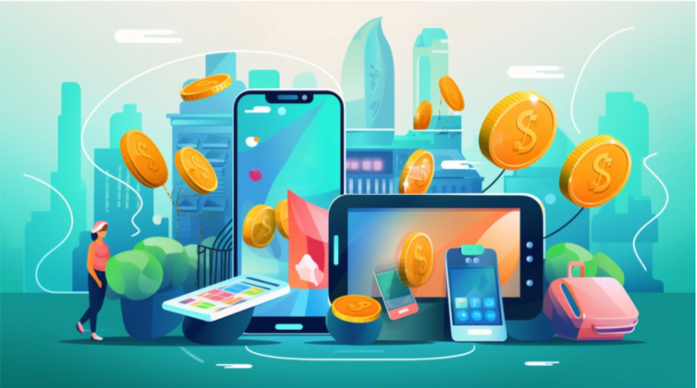
Source: Tsymbaliuk (2023)

University of Wales Trinity Saint David – MBA
What would be the factors affecting intention to use digital payment and what would be done to enhance the intention to use.
Name: AU YEUNG YAT HEI
Lecturer: Dr. Mo Wing Ying, Katherine

Contents
Abstract 1
1. Introduction 2
1.1 Research Background 2
1.2 Research Motivation 4
1.3 Research questions/problems 5
1.4 Research aims and objectives 6
1.4.1 Research aims 6
1.4.2 Research objectives 6
1.4.3 Limitations 8
1.5 Summary 8
2. Literature Review 10
2.1 Intention to use digital payment for transactions 10
2.1.1 Definition 10
2.1.2 Construct and measurement 11
2.2 Trust 11
2.2.1 Definition 12
2.2.2 Construct and measurement 13
2.2.3 Relationship between trust and intention to use digital payment 13
2.3 Security 14
2.3.1 Definition 14
2.3.2 Construct and measurement 17
2.3.2 Relationship between security and trust 18
2.4 Privacy 19
2.4.1 Definition 19
2.4.2 Construct and measurement 20
2.4.3 Relationship between privacy and trust 21
2.5 Convenience 22
2.5.1 Definition 22
2.5.2 Construct and measurement 23
2.5.3. Relationship between convenience and the intention to use digital payment 24
2.6 Social Influence 25
2.6.1 Definition 25
2.6.2 Construct and measurement 25
2.6.3 Relationship between social influence and intention to use digital payment 26
2.7 Demographic factors 26
2.7.1 Definition 26
2.7.2 Construct and measurement 27
3. Research Methodology 28
3.1 Research model with hypotheses 28
3.2 Triangulation 29
3.3 Qualitative and Quantitative research 30
3.4 Focus group 31
3.5 Quantitative survey methodology 32
3.6 Pilot Test 33
3.7 Target population 35
3.8 Sampling method 35
3.9 Sampling size 37
3.10 Data analysis techniques 38
3.11 Research Method Limitations 39
3.12 Research Ethics 41
4. Data Description and Analysis 43
4.1 Data from the Focus group 43
4.2 Data from the final survey 44
4.2.1 Demographic Data Collected 44
4.3 Cross Tabulation of Demographic Factors with Intention to use digital payment 52
4.3.1 Intention to use digital payment in future and gender 52
4.3.2 Intention to use digital payment in future and education levels 54
4.4 Each factor’s highest and lowest averages 55
4.5 Reliability Test 57
4.6 Factor analysis 57
4.7 Correlation Analysis 59
4.8 Regression Model 60
4.9 Independent t-test 64
4.10 One-way Analysis of Variance 66
4.10.1 One-way ANOVA for frequency of usage of digital payment in a week. 66
4.11 Summary of the Research findings 69
5. Conclusion and recommendation 71
5.1 Conclusion 71
5.2 Recommendations 73
5.2.1 Theoretical implications 75
5.2.2 Practical Implications 75
5.3 Limitations 79
5.4 Suggestion for future research 80
5.5 Summary 80
Reference: 81
Appendix 107
Appendix 1 Gantt Chart of the research 107
Appendix 2: Crucial opinion for using digital payment from Focus group 107
Appendix 3: Pilot test 108
Appendix 4: Sample size test 108
Appendix 5: Description of various data analysis techniques 109
Appendix 6: Abbreviation of terminologies 110

Abstract
Research Purpose: Various factors would be assessed to see whether there were any relationships for influencing the intention to use digital payment in Hong Kong and see how those factors encourage customers or potential customers to use digital payment for users’ purchasing and transactions; and locate solutions to improve so that could attract current users and potential customers to use digital payment.

Research Methodology:
Conducting focus group to first identify the factors in primary data collection and look into the factors further by secondary data collection; and questionnaire would be designed and would be spread online to obtain the answer in aspects of convenience, security, privacy, trust, social influence and the intention to use digital payment and see what could be done in order to increase the intention to use in Hong Kong

Findings: In summary, findings had shown that the impact of Security was of utmost importance to Trust and Convenience was significant to intention to use digital payment as both of the factors.

Conclusion and Recommendation: Convenience was the factor which would affect the intention to use digital payment by the respondents, also, intention due to higher usage would be and ease of use and peers and trustworthiness of digital payment itself., personal information protection and safe transaction was factors determined if the users had got higher intention to use. Measures like two-factor authentication and fraud detection systems could identify if there were suspected online payments, and simplified process for registration and payment could enhance the convenience.

Limitation: this research was based on the results of data of questionnaire and a focus group of total number of 148 valid respondents and 9 participants respectively. There were difficulties in controlling or monitoring the backgrounds of the respondents such as education level and income levels and, the intention of those who did not have experience in using digital payment was excluded.

Keywords: Intention to use, Convenience, Trust, Security, Privacy, Digital Payment

- Introduction

1.1 Research Background
Technology has been improving and made a lot of changes to cater the users. On the other hand, legal and regulatory changes have caused consumers and businesses runner towards choose to use digital payments. Introduction of widely usage of smartphones and increasing coverage of internet have been supporting the usage of online banking, mobile money and electronic wallets. (Glowka and Kosse and Szemere, 2023) At the same time, the number of point-of-sale (“POS”) terminals has been also increasing, while the network of traditional cash access points, such as the number of automated teller machines (“ATMs”) and bank branches, is decreasing. Moreover, as more and more people interact with each other with money transaction and doing purchasing with digitalized way, demand of speedy and real-time payments would be increased., and banks is no longer the main stream for providing payment services to customers as competition from non-bank payment service providers has become more popular. Digital payment product such as online direct debits, credit transfers, cards and e-money payments has become popular and this made the people make payments and transactions less on non-cash way such cash itself, cheques and other paper-based credit transfers. There were a number of information revealing the situation people using digital payment. The average number of transactions which was completed by digital payments for each person in the Red Book statistics countries was 179 in year 2012 time, and has been increased to 332 in year 2021 (Glowka and Kosse and Szemere, 2023). In addition, another type of digital payment method fast payment system (“FPS”) has been widely applied in a global scale, there were more than 60 jurisdictions have launched FPS and those which were not yet applied were in the progress to introduce to the countries. FPS, which has been on real-time basis for 24 hours in a week, processing of small-value account-based transactions so that funds are immediately available to the payees.

Figure 1.1 2019-2021 Volume of transactions by cards and e-money payment of Group of Seven countries
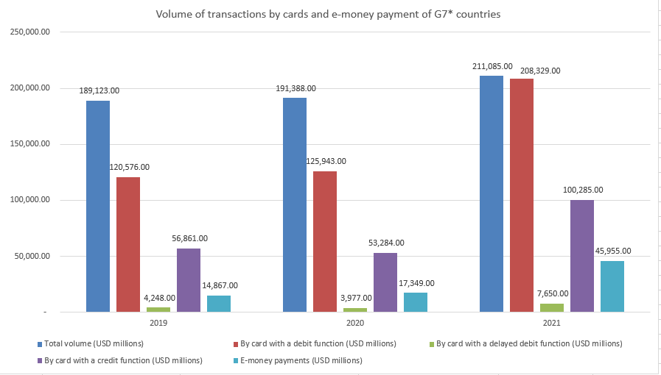
Source: constructed by author
From figure 1.1 which extracted from Bank of International Settlement (“BIS”) showed the volume of transactions by debit and credit cards as well as e-money payment for Group of Seven countries from year 2019 to year 2021 (Glowka and Kosse and Szemere, 2023). It was not difficult to find that the total volume has been increasing gradually from USD 1,891.23 billion to USD 2,110.85 billion, meanwhile the volume of credit and debit card payment has soared significantly from USD 56.861billion to USD100.285 billion or by 76.36% and from USD120.576 billion to USD208.329billion or 72.77% respectively., but it was noticed that the volume of e-money payment has grown from USD14.867 billion to USD45.955 billion, which more than 200% growth in these three years’ time. This obviously signified that the e-money payment has got a momentum for future payment methodology, although the nominal value was still very small compared with that of debit and credit card (BIS, 2023).
According to Khaitan and Joshi (2023), digital payment was not new in Hong Kong and has been widely using in Hong Kong and it was not difficult to notice that people in Hong Kong had played majority in using digital payment during Covid-19 pandemic (“The pandemic”) for completing purchasing and transactions among users’ social network. Digital payment in terms of mobile payment applications (“Apps”) such as Apple Pay, Google Pay, Samsung Pay, and local providers namely AlipayHK, Tap & Go, and WeChat Pay. Besides, customers could use QR Code Payments with smartphone mobile payment Apps to scan the QR code for the payment; Internet payment platforms with online payment platforms like PayPal, Stripe, and local providers namely PayMe and Faster Payment System (“FPS”). Contactless credit/debit cards were very common in Hong Kong; other digital payment method in Hong Kong has been used for fund transfer and payments between individuals and business counterparties, locally through Octopus, EPS (Easy Payment System), and FPS.

Figure 1.2 Value of cashless payments in Hong Kong (HKD billion)
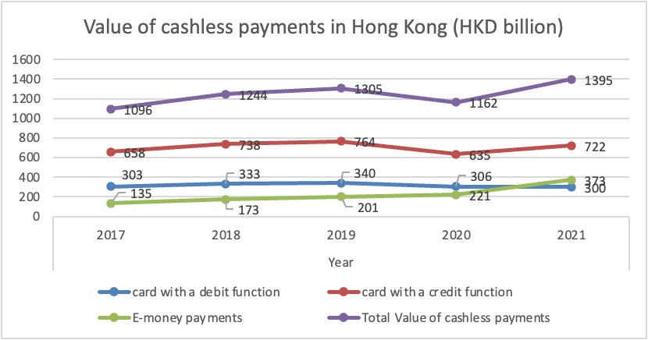
Source: graph constructed by author
Figure 1.3 Individual and collective consumption at current market prices (in HKD million)
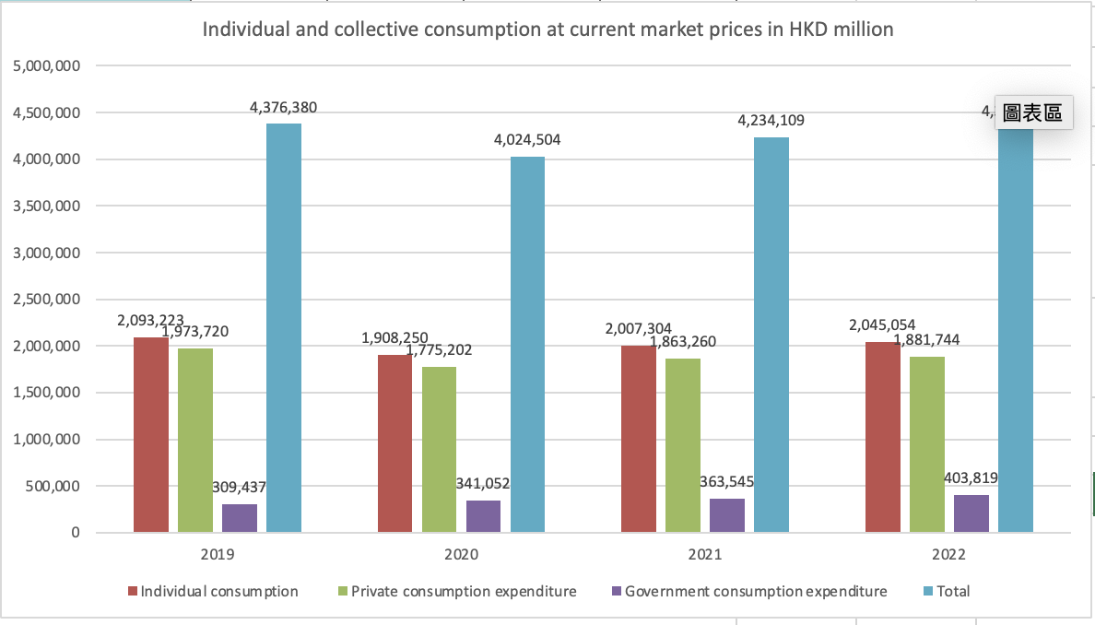
Source: constructed by author

1.2 Research Motivation
According to the report of Hong Kong Institute for Monetary and Financial Research (“HKIMR”), there were several factors have been causing rapid development of financial digitalization in Hong Kong (HKIMR, 2023). These factors included significant information technology penetration rate to the Hong Kong public, the COVID-19 pandemic made people stay at home and purchase with online shop, eventually establishing the online purchasing ecosystem, new entrants to the digital payment markets had stimulated the peer competition, these factors had been providing an opportunity to business owners to re-shape the model to digitization.
The COVID-19 pandemic has made significant impact on physical payments such as paper cash, credit and debit card and cheque payment related business (BIS, 2023), total value of non- cash based and credit card transactions in digitalized from had been growing considerably in all economies.
From figure 1.2, which information was extracted from Bank of International Settlement, there were HKD2,790 billion in total transacted with digital payment method. However, figure 1.3 of the information of Hong Kong Census and Statistics Department, there were transactions valued HKD4,234 billion and HKD4,331 billion in total in year 2021 and 2022 respectively (HKC&SD, 2023). These two pieces of information was the good evidence to show that there were many people and transactions have not yet been done through digital payment.
Nowadays, online shopping would be in favour in certain genders and other demographic factors such as education levels, income levels, employment, contactless device ownership, and internet knowledge, and the social influence (Wang and Ding and Xu, 2023) would contribute intention to use digital payment of individuals. Other than demographic factors mentioned above, people’s intention to use digital payment would be influenced by the other external factors such as convenience of the digital payment when compared with cash-payment, methodology, macroeconomic, regulatory of the local government, culture, and digital infrastructural readiness in different economies. All in all, the findings had provided evidence for digital payment stakeholders to make decision whether to use digital payment.

1.3 Research questions/problems
Hong Kong is an international financial centre and transactions could be conducted by digital payments. People could only use the digital payment method mentioned in section 1.1 and customers did not have to take out paper cash from the pocket (Khaitan and Joshi, 2023), it seemed safe and efficient as nobody would access physical cash However, by observation, it was noticed that there were still number of people in Hong Kong insisted to use physical cash for transactions and on the other hand a number of shops insisted to receive cash as the only payment method. This was noticed that from the figure 1.2 and figure 1.3 again, (BIS, 2023) and (HKC&SD, 2023) there were still total transaction amount valued HKD1,444billion were using non-digital payment. This is such a large room for digital payment method to expand its coverage in the Hong Kong Society. This has brought up to a question that there might be factors influencing people’s intention to use digital payment for transactions such as convenience, and people would use a portable device so that users could conduct transactions and purchasing quickly and easily (Cabanillas et al, 2020); privacy and privacy derived trust issue as the risks associated might adversely affect consumers’ confidence to use; and the reputation of the digital payment as a whole(Akanfe and Valecha and Rao,2020); security, commonly known as users would feel safe when making payment with specific digital payment channel; and security derived trust issue such as unauthorized payments would be the most considered concerns for users (Alswaigh and Aloud, 2021), trust, that customer might be positively perception towards usage of digital payment and other factors (Sahi et al, 2021) like ages, genders, education levels, income levels and users’ transactions and amount of transaction involved.

1.4 Research aims and objectives
The following paragraph would briefly discuss about the aims and objectives of this research.

1.4.1 Research aims
From the figure1.2 the total value of cashless transaction up to year 2021 was HKD1,395 billion or 20% more than that in year 2020., and 6% more than the same category in year 2019, although there was a considerable increase in digital payment by 68% to HKD373 billion (BIS, 2023).
This research therefore aims to find out the linkage among factors like convenience, privacy, privacy and trust relationships, security and security and trust relationships, trust and demographic factors like genders, ages, education levels, income levels and users’ transactions and number of transactions involved mentioned in section 1.3 in order to find out:
(1) how the factors inspire or discourage the intention of current users or potential users to use digital payment for purchasing and transactions; and
(2) what could be done to enhanced factors so that current or potential users to use digital payment.

1.4.2 Research objectives
The objective of this dissertation is to find out what would be the factors encouraging the intention of people to purchase and making transactions with digital payment through the analysis and eventually come up with the conclusions and recommendations for improving users’ intention to use digital payment. Convenience which made people easy to use (Ma 2022), security that the people’s habitat was well protected or safe from threats (Lai, 2016), privacy that control the flow of information about them (Alfarizia and Saria, 2023), trust that related to easiness to use and users' attitude (Zhong and Oh and Moon, 2021). Demographic factors such as ages, gender, education levels, income levels, frequency and volume of transactions involved (Sahi et al, 2021) and social influence between security and trust and privacy were to be assessed in order to assess how those mentioned factors affect the people’s intention to use digital payment.
To investigate the factors, the Triangulation (Moon, 2019) approach would be applied that both quantitative and qualitative method would be used. For quantitative method, data would be collected by means of issuing questionnaire through the convenient online communication devices such as WhatsApp and WeChat and eventually distributed widely to different groups of people through the snowballing method (Silva et al, 2022), and the data integrity cannot be completely confirmed, and general acceptable level of reliability would be the Cronbach’s alpha around 0.6-0.7 while 0.8 or greater would be treated as very good level (Ursachi and Horodnic and Zait, 2013). On the other hand, for qualitative research data collection, it involved creating the focus group with 6-7 individuals (Shaw et al, 2023) whom have got experiences on digital payment that to have more discussions on what would be the crucial factors and what hard and soft infrastructure could be provided so that people would be more likely to use digital payments in Hong Kong.
Hong Kong Monetary Authority (“HKMA”) has been putting effort to promoting digital payment related campaign such as cross-border digital payment on individual level, tokenization in debt security market, e-Hong Kong dollar pilot programme and inviting all banks in Hong Kong to go fintech; and to complete the mentioned campaign by various measure such as establishing the advanced data infrastructure, implementing measures to attract more fintech talents and aiding with formulating related policies in order to cultivating ecosystem for further development for digital payment in Hong Kong. HKMA also added that it is essential for Hong Kong as a financial services sector to be well equipped to innovation and ideas so that continue to be at the first line of fintech. Therefore, the best way to apply and/or implement the recommendations would be the authorities and it would be ideal to be delivered to the monetary authorities or financial services providers which could have leading position and have more power to implement relevant policies or take relevant actions based on the recommendations and conclusions.

1.4.3 Limitations
As the topic is related to digital payment, it would include all kinds of digital payment such as online store shopping, payment or transactions with mobile applications, contactless debit and/or credit cards payment, fast payment systems, e-wallet on the mobile phones, just to name a few. However, since the agenda digital payment has been a hot topic for a few decades and gradually developed into various sub-topics alone, such as e-wallet, online shopping. Therefore, inversely it would become an obstacle to obtain a general reference online in recent documents and academic reference related to the board topic digital payment.

1.5 Summary
After considerations, the introduction, the background, the aims and objectives, and the limitations of background of this research were defined. This research structured as follows (Figure 1.4) and the progress would be shown on the Gantt Chart (Appendix 1).
Figure 1.4 Research Structure
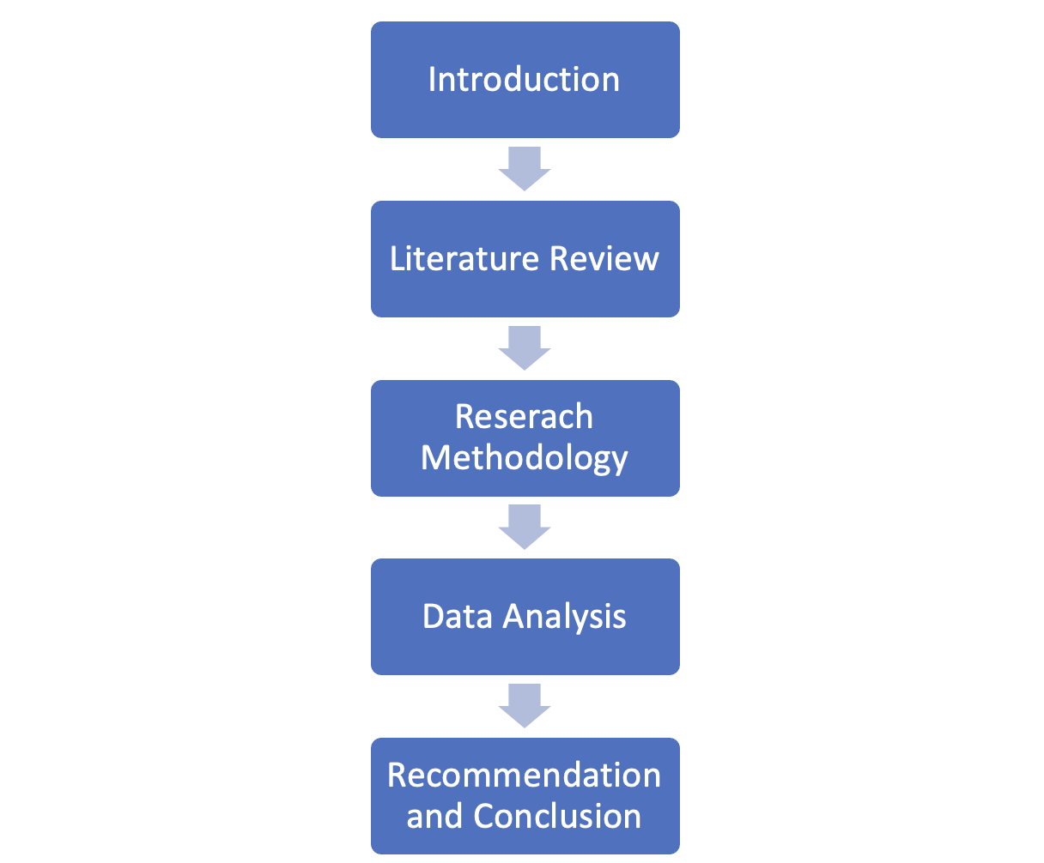
Source: constructed by author

- Literature Review

Digital payment transaction had started as early as in 1994, a company called First Virtual Holdings had established the first online payment system. Since then, customers could use their credit cards to make payments online utilizing this technique without concerning about safety (Finance Magnet, 2023). After decades, the popularity and acceptance of digital payment has been growing as mentioned in Section 1.1. However, there might have someone not very welcome this payment form.
In this Literature review, there were a number of hypotheses which might affect the intention to use digital payment, such as convenience, security, privacy, trust, customer characteristics and last but not least social influence currently would be investigated in order to find out any linkage between the intention of using or keep on using digital payments and the hypotheses factors. The related empirical researches had been used as reference and established the literature for building up th theoretical foundation of this research from framework developed.

2.1 Intention to use digital payment for transactions
Junadi and Sfenrianto (2015) stated that intention was a kind of behaviour and would creating a promising atmosphere which would make people using the technology.

2.1.1 Definition
Throughout the process of digital payment transactions, payers and payees of both utilize electronic methods to carry out the transactions. Technology in digital payments revolutionized the financial sector by initiating attractive features, including fast, convenient, and responsive delivery of payment solutions, compared to the manual system of payment.

2.1.2 Construct and measurement
Patil et al (2018) had stated that there would be obvious adverse and to trust on risk which eventually affect the customers’ willingness to use digital payment. Therefore, it is necessary to assess the customers’ trust on it to see whether there was any relationship between trust and intention to use digital payment.
It is found that when the digital payment system could enhance the enjoyment of users, and became user-friendly and beneficial, users would have intention to use the e-payment system (Vinitha and Vasantha, 2020).
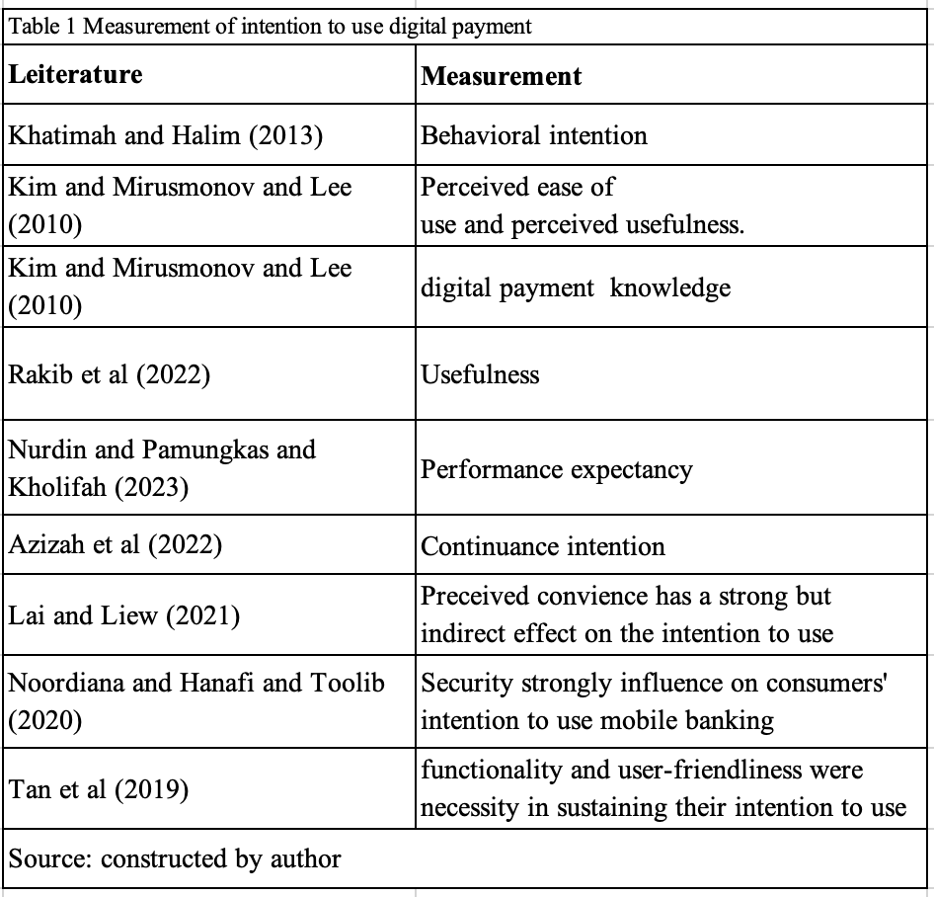

2.2 Trust
Trust as the expectancy of efficiency, reliability and effectiveness of technical gadgets and structures, from the attitude of human beings who've created the given technology, statistics structures of material objects and so on (Szumski, 2020) and
It turned into additionally observed that others issue which included perceived enjoyment, facilitating conditions, non-public innovativeness, coupon availability, perceived ease of use perceived usefulness and users` attitude (Zhong et al, 2021).

2.2.1 Definition
Li and Li (2023) had suggested the trust came from users’ faith towards technology, to institution, and an individual. In the digital payment context, users would trust digital payment system or technology itself and/or digital payment providers.
Alkhowaiter (2022) reported that trust was found to be important in relation to intention and use. Elements of trust included both individual and social aspects and could be crucial in establishing commitment between users and the providers.
Talwar et al (2020) had mentioned that not just trust but initial trust is crucial for initial acceptance and continued to apply digital payments because these online transaction methods meant the users would expose to higher risk options and initial trust may actually be compulsory for appeal customers to use digital payment.
Nelloha and Santoso and Slamet (2019), had suggested that trust was related to the belief of a certain performance but without ability control that performance in that individual or organization., in other words, trust had to do with of uncertain environment and uncontrollable future events with respect to unknown circumstances.
Ha and Sensoy and Phung (2023) had got an indirect view on trust that it might not have direct impact, but act as an intermediating role in encouraging the intention to use digital payment. Thus, trust would be one of the important elements make users to improve perceived usefulness and intention to use.

2.2.2 Construct and measurement
Technology acceptance model (TAM) which was developed by Davis (1989), might be applied as generally many comparable researches would cognizance on customers` conception together with the perceived ease of use and perceived usefulness., Trust might be assessed in phrases of notion from the users or potential users to decide the usefulness due to the fact that trust as such would develop first picture product Talwar et al (2020) and customers might no longer use digital payment.
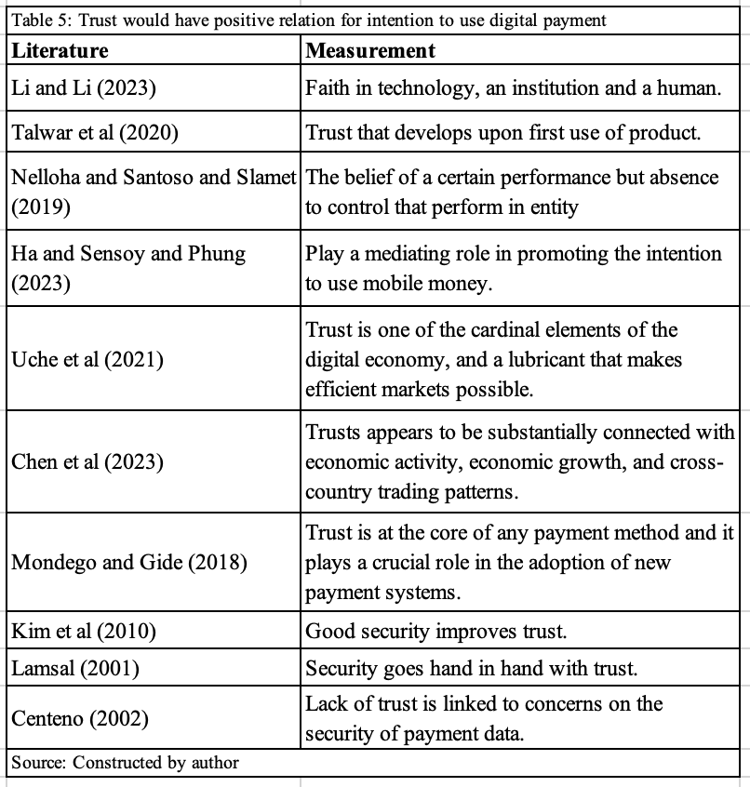

2.2.3 Relationship between trust and intention to use digital payment
According to Uche et al (2021), trust is one of the key elements of the digital economy, and a lubricant that makes efficient markets possible. Without trust, few transactions would take place. While mutual benefit is often the reason behind a transaction, trust is the insurance or likelihood that the purchaser will receive that benefit. While trust is important for all types of business, trust is even more crucial in the online business environment. Chen et al (2023) had further elaborated that trust has connected with economic activities, eventually economic growth, and cross-border trading activities and digital trust had to be improved so that more customer would feel comfortable to use.
Mondego and Gide (2018) agreed that trust would be the first priority of all payment method and it plays a crucial role in the adoption of new payment systems. Such as digital payment. Thus, digital payment has to be trustworthy by the users in order to endorse any monetary systems which had been newly developed.
H1: There are positive relations between trust and intention to use digital payment.

2.3 Security
Security became common understanding that the environment people live at became free from danger and it had become essential for cusotmers to determine whether or not to use digital payment (Lai, 2016).

2.3.1 Definition
Customers were worried about whether being the target of theft or got loss when bringing along with cash or physical cards. Moreover, when mentioning about security in association with digital payment, it was usually related to which (Lai, 2016) an individual or an organization had provided certain magnitude of security to customers and was related to with how confident the customers in applying the new technology of payment method.
Customer security was an important factor in digital payment system or devices which could give customers confidence to use digital payment with by maintaining security on every customer’s belonging.
Customers has been facing considerable exposures when conducting online settings on digital payment, including risk on identity theft and information misuse (Sahi et al, 2022). For instance, business owner might make use of customers’ data for marketing without customers’ consent or even disclosure the customers’ information, including financial and personal information, to the other parties. Thus, risk perception in terms of security would be important element to accepting this technology.
The information of customers that could not be accessed by other parties and being isolated in any given online payment transaction cycle was defined as the users’ payment related information (Aigbe and Akpojaro, 2014).
Therefore, it would require a method and system for verifying the identity of the user by an authority makes use of multiple various levels of gate keeping (Aigbe and Akpojaro, 2014). The method and system could be developed in an approach that require the users to provide the unique input such as biometrics like facial or pipul identification, cryptographic key, digital signature on the blank of the device, personal identification number (PIN), just to name a few, to create multiple layers of confirmation of the particular user.
Aigbe and Akpojaro (2014) also mentioned that change of layers of authentication factors could result in higher or lower the security, and the accuracy for any given layers of identification factor had to be firm enough without lowering the integrity of users’ digital payment information and the whole system. This meant that the identification factors system should be strong enough to resist different impacts of internet threat used by criminals.
Security would be the critical factor to apply a socio-technical approach to deal with digitalization and conducting valid change management strategies to further develop from a corporate to a social level, especially when the place or region became a smart cities as there would be more and more complicated system to cater the digital economy (Said and Najdawi and Chabani, 2021).
Security was a concern of both businessman and customers, and many a times security was described as an element of perceived risk without further elaboration. And such a risk would be widely applied to mobile payment system and thus has yet emerged, and this might be one of the reasons why digital payment could not further develop (Singh, 2019).
Parvathy and Durairaj (2021) also mentioned that digital payment security is related to risk of theft of information, transaction done with permission of the individual or organization, malware attack, and phishing, just not name a few, could inhibit the use of digital payment by individuals or in commercial transactions.
Iradianty (2021) had described that the security and protection on digital payment are users’ concern in making transactions through digital payment systems where the storage and move of personal data through digital payment methods was an important feature for the keep up of correctness, confidentiality and maintenance of relationships between the parties of that transaction.
Security issues that threaten electronic or digital payment systems has been changing from time to time with high speed. Cluj (2015) stated that the most common threats include viruses, worms and Trojan horses which, computer viruses attacked mobile banking payment system through malicious software by stealing passwords on the web browser or any enclosed information of users on operating system, while “worms” could be unique programs that did not require a host program for
activation and spread independently from one computer to another by making use of weakness or errors of security system and operating systems or applications respectively and Trojan horse could hide away or weaken most of the verification and users’ permission mechanisms used in digital payments.
Zhang and Yan and Song (2019) also mentioned about security of digital payment was related to the magnitude of reliability of users that making a digital transaction was secure enough in terms of moving financial and personal information to one to another.
Noordiana and Hanafi and Toolib (2020) research also pointed out that security of digital payment was treated as how consumers are protected from risk.

2.3.2 Construct and measurement
Security would be measured in several aspects: authentication, authorization, confidentiality, integrity and nonrepudiation (Al-Dala’in and Luo and Summons, 2008) from the users or potential users to determine if the digital payment system was useful. As security has been one of the important factors in digital services such as in full aspects of digital financial services (Neves et al, 2023), assess of view of security of customers could reveal whether customers would apply their transactions or purchase with digital payment.
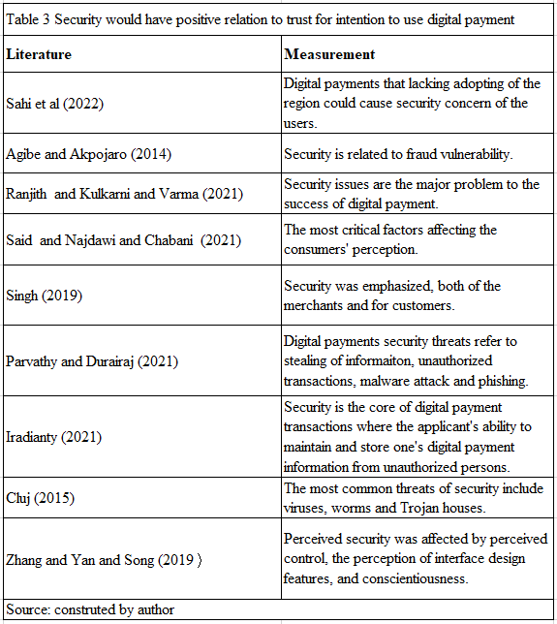

2.3.2 Relationship between security and trust
Tsiakis and Sthephanides, (2005) had referred that satisfying customers security expectations would be very important to obtain trust from the digital payment system of the users and therefore the trust would be closely related to the security of the digital payment. Kim et al (2010) mentioned that digital payments were facing various security threats and thus consumers’ trust on digital payment would be affected by perceived security. Nelloha and Santosob and Slametc (2019) also stated that security would be important and bring up positive effect on trust of digital payment.
H2: There are positive relations between security and trust of usage of digital payment.

2.4 Privacy
Alfarizia and Saria (2023) states that information Privacy was whether the personal lives and affairs of people could be kept away from the public, or to control the disclosure by the owners of information and could only be accessed by interested parties according to the nature and purpose of the information.

2.4.1 Definition
Karim et al (2020) had stated that privacy was defined as how well the users to keep the personal information not to be disclosed or disclosed according to the users’ willingness, such a ability would be important to each of the digital payment users.
Privacy could be termed as the users’ personal data that has to be secured. Parties other than the particular user could not and should not be possible to get the full process information of that transaction (Karnouskos et al,2004).
Riccardo et al (2019) had provided the definition of privacy when
design digital services have proven to be good to customers, any worries related to private data that would decrease the willingness of using personalized services under the digital payment.
Privacy on digital payment usually refers to when conducting such payments, the anonymity of the purchaser would be kept confidential. This would provide protection against moral hazard as the risk of theft. (Ahnert and Hoffmann and Monnet, 2022).
The definition of privacy that s the ability of individuals to control when, how, and to what extent their personal information is communicated to mobile applications as well as the right to prevent unauthorized disclosure of personal information (Ma et al, 2022). The risk of privacy would be the concern of the users’ personal data that has got chances to be stolen or damaged.
Gupta and Hakhu (2021) had pointed out that privacy of these transaction that information provided from the users to complete the transaction by digital payment could be attacked and abused by other parties.
Privacy would be how well the users could control users’ own person data. There would be different kindly of privacy such as supervising, weak in manipulating on private information and management on this data could affect customers’ thought and action and addressed that privacy issues might alter customers’ habit of actions in terms of digital payments (Dimitrova and Ohman and Yazdanfa, 2022).
Privacy, by Lallmahamood, (2007) had showed the manipulation of transactions between users. This concern would be discussed long ago and claimed that the final goal would be minimizing the harm of the personal information from the others. Akanfe, and Valecha and Rao (2020) also stated privacy risks were related to attacks from hackers and the danger from data being abused. This was expressed
(Riccardo et al, 2019) that the privacy in relation to digital payment that it was the companies’ storage and usage of data of the users would eventually cause consumers’ privacy concerns. Ladkoom and Thanasopon (2020), had also defined Privacy that could be defined potential loss of users’ self-control of personal data.
Widyanto and Kusumawardani and Septyawanda (2020) stated the level of the security was perceived in the context of mobile payment and how users trust while using mobile payment, privacy information was secured.

2.4.2 Construct and measurement
Privacy would be measured by perception of the users or potential users to determine the usefulness because users’ worries about the potential threats to the personal information (Ma et al 2022). As privacy of the digital payment could be maintained, providers could lower privacy risk, and eventually consumers would be willing to share their information (Gong et al, 2019), it is important to assess the privacy concern of the consumers and/or potential consumers on the view of privacy of applying digital payment and find out how privacy factor affects consumers' usage.

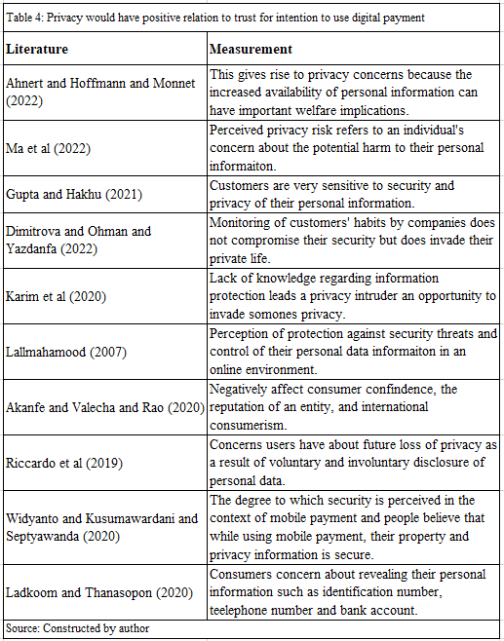

2.4.3 Relationship between privacy and trust
Customers would worry about personal information might be disclosed to the other parties through the digital payment devices or system without owners’ consent, and consequently impacting satisfaction, loyalty, and behavioural intention. (Kim and Seok and Roh, 2023) Therefore, trust-based privacy protection would be important that the digital payment devices or systems were trustworthy and thus users would have improved intention to use digital payment.
H3: There are positive relations between Privacy and trust of usage of digital payment.

2.5 Convenience
Digital payment, would encourage people to use was highly supported by factors like convenience, that users would be easy to use (Ma et al, 2022) by providing quick and user-friendly solutions to complete users’ transactions at anywhere at any time (Sahi et al, 2021).
This was agreed that by Wardana et al (2022) that convenience was defined as a situation that an individual felt relief when using the digital payment. Olipane and Inocencio (2023) had added that convenience related factors such as accessibility, swiftness, security and usefulness are priorities of customers in the acceptance and continuation of usage of digital payments.

2.5.1 Definition
Boden and Maier and Wilken (2020) described convenience perceptions of an innovation with its adoption. It had been argued that an adoption of a technology would reflect the acceptance and experience with digital payment and hence improve the convenience perceptions of the users.
Klapper (2023), mentioned that digital payment systems or devices functioned more than convenience, digital payments could also boost up business and lesser transfer time on payments for business licenses and permits.
Brown et al (2021) stated that the acceptance in business owner and speedy transactions, and convenience of digital payments would increase at a considerably high speed. This development could have a significant effect on consumer cash demand for payment or purchase.
Lai and Liew (2021) commented that the convenience from digital payment view point was related to how fast conducting payment transactions of customers.
Digital payments had offered convenience by saving time and labour, means the elements of convenience would be time and labour saving. There are further issues with cash use. While digital payment could provide a suitable-alternative to assist he informal or parallel economy by offering an ideal way for organizations to fix the problem of traceability of transactions (Shree et al, 2020).

2.5.2 Construct and measurement
Niankara and Traoret (2023) stated that convenience could be determined by the two factors: customers could complete the transactions without friction; and settling payments without using physical cash either in shops or purchasing online. Digital payments could also users several strengths such as “one-click” payments, that means there was no need to bring with cash for completing transactions or purchasing (Ramayanti et al, 2024). Bezhovski (2016) stated that convenience meant customers could make transactions or purchases at anywhere in any time.
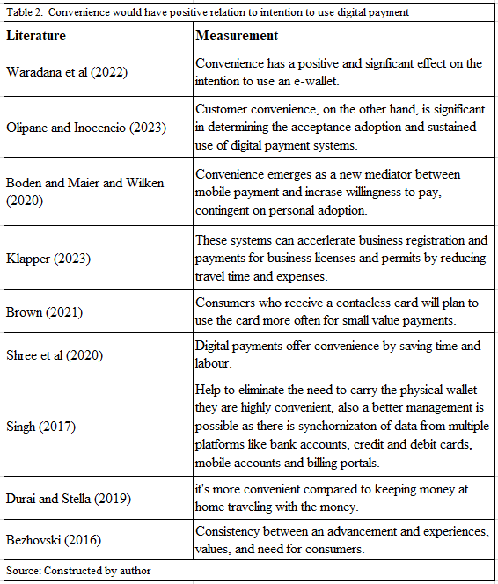

2.5.3. Relationship between convenience and the intention to use digital payment
convenience does not necessarily become a factor (Sari and Habibi and Hayuningputri, 2022) which affect users’ intention to apply digital payments because there are might be other factors which are of higher importance than convenience. As such, we have to investigate whether there was a top relationship between convenience and intention to apply digital payment method.
Digital payments could be a convenient and affordable means as users with lower income to save and borrow in the formal financial system or earning a financial return (Durai and Stella, 2019) supported that it has been necessary to the general public as it could also improve security for individuals’ cash and it would be more convenient than that keeping users’ cash at home or when traveling with the money.
H4: There are positive relations between convenience and the intention to use digital payment.

2.6 Social Influence
Social influence according to Khatimah and Susanto and Abdullah (2019), referred to social atmosphere expressed by users’ view and opinions.

2.6.1 Definition
Alfany et al (2019) stated that when social influence was mentioned, this could be thought of perception that power of people using new technology such as electronic payment system for making payment our purchasing and eventually inspire the other consumers around those people.

2.6.2 Construct and measurement
Personal habit and view would be a determinant towards social influences related to users’ perceptions of what would be done, also users’ can observation could reflect users’ decisions on how they think of the habit of other users (Nisa and Solekah, 2022). This might reflect the intention of using digital payment.
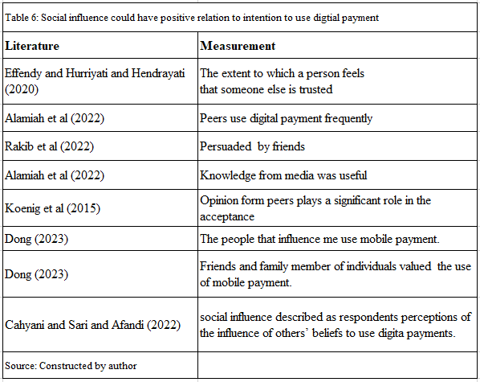

2.6.3 Relationship between social influence and intention to use digital payment
According to Ebubedike et al (2022), usually the term "social impact" would be applied instead to define a person's perception of the importance of other people's view in people’s decision to use or not to use digital payment.
H5: There are positive relations between social influences and the intention to use digital payment.

2.7 Demographic factors
According to Kanojia and Lal (2023), users’ age, income and education level could be the strong factor of attitude to establish the effect of intention to use digital payment.

2.7.1 Definition
Sahi et al (2021) have looked beyond the direct relationships and included several demographic factors such as such as ages, education levels, genders, income levels, usage frequency and size of transactions would determine whether users would choose to use digital payment.

2.7.2 Construct and measurement
(Said, 2021) had stated that people with higher-income would have higher intention to use digital payment more than lower-income people; Moreover, (Said, 2021) also pointed out that the education received and age were also the factor for users’ intentions to use digital payment because the more the age of the people, the more the education those people could receive and eventually higher income which could show that the higher intention to use. This was a fun finding and therefore it is necessary to investigate whether the various demographic factors could directly affect the intention to use digital payment.
For each variable (gender, age education level, income transaction volume and amount) would be the variables, the researcher to decide which would be the majority areas (Alshari & Lokhande, 2022).
H6a: There is a significant difference between the gender groups and intention to use digital payment.
H6b: There is a significant difference between the age groups and intention to use digital payment.
H6c: There is a significant difference between the education levels and intention to use digital payment.
H6d: There is a significant difference between the income levels and intention to use digital payment.
H6e: There is a significant difference between the usage frequencies and intention to use digital payment.
H6f: There is a significant difference between the volume of transactions and intention to use digital payment.

- Research Methodology

3.1 Research model with hypotheses
This Study aims to provide the conceptual framework for checking the relationship among convenience, security, privacy, trust, social influence and the intention to use the digital payment for transactions. Interestingly, the trust which would influence intention to use digital payment might be influenced by both the privacy and security (Figure 3.1 and Table 3.1).
Figure 3.1 Conceptual model of the study with hypotheses
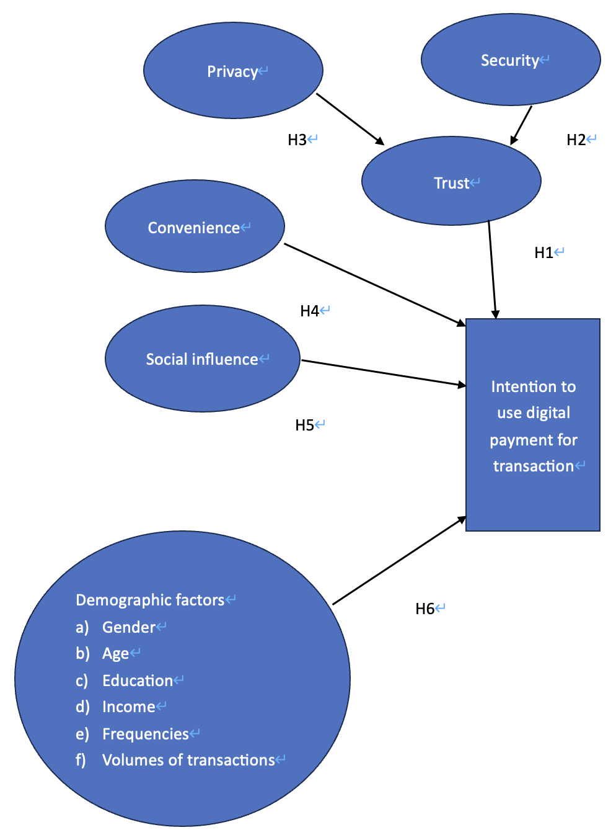
Source: Constructed by author

Table 3.1 hypotheses for affecting intention to use digital payment for transactions
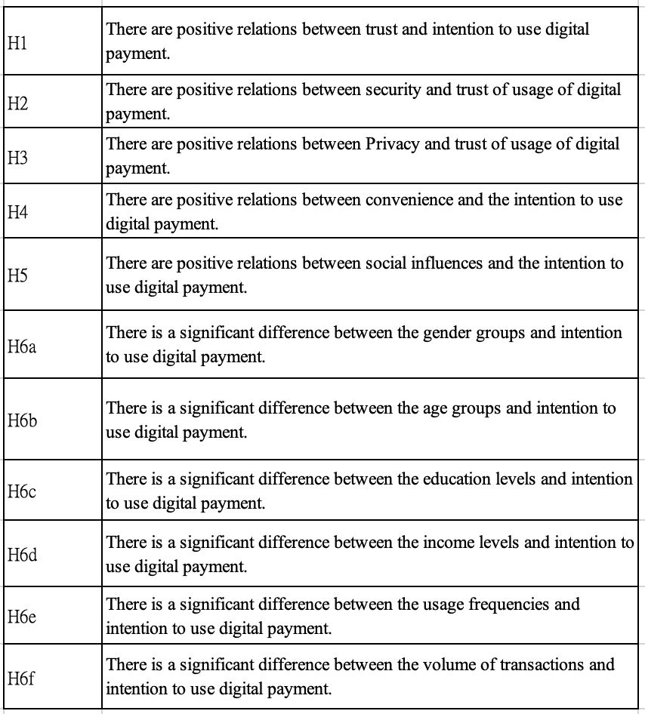
Source: Constructed by author

3.2 Triangulation
Triangulation as described in figure 1.3 which was developed by Denzin in 1978, was a methodology for conducting research using different data sets from various number of researchers, theories, so that the data obtained, analysis, and conclusions drawn from the researches would be accurate and completed (Moon, 2019).
Figure 3.2 Illustration of Quantitative and qualitative Research Methodology
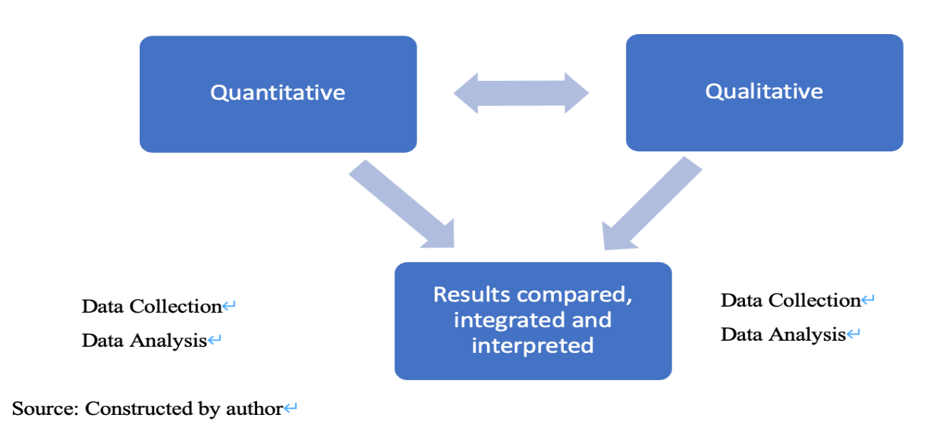

3.3 Qualitative and Quantitative research
When quantitative research was referred, obtaining and studying data would be included, and the data was usually related to numerical figure and statistics., while qualitative research was mentioned non-numerical figures such as key words would often be obtained instead. Qualitative and quantitative factors were equally important for consolidating different kinds of knowledge as some factors might not be quantified. (Streefkerk, 2023).
Triangulation used in qualitative research usually referred to conducting interviews, by observation, and taking notes. Qualitative method applied by researchers whom were studying human behavioural activities would usually collect data from interviews with individuals or groups of individuals. Based on purpose of the study needs and whether there were enough the resources, researchers would choose which kind of interview to be conducted (Carter et al, 2014).
Qualitative research would involve data collecting as mentioned above, this research would have one of the elements, the focus group with participants with experience using digital payment might have more comments on deciding the important elements and what infrastructures could be in place so that users would increase the intention to use digital payments.
For data collection in quantitative research, this could be done by designing questionnaire and deliver to the population by random with questions related to primary quantitative data (Mazhar et al, 2021) such as usage frequency and amount spent when using digital payment would be obtained. The data collected would be analysed with the secondary quantitative data or information (MacLaren, and Mills and Tommbe, 2014) from governmental reports or statistics, other education institutions with journals and research papers. For data collecting through questionnaire, Likert Scale of 5-scale would be used for most questionnaire questions (Anjaria, 2022) except demographic factors.
Figure 3.3 Data Collection Process
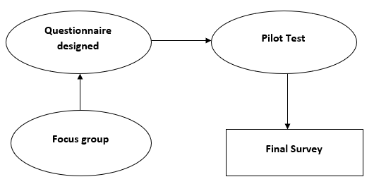
Source: Constructed by author

3.4 Focus group
Focus group would be used for qualitative data collection, and this method has become common among professionals in different areas including health and social care sectors. (Rabiee, 2004).
The focus group would be held in Hong Kong area and the discussion would last for about 45 to 60 minutes (Shimizu et al, 2021) and conducted in both English and Cantonese languages. The progress would be recorded on paper for further analysis. During the focus group discussion, the participants would be asked with a number of open-end questions (Sugovic, Nooraddini, and Sherehiy, 2016) on how to improve the intention to use digital payment. When there was situation that most of the answers or comments to the questions were similar and no addition answer exists, the focus group session would end.
A focus group as such would be consist of individuals with some similar characteristics relevant to the study and the number of individuals would between six to ten participants who did not know to each other (Powell and Single, 1996). In this way, not only were the participants not differentiae within the group, but the individual would enjoy the privacy and eventually created an atmosphere that promising honest expression of what could be crucial opinion (Please refer the Appendix 2).

3.5 Quantitative survey methodology
Due to privacy policies of each of the digital payment providers, gathering all digital payment users in a list would not be possible. Therefore, this research would apply non-probability sampling which respondents could access to the Internet and do the online surveys (Lamm and Lamm, 2019), this method is thus the cost would be relatively lower and the web surveys could be conducted online.
With Likert scale (Likert, 1932) that allows respondents to express agreement and disagreement to certain agenda or question with assigned magnitude. This research questionnaire would be graded with 5-point Likert Scale. From Taherdoost, (2019), odd number scale could direct the respondents to pick among different level of agreement or disagreement, and thus the respondents could choose a neutral option when the answer of respondents was duly neutral.

3.6 Pilot Test
A pilot test was conducted before full scale survey, in order to check if the hypothesis accepted and dependable through the result of the pilot test., and at the same time allowing researcher to make any changes the finalized research questionnaire. (Gani and Rathakrishnan and Krishnasamy, 2020). For sample size of pilot test, studies recommended over 30 samples (In, 2017). and the pilot test was conducted and concluded before 6 Jan 2024 with 30 samples were taken. The result (see Appendix 3) that each of the factors has got Cronbach’s alpha around higher than 0.7 while 0.8 or greater which considered as very good level (Ursachi and Horodnic and Zait, 2013).

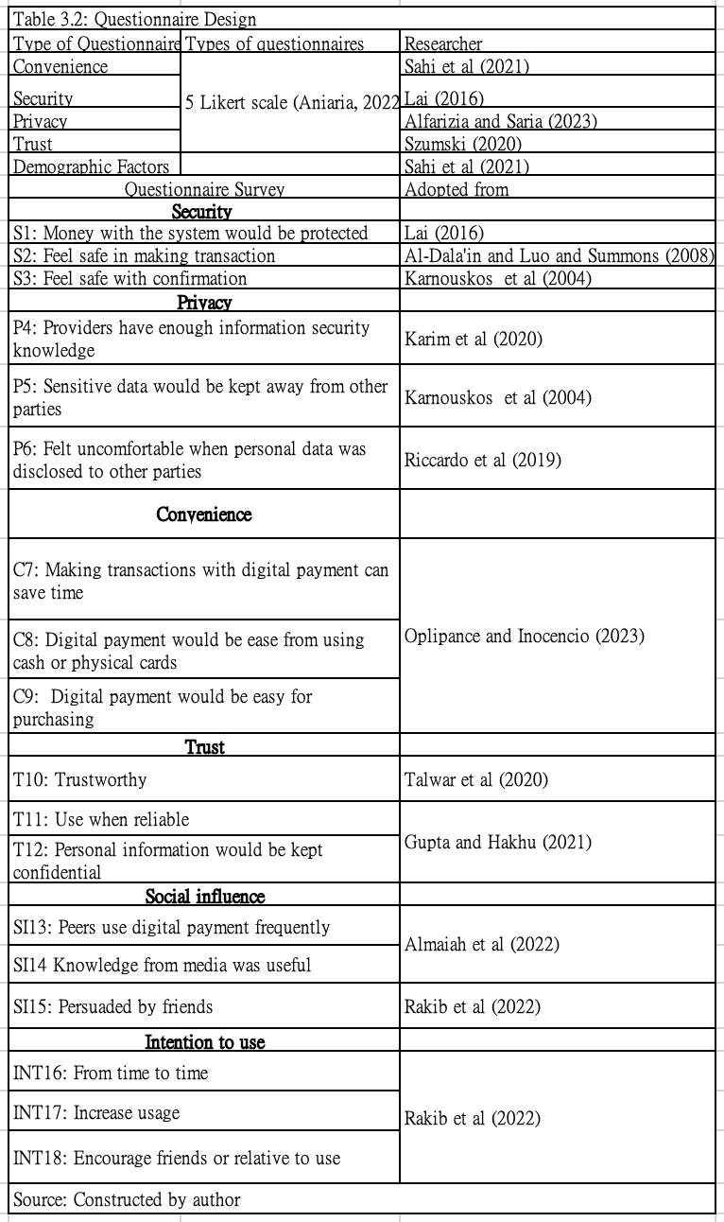

3.7 Target population
According to Target populations are the persons, groups, or firms selected for behavioural change by public policy initiatives such as statues, agency guidelines, or operational programs.
For this research, the population who from age higher than and living in Hong Kong in last 12 months who have experience or exposure using digital payment. According to the provision figure of population information from Hong Kong Census and Statistics Department (2023), there were 7.4981million people in Hong Kong., and referring to the Statista (2023) there were 6,551,900 in Hong Kong have involved digital Commerce.

3.8 Sampling method
After the pilot test was conducted, the questionnaire would be distributed to many groups of people through the snowball method.
Snowball sampling was very popular methodology of sampling. It spreads from the researcher to the network and from the network to the other networks and eventually made the characteristics of networking and referral (Parker and Scott and Gedees, 2019).
Non-Probability Sampling method would be applied as usage of Internet has become more and more popular because researchers could able to reach millions of potential respondents online through the use of opt-in panels. Opt-in panels are groups of people that are recruited to take part in studies from the Internet.
Many a times, researchers would like to begin the survey by inviting a relatively small number of people that conform the criteria of research target to be participants of the research.
There would be a strategy of sampling called stratified sampling. This was a method that involved the dividing different smaller population group known as strata. Then the strata were established based on members sharing features or characteristics. A random sample from each stratum would be taken in a number proportional to the stratum’s size when compared to the population. These splits of the strata are then pooled to from a unplanned sample. Such methodology could allow researchers to generalize from the sample to the population. This would be a major advantage because such process world be more likely to be considered to get external agreement (Sharma, 2017).
Another approach would be the cluster sampling would be used. This would involve groups which were chosen as samples in cluster sampling. All the other probability sampling methods such as simple random sampling or stratified sampling, would require sampling frameworks of all the sampling units, but cluster sampling would not have such criterion. When the clusters were chosen, individuals of the clusters would be compiled into framework. Sharma (2017) stated that advantages of cluster method would be cost effective when it came to cluster sampling. Researchers needed not desperately to investigate each of the participants. And the more variables available when researchers investigate the any other methods of probability sampling, increased variability in results is observed in cluster sampling (Sharma, 2017). Cluster sampling is very practical when dealing with large population as the numbers of groups of individuals are so large, deploying any other sampling method would be very difficult.
Once the participants accepted the invitation and the participants would be asked to recommend other contacts of those participants who were also conform the condition of the research and potentially might also be willing to help conducting the research and so on (Parker and Scott and Gedees, 2019).
Researchers in this way would make use of the social networks of the researcher itself to kick start the preliminary survey, and develop the pattern by capturing more and more participants. Such snowball sampling method would come to an end once the research has obtained enough samples of required.
Parker and Scott and Gedees, (2019) also stated that snowball sampling method has become popular in researching as this methodology had made use of the flexibility and networking features, that meant the researcher could reach the population who were no easy to reach currently when conducting the survey for research. Such potentially unreachable populations could have been a low number, geographically not concentrated, not unrecorded or not common, with perceived isolation and/or desire not easily disclosed to the others, being subtle and vulnerable, and required a certain level of trust before willing to take part in the research. (Parker and Scott and Gedees, 2019). However, snowball sampling would usually be applied to obtain for accessing the everyday, routine, and mainstream research.
Parker and Scott and Gedees, (2019) went on explained that snowball sampling has been often combining with target driven and, to a lesser extent, a sampling method that only required to reach certain number of participants, whereby those participants were selected based on curtain required characteristics or members of a particular group of people.

3.9 Sampling size
Sampling size was mentioned when choosing a portion of number of people from a population and construe the general features of whole population (Singh and Masuku, 2014). Every observation has the potential to explain one or more qualities of observable subjects that could be recognized as definite individuals. It was very important to choose the correct sampling methods and determine the sample size because it would affect conclusions for statistics research questions.
If the sample size is too small, the driven result might fail to detect important factors or linkage, or may not correctly estimate those impacts even the research had prepared the research thoroughly (Singh and Micah, 2014). On the other hand, if the sample size is too large, it might involve other unknown factors and eventually lead to inaccuracy of the research result. Another problem of taking a too large sample size would be the high cost of study might exist.

The sample size (“n”) would be computed as per formula as below:
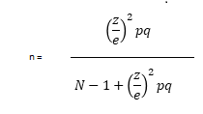
where:
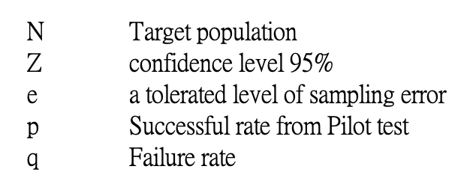

As mentioned in section 3.6, the target population would be more than 6.55million in Hong Kong, based on the construction of formula of determining the sample size above, we could calculate the number of samples would be obtain to support the research as 148 (please refer Appendix 3).

3.10 Data analysis techniques
SPSS version 29 would be used to assess descriptive statistics on the demographic data., the correlation analysis, reliability test, simple linear (SLR) (Zou and Tuncali. and Silverman, 2003) and multiple linear (MLR) regression analysis (Migliorini et al, 2021), independent T-test (Ortiz et al, 2005) and one-way ANOVA test (Kim, 2017) would be used this study.
The independent t-test would be used for comparing two sample means from different people providing scores for each group (Independent t-test, 2023) and this t-test is to determine whether there were different samples from each of the group.
The one-way analysis of variance (ANOVA) is used to compare the means of three group or more groups that are totally independent and satisfy the ordinariness and equal variance assumptions, (Kim, 2017) when each group is paired with another to attempt three paired comparisons. The brief data analysis techniques mentioned above were described in Appendix 4

3.11 Research Method Limitations
For qualitative research methodology for answering the questions, as focus group would focus on the participants whom usually have been using digital payment and shared feedbacks on intention to use the digital payment. However, there might be a problem that the focus group might not reach those who has not had exposure on using digital payment, this would cause “handicapped” that the suggestions from non-users to could not be obtained. Non-probability internet sampling method could be subject to significant biases as a result there might be under coverage and no responding by the potential participants. In fact, not all the people had got internet access, and there would be significant impact that the researcher could not collect the data from those who had got no access of internet. Moreover, it would be a concern that for individuals with lower incomes, less education, living in non-internet covered regions, although this seldom happened in Hong Kong area, might not be considered. There would also be selection bias for non-probability sampling due to that fact that the researcher would choose the individual based on the which type of person that would take part to complete a survey online.
For quantitative method, as the questionnaire had to send to the first layer of participants and not all the participants are active user of the digital communications method, although common communication devices such as WhatsApp or WeChat are seemed widely used nowadays, and there was news reported that fraud cases (Ng, 2023), which made the participants hesitate to take part in responding the questionnaire.
The snowball method used in this research has encountered some limitations. According to Parker and Scott and Gedees (2019), researchers often did not know the characteristics of the target population, making the research difficult to create a probability sample. As a result, snowball sampling would face challenges such as selection bias, lack of external validation, limited generalizability, and low representativeness.
Snowball sampling is a method used by researchers, especially those studying people's behaviours and cultures, where the researches did not aim for the kind of random, widely representative sample that statistical studies might require. Instead, it started with a few contacts that the researcher knew and asked the participants to refer others to join the study. This could make the study biased because this might end up with people who were all similar, like being mostly women or from the same ethnic group. Also, the people who were chosen to start the chain might pick others which participants think would cooperate well with the researcher. Chaim Noy (2008) had pointed out that this could lead to more women in the study because ladies might be more cooperative or less likely to deny to a researcher's request.
The survey will be done using a snowball method to reach more participants. However, participants in the second or third layers may be more careful about joining. The researcher cannot guarantee that participants will pass on the survey to others, and if even have done, the feedback might not happen promptly. This could cause delays in responses.
Limitation also brought to the stage on constructing questionnaire. As feedback from the participants, participants reflected that being exposed to many types of digital payment devices or systems, the participants might have the perception that the questionnaire would specify at certain type of digital payment device or system. This had happened at the pilot test stage. The questionnaire has been then revised with added an index to define “digital payment” included all types of non-cash payment our transactions.
As the questionnaire would be spread to closed colleagues and school mates and then forwarded with snow-ball methodology, there would not be any control on the background of the candidates whom would fill in the questionnaire. Therefore, there would be chance that the demographic factors such as would face a situation that not at a normal distribution, (i.e. left or right skew) and consequently the result might not accurately reflect the general social situation (Romeo, 2020).
Another limitation was that the potential respondents might refuse to fill in the questionnaire forward to the others as there might not be enough assurance of knowing someone who has already done the questionnaire (Lopez and Whitehead, 2012).

3.12 Research Ethics
This research had been maintained the confidentiality and privacy with the information gathered from the interview, and all information obtained would be used only for purpose of conducting this academic research. this research does not reveal personal data and no identifying data is necessary in the interviews, such as name, company, and contact information which were not necessary in the focus group interviews in order to ensure the confidentiality of the information provided by the interviewers.

- Data Description and Analysis

In this Section, the research would come with the result with supporting of information gathered from the participants who was willing to take part in the research. The information would be expressed in different kinds of charts which derived from statistical method in the form of number and information of variables.
The data collected was tested by for correlation and then decided whether there would be relationships between the variables. Cross-tabulation, correlations, factors analysis, independent T-test, one-way ANOVA, regression and reliability test would be applied in this research in order to help in drawing the conclusion of the research.

4.1 Data from the Focus group
A Focus group was conducted by a population or around 9 people which good for the research (Shaw et al, 2023). During the focus group meeting, the most mentioned term was "convenience" more than 20 times. Meanwhile the trust was also mentioned, by the frequency was significantly less than that of convenience, about 10 to 15 times. Trust was mentioned with mutual stand as participants believed that people would not even try to use the digital payment devices or application if the providers were not trustworthy. Privacy was mentioned less than 5 times and when privacy was mentioned, participants had expressed that as those digital payment was applied for payment, the users has unavoidably provided some personal information in order for recognition so that the fund would be delivered to the recipients accurately, and therefore the participants in certain extent has got trust from the digital payment devices or systems. Interestingly, the term of "social influence " was not mentioned during the discussion. Instead, participants would be appeal to use the digital payment devices or the system based on whether the provider would offer the redeem or discount when the participants use the devices or application for payment. And the participants felt satisfied with the digital payment applications or devices they had been using as participants would receive the notifications once the payment was done and thus participant felt comfort towards the security (Krishna et al,2016).

4.2 Data from the final survey
A survey was conducted to find out the influence of C, S, P, T and SI (abbreviation please see Appendix 6) towards peoples’ intention to apply and promote the use of digital payment. A questionnaire was delivered in terms of electronic form (“e-form”) through online communication applications mainly WhatsApp and We Chat and Facebook Message. The e-form was sent to the potential participants by providing a hyperlink. The survey was concluded on 31 January 2024 and a total number of 153 people had taken part in the survey. A total of 153 questionnaires were collected. That is, the respondent rate was 100%., however there were 5 questionnaire were excluded because it was suspected that those participants had filled in the questions randomly and had failed the checking question.
Thus, there were 148 replied questionnaires at the end of survey treated as valid. Among the valid questionnaire all the respondents were 18 years old or above.

Table 4.1: Rate or Response in the Pilot test and in the Final Survey
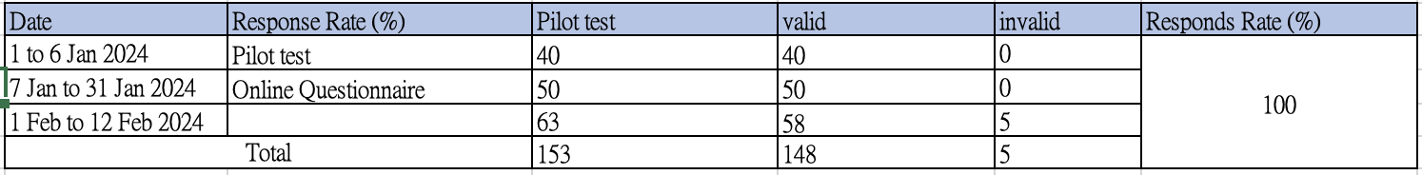
Source: Constructed by the author

4.2.1 Demographic Data Collected
Demographic data collected in different aspects. The collection of demographic data could help in making decisions which relied on the data for the research (Fernandez et al, 2016).
Table 4.2: Overview of Demographic Data collected from 148 questionnaire participants
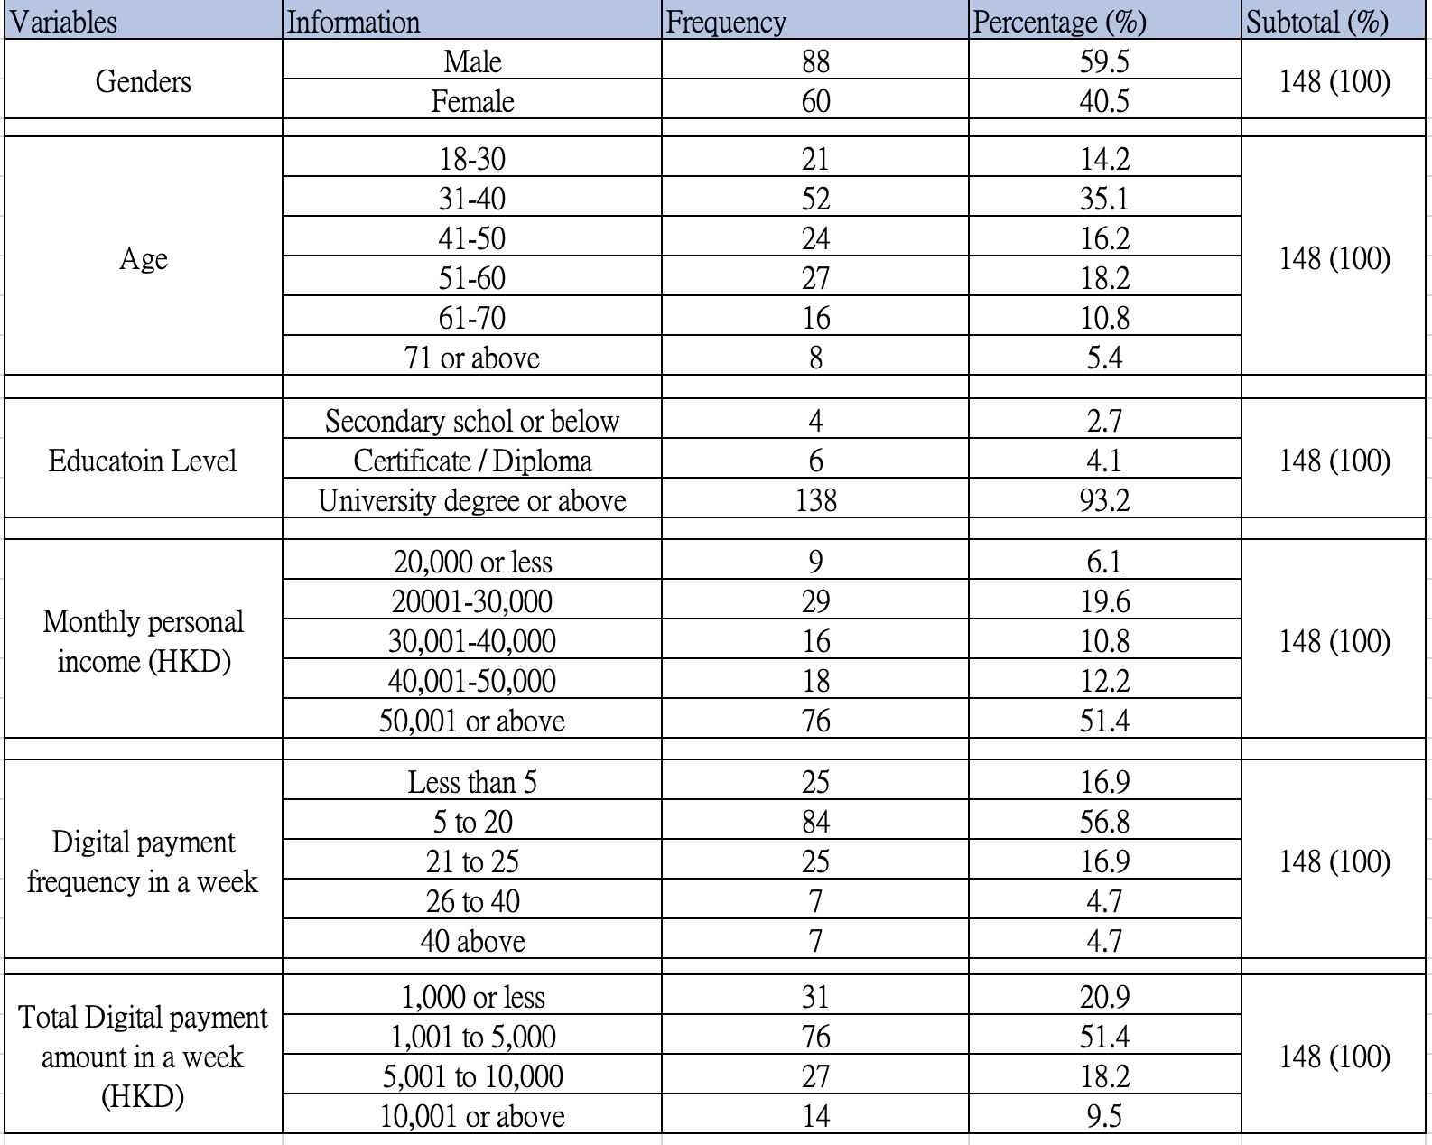
Source: Constructed by the author

4.2.1.1 Gender
Figure 4.1 had shown that the male and female respondents were 59.46% and 40.54% respectively. Both genders had got the close participation as homophilic tendency will exist when male and female were equally represented in the peer-review process of data collection (Helmer et al, 2017).
Figure 4.1: Graph of Participants’ Gender
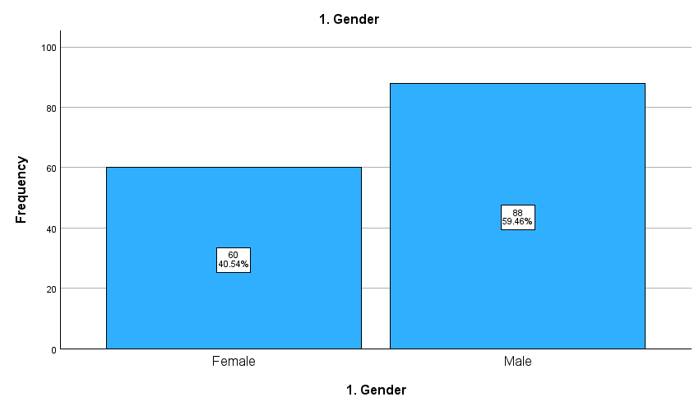
Source: Constructed by the author

4.2.1.2 Age
From figure 4.2, the 148 respondents which were divided into 6 age groups. Meanwhile, the age group between 31- and 40-year-old group occupied the largest portion of the respondents in this questionnaire. This was mainly because the respondent in this age group would agree the digital payment could reduce transaction cost (Nandal, 2021). With 52 respondents or 35.14%, while the least age group was 71 or above which only took 8 respondents or 5.41%.
Figure 4.2: Graph of Participants’ Age
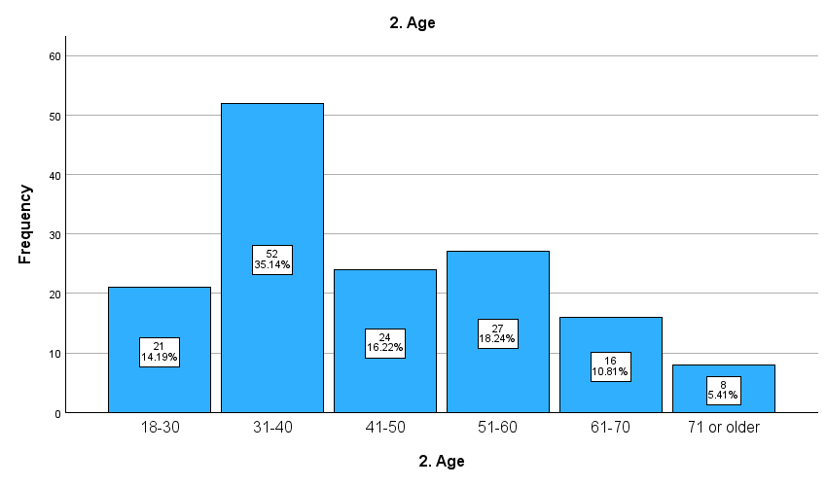 Source: Constructed by the author

4.2.1.3 Education level
The education level in the survey was divided by three levels in Figure 4.3. The group with university degree or above had got the largest number of respondents in the questionnaire and more than 90%, with 138 participants or 93.24%., while the smallest group was the secondary or below, with only 4 participants or 4.63%.
Figure 4.3: Graph of Participants’ Education Level
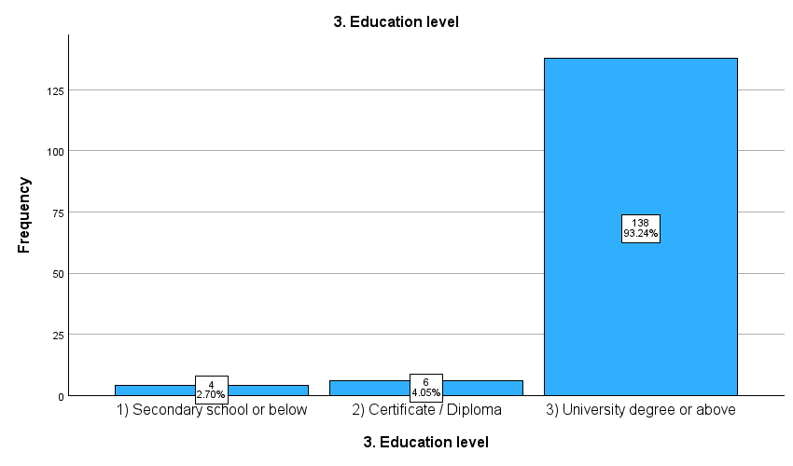
Source: Constructed by the author

4.2.1.4 The Monthly personal income (in HKD)
The Monthly personal income (in HKD) in the survey was divided by five groups in Figure 4.4. The group with 50,001 or above had got the largest number of participants in the questionnaire and more than 50%, with 76 participants or 51.35%., while the smallest group was the 20,000 or below, with only 9 participants or 6.08%.

Figure 4.4: Graph of Participants’ Monthly personal income in HKD
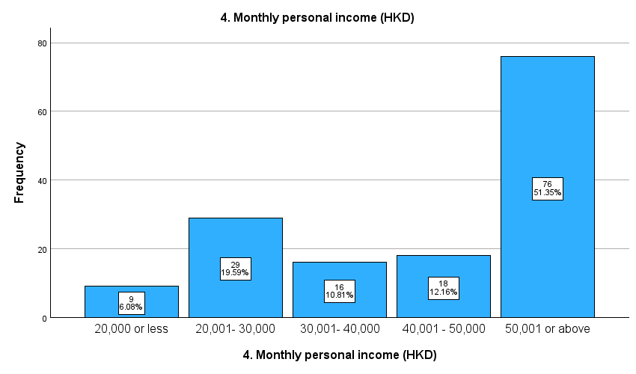
Source: Constructed by the author

4.2.1.5 Digital payment frequency in a week
The usage of Digital payment frequency in a week in average in the survey was also divided by five groups in Figure 4.5. The group between 5 and 20 times had got the largest number of participants in the questionnaire and more than 50%, with 84 participants or 56.76%., while the smallest group was consisting of the groups between 26 and 40 and 40 above, with only each of the group 7 participants or 4.73%.
Figure 4.5: Graph of Participants’ usage of digital payment frequency in a week
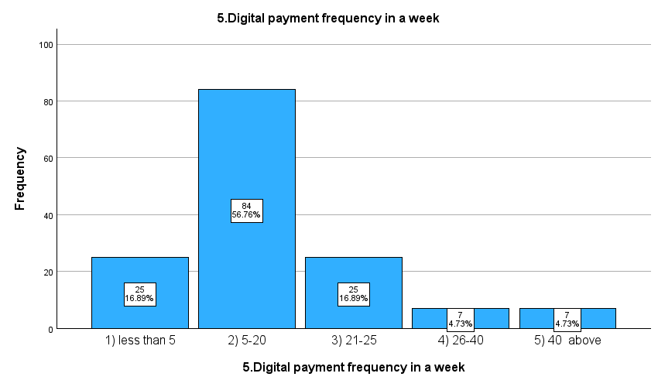
Source: Constructed by the author

4.2.1.6 Total digital payment amount in a week in HKD
The total digital payment amount in a week in average (in HKD) in the survey was divided by four groups in Figure 4.6. Meanwhile, the group between 1,001 and 5,000 had got the largest number of participants in the questionnaire and more than 50%, with 76 participants or 51.35%., while the smallest group was the group with amount 10,001 or above, with only 14 participants or 9.46%.

Figure 4.6: Graph of Participants’ total digital payment amount in a week (HKD)
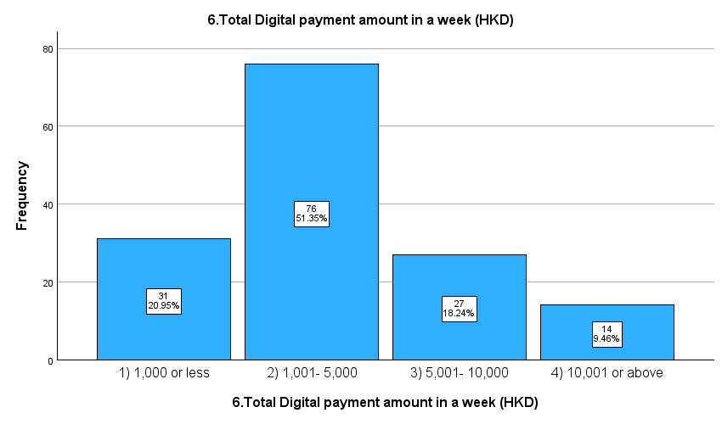
Source: Constructed by the author

4.2.1.7 Summary of demographic data
The survey has got 148 valid responses of this questionnaire. The number of males was more than that of the female but the difference was not very significant., and the largest age group was between 31 and 40 years old (35.14%). For the education level, more than 90% of the respondents had got a university degree or above (93.24%), and for monthly personal income in terms of HKD, the largest group was 50,001 or above. There was more than 50% of respondents had been using digital payment in a week of 5 to 20 times (56.76%), and for the total digital payment amount involved in a week in HKD, more than half of the respondents fell between 1,001 and 5,000.

4.3 Cross Tabulation of Demographic Factors with Intention to use digital payment
The use of cross tabulations of variables could help in research analysis for data collected. The characteristics of each kindly of data collected in the questionnaire might be tabulated in a contingency table in order to express the frequency of co-occurrence of the independent features of each variable, as labeled by the rows, columns, and other layers of the cross tabulation.

4.3.1 Intention to use digital payment in future and gender
From figure 4.7 and table 4.3, 73.7% of 148 valid respondents in total had agreed that would like to use digital payment in future. Meanwhile, male and female are of high proportion of agreement that male had got 62 respondents or 70.05% while female had got 47 respondents or 78.3%. Therefore, this could draw a conclusion that both male and female would like to apply digital payment as one of the payment methods in future. it is interest that the number of percentage of women which would use digital payment in future was higher than that of the male. This might be due to women had been the major population in online shopping as female has been spending more time online (Barasi et al, 2022).

Figure 4.7: Intention to use digital payment in future (INT 16) and gender
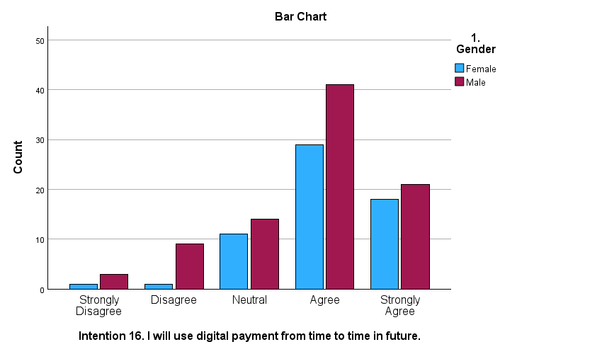
Source: constructed by author

Table 4.3: Factor for Gender and INT16
Source: constructed by author

4.3.2 Intention to use digital payment in future and education levels
From figure 4.8 and table 4.4, 73.7% respondents whom had got a university degree level agreed to apply digital payment in future, while there were 50% of respondents whom had got academic level upto certificate or diploma, and 78.3% of those whom had got education level at secondary school or less would agree to use digital payment in future. It seemed all the education level had got at least half of its population agreed to use digital payment future, However, there was an interesting outcome that, in this survey, there were 138 out of 148 or 93.24% of the samples were those whom had got a university degree or above, this might due to the fact that the sampling bias could exist to sabotage the external validity of a study and limit the generalizability of its findings. This happened when researchers conducted surveys, only a single data collection format would be applied in consideration of cost or other survey delivery feasibility (Chen et al, 2022). Apparently, using a single survey format could also jointly apply with other survey methods to “balance” such bias, but on the other hand, a survey in only one format applied could also provoke sampling bias, resulting from other issues such as internet accessibility, mobile phone ownership by a single person, internet service interruption, and respondents’ personal abilities such as optical difficulties.

Figure 4.8: Intention to use digital payment in future (INT 16) and Education level
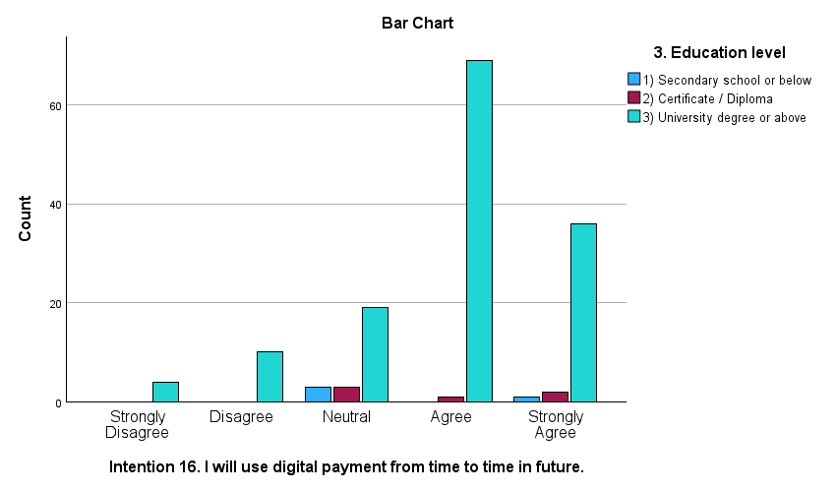
Source: constructed by author

Table 4.4: Intention to use digital payment in future (INT16) and Education level
Source: constructed by author

4.4 Each factor’s highest and lowest averages
Figure 4.9 had reflected the average rating of each of factor and the maximum and the minimum values. It is noticed that almost all the factors had got the minimum value more than 3 except the “P” which was 2.53. The results had shown that almost all the factors in relation to determine the intention to use digital payment were agreed by the respondents except the P. This also meant that for the respondents’ reply obtained, privacy was not considered as a factor which determine the intention to use digital payment.

Figure 4.9: Each factor’s highest and lowest averages
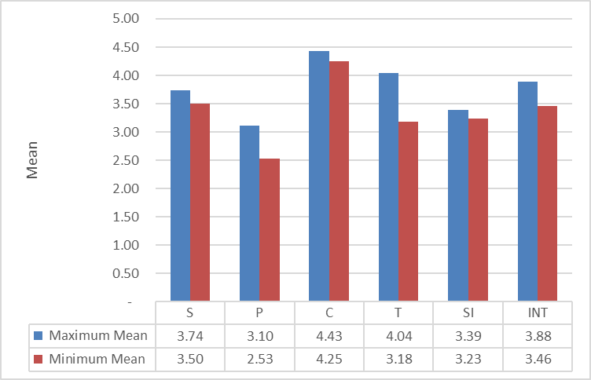
Source: constructed by the author

Table 4.5: Description of maximum and minimum mean of factors
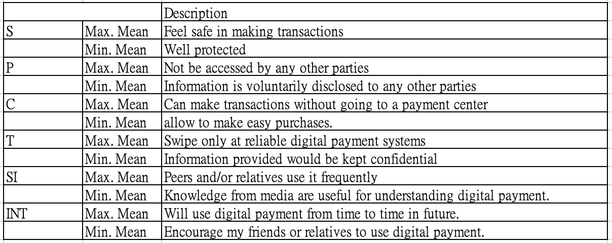
Source: constructed by author

4.5 Reliability Test
Cronbach's alpha was a means to check the consistency of a measurement method for assisting to determine how reliable of the test. (Pinto and Fogliatto and Qannari, 2014). and reliability test is used to check whether the test was accurate, consistent and not fluctuating (Akeem, 2015).
The Cronbach's alpha coefficient of the 18 elements of the questionnaire reached 0.927 (table 4.6). This value had exceeded the predefined minimum of 0.7 (table 4.6). signifying a very high level of reliability.

Table 4.6: for Cronbach’s Alpha or the research and other research (n=148)
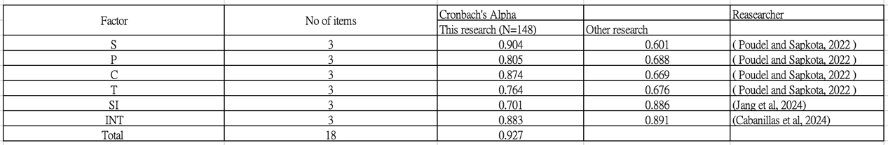
Source: constructed by author

4.6 Factor analysis
Kaiser-Meyer-Olkin (KMO) and Bartlett test were widely used as analytical means to access whether the factors were suitable and valid for the research (Silva et al, 2014). In general, KMO method was applied to check if the data collected was suitable for factor analysis (Tavan et al, 2016), Bartlett test was applied in order to prove if there was sufficient correlation between the variables (Shrestha, 2021).
The result of KMO test was between 0 and 1. When the result was close to 1, it signified that the higher of correlation and the variables of factors would be more reliable. For categorizing whether the variables as "reliable", the KMO value should fell on 0.7 or more, and if the KMO value fell on below 0.5, the variables would be treated as not reliable and researcher may have to re-conduct the test again (Shrestha, 2021).
According to the table 4.7, the KMO matrix value of the study was 0.895, which was treat as reliable and locate as meritorious zone (Djouhina, 2022), therefore factor analysis was to suitable means for this research.

Table 4.7: KMO Model and Bartlett’s Test
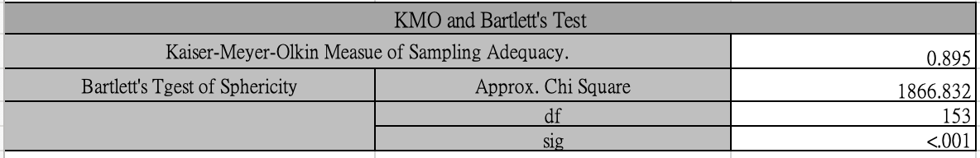
Source: Constructed by author
The eigenvalues of the comments in table 4.8 were greater than one which provided strong quantitative evidence for the reliability (Hayton and Allen and Scarpello, 2004). Under normal situation, the cumulative percentage had proved that the survey has got an organized variables arrangement or data set and eventually could explain the different performance of data collected.

Table 4.8: Total Variance Explained
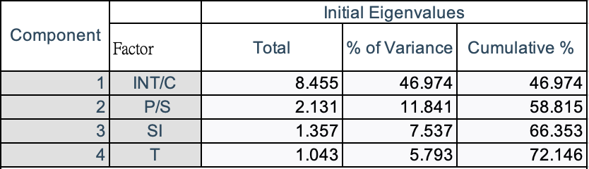
Source: constructed by author

Figure 4.10: Screen plot for Eigenvalues
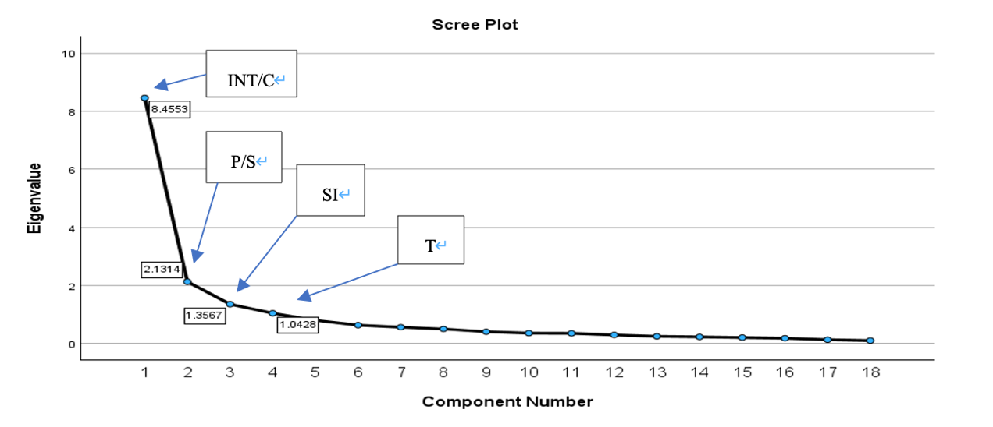
Source: constructed by the author

From the table 4.8 and figure 4.10, the eigenvalues are greater than one and the cumulative percentage of the eigenvalues expressed more than 72.146% which was an ideal value and this would be more valuable to the research (Suhr, 2005). The six factors were consisting of 4 components and the eigenvalues were 8.4553, 2.1314 1.3567 and 1.0428 respectively.
The scree plot had become horizontal after the fourth component was observed., nevertheless, the eigenvalues were greater than one, as such all the factors were important. This research methodology focused on INT/C, P/S, SI and T as key constituents.

4.7 Correlation Analysis
The correlation test was used to examine if there would be any relationship between two variables, no matter positive or negative. When the correlation coefficient lined close to either positive one or negative one, this would prove that there would be perfect positive and negative relationship respectively., while if the coefficient fell on or very close to zero, the relationship between the two assigned variables were very loose. (Obilor and Amadi, 2018).
In addition, correlation coefficients within the range that lower that 0.4, which the vector was neglected, represented there was low relationship of the two assigned variables, while the correlation coefficients fell between 0.4 and 0.6, the relationship
would be treated as medium magnitude and when the correlation coefficients fell on 0.6 or higher, the relationship would be high. (Obilor and Amadi, 2018).
Table 4.9 below had shown the range of each of the correlation coefficient fell between 0.4 and 0.8 at the 99% confidence level, signified that all the pairs of variables were on the fairly acceptable level of the relationships. Most of the correlation coefficients were higher than the other research, in fact both the correlation coefficients of the researches were more or less the same. The highest correlation value was between S and T (r=0.778, p<0.001).

Table 4.9: The range of each of the correlation coefficient
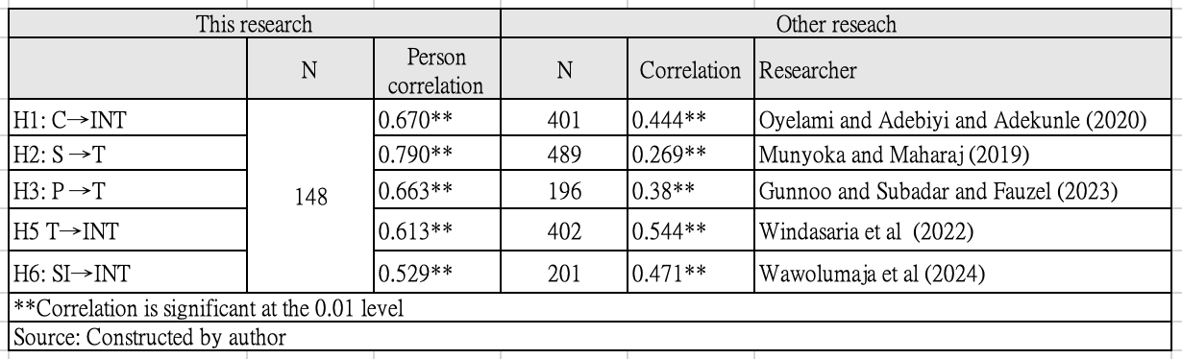

4.8 Regression Model
There were normally two regression analytical method namely simple linear regression (“SLR”) and multiple linear regression (“MLR”). Both of the methods serve different functions. SLR was applied to examine the linear relationship between two variables (Pedersen et al, 2022). On the other hand, MLR was applied instead of SLR when the research had been involved many variables and implies that there would be many independent variables which would jointly affect the dependent variables and therefore a model was required to be built for analysis. For this research, MLR would be applied.

Table 4.10: Model Summary and ANOVA of Dependent Variables
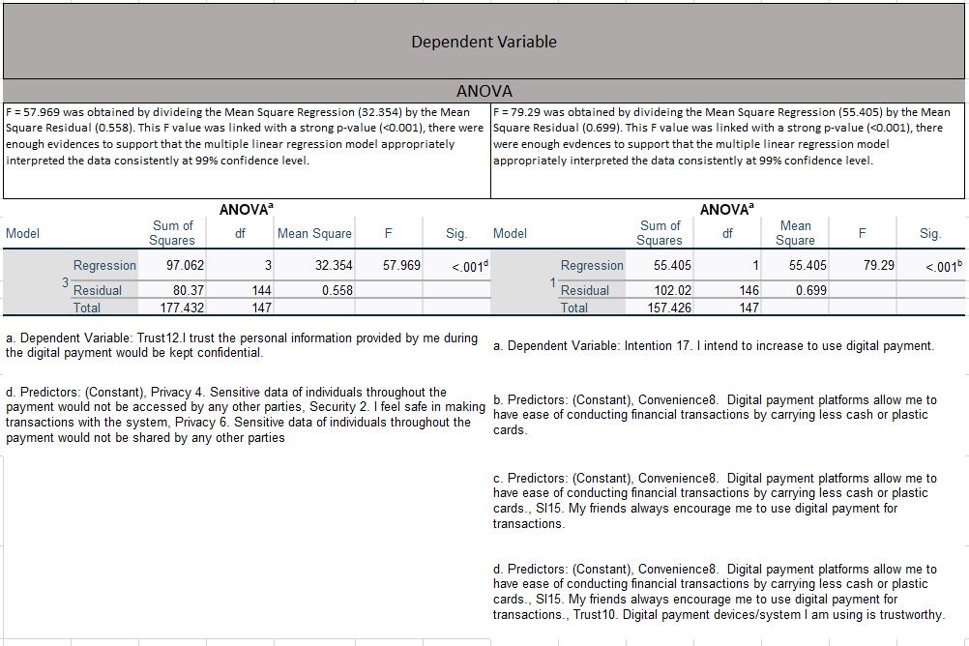
Source: Constructed by author

Table 4.11: Coefficients of Dependent Variables
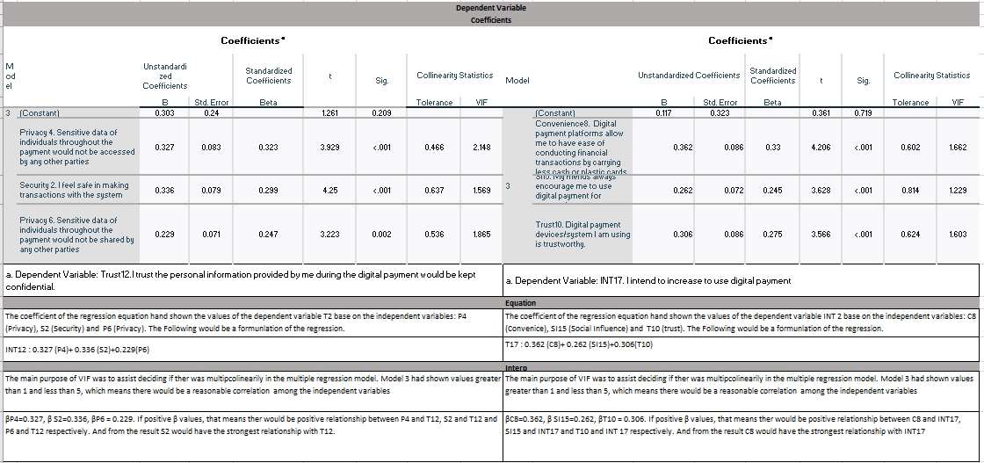
Source: Constructed by author

Table 4.12: Histogram and Scatter Plot of Dependent Variable
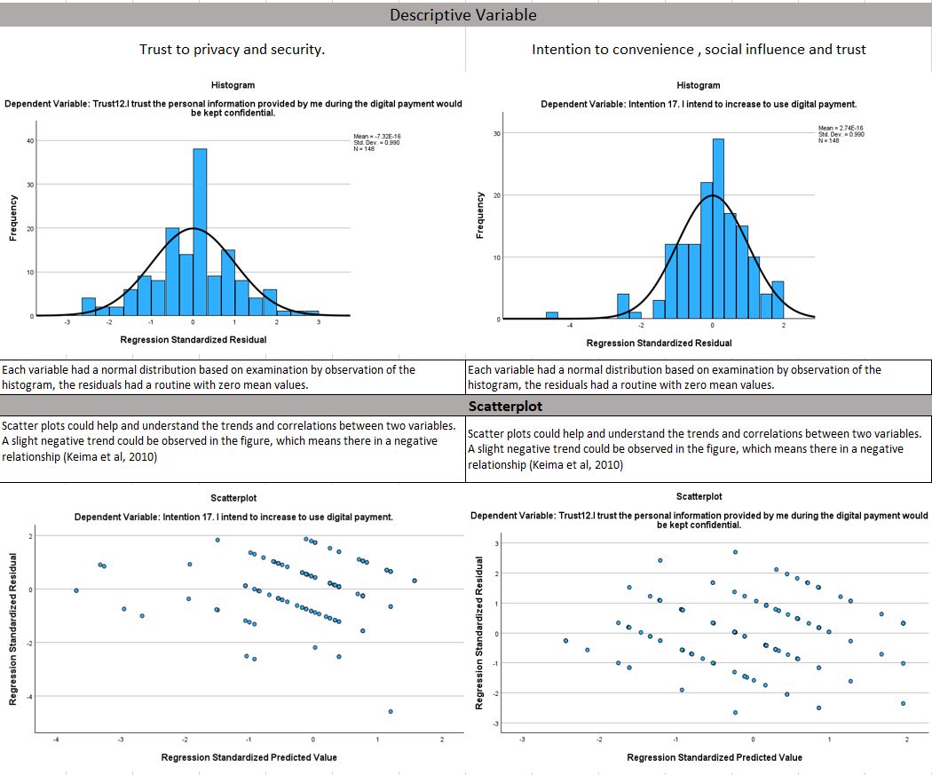
Source: Constructed by the author
Therefore, the histogram and the scatter plot from the table 4.12 had effectively solved this situation and had shown that the MLR model was suitable for the research.

4.9 Independent t-test
The use of independent t test was to make a comparison between the means of two independent samples to see whether there would be a difference and how different between the independent samples (Archie 1985). This research was conducted to with independent t-test to reflect the difference between INT under genders.

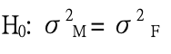
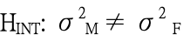

To test whether the proportion and destribution of males and females, independent t-test was thus applied. Also, Levene’s equation test was also applied. To achieve the purpose of comparison of variations in relation to the proportion among different groups and variation in the group itself in a single criterion of classification (Chan and Walmsley, 1997), F test would be applied. In order to determine which, one would be the denominator and nominator, the degrees of freedom were required to be calculated and the F vale would be computed as shown in Table 4.13
Table 4.13 Formula of F Test Statistic
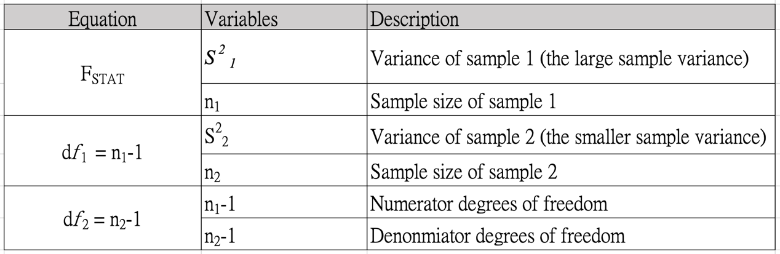
Source: constructed by author

Table 4.14 has shown the outcome of the sample means, the sample means of the male and female was very close that the female group had got then mean of Intention 16 score was 4.03 while the male group has got the score of 3.77. P-value was 0.043 which was less than 0.05 significant level, therefore the null hypothesis should be rejected. Therefore, male and female group were not equal variance.
p-value of t-test was 0.048 which less 0.05 significance level, so the null hypothesis had got different means of the two groups in intention to use digital payment would be rejected. Mean difference was -0.261 which the mean of intention to use for male was less than that of the female.

Table 4.14 Group Statistics for Independent test
Source: Constructed by the author

Table 4.15: Independent Sample Test
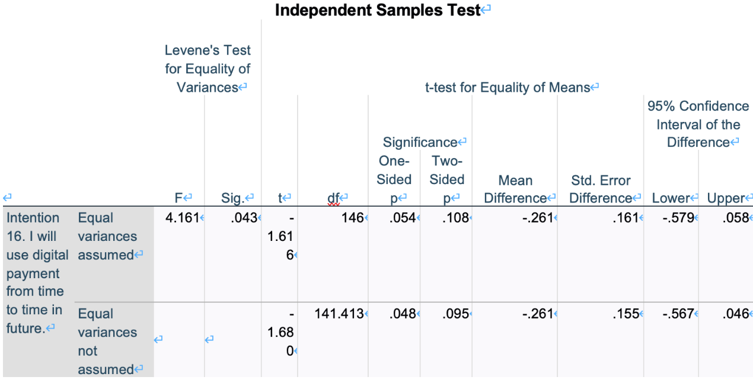
Source: Constructed by author

4.10 One-way Analysis of Variance
The one-way analysis of variance (ANOVA) would be applied for comparing the means of three group or more groups that are independent and satisfy the ordinariness and equal variance assumptions, when each group was paired up with one another to attempt three paired comparisons (Kim, 2017)

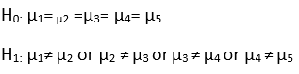
Source: constructed by author

4.10.1 One-way ANOVA for frequency of usage of digital payment in a week.
From table 4.15, it had shown the INT18 for different groups of people whom conduct a range of frequencies digit payment in a week, namely less 5 times, 5 to 20 times, 21-25 times, 26-40 times and 40 times or more. The table included the mean, standard deviation, and 95% confidence interval for the dependent variable. From table 4.15 the respondents in all groups would be encouraged by friends and relatives to use digital payment, with a total mean at 3.46.

Table 4.15: Descriptive table for frequency of usage of digital payment in a week.
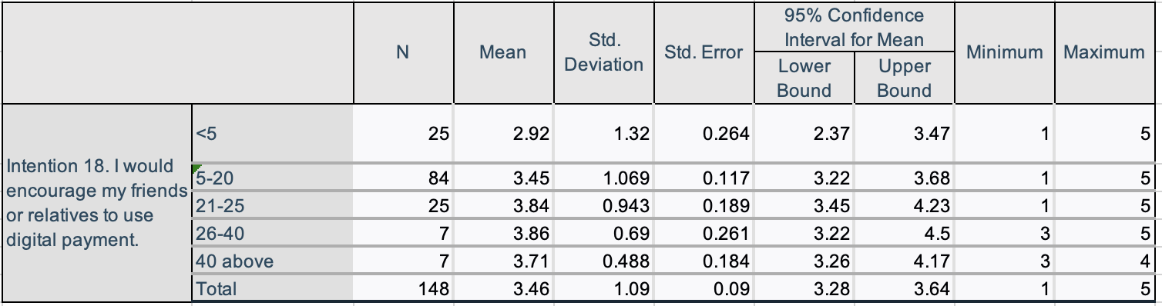
Source: constructed by author

Table 4.16 had shown the ANOVA analysis results and whether there was a statistical difference among different groups of respondents. The statistical difference was that the p-value would be less that 0.031, which was less than the significant level of 0.05. The one-way ANOVA analysis of variation test was thus valid at the 95% confidence level (Hemati and Lexian, 2023).

Table 4.16: ANOVA Table for frequency of usage of digital payment in a week.
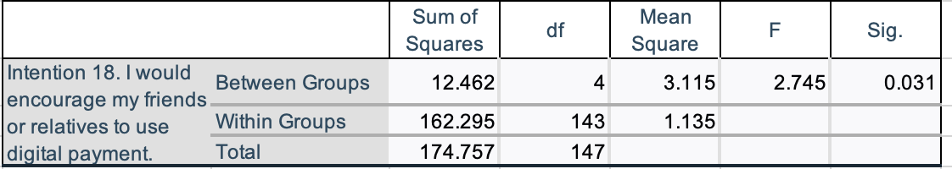
Source: constructed by author
Once the ANOVA analysis outcome was that the significant, there would be significant differences in means among groups. Bonferroni correction was widely used by the researchers as Bonferroni correction was a conventional methodology for comparison., another method for comparison was Sidak correction which was quite similar to the Bonferroni correction (Lesack, and Naugle, 2011). Tukey’s HSD would be applied in this research for comparison in pairs of differences among all age groups and compute the confidence intervals and eventually decide which levels of difference among the age groups are the most significant (Nanda et al, 2021).
Table 4.17 had reflected the differences among each group of frequency using digital payment in week, showing that there was statistically significance difference in the mean of INT18 of between 21 - 25 times and that < 5 times in a week (MD=0.920, p<0.05). From the results, the average INT of this frequency group was lower than the others.

Table 4.17 Multiple Comparison of different frequency of usage of digital payment in a week
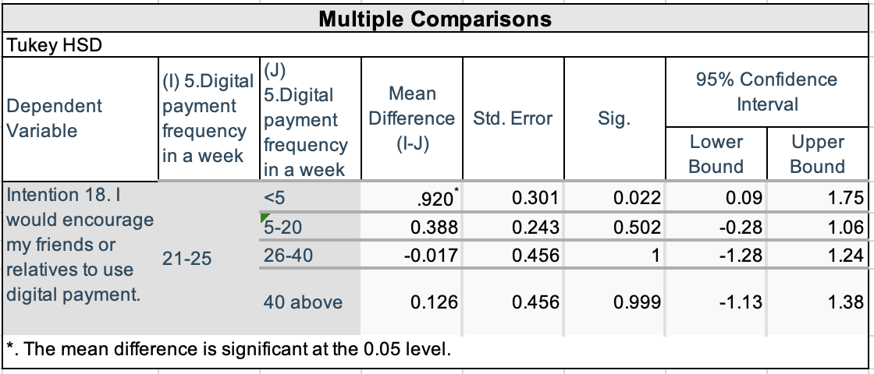
Source: Constructed by author
Figure 4.11 Mean plot of Intention to use digital payment in different age group

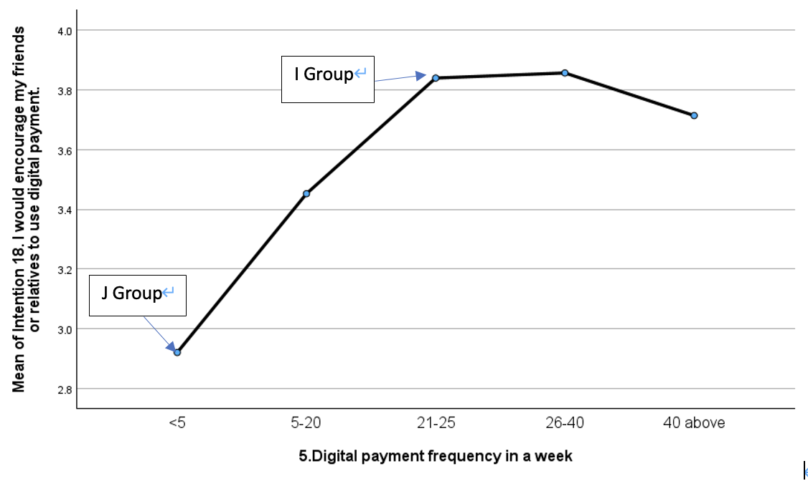
Source: constructed by author

4.11 Summary of the Research findings
The figure 4.12 and table 4.18 shown below had reflected the correlation coefficient (r) and R- squared (R2) from the regression analysis.

Figure 4.12 Explanation of Correlation Coefficient (r) and R-squared (R2)
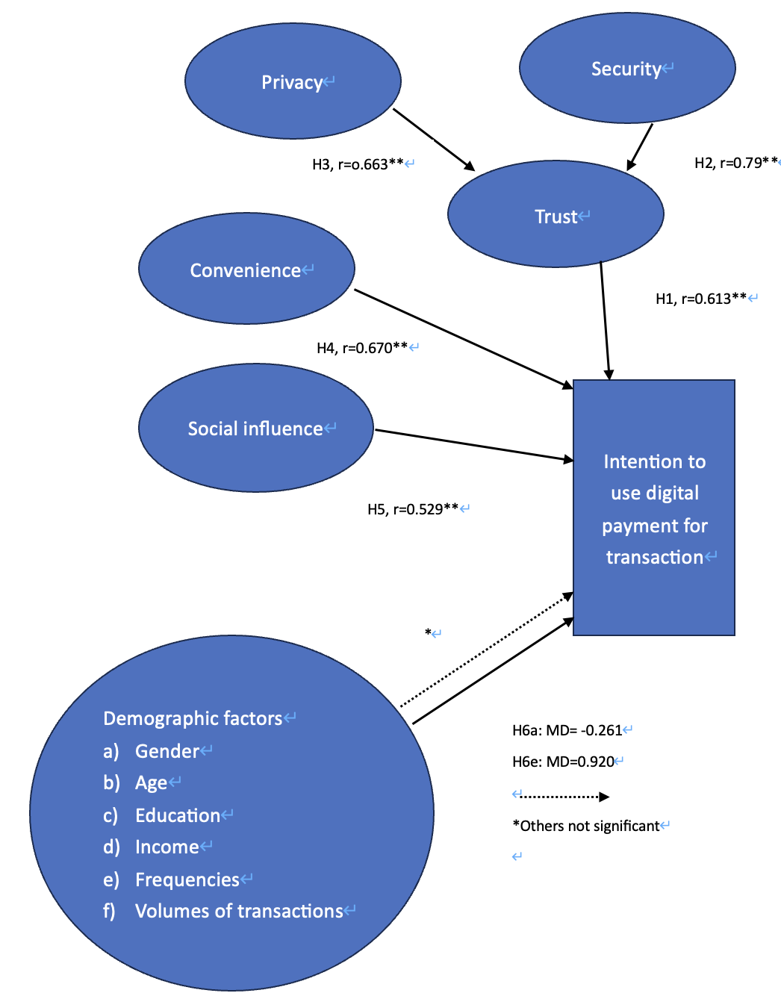
Source: Constructed by author

The Pearson correlation coefficient was computed to show if there was linear correlation and how strong the linear correlation between two factors. Meanwhile complete positive would be shown as 1 while complete negative would be shown as
-1 (Ratner, 2009).

Table 4.18, Summary of the research findings regarding the proposed hypothesis
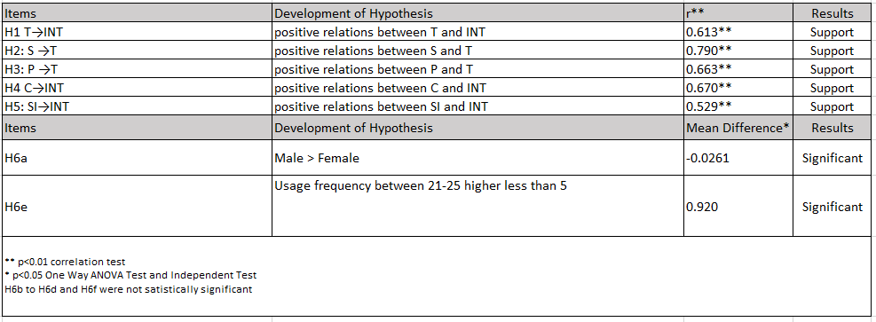
Source: Constructed by author
In summary, table 4.18 had shown that the impact of H2 and S to T was very significant with an r value of 0.790**. The impact of H1 and C to INT was quite obvious, with r value at 0.670**.

- Conclusion and recommendation

Digital payments exist in many different forms in Hong Kong included but not limited to Online shopping, applications in smartphones like PayMe, Ali Pay, WeChat Pay., credit cards with either PayWave or connect to e-wallet like Apple Pay or Samsung Pay, and Hong Kong’s unique invention Octopus card or its e-card.

5.1 Conclusion
In this research, the main goal was to find out what factors would be the majority for people in Hong Kong affecting the intention to use the digital payment. Various of factors including S, T, P, C, SI and INT, together with demographic factors for assessment using different methodology and explained by theories. The research was conducted by a focus group or 9 people, which was good enough to represent the opinion on for the research (Shaw et al, 2023) and had distributed questionnaire in electronic medium such as communication application on smartphone like WhatsApp and WeChat which were very common communication methodology in Hong Kong (Guo et al, 2022). This research was aimed to investigate the factors affecting the intention to use digital payment and how to enhance the coverage of digital payment. Snowball (Parker and Scott and Gedees, 2019) methodology was applied to pick up 148 respondents randomly responded the e-questionnaire. The questionnaire was consisting of five demographic factors, namely genders, ages, education levels, monthly income in Hong Kong dollars, the number of transactions completed by digital payment method in a week and the value of transactions done by digital payment in Hong Kong Dollars.
Among the genders, there were slightly more male than female, of 59.46% and 40.54% respectively; among age groups, the age range between 31 and 40 years old is the largest age group which took up 52 respondents or 35.14% of the total respondents; for education level, there were 93.24% or 138 respondents had got a university degree or above, this result was correspondent to other research (Chaveesuk and Chaiyasoonthorn, 2021) that the higher the education level, the higher the rate the one use or would use digital payment method.
For personal monthly income in Hong Kong dollar for the respondents, there were 51.35% or 76 respondents whom have been earning a monthly income at HKD50,001 or more which was categorized as highest population group would tend to or keep using non-cash payment such as credit cards, or the same features in digital payment version (Aurazo and Vega, 2021) than that got the education level lower than the undergraduates.
For total digital payment amount in a week in Hong Kong dollars, there was an interesting result that the largest group was spending between 1,001 and 5,000 the number of respondents in this group was the same as the group earning 50,001 or more, that was 76 respondents or 51.35% of the total respondents.
The mixture of quantitative and qualitative method was applied in triangulation (Hussein, 2009) in order to collect quantitative data from people in Hong Kong by both interview and surveys. After that the thematic analysis and regression and information analysis would be conducted in the research. For factor analysis, which was shown in table 4.8, a cumulative variation of 72.146% for the eigenvalues; with factors INT and C equals to 8.455, P and S equals to 2.131, SI equals to 1.357, T equals to 1.043. From the results of the eigenvalue of all the factors were more than 1, all the factors were thus of strong correlated to the intention to use digital payment (Zopluoglu and Davenport Jr, 2017).
In this research, it was noticed that the C was the factor which would affect the intention to use digital payment by the respondents, followed by the T towards the digital payment method. The T was also derived from the results of the S and P, although the minimum mean of P was 2.53 which less than 3.
In this research, the results had reflected that the INT17 would be greatly by the C8 and SI15 and last but not least T10 as the r value of INT17 was 0.683 which had showed strong relationship., besides the T12 would also be greatly affected by various independent variables mainly P4, P6 and last but not least S2 as the r value of T12 was 0.74 which had shown strong relationship of the independent factors and the T12.
The results of the research could provide a through insight of factors causing higher intention to use digital payment method. Therefore, strategies or measures could be designed and developed in order to advice the government, regulators and the digital payment providers as well as the virtual financial institutions for promoting more usage of digital payment to the general publics.

5.2 Recommendations
In order to response to the research question, it was noticed that C, T and SI would be critical to the INT, meanwhile P and S would also contribute to the T and consequently supporting the INT.
In application of digital payment could both benefit to the users and could also cause drawbacks to the users. People in the past making transactions or payments upon purchasing or transfer funds to one another and involving traditional means such as transferring at the counter, cheque payment or by credit card but the merchants would have to hand in the payment slip to the credit card center for processing fund transfer, such transactions usually restricted by the banking hours or banking days. With digital payment system or applications, people did not need to conduct payment or transactions within the banking days or banking hours, those people could make the payments at non-banking hours or even in the public holiday period. Such means of payments would be convenient to users especially for those who were usually very busy in their own work and did not have time to go to the bank for making payment or transactions. But a coin has got both sides, when a digital payment was conducted, for verification reason, usually the digital payment devices would request the user to provide the personal information, for more advanced system, password or one-time password would be sent to the user for confirming the transaction. This would provoke securities and privacy issue as usually the users need to memorize many different passwords for different digital payment devices, loss of passwords would be highly possible as sometimes user might forget the password for particular device, of course the user could use the solution provided by the suppliers to reset the new password, but this could make it inconvenience which again the original ideal of promoting digital payment. And when the user did not find it easy to handle the use of digital payment, the users might lose confidence to the device and the magnitude of trust towards digital payment would not be as high as expected.
For demographic factors, all genders and age ranges has got experience using digital payment, and 73.7% of total number of respondents would use digital payment from time to time ( table 4.8) in section 4.3.2, however, for there were also 76.1% of the respondent who has got an undergraduate degree or higher academic qualification would use digital payment from time to time, it seemed the higher the education level, the higher the intention to use digital payment, but there might be a discrepancy that the number of respondent which has got undergraduate degree or higher was 93.24% of the total number of respondents, although the researcher might not know the education background of the respondents, this might not fully understand what would be the opinion from those whom has got certificate or diploma and secondary school level or below.

5.2.1 Theoretical implications
The theoretical implication of this research was to conducting an in-depth investigation to understand what would be the actual factors that affecting the intention of usage of digital payment in Hong Kong from different angles such as genders, ages, education levels, income levels, usage experience and involved amounts. The intention might also be affected by the current regulation or law; therefore, the support of government and monetary authority would be crucial for further improve the coverage of digital payment.
When people conducted transactions with digital payment, there would be a series issues including privacy, security, convenience, trustworthiness, social influence which would affect the intention to use or continue to apply digital payment in future. This paper could assist the authorities to establish a supporting environment legally to build up a safe and efficient payment system environment (Malaguti, 2015).

5.2.2 Practical Implications
Improving intention to use digital payment methods, businesses and organizations could make the people more willing to use digital payment. However, as financial transactions have been highly regulated by the local governments and monetary authorities, therefore the best way to implement strategies should be kicked started by the government agencies. The following strategic measures could be done:

5.2.2.1 Collaborate with Partners could bring up the social influence
Increase awareness consumers about the benefits of digital payment methods through marketing campaigns such as providing significant refunding or discounting scheme by the government monetary authorities (Hameed et al, 2024). In the past, it was not common to noticed that digital payment providers would take lead to offer discounts or refund to the users in short term, but this would cause a huge financial burden to the providers and those providers would be very hesitate to offer the benefits to the users or customers. The forementioned issue could be solved by collaborating with partners like banks, non- bank financial institutions, and other digital payment providers to expand the acceptance of digital payment methods. Also, collaborating with retailers, merchants, and service providers to promote digital payments and create a seamless payment environment for customers. If the government could take lead, through social media and informational materials, the security features, convenience features, and potential rewards or discounts associated with digital payments could also be promoted the users so that security, convenience of digital payment could be instilled to the general public and eventually increase the social influence (Kaur et al 2020).
The Government authorities could co-operate with the providers to kick start a campaign offering incentives such as fiscal incentives (Allen et al ,2022) like refunding, discounts, loyalty points scheme, or exclusive deals for using digital payment methods in order to encourage people to apply more digital payment method on the daily transactions or purchase. Shops and digital payment providers could implement promotions and special offers that are exclusive to digital payment users to stimulate customers’ purchasing intention in the society to use digital payment for purchasing (Tan and Pangemanan and Saerang, 2021).

5.2.2.2 Improving Security and Privacy Measures
Since it was common to hear that usually both security and privacy were heard at the same time when discussing digital payment either in terms of trustworthiness or the terminology itself in the focus group, therefore, digital payment providers could enhance security measures on one hand by addressing concerns about security and privacy by implementing stronger security measures (Ferrari, 2022) such as encryption, two-factor authentication (Zarco, 2024), and fraud detection systems (Karthikeyan and Govindarajan and Vijayakumar, 2023) to identify whether there were suspected online payments. Eventually the measures mentioned above could enable the customers that the financial information was safe and well protected when conducting digital payment.

5.2.2.3 Improve User Experience by Enhancing the Convenience
Users’ experience of using digital payment platforms could be improved so that users would more willing to use digital payment for transactions because ease of access could be the contribution point of convenience to customers. This could be achieved by creating the seamless, spontaneous, and user-friendly platform (Daggubati, 2024), and Simplified process for registration and payment, provide clear instructions, and offer multiple payment options to cater to different preferences.

5.2.2.4 Provide Customer Support so that to increase the trust of digital payment of users:
From the focus group, it was common to hear that when the users got problems on process the registration and/or processing transaction, there was little customer support services for the users. Therefore, providing reliable customer support services to help the users for any issues or questions related to digital payments.
Ghrbeia, (2020) suggested that in order to improve services to customer experience, the digital payment companies could support by providing a range of Web-based resources, including but limited to customized applications, chatbots, e-mail, automated responding., for non-Web based resources, the providers could expand the help desks and call centers for those users who would like to have humanized interactions. Once such service reach or exceeds customers’ expectations, the relationship between the customer and the providers could improve and the trust would be strengthened in this way.
Moreover, Trustworthiness of digital payment could be built up by the users through enhance the transparency with fees, terms and conditions, and data privacy policies related to digital payments clearly communicated by documentation with platform that easily accessed by the users (Katz, 2012). Also, benefits and risks of using digital payment methods were clearly communicated with the users in order to create trustworthiness with customers.

5.2.2.5 Demographic Factors
According to the survey, all genders has ever used digital payments methods for fund transactions. It was discovered that the age group between 31 to 40 would have the intention to encourage people around him or her to user digital payment, this was due to the fact that the respondents in that age group thought that the transaction cost of using digital payment would be cheaper (Nandal, 2021). For genders, although the nominal number or male respondents is more than that of female (male 88 and female 60 respectively), meanwhile there was 78.3% of respondents in female group and 70.5% respondents in male group would have intention to use digital payment frequently in future. Although it seemed and convenience which affected the intention to use digital payment was stronger in male than that in female, both the proportion of intention among male and female did not have big difference.

5.3 Limitations
There might be the following limitations regarding the research of intention of using digital payment
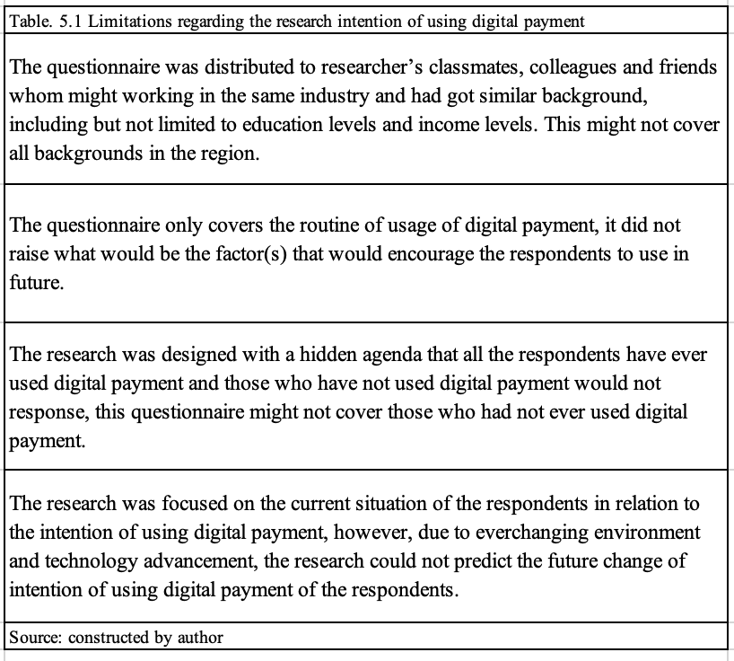
In general, this research was based on the results of data of questionnaire as well as focus group and a total number of 148 valid respondents and 9 participants consist of the focus group. There may be obstacle that due difficulties in controlling or monitoring the backgrounds of the respondents such as education level and income levels., also, the intention of those who did not have experience in using digital payment was not recorded and the research might just have got the data from those who have been using digital payment.

5.4 Suggestion for future research
This research had spotted C, S, P, T, SI and INT as crucial elements for intention to use digital payment and meanwhile P and S would be determinants for T. The following areas would be the recommended for future research:

Table 5.2 Highlight of future research
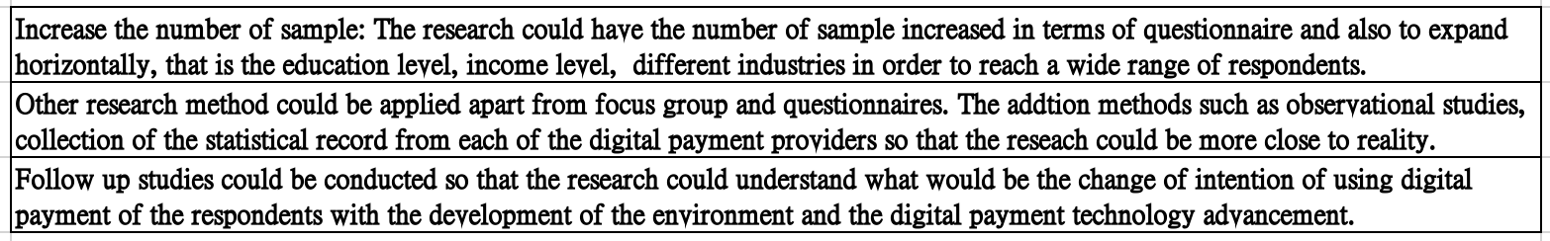
Source: constructed by author

5.5 Summary
Digital payment has been common since the beginning of the 21st century and on 3 April 2024, the Netherlands-based fintech company Adyen has announced that there would acquire the mobile payment service provider PayMe by HSBC in Hong Kong, signified that the value and importance of the digital payment in Hong Kong and attracted investors.

Reference:
Aguilar J. and Valencia M. and Vera R (2020), Forecast generation model of municipal solid waste using multiple linear regression, available at https://www.gjesm.net/article_36862_3e3b953800d1617d039d3a3dc4d1d447.pdf Accessed 1 April 2024

Ahnert T. and Hoffmann P. and Monnet C. (2022), The digital economy, privacy, and CBDC, Working Paper Series, European Central Bank, available at https://dx.doi.org/10.2139/ssrn.4109696 Accessed 11 December 2023

Aigbe P. and Akpojaro J. (2014), Analysis of Security Issues in Electronic Payment
Systems, available at https://scholar.googleusercontent.com/scholar?q=cache:vDeV44EmRaYJ:scholar.google.com/&hl=zh-TW&as_sdt=0,5
Accessed 17 December 2023

Akeem (2015), Principles and Methods of Validity and Reliability Testing of Questionnaires Used in Social and Health Science Researches, https://10.4103/1117-1936.173959 Accessed 18 March 2024

Akanfe O. and Valecha R. and Rao H. (2020), Assessing country-level privacy risk for digital payment systems, available at https://doi.org/10.1016/j.cose.2020.102065 Accessed 17 December 2023

Al-Dala’in T. and Luo S. and Summons P. (2008), A REVIEW OF CURRENT ONLINE PAYMENT SYSTEMS RELATED TO SECURITY AND TRUST SOLUTIONS, available at https://scholar.googleusercontent.com/scholar?q=cache:pbzxhXtT-PQJ:scholar.google.com/+security+relate+to+trust+digital+payment&hl=zh-TW&as_sdt=0,5 Accessed 17 December 2023

Alfany Z and Saufi A. and Mulyono L. (2019), The Impact of Social Influence, Self-Efficacy, Perceived Enjoyment, and Individual Mobility on Attitude toward use
and Intention to use Mobile Payment of OVO, available at https://d1wqtxts1xzle7.cloudfront.net/76949115/2852-libre.pdf?1640090642=&response-content-disposition=inline%3B+filename%3DThe_Impact_of_Social_Influence_Self_Effi.pdf&Expires=1713675013&Signature=HttcI8d1dV73-3iMVOFci5OIVZNy8LIpI611pIdJEx3l7GEsKMAvHvw5gYBdlTr05qjlyc~Be8yLtSL-maj4LDiFj241XZyRY0QUua0JoYuivZDXmECdXsRVM-6F7TgOtas17kClC0W4EeDLpGemwjY4xgZvQ6ZFunGqnEYiXe~vnmeKj2C7OJWHSIyF45IgWohQbbbJUvsxBQM~voJ8~HcoPTaRTWfOoP~JpVBipcOWdpuCoUbNQkgMZ5yxySZpxPG-gC4ZaLilQ99r-OD5fOz4Ki-hMBf3f8P~z37lakOtHRgxOYCuefoNLXE42nHclJlIXtE4~RJx6ceNy4GUSw__&Key-Pair-Id=APKAJLOHF5GGSLRBV4ZA Accessed 21 April 2024

Alfarizia M. and Saria R. (2023), Adoption Of Cash on Delivery (COD) Payment System in Shopee Marketplace Transaction, available at https://doi.org/10.1016/j.procs.2023.10.508 Accessed 17 December 2023

Alkhowaiter W. (2022), Use and behavioral intention of m-payment in GCC countries: Extending meta-UTAUT with trust and Islamic religiosity, Available at https://doi.org/10.1016/j.jik.2022.100240 accessed 10 December 2023

Allen J. and Valverde S. and Chakravorti S. and Fernandez F. and Ardic O. (2022), Assessing incentives to increase digital payment acceptance and usage: A machine learning approach, https://doi.org/10.1371/journal.pone.0276203 Accessed 2 April 2024

Almaiah et al (2022), Investigating the Effect of Perceived Security, Perceived Trust, and Information Quality on Mobile Payment Usage through Near-Field Communication (NFC) in Saudi Arabia, available at https://doi.org/10.3390/electronics11233926 Accessed 29 December 2023

Alshari H. and & Lokhande M. (2022), The impact of demographic factors of clients’
attitudes and their intentions to use FinTech services on the banking sector in the least developed countries, https://doi.org/10.1080/23311975.2022.2114305 22 April 2024

Anjaria (2022), Knowledge derivation from Likert scale using Z-numbers, available at https://doi.org/10.1016/j.ins.2022.01.024 Accessed 15 December 2023

Archie J. (1985), STATISTICAL ANALYSIS OF HETEROZYGOSITY DATA: INDEPENDENT SAMPLE COMPARISONS, available at https://onlinelibrary.wiley.com/doi/pdf/10.1111/j.1558-5646.1985.tb00399.x Accessed 10 April 2024

Aurazo J. and Vega M. (2021), Why people use digital payments: Evidence from micro data in Peru, https://doi.org/10.1016/j.latcb.2021.100044 , Accessed 29 March 2024

Azizah S. and Bintoro B. and Dinda R. and Rachmat A. (2022), Determining Factors of Continuance Intention to Use QR Code Mobile Payment on Urban Millennials in
Indonesia Empirical Study on Mobile Payment Funds, https://doi.org/10.34306/ajri.v3i2.562 Accessed 20 April 2024
Barasi A. and Calugag C. and Dumigsi A. and Soriano. M and Utrela N. (2022), FACTORS INFLUENCING CONSUMERS’ ONLINE SHOPPING DECISIONS, available at https://garph.co.uk/IJARMSS/Feb2022/G-2961.pdf Accessed 27 February, 2024

Bezhovski Z. (2016), The Future of the Mobile Payment as Electronic Payment System, available at https://eprints.ugd.edu.mk/15691/1/The%20Future%20of%20the%20Mobile%20Payment%20as%20Electronic%20Payment%20System.pdf Accessed 10 December 2023

BIS, (2017) Methodology of the statistics on payments and financial market infrastructures in the CPMI countries (Red Book statistics), Committee on Payments and Market Infrastructures, available at
https://www.bis.org/cpmi/publ/d168.pdf 2 February 2024

BIS (2023), T6: Value of cashless payments and withdrawal/deposit transactions, Bank of International Settlement, available at http://stats.bis.org:8089/statx/srs/table/T6?c=HK&f=xlsx 14 December
2023

BIS, (2023), CT6: Use of payment services/instruments: volume of cashless payments by instrument type, available at https://data.bis.org/topics/CPMI_CT/tables-and-dashboards/BIS,CPMI_CT6,1.0 Accessed 2 February 2024

Boden J. and Maier E. and Wilken R. (2020), The effect of credit card versus mobile payment on convenience and consumers’ willingness to pay, available at https://doi.org/10.1016/j.jretconser.2019.101910 Accessed 10 December 2023

Brown M. and Hentschel N. and Mettler H. and Stix H. (2021), The Convenience of Electronic Payments and Consumer Cash Demand – Causal Evidence from the Staggered Introduction of Contactless Debit Cards, Available at https://papers.ssrn.com/sol3/papers.cfm?abstract_id=3582388 Accessed 10 December 2023

Cabanillas F. and Japutra A. and Molinillo S. and Singh N. and Sinha N. (2020), Assessment of mobile technology use in the emerging market: Analyzing intention to use m-payment services in India, available at https://doi.org/10.1016/j.telpol.2020.102009 Accessed 17 December 2023

Cabanillas F. and Kalinic Z. and Leiva F. and Castillo E. (2024), Biometric m-payment systems: A multi-analytical approach to determining use intention, https://doi.org/10.1016/j.im.2023.103907 Accessed 1 April 2024

Cahyani U. and Sari D. and Afandi A. (2022), Determinant of Behavioral Intention to Use Digital Zakat Payment: The Moderating Role of Knowledge of Zakat, available at https://www.researchgate.net/profile/Utari-Cahyani/publication/361787533_Determinant_of_Behavioral_Intention_to_Use_Digital_Zakat_Payment_The_Moderating_Role_of_Knowledge_of_Zakat/links/63eef35519130a1a4a86f6f6/Determinant-of-Behavioral-Intention-to-Use-Digital-Zakat-Payment-The-Moderating-Role-of-Knowledge-of-Zakat.pdf?_sg%5B0%5D=started_experiment_milestone&origin=journalDetail&_rtd=e30%3D 21 April 2024

Canada and the G7, (2023), Canada and the G7, available at https://www.international.gc.ca/world-monde/international_relations-relations_internationales/g7/index.aspx?lang=eng#a2 2 February 2024

Carter N. and Bryant-Lukosius D. and DiCenso A. and Blythe J. and Neville A., (2014), The Use of Triangulation in Qualitative Research, available at https://scholar.googleusercontent.com/scholar?q=cache:hR5EDEZsb1EJ:scholar.google.com/+triangulation&hl=zh-TW&as_sdt=0,5 Accessed 17 February 2024

Chandrasekar R. and Chandrasekhar S. and Sundari K, and Ravi P. (2020), Development and validation of a formula for objective assessment of cervical
vertebral bone age, https://doi.org/10.1186/s40510-020-00338-0 Accessed 18 April 2020

Chan Y. and Walmsley R. (1997), Learning and Understanding the Kruskal-Wallis One-Way Analysis-of Variance-by-Ranks Test for Differences Among Three or More
Independent Groups, available at https://watermark.silverchair.com/ptj1755.pdf?token=AQECAHi208BE49Ooan9kkhW_Ercy7Dm3ZL_9Cf3qfKAc485ysgAAA1AwggNMBgkqhkiG9w0BBwagggM9MIIDOQIBADCCAzIGCSqGSIb3DQEHATAeBglghkgBZQMEAS4wEQQMersAKhyHlmhoiyAnAgEQgIIDA1BBYjrryEZ5yFRkQcXhQ6CoI9twWMRk1kiefpS9tx4Sy4nRVE1aREuSkWO-w_kO4ncNHm1EfPmuHv9ZOWz45APReL1BiP06ddLQaDiaetQxD7GMk9_EBg6kJP7oYjsTykDqB9D9k2Mo5sM3AFb7PhlhvgIT-a5ZyF2HajFvHg489JXyWvuNAfflvIFFfNeaqJZ64tkhpwmDqNrmpuyFuHWM_Omd5fgDIDCDWZzq-gY8C9FMCzjzYa2ANA-jzqm_XT3NEKtFXf4F-mxNuWldhbCTu9H1sUtvQmKib_CsejLEaiueOgnKd5LidEYXA0TVHo4hvIl7s9U2VF0fMH8oUZcvp_Lz0hlPkdtEnG6TTvupULnx8ujix7JVvDbm8vTvzSN07CoDP7Q58FqWdfVq7M3CecRWsW0L629VR0NYvjFpImRrsiO8xBV-UlUILZOzJSsUbeVlPVVGD8UwuMwwPYH6I7rbdV3LS2S51IFP4DVjzkefimt0-wZGPh6MKVLKlRCP-0IqEN7p7021u_egsqDI2-DJAV1SN0R6MCbxHgU73eRuzRmZXwH7mIjaWRHY0qwMcbi4BgK-zXYpq2MNtDuIJWhisTSAS1ppiWhMuqGMPE6XxJYQ_1fb0gvphfnz1PNYA1qH3r-t5nkuCsrlc-VRU1kmOTil5nBJ72nB_0OYXslGFRR4u1A5_wI4ocze6gItS0omRHuWlLeqVfY1WVdO0LWrtExTzXXQbi2vshTX2ZLbjCl9qw1_WsRSDA4XusjX1l0kx5mpKYta-Sugk8gEjW6k8Nizi2q5tu2LRxd6urtX9wJj3CVA6cFZjsOeLND_hUyaQgdh0295J70_EyR2QI8sB3BuMiFsEK5A4jRHPyiTHD9SVtJ92e99xlSp3cVKMf8PeAVY11KbhKgwT2XKZ4b0OTyARMnd3YQMZwkRWQcgS0PtggwGmLO9DlW1tFHAu9milr9qevoKGJMVqcnKhSiWA8WrOOgbZL6VM1iKOPLLcOeeCa2ZND-BFG4AMbG_dg , Accessed 12 April 2024

Chaveesuk S. and Chaiyasoonthorn W. (2021), Digital payment system innovations: A marketing perspective on intention and actual use in the retail sector, https://www.researchgate.net/publication/354281826_Digital_payment_system_innovations_A_marketing_perspective_on_intention_and_actual_use_in_the_retail_sector , Accessed 29 March 2024

Chen J. and Lin P. and Aminah H. and Rizaldy H. and Dinh D. (2023), How Digital Payment Applications and Digital Trust Response Industry 5.0?Avaliable at https://doi.org/10.1145/3568834.3568906 Accessed 10 December 2023

Chen S. and Keglovits M. and Devine M. and Stark S. (2022), Sociodemographic Differences in Respondent Preferences for Survey Formats: Sampling Bias and Potential Threats to External Validity, https://doi.org/10.1016/j.arrct.2021.100175 Accessed 27 February 2024.

Cluj B. (2015), SECURITY ISSUES AND SOLUTIONS IN E-PAYMENT SYSTEMS, available at https://fiatiustitia.ro/wp-content/uploads/2021/03/203-Article-Text-390-1-10-20151105.pdf Accessed 17 December 2023

Daggubati L. (2024), Designing Digital Payment Experiences: The Crucial Role of User-Centered Design and Effective User Feedback Integration, https://doi.org/10.14445/22312803/IJCTT-V72I2P105 Accessed 2 April 2024

Davis F (1989), Perceived Usefulness, Perceived Ease of Use, and User Acceptance of Information Technology, available at https://doi.org/10.2307/249008
Accessed 17 December2023

Dimitrova I. and Ohman P. and Yazdanfa D. (2022), Barriers to bank customers’
intention to fully adopt digital payment methods, available at https://www.emerald.com/insight/content/doi/10.1108/IJQSS-03-2021-0045/full/html Accessed 12 December 2023

Djouhina B. (2022), Rating of correlation and partial correlation matrices, available at https://www.math.elte.hu/thesisupload/thesisfiles/2023msc_mat2y-g12xw0.pdf Accessed 18 March 2024

Dong. X (2019), PERFORMANCE EXPECTANCY, EFFORT EXPECTANCY, SOCIAL INFLUENCE, FACILITATING CONDITIONS, AND RELATIVE ADVANTAGE AFFECTING THE CHINESE CUSTOMERS’ DECISION TO USE MOBILE PAYMENT IN BANGKOK, available at http://dspace.bu.ac.th/jspui/handle/123456789/3779 Accessed 21 April 2024

Durai T. and Stella G. (2019), DIGITAL FINANCE AND ITS IMPACT ON FINANCIAL INCLUSION, available at https://www.researchgate.net/profile/Tabitha-Durai-2/publication/330933079_DIGITAL_FINANCE_AND_ITS_IMPACT_ON_FINANCIAL_INCLUSION/links/5c5c28c1a6fdccb608af1cf1/DIGITAL-FINANCE-AND-ITS-IMPACT-ON-FINANCIAL-INCLUSION.pdf Accessed 10 December 2023

Ebubedike A. and Mohammed T. and Nellikunnel D. and Tan S. (2022), FACTORS INFLUENCING CONSUMER’S BEHAVIOURAL INTENTION TOWARDS THE
ADOPTION OF MOBILE PAYMENT IN KUALA LUMPUR, https://doi.org/10.26668/businessreview/2022.v7i6.e584 Accessed 22 April 2024

Effendy F. and Hurriyati R. and Hendrayati H. (2020), Perceived Usefulness, Perceived Ease of Use, and Social Influence: Intention to Use e-Wallet, https://doi.org/10.2991/aebmr.k.210831.060 Accessed 21 April 2024

Fernandez T. and Godwin A. and Doyle J. and Verdin D. and Boone H. (2016), More Comprehensive and Inclusive Approaches to Demographic Data Collection, available at https://docs.lib.purdue.edu/enegs/60/ Accessed 25 February 2024

Ferrari V. (2022), The platformisation of digital payments: The fabrication of consumer interest in the EU FinTech agenda, https://doi.org/10.1016/j.clsr.2022.105687 Accessed 2 April 2024

Finance Magnet (2023), Past, present, and future., The Evolution of Digital Payments and E-Commerce, available at https://www.financemagnates.com/fintech/payments/the-evolution-of-digital-payments-and-e-commerce/ Accessed 4 February 2024

Gani N. and Rathakrishnan M and Krishnasamy H. (2020), A PILOT TEST FOR ESTABLISHING VALIDITY AND RELIABILITY OF QUALITATIVE INTERVIEW IN THE BLENDED LEARNING ENGLISH PROFICIENCY COURSE, available at https://www.researchgate.net/profile/Mohan-Rathakrishnan/publication/342864562_Journal_of_critical_reviews_Journal_of_Critical_Reviews_A_PILOT_TEST_FOR_ESTABLISHING_VALIDITY_AND_RELIABILITY_OF_QUALITATIVE_INTERVIEW_IN_THE_BLENDED_LEARNING_ENGLISH_PROFICIENCY_COURSE/links/5f0946cc45851550509c732a/Journal-of-critical-reviews-Journal-of-Critical-Reviews-A-PILOT-TEST-FOR-ESTABLISHING-VALIDITY-AND-RELIABILITY-OF-QUALITATIVE-INTERVIEW-IN-THE-BLENDED-LEARNING-ENGLISH-PROFICIENCY-COURSE.pdf Accessed 17 December 2023

Ghrbeia S. (2020), CUSTOMER PERCEPTION TOWARDS THE DIGITAL PAYMENT, http://docs.neu.edu.tr/library/6818361362.pdf Accessed 3 April 2024

Glowka M. and Kosse A. and Szemere B. (2023), Digital payments make gains
but cash remains, available at https://www.bis.org/statistics/payment_stats/commentary2301.pdf , Accessed 31 January 2024

Gong X. and Zhang K. and Chen C. and Cheung C. and Lee M., (2019), What drives self-disclosure in mobile payment applications? The effect of privacy assurance approaches, network externality, and technology complementarity, available at https://www.emerald.com/insight/content/doi/10.1108/ITP-03-2018-0132/full/html Accessed 29 January 2024

Gunnoo L. and Subadar U. and Fauzel S. (2023), The mediating effect of attitude on adoption of mobile payment services in small island developing states. The case of Mauritius, https://doi.org/10.1016/j.ssaho.2023.100724
Accessed 2 March 2024

Guo Y. and Lam A. and Chiu D. and Ho K. (2022), Perceived Quality of WhatsApp Reference Service, https://doi.org/10.6017/ital.v41i3.14325 Accessed 22 April 2024

Gupta P. and Hakhu R. (2021), Impact of Perceived Security and Perceived Trust on
Intention to Use Digital Payments – A Study on Indian Customers, available at https://www.webology.org/data-cms/articles/20220212013917pmwebology%2018%20(6)%20-%2064%20.pdf Accessed 28 December 2023

Ha D. and Sensoy A. and Phung A. (2023), Empowering mobile money users: The role of financial literacy and trust in Vietnam, available at https://doi.org/10.1016/j.bir.2023.10.009 Accessed 10 December 2023

Hameed I. and Akram U. and Khan Y. and Khan N. and Hameed I. (2024), Exploring consumer mobile payment innovations: An investigation into the relationship between coping theory factors, individual motivations, social influence and word of mouth, https://doi.org/10.1016/j.jretconser.2023.103687 , Accessed 2 April 2024

Hayton J. and Allen D. and Scarpello V. (2004), Factor Retention Decisions in Exploratory Factor Analysis: A Tutorial on Parallel Analysis, available at https://journals.sagepub.com/doi/pdf/10.1177/1094428104263675 Accessed 3 March 2024

Helmer M. and Schottdorf M. and Neef A. and Battaglia D. (2017), Research: Gender bias in scholarly peer review, https://doi.org/10.7554/eLife.21718
Accessed 24 February 2024

Hemati M. and Lexian H. (2023), Analysis of variance (anova) of the influence of molybdenum and cobalt additives on piezoelectric, dielectric and ferroelectric properties of Pb(Zr0.52Ti0.48)O3, https://doi.org/10.1016/j.jer.2023.07.005 Accessed 19 March 2024

HKC&SD (2023), Table 310-32024 : Individual and collective consumption at current market prices, available at https://www.censtatd.gov.hk/en/web_table.html?id=310-32024 Accessed 8 December 2023

HKIMR (2023), The Digitalization of Financial Services in Hong Kong -
Recent experience, regulatory developments and considerations for sustainable innovation and growth, available at https://www.aof.org.hk/docs/default-source/hkimr/applied-research-report/drep.pdf Accessed 18 December 2023

Hussein A. (2009), The use of Triangulation in Social Sciences Research, https://doi.org/10.31265/jcsw.v4i1.48 Accessed 30 March 2024

Iftikhar A. and Qureshi K. and Shiraz M. and Albahli S. (2023), Security, trust and privacy risks, responses, and solutions for high-speed smart cities networks: A systematic literature review, available at https://doi.org/10.1016/j.jksuci.2023.101788 17 December 2023
In J. (2017), Introduction of a pilot study, https://doi.org/10.4097/kjae.2017.70.6.601 Accessed 17 December 2023

Independent t-test (2023), Independent t-test, Academic Success Center, National University, available at https://resources.nu.edu/statsresources
Accessed 17 December 2023

Iradianty A. (2021), Exploring Design and Security Perception on Digital
Payment Adoption Among the Z Generation in Indonesia, available at https://ejournal.aibpmjournals.com/index.php/JICP/article/view/1336/1213 Accessed 17 December 2023

Jang H. and Moon C. and Jung H. and Cho M. and Bonn M. (2024), Normative and informational social influence affecting digital technology acceptance of senior restaurant diners: A technology learning perspective, https://doi.org/10.1016/j.ijhm.2023.103626 Accessed 1 April 2024

Junadi and Sfenrianto (2015), A Model of Factors Influencing Consumer’s Intention To Use E-Payment System in Indonesia - International Conference on Computer Science and Computational Intelligence (ICCSCI 2015), doi: 10.1016/j.procs.2015.07.557 Accessed 20 April 2024

Karim W. and Haque A. and Ulfy M. and Hossain A. and Anis Z. (2020), Factors Influencing the Use of E-wallet as a Payment Method among Malaysian Young Adults available at https://scholar.googleusercontent.com/scholar?q=cache:Gar8AWi_En0J:scholar.google.com/+Factors+Influencing+the+Use+of+E-wallet+as+a+Payment+Method+among+Malaysian+Young+Adults+&hl=zh-TW&as_sdt=0,5
Accessed 12 December 2023

Karnouskos S. and Hondroudaki A. and Vilmos A. and Csik B (2004), Security, Trust and Privacy in the Secure Mobile Payment Service, available at https://citeseerx.ist.psu.edu/document?repid=rep1&type=pdf&doi=a1b50fd9e62526611bbae70bdedaa78aedefb1af Accessed 28 December 2023

Karthikeyan T. and Govindarajan M. and Vijayakumar V. (2023), An effective fraud detection using competitive swarm optimization based deep neural network, https://doi.org/10.1016/j.measen.2023.100793 , Accessed 2 April 2024

Katz M. (2012), CONSUMER PAYMENT INNOVATION IN THE CONNECTED AGE, An International Payments Policy Conference Sponsored by the Federal Reserve Bank of Kansas City, available at https://www.kansascityfed.org/Payments%20Conferences/documents/4068/2012-complete-proceedings.pdf#page=137 5 April 2024

Kaur J. and Kaur S. and Syan A. and Sharma R. (2020), Factors Influencing the Adoption of Payment Banks in India Using an Extended TAM, https://doi.org/10.1177/2319510X211013598 Accessed 4 April 2024

Keima D. and Haob M. and Dayal U. and Janetzkoa H. and Baka P. (2010), Generalized scatter plots, https://doi.org/10.1057/ivs.2009.34 1 April 2024

Khatimah H. and Halim F. (2013), The Intention To Use E-Money Transaction In Indonesia: Conceptual Framework, available at https://repo.uum.edu.my/id/eprint/16309/1/13.pdf Accessed 20 April 2024

Khaitan, (2023), What Is A Digital Payment and How Does It Work? Available at https://www.forbes.com/advisor/in/banking/what-is-a-digital-payment-and-how-does-it-work/ Accessed 9 December 2023

Kim C. and Tao W. and Shin N. and Kim K. (2010), An empirical study of customers’ perceptions of security and trust in e-payment systems, https://doi.org/10.1016/j.elerap.2009.04.014 Accessed 23 April 2024

Kim T. (2017), Understanding one-way ANOVA using conceptual figures, https://doi.org/10.4097%2Fkjae.2017.70.1.22 Accessed 17 December 2023

Klapper L. (2023), How digital payments can benefit entrepreneurs, available at https://wol.iza.org/articles/how-digital-payments-can-benefit-entrepreneurs/long Accessed 10 December 2023

Kim C. and Tao W. and Shin N. and Kim K. (2010), An empirical study of customers’ perceptions of security and trust in e-payment systems, available at https://doi.org/10.1016/j.elerap.2009.04.014 Accessed 12 December 2023

Kim Y. and Seok J. and Roh T. (2023), The linkage between quality of information systems and the impact of trust-based privacy on behavioral outcomes in unmanned convenience store: Moderating effect of gender and experience, available at https://doi.org/10.1016/j.techfore.2023.122852 17 December 2023

Koenig N. and Morgan, M. and Palmer A. and Zhao A. (2015), Enjoyment and social influence: predicting mobile payment adoption, https://doi.org/10.1080/02642069.2015.1043278 Accessed 21 April 2024

Krishna A. and Joy J. and Pattara F. and Xavier J. (2016), FLIPAY - QR Code Based Payment System, available at https://d1wqtxts1xzle7.cloudfront.net/49032402/IJSTEV2I11084-libre.pdf?1474538410=&response-content-disposition=inline%3B+filename%3DFLIPAY_QR_Code_Based_Payment_System.pdf&Expires=1713431219&Signature=Y7kp4xWl3wB7R890gd2Vke9pgaZ60b~fks~QGnnTV0Kxozoko7tsKVl1I09sFGBFhw4QUxwiW31ngKZIN9YtZDrwMw8vHO8SyFmNmKf1F-HjuheAL7yuyOikb5BcJhvg~uXwy2p6QdZlut2Bco~Ui6lZXX2LE4sgvv7K-wB~nAWjc0MmO8G523VVK9tKpC~RwaiL5t560-kjmrF0vYW-OoIIq84bkZQ6m0ODBPHgi2EaNxt~f4tQQO5AFT9q4U8YdrTAAg-sB2Cq4n0bia6C7afa-C9oPLo9IQLTAP2w9VYorqSkXYs~MXysYSIpFq~5n~m1PQ7KlJ9oCjW68p7lxg__&Key-Pair-Id=APKAJLOHF5GGSLRBV4ZA Accessed 18 April 2024

Lai P. (2016), Design and Security impact on consumers’ intention
to use single platform E-payment, available at https://doi.org/10.4036/iis.2016.R.05 17 December 2023

Ladkoom K. and Thanasopon B. (2020), Factors Influencing Reuse Intention of e-Payment in Thailand: A Case Study of PromptPay, available at https://www.scitepress.org/Papers/2020/94104/94104.pdf Accessed 12 December 2023

Lai P. and Liew E. (2021), Towards a Cashless Society: The Effects of Perceived Convenience and Security on Gamified Mobile Payment Platform Adoption available at https://journal.acs.org.au/index.php/ajis/article/view/2809/1135 Accessed 13 December 2023

Lai P. (2016), Design and Security impact on consumers’ intention
to use single platform E-payment, available at https://doi.org/10.4036/iis.2016.R.05 17 December 2023

Lallmahamood M. (2007), An Examination of Individual’s Perceived Security and
Privacy of the Internet in Malaysia and the Influence of This on Their Intention to Use E-Commerce: Using An Extension of the Technology Acceptance Model, Journal of Internet Banking and Commerce, available at https://scholar.googleusercontent.com/scholar?q=cache:mOVmdyVQhd0J:scholar.google.com/+An+Examination+of+Individual%E2%80%99s+Perceived+Security+and+Privacy+of+the+Internet+in+Malaysia+and+the+Influence+of+This+on+Their+Intention+to+Use+E-Commerce:+Using+An+Extension+of+the+Technology+Acceptance+Model,+Journal+of+Internet+Banking+and+Commerce,+&hl=zh-TW&as_sdt=0,5 Accessed 12 December 2023

Lamm and Lamm (2019), Using Non-Probability Sampling Methods in Agricultural and Extension Education Research, doi: 10.5191/jiaee.2019.26105
Accessed 17 December 2023

Lamsal P. (2001), Understanding Trust and Security, available at https://citeseerx.ist.psu.edu/document?repid=rep1&type=pdf&doi=056712cf5bc0fba369eb60ebbc23b327d23b1ab8 Accessed 12 December 2023

Li C. and Li H. (2023), Disentangling facial recognition payment service usage behavior: A trust perspective, available at https://www.sciencedirect.com/science/article/pii/S0736585323000035 Accessed 16 December 2023

Likert R. (1932), A technique for the measurement of attitudes, Archives of Psychology, available at https://psycnet.apa.org/record/1933-01885-001 Accessed 17 December 2023

Lesack K. and Naugle C. (2011), An open-source software program for performing Bonferroni and related corrections for multiple comparisons, https://doi.org/10.4103/2153-3539.91130 Accessed 19 March 2024

Lopez V. and Whitehead D, 2012) Sampling data and data collection
in qualitative research, available at https://www.researchgate.net/profile/Dean-Whitehead/post/How_many_participants_are_too_few_in_a_qualitative_study/attachment/59d657a679197b80779ade22/AS%3A535171319296000%401504606193549/download/4e+-+2nd+proof+-+ch+7.pdf Accessed 3 February 2024

Ma C. and Jin Z. and Mei Z. and Zhou F. and She X. and Huang J. and Liu D. (2022) Internet of Things Background: An Empirical Study on the Payment Intention of Central Bank Digital Currency Design, available at https://www.hindawi.com/journals/misy/2022/4846372/ Accessed 11 December 2023

Moon M. (2019), Triangulation: A Method to Increase Validity, Reliability, and Legitimation in Clinical Research, available at https://doi.org/10.1016/j.jen.2018.11.004 Accessed 12 December 2023

MacLaren M. and Mills J. and Tommbe R. (2014), Interpretive focus groups: a participatory method for interpreting and extending secondary analysis of qualitative data, https://doi.org/10.3402/gha.v7.25214 Accessed 18 April 2024

Malaguti (2015), Payment System Regulation for Improving Financial Inclusion, available at https://d1wqtxts1xzle7.cloudfront.net/40899301/CGD-Policy-Paper-70-Malaguti-Payment-Systems-Financial-Inclusion-1-libre.pdf?1451399764=&response-content-disposition=inline%3B+filename%3DPayment_System_Regulation_for_improving.pdf&Expires=1711935072&Signature=Vqh7PqpL48a0XOezh~~Z4NhLo0jA7nexfj2FF9tc4OVq0D1Ev67ZHif5z4~vtr2-xvF~mU94vosmLEDD6XVN3JbZtOSWGw4dO5Gmlx~8O7tUqc0ZxYHEJRdm-XtRmVRVRcDA3A-oMqCpOoSpp557FDBvtQT096mDXyRpgoVL5geI7j~Vp0g13vCYS8FB2g2YHhjbLWl4DNFxBQ8jsoQG8cYpnZ1RtBr3EZPLDAgcOPZOjQHZ0eXR5WBsi-M-YlPhCNunrO8vlnfGKjCIk3uL29LGvG0QNWgvT7Q0XD8WrdliWp2~aeRy~9tKEwRPrQ8p4743MFpjdjxfOg5SK0PjKA__&Key-Pair-Id=APKAJLOHF5GGSLRBV4ZA Accessed 31 March 2024

Mazhar S. and Anjum R. and Anwar A. and Khan A. (2021), Methods of Data Collection: A Fundamental Tool of Research, https://doi.org/10.24321/2319.9113.202101 Accessed 18 April 2024

Michalec O. and Shreeve B. and Rashid A. (2023), Who will keep the lights on? Expertise and inclusion in cyber security visions of future energy systems, available at https://doi.org/10.1016/j.erss.2023.103327 Accessed 17 December 2023

Migliorini F. and Mafulli N. and Eschweiler J. and Driessen A. and Tingart M. and Baroncini A. (2021), Reliability of the MOCART score: a systematic review, https://doi.org/10.1186/s10195-021-00603-w Accessed 18 April 2024

Mondego D. and Gide E. (2018), THE EFFECT OF TRUST ON MOBILE PAYMENT ADOPTION: A COMPREHENSIVE REVIEW OF LITERATURE, Available at https://www.universitypublications.net/ijas/1101/html/P8RS115.xml Accessed 10 December 2023
Moon M. (2019), Triangulation: A Method to Increase Validity, Reliability, and Legitimation in Clinical Research, https://doi.org/10.1016/j.jen.2018.11.004 Accessed 12 December 2023

Munyoka M. and Maharaj W. (2019), Privacy, security, trust, risk and optimism bias in e-government use: the case of two Southern African Development Community countries, available at https://hdl.handle.net/10520/EJC-151790b939 Accessed 18 March 2024

Nanda A. and Mohapatra B. and Mahapatra A. and Mahapatra A. and Mahapatra A. P. (2021), Multiple comparison test by Tukey’s honestly significant difference (HSD): Do the confident level control type I error, https://doi.org/10.22271/maths.2021.v6.i1a.636 Accessed 19 March 2024

Nandal N. and Nandal N. and Mankotia K. and Jora N. (2021), Investigating Digital Transactions in the Interest of a Sustainable Economy, available at https://www.researchgate.net/profile/Nisha-Nandal-2/publication/371699479_1378-Article_Text-2406-1-10-20210718/links/6491288295bbbe0c6edbb1df/1378-Article-Text-2406-1-10-20210718.pdf Accessed 7 April 2024

Nelloha, L. and Santoso A. and Slamet M. (2019), Will Users Keep Using Mobile Payment? It Depends on Trust and Cognitive Perspectives, available at https://doi.org/10.1016/j.procs.2019.11.228 Accessed 10 December 2023

Neves C. and Oliveira T. and Santini F. and Gutman L. (2023), Adoption and use of digital financial services: A meta-analysis of barriers and facilitators, available at https://doi.org/10.1016/j.jjimei.2023.100201 Accessed 26 January 2024

Niankara I. and Traoret I. (2023), The digital payment-financial inclusion nexus and payment system innovation within the global open economy during the COVID-19 pandemic, available at https://doi.org/10.1016/j.joitmc.2023.100173 Accessed 17 December 2023

Nisa U. and Solekah N. (2022), The Influence of TAM, Social influence, Security Relationship Toward Intention to Use E Wallet through Attitude and Trust, available at http://repository.uin-malang.ac.id/10604/ Accessed 22 April 2024

Noordiana and Hanafi and Toolib S. (2020), Influences of Perceived Usefulness, Perceived Ease of Use, and Perceived Security on Intention to Use Digital Payment: A Comparative Study Among Malaysian Younger and Older Adults, available at https://journal.uniten.edu.my/index.php/ijbm/article/view/225/266 Accessed 17 December 2023

Ng T. (2023), Police alert as WhatsApp scams rise, available at https://www.thestandard.com.hk/section-news/section/4/257076/Police-alert-as-WhatsApp-scams-rise Accessed 13 February 2024

Nurdin A. and Pamungkas A. and Kholifah A. (2023), Factors that influence the use of digital payments as ease of transactions in the digital era, https://doi.org/10.31940/matrix.v13i1.25-32 Accessed 20 April 2024

Obilor E. and Amadi E. (2018), Test for Significance of Pearson’s Correlation Coefficient, available at https://seahipaj.org/journals-ci/mar-2018/IJIMSEP/full/IJIMSEP-M-2-2018.pdf Accessed 18 March 2024

Olipane H. and Inocencio M. (2023) DIGITAL PAYMENT AND ITS INFLUENCE TO CUSTOMER CONVENIENCE, available at https://www.ajhssr.com/wp-content/uploads/2023/09/D237095667.pdf Accessed 10 December 2023

ORTIZ A. and OLSON S. and RODDEY T. and MORALES J. (2005), RELIABILITY OF SELECTED PHYSICAL PERFORMANCE TESTS IN YOUNG ADULT WOMEN, available at http://staps.nantes.free.fr/L3/entrainement/tests/Reliability%20of%20selected%20physical.pdf Accessed 18 April 2024

Oyelami L. and Adebiyi S. and Adekunle B. (2020) Electronic payment adoption
and consumers’ spending growth: empirical evidence from Nigeria, available at https://link.springer.com/article/10.1186/s43093-020-00022-z Accessed 17 March 2024

Parker C. and Scott S. and Gedees A. (2019) Snowball Sampling, available at https://methods.sagepub.com/foundations/snowball-sampling
Accessed 19th February 2024

Parvathy V. and Durairaj D. (2021), A Study on Users Perception and Awareness towards Digital Payment Security Threats among Youngsters in Chennai, Tamil Nadu, India, available at https://www.researchgate.net/profile/Parvathy-v-2/publication/356475150_Asian_Review_of_Social_Sciences_A_Study_on_Users_Perception_and_Awareness_towards_Digital_Payment_Security_Threats_among_Youngsters_in_Chennai_Tamil_Nadu_India/links/619d659f07be5f31b7b2e10a/Asian-Review-of-Social-Sciences-A-Study-on-Users-Perception-and-Awareness-towards-Digital-Payment-Security-Threats-among-Youngsters-in-Chennai-Tamil-Nadu-India.pdf Accessed 17 December 2023

Patil P. and Rena N. and Dwivedi Y. and Abu-Hamnour H. (2018), The Role of Trust and Risk in Mobile Payments Adoption: A Meta-Analytic Review, available at https://web.archive.org/web/20220802071440id_/https://aisel.aisnet.org/cgi/viewcontent.cgi?article=1128&context=pacis2018 Accessed 28 January 2024

Pedersen M. and Klesiewicz A. Marqvorsen H. and Pedersen H. and Secher J. (2022), Ultrasonographic determination of day of parturition based on fetal biparietal diameter in pregnant bitches: Comparison of simple linear regression and mixed linear regression in breed-specific models and maternal weight grouped models, https://doi.org/10.1016/j.theriogenology.2022.03.001 Accessed 19 March 2024

Pinto F. and Fogliatto F. and Qannari E. (2014), A method for panelists’ consistency assessment in sensory evaluations based on the Cronbach’s alpha coefficient, https://doi.org/10.1016/j.foodqual.2013.06.006 Accessed 18 March 2024

Priya N. and Ahmed J. (2021), A Survey on Digital Payments Security: Recent
Trends and Future Opportunities, available at https://www.researchgate.net/profile/Neha-Priya-4/publication/354635315_A_Survey_on_Digital_Payments_Security_Recent_Trends_and_Future_Opportunities/links/62896f0339fa217031651e9d/A-Survey-on-Digital-Payments-Security-Recent-Trends-and-Future-Opportunities.pdf Accessed 17 December 2023

Powell A. and Single H., (1996), Focus Groups, https://doi.org/10.1093/intqhc/8.5.499 Accessed 16 February 2024

Rakib R. and Pramanik S. and Amran A. and Islam N. and Sarker O. (2022), Factors affecting young customers’ smartphone purchase intention during Covid-19 pandemic, available at https://www.cell.com/heliyon/pdf/S2405-8440(22)01887-4.pdf Accessed 30 December 2023

Ranjith P. and Kulkarni S. and Varma A. (2021), A Literature Study Of Consumer Perception Towards Digital Payment Mode In India, available at https://www.researchgate.net/profile/Aparna-Varma-3/publication/349381000_A_Literature_Study_Of_Consumer_Perception_Towards_Digital_Payment_Mode_In_India/links/60426d294585154e8c789ab5/A-Literature-Study-Of-Consumer-Perception-Towards-Digital-Payment-Mode-In-India.pdf Accessed 17 December 2023

Ramayanti R. and, Rachmawati N. and Azhar Z. and Azman N. (2024), Exploring intention and actual use in digital payments: A systematic review
and roadmap for future research, available at https://doi.org/10.1016/j.chbr.2023.100348 Accessed 24 January 2024

Tsymbaliuk I, (2023), Digital Payment Services in 2023: Payment Methods, available at https://rates.fm/payment-systems/digital-payment-services-payment-methods/ Accessed 24 April 2024

Ratner B. (2009), The correlation coefficient: Its values range between + 1 / − 1, or do they ? - Journal of Targeting, Measurement and Analysis for Marketing, available at https://link.springer.com/content/pdf/10.1057/jt.2009.5.pdf Accessed 17 April 2024

Riccardo R. and Christoph D. and Dennis W. and Bettina L. and Torsten W. (2019), HOW PRIVACY AFFECTS THE ACCEPTANCE OF MOBILE PAYMENT SOLUTIONS, available at https://eprints.qut.edu.au/204994/ Accessed 12 December 2023
Romeo. G (2020), Elements of Numerical Mathematical Economics with Excel
Static and Dynamic Optimization
Available at https://www.sciencedirect.com/book/9780128176481/elements-of-numerical-mathematical-economics-with-excel Accessed 3 February 2024

Sahi A. and Khalid H. and Alhamzah F. Abbas A. and Khatib S. (2021), The Evolving Research of Customer Adoption of Digital Payment: Learning from Content and Statistical Analysis of the Literature, available at https://doi.org/10.3390/joitmc7040230 Accessed 16 December 2023

Shaw S. and He X. and Haban A. and Tomasallo C. and Meiman J. (2023), A focus group study of fish consumption behaviors among Asian women in Milwaukee, Wisconsin, available at https://doi.org/10.1016/j.pmedr.2023.102528 Accessed 2 February 2024

Silva I. and Nogueira T. and Couto D. and Lima D. and Bonfim N. and Sousa I. and Hecht A. and Alkmim N. and Pen G. (2022), available at https://doi.org/10.1016/j.bjorl.2022.01.005 Accessed 3 February 2024

Sa’diyah M. and Soegoto D. (2023), The Effect of Perceived Security towards Intention to Use Digital Payment through a Trust, available at https://doi.org/10.34010/icobest.v2i.277 Accessed 17 December 2023

Sahi. A. and Haliyana K. and Alhamzah F. and Saleh F. (2021), The Evolving Research of Customer Adoption of Digital Payment: Learning from Content and Statistical Analysis of the Literature, available at https://doi.org/10.3390/joitmc7040230
Accessed 17 December 2023

Sahi A. and Khalid H. and Abbas A. and Zedan K. and Khatib S. and Amosh H. (2022), The Research Trend of Security and Privacy in Digital Payment, available at https://www.mdpi.com/2227-9709/9/2/32
17 December 2023

Sari R. and Habibi A. and Hayuningputri E. (2022), Impact of Attitude, Perceived Ease of Use, Convenience, and Social Benefit on Intention to Use Mobile Payment , available at https://apmba.ub.ac.id/index.php/apmba/article/view/601/366 Accessed 26 January 2024

Said R. and Najdawi A. and Chabani Z (2021), Analyzing the Adoption of E-payment Services in Smart Cities using Demographic Analytics: The Case of Dubai, available at https://www.researchgate.net/profile/Raed-Said-2/publication/350099696_Analyzing_the_Adoption_of_E-payment_Services_in_Smart_Cities_using_Demographic_Analytics_The_Case_of_Dubai/links/605cdd01299bf173676ba2b5/Analyzing-the-Adoption-of-E-payment-Services-in-Smart-Cities-using-Demographic-Analytics-The-Case-of-Dubai.pdf Accessed 29 January 2024

Sharma (2017), Pros and cons of different sampling techniques, available at https://scholar.googleusercontent.com/scholar?q=cache:pz8JiCPzNyEJ:scholar.google.com/+Probability+sampling+method+disadvantages&hl=zh-TW&as_sdt=0,5 Accessed 16 February 2024

Shree S. et al (2020), Digital payments and consumer experience in India: a survey based empirical study, available at https://link.springer.com/article/10.1007/s42786-020-00024-z Accessed 10 December 2023

Silva D. and Sabino L. and Lanuza D. and Adina E. and Villaverde B. and Pena E (2014), Silva’s Management Competency Theory: A Factor-Item Analytic Approach Utilizing Oblique Rotation Direct Oblimin Method under Kaiser-Bartlett’s Test of Sphericity, https://www.iaeng.org/publication/WCECS2014/WCECS2014_pp300-305.pdf Accessed 18 March 2024

Singh A. and Masuku M (2014), SAMPLING TECHNIQUES & DETERMINATION OF SAMPLE SIZE IN APPLIED STATISTICS RESEARCH: AN OVERVIEW, available at https://d1wqtxts1xzle7.cloudfront.net/65225177/21131_IJECM-libre.pdf?1608404466=&response-content-disposition=inline%3B+filename%3DInternational_Journal_of_Economics_Comme.pdf&Expires=1708501685&Signature=JG0buksJ7iuJ8IOASyujQD2-cqTHazFMuAKZdEPVXUjQVgA9LsFHyYWlDdvF4Dnb3Qd77eAw-53khDIioMToRp2EaUvE nTK8BylVkKn27l1x0r9BO1uN2NgztL5eKaClMkin5S5vbF1Cgs8jGeb-~KL~un8UpoDLCh1VYvYt5pbtg91eKU8pIDl67Ws4NsB0qKNmViG0ssHvMEw~EYZ69HlYFStJuD5tufK--w3S2L8u4iY9jmaWH1GSb56Y0VRSBLwP6L-1wJj7dhveFcvr6-9FMepFKajyS2z646-ym543s9YMCKKxkt-l8EMIggLtI6rmjumDeV1EKtsOYqwdgQ__&Key-Pair-Id=APKAJLOHF5GGSLRBV4ZA Accessed 18 February 2024

Singh G. (2019), A Review of Factors Affecting Digital Payments and Adoption
Behaviour for Mobile e-wallets, available at https://www.researchgate.net/profile/Gagandeep-Singh-Salhan/publication/340385808_A_Review_of_Factors_Affecting_Digital_Payments_and_Adoption_Behaviour_for_Mobile_e-wallets/links/5e86090f92851c2f52765878/A-Review-of-Factors-Affecting-Digital-Payments-and-Adoption-Behaviour-for-Mobile-e-wallets.pdf Accessed 17 December 2023

Shaw S. and He X. and Haban A. and Tomasallo C. and Meiman J. (2023), A focus group study of fish consumption behaviors among Asian women in Milwaukee, Wisconsin, available at https://doi.org/10.1016/j.pmedr.2023.102528 Accessed 2 February 2024

Shaw S. and He X. and Haban A. and Tomasallo C. and Meiman J. (2023), A focus group study of fish consumption behaviors among Asian women in Milwaukee, Wisconsin, available at https://doi.org/10.1016/j.pmedr.2023.102528 Accessed 2 February 2024

Shimizu I. and Matsuyama Y. and Duvivier R. and Vleuten C, (2021), Contextual attributes to promote positive social interdependence in problem-based learning: a focus group study, https://doi.org/110.1186/s12909-021-02667-y Accessed 20 April 2024

Shrestha N. (2021), Factor Analysis as a Tool for Survey Analysis, available at https://pubs.sciepub.com/ajams/9/1/2/ Accessed 18 March 2024

Streefkerk R. (2023), Qualitative vs. Quantitative Research | Differences, Examples & Methods, available at https://www.scribbr.com/methodology/qualitative-quantitative-research/ Accessed 12 December 2023

Sugovic M., Nooraddini I., and Sherehiy B. (2016), Evaluation of Safety Label Design: Comparison between Cognitive Interviewing versus Focus Group Methods, https://doi.org/10.1177/1541931213601376 Accessed 17 April 2024

Suhr (2005), Principal Component Analysis vs. Exploratory Factor Analysis, available at https://citeseerx.ist.psu.edu/document?repid=rep1&type=pdf&doi=936e76d8f2203cb534a3952d3ea7032fc57f8ad0 Accessed 18 March 2024
Szumski (2020), Technological trust from the perspective of digital payment, available at https://www.sciencedirect.com/science/article/pii/S187705092031927X Accessed 10 December 2023

Tan T. and Pangemanan S. and Saerang R. (2021), THE INFLUENCE OF DIGITAL PAYMENT AND SALES PROMOTION TOWARDS CUSTOMER PURCHASE INTENTION AT CONVENIENCE STORES (CASE STUDY OF ALFAMART AND ALFAMIDI IN CITRALAND, MANADO), https://doi.org/10.35794/emba.v9i4.36147 Accessed 2 April 2024

Talwar S. and Dhir A. and Khalil A. and Mohan G. and Islam A. (2020), Point of adoption and beyond. Initial trust and mobile-payment continuation intention, available at https://doi.org/10.1016/j.jretconser.2020.102086 Accessed 10 December 2023

Taherdoost H. (2019), What Is the Best Response Scale for Survey and Questionnaire Design; Review of Different Lengths of Rating Scale / Attitude Scale / Likert Scale, available at https://papers.ssrn.com/sol3/papers.cfm?abstract_id=3588604 Accessed 17 December 2023

Talwar S. and Dhir A. and Khalil A. and Mohan G. and Islam A. (2020), Point of adoption and beyond. Initial trust and mobile-payment continuation intention, https://doi.org/10.1016/j.jretconser.2020.102086
Accessed 10 December 2023

Tan K. and Memon M. and Sim P. and Leong C. and Soetrisno F. and Hussain K. (2019), Intention to Use Mobile Payment System by Ethnicity: A
Partial Least Squares Multi-Group Approach, http://dx.doi.org/10.14707/ajbr.170035 Accessed 20 April 2024

Tavan H. and Menati W. and Azadi A. and Sayehmiri K. and Sahebi A. (2016), Development and Validation of a Questionnaire to Measure Iranian Nurses’ Knowledge, Attitude and Practice Regarding Disaster Preparedness, https://10.7860/JCDR/2016/19894.8337
Accessed 18 March 2024

Tsiakis T. and Sthephanides G. (2005), The concept of security and trust in electronic payments, available at https://doi.org/10.1016/j.cose.2004.11.001 Accessed 17 December 2023

Uche D. and Osuagwu O. and Nwosu S. and Otika U. (2021) INTEGRATING TRUST INTO TECHNOLOGY ACCEPTANCE MODEL (TAM), THE CONCEPTUAL FRAMEWORK FOR E-PAYMENT PLATFORM ACCEPTANCE, Available at
https://abjournals.org/bjmms/wp-content/uploads/sites/3/journal/published_paper/volume-4/issue-4/BJMMS_TB3XTKPI.pdf Accessed 10 December 2023

Ursachi G. and Horodnic I. and Zait A. (2013), How reliable are measurement scales? External factors with indirect influence on reliability estimators, available at https://doi.org/10.1016/S2212-5671(15)00123-9 Accessed 17 December 2023

Vinitha K. and Vasantha S. (2020), Determinants of Customer intention to use
Digital payment system, DOI: 10.5373/JARDCS/V12I2/S202010019 Accessed 22 April 2024

Wang Y. and Ding A. and Xu C (2023), The impact of paid social Q&A on panic buying and digital hoarding at the stage of coexistence with COVID-19: The moderating role of sensitivity to pain of payment, available at https://doi.org/10.1016/j.telpol.2020.102009 Accessed 17 December 2023

Wardana A. and Saputro E. and Wahyuddin M. and Abas N. (2022), The Effect of Convenience, Perceived Ease of Use, and Perceived Usefulness on Intention to Use E-Wallet, available at https://www.atlantis-press.com/proceedings/icoebs-22/125975182 Accessed 10 December 2023

Wawolumaja J. and Puspitasari R. and Sumarauw Z. and Gunadi W. (2024), THE INTENTION TO USE DIGITAL PAYMENT IN THE UMKM SECTOR IN MANADO CITY, https://doi.org/10.58344/jws.v3i2.551 Accessed 21 April 2024

Weck M. and Afanassieva M. (2023), Toward the adoption of digital assistive technology: Factors affecting older people's initial trust formation, available at https://doi.org/10.1016/j.telpol.2022.102483 Accessed 17 December 2023

Widyanto H. and Kusumawardani K. and Septyawanda A. (2020), ENCOURAGING BEHAVIORAL INTENTION TO USE MOBILE PAYMENT: AN EXTENSION OF UTAUT2, available at https://doi.org/10.24912/jmieb.v4i1.7584 Accessed 12 December 2023

Windasaria N. and Kusumawati N. and Larasati N. and Amelia R. (2022), Digital-only banking experience: Insights from gen Y and gen Z, https://doi.org/10.1016/j.jik.2022.100170 Accessed 17 March 2024

Zarco C. and Giraldez-Cru J. and Cordon´ O. and Cabanillas F. (2024), A comprehensive view of biometric payment in retailing: A complete study from user to expert, https://doi.org/10.1016/j.jretconser.2024.103789 Accessed 2 April 2024

Zhang J. and Yan L. and Song Y. (2019), The Role of Consumers’ Perceived Security, Perceived Control, Interface Design Features, and Conscientiousness in Continuous Use of Mobile Payment Services, available at https://doi.org/10.3390/su11236843 Accessed 17 December 2023

Zhong Y. and Oh S. and Moon H. (2021), Service transformation under industry 4.0: Investigating acceptance of facial recognition payment through an extended technology acceptance model, available at https://doi.org/10.1016/j.techsoc.2020.101515 Accessed at 17 December 2023

Zopluoglu C. and Davenport Jr. E. (2017), A Note on Using Eigenvalues in Dimensionality Assessment, available at https://scholarworks.umass.edu/cgi/viewcontent.cgi?article=1358&context=pare Accessed 30 March 2024

Zou K. and Tuncali K. and Silverman S. (2003), Correlation and Simple Linear Regression, https://doi.org/10.1148/radiol.2273011499 Accessed 18 April 2024

Appendix

Appendix 1 Gantt Chart of the research
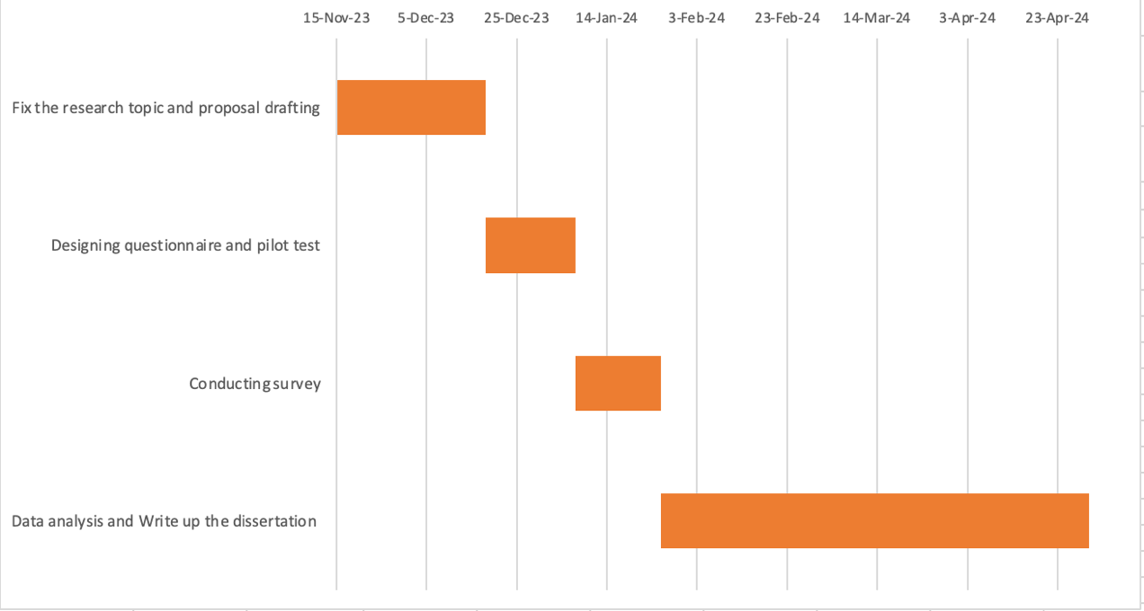
Source: constructed by author

Appendix 2: Crucial opinion for using digital payment from Focus group
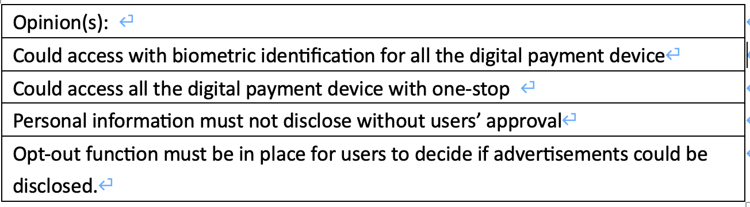
Source: Constructed by author

Appendix 3: Pilot test
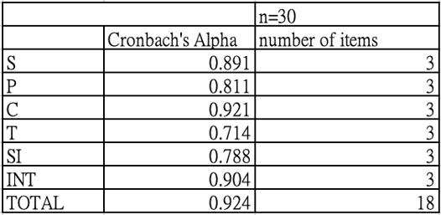
Source: Constructed by author

Appendix 4: Sample size test
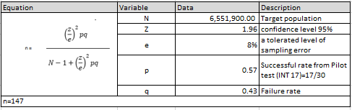
Source: Constructed by author

Appendix 5: Description of various data analysis techniques
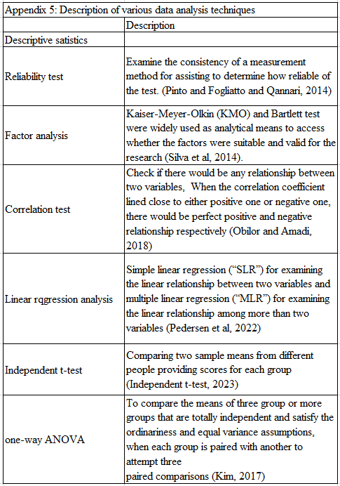

Appendix 6: Abbreviation of terminologies
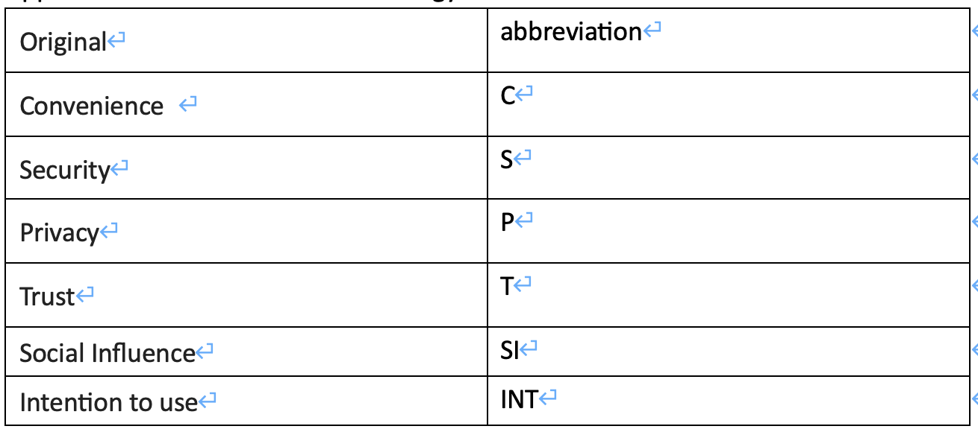
Source: Constructed by author

