

Developing Relationships and Workplace Achievement
(BMSW5102_LON)

Student Name: Catalina Anastasoaie
Student ID: 1908747
Lecturer Name: Nandish Patel
Contents
Introduction: 3
a) Evaluating development vehicles available in Unilever and explaining reasons behind their suitableness for meeting the development needs of the individual. 3
b) Developing a plan to meet the indentified development needs and expectations of an individual. 5
Conclusion: 8
References: 9


Introduction
Personal development is a conglomeration of exertions that assist the workforce of an organization to develop their quality and overall skills to generate high performance in an organization. The report will be based on Unilever, a UK based company, serving their products in more than 190 countries in the world. The company has one of the largest lines of products category like food, beauty, refreshments etc in the world. It has a premium organizational structure and multiple training & development vehicles are conducted within this organization. Workforces of Unilever can develop themselves through proper training, observation, technological training, representing, researching, involving in several projects, participating in various events, utilising provided feedbacks and so on. These development vehicles of Unilever are highly effective in the development process of its personnel.

Evaluating development vehicles available in Unilever and explaining reasons behind their suitableness for meeting the development needs of the individual.
Unilever, one of the largest successful organizations in the world highly emphasizes on the effective organizational structure and the development of individuals working for it. There are so many development vehicles are extant in the Unilever to develop its personnel. Unilever creates a favourable scope for their employees to develop their internal skills and efficiency. In Unilever, proper training for their workforce is ensured.
As, there are a high volume of activities to perform for Unilever around the world and they have to provide proper quality services, it is highly significant for them to train their individuals who will directly handle their customers. For this purpose, proper tanning are mandatory for individuals and individuals get the chance of developing themselves in this way (Magnusson & others, 2015). The next vehicle of development in Unilever is gathering learning through observation. Individuals can observe activities performed within the organization and learn the ways of performing things effectively. This highly helps new individuals who are in lack of experiences in organizational activities. They can learn and earn suggestions from experts to accomplish things effectively and efficiently. This one is very effective way for individual development purpose (Cummings & others, 2014). I find this a fast way of personal developing that Unilever supports for their new employees. Instead of reading an article of doing things, this way facilitates the way of learning from practical experiences within a short period & effectively. The next development vehicle available in Unilever is technological training, one of the most vital activities in this organization. In Unilever, most of the works and productions are performed in a technological manner. Therefore, it is highly required for individuals within this organization to be efficient in maintaining technology. Unilever generates every products and services using technology. Workers have to be expert in these technologies to operate the production functions properly. In Unilever, proper technological training is provided to individuals so that they can run production function without any technological error. The overall quality & supply of Unilever products depend on the efficiency in maintaining technology. Therefore, Unilever emphasize most in technological training for the development of its workers. Thus, employers also get the scope of developing their technological skills. Unilever provides its employees the opportunity of acting as a representative in various business programs. This helps individuals learn to manage and solve problems effectively and they can develop their leadership quality through this process. Individuals learn to present their professionalism and effectiveness through working as a representative (Magnusson & others, 2015). The eulogy they get from their leaders inspires them more to achieve their desired goal. They gather several experiences in working environment by constantly co-operating with others. Thus, Unilever offers a great way of developing individuals through working as representative in business programs. Unilever provides their employees proper scope and facility for research purpose. There is continuous development of products and services must be ensured to hold a good position in market for Unilever. For this purpose, they have to constantly research about bringing new products and services for their customers in the market. Unilever provides special facility to its researchers and provides opportunities to new individuals in research field to make individuals germinal. Individuals also get appropriate materials from Unilever for their research purpose. They learn to invent things and new ways of creating new services. This is inevitable element for Unilever, as the organization is required to propose new value over time. Individuals can develop their research capability through working on it in this company. Another individual development vehicle, learning from several projects, is available in Unilever. Beside theoretical development, it is highly required to develop the practical excellence for individuals working in organization like Unilever. The individuals expect their involvement in various projects through which they can develop and learn to work in a project environment. Unilever understands the demand of its employers and it involves its workforce in various projects for specific category products. This scope increases the capability of managing projects and work in a project environment for individuals. Unilever has created another personnel development scope as they arrange multiple events in many places around the world. There are enormous numbers of individuals from many countries participate in these events. Various kinds of human development materials are presented in these events and individuals can gather huge learning from those (Sanford & others, 2017). Various types of strategic moves are applied through which individuals can understand the organizational development strategy. Feedbacks from the activities done by individuals in Unilever are also a vehicle of personal development. Considering and analysing the performance of the workers, experts and authority provides various suggestions to make things better in a friendly way. Individuals are highly enthusiastic about getting feedbacks about their work (Bashir & others, 2013). These remarks and suggestions help them make things better and develop their way of exertions within the organization.
In organizations like Unilever, individuals find it a great opportunity to develop them and expect to gather proper learning from various remaining scope. Unilever creates scope and develop their individuals with these multiple development vehicle that develops the overall technical, theoretical, practical knowledge of an individual. This is what employees expect from the organization they work. The overall development vehicle is imposed for increasing the quality. Through proper training, observing, developing technological training, representing, researching, involving employees in several projects, involving them in various events, providing constructive feedbacks & providing rewards, Unilever fully meet the development needs for an individual. Therefore, I think these methods the greatest way of developing individuals and most effective way of meeting their demand.

Developing a plan to meet the indentified development needs and expectations of an individual.
There are multiple numbers of development vehicles have been offered by Unilever to their employees. All these opportunities and scopes help their employees to meet their demand in developing their qualities. In this organization, employees have to perform activities in various categories. For this reason, they have to be sufficient qualified to perform those activities within the organization. Unilever takes the responsibility of developing their required individuals and creates proper scope of developing individuals. In Unilever, employees need proper training, observation, technological training, representing, researching, maintaining projects, involving in various events & getting feedbacks for their organizational and personal development purpose. There are also various expectations of employees are also extant & when those are also ensured, employees provide proper organizational behaviour that indicates the relation between the employees and an organization and identifies the impression of an employee about his organization (Worley & others, 2014).
It is required to develop a plan, which will indicate how Unilever will meet the required development and expectations of an individual. To plan this, the duties and responsibilities of an employee within the organization, what type of skills required for an individual, in which field an individual contributes in Unilever and expectations of an individual need to be identified first. In Unilever, many employees work at a time in multiple categories. Their skills are also different from one another. Here are the ways discussed, Unilever will meet the individual development needs and expectations.
Development of practical excellence through training
Unilever will train its employees from every department and will focus on their certain responsibility of an individual. The first step will Unilever take is to identify the key function of an individual is performing. They will be trained on their certain activities to make them skilled in that work. The individual who perform technological activities will be trained on all technical fields and will find their interest on learning production activities (Burke & others, 2012). Like this one, every individual performing certain responsibilities will be trained on their key job to develop their skills. Key activities of Unilever where most of the workers work are production, marketing, researching, processing, quality evaluation, customer maintain, operating machine etc. Every individual in these functions will be trained through expert trainer managed by Unilever.
Developing individual knowledge through observation
This is an effective way of developing individuals where employees will learn through observing and taking suggestions from experts in Unilever. In this process, individuals will go through the advanced practical working environment and Unilever will let them observe how things are accomplished. Each employee will observe the whole process and can take recommendations and suggestions to make things in a better way. For example, in Unilever an individual can observe how facial creams are engendered through which machine and in which way the whole technology is controlled. This will also help them to understand the contingency theory in HRM, which indicates the situation where human resource management suits the organizational environment to achieve desired fruition.
Technological skill development
According to resource-based theory in HRM, which indicates the unique style of using resources of an organization that other organizations do not follow, Unilever can generate more unique products if it can use the technology in the most effective manner. In organizations like Unilever, technological efficiency determines the overall achievement. The more individuals can be skilled in technology, the more organization will ensure the quality of the products. Every production function is performed through technology. Proper technical training will ensure to generate more diversified products effective and the quality of services will be enhanced (Harrison & others, 2012). To increase this skill, Unilever will train every employee in technological platforms and it will train them to operate machines effectively. For this purpose, Unilever will provide proper training on maintaining technology and will guide them through high skilled professionals to make the use of it in the most effective manner. From the production purpose to delivering them at the door of customers, high volume of use of technology is ensured. So, Unilever highly emphasizes in this section to develop individuals.
Reward System
Following the motivation theory in HRM indicating the steps taken by the organizations through which employees become more enthusiastic and motivated in developing their quality and provide high performance in the organization, Unilever will take various enthusiastic actions to motivate its employees in the path of developing themselves. Unilever will announce reward system for several accomplishments to its employees. The employees, who will perform best output in the organization, will be rewarded. This will motivate them to develop their personal skills and will make them more enthusiastic in the personal development activities (Salas & others, 2012). It will also fill their financial expectation from the organization for their performed activities. Through offering reward and bonus for high performance, individuals will be motivated in their work and will try to provide their best output in the organization. Financial motivation is one of the most effective ways for individual development purpose as employees try to develop their exertions and quality to reach that offered benchmark of reward.
Development through representative activities
According to the agency theory of HRM that indicates a situation where authority allows its employees to act as a representative on behalf of the organization and provides some right of decision making activities, Unilever will also provide the opportunity to act as a representative in various business events to its individuals. Their leadership and decision making quality will be improved through this action. Individual will learn organizational behaviour through these activities. As they are getting authorization about making decision from their organization, they will try to be germinal and this will improve their decision making quality and solving problems instantly. This will meet the expectation of having priority from the organization for an individual.
Involving individuals in research projects and remuneration system for it
Research is one of the most vital elements for organizations including Unilever. Involving individuals in research projects will develop their analyzing and research capability. This will also help organization to meet innovative actions. Through research activities, the individuals in the organization will be able to learn innovative things and they will have proper idea about developing processes (Mozael & others, 2015). This will make individuals more innovative and employees will also be satisfied as they are contributing in the development of the organization directly. And, for every contribution Unilever will offer remuneration to employees which will motivate them and fulfil their expectations from the organization.
In these ways, Unilever facilitates the way of personal development for individuals and meet their overall expectation. Individuals in an organization expect proper support from it so that they can perform their job in a comfortable manner. Proper training and other offerings motivates employees to develop themselves. To perform and provide high performance in organizations like Unilever, employees must be sufficiently developed and so ensuring overall development is inevitable.
Recommendation
Human capital theory in HRM focuses on the proper educational development of human which results in high performance and productivity in an organization (Sal & others, 2016). To meet the expectation of employees, an organization must provide proper facility and scope for personal development. Unilever must consider the exertions of employees from the financial perspective. They have to motivate employees in their personal development by offering various lucrative financial supports and they must consider the whole development process as a learning time for individuals. During the development process, Unilever has to wisely guide and provide proper recommendation and instructions to its employees for a sustainable development that will help the organization propose new value to its customers. Proper monitoring and evaluation is highly required for individuals whether they are developing their qualities properly. Proper practical application of technology must be applied so that the employees can use technologies in an innovative way for the purpose of product development. So it is highly to be monitored if employees are getting the right directions. Proper remuneration must be offered for estimable performance of employees to make them motivated in their work. And various financial reward can be ensured for better performance and development over time.

Conclusion
The overall success of an organization relies on the contribution of the individuals working within its environment. For better contribution, it is inevitable to be proper developed in quality for individuals. The report shows the development vehicles available in Unilever and critically analyzes every component of it. A proper development plan on applying the proper development and meeting the expectation of employees within the organization has also been discussed constructively mentioning various HRM theories such as contingency theory, organizational behaviour theory, resource-based theory, motivation theory as well as agency theory. Proper development needs and ways to accomplish and achieve those as well as meeting individual’s expectation has been elaborated.

References:
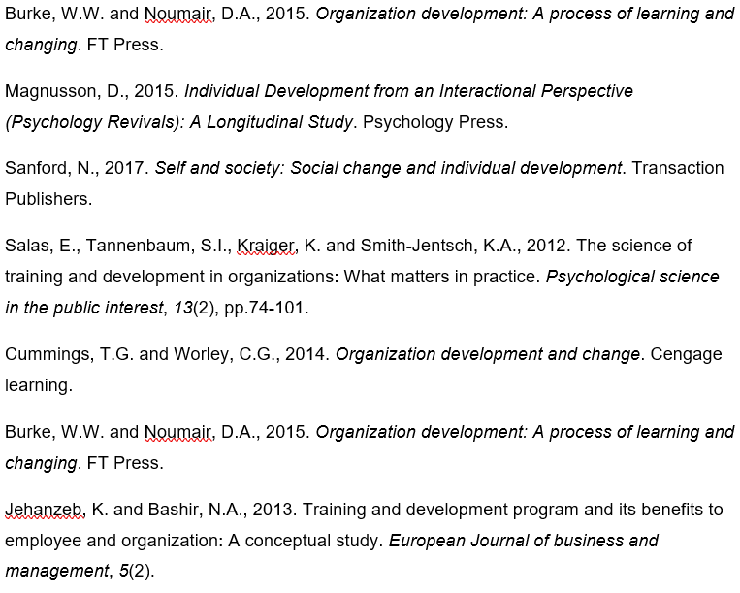
Harrison, R., 2012. Employee development. Universities Press.
Jha, V., 2016. Training and development program and its benefits to employee and organization: A conceptual study. International Journal of Scientific Research in Science and Technology, 2(5), pp.80-86.
Mozael, B.M., 2015. Impact of training and development programs on employee performance. International Journal of Scientific and Research Publications, 5(11), pp.37-42.
Sessa, V.I. and London, M., 2015. Continuous learning in organizations: Individual, group, and organizational perspectives. Psychology Press.
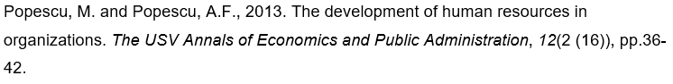Sal, A. and Raja, M., 2016. The impact of training and development on employees performance and productivity. International Journal of Management Sciences and Business Research, 5(7).
Jehanzeb, K. and Bashir, N.A., 2013. Training and development program and its benefits to employee and organization: A conceptual study. European Journal of business and management, 5(2).
Salas, E., Tannenbaum, S.I., Kraiger, K. and Smith-Jentsch, K.A., 2012. The science of training and development in organizations: What matters in practice. Psychological science in the public interest, 13(2), pp.74-101.

