Digital Identity and Social Media
(Student Name)
10/20/2018

Table of Contents
Introduction 2
Impact of technology 2
Role of Innovation 5
Sustainability Business Practice 5
Conclusion 6
References 7

Introduction
In the 21st century, the internet is one of the fast-moving dynamic sectors. The introduction of the internet and its uses represent an illustration that how its character and their cost have been transforming the humanity (Ashton, 2009). The social media is more pervasive in the present scenario of the globalized world (Ryan, 2015). The extent of the use of the internet is such a manner that any individual can contact any kind of knowledge from anywhere (Castells, 2015). There are no environmental borders left as these all are separated by the internet communication expertise (Wortmann & Fluchter, 2015).
Technology plays a prominent role in the global world. In the present scenario, the world is categorized no longer by the ideology but by the technology. Approximately fifteen percent of the population provides nearly all of the technology innovation at the global level (Chatfield, 2018). Half of the population is able to accept these technologies in creation and using up and the remaining part, technologically cut off. According to the theory of new growth, innovation is the primary source of advancement of technology which in turn drives to economic growth (Avgerou & Walsham, 2017).
In the following context, there will be a detailed discussion on the impact of technology and innovation on the growth of the economy and the society which play a vital role at the global level

Impact of technology
‘The Internet, like the steam engine, is a technological breakthrough that changed the world’. According to this statement, the author has reviewed that the internet has a critical role in the epitome of the fast moving in the dynamic world. With the extension of internet technology, the progress has been in full swing taking place. The importance of the internet has no limit in the area of communication only but as well into each and every area of the life of individuals. It is one of the best platforms to enhance the performance of the society and economy (Winston, 2012).
The scene of information management has been completely changed in developing countries. It enhanced the system of communication and has also developed the environment of user-friendly for the sharing and exchange of information (Brown & Duguid, 2017). It has inspired most of the developing countries to develop the use of the internet to their benefits. The impact of the technology has caused the developing countries to enhance and modify their conventional methods of conducting the information industry b setting up a new source of information and a new method of communication on a worldwide level (Brynjolfsson & McAfee, 2014). The technology helps the developing countries to acquire benefit of access to universal sources of information in order to enhance their economic market. The technology is the remarkable power of pervading companies (Watkins, Papaioannou & Kale, 2015). The economy of the technology has been increased by observing the spending level of Worldwide IT. The companies have enhanced their commercial expenditure for software, hardware, data center, networks and internal and outsourced workforce for IT services. In the recent, this volume is close to the US$6 trillion per year (Magalhaes & Afonso, 2017). To think about the universal technology wealth of a country and its yearly expenditure it GDP, it would be ranked as the world third-largest economy, linking the economies of China and Japan and also more than the twice in the dimension of the UK economy which is revealed on below chart (Baldwin & Lopez, 2015):
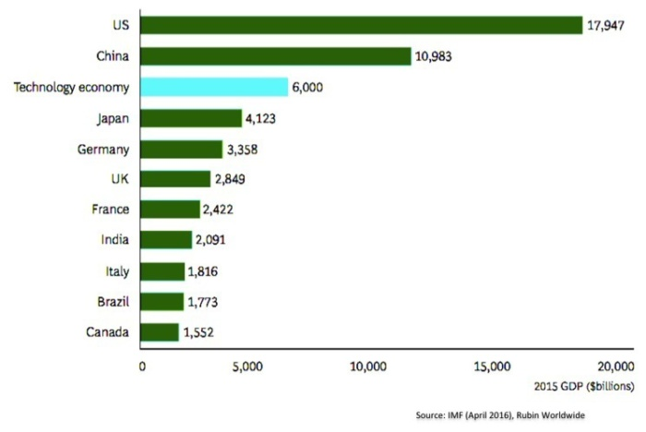
(Source: Cavallo, 2016)
Many research conducted from different organizations such as BCG, IMF and World economic Forum represent that at any time organizations take back their investment in the technology has created direct impact on the GDP of the country as it fall drastically and within a coming years, the efficiency of labor throughout the economy also fall down (Cavallo, 2016). The innovation of technology is a significant section of efficiency. The decline in the spending of the technology cause decrease in the labor force which affected on the productivity for up to three years later, with the reason that productivity is a “sticker” measure (Liu, Zhou & Wu, 2015).The association involving the passion of technology and GDP is shown in the below diagram:
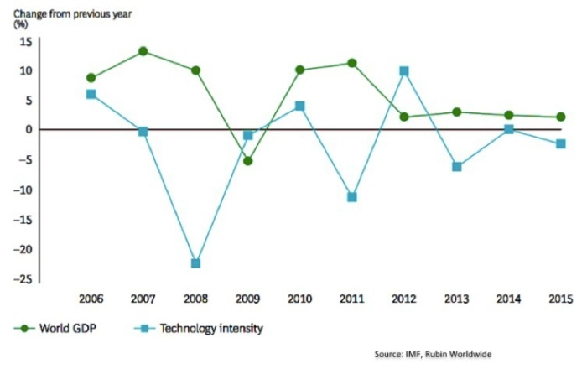
(Source: Cavallo, 2016)

Most of the countries have achieved considerable growth in its GDP such as the country South Korea, as the country attain the expansion in its GNP as of US$ 87 in 1962 to US$ 936 in 2001. It is almost close to the greatly urbanized countries. The advanced goods are enhancing consecutive years among the volumes of exports. It has been analyzed that the total exporting volume of high-tech products accounted for 15.97% and in 1999, it has reached 32.2 %. The innovation in technology has significantly helped South Korea in achieving the high-quality result in the market of universal deal. It also resulted in a high expansion in the GDP and it’s taken as a whole economy (Saidi, Toumi & Zaidi, 2017).
The technology has both negative and positive impact on the society. The number of users of technology has been continuously increased. The digital media has the following impact on the society which is explained in below points (Sullivan, 2011):
Child Literacy
The National Literacy of trust has reported the result of survey being done on over 3000 children, as they have been observed a correlation between the engagement of children with technology and their literacy. Technology helped the children to enhance their knowledge and become more literate.
Enhance communication channel
The technology overcomes the physical barriers to communication over the distance. The mechanized and consumer goods companies have adopted and also developed the Links through online with their suppliers and also provide the service of customer support. They adopted the automated system to enhance their productivity which is the positive sign for the growth of GDP of the country (Tuten & Solomon, 2017).
Political Influence
The explicit of technology proliferates and obliquely spreads the values of western democratic. Some of the governmental organization or the sponsored group of government has spread such views in the market. Internet degraded and also repudiates those countries, political parties, and governments that have different viewpoints from those of the West. It can be used by some of the people as a tool to destruct the dominion of a nation and also obstruct the relationship with the other nations.
Social life Affected
Technology has provided the communication in an easier way and also faster for the individual and firm of the countries but at some point, the social network in the world as made it harder for the individual to have face to face communication which may create distance among them (Eliezerov, 2018).
Impact on income distribution and jobs
The technology has also impacted on the workforce in different ways. The whole world is now converted their business in automation, therefore the companies require more skillful individuals to adopt the technologies efficiently. It gives the opportunities to the individual to showcase their talent and increase the opportunity for the employment. It also generates the equitable distribution of income and wealth in the society. It reshapes the environment with the aid of practical, experimental, and scientific knowledge or innovation in technology.

Role of Innovation
In promoting the economic, social, and environmental development, the varied range of innovation in technology plays a considerable role in all over the world. The remote areas of Kenya are suffering from the issue of clean water for drinking and also facing the issue of limited use of energy. The Water-Energy Hub (WE-Hub) is an initial design to properly utilization of solar technology which helps in providing the clean water and electricity for local individuals. Some of the projects are also conducted in support with the local communities, partners which are self-sustainable socially and financially (Daxton, 2015).
In the country, South America, an organization with the name Enlace Hispano Americano de Salud (EHAS) is steep out essential connectivity of internet for the health professionals in the villages of remote and rural area. Now, the doctors are able to connect with medical professionals in leading, who can assist with the diagnosis and treatment of patients. With the help of the internet, the doctors are even able to navigate and assist in clinical scans which would help in identifying the main cause of the problem (Lederman & Porto, 2015).

Sustainability Business Practice
The innovation of technology in the business has caused a remarkable development in trade and commerce industry. As a result of the preamble of technology, the concept of trade as well as model was revolutionized. The main reason behind it is that the technology gave a new and better approach on how to go about with the business. It provides more convenient, more efficient, and faster way of performing the transaction of business. Due to the innovation of technology, the globalization has been realized. Any individual be able to start their own company at any place at global level. Technology provides the best opportunities for the individuals to reach and get success in the market globally. In the technology, internet is one of the effective marketing tools to attract most consumers in availing product and service which has been offered by various businesses (Carley & Spapens, 2017).
With the innovation in technology, most of the companies adopted sustainable business practices. The business form different associations and assorted sectors have used the approaches of a similar set to achieve their own version of sustainable business practices. The improvement in the practices of business has come from a new way of thinking about meeting the needs of the customers and redesigning the operations of production with environmental concern in mind. The steps which have been taken by the company for sustainable business practice with the help of the innovation are explained in below points (Dyllick & Muff, 2016):
Water stewardship: Cola-cola
The soft drink companies such as Coca-cola has improved the efficiency of use of its water by twenty percent and also identified the need for the exact evaluation of third-party of its water management system approach ((Dyllick & Muff, 2016).
Reduction of Greenhouse gas emission: Adobe
The software company Adobe has an aim to achieve at least a 75% reduction in the emission of greenhouse gas from 2000 levels by 2015. The company is using the technology of renewable energy which includes hydrogen fuel cells and solar arrays, and the company is also focused on reducing the energy needs by improving the efficiency of cooling of its data centers, platforms, and devices.
Sustainable agriculture: General Mills
The company of food recently released a set of sustainable sourcing commitments which start with the robust risk assessment process which is undertaken in partnership with a third party. With the help of the innovation in the technology, the company of food chain concentrated on adopting sustainable agriculture (Dyllick & Muff, 2016).
Design: Dell
The company of computer incorporate alternative, recycled and recyclable materials in packaging design and product, focus on improving the efficiency in energy, and design for end of life and recyclability. The company also committed to reducing the energy intensity of their product portfolio by eighty percent by 2020 with the help of technology.

Conclusion
From the above, it can be concluded that technology act as a prominent character in the economy and society development. By introducing the technology in the market, the drastic changes have been experienced at the global level. The internet is an important tool that changed the whole world. Most of the population has been greatly dependent on the technology. It helps in enhancing the performance of the individual at a greater level. Most of the companies have invested a certain amount in the development of the technology which also helps in improvement in the GDP of the country. Therefore, technology has a direct impact on the economy of the company. The society is also greatly affected by technology. It helps in the enhancement of child literacy level. Most of the countries have taken steps towards the digital world which help them to enhance their knowledge and also increase the opportunity of the employment. Most of the companies adopted sustainable business practices with the help of innovation in technology. Therefore, it has been proved that technology plays a prominent role at the global level.

References
Ashton, K. (2009). That ‘internet of things’ thing. RFID Journal, 22(7), 97-114.
Avgerou, C., & Walsham, G. (2017). Information Technology in Context: Studies from the Perspective of Developing Countries: Studies from the Perspective of Developing Countries. London: Routledge.
Baldwin, R., & Lopez‐Gonzalez, J. (2015). Supply‐chain trade: A portrait of global patterns and several testable hypotheses. The World Economy, 38(11), 1682-1721.
Brown, J. S., & Duguid, P. (2017). The Social Life of Information: Updated, with a New Preface. London: Harvard Business Review Press.
Brynjolfsson, E., & McAfee, A. (2014). The second machine age: Work, progress, and prosperity in a time of brilliant technologies. New York: WW Norton & Company.
Castells, M. (2015). Networks of outrage and hope: Social movements in the Internet age. New Jersey: John Wiley & Sons.
Carley, M., & Spapens, P. (2017). Sharing the world: sustainable living and global equity in the 21st century. London: Routledge.
Cavallo, M.A. (2016). The Growing Importance of the technology economy. Retrieved from: https://www.cio.com/article/3152568/leadership-management/the-growing-importance-of-the-technology-economy.html
Chatfield, C. (2018). Statistics for technology: a course in applied statistics. London: Routledge.
Dyllick, T., & Muff, K. (2016). Clarifying the meaning of sustainable business: Introducing a typology from business-as-usual to true business sustainability. Organization & Environment, 29(2), 156-17
Daxton, R. (2015). Social Media and the Law A Guidebook for Communication Students and Professionals. London: Routledge.
Eloezerov, R. (2018). The Digital Identity Crisis: How The Explosion of Personal Information Is Transforming Technology, Business, and Society. New Jersey: Wiley.
Lederman, D., & Porto, G. (2015). The price is not always right: on the impacts of commodity prices on households (and countries). The World Bank Research Observer, 31(1), 168-197.
Liu, Y., Zhou, Y., & Wu, W. (2015). Assessing the impact of population, income and technology on energy consumption and industrial pollutant emissions in China. Applied Energy, 155, 904-917.
Magalhaes, M., & Afonso, O. (2017). A multi-sector growth model with technology diffusion and networks. Research Policy, 46(7), 1340-1359.
Ryan, D. (2015). Understanding Social Media How to create a plan for your business that works. London: Kogan Page.
Saidi, K., Toumi, H., & Zaidi, S. (2017). Impact of information communication technology and economic growth on the electricity consumption: Empirical evidence from 67 countries. Journal of the Knowledge Economy, 8(3), 789-803.
Sullivan, C. (2011). Digital identity: an emergent legal concept the role and legal nature of digital identity in commercial transaction. Adelaide: Adelaide Press
Tuten, T., & Soloman, M. (2017). Social Media Marketing. New York: Sage
Watkins, A., Papaioannou, T., & Kale, D. (2015). National innovation systems and the intermediary role of industry associations in building institutional capacities for innovation in developing countries: A critical review of the literature. Research Policy, 44(8), 1407-1418.
Winston, B. (2012). A right to Offend: Free expression in the Twenty-first Century. London: Bloomsbury
Wortmann, F., & Fluchter, K. (2015). Internet of things. Business & Information Systems Engineering, 57(3), 221-224.

