Digital skills and Research Methods
BMSW4003 Certificate of Higher Education in skills for the Workplace

Stanciu Radu Mihai
Student ID: 2111825

Contents

Discuss research 2
Rusell approach 4
Data collection and process of DIKW pyramid 5
Data collection 5
Turn Data to information, Class survey 6
Comparison of grit score 7
Conclusion 15
References 17

Discuss research

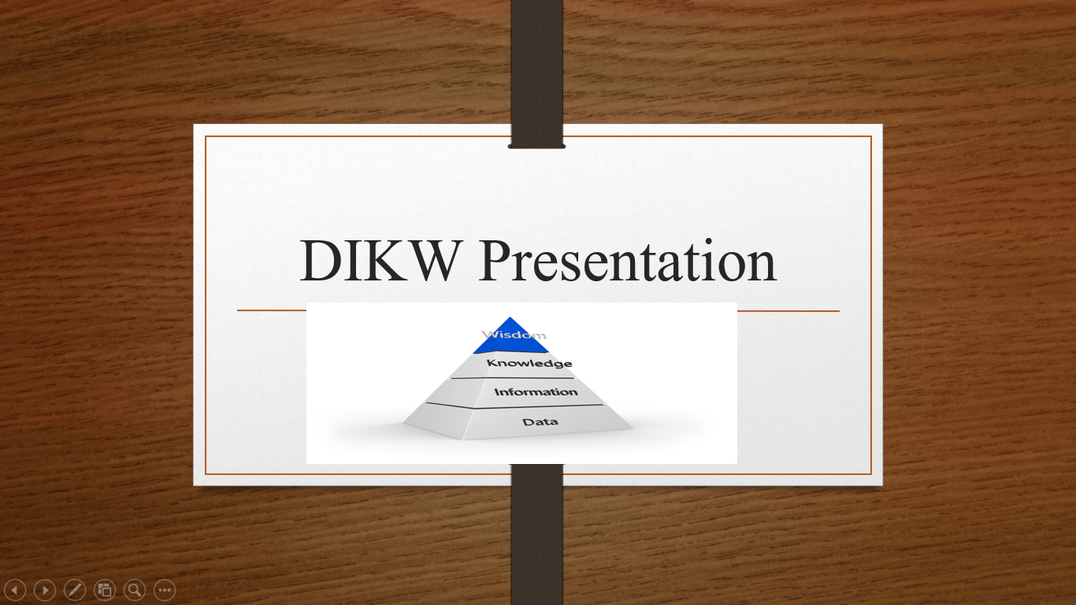

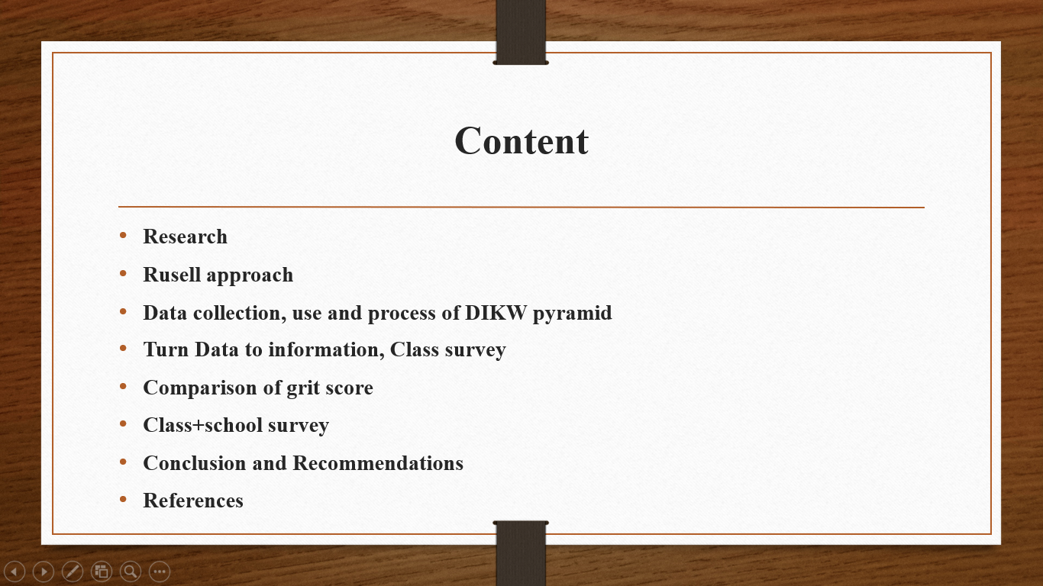
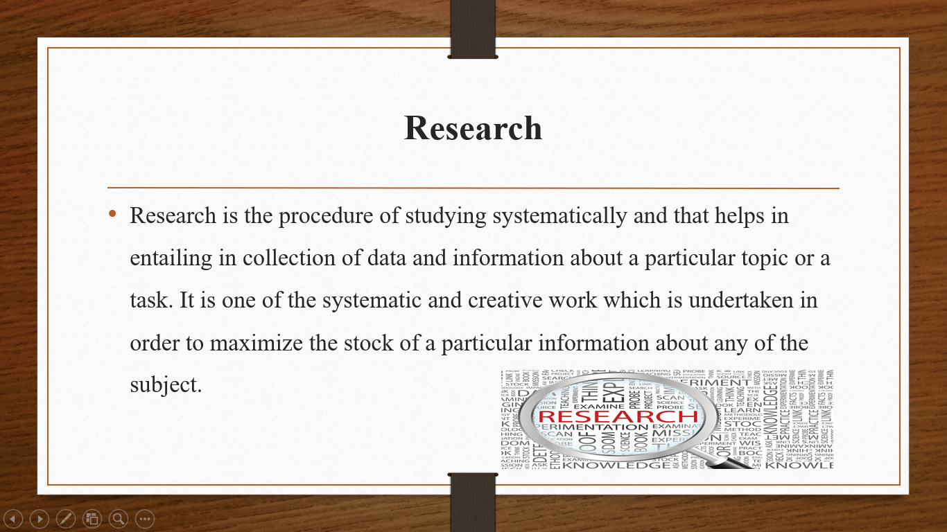

Research is a process of collecting, analysing and evaluating the data and information about a particular field and a topic (Datta, 2021). It helps in collecting, organising and evaluating of the data in most effective manner. Research is regarded as the review which helps in describing the information, predict and control the data and observed the phenomenon. It includes two methods.
These are qualitative and quantitative method of research and also it includes two type of approaches these are inductive and deductive approach. It helps in brings true and reliable information and develops information so that to achieve research aim and objectives. Further, it results in achieving data and information in most effective manner and develops most effective information. This helps in enhancing of the performance of business and provide it in direct and positive manner. Further, there are various types of purposes which helps in identification of the potential customers, setting pragmatic goals and objectives, underrating the existing customer and developing productivity of the marketing strategies, identification of new challenges and techniques coming in the modern market (West, Zou, and Stoll, 2021). There are also three types of designs which re used in research these are exploratory, descriptive and explanatory. These all types and methods helps the researcher in completing of the research in effective manner and achieving research aim and objectives.

Rusell approach

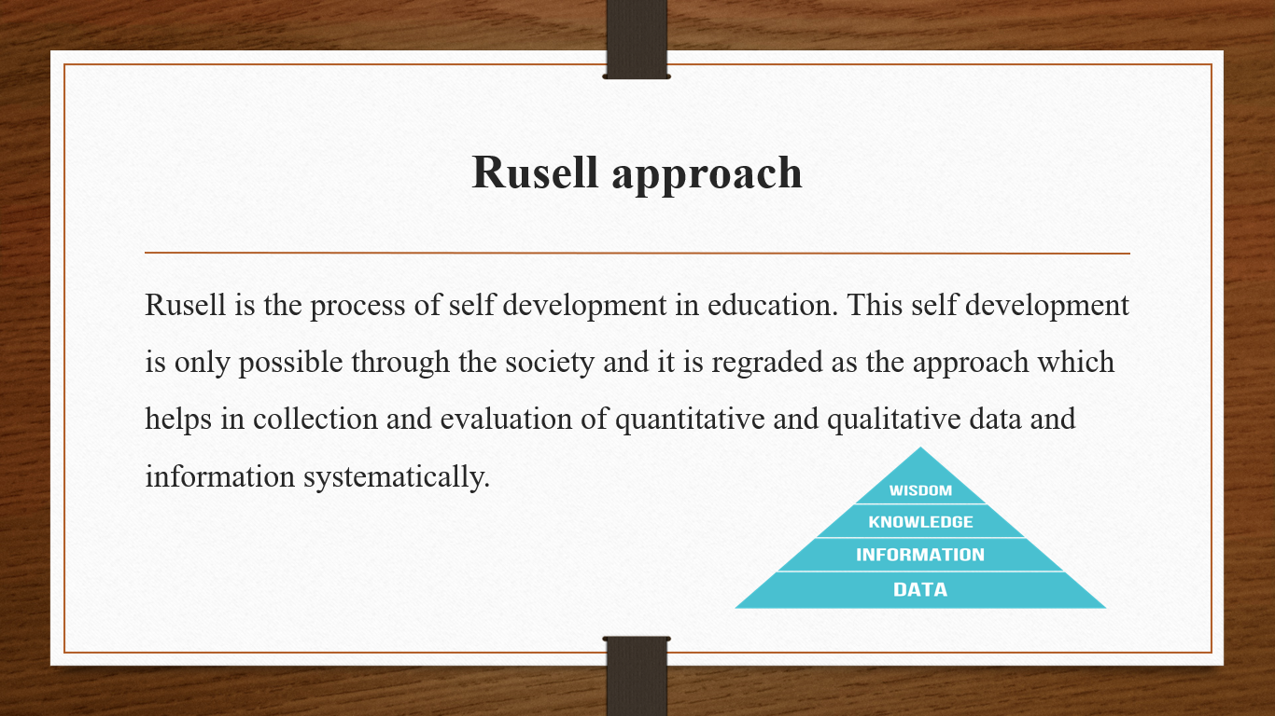
Rusell approach helps the researcher in getting reliable and valid outcomes of a particular topic and area of research. Qualitative method within this Rusell approach consisting of various type such as it includes interpretivism philosophy, inductive approach and many other. There are some of the effective methodologies which helps in facilitating the audience and attainment of the research aim and objectives (Pop, Badea, and Pop, 2021). On the next hand, quantitative method within this, some of the methods come like positivism philosophy, deductive approach etc. these methods will helps in achievement of the aim and objectives of the successful research.
DIKW pyramid is one of the relationship which is between knowledge, information, data and wisdom. It consisting of some of the main steps of this pyramid and which helps in development of the accurate information about a specific topic. This helps in introduction of the model class for demonstration of the functional and structural relationship in between knowledge, data and information and wisdom (Zhang, and Lobov, 2021). Thus, this is an effective model in order to define the information and data which is regarded the particular field of subject.

Data collection and process of DIKW pyramid
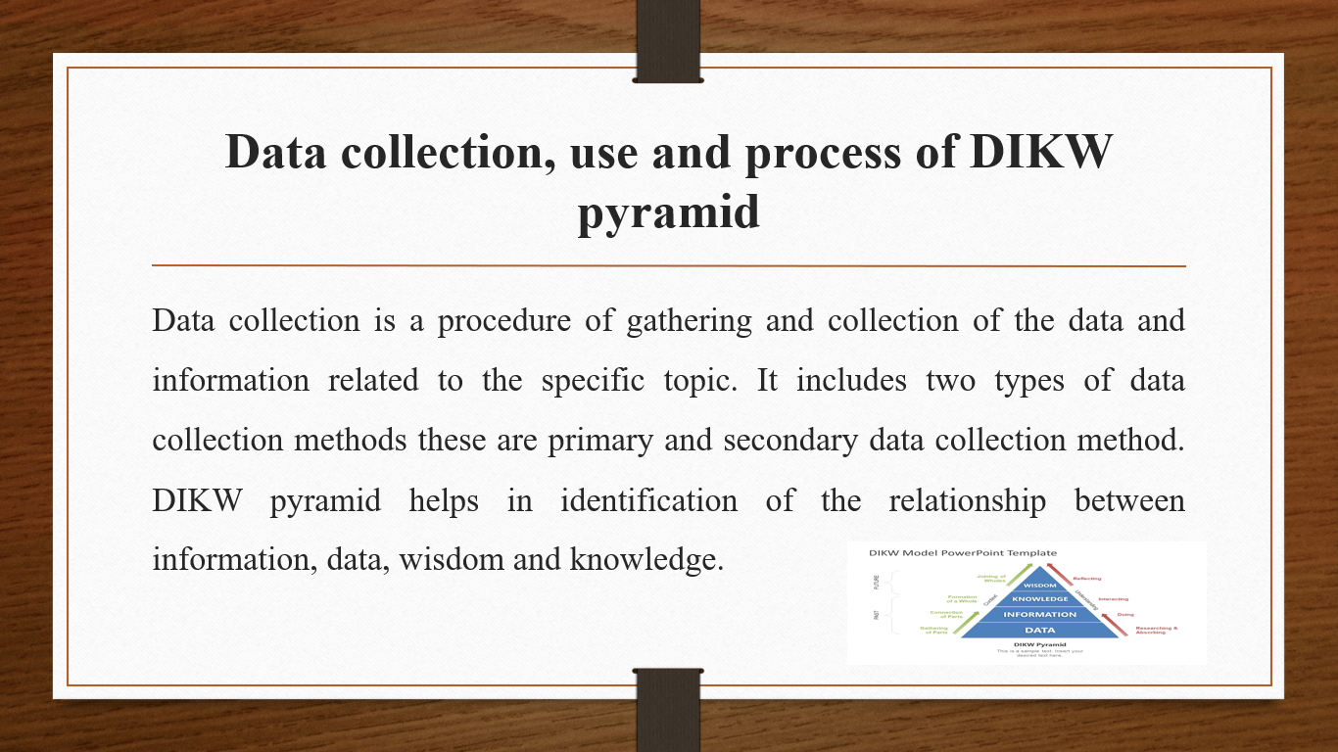

Data collection
Primary and secondary data collection method are the two most essential method which helps in collecting data and information in most effective manner. It also includes in depth knowledge about a particular area and get to know in depth information about a specific topic. In relation with primary data collection method, data is collected through survey, interview and focus groups etc. further, it includes graphs, charts and tables top collect data and information (Esposito, and Romagnoli, 2021). On the next hand, secondary data is collected through books and articles and published data etc. it brings in depth information about a topic.

Use of DIKW pyramid
There is a use of DIKW pyramid framework which is to identify the continuum of CDS requirements. Also, there are certain uses of this pyramid like meeting of the information needs, capture, facilitating of the data and making decisions etc.
Process of DIKW pyramid
There is a certain procedure of DIKW pyramid process which is being explained in some of the steps which is mentioned below :
Data : DIKW pyramid allows to collect and gather accurate data about a specific topic of a research.
Information: Some of the information is like structured, organised and categorised is the step which is mentioned in this step in this pyramid.
Knowledge : This step will helps in development of the effective data, learning, notion and concept etc ( Kallio, 2021).
Wisdom: This is a part of the pyramid which helps in understanding of the knowledge about a specific information.
This process will helps in creation of survey on any topic. This is a model which helps in collection of the true and valid information and helps in completion of the process of survey in a systematic manner.

Turn Data to information, Class survey
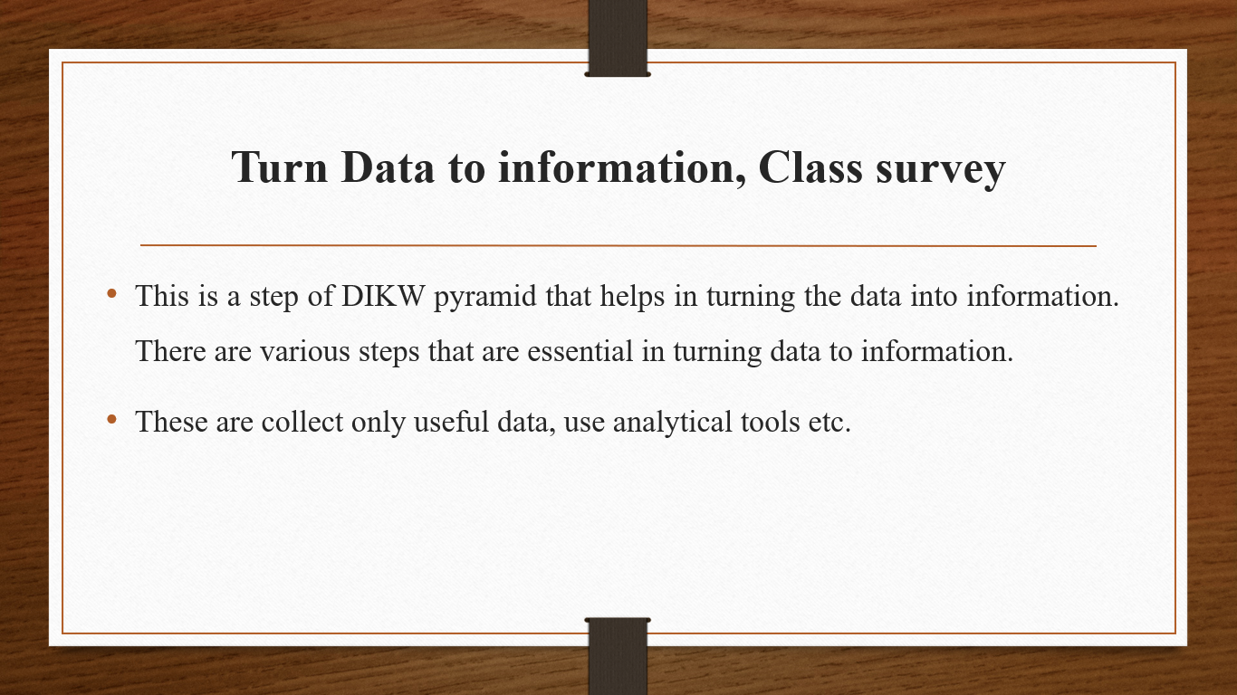
From the above, it is presented survey, it is interpreted that the survey is conducted in between 37 members. Out of those highest academic level of 19 people in this survey is 2 which is medium. Higher academic level of having 13 participants out of the 37 survey is 3 that are also preferring medium. Further, highest academic level of 2 participants is having 4 preferring medium. 2 of the participants is having highest academic level which is 5 that means they are more focusing on achievement of the long term goals. Rest of the 1 participant has highest academic level of 6 who is having the grid score of 4.15 that comes in medium. From the above, it is discussed that accurate and reliable data is regraded with the grit score of students. Also, the grit measures the extent within which the people is capable of having interest and focus and preserve in obtaining of the long term goals and objectives.

Comparison of grit score
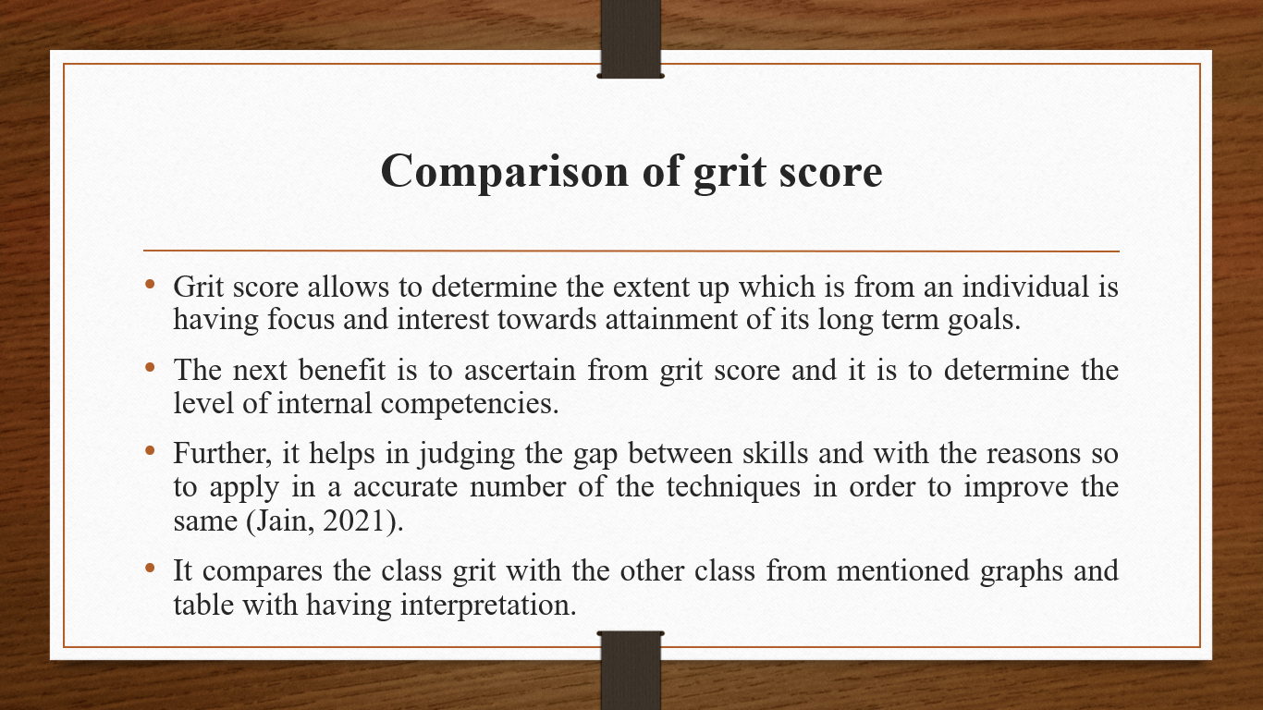
- Grit score allows to determine the extent up which is from an individual is having focus and interest towards attainment of its long term goals.
- The next benefit is to ascertain from grit score and it is to determine the level of internal competencies.
- Further, it helps in judging the gap between skills and with the reasons so to apply in a accurate number of the techniques in order to improve the same (Jain, 2021).
- It compares the class grit with the other class from mentioned graphs and table with having interpretation.

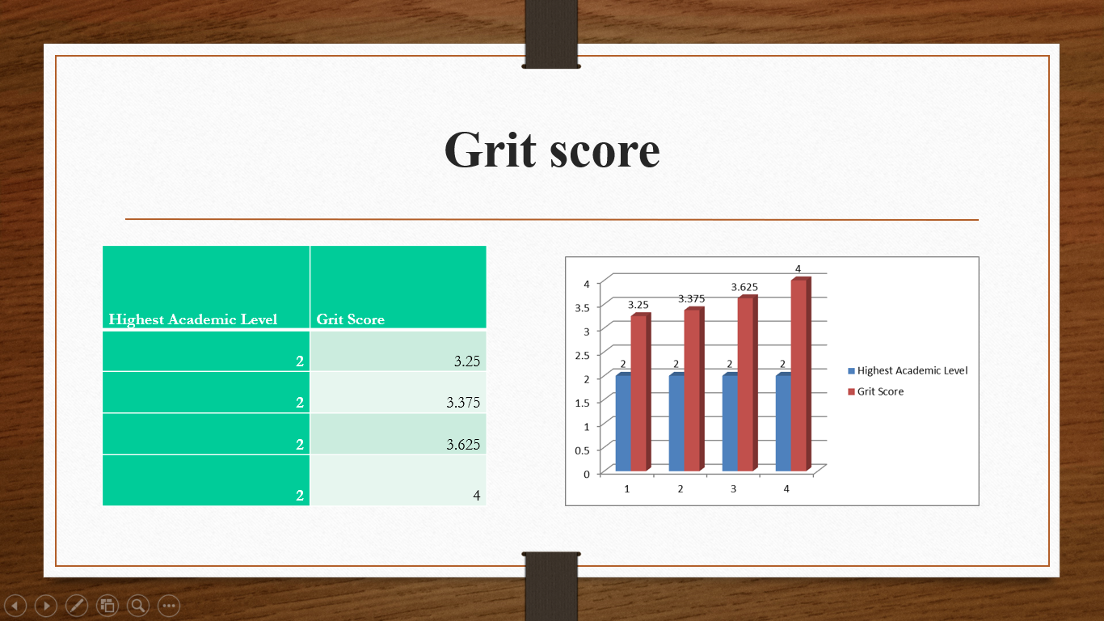
Interpretation: As per the above chart it is analyzed that at the stage of academic level of 2 every student collect different score in regard of their assessment. Different student have different score like 3.25, 3.375, 3.625 and 4. Highest score is 4 of a student at the level of second.

CRAAP is acronym of relevance, currency, accuracy, authority and purpose. This helps in determine the validity of a sources on the basis of different aspects. In this sources which are used are resilient and true. In this information provided is true and valid.
Class+school survey
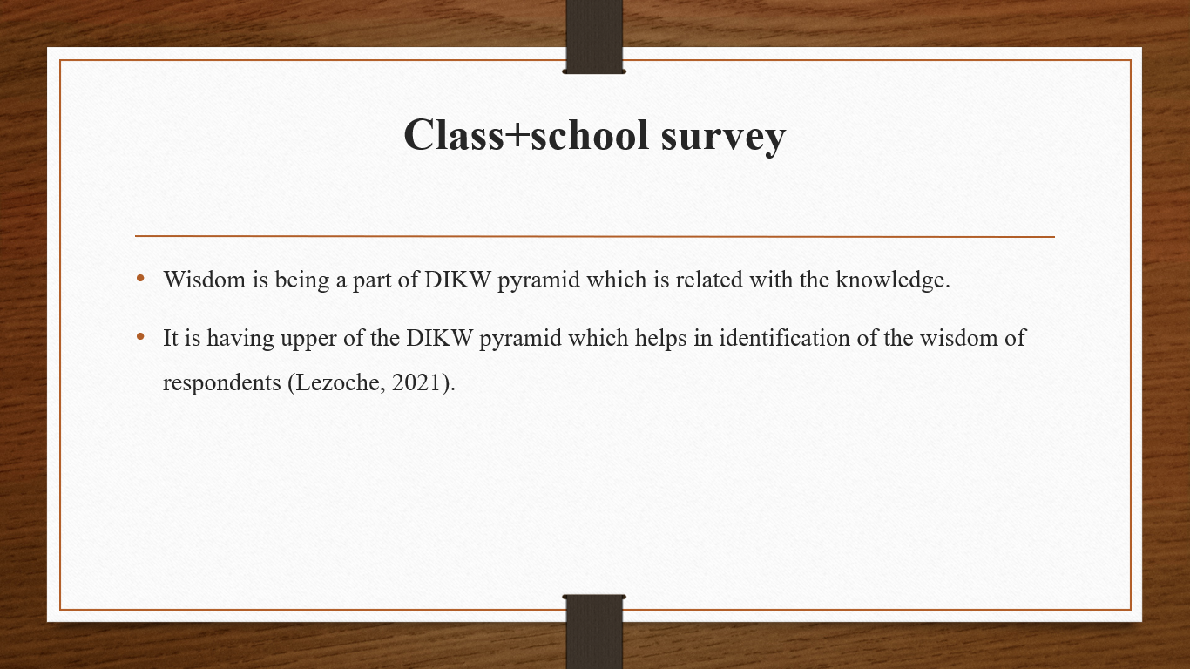
- Wisdom is being a part of DIKW pyramid which is related with the knowledge.
- It is having upper of the DIKW pyramid which helps in identification of the wisdom of respondents (Lezoche, 2021).

Highest Academic Level | Grit Score
3 | 1.75
3 | 2.2
3 | 2.5
3 | 2.6
3 | 2.75
3 | 2.75
3 | 2.75
3 | 2.8
3 | 2.8
3 | 2.8
3 | 2.8
3 | 2.8
3 | 2.8
3 | 2.8
3 | 2.8
3 | 2.87
3 | 2.875
3 | 2.875
3 | 2.9
3 | 3
3 | 3
3 | 3
3 | 3
3 | 3
3 | 3
3 | 3
3 | 3
3 | 3
3 | 3.1
3 | 3.1
3 | 3.12
3 | 3.12
3 | 3.125
3 | 3.125
3 | 3.13
3 | 3.2
3 | 3.2
3 | 3.2
3 | 3.2
3 | 3.2
3 | 3.2
3 | 3.2
3 | 3.25
3 | 3.25
3 | 3.25
3 | 3.25
3 | 3.3
3 | 3.3
3 | 3.3
3 | 3.3
3 | 3.3
3 | 3.375
3 | 3.375
3 | 3.375
3 | 3.38
3 | 3.4
3 | 3.4
3 | 3.4
3 | 3.4
3 | 3.4
3 | 3.5
3 | 3.5
3 | 3.5
3 | 3.5
3 | 3.5
3 | 3.5
3 | 3.5
3 | 3.5
3 | 3.6
3 | 3.6
3 | 3.6
3 | 3.6
3 | 3.6
3 | 3.6
3 | 3.6
3 | 3.62
3 | 3.625
3 | 3.625
3 | 3.625
3 | 3.63
3 | 3.7
3 | 3.7
3 | 3.7
3 | 3.7
3 | 3.75
3 | 3.75
3 | 3.75
3 | 3.75
3 | 3.75
3 | 3.8
3 | 3.8
3 | 3.8
3 | 3.8
3 | 3.8
3 | 3.8
3 | 3.8
3 | 3.8
3 | 3.8
3 | 3.8
3 | 3.8
3 | 3.8
3 | 3.8
3 | 3.8
3 | 3.8
3 | 3.87
3 | 3.875
3 | 3.875
3 | 3.875
3 | 3.875
3 | 4
3 | 4
3 | 4
3 | 4
3 | 4.1
3 | 4.1
3 | 4.1
3 | 4.25
3 | 4.25
3 | 4.3
3 | 4.3
3 | 4.3
3 | 4.3
3 | 4.3
3 | 4.37
3 | 4.6
3 | 3.75

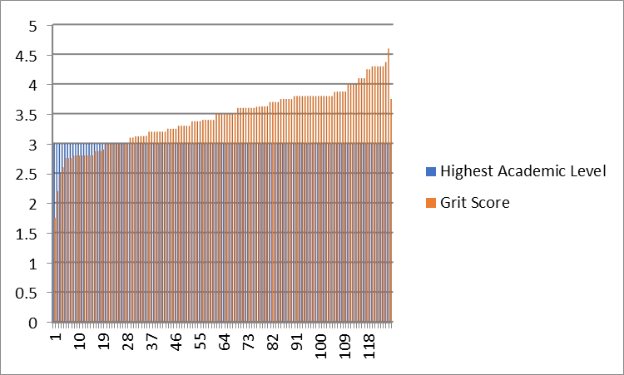
Interpretation: This chart presents that at the level of 3rd various students and gets different score which is according to their performance. Along with different students pass their exams at third level. Highest score 4.37 get by student at the level of third.
4 | 3.2
4 | 3.2
4 | 3.5
4 | 3.5
4 | 3.6
4 | 3.6
4 | 3.87
4 | 4.3
4 | 4.375
4 | 2.125
4 | 3.2
4 | 3.25
4 | 3.6
4 | 3.7
4 | 3.7
4 | 3.75
4 | 3.75
4 | 3.75
4 | 3.75
4 | 3.8
4 | 4
4 | 4
4 | 4
4 | 4
4 | 4.1
4 | 4.5
4 | 4.6

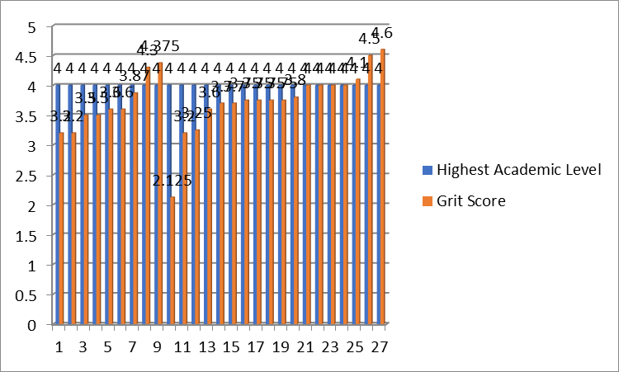
Interpretation: From this chart it is getting that at the level of 4 different students get different grit score. The highest score is 4.6 which is gain by student at level 4.

Highest Academic Level | Grit Score
5 | 2.2
5 | 3.4
5 | 3.4
5 | 3.5
5 | 3.8
5 | 4
5 | 4
5 | 4.3
5 | 4.3
5 | 4.5
5 | 4.5
5 | 4.59
5 | 4.6
5 | 4.8

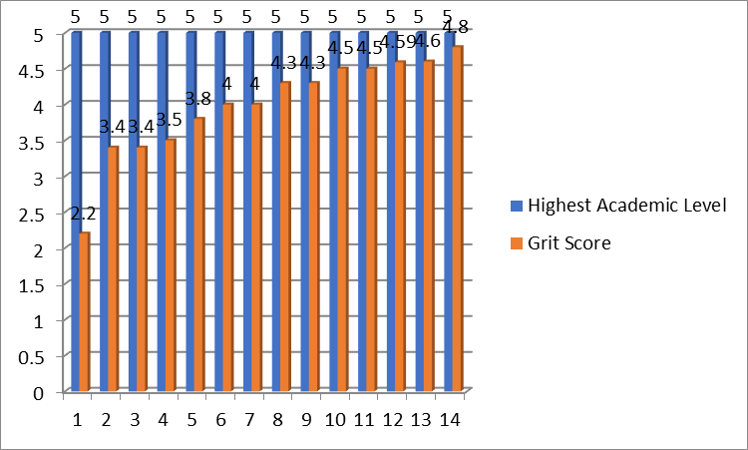
Interpretation: The level 5 is highest level where get highest score is 4.8 and lowest score is 2.2. It is highest level get different results by the students.

Conclusion
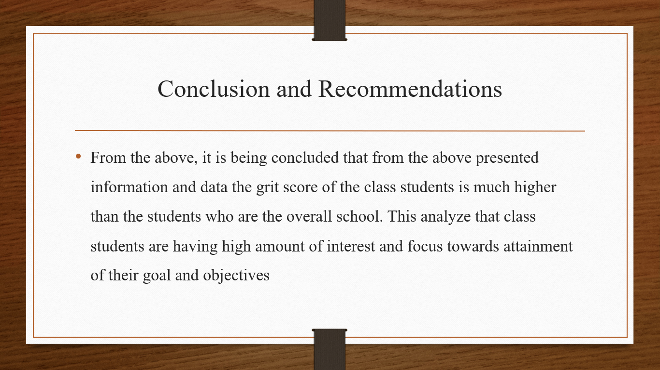
Also, it is ascertained that the point of comparison is a need that there is a requirements to apply the better tools and techniques so that to improve the overall focus and interest level of the school students. The main reason of this that by having higher level of focus and the interest of the class students is the level of knowledge and the capabilities of the learning. It is also analysed that from overall presentations the grit score is regarded as the effective tools which is helpful for the measurement of the interest and focus among the students. It is not only focusing on one factors for the comparison but also provides emphasis on the diverse determinants which is like interest, focus and preserve. This is one of the tool which helps in compare of the performance of the personnel which is against the ability of attainment of goals and objectives. The higher amount of score of grit depicts achieves the higher level of focus and the interest in personal achievement of of objectives.
Further, it is recommended to the school that students should have to focus on applying of the techniques such as training and development sessions and also the appraisal. This helps in providing the opportunity to build a technique and tool which helps in enhancing the overall performance. In addition, it will definitely helps in improving the grit score of their students along with the focus on the individual goals and objectives.

References
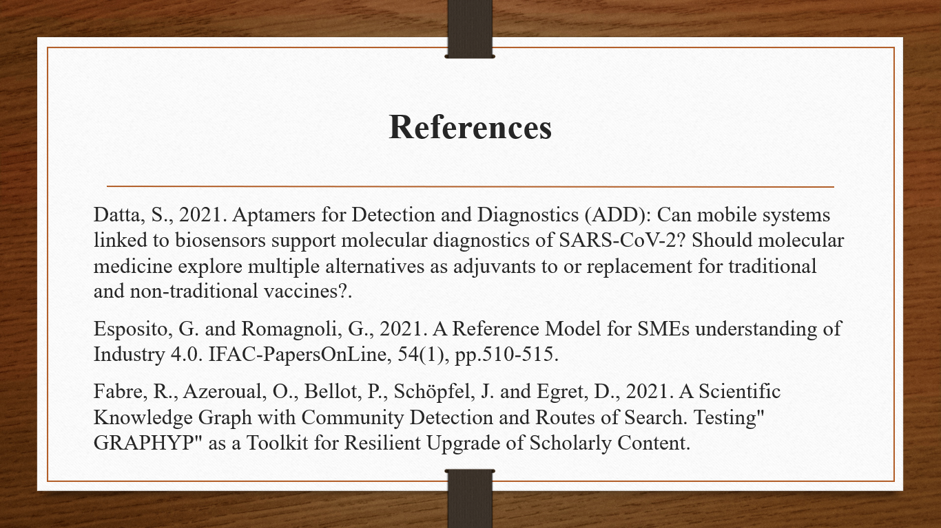

Jain, S., 2021. Understanding Semantics-Based Decision Support. CRC Press.
Kallio, A., 2021. A multi-case study of the analytical capabilities of Finnish e-commerce businesses: a resource-based view.
Lezoche, M., 2021. Formalisation models and knowledge extraction: Application to heterogeneous data sources in the context of the Industry of the Future (Doctoral dissertation, Université de Lorraine).
Lin, L., Athe, P., Rouxelin, P., Avramova, M., Gupta, A., Youngblood, R., Lane, J. and Dinh, N., 2021. Development and assessment of a nearly autonomous management and control system for advanced reactors. Annals of Nuclear Energy, 150, p.107861.
Pop, I.G., Badea, C.M., Jaradat, M.H., Văduva, S., Prisac, I., Talpoș, M.F. and Pop, I.E., 2021. Considerations about Sustainable Development of the ENSEC (Environmental-Social-Economic) Systems. Transdisciplinary MEN (Megawatt, Ecowatt, Negawatt) Eco-Energetic Paradigm. Modern Perspectives in Economics, Business and Management Vol. 3, pp.26-58.
Pritoni, M., Paine, D., Fierro, G., Mosiman, C., Poplawski, M., Saha, A., Bender, J. and Granderson, J., 2021. Metadata Schemas and Ontologies for Building Energy Applications: A Critical Review and Use Case Analysis. Energies, 14(7), p.2024.
Stürmer, M., Nussbaumer, J. and Stöckli, P., 2021. Security implications of digitalization: The dangers of data colonialism and the way towards sustainable and sovereign management of environmental data. arXiv preprint arXiv:2107.01662.
West, S., Zou, W., Rodel, E. and Stoll, O., 2021. Value Co-creation in Digitally-Enabled Product-Service Systems. In The Palgrave Handbook of Servitization (pp. 403-417). Palgrave Macmillan, Cham.
Zhang, L. and Lobov, A., 2021, July. Extending design automation by integrating external services for product design. In 2021 IEEE 19th International Conference on Industrial Informatics (INDIN) (pp. 1-6). IEEE.

