

Improving Effluent Management through Automation

by
Scott Thomas

Supervisor: Stephen Mosey

Project submitted as part of the requirements for the award of
BEng (Hons) Electrical and Electronics Engineering

October 2024

Table of Contents
Introduction 2
Aims & Objectives 2
Background 3
Literature Review 4
Legislation and Standards 4
Project Design 5
Data Collection Requirements 5
Upgrade Options 5
Conclusion on Options 7
Visual Representation 8
Resources 8
References 12
Appendix 1 14
Appendix 2 15

Table Of Figures
Figure 1 7
Figure 2 9
Figure 3 10
Figure 4 13
Figure 5 13
Figure 6 14
Figure 7 14
Figure 8 14
Figure 9 14
Figure 10 15
Figure 11 15

Introduction
This project aims to automate pumps at the effluent pumping station, addressing inefficiencies in the manual system that lead to equipment damage and lack of remote control. The goal is to enhance reliability, reduce the need for on-site operators, and improve overall efficiency, particularly in the manned No. 2 sump, in light of ongoing company restructuring. Ultimately, the aim is to ensure that the level of service from No. 2 sump will not be reduced despite the absence of on-site manning.

Aims & Objectives
The following are the aims and objectives for the project, structured using the SMART criteria. [1]
Specific aims:
- Integrate existing level transmitters (LTs) into the control setup for remote sump level indication.
- The PLC will regulate sump levels to a setpoint in automatic mode, maintaining levels within defined error bands.
- Ensure the ultimate stop float switch is part of the hardwired control system for reliability.
Achievable aims:
- Add a Man/Auto toggle for each pump on the HMI, allowing operators to easily switch modes.
- Control will utilize the highest level reading from two transmitters via a voting system for accuracy.
- If manual is selected on the HMI, operators will be able to start and stop pumps via buttons on the HMI.
Measurable aims:
- Equip each pump with an ultimate stop float switch to ensure operational safety.
- Each band will activate specific pumps, starting at the band boundary and stopping below the setpoint.
- When a pump is switched to remote mode, it will appear on the HMI for easy operation.
- Reduce operator time spent in No. 2 sump by 50% within six months of automation implementation.
Relevant aims:
- Introduce a PLC for automatic pump control, replacing outdated relay control systems to improve reliability.
- A pump will start when the PV exceeds a start point and will run until the level drops below a stop point.
- Maintain the level of service from No. 2 sump without on-site manning.
Time-bound aims:
- Enable remote mode switching via a MCC cabinet switch, controlled through the HMI, by the end of Q4 2024.
- Implement safety measures to halt all pumps if both level transmitters fail, requiring manual reset, by the end of Q1 2025.
- Complete the automation project by the end of Q2 2025 to align with company restructuring goals.

Background
The effluent management system at Tata Steel is crucial for treating water before it discharges into the Long Sea Outfall shown in Appendix 1 and an example of the control panel in Appendix 2 . Comprising twelve pumping sumps, No. 2 sump is essential for ensuring compliance with environmental standards monitored by Natural Resources Wales. Continuous monitoring of temperature, pH, and flow rate through SCADA / IFiX guarantees safety, activating alarms if pH levels deviate from the range of 6.5 to 9.5 or temperatures exceed 35°C. However, the current system’s simplistic on/off monitoring fosters inefficiencies. Operators in the manned pump house must frequently assess the sump's condition due to inadequate information. Malfunctions stemming from float switch issues necessitate manual intervention, resulting in significant resource wastage. Operators in No. 2 sump are tasked with logging all activities, including the duration of each task, using SAP for documentation. Given the reduction in manning, this project is imperative. A budget of approximately £20,000 has been allocated for the work, but every expenditure must be substantiated under the company's "drive to save" initiative. Furthermore, the organizational structure is slated to transform in the middle of 2025, underscoring the urgency for timely completion. Investing in advanced monitoring and automated controls for the No. 2 sump is vital for sustaining operational efficiency and safety, curtailing labour costs, and ensuring environmental compliance.

Literature Review
A literature review underscores both the advantages and challenges of automating effluent and wastewater management systems. Research indicates that automating pumping systems can significantly improve operational efficiency, reduce labour costs, and enhance compliance with environmental regulations.
Steelworks may seek innovative strategies to improve efficiency, comply with regulations, and reduce costs. Ahmed et al. (2023) identify barriers such as limited financial resources and insufficient stakeholder knowledge that can hinder this pursuit. Addressing these challenges is crucial for adopting advanced technologies that enhance sustainability and competitiveness. Research indicates that automation technologies can significantly improve operational efficiency and reliability. Automated systems reduce the frequency of human error and allow for real-time monitoring of critical parameters. This is particularly relevant in effluent management, where maintaining compliance with environmental standards is crucial. The ability to automate routine tasks not only increases reliability but also optimizes resource allocation. [2] [3]

Legislation and Standards
This project will need to comply with the relevant legislation and standards, examples including:
- Water Resources Act 1990 [4]
- The Electricity at Work Regulations 1989 [5]
- Health and Safety at work Act 1974 [6]
- COSHH [7]
- Site Standards – ESI 7 (Low voltage rules)

Project Design
I have been appointed to manage the project, overseeing design and installation with a dedicated team. Bi-weekly meetings will track progress. I proposed a cost-effective solution utilising existing infrastructure and internal electrical personnel, significantly reducing costs. Given the critical role of the pumps, a comprehensive plan is essential before upgrades. We will upgrade one pump at a time to minimize disruptions, although this may extend the overall timeline.

Data Collection Requirements
Data collection before and after the upgrades will focus on productivity and efficiency, with key metrics including:
- Downtime
- Operator time at No. 2 sump
- Engineering time (faults)
- Engineering costs
- Operation time of pumps
- Input and output from No. 2 sump
This data will be logged and analysed through SAP for work planning and fault recording. Lean Six Sigma methodologies will enhance performance by improving workflows and identifying root causes. A quantitative analysis will support decisions on operational changes and upgrades, with historical data serving as benchmarks. [8] [9]

Upgrade Options
Several upgrade options are available, differing by approximately £1,900 per pump, totalling around £9,500 for the project:
Option 1:
- Overview: Uses overload and auxiliaries with normally open/closed contacts for the PLC.
- Cost: Affordable, lowering initial investment.
- Data Collection: Limited capabilities may hinder pump performance monitoring.
- Control Interface: Retains current HMI (Red Lion) and button layout, simplifying upgrades but lacking advanced features.
- Integration: Uses existing level transmitters and float switches, reducing costs but potentially limiting functionality.
Risks:
- Limited Data: Insufficient monitoring could lead to undetected issues and increased downtime.
- Outdated Components: May hinder future upgrades.
- Inefficiency: More manual checks increase labour costs.
- Fault Response: Delays could risk environmental compliance.
Option 2:
- Overview: Employs overload and contactor with Ethernet connectivity.
- Cost: Higher initial cost but offers extensive data collection.
- Data Collection: Enables monitoring of line voltages, current, and power factor for better decision-making.
- Control Interface: Upgrades front panel and HMI screen, enhancing usability.
- Integration: Installs accurate level transmitters and ultimate stop float switches for improved reliability.
Risks:
- Higher Costs: Increased investment may face budget resistance.
- Installation Complexity: Advanced technology may extend installation time and disrupt operations.
- Training Needs: Staff may require training for new features, adding costs.
- Compatibility Issues: New systems may conflict with existing infrastructure, causing delays.

Conclusion on Options
Both options have distinct advantages. Option 1 is cost-effective but may limit data collection and monitoring capabilities. In contrast, Option 2, while pricier, offers significant benefits in operational insight and efficiency. The final decision will need to balance these factors to ensure the best outcome for the project.
Risks Management
- Project Timeline: Delays could extend completion beyond the mid-2025 restructuring deadline.
- Regulatory Compliance: Non-compliance during upgrades may result in fines.
- Operational Disruption: Incremental upgrades could impact productivity.
- Stakeholder Expectations: Unmet results might affect future support for initiatives.
Mitigation Strategies
- Conduct thorough risk assessments during planning.
- Establish contingency budgets for unforeseen costs.
- Develop training programs for staff on new systems.
- Create a detailed project timeline with buffers for delays.

Visual Representation
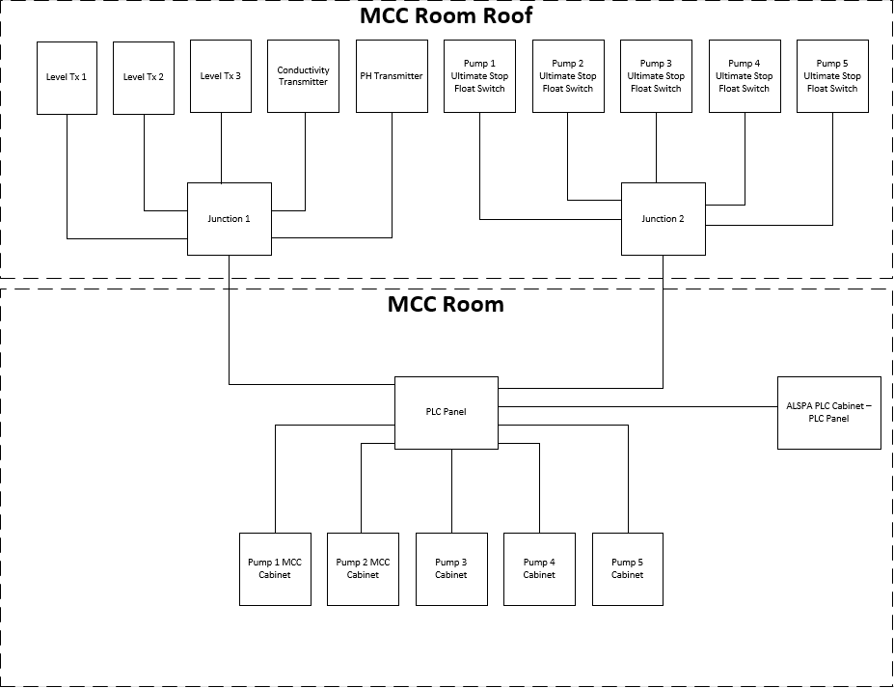
Image 1 is a single line diagram (SLD) providing a clear overview of the proposed plan, serving as a valuable tool for understanding the system layout.
Figure 1

Resources
The project requires substantial resources, but to align with cost-saving efforts, this is an item list of the proposed budget for initial parts for two pumps. Many components are packaged in sets, allowing some items to be used for the entire project. The total cost for this proposed budget, which includes 624 items, is £10,147.80. Additionally, the proposed labour includes two weeks of installation work per pump. This demonstrates that the work can be completed within the overall budget of £20,000.
The hardware for this project includes the physical components necessary for the two pumps, such as sensors, valves, and the PLC. Some of the components and equipment will be site standard, limiting options for selection. Materials will be sourced from two main contractors to ensure quality and reliability. The company has also considered the environmental impacts of the project, aiming to minimize any adverse effects.
For the software aspect, Studio 5000 will be used to program the PLC. This approach streamlines the design process by addressing the specific needs of various tasks.
The list of proposed items to order is shown below in Image 2:
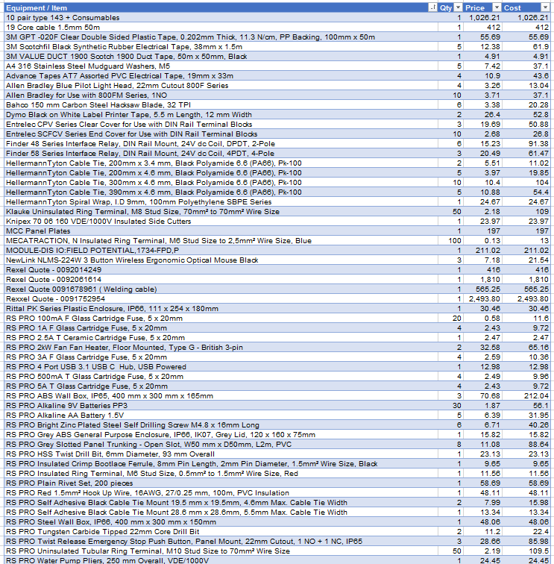
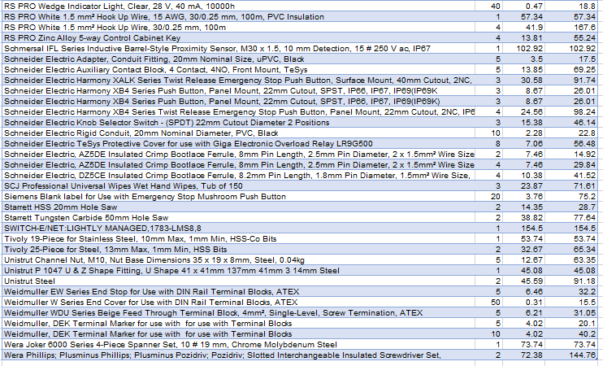
Figure 2
Project Plan
To ensure the project runs smoothly, a Gantt chart will track progress and provide a visual timeline of tasks, helping to manage resources and deadlines effectively. Several key stages must be completed before any isolations occur, including:
- Panel construction
- Installation of power, control, and Ethernet cables
- Completion of any prefabrication work
This strategy aims to minimize downtime, as at least four pumps need to be operational at all times. The Gantt chart will help coordinate these activities to ensure that critical milestones are met. Key milestones have been established, including:
- Completion of preparation work
- Key stakeholder meetings
- Pump outages
- PLC installation
- HMI modifications
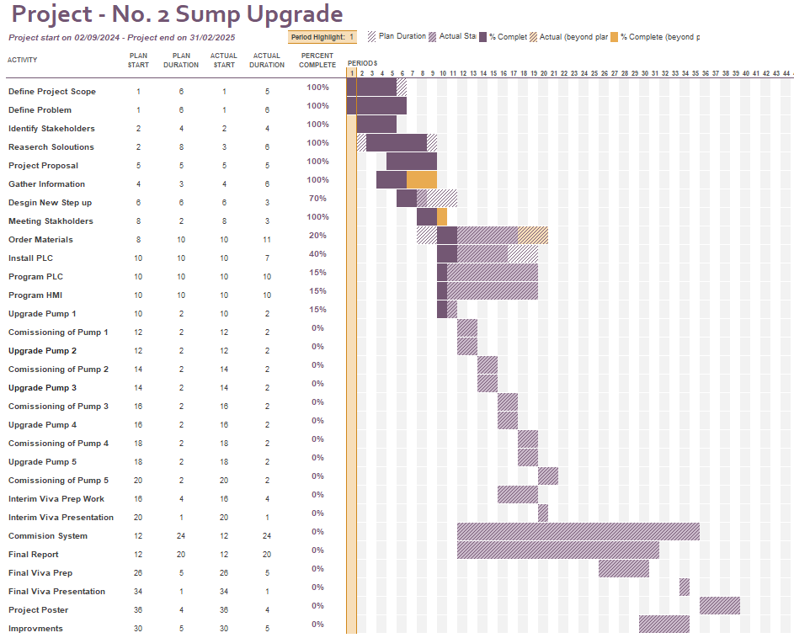
- Final connections
Figure 3

References

[1] | K. Boogaard, “www.atlassian.com,” 26 12 2023. [Online]. Available: https://www.atlassian.com/blog/productivity/how-to-write-smart-goals#:~:text=The%20SMART%20in%20SMART%20goals,within%20a%20certain%20time%20frame.. [Accessed 01 10 2024].
[2] | F. J. D. H. R. H. N. Ahmed, “Barriers to Innovation in Water Treatment,” Water 2023, vol. 15, no. 773, p. 11, 2023.
[3] | E. B. M. T. S. Filippi, “Automation technologies and their impact on employment: A review, synthesis and future research agenda,” Technological Forecasting and Social Change, vol. 191, p. 21, 2023.
[4] | Legislation.gov.uk, “Legislation.gov.uk,” 01 10 2024. [Online]. Available: https://www.legislation.gov.uk/ukpga/1991/57/contents. [Accessed 01 10 2024].
[5] | HSW, “hse.gov.uk/pubns/books/hsr25.htm,” 01 10 2015. [Online]. Available: https://www.hse.gov.uk/pubns/books/hsr25.htm. [Accessed 05 10 2024].
[6] | HSE, “https://www.legislation.gov.uk/ukpga/1974/37/contents,” 05 10 2024. [Online]. Available: https://www.hse.gov.uk/legislation/hswa.htm. [Accessed 05 10 2024].
[7] | HSE, “https://www.hse.gov.uk/coshh/,” 06 10 2024. [Online]. Available: https://www.hse.gov.uk/coshh/. [Accessed 06 10 2024].
[8] | Australian Bureau of Statistics, “abs,” 02 10 2024. [Online]. Available: https://www.abs.gov.au/statistics/understanding-statistics/statistical-terms-and-concepts/quantitative-and-qualitative-data#:~:text=Quantitative%20data%20are,how%20much%20or%20how%20often).. [Accessed 02 10 2024].
[9] | W. Kenton, “www.investopedia.com,” 01 07 2024. [Online]. Available: https://www.investopedia.com/terms/l/lean-six-sigma.asp#:~:text=Lean%20Six%20Sigma%20seeks%20to,Six%20Sigma%20and%20Lean%20enterprise.. [Accessed 04 10 2024].

Appendix 1
The images below depict the Abbey No. 2 sump pumphouse and the Long Sea Outfall (LSO).
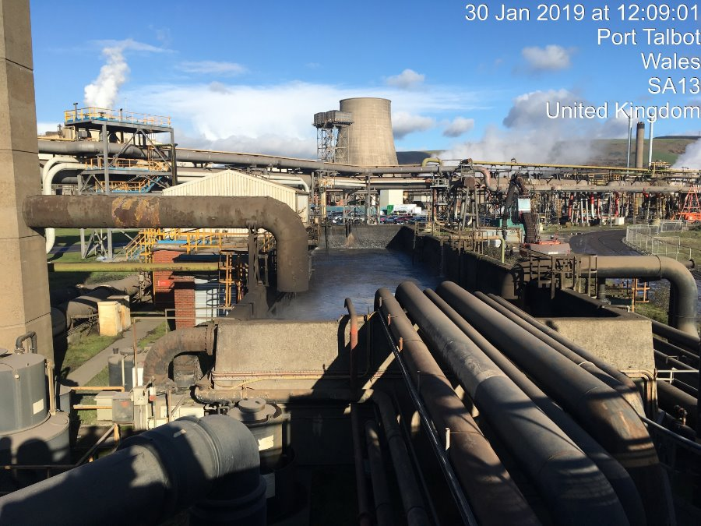
Figure 4

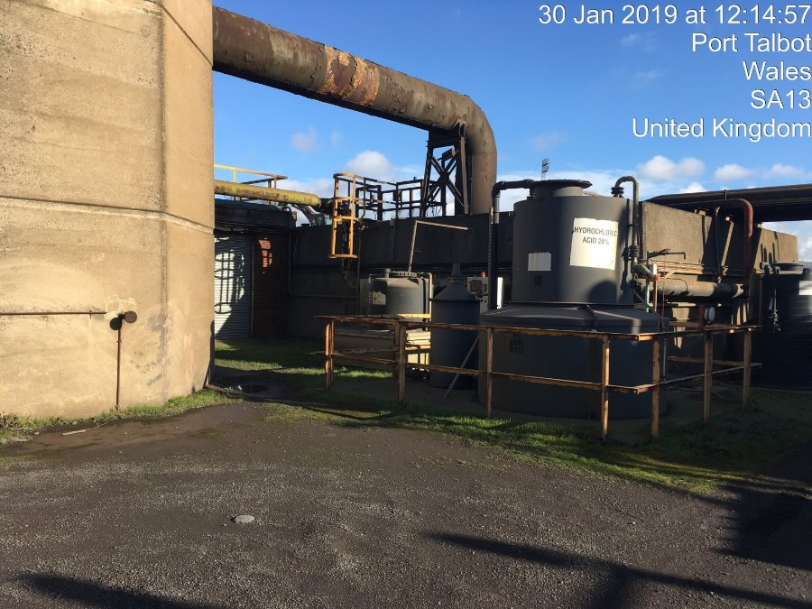
Figure 5


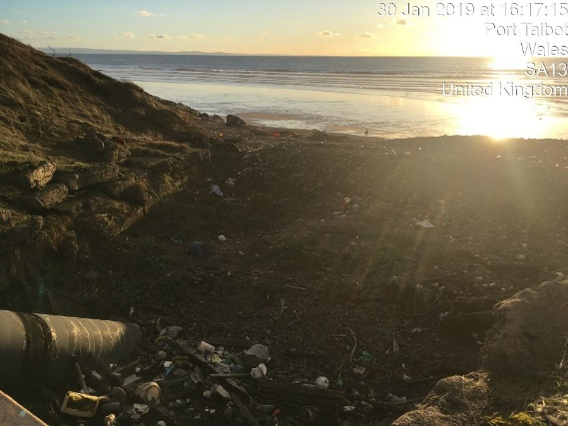
Figure 6
Figure 7

Appendix 2
Below are images of the control panel at No.2 sump.
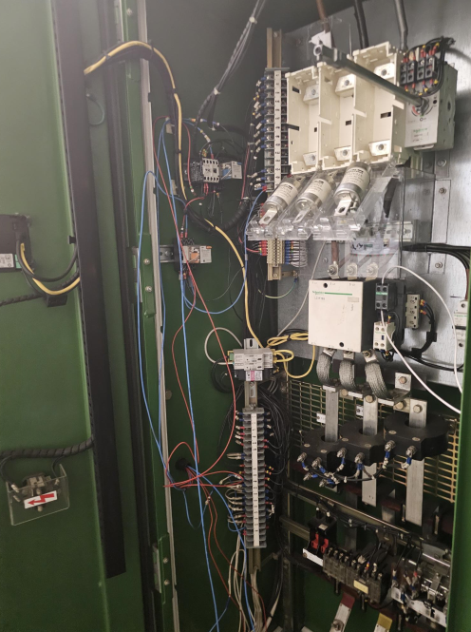
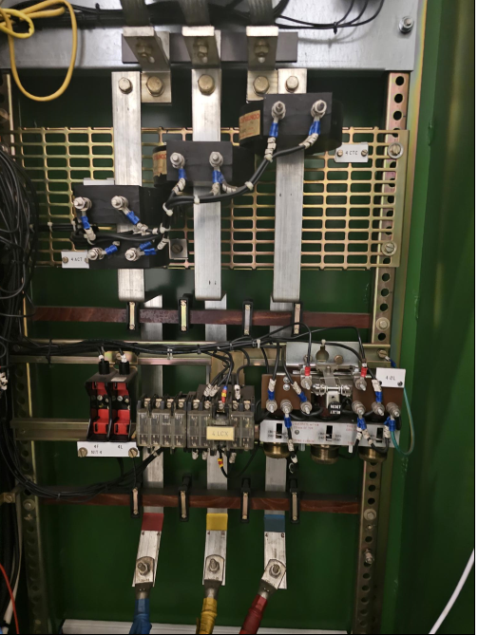
Figure 8
Figure 9

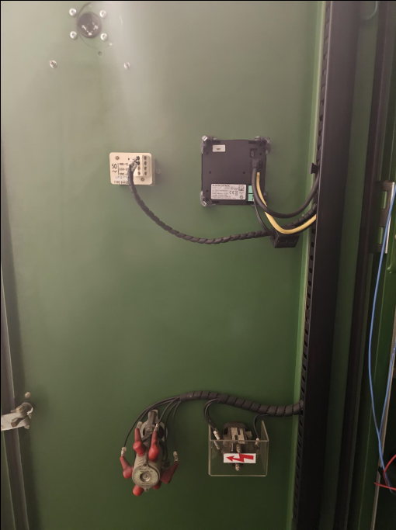
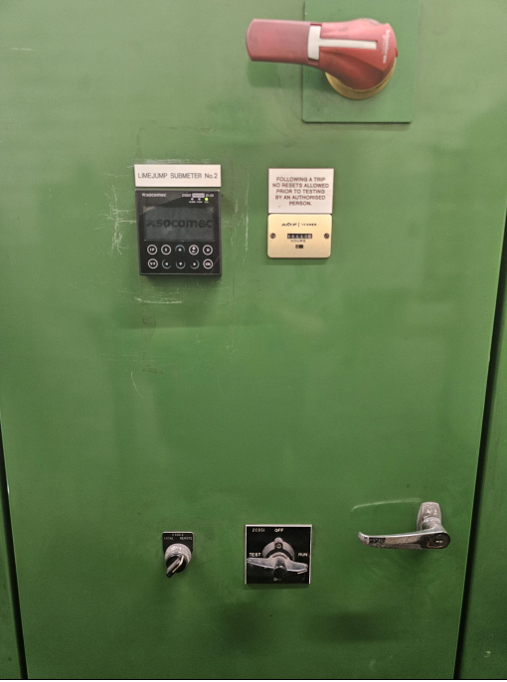
Figure 10
Figure 11

