Academic skills and employment skills
For the purposes of this review, we use "academic skills development" as an umbrella term to encompass interventions aimed at enhancing students' capabilities for academic study, whether focused on general study strategies, English language proficiency, or discipline-specific literacies. However, we recognise debates around these terms and aim to be sensitive to different theoretical orientations. Our broad conception aligns with BlajWard's (2022) definition of "academic literacies provision" as learning activities designed to facilitate fuller academic experiences for students, increasing awareness of academic communication while developing language proficiency. Like Blaj-Ward, we see value in drawing on multiple strands of scholarship - including applied linguistics, language learning pedagogy, and higher education research - to inform effective academic support that is responsive to diverse student needs and aspirations. [1]
These activities encourage the learner to concentrate on learning activities and tasks, spend more time learning, use efficient studying and learning strategies, and enjoy the help of others when needed, thus facilitating the achievement of academic goals. [2]

employment skills

References

[1] | J. d. Henau, “university of Oxford,” Octomber 2024. [Online]. Available: https://www.ctl.ox.ac.uk/sites/default/files/ctl/documents/media/academic_skills_literature_review.pdf. [Accessed 25 June 2026].
[2] | Fatemeh Kordsalarzehi, Sajad Salehipour, Mahsa Asadollahi Hamedani , Rokhsare Zarei Jahromi , Azizollah Arbabisarjou , Mahnaz Ghaljeh, “National Library of Medicine,” 28 February 2025. [Online]. Available: https://pmc.ncbi.nlm.nih.gov/articles/PMC11940016/. [Accessed 25 June 2026].

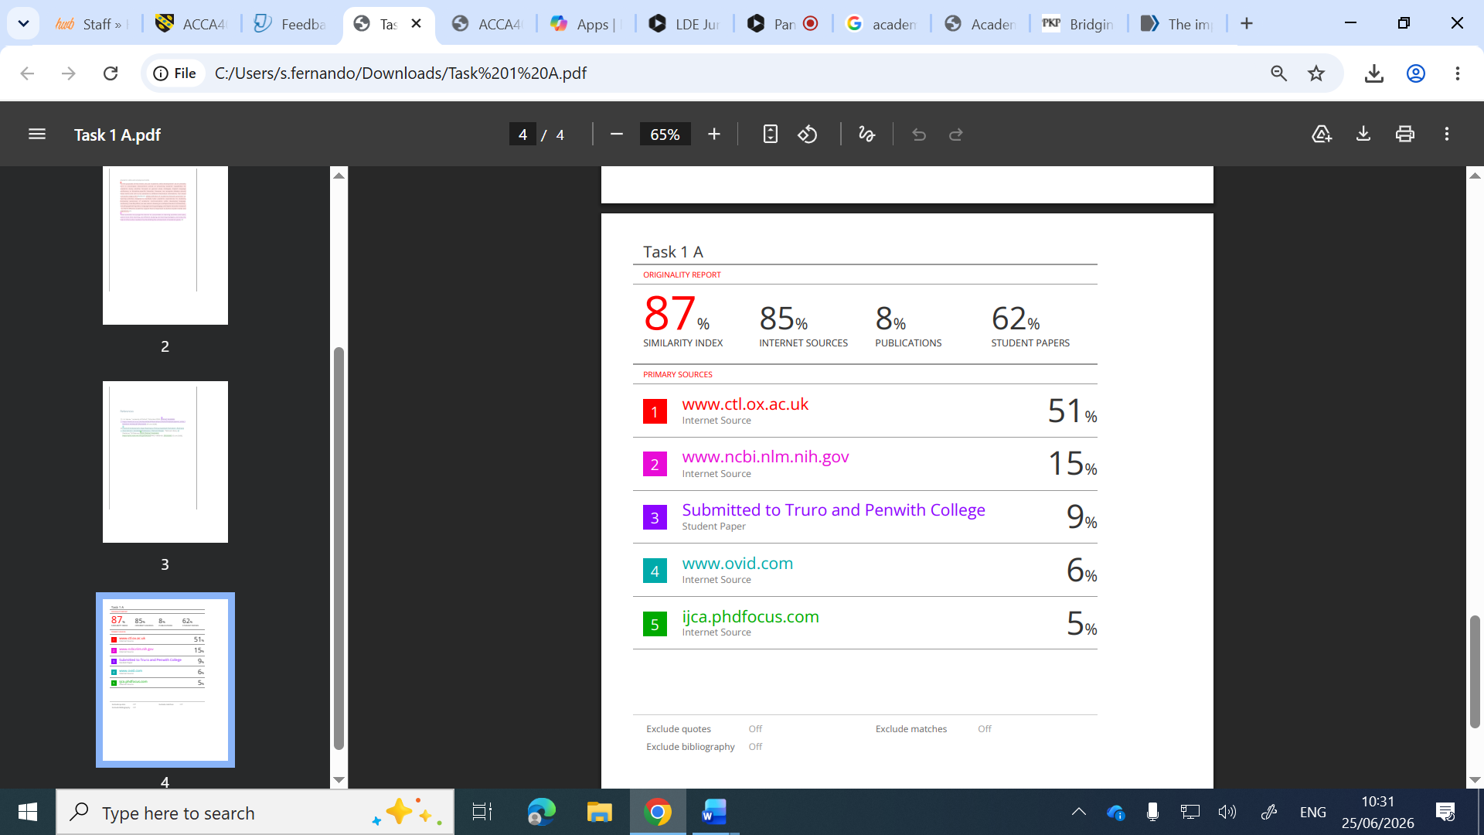
Self Evaluation
According to my report the similarity percentage is 87%. 85% coming from Internet source, 8% coming from publications, 62% coming from student papers which is not acceptable. In this article there are five sources used. Each source the similarity percentage is more than 5%. The standard similarity percentage from each source should be less than 5%.

