APPLICATION FOR ETHICAL APPROVAL

RESEARCH STUDENTS
This form is to be completed by the student within SIX months for full-time students and TWELVE months for part time students, after the commencement of the research degree or following progression to Part Two of your course.

Once complete, submit this form via the MyTSD Doctoral College Portal at (https://mytsd.uwtsd.ac.uk).

This document is also available in Welsh.

RESEARCH STAFF ONLY
All communications relating to this application during its processing must be in writing and emailed to pgresearch@uwtsd.ac.uk , with the title ‘Ethical Approval’ followed by your name.

STUDENTS ON UNDERGRADUATE OR TAUGHT MASTERS PROGRAMMES should submit this form (and receive the outcome) via systems explained to you by the supervisor/module leader.

In order for research to result in benefit and minimise risk of harm, it must be conducted ethically. A researcher may not be covered by the University’s insurance if ethical approval has not been obtained prior to commencement.

The University follows the OECD Frascati manual definition of research activity: “creative work undertaken on a systematic basis in order to increase the stock of knowledge, including knowledge of man, culture and society, and the use of this stock of knowledge to devise new applications”. As such this covers activities undertaken by members of staff, postgraduate research students, and both taught postgraduate and undergraduate students working on dissertations/projects.

The individual undertaking the research activity is known as the “principal researcher”.

Ethical approval is not required for routine audits, performance reviews, quality assurance studies, testing within normal educational requirements, and literary or artistic criticism.

Please read the notes for guidance before completing ALL sections of the form.

This form must be completed and approved prior to undertaking any research activity. Please see Checklist for details of process for different categories of application.

SECTION A: About You (Principal Researcher)
1 | Full Name: |  | Eden Mainwaring
2 | Tick all boxes that apply: |  | Member of staff: | ☐ | Honorary research fellow: | ☐
 | Undergraduate Student | ☒ | Taught Postgraduate Student | ☐ | Postgraduate Research Student | ☐

3 | Institute/Academic Discipline/Centre: | University of Wales Trinity Saint David
4 | Campus: | IQ
5 | E-mail address: | 2103222@student.uwtsd.ac.uk
6 | Contact Telephone Number:
 | For students:
7 | Student Number: | 2103222
8 | Programme of Study: | BSc Psychology and Counselling
9 | Director of Studies/Supervisor: | Zoe Cooke

SECTION B: Approval for Research Activity
1 | Has the research activity received approval in principle?  (please check the Guidance Notes as to the appropriate approval process for different levels of research by different categories of individual) |  | YES | ☒ | NO | ☐
 |  |  |  |  | Date
2 | If Yes, please indicate source of approval (and date where known): Approval in principle must be obtained from the relevant source prior to seeking ethical approval | Research Degrees Committee |  | ☐
2 |  | Institute Research Committee |  | ☐
2 |  | Other (write in) |  | ☒ | Supervisor: Zoe Cooke 3/11/23

SECTION C: Internal and External Ethical Guidance Materials
 | Please list the core ethical guidance documents that have been referred to during the completion of this form (including any discipline-specific codes of research ethics, location-specific codes of research ethics, and also any specific ethical guidance relating to the proposed methodology). Please tick to confirm that your research proposal adheres to these codes and guidelines. You may add rows to this table if needed.
1 | UWTSD Research Ethics & Integrity Code of Practice | ☒
2 | UWTSD Research Data Management Policy | ☒
3 | BPS Code of Ethics and Conduct December 2021,  BPS Code of Human Research Ethics  BPS Data Protection Regulation – Guidance for researchers  BPS Ethics Guidelines for Internet-mediated Research | ☒

SECTION D: External Collaborative Research Activity
If there are external collaborators then you should gain consent from the contact persons to share their personal data with the university. If there are no external collaborators then leave this section blank and continue to section E.
1 | Institution
2 | Contact person name
3 | Contact person e-mail address
4 | Is your research externally funded? |  | YES | ☐ | NO |  | ☐
5 | Are you in receipt of a KESS scholarship? |  | YES | ☐ | NO |  | ☐
6 | Are you specifically employed to undertake this research in either a paid or voluntary capacity? | Voluntary | YES | ☐ | NO | ☐
7 |  | Employed | YES | ☐ | NO | ☐
8 | Is the research being undertaken within an existing UWTSD Athrofa Professional Learning Partnership (APLP)? | If YES then the permission question below does not need to be answered. | YES | ☐ | NO |  | ☐
9 | Has permission to undertake the research has been provided by the partner organisation? | (If YES attach copy)  If NO the application cannot continue | YES | ☐ | NO |  | ☐

Where research activity is carried out in collaboration with an external organisation
10 | Does this organisation have its own ethics approval system? | YES | ☐ | NO | ☐
 | If Yes, please attach a copy of any final approval (or interim approval) from the organisation (this may be a copy of an email if appropriate).

SECTION E: Details of Research Activity
1 | Indicative title: | Exploring the relationship between attitudes towards women and attitudes towards women’s sports
2 | Proposed start date: | 27th November | Proposed end date: | March 2024
Introduction to the Research (maximum 300 words per section)
Ensure that you write for a Non-Specialist Audience when outlining your response to the points below:
- Purpose of Research Activity
- Proposed Research Question
- Aims of Research Activity
- Objectives of Research Activity
Demonstrate, briefly, how Existing Research has informed the proposed activity and explain
- What the research activity will add to the body of knowledge
- How it addresses an area of importance.
3 | Purpose of Research Activity  The purpose of this study is to find out whether participants attitude towards women correlates to the participants attitudes towards women’s sports.  Over time attitudes towards women have changed as society has become more egalitarian. A study was conducted using the attitudes towards women scale (Spence & Helmreich, 1972) a study looked into the social climate change of attitudes towards women from the 1970s to the 1990s. In this study, mens scores showed a trend which correlated with liberal/feminist attitudes of the time. (Twenge, 2006) This shows that attitudes can change.  In this day in age a lot of media exploits women’s sexuality to sell products and to entice viewers into their advertisements. Another study examined the impact of seeing sex images and advertisements on attitudes toward feminism and the women’s movement. The results of the study suggested that those seeing sexual imagery and advertisements also showed lower acceptance of feminism (MacKay & Covell, 1997)  Media coverage has a big influence on opinions, specifically with those who do not have personal experience when it comes to the topic, meaning, men who do not have close relationships with women will have a warped opinion of them. As media coverage of women’s sport is not common, and in relation to coverage of men’s sports is much less, attitudes towards women’s sports is much less positive. A study conducted in the US predicted exposure to women’s sports and positive coverage in the media will increase an individuals interest and decrease their prejudice towards female athletes did significantly decrease after 3 weeks. (Scheadler & Wagstaff, 2018)  A lot of opinions on women’s sports have to do with women not fitting into ‘feminine roles’, meaning that women are not seen as feminine and are seen more masculine, which in turn means that women are treated with less respect based on how they look. Another study assessed peers opinions on ‘masculine’ and ‘feminine’ traits of participants of male and female-oriented sports, by being presented with a description of the participant. The results of the study revealed that common stereotypes do have an affect on how an individual is treated by their peers and whether or not they participate in sports based on how they will be perceived. (Alley & Hicks, 2005)  Another study conducted in the US looked into young children’s attitudes towards female involvement in sports. To do this a questionnaire was administered to the students. The results indicated that females of all ages and participation levels had significantly more positive attitudes compared to the male participants. (Selby & Lewko, 2013) This study shows that bias can occur from a young age and is influenced by parents and adults around the individual as well as media and taking in information such as newspaper articles etc.  The rationale for this study is that those with positive views towards women and feminism are more likely to have positive views towards women’s sports, because the overall consensus of individuals with these beliefs is that women’s sports will be equal to men’s sports.  (this box should expand as you type)
4 | Research Question  What is the relationship between students’ attitudes towards women and women’s sports?  (this box should expand as you type)
5 | Aims of Research Activity  The aim of this study is to find out whether there is a relationship between attitudes towards women and attitudes towards women’s sports.  (this box should expand as you type)
6 | Objectives of Research Activity  The objective for this study is to find out whether there is a relationship between student’s attitudes towards women and women’s sports.  (this box should expand as you type)
Proposed methods (maximum 600 words)
Provide a brief summary of all the methods that may be used in the research activity, making it clear what specific techniques may be used. If methods other than those listed in this section are deemed appropriate later, additional ethical approval for those methods will be needed. You do not need to justify the methods here, but should instead describe how you intend to collect the data necessary for you to complete your project.
7 | To gain participants for this study, the participant will sign up online through the experiment management system (EMS) and will be available to psychology students from the university.  For this study, the first method of data collection will be a demographics questionnaire asking for the age and gender of the participant.  They will be presented with a consent form, this form will also let the participant know that their information can be withdrawn if needed.  Two questionnaires will be administered to find participants attitudes on a specific topic. These questionnaires will be presented to the participants online, through EMS.  The questionnaires that will be used in this study will be the attitudes towards women scale (ATWS) (Spence, Helmreich & Stapp, 1978) which consists of 25 questions focused on attitudes towards women with different scenarios. For example ‘swearing and obscenity are more repulsive in the speech of a women than of a man’ or ‘sons in the family should be given more encouragement to go to college than daughters.’ To answer these statements the participant will answer on a scale with 5 parts, strongly disagree, slightly disagree, neither agree nor disagree, slightly agree and strongly agree.  The participants will also be administered another questionnaire to find their attitudes towards women’s sports. The questionnaire used for this will be the attitudes towards women’s sports scale (ATWSS, Mumcu & Marley, 2017) This is a 34-item scale which evauates the participants attitudes with eight subscales: excitement, opportunity for women, accessibility, aesthetic, affect, drama, entertainment value and athlete quality.  At the end of the study the participants will be presented with an online debrief where they will be given information about the purpose of the study, and contact details with myself and the supervisor of the study.  (this box should expand as you type)
Location of research activity
Identify all locations where research activity will take place.
8 | Online  (this box should expand as you type)
Research activity outside of the UK
If research activity will take place overseas, you are responsible for ensuring that local ethical considerations are complied with and that the relevant permissions are sought. Specify any local guidelines (e.g. from local professional associations/learned societies/universities) that exist and whether these involve any ethical stipulations beyond those usual in the UK (provide details of any licenses or permissions required). Also specify whether there are any specific ethical issues raised by the local context in which the research activity is taking place, for example, particular cultural and/or legal sensitivities or vulnerabilities of participants. If you live in the country where you will do the research then please state this.
9 | N/A  (this box should expand as you type)

10 | Use of documentation not in the public domain: Are any documents NOT publicly available? | NO | ☒
10 |  | YES | ☐
11 | If Yes, please provide details here of how you will gain access to specific documentation that is not in the public domain and that this is in accordance with the current data protection law of the country in question and that of England and Wales.  (this box should expand as you type)

 | Does your research relate to one or more of the seven aims of the Well-being of Future Generations (Wales) Act 2015? | YES | NO
12 | A prosperous Wales | ☐ | ☒
13 | A resilient Wales | ☐ | ☒
14 | A healthier Wales | ☐ | ☒
15 | A more equal Wales | ☐ | ☒
16 | A Wales of cohesive communities | ☐ | ☒
17 | A Wales of vibrant culture and thriving Welsh language | ☐ | ☒
18 | A globally responsible Wales | ☐ | ☒
19 | If YES to any of the above, please give details:
 | (this box should expand as you type)

SECTION F: Scope of Research Activity
 | Will the research activity include: | YES | NO
1 | Use of a questionnaire or similar research instrument? | ☒ | ☐
2 | Use of interviews? | ☐ | ☒
3 | Use of focus groups? | ☐ | ☒
4 | Use of participant diaries? | ☐ | ☒
5 | Use of video or audio recording? | ☐ | ☒
6 | Use of computer-generated log files? | ☒ | ☐
7 | Participant observation with their knowledge? | ☐ | ☒
8 | Participant observation without their knowledge? | ☐ | ☒
9 | Access to personal or confidential information without the participants’ specific consent? | ☐ | ☒
10 | Administration of any questions, test stimuli, presentation that may be experienced as physically, mentally or emotionally harmful / offensive? | ☐ | ☒
11 | Performance of any acts which may cause embarrassment or affect self-esteem? | ☐ | ☒
12 | Investigation of participants involved in illegal activities? | ☐ | ☒
13 | Use of procedures that involve deception? | ☐ | ☒
14 | Administration of any substance, agent or placebo? | ☐ | ☒
15 | Working with live vertebrate animals? | ☐ | ☒
16 | Procedures that may have a negative impact on the environment? | ☐ | ☒
17 | Other primary data collection methods. Please indicate the type of data collection method(s) below. | ☐ | ☒
 | Details of any other primary data collection method:  (this box should expand as you type) | ☐ | ☒
If NO to every question, then the research activity is (ethically) low risk and may be exempt from some of the following sections (please refer to Guidance Notes).

If YES to any question, then no research activity should be undertaken until full ethical approval has been obtained.

SECTION G: Intended Participants
If there are no participants then do not complete this section, but go directly to section H.

 | Who are the intended participants: | YES | NO
1 | Students or staff at the University? | ☒ | ☐
2 | Adults (over the age of 18 and competent to give consent)? | ☐ | ☒
3 | Vulnerable adults? | ☐ | ☒
4 | Children and Young People under the age of 18? (Consent from Parent, Carer or Guardian will be required) | ☐ | ☒
5 | Prisoners? | ☐ | ☒
6 | Young offenders? | ☐ | ☒
7 | Those who could be considered to have a particularly dependent relationship with the investigator or a gatekeeper? | ☐ | ☒
8 | People engaged in illegal activities? | ☐ | ☒
9 | Others. Please indicate the participants below, and specifically any group who may be unable to give consent. | ☐ | ☒
 | Details of any other participant groups:  (this box should expand as you type) | ☐ | ☒

Participant numbers and source
Provide an estimate of the expected number of participants. How will you identify participants and how will they be recruited?
10 | How many participants are expected? | Around 30 participants are needed for Spearmans rank correlation.  (this box should expand as you type)
11 | Who will the participants be? | The participants will be adults over 18, drawn from the student population, studying within the psychology department of UWTSD.  (this box should expand as you type)
12 | How will you identify the participants? | Participants will be recruited through the departments Experiment Management System (EMS). In exchange for EMS credits.  (this box should expand as you type)

 | Information for participants: | YES | NO | N/A
13 | Will you describe the main research procedures to participants in advance, so that they are informed about what to expect? | ☒ | ☐ | ☐
14 | Will you tell participants that their participation is voluntary? | ☒ | ☐ | ☐
15 | Will you obtain written consent for participation? | ☐ | ☒ | ☐
16 | Will you explain to participants that refusal to participate in the research will not affect their treatment or education (if relevant)? | ☒ | ☐ | ☐
17 | If the research is observational, will you ask participants for their consent to being observed? | ☐ | ☐ | ☒
18 | Will you tell participants that they may withdraw from the research at any time and for any reason? | ☒ | ☐ | ☐
19 | With questionnaires, will you give participants the option of omitting questions they do not want to answer? | ☒ | ☐ | ☐
20 | Will you tell participants that their data will be treated with full confidentiality and that, if published, it will not be identifiable as theirs? | ☒ | ☐ | ☐
21 | Will you debrief participants at the end of their participation, in a way appropriate to the type of research undertaken? | ☒ | ☐ | ☐
22 | If NO to any of above questions, please give an explanation
Consent will be obtained via tick boxes on Qualtrics following the information sheet. Participants will be asked to confirm they have read and understood the study information sheet and are happy to proceed.

(this box should expand as you type)

 | Information for participants: | YES | NO | N/A
24 | Will participants be paid? | ☐ | ☒ | ☐
25 | Is specialist electrical or other equipment to be used with participants? | ☐ | ☒ | ☐
26 | Are there any financial or other interests to the investigator or University arising from this study? | ☐ | ☒ | ☐
27 | Will the research activity involve deliberately misleading participants in any way, or the partial or full concealment of the specific study aims? | ☐ | ☒ | ☐
28 | If YES to any question, please provide full details
 | (this box should expand as you type)

SECTION H: Anticipated Risks

Outline any anticipated risks that may adversely affect any of the participants, the researchers and/or the University, and the steps that will be taken to address them.

If you have completed a full risk assessment (for example as required by a laboratory, or external research collaborator) you may append that to this form.
1 | Full risk assessment completed and appended? |  | Yes | ☐
1 |  |  | No | ☒
2 | Risks to participants  For example: sector-specific health & safety, emotional distress, financial disclosure, physical harm, transfer of personal data, sensitive organisational information
 | Risk to participants:  This study has a low risk to participants, as participants will be filling out an online questionnaire from home, no physical harm or sector-specific health and safety. It may cause some distress as the study is on the topic of prejudice and social bias towards women, to women themselves if they have strong opinions, and previous negative experiences with the subject.  (this box should expand as you type) | How you will mitigate the risk to participants:  To minimise the risk, the participants will know the topic of the study before participating, and if the topic is too personal, they will be able to not take part.  No information will be hidden from the participant, so the participant will know all the details before taking part so they will be prepared.  If the study does cause harm, emotionally to the participant, there will be contact details to the investigator and to the study supervisor, who can help them with any questions or queries they have.  (this box should expand as you type)
3 | If research activity may include sensitive, embarrassing or upsetting topics (e.g. sexual activity, drug use) or issues likely to disclose information requiring further action (e.g. criminal activity), give details of the procedures to deal with these issues, including any support/advice (e.g. helpline numbers) to be offered to participants. Note that where applicable, consent procedures should make it clear that if something potentially or actually illegal is discovered in the course of a project, it may need to be disclosed to the proper authorities
N/A

(this box should expand as you type)
4 | Risks to the investigator  For example: personal health & safety, physical harm, emotional distress, risk of accusation of harm/impropriety, conflict of interest
 | Risk to the investigator:  There is no anticipated risks to the investigator.  (this box should expand as you type) | How you will mitigate the risk to the investigator:  Any accusations or risks that come up will be shared with the supervisor, although there is no face to face interaction with the investigator, so the risk of this happening is low.  (this box should expand as you type)
5 | University/institutional risks  For example: adverse publicity, financial loss, data protection
 | Risk to the University:  The information in this study will be password protected and will only be accessed by the investigator and study supervisor.  No personal data is conducted for this study, other than age and gender.  There is no other anticipated risks to the university.  (this box should expand as you type) | How you will mitigate the risk to the University:  To minimise the risk, the participants will know the topic of the study, before participating, and if the topic is too personal, they will be able to not take part.  No information will be hidden from the participant, so the participant will know all the details before taking part, so they will be prepared.  If the study does cause harm, emotionally to the participant, there will be contact details to the investigator and to the study supervisor, who can help them with any questions or queries they have.  (this box should expand as you type)
6 | Environmental risks  For example: accidental spillage of pollutants, damage to local ecosystems
 | Risk to the environment:  N/A  (this box should expand as you type) | How you will mitigate the risk to environment:  N/A  (this box should expand as you type)

 | Disclosure and Barring Service
 | If the research activity involves children or vulnerable adults, a Disclosure and Barring Service (DBS) certificate must be obtained before any contact with such participants. | YES | NO | N/A
7 | Does your research require you to hold a current DBS Certificate? | ☐ | ☒ | ☐
8 | If YES, please give the certificate number. If the certificate number is not available please write “Pending”; in this case any ethical approval will be subject to providing the appropriate certificate number.

SECTION I: Feedback, Consent and Confidentiality

1 | Feedback  What de-briefing and feedback will be provided to participants, how will this be done and when?
Once the study is conducted the participant will be provided a debrief sheet on the screen which tells them all the details of the study. Specifically, that the questionnaires from this study will explore their attitudes towards women and their attitudes towards women’s sport. On this debrief form they will be given contact details to the investigator and to the study supervisor. They will be told that once they have answered the questionnaire and submitted their responses they will not be able to retract their data, however if they would like to retract it they can close the browser before clicking the final arrow.

(this box should expand as you type)
2 | Informed consent  Describe the arrangements to inform potential participants, before providing consent, of what is involved in participating. Describe the arrangements for participants to provide full consent before data collection begins. If gaining consent in this way is inappropriate, explain how consent will be obtained and recorded in accordance with prevailing data protection legislation.
Before participating in this study, participants will have access to a brief description of the study through EMS. Once they have signed up they will be given a study information page. The study information sheet will state the aims of the study, which are to explore their attitudes towards women and women’s sports. They will be informed that their answers are completely anonymous and that there is no way of tracing their answers back to them. They will also be told they can stop the study at any time by closing the browser and their incomplete data will not be included in the analysis.

After this information, there will be tick boxes; of statements they must agree too, for example ‘tick if you have read and understood the study information and what will be asked of you. They will have to tick boxes to participate in the study. This will indicate their consent to taking part in the study.

(this box should expand as you type)
3 | Confidentiality / Anonymity  Set out how anonymity of participants and confidentiality will be ensured in any outputs. If anonymity is not being offered, explain why this is the case.
As this is an online study using Qualtrics, the data collected will be anonymous. Data will then be stored on a password protected computer file with only the researcher and supervisor having access. There will be no way of linking participants to their data as they will have signed up via EMS and only their age and gender will be collected.

(this box should expand as you type)

SECTION J: Data Protection and Storage

 | Does the research activity involve personal data (as defined by the General Data Protection Regulation 2016 “GDPR” and the Data Protection Act 2018 “DPA”)? | YES | NO
1 | “Personal data” means any information relating to an identified or identifiable natural person (‘data subject’). An identifiable natural person is one who can be identified, directly or indirectly, in particular by reference to an identifier such as a name, an identification number, location data, an online identifier or to one or more factors specific to the physical, physiological, genetic, mental, economic, cultural or social identity of that natural person. Any video or audio recordings of participants is considered to be personal data. | ✓ | ☐
 | If YES, provide a description of the data and explain why this data needs to be collected:
2 | Collecting information on age and gender. This will help in understanding those from different generations will have different values and attitudes.  (this box should expand as you type)
 | Does it involve special category data (as defined by the GDPR)? | YES | NO
3 | “Special category data” means sensitive personal data consisting of information as to the data subjects’ –  (a) racial or ethnic origin,  (b) political opinions,  (c ) religious beliefs or other beliefs of a similar nature,  (d) membership of a trade union (within the meaning of the Trade Union and Labour Relations (Consolidation) Act 1992),  (e) physical or mental health or condition,  (f) sexual life,  (g) genetics,  (h) biometric data (as used for ID purposes), | ☐ | ✓
 | If YES, provide a description of the special category data and explain why this data needs to be collected:
4 | (this box should expand as you type)

 | Will data from the research activity (collected data, drafts of the thesis, or materials for publication) be stored in any of the following ways? | YES | NO
5 | Manual files (i.e. in paper form)? | ☐ | ☒
6 | University computers? | ☒ | ☐
7 | Private company computers? | ☐ | ☒
8 | Home or other personal computers? | ☒ | ☐
9 | Laptop computers/ CDs/ Portable disk-drives/ memory sticks? | ☒ | ☐
10 | “Cloud” storage or websites? | ☐ | ☒
11 | Other – specify: | ☐ | ☒
12 | For all stored data, explain the measures in place to ensure the security of the data collected, data confidentiality, including details of backup procedures, password protection, encryption, anonymisation and pseudonymisation:
When participants sign up for the study, their name or personal information is not available to the researcher. When filling out the demographics form, the only information that will be asked of them will be their age and gender. Once the data collection is obtained, it will be password protected, this password will only be known by the investigator and the study supervisor.

(this box should expand as you type)

 | Data Protection
 | Will the research activity involve any of the following activities: | YES | NO
13 | Electronic transfer of data in any form? | ☒ | ☐
14 | Sharing of data with others at the University outside of the immediate research team? | ☐ | ☒
15 | Sharing of data with other organisations? | ☐ | ☒
16 | Export of data outside the UK or importing of data from outside the UK? | ☐ | ☒
17 | Use of personal addresses, postcodes, faxes, emails or telephone numbers? | ☐ | ☒
18 | Publication of data that might allow identification of individuals? | ☐ | ☒
19 | Use of data management system? | ☐ | ☒
20 | Data archiving? | ☐ | ☒
21 | If YES to any question, please provide full details, explaining how this will be conducted in accordance with the GDPR and Data Protection Act (2018) (and any international equivalents, where appropriate):
The data may be transferred from university computers to the investigators personal computer, for analysis of the results. This will only occur after the participant data has been obtained on Qualtrics which is anonymous, meaning there will be no identifiable data shared.

(this box should expand as you type)
22 | List all who will have access to the data generated by the research activity:
Eden Mainwaring (Investigator), Zoe Cooke (Supervisor)

(this box should expand as you type)
23 | List who will have control of, and act as custodian(s) for, data generated by the research activity:
Eden Mainwaring (Investigator)

(this box should expand as you type)
24 | Give details of data storage arrangements, including security measures in place to protect the data, where data will be stored, how long for, and in what form. Will data be archived – if so how and if not why not.
The data collected via Qualtrics will be stored on the cloud system and downloaded onto a password protected computer. This data will also be deleted from the university computers at the end of the project.

Once the data has been transferred to SPSS for analysis, the files will be stored digitally labelled with the investigators name, year and project title and given to the study supervisor for storage. The data will be stored securely by the programme team for the requisite time.

The SPSS data will be stored anonymised with a key to identify information. The data on SPSS is completely anonymous and will be deleted after the study has completed.

(this box should expand as you type)
25 | Please indicate if your data will be stored in the UWTSD Research Data Repository (see https://researchdata.uwtsd.ac.uk/ ). If so please explain. (Most relevant to academic staff)
No

(this box should expand as you type)
26 | Confirm that you have read the UWTSD guidance on data management (see https://www.uwtsd.ac.uk/library/research-data-management/) | YES | ☒
27 | Confirm that you are aware that you need to keep all data until after your research has completed or the end of your funding | YES | ☒

SECTION K: Declaration
The information which I have provided is correct and complete to the best of my knowledge. I have attempted to identify any risks and issues related to the research activity and acknowledge my obligations and the rights of the participants.

In submitting this application I hereby confirm that I undertake to ensure that the above named research activity will meet the University’s Research Ethics and Integrity Code of Practice which is published on the website: https://www.uwtsd.ac.uk/research/research-ethics/
1 | Signature of applicant: | Eden Mainwaring | Date: 1.12.23

For STUDENT Submissions:
2 | Director of Studies/Supervisor: | Zoe Cooke | Date: 1.12.23
3 | Signature: | 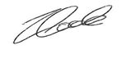 | Date: 1.12.23

For STAFF Submissions:
4 | Academic Director/ Assistant Dean: |  | Date:
5 | Signature: |  | Date:

Checklist: Please complete the checklist below to ensure that you have completed the form according to the guidelines and attached any required documentation:
☒ | I have read the guidance notes supplied before completing the form.
☒ | I have completed ALL RELEVANT sections of the form in full.
☒ | I confirm that the research activity has received approval in principle
☒ | I have attached a copy of final/interim approval from external organisation (where appropriate)
☐ | I have attached a full risk assessment (where appropriate) ONLY TICK IF YOU HAVE ATTACHED A FULL RISK ASSESSMENT
☒ | I understand that it is my responsibility to ensure that the above named research activity will meet the University’s Research Ethics and Integrity Code of Practice.
☒ | I understand that before commencing data collection all documents aimed at respondents (including information sheets, consent forms, questionnaires, interview schedules etc.) must be confirmed by the DoS/Supervisor, module tutor or Academic Director.

RESEARCH STUDENTS ONLY
Once complete, submit this form via the MyTSD Doctoral College Portal at (https://mytsd.uwtsd.ac.uk).

RESEARCH STAFF ONLY
All communications relating to this application during its processing must be in writing and emailed to pgresearch@uwtsd.ac.uk , with the title ‘Ethical Approval’ followed by your name.

STUDENTS ON UNDERGRADUATE OR TAUGHT MASTERS PROGRAMMES should submit this form (and receive the outcome) via systems explained to you by the supervisor/module leader.

Appendix
Appendix A: ATWS
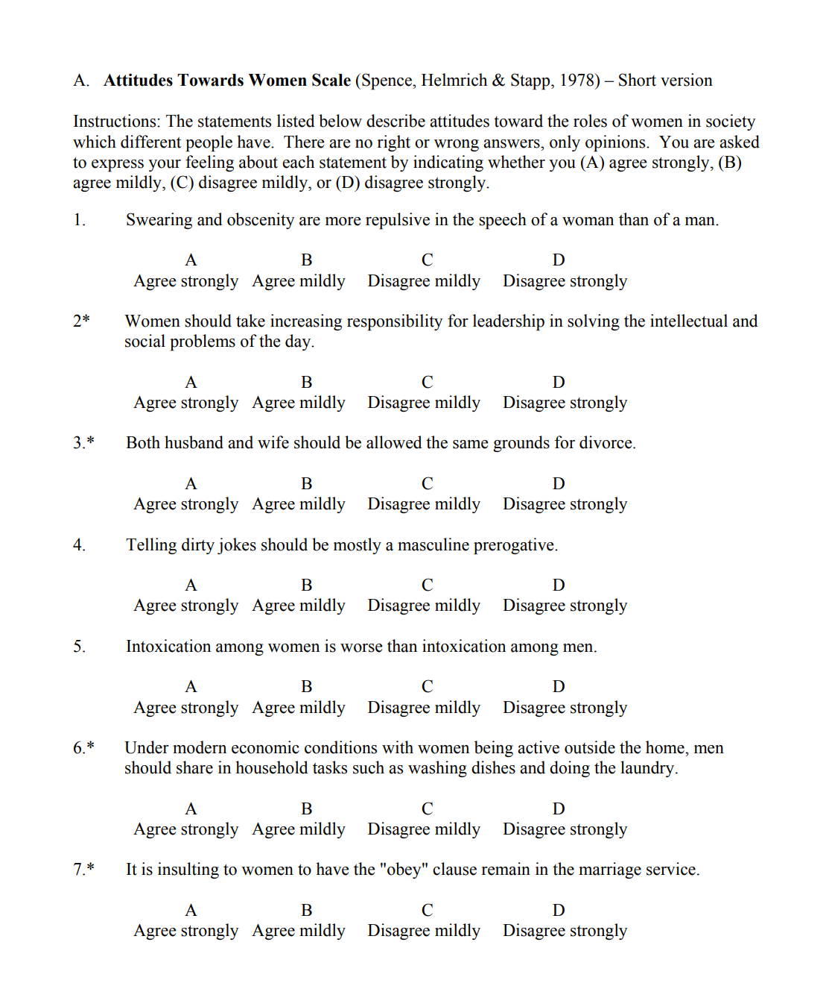

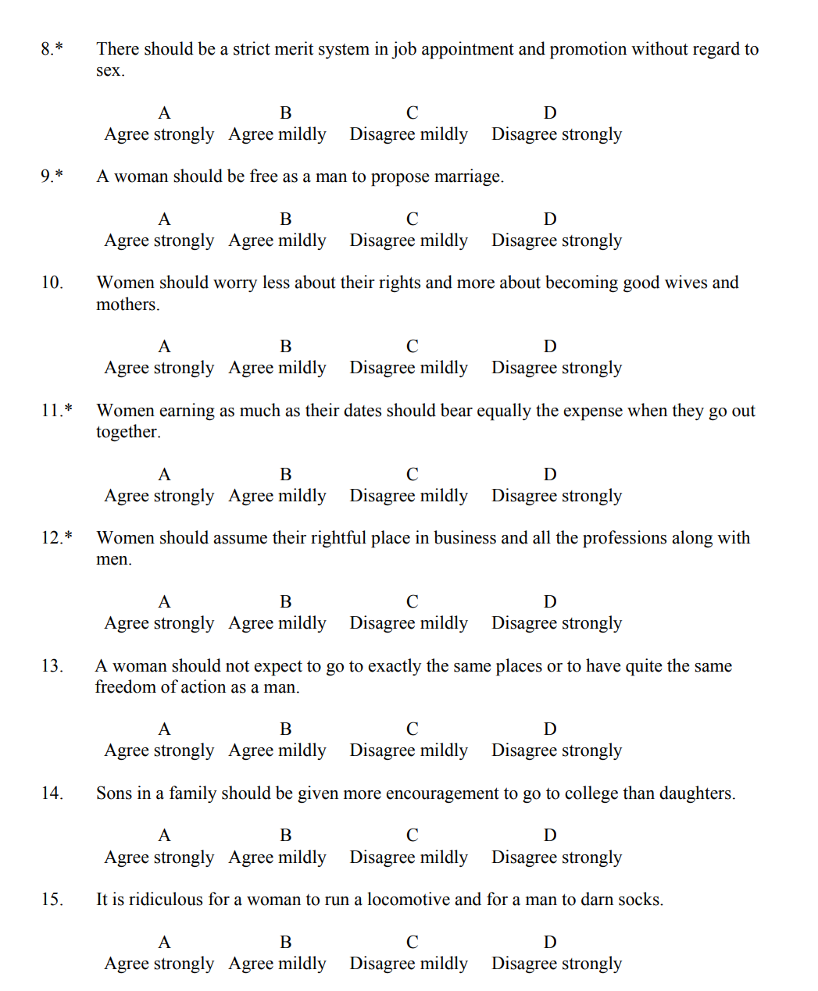

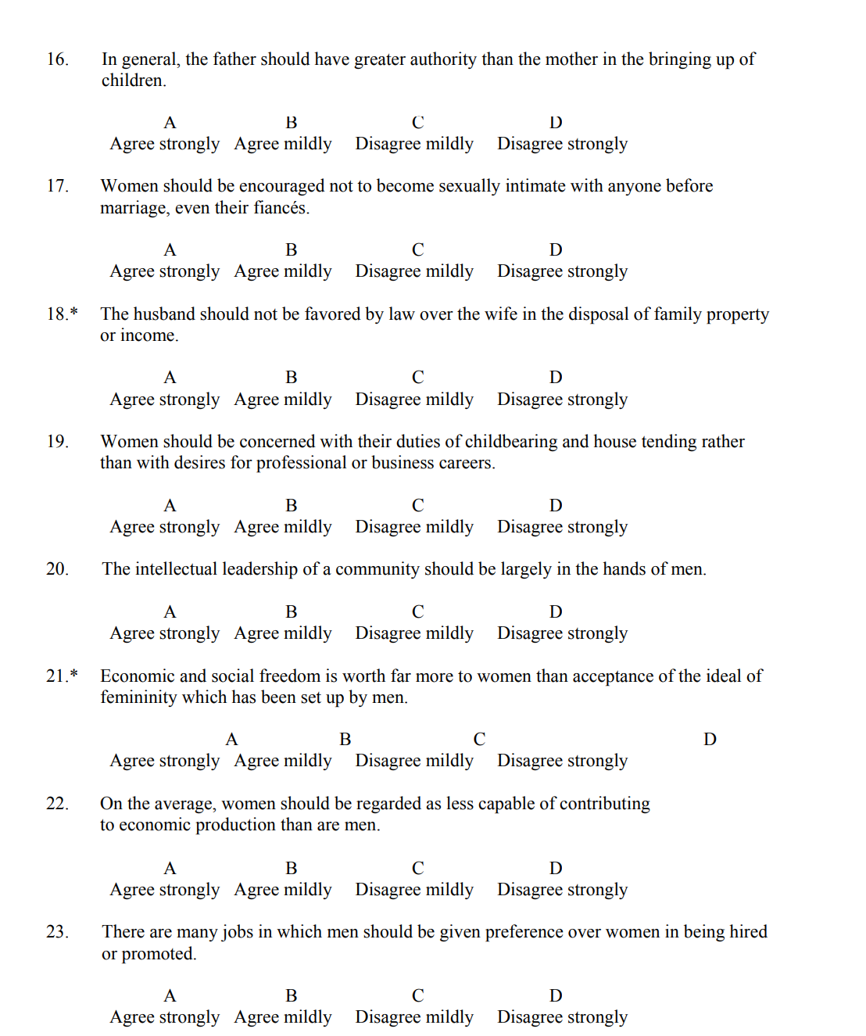

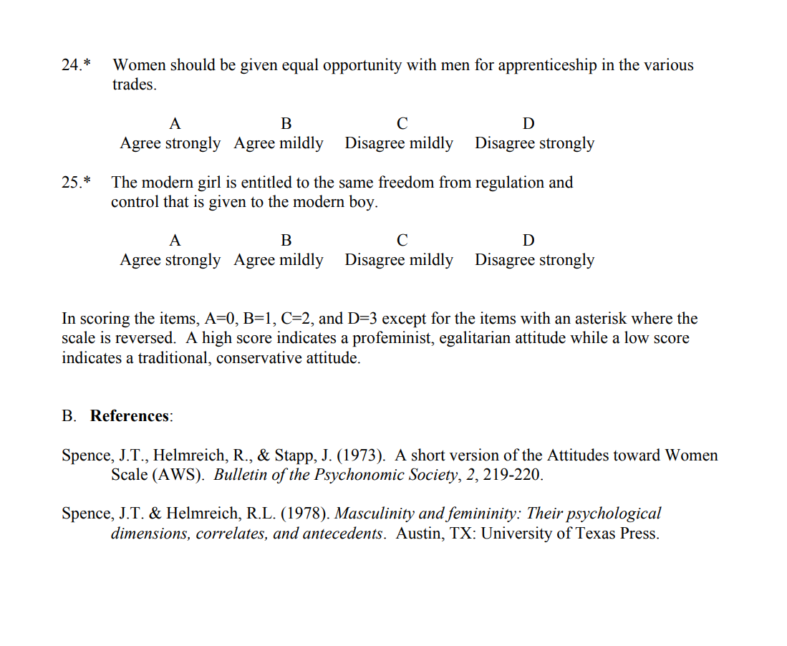

Appendix B: ATWSS

Attitude toward Women’s Sports Scale (ATWS Scale). The original ATWS Scale was a 119-item self-report inventory consisting of 16 subscales that was used to assess women’s sport fans’ attitudes toward women’s sports. Response options to the items ranged from 1 (strongly disagree) to 7 (strongly agree). Higher scores indicated greater positive attitude toward women’s sports

Thank you for agreeing to participate in this study. Please read each question carefully and decide what best represents your beliefs and feelings. There is no correct answer to any question. If you are not certain about the exact answer to a question, please mark your immediate thoughts. Please give you best estimate and work quickly through the questionnaire. It is important that you answer all the questions. Your best response is more useful than an incomplete response. As you answer the questions, always do so with your favorite women’s sport in mind. If you have multiple favorites, please choose one and answer all of the questions with that one in mind.

Development of the Attitude Towards Women’s Sports Scale (ATWS) (newhaven.edu)
Attitude toward Women’s Sports Scale (ATWS Scale). The original ATWS Scale was a 119-item self-report inventory consisting of 16 subscales that was used to assess women’s sport fans’ attitudes toward women’s sports. Response options to the items ranged from 1 (strongly disagree) to 7 (strongly agree). Higher scores indicated greater positive attitude toward women’s sports

Accessibility Subscale
7: It is easy to find information about ___
21: ___ competitions can easily be accessed via television or the internet
34: There are lots of opportunities to watch ___ competitions
72: It is easy to find schedule of competitions of ___
Aesthetic Subscale
1: There is a certain natural beauty to the ___ competitions
28: There is a beauty inherent in ___ competitions
53: ___ competitions are form of art
65: ___ competitions are aesthetically pleasing
78: ___ competitions are pleasing to eye

Affect Subscale
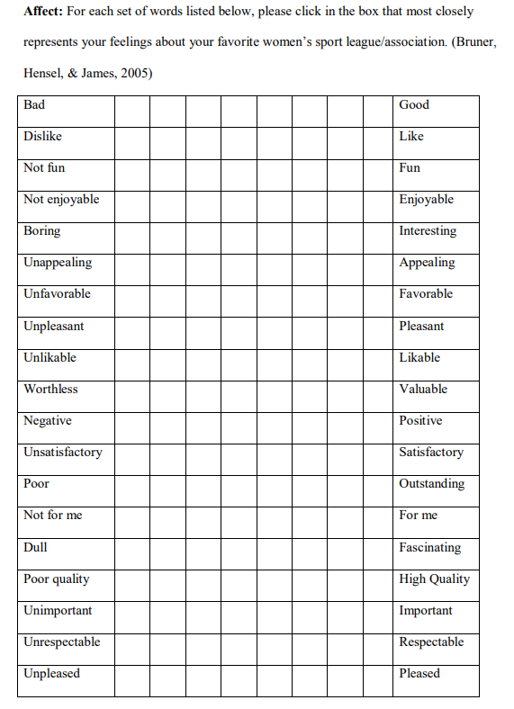
85: Dislike –Like
86: Unfavourable –Favourable
89: Valuable –Worthless
90: Negative –Positive
91: Unimportant –Important

Entertainment Value Subscale
16: ___ competitions are great entertainment for the price
31: ___ provides entertaining events for a reasonable price
44: It is affordable to be a fan of __
56r: ___ competitions are expensive
79r: ___ competitions are not affordable

Excitement Subscale
2: ___ competitions are exciting
14: ___ competitions are full of excitement
29: There is high level of excitement at ___ competitions
42: ___ competitions are thrilling
66r: ___ competitions are not very exciting

Opportunity for Women Subscale
1: ___ increases opportunities for women in life
26: ___ creates areas that women can take part in life
39: ___ plays a leader role in gaining gender equality in life
51: ___ opens up opportunities for women to excel in life

Player Skills Subscale
5: ___ athletes are experts at their sport
18: ___ athletes are the best at their sport
32: ___ athletes have excellent skills
69: ___ athletes demonstrate great fundamentals of the sport

Popularity Subscale
8: People always talk about ___
22: My friends and family talk about ___
73: ___ is popular among my friends and family
82: ___ is popular
Role Model Subscale
30: ___ athletes are good role models for girls and boys
43: ___ athletes have positive influence on young girls
55: ___ athletes provide inspiration for children
67: ___ athletes should be emulated by young women

Star Power Subscale
6: ___ has recognizable athletes
19: ___ has star athletes
33: ___ athletes are celebrities
70: ___ athletes are well-known and recognized

Style of Play Subscale
23: Style of play at ___ competitions is a more pure form of sport
36: ___ competitions display athleticism
49: Style of play at ___ competitions emphasise traditional aspects of the sport
62: ___ competitions display skilful performance
74: Style of play at ___ competitions emphasizes strategy

Wholesome Environment
4: ___ competitions provide fun atmosphere
45: ___ competitions provide good and clean environment
81: ___ competitions provide great atmosphere for the whole family

Appendix C: Study information sheet


Study Information
This information sheet contains important information regarding the study you have signed up to take part in, so please read the information sheet before continuing to the consent form.
During this study you will be required to do the following:
- Complete a short questionnaire regarding your demographic factors: gender and age.
- Complete a 25-item questionnaire that will assess your attitudes towards women
  - Each question will require you to rate your agreement to the statement provided on a scale of strongly disagree to strongly agree
- Complete a 34-item questionnaire which will assess your attitudes towards women’s sports
  - This consists of eight subscales which will assess your attitudes towards women in different scenarios
  - Each question will require you to rate your agreement to the statement provided on a scale of strongly disagree to strongly agree
A repeat of the specific instructions for each questionnaire will be provided at the beginning of each questionnaire.
At the end of the study, you will be presented with a debrief sheet that you can download for your records. The contact details of the researcher and the research supervisor will also be provided.
If you do not feel comfortable disclosing information on your attitudes towards women, then you are advised not to take part in this study. If this is the case, please note that you can close your browser now, or at any point during the study, and no data will be used.
If you are happy to participate in this study, please select the arrow below to proceed to the Consent Form.

Appendix D: Consent form

Consent Form
I understand that I will be taking part in this research study that is being conducted by a third-year student for the purpose of their undergraduate dissertation and that taking part in this study will require me to complete a 25-item questionnaire that will assess my attitudes towards women and another 34-item questionnaire that will assess my attitudes towards women’s sports.
I understand that this will take up to 15 minutes of my time and that, as a student at UWTSD, I will be rewarded course credit for my participation.
I understand that my data will be stored anonymously and that my data cannot be traced back to my following the final submission of my responses. I further understand that, whilst I may request for my data to be deleted up until the end of the study debrief, it will not be possible to trace my data to me as an individual or to withdraw my data from that point on. I understand that all data submitted by me will be stored in accordance with the Data Protection Act (2018), the UK’s implementation of the General Data Protection Regulation (GDPR).

If you have any questions regarding this study, you can contact the researcher Eden Mainwaring 2103222@student.uwtsd.ac.uk and/or the research supervisor Zoe Cooke zoe.cooke@uwtsd.ac.uk
To download a copy of this consent form please click here: Consent Form
Please select each of the boxes below to confirm your consent to participate in this study:
- I have read and understood the information above.
- I am over 18 years of age.

- I understand I can withdraw my participation at any time without penalty by closing the online browser and that partial data will not be used

- I understand that my data may be used in an aggregated format only with data from other participants in future reports, articles, or presentations.

- I agree to take part in this study

Appendix E: Debrief

Debrief
Title: Exploring the relationship between attitudes towards women and attitudes towards women’s sports.

Thank you for participating in this study.
Please note that there is a final ARROW BUTTON at the bottom of this page. If you are happy to submit your data for use in this study, please ensure you click this arrow button. After you have done this, your data will be anonymous and will remain confidential and therefore will not be traced back to you.
The aim of this study was to find out whether there is a relationship between attitudes towards women and attitudes towards women’s sports based on previous research in this area it was hypothesised that participants with positive attitudes towards women and feminism would be in support of women’s sports.

I wish to remind you that all data provided during this research study will be kept confidential and that if you wish to withdraw your data from the study at this point, your data will become anonymous, and we will not be able to trace it back to you.

If taking part in this study has raised any questions, please contact the researcher Eden Mainwaring 2103222@student.uwtsd.ac.uk or the research supervisor Zoe Cooke zoe.cooke@uwtsd.ac.uk

To download a copy of this debrief form, please click here: Debrief Form
Thank you once again for taking the time to participate in this study.

Eden Mainwaring
BSc Psychology and Counselling

University of Wales Trinity Saint David

