University of Wales Trinity Saint David.
School of Engineering.



Subject: Control Technology.

Title: Factory Control 1.



Name: George Griffiths (0901007).

Date: 31st July 2022.

Contents page:

Introduction. ~ Page 3.

Literature Review. ~ Page 4.

Ladder Logic Analysis. ~ Page 5.

HMI Screens. ~ Page 16.

Conclusion. ~ Page 19.

Bibliography. ~ Page 20.

1.0 Introduction
Programmable logic controllers (PLC’s) are utilized globally within manufacturing to “monitor and control automated processes like assembly lines, machine functions, or robotic devices” (InductiveAutomation, 2020) as they have the ability to “continuously monitor the state of input devices and makes decisions based upon a custom program to control the state of output devices” (AdvancedMicroControlsInc, 2022).

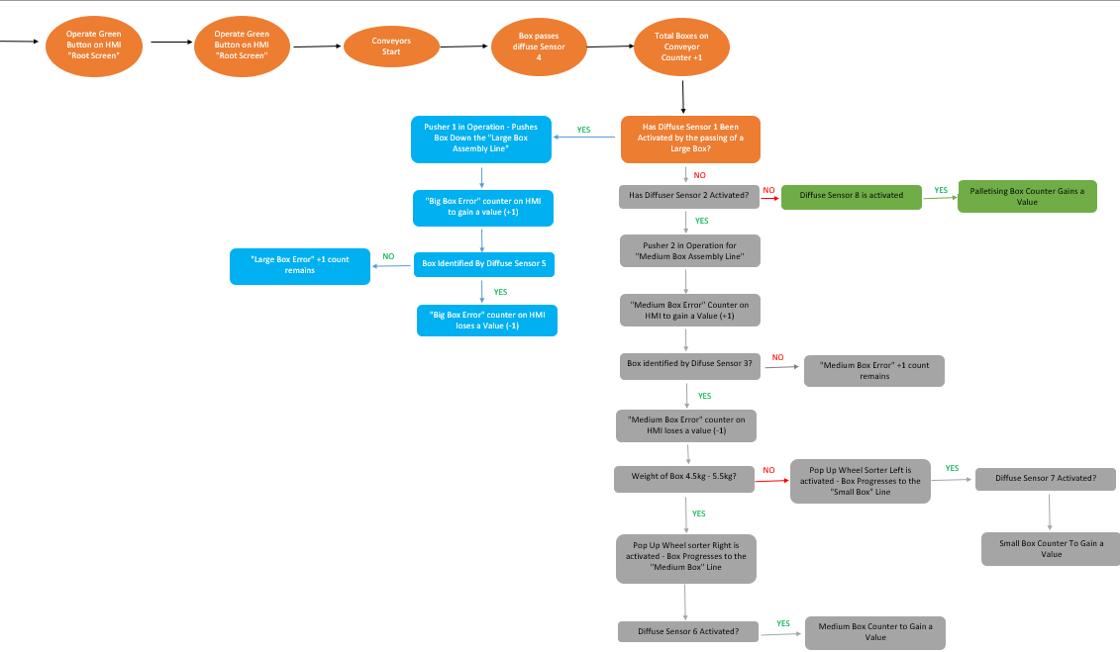
The below technical report considers how a PLC system has been created to decipher a variation of box sizes throughout a manufacturing process and the subsequent errors and interfaces generated to ensure efficient production is maintained, as seen by the completed process flow chart seen in figure 1.
(Figure 1 – Process Flow Chart of Factory IO Configuration
Reference – Microsoft Excel,2022).

2.0 Literature Review.
PLC’s (programmable logic controllers) are commonly used within the steel, chemical and automotive industry as a control mechanism to ensure a manufacturing facility can manufacture produce efficiently through pre-set conditions/operations written into the systems program.

Whilst considering different variations of PLC’s, it is important to note fixed PLC’s are generally utilized within manufacturing environments to perform singular operations in a less complex environment. Fixed PLC’s have fixed limitations to the quantity of I/O modules which are able to be assigned to the manufacturer’s discretion, “Fixed PLC’s are typically designed to perform basic functions. They are small and consist of a power supply and the CPU and I/O systems, which are all housed in one entity. The proper functioning of all processes largely depends on the flawless execution of every component” (Gilbert, 2014). A disadvantage, due to the limitation of I/O modules whilst using a fixed PLC, is if a process requires expansion and requires additional control methods, its possible a fixed PLC may be unable to accommodate these changes.

Advantages/Disadvantages of Fixed PLC’s
Advantages | Disadvantages
Cost significantly less than that of a Modular PLC. | Limitations to the quantity of I/O modules (whether this be digital or analogue)
Appropriate for use within a non-flexible simple operation. | Unable to comprehend ever-evolving complex processes.
Small in size – May be appropriate for less intense processes. | Fixed Memory due too component being housed within one compact hardware.
 | If a fault is identified with a fixed PLC, the whole unit will require replacing due to maintenance not being possible.

Alternatively, to an application specific hardware such as the fixed PLC, more complex assembly process which require consistent manipulation/expansion would be controlled via the utilization of a modular PLC. Unlike fixed PLC’s, modular PLC’s allow for the addition of analogue/digital IO cards to accommodate for ever-evolving processes across an assembly line, “because of the modular PLC’s design, a company would be able to expand their assembly lines by adding more similar output devices that perform similar tasks to be controlled by the same controller” (Philips, 2019). As previously discussed, this would not be possible with a standard fixed PLC as the user is restricted to the quantity of input and output modules manufactured into the component. A Modular PLC also allows for easier fault detection in the event of the PLC not completing its desired process due to the construction of the physical PLC. Due to a modular PLC’s functions being separated by modules within its assembly, it is possible to troubleshoot/replace individual modules within its assembly to determine where the error is occurring, thus resulting in potentially less downtime than that if the business required to troubleshoot a fixed PLC.

Advantages/Disadvantages of Modular PLC’s
Advantages | Disadvantages
Provides improved scalability to a business than that of a fixed PLC as its possible to modify I/O quantities (Ever-growing capacity) | Generally larger in size than that of a fixed PLC
Ease of fault detection – As components are separated via modules it is easier to troubleshoot issues | Slower Communication Speed
Greater memory than that of a fixed PLC | Initial cost to implement is greater than that of a Fixed PLC
Maintenance is Possible – Unlike Fixed PLC’s

3.0 Ladder Logic Analysis

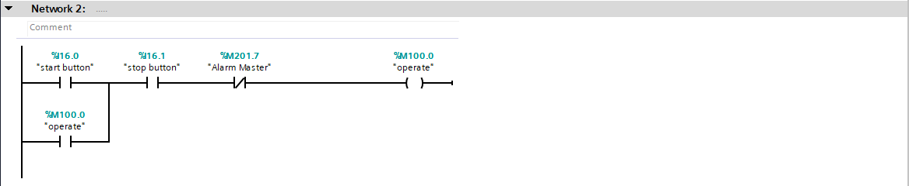
(Figure 2 – Network Line 2
Reference – TIA16, 2022)

Network line 2, as seen in figure 2, are the start and stop functions used within the ladder logic. The operate tag is assigned to both the start button (when the value for on = 1) and the stop button (where the value for on = 0).

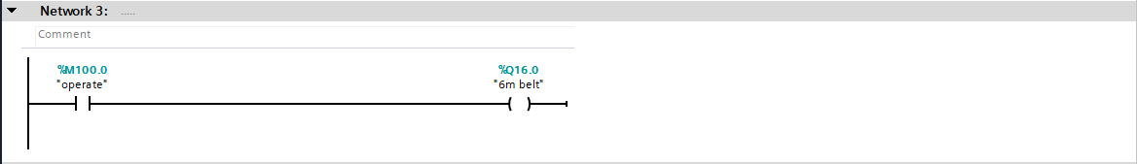
(Figure 3 – Network Line 3
Reference – TIA16, 2022)

As per figure 3, the command states to begin the 6m Belt as per the operate function. It is important to note the 6m belt has been assigned a Boolean data type within the PLC tag area under the address of Q16.0 – Which represents that the function is a output.

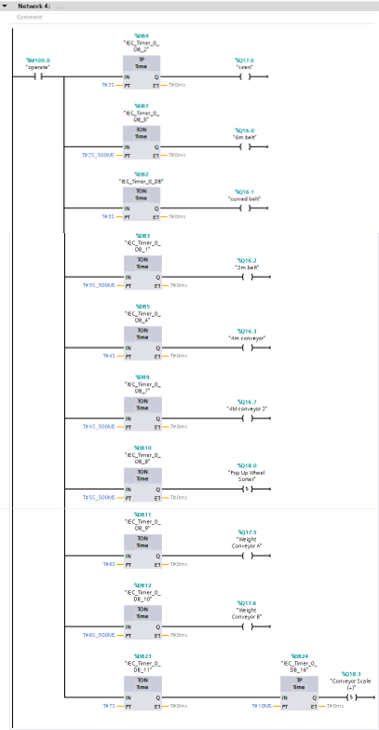

(Figure 4 – Network Line 4
Reference – TIA16, 2022)

Network 4, as seen in figure 4, states the beginning of movement of all conveyors within the system. Initially the operate function, as utilized within Line 3, triggers a warning siren to inform all personnel working within the area that the conveyor belt process is beginning. It is also important to note, to reduce potential stress placed on the electrical supply in the event of the production line being turned off and re-activated, a staggered activation has been implemented which will reduce potential stress placed on the system.
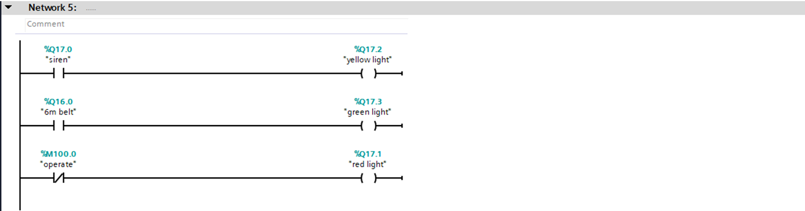
(Figure 5 – Network Line 5
Reference – TIA16, 2022)

As seen within the Factory IO configuration, the production line includes a siren and stack light above the electrical box to notify lineside personnel that the assembly line is in operation. As seen in the first segment of network line 5 when the siren is activated, we see the yellow light is displayed. Similar to the above, when the 6m belt is turned on (as seen during the delayed start up in figure 4) the green light will aluminate, notifying the lineside technicians that the production line is now active. Contrary to the above, network line 5 states when the operation becomes a closed contact the red light is to be activated, indicating to lineside personnel that all conveyors have stopped.
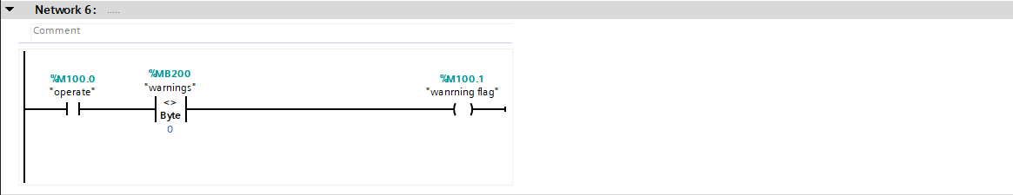

(Figure 6 – Network Line 6
Reference – TIA16, 2022)

Figure 6 denotes the introduction of the “warning flag” tag which will be linked to the root screen within the HMI. It states If operate is live and memory bite 200 is anything but 0 – the output warning flag will illuminate.
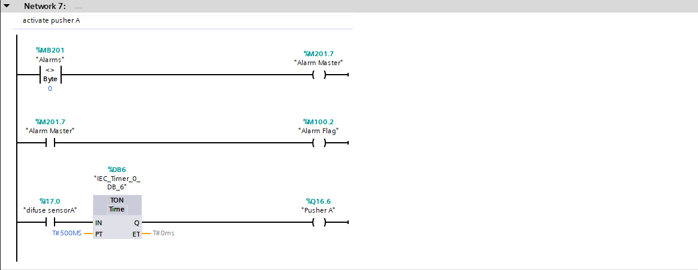
(Figure 7 – Network Line 7
Reference – TIA16, 2022)

The final Network within the program is the initial action which instructs the first pusher (“Pusher A”) to operate, thus allowing large boxes passed through the conveyor to be segregated from the process. It is also important the utilization of a TON timer allows for a 500ms delay to be implemented into the process also, thus allowing enough time post diffuse sensor A being activated for pusher A to deploy.

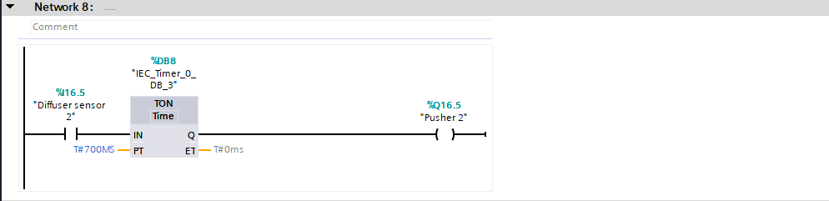
(Figure 8 – Network Line 8
Reference – TIA16, 2022)

Similar to that of Pusher A, post large boxes being detected and removed, both small, medium and palletized boxes will continue through the assembly process. Figure 8 demonstrates how when Diffuse Sensor 2 is passed pusher 2 is to be activated, whilst incorporating a 700ms delay. A 700ms delay has been introduced as this is the time required post the medium/small boxes passing diffuse sensor 2 to align to pusher B, which when deployed will progress the boxes down the conveyor.
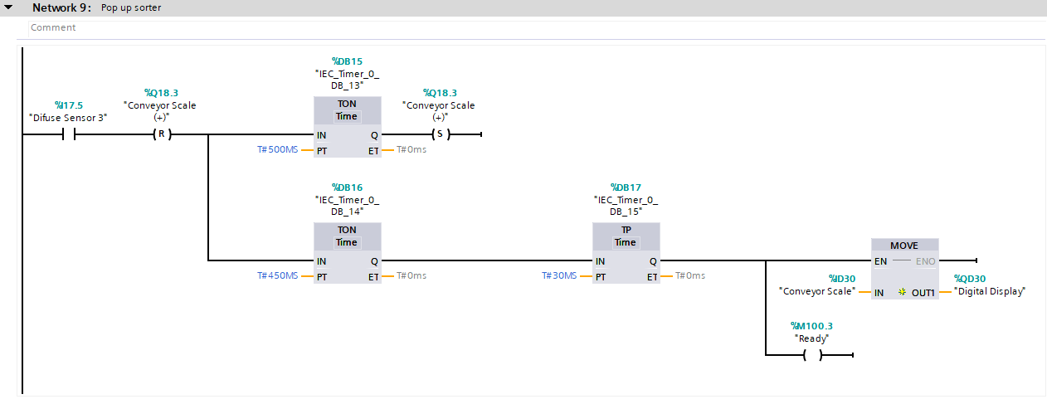

(Figure 9 – Network Line 9
Reference – TIA16, 2022)

Figure 9 demonstrates the process of the weight conveyor scale visualizing the weight of the medium/small boxes on the conveyor scale. As we see, when diffuse sensor 3 is crossed, the conveyor scale is reset for a delay of 500ms, prior to continuing. During this period, there is a time pulse of 30ms which demonstrates the digital display of the box, thus differentiating if the box is a medium or small box.

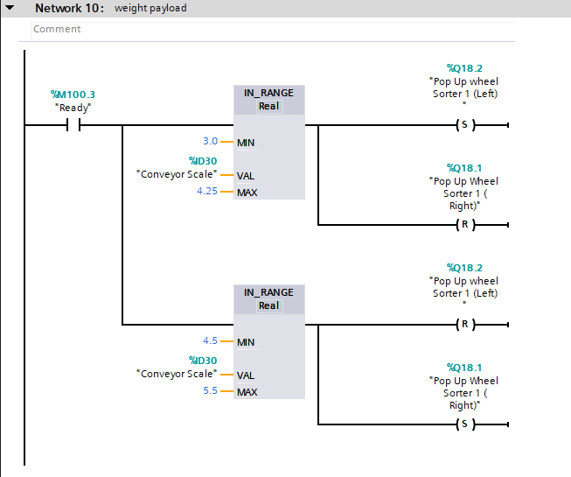
(Figure 10 – Network Line 10
Reference – TIA16, 2022)

Utilizing the “ready” tag as seen in line 9, network 10 differentiates the boxes by weight payload to determine if they are pushed onto the medium or small box conveyor post being weighed. The initial line states if the value of that displayed on the conveyor scale is between 3.0-4.25kg (Minimum and maximum values assigned), pop up wheel sorter left is set (thus meaning the sorter will turn left) and pop up wheel sorter right is reset, meaning this is not activated. Contrary to this, as seen in the final line of the program if the value displayed on the conveyor scale is between that of 4.5 and 5.5kg, this results in pop up wheel sorter Left being reset, and pop up wheel sorter right being set. This process, through the successful implementation of in “in-Range Sorters” allows for the differentiation of boxes through weight, with small boxes being pushed to the left conveyor and medium boxes pushed to the right conveyor.

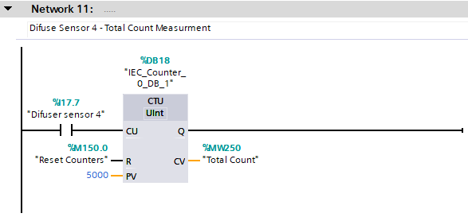
(Figure 11 – Network Line 11
Reference – TIA16, 2022)

Figure 11 demonstrates how the system can monitor/count the value of boxes processed during a set time frame. Utilizing a count up system, it is possible by utilizing diffuse sensor 4 to determine the total value of boxes processed. As Diffuse sensor 4 is passed, the counter value of the Total count memory tag increases. It is important to note, the technicians/engineer working on the system will have visibility of this on the HMI, on the Engineering screen, which is directly linked to the Total count memory tag. To Reset this counter, it is possible to press the Reset counters button on the Home page within the HMI which is directly linked to the “Reset Counters” memory tag, thus allowing for the total count measurement to be reset. It is also important to note it is programmed that the Reset counters tag is to automatically reset when the value exceeds 5000 units.
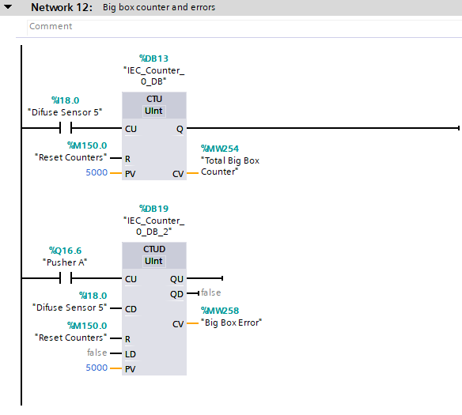

(Figure 12 – Network Line 12
Reference – TIA16, 2022)

Network 12 provides us with the program required to view the deviance of Big box error throughout the process, allowing us to view if all big boxes have reached the end of the assembly process. As seen in the initial line of the program, unitizing a count up system, when diffuse sensor 5 is activated by the passing of a box this will result in the total big box counter memory tag gaining a value. This provides us with knowledge that this box has progressed to the end of the assembly line. The second line within the program, utilizing a count up/down system, provides us with data with regards to the quantity of boxes processed via Pusher A. This system when activated will count down from the quantity of boxes passed through diffuse sensor 5, thus notifying lineside engineers if the quantity of boxes pushed via Pusher does not align to that detected via diffuse sensor 5. To support this, the count up/down system will increase the value of the Big box error counter located on the HMI screen, which is linked to the Big box error memory tag as seen in Figure 12.
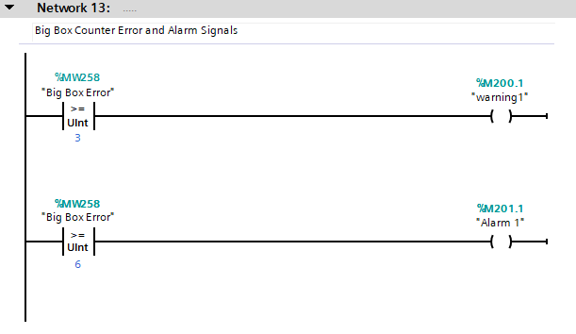
(Figure 13 – Network Line 13
Reference – TIA16, 2022)

As network 12 allows us to determine the errors within the system (i.e Boxes which haven’t reached the end of the process) it is important to consider potential countermeasures required if this error count is excessive. Figure 13 demonstrates how when big box error memory tag is equal or exceeds 3 (3 units not detected via diffuse sensor 5 but pushed by Pusher A) this will activate a warning light on the Engineering screen, which is linked via the “warning 1” tag as seen in figure13. The second line of the program repeats the same principal but has a increased value of 6, which when activated will activate alarm 1 and stop the production line.

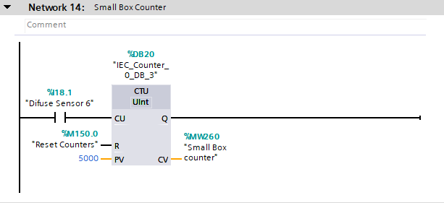
(Figure 14 – Network Line 14
Reference – TIA16, 2022)

Like that of the total box counter, the HMI will also include a counter for medium boxes which would not have been removed via any pushers throughout the process. This is identified as a box passes diffuse sensor 6 the value of the medium box counter memory tag is increased which is directly linked too the small box quantity counter on the HMI. The program also states that the quantity counter will be reset by pressing the Reset counters button on the HMI, and that the counter will reset when its value exceeds 5000 units.

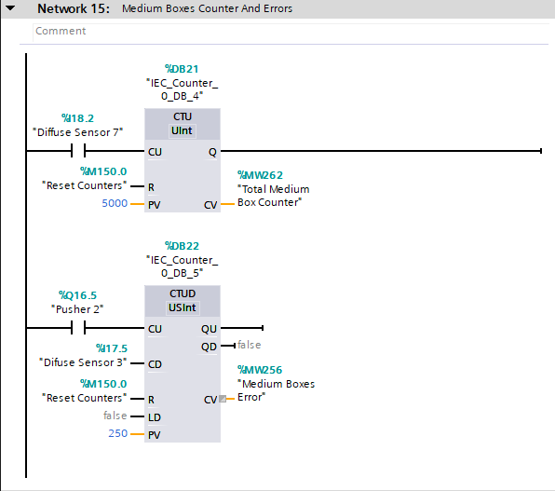

(Figure 15 – Network Line 15
Reference – TIA16, 2022)

Similar to that of Network 12, network 15 provides us with a robust process of identifying if we have lost volume during the assembly of small size boxes. The first line of the program states when diffuse sensor 7 is activated by the passing of a box, the total small box counter will gain a value, thus telling the technician lineside the box successfully reached the end of the assembly line. The second line of the system, once again utilizing a up/down count system provides us with the count of boxes processed via pusher b. This system when activated will subtract the quantity of boxes processed by diffuse sensor 7 to calculate any deviation in boxes which were pushed onto the conveyor but did not reach the end of the assembly process (I.e. were not seen by diffuse sensor 7). To support this, the count up/down system will increase the value of the small box error counter, which is located on the HMI , which is linked to the small box error memory tag as seen in figure 15.
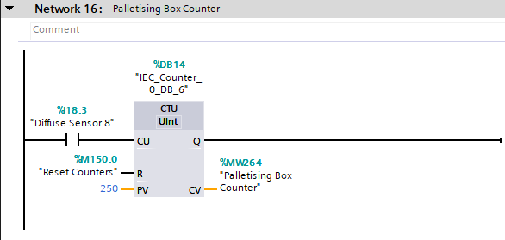
(Figure 16 – Network Line 16
Reference – TIA16, 2022)

Figure 16 demonstrates how palletising box counters are caluclated within the HMI. The ladder logic states when Diffuse sensor 8 is passed, the palletising box counter tag is to increase by a value. This counter will also be reset by pressing the “reset counters” button on the HMI as we see the reset counters tag used in the program.

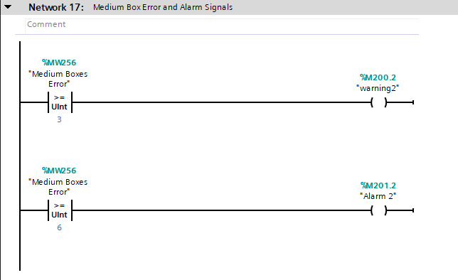
(Figure 17 – Network Line 17
Reference – TIA16, 2022)

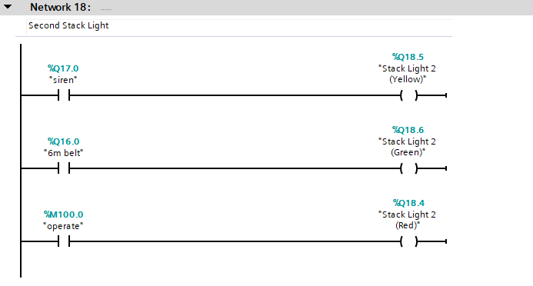
Similar to that of figure 13, in network 17 it has been reciprocated to have countermeasures in place to prevent failures from being excessive from within the assembly line. The first line of the program as seen in figure 17, demonstrates when the medium box error tag is equal or greater than that of 3 warning light 2 is to illuminate on the HMI to raise awareness to lineside technicians. If this failure is consistent, line 2 of the program states that if the error is equal or exceeds 6 then alarm 2 will be activated and stop the production line.

(Figure 18 – Network Line 18
Reference – TIA16, 2022)

Similar to that of figure 5, figure 18 demonstrates how the second stack light within the factory IO configuration is linked to that of the conveyors and lineside sirens to notify lines operatives if the conveyors are in motion or are stationary.

4.0 HMI Screens
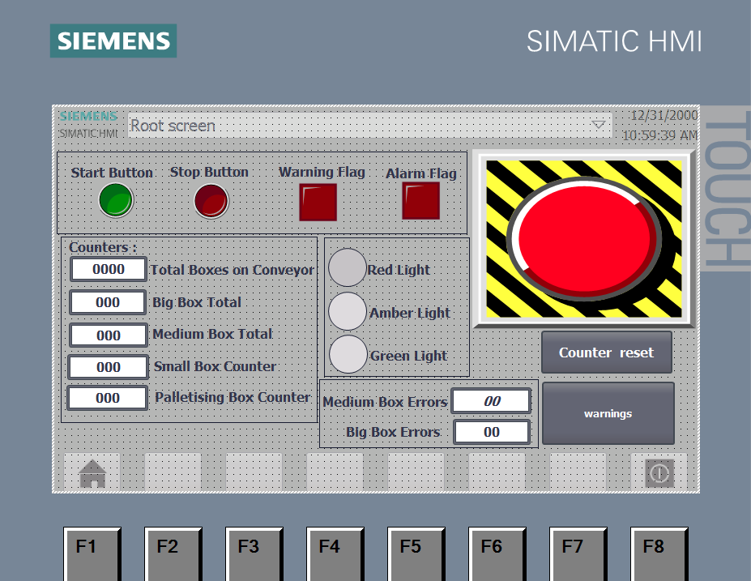
As per the assembly process beginning, it is imperative lineside engineers/operations managers have visibility of the assembly lines performance and have visibility of where errors are occurring during process.
(Figure 19 – HMI Root Screen
Reference – TIA16, 2022)

Post opening the HMI, the root screen is the initial display an operative would operate. The start/stop buttons within the HMI screen, as seen in figure 19, allows the operative to start/stop all conveyors within the manufacturing assembly line to they’re discretion. As discussed previously, the medium box/big box error counters display a count of boxes which were processed via the pusher but not identified by the diffuse sensors at the end of each assembly line, the counters visualized on screen visualize this error count. In the event of the error count reaching a total of three, the warning flag will arise as seen on the HMI, and if this total rises to 6 the alarm flag will aluminate and stop the conveyors within the assembly process for review. The emergency stop button is also operational through this screen, which will also stop all conveyors within the assembly process. The stack lights are also representative of both stack lights within the factory, thus highlighting if an error has arisen during processing. The counters to the left of the HMI display the total value of boxes processed for all variations of box sizes, this is calculated post the boxes passing they’re respected diffuse sensor. The counter reset button displayed on the HMI will reset all counters, and the warnings button navigates the user to the warning screen as seen in figure 19.

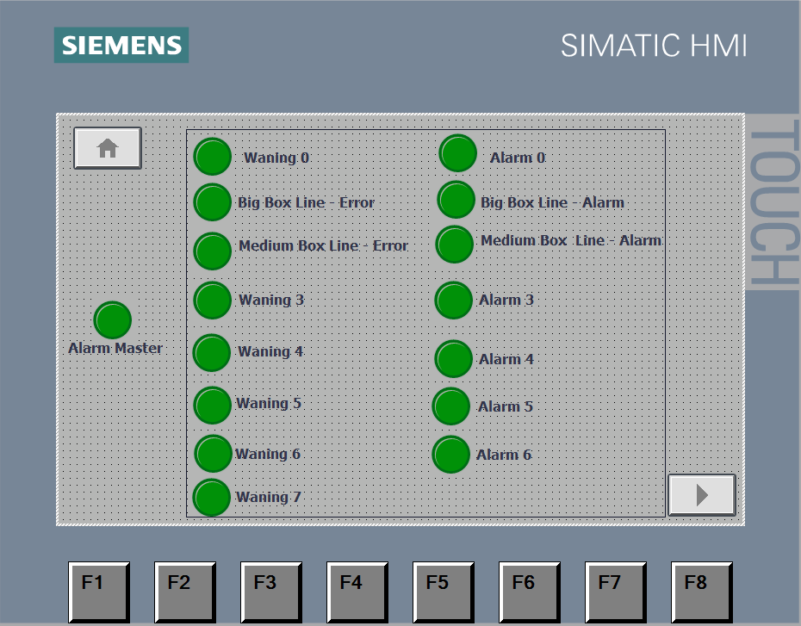
(Figure 20 – HMI Warning Screen
Reference – TIA16, 2022)

The warning screen on the HMI is to allow operatives to determine where within the production line where a warning/alarm has arisen. When the large box error/medium box error is equal to or greater than 3, the “big box line -error” and “medium box line – error” buttons will illuminate to display a warning. Similar to this, when the “medium box line – error” and “medium box line – alarm” aluminate, we can assume the error in the assembly line has equaled 6, thus stopping all conveyors. The home screen button located on the HMI allows for navigation back to the root screen, and the forward button allows for navigation to the engineering screen.

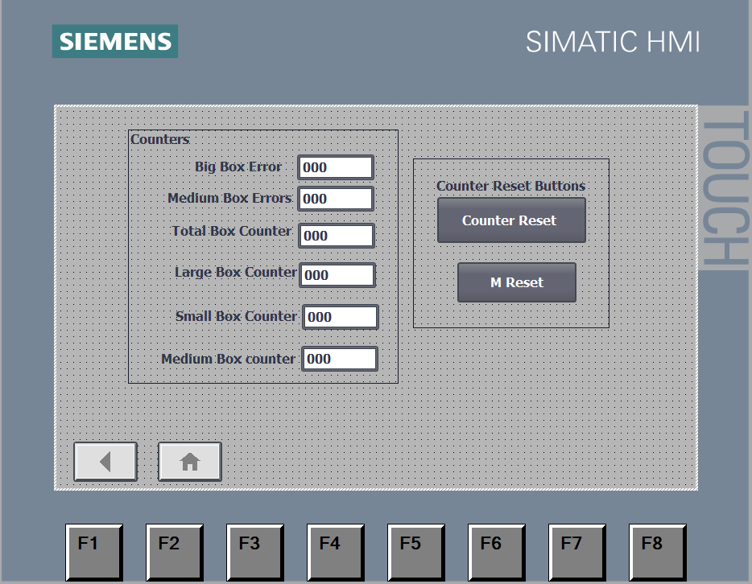
(Figure 21 – Engineering HMI Screen
Reference – TIA16, 2022)

The engineering root screen includes all counters for all box variations, with the inclusion of error counters. It is important to note, if an engineer requires to change the error/alarm quantities, it is required to modify figure 13 and figure 16 of the PLC program. The counter reset button allows for the resetting of box counters and the Master reset button allows for the resetting of all counters and errors. The home screen button allows for navigation back to the root screen and the back button allows for navigation to the warning screen.

5.0 Conclusion
To conclude, the above technical report demonstrates how through efficient use of Siemens TIA it is possible to simulate and manipulate four different package types across a production line, whilst also generating a HMI screen for lineside operatives and engineers to determine warnings and alarms through pre-set conditions.

6.0 Bibliography

AdvancedMicroControlsInc. (2022, 01 01). What is a PLC? (AdvancedMicroControlsInc, Editor, AdvancedMicroControlsInc, Producer, & AdvancedMicroControlsInc) Retrieved 07 27, 2022, from What is a PLC?: https://www.amci.com/industrial-automation-resources/plc-automation-tutorials/what-plc/

Gilbert, C. (2014, 08 19). Advantages of a Moduar PLC over a Fixed PLC. (I. S. University, Editor, C. Gibert, Producer, & Idaho State University ) Retrieved 07 11, 2022, from Advantages of a Moduar PLC over a Fixed PLC: https://blog.cetrain.isu.edu/blog/bid/353287/advantages-of-a-modular-plc-over-a-fixed-plc

InductiveAutomation. (2020, 02 24). What is a PLC? (InductiveAutomation, Editor, InductiveAutomation, Producer, & InductiveAutomation) Retrieved 07 27, 2022, from What is a PLC?: https://www.inductiveautomation.com/resources/article/what-is-a-PLC

Philips, R. (2019, 11 13). What are the different types of PLC? (R. Philips, Editor, & R. Philips, Producer) Retrieved 07 31, 2022, from BasicPLC.com: https://basicplc.com/different-types-of-plc/

