

Cover Page

Naveeda Qayyum 2325253
Olufemi Oluranti
BMHP5015

Task 1 – Personal Brand
Write about your own person brand and how you could develop this to enable you to reach your employment goals (200 words- 2 referenced sources)
Introduction
Personal branding can be described as strategic display of individual skills, values, professional identity to generate a clear and believable image (Molares-Cardoso, Aguileta and Legerren Lago, 2020). Personal branding is also critical in employability in health and social care since it is indicative of professional competence, ethical attitude and congruence with the standards of the sector.
Current Personal Brand
I am now introducing myself as a caring, trustworthy and dedicated person to the person-centred care. The main strength is my communication abilities, especially active listening and a respectful approach, which is expected of the professional in the healthcare field (O’Toole, 2024). I am a team player and amiable in academic and placement environments. I am seen as friendly and trustworthy by other people, which indicates the NHS values like compassion and being respectful. Nevertheless, although communication maintains visibility, Culo, Borcic and Mustapic (2023) state that networks are instrumental in helping leaders in the healthcare sector to build professional identity, which is a process that I am still in the process of developing.
Areas for Improvement
I will have to boost leadership confidence and broaden my professional base. According to Jackson et al. (2021), the concept of career progression in the health professions revolves around leadership capability. Increasing my professional visibility and networking abilities will make me more employable in the future.
Conclusion
Cultivating my own brand will help me to offer a holistic picture of my own professional identity, increase the capacity to lead and create sustainable job prospects in the line of health and social care.

Task 2 - Network Map and Rationale
Create a map of your own network considering career, support, social and community dimensions. Additionally you should provide a supporting rationale explaining and critically assessing this (200 words- 2 referenced sources).

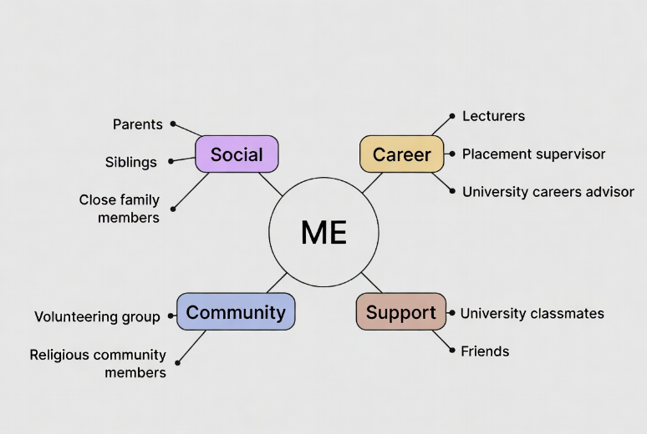
Type of Network
I would say that I had a hybrid network because I maintained a close relationship with a few people and fewer relationships with a growing number of people in a professional context. Who then explains that modern professional networks exist in both bonding and digital space and what Raza (2025) points out is that social capital can be a significant factor in the formation of career aspirations. Personal and emerging professional connections are represented in my network. I also have good bonding capital because I am well connected with my family and close family members who can offer emotional support. Nonetheless, my bridging capital is not very extensive, seeing as I have fewer acquaintances beyond my immediate academic community. Connection to capital, which entails connection to people in high authority, is also not well developed. According to Raza (2025), the lack of linking capital can limit the mobility in the career, which can have an impact on my career development into the leadership positions. In order to build my network, I intend to participate in professional workshops, linking strategically and forming relationships in placements using LinkedIn. According to Culo, Borcic and Mustapic (2023), social networks have the potential to increase leadership visibility as long as they are utilised appropriately. My employability and professional development will be enhanced by growing bridging and connecting capital.

Task 3- Blog
Write a blog exploring a current topic or issue of your choice within the health and social care sector in the UK. The purpose of this is to inform a specific target audience of your choosing (300 words)
Why Emotional Wellbeing Support for Care Staff Must Be a Priority

Health and social care practitioners work all their lives to help others but the emotional wellbeing is normally neglected. The care workers, the managers and the students of health and social care will be the targets of this blog since they wish to know more about the reason why staff wellbeing is important in delivering the quality care. A health and social care worker might be an emotionally demanding job. Employees are constantly faced with sickness, bereavement, work and staffing problems. With time this pressure may cause stress, burnout and low job satisfaction. Lack of provision of emotional wellbeing influences the morale of the staff and the quality of patient care. Burnout may decrease concentration, empathy and effectiveness of communication. Within the care environments, it can make the errors more likely and lower the person-centred engagement. Unsupported staff are also likely to leave their positions and this is one of the reasons that there will be a challenge in recruitment and retention within the industry.

Ways to Support Emotional Wellness
A conducive environment does not necessarily have to be of a big monetary outlay. The straightforward solutions like regularly supervising, open communication, debriefing of teams and flexible working arrangements could prove to make a difference. Managers have a major role to ensure that there is psychological safety where employees are free to talk about issues without fear of being judged. Wellbeing promotion also enhances the identity of a professional. Care workers feel confident, motivated and involved in their work when they have a sense of value and support. Emotional wellbeing is not an option but it is a component of sustainable healthcare. We, as future and present professionals, have a role to play in terms of influencing supportive working environments that appreciate their staff as much as service users. Healthy employees bring healthier care conditions.

Task 4- NHS Equality, Diversity and Inclusion Quiz (250 words equivalent)
- What is the primary goal of the NHS Equality, Diversity, and Inclusion Improvement Plan?
The major aim is to establish a fair, inclusive and representative workforce, in which discrimination will be minimised and all the opportunities will be equal among all the protected characteristics.
- How does the NHS EDI Improvement Plan propose to tackle the gender pay gap?
It suggests enhanced compensation openness, administration responsibility and focused advancement programs in the underrepresented communities.
- What is meant by the term ‘intersectionality’ as used in the NHS EDI Improvement Plan?
Intersectionality acknowledges that individuals can face intersecting types of discrimination, grounded in a combination of diverse characteristics that are protected by law, including gender, racial and disability.
- Why is it important for the NHS to create a psychologically safe work environment?
Psychological safety enables the staff to express issues of concern without the fear of being blamed, enhancing wellbeing, retention and patient safety.
- How does the NHS EDI Improvement Plan suggest improving the experience of internationally recruited staff?
It encourages effective recruitment practices, culture support processes and equitable access to development opportunities.
- What role does leadership play in advancing EDI objectives according to the NHS Improvement Plan?
The leaders will be tasked with exemplifying inclusive behaviours, tracking workforce data, and making themselves accountable to EDI results.
- Identify one way the NHS EDI Improvement Plan aims to reduce health inequalities within the workforce.
It utilises data on the workforce to determine discrepancies and institute specific interventions.
- Why does the NHS EDI Improvement Plan emphasise the importance of collecting and analysing data on protected characteristics?
Evidence-based decision-making can be achieved through data collection and can assist in tracking the progress of achieving equality objectives.

- Explain how flexible working policies can contribute to equality and inclusion in the NHS workforce.
Flexible working helps in maintaining a balance between work and life, especially to carers, disabled employees and those with family obligations.
- What is one strategy mentioned in the NHS EDI Improvement Plan to combat bullying and harassment in the workplace?
Enhancement of reporting systems and instilling a culture of zero tolerance through the accountability of the leadership.

Task 5- A Letter to Yourself
Think of a time in the past when you may have been experiencing issues or difficulties, and after considering what you have learned in this module about emotional intelligence and resilience write a letter to your younger self explaining how these attributes were important at that time and perhaps how developing these areas could have been useful (250 words)

Dear Younger Me,

I am aware that you are passing through one of the most challenging moments in your life. You are drunk, tired and you do not know if you can be that strong to go on. You are putting the hurt behind your back and doubting yourself more than you need to. Had I the power to sit close to you just now I should say to you that you are not failing--you are growing. You had not yet learnt emotional intelligence. You were experiencing anxiety and self-doubt but failed to realise that they were short-term feelings. Having a better sense of self, you would have been able to keep your emotions out of your identity. You are not your stress. You are not your mistakes.
Being able to control your feelings has been a skill you should have learned so that you would not have reacted as angry or self-critical. A pause and breathing in and requesting help would not have made you weak. It would have made you an emotional person. Being resilient is not about pretending that everything is okay, it is being able to adapt, learn, and carry on despite the challenge. You just happened to be stronger than you thought. All adversity you were going through was adding up to your strength, patience and empathy. Those experiences are currently molding you into a caring and a competent expert.
Please be kinder to yourself. Trust that failures are only short-term and that challenges bring about development. Continue to make progress, even step by step. As you will see one day, it is this turbulent chapter that you were just going through, that formed your confidence, your toughness and your inner strength.

Task 6- GANTT Chart (200 words equivalent)
Compile a Gantt chart which illustrates the tasks you have to complete to achieve your future employment goals

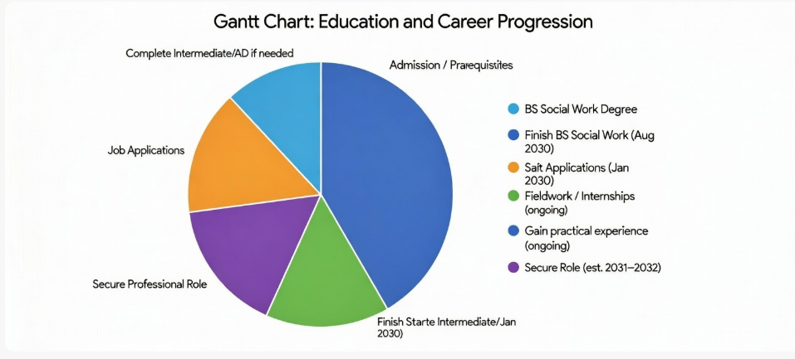

Task 7- Making Changes- Report
You are the manager of a care home and want to make changes your workplace. Identify one specific change that you want to implement and write a brief report on how this is going to be achieved considering the necessary skills needed and addressing possible barriers to success. Relevant change models can be highlighted (250 words- 2 referenced sources).
Introduction
I would also introduce a digital care planning system as a manager in a care home because this system helps to enhance documentation accuracy, communication, and quality of care.
Planning the Change
I will use the Change Management Model of Lewin (unfreeze- change -refreeze). The necessity to change is caused by the inefficiency of the paper-based records and the threats of the wrong documentations. Maki-Koivisto (2025) states that transformation in healthcare through digitalisation enhances coordination and needs organised leadership. The unfreezing stage will be addressed by explaining the rationale to employees and getting feedback. The change phase will comprise of step by step training and pilot implementation. Lastly, the freezing phase will incorporate the system into everyday life by the process of monitoring and evaluation.
Skills Required
Understanding and efficient leadership, communicating, time management and conflict resolution are necessary. According to Johnson (2021), effective healthcare managers have transparent communication during change to minimise uncertainty. The leadership should also provide support and inclusion.
Barriers and Solutions
Barriers such as staff resistance, insufficient funding and training gaps are possibilities. According to Chu (2025), the retention rate of staff and the quality of care is enhanced when leaders engage the workforce actively in change processes. Thus, I will engage employees in the decision-making process, conduct formal training seminars and guarantee continuous technical assistance. The insufficiency of funds could be solved with phased budgeting and finding external grants. The following can be used to mitigate resistance: showing how it is beneficial and creating an open discussion. Nonetheless, the necessity to use emotional support and realistic deadlines is also emphasised by the idea that digital change can make work and stress levels higher at the beginning of the process (Makikki-Koivisto, 2025).
Conclusion
The adoption of digital care planning will lead to efficiency, accountability and patient outcomes, as long as the leadership is supportive, inclusive and strategically planned.

Task 8- Self-Reflection
Using one of the highlighted models of reflection, reflect on what you have learned about yourself during this module ,as well as the knowledge you have gained, and explain how this has developed your skills and informed your future practice (250 words- you must reference the model you use)
Reflective Model: Gibbs Reflective Cycle (1988)
Description
In this module, I have undertaken a personal brand reflection experience in which I have assessed my employability competencies and professional identity in health and social care.
Feelings
At the beginning, I was feeling not quite sure and even a little bit nervous regarding the critical analysis of myself. Nevertheless, with further development, I was motivated and grew more confident in identifying my strengths and areas of development.
Evaluation
The practice was successful since I was truthful about my strengths in communication and empathy. I was able to connect theory and practice. Nevertheless, I had difficulties in critically analysing weaknesses initially, because I was not comfortable in self-criticism.
Analysis
This experience was significant as it proved that professional development must be accompanied by vulnerability and critical thinking. I also realised that the key to employability is self-understanding. I found this deep reflection helpful because I realised that my confidence in leadership needs development. It also revealed that personal branding is not self-promotion but rather genuine professional identity construction.
Conclusion
In case I undertaken the task once more, I would have requested the input of my peers in the past to widen my angle. Positive communication would have enhanced my analysis.
Action Plan
In my practice, I will most certainly contemplate my competencies on a regular basis, find mentorship and actively train as a leader in the future. Such reflective practice will make ongoing professional growth possible and reinforce my future career advancement.

References
Brandner, L.O.U. (2021) The social capital of creative freelancers: Networking practices in digital and urban spheres.
Chu, E.C. (2025) Effective Strategies Nursing Home Leaders Use to Implement Changes and Increase Staff Retention and the Quality of Patient Care. Doctoral dissertation. Walden University.
Culo, I., Borcic, N. and Mustapic, M. (2023) ‘Role and Communication Potential of Social Networks in the Personal Branding of Leaders in Health Sector’, Economic and Social Development: Book of Proceedings, pp. 138–146.
Gibbs, G. (1988) Learning by Doing: A Guide to Teaching and Learning Methods. Oxford: Oxford Polytechnic.
Jackson, C., McBride, T., Manley, K., Dewar, B., Young, B., Ryan, A. and Roberts, D. (2021) ‘Strengthening nursing, midwifery and allied health professional leadership in the UK – a realist evaluation’, Leadership in Health Services, 34(4), pp. 392–453.
Johnson, L.S. (2021) Case Study Exploration of Strategies Public Healthcare Managers Use to Communicate Change. Grand Canyon University.
Mäki-Koivisto, J. (2025) Change management in digital transformation of health care.
Molares-Cardoso, J., Aguileta, C.L.D. and Legerén Lago, B. (2020) ‘The importance of personal branding as an element of public relations: an international experience’, Comunicação e Sociedade, Special Issue, pp. 19–35.
O’Toole, G. (2024) Communication: Core Interpersonal Skills for Healthcare Professionals. Elsevier Health Sciences.
Raza, A. (2025) Social Capital and Career Aspirations: A Case Study of Public and Private Universities in Islamabad. Master’s thesis.

