ACCOUNTING FUNDAMENTALS

Executive Summary
The study has conducted an analysis over the financial statement of Kedison plc that has measured the financial strength of the organization. The projection of statement has mainly analyzed the profit value including the financial margin. The valuation of study has also measured the positional margin. It has further analyzed the ratio value of Chocco plc. It has found a higher return margin as per estimation of profitability ratio. Furthermore, the study has also computed the financial margin as per liquidity factor.
Table of Contents
Introduction 3
Question 1: Financial position of the business 3
a.) Income statement for the business at the end of 31st December 2020 3
b.) Reason for a statement of financial position matches 5
Question 2: Ratio computation 5
a.) Ratio calculation for the business 5
b.) Comment on the performance 9
Conclusion 9
References 10

Introduction
Accounting is considered to be one of the important fundamentals for a business that allows them to evaluate income and expenditure conducted during the year. It provides a quick overview of the financial information and health for a period. This assessment has shed light on the importance of accounting fundamentals by computing income statements and financial positions for a business. Furthermore, ratio analysis has also been computed to recommend the firm for its performance.

Question 1: Financial position of the business

a.) Income statement for the business at the end of 31st December 2020
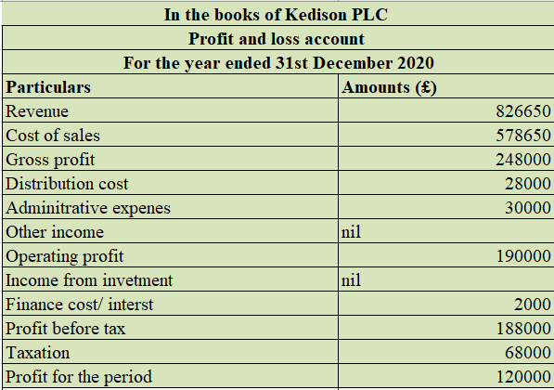
Figure 1: Income statement
(Source: self-developed)
From the above income statement, it can be identified that Kedison PLC will earn a gross profit of £248000 from their revenue balance of £826650 and cost of sales of £578650. The gross profit has been computed by deducting the cost of sales from the balance of revenue (Garbowski et al. 2019, p.1). There were other expenses that have been identified such as administrative expenses, distribution cost and from which the operating profit has been computed at £190000. The finance cost of £2000 has been deducted to compute PBT of £188000. Furthermore, the taxation expenses of £68000 have been subtracted and from which the profit of the year is computed at £120000.
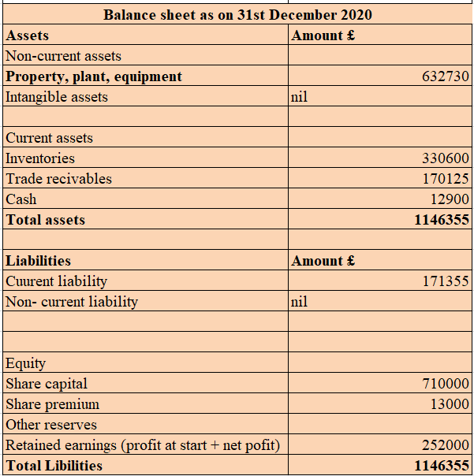
Figure 2: Balance sheet
(Source: self-developed)
The balance sheet has been computed for the business Kedision PLC for the year 2020. The asset balance of the business is reflecting a figure of £1146355 that includes the balance of inventories, receivables, and cash. On the other hand, the business has a current liability balance of £171355. Furthermore, the equity account consists of share capital of £710000 and a share premium of £13000. Additionally, the business also has retained earnings that include the net profit during the year of £252000. Therefore, the total balance at the end of the financial year for both the accounts is reflecting a balance of £1146355.

b.) Reason for a statement of financial position matches
The balance sheet is prepared by a business to identify its final position of all assets and liabilities during a year. It is computed at the end of a financial year after considering necessary adjustments (Gardi, 2021, p.25). The double-entry accounting system plays an important role in the tally of balance sheets at the end of the year. Every single transaction is recorded in two different places reflecting the matching concept behind it. This means any transaction recorded on the debit side will also be recorded on the credit side for balancing the position. In other words, the accounting principle of double-entry is responsible for the tally of balance sheets every year (Schroeder et al. 2019, p.1). However, incorrect placement of financial data can reflect a negative figure or misbalance the financial position. The reason for the balance of financial position can be understood with the help of an example: If a company purchases a motor car from a bank loan for £10000, the balance will be reflected in two different places. The liability position will increase by £10000 and the balance of assets account will increase similarly.

Question 2: Ratio computation

a.) Ratio calculation for the business
1.) ROCE
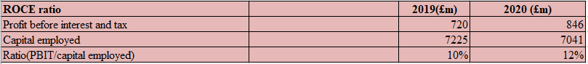
Figure 3: ROCE
(Source: self-developed)
The ratio has been computed for the business to identify their ability to earn income from their capital invested. The ideal is considered to be 10% to 15% for a business (Aksan et al. 2019, p.25). The value has increased during the year from 10% to 12%. The ratio has been increased because the value of PBIT has also improved in the current year. However, the balance of Capital employed has decreased.
2.) ROE
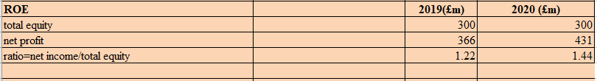
Figure 4: ROE
(Source: self-developed)
This ratio is computed for identifying the capability of generating income from equity. The ideal position is considered to be around 15% to 20% (Garas and Hassan, 2018, p.1). The above ratio is indicating a positive sign as the value has increased from 1.22 to 1.44 in the current year. Furthermore, the value of net profit has also been uplifted that helps the business to maximize its ability. However, Chocco PLC can further improve this by focusing on increasing net profit.
3.) EPS
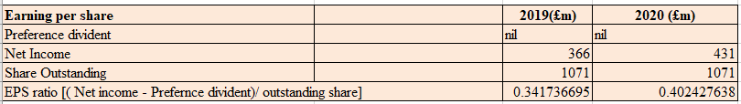
Figure 5: EPS
(Source: self-developed)
This ratio has been computed for the business to identify the potentiality of earning income in each share. The ideal position lies from £0.13 to £0.15 during a year. The EPS of the business in 2020 has improved from £0.34 to £0.40 due to an increase in net income. The management can further improve the ratio by focusing on reducing the cost that will help them to maximize their profit in the long run.
4.) N.P margin
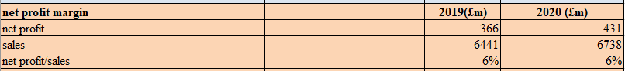
Figure 6: NP Margin
(Source: self-developed)
The NP margin of the business has been computed by dividing the balance of profit with the balance of sales. The ideal position for this ratio is considered to be from 10% to 15% during a year. The ratio for business Chocco PLC has shown no changes during the year as the balance remains the same at 6%. Furthermore, the output does not match with the ideal position which is 10%. Therefore, the company can improve this ratio by maximizing its revenue and decreasing its cost for sales.
5.) Asset turnover
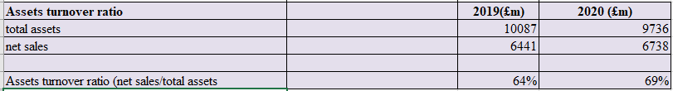
Figure 7: Asset’s turnover
(Source: self-developed)
This ratio is computed to identify the potentiality of a business in using its assets efficiently (Supardi et al. 2018, p.16). The ratio for the business has improved from 64% to 69% in the current year. The reason behind the increase is an increase in the value of net sales (Supardi et al. 2018, p.16). The business can improve the ratio by increasing its revenue and maximizing its receivables.
6.) Holding period
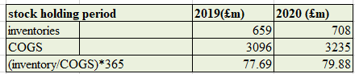
Figure 8: Stockholding
(Source: self-developed)
The holding ratio indicates the capability of a business to hold its assets during a year. The ideal holding period is observed to be recorded at 10 to 15 days (Sari and Dwirandra, 2019, p.851). The holding period for the business has increased from 78 days to 80 days which is considered to be a negative sign for the company. The company can improve the ratio by conducting proper forecasting of sales that will help them to overcome the impact of maximum stock holding.
7.) Collection period
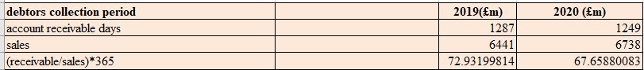
Figure 9: collection period
(Source: self-developed)
The ideal period for this ratio is around 30 to 45 days that indicates a minimum time required by the business to collect their payment. The collection period for the business has decreased from 73 days to 68 days that indicates a good sign for the business. The reason behind the improvement is because the management has maintained to decrease its collection amount. However, the company can improve further by offering discounts for accessing collections easily from debtors.
8.) Current margin
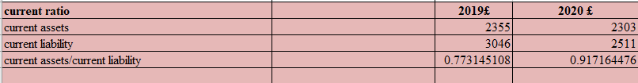
Figure 10: Current ratio
(Source: self-developed)
The reason behind evaluating the above ratio is to identify the capability of businesses in undertaking short liabilities with the help of their assets (Suryawan and Wirajaya, 2017, p.1317). The ideal position is considered to be 2:1 during a year. The ratio position for the business has increased from 0.77 to 0.91 during 2020 that indicates a positive sign for the business as their liability value has decreased. The company can improve this ratio by settling down its short liabilities.
9.) Gearing margin
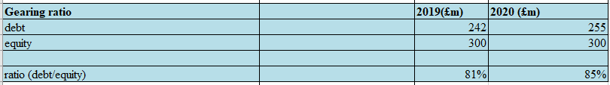
Figure 11: gearing ratio
(Source: self-developed)
The motive of computing this ratio is to evaluate the capability of undertaking business with the help of equity. The ideal is observed to be around 25% to 50% for a healthy business (Nurmasari, 2017, p.112). The ratio has been increased from 81% to 85% indicating a challenging situation for the company as the value of debt has increased from £242 to £255.
10.) Interest coverage
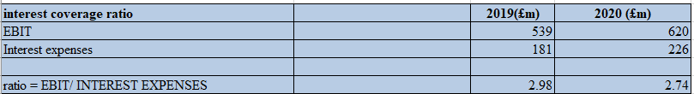
Figure 12: Interest coverage
(Source: self-developed)
This ratio is computed for analyzing the ability to undertake interest expenses with the help of EBIT. The ideal position is considered to be between 1.5% to 2%. The ratio position has decreased, which indicates a positive sign for the business as it reflects that the business has enough ability to overcome interest expenses.

b.) Comment on the performance
The business is observed to be performing well in the current financial year as their liquidity, profitability and even their efficiency have been increased. The respective business has successfully maintained to uplift their profitability that is helping them to overcome their expenses easily (Supardi et al. 2018, p.16). The businesses improve their sales that become a major reason behind an increase in the net profit during the year. Additionally, their EBIT and PBT balance has also been uplifted in the financial year that has helped them to satisfy their shareholders easily. However, the balance of current assets has decreased during the year that indicates a challenging situation for the business to overcome the impact of current liabilities (Hasanudin and Awaloedin, 2020, p.6). Therefore, it can only be suggested that the management of Chocco PLC needs to focus on improving the current asset balance and to increase the equity position that will help them to overcome short business liabilities easily.

Conclusion
This assessment can be concluded by the financial performance of the business that has been computed from the fundamentals of accounting. The income statement is reflecting a good net income during the year as a business has maintained it’s cost-effectively. Furthermore, the financial position has been compiled that indicates true figures and good health during the year. Additionally, Chocco PLC has successfully maintained its health by uplifting its financial ratio performance. Therefore, both the businesses have shown great response in their performance that will help them to maximize their profit volume in the upcoming years easily.

References
Aksan, I., Setiawan, D. and Gantyowati, E., 2019. Research development related to the implementation of financial accounting standards in Indonesia. International Journal of Economics, Business, and Accounting Research (IJEBAR), 3(04).
Garas, S. and Hassan, M., 2018. Student performance on computer-based tests versus paper-based tests in introductory financial accounting: UAE evidence. Academy of Accounting and Financial Studies Journal, 22(2), pp.1-14.
Garbowski, M., Drobyazko, S., Matveeva, V., Kyiashko, O. and Dmytrovska, V., 2019. Financial accounting of E-business enterprises. Academy of Accounting and Financial Studies Journal, 23, pp.1-5.
Gardi, B., 2021. Investigating the effects of Financial Accounting Reports on Managerial Decision Making in Small and Medium-sized Enterprises. Available at SSRN 3838226.
Hasanudin, H. and Awaloedin, DT, 2020. The Effect of Current Ratio, Debt To Equity Ratio and Net Profit Margin on Stock Returns in Telecommunication Sub-Sector Service Companies Listed on the Stock Exchange for the 2012-2018 Period. Journal of Information Engineering , 9 (1), pp.6-19.
Nurmasari, I., 2017. Analysis of Current Ratio, Return on Equity, Debt to Equity Ratio and income growth affect stock returns in mining companies on the Indonesia Stock Exchange 2010-2014. Creative Journal , 5 (1), pp.112-131.
Sari, PRP and Dwirandra, AANB, 2019. The Effect of Current Ratio and Debt To Equity Ratio on Profitability with Intellectual Capital as Moderating. E-Journal of Accounting , 26 (2), pp.851-880.
Schroeder, R.G., Clark, M.W. and Cathey, J.M., 2019. Financial accounting theory and analysis: text and cases. John Wiley & Sons.
Supardi, H., Suratno, HSH and Suyanto, S., 2018. Effect of Current Ratio, Debt to Asset Ratio, Total Asset Turnover and Inflation on Return on Assets. JIAFE (Scientific Journal of Accounting, Faculty of Economics) , 2 (2), pp.16-27.
Suryawan, I. and Wirajaya, IGA, 2017. Effect of Current Ratio, Debt To Equity Ratio and Return On Assets on Stock Prices. Udayana University Accounting E-Journal , 21 (2), pp.1317-1345.

