Heathrow airside delay Management
The airside Operation Department at Heathrow Airport Help reduce flight delays through turnaround coordination, gate management and real time operational decision- making.

Student Name : Rapaka Vamsi

Student ID : 2514890

Module Code : BMMB7003

Module Name : Dissertation

Name of the University : University of Wales Trinity Saint David

Year Of Submission : 2026

Acknowledgements

I would like to thank my supervisor for her guidance and constructive feedback and constant support during the course of this dissertation. I would like to also thank all of the operational stakeholders who took part in the survey and provided useful experiences and insights on airside operations at Heathrow Airport. They helped complete this research. I am also grateful to my university, lecturers and academic staff for imparting the knowledge and materials necessary to conduct such a study. Finally, I would like to express my sincere gratitude to my family, friends and colleagues who have had the time, patience and encouragement to support me during the research.

DECLARATION

​This work has not previously been accepted in substance for any degree and is not being concurrently submitted in candidature for any degree.​

Signed ......R Vamsi.................................................. (candidate)​

Date ..........25/09/2026..............................................​

STATEMENT 1​

This work is the result of my own investigations, except where otherwise stated.

Other sources are acknowledged by footnotes giving explicit references. A bibliography is appended.

Signed .......R Vamsi.............................................................. (candidate)​

Date ...........25/09/2026.............................................................​

STATEMENT 2​

I hereby give consent for my work, if accepted, to be available for photocopying and for inter-library loan, and for the title and summary to be made available to outside organisations.​

Signed .......R Vamsi............................................... (candidate)​

Date .........25/09/2026..........................................

Abstract
In this dissertation, the management of airside delay at Heathrow Airport (HRT) has been investigated to determine how both the Airport Collaborative Decision-Making (A-CDM) and the Airport Operations Centre (APOC) help to make the stakeholders at HRT more coordinated, efficient and to ensure a high level of passenger perceived service. A quantitative research method that is primarily positivist, top-down and is cross-sectional was followed and adopted a structured questionnaire which was distributed to four categories of respondents including the airside operations staff, the airline station staff, the ground handling supervisors and ground handling duty managers. For the purposes of the study, a combination of A-CDM and SERVQUAL has been used to explore the bonding of operational coordination to the results of service-quality. Results show that GH, boarding, catering, refuelling and crew availability as contributing factors to turnaround delays are vital. Confidence in A-CDM's ability to give the right shared operational picture was high overall and confidence in the speed and resilience of coordinated decision-making in disruptive situations was lower, but generally positive. The most important negative SERVQUAL gap identified was responsiveness in relation to disruption and the open-ended responses identified the need for more information flows to the teams at the front of the house. The study argues that the main weaknesses of Heathrow are not so much whether the information is available when needed to operate the airport as whether such information is translated into fast, co-ordinated action during the high-disruption situations. Recommendations are put forth for more robust disruption protocols, better sharing of the information on passengers for the disruption, post-disruption review, pre-positioning of resources based on predictions and better coordination of crew turn around.

Contents
Acknowledgements 1
Declaration 2
Abstract 3
List of figures 6
List of Tables 6
Chapter 1: Introduction 8
1.1 Background to the Study 8
1.2 Research Focus and Problem Statement 10
1.3 Rationale 10
1.4 Research Aim and Objectives 11
1.5 Research Questions 13
1.6 Scope and Structure of the Dissertation 13
1.7 Chapter Summary 14
Chapter 2: Literature Review 15
2.1 Introduction 15
2.2 Airport Operations and Airside Delay 15
2.3 Collaborative Decision-Making Frameworks 18
2.4 Service Quality Theory 21
2.5 Linking Operational Coordination to Service Quality 23
2.6 Heathrow-Specific Evidence 25
2.7 Conceptual Framework 27
2.8 Research Gap and Chapter Summary 29
Chapter 3: Research Methodology 31
3.1 Introduction 31
3.2 Research Aim and Objectives 31
3.4 Research Rationale 33
3.5 The Research Onion and Overall Methodological Approach 35
3.6 Research Philosophy 35
3.7 Research Approach 37
3.8 Research Strategy and Design 37
3.9 Selecting and Justifying the Primary Research Method 39
3.10 Designing the Research Instrument 40
3.11 Piloting the Questionnaire 41
3.12 Population and Sampling 42
3.13 Data Presentation and Analysis 43
3.14 Reliability and Validity 45
3.15 Research Ethics 45
3.16 Anticipated Limitations of the Methodology 46
3.17 Scope for Future Research 47
Chapter 4: Findings 49
4.1 Introduction 49
4.2 Survey Structure and Respondent Profile 50
4.3 Delay Causation (RQ1) 53
4.4 A-CDM/APOC Coordination Effectiveness (RQ2) 56
4.5 SERVQUAL Service Quality Gap (RQ3) 60
4.6 Priority Ranking and Open-Ended Themes 65
4.7 Bridge to Section Two 67
4.8 Approach to Section Two 67
4.9 Delay Causation Revisited: Analytical Synthesis 68
4.10 A-CDM/APOC Coordination: Critical Analysis 69
4.11 Passenger-Perceived Service Quality: SERVQUAL Synthesis 72
4.12 Cross-Cutting Synthesis: The Passenger-Communication Bridge 74
4.13 Summary of Section Two and Link to Chapter Five 75
Chapter 5: Conclusion and Recommendations 76
5.1 Introduction 76
5.2 Revisiting the Research Aim and Objectives 76
5.3 Conclusion 1: Main Causes of Airside Turnaround Delay 76
5.4 Recommendation 1: Strengthen Turnaround Readiness and Resource Coordination 77
5.5 Conclusion 2: A-CDM Provides Information More Effectively Than Coordinated Action 78
5.6 Recommendation 2: Introduce a High-Disruption Coordination Protocol 79
5.7 Conclusion 3: Responsiveness Is the Principal Service-Quality Vulnerability 79
5.8 Recommendation 3: Extend Operational Information to Passenger-Facing Teams 80
5.9 Conclusion 4: Improvement Should Be Targeted Rather Than System-Wide 81
5.10 Recommendation 4: Establish Continuous Monitoring of Coordination Performance 81
5.11 Contribution to Knowledge 82
5.12 Limitations of the Study 83
5.13 Recommendations for Future Research 83
5.14 Concluding Remarks 84
References 85
Appendix 88

List of figures

Figure 1 Conceptual framework linking A-CDM coordination and SERVQUAL service outcomes at Heathrow's Airside Operations Department (developed by the author) 27
Figure 2 The Research Onion, applied to this study (adapted from Saunders, Lewis and Thornhill, 2019) 33
Figure 3 respondent profile by stakeholder group, experience and APOC interaction frequency (Q2–Q4) 50
Figure 4 observed causes of turnaround delay, Q18, ranked by % of respondents 53
Figure 5 Section B coordination items, Q7–Q13, agreement profile 57
Figure 6 paired Expectation vs Perception scores for each SERVQUAL dimension, Q19–Q28 62
Figure 7 Q29 forced-choice priority ranking, all five attributes 64

List of Tables

Table 1 Respondent profile (Section A, selected variables) 48
Table 2 Airside delay causation (Section C) 51
Table 3 Causes of turnaround delay personally observed in the past month (Q18) 52
Table 4 A-CDM / APOC coordination effectiveness (Section B) 54
Table 5 SERVQUAL-style gap scores by dimension (Section D) 58
Table 6 Aggregate priority ranking of coordination/service attributes (Q29) 63

Chapter 1: Introduction

1.1 Background to the Study
The key features of aviation operations at large international airports are very close time tolerances, high traffic density and a complicated mesh of interdependent stakeholders that all need to work well together to ensure the smooth departure and arrival of flights. London's main international airport is Heathrow Airport Limited (Heathrow) which is located in the City of London. Heathrow is one of the busiest two-runway airports in the world and the key international airport for the United Kingdom, serving 83.9 million passengers and over 450,000 aircraft movements in 2024 (Heathrow, 2025). Heathrow is running on near full-runway at most parts of the day, and when it comes to operational disruption, there is little flexibility in a structure which can absorb it, as a small delay to the point at which an aircraft arrives, for instance at the end of its turnaround, can have a rapid domino effect on the rest of the day, impacting the next aircraft rotation, connecting passengers, and the integrity of the airline schedule.
The academic literature has identified airside delay, which is disruption that happens within the aircraft turnaround process, including things like deboarding, cleaning, and resupplying of catering, handling of luggage and boarding, as one of the most critical and persistent delays at congested hub airports (Ding et al., 2024; CM et al., 2025). Airside delay is quite distinct from strategic-level capacity constraints, which involve infrastructure investment and slot regulation, as it is an operational (and coordination) problem where the real-time interaction between airlines, ground handling agents, air traffic control and airport operators is at fault. These stakeholders tend to have their own performance goals, information systems, and resourcing decisions, and this could lead to misalignment, miscommunication, and misallocation of resources at exactly the wrong times, especially when the coordination is needed.
These challenges have led to a growing trend in the aviation industry in transferring to collaborative operational models designed to bring in a more integrated decision-making process between stakeholders and increase operational predictability in the turnaround process. The most well-known of these are those defined and promoted by EUROCONTROL, namely the Airport Collaborative Decision-Making (A-CDM) framework, which enables the progressive replacement of sequential, siloed scheduling with a jointly shared, real-time information environment, where all actors share and rely on the same, constantly updated operational picture (OP) (Eurocontrol, 2024). It has been the practice at Heathrow to implement A-CDM at an early stage, setting up an Airport Operations Centre (APOC), which brings together representatives from airlines, ground handlers, air traffic control, and airport management with the aid of predictive analytics that can predict when a turnaround is likely to be completed and what the risk of disruption is in real time (Guo et al., 2020).
Airside delay is still an issue at Heathrow, despite all this investment in collaborative infrastructure, and it has repercussions beyond just keeping people off schedule. Flight delays have a significant impact on passenger dissatisfaction, lower service quality perceptions, and negative behavioral outcomes like lower loyalty toward the airline and poor word-of-mouth (Shah et al., 2020; Song et al., 2024). In the services marketing literature, the SERVQUAL Service Quality Gap Model (A Parasuraman et al., 1988) offers a well-established theory for the systematic analysis of the gap between expected and perceived service, which is the gap between expected and actual turn around and departure punctuality in this context. The operational context of practising delay management on Heathrow's airside presents a chance to link up operational performance to the passenger-perceived service quality outcomes, where the existing literature is well established at a general level but has not been applied to the specific organisational practices of a single large hub airport.

1.2 Research Focus and Problem Statement
The dissertation addresses the management of airside delay at Heathrow Airport specifically, their operational practices, coordination mechanisms and decision-making process with stakeholder partners in the Airside Operations Department (AOD) in this regard. Although research on airport delay management is extensive, the relationship between collaborative frameworks like A-CDM and operational and service quality outcomes has been examined to a lesser degree from the perspective of the organisational architecture of a single airport, defined as its governance structures, communication processes, and frontline decision-making procedures.
The research problem at the core of this study can therefore be summarised as follows: Heathrow has established complex collaborative decision-making infrastructure designed to alleviate airside delay, but it is still subject to high levels of turnaround-related disruption which has measurable impacts on the airport's passenger perceived service quality and it is not clear from the existing literature what operational practices, stakeholder behaviours or organisational factors are most influential in both mitigating and exacerbating this disruption at frontline level. This study aims to directly explore that issue by adopting a theoretical grounding in collaborative airport operations and service quality management and primary survey-based data collection from stakeholders operating at Heathrow.

1.3 Rationale
This research can be justified in three aspects: academic, practical, and organisational. Academically, while the study of airport delay management has grown significantly in recent times, covering process analysis of turnaround sub-activities (Ding et al., 2024), optimisation modelling for stand and gate allocation (Seifi et al., 2024), and the incorporation of aircraft recovery strategies (Evler et al., 2022), few studies relate an operational delay management perspective to a service quality theoretical framework specific to a single major hub airport. Existing evidence for Heathrow, most notably from Guo et al. (2020), is largely about the technical and analytical aspects of the APOC system, and not necessarily frontline stakeholder perceptions of the implications of collaborative decision making for operational and service outcomes. Thus, this dissertation aims to fill a gap between the operations management and service quality literature by using the SERVQUAL framework in an A-CDM operational context.
At a very practical level, the research has immediate importance for Heathrow's operational management and also for the broader airline, ground handling and regulatory community who are part of the Heathrow community. The level of airside delay management at Heathrow is immense and as it is a vital link in the European and global aviation network, small improvements that reduce airside delays could have significant cumulative benefits in terms of cost savings, schedule reliability and passenger satisfaction. These findings can hence guide practical suggestions for protocols of communication between the stakeholders, allocation of resources and staff training in the airside operational environment.
Lastly, from an organisational and professional development perspective, this research aligns well with the researcher's own professional interest and involvement with airport operations management, as this will allow the researcher to put theory into practice on an actual, practitioner-relevant operational issue. The study also responds to the broader industry need highlighted by Eurocontrol (2024) and echoed in the literature on aviation management, that collaborative decision-making processes need to be continually tested empirically, and see how they can enhance airport resilience as it seeks to become more resilient in its operations following the pandemic.

1.4 Research Aim and Objectives
In this research, Airport Collaborative Decision-Making (A-CDM) framework and the Service Quality Gap Model (SERVQUAL) will be used as two theories to critically analyse the Airport's operational practices and coordination mechanisms between stakeholders and their impact on turnaround efficiency and the perceived service quality by the passengers at Heathrow Airport.
To this end, the following four research objectives have been stated:
1. Objective 1 (Identify): To identify and explain the main sources and characteristics of airside delay in the aircraft turnaround process at Heathrow Airport, based on existing academic and industry literature.
2. Objective 2 (Explore): To investigate the role of Airport Collaborative Decision-Making (A-CDM) and Airport Operations Centre (APOC) in coordinating stakeholder decision making and reducing the spread of airside delays at Heathrow.
3. Objective 3 (Critically Evaluate): To critically assess the link between airside delay management practices and passenger perceived service quality at Heathrow, using the SERVQUAL Service Quality Gap Model as a theoretical foundation, whilst including primary evidence gathered from operational stakeholders through a survey.
4. Objective 4 (Recommend): To develop evidence-based recommendations to improve airside delay management practices with the aim of improving turnaround efficiency, stakeholder coordination and outcomes of passenger service at Heathrow Airport.
These objectives have been carefully designed to progress from basic, descriptive understanding (Objective 1) to an examination of the current collaborative structures (Objective 2), to critical, theoretically based analysis based on primary data (Objective 3), and to proposals for practice (Objective 4). The structure is directly relevant to how the rest of the dissertation will be organised such that there is a logical flow of argument from the initial problem identification to the applied conclusions.

1.5 Research Questions
This study has been guided by the following research questions that are aligned with the research objectives stated above:
- RQ1: What are the main operational reasons for airside delays to the aircraft turnaround at Heathrow Airport?
- RQ2: What effect does the Airport Collaborative Decision-Making (A-CDM) framework have on the coordination of stakeholders in airside delay management at Heathrow as implemented in their Airport Operations Centre?
- RQ3: What is the extent to which the performance of the airline's airside delay management has an impact on passenger perceived service quality based on the SERVQUAL framework at Heathrow?
- RQ4: How the current practices and coordination of airside delay management at Heathrow Airport could be enhanced in practice??

1.6 Scope and Structure of the Dissertation
The study is limited to Heathrow Airport in Britain specifically to the airline-side operational environment, concentrating on the processes of aircraft turnaround, gate and stand management, and coordinating mechanisms for stakeholders within and around the Airport Operations Centre. The research does not cover the ground-level activities of the terminal (airside turnaround coordination), terminal passenger processing, security screening, or surface access, and it does not analyze air traffic control decision making outside of its immediate interface with airside turnaround coordination. The primary research focuses on operational stakeholders involved in Heathrow's airside processes and is collected using survey methodology, and does not incorporate primary data collected by passengers, but does consider passenger service quality outcomes by applying the SERVQUAL theoretical framework to the operational performance reported by the operational stakeholders.
The rest of this dissertation follows this outline. Chapter Two is a critical literature review that will first look at relevant research in the academic and industry literature on airside delay causation, collaborative decision-making frameworks, gate and stand management and service quality theory, and will then identify the specific research gap which this study will fulfil. The research methodology is presented in chapter three which covers the research philosophy, design, instruments for collecting data, sampling procedure and ethical issue in the primary research. The findings of the primary research and a discussion of these findings in relation to the literature reviewed in Chapter Two are presented in Chapter Four. At last, Chapter Five summarizes the findings of the study, assesses the outcomes of the research aim, objectives, and makes recommendations for managerial practice and future research.

1.7 Chapter Summary
The operational and academic context of the study of airside delay management at Heathrow Airport has been set and it has identified the specific research problem which the dissertation aims to solve. It has also outlined the rationale behind the academic and practical importance of the study. The research goal, the four research objectives and the corresponding questions have been stated and form the foundation for the rest of the dissertation. This groundwork has been laid and the next chapter focuses on a detailed and critical review of the existing literature related to airside delay management, collaborative decision making and service quality theory.

Chapter 2: Literature Review

2.1 Introduction
This chapter presents a critical review of the literature underpinning the study of airside delay management at Heathrow Airport and its consequences for passenger-perceived service quality. In keeping with the research aim established in Chapter One, to critically analyse Heathrow's operational practices and stakeholder coordination mechanisms using the Airport Collaborative Decision-Making (A-CDM) framework and the Service Quality Gap Model (SERVQUAL), the chapter has been structured to move from the wider operational context of hub airport congestion towards the specific theoretical and empirical evidence relevant to Heathrow. It begins with the macro-level nature of airside delay and turnaround coordination (Section 2.2), before narrowing to the collaborative decision-making frameworks used to manage it (Section 2.3) and the service quality theory used to evaluate its consequences for passengers (Section 2.4). Sections 2.5 and 2.6 draw these two literatures together and examine the evidence available specifically for Heathrow, before a conceptual framework and the research gap that this dissertation addresses are presented in Sections 2.7 and 2.8.

2.2 Airport Operations and Airside Delay
Large hub airports operate with very narrow margins of slack between scheduled activities, and Heathrow is a particularly acute example of this, functioning at close to full runway capacity for most of the operating day and handling 83.9 million passengers and over 450,000 aircraft movements in 2024 alone (Heathrow, 2025). Within this environment, airside delay, disruption arising specifically within the aircraft turnaround process, has been consistently identified in the literature as one of the most persistent operational problems facing congested hub airports (Ding et al., 2024; CM et al., 2025). The turnaround itself is not a single activity but a tightly sequenced chain of interdependent sub-processes, including deboarding, cabin cleaning, catering resupply, baggage handling, refuelling and boarding, each typically performed by a different organisation working to its own resourcing schedule and reporting line.
Ding et al. (2024) provide a methodologically rigorous account of how this interdependency generates delay, using a process-relevance analysis to demonstrate that boarding, baggage handling and pushback sequencing are the sub-processes most strongly correlated with eventual departure delay. Their central argument, that disruption in any one sub-process propagates through the remainder of the turnaround's critical path, is significant for Heathrow because the airport's lack of schedule buffer leaves little opportunity for upstream delay to be absorbed before it affects departure punctuality. This is consistent with the broader, systems-level view of turnaround delay causation taken by CM et al. (2025), whose review of ground handling bottlenecks across several major airports identifies resource constraints, equipment failure and inter-agency communication failure as the principal causes, and argues that these factors interact and compound one another most severely during peak scheduling periods, precisely the conditions under which Heathrow's near-saturated schedule operates for much of the day.
A further strand of the literature has focused on the allocation of physical resources, particularly gates and stands, as a lever for controlling the spread of turnaround delay. Seifi et al. (2024) develop a centralised optimisation model showing that proactive stand reallocation, balanced against real-time demand and capacity information, can prevent a delay to a single flight from propagating into a network-wide disruption; this reflects the intervention logic underlying Heathrow's own Airside Operations Department. Evler et al. (2022) extend this argument, showing that when turnaround management is integrated with aircraft recovery planning rather than treated as a separate, sequential process, on-time departure performance improves measurably. Taken together, these studies confirm that airside delay management is not simply an engineering or scheduling problem but a coordination problem: it depends on how effectively information about resource availability and turnaround progress is shared and acted upon by the several organisations occupying the same physical and temporal footprint.
It is also useful to distinguish airside delay of this operational kind from the strategic-level capacity constraints, such as runway slot regulation and infrastructure investment, that dominate much of the wider airport economics literature. Okwir, Ulfvengren, Angelis, Ruiz and Núñez Guerrero (2017), analysing over six thousand turnaround movements at a major collaborative-decision-making airport, demonstrate that turnaround performance is not solely a function of physical capacity but of the collaborative measures adopted by the actors involved; airports best able to translate real-time operational data into coordinated action outperform others with comparable infrastructure but weaker information sharing. This finding matters for the present study because it establishes that even a highly resourced, technologically advanced airport such as Heathrow can continue to experience turnaround-related delay if the human and organisational dimensions of coordination, rather than the technical ones, remain under-optimised, a theme that recurs throughout the remainder of this review.
The coordination problem described above is ultimately enacted by a specific set of frontline personnel rather than by the technical system alone. Airside operations staff and duty managers hold overall responsibility for monitoring the turnaround against its Target Off-Block Time and for escalating disruption when it threatens to propagate; airline station staff represent the operating carrier's own scheduling priorities within the process; ground handling supervisors, employed by companies such as Swissport, Menzies Aviation and Worldwide Flight Services, are responsible for the physical execution of baggage, cleaning, catering and pushback tasks; and gate and check-in staff sit at the interface between the turnaround process and the passengers who ultimately experience its outcomes (Ding et al., 2024; Eurocontrol, 2024). Because each of these roles reports to a different employer with its own performance targets, the literature's emphasis on shared information systems, discussed in Section 2.3, addresses only part of the coordination problem; the remaining part is behavioural, resting on how these individual personnel interpret and act on the information available to them. This distinction between the technical infrastructure of coordination and the frontline personnel who operationalise it is returned to throughout the remainder of this chapter, and it is precisely these role categories, airside operations staff, airline station staff, ground handling supervisors and duty managers, that form the target population for this dissertation's primary survey.

2.3 Collaborative Decision-Making Frameworks
The most established response to the coordination problem described above is the Airport Collaborative Decision-Making (A-CDM) framework, developed and promoted across the European network by EUROCONTROL. A-CDM replaces the traditional, sequential model of turnaround management, in which each stakeholder plans around its own information, with a shared, continuously updated operational picture to which airlines, ground handlers, air traffic control and airport operators all contribute and refer (Eurocontrol, 2024). Central to the model are standardised milestones, most notably the Target Off-Block Time, marking the point at which an aircraft is expected to be ready to push back, which allow the network to move from a reactive, first-come-first-served approach to a more predictive, sequenced allocation of resources. At Heathrow, this framework has been operationalised through the Airport Operations Centre (APOC), a physical and organisational hub bringing together representatives of the various turnaround stakeholders alongside predictive analytics capable of forecasting turnaround completion and disruption risk in real time (Guo, Grushka-Cockayne and De Reyck, 2020).
Guo et al. (2020) remain the most authoritative published account of how this arrangement functions at Heathrow specifically. Their study, recipient of the INFORMS Aviation Applications Best Paper Award, demonstrates that integrating real-time predictive analytics within a shared-stakeholder environment measurably improves the accuracy of turnaround completion forecasts and reduces delay attributable to resource misallocation. This is a valuable and comparatively rare piece of Heathrow-specific empirical evidence, but its focus, consistent with its origin as an operations research and analytics study, is on the technical performance of the APOC's forecasting systems rather than on how the stakeholders who operate within that environment experience or exercise discretion in the coordination process, a distinction that becomes important later in this chapter.
The wider A-CDM literature offers a more mixed picture of how successfully collaborative information sharing translates into improved turnaround outcomes in practice. Okwir et al. (2017) provide a useful counterpoint, showing that although the technical infrastructure for collaborative decision-making was in place at their case airport, actual turnaround performance depended heavily on how the various stakeholders used the collaborative measures made available to them, and that stakeholders' differing operational targets and priorities could limit the extent to which a shared operational picture translated into genuinely joint decision-making. This is consistent with the argument made by Seifi et al. (2024) and Evler et al. (2022) in the previous section, that stand allocation and recovery planning deliver the greatest benefit when treated as continuously coordinated activities rather than as static plans updated only at moments of disruption. Collectively, this body of work indicates that A-CDM's contribution to reducing airside delay is real but conditional: the framework provides the technical and informational infrastructure for coordination, but the degree to which coordination is realised in practice appears to depend on organisational and behavioural factors that remain considerably less well documented than the technical performance of the systems themselves.
A further point of critical evaluation concerns the methodological basis on which these conclusions rest. Guo et al. (2020) and Okwir et al. (2017) each draw on a single case-airport setting, London Heathrow and an unnamed comparator respectively, and rely predominantly on operational log data and system-performance metrics rather than on structured engagement with the individuals who operate within those systems. This is methodologically appropriate to the operations-research tradition from which both studies emerge, but it means that claims about "behavioural factors" or "differing stakeholder priorities" are inferred from aggregate performance patterns rather than measured directly through instruments such as surveys or interviews. Seifi et al. (2024) and Evler et al. (2022), similarly, validate their optimisation models against simulated or historical operational data rather than against the judgement of the practitioners who would apply them in practice. The cumulative effect of this methodological pattern is that the A-CDM literature is strong on demonstrating that behavioural and organisational factors matter, but comparatively weak on directly evidencing how or why they matter from the perspective of the stakeholders concerned, precisely the evidentiary gap that a survey-based approach, of the kind adopted in this dissertation, is well suited to address.
A further limitation evident across this literature is its almost exclusive reliance on operational and quantitative performance indicators, such as on-time departure rates or predicted-versus-actual turnaround duration. While these measures are appropriate for evaluating the technical success of A-CDM, none of the studies reviewed above extend their analysis to the passenger-facing consequences of improved coordination, that is, whether more accurate turnaround forecasting and resource allocation is actually perceived by passengers as an improvement in service quality. This is a significant omission given that the justification for continued investment in collaborative decision-making infrastructure, at Heathrow as elsewhere, rests as much on passenger experience and airline reputation as on internal efficiency metrics (Eurocontrol, 2024). The service quality literature reviewed in the next section offers a theoretical basis for closing this gap.

2.4 Service Quality Theory
The theoretical tool most widely used to evaluate how operational performance translates into passenger experience is the SERVQUAL Service Quality Gap Model, developed by Parasuraman, Zeithaml and Berry (1988). The model conceptualises service quality as the gap between what a customer expects from a service and what they perceive themselves to have received, and operationalises this gap across five dimensions: tangibles, reliability, responsiveness, assurance and empathy. Although originally developed for general services marketing, SERVQUAL has become one of the dominant frameworks used to evaluate air transport services, precisely because reliability, whether the service is delivered dependably and on time, and responsiveness, how quickly and appropriately the provider reacts when something goes wrong, map directly onto the operational realities of flight punctuality and disruption recovery.
Zhang, Lee and Gu's (2023) systematic review of the air transport service quality literature confirms this dominance, finding that the substantial majority of published studies in this field explicitly or implicitly apply SERVQUAL, or one of its aviation-specific derivatives such as AIRQUAL, to assess passenger perceptions of airline and airport services. Their review also identifies areas in which the model has been extended or challenged, calling for renewed attention to digital and technology-enabled service dimensions, which signals that SERVQUAL, while dominant, is not treated by the literature as a fixed or uncontested instrument; its dimensions and their relative weighting continue to be adapted to the context in which they are applied.
More recent applications illustrate this adaptability. Bakır, Atalık and Itani's (2025) study of United Kingdom airline passengers uses expectation confirmation theory alongside a service-quality framework consistent with the SERVQUAL logic to show that service quality exerts a direct, positive effect on customer citizenship behaviour and, through this, on repurchase intention, with advocacy and tolerance behaviours acting as significant mediators of that relationship while feedback and helping do not. This finding is useful for the present study because it demonstrates that the consequences of a positive or negative SERVQUAL gap are not confined to a single, immediate satisfaction judgement, but propagate into a wider set of behavioural and reputational outcomes relevant to Heathrow's commercial partners, the airlines that operate from it. Considered alongside the review evidence above, this body of work establishes SERVQUAL as both a theoretically well-grounded and empirically active model with which to interpret how operational performance, including that generated by A-CDM coordination, might be expected to influence Heathrow passengers' experience of the airport.
The internal structure of the SERVQUAL model is central to how it is applied in this dissertation and therefore warrants closer specification. Parasuraman et al. (1988) conceptualise service quality as a set of five potential gaps between different stages of service design and delivery, of which Gap 5, the gap between what a customer expects and what they perceive themselves to have received, is the one the model is principally used to measure. This overall perception gap is, in turn, operationalised across five service dimensions: tangibles (the physical and visible elements of the service environment), reliability (the ability to perform the promised service dependably and accurately), responsiveness (willingness to help customers and provide prompt service), assurance (staff knowledge and courtesy, and their ability to convey trust and confidence) and empathy (the provision of caring, individualised attention). For this dissertation, reliability and responsiveness are the two dimensions of principal theoretical interest, since on-time turnaround performance maps directly onto reliability, while the speed and adequacy of the operational response to disruption once it occurs maps onto responsiveness.
Positioned alongside the A-CDM framework reviewed in Section 2.3, SERVQUAL is best understood not as a competing theory but as the second half of a single explanatory chain. A-CDM is a framework of operational coordination: it describes how shared information and standardised milestones such as the Target Off-Block Time are used to manage the turnaround process itself. SERVQUAL, by contrast, is a framework of perceived outcome: it describes how the results of that coordination process, principally punctuality and disruption recovery, are experienced and evaluated by the passenger. The two models therefore operate at different points along the same causal pathway, with A-CDM addressing the operational cause and SERVQUAL addressing the passenger-facing effect, and it is the relationship between these two points, rather than either model in isolation, that this dissertation is designed to examine.

2.5 Linking Operational Coordination to Service Quality
Read together, Sections 2.2 to 2.4 point to a gap in how the airside delay management and service quality literatures currently relate to one another. The operational literature reviewed above (Ding et al., 2024; CM et al., 2025; Okwir et al., 2017; Guo et al., 2020) is concerned almost entirely with the causes of turnaround delay and the effectiveness of A-CDM in reducing it, measured through technical and schedule-based indicators. The service quality literature (Parasuraman et al., 1988; Zhang et al., 2023; Bakır et al., 2025) is concerned with how passengers evaluate and respond to service performance, but treats the causes of that performance, including the coordination processes examined in Section 2.3, largely as a black box: passenger evaluations are modelled as a function of observed service outcomes such as delay length, without reference to the internal coordination decisions, information flows or stakeholder discretion that produced those outcomes in the first place. Neither literature, in other words, currently traces the full pathway from how airside stakeholders coordinate through to how passengers subsequently judge the service they receive.
A small but important set of studies begins to bridge this divide by demonstrating a direct empirical link between punctuality-related operational performance and passenger service quality judgements. Shah, Syed, Imam and Raza (2020), analysing airline passengers, find that on-time departure is among the strongest predictors of passenger behavioural intention, including intention to repurchase and willingness to recommend the airline to others, positioning punctuality not merely as an operational metric but as a direct input into the SERVQUAL reliability dimension as perceived by the passenger. Song, Ma, Ardizzone and Zhuang (2024) extend this relationship using a predictive modelling approach, showing that the effect of delay length on passenger satisfaction is non-linear: satisfaction declines only modestly for short delays but falls sharply once delay exceeds a threshold of around an hour, a threshold regularly exceeded during periods of significant airside disruption at congested hub airports such as Heathrow. Considered alongside Bakır et al.'s (2025) mediation findings, this evidence suggests that the operational outcomes A-CDM is designed to protect, namely turnaround punctuality, sit directly upstream of the SERVQUAL gap and, through it, of the wider behavioural and reputational consequences documented in the service quality literature.
This chain of reasoning constitutes the theoretical bridge on which this dissertation is built: A-CDM coordination is theorised to influence turnaround efficiency (Sections 2.2 and 2.3), which in turn influences the passenger-perceived service gap captured by SERVQUAL (Section 2.4), which in turn shapes satisfaction, loyalty and related behavioural outcomes. What none of the studies reviewed so far provide, however, is any primary evidence, from either operational stakeholders or passengers, that traces this chain specifically within the organisational context of a single hub airport's airside operations department. This is the gap that the remaining sections of this chapter narrow towards.
It is also worth noting that timeliness is not the only turnaround-related failure mode with implications for passenger-perceived service quality. Baggage handling, one of the sub-processes identified in Section 2.2 as central to turnaround delay, generates its own distinct service failures, including lost, damaged and mis-routed baggage, which are only partially correlated with schedule punctuality. Rezaei, Kothadiya, Tavasszy and Kroesen (2018) apply the SERVQUAL model directly to airline baggage handling and find that passengers weight reliability most heavily, followed by responsiveness, when evaluating baggage service, mirroring the dimensional priorities identified for punctuality-related service quality in the studies reviewed above. This suggests that the theoretical bridge being constructed in this section, linking A-CDM coordination to SERVQUAL outcomes, is not limited to on-time performance but extends to other turnaround sub-processes that the primary survey instrument, introduced in Chapter Three, is also designed to capture.

2.6 Heathrow-Specific Evidence
Before turning to the empirical evidence available for Heathrow specifically, it is useful to set out the airport's current operational positioning in this area. Heathrow's own Airport Operations Plan formalises the airport's approach to logistics, planning and delay management, setting out the standard operating procedures, roles and escalation routes that govern turnaround coordination across the airfield (Heathrow Airport, 2020). This policy framework is delivered operationally through the Airport Operations Centre (APOC), which functions as Heathrow's single coordination point for real-time information sharing between airlines, ground handlers, air traffic control and airport management, and which represents the airport's practical implementation of the wider A-CDM framework discussed in Section 2.3 (Guo et al., 2020). Heathrow's current strategic positioning, in other words, already reflects considerable investment in the technical and procedural infrastructure for collaborative coordination; the question this section turns to is how much published, Heathrow-specific evidence exists to demonstrate how that infrastructure performs, and for whom, in practice.
Empirical literature specific to Heathrow's airside operations is comparatively scarce, and Guo et al. (2020) remain the single most substantial published source. Their analysis of the APOC's real-time analytics capability provides strong evidence that Heathrow's collaborative decision-making infrastructure functions effectively at a technical level, and their finding that predictive analytics measurably improves turnaround completion forecasting is an important part of the evidence base for this dissertation. However, as noted in Section 2.3, their study is explicitly framed around the performance of the analytics system itself; it does not examine how the airside operational stakeholders who use that system, airline station staff, ground handling supervisors and airside duty managers among them, experience the coordination process, exercise discretion within it, or perceive its consequences for the passengers they ultimately serve. Given the scale of Heathrow's operation (83.9 million passengers and over 450,000 aircraft movements in 2024 alone) (Heathrow, 2025), this represents a significant gap: a small proportion of frontline coordination failures, scaled across an operation of this size, is capable of generating a substantial cumulative effect on both schedule reliability and passenger-perceived service quality.
The scarcity of frontline-level evidence noted above is unlikely to reflect a lack of academic interest so much as the practical difficulty of accessing this population for research purposes. Airside operational areas are subject to stringent security clearance and confidentiality requirements, and the stakeholders concerned, airline station staff, ground handling supervisors and duty managers among them, are typically bound by commercially sensitive employment arrangements that make them a difficult population for external researchers to reach at scale. This access constraint plausibly explains why the existing empirical base for Heathrow, such as it is, comes predominantly from studies conducted in partnership with the airport itself, such as Guo et al. (2020), rather than from independent survey-based research of the kind this dissertation undertakes. It also underlines the practical as well as academic value of the primary data collection described in Chapter Three, since a Heathrow-specific stakeholder survey addresses an evidentiary gap that is, in part, a function of the setting's inherent difficulty of access rather than simply an oversight in the existing literature.
The absence of frontline-level Heathrow evidence is compounded by the wider observation, made in Section 2.3, that the A-CDM literature more generally treats coordination outcomes largely through operational indicators rather than through the perspectives of the people managing the coordination process day to day. Where organisational-level studies of A-CDM implementation do exist elsewhere in the literature, they point towards behavioural factors, differing stakeholder priorities and the discretionary judgement exercised under operational pressure, as material to how effectively collaborative infrastructure is used (Okwir et al., 2017), yet no comparable study has been conducted within Heathrow's specific organisational architecture. This dissertation's primary research, a survey of airside operational stakeholders (comprising airside operations staff, airline station staff, ground handling supervisors and airside duty managers drawn from Heathrow Airport Limited and its principal airline and ground handling partners) , is designed directly to address this gap.

2.7 Conceptual Framework
The conceptual framework in Figure 2.1 draws together the theoretical relationships established across this chapter. A-CDM coordination, operationalised through the Airport Operations Centre's information sharing and milestone tracking, is theorised to influence turnaround efficiency (Sections 2.2 and 2.3); turnaround efficiency, principally through its effect on punctuality and disruption recovery, is theorised to influence the SERVQUAL-defined service gap experienced by passengers, particularly along the reliability and responsiveness dimensions (Sections 2.4 and 2.5); and this service gap, in turn, is theorised to shape passenger behavioural outcomes such as satisfaction, loyalty and word-of-mouth (Section 2.5). The framework also incorporates the research gap identified in Section 2.6: the degree to which frontline stakeholder discretion and the organisational architecture of Heathrow's Airside Operations Department moderates the first of these relationships is not addressed by the existing literature, and is represented in the framework as a direct influence on the A-CDM coordination process itself. The dashed feedback arrow reflects the possibility, consistent with the systemic view of turnaround management taken by Okwir et al. (2017), that operational and passenger outcomes in turn inform stakeholder practice in subsequent turnaround cycles. This framework provides the structure against which the primary survey data collected for this dissertation, described in Chapter Three, will be interpreted.
The value of setting this framework out explicitly, rather than leaving the relationship between A-CDM and SERVQUAL implicit, is that it makes clear precisely where the survey instrument developed in Chapter Three needs to intervene. Questions addressing turnaround coordination and information sharing correspond to the left-hand side of the framework, while questions addressing stakeholders' perceptions of passenger consequences correspond to its right-hand side; the moderating influence of frontline discretion, positioned at the centre of the framework, is the specific theoretical contribution that the survey is designed to evidence. In this respect, the framework functions not only as a summary of the literature reviewed but as a direct design specification for the primary research that follows.
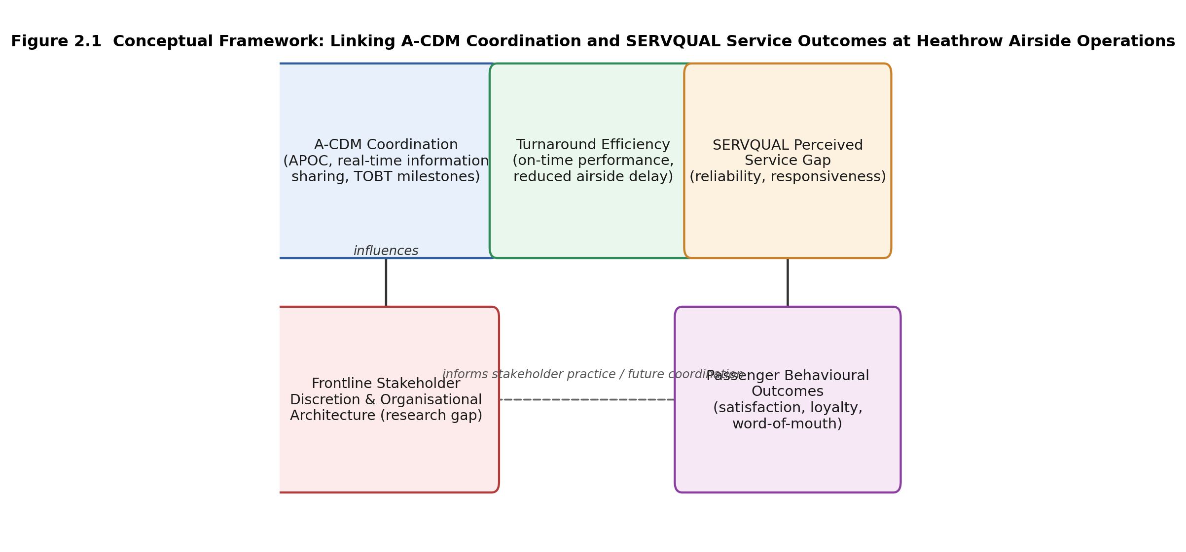
Figure 1 Conceptual framework linking A-CDM coordination and SERVQUAL service outcomes at Heathrow's Airside Operations Department (developed by the author)
Figure 2.1: Conceptual framework linking A-CDM coordination and SERVQUAL service outcomes at Heathrow's Airside Operations Department (developed by the author).

2.8 Research Gap and Chapter Summary
The literature reviewed in this chapter establishes that airside delay is a well-documented coordination problem (Section 2.2), that the Airport Collaborative Decision-Making framework provides a technically effective but organisationally conditional response to it (Section 2.3), and that the SERVQUAL model offers a robust means of theorising how operational performance is translated into passenger experience (Section 2.4). It also demonstrates a credible, if still thinly evidenced, empirical bridge between operational punctuality and passenger service quality outcomes (Section 2.5). What the literature does not provide, and what constitutes the specific gap this dissertation addresses, is primary evidence of how airside operational stakeholders at a single, large hub airport experience and exercise discretion within a collaborative decision-making environment, and how they perceive the relationship between that coordination process and the service quality outcomes experienced by passengers. This gap corresponds directly to Objective 3 of this study, to critically assess the link between airside delay management practices and passenger-perceived service quality, as reported by the frontline stakeholders, such as gate and check-in staff, who liaise directly with passengers during disruption and are therefore well placed to describe its consequences for them, using SERVQUAL, incorporating primary evidence from operational stakeholders, and to Objective 4, to develop evidence-based recommendations grounded in that evidence. The following chapter sets out the research methodology designed to collect and analyse the primary data needed to address this gap.
It should be noted that this dissertation does not collect primary data directly from passengers; as set out in Chapter One, the primary research is a survey of airside operational stakeholders. Passenger service quality outcomes are instead theorised through the SERVQUAL framework applied to the turnaround performance and disruption-recovery experiences reported by those stakeholders, several of whom, such as gate and check-in staff, liaise with passengers directly and are therefore able to comment on passenger-facing consequences. No separate passenger context section has accordingly been included in this chapter, as the review's focus is deliberately confined to the operational and theoretical literature that supports this stakeholder-based approach.

Chapter 3: Research Methodology

3.1 Introduction
This chapter sets out and justifies the research methodology adopted to address the research aim, objectives and questions established in Chapter One, and to generate the primary evidence identified in Chapter Two as absent from the existing literature. Following the structure recommended in the module guidance, the chapter is organised around Saunders, Lewis and Thornhill's (2019) 'Research Onion' (Figure 3.1), which is presented in Section 3.5 and used as the organising structure for Sections 3.6 to 3.9. The chapter follows the chronological order in which the methodological decisions were actually taken: secondary data was considered first, before the philosophical position, approach, strategy and primary method were settled, and the research instrument, sampling strategy and analysis plan were then developed. The chapter closes with the steps taken to establish reliability, validity and research ethics, before assessing the limitations of the methodology adopted and the scope this creates for future research.

3.2 Research Aim and Objectives
This research used the Airport Collaborative Decision-Making (A-CDM) framework and the Service Quality Gap Model (SERVQUAL) to critically analyse Heathrow's operational practices and stakeholder coordination mechanisms and their impact on turnaround efficiency and passenger-perceived service quality. The following four objectives guided the study:
1. Objective 1 (Identify): To identify and explain the main sources and characteristics of airside delay in the aircraft turnaround process at Heathrow Airport, based on existing academic and industry literature.
2. Objective 2 (Explore): To investigate the role of A-CDM and the Airport Operations Centre (APOC) in coordinating stakeholder decision-making and reducing the spread of airside delays at Heathrow.
3. Objective 3 (Critically Evaluate): To critically assess the link between airside delay management practices and passenger-perceived service quality at Heathrow, using SERVQUAL as a theoretical foundation and primary survey evidence from operational stakeholders.
4. Objective 4 (Recommend): To develop evidence-based recommendations to improve airside delay management practices, turnaround efficiency, stakeholder coordination and passenger service outcomes at Heathrow Airport.
The methodology set out in this chapter was designed principally to satisfy Objectives 3 and 4, which required primary data collection, while remaining consistent with the descriptive and theoretical groundwork established in Chapters One and Two in pursuit of Objectives 1 and 2.

3.3 Secondary Data Considerations
Before any primary research method was selected, consideration was given to the extent to which the research objectives could be addressed using secondary data alone, since this was the first methodological question addressed in the dissertation process. Existing secondary sources, including Heathrow's own published operational statistics (Heathrow, 2025), Eurocontrol's A-CDM implementation guidance (Eurocontrol, 2024), and prior empirical studies of A-CDM elsewhere (Guo et al., 2020; Okwir et al., 2017), were reviewed in Chapter Two and provided valuable theoretical and contextual grounding for the study. These sources were strong on describing the technical architecture and system-level performance of collaborative decision-making infrastructure, but, as established in Section 2.6, none reported frontline stakeholder perceptions of A-CDM coordination or passenger-facing SERVQUAL outcomes specific to Heathrow.
This absence was not incidental: secondary sources of this kind are generated either by the airport and its analytics partners, whose reporting priorities are technical and operational rather than perceptual (Guo et al., 2020), or by researchers working in the operations-research tradition, whose methodological conventions favour system-log and performance-indicator data over structured engagement with practitioners (Section 2.3). Secondary data was therefore judged necessary but insufficient: it justified and shaped the theoretical framework used in this study, but could not, by its nature, supply the frontline perceptual evidence that Objectives 3 and 4 required. This conclusion, reached early in the research process, was the basis on which primary data collection was subsequently pursued, and it directly informed the design of the primary research instrument described in Section 3.10.

3.4 Research Rationale
The methodological choices made in this chapter were grounded directly in the research gap identified in Chapter Two: the absence of primary evidence concerning how airside operational stakeholders at Heathrow experienced A-CDM coordination and perceived its relationship to passenger service quality. Addressing this gap required data capable of capturing the perspectives of a reasonably large and varied group of stakeholders, airside operations staff, airline station staff, ground handling supervisors and duty managers, across the several organisations that jointly managed the turnaround process, since the literature reviewed in Section 2.3 indicated that differing organisational priorities between these groups could materially affect how collaborative infrastructure was used in practice (Okwir et al., 2017).
Two broad methodological traditions were weighed against this requirement. A qualitative, interview-based design would have allowed the discretionary and behavioural dimensions of coordination, identified in Chapter Two as under-researched, to be explored in considerable depth, and would have suited an interpretivist reading of the research problem in which stakeholder meaning-making was treated as the primary object of enquiry (Bryman, 2016). However, such a design carries a well-documented trade-off: the depth gained from a small number of interviews is achieved at the cost of breadth, and comparison across four distinct stakeholder categories, each drawn from different employing organisations, would have been difficult to sustain with a sample size realistically achievable within the time and resource constraints of a postgraduate dissertation (Saunders et al., 2019). A quantitative, survey-based design was judged better suited to this study for two connected reasons. First, it allowed data to be collected efficiently from a sample large enough to detect patterns of response across several stakeholder groups operating at Heathrow, supporting the comparative element of Objective 3 that a small number of in-depth interviews would struggle to achieve. Second, because the constructs under investigation, turnaround coordination effectiveness and SERVQUAL-based service quality perception, were already reasonably well defined by the existing literature reviewed in Chapter Two, a structured instrument could be designed to measure them directly rather than to explore them inductively from first principles; this is consistent with Creswell and Creswell's (2018) argument that quantitative designs are best suited to research questions in which the relevant variables and their relationships are already theoretically specified, as was the case here given the prior specification of the A-CDM and SERVQUAL frameworks.
This choice was not without cost. A quantitative design was recognised, at the point the decision was made, to risk under-capturing the discretionary and organisational behaviour that Chapter Two identified as a significant gap in the wider A-CDM literature (Okwir et al., 2017); a structured questionnaire cannot probe why a respondent holds a given perception in the way a follow-up interview question could. This limitation was accepted rather than resolved, on the basis that a small number of brief open-ended items, described in Section 3.10, could partially offset it without compromising the comparability that the quantitative design was chosen to secure. The limitation is returned to explicitly in Section 3.16.

3.5 The Research Onion and Overall Methodological Approach
Saunders et al.'s (2019) Research Onion (Figure 3.1) provided a widely used framework for structuring the methodological decisions made in this dissertation, moving from the outer layer of philosophy through approach, strategy and choices to time horizon and, finally, to the specific techniques and procedures used to collect and analyse data. Each of these layers is addressed in turn in Sections 3.6 to 3.9 below, before the chapter moves to the more practical matters of instrument design, sampling, analysis, ethics and limitations. Structuring the chapter in this way ensured that each methodological decision, for example the choice of a quantitative survey over a qualitative interview strategy discussed in Section 3.4, followed logically from the layer above it, rather than being presented as a series of unconnected choices.
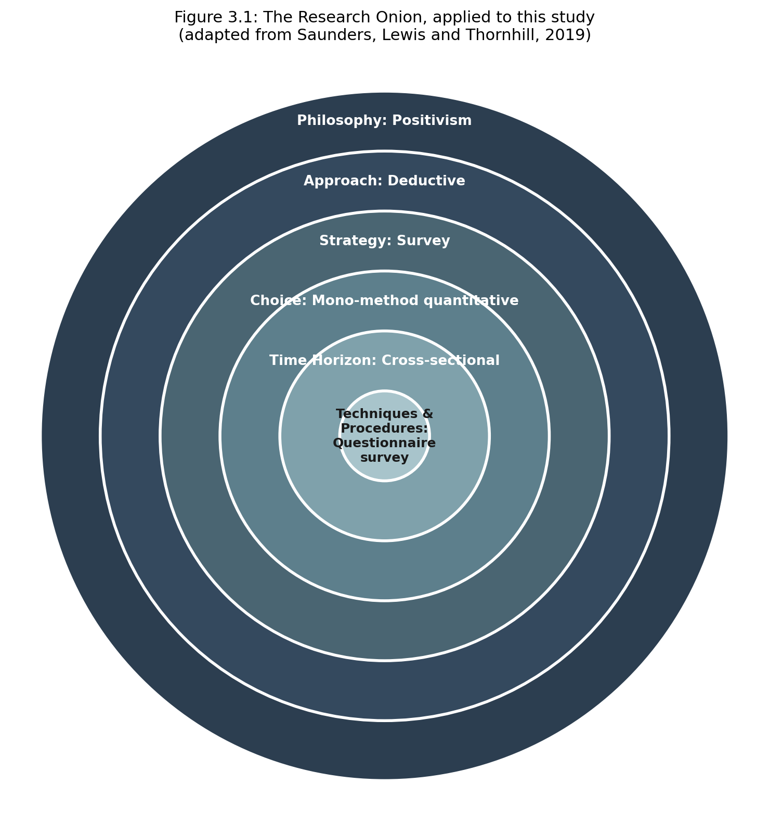
Figure 2 The Research Onion, applied to this study (adapted from Saunders, Lewis and Thornhill, 2019)
Figure 3.1: The Research Onion, applied to this study (adapted from Saunders, Lewis and Thornhill, 2019)

3.6 Research Philosophy
Research philosophy concerns the assumptions a researcher makes about the nature of the reality being studied (ontology) and about what constitutes acceptable knowledge of it (epistemology), and these assumptions shape every subsequent methodological decision (Saunders et al., 2019). Three broad philosophical positions are commonly distinguished in business research: positivism, interpretivism, and pragmatism.
Positivism holds that an objective social reality exists independently of the researcher and can be measured using observable, quantifiable indicators, typically tested through hypothesis-driven, statistical analysis (Saunders et al., 2019; Bryman, 2016). Interpretivism, by contrast, holds that social reality is constructed through the meanings actors attach to it and is therefore best understood through detailed, contextual, typically qualitative enquiry that treats the researcher as inseparable from the phenomenon being studied (Bryman, 2016). Pragmatism treats the appropriateness of a philosophical position as contingent on the specific research question rather than as a fixed commitment, and permits the combination of positivist and interpretivist elements within a single study where doing so best serves the research objectives (Saunders et al., 2019).
This research adopted a broadly positivist philosophy. The core constructs under investigation, the effectiveness of A-CDM coordination and the extent of the SERVQUAL service gap, were drawn from established theoretical models that already specified measurable dimensions, for example the five SERVQUAL dimensions of tangibles, reliability, responsiveness, assurance and empathy, and the research aim was to test the strength and pattern of relationships between these dimensions across a defined population of Heathrow airside stakeholders, rather than to construct new theory inductively from stakeholders' own interpretive accounts. A purely positivist position was, however, judged to have limitations in this context. Bell, Bryman and Harley (2022) caution that a strictly positivist design can flatten the discretionary and contextual behaviour that motivates much organisational research, a concern directly applicable to the behavioural gap identified in Chapter Two. The inclusion of brief open-ended questions within the survey instrument, described in Section 3.10, reflected a recognition that some of this discretionary and organisational behaviour might not be fully captured by closed, quantified items alone. The philosophical position adopted was therefore predominantly positivist, with a limited interpretivist accommodation built into the instrument design rather than into the overall research strategy.

3.7 Research Approach
Consistent with the positivist philosophy set out above, this research followed a deductive approach. A deductive approach begins from an existing theory or set of theories, derives specific, testable propositions from that theory, and then collects data to establish whether the propositions hold in a particular empirical setting (Saunders et al., 2019; Bell, Bryman and Harley, 2022). Applied to this study, A-CDM and SERVQUAL supplied the constructs and hypothesised relationships to be tested, and primary data was then collected to establish whether the patterns observed at Heathrow were consistent with those theoretical expectations. This differs from an inductive approach, in which theory would instead be developed from the primary data itself, typically through the iterative coding procedures associated with qualitative enquiry (Bryman, 2016). An inductive design was judged less appropriate given that the research questions established in Chapter One already specified the theoretical relationships, A-CDM's effect on coordination and the SERVQUAL-based link between operational performance and service quality, to be investigated; adopting an inductive approach in this context would have required the researcher to set aside a well-developed body of theory in favour of ground-up theory-building for which the study's scope and timeframe were not well suited.

3.8 Research Strategy and Design
The chosen research design was a cross-sectional, quantitative survey. Quantitative methods refer to research approaches in which data is collected and analysed in numerical form, typically through structured instruments applied to a defined sample, with the aim of testing relationships between variables using statistical techniques (Creswell and Creswell, 2018). A survey strategy was selected in preference to a qualitative case-study or interview-based design because the research objectives required comparison across a defined and reasonably large population of stakeholder types (Section 3.12), which a small number of interviews would have been poorly placed to support; a survey strategy was also consistent with the stakeholder-coverage logic evident in the closest existing empirical precedent for Heathrow-based operational research (Guo et al., 2020). A cross-sectional, rather than longitudinal, design was chosen because the research questions concerned the current state of coordination practice and its perceived relationship to service quality, rather than change over time; a longitudinal design, while capable of tracking how perceptions evolved as operational conditions changed, was judged unnecessary for objectives that were explicitly framed around a present-state assessment and was, in any case, incompatible with the single-submission timeframe available for a postgraduate dissertation.
A mono-method quantitative design, using a single structured questionnaire as the principal data collection instrument, was adopted rather than a full mixed-methods design. A mixed-methods approach combining survey data with in-depth interviews would have offered richer insight into the discretionary behaviour highlighted in Chapter Two and discussed in Section 3.4, and was seriously considered for this reason. It was ultimately judged to exceed the practical scope available for the primary research phase of this dissertation, given the additional time required for interview recruitment, transcription and thematic analysis alongside survey administration, and is noted as a direction for future research in Section 3.17.

3.9 Selecting and Justifying the Primary Research Method
Two broad primary research methods were considered for this study: a semi-structured interview approach and a structured questionnaire survey. An interview-based approach was considered because it would have allowed deeper exploration of the discretionary, organisational behaviour identified in Chapter Two as under-researched, and because semi-structured interviews are well suited to capturing the situated, practitioner-specific reasoning that a closed-item survey cannot (Bryman, 2016). However, it was rejected as the principal method for two reasons. First, the number of interviews practically achievable within the time and resource constraints of a postgraduate dissertation would have been too small to support meaningful comparison across the four stakeholder groups identified in Section 3.12; a sample of, at most, ten to fifteen interviews would not have permitted the group-level comparison that Objective 3 required. Second, because the core constructs under investigation were already well defined by existing theory, a structured, quantifiable instrument was judged more appropriate to the deductive, theory-testing design established in Section 3.7 than an exploratory interview format designed to surface constructs not yet specified in the literature.
A structured questionnaire survey was therefore selected as the primary research method, on the grounds that it could be distributed efficiently to a large and stratified sample, would produce data directly comparable across respondents and stakeholder groups, and allowed the SERVQUAL and A-CDM constructs identified in Chapter Two to be measured using established, previously validated item formats. This choice is not without a documented weakness: Bell, Bryman and Harley (2022) note that structured questionnaires, by fixing response categories in advance, can constrain respondents to a predefined conceptual frame that may not fully match their own understanding of the phenomenon, a risk this study sought to mitigate, though not eliminate, through the inclusion of brief open-ended items and through piloting (Section 3.11).

3.10 Designing the Research Instrument
The research instrument was a structured, self-administered online questionnaire, distributed to the stakeholder population described in Section 3.12. The questionnaire was designed in four sections. Section A collected respondent and organisational classification information, including stakeholder group, years of airside experience, and frequency of interaction with the APOC or A-CDM processes, together with standard demographic items (age band and gender) included to support the cross-tabulation analysis described in Section 3.13 and restricted to respondents aged eighteen or over. Section B addressed Research Question 2 and Objective 2, using five-point Likert items, each presented with the full labelled scale (1 = Strongly Agree, 2 = Agree, 3 = Don't Know, 4 = Disagree, 5 = Strongly Disagree) to avoid ambiguity, to measure respondents' perceptions of A-CDM information sharing, APOC coordination during disruption, predictive time-data reliability, disruption decision-making speed, and cross-stakeholder goal alignment, informed by the milestone- and information-sharing constructs identified in the A-CDM literature (Eurocontrol, 2024; Guo et al., 2020; Okwir et al., 2017). Section C addressed Research Question 1 and Objective 1, asking respondents to indicate which of several delay-causing factors, drawn directly from the literature reviewed in Chapter Two following Ding et al. (2024) and CM et al. (2025), applied to their own experience of turnaround delay; this section was deliberately designed as a multi-select item rather than a forced individual rating of every factor, since it could not be assumed that every respondent would attribute delay to the full set of causes rather than to one or a few of them. Section D addressed Research Question 3 and Objective 3, adapting the SERVQUAL model established by Parasuraman et al. (1988) into a paired Expectation/Perception format across the five service dimensions relevant to Heathrow's airside operation, and included ranked-preference items asking respondents to order the relative importance of the five SERVQUAL dimensions to their own role.
Particular attention was paid, during instrument design, to avoiding item wording likely to lead respondents toward a particular answer. Items were checked to ensure that value-laden phrasing, for example presupposing that A-CDM information is 'generally reliable' or that disruption decision-making is 'faster' or 'better' as a result of coordination, was replaced with neutrally framed statements that allowed respondents to express agreement or disagreement without the item itself signalling an expected direction of response (Bell, Bryman and Harley, 2022); item phrasing was also varied across the questionnaire, mixing positively and negatively worded statements, to reduce the risk of acquiescence bias.
The instrument was developed by adapting items from previously validated SERVQUAL and A-CDM-related survey research identified in Chapter Two, in order to strengthen content validity (see Section 3.14). Consistent with the supervisory guidance received, a finalised draft of this questionnaire was submitted separately for review and approval prior to piloting and distribution, and no data collection took place until that approval had been obtained. A copy of the approved questionnaire is provided in the appendices.

3.11 Piloting the Questionnaire
Prior to full distribution, the questionnaire was piloted with a small sample of accessible airside-experienced contacts, consistent with recommended postgraduate research practice (Saunders et al., 2019). The purpose of the pilot was to identify ambiguous, poorly worded or double-barrelled items, to check that the estimated completion time, targeted at between five and ten minutes in order to minimise respondent fatigue and non-completion, was acceptable to prospective respondents, and to confirm that the online survey platform functioned correctly across devices. Feedback from the pilot was used to refine the wording and, where necessary, the structure of the instrument before it was distributed to the full sample; any substantive changes made as a result of piloting are recorded and reported in this section once the pilot has been completed.

3.12 Population and Sampling
The population for this research consisted of operational stakeholders involved in the management of aircraft turnaround at Heathrow Airport: airside operations staff, airline station staff, ground handling supervisors and airside duty managers, drawn from organisations including Heathrow Airport Limited itself, resident airlines, other airlines operating at the airport, and ground handling providers. This population was selected because it corresponded directly to the stakeholder groups identified in the A-CDM literature as jointly responsible for turnaround coordination (Eurocontrol, 2024; Okwir et al., 2017), and because members of this population were positioned to report directly on the frontline coordination experience that Chapter Two identifies as absent from the existing evidence base.
A target sample of 150 to 200 respondents was set, consistent with general guidance for a quantitative survey-based postgraduate dissertation of this kind. Given that a full sampling frame of Heathrow's airside workforce was not accessible to an external postgraduate researcher, a probability sampling approach, in which every member of the population has a known, non-zero chance of selection, was not achievable (Etikan, Musa and Alkassim, 2016), and a non-probability approach was accordingly adopted. Access to the population was sought through professional and organisational contacts within the researcher's own aviation-related network, supplemented by distribution through relevant professional groups. This can properly be described as a purposive, stratified approach rather than simple convenience sampling: purposive sampling involves the deliberate selection of participants judged likely to hold relevant knowledge or experience relative to the research question, rather than participants selected solely because they are easiest to reach (Etikan, Musa and Alkassim, 2016), and respondents were deliberately sought across the four stakeholder categories described above rather than drawn opportunistically from whichever contacts were easiest to reach.
Snowball sampling, in which initial participants are asked to refer the researcher to further eligible contacts within their professional network, was used to extend coverage beyond the researcher's immediate contacts into other organisations and stakeholder categories (Parker, Scott and Geddes, 2019). This step was taken specifically to guard against the risk that convenience sampling alone provides an insufficiently justified basis for postgraduate-level research, and to reduce the likelihood that the achieved sample would be drawn disproportionately from a single employing organisation, which would have limited the cross-stakeholder comparison central to Objective 3. It is nonetheless acknowledged that both purposive and snowball sampling remain non-probability methods: neither can guarantee that the achieved sample is statistically representative of the underlying population in the way that a random probability sample would, and referrals generated through snowball sampling risk clustering around respondents with similar views or within the same organisational networks (Etikan, Musa and Alkassim, 2016). This limitation is revisited in Section 3.16. The actual achieved sample size and response rate will be reported at the start of Chapter Four once data collection has closed.

3.13 Data Presentation and Analysis
Once the survey period had closed, responses were analysed primarily through descriptive statistics: frequencies and percentages were calculated for the respondent classification items (Section A) and for each Likert item in Sections B, C and D, and mean scores were computed for every item, establishing the overall pattern of stakeholder perception ahead of any further interpretation, consistent with the minimum expectation for quantitative postgraduate dissertation analysis (Saunders et al., 2019). For Section D, the paired Expectation and Perception items were used to compute a SERVQUAL-style gap score for each of the five service dimensions surveyed, calculated as the mean Perception score minus the mean Expectation score for each dimension, following the scoring convention established by Parasuraman et al. (1988); a negative gap score would indicate that perceived service delivery fell short of what stakeholders regarded as important, while a positive score would indicate that perceived delivery met or exceeded expectations on that dimension.
Where the respondent-level dataset permitted, cross-tabulation of responses by stakeholder group against the coordination-effectiveness and SERVQUAL-based items, together with chi-square tests of association and correlation analysis, was conducted to test for differences between stakeholder groups; a chi-square test was used specifically to assess whether categorical patterns of response, for example agreement versus disagreement with a coordination item, differed significantly by stakeholder group, while correlation analysis was used to examine the strength and direction of the relationship between coordination-effectiveness scores and SERVQUAL gap scores across respondents. Data was managed and analysed using Microsoft Excel for descriptive statistics and initial data cleaning, with IBM SPSS Statistics (Statistical Package for the Social Sciences), a widely used software package for the statistical analysis of survey and social-science data (IBM Corp., 2023), used for cross-tabulation, chi-square testing, correlation and any further inferential testing. Findings are presented in Chapter Four using summary tables and charts, with SERVQUAL gap scores displayed dimension-by-dimension to allow direct visual comparison against the theoretical framework established in Section 2.7, and cross-tabulated findings presented alongside their associated significance values so that the strength of any reported group difference can be assessed by the reader. Any constraints encountered in the actual dataset obtained, for example if respondent-level linkage between stakeholder classification and item responses proves unavailable, will be reported transparently in Chapter Four and revisited as a limitation in Section 3.16.

3.14 Reliability and Validity
Reliability, the extent to which the research instrument produces consistent results, and validity, the extent to which it measures what it is intended to measure, were both addressed at the design stage of this research. Content validity was supported by grounding each section of the questionnaire directly in an established theoretical source: delay-cause items were drawn from Ding et al. (2024) and CM et al. (2025), coordination items were drawn from the A-CDM literature reviewed in Section 2.3, and service-quality items were adapted directly from Parasuraman et al.'s (1988) established SERVQUAL dimensions. Piloting the questionnaire with a small sample of accessible, airside-experienced contacts prior to full distribution, described in Section 3.11, provided a further check on face validity, allowing ambiguous or poorly worded items to be identified ahead of the main data collection.
Subject to the format in which the final dataset is obtained, internal consistency of the multi-item Likert scales will be assessed using Cronbach's alpha once respondent-level data is available; this calculation, and its result, will be reported in this section once data collection and analysis are complete. The steps described in this section, and the ethical safeguards described in Section 3.15, were formally documented and submitted for approval on the University's PG2 ethics form, provided in the appendices; the reliability and validity measures adopted here were designed to satisfy the methodological rigour requirements set out in that approval process, and any conditions attached to the PG2 approval are reported alongside the findings in Chapter Four.

3.15 Research Ethics
This research was conducted in accordance with the ethical requirements of the University, and a completed PG2 ethics approval form is provided in the appendices. Participation was entirely voluntary, and an information sheet was provided to all potential respondents prior to participation, setting out the purpose of the research, the nature of the data being collected, and their right to withdraw without giving a reason. Informed consent was obtained from all respondents before they proceeded to the substantive questionnaire items; because responses were collected anonymously, respondents were also informed at the outset that, once a completed survey had been submitted, it would not be possible to withdraw their individual responses from the dataset, and that continuing with the survey indicated their understanding of this and their consent to participate.
All responses were collected and stored anonymously; no respondent was asked to provide their name, and organisational affiliation was recorded only at the level of stakeholder category rather than by naming a specific employer, in order to prevent individual respondents or their organisations from being identified in the reported findings. All data was stored securely in accordance with UK GDPR requirements and University policy, accessible only to the researcher and supervisor, and will be destroyed following completion and assessment of the dissertation in line with university policy. No question required a respondent to disclose commercially confidential organisational performance data; all items asked for perceptions and experiences rather than specific figures. Where distribution involved contacting respondents through Heathrow Airport Limited or its principal airline and ground handling partners directly, written consent was sought from the relevant organisation in advance of distribution, consistent with the University's requirements for research conducted on or in relation to a third-party operational site.

3.16 Anticipated Limitations of the Methodology
Several limitations of the chosen methodology should be acknowledged in advance of data collection. First, reliance on self-reported perception data means that the research captures how stakeholders perceive coordination effectiveness and service quality outcomes, rather than directly observed operational or passenger data; the findings should therefore be interpreted as evidence of stakeholder perception rather than as an independent audit of Heathrow's operational performance. Second, the purposive and snowball sampling strategy described in Section 3.12 cannot guarantee a fully representative sample of the underlying population in the way that a full probability sample would, and referrals generated through snowball sampling in particular risk clustering around respondents with similar views or organisational networks; the findings should be generalised with appropriate caution. Third, as a cross-sectional, mono-method quantitative study, the research provides a single-point-in-time, self-reported account of coordination and service quality perception and cannot capture how these relationships change across different operational conditions, nor fully explore the discretionary, frontline behaviour identified as an area for future enquiry in Chapter Two and discussed in Section 3.4. Fourth, the decision to prioritise breadth of stakeholder coverage over depth of individual insight, discussed in Section 3.9, means that the survey instrument may not fully capture the reasoning underlying a given response in the way a follow-up interview question could, notwithstanding the inclusion of brief open-ended items intended to partially offset this constraint. Any further, dataset-specific limitations that emerge once data collection and analysis are complete will be reported transparently alongside the findings in Chapter Four.

3.17 Scope for Future Research
The mono-method, cross-sectional design adopted here creates several opportunities for future research. A mixed-methods extension incorporating semi-structured interviews with a smaller number of stakeholders would allow the discretionary, organisational behaviour behind the survey responses to be explored in greater depth, addressing the trade-off between breadth and depth discussed in Sections 3.4 and 3.9. A longitudinal design tracking coordination and service quality perceptions over time would allow the effect of specific operational interventions, for example changes to A-CDM predictive data systems, to be evaluated directly. A probability-based sampling design, were a full sampling frame of Heathrow's airside workforce to become accessible to a future researcher, would also allow the representativeness limitations noted in Section 3.16 to be addressed more directly than was possible within the scope of this study. These directions are returned to in Chapter Five.

Chapter 4: Findings

4.1 Introduction
The results of the first survey research mentioned in Chapter Three are presented in this chapter. The chapter is organized in two parts based on the supervision received during the dissertation tutorial on 21 August. The survey instrument designed directly around the study's research questions and objectives is presented and worked through in Section One (Sections 4.2 to 4.7): Section A of the questionnaire was used to gather data about the respondent classification; Section B addressed RQ2, A-CDM/APOC coordination; Section C, together with Question 18, addressed RQ1, delay causation; Section D addressed RQ3, the SERVQUAL-based service quality gap; and Section E captured open-ended reflections feeding into RQ4. Section One reports the descriptive statistics associated with each part of the instrument, concentrating on the items most directly relevant to the research questions rather than working through every question individually, and reads related questions against one another to draw out inferences beyond the raw percentages wherever the aggregate dataset allows this. Section Two (Sections 4.8 to 4.13) then moves to a more rigorous, analytical treatment of the same results, synthesising them against the A-CDM and SERVQUAL literature reviewed in Chapter Two and against the wider operating context of the airline industry, before a brief lead-in to Chapter Five.
As with the survey data supplied to the researcher, findings throughout this chapter are reported at the aggregate, question level. The respondent-level linkage that would have been required for the formal cross-tabulation, chi-square testing and correlation analysis planned in Section 3.13 was not available in the dataset obtained, so relationships between questions are explored below by reading aggregate response patterns against one another rather than through statistical association tests; such comparisons are accordingly presented as indicative, descriptive inference rather than as statistically confirmed association, and this constraint is revisited as a limitation in Chapter Five.
SECTION ONE — DESCRIPTION AND GENERAL INFERENCES

4.2 Survey Structure and Respondent Profile
As noted above, the questionnaire's five sections map directly onto the study's objectives and research questions, moving from respondent classification (Section A) through coordination effectiveness (Section B, RQ2) and delay causation (Section C, RQ1) to the SERVQUAL service quality gap (Section D, RQ3) and open reflection (Section E, RQ4). Of those who opened the survey, 63% agreed to participate, which is in the range of 150-200 respondents as targeted in Section 3.12. Table 4.1 summarises the three classification variables most relevant to interpreting the sections that follow.
Table 4.1: Respondent profile (Section A, selected variables)
Table 1 Respondent profile (Section A, selected variables)
Variable | Category | % of respondents
Stakeholder group | Airside operations staff (Heathrow Airport Ltd / APOC) | 22.0
 | Airline station staff (airline / ground operations) | 38.0
 | Ground handling supervisor | 37.0
 | Other | 3.0
Years of airside/airport experience | Less than 2 years | 10.5
 | 2–5 years | 37.0
 | 6–10 years | 33.5
 | More than 10 years | 19.0
Frequency of APOC/A-CDM interaction | Daily | 11.5
 | Several times a week | 51.0
 | Occasionally | 28.0
 | Rarely or never | 9.5
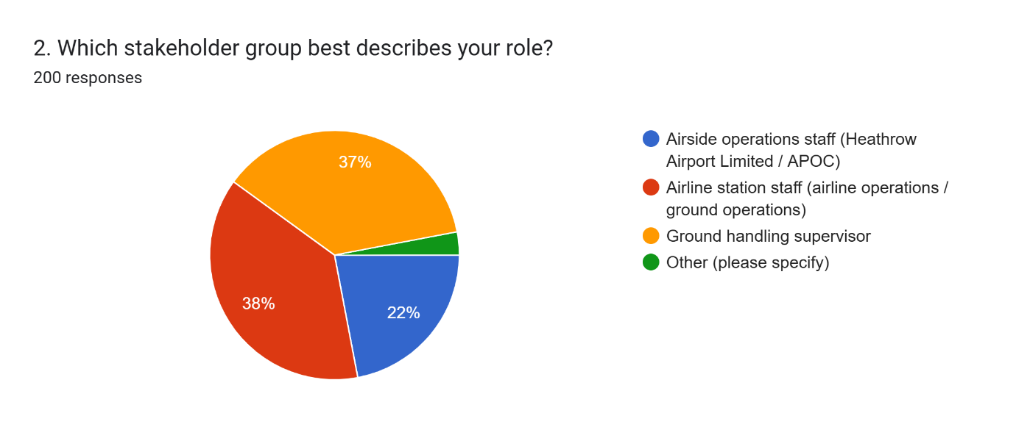
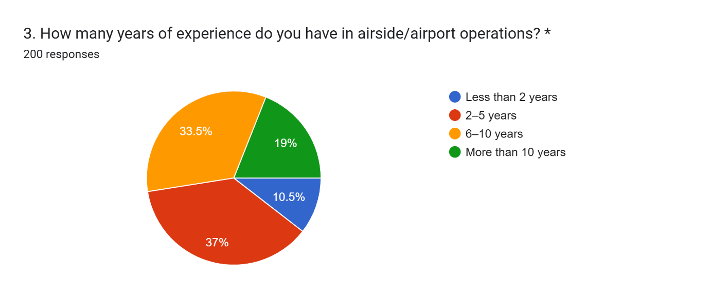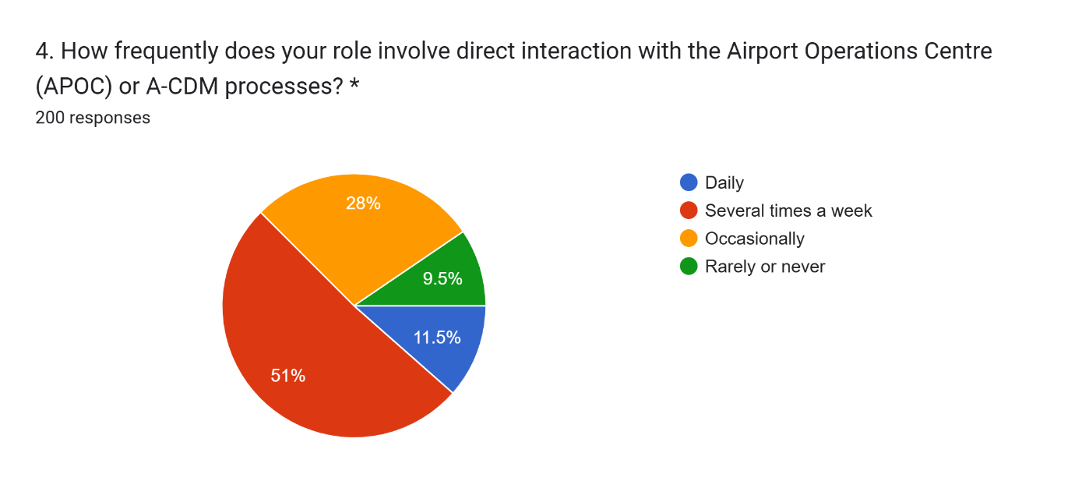
Figure 3 respondent profile by stakeholder group, experience and APOC interaction frequency (Q2–Q4)
Figure 4.1 — respondent profile by stakeholder group, experience and APOC interaction frequency (Q2–Q4)
The achieved sample was weighted towards airline station staff (38.0%) and ground handling supervisors (37.0%), with airside operations staff drawn from Heathrow Airport Limited and the APOC comprising 22.0%. This distribution matters for how the coordination findings in Section 4.4 should be read: three-quarters of respondents are reporting on the APOC and A-CDM from outside it, as users of its outputs, rather than from within it. The sample was also well exposed to the process under study, with 62.5% interacting with the APOC or A-CDM daily or several times a week; this exposure level is used below to test whether the more muted coordination findings in Section 4.4 might simply reflect unfamiliarity, or whether a more substantive explanation is required.

4.3 Delay Causation (RQ1)
Table 4.2 reports the four Section C items, scored 1 (Strongly Agree) to 5 (Strongly Disagree), so that a lower mean indicates stronger agreement.
Table 4.2: Airside delay causation (Section C)
Table 2 Airside delay causation (Section C)
Item (Section C: delay causation) | Mean* | Agree % | Disagree %
Q14 Ground handling activities are a significant contributor | 2.03 | 69.3 | 15.1
Q15 Knock-on effects outweigh the current turnaround itself | 2.78 | 47.7 | 32.7
Q16 Communication gaps are a significant contributor | 2.70 | 52.0 | 26.5
Q17 Resourcing/staffing constraints are a significant contributor | 2.94 | 44.0 | 39.5

Ground handling activities attracted the strongest agreement of any item in the questionnaire (69.3% Agree, mean 2.03), and communication gaps between stakeholders were also widely endorsed (52.0% Agree). Question 18 asked which specific causes respondents had personally observed in the past month; Table 4.3 ranks the results, and only 3.5% of respondents selected “none of the above”.
Table 4.3: Causes of turnaround delay personally observed in the past month (Q18)
Table 3 Causes of turnaround delay personally observed in the past month (Q18)
Cause personally observed in the past month (Q18, select all) | % of respondents
Boarding | 45.0
Catering resupply | 43.5
Refuelling | 37.5
Crew availability | 34.0
Air traffic control restrictions | 32.0
Cabin cleaning | 31.0
Weather | 25.5
Baggage handling | 20.5
Equipment or technical fault | 20.0
Other | 8.0
None of the above | 3.5
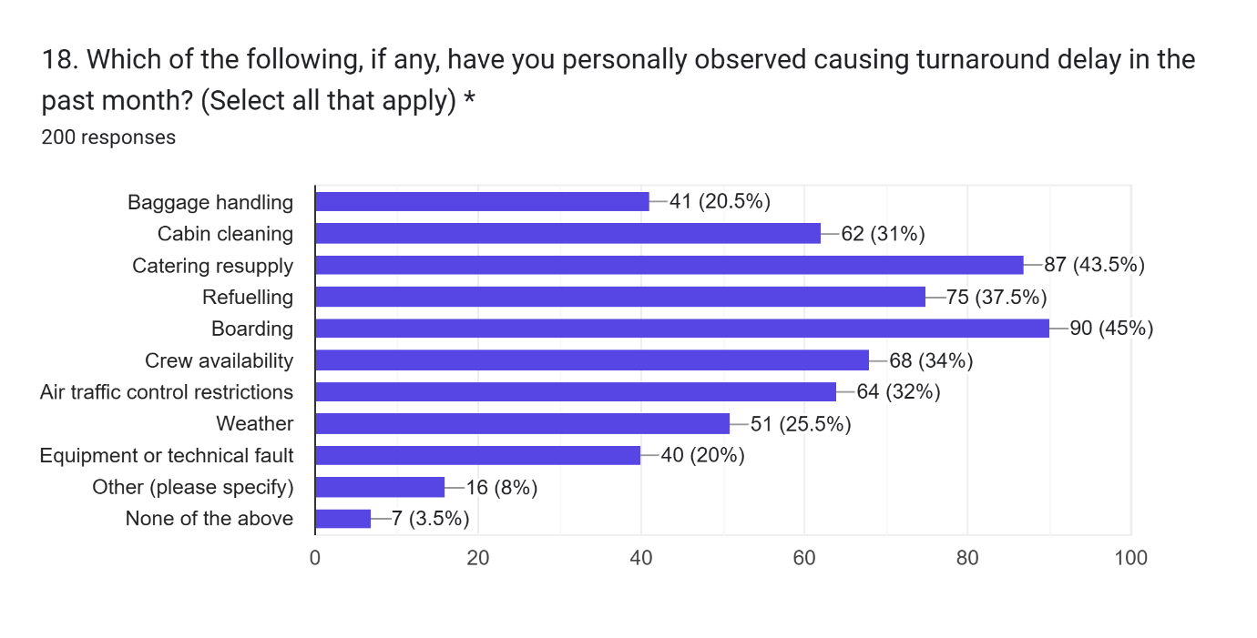
Figure 4 observed causes of turnaround delay, Q18, ranked by % of respondents
Figure 4.2 —observed causes of turnaround delay, Q18, ranked by % of respondents
Reading Table 4.2 against Table 4.3 is instructive. Ground handling is endorsed in principle as the leading category of delay cause, yet the single most frequently observed specific cause in practice was boarding (45.0%), a passenger-flow activity that sits at the edge of, rather than squarely within, the ground handling sub-processes (cleaning, catering, fuelling, baggage) that Section C.14 asked about directly. Catering resupply (43.5%) and refuelling (37.5%) then follow as the most frequently observed classic ground handling activities, broadly consistent with the strength of agreement in Table 4.2. Crew availability (34.0%) and air traffic control restrictions (32.0%), by contrast, sit outside the ground handling category altogether, indicating that the category-level endorsement in Question 14 understates the range of proximate causes stakeholders actually encounter month to month.
Two other items in Section C are also of interest in a brief way. Stakeholder views are less homogeneous on whether they agree with the knock-on effect from earlier disruption is a bigger cause of delay than the disruption itself (47.7% Agree compared with 32.7% Disagree) than on the ground handling service. The difference in responses to Question 17 on resourcing and staffing constraints was the most evenly split one in Section C as a whole, with 44.0% of respondents agreeing and 39.5% disagreeing, which, unsurprisingly, could reasonably be interpreted as different views across organisations and stakeholder groups on the adequacy of resourcing, and not necessarily as a response to a shared issue at Heathrow.

4.4 A-CDM/APOC Coordination Effectiveness (RQ2)
Table 4.4: A-CDM / APOC coordination effectiveness (Section B)
Table 4 A-CDM / APOC coordination effectiveness (Section B)
Item (Section B: A-CDM / APOC coordination) | Mean* | Agree % | Disagree %
Q7 A-CDM gives an accurate, shared real-time picture | 2.17 | 63.8 | 14.6
Q8 APOC improves coordination during disruption | 2.87 | 35.9 | 25.3
Q9 Predicted times (TOBT/TSAT) match outcomes | 2.85 | 41.2 | 34.6
Q10 Decisions are faster because of A-CDM/APOC | 2.94 | 42.4 | 37.8
Q11 Decisions are better-informed because of A-CDM/APOC | 2.70 | 50.7 | 29.2
Q12 Organisational goals well aligned with other stakeholders | 2.62 | 54.3 | 25.2
Q13 Coordination often breaks down under high disruption | 2.74 | 46.5 | 31.8
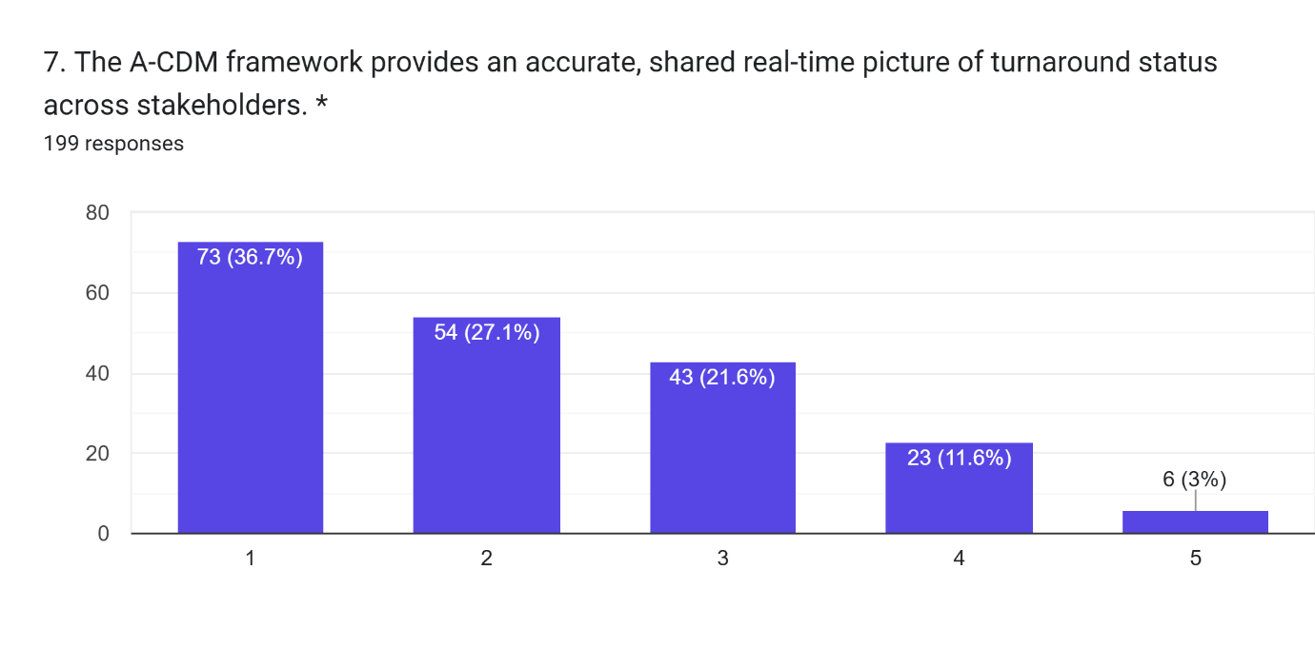
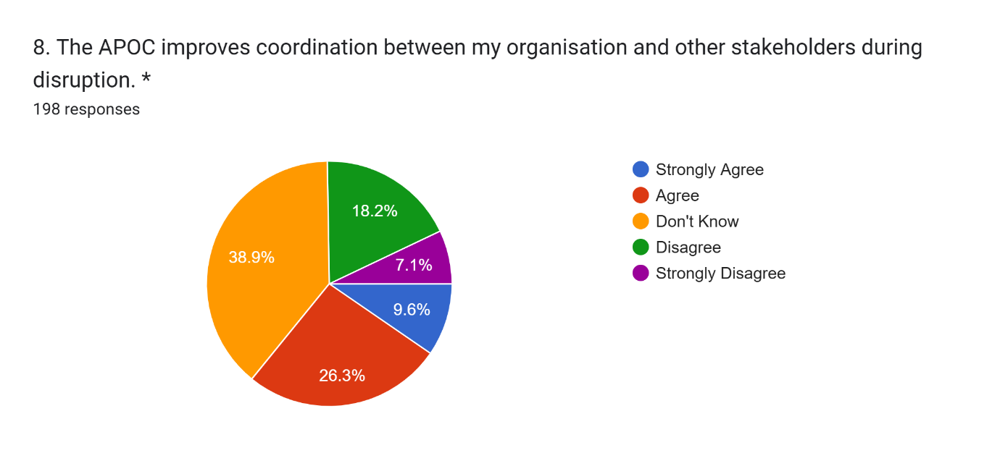
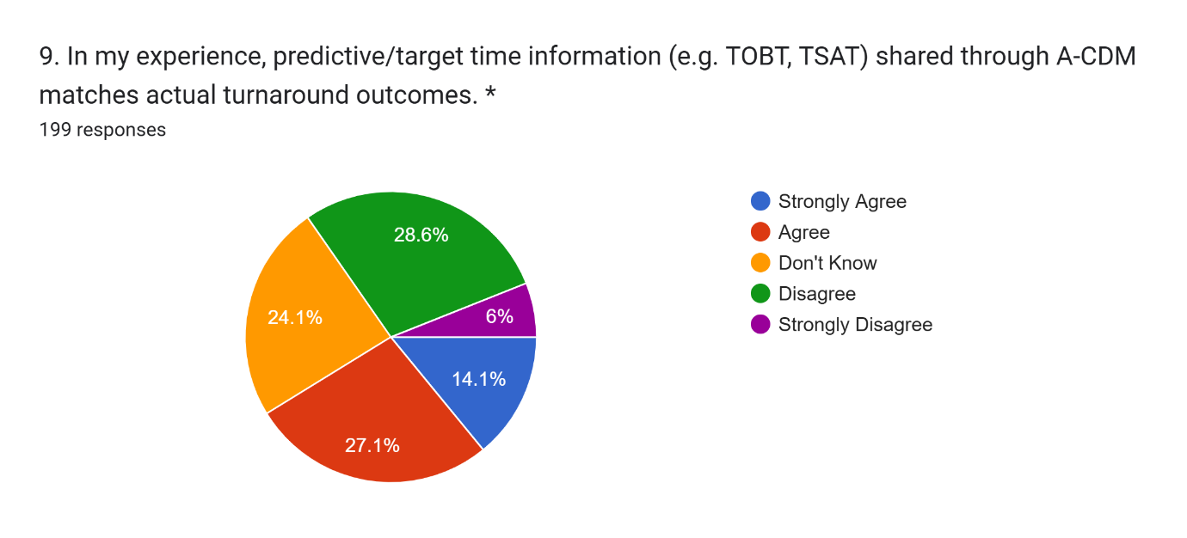
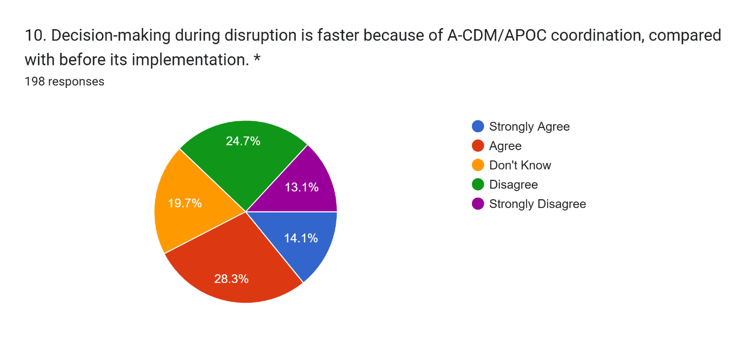
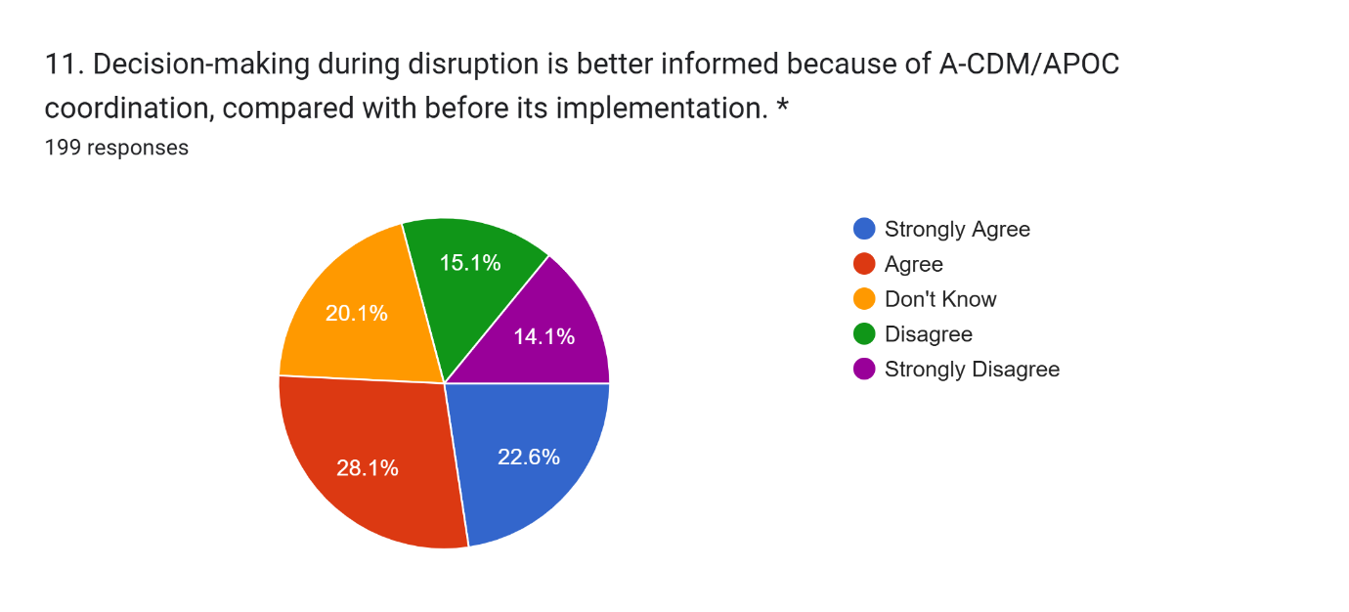
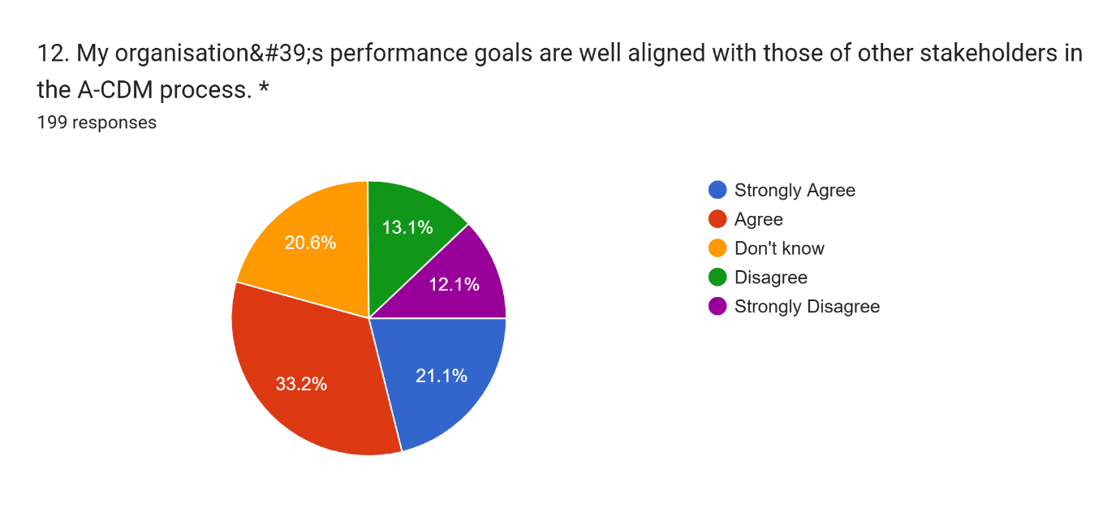
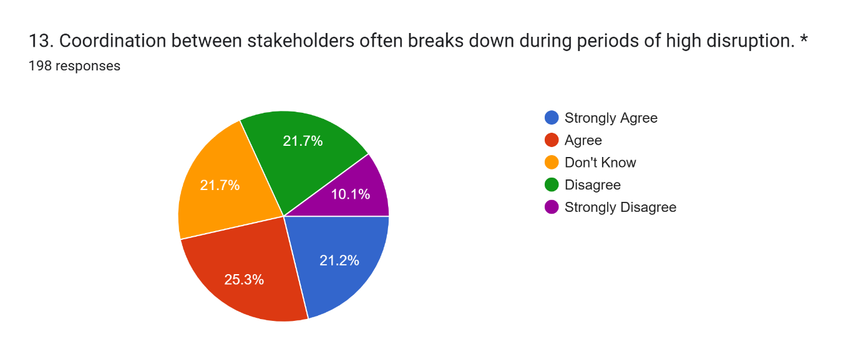
Figure 5 Section B coordination items, Q7–Q13, agreement profile
Figure 4.3 —Section B coordination items, Q7–Q13, agreement profile
The greatest consensus in this section was around the informational role of A-CDM as 63.8% agreed that A-CDM presents an accurate and shared real-time view of the status of a turnaround. But agreement was lacking for questions concerning the relationship between this common image and better coordination outcomes: just 35.9% agreed that the APOC fosters better coordination in times of disruption, with 38.9% responding “don't know” (the highest rate in the questionnaire). This vague and ambiguous response, however, is not easily explained by lack of familiarity with the APOC or A-CDM, and may rather indicate that the coordination advantage of the APOC is less apparent or less frequently experienced by stakeholders outside of the APOC, than the accuracy of the shared data.
Another related pattern can be seen when comparing Questions 10 and 11. A slim majority (50.7%) agreed that decision-making during disruption is better-informed because of A-CDM/APOC coordination, yet only 42.4% agreed that it is faster, the most evenly divided item in the section. A large proportion of respondents also indicated that there is inadequate coordination between stakeholders during disrupted times (46.5%) compared to 31.8% who disagreed. These three comparisons suggest a general trend, not three independent outcomes: stakeholders have faith in the information provided by A-CDM, but their faith is significantly lower that this information will swiftly and effectively accelerate or normalise joint decision-making when the level of disruption increases.

4.5 SERVQUAL Service Quality Gap (RQ3)
Table 4.5: SERVQUAL-style gap scores by dimension (Section D)
Table 5 SERVQUAL-style gap scores by dimension (Section D)
SERVQUAL dimension | Mean importance (E) | Mean perceived delivery (P) | Gap (P − E)
Timeliness of information sharing | 2.16 | 3.17 | +1.01
Accuracy of predicted turnaround/departure times | 2.77 | 3.05 | +0.27
Responsiveness of stakeholders during disruption | 2.98 | 2.77 | −0.21
Reliability of resource allocation | 3.02 | 2.85 | −0.17
Overall confidence processes minimise passenger-facing delay | 2.94 | 2.88 | −0.06
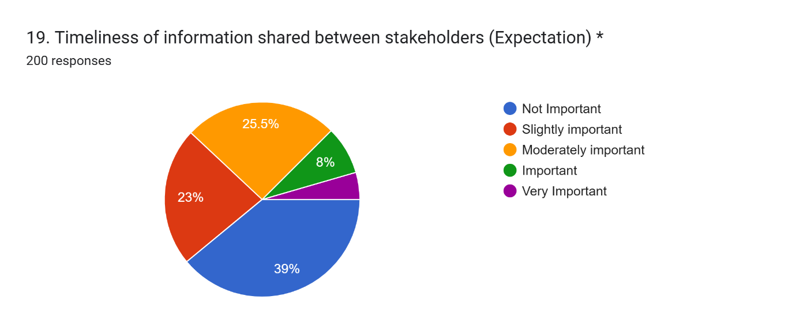
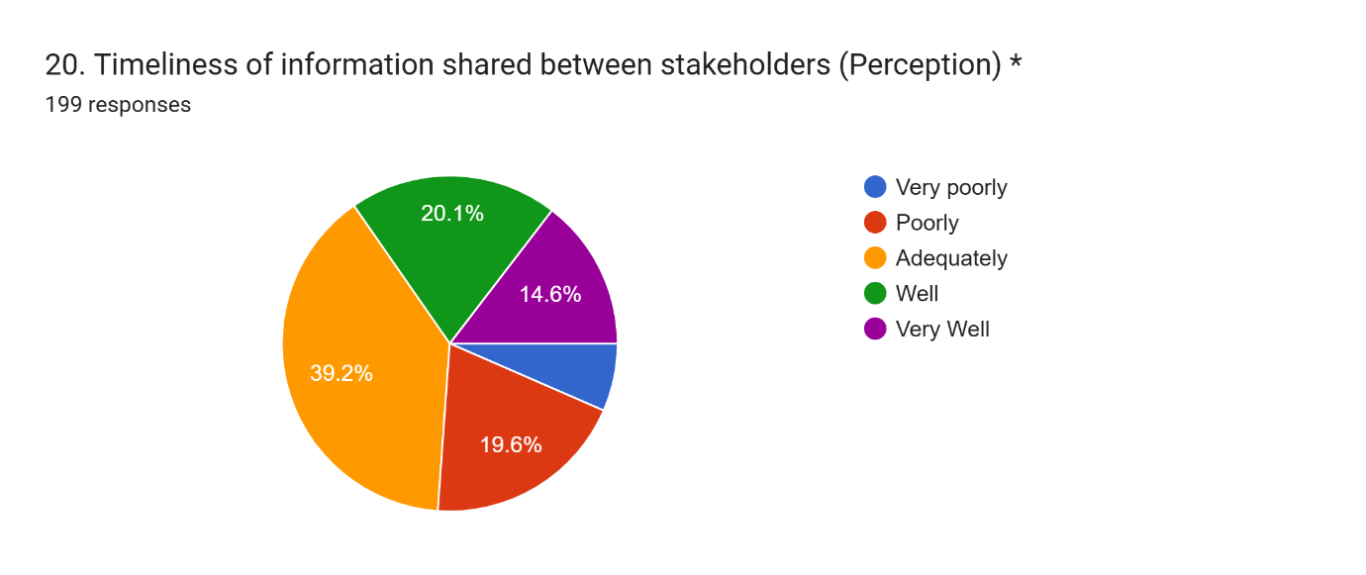
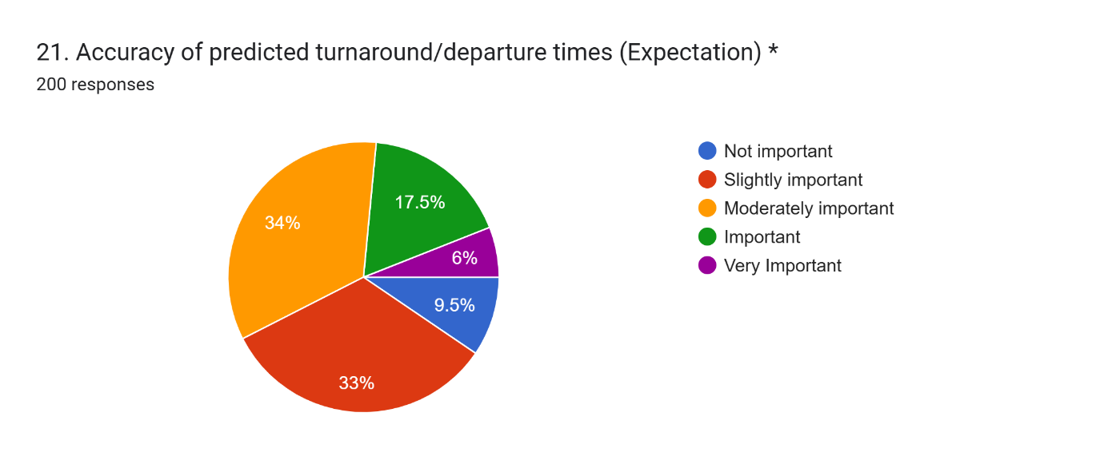
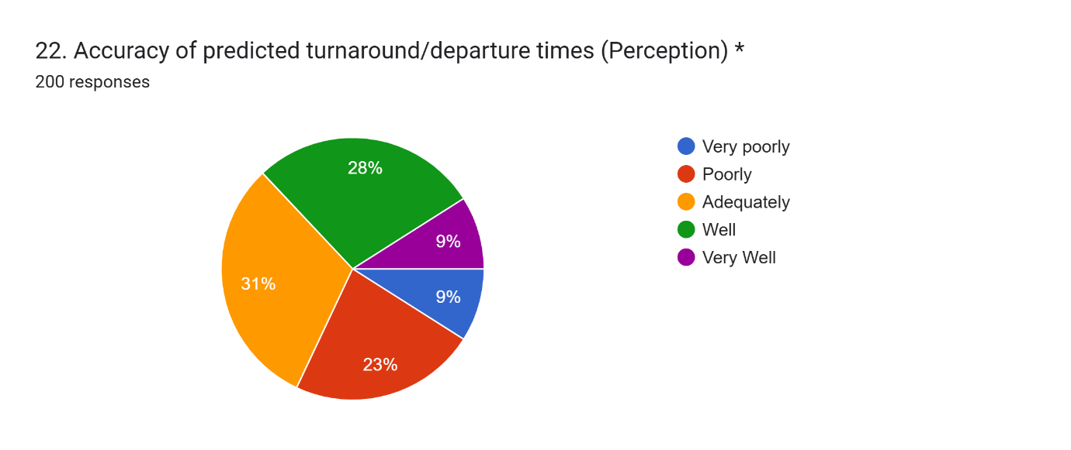
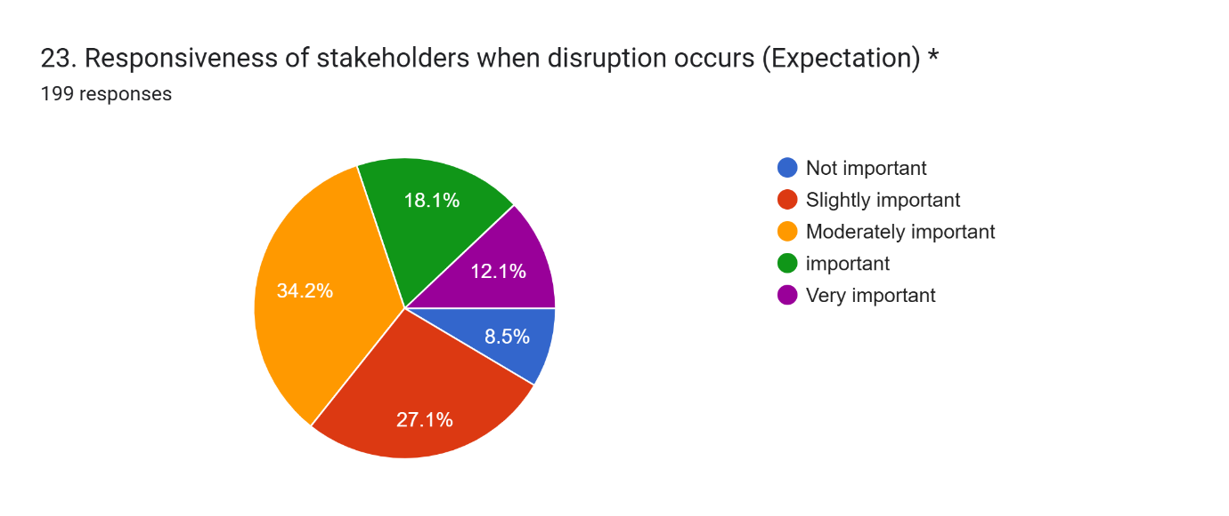
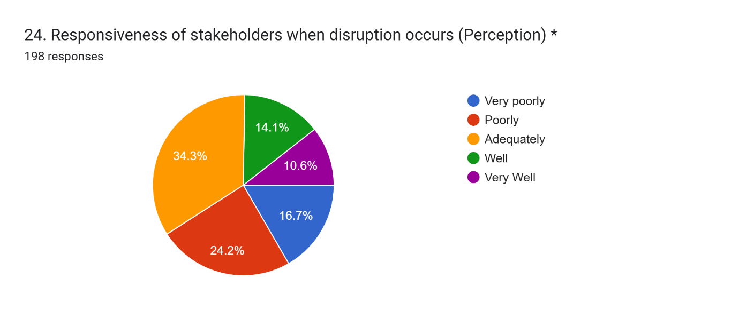
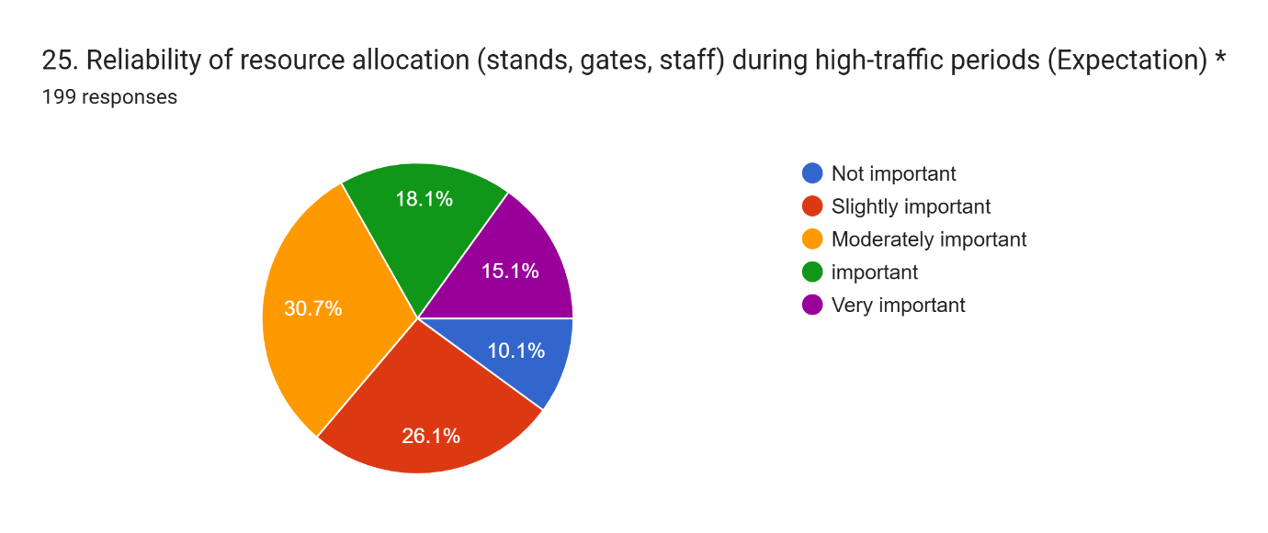
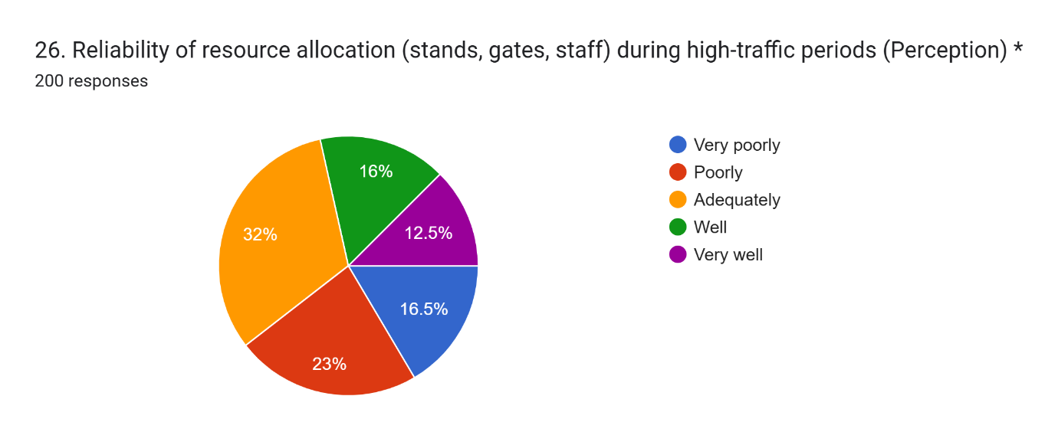
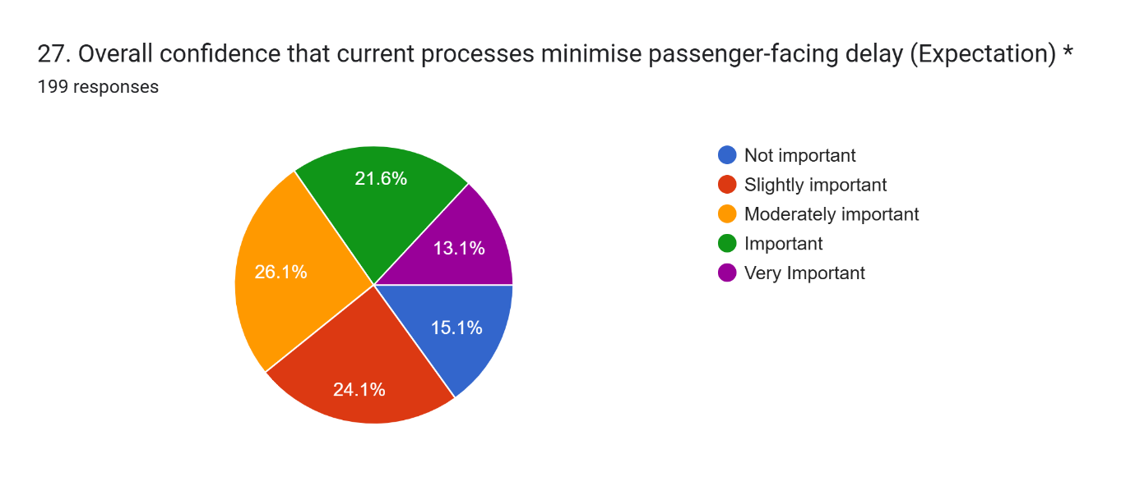
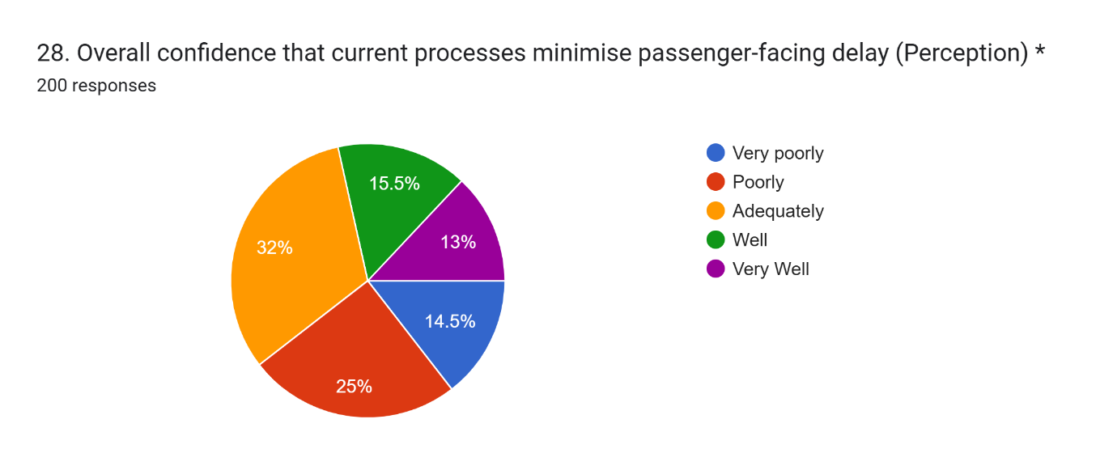
Figure 6 paired Expectation vs Perception scores for each SERVQUAL dimension, Q19–Q28
Figure 4.4 — paired Expectation vs Perception scores for each SERVQUAL dimension, Q19–Q28
Three of the five dimensions had small negative gaps: overall confidence that processes minimise passenger facing delay (−0.06), reliability of resource allocation (−0.17) and responsiveness of stakeholders during disruption (−0.21). The underlying condition, cross-stakeholder performance during disruption, also emerged independently in the other such item which appeared in the responsiveness gap for Question 13 in Table 4.4 (46.5% agree that the coordination breaks down during high disruption), adding to the confidence in the finding beyond what either item would provide on its own.
Positive gaps were obtained for the other two dimensions. The level of accuracy of predicted turnaround/desparture times (+0.27) indicates that the perceived quality of the delivery is generally aligned with the perceived importance of the service. Timeliness of information sharing returned a significantly larger positive gap (+1.01), with 39% of respondents rating timeliness as not important on the Expectation item – which is in tension with the strong endorsement of A-CDM's real-time information picture in Section 4.4, and therefore is treated with caution rather than taken at face value; the priority-ranking data from Section 4.6 helps to resolve this apparent tension.

4.6 Priority Ranking and Open-Ended Themes
Table 4.6: Aggregate priority ranking of coordination/service attributes (Q29)
Table 6 Aggregate priority ranking of coordination/service attributes (Q29)
Rank | Coordination attribute | Weighted priority score*
1 | Accuracy of predicted turnaround/departure times | 110
2 | Responsiveness of stakeholders during disruption | 104
3 | Reliability of resource allocation | 58
4 | Timeliness of information sharing | 57
5 | Overall confidence that processes minimise passenger-facing delay | 32
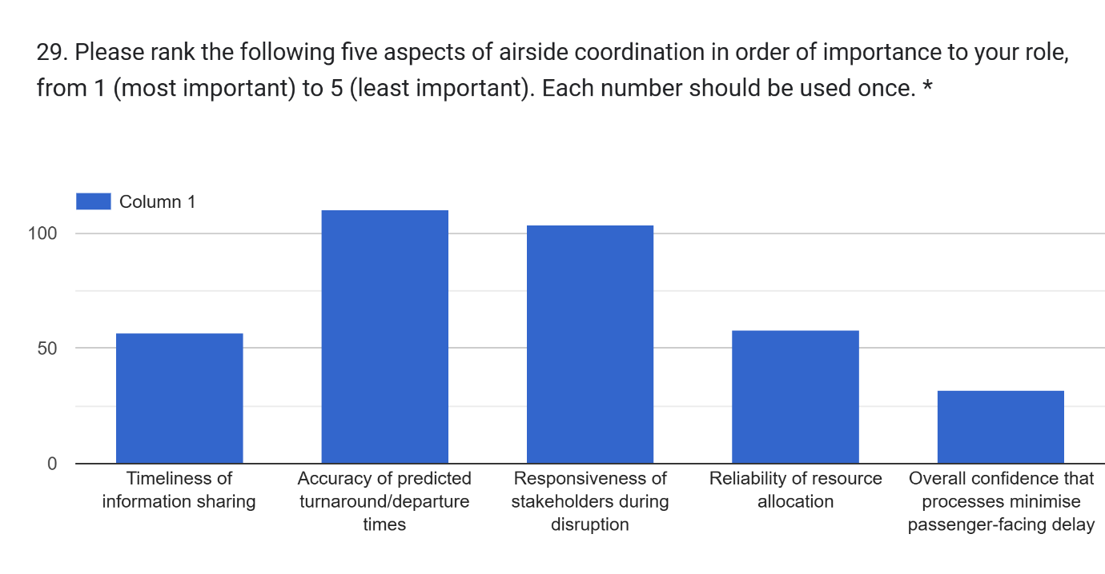
Figure 7 Q29 forced-choice priority ranking, all five attributes
Figure 4.5 —Q29 forced-choice priority ranking, all five attributes
Question 29 asked the respondents to compare the five attributes with each other, not to rate each attribute independently. This forced-choice exercise clearly confirms the importance of accuracy of predicted times and responsiveness during disruption, and, together with the other three attributes, brings timeliness of information sharing back to a mid-table position, although there is no indication that it is “not important”, as suggested by Question 19. The ranking of the gap scores in Table 4.5 also recovers the earlier observation, that responsiveness during disruption is both the second highest priority and the lowest perceived delivery dimension, which is not immediately apparent from either the overall priorities or the perceived deliveries alone.
The questionnaire ended with two open-ended items. Regarding causation, the same issues identified in Section 4.3 were repeated in Question 30 (66 responses) where the majority of respondents indicated that they were pre-positioning ground crews and equipment before they arrived at the stand, sharing information with ground crews in real-time, and making stand/gate allocations effectively. There was one repeated theme not covered by the closed items which dominated Question 31: the lack of information from the operational teams (airside and airline) to the passenger facing and customer-service teams, and the need for quicker, more regular access to passenger information in disruption.

4.7 Bridge to Section Two
The results of the questionnaire have been presented partially from the viewpoint of each question, and with little interquestioning. The three themes that run through Sections 4.3 to 4.6 are: the practical scope of delay beyond narrow ground handling; a trusted model of coordination for information, but not yet for speed and resilience at pressure; and a lack of communication between passengers and stakeholders, which is raised spontaneously by stakeholders. These threads are now explored in a critical way in Section Two, in the context of the theory developed in Chapter Two.
SECTION TWO — ANALYSIS, SYNTHESIS AND THEORETICAL LINKAGE

4.8 Approach to Section Two
This section goes beyond description and probes the why of the patterns observed above in relation with the A-CDM or SERVQUAL literature discussed in Chapter Two and from the broader operating context of hub-airport turnaround management. It is organised thematically around the three threads identified in Section 4.7 rather than question by question, reflecting the supervisory guidance that this section should be considerably more rigorous in its analysis and synthesis than Section One, using the remaining scope of the chapter to develop argument rather than to add further description.

4.9 Delay Causation Revisited: Analytical Synthesis
The strength of agreement that ground handling activities are a significant contributor to turnaround delay (69.3%, the single strongest agreement recorded in the survey) provides Heathrow-specific, frontline stakeholder confirmation of the process-relevance and bottleneck arguments developed by Ding et al. (2024) and CM et al. (2025), extending evidence that had previously been established at the level of process analysis and modelling rather than through the perceptions of the stakeholders who operate those processes daily. This is directly relevant to the gap identified in Section 1.3: existing Heathrow-specific evidence, principally Guo et al. (2020), addresses the technical and analytical architecture of the APOC rather than frontline experience of what actually causes delay.
The comparison drawn in Section 4.3 between the category-level endorsement of ground handling and the item-level prominence of boarding in Question 18, however, qualifies this confirmation rather than simply reinforcing it. Boarding sits at the boundary between the airside turnaround processes this study is scoped to examine and the terminal passenger-processing activities explicitly excluded from that scope in Section 1.6. Its prominence as the most frequently observed delay cause suggests that the airside/terminal boundary drawn for research design purposes does not fully correspond to the operational reality stakeholders describe, in which passenger-flow activities and ground handling activities interact directly at the stand. This is a nuance the primary data contributes beyond the process taxonomies in the existing literature, which tend to treat turnaround sub-activities as discrete categories rather than as a boundary-spanning system.
The 52.0% agreement that communication gaps between stakeholders are a significant contributor to delay is, in this respect, the more theoretically important of the four Section C findings, because it indicates that delay causation at Heathrow cannot be fully separated from the coordination architecture examined in Section 4.10 below. This is consistent with the framing set out in Section 1.1, that airside delay is fundamentally a coordination problem arising from real-time interaction between decentralised stakeholders rather than a purely mechanical, task-execution problem; the survey data lends direct empirical support to that framing, rather than treating delay causation and A-CDM coordination as two independent phenomena to be examined in separate sections of the study.
Viewed against wider airline industry practice, this pattern is unsurprising but still consequential. Ground handling at a hub the scale of Heathrow is delivered by multiple competing and cooperating organisations operating under separate commercial contracts, service-level agreements and performance incentives with the airlines they serve, rather than by a single integrated operator; the near-even split recorded on Question 17, resourcing and staffing constraints (44.0% Agree against 39.5% Disagree, the most contested Section C item), is consistent with this fragmented delivery model, in which staffing decisions are made independently by each ground handling provider rather than centrally by the airport. This industry structure helps explain why communication, rather than any single organisation's task performance, is repeatedly identified by stakeholders as a decisive variable: in a multi-operator delivery model, the quality of coordination between organisations is often a stronger determinant of overall turnaround performance than the competence of any one organisation acting alone, a dynamic well recognised in the operations management literature underpinning A-CDM itself (Eurocontrol, 2024) but one this study's findings confirm is still keenly felt at the frontline of Heathrow's operation.

4.10 A-CDM/APOC Coordination: Critical Analysis
The clearest pattern to emerge from Section 4.4 is what might be termed an “informed but not faster” paradox: strong confidence in the accuracy of A-CDM's shared operational picture (63.8% agreement) coexists with much weaker confidence that this shared picture translates into faster (42.4%) or more resilient (35.9% agreement that the APOC improves coordination) joint decision-making. Eurocontrol's (2024) account of the operational picture presents it as the foundation on which synchronised, collaborative action is built; the Heathrow evidence gathered here suggests that, at this hub at least, the foundation has been more successfully established than the synchronised action it is intended to enable. This distinction is not visible in Guo et al.'s (2020) technical case study of Heathrow's predictive analytics, which evaluates the performance of the underlying system rather than the frontline experience of the decisions it supports, and represents a specific contribution of this study's stakeholder-survey design.
The comparatively high “don't know” response to Question 8 (38.9%) is itself analytically informative. Given that the achieved sample was weighted towards airline station staff and ground handling supervisors rather than APOC-based airside operations staff (Section 4.2), and that this pattern persists despite frequent APOC exposure, the uncertainty is better explained by an asymmetry of organisational visibility than by unfamiliarity with the process: coordination that occurs within the APOC may be considerably more visible, and more confidently attributable, to those working inside it than to peripheral stakeholders who experience its outputs without visibility of the internal decision-making it involves. This reading is consistent with the organisational-architecture framing set out in Section 1.2, which identifies governance structures, communication processes and frontline decision-making procedures, rather than the technology itself, as the object of enquiry in this dissertation.
The finding that coordination is perceived by almost half of respondents (46.5%) to break down specifically during periods of high disruption is, on this reading, the most operationally consequential result in Section One. Section 1.1 characterises Heathrow's operational structure as one with little tolerance for disruption, in which a small delay can produce a rapid domino effect across the rest of the day's schedule. If the coordination mechanism designed to manage exactly this kind of cascading disruption is itself perceived to be least reliable precisely when disruption is highest, this points to a structural vulnerability in how the collaborative model is currently operationalised at Heathrow, rather than a marginal or peripheral weakness, and is a finding this study's primary data uniquely surfaces, since it depends on stakeholder-reported experience under pressure rather than on system-level performance logs of the kind reported in prior Heathrow-specific research such as Guo et al. (2020).
It is also worth situating this finding within Okwir et al.'s (2017) argument that the effectiveness of collaborative decision-making systems depends substantially on organisational and behavioural factors, differing performance incentives, information systems and resourcing decisions across the organisations involved, rather than on the technical adequacy of the shared information platform alone. The Heathrow findings are broadly consistent with this argument: the technical foundation (an accurate shared picture) appears sound, while the behavioural and organisational layer built on top of it, the speed and resilience of joint decision-making under pressure, is where the coordination model's current limitations are concentrated.
This difference has implications beyond Heathrow of how A-CDM's benefits are typically described in the broader aviation industry. Industry and regulatory discussions about collaborative decision-making tend to focus on the combined effect of the shared operational picture and the increase in coordination, describing this combined effect as a benefit of the implementation. The Heathrow evidence suggests these are better treated as two separable outcomes that do not necessarily arrive together: an airport or network can succeed in establishing shared situational awareness, the informational half of the A-CDM proposition, without yet realising the coordination-speed and resilience benefits that are typically assumed to follow automatically from it. For an airline schedule integrity perspective, in which a small turnaround delay can propagate rapidly through connecting rotations and passenger itineraries (Section 1.1), this distinction matters: airlines and ground handlers relying on A-CDM data for tactical recovery decisions during disruption should not assume that data accuracy alone guarantees a correspondingly fast or coordinated organisational response, and Heathrow's own performance monitoring of A-CDM would benefit from tracking these two outcomes separately rather than as a single composite measure of “A-CDM effectiveness”.

4.11 Passenger-Perceived Service Quality: SERVQUAL Synthesis
The SERVQUAL Service Quality Gap Model conceptualises service quality as the discrepancy between customer expectation and customer perception of delivery (Parasuraman et al., 1988). As set out in Section 1.6, this study did not collect primary data directly from passengers, and the gap scores reported in Section 4.5 should therefore be understood as an operational-stakeholder proxy for passenger service quality rather than as a direct measurement of it; operational stakeholders were asked to rate the importance of, and delivery against, service attributes they judged relevant to the passenger experience, rather than passengers rating their own experience. This proxy has a defensible rationale given the study's scope and the practical inaccessibility of a passenger sample within a postgraduate dissertation timeframe, but it is a genuine measurement limitation that qualifies the strength of any conclusion drawn from Section 4.5, and is revisited in Chapter Five.
Subject to that caveat, the modest negative gaps recorded for responsiveness (−0.21), reliability (−0.17) and overall confidence (−0.06) carry more significance than their small magnitude alone might suggest, once read against the wider service quality literature. Shah et al. (2020) and Song et al. (2024) both provide evidence that passenger-perceived service quality, however it is measured, is strongly linked to downstream behavioural outcomes including loyalty and word-of-mouth; on this basis, even a modest, consistently negative gap on a dimension stakeholders regard as high-priority should be read as carrying amplified practical significance rather than being dismissed as statistically small.
The convergence between the SERVQUAL responsiveness gap and the A-CDM coordination-breakdown finding in Section 4.10 is the single most important analytical result of this chapter. Two independently designed theoretical instruments, one measuring collaborative coordination effectiveness and one measuring service quality perception, arrive at the same operational moment, cross-stakeholder response during high disruption, as the point of greatest concern. This convergence is not accidental: it is precisely the outcome the study's dual-theory design (A-CDM and SERVQUAL together, Section 1.4) was intended to be capable of revealing, and its emergence here provides empirical validation of that design choice, since it demonstrates that the two frameworks are triangulating on a single underlying operational vulnerability rather than describing two disconnected sets of concerns.
By contrast, the positive gap on accuracy of predicted turnaround/departure times (+0.27), the attribute ranked highest priority overall in Question 29, indicates that this particular dimension is, on the evidence available, already reasonably well served relative to its importance to stakeholders. Read together with the responsiveness finding, this suggests an opportunity-cost argument relevant to Chapter Five: further investment directed at improving predictive accuracy is likely to yield comparatively limited additional benefit relative to investment directed at strengthening responsiveness during disruption specifically, where the priority-delivery gap is both real and unaddressed.
SERVQUAL's continued relevance to this analysis also reflects its established position within airline-specific service quality research, rather than a generic application of a retail-originated model to an unrelated context. Both Shah et al. (2020) and Song et al. (2024) apply service-quality and delay-perception constructs directly within an airline setting, and the conceptual framework developed in Section 2.7 explicitly adapted SERVQUAL's five dimensions to the airside coordination context examined here. The findings in this section therefore extend an already airline-specific literature rather than importing a service-quality model wholesale from outside the industry, and the responsiveness gap identified above should accordingly be read as directly comparable to, rather than merely analogous with, the passenger-service-quality constructs used elsewhere in the airline service quality literature.

4.12 Cross-Cutting Synthesis: The Passenger-Communication Bridge
The qualitative themes reported in Section 4.6 corroborate, and in one respect extend, the quantitative findings above. The pre-positioning theme in Question 30 reinforces the primacy of ground handling readiness identified in Section 4.9, while the recurring call for real-time, automated information sharing between ground teams independently echoes the “informed but not faster” coordination pattern identified in Section 4.10; that respondents raised this pattern unprompted, in their own words, in response to an open question, rather than only in response to a closed item designed to measure it, strengthens confidence in the validity of that finding beyond what the closed items alone would support, and is consistent with the content-validity safeguards, including questionnaire piloting, described in Section 3.14.
The dominant Question 31 theme, the perceived gap between the operational information reaching airside/airline staff and that reaching passenger-facing and customer-service teams, is the qualitative contribution that the closed items were not designed to capture. This is precisely the discretionary, organisational dimension of coordination that Chapter Two identified as under-researched in the wider A-CDM literature, and which the predominantly positivist, quantitative design of this study was acknowledged in Section 3.4 and Section 3.6 to risk under-capturing; its emergence through the limited interpretivist accommodation built into the instrument, a small number of open-ended items, indicates that this design choice was justified. Functionally, this theme also operates as an indirect, stakeholder-relayed proxy for a passenger-side SERVQUAL gap that the study's scope, as defined in Section 1.6, did not permit it to measure directly: operational stakeholders are, in effect, reporting their own perception of a passenger-facing service consequence that flows from the coordination shortfall documented quantitatively in Sections 4.10 and 4.11, giving Objective 3's operational-to-passenger link a qualitative as well as a quantitative evidential basis.
This bridge is also consistent with the respondent profile discussed in Section 4.2. Because the achieved sample was dominated by airline station staff and ground handling supervisors, roles that routinely interact with passengers or their baggage during disruption, rather than by APOC-based airside operations staff working one step removed from the passenger interface, it is unsurprising that the passenger-communication theme emerged as strongly as it did in the open-ended responses. This is a further, indirect instance of the cross-referencing encouraged in Section 4.1: the composition of the sample itself helps explain the salience of a theme that a differently composed sample, weighted more heavily towards APOC staff, might have surfaced less prominently, and this should be borne in mind when the theme is used to inform the recommendations developed in Chapter Five.

4.13 Summary of Section Two and Link to Chapter Five
Section Two has argued that the findings reported descriptively in Section One resolve into a single, converging central finding: coordination and communication under high-disruption conditions, rather than the shared informational architecture of A-CDM itself, is the specific point at which Heathrow's airside operational practice is most exposed, with direct and theoretically supported implications for passenger-perceived service quality. This finding is corroborated across three independent sources within the same dataset, the closed coordination items, the SERVQUAL gap analysis, and the open-ended responses, which strengthens the confidence that can be placed in it notwithstanding the sampling and aggregate-data limitations discussed in Section 4.1.

Chapter 5: Conclusion and Recommendations

5.1 Introduction
This final chapter draws together the findings reported and analysed in Chapter Four to reach conclusions against the research aim, objectives and questions established in Chapter One. Following the supervisory feedback, conclusions and recommendations are presented sequentially so that each major conclusion is immediately followed by the practical recommendation arising from it. This structure makes the relationship between the empirical findings and the proposed operational improvements more explicit. The chapter subsequently identifies the study’s contribution to knowledge, consolidates its limitations, outlines directions for future research and closes with concluding remarks.

5.2 Revisiting the Research Aim and Objectives
The dissertation aimed to use the Airport Collaborative Decision-Making (A-CDM) and SERVQUAL frameworks to critically analyse Heathrow’s operational practices and stakeholder coordination mechanisms and their impact on turnaround efficiency and passenger-perceived service quality.
Objective 1, to identify and explain the main sources of airside delay, was addressed through the literature review and primary findings, particularly Section 4.9. Objective 2, concerning the role of A-CDM and the Airport Operations Centre (APOC), was addressed through the coordination-effectiveness findings in Sections 4.4 and 4.10. Objective 3, to critically evaluate the relationship between delay-management practices and passenger-perceived service quality, was addressed through the SERVQUAL analysis in Sections 4.5 and 4.11. Objective 4, to develop evidence-based recommendations, is addressed throughout the conclusion-recommendation sequence below.

5.3 Conclusion 1: Main Causes of Airside Turnaround Delay
In relation to RQ1, the study concludes that airside turnaround delay at Heathrow is generated by a combination of operational process failures and cross-stakeholder coordination weaknesses. Ground handling activities were the most strongly endorsed general source of delay, with 69.3% of respondents agreeing that they were a significant contributor. More specifically, boarding was the most frequently observed individual cause at 45.0%, followed by catering resupply at 43.5%, refuelling at 37.5%, crew availability at 34.0% and air traffic control restrictions at 32.0%.
The findings therefore support the process-oriented arguments established in Chapter Two, while adding an important Heathrow-specific nuance. Boarding, which sits partly between terminal passenger processing and airside turnaround activity, emerged as more prominent than several conventional ground-handling tasks. This demonstrates that operational boundaries used for organisational purposes do not necessarily reflect how delay occurs in practice.
Communication was also important, with 52.0% of respondents agreeing that communication gaps between stakeholders significantly contribute to delay. Airside delay at Heathrow should therefore not be understood solely as a mechanical or resource-execution problem. Instead, it is better interpreted as a joint outcome of task execution, resource readiness and information flow between interdependent organisations.

5.4 Recommendation 1: Strengthen Turnaround Readiness and Resource Coordination
The first recommendation is to formalise pre-positioning protocols for ground handling, catering and refuelling teams before aircraft reach the stand. These protocols should use predictive turnaround information, including Target Off-Block Time data, to ensure that staff and equipment are available before they become part of the critical path.
This recommendation is directly supported by the 69.3% agreement that ground handling contributes significantly to delay and by the repeated open-ended responses emphasising pre-positioning of ground crews and equipment. Ground handling providers should therefore lead the implementation of formal readiness procedures for high-risk or tightly scheduled turnarounds.
Resident airlines should also review the integration of crew scheduling with turnaround planning. Crew availability was observed as a cause of delay by 34.0% of respondents, making it the fourth most frequently reported proximate cause. Improved coordination between crew scheduling and turnaround control would therefore address another recurring source of disruption identified by frontline stakeholders.

5.5 Conclusion 2: A-CDM Provides Information More Effectively Than Coordinated Action
In relation to RQ2, the study concludes that A-CDM has successfully established a credible shared operational picture at Heathrow but has been less successful in translating that information into fast and resilient collective action.
The strongest coordination finding was the 63.8% agreement that A-CDM provides an accurate shared real-time picture of turnaround status. This indicates that the informational foundation of the collaborative system is broadly trusted. However, only 35.9% agreed that the APOC improves coordination during disruption, while 42.4% agreed that decisions are faster because of A-CDM/APOC coordination. By comparison, 50.7% agreed that decisions are better informed.
These results support the “informed but not faster” pattern developed in Chapter Four. Shared situational awareness has therefore been achieved more successfully than accelerated decision-making. This distinction becomes particularly important during major disruption: 46.5% of respondents agreed that coordination often breaks down under high-disruption conditions.
The study consequently concludes that A-CDM’s current strength at Heathrow lies principally in information visibility and situational awareness rather than consistently rapid cross-organisational action. The problem is not primarily the availability of operational information but the organisational process through which that information is converted into decisions during periods of pressure.

5.6 Recommendation 2: Introduce a High-Disruption Coordination Protocol
Heathrow and the APOC should establish a formal high-disruption coordination protocol containing pre-agreed escalation triggers, named cross-organisational responsibilities and clearly defined decision authority.
This recommendation directly responds to the finding that 46.5% of respondents perceive coordination to break down during high disruption. Rather than redesigning the existing A-CDM system, the proposed protocol should strengthen how organisations respond once disruption reaches a defined operational threshold.
Heathrow should also introduce structured joint post-disruption reviews involving APOC representatives, airline operations teams and ground handling providers. These reviews should examine where decision-making slowed, where information was not acted upon and whether responsibility or escalation routes were unclear. This recommendation responds directly to the difference between respondents feeling better informed (50.7%) and experiencing faster decision-making (42.4%).
Such reviews would help convert the informational strength of A-CDM into stronger organisational learning and improve the resilience of coordinated decision-making during future disruption.

5.7 Conclusion 3: Responsiveness Is the Principal Service-Quality Vulnerability
In relation to RQ3, the SERVQUAL analysis identifies responsiveness during disruption as the most important service-quality vulnerability within the evidence gathered.
Responsiveness produced the largest negative SERVQUAL-style gap at −0.21 and was simultaneously ranked as the second-highest priority by respondents. Reliability of resource allocation also produced a negative gap of −0.17, while overall confidence that processes minimise passenger-facing delay produced a smaller negative gap of −0.06.
The significance of the responsiveness result increases when it is considered alongside the A-CDM findings. The coordination analysis and SERVQUAL analysis independently identify the same operational moment—cross-stakeholder response during disruption—as the point of greatest concern. This convergence supports the dual-framework design adopted in the dissertation and indicates that operational coordination problems may extend beyond schedule performance into passenger-facing service outcomes.
The positive gap for accuracy of predicted turnaround and departure times (+0.27) also reinforces this conclusion. Predictive information appears comparatively well developed, while the response that follows that information remains weaker.
However, these findings should remain subject to the study’s stated scope. Passenger-perceived service quality was assessed through operational stakeholders rather than directly through passengers. The results therefore represent a stakeholder-based proxy for passenger service consequences rather than direct passenger SERVQUAL measurement.

5.8 Recommendation 3: Extend Operational Information to Passenger-Facing Teams
Heathrow, resident airlines and ground handling partners should extend relevant A-CDM operational information to passenger-facing and customer-service teams through a linked digital information feed.
This recommendation arises directly from the dominant theme in the open-ended responses, where participants identified insufficient transfer of operational information from airside and airline teams to passenger-facing staff. Respondents called for quicker and more regular communication during disruption.
The recommendation would therefore extend the benefit of Heathrow’s already trusted shared operational picture beyond the operational coordination environment. Passenger-facing employees should receive simplified, actionable updates on disruption status, revised timings and expected recovery actions so that they can communicate more consistently with affected passengers.
This would address the “passenger-communication bridge” identified in Chapter Four and strengthen the relationship between operational responsiveness and perceived service quality without requiring a wholesale redesign of A-CDM.

5.9 Conclusion 4: Improvement Should Be Targeted Rather Than System-Wide
In relation to RQ4, the study concludes that Heathrow does not require a wholesale redesign of its A-CDM/APOC architecture. The evidence indicates that the shared-information foundation is functioning comparatively well. The greater opportunity lies in strengthening the operational processes surrounding that information.
The highest-leverage areas are therefore coordination under high disruption, resource pre-positioning, communication with passenger-facing teams and organisational learning following disruption. These areas correspond directly to the weaknesses identified consistently across the closed coordination questions, SERVQUAL gap analysis and open-ended responses.
The study therefore favours focused interventions over broad technological redevelopment. Improvements should seek to strengthen how existing information is interpreted, escalated, communicated and converted into coordinated action.

5.10 Recommendation 4: Establish Continuous Monitoring of Coordination Performance
Heathrow Airport Limited should repeat the stakeholder survey at a defined interval, such as annually, to monitor whether perceptions of coordination effectiveness and service quality improve following implementation of the recommended interventions.
Repeating the same or a refined version of the instrument would establish a longitudinal performance baseline and allow Heathrow to determine whether responsiveness gaps, perceived coordination breakdown and passenger-information concerns reduce over time.
Monitoring should distinguish between the accuracy of A-CDM information and the speed and resilience of organisational response rather than combining these into a single measure of A-CDM effectiveness. This would directly reflect one of the study’s principal conceptual findings: reliable information and effective collaborative action are connected but distinct operational outcomes.

5.11 Contribution to Knowledge
Academically, this study contributes by combining A-CDM and SERVQUAL within a single Heathrow-specific stakeholder investigation. Previous Heathrow-specific evidence, particularly Guo et al. (2020), has concentrated primarily on the technical and analytical performance of real-time operational systems. This dissertation extends that perspective by examining how those systems are experienced by frontline stakeholders.
A further contribution is the distinction between A-CDM’s informational benefit and its coordination-speed benefit. The study demonstrates that a shared operational picture can be viewed positively even when stakeholders remain less confident about the speed and resilience of collective decision-making.
The convergence between the A-CDM and SERVQUAL findings also demonstrates the value of linking an operational coordination framework with a service-quality framework. Both identify responsiveness under disruption as the principal point of vulnerability.
Practically, the findings provide Heathrow Airport Limited, airlines and ground handling providers with stakeholder-sourced evidence that can support the prioritisation of targeted operational improvements.

5.12 Limitations of the Study
The most significant limitation was that the dataset was supplied at aggregate question level rather than respondent level. Consequently, the cross-tabulation, chi-square and correlation analysis originally planned in Section 3.13 could not be undertaken. Relationships between variables were therefore interpreted through descriptive comparison rather than formal statistical association.
The purposive and snowball sampling strategy also limits statistical representativeness. The sample was weighted towards airline station staff and ground handling supervisors relative to APOC-based airside operations staff, meaning that the findings primarily represent the experience of users of APOC outputs rather than a fully balanced internal and external assessment.
The SERVQUAL analysis also relied on operational stakeholders as proxies for passenger perceptions. The study therefore cannot claim to have directly measured passenger service quality.
The anomalous positive timeliness gap (+1.01) further highlights the limitation of isolated importance ratings and was interpreted cautiously using the forced-ranking results. Finally, the cross-sectional mono-method design captures perceptions at a single point in time and cannot establish how these relationships evolve following operational changes.

5.13 Recommendations for Future Research
Future research should obtain respondent-level data to enable formal statistical testing of differences between stakeholder groups and relationships between coordination effectiveness and SERVQUAL outcomes.
A mixed-methods study incorporating semi-structured interviews, particularly with APOC-based staff, would provide deeper understanding of why coordination speed and resilience weaken under disruption.
Future studies should also collect primary SERVQUAL data directly from passengers affected by Heathrow turnaround-related delays. This would allow the stakeholder-proxy findings reported here to be tested against passengers’ own perceptions of reliability, responsiveness and disruption communication.
Longitudinal research would additionally allow the effect of the recommended interventions to be measured over time.

5.14 Concluding Remarks
This dissertation examined why airside delay remains a persistent challenge at Heathrow despite substantial investment in collaborative decision-making infrastructure and considered the implications for passenger-perceived service quality. The findings indicate that A-CDM has successfully established a trusted shared operational picture, but the coordination benefits expected from that information are less consistently realised during high-disruption conditions.
The central conclusion is therefore that Heathrow’s principal vulnerability lies not in the availability of operational information but in converting that information into rapid, resilient and passenger-aware coordinated action. By linking each conclusion directly to a corresponding practical recommendation, the study identifies a focused pathway for strengthening ground-handling readiness, high-disruption coordination, passenger-facing communication and continuous performance monitoring.

References
Bakır, M., Atalık, Ö. and Itani, N. (2025) ‘Service quality and repurchase intentions in the airline industry: a multiple mediation analysis through customer citizenship behaviour’, Current Issues in Tourism, 28(24), pp. 4025–4046. Available at: https://doi.org/10.1080/13683500.2024.2410935
Bell, E., Bryman, A. and Harley, B. (2022) Business Research Methods. 6th edn. Oxford: Oxford University Press.
Bryman, A. (2016) Social Research Methods. 5th edn. Oxford: Oxford University Press.
CM, Vigneswaran, Khan, Syedeen, M., B., R., S., PR, M., R. Pothnis, J. and Hasan, I. (2025) ‘Aircraft turnaround bottlenecks: addressing ground handling delays for operational excellence’, International Journal of Aviation, Aeronautics, and Aerospace, 12(2). Available at: https://doi.org/10.58940/2374-6793.1981
Creswell, J.W. and Creswell, J.D. (2018) Research Design: Qualitative, Quantitative and Mixed Methods Approaches. 5th edn. Thousand Oaks, CA: Sage.
Ding, Q., Ma, L., Cui, Y., Cheng, B. and He, X. (2024) ‘Identification and analysis of flight delay based on process relevance’, Aerospace, 11(6), p. 445. Available at: https://doi.org/10.3390/aerospace11060445
Etikan, I., Musa, S.A. and Alkassim, R.S. (2016) ‘Comparison of convenience sampling and purposive sampling’, American Journal of Theoretical and Applied Statistics, 5(1), pp. 1–4.
Eurocontrol (2024) Airport Collaborative Decision-Making (A-CDM). Available at: https://www.eurocontrol.int/concept/airport-collaborative-decision-making
Evler, J., Lindner, M., Fricke, H. and Schultz, M. (2022) ‘Integration of turnaround and aircraft recovery to mitigate delay propagation in airline networks’, Computers & Operations Research, 138, 105602. Available at: https://doi.org/10.1016/j.cor.2021.105602
Guo, X., Grushka-Cockayne, Y. and De Reyck, B. (2020) ‘London Heathrow Airport uses real-time analytics for improving operations’, INFORMS Journal on Applied Analytics, 50(5), pp. 325–339. Available at: https://doi.org/10.1287/inte.2020.1044
Heathrow (2025) Heathrow Airport annual traffic statistics. Available at: https://www.heathrow.com/
Heathrow (2025) Heathrow: Welcome to Heathrow Airport. Available at: https://www.heathrow.com/
Heathrow Airport (2020) Operational Safety Instruction: Airport Operations Plan. Available at: https://www.heathrow.com/
IBM Corp. (2023) IBM SPSS Statistics for Windows (Version 29.0). Armonk, NY: IBM Corp.
Okwir, S., Ulfvengren, P., Angelis, J., Ruiz, F. and Núñez Guerrero, Y.M. (2017) ‘Managing turnaround performance through Collaborative Decision Making’, Journal of Air Transport Management, 58, pp. 183–196. Available at: https://doi.org/10.1016/j.jairtraman.2016.10.008
Okwir, S., Ulfvengren, P., Angelis, J., Ruiz, F. and Núñez Guerrero, Y.M. (2017) ‘Managing turnaround performance through Collaborative Decision Making’, Journal of Air Transport Management, 58, pp. 183–196. Available at: https://doi.org/10.1016/j.jairtraman.2016.10.008
Parasuraman, A., Zeithaml, V.A., Berry, L.L. and Marketing Science Institute (1988) SERVQUAL: A Multiple-Item Scale for Measuring Customer Perceptions of Service Quality. Marketing Science Institute.
Parker, C., Scott, S. and Geddes, A. (2019) ‘Snowball sampling’, in Atkinson, P. et al. (eds.) SAGE Research Methods Foundations. London: Sage.
Rezaei, J., Kothadiya, O., Tavasszy, L. and Kroesen, M. (2018) ‘Quality assessment of airline baggage handling systems using SERVQUAL and BWM’, Tourism Management, 66, pp. 85–93. Available at: https://doi.org/10.1016/j.tourman.2017.11.009
Saunders, M.N.K., Lewis, P. and Thornhill, A. (2019) Research Methods for Business Students. 8th edn. Harlow: Pearson.
Seifi, A., Ponnambalam, K., Kudiakova, A. and Aultman-Hall, L. (2024) ‘An optimization model for flight rescheduling from an airport’s centralized perspective for better management of demand and capacity utilization’, Computation, 12(5), p. 98. Available at: https://doi.org/10.3390/computation12050098
Shah, F.T., Syed, Z., Imam, A. and Raza, A. (2020) ‘The impact of airline service quality on passengers’ behavioural intentions using passenger satisfaction as a mediator’, Journal of Air Transport Management, 85(1), 101815. Available at: https://doi.org/10.1016/j.jairtraman.2020.101815
Song, C., Ma, X., Ardizzone, C. and Zhuang, J. (2024) ‘The adverse impact of flight delays on passenger satisfaction: an innovative prediction model utilizing wide & deep learning’, Journal of Air Transport Management, 114, 102511. Available at: https://doi.org/10.1016/j.jairtraman.2023.102511
Zhang, Y., Lee, S. and Gu, Y. (2023) ‘A review of air transport service quality studies: current status and future research agenda’, Journal of the Air Transport Research Society, 1(1), pp. 9–21.

Appendix
Appendix A – Survey Questionnaire
Section | Q. No. | Questionnaire Item | Response Format / Options
Section A – Respondent Profile | 1 | I confirm that I am 18 years of age or older and consent to participate in this research. | Yes, I consent to participate; No, I do not wish to participate.
Section A | 2 | Which stakeholder group best describes your role? | Airside operations staff (Heathrow Airport Limited / APOC); Airline station staff (airline operations / ground operations); Ground handling supervisor; Other (please specify).
Section A | 3 | How many years of experience do you have in airside/airport operations? | Less than 2 years; 2–5 years; 6–10 years; More than 10 years.
Section A | 4 | How frequently does your role involve direct interaction with the Airport Operations Centre (APOC) or A-CDM processes? | Daily; Several times a week; Occasionally; Rarely or never.
Section A | 5 | Which age group do you belong to? | 18–29; 30–39; 40–49; 50–59; 60+.
Section A | 6 | What is your gender? | Male; Female; Prefer to self-describe (please specify); Prefer not to say.
Section B – A-CDM / APOC Coordination Effectiveness | 7 | The A-CDM framework provides an accurate, shared real-time picture of turnaround status across stakeholders. | 1 = Strongly Agree; 2 = Agree; 3 = Don’t Know; 4 = Disagree; 5 = Strongly Disagree.
Section B | 8 | The APOC improves coordination between my organisation and other stakeholders during disruption. | Strongly Agree; Agree; Don’t Know; Disagree; Strongly Disagree.
Section B | 9 | In my experience, predictive/target time information (e.g. TOBT, TSAT) shared through A-CDM matches actual turnaround outcomes. | Strongly Agree; Agree; Don’t Know; Disagree; Strongly Disagree.
Section B | 10 | Decision-making during disruption is faster because of A-CDM/APOC coordination, compared with before its implementation. | Strongly Agree; Agree; Don’t Know; Disagree; Strongly Disagree.
Section B | 11 | Decision-making during disruption is better informed because of A-CDM/APOC coordination, compared with before its implementation. | Strongly Agree; Agree; Don’t Know; Disagree; Strongly Disagree.
Section B | 12 | My organisation’s performance goals are well aligned with those of other stakeholders in the A-CDM process. | Strongly Agree; Agree; Don’t Know; Disagree; Strongly Disagree.
Section B | 13 | Coordination between stakeholders often breaks down during periods of high disruption. | Strongly Agree; Agree; Don’t Know; Disagree; Strongly Disagree.
Section C – Airside Delay Causation | 14 | Ground handling activities (baggage, cleaning, catering, fuelling) are a significant contributor to turnaround delay in my experience. | Strongly Agree; Agree; Don’t Know; Disagree; Strongly Disagree.
Section C | 15 | Delays are more often caused by knock-on effects from earlier disruption than by the current turnaround itself. | Strongly Agree; Agree; Don’t Know; Disagree; Strongly Disagree.
Section C | 16 | Communication gaps between stakeholders are a significant contributor to airside delay. | Strongly Agree; Agree; Don’t Know; Disagree; Strongly Disagree.
Section C | 17 | Resourcing/staffing constraints are a significant contributor to airside delay at Heathrow. | Strongly Agree; Agree; Don’t Know; Disagree; Strongly Disagree.
Section C | 18 | Which of the following, if any, have you personally observed causing turnaround delay in the past month? | Select all that apply: Baggage handling; Cabin cleaning; Catering resupply; Refuelling; Boarding; Crew availability; Air traffic control restrictions; Weather; Equipment or technical fault; Other; None of the above.
Section D – Service Quality Gap (SERVQUAL-adapted) | 19 | Timeliness of information shared between stakeholders (Expectation). | Not Important; Slightly Important; Moderately Important; Important; Very Important.
Section D | 20 | Timeliness of information shared between stakeholders (Perception). | Very Poorly; Poorly; Adequately; Well; Very Well.
Section D | 21 | Accuracy of predicted turnaround/departure times (Expectation). | Not Important; Slightly Important; Moderately Important; Important; Very Important.
Section D | 22 | Accuracy of predicted turnaround/departure times (Perception). | Very Poorly; Poorly; Adequately; Well; Very Well.
Section D | 23 | Responsiveness of stakeholders when disruption occurs (Expectation). | Not Important; Slightly Important; Moderately Important; Important; Very Important.
Section D | 24 | Responsiveness of stakeholders when disruption occurs (Perception). | Very Poorly; Poorly; Adequately; Well; Very Well.
Section D | 25 | Reliability of resource allocation (stands, gates, staff) during high-traffic periods (Expectation). | Not Important; Slightly Important; Moderately Important; Important; Very Important.
Section D | 26 | Reliability of resource allocation (stands, gates, staff) during high-traffic periods (Perception). | Very Poorly; Poorly; Adequately; Well; Very Well.
Section D | 27 | Overall confidence that current processes minimise passenger-facing delay (Expectation). | Not Important; Slightly Important; Moderately Important; Important; Very Important.
Section D | 28 | Overall confidence that current processes minimise passenger-facing delay (Perception). | Very Poorly; Poorly; Adequately; Well; Very Well.
Section E – Priority Ranking and Open Reflections | 29 | Please rank the following five aspects of airside coordination in order of importance to your role, from 1 (most important) to 5 (least important). | Timeliness of information sharing; Accuracy of predicted turnaround/departure times; Responsiveness of stakeholders during disruption; Reliability of resource allocation; Overall confidence that processes minimise passenger-facing delay.
Section E | 30 | In your view, what is the single most effective change that could be made to reduce airside turnaround delay at Heathrow? | Open-ended response.
Section E | 31 | Is there anything else about A-CDM coordination or passenger service quality at Heathrow you would like to add? | Open-ended response.

Appendix B – Survey Response Data
Data Screening | Number of Responses | Percentage
Total survey submissions contained in the attached response file | 200 | 100.0%
Yes, I consent to participate | 126 | 63.0%
No, I do not wish to participate | 74 | 37.0%
Valid consenting analytical sample | 126 | 63.0% of total submissions
Data treatment | Only consenting responses are reported below | n = 126

Respondent Profile Variable | Category | Frequency (n) | Percentage (%)
Stakeholder group | Airside operations staff (Heathrow Airport Limited / APOC) | 25 | 19.8
Stakeholder group | Airline station staff (airline operations / ground operations) | 43 | 34.1
Stakeholder group | Ground handling supervisor | 53 | 42.1
Stakeholder group | Other | 5 | 4.0
Airside/airport experience | Less than 2 years | 14 | 11.1
Airside/airport experience | 2–5 years | 52 | 41.3
Airside/airport experience | 6–10 years | 43 | 34.1
Airside/airport experience | More than 10 years | 17 | 13.5
APOC/A-CDM interaction | Daily | 12 | 9.5
APOC/A-CDM interaction | Several times a week | 68 | 54.0
APOC/A-CDM interaction | Occasionally | 35 | 27.8
APOC/A-CDM interaction | Rarely or never | 11 | 8.7
Age group | 18–29 | 10 | 7.9
Age group | 30–39 | 22 | 17.5
Age group | 40–49 | 56 | 44.4
Age group | 50–59 | 26 | 20.6
Age group | 60+ | 12 | 9.5
Gender | Male | 41 | 32.5
Gender | Female | 75 | 59.5
Gender | Prefer not to say | 6 | 4.8
Gender | Missing response | 4 | 3.2

Q. | A-CDM / APOC Coordination Item | Valid n | Strongly Agree | Agree | Don’t Know | Disagree | Strongly Disagree | Mean
7 | A-CDM provides an accurate shared real-time picture | 125 | 39 | 37 | 34 | 10 | 5 | 2.24
8 | APOC improves coordination during disruption | 124 | 15 | 34 | 49 | 19 | 7 | 2.75
9 | Predictive/target times match actual outcomes | 125 | 20 | 35 | 28 | 37 | 5 | 2.78
10 | Decision-making is faster because of A-CDM/APOC | 124 | 21 | 36 | 26 | 26 | 15 | 2.82
11 | Decision-making is better informed because of A-CDM/APOC | 125 | 29 | 39 | 25 | 15 | 17 | 2.62
12 | Organisational performance goals are aligned | 125 | 28 | 41 | 27 | 17 | 12 | 2.55
13 | Coordination breaks down during high disruption | 124 | 32 | 31 | 28 | 23 | 10 | 2.58

Q. | Airside Delay Causation Item | Valid n | Strongly Agree | Agree | Don’t Know | Disagree | Strongly Disagree | Mean
14 | Ground handling activities significantly contribute to delay | 126 | 50 | 37 | 19 | 18 | 2 | 2.09
15 | Knock-on effects from earlier disruption contribute to delay | 126 | 35 | 32 | 24 | 19 | 16 | 2.60
16 | Communication gaps significantly contribute to airside delay | 126 | 22 | 49 | 25 | 18 | 12 | 2.60
17 | Resourcing/staffing constraints significantly contribute to delay | 126 | 27 | 32 | 23 | 24 | 20 | 2.83

Q18 – Turnaround Delay Cause Personally Observed | Frequency (n) | Percentage of Valid Sample (%)
Catering resupply | 59 | 46.8
Boarding | 58 | 46.0
Refuelling | 49 | 38.9
Crew availability | 48 | 38.1
Air traffic control restrictions | 47 | 37.3
Cabin cleaning | 42 | 33.3
Weather | 29 | 23.0
Equipment or technical fault | 28 | 22.2
Baggage handling | 24 | 19.0
Other | 8 | 6.3
None of the above | 5 | 4.0
Question format | Multiple response | Percentages do not total 100%

SERVQUAL-Adapted Dimension | Expectation Valid n | Mean Expectation (E) | Perception Valid n | Mean Perception (P) | Gap (P − E)
Timeliness of information sharing | 126 | 2.26 | 125 | 3.08 | +0.82
Accuracy of predicted turnaround/departure times | 126 | 2.73 | 126 | 3.04 | +0.31
Responsiveness of stakeholders during disruption | 125 | 2.96 | 124 | 2.69 | −0.27
Reliability of resource allocation | 125 | 2.97 | 126 | 2.79 | −0.17
Overall confidence that processes minimise passenger-facing delay | 125 | 2.98 | 126 | 2.76 | −0.22

SERVQUAL Scale | Score 1 | Score 2 | Score 3 | Score 4 | Score 5
Expectation | Not Important | Slightly Important | Moderately Important | Important | Very Important
Perception | Very Poorly | Poorly | Adequately | Well | Very Well

Q29 Exported Attribute | “Column 1” Recorded | Blank | Data Status
Timeliness of information sharing | 41 | 85 | Original 1–5 rank value not present in attached CSV
Accuracy of predicted turnaround/departure times | 61 | 65 | Original 1–5 rank value not present in attached CSV
Responsiveness of stakeholders during disruption | 69 | 57 | Original 1–5 rank value not present in attached CSV
Reliability of resource allocation | 42 | 84 | Original 1–5 rank value not present in attached CSV
Overall confidence that processes minimise passenger-facing delay | 22 | 104 | Original 1–5 rank value not present in attached CSV

Appendix C – Open-Ended Survey Responses
Response No. | Q30: Most Effective Change to Reduce Airside Turnaround Delay | Q31: Additional Comment on A-CDM Coordination / Passenger Service Quality
1 | Improving baggage loading and unloading efficiency would help aircraft depart on time. | More accurate and timely information about delays would help passengers plan better and reduce frustration.
2 | Using real-time digital communication between all teams could make turnaround operations faster and more coordinated. | Heathrow could improve passenger service by providing clearer updates when flights are delayed or gates change.
3 | Increasing the availability of ground handling staff during busy periods could reduce delays. | Better coordination between airlines and airport staff would improve both operational efficiency and passenger satisfaction.
4 | Improving baggage-handling systems would be one of the most effective ways to reduce turnaround delays. | Improving staff communication during disruptions could make the passenger experience much better.
5 | More accurate scheduling of ground services would prevent aircraft from waiting for equipment or staff. | Passengers would benefit from clearer announcements and more frequent updates during delays.
6 | Increasing the use of automated ground-handling and baggage systems could improve turnaround efficiency. | Heathrow should continue investing in technology that provides accurate real-time information to both staff and passengers.
7 | Ensuring ground crews and equipment are ready before an aircraft reaches the stand could save valuable time. | More proactive communication during delays would make passengers feel better informed and supported.
8 | Better communication about delays and changes between airlines, handlers and airport control would improve turnaround performance. | A-CDM coordination could be strengthened by ensuring that all teams have access to the same updated operational information.
9 | Reducing congestion around aircraft stands and taxiways would help aircraft move more efficiently. | Passenger service could improve through better assistance during disruptions, especially when delays affect connecting flights.
10 | A combination of real-time information sharing and better coordination among ground teams would have the biggest impact. | Stronger coordination between airport operations and passenger-facing teams would help turn operational improvements into better passenger satisfaction.
11 | Better coordination between ground staff, airlines and airport operations could significantly reduce aircraft turnaround delays. | Better communication between airport teams and passengers during delays would improve the overall passenger experience.
12 | Real-time sharing of operational information between all teams could reduce unnecessary waiting time. | Consistent information across airport screens, announcements and airline staff would reduce passenger confusion.
13 | Improving the availability of ground equipment during peak periods could reduce turnaround delays. | Clearer communication about gate changes would make it easier for passengers to navigate Heathrow.
14 | Faster aircraft cleaning and cabin preparation could help aircraft leave the stand sooner. | Passengers would benefit from receiving earlier notifications when flights are delayed.
15 | More efficient gate and stand allocation could reduce aircraft waiting time. | Heathrow could improve service by ensuring staff have the latest operational information when assisting passengers.
16 | Increasing ground-handling staff during busy periods could help reduce turnaround delays. | Better staff availability during busy periods would make it easier for passengers to get assistance.
17 | Improving baggage-handling technology could significantly reduce aircraft turnaround times. | Better communication about baggage delays would reduce passenger frustration.
18 | Faster passenger boarding procedures could help aircraft depart their stands on time. | More accurate boarding and gate information would make the passenger journey smoother.
19 | Better coordination between airport control and ground handlers could reduce unnecessary aircraft waiting. | Stronger coordination between airport operations and customer-service teams could reduce passenger confusion.
20 | Reducing congestion around aircraft stands would allow ground vehicles and service teams to work more efficiently. | Clearer signage and directions during gate changes would improve the passenger experience.
21 | More accurate turnaround scheduling would allow different ground teams to organise their activities more effectively. | Passengers would benefit from receiving realistic and regularly updated departure times.
22 | Improving the reliability of ground-handling equipment would help prevent unexpected turnaround delays. | Better information about operational problems would help passengers understand delays.
23 | Better staff scheduling around peak arrival and departure times could improve turnaround performance. | Having more customer-service staff during peak periods would improve passenger support.
24 | Faster response to unexpected ground-handling problems would help aircraft maintain their schedules. | Faster communication about disruptions would make passengers feel more informed.
25 | Standardising turnaround procedures across airlines and ground handlers could improve efficiency. | Consistent communication procedures between airport stakeholders would improve passenger service.
26 | Better monitoring of turnaround progress in real time could allow staff to address problems earlier. | Real-time information should also be made available to passengers whenever possible.
27 | Improving coordination between airlines and handling companies could reduce delays caused by ground services. | Better cooperation between airlines and airport staff would reduce confusion for passengers.
28 | Reducing waiting time between individual turnaround activities could make the entire process faster. | Reducing passenger waiting times would have a positive impact on overall service quality.
29 | Better allocation of staff and equipment between aircraft stands could prevent operational bottlenecks. | Better allocation of customer-service staff could improve support during busy periods.
30 | More efficient movement of ground vehicles could help service teams reach aircraft faster. | Clearer information about where passengers need to go would improve airport navigation.
31 | Improving coordination during aircraft arrival would allow ground services to begin sooner. | Passenger-facing teams should receive operational updates as quickly as other airport teams.
32 | Better contingency planning for equipment or staff shortages could prevent unexpected delays. | Having stronger support arrangements during disruptions would improve passenger satisfaction.
33 | Faster turnaround of baggage from arriving to departing aircraft could improve punctuality. | More accurate baggage information would make passengers feel more confident.
34 | Reducing manual processes and unnecessary paperwork could speed up turnaround operations. | Greater use of digital passenger information could make communication faster and easier.
35 | More proactive management of turnaround milestones could help prevent delays before departure. | More proactive passenger notifications could help reduce uncertainty during delays.
36 | Ensuring replacement equipment is available quickly when equipment fails could prevent long delays. | Providing quick assistance when problems occur would improve passenger confidence.
37 | More flexible ground operations could help Heathrow respond better to unexpected disruptions. | Flexible passenger-support arrangements would also help during major disruptions.
38 | Better sharing of information between airlines and airport operators could reduce last-minute operational changes. | Sharing the same updated information with passengers would reduce confusion.
39 | Improving coordination of aircraft departure slots with actual aircraft readiness could reduce waiting. | Better communication about departure times would help passengers plan their journeys.
40 | Reducing delays caused by waiting for catering, cleaning or fuelling services could improve turnaround times. | Better coordination with these service teams could also improve the passenger experience.
41 | Improving aircraft stand management could reduce delays caused by gate availability. | Faster communication about gate assignments and changes would benefit passengers.
42 | Faster handling of operational disruptions could prevent small delays from becoming major delays. | Faster passenger support during disruptions would help reduce frustration.
43 | Better coordination between all turnaround service providers would have a significant impact on punctuality. | Better coordination between all passenger-facing teams would improve consistency in service.
44 | The most effective change would be stronger real-time coordination between ground staff, airlines and airport operations. | Overall, stronger coordination, accurate information and proactive passenger support would significantly improve the Heathrow experience.

