

Student Name: Gnahore Badi Charlotte Legre
Student ID Number:2331156
Lecture Name: Caroline Salami
Module Code: Changemakers: building Your personal brand for sustainable employment (BMHP5015_LON)
Words count: 2000.

Introduction
The focus of this assignment is module BMHP5015, what I have learned from four main units. It considers how these lessons will go on to be useful in my future career in health and social care. In writing what I studied, how they connect to the real work and which ideas I understood.

Unit 1 is called "Brand You," It educates me on personal branding — how to let people know who I am, what I am capable of doing and why you should care. It shows the most important things for me and what I learnt in simpler ideas (mainly from books or works very similar to studies), followed by some pieces of work I did online this unit as examples.

Moving on to Unit 2: It's a Small World. This section serves to me as a global eyeopener on the interrelation of health care delivery with social work. It tells me there are problems and best practice on both sides of the UK – we all learn from one another. I will demonstrate this with supporting evidence based on what I have read, and examples of tasks that I perform online.

Next is Unit 3: 'Opportunity Knocks' This unit guides me in understanding how opportunities can be identified to become more adept at the role and facilitate development for a better future. That reminds me not to wait, when it is my time but be READY and take everything as it comes. I will reflect on things I learnt from this unit, cite useful references and showcase my online practice.

Finally, Unit 4: The Pursuit of Happiness. This reflections my deep sense of wellbeing, being happy about what I do and how this relates to caring for others. This will be a summary of everything that I have learned throughout the whole module, and how all of these skills and knowledge are going to assist me to do my work properly with kindness and confidence. The other option would be me adding links to some of my online work here too. Finally, I will tie all my points into conclusion reflecting how this learning would help me initiate in my career.

Task 1: Brand You
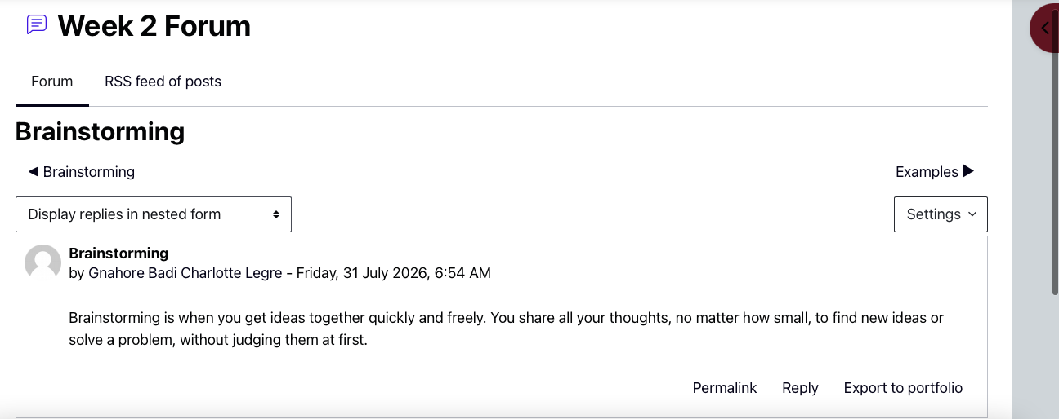
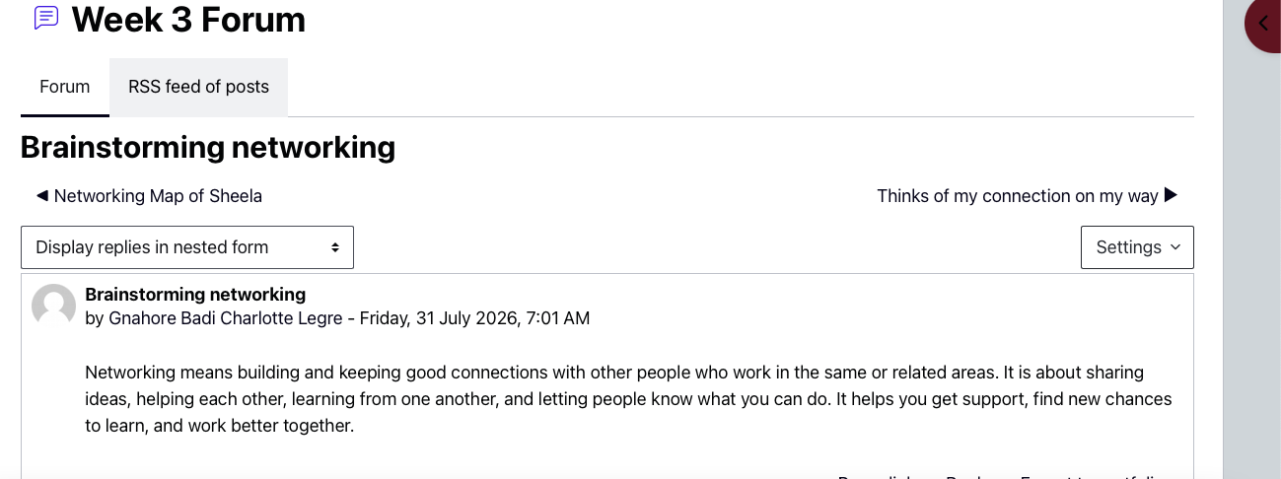

Unit Brand You helped me to understand that branding oneself is more than dressing well or speaking eloquently – it is about demonstrating who you are, what you stand for, and adding value to health and social care. Our lectures very much illustrate how you come to be perceived by an employer (or the people we as Support Workers are going to support) from your first touch point, and how being consistent, honest and clear contributes towards creating a trusting relationship.

The following three main ideas resonated with me more than the rest. Number one, alignment with personal values: this means ensuring I always live my declared values, for example respect and kindness and fairness. According to CIPD (2025), when workers are acting in line with their values, they are making more effective decisions and forming stronger relationships with service users. Second, digital footprint: I discovered that whatever I publish on the internet – even in personal social media – will influence how people perceive me. The NHS Code of Conduct states unequivocally that professionals should always ensure their public conduct is proper so as to maintain respect for the care sector. Third, good communication: The way I speak, listen and present myself — in person as well as on paper. As Guffey and Loewy (2023) state, "the most powerful skills for healthy relations with colleagues and family members is clear, kind communication."

Wrote a personal statement, worked on your professional profile etc. completing the online activities acted as a practice for these thoughts and experiences. It occurred to me that I am building my own brand every day and this was what would make me unique as a caring employee who does good work, reliable, willing and able.

Task 2: it’s a small work

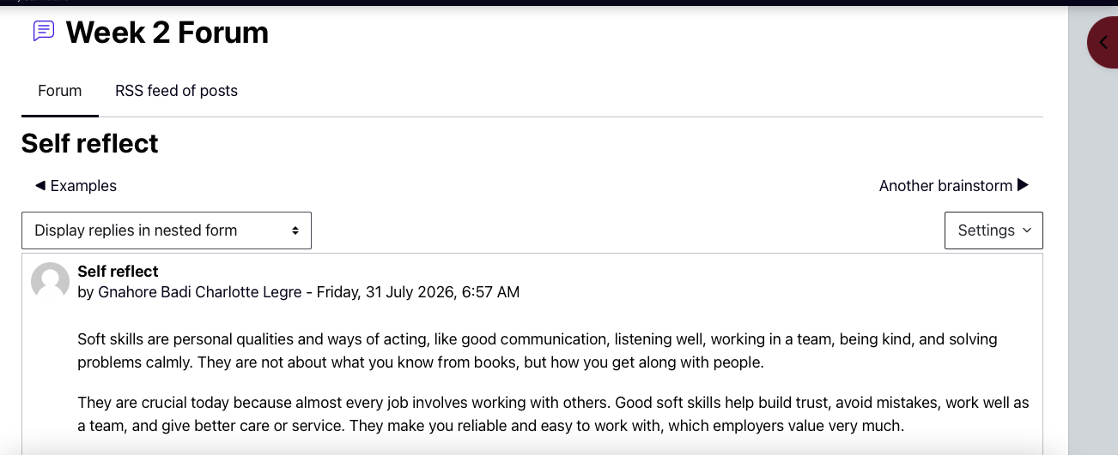
This rest of world, and how social care and health care are linked to each other in the unit opened my eyes. Among other things, we discussed global health challenges, the way different countries set up their care services and why it's so important to understand a range of cultures when working in the UK – as we help support individuals from all backgrounds.

This helped me realise global health problems like infectious diseases, climate change and migration are directly affecting those you will have to treat. But new diseases move swiftly across countries so UK care workers need to know about international guidance and how the rules apply to keeping everybody safe, I also realised that care practices differed across countries, and keeping learning from different ways of working makes our services better. The most important thing I learnt was to respect cultural differences because what may seem normal or polite behaviour for one individual is not necessarily going to be the same for another. According to Green and Powell (2024), treating each other with respect considering their background helps eliminate the unfair treatment of others. The World Health Organization (2025) reminds us good care must work for everybody, everywhere.

Online, I saw these ideas in practice through the research of other countries→on care systems and discussing cultural needs in forums. It has allowed me to feel more confident in being able to change how I work towards the person and it reminded me that, caring for someone means taking a step back and looking at their life as a whole, including knowing where they come from.

Task 3: Employability

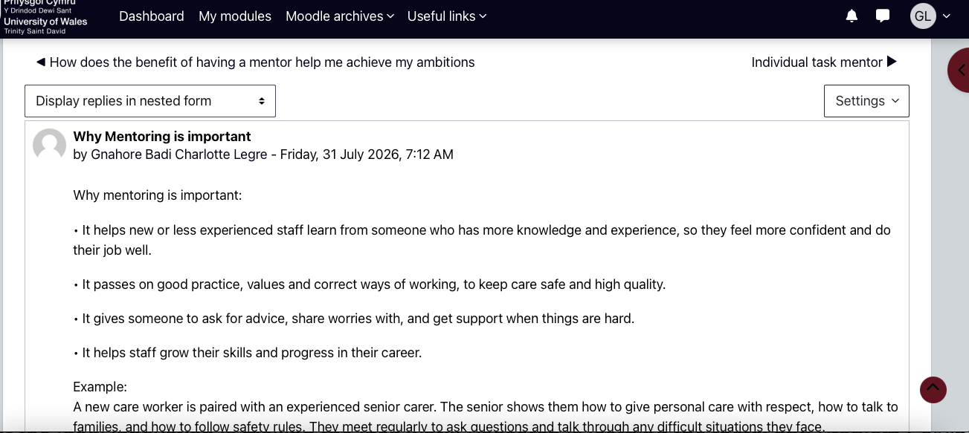
Unit 3: Skills for health and social care I studied the practical skills that I require to gain employment and flourish in this environment. Whether about writing a decent CV and cover letter, preparing for the interview, the importance of teamwork or continuing education during my career.

However, one valuable thing I learned besides this is that employability Skills do not forget to be qualified; it also relates to attitude and a willingness to learn. Performing optimally as part of a team occupies an immense share of care work: not only does nobody provide assistance to one individual, but also heeding suggestions from peers ensures safety for the service users. NHS Quality Improvement Scotland (2012) as cited by Skills for Care (2025) would further this regarding strong team-work reducing error and lead to more integrated care across families enjoying a joined-up service. I am also learning that reflecting on my own work makes me better: when the result was bad, to think about what went wrong and how I can do better next time, makes me a better worker. Moreover, as mentioned by Moon (2022), taking ownership of your own development is one of the most appreciated traits in care staff.

Tasks such as writing a CV and doing mock interview sessions prepared me more for applying for jobs in the online world. It has taught me that being adaptable, dependable and willing to learn is the key towards a long and prosperous career in this sector.

Task 4: Professionalism

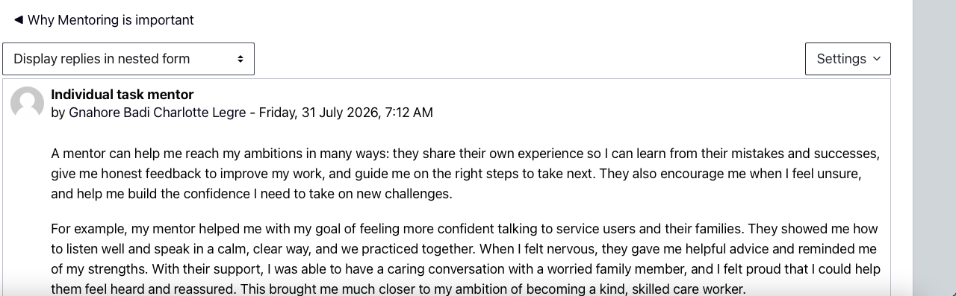
The content of this unit has defined professionalism in health and social care for me. It covered codes of practice standards I have to adhere to, legal rules that guide me in my role and how to make good decisions when things are tough.

This taught me that professionalism is not just about following the rules: it's also about putting those you serve first, maintaining confidentiality, and doing the right thing when no one will see. Confidentiality, followership and staying current with new methods of working were key elements. Care must always be provided to encourage individuals and others such as the Health and Care Professions Council (2024) indicates that all care workers must behave in a way that justifies the trust placed in them, note: There is a potential for serious harm if an individual fails to meet this standard when providing care. I also considered how to reach an ethical decision – in the event of competing rights or needs, I should seek advice and discuss with colleagues, but always emphasise what really matters is the wellbeing of the person that I am caring for. Clear ethical thinking will ensure that staff can act in consistent ways — pulling towards kindness even when times are stressful (Buka, Snelgrove. 2023).

Reviewing case studies online and writing about how I would go about dealing with tricky situations were examples of the practical application of these standards. I am now aware that professional conduct is a huge responsibility that I should carry every day, and the basis for safe quality care.

Conclusion

Using this portfolio, I have been able to translate what has learned in class into an clear idea of how 2 is evident in health and social care work. Being able to build my brand will allow me to demonstrate that I am a reliable person whom employers and service users can trust. Knowing about global connections will assist me in providing respectful care for persons of diverse trainings. An employability skill will help me get a job and be the best in the team. Plus complying with professional standards is ensuring I keep people safe and be professional.

From this point, I will continue to use these concepts in future studies and work experiences. I shall continue my learning, question and reflect upon my practice in order to become the type of care worker who will make a real difference in the lives of those I support.

References

Papers: • Buka, P. Snelgrove, R. Ethics in Health and Social Care (2023). 3rd edn. London: Sage. Available at: https://uk.sagepub.com/en-gb/eur/ethics-in-health-and-social-care/book257888

• CIPD (2025) The Role of Personal Branding in Career Success. London: Chartered Institute of Personnel and Development. Available at: https://www.cipd.co.uk/knowledge/careers/personal-branding-factsheet

• Guffey, M.E. and Loewy, D.: Business Communication: Process and Product(2023). 12th edn. Boston: Cengage. Available at: https://www.cengage.co.uk/c/business-communication-process-and-product-12e-guffey

• Health and Care Professions Council (2024a): Standards of Proficiency: Social Workers. London: HCPC. Available at: https://www.hcpc-uk.org/standards/standards-proficiency

• Moon, J.A. Reflection in Learning and Professional Development: Theory and Practice (2022) 2nd edn. London: Routledge. Available at: https://www.routledge.com/Reflection-in-Learning-and-Professional-Development-Theory-and-Practice/Moon/p/book/9780367485882

• NHS Employers (2025) The Code of Conduct for NHS Staff. London: NHS. Available at: https://www.nhsemployers.org/policies-and-publications/nhs-code-of-conduct

• Skills for Care (2025) Working as part of a Team in Adult Social Care. Leeds: Skills for Care. Available at: https://www.skillsforcare.org.uk/Resources/Workforce-development/Team-working.aspx

• World Health Organization Global Standards for Person-Centred health and social care (2025) Geneva: WHO. Available at: https://www.who.int/publications/i/item/WHO-2019-nCoV-Clinical-2025
Introduction

The focus of this assignment is module BMHP5015, what I have learned from four main units. It considers how these lessons will go on to be useful in my future career in health and social care. In writing what I studied, how they connect to the real work and which ideas I understood.

Unit 1 is called "Brand You," It educates me on personal branding — how to let people know who I am, what I am capable of doing and why you should care. It shows the most important things for me and what I learnt in simpler ideas (mainly from books or works very similar to studies), followed by some pieces of work I did online this unit as examples.

Moving on to Unit 2: It's a Small World. This section serves to me as a global eyeopener on the interrelation of health care delivery with social work. It tells me there are problems and best practice on both sides of the UK – we all learn from one another. I will demonstrate this with supporting evidence based on what I have read, and examples of tasks that I perform online.

Next is Unit 3: 'Opportunity Knocks' This unit guides me in understanding how opportunities can be identified to become more adept at the role and facilitate development for a better future. That reminds me not to wait, when it is my time but be READY and take everything as it comes. I will reflect on things I learnt from this unit, cite useful references and showcase my online practice.

Finally, Unit 4: The Pursuit of Happiness. This reflections my deep sense of wellbeing, being happy about what I do and how this relates to caring for others. This will be a summary of everything that I have learned throughout the whole module, and how all of these skills and knowledge are going to assist me to do my work properly with kindness and confidence. The other option would be me adding links to some of my online work here too. Finally, I will tie all my points into conclusion reflecting how this learning would help me initiate in my career.
learnt in simpler ideas (mainly from books or works very similar to studies), followed by some pieces of work I did online this unit as examples.

Moving on to Unit 2: It's a Small World. This section serves to me as a global eyeopener on the interrelation of health care delivery with social work. It tells me there are problems and best practice on both sides of the UK – we all learn from one another. I will demonstrate this with supporting evidence based on what I have read, and examples of tasks that I perform online.

Next is Unit 3: 'Opportunity Knocks' This unit guides me in understanding how opportunities can be identified to become more adept at the role and facilitate development for a better future. That reminds me not to wait, when it is my time but be READY and take everything as it comes. I will reflect on things I learnt from this unit, cite useful references and showcase my online practice.

Finally, Unit 4: The Pursuit of Happiness. This reflections my deep sense of wellbeing, being happy about what I do and how this relates to caring for others. This will be a summary of everything that I have learned throughout the whole module, and how all of these skills and knowledge are going to assist me to do my work properly with kindness and confidence. The other option would be me adding links to some of my online work here too. Finally, I will tie all my points into conclusion reflecting how this learning would help me initiate in my career.

