Marketing Essentials
Marketing Plan&Slides
Student Ribon Khan, Student No 2225725
Lecturer Ruth Taylor-Davis
Word Count 1,230 (approximately) without references and Slides

Table of Contents

Introduction: 3
Situation analysis 5Cs: 4
Objectives: 5
Strategy: 5
Tactics: 6
Action: 7
Control: 7
Conclusion: 8
References: 9
Appendix: 10

Introduction:
Hilton is a Uk, London-based hotel Its products and services have earned widespread recognition. Families, professionals, adults, tourists, and the elderly all make up its intended clientele. The company's effective pricing policy, or goal-oriented pricing policy attracts customers from a variety of socioeconomic backgrounds. Branding is a strategy used by the company to market its offerings, but its success is also attributed to its employees' hard work and innovative policies.

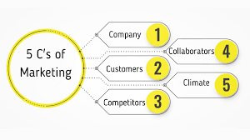
Situation Analysis 5Cs:
Hilton Hotels is the largest hotel chain in the world, with 570 hotels in 85 countries. Despite their global fame, their reputation has not reflected their stock price. Smart sales-marketing partnerships are needed, and strategic R&D may provide a worldwide edge. Hilton's lower-priced luxury rooms may attract middle-class customers, but production and delivery delays should concern marketers. Advertising doesn't help failing companies in high-standard, low-loyalty markets. (Cohen, P.G., 2015).
Customer: Hilton's marketing strategy is to identify the correct target market and create marketing actions to reach it. CRM Hilton marketing managers must consider industry growth, potential market size, product features, primary reason for purchasing, frequency and most recent purchases, industry trends, income levels, etc.
Competitor: people use Bowman’s clock to identify the target competitor. Hilton’s marketers develop competitive tactics. Rivalries. High-competition markets always stagnate earnings. Hilton must promote. Technology and economy threaten Hilton. Certain markets require Hilton rebranding.
Collaborators: An in-depth analysis of the company's B2B connections is necessary to grasp the significance of its partnerships and franchises. One can utilize this data to pinpoint chances to deepen and broaden these connections to fuel the company's expansion.
Climate: Hilton must find a new way to attract customers. Value chains link suppliers, CRM assess partner bargaining strength, supplier contributions, agility, adaptability, and value chain revenue allocation. Cyberattacks and patent, copyright, and intellectual theft limit profitability. Hilton marketing managers must predict client behavior in the current economy, and the US-China trade war, Brexit, and the "yellow vest" revolution have raised political risks for three to four years. (HOSANLI, A.P.D.D.A. and ŞUMNU, U., 2023).

Objectives:

The most important details are that the company must have a smart objective that is measurable, timely, easily accessible, and specific, and that they must set marketing department targets to attract customers and compete. Hilton Hotel is establishing effective techniques to achieve comparable goals, allowing any corporation to add another highly functional hotel to its choices. For the marketing plan, the marketing staff collected and compiled finance, advertising, and marketing budget data to aid in hotel advertising expense estimation. (Chaffey, D. and Ellis-Chadwick, F., 2012).

Strategy:
The Hilton is a popular option for families due to its high-quality services, amenities, and secure setting. It is also a popular venue for business gatherings due to its welcoming ambiance and tasteful design. The hotel has implemented a branding plan to become the industry standard-bearer and has risen to the top of its industry due to its specialized offerings, reasonable pricing, and extensive service offerings. (Dolnicar, S., 2020).

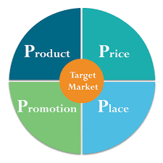
Tactics:
Product: The company provides its clients with a variety of hospitality-related services. Restaurants, banquet halls, wedding receptions, gift stores, swimming pools, retail space, and specialized event planning are all part of the package. As a result of the firm's commitment and enthusiasm for providing these services, it commands a sizable share of the market. Both domestic and foreign visitors favor staying, meeting, and dining there (Išoraitė, M., 2016).
Place: Hilton Hotel is a worldwide network, but this business plan will concentrate on the Hilton Hotels in the United Kingdom. The hotel chain has multiple locations across the United Kingdom. The hotels are convenient for both tourists and locals thanks to their proximity to popular landmarks. The Hilton London is conveniently located in the heart of the city, making it a popular choice for visitors, business travelers, and Londoners from all walks of life. Its convenient location and attractive rates make it a popular choice among vacationers, while its array of business services makes it a top pick among professionals planning conferences and seminars (Išoraitė, M., 2016).
Price: Hilton Hotels' pricing policy varies based on the branch's location and customer's desired level of service. Customers are expected to pay extra for amenities like parking, lunches, and Internet access, but the hotel's policies provide additional perks to members.
Promotion: Hilton is a well-known company in the hospitality sector due to its extensive marketing efforts. It has been successful in gaining client loyalty due to its use of appropriate and effective branding methods (2ALFA, s2020) and efficient rules to prioritize client interactions.

Action:
Hilton Hotels can increase its influence in the market by boosting its visibility on social media. Instagram, Facebook, and Twitter are three of the most popular social networking platforms. The company should advertise its deals and bundles on a regular basis and use relevant hashtags when promoting digital bargains to attract more customers. (Yimga, J., 2022).

Gantt Chart
Marketing Activities
Activities | Time Framework
Activities | Week 1 | Week 2 | Week 3 | Week 4 | Week 5
Facebook Marketing
Sponsorship in sports
Internet marketing
TVC
Open Marketing

Control:
Customers are the most visible indicator of a company's viability. A lot of companies use customer-brand relationship data to monitor market fluctuations and plan for the future. There has been a rise in the use of metrics that aim to quantify every part of a company's relationships with its customers. Revenue minus expenses yields the net income ratio, often known as profit. Companies have traditionally relied on this indicator of performance to gauge how well their operations are going (Mauboussin, M.J., 2012).

Conclusion:
The study detailed the Hilton hotel's business strategy, which was challenged by a lack of funding or other resources. This could be due to financial woes or the inability of advertising to turn a profit. To address this, the marketing department must prove its importance to higher management and reporting on helpful performance measures is an excellent strategy.

References:
- HOSANLI, A.P.D.D.A. and ŞUMNU, U., 2023. Anxiety of Luxury: Istanbul Hilton Hotel at the Stage of the Turkish Cinema during the 1960s-1970s. Online Journal of Art and Design, 11(2).
- Cohen, P.G., 2015. The Origin of the Claim Doctrine and Litigation Expenses with a Connection to Property Transactions-Woodward and Hilton Hotels Post Ash Grove Cement. Hous. Bus. & Tax LJ, 15, p.1.
- Poterlowicz, K., Yarker, J.L., Malashchuk, I., Lajoie, B.R., Mardaryev, A.N., Gdula, M.R., Sharov, A.A., Kohwi-Shigematsu, T., Botchkarev, V.A. and Fessing, M.Y., 2017. 5C analysis of the Epidermal Differentiation Complex locus reveals distinct chromatin interaction networks between gene-rich and gene-poor TADs in skin epithelial cells. PLoS genetics, 13(9), p.e1006966.
- Sauria, M.E., Phillips-Cremins, J.E., Corces, V.G. and Taylor, J., 2015. HiFive: a tool suite for easy and efficient HiC and 5C data analysis. Genome biology, 16, pp.1-10.
- Chaffey, D. and Ellis-Chadwick, F., 2012. Digital marketing: strategy. Implementation and.
- Chaffey, D. and Bosomworth, D., 2013. Digital marketing strategy planning template. Smart Insights, pp.1-14.
- Turnbull, S., 2014. Setting SMART objectives for brand ‘ME’.
- Dolnicar, S., 2020. Market segmentation for e-tourism. Handbook of e-Tourism, pp.1-15.
- Išoraitė, M., 2016. Marketing mix theoretical aspects. International Journal of Research-Granthaalayah, 4(6), pp.25-37.
- Thabit, T. and Raewf, M., 2018. The evaluation of marketing mix elements: A case study. International Journal of Social Sciences & Educational Studies, 4(4).
- Yimga, J., 2022. To Pad or Not to Pad? A Note on the Schedule Padding Behavior of Airlines. Applied Economics Letters, 29(4), pp.325-332.
- Mauboussin, M.J., 2012. The true measures of success. Harvard Business Review, 90(10), pp.46-56.

Appendix:
Slide 1
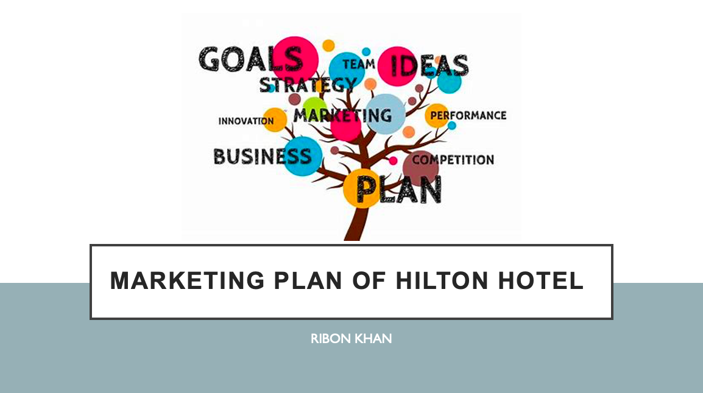

Slide 2
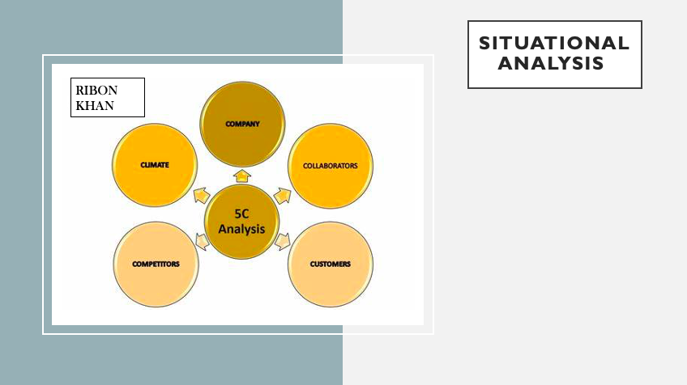
The Hilton Hotel is the largest. Although Hilton has hotel holdings in many different countries, the United States is where the company's primary focus lies. They may be wealthy, but their bad name has wiped them out. Their stock price does not reflect their worldwide recognition. Change happens slowly in large companies. Around the world, it has 169,000 workers on staff. Resorts. Sales and marketing should work together more effectively. A global advantage could be gained through strategic R&D. Terrorism and government policy are two areas that are influenced by globalization. Hilton Hotels may be able to attract middle-class consumers with their more affordably priced opulent suites. Earlier than marketing, customer relationship management The Hilton hotel chain's advertising department has to take stock of the company's strengths and weaknesses. There is a wide range of approaches to advertising amongst businesses. The advertising efforts of Hilton Hotels are optimized. CRM Advertising for Hilton should be worried about production and shipping delays (Betsch, C., Schmid, P., 2018).

Slide 3

The primary objective of the corporation is to achieve victory over the rival business by constructing a hotel and filling sufficient positions with employees. To compete successfully in the same market, every company is always developing new items (Chaffey, D. and Bosomworth, D., 2013).

Slide 4
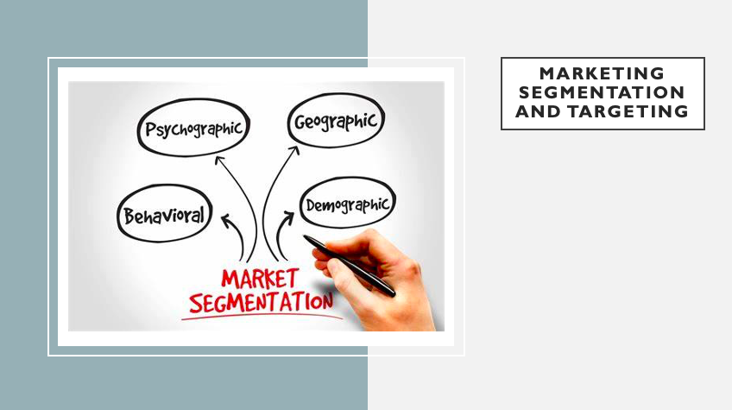
Visitors on vacation, business travelers, and families can all find suitable lodging at this hotel. The Hilton is a popular choice for families due of its convenient location, safe environment, and high standard of service and activities aimed squarely at youngsters (Andaleeb, S.S., 2016).

Slide 5
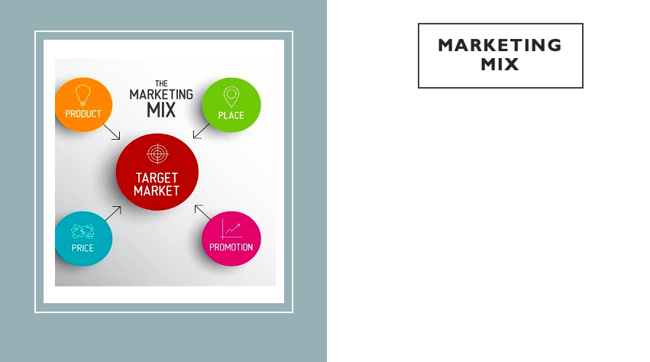

The company provides hotel services. Restaurants, reception spaces, gift shops, pools, shops, and event organizing. This business strategy will focus on UK Hilton Hotels, despite their global reputation. It operates numerous UK hotels. Hotels near attractions are popular among guests and inhabitants. Hilton Hotels pricing for desired result. Branch and service prices vary. Successful businesses promote products and services well. Hilton's aggressive advertising has made it a hospitality staple (Londhe, B.R., 2014).

Slide 6
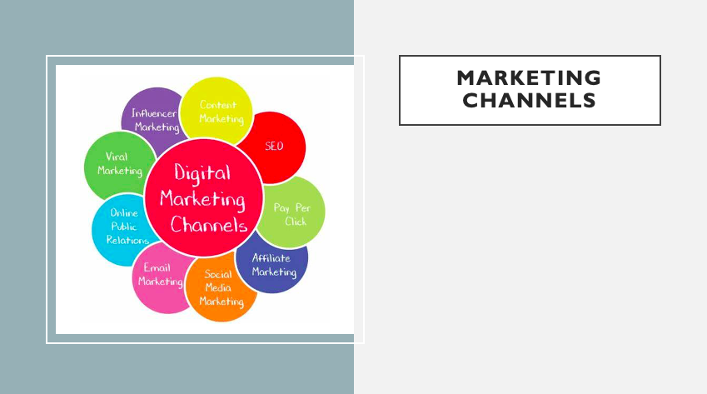
Promotional efforts frequently employ digital methods, and this trend is only expected to continue. To advertise a product or service to a target audience online. Hilton Hotels' social media presence is a key to the company's success in today's competitive marketplace. Among the many available social media sites, Instagram, Facebook, and Twitter are among the most widely used (Printezis, I. and Grebitus, C., 2018).

Slide 7
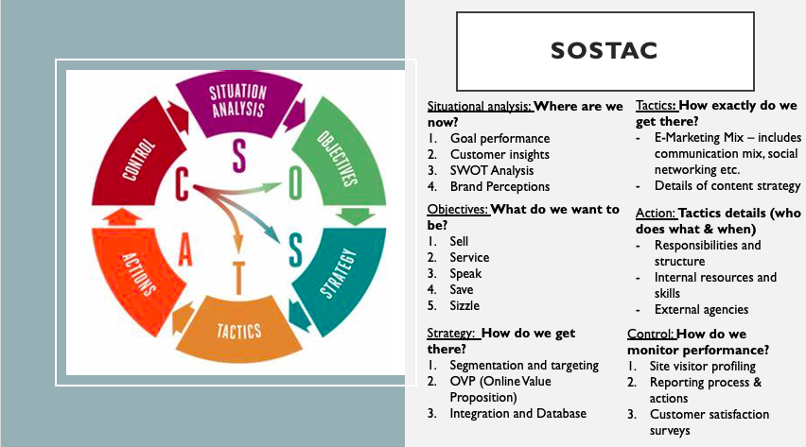

Slide 8


