Benjamin Andrew Woodhead P151944
Bwoodhead.151944@student.uwtsd.ac.uk

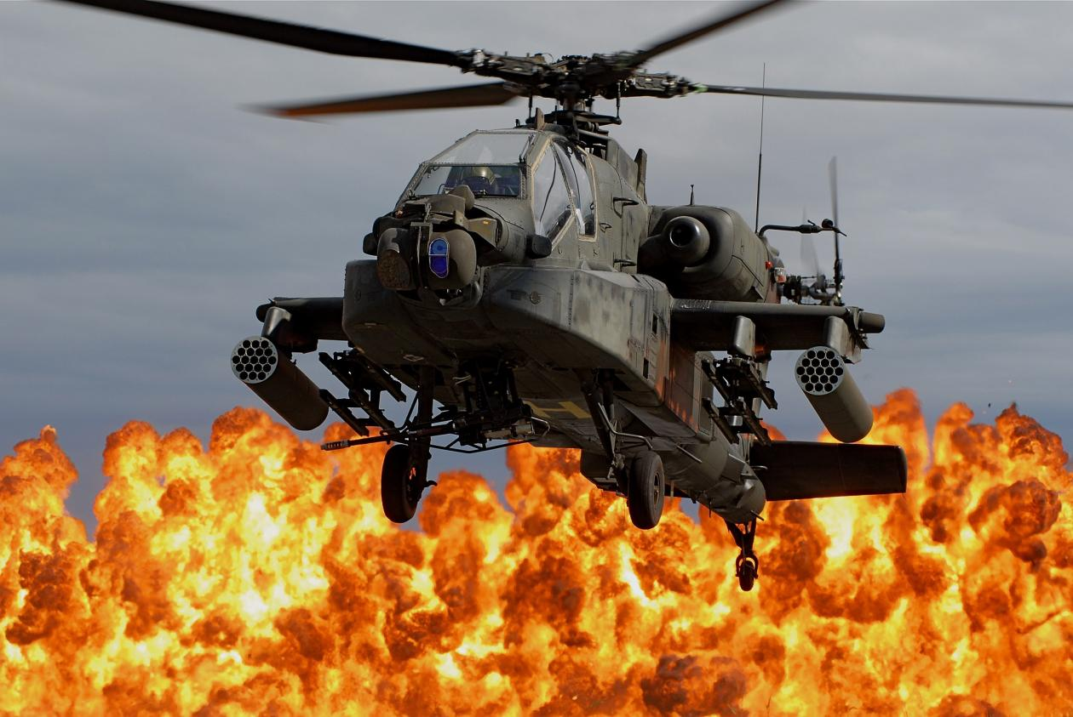
Assessment of a helicopter tail rotor
Advanced Computation Methods Coursework
Contents
Introduction 1
Loading Research 2
Basic Loading 2
Intermediate Loading 2
Advanced Loading 3
FEA Critical Analysis 5
Calculations: 5
FEA Model 5
Analysis of FEA model 7
Conclusion and Recommendations 8
Bibliography 9

Introduction
The purpose of this report is to create a Finite Element Analysis simulation model of an AH-64 Apache tail rotor from a given CAD model. This took on three main stages of investigation; researching how such a part would be loaded during operation, applying these loads to the CAD model and running the simulation, then critically analysing the results. Because of the varying potential scope of such a task, the depth of this FEA analysis would have to be balanced against the limited available computing resources and software packages – this report breaks down the possible loading scenarios in to three levels of complexity, and how each of them will affect the required computational power and simulation time. It also assesses the reliability of the information given by the simulation, and how useful this would be in a real-world design project.

Loading Research
The loading of a helicopter tail rotor, or any form of aerofoil, is a complex combination fluid flow, applied stresses and motion. Because of this, a comprehensive FEA model would be incredibly complex to build and not necessarily required depending on the purpose of the model; a simulation designed to simply test the suitability of a material selection under load for example, will not need to be as complex and resource consuming as a model intended to find the maximum design efficiency of the blade assembly. There is scope to build a study with any combination of loads to suit the specific needs of a given project, but these simulation builds can be split approximately in to three levels of complexity:

Basic Loading
This will be the simplest load study requiring less expensive simulation packages and less computational time and ability. The main considered components and assumptions are:
- A coarse simulation mesh – due to the limited computational power available, a coarse mesh will be used on the part body in order to reduce the time taken to perform the stress analysis calculations. This will result in less accurate results than if a fine mesh was used but is still useful for finding approximate values quickly.
- A single rotational speed – the maximum stresses will be present at the maximum rotational speed, so this study will focus only on using the maximum operational motor speed on the rotor assembly. This is given as 1411 RPM, with a tip speed of 221.62m/s (Swopes, 2016).
- A uniform air pressure differential across the top and bottom of the blade - calculated by finding the net lift of blade profile to be 16N (Maloney, 2019), this would be applied as a spread load across the underside of the blade. In reality the pressure differential at the base and tip of the blade will be different due to their different linear velocities, but for this basic loading an average will be taken and applied across the area of the aerofoil.
- A constant air temperature and pressure – this study will not allow for a varying Reynold’s number due to variations in air temperature and pressure, and will be assumed at a constant 15°C and 1 atmosphere.
- A single material across the whole structure of the blade – this basic study will apply 316 stainless steel as the only material in the blade structure.
These parameters would then be used to find the natural vibration harmonics (NVH) of the blade, as well as the deflection and stress concentrations across the body of the blade. This simulation can be run on any CAD-capable computer with limited simulation software, and can be completed in a matter of seconds

Intermediate Loading
This is similar to the basic loading, but the blade body would be split into regions in order to calculate the stress and deflection of each zone along the length of the blade. This is because of the differing linear velocities of the base. The considered components and assumptions are:
- A medium-fine simulation mesh – when more accurate results are required, a finer mesh is necessary in order to provide more accurate stress calculations. However, assuming computational power is still limited, this cannot be too fine or the time taken to produce results will be too great.
- A single rotational speed – similar to the basic, the maximum stress would be found at the maximum rotational speed so only this condition would be considered.
- Linear velocity calculations at set points along the blade – the blade would be split in to approximately 10 segments along the length, as each segment would have a different linear velocity.
- The lift force for each segment of the blade – this can be found by using the linear velocity of each segment as a function of the lift force equation. The found forces could then be applied to each segment of the blade as a spread load. The total of these forces should be similar to that of the basic simulation, but the stresses will be much greater at the tip of the blade and lower at the base.
- An assumed constant air temperature and pressure – similar to the basic loading, no consideration of variations to these components would be made; temperature and pressure would be assumed to be 15°C and 1 atmosphere respectively.
- A compound material design – the Apache helicopter has a rotor blade assembly consisting of a stainless steel framework, surrounded by a fibreglass skeleton, with a titanium leading edge and a graphite composite trailing edge (How Stuff Works, 2019). This structure has been specifically designed to withstand the specific stresses of low-altitude flight, and so using a CAD model with the correct materials will yield more accurate results. This however will also result in a longer computational time as there are more elements for the simulation software to consider, so it may be prudent to generate a model with a simplified version of this structure.
These conditions can then be used to check the natural vibration harmonics of the blade against the operational frequency, the deflection of the blade body and to locate any critical stress concentrations. This will be a more accurate simulation than the basic as the meshing of the body will allow the user to focus on the areas of high stress and deflection at the tips of the blade. It will however require a higher-end computer and will likely take a matter of minutes rather than seconds to solve – because of this, it is a study more suited to the initial approximate analysis of a design team at an engineering company that are willing to invest the time and resources to create a more accurate model.

Advanced Loading
This loading majorly differs from the previous studies as it will utilise a Computation Fluid Dynamics simulation tool to create a simulation of the blades as they pass through the air. This will allow the user to measure the fluid dynamic effects of the air as it passes over each aerofoil, and how this flow can potentially affect the forces on the following blade. The considered components and assumptions of this study are:
- A full range of rotor speeds, from take-off to landing – by using motion simulation software, this study can cover the full operational range of speeds experienced by the assembly.
- A fine mesh across the body of the assembly – with more advanced software and computational equipment, the study can be run with a mesh containing much smaller elements than in the previous two levels. This will give much greater accuracy to the calculated resultant values and give the user a clearer idea of where stress concentrations are located.
- Use the CFD to find the lift force change along the length of the aerofoil – by using CFD simulation, the linear velocity of each point along the length of the blade can be used to find the lift force at each point – as the linear velocity is much greater at the end of the blade, this force should be much greater at this point.
- Run the simulation for different air densities depending on temperature and pressure – air density, a key component of the aerofoil’s Reynold’s number, changes with ambient temperature and pressure. As the helicopter will be expected to perform in a range of environments at varying altitudes, these variations in air density will have to be accounted for in order to ensure the aerofoil can deal with these force variations (Engineer's Edge, 2019).
- Allow for vortex shedding when calculating vibration – as an aerofoil moves through a fluid, the vortices off the trailing edge create vibrations in the part body. These will need to be simulated in order to make sure these vibrations do not coincide with the natural harmonics of the assembly and do not cause excess stress to the material (Parramore, 2019).
- Allow for leading and trailing edge effects – similar to vortex shedding, the fluid edge effects can cause additional stresses to the material and these must be calculated to ensure they are within the yield strength (Parramore, 2019).
- Allow for buffeting from the previous blade – all previous studies assume that the aerofoil is passing through still, undisturbed air. This is not the case however, as each blade will be operating in the turbulent air of the blade preceding it, which will have affects on the air flow around the aerofoil. This turbulent air could cause a build up of excess heat or not provide the flow needed to generate the required lift, so this must be accounted for (Parramore, 2019).
- Allow for wingtip vortices – this effect occurs when the air on the high-pressure underside of the aerofoil moves to the low-pressure side at the tip of the aerofoil. This can not only cause a decrease in lift, but also cause an increase in the opposing directional force, reducing the amount of lift the aerofoil can supply. Simulation must be used to ensure this effect does not affect the operational performance of the part (Parramore, 2019).
- Simulate varying angles of attack for the aerofoil – this is for efficiency, as there may be an angle of attack that the aerofoil can be set to that will generate the same amount of lift at lower motor speeds. This will be beneficial when considering factors such as fuel costs, part wear and noise pollution.
- Twisting and bending of the aerofoil – with the variable applied forces and fluid effects along the length of the blade, there is a possibility that the aerofoil will deform in such a way that the angle of attack or linear velocity is affected. These factors would result in a change in the lift force generated by the aerofoil, which could potentially reduce the operational effectiveness of the part.
- A complete CAD model – as stated at the intermediate level, the Apache helicopter has a multi-material composite design for its rotor assemblies. For an advanced simulation, this structure should be completely represented by the CAD model, with the correct materials selected for each part in order to generate the most accurate results.
These FEA conditions can be considered to create an almost real-world simulation of this part, yielding much more accurate results than the previous two levels as it would utilise the true design of the part and consider the dynamic environment in which it will operate. The trade-off for this is that it will require both advanced computational machinery – most likely a dedicated simulation server bank – and a much longer calculation time. This level of simulation would be reserved for advanced research purposes, most likely of the OEM manufacturer prior to a full-scale prototype testing project.

FEA Critical Analysis

Calculations:
Below is a list of values and calculations used to find forces the aerofoil would be subjected to:
- Mass – 3.671Kg, from CAD model with material set to 316 Stainless Steel
- Angle of attack – 5.18°, from CAD model
- Angular velocity – 1411rpm/147.76rad/s (Swopes, 2016)
- Density of air – 1.225kg/m³ (Engineer's Edge, 2019)
- Radius from spindle to centre of aerofoil edge – 0.255m, from CAD model
- Linear velocity of aerofoil centre – 37.70m/s
- Reynolds number – 164329 (Engineering Toolbox, 2003)
- Coefficient of lift – 1.20 (Airfoil Tools, 2019)
- Area under aerofoil – 0.0162m², from CAD model
- Net lift force – 16.97N (Maloney, 2019)
  - This lift force value is low – it appears that the CAD model is roughly a 1:4 scale model of the helicopter, and this downscaling would explain the low lift value. When adjusted to full-scale size the lift force is calculated to be 270.77N, however for the sake of the simulation the scaled version will be used.
- Area of aerofoil leading edge – 0.00189m², from CAD model
- Coefficient of drag – 0.02 (Airfoil Tools, 2019)
- Drag force – 0.025N, from Cd v Alpha graph (Airfoil Tools, 2019)
- Mesh – a 10mm element size was chosen to provide relatively accurate results at a reasonable calculation time. This mesh was set to ‘curvature driven’ in order to allow for the geometry of the part.

FEA Model
Below are a number of images demonstrating how the part was loaded during simulation, with the found values for maximum stress, displacement and strain listed, as well as the natural vibrational frequency.
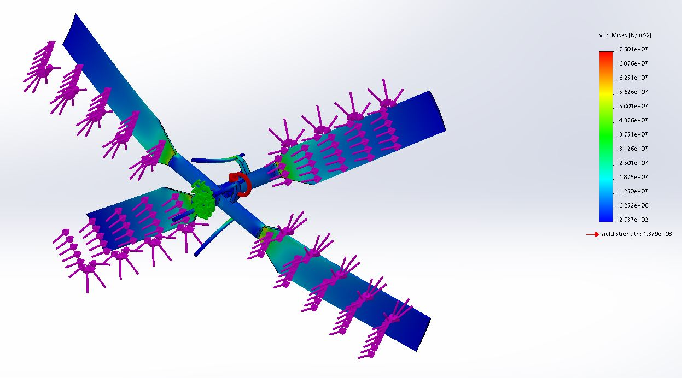
Figure 1 - stress calculation
Max Stress (von Mises): 75.01MPa
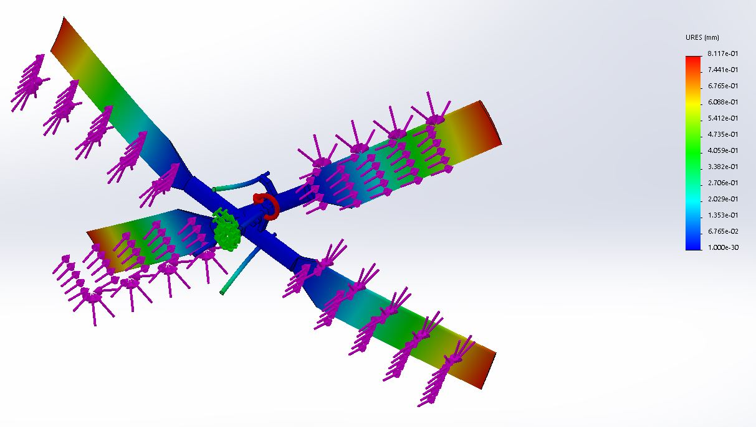
Figure 2 - calculated displacement
Max Displacement: 8.12mm
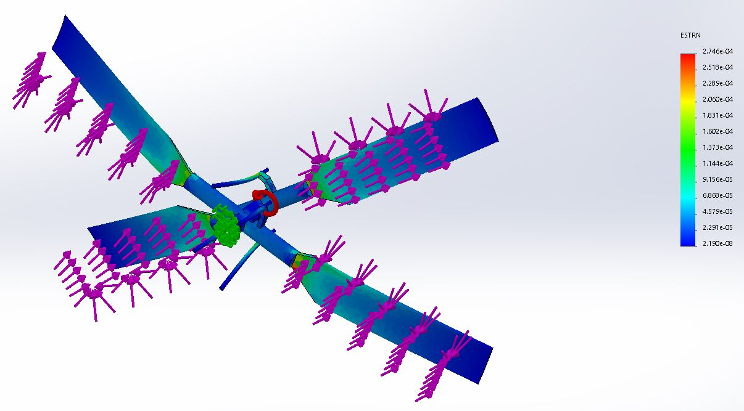
Figure 3 - calculated strain
Max Strain: 2.75e⁻⁴
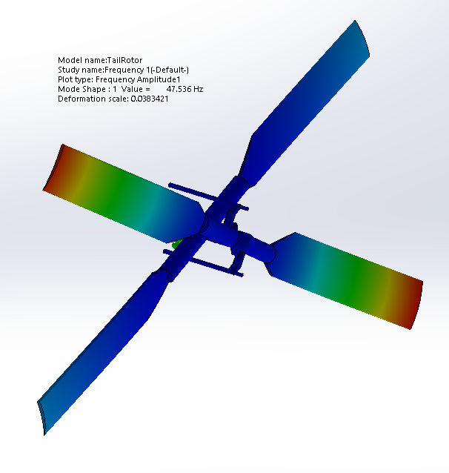
Natural vibrational frequency: 47.80Hz

Analysis of FEA model
The shown model is clearly a very simplistic view of the forces experienced by a helicopter rotor assembly. The major static loads are present – lift, drag and centrifugal force – which gives the simulation some credence for its assessment of the material capabilities, but it provides no useful information on the design’s ability to perform its intended task. Additionally, the lift force calculated appears to be very low for the design’s requirements at just 16N, which implies either poor calculation or an incorrect CAD model – this could be verified if motion simulation and fluid dynamics software were available, but as this is a simple level analysis the calculated values must be assumed to be correct. The stress calculation implies that the material is suitable for task, with the maximum stress not reaching within a factor of 10 from the yield strength of the material, with only some minor stress concentrations on the inner corners of the blade that could be remedied by converting these sharp corners to rounded radii. However, as stated in the previous section this blade design is not actually a single solid material but a multi-material compound construction, which means that this simulation is of no real-world use to the designers of the part.
The maximum displacement has been calculated at 8.12mm, which would be an expected value given the loading conditions. It appears here that the low lift force and the single-material, unstiffened CAD model have combined to give a relatively realistic value for displacement, however this should be considered a coincidence and not relied upon as an accurate value of the actual design. The strain value of 0.00027 is very low, and obviously well within the limits of stainless steel, but this calculation suffers from the same fundamental drawbacks as the stress calculation if to to be used as an accurate simulation of an operational part. This also applies to the found NVH frequency, as while it is accurate for the supplied CAD it likely bears little resemblance to the true value of the in-depth design. As the NVH value is used to dictate the operational parameters of other parts in order to not produce large-amplitude natural oscillation, the NVH value must be accurately calculated in order to be of any use to a design team.

Conclusion and Recommendations
In conclusion, what this FEA model proves best is that a simulation is only as good as the information put into it. Basic simulation is a useful tool for calculating simple stresses on simple parts, and finding materials suitable to that application, but it can provide hugely inaccurate and potentially dangerous results when relied upon for more complex systems. For complex designs intended for dynamic operation, motion study and computational fluid dynamics are key simulation tools when trying to create an accurate depiction of the system in use. With aerofoil design in particular, the fluid dynamics have such a large effect on the ability of the design to perform its intended function safely and efficiently that it would be recommended to not even consider the results of any simulation that did not include these tools. A designer needs confidence in their both FEA simulation and their ability to spot incorrect values in order for the tool to be of any use, and so this particular study could not be considered either reliable or useful.

Equations
Reynold’s Number = (density x velocity x relevant length) / dynamic viscosity (Engineering Toolbox, 2003)
Coefficient of Lift = (2 x Lift) / (density x velocity^2 x wing area) (Maloney, 2019)
Centrifugal force = (mass x linear velocity^2) / radius (OmniCalculator, 2019)

Bibliography
Airfoil Tools. (2019). NACA6409. Retrieved from Airfoil Tools: http://airfoiltools.com/airfoil/details?airfoil=n6409-il
Boeing. (2019). AH-64 Apache. Retrieved from Boeing: https://www.boeing.com/defense/ah-64-apache/
Engineering Toolbox. (2003). Reynolds Number. Retrieved from Engineering Toolbox: https://www.engineeringtoolbox.com/reynolds-number-d_237.html
Engineer's Edge. (2019). Air Density and Specific Weight Equations and Calculator. Retrieved from Engineer's Edge: https://www.engineersedge.com/calculators/air-density.htm
Engineer's Edge. (2019). Viscosity of Air. Retrieved from Engineer's Edge: https://www.engineersedge.com/physics/viscosity_of_air_dynamic_and_kinematic_14483.htm
How Stuff Works. (2019). How Apache Helicopters Work. Retrieved from How Stuff Works: https://science.howstuffworks.com/apache-helicopter1.htm
Maloney, L. (2019). How To Calculate Lift Coefficient. Retrieved from Sciencing: https://sciencing.com/calculate-lift-coefficient-7463249.html
OmniCalculator. (2019). Centrifugal Force Calculator. Retrieved from OmniCalculator: https://www.omnicalculator.com/physics/centrifugal-force
Parramore, M. (2019, November 5). Aerofoil Design and Edge Effects. (B. Woodhead, Interviewer)
Raymond, J. (2015). Airplane Wing Lift Design Equation Calculator. Retrieved from AJ Designer: https://www.ajdesigner.com/phpwinglift/wing_lift_equation_force.php#ajscroll
Swopes, B. R. (2016). AH-64 Apache. Retrieved from This Day In Aviation: https://www.thisdayinaviation.com/tag/ah-64-apache/

