

Energy sector price increase
Evaluation of the impact on businesses, households and on the UK economy as a whole. Impact on the managerial decisions within small and large organisations
Nikola Chakrakchiev
Student No.: | 2029324
Course Name: | BA Business Management
Module: | Management Economics (LCBB5003)
Lecturer: | Vasilios Tavlaridis

Contents
Introduction 1
Supply of energy in the UK – current and future trends 1
Coal 1
Oil, Gas, and Oil Products 2
Renewable sources 2
National Income 3
Unemployment 4
Currency 5
Managerial decisions 7
Conclusion 8
Reference list 8

Introduction
European industries are placed under severe pressure due to the surging prices of fuels, gas, and electricity. The rising deficit in the supply of fossil fuels and the high sales prices coming out of that, put some challenges before the businesses faced in a different fashion by the various industries. This work will try to explain the causes and give a forecast of the situation and how it will reflect on the managerial decision of small and large organisations.

Supply of energy in the UK – current and future trends
Discussing the trends in the supply of energy in the UK for the near future is key for the other parts of this paper. It will reveal the reasons behind the rising prices and the trend for them to continue to rise in the future.

Coal
Although the European governments worked for the entire last decade to abolish the need for burning coal, it is still part of the country’s energy mix. It is expected that the United Kingdom will cease the use of coal for the generation of electricity in October 2024 (ONS Department for Business, Energy & Industrial Strategy, 2022).
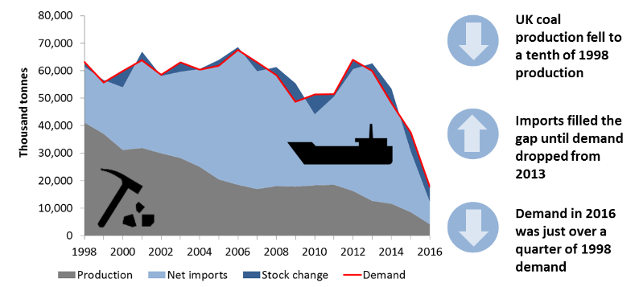
Figure 1. UK coal demand and supply since 1998 up to 2017 (ONS Department for Business, Energy & Industrial Strategy, 2017, p. 39)
Figure 1 shows the gradual decrease in demand and production of coal in the UK. The last coal mine in Britain closed its doors already, but the demand is still there and visible from Figure 2, Russia was among the biggest suppliers because of its low prices and abundance of resources.
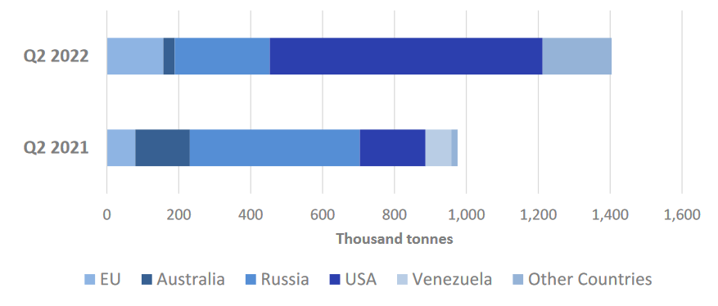
Figure 2. Coal imports to the UK (ONS Department for Business, Energy & Industrial Strategy, 2022, p.5)
However, the demand is still there and the supply is shifted from cheap to more expensive sources which contributes to the rising energy prices.

Oil, Gas, and Oil Products
Fortunately, the United Kingdom has 21 offshore drilling rigs in operation and they supply the country with a sufficient amount of its oil and gas. (Yusuf et al., 2013, p. 505)
The demand for liquid fuels, petrol and diesel has been gradually rising for the last year and has already reached its pre-pandemic levels (ONS Department for Business, Energy & Industrial Strategy, 2022). Jet fuel is consumed in more than three times higher quantities compared to the time of the COVD pandemic (ONS Department for Business, Energy & Industrial Strategy, 2022). Production and import of jet fuel have been increased in order to meet the rapidly increasing demand, however, jet-fuel consumption is much lower than the levels recorded in 2019 (ONS Department for Business, Energy & Industrial Strategy, 2022). This means that we can expect a further rise in demand.

Renewable sources
The last two decades were marked by the politics of greenhouse gases reduction and a shift towards greener energy. Priority was given to renewable sources like wind and solar energy. A decision was taken to abolish the nuclear energy programs of a number of European states. However, the UK will abolish it in 2035 (Energy UK, 2022). The current state of the British energy market is that burning fossil fuels form more than 41.9% of the national energy production, 19.5% comes from nuclear plants, and the share of renewable sources is 38.6% (ONS Department for Business, Energy & Industrial Strategy, 2022). This means that despite all the efforts in the last decades, fossil fuels are still a general energy source for the UK.
The main issue with this is that a great quantity of the energy imported into Europe was coming from Russia before Europe and the United States placed several sanctions packages on Russia and thus made it impossible for Russian fossil fuels to enter the UK market. This creates certain shortages in the supply of energy and therefore increases in price (Nigusse, Tadesse & Melaku, 2019).
The UK government agencies rely on the import of LNG and oil from the United States (ONS Department for Business, Energy & Industrial Strategy, 2022). Currently, the US supplies constitute 40% of the import of fuels in Europe (Shiryaevskaya and Chapa, 2022). However, Chestney and Sharafedin (2022) came up with a vast analysis of the gas imports in Europe and how the reduced import of Russian gas is creating a deficit of 155 mcm/day.
All the above facts indicate that there will be shortages in the supply of energy on the market in Europe and this can only bring to yet higher energy prices (Nigusse, Tadesse & Melaku, 2019). Bearing that in mind we can try to forecast how it will reflect on the national income, the unemployment rate, the UK currency – the lira, and the international trade.

National Income
The World Inequality Database claim on its site that the gross domestic product (GDP) does not give a clear picture of the wealth of a given country. They favour the concept of national income as a more indicative method of reflecting a country’s welfare. National income is calculated by deducting from GDP the “consumption of fixed capital (capital depreciation) plus net foreign income” (World Inequality Database, 2022). National income bears more meaning, “because it takes into account the depreciation of the capital stock (including in principle natural capital), which is not an income to anyone, as well as the fraction of domestic output that is transferred to foreign capital owners (including in principle offshore wealth)” (World Inequality Database, 2022). For example, countries with large GDP, but pervasive loss of capital value and outflow abroad, would not have much to distribute among the population of the country. (World Inequality Database, 2022)
National income has the advantage that almost every country keeps a record of it and it is measured under concrete international standards. However, it still has some drawbacks. Since it measures the income from capital and labour, it does not include the transfer payments, which constitute the main source of income for some households. Also, the measurements can be misleading about some groups of the population, like retirees, for example. In the times when they accrue their retirement funds, they are considered citizens with higher income, but when they retire, their savings are drawn down and they begin receiving Social Security pension benefits from the government, and this places them among the people of lower or no income. (Auten, 2022).
Transactions that do not contribute value to the national income are not calculated, too. This means that if the transaction involves the sale of a used vehicle which was new a couple of months earlier, it will not be accounted for the purposes of the national income. Other such transactions are the purchase of gifts and welfare transfers from the government such as pensions and disability allowances. (Auten, 2022)

Figure 3. National Income of the UK by quarters from Quarter 4 of 2006 until Quarter 2 of 2022 (Office for National Statistics, 2022a)
As we can see from Figure 3 the national income of the United Kingdom is gradually rising, with a couple of drops during the World Financial Crisis in 2008-2009, and during the COVID pandemic in 2020 when all but the essential industries remained working for the best part of half a year.
This trend is showing that when industries do not operate at the best of their capacities the national income is in decline.
And, indeed, more and more reports are coming with industries complaining of mass closures. Sixty per cent of British factories are at risk of ceasing production due to the climbing energy bills (Harris, 2022), as well as the entertainment industry in the face of pubs and nightclubs, where one nightclub closes every two days (Murray, 2022).

Unemployment
Unemployment rates in the UK are another measure of UK politicians' competence and their decisions' efficiency (Bartholomew et al., 1995). Therefore, it is expected and followed with interest by the UK public (Bartholomew et al., 1995). As visible from Figure 4, in times of recession, unemployment in the UK rises and when the economy is thriving unemployment falls. Following the recessions in 1990-1991 (Smith, 2011), unemployment climbed for the following years to 10.6% and got to its pre-recession levels yet in the late ’90s (Office for National Statistics, 2022c). Then figures rise again following the World Financial Crisis in 2008 to the rate of 8.1% in 2011, and then gradually fell with a small spike following the lockdown in 2020 in order to fall to its historically low nowadays – 3.6% (Office of National Statistics, 2022c).
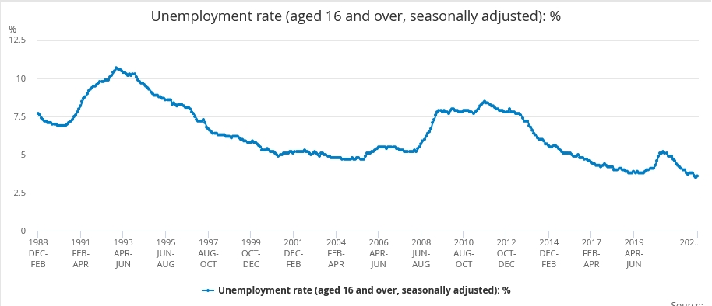
Figure 4. Unemployment rate in the UK from January 1989 to September 2022 (Office for National Statistics, 2022)
The pattern we see from the statistics is that unemployment reflects recessions with a lag of several months and can last several years after and during that (Smith, 2011).
Having in mind the reports of mass industries closure, unemployment is expected to rise during the following months. And having in mind that Britain is expected to enter the deepest and longest deep recession since the 1930s, it is also logical to expect that unemployment rates will spike at the end of 2022 and the beginning of 2023.

Currency
The British Lira, being one of the strongest currencies in the first decades of the 21st century, is put under a lot of pressure in the last couple of months. Along with the consequences of Brexit, the COVID pandemic and its lockdowns, now the scarcity of resources and the rising prices ad up to the rising inflation in the country. The data from the ONS shows that the prices of the cheapest groceries in the store network in the UK in comparison with one year earlier have risen by an average of 17% for October 2022 (Office of National Statistics, 2022d), when inflation was claimed to be at the level of 8.8% (Office for National Statistics, 2022b). Figure 5 shows that the price for some goods has risen by a staggering 65% within the period between September 2021 and the same period of 2022.
The grim part for the British Lira is still to come, because for the period between October 2022, when the figure of 8.8% was officially calculated and stated in the webpage of the ONS, and mid-November 2022, inflation grew by 2.3% up to 11.1% (Sky News Breakfast, 2022).
In order to reduce the inflation growth rate, the new government of Rishi Sunak and His Chancellor Hunt have taken the course of promising cuts in public spending starting in 2027 and heavy tax raises from 2023 (HM Treasury, 2022). On top of that, they promise a raise in the National Living Wage by 9.7% (HM Treasury, 2022).
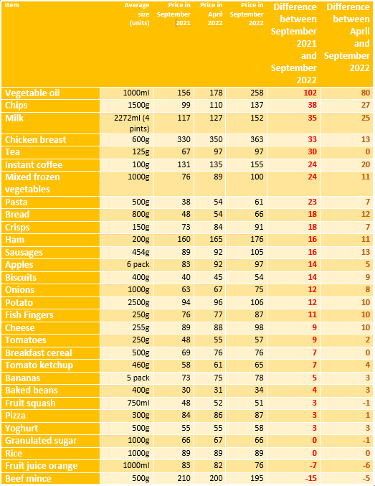
Table 1. Essential groceries - prices in September 2021 and September 2022 (Office of National Statistics, 2022d)
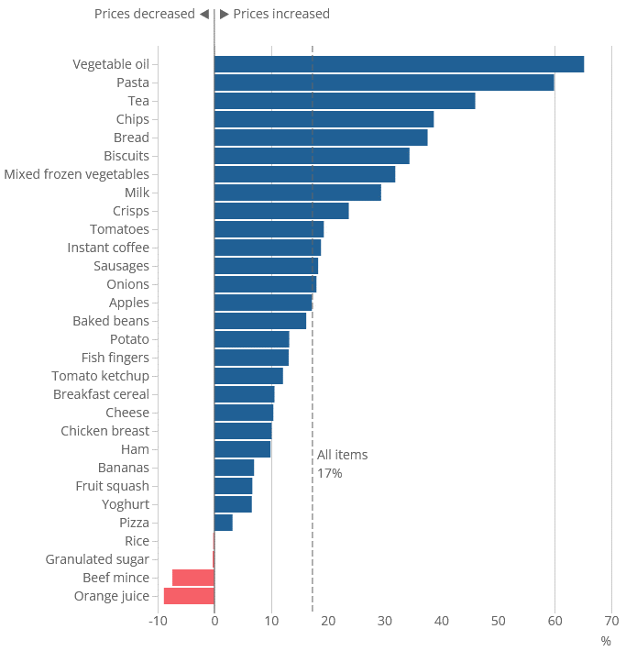
Figure 5. Rise in prices of essential groceries in percentages (Office for National Statistics, 2022d)
At the beginning of November 2022, the Bank of England raised the interest rates to 3% and the financial markets forecast it rising to 4.75% (Inman, 2022). This raises the instalments of the loans of the heavily indebted UK citizens and businesses, making it impossible to pay (Inman, 2022). Figure 6 is visualising the deviations in the interest rate since the 1970s. It clearly shows that high-interest rates are not a precedent for the UK and that they were over 15% when Margaret Thatcher became a prime minister.
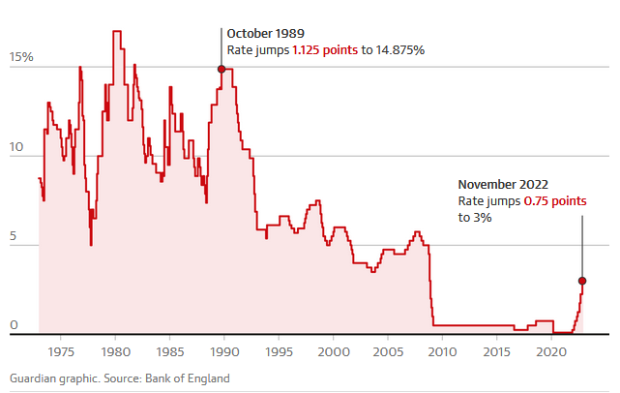
Figure 6. The interest rates of the Bank of England since the 1970s (Inman, 2022)
However, the population of the UK are witnessing a continuous fall in the price of their currency (Figure 7). This brought the fall of the fresh government of Liz Truss, whose mini-budget provoked only mistrust among the population and the political class in the UK.
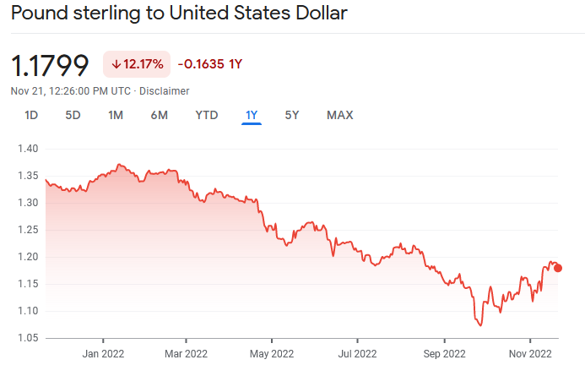
Figure 7. The course of the continuous fall of the British Sterling (Google Finance, 2022)

Managerial decisions
As mentioned above – the situation in the UK becomes harder for the population and the business. The surging gas and electricity bills leave no choice for some other than to close doors and cease operation. This is the choice that stands before small and medium businesses. Others, like the bug manufacturers, are shifting operations to other continents – Asia and America in order to relieve the production of the heavy burden of the surging energy prices (Uberti, 2022). ArcelorMittal is cutting production in two German factories in favour of its US factories. Volkswagen and the Danish Pandora are expanding in the USA. The chemical producer OCI is also betting on US expansion (Uberti, 2022).
The surging inflation bares losses of capital, it requires a constant change of price tags, which, in turn, discourages consumers to make purchases and chases them away, because of the notion of disappointment left in them because prices change too rapidly for no reason (Griffiths, 2011, p. 328). Future contracts are under threat because of the surging prices (Griffiths, 2011, p. 328). Business managers must be careful to contract not at fixed rates, but to implant the clause of adjustments in case of growing inflation (Griffiths, 2011, p. 328).
Since unemployment is expected to rise, the population will become poorer and businesses in the UK will face an increasing rate of strikes from various industries all demanding higher pay rates. So far, we have had a constant disorder in railway transport due to regular strikes (Stewart, 2022). However, other industries are threatening strikes, too, like, for example, NHS (PA Media, 2022).
Businesses are facing rising expenses in terms of higher bills, and new government regulations, like rising salaries and heavier taxation, and that will encourage a large majority to declare insolvency (Griffiths, 2011, p. 328).

Conclusion
The war in Ukraine and the sanctions imposed on Russia added to the consequences of Brexit and the recovery from the COVID pandemic economy, and Europe and the UK are preparing to enter the hardest and longest recession since the 1930s. The scarcity of energy resources is a preposition for surging energy prices and this, in its turn leads to high inflation rates, higher taxes imposed by the government, and increasingly reduced well-being among the population. Businesses will face the choice to either move production and operation overseas or cease operation. In both cases, Europe and the UK are facing hard times in the near future.

Reference list
Auten, G. (2022), August. Distributing National Income in the US: Alternative Income Definitions and Data Issues. In 37th IARIW General Conference, Friday, August (Vol. 26).
Bartholomew, D. et al. (1995) ‘The Measurement of Unemployment in the UK’, Journal of the Royal Statistical Society. Series A, Statistics in society, 158(3), pp. 363–417. Available at: https://doi.org/10.2307/2983439.
Chestney, N. and Sharafedin, B. (2022)’ Analysis: Russian gas supply gap casts chill in Europe as winter nears’. Reuters, 11th October. Available at: https://www.reuters.com/business/energy/russian-gas-supply-gap-casts-chill-europe-winter-nears-2022-10-11/ (Accessed: 17 November 2022)
Energy UK (2022) Electricity generation. Available at: https://www.energy-uk.org.uk/our-work/generation/electricity-generation.html (Accessed: 14 November 2022)
Google Finance (2022) Pound sterling to United States Dollar. Available at: https://www.google.com/finance/quote/GBP-USD?sa=X&ved=2ahUKEwj_idmxor_7AhVKhFwKHX31C-4QmY0JegQIBhAc&window=1Y (Accessed: 21 November 2022)
Griffiths, A. (2011) Economics for business and management. Third edition. Harlow, England :, Pearson Education Limited.
Harris, J. (2022) Six in 10 British Factories at Risk of Going Under as Bills Soar. Bloomberg, 3rd September. Available at: https://www.bloomberg.com/news/articles/2022-09-02/six-in-10-british-factories-at-risk-of-going-under-as-bills-soar (Accessed: 19 November 2022)
HM Treasury (2022) News story. Chancellor delivers plan for stability, growth and public services. gov.uk. 17 November. Accessible at: https://www.gov.uk/government/news/chancellor-delivers-plan-for-stability-growth-and-public-services (Accessed: 21 November 2022)
https://www.ons.gov.uk/economy/governmentpublicsectorandtaxes/publicspending/timeseries/abmx/ukea (Accessed: 10 November 2022)
https://www.ons.gov.uk/economy/inflationandpriceindices/articles/trackingthelowestcostgroceryitemsukexperimentalanalysis/april2021toseptember2022#:~:text=Highly%20experimental%20research%2C%20based%20on,12%20months%20to%20April%202022. (Accessed: 21 November 2022)
Inman, P. (2022) ‘Bank of England warns of longest recession since the 1930s’. The Guardian. 3rd November. Available at: https://www.theguardian.com/business/2022/nov/03/bank-of-england-raises-interest-rates-to-3-percent (Accessed: 21 November 2022)
Murray, J. (2022) ‘One UK nightclub closing every two days over soaring costs, industry says’, The Guardian, 3rd November. Available at: https://www.theguardian.com/business/2022/nov/03/one-uk-nightclub-closing-every-two-days-over-soaring-costs-night-time-industries-association-warn (Accessed: 19 November 2022)
Nigusse, T., Tadesse, T. & Melaku, T. (2019) ‘Supply and Demand Side Determinants of Inflation in Ethiopia: Auto-Regressive Distributed Lag Model (ARDL)’, International Journal of Commerce and Finance, vol. 5, no. 2, pp. 8-21.
Office for National Statistics (2022a) UK Gross National Income: Current price: £ million: Not seasonally adjusted. Available at:
Office for National Statistics (2022b) Consumer price inflation, UK: September 2022. Accessible at: https://www.ons.gov.uk/economy/inflationandpriceindices/bulletins/consumerpriceinflation/latest (Accessed: 14 November 2022)
Office for National Statistics (2022c) Unemployment rate (aged 16 and over, seasonally adjusted): %. Available at: https://www.ons.gov.uk/employmentandlabourmarket/peoplenotinwork/unemployment/timeseries/mgsx/lms (Accessed: 21 November 2022)
Office of National Statistics (2022d) Tracking the price of the lowest-cost grocery items, UK, experimental analysis: April 2021 to September 2022. Available at:
ONS Department for Business, Energy & Industrial Strategy (2017) Digest of United Kingdom Energy Statistics 2017. Available at: https://assets.publishing.service.gov.uk/government/uploads/system/uploads/attachment_data/file/643414/DUKES_2017.pdf (Accessed: 14 November 2022)
ONS Department for Business, Energy & Industrial Strategy (2022) Energy Trends. UK, April to June 2022. Available at: https://assets.publishing.service.gov.uk/government/uploads/system/uploads/attachment_data/file/1107502/Energy_Trends_September_2022.pdf (Accessed: 14 November 2022)
PA Media (2022) Unite to ballot nearly 10,000 NHS workers in latest vote on strikes. The Guardian, 13 November. Accessible at: https://www.theguardian.com/politics/2022/nov/13/unite-union-ballot-vote-nhs-workers-strikes (Accessed: 21 November 2022)
Shiryaevskaya, A. and Chapa, S. (2022) ‘Europe Can’t Rely on US Gas to Plug Growing Gap Next Year’. Bloomberg UK, 28th October. Available at: https://www.bloomberg.com/news/articles/2022-10-28/europe-can-t-rely-on-us-gas-to-plug-growing-shortfall-next-year?leadSource=uverify%20wall#xj4y7vzkg (Accessed: 17November 2022)
Sky News Breakfast (2022) Sky News Breakfast: Inflation hits 11.1% as food and energy bills soar. Sky News, 16th November. Available at: https://www.youtube.com/watch?v=lryNcdL5woc&list=WL&index=8&t=408s (Accessed: 17 November 2022)
Smith, J. (2011) ‘The ins and outs of UK unemployment’. The Economic Journal, 121(552), pp.402-444.
Stewart, H. (2022) UK facing Christmas travel chaos as civil servants in three departments to strike. The Guardian, 18th November. Accessible at: https://www.theguardian.com/politics/2022/nov/18/civil-servants-in-three-whitehall-departments-to-go-on-strike-for-a-month (Accessed: 21 November 2022)
Uberti, D. (2022) High Natural-Gas Prices Push European Manufacturers to Shift to the U.S. The Wall Street Journal. 21st September. Accessible at: https://www.wsj.com/articles/high-natural-gas-prices-push-european-manufacturers-to-shift-to-the-u-s-11663707594 (Accessed: 21 November 2022)
World Inequality Database (2022) Methodology. Available at: https://wid.world/methodology/ (Accessed: 12 November 2022)
Yusuf, Y. et al. (2013). ‘The UK oil and gas supply chains: An empirical analysis of adoption of sustainable measures and performance outcomes’, International Journal of Production Economics, 146(2), pp.501-514.

