Adam Willstead (2309258)



Abstract:
This report studies fluid flow around a kiteboard hydrofoil, assessing the Reynolds number, boundary layer and forces acting on the component. The aerodynamic performance, material and design are assessed alongside fluid dynamics. The Reynolds number, which is used to calculate flow characteristics such as turbulence, separation and lift. An appraisal of the forces in initial design is provided with an evaluation of the carbon fiber reinforced plastic material of the hydrofoil.
This report includes various simulation techniques for modelling fluid structure and records advantages and disadvantages of various methods. Validation of these methods through testing is discussed, with a focus on comparison of data of outcomes. This study aims to give great depth in the understanding of fluid flow and material considerations in the design of kiteboard hydrofoils.

Contents
Abstract: 2
List of figures: 3
Introduction: 4
Task 1: 5
Reynolds Number: ……………………………………………………………………………………………5
Reynolds Number Importance: 6
Affects to lift and drag coefficients: 7
Scaling/model testing: 7
Impacts cavitation onset: 7
Reynolds number influence: (Flow around hydrofoil) 7
Reynolds number ratio: 7
Flow around the hydrofoil: Laminar/Turbulent 7
Influence on boundary layer behaviour: 8
Influence on lift and drag: 8
Estimate of Reynolds number of the fluid flowing around the wing: 9
Task 2: 9
Analysis of boundary flow around the hydrofoil: 9
Types of boundary layers: 10
Pressure distribution and boundary-layer behaviour: 11
Flow separation: 11
How turbulence influences separation: 11
Flow pattern around a hydrofoil: 11
Why the foil has been designed like this: 12
Task 3: 12
Analysis of assumed Forces (500N Vertically per Side): 12
Critical Appraisal: 13
Task 4: 13
Evaluation of implications in terms of performance of the hydrofoil: 13
Carbon fibre reinforced plastic (CFRP): 13
Benefits for hydrofoils: 13
Corrosion resistance: 13
Cost/manufacturability: 14
Brittleness/impact damage: 14
Performance summary: 14
Carbon fibre kiteboard use conclusion: 14
Historical Developments: 15
Materials: 15
Modern Developments: 15
Shift to composites: 15
Examples: 15
Disadvantages: 16
Next Generation Hydrofoils: 16
Innovations: 16
Industry Standards & Regulations: 16
Task 5: 17
Modelling techniques used to simulate the fluid flow around hydrofoils: 17
Modelling purpose: 17
Modelling the Fluid Flow: 17
Potential Flow / Boundary Element Methods (BEM) 17
Computational Fluid Dynamics: CFD & RANS 18
Large Eddy Simulation (LES) & Detached Eddy Simulation (DES): 18
Free-Surface & Cavitation Modelling: 19
Modelling the Structural Response: 19
Finite Element Analysis (FEA) 19
Material Considerations: CFRP Hydrofoil 19
Estimated Forces on the Wing: 20
Task 6: 21
Prototype Testing: 21
Setup: Water Tunnel 21
Data capture: 21
Comparison: Validation/Discrepancy Analysis. 22
Considerations: 22
References 23

List of figures:
Figure 1: Turbulent and laminar flow diagram.
Figure 2: Influence on lift and drag behaviour table.
Figure 3: Boundary layer velocity profile over a foil. It shows the flow speed going from zero at the surface (no-slip) up toward the free-stream velocity.
Figure 4: Boundary layer development over an airfoil, including transition from laminar to turbulent and how the layer grows downstream.
Figure 5: Performance summary table.
Figure 6: Hydrofoil mounted in a water tunnel with load cell for force measurement.
Figure 7: Close up of the test section showing the hydrofoil, the laser sheet, and PIV measurement plane.

Introduction:
The design of hydrofoils for kiteboarding is a specialized sector that combines principles of fluid mechanics, engineering and materials science. Performance of hydrofoils can be heavily influenced by fluid flow dynamics around their surfaces. Reynolds number, boundary layer and turbulence contribute to changing efficiency and stability. The aim of this study is to assess the fluid flow around a kiteboard hydrofoil by using analysis and simulation tools. The hydrofoil is designed to provide lift and stability of a kiteboard and must be carefully optimized to balance the forces exerted by the surrounding fluid.
The report will focus on how Reynolds number affects the flow characteristics around the hydrofoil, including potential separation and turbulence that arise at different velocities. A review of material of the hydrofoil, particularly carbon fiber reinforced plastic will be documented with emphasis on impact on both structural performance and durability. Various computational fluid dynamics (CFD) techniques will be explored to model fluid flow around the hydrofoil, noting pros and cons of each. An experimental methodology will be undertaken to validate the simulation results, ensuring accuracy and reliability of the design before physical prototypes are developed and tested.
By the end of this report, hydrofoils design, material, fluid dynamics, and testing methods will be summarised, providing an assessment of how to optimize the performance of hydrofoils for kiteboarding.

Task 1:

Reynolds Number:
Reynolds number (Re) predicts patterns of flow. Fluid flow will be laminar (smooth) or turbulent (disrupted).
$$Re=\frac{ρVL}{μ}$$
ρ = Density of salt water (Approx.) = 1000 kg/m³
V = Velocity of flow relative to the foil (5 to 10 m/s for kitesurf speeds)
L = Length of foil = 0.15 to 0.3m
μ = Viscosity of water ≈ 1.0 × 10⁻³ Pa·s

Example:
For V = 8 m/s and L = 0.2 m:
$$Re=\frac{1000×8×0.2}{1×{10}^{-3}}=1.6×{10}^{6}$$

Reynolds Number Importance:
Increased drag due to Turbulence but enhances lift stability. High Reynolds number will cause thin boundary layers and separation of flow. Hydrofoils design of thin profile and a smooth surface will reduce separation/maintain laminar flow suggests (White, 2016). The Reynolds number is important for hydrofoils because it governs how water flows around the foil’s surface. (Anderson, 2011) states this will Determine lift, drag, and overall performance.
1. Flow: laminar vs. turbulent
“Low Reynolds number = flow is laminar/smooth.” (Munson et al., 2013)
“High Reynolds number = flow becomes turbulent/higher drag.” (Munson et al., 2013)

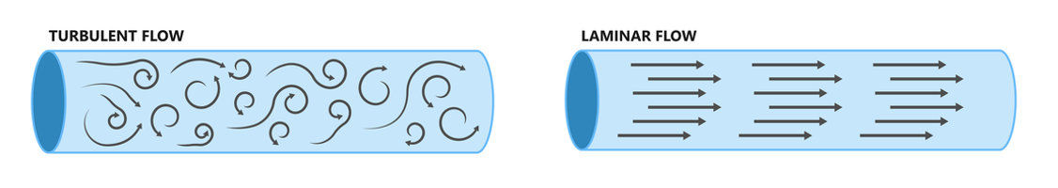
(Figure 1) (Toptec 2025)
This will affect:
- Lift generation efficiency.
- Amount of drag.
- Flow separation
- Loss of lift and cavitation.

Affects to lift and drag coefficients:
“The lift $C_{L}$ and drag $C_{D}$ coefficients of a hydrofoil are both the angle of attack and the Reynolds number.” (Abbott & von Doenhoff, 1959)
Low Reynolds number: The boundary layer may separate early which causes lower lift/higher drag.
High Reynolds number: Turbulent boundary layer attaches longer which causes higher lift/lower drag.

Scaling/model testing:

To test a hydrofoils design via a simulation, engineers use the Reynolds number to ensure there is similarity between model and full-scale operation. If the Reynolds number is not matched, the test data (lift/drag, stall angle) may not align to real world performance suggests (White, 2016).

Impacts cavitation onset:
(Brennen, 1995) states “At higher speeds/higher Reynolds number, pressure will drop on the ‘suction side’ causing cavitation.” The formation of vapor bubbles that damage the surface/reduce lift. Reynolds number will predict when/where cavitation begins.

Reynolds number influence: (Flow around hydrofoil)
Reynolds number influences hydrofoil flow behaviour as it governs the ratio of inertial to viscous forces acting on the fluid (White, 2011). It affects boundary layer development, separation, and momentum transfer, which in turn determine lift, drag, and overall stability (Anderson, 2017).

Reynolds number ratio:
$$Re=\frac{\text{Inertial Forces}}{\text{Viscous Forces}}$$
Reynolds number influences how the water flows around a hydrofoil by controlling: The boundary layer thickness and behaviour, the onset of separation/stall and the resulting lift and drag characteristics. (Mudgala, S. 2021)

Flow around the hydrofoil: Laminar/Turbulent

Laminar flow: (Low Re: less than 10⁵)
- The flow moves in smooth layers, with little mixing suggests (White, F.M. 2016)
- The boundary layer (thin region near the foil surface) stays orderly and thin.
Advantages: lower friction drag.
Disadvantages: Sensitive to surface imperfections and pressure gradients. Flow can separate, meaning early stall and lift loss.

Turbulent flow: (High Re: Greater than 10⁶)
- Boundary layer of small-scale vortices and mixing.
- Turbulence adding energy to the boundary layer/helping to stay attached to the foil longer during adverse pressure gradients suggests (White, F.M. 2016)
Advantages: Delayed flow separation/higher max lift/more stable flow.
Disadvantages: Higher friction drag.

Influence on boundary layer behaviour:
The Reynolds number also influences boundary-layer thickness, transition location, and separation point, with high Re producing thinner layers, earlier transition to turbulence and later separation (Schlichting & Gersten, 2017).
Thickness: High Re = thinner boundary layer.
Transition point: High Re, laminar flow changes to turbulent flow earlier.
Separation point: High Re delays separation and improves performance.
“For low-speed hydrofoils, the laminar boundary layer may separate early on the suction side, reducing lift, while high-speed hydrofoils benefit from turbulent boundary layers that remain attached longer, improving lift retention at higher angles of attack” (Hoerner, 1965).

Influence on lift and drag:
Designers balance laminar vs. turbulent flow depending on the expected operating Re range.

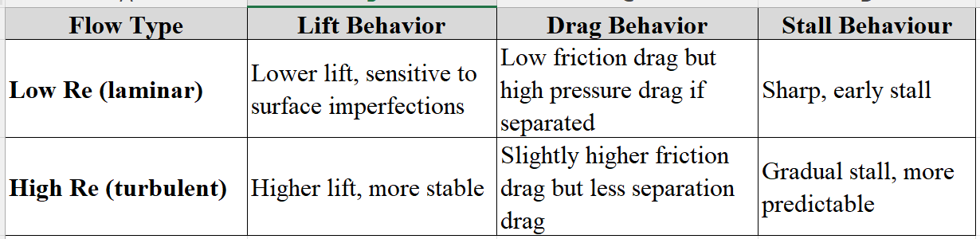

(Figure 2)

Examples:
- A surf foil at 3 m/s with chord 0.15 m
$Re=4.5×{10}^{5}$(mostly laminar).
- A boat hydrofoil at 10 m/s with chord 0.3m
$Re=3×{10}^{6}$(mostly turbulent).
Surf foils = smoother surfaces and more laminar-optimized profiles
Boat hydrofoils = turbulence/stability/stall resistance.

Estimate of Reynolds number of the fluid flowing around the wing:
- (A kiteboard hydrofoil at 5 m/s with chord 0.2m) $Re=4.5×{10}^{5}$(mostly laminar–transitional).
Kiteboards = laminar and have a smooth finish (Like a surf board)

Task 2:

Analysis of boundary flow around the hydrofoil:
The fluid right next to its surface of a hydrofoil when it glides through water is slowed by friction. Velocity changes from zero at the surface to the free-stream velocity a short distance away. (Delafin, Deniset & Astolfi, 2014) Outside the boundary layer pressure acts, imposed by the shape and angle of attack of the hydrofoil.
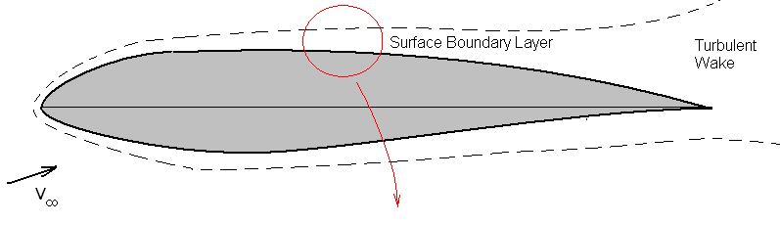
(Figure 3) (G. Nampelly 2019)
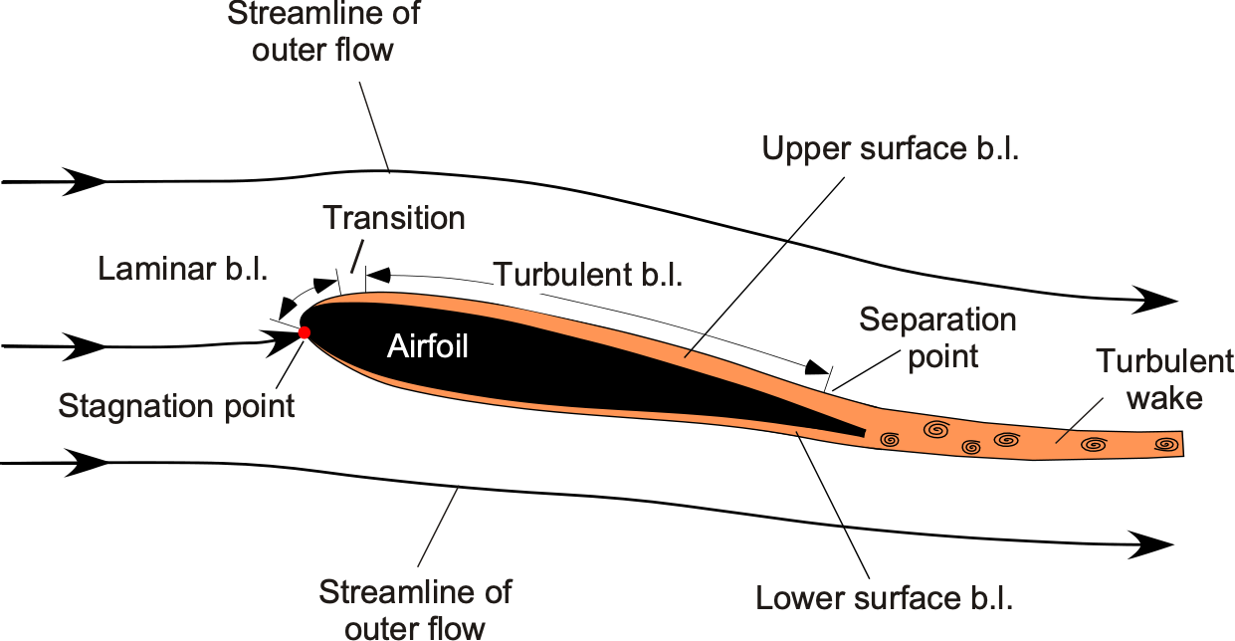
(Figure 4) (ERAU. 2025)

Types of boundary layers:
- Laminar (Smooth layers, little mixing), Low drag but separates easily.
- Turbulent (Disorderly, mixes), High drag and more separation.
When Reynolds number increases, boundary layer evolves from laminar to turbulent. Between: $Re=3×{10}^{5}$and $Re=1×{10}^{6}$ depending on shape and surface roughness suggests (Ceccio & Dowling, 2005).

Pressure distribution and boundary-layer behaviour:
Along the chord of a hydrofoil:
At the leading edge, flow accelerates/pressure drops/pressure decreases downstream/boundary layer thin and attached. “After the point of minimum pressure, flow decelerates/pressure increases downstream/Flow loses momentum.” (Redalyc, 2018). If the fluid particles in the boundary layer do not have enough momentum to move against this rising pressure, the flow reverses direction which equals separation.

Flow separation:
Flow separation occurs when:
$$\frac{dU}{dy}=0 \text{at the wall, and }U\text{ switches direction}$$
Creates a recirculation region behind the separation point.
Effects: Reduction/loss of lift, pressure drag increase, uneven flow/stall, turbulence downstream.

How turbulence influences separation:

A turbulent boundary layer/intense mixing, which will elevate high-momentum fluid from outside into the near wall region (Struzziero, G. 2019). This will energize the boundary and helps it resist the adverse pressure gradient, stay attached to the surface, delay separation. (smooth, more stable lift curve). (Eich, 2020)

Laminar flow = low drag/early separation.

Turbulent flow = Higher drag/maintains lift and stability.

Flow pattern around a hydrofoil:
Low speeds/Re:
- Laminar boundary layer takes over.
- Flow separates early on the suction side.
- Lift drops off at small angles of attack/stall.
High speeds/Re:
- Boundary layer changes to turbulence earlier.
- Layer remains attached longer.
- Lift increase/stalls gradually.

Why the foil has been designed like this:
“Hydrofoils are created the way they are to control the boundary layer and stop flow separation” (Zotti A, Burelli M and Giorgini A 2018). Flow separation causes loss of lift, drag, turbulence, and stall. Intended camber, thickness and curvature creates good pressure distribution. Smooth acceleration at the front and pressure recovery so the boundary layer keeps momentum to stay attached. (Zotti A, Burelli M and Giorgini A 2018) suggest hydrofoils use smooth surfaces to reduce drag and shapes that ensure the boundary layer becomes turbulent before strong adverse pressure gradients at higher Re numbers.
Hydrofoils are designed to: Keep the boundary layer energetic enough to avoid separation, maintain attached flow, delay stall, limit drag and ensure there is stable lift across all speeds.

Task 3:

Analysis of assumed Forces (500N Vertically per Side):
500N per side = Total lift = 1000 N.
Person (Average man UK) + Board + Foil = 84 kg × 9.81 = 824N
Lift changes due to speed/angle of attack:
$$L=\frac{1}{2}ρV^{2}SC_{L}$$
$L$= Lift force (Upward force generated by hydrofoil)
$\frac{1}{2}$= (constant of dynamic pressure in fluid flow)
$ρ$(rho) = Air/saltwater density approx. (kg/m³)
$V$= Velocity (m/s) (speed relative to the air/fluid) = 8
$S$= Wing area (m²) = 0.05m2
$C_{L}$= Coefficient of lift = 0.8
$$L=0.5×1000×8^{2}×0.05×0.8=1280N$$

Critical Appraisal:
The assumed 500 N per side is realistic for design purposes but simplifications include:
- Steady state flow assumption/ignores dynamic lift changes.
- No angle-of-attack variation.
- Assumes symmetric loading — real foils have asymmetry due to person differences and yaw.

Task 4:

Evaluation of implications in terms of performance of the hydrofoil:

Carbon fibre reinforced plastic (CFRP):
- “Fibres provide extremely high strength and stiffness.” (Ferreria, A. 2024)
- Polymer resin matrix binds the fibres/transfers load/resists corrosion states (Hearn, E. J. 1997).
CFRP is used in aerospace, automotive, and marine performance applications because of its exceptional strength-to-weight ratio. (Hearn, E. J. 1997)

Benefits for hydrofoils:

Weight reduction = lower drag and greater lift efficiency.
- Carbon fibre is lightweight/lighter than other materials like aluminium or steel.
- Weight reduction decreases the displacement of the kiteboard so induced drag and resistance drop.
- “The hydrofoil can reach its quicker speeds easier with improved acceleration and efficiency” (Zotti A, Burelli M and Giorgini A 2018).
High stiffness = better hydrodynamic stability:
- CFRP has high modulus of elasticity along the fibre direction. (Predictable performance) stated by (Ferreria, A. 2024)
- A CFRP hydrofoil resists bending or twisting under loads. (Lower vibration)
- High stiffness helps maintain angle of attack ensuring lift/drag stay consistent (Good handling/stability).

Corrosion resistance:
- CFRP is immune to corrosion from seawater, which is a major advantage for marine environments. (Long lifespan)
- Good fatigue resistance = less long-term degradation.

Disadvantages:

Cost/manufacturability:
- CFRP is more expensive than metals. Raw materials/Manufacture. (Hearn, E. J. 1997).
- Requires special lay-up/tooling processes.
- Repairs can be complex damaged (fibres are difficult to fix).

Anisotropy (directional strength)
- CFRP is anisotropic/its strength and stiffness depend on fibre orientation.
- Poor lay-up can lead to weakness in certain directions suggests (Jalili, S. 2021).
- Delamination can reduce structural integrity without warning signs.

Brittleness/impact damage:
- CFRP can fail suddenly, no warning signs/yield like metal.
- An underwater impact with debris can cause fracture/delamination.
- Detecting internal damage may require ultrasound or NDT techniques.

Thermal and manufacturing sensitivity:
- Mechanical properties depend on curing, fibre alignment and resin used.
- Differences in manufacture types can lead to inconsistent stiffness or tolerances.

Performance summary:
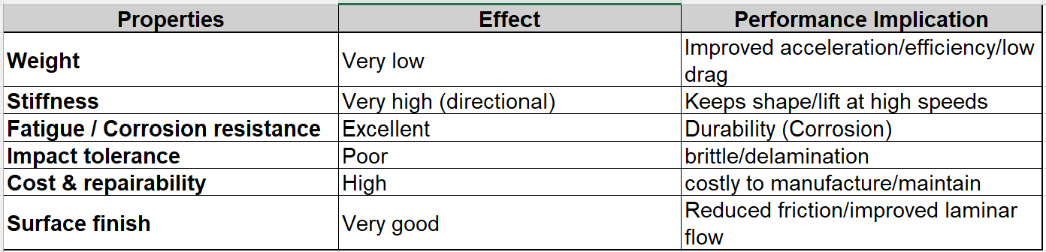

(Figure 5)

Carbon fibre kiteboard use conclusion:
Using carbon fibre reinforced plastic for a hydrofoil offers superior efficiency and structural stiffness, directly enhancing performance by reducing drag, maintaining foil geometry under load and increasing lift consistency and responsiveness.
However, it introduces engineering challenges consisting of high cost, brittleness under impact and complete manufacture/repair.
In high-performance applications (e.g. racing sailboats, foiling yachts, or advanced recreational foils), these trade-offs are justified suggests (Monti, M. 2022).
For commercial or recreational designs where cost and durability dominate, metallic alloys or hybrid composites might be more practical.

Historical Developments:

Materials:
The first hydrofoils (early 1900’s) were manufactured from steel/aluminium alloys. (Zotti A, Burelli M and Giorgini A 2018). They were riveted/welded with simple shaping.
Advantages: Strong, durable, repairable.
Disadvantages: Heavy, prone to corrosion/structural deformation.
Higher mass = early hydrofoils required more power/produced more drag to lift.
Metallic hydrofoils demonstrated the principle of lift on water but were limited in efficiency and maintenance due to weight/corrosion issues suggests (Newman, 2018)

Modern Developments:

Shift to composites:
A change to “composite materials (carbon fibre/glass fibre) from 1980s” (Zotti A, Burelli M and Giorgini A 2018).
Carbon fibre reinforced plastic (CFRP) became popular in all marine environments (kiteboards, yachts, surfboards).
High stiffness-to-weight ratio allowed for thinner foil sections with precise hydrodynamic advantages.
Low weight improved speed/efficiency.
Smooth surfaces encouraged laminar flow, reducing friction.

Examples:
- Modern boats/yachts: Carbon hydrofoils designed to lift in excess of 10 tonne.
- Motorised foiling craft/jetboards: CFRP used for high rigidity and minimal mass. (Zotti A, Burelli M and Giorgini A 2018).
- Competitive Watersports: windsurfers/rowing shells, Carbon masts and wings allow planing and lift in minimal wind.

Disadvantages:
- Expensive/brittle.
- Laminates to improve impact tolerance and reduce high cost.

Next Generation Hydrofoils:

Innovations:
Moving toward lighter/efficient composites:
Nano-reinforced composites
- Nanotubes/graphene to increase impact strength.
- Increased CFRP’s brittleness/maintaining stiffness.
Thermoplastic composites
- Recycling and reshaping, addressing the current sustainability issue of epoxy-based CFRP.
- Easy to repair compared to thermoset composites.
Adaptive materials
- Internal sensors for structural monitoring.
- Foils could dynamically adjust stiffness or camber for optimal hydrodynamic efficiency (Hoerner, S.F. 1965)
Additive manufacturing of composites:
- Complex internal structures for custom strength-to-weight ratios.
- Reduce waste.

Industry Standards & Regulations:
Standards for designing, testing, and certifying CFRP composite hydrofoils:
DNV ST-C501 - Composite Components – Load bearing composite structures must comply with recognised design standards. (DNV, 2021)
ISO 12215-5 - Small Craft/Hull Construction – Small craft hull scantlings are determined according to ISO 12215-5’s ply-level analysis rules. (ISO, 2019)
ASTM D3410 – In plane compression properties - Tensile performance of CFRP laminates is typically characterised using ASTM D3039. (ASTM International, 2023)
ASTM D3039 - Tensile properties of polymer matrix composites - (ASTM International, 2014)
ASTM D4762 - Guide for testing polymer matrix composites - Polymer composite testing across multiple modes follows the guidance of ASTM D4762 (ASTM International, 2016)
ISO 14127 - Resin/fibre/void content - (ISO, 1998)
BS 4994 - Design of reinforced-plastics vessels - Legacy FRP vessel design sometimes references the older BS 4994 standard (BSI, 1987)

Related to Hydrofoil Design:
Industry standards DNV-ST-C501 and ISO 12215-5 link to engineering, safety, and structural design rules for composite marine parts. Manufacturing hydrofoils, certifying or aligning to classification/regulatory regimes make these essential.
ASTM / ISO test standards give the test methods to characterize CFRP material tensile, compression, shear, fatigue specs, which is critical for design.

Task 5:

Modelling techniques used to simulate the fluid flow around hydrofoils:

Modelling purpose:
To predict and optimise the hydrodynamic performance and structural behaviour of a hydrofoil, engineers must simulate: (Barnard, R. H. 2009)
- The fluid flow field (velocity, pressure, turbulence, cavitation, etc.)
- The hydrodynamic forces (lift, drag, moments)
- The structural response (stresses, deformation, vibration)
- The interaction between flow and structure (fluid–structure interaction, or FSI)

Modelling the Fluid Flow:

Potential Flow / Boundary Element Methods (BEM)
Concept: Solve ‘Laplace’s equation’ for velocity potential assuming inviscid, incompressible, irrotational flow. (Barnard, R. H. 2009)
Use: Early design stages to estimate pressure distribution, lift and induced drag.
Tools: XFOIL, Athena Vortex Lattice, OpenVSP, or proprietary marine BEM codes.
Advantages:
- Fast computation for parametric studies including foil shape/angle of attack. (Dowling, D.R. 2003)
- Aids understanding pressure loading and lift trends.
Limitations:
- Neglects viscous effects (boundary layer, turbulence, separation).
- Cannot predict cavitation or stall.

Computational Fluid Dynamics: CFD & RANS
Reynolds Averaged Navier Stokes (RANS): “Most common engineering approach to simulate viscous, turbulent water flow around hydrofoils.” (Dowling, D.R. 2003)
Description:
- Solves the Navier Stokes equations for conservation of mass and momentum.
Outputs:
- Pressure/velocity fields.
- Lift, drag, and moment coefficients.
- Flow separation, vortex formation, and wake characteristics.
Advantages:
- Accurately predicts viscous effects, pressure distribution, and cavitation inception. (Astolfi, J.A. 2014)
- Suitable for validation against experimental or sea-trial data.
Limitations:
- Computationally intensive.
- Accuracy depends on mesh quality, turbulence model, and boundary conditions.

Large Eddy Simulation (LES) & Detached Eddy Simulation (DES):
Purpose: High-fidelity, unsteady turbulence and wake modelling.
Features:
- Resolves large-scale turbulent structures, while smaller eddies are modelled. (Astolfi, J.A. 2014)
- Ideal for analysing unsteady vortex shedding, stall, and cavitation collapse.
Advantages:
- Captures time-dependent pressure fluctuations and flow separation.
- Provides detailed insight into dynamic loads and potential fatigue effects.

Limitations:
- High computational cost mainly used for research or final-stage validation
Example: “Used in America’s Cup and naval CFD studies to investigate foil vortex interactions.” (Giorgini. A 2018)

Free-Surface & Cavitation Modelling:
Hydrofoils operate near or below the water surface: Free surface effects and cavitation can be critical. (Giorgini. A 2018)
- Volume of Fluid methods simulate water/air interfaces.
- Cavitation models predict vapor bubble formation when pressure falls below vapour pressure.
Relevance: Predicts loss of lift and potential cavitation erosion.

Modelling the Structural Response:

Finite Element Analysis (FEA)
Purpose: Determine stresses, strains, and deflections due to loads.
Process: CFD pressure distributions as surface loads on a solid or shell element model of the hydrofoil. (Gupta V 2018)

Material Considerations: CFRP Hydrofoil
Must model anisotropic material properties and requires laminate definition, ply angles, stacking sequence, fibre volume fraction.
Outputs: Stress/strain distribution, bending/torsional stiffness, vibration analysis to avoid flutter. (Gupta V 2018)

Validation Techniques: Results must be validated against experimental or empirical data.
Towing tank tests: Lift/drag vs. angle of attack.
Cavitation tunnel tests: Cavitation inception and erosion mapping.
Particle Image Velocimetry: Flow visualization and velocity field validation.
Strain gauges/fibre optic sensors: Compare with FEA stress data.

Estimated Forces on the Wing:
$$L=\frac{1}{2}ρV^{2}AC_{L}$$
ρ water (Approx) = 1000 kg/m³
V = 10 m/s Approx foiling speed
A = Area of average front wing approx (0.05m²)
$C_{L}$= 0.8 for hydrofoil

$$V^{2}={10}^{2}=100\text{ m²/s²}$$
$$\frac{1}{2}ρ=0.5×1000=500$$
$$500×100=50,000$$
$$50,000×0.05=2,500 \\ 2,500×0.8=2,000 \\ L=2,000\text{ N}$$
Hydrofoil generates about 2000N of lift, supporting 200 kg in water.
Drag force typically 5 to 12% of lift, 100 to 250N drag.

Task 6:

Prototype Testing:
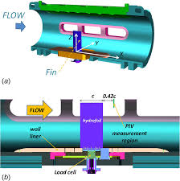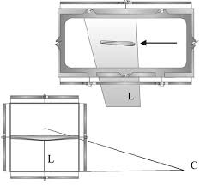
(Figure 6) (Mallah S.R 2021) (Figure 7) (Ristic, S. 2007)
The Experiment: Validate hydrofoil’s performance/fluid flow characteristics found in simulations. This involves measuring forces, flow patterns, and lift/drag generated by hydrofoil.

Setup: Water Tunnel
- Smaller scale hydrofoil in water tunnel. Tunnel should provide uniform flow velocity and adjustable flow rates to simulate different surfing speeds.
Instrumentation:
- Mount hydrofoil on load cell to measure lift, drag, and side forces.
- Ensure the hydrofoil is aligned correctly with the flow to replicate realistic angles of attack.
Flow Visualization Techniques:
- Dye injection to visualize streamlines around the hydrofoil.
- Particle Image Velocimetry: Measurements of velocity fields and turbulence patterns.
- Cameras can capture flow separation.

Data capture:
Measure: Lift and drag forces, flow velocity/turbulence around the hydrofoil, pressure distribution on the hydrofoil surface.
Record environmental parameters like water temperature/viscosity for accurate Reynolds number calculations.

Comparison: Validation/Discrepancy Analysis.
- Compare experimental lift/drag/moment coefficients with CFD predictions from Task 4.
- Compare flow separation/turbulence patterns observed in experiments with CFD velocity.
- Differences arise due to scaling/roughness/turbulence models used in simulation.
- Quantify errors and discuss potential causes.

Considerations:
Scaling: Using scaled models apply Reynolds number to ensure fluid behavior is representative of full size hydrofoil.
Boundary Effects: Ensure walls of water tunnel don’t interfere with flow patterns around hydrofoil.
Safety and Practicality: Secure hydrofoil/sensors to avoid damage to equipment or inaccurate readings.

References
Altair. (2025). Altair: Practical Aspects of Finite Element Analysis.
Altair. (2025). Altair: Practical Aspects of Structural Optimization with Altair OptiStruct.
ARIKAN, V. (2025). Bridging experiment and simulation: Image processing-driven FEA of carbon fiber powder reinforced LDPE. Materials Today Communications.
Barnard, R. H. (2009). Road vehicle aerodynamic design : an introduction. St Albans: MechAero.
Ferreria, A. (2024). Optimization of Structures and Composite Materials: A Brief Review. Optimization of Structures and Composite Materials, 2-20.
Gu, X. (2025). Influence of matrix plastic properties on compressive strength of carbon fiber composites: A combined FEA and experimental study. Composites Part A: Applied Science and Manufacturing.
Hearn, E. J. (1997). Mechanics of materials. Oxford: Butterworth-Heinemann.
Hearn, E. J. (1997). Mechanics of materials 2. Boston: Butterworth-Heinemann.
Jalili, S. (2021). Performance assessment of meta-heuristics for composite layup. Performance assessment of meta-heuristics for composite layup, 1-24.
Koppunur, R. (2025). Topology optimization and manufacturing of maxillofacial patient specific implant using FEA and AM. Bioprinting.
Kumar, S. (2025). Thermogravimetric investigation and FEA study on mechanical properties of Grewia optiva/Basalt fiber reinforced hybrid polyester composites. Journal of the Indian Chemical Society.
Liu, W. K. (2022). Eighty Years of the Finite Element Method: Birth, Evolution, and Future. Boston: Northwestern University.
Mac Donald, B. J. (2020). Practical stress analysis with finite elements. Dublin, Ireland: Machdohnil Ltd.
MDPI. (2023). Application of the Finite Element Method in the Analysis of Composite Materials: A Review. Application of the Finite Element Method in the Analysis of Composite Materials: A Review, 1-31.
Monti, M. (2022). Design, manufacturing and FEA prediction of the mechanical behavior of a hybrid-molded polycarbonate / continuous carbon fiber reinforced composite component. Composites Part B: Engineering.
Mudgala, S. (2021). A comparative dynamic analysis of rotor involving three engineering materials applying finite element analysis (FEA) simulation. In S. Mudgala, Materials Today (pp. 4003-4014). Karnataka, India: Department of Mechanical Engineering.
Struzziero, G. (2019). Numerical optimisation of thermoset composites manufacturing processes: A review. Numerical optimisation of thermoset composites manufacturing processes: A review, 1-18.
Versteeg, H. K. (2007). An introduction to computational fluid dynamics : the finite volume method. Harlow: Pearson Prentice Hall.
Wu, T. (2023). Electromechanical behavior and damage index system of 3D carbon fiber angle-interlock woven composites with FEA and data processing tools. Composites Science and Technology.
Yan, X. (2024). A combined FEA and CFD method to predict aero-thermal performance degradation in worn squealer tip region. Progress in Engineering Science.
Yilmazçoban, I. K. (2011). Mechanical test simulations using FEA of sheep tibia verified by the engineering data of the biomechanical tests. In M. Dundar, Current Opinion in Biotechnology (p. 551). Sakarya, Turkey: Sakarya University.
Ashby M (2017) Materials Selection in Mechanical Design, 5th edn. Butterworth-Heinemann.
Chandrupatla T R and Belegundu A D (2012) Introduction to Finite Elements in Engineering, 4th edn. Prentice Hall.
Chen L, Zhang Y and Liu P (2022) ‘Machine learning for composite laminate optimisation’, Composite Structures, 283, 115138.
Daniel I M and Ishai O (2006) Engineering Mechanics of Composite Materials, 2nd edn. Oxford University Press.
Hoerner S F (1965) Fluid-Dynamic Lift. Hoerner Fluid Dynamics.
ISO 12215-5 (2019) Small craft – Hull construction and scantlings – Part 5: Design stresses. ISO.
Kumar S, Singh P and Gupta V (2018) ‘Topology and laminate optimisation in composite structures using FEA’, Composite Structures, 184, 280–291.
Zotti A, Burelli M and Giorgini A (2018) ‘Composite design of marine hydrofoils’, Composite Structures, 202, 783–792.
Abbott, I.H. & von Doenhoff, A.E. (1959) Theory of Wing Sections. New York: Dover Publications.
Anderson, J.D. (2011) Fundamentals of Aerodynamics. 5th edn. New York: McGraw-Hill.
Brennen, C.E. (1995) Cavitation and Bubble Dynamics. New York: Oxford University Press.
White, F.M. (2016) Fluid Mechanics. 8th edn. New York: McGraw-Hill.
Schlichting, H. and Gersten, K. (2017) Boundary-Layer Theory. 9th ed. Berlin: Springer.
Bourgoyne, D.A, Hamel, J.M, Ceccio, S.L. and Dowling, D.R. (2003) ‘Time-averaged flow over a hydrofoil at high Reynolds number’, Journal of Fluid Mechanics, 496, pp. 365–404. Cambridge University Press & Assessment.
Delafin, P.L. Deniset, F. and Astolfi, J.A. (2014) ‘Effect of the laminar separation bubble induced transition on the hydrodynamic performance of a hydrofoil’, European Journal of Mechanics
Redalyc (2018) Laminar separation bubbles on the transitional flow around airfoils’, Revista Mexicana de Ingeniería Aeronáutica.
Eich, F., 2020. Large-scale coherent motions in turbulent boundary layers under an adverse pressure gradient. International Journal of Heat and Fluid Flow.
Newman, J.N. (2018) Marine hydrodynamics, 2nd edn. Cambridge: MIT Press.
Toptec (2025) Laminar flow vs turbulent flow. Available at: https://toptec.pk/laminar-flow-vs-turbulent-flow/ (Accessed: 18 November 2025).
Mallah, S.R., Padinjattayil, P., Sharma, A. & Agrawal, A., 2021. Effect of superhydrophobicity on the wake of a pitching foil across various Strouhal numbers. Physics of Fluids.
Ristic, S., 2007. Flow Visualisation Techniques in Wind Tunnels – Part I: Non-optical Methods. Scientific Technical Review, pp.39–49.
Nampelly, G (2019) Effect of Surface Blowing on Aerodynamic Characteristics of Tubercled Straight Wing, ResearchGate. Figure 1. Schematic of velocity profile over an airfoil with and without blowing.
ERAU (Embry-Riddle Aeronautical University) 2025 Boundary Layer Flows, in Introduction to Aerospace Flight Vehicles. Chapter on boundary layers, Figure illustrating laminar and turbulent boundary layers over an airfoil.

