CHANGEMAKER: BUILDING YOUR PERSONAL BRAND FOR SUSTAINABLE EMPLOYMENT
(BMPH 5015)
EPORTFOLIO; CV AND COVER LETTER

OMENEKE YUSUF (2009232)
KENNEDY OBOHWEMU(LECTURER)
The Manager, Omeneke Yusuf
Fine Futures Longford Road,
Leamington spa Coventry.
Warwickshire, 22 Oct,2022
Sir/Ma,
Re: Application for the post of Health Care Team Leader.
I came across your advertisement for the position of Team support worker on the website Indeed, and as a result, wish to apply chosen to send your organization my cv for consideration for the position. In 2004, I completed the necessary coursework to become a Registered Nurse/Midwife. Since then, I've worked as a Staff/midwife in a variety of Nigerian hospitals, including those with obstetrics, surgery, and medicine.
In 2011, I spent approximately a year studying the Dutch language at the basic level and acquired a level 2 in speaking, writing, and listening; this has allowed me to adapt effectively to a new culture and learn new ways of doing things. I also got into the European school of physiotherapy in Amsterdam after finishing my language curse, I stay there for a year before moving to the UK with my family in 2014. I worked with a health care agency helping persons with autism and learning difficulties at cygnet mental health facility.
Working as a support worker is difficult but gratifying because it allows me to help others attain the highest level of independence possible by allowing them to participate in the things they would like to do if they had the required will and strength to do it on their own. I can work well alone as well as with the care team to facilitate the service user's ability to use a walking aid and transfer aids.
Despite the challenges of working in a crowded psychiatric hospital and care homes, the job was rewarding. Patients reported feeling well cared for and listened to, this has equally improved my interpersonal skills, the ability to diffuse conflict and working well under pressure.
Being initiative-taking and thoughtful helped me stand out among my co-workers, this has contributed to the development of my people skills. I am trained in risk assessments and restraints using PMVA (a conflict management technique used to "break away" from patients or carry out physical restraints). Team leaders of the mental health institutions I have worked often assign responsibilities including one-on-one patient observations to me, which I felt has Improved my self-confidence.
To satisfy my need for additional knowledge and relevance in the field of healthcare, I enrolled in the University of Wales Trinity Saint David's level four certificate of higher learning skills for the workplace programme in 2020 and completed it in 2021. I am currently enrolled in the BSc health and social care programme; my educational goal at the moment is to complete my Bachelor of Science in Health and Social Care degree by May of 2024.
Having the chance to learn from the wonderful individuals I have had the honour and privilege of helping in the course of my duties is one of the many reasons I value my profession so much. My experience and qualifications make me a good fit for this role.
I am looking forward to working with your organisation as I will be able to meet new people, assist them in reaching their personal and health goals, and improve my abilities to protect the most vulnerable among us while also expanding my knowledge of Makaton sign language.
Please find a copy of my CV attached below.
Warm Regard,
Omeneke Yusuf

 | 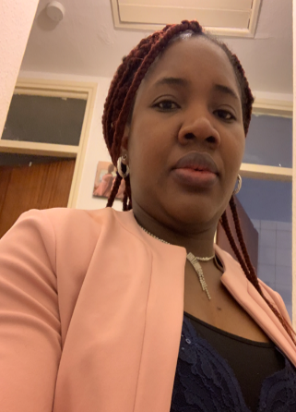 |  | CURRICULUM VITAE  OMENEKE YUSUF  - 111 Longford Road  - Coventry
PROFILE  - Worked effectively both alone and with the care team to promote the service user's capacity.  - Effective communication abilities with the People  - Having a self-driven attitude yet also being considerate  - My ability to handle risks and tasks well enables me to de-escalate violent situations.  - Perform admirably in adverse conditions.  - Pleasant, patient, and demonstrating sympathy  - Good sense of humours and listening abilities  - Adaptability in the face of changing circumstances  - capable of negotiation and communicate effectively to defuse confrontational situations.  - Ability to think creatively and critically in order to think beyond the box.  Contact  - PHONE:  - 07448057467  - WEBSITE:  - EMAIL:  - 2009232@student.uwtsd.ac.uk  Hobbies  - Social networking  - Group walking  - Cooking  - Knitting  - Cycling  Language and Interest  - English (good)  - Nederlands (Basic)  - Ebira (Excellent) |  |  | EDUCATION  University of Wales Trinity Saint David (UWTSD)  BSC HEALTH AND SOCIAL CARE  May,2022 till Date.  University of Wales Trinity Saint David (UWTSD)  Certificate Of Higher Learning; Skills for The Workplace level 4  sept,2020 – Sept,2021.  School of midwifery Grimard catholic Hospital Anyigba, Nigeria: 03/2003 – 03/2004  Registered Midwife (R.M) :11/03/2004  Kogi state school of Nursing Obangede, Nigeria  10/1999 – 11/2002  Registered nurse (R.N.) Diploma: 20/02/2003  Certificate for Senior secondary School Exams 09/1991 – 07/1997  WORK EXPERIENCE  Turning Point UK (02/03/20 – present)  Healthcare Assistant  (Personal care and dressing, Feeding, and cooking support,  1:1 observation and safety. Mobility Aids and transfers,  resident activities and Escorts.  Cygnet Hospital Coventry  (02/2019 - 12/2020)  Mental Health Support Worker  Responsibilities:  • Enhance observations and Recording.  •Emotional support  •Assistance with NG Feeding.  • One-on-one observation and safety.  • PMVA restraints, escorted leave, and writing reports.  St. Catherine Church Stoke Aldermoor, Coventry (2018 to 2022).  Volunteering to help with safeguarding, recruitment, and PCC meetings.  Care UK (May 2015 to Oct 2018.  Healthcare Assistant  Responsibilities  • Assistance with eating and dressing ; • Taking care of their personal hygiene, bathing, and pressure sores Prevention; • Transfers from bed to chair and chair to bed; • Providing general help with mobility and transfer aids. Stoma and catheter care.  Garki Hospital Abuja Nigeria (06/2011 - 12/2011)  Nurse/ midwife  Responsibilities  • Giving injections and medications, admitting and discharging patients, caring for patients before and after surgery; during and after pregnancy, writing reports, caring for wounds, giving oral care and bed baths, caring for new-borns.  Kogi State general hospital (12/2005 - 04/2009)  Staff Nurse/midwife  Responsibilities  • Giving injections and medications, admitting, and discharging patients, caring for patients before and after surgery. Ante natal clinics and Immunizations, writing reports, caring for wounds, Oral care, and giving bed baths. Home visits.  • Help with giving birth and taking care of pregnant women in general.  Motayo hospital, Ikeja, Nigeria (July 2005 to December 2005).  Staff Nurse/Midwife  Responsibilities: injections Administration and medications, Pre and post Operative Care, Pre and Post Natal Care, writing Reports Writing, Neonatal care and observations, Wounds Care, Oral care, and bed bath.  TRAINING AND CLASSES  • Health and safety at work • Moving and handling • First aid • Food hygiene • Infection control •Adults and children• Dementia awareness  Mental health and Autism Awareness • Safety of information  Nederland: Inburgering cursus Agens Amsterdam: 01/2012 – 12/2012 (Nederland speaking, Writing, Listening and Reading) Diploma 12/2012  REFREES  References are available if needed.

PITCH: SENIORS AND AGING – OSTEOPOROSIS
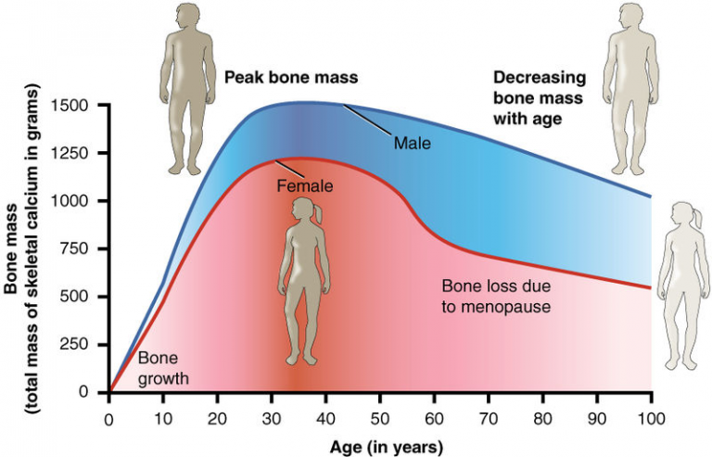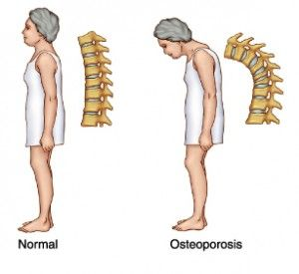
This Photo by Unknown Author is licensed under CC BY-NC-ND
This Photo by Unknown Author is licensed under CC BY-NC-ND
The disease known as osteoporosis, which weakens the bones and primarily affects women but can also have an impact on males, is the subject of my Pitch. Osteoporosis is a disease that progressively worsens over time, and most people do not notice they have it until they have a bone fracture for the first time. By discussing it freely on the BBC one television network, we can raise awareness about this Health issues and take preventative measures . Osteoporosis weakens your bones, make them more fragile and prone to break; It is something that happens gradually over the course of years, and the only way to diagnose it is if a bone breaks (NHS, 2019).

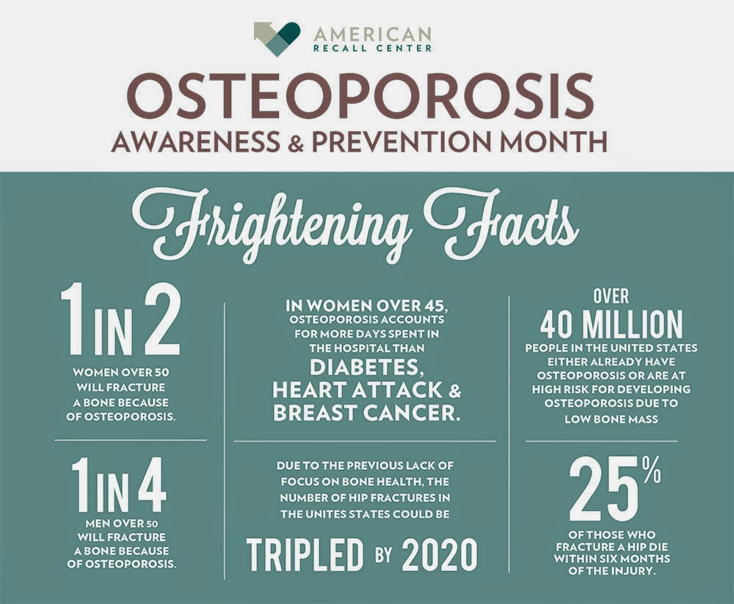

The target population is the over fifties since the incidence of Osteoporosis is highest among the elderly. Fragility fractures are a typical complication of osteoporosis, characterised by a general reduction in bone mass and microarchitecture and can affect people of any age, (Kirkham-Wilson And Dennison, n.d.), (Lippuner, 2012). The medical and social impact of osteoporosis, in especially postmenopausal osteoporosis, is expected to rise even more as the population in general continues to age, (Rachner, Khosla and Hofbauer, 2011). Although osteoporosis may be found in persons of various ages, genders, and ethnicities, the Caucasian (white race), elderly, and female populations are the most likely to be affected by it,(Sozen, Ozisik and Calik Basaran, 2017)
EPISODE 2; 13 OCT 2022 AT 20:10 TO 20:30
CAUSES AND SYMTOMS
- Has experienced a fractured bone after the age of fifty. Has had surgery to remove their ovaries before their cycles ceased.
- Has experienced early menopause.
- Has not obtained enough calcium and/or vitamin D throughout their life.
- lack of consistency in physical activity frequent heavy alcohol consumption and smoking
- Has been bedridden for a lengthy period.
- Smoke (smokers may absorb less calcium from their diets)
- Take certain medications, such as those for arthritis, asthma, and some cancer treatments.
- Frequently used certain medications
- possessing a slim body frame, (National Institute on Aging (2017).

EPISODE 4 ;27 OCT 2022 AT 20:10 TO 20:30
TREATMENT AND CURRENT THERAPIES AND PREVENTION
It is outrageous that so many at high risk of fracture do not receive proper care, especially hip fractures, (Kanis et al., 2014).
- Osteoporosis is treated using bone-building drugs.
- Physical Activities
- Vitamin D and Calcium supplements
- Balance diet and calcium rich diet
- Antiresorptive treatments helps reduces bone reabsorption
- Anabolic drugs will help in bone formation. (NHS, 2019; theros.org.uk, 2022)
EPISODE 1; 06 OCT. 2022 AT 20:10 TO 20:30
INCIDENCE OF OSTEOPOROSIS
In 2018, the International Osteoporosis Foundation (IOF) reported that sixteen million women and four million men in France, Germany, Italy, Spain, Sweden, and the UK have osteoporosis,( Borgström,et.al)
- Musculoskeletal conditions affect about 1.71 billion people around the world (WHO, 2021)
- One in three women over fifty and one in five men may develop osteoporotic fractures in their life. (Sozen, Ozisik and Calik Basaran, 2017)), This may be because men have high bone density and losses it slowly.
- The medical and social impact of osteoporosis, in especially postmenopausal osteoporosis, is expected to rise even more as the population in general continues to age. (Rachner, Khosla and Hofbauer, 2011).
- Genes affect skeletal size and strength. If a parent fractured their hip, you may likely to do so, too.
- From late thirties, bone tissue decreases normally.

EPISODE 3; 20 OCT 2022 AT 20:10 TO 20:30
LIVING WITH OSTEOPOROSIS
- Remove any potential dangers from your house and be sure to get your eyes and ears checked regularly.
- You might attempt the following methods to speed up your recovery after suffering a fracture
- Painkillers
- therapies involving hot and cold temperatures, such as hot baths and cold packs
- Various methods of pain relief, include relaxation techniques for pain relief
- Prevent fall of the elderly people
- Strength exercise to improve muscles strength
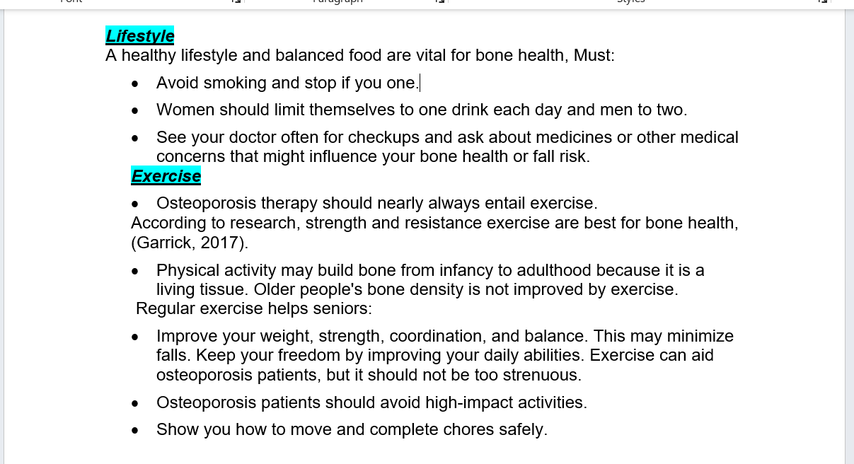

BBC ONE
As the world day for Osteoporosis is celebrated on the 20th of October, I will like to use the opportunity to conscientize the public by creating awareness for this silent killer disease on your popular network. Four slots for my Series on osteoporosis is required for airing this program at 20:10 to 20:30 for 20 minutes after the East Ender on BBC . The four episodes will be throwing light on the Incidence of Osteoporosis, causes and symptoms, treatment, prevention and lifestyle changes. This will give opportunity to more people to be educated on Osteoporosis which has devastating effect on the elderly but mostly overlooked and not spoken about enough for bone health to be taken seriously. The BBC 1 network was selected since it is one of the oldest TV stations in the United Kingdom and is also a popular channel that many people loved to watch. The time slot will best suit my series because EastEnders is a popular drama series watched by a lot of people since 1985, particularly women. The two invited guest speakers who will be talking to the general public and share their knowledge on the 20th of October; World Osteoporosis Day are The president and the director of clinical Services of the Osteoporosis Society


This Photo by Unknown Author is licensed under CC BY-NC

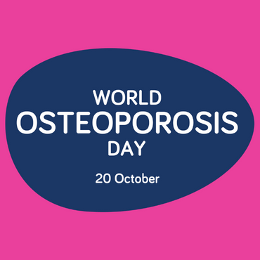(Theros.org.uk, 2019).
The world osteoporosis day is celebrated on 20th October, and it is vital to create more awareness on this pressing issue,( Theros.org.uk, 2019).Our bones supports us in movements, posture and stability. since we all have bones, knowledge of the factors that put us at risk of osteoporosis and fractured bones is very Important, this may determine if anything can be done to reduce those risks. Even after receiving a diagnosis, keep in mind that it is never too late to begin doing something for the health of your bones.

GUEST SPEAKERS FOR THE DAY
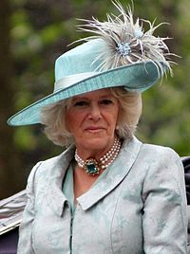PRESIDENT ROYAL OSTEOPOROSIS SOCIETY – Her Majesty Queen Camilla, became president of the Royal Osteoporosis Society in 2001. This was a prize for her osteoporosis efforts and charitable assistance. When her mother died of osteoporosis in 1994, Her Majesty began aiding the foundation. She will be talking about Living with Osteoporosis in the third Episode as a person whose family members has experienced this condition.
This Photo by Unknown Author is licensed under CC BY-SA
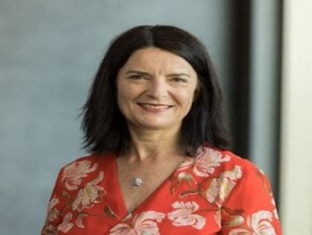DIRECTOR OF CLINICAL SERVICES OF THE ROYAL OSTEOPOROSIS SOCIETY- Lauren Wiggen. Our second guest Speaker for the day on this who will enlighten the people on healthy lifestyle and Exercise. Lauren manages teams that provide patient and general information and assistance, trains healthcare staff and education, and medical research. She leads the Osteoporosis and Bone Health Academy.

CONTACTS: seniorsaging@osteoporosis.co.uk
08045660114

REFERENCE
Borgström, et.al. (2020). Fragility fractures in Europe: burden, management, and opportunities. Archives of Osteoporosis, 15(1). doi:10.1007/s11657-020-0706-y.
Garrick, N. (2017). Osteoporosis. [online] National Institute of Arthritis and Musculoskeletal and Skin Diseases. Available at: https://www.niams.nih.gov/health-topics/osteoporosis/diagnosis-treatment-and-steps-to-take [Accessed 2 Nov. 2022].
Javaid, M.K., Harvey, N.C., McCloskey, E.V., Kanis, J.A. and Cooper, C. (2022). Assessment and management of imminent fracture risk in the setting of the fracture liaison service. Osteoporosis International. doi:10.1007/s00198-021-06284-9.
Kanis, J.A., Svedbom, A., Harvey, N. and McCloskey, E.V. (2014). The Osteoporosis Treatment Gap. Journal of Bone and Mineral Research, [online] 29(9), pp.1926–1928. doi:10.1002/jbmr.2301.
Kirkham-Wilson, F. And Dennison, E. (n.d.). Royal Osteoporosis Society | Epidemiology of Osteoporotic Fracture: an overview. [online] theros.org.uk. Available at: https://theros.org.uk/healthcare-professionals/epidemiology-of-osteoporotic-fracture-an-overview/ [Accessed 1 Nov. 2022].
Kreiger, N., Bentvelsen, K. and Tenenhouse, A. (1997). The Epidemiology of Osteoporotic Fracture. Journal SOGC, 19(10), pp.1059–1074. doi:10.1016/s0849-5831(97)80042-0.
Lippuner, K. (2012). The future of osteoporosis treatment - a research update. Swiss medical weekly, [online] 142, p.w13624. doi:10.4414/smw.2012.13624.
National Institute on Aging (2017). Osteoporosis. [online] National Institute on Aging. Available at: https://www.nia.nih.gov/health/osteoporosis [Accessed 30 Oct. 2022].
NHS (2019). Osteoporosis. [online] NHS. Available at: https://www.nhs.uk/conditions/osteoporosis/ [Accessed 31 Oct. 2022].
Rachner, T.D., Khosla, S. and Hofbauer, L.C. (2011). Osteoporosis: now and the future. The Lancet, [online] 377(9773), pp.1276–1287. doi:10.1016/s0140-6736(10)62349-5.
Sozen, T., Ozisik, L. and Calik Basaran, N. (2017). An overview and management of osteoporosis. European Journal of Rheumatology, [online] 4(1), pp.46–56. doi:10.5152/eurjrheum.2016.048.
Theros.org.uk. (2022). Osteoporosis causes - Osteoporosis risk factors | ROS. [online] Available at: https://theros.org.uk/information-and-support/osteoporosis/causes/ [Accessed 29 Oct. 2022].
WHO (2021). Musculoskeletal conditions. [online] Who.int. Available at: https://www.who.int/news-room/fact-sheets/detail/musculoskeletal-conditions [Accessed 31 Oct. 2022].

