

Programme: BSc Health and Social Care

student name: Reza Foroozan

STUDENT NUMBER: 2411283
MODULE NAME: Changemakers: Building your Personal Brand for Sustainable Employment
MODULE CODE: BMHP5015
Assignment Title: Component 1:
Online Portfolio of Set Exercises
From Task 1 to Task 7
INTERNAL VERIFIER: Dr Eleni Koutsogeorgou-Andreou
LECTURER NAME: Olufemi Oluranti

This Portfolio is going to explain “Sustainable Employment”, Seven tasks of “Personal Brand”, “Network Map and Rationale”,“The Importance of Healthy Ageing in the UK”, Equality, Diversity, and Inclusion Improvement Plan”, “develop a Letter to the author”, “Create a GANTT Chart (Start Date: 10 July 2026; End Date: 31 March 2027) in order to log progress toward the objectives” and offers an insight into “Falls Prevention Program – Report on Making Changes” through a fictional incident. Furthermore, it is going to make inference within a conclusion section, to complete the task.

Introduction
What is “Sustainable Employment”
According to Citaristi (2022) state Sustainable Employment means having a job that can be maintained over time, providing good living conditions, decent work, fair wages, and adequate opportunities for all.
Analysis
Based on this definition from the International Labor Organization, I understood that sustainable employment is not just a job, but a comprehensive, long-term situation that allows everyone to have a decent life, fair working conditions, and equal opportunities.
According to the findings of Ghaltakhchyan (2025) building a personal brand allows individuals to stand out in a competitive environment, earn trust, and establish a unique professional position.
The Role of Personal Branding in My Workplace Performance
“Personal Brand” is a method of how I project myself in the workplace through exhibiting my professionalism to perform inter-mutually beneficial in my workplace. It will help me to meet the objectives of my career and enables my employer to reach its objectives as well. It reflects what I can perform to help me in, how I act, and what sort of reputation I have at work.
Task 1: Personal Brand
I see my personal brand as being inter-dependable, organised and wanting to always learn. I like problem solving, meeting deadlines, and teamwork. My research, analytical and time management skills have refined through my academic studies, and group projects have increased my teamwork skills. I consider these traits to be essential for being trustworthy and responsible. However, “I do realise that I need to work on my communication and networking skills” to make me more confident in the work environment. I also want to get more practical experience, both in internships and professional development courses. Further developing my online professional profile and more industry knowledge will continue to enhance my own brand. These improvements will enable me to demonstrate my ability in a more effective way and will help to boost my employability in a competitive job market.
Analysis
In conclusion, personal branding is an on-going process that will help me advance my career. My communication skills will become better, I will have experience of and will develop the field, and I will be better prepared to reach my employment objectives so that I can have a successful career.

Task 2: Network Map and Rationale
Part 1: My Network Map

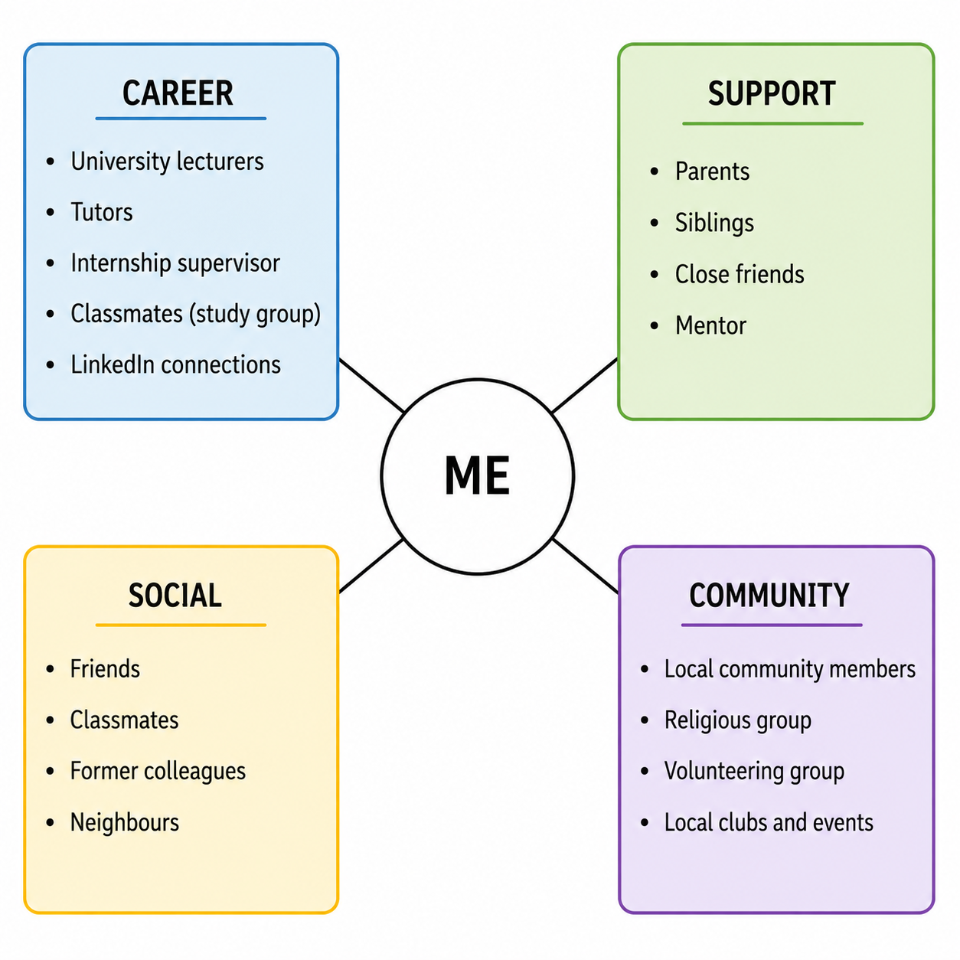
Figure 1: My Network Map – Hybrid Network

Part 2: Rationale

From my perspective I have a hybrid network. I have a mix of family- friends and University contacts. I also have relevant contacts that are employed via LinkedIn and my lecturers. This network helps me with my studies and career planning and provides emotional support. As reported by Schlinger (2022) networking can be done in a variety of ways, such as attending conferences and social events, participating in virtual meetings through social media such as LinkedIn and Facebook.
As outlined by Ben-Hador et al. (2021) social capital refers to the benefits that people gain through their social connections and networks.
My network has high bonding social capital: I have close ties with my family/close friends. They motivate me and support me when I am having difficulties. But, in terms of my bridging social capital, I do not know many individuals from other industries and backgrounds. Additionally, my “linking social capital” is minimal as I lack numerous networks with managers, organizations, and industry leaders to assist me in locating career opportunities.
I would like to attend career expos, professional organizations and get more involved in LinkedIn to enhance my network. I would also like to be involved in volunteering and University activities. These will help me to connect with others and learn from experts. This will help me to become more knowledgeable, confident, and have more options for employment as I expand my network and increase the diversity of it. It will also assist me in the acquisition of new skills and establish my professional relationships for the future career development.

Task 3: Blog - The Importance of Healthy Ageing in the UK
Introduction
The number of older people in the UK is increasing every year. Many senior citizens want to maintain their independence for as long as they can. The importance of healthy ageing is so people can remain active, safe, and connected with communities. Families and carers have also a key function regarding supporting older adults.

Main Body
The healthy ageing process involves caring for physical, mental, and social health. Taking regular exercise, eating healthily, and having regular health checks can help lower people's risk of getting ill. Remaining active can also help you to feel more balanced and less likely to fall, as many elderly people do (NHS, 2024).
Many elderly people also suffer from loneliness. Living alone can make you feel lonely, which can have a negative impact on both mental and physical well-being. Families, friends, and local groups can provide regular visits, social interaction, and check-ins on older family members. A phone call or brief visit can go a long way.
There is also a significant contribution from health and social care services. GPs, nurses, social workers, and carers are all involved in support and play a key role in helping older people to be independent. Community services, home care, and local support groups can enhance quality of life and decrease hospitalizations.
An early intervention is usually better than waiting until health issues are severe (Age UK, 2024).
Analysis
In my view, healthy ageing is a comprehensive approach that enables individuals to improve their quality of life by accessing affordable medical care, healthy nutrition, physical activity, senior support services, a positive mindset, good mental health, adequate housing, lifelong learning, a sense of purpose, and physical and financial security, along with planning for the future,

Image
Figure 2 shows healthy ageing process describing key steps for maintaining physical, mental, and social wellbeing among older adults.

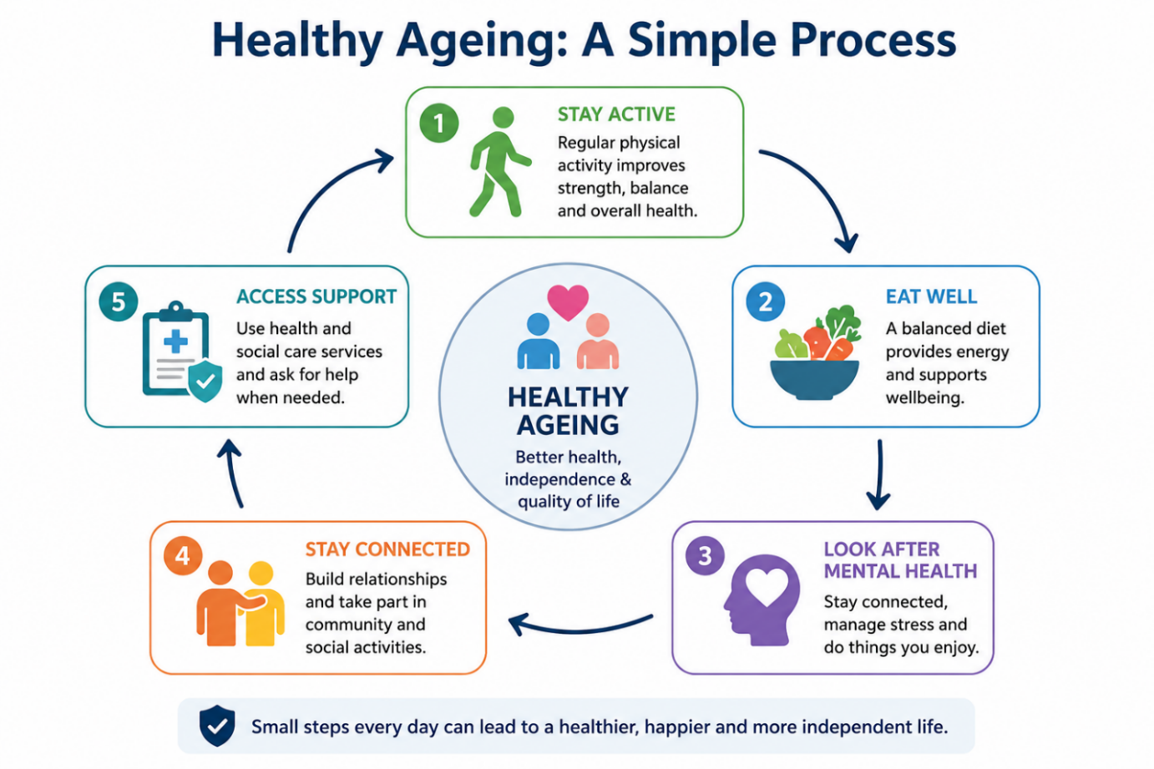

Figure 2: Healthy Ageing Process

Task 4: Quiz - NHS Equality, Diversity, And Inclusion Improvement Plan
- Primary goal of the NHS EDI Improvement Plan
The main goal is to improve equality, diversity, and inclusion by reducing discrimination and creating a workplace where all NHS staff feel valued, included, and supported.
- Gender Pay Gap
It aims to analyse pay gap data, implement improvement plans, follow the Mend the Gap recommendations, and promote flexible working.
- Intersectionality in the NHS EDI Improvement Plan
Intersectionality means people may have multiple identities, and different forms of disadvantage can combine to create greater barriers.
- Psychologically safe work environment
It helps staff speak up, ask questions, admit mistakes, and improves teamwork, staff wellbeing, and patient safety.
- Improving the experience of internationally recruited staff
It recommends clear communication, a strong induction programme, cultural support, and equal access to training and career development.
- Leadership Role
Leaders must set a positive example, have measurable EDI objectives, and be accountable for creating an inclusive workplace.
- One Way to reduce health inequalities within the workforce.
It encourages regular wellbeing conversations between managers and staff to improve health and wellbeing.
- Importance of collecting and analysing data on protected characteristics
It helps identify inequalities, monitor progress, and develop targeted actions to improve fairness.
- Flexible working policies contribution.
Flexible working supports work-life balance, reduces barriers for separate groups, and helps create fairer career opportunities.

- One strategy to combat bullying and harassment.
The plan recommends reviewing bullying data, setting reduction targets, and creating a workplace where staff feel safe to speak up (NHS England, 2023).

Task 5: A Letter to Myself
Dear Younger Me,
I understand that you are facing a challenging period in your life. Due to studying, family obligations, and concerns about the future you feel stressed. At times you feel that you are not good enough. You are measuring yourself against other people; you lose self-confidence. I want to tell you these emotions will not last.
The one thing that I want you to know from the beginning is that you need to be aware of emotional intelligence. Feelings of sadness, worry or disappointment are acceptable. Do not suppress your emotions, embrace them, and find a safe person to speak with. You do not lose anything by sharing what you think. It strengthens you up!
I also want you to build resilience. You will always have things that do not go your way. Things will go wrong, will take longer than planned, and there will be difficulties. Do not give up when things become difficult. Every error is an opportunity to gain experience, and no mistake is forever. Continue to move forward, even though it might be slow.
Do not forget to take care of yourself. Sleep well, eat nutritious meals, and take time for pleasurable pursuits. Be mindful of spending all your time worrying about things you cannot control. Think in terms of today. Making small steps each day will help you achieve your goals.
Remember to take care of yourself. Everyone has their own path to success, and it takes time. Have confidence in yourself and acknowledge your successes, no matter how small. They can be just as significant as the large ones.
Looking back now, I see how the challenging moments strengthened and enlightened me. They showed me how to remain calm, to solve problems and never to stop believing in myself. Continue to learn, maintain positivity, and never give up. There is hope for better days.
With care,
My Future Self.

Task 6: GANTT Chart (Start Date: 10 July 2026; End Date: 31 March 2027)

Task | Jul 2026 | Aug 2026 | Sep 2026 | Oct 2026 | Nov 2026 | Dec 2026 | Jan 2027 | Feb 2027 | Mar 2027
Complete university coursework
Update cv and LinkedIn profile
Attend career workshops and networking events
Apply for internships and graduate jobs
Develop professional skills.
(communication, teamwork, digital skills)
Prepare for interviews and secure employment

Gantt Chart
According to Bdair, N., Alzyadat, W. and AlZubi, S. (2023) using appropriate algorithms makes things better and faster, helps individual or group projects move forward successfully, and is essential for project management.

Gantt Chart Explanation
My plan to achieve my future employment goals are displayed in this Gantt chart, covering the nine-month period from 10 July 2026 to March 2027. I have listed the key activities that will enable me to prepare for my career.
Firstly, I must finish my university studies as my priority is to get my qualification. Meanwhile, I will be updating my cv and LinkedIn profile to be prepared to apply for jobs. I will be going to Career Workshops and Networking events in the next few months. Through these activities, I will be able to enhance my communication skills and connect with professionals in my field.
September is when I am going to start applying for internships and graduate jobs. During the entire timeframe, I will build my professional competencies, like teamwork, communication, digital skills, and time management. These skills are relevant because it is expected that graduates will possess skills in the workplace as well as knowledge in their course.
I will be preparing for interviews during the last couple of months and will be practicing some of the questions that I encounter as well as building confidence and learning about employers. I want to get a good graduate position at the completion of the plan. By following this schedule, I will be able to remain organised, complete my tasks within time, and have better chances of landing a successful career.

Task 7: Falls Prevention Program – Report on Making Changes
Introduction
As the manager of a care home, I want to introduce a falls prevention programme. Older people are at risk for falls, which can result in severe injuries. This programme will enhance the safety of residents within the care home and decrease the number of falls in the home (NICE, 2022a).

Planning the Change
I will be using Lewin's Change Model (Lewin, 1951) to introduce this programme. During unfreeze I will let staff know the importance of fall prevention. I will provide updates on recent incidents and provide an overview of the advantages of the new programme. At the change stage, staff will be trained to recognise risks for falls, how to use mobility equipment safely, and how to report hazards. Safety checks will be done at regular intervals in areas occupied by the residents and any communal spaces. These safety checks and good practices will be a part of the daily routine in the refreeze stage. Progress will be measured and further improvements identified through monthly reviews.

Skills Required
I need to be able to lead, communicate and make decisions as the manager. I also require critical thinking skills and team work to assist staff in the change.
Success in implementing the programme will depend upon good planning and organisation (Burnes, 2017).

Barriers and Solutions
Staff may have some resistance to the new procedures, as they are accustomed to current procedures. I will engage them in planning and offer hands on training. Time constraints can also be a challenge for performing safety checks. To overcome this, I will include these checks in daily work schedules. Limited resources will also be another challenge; equipment will be reviewed regularly and replaced, as necessary.
There will be regular meetings and feedback to ensure staff commitment to the programme (National Institute for Health and Care Excellence (NICE, 2025b).
Analysis
The falls prevention programme will enhance safety and minimise preventable injuries for the residents. The change will be successful, and the quality of care will benefit from good planning, staff training, and regular monitoring.
Image
Figure 3 depicts Falls Prevention Programme Using Lewin's Change Model – A simple overview of the stages, required skills, barriers, and solutions for implementing a falls prevention programme in a care home.

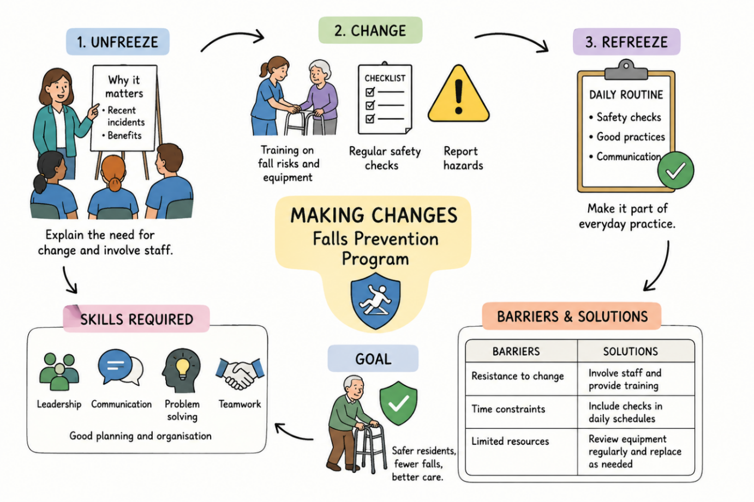
The National patient Safety Team supports the NHS in achieving the objectives of this strategy through a range of programmes and work areas. These efforts are underpinned by the strategy’s two main pillars, patient safety culture and patient safety systems, and its three key objectives, insight, engagement, and improvement (NHS, 2023).

Bibliography

Age UK (2024) Healthy ageing. Available at: https://www.ageuk.org.uk/siteassets/documents/reports-and-publications/reports-and-briefings/health--wellbeing/state-of-health-and-care/state_of_health_and_social_care_24.pdf (Accessed: 25 June 2026).
Bdair, N., Alzyadat, W. and AlZubi, S. (2023) ‘Intelligent Model for Optimizing Gantt Chart in the Planning Stage’, International Conference on Information Technology Research, IEEE, pp. 556–560. Available at: https://doi.org/10.1109/ICIT58056.2023.10225762 .
Ben-Hador, B., Eckhaus, E., & Klein, G. (2021) ‘Personal Social Capital in Organizations: A new scale to assess internal and external personal social capital in organizations’, Social Indicators Research, 157(3), 1155–1177. Available at: https://doi.org/10.1007/s11205-021-02702-x.
Burnes, B. (2017) Managing Change. 7th edn. Harlow: Pearson.
Citaristi, I. (2022) ‘International Labour Organization—ILO’, Routledge eBooks, pp.343–349. Available at: https://doi.org/10.4324/9781003292548-71.
Ghaltakhchyan, S. (2025) ‘PERSONAL BRANDING: SHAPING AND MAINTAINING A SUCCESSFUL PERSONAL BRAND’, Armenian Folia Anglistika, 21(1(31)), pp. 125–142. Available at: https://doi.org/10.46991/AFA/2025.21.1.125 .
Lewin, K. (1951) ‘LEWIN, KURT. Field Theory of Social science: Selected Theoretical papers. (Edited by Dorwin Cartwright.) Pp. xx, 346. New York: Harper & Brothers,’ 1951. The ANNALS of the American Academy of Political and Social Science, 276(1), pp.146–147. Available at: https://doi.org/10.1177/000271625127600135.
NHS (2024) Healthy ageing. Available at: https://www.england.nhs.uk/ourwork/clinical-policy/older-people/healthy-ageing-caring/ (Accessed: 25 June 2026).
NHS England (2023) NHS equality, diversity, and inclusion improvement plan. Available at: https://www.england.nhs.uk/wp-content/uploads/2023/06/edi-improvement-plan-plain-english.pdf (Accessed: 25 June 2026).
NHS England (2023) NHS Patient Safety Strategy. London: NHS England. https://www.england.nhs.uk/patient-safety/the-nhs-patient-safety-strategy/ (Accessed: 25 June 2026).
NICE (2025) Overview | Falls: Assessment and Prevention in Older People and in People 50 and over at Higher Risk | Guidance | NICE. Nice.org.uk. Available at: https://www.nice.org.uk/guidance/ng249 (Accessed: 25 June 2026).
Schlinger, R. (2022) ‘Network for your Job and Career’, Chemical Engineering Progress, 118(8), pp. 22–22.

