243745 (Keelan Rochard)

Usability engenerring assignment 1

Contents
Introduction 3
Interface design Background research 3
User groups and requirements 6
Paper prototype 12
Paper prototype - design 13
Paper prototype - in use 15
User participation 24
Self-evaluation 26
Overall evaluation & conclusion 27

Introduction
I have been tasked with the implementation of an enrolment kiosk inside the NPTC community college. This enrolment kiosk will be for potential student to self-enrol at home or within the college. This kiosk is to update the current time consuming enrolment system at NPTC so it will need to be quick understandable and accessible. The current system is to physically go into the campus receive a form and then proceed to walk around the entire campus to different departments which then allow the student to enrol. There is a lot of room for human error as many different staff members are looking at different forms for many different students for a number of days. If there is an issue you will have to physically walk all the way around the departments again to see the issue through. If the kiosk is accessible at home or just online it can be a straight forward procedure that can take no longer than 15 minutes.

Interface design Background research

Research methodology
I will be using primary and secondary research to carry out the tasks of making the enrolment system. The primary research will be for a user to test the system requirements through a paper prototype. The secondary research that will take place is to look into the background research of HCI, UE and UI design principles. I have chosen these types of research methods as I believe they give a wide range of variety and information to be looked at. The questionnaire can give numerical data and qualitative data which will allow statistical values to be made and to examine how someone feels about the systems prototype.
What is HCI?
Human computer interaction is when humans interact with computers through user interfaces or hardware to complete tasks. It is also how humans interact with machines through their senses and body parts such as fingers, touch, eyes, sight, and hearing and with their heads and body. [1]

What is usability engineering?
This is when people create usable platforms for tasks to be completed. This can be anything from dashboards online that represent data to new physical design of keyboards or other hardware that allow an unable user to become an able user. It has been said that usability can be the speed of user task performance and usefulness of a project that aids a user in completing tasks. [2]

What is UI design?
User interface design is applied whenever there is an application that requires a user to effectively use it to generate a process. Like usability engineering it is to take into account requirements that are needed to help a user complete a task. [3]

The stages of a life cycle

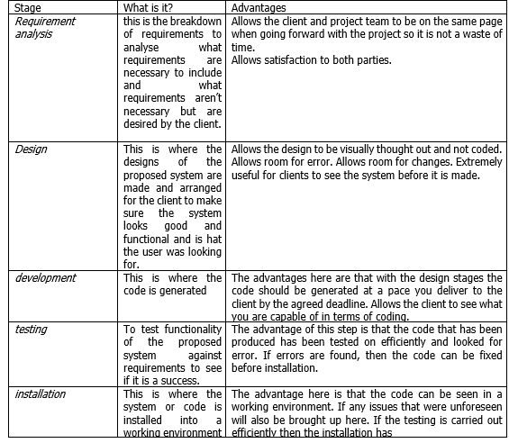[4]

Design principles – comparison of dix, Schiderman, Nielsen and Norman.

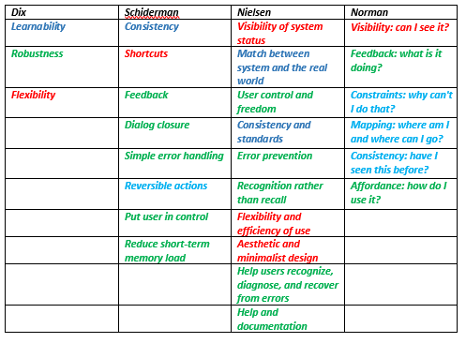

As you can see in the table above there are many comparisons and similarities to be made. These are colour coded to how Schiderman, Norman and Nielsen relate to Alan Dix’s work. As you can see there are lots of similarities between the titles and the topics of rules they all cover. For example, almost everyone includes visibility or system status. Everyone includes consistency through design as I believe it is one of the most important rules to consider as consistency is a good design element to have as it provides familiarity to the user. However, I believe that Alan dix has a very wide range of rules within the shortest list as there are many different aspects to consider within the 3 rules. schiderman’s rules are very concise and quite short commands to follow. Nielsen’s rules are slightly more in-depth and add to schniderman’s rules finally Normans rules are again limited but they’re more philosophical and ask the question to each rule to save as a small guide and shows what he was thinking about when generating these rules. To conclude they all, borrow from each other but I would say Nielsen’s rules are better to follow as there are a lot of rules to follow and covers more aspects of the design rules than the rest.

User groups and requirements

User group’s students aged 15-23 are the main user groups these are the core years in that students and people will be enrolling for multiple years to make sure the data is kept up to date the other user groups are people who are working with the system so a potential college employee aged 25-60 this is someone who works in the college and may help the enrolment process continue smoothly if there are any issues. The current enrolment system at NPTC Neath campus is 5 different areas all with staff member entering details for the specific departments they are in. however the argument can be made that if the user is aged 16 then the employees should be able to use the system.

System requirements
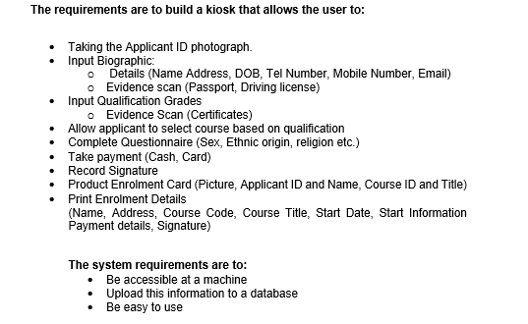
It is important to keep these requirements in mind during the creation of the project to protect the project from losing track of its original destination. If changes are suggested or the scope is required to change due to new legislations, then of course the requirements will have to be re-evaluated.

Hierarchical task analysis
Found below are screenshots of the system broken down into tasks accomplished within the system and broken down into a coherent string of tasks. Each screen will have the full navigational menu at the top with the pages listed and each block underneath this row will represent the tasks taken on each screen.
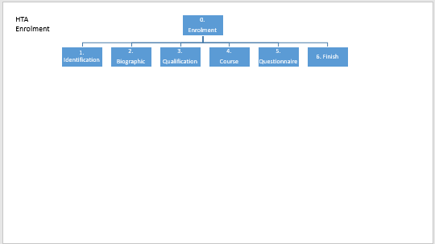
This is the first stage of the HTA as the sequence is as follows
0 = the system
1 = identification/log on
2 = biographic
3 = qualification
4 = course
5 = questionnaire
6 = finish

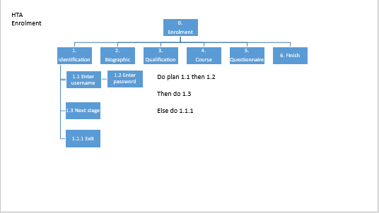
This screen is a simple login page so the first tasks will be to enter a name and password provided by the college. Then to move onto the next page. However, if the user does not want to continue they can exit at any time and it will close the application, this exit button will be included in every page.

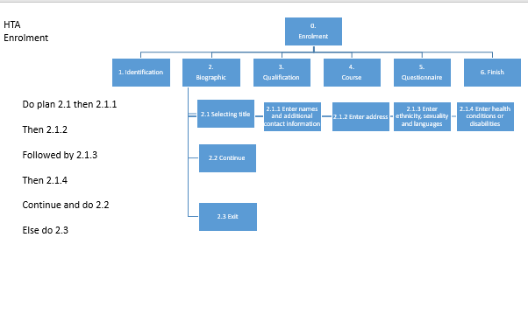
This page is to enter personal details. So the first lot of stages are to enter names and other information this is represented as being on the same hierarchical line of importance. The first task to the last tasks moves left to right.

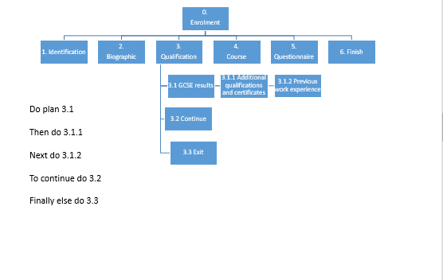
This screen is for GCSE results this will lead into the next screen. The first step is to either scan or enter GCSE results as the requirements would like the user to scan them through. However, if the user cannot scan then they should still be able to enter them manually. The other steps are to enter any additional qualifications to cater to older or mature students.

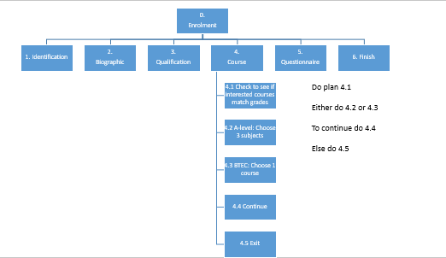
This screen should take information from the last screen with regards to GCSE grades highest or most common grade found and give course suggestions. If the user enters the GCSE were drama at A* level, then they should be recommended drama courses. The user can select others from a list if they do not wish to proceed. They should also have the ability to choose between a BTEC course and A level courses when applying to the college this option will make the courses options limited from 3 subjects to 1 as that is how the college system works.

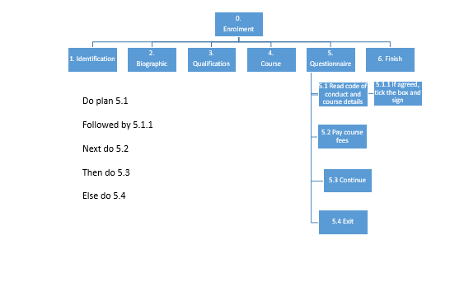
This screen will be to collect digital signatures from the potential pupils attending the college and to make sure they have read ay terms of service and that thy understand any course details hey did not already know. The next step will be to take payment and this can be done by entering car numbers or to select pay cash on the first day of college this allows the user to not feel excluded if they do not currently have the money to be able to enrol online.

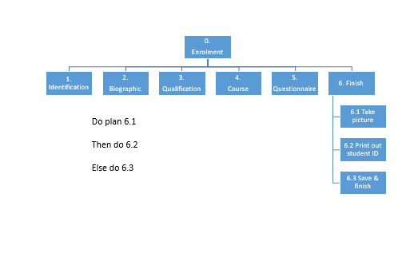
This final screen is to make sure that the user can finalise details such as taking a picture and to print out a student ID to then present as a bus pass or exchange for a plastic one in the college building. This design is not included in the requirements but I believe this can help staff find the student easier if a copy of their card exists to then give them the actual card quicker and also majority of students will have a form of ID coming onto the premises of the college which is a requirement enforced by the college itself. When the finish and save button is pressed this is where the data will be sent off to a database.

Paper prototype
The following table includes a list of human factors to take into account when designing the system. The column alongside the human factors is a section on what designs can be taken to help cater to the human factors.

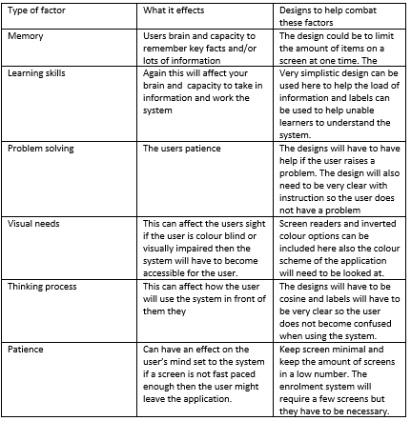[5]

Paper prototype - design
I will be demonstrating the thought process behind the designs on one screen. The other screens use the same consistent format so the coverage on one screen will give you enough depth to for the other screens.
The following screen shot is the first mock up design of the system this is the entering of personal details screen. This screen follows the z test of screen design. This is where the user will look at the screen like it is the letter ‘Z’ and will follow the page in this format so the items of importance is the key aspect of layout. The logo should be first as it doubles to a home button. Then the title of instruction of what the user should be dong on that page. Then the entering of the details and finally the buttons to navigate to the next stage. The logo is borrowed from the client. The labels are in a readable contrast compared to the background which is matched from the logo. The font is readable and appropriate. The instruction is clear. And the buttons appear as buttons on the bottom with contrasts so the user can read the text. I considered the human factor of memory in my design as the bottom two buttons are always in the same place. Other screens have yes and no buttons in green and red to provide familiarity with the system. [7]
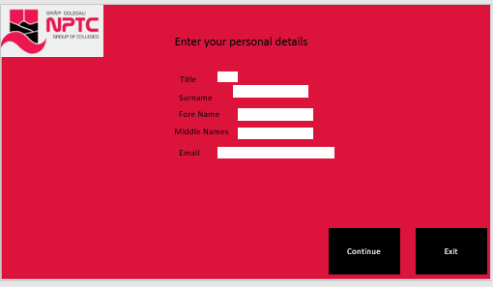
The image below is the z test and how the page is laid out to follow it.
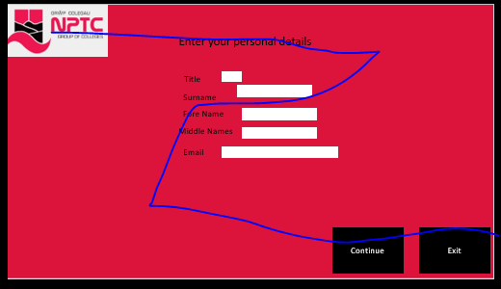
Here are the other screens for reference:
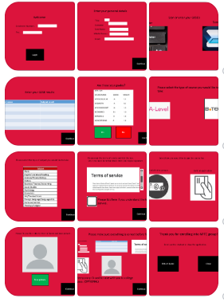

Paper prototype - in use
Found below are images of a user using the paper prototype to enrol into the college. I have selected this user to do this as they will be the right age to use the system as they are in GCSE year and for legislation purposes their face will not be shown as they are under the age of 18. The system was used as it would be in tablet format.

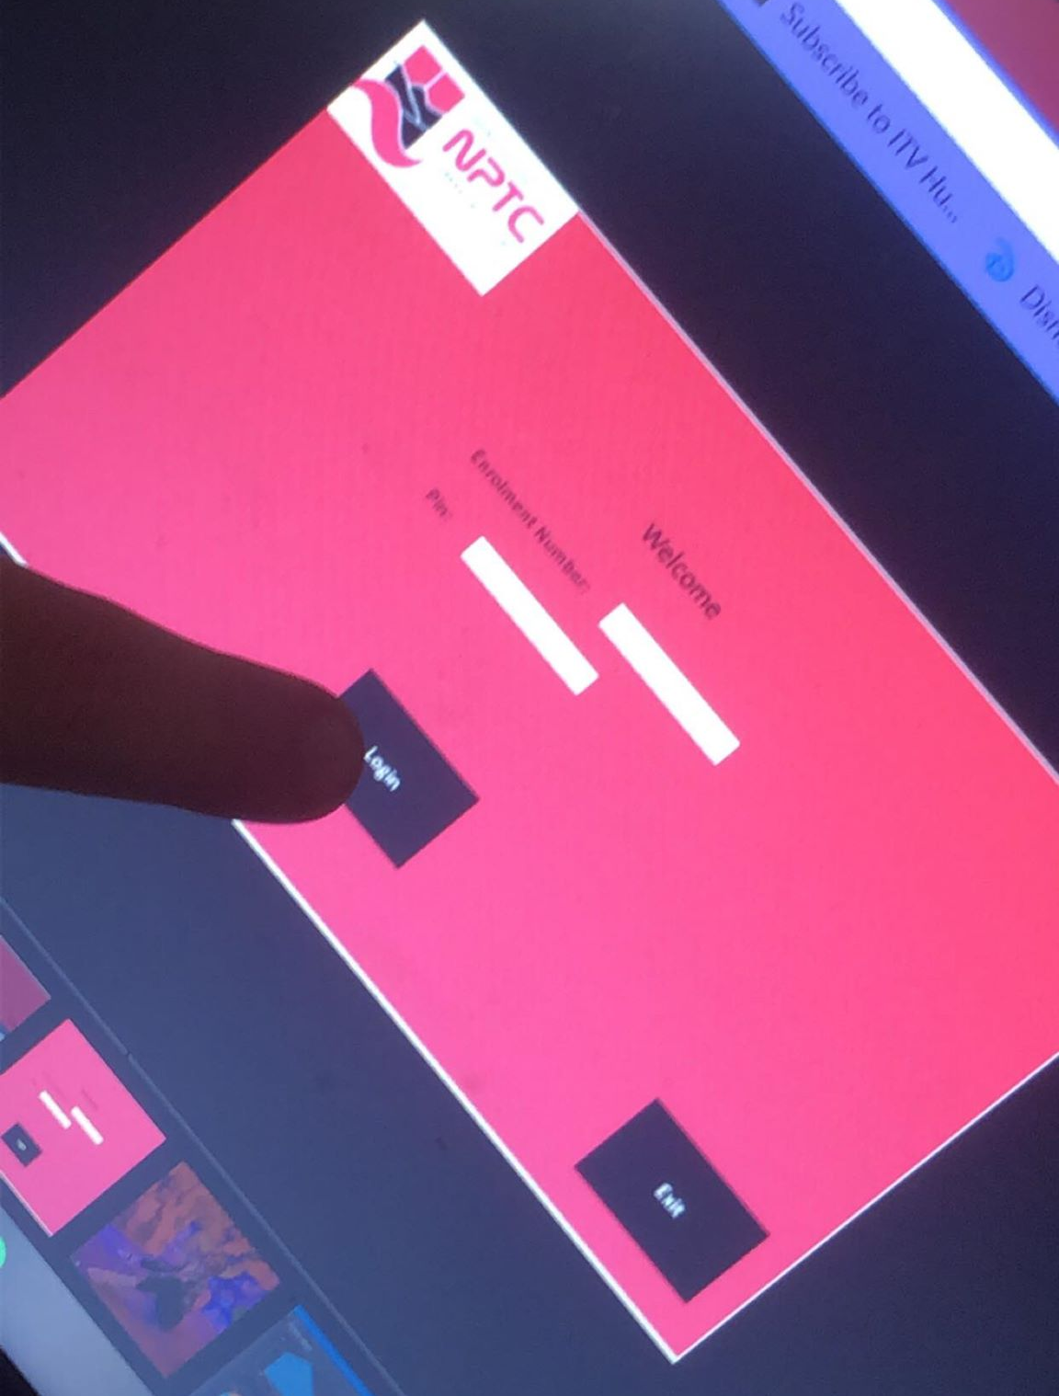
This is the user loging in to the system
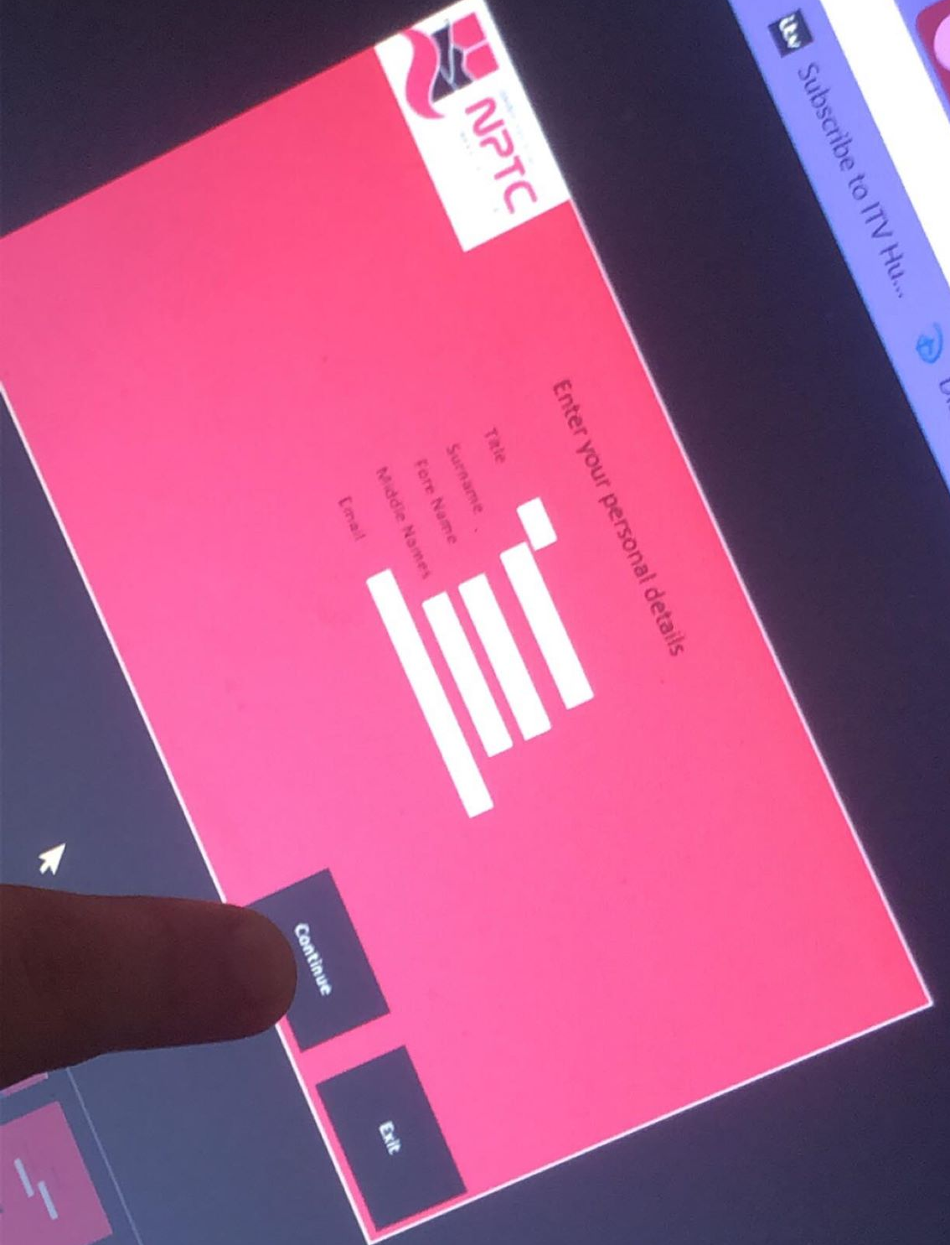
This is the user entering details
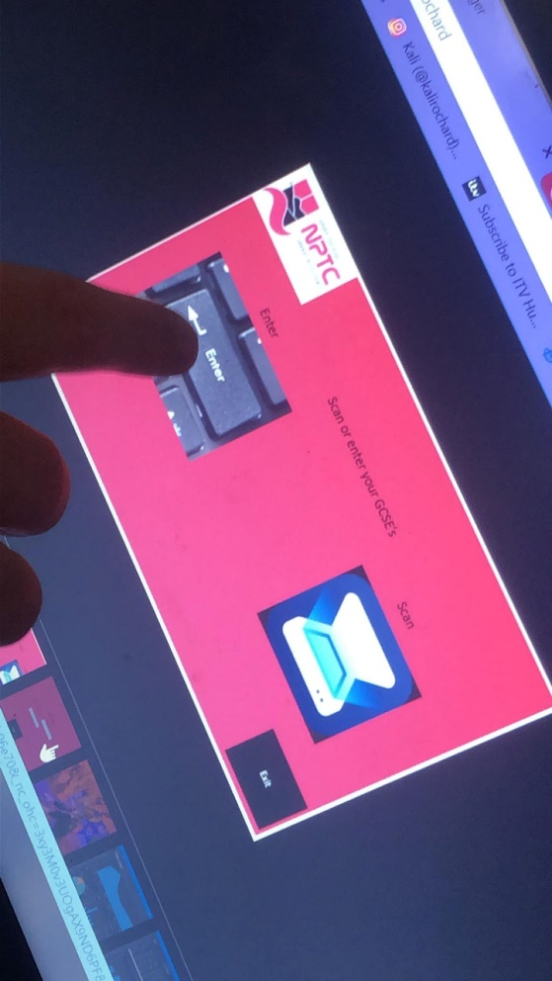
This is the user selecting how to enter their gcse’s
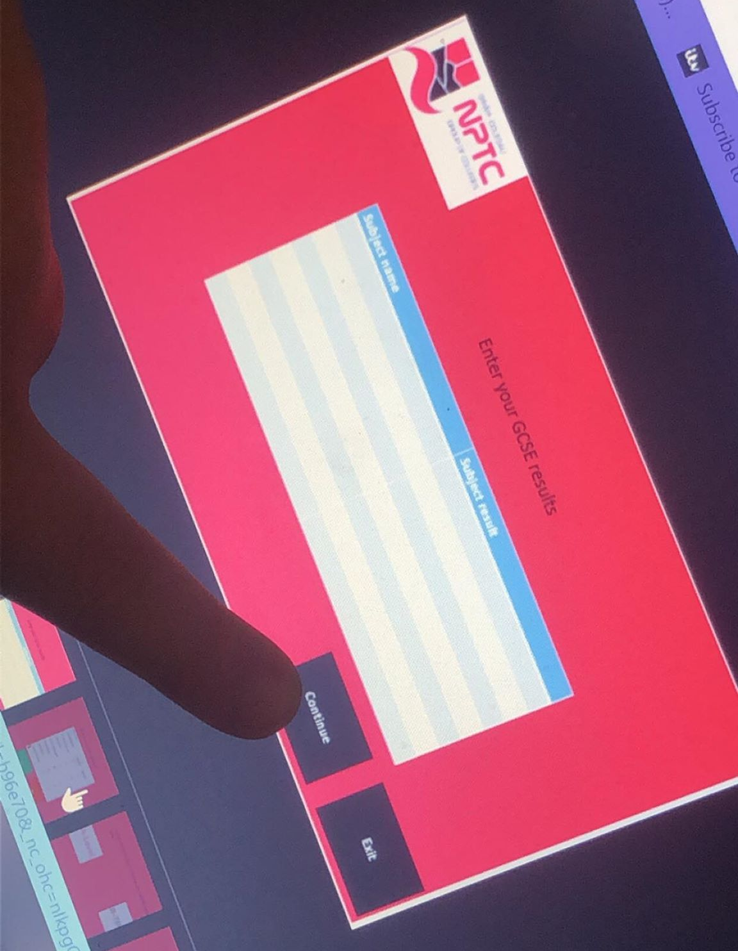
This is the user entering the gcse results into the table.
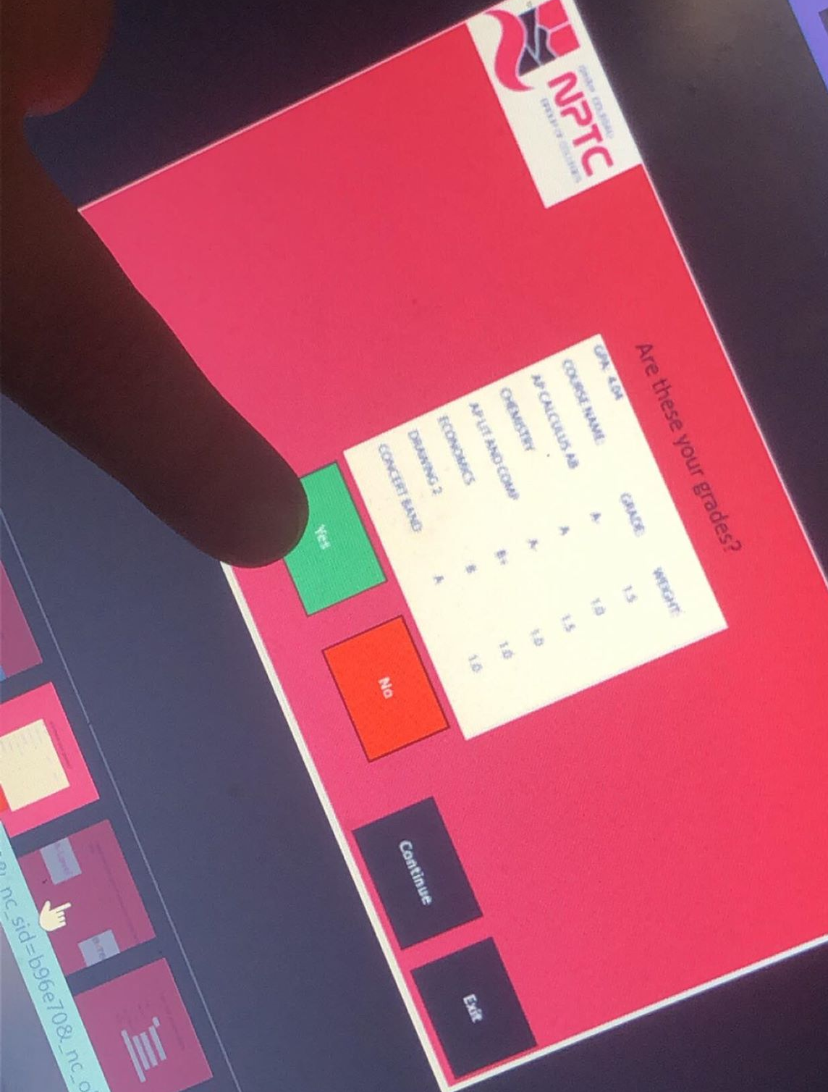
This is the user confirming the grades they have entered.
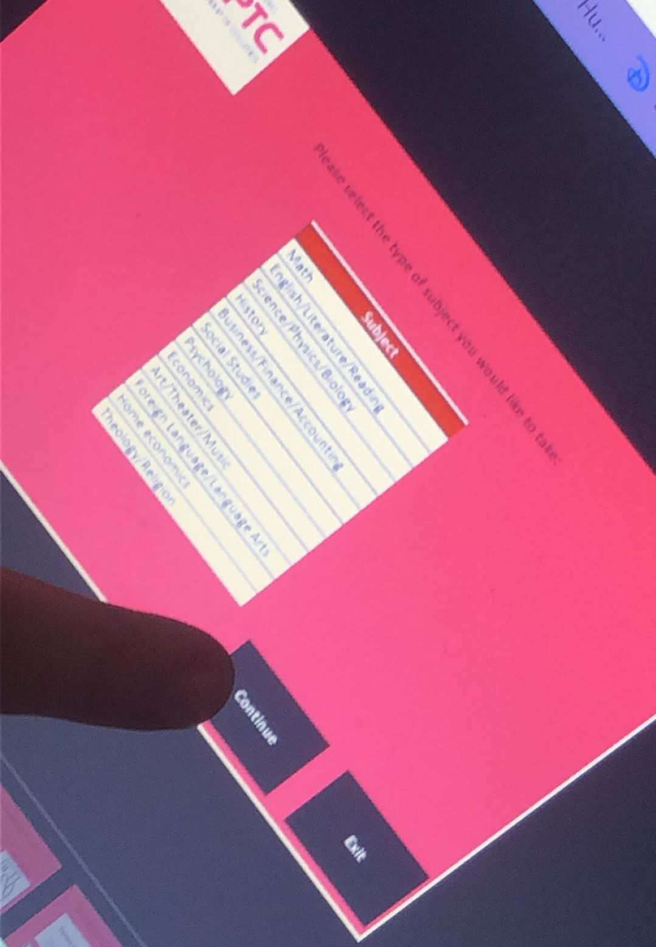
This is the course selection page

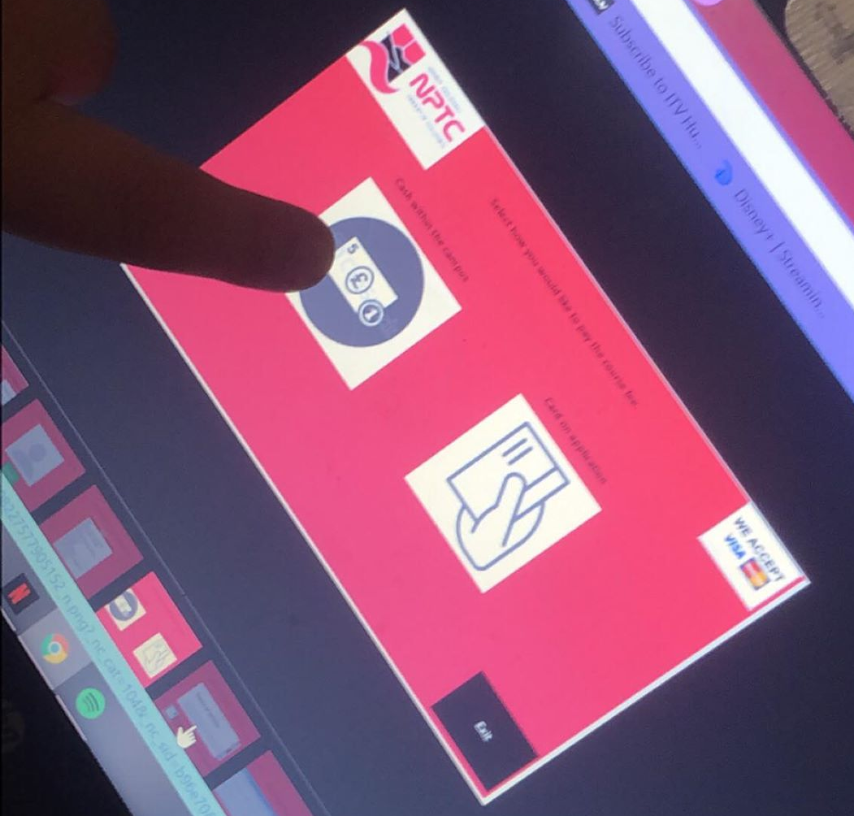
This is the user selecting the pay cash option
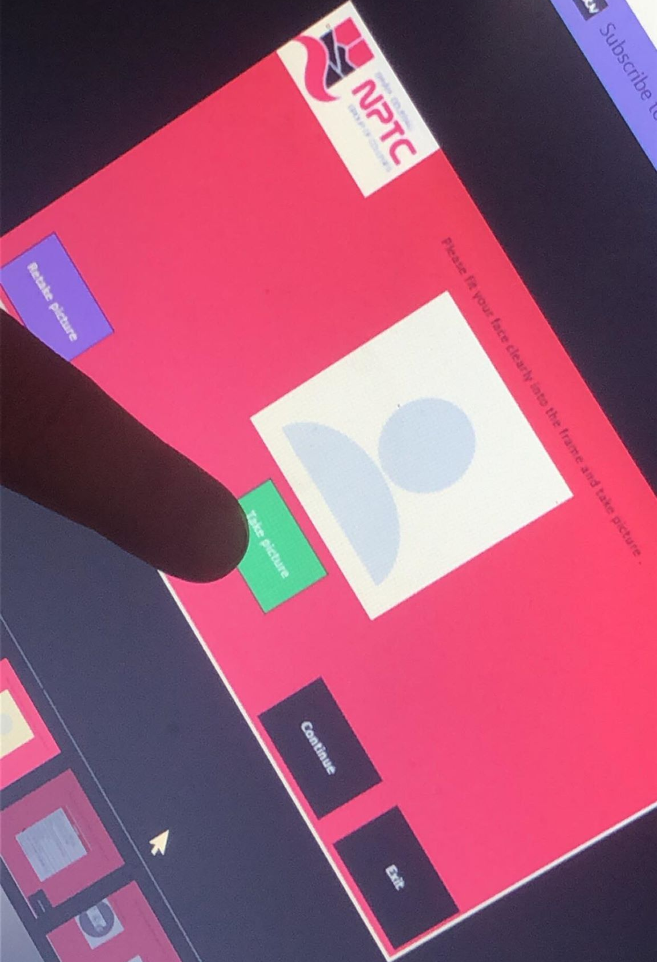
This is the user taking a picture of themselves
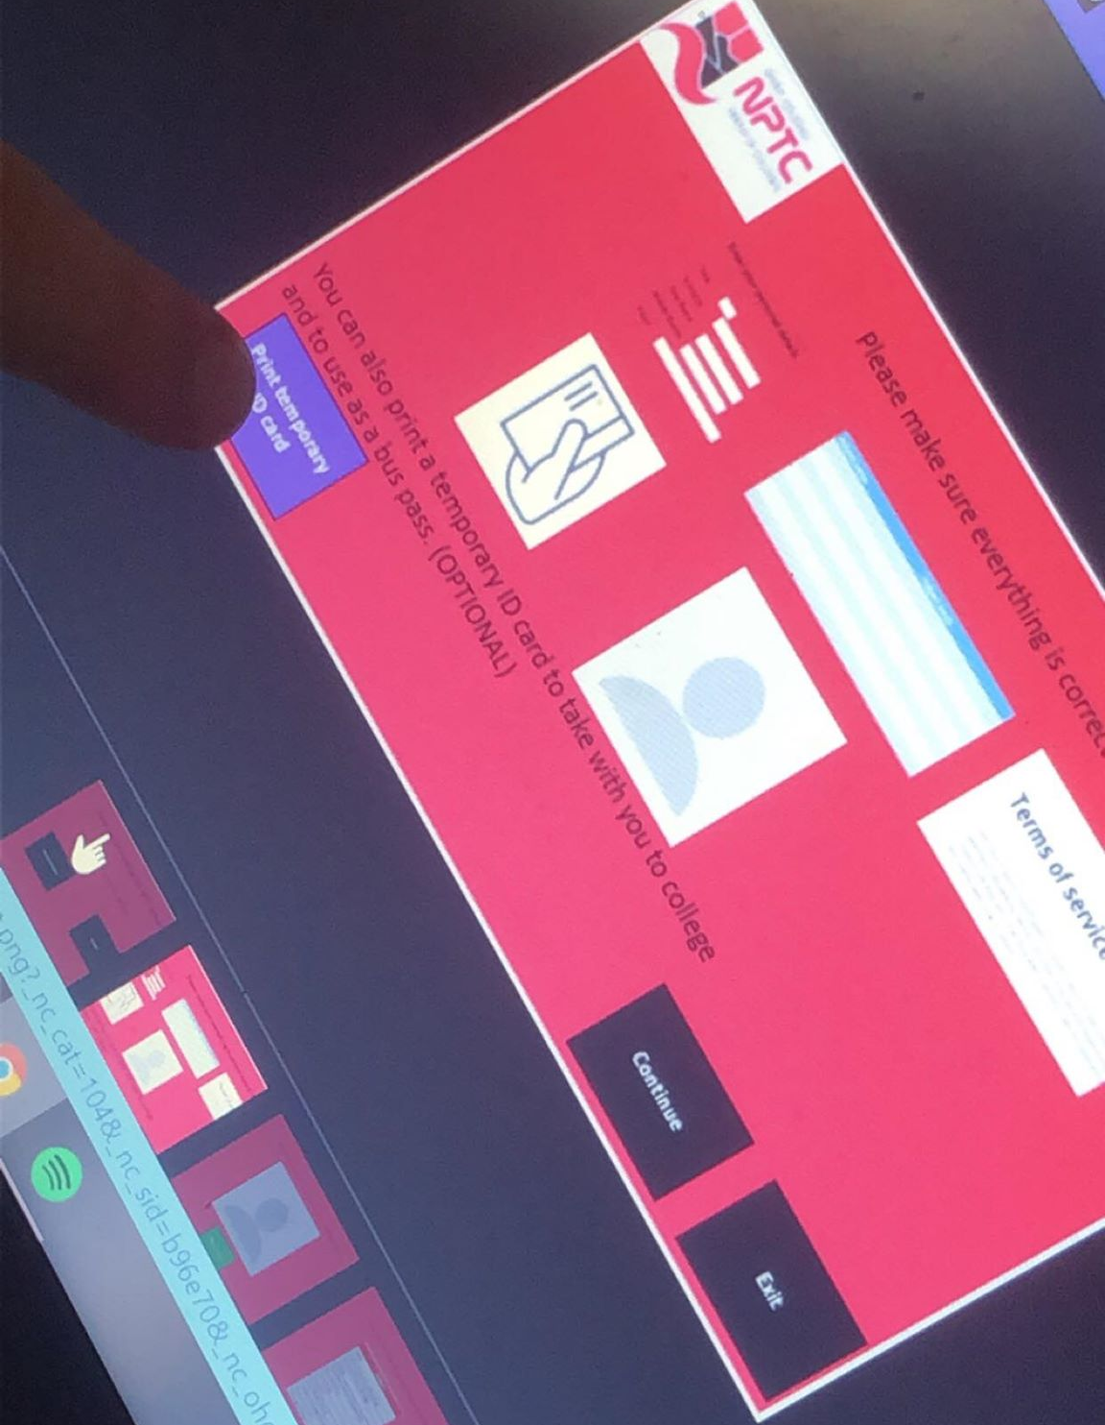
This is the user finalising the choices they have made

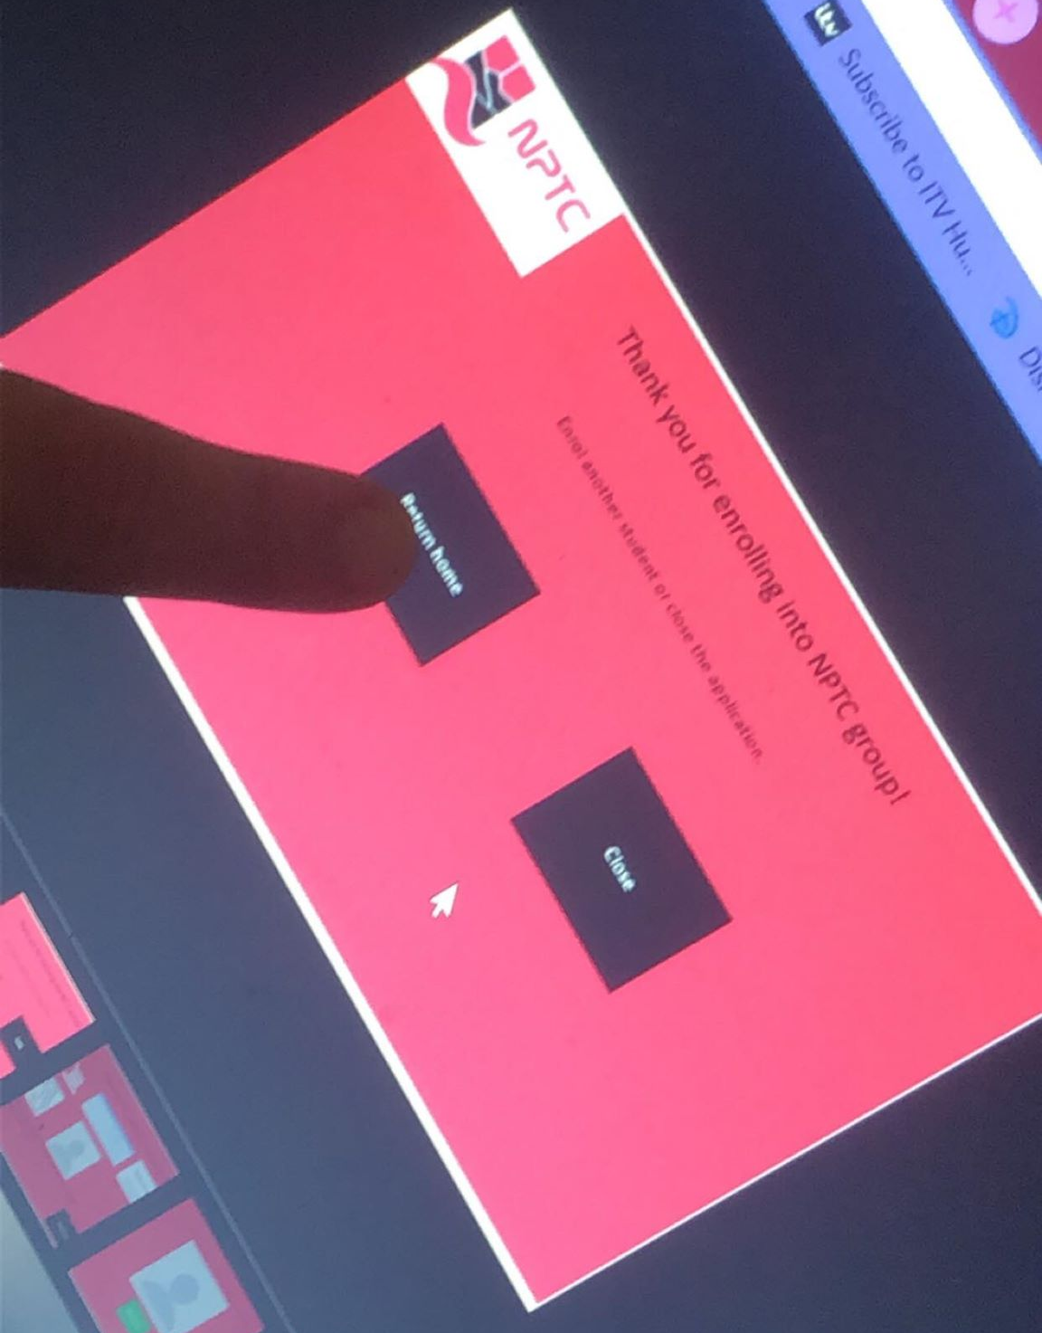
Finally, this is the user returning to the home page so their sibling can enrol.

User participation
In my current work space there are other students learning and developing their own user interfaces for this enrolment system. I asked one pupil to complete my enrolment form and fill in a questionnaire to see how the designs could improve. This is a type o end user testing and is a quick way to receive feedback and make changes to the system before deployment which is an advantage of the testing rule from a lifecycle.

This is one of the screens that was shard to me from Jamie Thomas. I personally do not like the screen design I believe it does not follow a lot of the design principles. I feel as though I cannot learn from this system enough in the instructions and there is no colour scheme except for the buttons of navigation. The use of metaphors is really good though. It also does not follow the z test but I believe it will follow the squint test. This is where users squint at a screen and to see if most important aspects stand out. Which is almost the opposite to my system. It is very formal and professional looking.
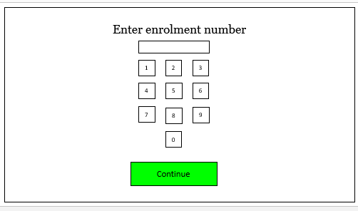

This peer also evaluated my own work and the comments are as follows in the image below.
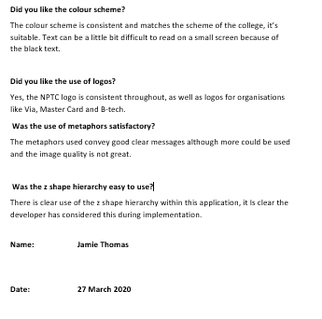
After reading this review over, I am in agreement to everything said in this document and I will be more inclined to take this feedback on in future project designs. The comments made here are critical to the design of the project acknowledging good and bad points. I did not realise that the colour scheme would contrast badly with the fonts colour and background colour. I also did not realise that my images appeared unclear in some screens compared to others. This was a factor of hardware I did not consider. It is clear that we both took very separate choices in the making of this prototype and I will consider changes made apparent here in my evaluation.

Self-evaluation
I believe I have conducted myself in a professional manor towards my peer to help them accomplish the feedback forms and end user participation section of this report. I also believe that I have studied a great deal into the design principles and done my best to convey some of them into to the final designs of the system. If I were to complete this project again I would consider taking a slightly different approach in regards to sharing documents with peers. I did it this time over Facebook messenger which is the quickest way to contact someone of my age group however in the future I would do this over email instead and maybe make use of online shared drives for document storage. I also believe that the feedback I did give was efficient but also if shared drives were included I could have given my feedback directly to the document and then later formalized it to a questionnaire answer.
To reflect on my personal self in this report I believe I have made an effective system with design from rules of designers to be tested by multiple users and for the feedback to be positive other than some minor issues that can be fixed quickly.
To conclude I also believe I conducted myself in a professional manor to help another peer develop their ideas further.

Overall evaluation & conclusion
The evaluation I am going to use is the Gibbs reflection cycle I belie this is the best way to cover all aspects of reflection. [8]
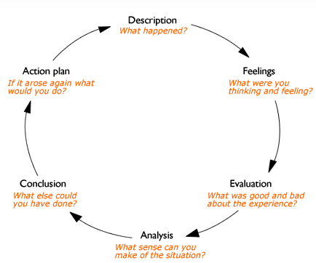
I was tasked to complete designs of an enrolment system for the NPTC Group of colleges. This lead into background research of UI design and design principles. Then into task analysis and then into generating the designs for feedback.
Overall the projects design I believe went well. The only factors I will consider next time is to print out the paper prototype designs unfortunately I did not have access to the facilities to print out the paper print outs efficiently. Black and white paper prototypes would have not been as effective as the colour scheme would not be present. What went well was the overall effectiveness of the design in using the ‘Z Test’ on screens to make sure the screens have a nice flow to them of hierarchical importance. I would say nothing went entirely bad except for the thought process of the system requirements in terms of scanning and photo taking. If the system was implemented into the real world, then the photos would not happen to their full extent and should not have not be a requirement in the first place. I do see where the college is getting the idea from but in reality not a lot of people will use the camera feature or the scanning feature because people may not have access to those facilities at home.
To evaluate I think that this was a good design experience and the feedback forms were a good exercise to have as the client was not involved during the creation this design project it allowed insights into your designs and gave me elements of my own work I did not consider.
To conclude I believe I have designed an effective and simplistic enrolment system for NPTC group. I believe this is because of the requirements I have discovered were met through conventional means of design rules. I believe what could have gone better is the system status I did not initially include this because I thought the sections were short and quick enough to finish and would not feel long upon reflection I feel as though if the section number or where the user is n the system could have been displayed on the screen to keep the user informed.
Action plan
If I were to carry out this project again I would include the use of wire frames and use that for feedback for then final deigns I believe this would work well because the wire frames would provide me with the feedback, I had to them make changes in the final design to have better final designs.

References
[1]
Dix A, Finlay J, Abowd G, Beale R. Human-Computer Interaction [Internet]. ResearchGate. ResearchGate; 2004 [cited 2020 Feb 4]. Available from: https://www.researchgate.net/publication/224927543_Human-Computer_Interaction/link/02e7e51a84759ab04d000000/download
‌
[2]
Downey L, Laskowski S. Aiiios Dflfiibfi pecial Publication 500-237 Government Collaboration for System Effectiveness and Efficiency SYMPOSIUM TRANSCRIPTION [Internet]. 1997. Available from: https://www.govinfo.gov/content/pkg/GOVPUB-C13-c6d53b6e12963a6af03c8b21bce1a8c1/pdf/GOVPUB-C13-c6d53b6e12963a6af03c8b21bce1a8c1.pdf
‌
[3]
User Interface Design Designing effective interfaces for software systems [Internet]. Available from: https://www.cs.umd.edu/~atif/Teaching/Spring2011/Slides/8.pdf
‌
[4]
Asloob S, Dr Q, Durrani Q. Practice of Usability Engineering in SDLC [Internet]. Available from: https://pdfs.semanticscholar.org/228d/8b1f7452953b92cf998be34d76ca54c0d81b.pdf
‌
5
Human Factors / User Interface Design Guidelines [Internet]. Available from: https://courses.engr.illinois.edu/cs126/fa2017/slides/L17-GUI.pdf
‌

6
Hernan Casakin. Assessing the Use of Metaphors in the Design Process [Internet]. ResearchGate. Environment and Planning B Planning and Design; 2006 [cited 2020 Mar 10]. Available from: https://www.researchgate.net/publication/23541537_Assessing_the_Use_of_Metaphors_in_the_Design_Process
‌
7
A Pattern-Based Approach for GUI Modeling and Testing Rodrigo M. L. M. Moreira, Ana C. R. Paiva
http://www.cs.umd.edu/~atif/papers/ISSRE2013.pdf
8.
Reflective writing: About Gibbs reflective cycle - Oxford Brookes University [Internet]. Brookes.ac.uk. 2020 [cited 2020 Mar 27]. Available from: https://www.brookes.ac.uk/students/upgrade/study-skills/reflective-writing-gibbs/
‌

