

STUDENT NAME: Dragos Caciulan
STUDENT ID: 2314611

LCLM6004: RESEARCH METHODS FOR BUSINESS
COMPONENT 2: ACADEMIC DISCUSSION ON BUSINESS RESEARCH PROPOSAL

TITLE: LEADERSHIP IN SAFETY IN THE AGE OF ROBOTICS: A CASE STUDY OF BERNARD MATHEWS

Executive Summary
The current research has been looking to reflect leadership for safety in the age of robotics by taking into account the evidence of Bernard Mathews. In this case, the study has maintained it extreme emphasis to signify safety leadership for the creation of safety culture in the workplace to expand workers safety. Along with highlighting relevant literature to signify safety leadership, the current study has also denoted the methodological choices with the discussion about reliability and ethical integrity. The practical implications of this study are also highlighted at the end for informing business decision-making.

Table of contents
Discussion Format 4
a. Business Problem Statement 4
b. Research Aims and Questions 4
c. Literature Review 7
d. Methodology 9
e. Business and Practical Implications 10
f. Expected Outcomes 11
References 12
Appendix 1: Research timeline 15

Discussion Format

a. Business Problem Statement
Alignment of identified issue with current organisation or industry challenge
Leadership is playing a pivotal role to influence safety attributes in this current era of digitisation concerning robotics. Safety leadership is provided with greater attention in this present era of robotics as a human centred approach for risk assessment. Bernard Mathews is prominently accused of indulging safety concerns with reference to the evidence of workers getting injured. For example, the food manufacturer Bernard Mathews has faced a legal penalty of 400,000 GBP during 2022 after a worker was left paralyzed with several broken ribs (Iosh Magazine, 2022). Comprehensive evidence of machinery issues are also denoted from the perspective of Bernard Mathews. For evidence, missionary fault was reported in Bernard Mathews as one of the wings stuck in the belt under the machine during operating with surplus production line (Iosh Magazine, 2022). This evidence comprehensively questions the existing leadership of Bernard Mathews with lack of technical advancement and machinery guidance to the workers for manufacturing practices and operations.
Significance of the issue in the broader business context
The highlighted issue of worker injury due to poor safety practices is relatively indicating the values of effective leadership to prevent such accidents in the workplace. Considering a broader business context, the Health and Safety At Work Act 1974 is followed in the UK covering occupational health and safety (GOV.UK, 2026). In this case, perceived significance of the issue is underpinned by reflecting the values of leadership to contextualize evident safety concerns in the age of robotics. As stated by Howard et al. (2025), the integration of robotics is helpful to consider workers safety and welfare along with shaping the future of work. Referring to this understanding, the issue is worth investigating for underpinning the value of leadership to consider the strategic vision of deploying robotics for maintaining workplace safety by preventing accidental events.

b. Research Aims and Questions
Aim
The present research aims to critically evaluate the implications of safety leadership to empower safety in the workplace of Bernard Mathews with strong machine guarding and risk assessment.
Questions
Questions | Specific | Measurable | Achievable | Relevance | Time bound
What are the implications of safety leadership to extend workplace safety through creating a safety culture? | Specifically denotes the context of safety leadership to increase safety at workplace | Measures the internal ability of leaders to empower workers safety and health | Achieves sound understanding of human centred approach with staff safety and welfare | Relevant to maintain basic fundamental rights of safe working environment | 6 months
How does safety leadership create the pathway to enhance safety in the age of robotics in Bernard Mathews? | Specific to denote the influence of safety leadership to ensure workplace safety | Measures farsighted vision of leaders to empowered safety concerned in the age of robotics | Achieves linear relationship of robotics to empower workplace safety | Relevant for deriving the role of leaders to create strategies for enhancing safety | 9 months
What challenges might be faced by leaders of Bernard Mathews to extend safety in the age of robotics? | Specific to enlighten leadership challenges to enable workplace safety with robotics | Measures the internal gaps in workplace to enhance safety in the age of robotics | Achieves concrete understanding of improvement areas for enhancing safety with robotics | Relevant to evaluate appropriate leadership style for staff centricity with safety | 1 year
Which strategies should be followed by leaders to enhance safety concerns in the workplace in the current age of robotics in Bernard Mathews? | Specific to interpret pathways of addressing leadership challenges for enhancing safety with robotics | Measures the strategic values for empowering workplace safety | Achieves safe and sound workplace environment with robotics | Relevant for comprehending workplace safety regulations | 1 year
Table 1: SMART research questions
(Source: Self-developed)
Addressing the business problem directly and logically
The research questions are comprehensively defining the vision of safety leadership as an integral part of ensuring workplace safety in the age of robotics. The evidence of Bernard Mathews is also concretely aligned to denote the necessity of enhancing workers safety with strong machinery guarding and regular risk assessment. As opined by Giallanza et al. (2024), human robot collaboration can be highly effective to ensure occupational health and safety with the interaction of robots and workers with a shared approach. Henceforth, the identification of leadership strategies to empower workplace safety would help in addressing the business problem of Bernard Mathews concerning workers safety issues.

c. Literature Review
Significance of safety leadership to create workplace safety culture in the age of robotics
The concept of safety leadership is comprehensively recognised as a critical differentiator to ensure robust workplace safety culture. As opined by Ciekanowski et al. (2025), safety culture concretely denotes the values and norms as well as practices shaping the approach towards occupational hygiene and safety. In this case, safety leadership has been playing an integrated role by transition in the human centred approach for managing the risks of human-machine collisions. Referring to this understanding, Ali and Nouban (2024) has also denoted the values of creating strong safety culture as a critical factor for reducing hazards alongside promoting workers well-being. Thus, the transverse relationship of safety leadership can be signified for extending safety culture in the age of robotics to support a safe environment for the workers and staff.
Challenges of integrating workplace safety in the age of robotics and strategies to overcome those
Several challenges may be experienced by safety leadership in terms of integrating workplace safety in the age of robotics. As opined by Yeboah et al. (2025), safety motivation and safety culture are considered as mediating variables to define leaders' ability for creating robust workplace safety. In this case, lack of integrated safety culture in the workplace may become extremely challenging for the leaders to empower workplace hygiene and safety. The present era of robotics is also denoting conclusive application of tech advancements with human machine collaboration to enhance safety (Rahman et al., 2024). Referring to this aspect, poor technical proficiency and literacy may also create obstacles to complement human machine collaboration. These challenges may also create troublesome consequences for organisations with the addition of financial penalties and punishments for not copying with safety guidelines and standards. Referring to the challenges as mentioned, empowerment of leadership should be emphasized with safety culture to create a strong safety climate that may also lead to safety behaviour from employees (Ta et al., 2022). Alongside this, organisations should also deploy training arrangements and programs to support digital proficiency and technical literacy of the workers to align robotics technology for machinery guidance to ensure workers safety.
Socio technical systems theory
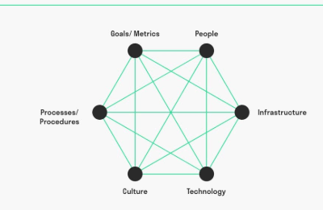\
Figure 1: Socio-technical systems theory
(by Bayramova et al., 2023)
The theoretical concept imposes the optimisation of corporate performance by designing social and technical aspects to work in harmony. As denoted by Bayramova et al. (2023), the implications of socio-technical systems concept are signified through the interrelationship of components within a complex system. Featuring this understanding, the attributes of safety leadership can be comprehended as the determinant factor to integrate safety culture as a crucial social element. Alongside this, deployment of technology with robotics may also be formulated as a significant option to empower workplace safety by taking into account safety culture. Relating to this understanding, the values of safety leadership are pointed out to encourage workplace safety by featuring both social and technical elements in harmony.
Addressing literature gap
The present literature has emphasized on denoting the aspects of safety leadership regarding the creation of workplace safety culture in the age of robotics. In this case, the study of Ciekanowski et al. (2025) has not mentioned the challenges that may emerge to integrate workplace safety culture. Similarly, the research of Ali and Nouban (2024) also did not mention the challenges associated with safety leadership to deploy workplace safety in the age of robotics. The current literature has looked forward to address this gap by discussing the challenging factors of lack of safety culture and poor technical knowledge that may hinder workplace safety in the age of robotics.

d. Methodology
Research design and data collection method
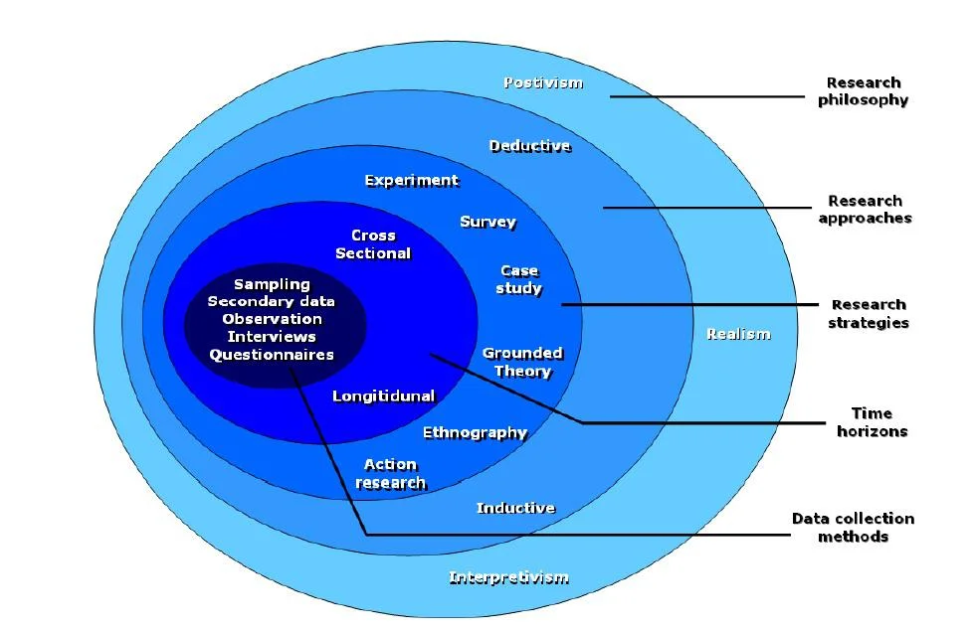
Figure 2: Research onion
(by Saunders et al., 2019)
Research onion framework helps in underpinning the methodological choice and preferences of researchers to generate effective outcomes by aligning with the research objectives. As opined by Saunders et al. (2019), research onion is also considered as a structured tool in order to guide methodological choices with practical steps by determining overall research design. The current research would follow interpretivism philosophy in order to consider subjective context associated with the study arena. Pervin and Mokhtar (2023) have mentioned the consideration of a subjective notion of the social context in interpretivist research paradigm. This subjective principle of interpretivism philosophy would be beneficial for enlightening the implications of safety leadership to enhance safety culture in the workplace for Bernard Mathews. The inductive approach would also be chosen for this research with specific observations for identifying patterns. Vears and Gillam (2022) have denoted the implications of an inductive approach to comprehend flexibility by developing new theories. This theory development principle of inductive approach would empower the current study outcomes by explaining the relationship of safety leadership with enhancing workplace safety for Bernard Mathews in the age of robotics. The descriptive design would be taken for this purpose that focuses on providing systematic description of the research problem and context (Ansari et al., 2022). The application of descriptive design would enable in-depth evaluation of safety leadership to encourage workers safety in the age of robotics with strong machinery guidance and risk assessment.
The secondary data collection method would be followed for this research context by undertaking existing information about the topic from accessible public domains. As opined by Baldwin et al. (2022), secondary data consist of the potential to provide appropriate answers to the social context and questions. In this present case, evident secondary data would be collected from relevant news articles like BBC and The Guardian for including updated evidence on workers safety in Bernard Mathews. The official websites of Bernard Mathews would also be explored for collecting authentic data about workers safety. The Google Scholar database would also be visited for collecting academic understanding from journal articles related to the study topic. Interpretation of collected data would be conducted by referring to the secondary thematic analysis process. The Braun and Clarke six step coding process would be conducted for identifying themes to address the research questions and objectives (Braun and Clarke, 2023). Based on thematic analysis, real time facts would be included in this research regarding workers safety in Bernard Mathews alongside denoting the implications of safety leadership.
Reliability, validity and ethical integrity
The current study would consider extended stands for data protection and privacy for enhancing authenticity and reliability. The Data Protection Act 2018 (c.23) would be followed in this case for the prevention of data breaches and misuse. Apparently, the university drive would be considered as a secured storage place for safeguarding the collected data. All data would be deleted from the university drive permanently after finishing this study to prevent its application for commercial purposes.
Limitations and challenges of methodical approach
The current research would not consider primary data collection techniques for collecting required research information. In this case, the limitation of the methodical approach is reflected through lack of first-hand information related to the study topic and context for supporting the research arguments.
Research timeline
(Refer to Appendix 1)

e. Business and Practical Implications
Findings informing business decision-making
The research findings would integrate sound understanding of deploying safety leadership in order to ensure workplace safety in Bernard Mathews in the age of robotics. In this case, preference of a safety culture would be comprehended as a prominent solution based on safety leadership to prevent workers injury by establishing explicit safety concerns.
Challenges may arise in implementing recommendations
Lack of staff engagement may arise as a challenge for implementing safety leadership for enhancing workplace safety in the age of robotics. This challenge can be overcome through reshaping leadership vision with a participative and transformative approach.

f. Expected Outcomes
Expected outcomes of this research are underpinned through outlining the linear relationship of safety leadership with the extension of workplace safety for Bernard Mathews. In this case, the research would also denote the strategies to overcome challenges in creating safety culture with strong machinery guidance and risk assessment.

References
Ali, A.M. and Nouban, F., (2024) ‘Analyzing the role of leadership in promoting a positive safety culture in the construction sector’. World J. Adv. Res. Rev, 21(1), pp.882-887. Available at: https://www.researchgate.net/profile/Abdirahman-Ali-32/publication/377387649_Analyzing_the_role_of_leadership_in_promoting_a_positive_safety_culture_in_the_construction_sector/links/65a393e040ce1c5902dac216/Analyzing-the-role-of-leadership-in-promoting-a-positive-safety-culture-in-the-construction-sector.pdf
Ansari, M.R., Rahim, K., Bhoje, R. and Bhosale, S., (2022) ‘A study on research design and its types’. International Research Journal of Engineering and Technology (IRJET), 9(7), pp.1132-1135. Available at: https://www.academia.edu/download/92557672/IRJET_V9I7216.pdf
Baldwin, J.R., Pingault, J.B., Schoeler, T., Sallis, H.M. and Munafò, M.R., (2022) ‘Protecting against researcher bias in secondary data analysis: challenges and potential solutions’. European journal of epidemiology, 37(1), pp.1-10. Available at: https://link.springer.com/content/pdf/10.1007/s10654-021-00839-0.pdf
Bayramova, A., Edwards, D.J., Roberts, C. and Rillie, I., (2023) ‘Enhanced safety in complex socio-technical systems via safety-in-cohesion’. Safety science, 164, p.106176. Available at: https://www.sciencedirect.com/science/article/pii/S0925753523001182
Braun, V. and Clarke, V., (2023) ‘Toward good practice in thematic analysis: Avoiding common problems and be (com) ing a knowing researcher’. International journal of transgender health, 24(1), pp.1-6. Available at: https://www.tandfonline.com/doi/pdf/10.1080/26895269.2022.2129597
Ciekanowski, Z., Żurawski, S., Wysokińska, A. and Kacprzak, A., (2025) ‘The role of a leader in shaping the safety culture of an organization’. Available at: https://www.um.edu.mt/library/oar/bitstream/123456789/133517/1/ERSJ28%281%29A35.pdf
Giallanza, A., La Scalia, G., Micale, R. and La Fata, C.M., (2024) ‘Occupational health and safety issues in human-robot collaboration: State of the art and open challenges’. Safety science, 169, p.106313. Available at: https://www.sciencedirect.com/science/article/pii/S0925753523002552 (Accessed: 15 April 2026).
GOV.UK, (2026). Health and Safety at Work etc Act 1974 Available at: https://www.hse.gov.uk/legislation/hswa.htm (Accessed: 15 April 2026).
Howard, J., Murashov, V., Roth, G., Wendt, C., Carr, J., Cheng, M., Earnest, S., Elliott, K.C., Haas, E., Liang, C.J. and Petery, G., (2025) ‘Industrial robotics and the future of work’. American Journal of Industrial Medicine, 68(7), pp.559-572. Available at: https://scholar.google.com/scholar?output=instlink&q=info:jUgCIZtw_qkJ:scholar.google.com/&hl=en&as_sdt=0,5&as_ylo=2022&scillfp=16548191584845334020&oi=lle
Iosh Magazine, (2022). Bernard Matthews fined £400,000 after worker left paralysed. Iosh Magazine, 21 October. Available at: https://www.ioshmagazine.com/2022/10/21/bernard-matthews-fined-ps400000-after-worker-left-paralysed (Accessed: 15 April 2026).
Pervin, N. and Mokhtar, M., (2022) ‘The interpretivist research paradigm: A subjective notion of a social context’. International Journal of Academic Research in Progressive Education and Development, 11(2), pp.419-428. Available at: https://www.academia.edu/download/88131967/the-interpretivist-research-paradigm-a-subjective-notion-of-a-social-context.pdf
Rahman, M.M., Khatun, F., Jahan, I., Devnath, R. and Bhuiyan, M.A.A., (2024) ‘Cobotics: the evolving roles and prospects of next‐generation collaborative robots in Industry 5.0’. Journal of Robotics, 2024(1), p.2918089. Available at: https://onlinelibrary.wiley.com/doi/pdf/10.1155/2024/2918089
Saunders, M.N.K., Lewis, P., and Thornhill, A. (2019) ‘Research Methods for Business Students’. 8th, Pearson, Harlow. Available at: https://librarysearch.uwtsd.ac.uk/permalink/44WHELF_UWTSD/1pbrh66/alma99100313060202421
Ta, M.T.D., Kim, T.E. and Gausdal, A.H., (2022), January. ‘Leadership styles and safety performance in high-risk industries: a systematic review’. In Safety and Reliability (Vol. 41, No. 1, pp. 10-44). Taylor & Francis. Available at: https://www.tandfonline.com/doi/pdf/10.1080/09617353.2022.2035627
Vears, D.F. and Gillam, L., (2022) ‘Inductive content analysis: A guide for beginning qualitative researchers’. Focus on Health Professional Education: A Multi-Professional Journal, 23(1), pp.111-127. Available at: https://search.informit.org/doi/pdf/10.3316/informit.455663644555599
Yeboah, M.A., Kalvei, M., Ansong, L.O. and Ansong, A., (2025) ‘Responsible leadership and workplace safety: do safety culture and safety motivation matter?’. Asia-Pacific Journal of Business Administration, 17(2), pp.285-302. Available at: https://www.emerald.com/apjba/article-pdf/17/2/285/9686424/apjba-05-2023-0207.pdf

Appendix 1: Research timeline
Actions | Month
Actions | 1 | 2 | 3 | 4 | 5 | 6 | 7 | 8 | 9 | 10 | 11 | 12
Identification of research topic
Determining aim and objectives, questions
Understanding research methods
Collection of literature
Conducting literature review
Methodological selection
Data collection
Collecting secondary data
Data analysis
Monitoring and evaluation
Presenting findings and discussion
Conclusion
Rrecommendation
Submission and Feedback

