Social Media Safety Sessions
Introduction
From the research found in my Needs Analysis around Social Media and children, I have put in place a project to protect children from Social Media, and workshops on how to stay safe online. There are similar projects linked to internet safety, but this will focus specifically on certain social media sites, and what is around to help them stay safe. The Welsh midyear population Figure currently stands at 3,113,200. The NSPCC presents the findings from an online self-completion survey of 1,024 11-16 year olds in the UK, 28% of which were aged 11-12 years. Their research found 23% of 11 and 12 year olds with a social networking site profile had been upset by something on it over the last year. The aim of this project is to equip children and parents with knowledge around online safety and staying safe on social media. Most parents are unaware of the ‘newer’ online trends and what the latest in social media are. By helping parents know how to help their children stay safe online, will allow communication between parent and child, and show parents how to put certain stops on their child’s item of technology.

Problem/issues identified
Social Media in the 21st Century is becoming more concerning, as the cause of many deaths, bullying, conflicts and a click away from finding out a huge amount of information about anything and anyone. Social Media was introduced for the concept of keeping in touch with friends and family, near and far. New research from the NSPCC has found that almost a quarter (23 per cent) of 11 and 12 year olds who have a profile on a social networking site say that they have been upset by something on it over the last year. Some of the most popular sites, such as Facebook, Twitter and YouTube, require users to be over the age of 13 to have a profile. There is reliable evidence from a variety of sources that large numbers of children under the age of 13 are active users of these sites. The issues around social media are increasing, and bullying on social media is not disappearing. Children have openly admitted to being a victim of online bullying, and openly admitted to not knowing people who they are talking to. In the 21st century, this is a growing problem, as children are trusting strangers online, and developing an online relationship.
To help your child understand how this will help keep them safe, you can: Explain why it's important that they never share personal information with people they don’t know online. Remind your child to come and talk to you if someone or something online is making them feel uncomfortable. Be clear that your child should never ever meet someone face to face without your consent or you present, and that the young gorgeous person they've been chatting to could easily be someone with bad intentions. Most social media apps have a minimum age rating of 13.
If a social network has set an age limit it means that some of the content may not be suitable for a younger child. Recommendations if your child is under the minimum age for a social network and they want to join:
Research the social network, find out what type of content your child may be exposed to. Decide whether they're ready for it. Encourage them to join age-appropriate social networks like Kuddle.
Discuss if they're mature enough to handle the type of content they may see on social platforms and if you feel comfortable with them possibly being in contact with adults and strangers.
We'd strongly advise you to follow the minimum age rating. If you do say yes, use strict privacy settings and either ‘friend’ your child or ask a family member.
As children between the ages of 11 and 13 make the transition to a more independent stage with the move to secondary school, they become more confident internet users with more varied habits. Internet use can be hugely positive for children, but it’s vital to continue discussing online safety with them.
The more you know about the kind of social networking sites your child belongs to and what information they like to share, the more likely you’ll be able to keep them safe: The lower age limit for most social networking sites is 13. The most popular social networks include Facebook, Instagram, YouTube, Twitter, Tumblr, Ask.fm and Snapchat. Sites aimed at younger children, like Club Penguin and Moshi Monsters, also have a social networking element
Many sites include an instant message function which allows private conversations between site members, because some children and teens don’t fully understand the dangers of talking to strangers online, they may engage in this behaviour. If they know you disapprove, they may attempt to hide it. So, educate yourself on the chat lingo they may use to hide their conversations.
ChatSlang has a full list of terms that parents should recognize. Among them:
9 or C9 – Parent in room
CD9 – Parents are watching
SPROS – Stop parents reading over shoulder
KPC – Keeping parents clueless
ASLP – Age/Sex/Location/Picture
These are only a few of the acronyms children use to attempt to keep their parents in the dark. Parents need to be made aware of any unusual acronyms and question the child if they don’t understand their messages.
The SDDA reports that, “71% of parents stop supervising Internet use by their children after the age of 14, yet 72% of all Internet-related missing children cases involve children who are 15 years of age or older.” This report shows that parental supervision is needed at all ages. If the issue of communication is tackled between parents and children, then it allows children to speak up if there are any issues around their internet lives.

Project description
The project itself will consist of six sessions, which will vary between workshops, games and sit in talks with parents. The project itself will not require any contribution from parents or schools, but just their willingness to listen. The aim of the workshops is to make it as fun as possible for the children, and for them to be able to ask questions. The Workshops will run for school ages 9-13 ( Year 5 to Year 7/8). Those ages have been specifically chosen due to the early introduction of technology to young children in the 21st Century.

Session 1 – Introduction with parents and children
Session 2 – Workshop with iPads and games – children only
Session 3 – Guest speaker – children only
Session 4 – Social Media sites – children only
Session 5 – Open questions
Session 6 – Parents and Children, what have I learnt?

Being able to equip children with the essential skills they need to be safe online is a need. Whitmore, (2002) identifies the positive impact teaching and developing skills can have. The Grow Model, Whitemore, (2002) is as follows :
The GROW Model is an acronym standing for (G)oals, (R)eality, (O)ptions and (W)ill, highlighting the four key steps in the implementation of the GROW Model. By working through these four stages, the GROW Model raises an individual’s awareness and understanding of:
- their own aspirations;
- their current situation and beliefs;
- the possibilities and resources open to them; and
- the actions they want to take to achieve their personal and professional goals.
By setting goals which are inspiring and challenging as well as specific, measurable and achievable in a realistic time frame, the GROW Model successfully promotes confidence and self-motivation, leading to increased productivity and personal satisfaction. The Will element of the fourth stage in the model is the barometer of success. It relates to volition, desire and intention.
Some websites, such as the NSPCC, have listed advice for young people and parents, on how to stay safe on the internet. It is important that all users, no matter what age, are informed about the dangers of Social Media, and the impact that it can have on lives. Users should be able to access the negative impacts of previous issues with social media, such as stories of children etc who have had the worst happen to them. These websites are put in place for children to feel safe and talk to someone who is not necessarily in direct contact with them. Children often feel more comfortable to discuss issues with those they do not know. These websites help raise the awareness of the dangers of the internet, but also support both parents and children.
Meeting and chatting with stranger’s online poses risks to young people who might be vulnerable to grooming and online (and offline) forms of sexual abuse.
With the physical barrier of a screen, some people feel more empowered to pressurise others into sending messages, often of a sexual or derogatory nature.
Many apps share the user’s location. This can put children at risk from others who actively seek out children with the intention of meeting in the real world. Sharing a location can also raise concerns with identity theft and privacy.
Although most apps now go through a process of classification and are rated based the type of content they contain, all apps are available to download by anyone who has a password to the app store.
This may expose children to explicit content, sometimes without their parents knowing. Some of this content can be illegal or simply inappropriate for children as it’s meant for adults.
Apps can cost money to buy from the app store – and some of them can be very expensive.
Some of the ‘free’ apps make their money in diverse ways, by encouraging you to spend money when using the app. This can mean that bills quickly build up without you even realising it.

Example letter
Dear Parents/Guardians,

The week commencing 19th February 2018, we will be offering Social Media Safety afterschool workshops for years 5-8 (age 13). These sessions will be run by volunteers who will all have an updated DBS. There is no fee for these workshops, but we do ask for parents to sit in on two of the sessions.
Session 1 – Introduction with parents and children
Session 2 – Workshop with iPads and games – children only
Session 3 – Guest speaker – children only
Session 4 – Social Media sites – children only
Session 5 – Open questions
Session 6 – Parents and Children, what have I learnt?

The workshops will run 3:15pm until 4pm every Monday, held in Dinas Powys Community Library ( opposite the school )

Please sign and give this form in to the school if you would like your child to attend.

Many Thanks,

Staffing
This letter will be given out to children in school, to take home to their parents. The school have a huge part to play in the community, and are always willing to see how they can get involved. The library is keen to have children through its doors to help develop their education where they can further their learning.
We will use volunteers from the local church who have strong links with the school and community, with one or two being IT specialists. All volunteers have an updated DBS to fall under the requirements of the local authority. Usually, projects like this are not fortunate enough to have willing volunteers to help from the goodness of their hearts. Dinas Powys as a community are fortunate to have a close community where there are others who would like to help the schools and children. All are aware of the issues around social media and are willing to promote awareness of issues. The school, library and church are all within walking distance of each other and share a carpark. This is perfect for the project as there are no issues around transport for the children or parents. Which leads on to the funding needs of the project.
There are no funding needs for the project, as all staff are local volunteers. The school have agreed to provide iPads for the children to use - those who do not have their own. The library have not asked for a hire fee of the space, as they want to support this project.

The maps below show Library location in Dinas Powys. 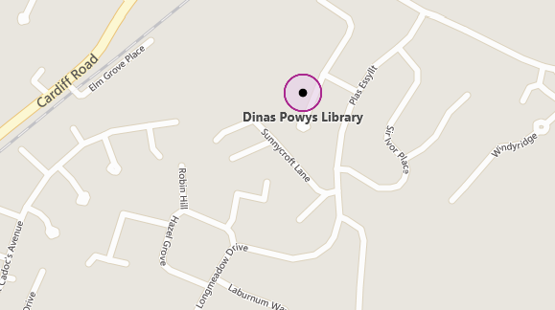
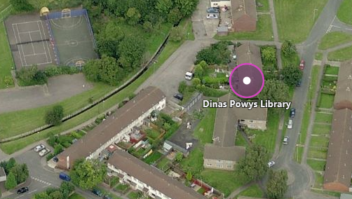

Worksheets and Games around social media will engage children into listening and using their own knowledge, as well as help from volunteers. Below are a few examples of games and worksheets that are centred around social media and internet safety. It makes learning fun for the children as after a long day at school, most children do not want to sit and listen to more information, that to them, may not seem like a dangerous issue.
Worksheets are a fantastic way of getting children to actively engage with their peers as well as adults. It gives a relaxed approach to work and findings, as children do not see it as work. They are happy to engage and play the games or complete worksheets.

This project will also improve the gap between peers. Having issues in common, draw children closer to each other, and gives them a voice. If children are comfortable around each other to speak up about their experiences online, in a safe space, it will encourage them to talk to their parents or teachers about this too.

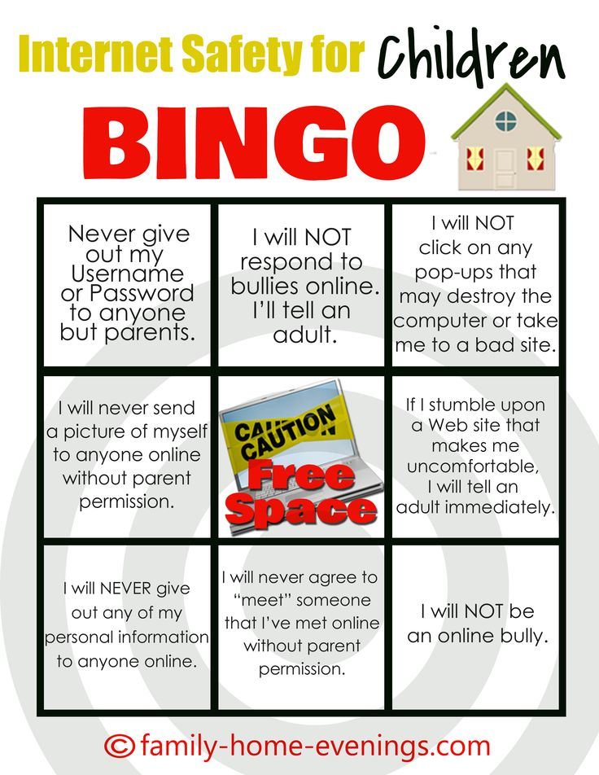

A SMART safety poster for children to visualise and learn the acronym.
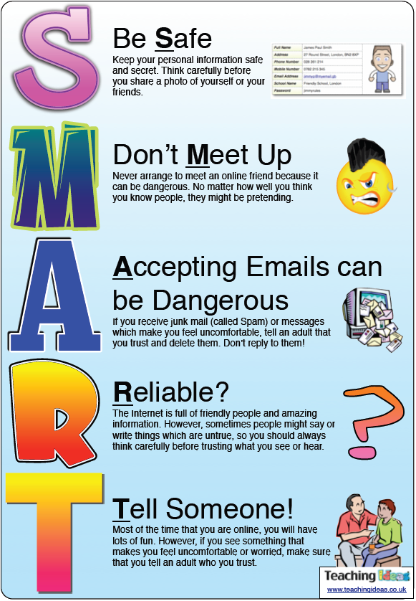

Once the project has run its course, we will offer a survey for both, parents and children to complete on their experience of the sessions, and whether it would be useful to run the course or a similar course in the future. The outcome of the project would be that children feel they have a voice to speak up about the issues that they are facing online and that the communication barrier between them and parents is lifted. We would hope that it provides children the knowledge to know right and wrong on the internet, and that they are aware of boundaries needed in place for them to stay safe and be protected. The idea is that as social media becomes more of an issue, there will be more awareness around the internet. In 2015, the number of internet users across the world is a massive 3.14 billion. It was 2.94 billion a year earlier. That’s massive, considering the world population is just over 7 billion. So, if this trend continues, we expect there to be 5 billion active internet users by 2020 – which means a clear majority of the world’s population will have access to internet. By 2020, the number of hackers active on the internet will be at an all-time high. Every year, we see more and more malicious code being released into the internet. By 2020, the attacks will become better targeted and more sophisticated. Cyber security will improve as well, but may not be able to keep up with the increasing complexity of the cyber threats. When you see your child texting or chatting online, you may assume they are communicating with friends and family. But that may not always be the case. A study from Cox Communications found that 69% of teens regularly receive personal messages online from strangers. Many parents may be unaware of this because only 21% of teens who receive messages from strangers tell a trusted adult. This issue is scarily becoming more common, and it is our job to raise the awareness that is needed. By the end of the six-week sessions, we hopefully would have made a dent in this ever-rising number.
If this is successful, we will have completed the aim of the project, which is to raise awareness for children and parents around the issues of social media. The best outcome from this project would be that all parties will have understood and learnt something from these sessions, even if it is one thing. If projects similar continued throughout the UK, we would see statistics on social media issues decrease. It is unlikely that all issues will disappear in the future, but an awareness and knowledge around social media and the internet will have an impact on these figures that have been listed in this project proposal and needs analysis.

References

NSPCC. (2013) Younger children networking sites report.
https://www.nspcc.org.uk/globalassets/documents/research-reports/younger-children-social-networking-sites-report.pdf

GROW MODEL. (2002) Skills and coaching. https://www.performanceconsultants.com/grow-model
https://www.internetmatters.org/advice/social-media/#minimum-age-to-get-social-media-account
Ofcom Children and Parents (2014): Media Use and Attitudes Report p.32, Figure 8
NSPCC. (2013) Younger children and social networking sites: a blind spot
Cybersafe Opinion Leader Report (Sept 2013)

Big predictions of 2020. http://www.dospeedtest.com/blog/the-future-of-the-internet-7-big-predictions-of-2020/

