Construction and Research of Network & Data Centre Management systems
Justin Rastatter P141652 jrastatter.141652@student.uwtsd.ac.uk
Abstract— This report contains two main parts, task 1 which Is the practical part of the assignment, this will contain information regarding the construction of an enterprise network and data Centre also with screenshots including annotations describing what’s in the given screenshots, the last main part will be the research element, this will be in-depth research form the list of topics given in assignment.

INTRODUCTION
This report will consist of two main parts, task 1 which will be the design and configuration of an enterprise network this will include screenshots of each part of the network and annotation of what’s in the screenshot and why. the second mains part of the report will contain an in-depth report on one of the given subject from the assignment. in this case it will be Security issues and solutions for wireless networks [1] this will include discussions on wireless mesh, MANET [2], Wireless Sensor Network [3], cellular, LTE and WiMAX, this will interlink with task 1 and will include a section on how to improve the network and data Centre’s further growth.

Related work
As stated in the introduction this will be the report section for this assignment, the topic of this report will be security and solutions for wireless networks, firstly we need to know what are wireless networks and why do we used them, so to start a wireless network uses radio frequency technology to communicate between devices, this gives you the freedom and mobility to work where every you want, since wireless networking gives the ability to work from anywhere. It also gives you the option to access information when and where you need it, so what are the main reasons to use wireless networks over a wired network? The first one would be the productivity [1]. a network with wireless access will improve productivity with a company by a lot over a network with only wired access, another benefit for having wireless access is easier network expansion, if a company is adding more offices or its adding more staff it won’t cost anything to get the new offices/staff set up since you don’t need to run any cables or wires these are just some the advantages of using wireless technology over wired.

Now to talk about security and solution for the different types of wireless networking to start this section will be about wireless mesh networking. The idea of wireless mesh networks is to provide better wireless coverage, this is mostly used for home network because there could be “blind spots” in your home meaning there’s no wireless access, if this is the case you can use wireless mesh networking this is done by adding wireless access nodes around a home to increase the area coverage, these devices are commonly called range extenders. It can be used in a work environment although it is generally avoided, moving on to the security side of wireless mesh network to better explain this it will be separated into two parts internal attacks and external attacks.

Firstly, internal attack, an internal attack is and attack from within the network and from users with authorization. Users can use an internal attack for a number of reasons, one could be that they want to gather data from other users, another reason would be to try and deny access of other users to gain better network bandwidth, this can be done by used an attack called a blackhole[2] what this does is when is receives a packet it will drop the packet which in turn cause a denial of service, if there is a black hole node in the network the attacker must generate a RREP message but to get the packet it will forge the message to say it has the shortest path to the destination, once the attacker had formed a path it will start dropping packets when it recives them. Another internal attack would be a creating a wormhole[4], this is simular to a black hole except this dosent drop the packets, it will collect the data this can be used to spy on the information within the packet i.e sensitive information.

An external attack is an attack from outside the network this mean that the attack dosent have autherization to access the network. A common external attack would be a flooding attack[4],this is where the attack can flood the WMN with PREQ frames this is will inturn deplete network resources and reduce the speed of the network. Another external attack would be a replay attack[5] this is where the attacker dectects the transmission and either has it delayed or repeated, the information they gather doing this can help them gain access to the network or gain access to sensitive information.

Also theres a passive attack (eavesedropping)this is where the attacker will try to gather the routing information by sniffing[6], this is an applicaion or device that can monitor, read and capture network data exchanges, an easy way for an attack to gain this ifformation is by predending to be a root mesh STA[4] and broadcasting the RANN, then once all the other mesh STA’s recive the RANN they will respond with PREQ frames with the root mesh STA, the attacker will then know the number of mesh STA’s, the path metrics and the MAC address of all mesh STA within the WMN

One way to stop these types of attacks is 802.11s this has simulataneous authentication of Equals and 802.1x these use authenitcation protocols which are authentication keys such as PTK/GTK the keys can then be used to authenicate the frames and with this any frame that hasen’t been authenicated will not be used by the mesh STA’s.

Wireless sensor networks, when it comes to sensor networks there are multple security threats which can affect the network. One of the main threats is a DDOS attack[7][8], a DDoS attack inst just one form of attack a DDOS attack can come in many different ways to list a few an SYN Flood this exploits weaknessess in TCP connection sequence i.e three way handshake[9][10], another attack would be an ICMP attack/Smurf Attack this is used in TCP/IP it will send large amounts of Internet Control Message Potocol(ICMP) packers (Ping packet) with the spoofed IP this will then basicly spam the netwoprk with these packet without waiting for a reply[10].

Another secuirty issues would be sniffer attacks[11] this can intercept, read and monitor network data/packets, one way to help stop this type of attack is to encrpyt the packet[11]. Also you should be using secure protcols such as HTTPS, Secure file tranfer prolocols(SFTP) and SSH, another good option would be to use a VPN[12], a VPN(virual private network) encrypts traffic between a device and the network this mean that you can work outside of the network and still be connected to it securly[13]

Another problem with wireless sensor nodes is that they have limited resources because of how small some node can be, they can also have unreliable communtcation meaning the range of the nodes is limted [14]

further growth for network
both wireless networks talked about have appealing factors for further growth for example both wireless mesh and sensor networks give the network a fast and easy way increasing the size of network coverage, but also they come with some disadvantage which could be off putting just to list a few slower speed compared to a wires network, also the surrounding element could affect the signals i.e. walls, another would be that its costly depending on how much you want to increase the network coverage by.

Design/implementation
In this section of the assignment there will be multiple screenshots with annotations describing what’s in the screenshots, this section will also include information on network design, server load balancing and redundancy.

Firstly, the network design in the screen shot below you will see the layer 3 topology layout for the network the core and distribution layer are essentially the Swansea backbone since the assignment asked for the main campus be in the city of Swansea
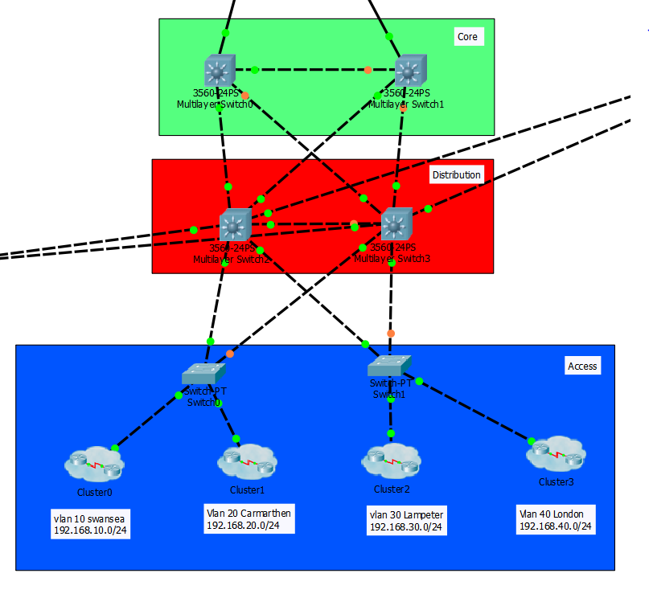
As you can see in the above screen shot there’s 3 layers, the core layer, the distribution layer and the access layer all with multiple switches 2 for the core 2 for the distribution and 2 for the access layer you can also see that there’s multiple links going to the core layer and distribution layer this is for redundancy for example the links between the core layer and the distribution layer all have multiple links to each other this is in place incase one of the link goes down.
If the currently active link goes down, then another will activate this in turn doesn’t disrupt the network and a fix can be implemented and restored to normal without losing network connectivity
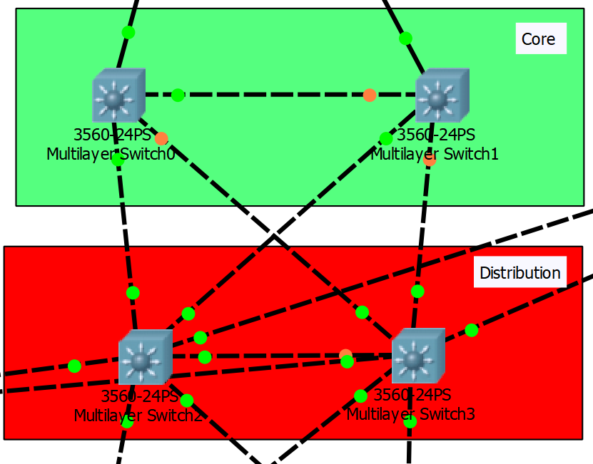

Example you can see the link between core switch 2 and distribution switch 2 going across the middle
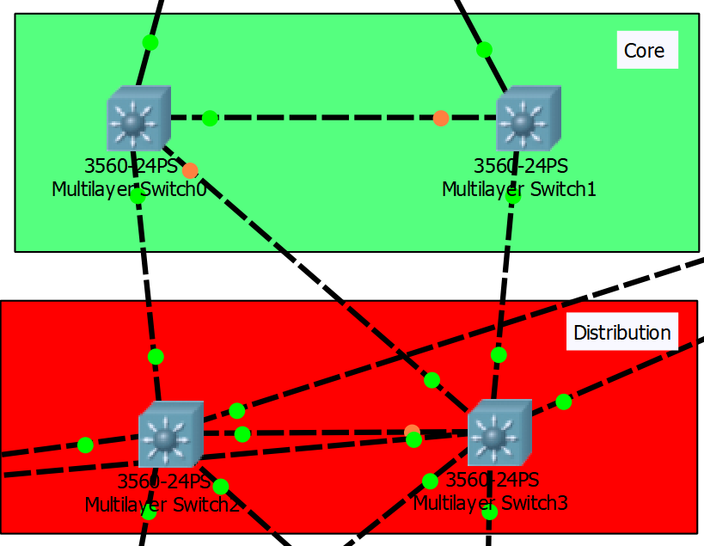

Now with the that removed the link that was previously down on the right-hand side has now change into and up state keeping the network connectivity, this is called redundancy.

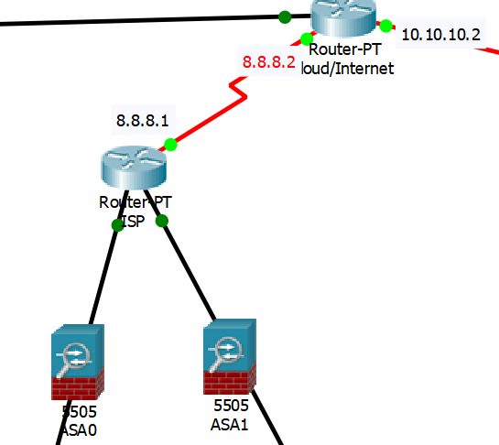

In the screenshot above you can see the ISP router which has 2 links going to the core layer, also a link going to the cloud/Internet Router, you can also see the firewall nodes now due to lack of experience and complexity of configuring firewalls in cisco packet tracer they aren’t connected to the network, but put them there are a place marker on where they should be.

In the screenshot below, you will see the access layer of the network this include the 4 main campuses of UWTSD Swansea, Carmarthen, Lampeter and London
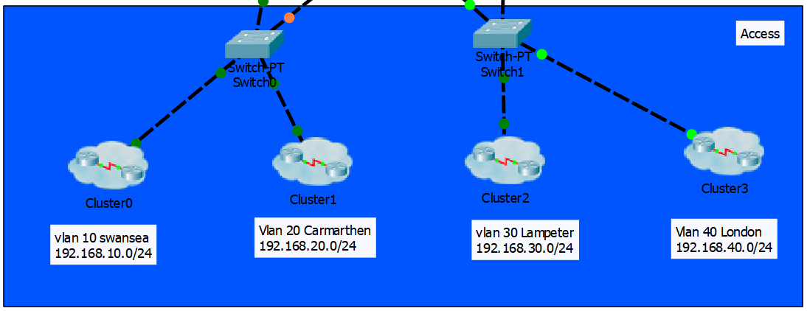

Each campus has its own Vlan as you can see in the screenshot. Going in the cluster 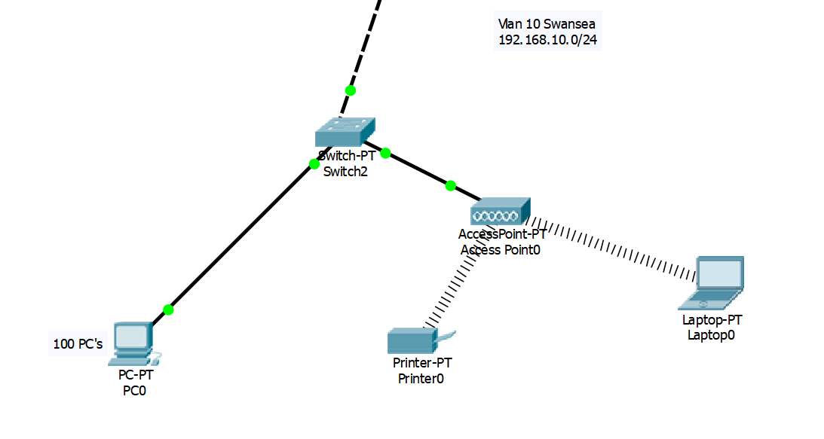
You will see a basic setup with wired and wireless aspects 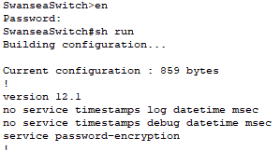
All switch in the network has basic security settings, in the screenshot above you can see you need a password to enable privileged EXEC mode you will also see there is password encryption on all switches
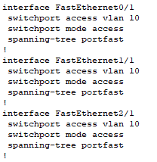
In the screenshot above you can see the interfaces connected are all on the VLAN assigned to the campuses this is done on all campus 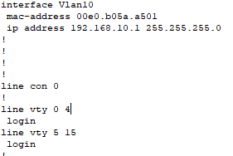
This screenshot shows the VLAN IP address and subnet mask also the VTY configuration for telnet.
Also, there’s a wireless aspect to each campus in the screenshot below you will see the wireless security settings 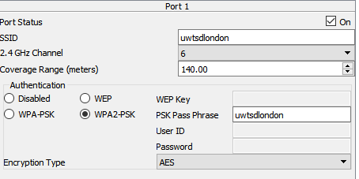
As you can see in the screenshot the SSID has been change from the defaults and the authentication method has been changed and a pass phrase put in place this is done on all campus wireless access points with their own SSID’s and pass phrases.

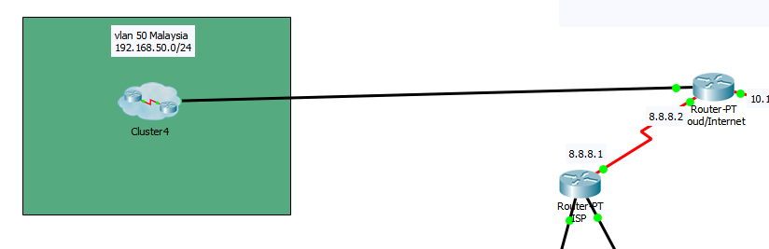
This screenshot shows the overseas campus of UWTSD as you can see its connected to the network through the internet since its half way around the world.

Moving on to the data Centre in the screenshot below you can see multiple storage servers and back up servers with a few switches all with multiple links to help with server load balancing this is then connected to the distribution layer of the network.
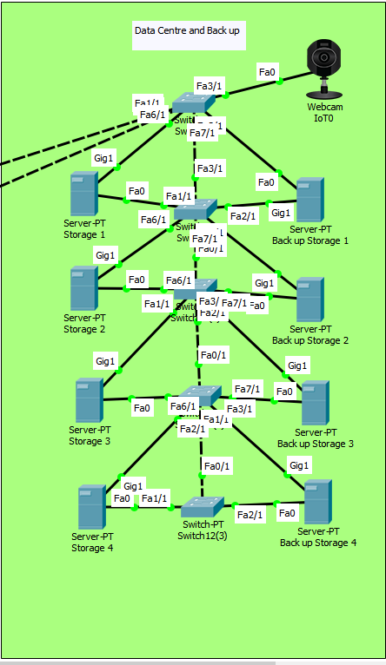
Also, you will see the webcam put in place for added security, other security measures could be put in place for example a security door with pin code lock or card scanner.

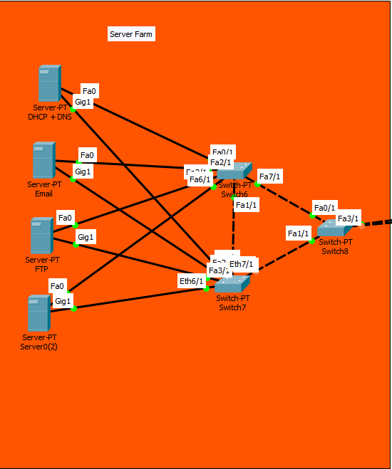
As you can see about this is the server farm of the network which is also connected to the distribution layer of the network.
It also shows multiple switch with multiple links to each server.
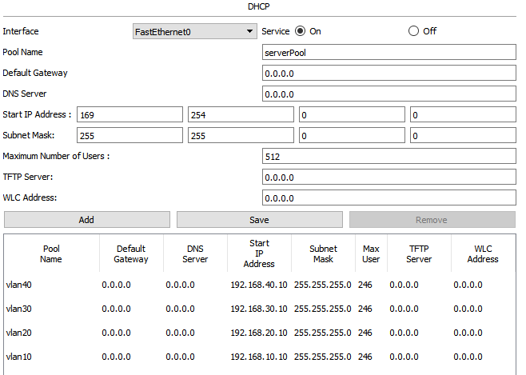
The screenshot show the DHCP server with all VLANS given a pool of addresses

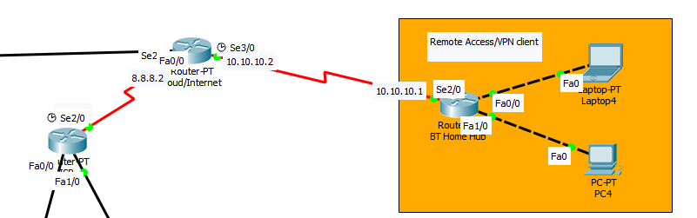
Final screenshot, this show the remote access aspect of the network this is for connecting to the network for the outside.

conclusion/further work
To sum up the report, the main points talked about wireless networks and the security issues which came with each network, and how you could deal with said issues, the last part included the design and implementation of a network in cisco packet tracer. For further work, more time and configuration could be spent implementing more security measures to increase network security.

References
[1] https://www.cisco.com/c/en/us/solutions/small-business/resource-center/work-anywhere/wireless-network.html
[2] R. Ranjan, N. K. Singh and A. Singh, "Security issues of black hole attacks in MANET," International Conference on Computing, Communication & Automation, Noida, 2015, pp. 452-457.
[3] V. Potdar, A. Sharif and E. Chang, "Wireless Sensor Networks: A Survey," 2009 International Conference on Advanced Information Networking and Applications Workshops, Bradford, 2009, pp. 636-641
[4] https://www.ncbi.nlm.nih.gov/pmc/articles/PMC3821297/
[5] https://www.techopedia.com/definition/21695/replay-attack
[6] https://technet.microsoft.com/en-us/library/cc959354.aspx
[7] L. A. B. Pacheco, J. J. C. Gondim, P. A. S. Barreto and E. Alchieri, "Evaluation of Distributed Denial of Service threat in the Internet of Things," 2016 IEEE 15th International Symposium on Network Computing and Applications (NCA), Cambridge, Boston, MA, USA, 2016, pp. 89-92.
doi: 10.1109/NCA.2016.7778599
[8] K. N. Mallikarjunan, K. Muthupriya and S. M. Shalinie, "A survey of distributed denial of service attack," 2016 10th International Conference on Intelligent Systems and Control (ISCO), Coimbatore, 2016, pp. 1-6.
doi: 10.1109/ISCO.2016.7727096
[9] https://www.cs.purdue.edu/homes/park/cs536-e2e-3.pdf
[10] D. Moustis and P. Kotzanikolaou, "Evaluating security controls against HTTP-based DDoS attacks," IISA 2013, Piraeus, 2013, pp. 1-6.
doi: 10.1109/IISA.2013.6623707
[11] S. Dhar, “Sniffers basic and detection,” Vols. 1.0-1.
[12] https://us.norton.com/internetsecurity-privacy-what-is-a-vpn.html
[13] https://www.cisco.com/c/en/us/products/security/vpn-endpoint-security-clients/what-is-vpn.html
[14] P. B. Hari and S. N. Singh, "Security issues in Wireless Sensor Networks: Current research and challenges," 2016 International Conference on Advances in Computing, Communication, & Automation (ICACCA) (Spring), Dehradun, 2016, pp. 1-6.

