Learning and Collaboration for Global Citizenship – BMSP4003
Alex Bell - Module Lecturer

Nicola Louise Bragg
Unilever’s contribution to sustainability

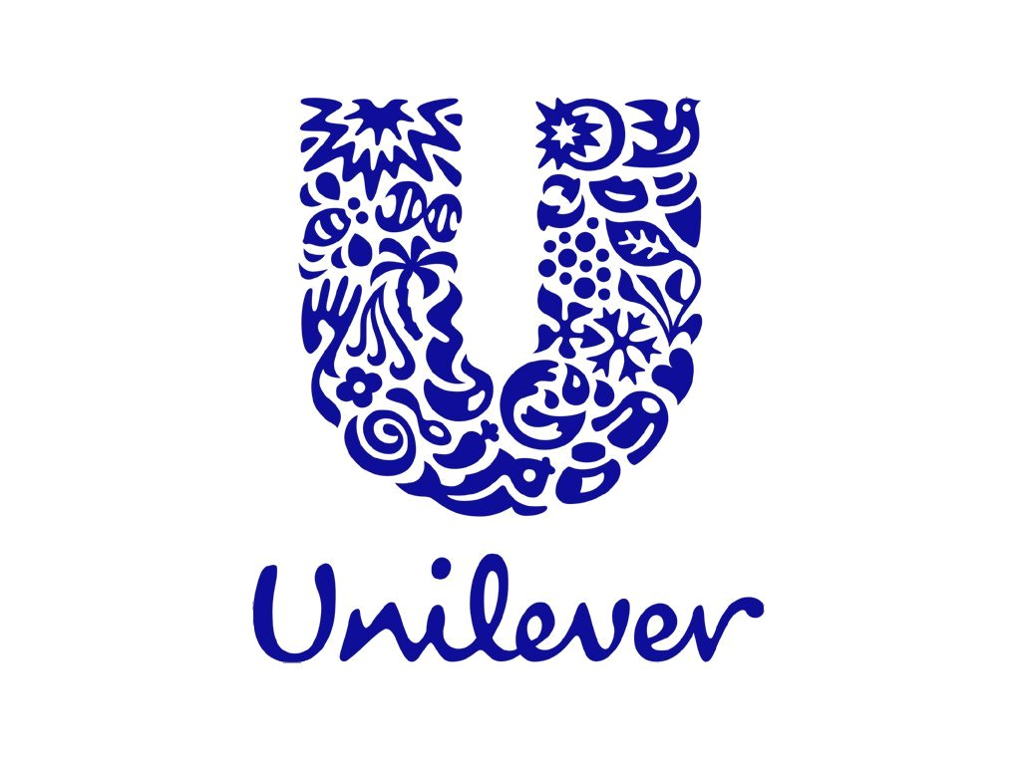

Introduction
This essay will investigate Unilever’s contribution to sustainability, and the actions they are taking to advance this, the findings will be analysed thus ending in conclusion.
History
Unilever is a consumer goods company, situated in two locations within the UK, then one location within Bangalore (India), Shanghai (China), Trumbull North (America), Vlaardingen (The Netherlands). “Founded on a sense of purpose” by Margine Unie and Lever Brothers formulating “one of the largest merges of its time” during September 1929. Its original focus was in the production of sale and soap, “to help popularise cleanliness and hygiene in Victorian England.” Hesketh Lever, founded of Lever Brothers also states, “purpose and mission has always been part of Unilever’s culture” (Unilever, 2019).
Contribution towards advancing sustainability
During the nineties Unilever had a major restructure to which stemmed its first sustainable project in 1996 “to source all fish from sustainable stocks” and establish the Marine Stewardship Council alongside the WWF to certificate sustainable fisheries. Year 2000 they open a “Health Institute – a centre of excellence in nutrition, health and vitality.” Unilever reveals in 2010 their Sustainable Living Plan to show how they are acting on waste and packaging, opportunities for women, sustainable sourcing, fairness in the workplace, water use and improving nutrition. Covering waste and packaging within Unilever their targets are to reduce waste from manufacturing and offices, for all products containing plastic packaging to be fully reusable, recyclable or compostable, reduce/recycle packaging, eliminate PVC, and tackle sachet waste. (Unilever, 2019).
Sustainable Stock
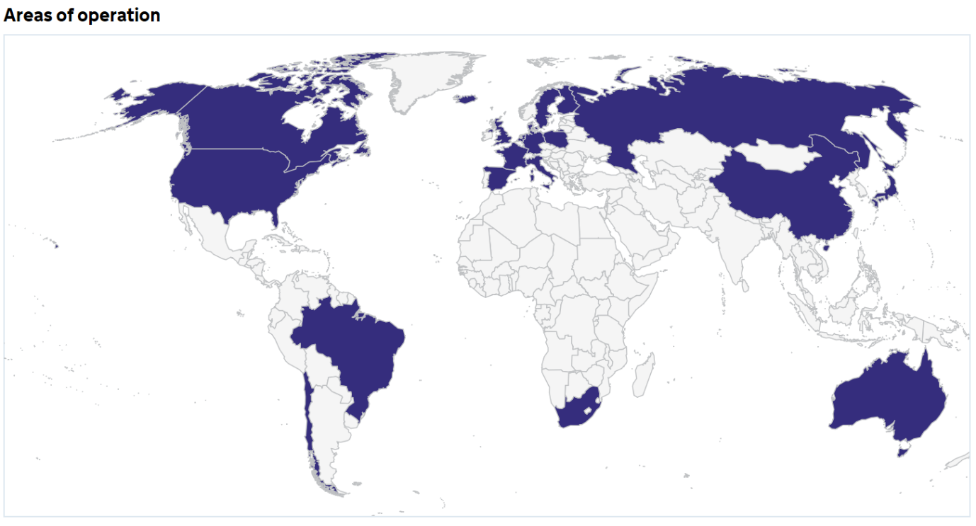
WWF (2018) confirm that the Marine Stewardship Council has indeed been operating for decades they now have a “internationally-recognized standard for fisheries environmental performance.” The Map above indicates ‘areas of operation’ for the council at present. Marine Stewardship Council (2018) also declared that their “first Mediterranean fishery” had acquired a certification, which displays an enormous effect in performance by the amount of locations acquired since operations begun. Below are two graphs; one that shows the financial history and the other compliance of the council. Over the years contributions from the public have increased thus discovering that this is of public interest and what the public feel strongly towards. The graphs also reveal that throughout the growth compliance records have broken-even every year which suggests that the Marine Stewardship Council is now standing strong and is truly set into the structure process of fisheries.
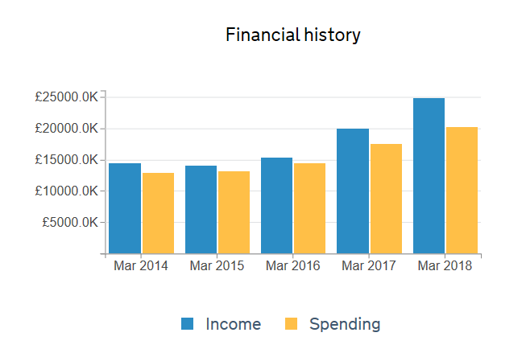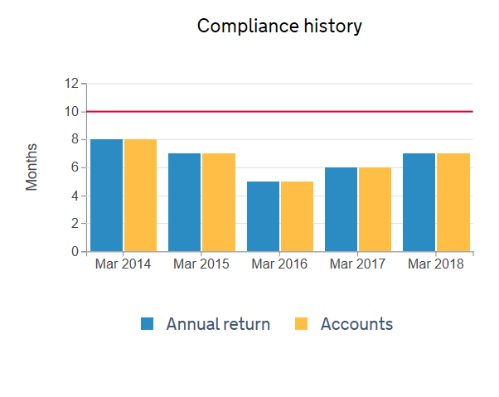
The Health Institute
One of its objectives is “employee health, nutrition and wellbeing” which is reflected highly by a former employee submitting, “they have an excellent work/life balance, great employee support mechanisms and a solid and achievable sustainability plan for the environment.” A current employees review seems to suggest that circumstances aren’t always positive by submitting cons to which one was management culture. Could this indicate that maybe the management style is too laid back therefore frustration and conflict could arise within the team leading to lessened productivity causing risk to the sustainable processes Unilever use (Unilever, 2019; Indeed, 2019).
Sustainable Living Plan
Conserve Energy Future (2019) defines sustainable living as “the practice of reducing your demand on natural resources” and ensuring used resources are replaced to one’s best ability. According to Newint (2017) Unilever’s plan “shows a company acutely aware of the great ecological and social challenges of our time, such as global warming, imminent food shortages and the ever-widening gap between rich and poor.” The plan has three major goals complying of many objectives, to meet the end targets. These are; improving health and wellbeing for more than a billion people, reducing environmental impact by half and to enhance livelihoods of millions (Unilever, 2019). Sustainable brands (2018) have displayed some accomplishments Unilever has made since announcing this plan. Since 2016 they have developed eight sustainable brands some are; “Vaseline, Sunlight, Sunsilk and Wall’s,” by doing this Unilever is combating a huge amount of plastic waste for business and consumers whilst promoting sustainability around the world. Taking this approach to the production and sale of Unilever products, reduces waste as cleaner alternative packaging is taken into account and used, as a result less manufacturing waste is accumulated and thus ripples down to when the packaging is easily recycled by the customer.
Waste and Packaging
Sustainability at Unilever (2011) briefly delves into the process the team goes through in reducing and developing packaging to “protect and preserve” products to meet a more sustainable level. Supported by Euromonitor International (2016) they believe “this trend is about ensuring consumer products are packaged appropriately to meet consumers’ needs and relevant to the time and occasion of consumption.” Over the years it has been easily noticeable how products have reduced in size, to the likes of aerosol cans being halved in size by compacting gas, or for plastic rings on beer cans to be replaced with cardboard, or only sold individually.
The Guardian (2012) announced that the “Unilever factory … India, has successfully used fuel extracted from post-industrial sachet waste to power its plant,” showing initiative for other companies to expand into green power. Qureshi (2017) revealed that Unilever had created CreaSolv a process to recycle sachets; for them to return to the supply chain by modification into plastic. Whilst this was announced seven years ago very little or no evidence can be found linking to the benefits or achievements of this process which could suggest Unilever may not be on schedule and that it is a harder area to aspire sustainable satisfaction. Whilst it is unknown the progress of this goal maybe Unilever has influenced other organisations to investigate this matter for example the UK Government (2018) announced that part of an “innovate scheme” that sauce sachets could be replaced by seaweed “to cut down on harmful plastic waste.”
Conclusion
It is easily shown through Unilever’s history that throughout operation they were trying to address issues concerning this area but, it was only in 2010 when they announced the sustainable living plan that they portrayed themselves as a strong influence, towards sustainability. Creating a council to observe and maintain the sustainable resourcing of fisheries is a massive achievement for a consumer goods company in itself and a relief for supermarkets/local food facilities by knowing they are not contributing to the demise of certain species but obtaining them from sustainable resources, this ensures the stock is high and treated correctly. Unilever concerned with their employee and consumer welfare developed the health institute, by doing this it created public interest therefore leading to the general public becoming more aware of this crucial topic. Waste and Packaging is a major factor present within sustainability and Unilever are forging many paths to accomplish it, they may not have much or any data on the progress at present, but they have their aims and objectives to which hopefully they will achieve in the future. As a whole Unilever seem to be creating a broad network/community to achieve sustainability far across the ocean whether this be within their management style or through their buyers, and in summary only a small part of the sustainable living plan was investigated. This shows that Unilever has a huge workforce dedicated to the upkeep of sustainability, and this essay can confirm that Unilever is bringing new technologies, contributing and advancing sustainability in business, and in day to day life since 1996 to present. As long as Unilever is still trading in the foreseeable future and carrying further the development of new ideas whilst inspiring others along the way, sustainable living will be a prominent aspect in everyone’s lives.

References
Beta Charity Commission (2018)
Areas of operation [image]
Available at: https://beta.charitycommission.gov.uk/charity-details/?regid=1066806&subid=0 (Accessed 23 November 2019)
Financials [bar graph]
Available at: https://beta.charitycommission.gov.uk/charity-details/?regid=1066806&subid=0 (Accessed 23 November 2019)
Bing (2011) Sustainability at Unilever, Protecting Products and the Planet [video]. 30 August.
Available at: https://www.bing.com/videos/search?q=unilever+waste+and+packaging&&view=detail&mid=9FF7DC4FF2F95562744E9FF7DC4FF2F95562744E&&FORM=VRDGAR
Bing (2019) Unilever [image]
Available at: https://www.bing.com/images/search?view=detailV2&id=A4E09D47BC3C04955D31CB526A309625B62D9753&thid=OIP.97Y33vlWcwl-TLNTANX3wHaFj&exph=768&expw=1024&q=unilever&selectedindex=1&ajaxhist=0&vt=0&eim=0,1,2,3,4,6,8,10 (Accessed 19 November 2019)
Conserve Energy Future (2019) Sustainable Living
Available at: https://www.conserve-energy-future.com/15-ideas-for-sustainable-living.php (Accessed 23 November 2019)
Dupont-Nivet D, Ruhaak A, Schuurs M, Tielbeke J, Woutersen, E (2017, April 13) Inside
Unilever’s Sustainability Myth
Available at: https://newint.org/features/web-exclusive/2017/04/13/inside-unilever-sustainability-myth/
Euro Monitor (2016) Smaller is Better as Global Packaging Growth is Shaped by Variation in Pack Sizes [blog]. 06 June.
Available at: https://blog.euromonitor.com/smaller-is-better-as-global-packaging-growth-is-shaped-by-variation-in-pack-sizes/
The Guardian (2019) Unilever Sustainable Living Plan
Available at: https://www.theguardian.com/sustainable-business/unilever-sustainable-living-plan (Accessed 24 November 2019)
Indeed (2018) Reviews
Available at: https://www.indeed.co.uk/cmp/Unilever/reviews (Accessed 24 November 2019)
Marine Stewardship Council (2018) Press releases
Available at: https://www.msc.org/media-centre/press-releases/first-mediterranean-fishery-gains-msc-certification (Accessed 23 November 2019)
Queshri W (2017, May 11). Unilever makes push for plastic sachet recycling, p. 1.
Available at: https://www.packagingnews.co.uk/news/environment/unilever-makes-push-for-plastic-sachet-recycling-11-05-2017
UK Government (2018) Dissolving seaweed sauce sachets among innovative schemes to cut down on harmful plastic waste
Available at: https://www.gov.uk/government/news/dissolving-seaweed-sauce-sachets-among-innovative-schemes-to-cut-down-on-harmful-plastic-waste (Accessed 24 November 2019)
Unilever (2019) 1920-1929 Unilever is formed
Available at: https://www.unilever.co.uk/about/who-we-are/our-history/1920-1929.html (Accessed 20 November 2019).
1990-1999 Restructuring and Consolidating
Available at: https://www.unilever.co.uk/about/who-we-are/our-history/1990-1999.html (Accessed 20 November 2019).
2010-present. Sustainable Living
Available at: https://www.unilever.co.uk/about/who-we-are/our-history/2010-present.html (Accessed 20 November 2019).
Our History
Available at: https://www.unilever.com/about/who-we-are/our-history/ (Accessed 20 November 2019).
Our R & D Locations.
Available at: https://www.unilever.com/about/innovation/our-r-and-d-locations/ (Accessed 20 November 2019).
WWF (2018) WWF statement on Marine Stewardship Council Reforms [blog]. 29 March.
Available at: http://wwf.panda.org/wwf_news/?325605/WWF-Statement-on-Marine-Stewardship-Council-Reforms

