MODULE HANDBOOK
Leading and Developing People
BMBM6012
LEVEL 6
Assignment title: The complexity of modern leadership: a case study of Reed Hastings
Student Name: Jing Cai
Student ID: 2200245
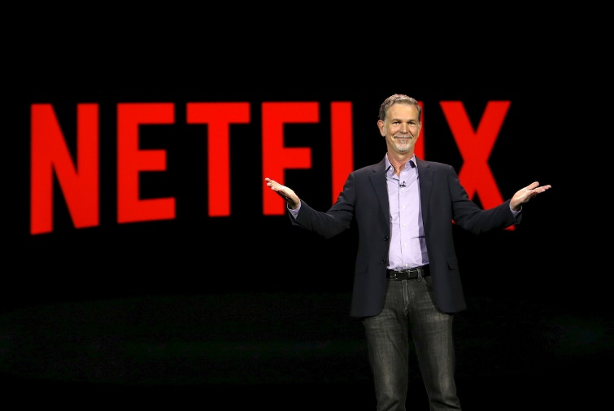

Introduction
The present essay intends to shed light on the leader of Netflix – Reed Hastings. Hastings was an American-born entrepreneur. He received Marine Corps officer training when he was young, and attained a bachelor’s degree in mathematics at Bowdoin College. Hastings joined the Peace Corps and taught high school mathematics in Swaziland, South Africa, from 1983 to 1985. He credits his entrepreneurial spirit to this period of experience, as he recalled “ If you've experienced hitchhiking in Africa with ten dollars, entrepreneurship doesn't seem too intimidating." (Hastings and Meyer, 2022) After returning from the Peace Corps, he furthered his master's education in computer science at Stanford University in 1988.
Hastings started to work at Adaptive Technology upon his graduation, where he was responsible for creating debugging tools. He left the company in 1997 for entrepreneurship, and he created Pure Software to develop troubleshooting software. Although Pure was acquired by Rational Software, Hastings did not perceive it as a success the share prices dropped significantly after the acquisition announcement (Grinapol, 2013). Hastings was appointed Chief Technology Officer of the combined company and left shortly after the acquisition. This up-and-down experience allowed Hastings to spend two years thinking about how to avoid similar problems in his next venture.
After leaving Pure, Hastings didn't stop with his entrepreneurial endeavours. One day when he was fined $40 for not regularly returning the movie discs he had rented from a disc renter, it occurred to him that it would be nice if there was a smarter and more convenient way to rent movies while also reminding customers of deadlines (Jenner, 2018). In 1997, Hastings and former Pure Soft employee Marc Randolph co-founded Netflix, a service they offer to US customers to rent movies for a fixed price by mail. Later, Netflix successfully transited from the disc-renting business to the blue ocean of live streaming, and its initiative opened a new era of video streaming (Grinapol, 2013). So far, Netflix, under the leadership of Hastings as the chief executive officer, is the absolute dominant market leader within the global streaming market, with a market share of 39.4%. (See the following figure) (T4, 2021).
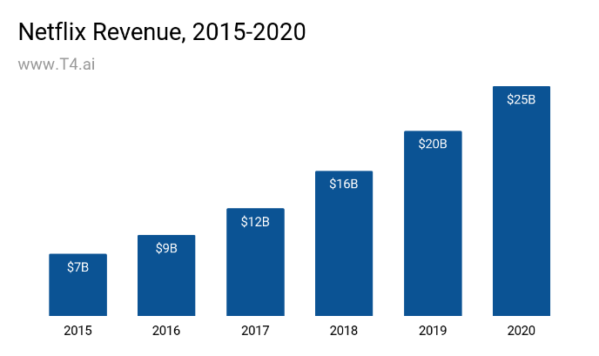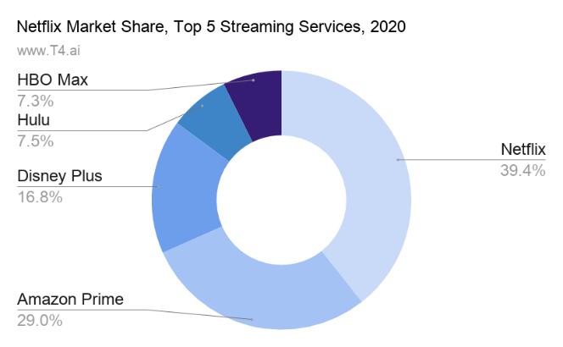
Figure 1: The revenue of Netflix (left); the market share of leading streaming service provider(right)
Source: (T4, 2021)
Hastings is well known for its particular focus and ambition for innovation, which is well reflected in the following quote: “Don’t be afraid to change the model”. It can be argued that the streaming service market is created by Netflix, and so far, is dominated by Netflix, but the market is filled with hyper-competition, extensive complexities, and uncertainties. Having considered the environment within which Hastings operates, the present essay aims to critically evaluate whether his leadership approach is effective in inspiring innovation, adaption and high performance.

Leadership in uncertainty and complexity

The complexity of the streaming service industry
The streaming industry is featured with particular uncertainty and complexity. It is expected that the changed consumer behavior due to the sudden outbreak of covid-19, represented by more people staying at home and choosing streaming services, will continue to benefit the industry for a while (Lotz, 2021). However, the industry as a whole still faces several challenges due to intensified competition and economic uncertainty (Lamkhede and Das, 2019; Kweon and Kweon, 2021).
On the one hand, the production of content is the lifeblood of streaming platforms, and when platforms run out of "inventory" in the future, they may be left with a shortage of new content. For this reason, some streaming platforms are exploring new production models, including partnerships with the film industry, such as Disney's choice to launch films on its streaming platform that were originally planned for theatrical release (Snyman and Gilliard, 2019). On the other hand, major film and media companies have been experimenting with streaming media, leaving the industry saturated and the market increasingly competitive (Oliveira, Azevedo and da Silva, 2020). This has forced platforms to innovate their services and implement differentiation strategies through continuous innovation.
Netflix's share price doubled sevenfold in the five years from 2017 to 2021, while in 2021 Netflix's share price experienced a price cliff plunge that affected the entire streaming, film and TV section along with it (CNBC, 2022). The company believes a number of factors have contributed to this outcome, firstly because the market has saturated and the entry of competitors such as Disney+ and Paramount+ into the streaming AV platform fray has made the competition more intense, in addition to this, Netflix also believes that shared accounts are one of the key barriers to subscriber growth and is therefore thinking about how to deal with it (Yahoo Finance, 2022).
The above analysis indicates the volatilities, uncertainties, and complexities of the global streaming market, which calls for effective leadership for promoting innovation, adaptation, and performance.
2.2 The effectiveness of the leadership approach in dealing with complexity
Leadership theory began with leadership trait theory, which started with the "great man theory" in the early 20th century. By the 1930s, the theory had become more focused on the psychological, personality, intellectual, and competency characteristics of leaders. Kirkpatrick and Locke (1996) argue that personal qualities give an individual the "right qualifications" to be a competent leader and that qualities are "prerequisites" for being a leader. The key qualities are motivation, honesty, integrity, self-confidence, collaboration, and expertise. In the 1950s, leadership behavior theory focused on the impact of leader behaviour on followers and suggested that leadership could be studied in terms of the impact of leader behaviour on followers, evolving from trait theory, where specific practical behaviours could be learned to ensure effective leaders. In the 1960s, Fiedler (1964) developed the theory of leadership contigency, which emphasises the pattern of interaction between leader styles and situations, viewing the organisation as an open system that evolves through constant interaction with its environment. Later, Bass and Riggio (1998) promoted the transformational leadership theory with an essence in the inspiration of deliveries and changes. The initiative has directed the research of leadership into a new paradigm of leadership style categorization. However, despite the difficulties in conceptualizing leadership, it can be argued that leadership has become one of the components necessary to determine the overall competencies of a leader, and it has been perceived as one fundamental precondition for the strategic effectiveness, especially under uncertainty an complexity.
Transformational leadership theory will be leveraged here to analyze Hastings’ behaviorus when leading Netflix, along with a comprehensive discussion of whether Hastings demonstrates characteristics associated with emotional and social intelligence. Transformational leadership, defined by Bass and Riggio (1998) aims o stimulate the subordinates to deliver beyond what they are required, build an environment that supports mutual trust, and motivate employees for active engagement and commitment. According to Bass and Riggio (1998), There are four main ways in which transformational leaders can influence their employees: idealised influence (the influence ushered from the leader’s personality), inspirational motivation (the ability of the leader to develop a well-articulated vision), intellectual stimulation ( the ability to encourage innovation) and individual care (the ability to care employees genuinely)
In terms of personal influence, Hastings is clear and straightforward that there are certain things a leader has to do to get feedback from his employees. Not only does he have to ask his employees for feedback, but he has to tell them that he expects their feedback on Netflix, and Hastings gets feedback in both ways on a regular basis. One of the items he receives more negative feedback on than any other leader in the company is his written 360-degree assessment. This assessment of his is available to everyone and he is constantly getting more feedback than any other employee. Hastings constantly solicits feedback and responds honestly through recognition prompts. He has even spoken in public about his joy at receiving critical comments. The following passage is taken from a memo he shared with all Netflix employees in 2019: "It's exciting to read 360-degree written feedback. I find that it is precisely the most outspoken criticism that is most helpful to me. So, in the spirit of 360-degree feedback, I thank you all for your courage and honesty in pointing out problems to me" (Hastings and Meyer, 2022). Hastings's openness and encouragement of feedback have resulted in a highly positive and transparent communication culture within Netflix, reflected in the 4A principles of the feedback mechanism in Netflix (Aim to Assist, Actionable, Appreciate, and Accept or discard) (McCord, 2014). The bi-directional and transparent feedback mechanism within Netflix has served as the basis of its social intelligence and emotional intelligence of Hastings, as the mechanism develops mutual understanding, trust, and respect between Hastings and employees (Worley, Williams and Lawler, 2016). Based on this, Hastings is able to manage his emotions, and how his emotions, based on his personal influence on Netflix could influence people around him.
In terms of inspiration motivation, at Netflix, the goals for the future of the company are not controlled and measured by KPIs. Hastings believes that the goal is to make employees feel like they own the company and thus increase their sense of responsibility (Rataul, Tisch and Zámborský, 2018). The sense of responsibility allows employees across levels to develop business acumen, with sensitivity to any market shifts internally and externally, as to eliminate threats and seize opportunities. This is especially relevant for competing in a highly uncertain and complex environment while the predetermination of strategic goals can be less effective due to the rapidly changing landscape (Gulati, 2019). The entrepreneurship orientation and market orientation allow the employees of Netflix to be directed by the lasted trends or changes in the market and effectively adjust their current operational activities accordingly (Smith and Cao, 2007). Thus, being directed by the market rather than the predetermined KPI, Netflix could effectively foster adaptation and innovation. As such, Netflix is a loosely coupled company with an 'informed command' model with a highly flat organizational structure and highly decentralized decision-making process (Jaworski, 2021). The flexibility has allowed employees to avoid bureaucratic procedures but spare more time and resources in the value-added activities
In terms of intellectual stimulation, Hastings believes that the core of the Netflix culture is talent, based on the "talent efficiency phenomenon" that “we must all focus on, i.e., that a talented person will produce several times more innovation than a moderately competent person, and that this multiplier will continue to increase as technology and innovation develop” (Hastings and Meyer, 2022). It is important to emphasize that this talent efficiency phenomenon is directed at jobs where innovation is decisive, such as technology research and product development. In response to this phenomenon, Hastings proposes to use talent density as the core basis for a company's innovation capacity. Because the best people inspire other good people, and the best people create outstanding results that infect more good people. Based on this management philosophy, Hastings has boldly explored different management mechanisms to increase talent density. The first is a talent compensation strategy. Netflix is obsessed with finding top talent to join the company and is unwavering in its commitment to pay the highest salaries in the market for the respective positions (Mier and Kohli, 2021). The second is the retention strategy; Hastings' approach is unconventional, as employees at Netflix can be told to leave at any time if they do not keep up with the pace of innovation, even if they are working hard and contributing. At the same time, without access to the opinions and advice of others, Hastings believes he can't make the best decisions. That's why Hastings and the rest of the Netflix staff actively seek different opinions before making major decisions - they call it gathering dissent (Hastings and Meyer, 2022). As a rule, Hastings tries to avoid having too many processes in place, but the basic principle of gathering dissent is so important that Netflix has systems in place to ensure that different voices are heard before decisions are made. At the same time, Hastings' response is a really good way to inspire innovation in its employees: “firstly, if you fail to make a decision, your manager will ask you what you learned from it, and secondly, if you make an important decision and it fails, no one will laugh at you and you won't lose your job because of that one failure!” (Hastings and Meyer, 2022)
In terms of personal care, Hastings found that employees were most creative "when they were paid well enough to help ease the burden on their families. But if they are not sure they will be paid extra, creativity declines". The whole premise of the bonus system is that the company can make reliable predictions about the future and can set a target at a certain time that will remain critical in the future. At Netflix, however, Hastings believes that "we must be able to adjust our direction quickly to respond to rapid change" (Hastings and Meyer, 2022). Hastings said that "the last thing we want is for our employees to achieve the goals they set in January of the same year in December and still be rewarded. The risk with this approach is that employees will focus on the goal itself and not consider what is best for the company's development at this stage" (McDonald and Smith-Rowsey, 2018). It follows that what is conducive to stimulating creativity is a sufficiently high salary, not a performance bonus. This is why Netflix's direct care for its employees is the highest salary in the industry. At the same time, Netflix has abolished the rules on employee holidays, giving employees full freedom to decide when and how many days to take off; secondly, Netflix has abolished travel and funding approvals (Jenner, 2018). These policies give employees more freedom and personal attention in different dimensions, allowing them to make greater use of their talents, but also requiring them to take further corporate responsibility and control the risks that this entails (Aversa, Haefliger and Reza, 2017).

Conclusion
In summary, transformational leadership has been adopted by Hastings and has been well performed on Netflix through the above discussion. The core of Hastings' Netflix culture is talent, which is based on the theory of the 'talent effectiveness phenomenon'. High talent density is only the basis for innovation, to give full play to the innovation potential of these people, companies must also establish a multi-level, multi-dimensional, complete culture and management system, and this corporate culture requires the underlying foundation of open communication and positive and effective feedback. Based on high talent density and effective communication and feedback, Hastings has created a series of innovative and effective leadership practices that all revolve around decentralising management, while also allowing them to take on their corresponding corporate responsibilities. As a result of Hastings and his team's long-term efforts, Netflix has developed a very unique and strong corporate culture, which is constantly evolving and renewing itself, and this ushers significant ability to Netflix to adapt, innovate and generate high performance continuously against the market uncertainty and complexities.

References
Aversa, P., Haefliger, S. and Reza, D.G. (2017) ‘Building a winning business model portfolio’, MIT Sloan Management Review, 58(4), pp. 49–54.
Bass, B.M. and Riggio, R.E. (1998) Transformational leadership. Psychology press.
CNBC (2022) Netflix stock plunges on shocking subscriber loss. Available at: https://www.cnbc.com/2022/04/20/netflix-plunges-trading-subscriber-loss.html (Accessed: 9 March 2023).
Fiedler, F.E. (1964) ‘A contingency model of leadership effectiveness’, in Advances in experimental social psychology. Elsevier, pp. 149–190.
Grinapol, C. (2013) Reed Hastings and Netflix. The Rosen Publishing Group, Inc.
Gulati, R. (2019) ‘The soul of a start-up: companies can sustain their entrepreneurial energy even as they grow’, Harvard Business Review, 97(4), pp. 84–92.
Hastings, R. and Meyer, E. (2022) ‘Review of No Rules Rule: Netflix and the Culture of Reinvention’, Level 3, 17(1), p. 3.
Jaworski, B.J. (2021) ‘Netflix: Reinvention across multiple time periods’, AMS Review, 11(1–2), pp. 180–193.
Jenner, M. (2018) Netflix and the Re-invention of Television. Springer.
Kirkpatrick, S.A. and Locke, E.A. (1996) ‘Direct and indirect effects of three core charismatic leadership components on performance and attitudes.’, Journal of applied psychology, 81(1), p. 36.
Kweon, H.J. and Kweon, S.H. (2021) ‘Pricing strategy within the US streaming services market: A focus on Netflix’s price plans’, International Journal of Contents, 17(2), pp. 1–8.
Lamkhede, S. and Das, S. (2019) ‘Challenges in search on streaming services: netflix case study’, in. Proceedings of the 42nd International ACM SIGIR Conference on Research and Development in Information Retrieval, pp. 1371–1374.
Lotz, A.D. (2021) ‘In between the global and the local: Mapping the geographies of Netflix as a multinational service’, International Journal of Cultural Studies, 24(2), pp. 195–215.
McCord, P. (2014) ‘How netflix reinvented HR’, Harvard Business Review, 92(1), pp. 71–76.
McDonald, K. and Smith-Rowsey, D. (2018) The Netflix effect: Technology and entertainment in the 21st century. Bloomsbury Publishing USA.
Mier, J. and Kohli, A.K. (2021) ‘Netflix: reinvention across multiple time periods, reflections and directions for future research’, AMS Review, 11, pp. 194–205.
Oliveira, A., Azevedo, A. and da Silva, S.M. (2020) ‘Streaming Services Consumer Behaviour: A Netflix User Case Study in Brazil and Portugal.’, in. ICETE (3), pp. 173–180.
Rataul, P., Tisch, D.G. and Zámborský, P. (2018) ‘Netflix: Dynamic capabilities for global success’, in SAGE Business Cases. SAGE Publications: SAGE Business Cases Originals.
Smith, K.G. and Cao, Q. (2007) ‘An entrepreneurial perspective on the firm‐environment relationship’, Strategic Entrepreneurship Journal, 1(3‐4), pp. 329–344.
Snyman, J.H. and Gilliard, D.J. (2019) ‘The streaming television industry: mature or still growing?’, Journal of marketing development and competitiveness, 13(4), pp. 94–105.
T4 (2021) Netflix Market Share. Available at: https://www.t4.ai/companies/netflix-market-share (Accessed: 9 March 2023).
Worley, C.G., Williams, T. and Lawler, E.E. (2016) ‘Creating management processes built for change’, MIT Sloan management review, 58(1), pp. 77–82.
Yahoo Finance (2022) Netflix stock sinks after reported ad target miss as analysts warn of ‘competitive disadvantage’. Available at: https://finance.yahoo.com/news/netflix-stock-sinks-after-reported-ad-target-miss-as-analysts-warn-of-competitive-disadvantage-154853513.html (Accessed: 9 March 2023).

