Managing enterprise in the 21st century
BMSW4006_LON

-BALKAN-
Eastern European Food Shop
Business plan

Business/Company overview -- Elizabeta Trapkovska (1920278)
Product and Services ------------ Georgi Todorov (1922057)
Market and Targets --------------- Lidia Temelkovska (1920277)
Marketing ---------------------------- Vera Ursu (1918683)
Management team ---------------- Sakib Sikder (1921335)
Financial information -------------- Xenia Eniko Gyorgy (1921775)

Lecturer: Ejiro Esohwode

Date: 08/12/2020

Table of content
1 | Executive Summary | 3
2 | Company Overview | 3
2.1 | Mission, Vision, Objectives, and Core competencies | 4
2.2 | Stakeholders’ Analysis | 4
2.3 | SWOT Analysis | 6
2.4 | Influences of the external environment on Eastern European Foods Limited | 7
3 | Products and services | 9
3.1 | Different layers of products | 10
3.2 | Products of ‘Balkan’ Eastern European Food Shop | 10
3.3 | Services of ‘Balkan’ Eastern European Food Shop | 13
4 | Market audit of ‘Balkan’ Eastern European Food Shop | 15
4.1 | Internal marketing environment | 16
4.2 | External marketing environment | 17
4.3 | Evaluating the current market strategy | 17
5 | Target market analysis of ‘Balkan’ Eastern European Food Shop | 18
5.1 | Targeting | 19
5.2 | Positioning | 19
6 | Marketing plan | 20
7 | Marketing strategies | 24
7.1 | Social media | 24
7.2 | Web-site | 24
7.3 | Advertising | 25
7.4 | Exceptional customer services | 26
8 | Competitors | 26
8.1 | Strength and weaknesses of competitors | 27
9 | SWOT Analysis | 28
9.1 | Strengths | 28
9.2 | Weaknesses | 28
9.3 | Opportunities | 29
9.4 | Threats | 29
9.5 | Unique selling point | 30
10 | Managing team | 30
10.1 | Key roles | 30
10.2 | Personnel plan | 31
10.3 | Strengths and weaknesses | 32
10.4 | Suppliers | 33
11 | Finance plan | 35
11.1 | Keys to financial success | 36
11.2 | Sales strategy | 36
11.3 | Expenses | 38
11.4 | Funds required and use | 39
11.5 | Break-even analysis | 40
11.6 | Projected Profit as well as Loss | 40
11.7 | Projected cash flow | 42
11.8 | Projected balance sheet | 45
12 | Conclusion | 49
13 | References | 49
14 | Appendix – Converted presentation of business plan | 53

Executive summary
Eastern European Foods Limited – "Balkan" is an organization operating their business in London – Watford area, and they are engaging with providing suitable foods to their customers. This report will show our company overview of the mission, vision, goals, objectives, and core competencies. The organization's strategic management plan is well established, but they face some problems arising from the external environment. Their stakeholders are favorable to this organization, and the employees are paying their best responsibilities to this organization. The strengths and opportunities of this company are more than weaknesses and threats. The assignment will also cover its Product and services, Market audit plan, Target market analysis, the company's Marketing, Management, and Finance plan. It also shows the products and services of the company.

Company Overview
Eastern European Foods Limited is operating its business with a reputation from its inception. Balkan Eastern European Food Shop is a partnership founded by me Elizabeta Trapkovska, Georgi Todorov, Lidia Temelkovska, Vera Ursu, Sakib Sikder, and Xenia Gyrgu in 2020. We have all previously worked in retail and customer service. We all met during our studies in UWTSD. We have a clear vision for our shop, and we also have long term plans for development. We intend to sell eastern European food and fresh produce in our shop in Watford. We chose Watford as a location for our business as a starting point because many people from Eastern Europe and especially from the Balcan live in this area. We are investing an equal part of £5000 each in this partnership. Also, we are seeking a loan of £30000 more, and we are planning to return that money in a period of 10 years with 5% interest. We will use these funds for our set up cost and our first orders.
Since our company was incorporated in July 2020, we are giving our best to satisfy our customers. Basically, this is referred to as a private limited company and sells its products and services to non-specialized stores and consumers (Eastern European Foods Ltd, 2020).

Mission, Vision, objectives, and Core competencies of eastern European foods shop – "Balkan"
Mission: Our mission is to import quality food from the Balcan region and some Eastern European countries. We know that there is room for our small profitable shop with many immigrants in the U.K. and Watford area. We want to supply our customers with the best products and services and develop internally in every segment. This is the Eastern European foods shop – "Balkan" mission, and we will give our best level to accomplished.
Vision: The Vision of Eastern European foods shop - Balkan is to be the number one food provider in London, and we are trying to stretch our operational activities. Hopefully, our business will grow, and what started as a local shop will grow into a chain of shops for Eastern European food.
Objectives: The goals and objectives of Eastern European Foods limited are described below in brief.
- Satisfying the expected consumers
- Expanding their operational activities
- Maximizing the profit in the short term and maximizing the wealth in the long term
- Providing excellent and attractive quality foods
Core Competencies: Our employees and customers; our business politic is the core competencies and primary concern. Thus, we always try to provide satisfactory products to the customers and good behavior to the employees.

Stakeholders' Analysis
We are investing an equal part of £5000 each in this partnership, like that we decided that we will be equal stakeholders in our company. Stakeholders are those people who have some interest in that particular organization and who influence that organization in every step. The managerial public always takes stakeholders with top priority and sets their business policy in concern of its stakeholders (Ansoff et al., 2018). Basically, stakeholders are those people who are directly or indirectly engaged with the organization. The stakeholders of eastern European foods are employees, owners, managers, competitors, and suppliers. There are two basic types of stakeholders who influence the business organization.
Internal Stakeholders: Saying everything from above, it becomes that we are internal stakeholders, and we will directly impact the organization in every situation. Employees, owners, and managers are considered as internal stakeholders. They all have specific duties and responsibilities to the organization, and they are playing a vital role in this perspective.
External Stakeholders: external stakeholders refer to those stakeholders who significantly impact business organizations but do not influence directly. Indirectly they force the organization to set or formulate their rules and regulations in favor of them (Barney and Hesterly, 2010). Government, suppliers, and customers are the primary external stakeholders of eastern European foods limited.
Power interest matrix model can be used to clarify the condition of the stakeholders of a particular organization.
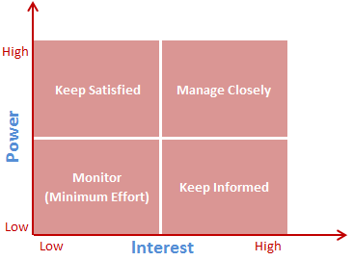
Figure: Power interest matrix model
Source: (Ansoff et al., 2018).
This model suggests how our organization can satisfy its internal and external stakeholders and, in return, achieve success. Stakeholders play a vital role in an organization to succeed or be a failure in the market. Sometimes, they can cause a great loss to the organization. So an organization should manage its stakeholders properly and try their level best to satisfy them (Palepu et al., 2020). The above-shown model demonstrates the measures or procedures that allow a company to handle its stakeholders appropriately. They are essential players who should be happy and prioritized by the company. If the stakeholders' influence is strong and the company's value is also high, they should be handled closely by the organization's top management. In this way, Eastern European Foods limited will virtually guarantee its success.

SWOT Analysis
Strengths, Weaknesses, Opportunities, and Threats are the four terms which are used to determine an organisation's market condition. SWOT analysis gives an overview about an organisation and by analysing this an organisation can take proper steps which help to compete with the competitors in the market.
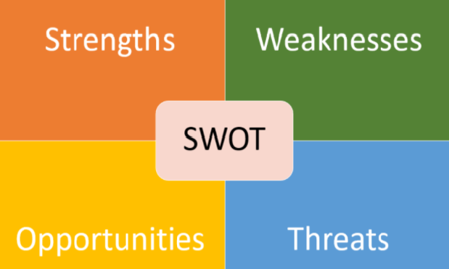
Figure: SWOT analysis
Source: (Gharajedaghi, 2011)
Strengths and weaknesses arise from the internal section of our organization, and the other two emerge from the external area of our organization. SWOT analysis of Eastern European Foods limited is discussed below with explanation.
Strengths: The local people know this food shop, and they will buy specific products from our shop. They are satisfied with this organization's service, and the number of customers is increasing day by day. This organization provides food and products to the customers, so they have a lower dependency upon others. Our customers' list is growing, and we are taking a suitable position in the market.
Weaknesses: The number of average employees is sex, and it is not perfect for providing service properly. So, they lack employees, which means that we need to work even more without enough time for rest.
Opportunities: People are moving to this area, which will give our shop the chance to grow into something bigger. The population growth rate is high, and their living standard is also increasing.
Threats: Competitors of food shops are increasing every day, and the global pandemic situation creates the wrong environment for our organization. The recent few years were not favorable for this kind of business organization because of the Brexit issue. This year the Covid-19 situation becomes a reason for significant loss for every business organization. Now, they are trying to face this by providing service online and parcel.

Influences of external environment on Eastern European Foods Limited
The internal and external environment are two influential environments which affect a business organization a lot in every step. This food provider organization faces some problems arising from its external environment. PESTEL analysis helps an organization to identify threats and opportunities which come from the macro environment of an organization.
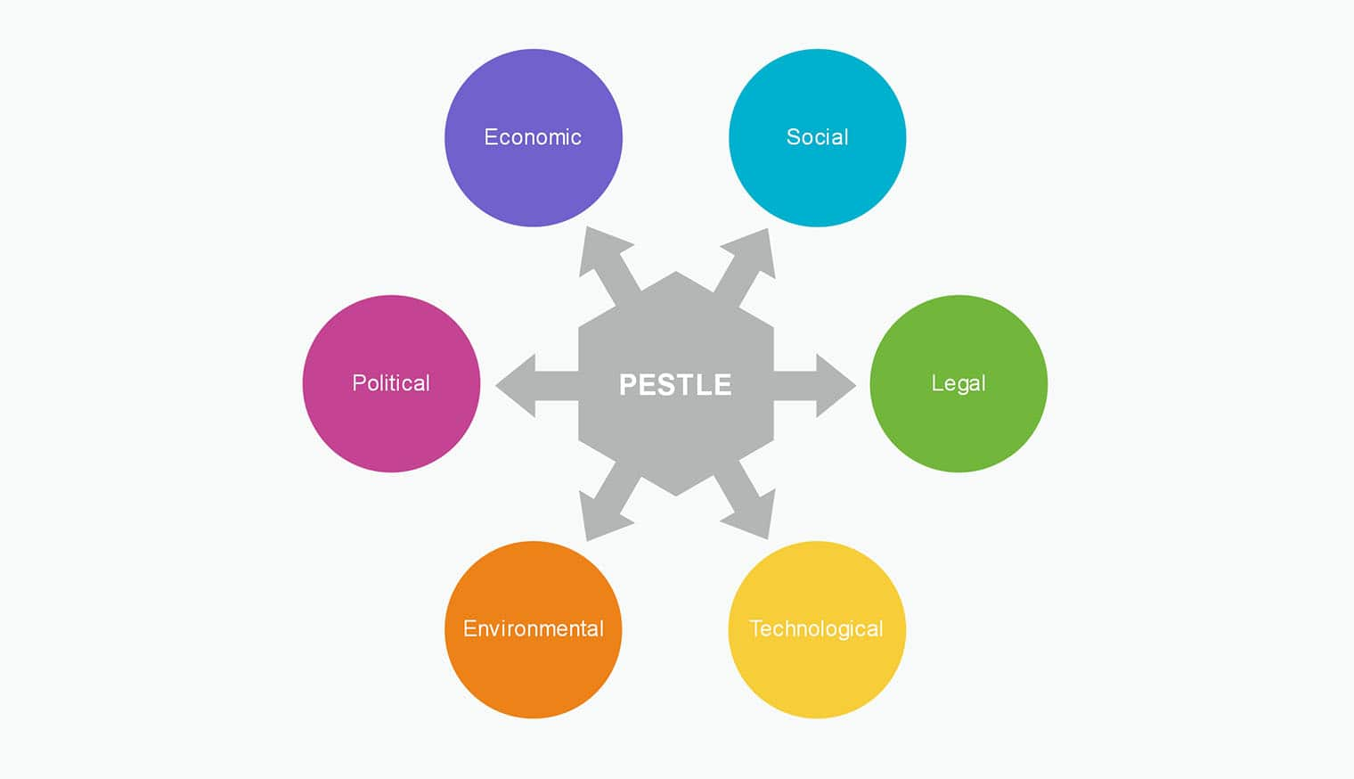
Figure: PESTEL analysis
Source: (Palepu et al., 2020)
Political Factors: Political influences are factors in which democracy, political parties, stable or dysfunctional political conditions are interlinked with each organization. These aspects often bring a significant loss to the company enterprise (Welford, 2014). For example, the Brexit problem has given rise to an unwanted circumstance for any organization, and the raw materials coming from other European countries can be received with considerable difficulty. Our organization will be able to avoid this problem because it's local and does not depend on other European countries.
Economic Factors: The economic practices of a nation, such as labor rates, bank rate, inflation rate, people's per capita income, interest rate, have an impact on the organization's environment. A company still needs a healthy economic climate that will help complete its commercial operations correctly (Barney and Hesterly, 2010). Now, the U.K.'s economic situation is suitable to run business organizations, and this organization can take this privilege.
Social Factors: A Corporation must conduct its corporate operations in the society of a country, and the features of the company have a direct effect on the business organization. Cultural activities, social expectations, and behavior, culture, population development, diversity are all influences that affect the entity (Ansoff et al., 2018). For illustration, as the birth rate is too high, the number of revenue will also rise, and it will be beneficial to make a profit. Eastern European Foods shop- Balkan can take this advantage in the U.K.'s market easily.
Technological Factors: Today, these company operations can conveniently be carried out with the aid of technical innovation, allowing the enterprise to reduce its operational and distribution costs. Customers can easily view campaigns that are important to a company via social media such as Facebook, Snap chat, Integra, and so on (Welford, 2014). At the period of Covid-19, Eastern European Foods shop - Balkan shipped the entire order electronically, and we were able to resolve these problems during this pandemic. We manage to overcome this as a problem only with the advancement of technologies and technological development.
Environmental Factors: Extreme warming and air degradation have become one of the world problems in recent decades. Climate plays a significant role in any company enterprise and must face it successfully (Daniels et al., 2014). Eastern European Foods Limited is an eco-sustainable organization that supplies suitable food to its customers. Eastern European Foods Limited uses a packet of this kind that is not liable for global pollution.
Legal Factors: Legal factors are the mixture of government rules, laws, regulations, and ordinances that affect the performance at every step of the way of an organization. Every plan should contain all the legal factors of an organization, and these criteria sometimes have a beneficial and sometimes detrimental effect (Welford, 2014). Eastern European Food shop - Balkan is a local organization and must abide by all the rules laid down by the Government.

Products and services
'Balkan' - Eastern European Food Shop will provide an extensive range of products and services. The company will offer both home delivery services and in-house services with a different range of products. The products and services of 'Balkan' - Eastern European Food Store are described below with details:

Different layers of products
The product baseline of the company is designed with different layers of product. The product layer of 'Balkan'- Eastern European Food Shop is described below:
Core product
The core product is the main benefit that is gained from the product purchase by a customer. The customers of 'Balkan' - Eastern European Food Shop purchase the products of food items to meet the needs of food and meet the needs of basic eating needs. The products' value can be gained by consuming the products effectively (Farmer et al., 2016). For example, the core product of the baby foods of 'Balkan' - Eastern European Food Shop is to feed the baby to meet the basic need of surviving.
Actual product
This is a tangible product that can be seen, and the customers initially purchase to meet the needs of food products. This is the actual product that the customer buys such as dairy products, frozen items, fruits and vegetables, baby foods, drink items, pickled vegetables etc. (Suslin and Gurov, 2017). The customers can directly observe the actual product by the physical presence, texture and color of the products to make a purchase decision.
Augmented product
This intangible product adds value to the actual product. Such as the warranty is given with the products and different service processes. The company's products are delivered in both online and offline services, which is one of the company's augmented products (Farmer et al., 2016).

Products of ‘Balkan’ Eastern European Food Shop
The shop is embedded with a different range of products, including grocery and food items. Those are described below:

Frozen food products
'Balkan" – Eastern European food shop Ltd. will provide a different kind of frozen products such as sausage, frozen meat, BBQ, frozen spices, frozen fruit, nuggets, bread, etc. The frozen foods are easy to store for a long time to add value in the production and cease the day to day life of the potential customers by providing frozen foods to ease the food consumption (Suslin and Gurov, 2017).
Dairy products
Our company will sell dairy products, including milk, cheese, mayonnaise, butter, and other dairy products that satisfy the needs of relevant target customers by meeting their needs. 'Balkan' - Eastern Eiropean Shop customers can get the required dairy products from both the outlets and the online and home delivery process.
Baking items
Our company also will provide baking items such as pastry, baking chocolate, melted chocolate, and other baking ingredients. The customers who are interested in baking purchase from the company to fulfill their needs as they can buy the products by sitting at home (Slocum and Curtis, 2017).
Pickles
'Balkan' - Eastern European Food Shop sells different pickled products that can be stored or consumed immediately after the purchase. Some pickled items of the company are mixed vegetables or separately beetroot, paprika, gherkins, mushrooms, etc. The target customers of the company reach to them anyhow to get the required products.
Meat items
Our company will provide different types of meat and meat products. As fresh meat, we will offer chicken, beef, lamb, and pork. We will also offer meat products such as sausages, salami, and even BBQ flavored meat, which will be frozen. The company has a massive demand for meat items because of the customers' reliability regarding the business to get fresh products.
Soup
Our company will sell different kinds of semi-processed or raw soup to the customers to meet their needs. The company is successful in modifying the taste and food habits of the target customers effectively.
Spices
'Balkan'- Eastern European Food Shop will sell different spices of several eastern european cuisine. The spices are the most demanded products as those spices can satisfy customers' demands of different regions to cook the eastern food by own to get a taste relevant to the specific area by avoiding restaurants to get a healthy life.
Desserts and supporting items
Our company will sell different dessert items, including cakes, cookies, ice-cream, halva, chocolates etc. The supporting items such as jam, jelly, honey, chocolate items etc. Also, have a massive demand in the potential market.
Fruits and vegetables
Our company will provide different kinds of fresh fruits, vegetables, and juice to the target customers (Slocum and Curtis, 2017). Our organization will always collect fresh fruits and vegetables to retain our target customers to get a competitive advantage. Fresh fruit juice is also a valuable addition in our shops that is demanded by the customers.
Coffee and drinks
'Balkan"- Eastern European Food Shop will sell different types of quality coffees, hard and soft drinks, water, and other liquid food items. The company is famous for selling different packages of beverages such as Vodka and champaign (Teller, et al., 2018).
Baby foods
'Balkan' - Eastern European Food Shop will sell each sort of baby food to grab a large variety of market. The families are more concerned about purchasing foods for their babies. In this regard, our company imports and distributes quality foods for children with the utmost health guarantee.
Different types of products that 'Balkan' - Eastern European Food Shop Ltd., will provide other purposes to meet several target customers' needs.

Services of ‘Balkan’ Eastern European Food Shop
The company will be efficient in serving customers in different ways. The customers nowadays want the maximum convenience in return for their payment for a purchase. For this reason, they find places where they can find the utmost comfort to get the required products and services. Different services that will be found in 'Balkan' - Eastern European Food Shop are described below:
Both online and offline services
Our organization will serve food items, including processed and semi-processed food, in online and offline services. The potential target customers of 'Balkan' - Eastern European Food Shop can walk in and choose the required products by themselves to clear the confusion and purchase the products needed with their expected price. On the other hand, the company also will be taking online orders to make the services convenient for them to achieve purposes (Slocum and Curtis, 2017). The company can be successful by developing an appropriate online-based service action to grab the maximum portion of the target market. Due to the lockdown because of the outbreak of Covid-19, most people around the world have become dependent on the online ordering and delivery process to ensure the safety of the customers (Sparks, 2016, p. 200). Our organization also gives priority to the customers' demands, which means if they want to visit us and buy from the shop, they are welcomed. But if it is more convenient for them, they can make online orders.
Home delivery within three days
Our company will provide the product in the home delivery system within a maximum of three days in the places where they serve the services. The home delivery depends on the distance where it should be delivered and the number of products ordered. Our organization can feel the customers' problems and inconvenience of going to the shop and taking their required products. In this regard, they started home delivery services (Teller, et al., 2018). We improve our service quality from time to time, and the result is delivered in a maximum of three days to make the customers happy and serve the needs of the potential customers.
Establishing export and import services
In the beginning, 'Balkan' – Eastern European food shop will provide most of the products from "Magaza" food shop. And also, different products from other European countries, from different U.K. suppliers. The research regarding the company's customers has found the need to import different branded products to meet particular customers. On the other hand, the organization has seen the demand for their products outside the country (Sparks, 2016). For this reason, our company would start importing and exporting products to achieve the maximum target customers and satisfy their needs as well.
Feedback management
The company will take feedback from the customers about their complaints, negative reviews, and political views as well. Our organization takes feedback about the products and services after the usage to know the drawbacks of the organization to improve, quality of services through different strategies and product and service development. Proper feedback management helps the company develop its reliability and trust to gain a competitive advantage (Teller, et al., 2018).
Serving new products
"Balkan" - Eastern European Food Shop will always research the market trends and the potential market to serve the customers' needs (Sparks, 2016). In this way, our organization will analyze the customers' needs and design the services according to the potential market's benefit to grab customers' attention to retain the existing customers and catch new customers

Different promotional activities
Our organization will develop services and attract customers while launching different promotional discounts and sales to attain the target customers' interest. The organization's customers can contribute to the organization's success by giving deals and sales promotions to provide the needed products at a minimum price to increase sales and improve customers' range (Teller, et al., 2018).
Our organization's services, named 'Balkan' - Eastern European Food Shop Ltd., enhance the value of the products to develop the customers' satisfaction towards the company for grabbing a large number of customers towards the company in the shortest possible time. The company is liable to take responsibility for any kind of mistake in the service distribution to develop the customers' power.

Market audit of ‘Balkan’ Eastern European Food Shop

In every business there is doubt why a marketing audit is even necessary. But a marketing audit is an extraordinarily functional and practical tool especially for small business in particular us. That is to be better and stronger, totally understand the current marketing ecosystem at their disposal, formulate a distinct marketing plan and policy. Marketing audit helps to solve any primary problems that can be revealed through the audit process. The marketing audit gives us management with an in-depth observation at the marketing performance of the business, which enables them to evaluate the execution, budget, and resources accessible to the department as a whole.
This is an effective element of developing business plan of a business, which encompasses marketing environment of a business. Before developing marketing plan of a business plan, it is very crucial for conducting the marketing environment of a business for gaining comprehensive knowledge and idea about the market condition of a business (Eshleman and Lawson, 2017). This part of this business plan will examine both internal and external marketing environment of Eastern European Food Shop. This analyzing will help to develop robust marketing strategy for the business as well as preparing marketing plan for the business, which can help the business to gain competitive advantage over the competitors of the business.
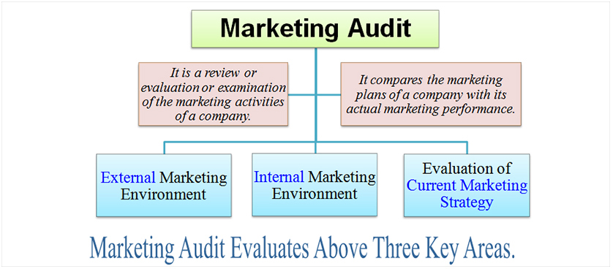
Figure: Marketing audit
Source: (L’AUDIT MARKETING and DE, 2019)

The marketing audit of a business generally underscores on above three areas which are external marketing environment of a business, internal marketing environment of a business as well as evaluation of the current marketing strategy of a business. a proper marketing audit of Eastern Food Shop is given below.
  - Internal marketing environment
Internal marketing environment of the business is associated with the internal stakeholders of the business who play a very significant role regarding the marketing process development of the business. for example, the employees, suppliers, management body have significant impact regarding the marketing plan development of the business ((L'AUDIT MARKETING and DE, 2019). there are several issues which should be considered while developing the internal marketing strategy for examining core competency and capabilities of a business for meeting their marketing goals. For example, for auditing the internal marketing environment of Eastern European Food shop, attention should need to be given on the capabilities and skills of the employees of the business. Visions, mission and objectives of this business, goals of the stakeholders as well as the running marketing strategy of the business.
  - External marketing environment
Regarding the effective market audit of the Eastern European Food Shop, attentions should also be given regarding the external marketing environment of the business which is also very crucial for developing robust marketing strategy for the business. External marketing environment of Eastern European Food shop is associated with the external stakeholders of the business who remain out of the control of the business, but these elements have significant impact on the marketing plan of a business (Eshleman and Lawson, 2017). Regarding the audit of external marketing environment, attention should be given regarding the needs and wants of the customers, demand of the host community, government rules etc. these are very influential issues on the development of marketing plan for this business and this auditing can help to develop good marketing plan for the business in the future.
  - Evaluating current marketing strategy
Evaluation of current marketing strategy is also necessary for preparing marketing plan of a business. For developing future marketing plan of Eastern European Food shop, it is very necessary to evaluate the current marketing strategy of the business. In this regard, different issues should be analyzed (Lamb and Crompton, 2017). For example, the current product quality of the shop, pricing strategy of the shop, places strategy of the shop as well as the promotional strategy of the shop. Evaluation of these areas can help to gather valuable information to prepare future marketing plan for the shop.
- Target market analysis of ‘Balkan’ Eastern European Food shop
Identifying the target market is the crucial part of every business plan and on the perspective of European Food Shop, it is also very crucial to analyze the target market. Target market is that particular segment of a business for which the business will produce their products for satisfying their needs and wants. So, in this regard, the defining the target market is very necessary. While selecting the target market, the business should determine the needs and wants of the key customers of hat particular market, behavioral characteristics of them as well as their economic condition (Kohne, 2019). In this regard, the business should select the profitable market which can provide higher profitability opportunity for the business as the success of a business is highly dependent on the successful selection of the profitable target market as well as positioning the products and services according to the needs of that particular market. European Food Shop can implement segmentation, targeting and positioning strategy for selecting the most profitable market for the business.
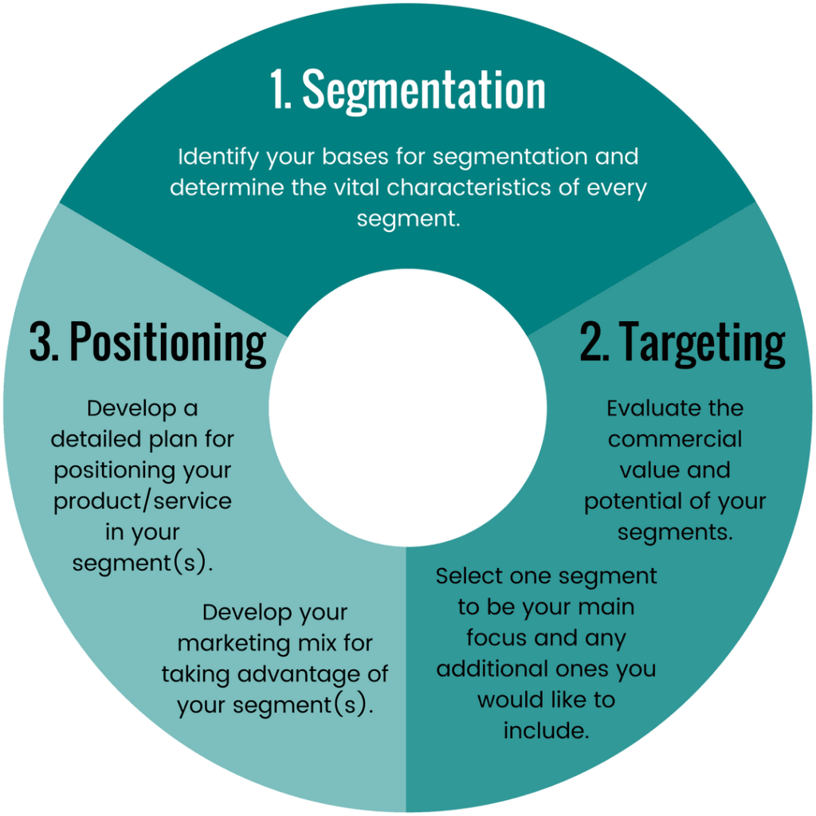
Figure: Segmentation, targeting and position (STP)
Source: (Andaleeb, 2016)
Segmentation: this strategy can help to segment the market according to different characteristics of the customers. for example, market can be divided regarding the income level of the customers, psychographic characteristics, behaviousral characteristics, psychographic characteristics etc. after the classification the best segment which will seem the most profitable for the business will be selected (Camilleri, 2018). For example, as the European Food Shop supplies food products to the customers, market segmentation in this regard can conduct according to the demographic characteristics of the market. In this regard, the key customers of the country will be divided according to the age, gender, income, lifestyles, social class etc.
  - Targeting
After segmenting the market, the targeting approach will be adopted which will help the business to choose the best market after the segmentation. Perfect targeting is very crucial because positioning strategy will be adopted on the targeted market segment. In this shop as well as the marketing department should need to be very tactic as they need to pick the best segment from the set of the different market segment (Kohne, 2019). In this regard, the business should analyze their own food products as well as the choices, lifestyle, income level, buying behavior of all segments. After perfect analyzing, the business should have to choose the best segment which can provide the best profitability opportunity for the business.
  - Positioning
After conducting the targeting step, the business will then select the best market on which the business will conduct its business. In this regard, the business should have conducts robust marketing strategy for identifying the needs and wants of the customers as well as their requirement towards certain products (Andaleeb, 2016). For, example, target market wants more nutritious food for their meal. In this regard, the business should focus on adding nutritious value in the products of the business. At this positioning stage, the business also should have to conduct marketing strategy to inform the customers about the products and services of the business as well as attract them to the business.

Marketing plan of Eastern European Food Shop
Executive summary
Marketing plan can be defined as a written, which includes the marketing activities of a business. Marketing plan is a very essential tool of a shop, which can help to conduct the marketing activities of a business very effectively and efficiently. European Food Shop is food Supplier business that sell food items and this marketing plan will be conducted to develop marketing plan of this business regarding the healthy food items.
Business overview: European Food Shop is private shop, which was established in 2011, and since then it has been operating its business very honestly by providing good and healthy foods to the customers (Chernev, 2020). This is food Retailer business that generally sells different types of food items to the customers.
Industry trends: The demand of food Market business is increasing around the world and this is not exceptional on the perspective of UK. People are being so much busy with their work day by day and they are relying highly on readymade food item because cooking may cause huge spend of their time.
Goals and objectives:
- Defining the profitable market segment for the shop
- Increase the sale of the business by 30% within 6 months
- Increase the customer satisfaction of the business
- Identifying the scope of increasing the market of the business
Situational analysis: this is another crucial part of the development of the marketing plan of a shop. For the development of marketing plan of European Food Shop, the marketing department of the shop should have to conduct the situational analysis of the business (Wood and Jobber, 2016). Regarding the situational analysis, the business should have to consider the market trend, condition of the competitors as well as the level of competition in the target market.
PEST analysis:
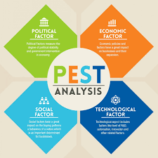
Figure: PEST analysis
Source: (Barabás, 2018).
After conducting the perfect situational analysis, the business should have to conduct PESTEL analysis for determining the external business environment of the business. in this regard, the business should analyze the current political issues of the business which may impact on the business. then the business should analyses the economic factors like recession, economic condition, disposable income of the customers. Regarding the technological factors, the business should emphasize on implementing innovative technology regarding the operation of the business and social factors like age, gender, demographic etc. should be considered while developing marketing plan of a business.
Marketing mix: Another essential part of developing marketing plan of business is designing the marketing mix strategy of a business. The probability of the achieving of the marketing plan depends on the successful implementation of the marketing mix in the business (Loo and Leung, 2018). the effective marketing mix of the business is given below.
Products: European Food Shop should ensure high quality in the food products. In this regard, the business should focus on the requirements of the customers regarding development of their products.
Price: At the very beginning of launching new nutritious products, the business should use penetration pricing strategy which will be low price than the price of the products of the customer for attracting huge customers (Wood and Jobber, 2016).
Promotion: regarding the promotional strategy, the business should focus on both TV and radio advertisement as well as special attention should be provided regarding the social media marketing which is an effective tool of advertising.
Place: Regarding choosing the place strategy, the business should choose the convenient place of selling the products to the customers (Barabás, 2018). In this regard, the place can be chosen behind the residential areas of the key customers. Behind the physical presence, the business should ensure the online presence of by developing online server.
People: The success of a business is highly dependent on the productivity of the employees of a business. The business should recruit skilled employees for the operation of the business as well as carries out training and development program for the skill development of the employees (Loo and Leung, 2018).
Process: every customer expects to have easy process of getting products from a shop. In this regard, the business should ensure convenient process of buying and selling.
Physical evidence: This is the tangible part of the business, which has huge impact on attracting the mind of customers. The business should have the arrangement adequate shelves, refrigerator; basket for arraying their products as well as good decoration of the shop should be ensured.
Budgeting:
Every marketing plan should have appropriate budget and functions of marketing should be conducted according to the budget. The budget of the marketing plan is given below.
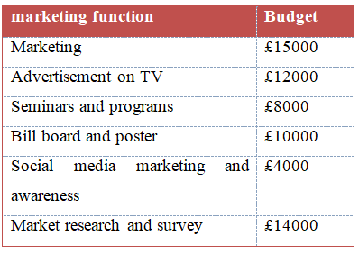
Cost-benefit analysis: The cost and benefit of the marketing activities of the business should be analyzed. The expenses should be carried by determining the benefit as well as the cost benefit analysis of the marketing plan is given below.
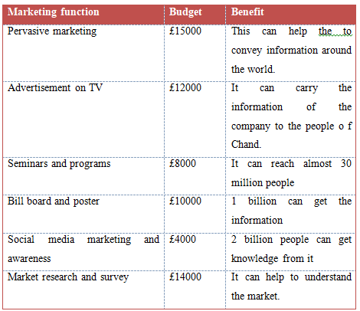
Sales analysis: The main objective of the marketing plan was to increase the sale of the business by 30% within 6 months. Therefore, the marketing activities will be conducted to increase the sale of the business by 30% within the next 6 months for achieving the success of the marketing plan.

- MARKETING STRATEGIE
  - Social Media
People want connections on social networks, and companies that create genuine connections with their customers will thrive - but it is getting harder than ever
In addition to believing that social media has the fastest growing user base in the world, it is crucial to perceive the enormous chances of providing value to our audience, to look at the benefits of having a social media marketing strategy for our company.
An effective social media marketing plan will help us to build an online community. Social media marketing will allow us to get web traffic and potential customers. (Sikandar,2018)
It is essential to know the audience before acting. Our business has its specifics, so we must consider that offline, meaning in real life, our products are intended more for the people of Eastern Europe. If we know the pattern of our real buyer then we can get an idea of how it would behave in the online environment. Which benefits of the product or service we offer could attract it. What details could keep him away from our offer. Loyal customers and the public will be able to follow us on social media platforms to be up to date with our new achievements. Social media gives us the opportunity to advertise about the products we offer.
Thus, a social media account can be used as a marketing tool to help us disseminate essential information about our business.
  - Web site
First, a website gives Balkan Food Shop an online presence. A website works to convey information about the business, including address, phone number and work schedule.
Before starting this marketing process, it is necessary to think about the image we want to promote about the Balkan Food Shop. That is why the company will focus on creating the right combination of special offers, promotions, prizes, and other promotion tactics. Using the right set of marketing messages, the business can gain recognition and build a solid brand in the medium and long term.
It is said that a picture is worth a thousand words. That is why Balkan Food Shop will attract potential customers much easier and even generate sales - just by posting pictures. There are definite opinions that well-presented food tastes better. Given how important the aspect is in relation to the way we perceive things, it is obvious that investments in photographing quality products will have a similar effect on site visitors. (Shewan,2020) The website will contain photos related to the store's products and its interior. We need to become visible online. This way we will make ourselves known, the members of the team or the products we sell through pictures or videos.
Another virtual tool to increase sales would be the online store, which would contain the product catalogue, prices, and delivery method.
  - Advertising
Flyer publicity is tempting because it is inexpensive to produce and we can deliver flyers directly to potential buyers. It is, however, far less risky than other marketing strategies.
Private mailboxes and small retailers are among the easiest ways to deliver leaflets.
Most small firms supply leaflets to other local corporations for which they do not contend. It is a method to receive visibility by word of mouth through the small business community to attract clients. Another suggestion will also be to make available flyers to reach customers at shop counters.
Local newspapers and the shopping press can at a reasonably low cost, agree to publish the flyer. This is a perfect way to target a mass audience using a proven distribution channel. It is much more economical to deliver leaflets than spending your own time or paying staff. For our soon-to-be-launched business, this is an especially efficient solution. (Johnson,2019)
Loyalty cards are a fantastic way to generate extra business and work well as a simple marketing tool. Many businesses find that loyalty card schemes increase sales through existing customers and attract new ones.
Loyalty card policy is not only a reliable way to attract new customers, but it is also a tried and trusted way to maintain them. The prospect of a free reward for something they buy will win almost everyone anyway; so, in essence, the idea of a loyalty scheme is brilliant. As a brand, delivering a reward program means that consumers continue to return to the store, instead of buying from elsewhere. (Stamps Direct,2012)
  - Exceptional customer service
Customer service helps retain the customers that marketing spent their budget obtaining in the first place. Acquiring a new customer costs 6 to 7 times more than efforts spent on customer service and customer retention. Rather than waiting until a contract is up, take the time to make the effort to retain your customers. An important factor for Balkan Food Shop is to empower all employees to find solutions to the problems that customers have. Customer care, even over retention and new customer acquisition, should be held in high regard. The consumers can pay more for a decent customer service experience. (Brandwatch,2014)
- COMPETITORS
In the immediate area, there are three main competitors. These include Sainsbury's, Marks & Spencer, and Morrison's.
These are the largest store chains with strong investments. The products of these stores are universal, for general use. They are intended for a wide range of customers. Due to the fact that they are located in almost all areas of London, anyone has shopped there at least once. So, these stores do not require a thorough presentation. However, every regular buyer knows that these retailers have gained a secure position in the market because they offer high quality products. This quality is also reflected in the pricing policy developed by them. So, the prices approached by these stores are quite high and are not affordable for any pocket.
Table: The key factors of market demand
(The Business Plan Shop Ltd,2020)

Company | Competitor 1  (Sainsbury's) | Competitor 2  (Marks & Spencer) | Competitor 3  (Morrison's) | Balkan Food Shop
Nb. employees | 17 | 15 | 20 | 6
Price | High | High | Average | Low
Quality | Average | High | Average | Superior
Choice | High | Average | Average | Average
Delivery | No | £10, free from £65 | £15, free from £70 | Free

  - Strengths and Weaknesses of competitors:
Strengths | Weaknesses
-A wide range of products for consumers  -Big and strong investments  -Possibility to juggle prices  -High quality products  -They are well-known brands  -Possibility to make substantial discounts and promotions  -In addition to food, they offer another range of products: clothing, footwear, hygiene products and home | -Product prices are quite high  -The price level is affordable for people with above-average incomes  -They do not have products specific to the local population

(Roque,2016)
- SWOT ANALYSIS FOR BALCAN FOOD SHOP:
  - Strengths:
- People become curious when something new appears next to them, so many are eager to visit and buy something from the new store. Due to the fact that the products are of Eastern European origin, many people will want to try and taste something new, unique, and maybe, if they remain satisfied with their quality, they will become loyal customers of the store.
- Competing shops are within walking distance of several bus stops. Thus, people who live and work nearby will prefer to shop a few steps away, instead of wasting their time in traffic.
- The immigrant population in the area comes mainly from Eastern Europe and the Balkans. Thus, the products are mainly destined for this market segment.
- Also, the policy of low prices is not to be neglected. The products will be affordable for every pocket, especially because most customers have below average incomes.
  - Weaknesses:
- It is a start-up business that requires large immediate investments. Like any new business, it requires time, dedication, effort, and the ability to perform multiple tasks at the same time. Compared to competitors stores, Balkan Food Shop has not yet adopted a pre-established policy and regulations. All this comes with time and experience.
- The entire staff is new and needs time to form a strong team. Balkan Food Shop is a start-up company that still cannot afford to hire other accounting firms or lawyers to regulate and determine the smooth running of things. Thus, the company must hire new staff to try to create a team that will make things work.
- Most people, who still do not trust the new store, still shop at competitors. To gain the goodwill of customers, we must first gain their trust. We must be fair and honest with them, so that customers want to come and return to our store.
  - Opportunities:
- Near the store there are bus stations, the metro station, and a construction site with immigrant workers, mainly from Eastern Europe and the Balkans. This site builds about several blocks of flats and houses. The duration of this construction site, according to the information panel, is over 3 years and the number of workers exceeds 150 people. Already from these three strengths we can consider that at least 60-70% of them will become potential customers of the Balkan Food Shop.

- The nearby construction site will also create new tenants and landlords. This aspect is not to be neglected at all, because it can generate a stable contingent of customers, who, for sure, will be happy to find products of impeccable quality and at good prices.
- Due to the Covid-19 situation, online shopping is on the rise. It is no longer a novelty that having an online store significantly increases the possibility of developing the business.
  - Threats:
- Brexit will negatively influence the stopping / leaving of immigrants, who are the main customers. Many people are not yet well informed about what will happen after Brexit, and what the consequences will be. The immigrant population is worried about this and is in a situation to decide to stay in the UK or leave the country.
- Due to the lockdown and Covid-19, a large part of people has lost their jobs and are not willing to spend much. Even if the government supports those in difficulty, the population is uncertain about their future. People are trying to save as much money as they can to survive and get through a possible third wave and lockdown.

  - Unique Selling Point
The store has a specific orientation and is intended for the immigrant population of Eastern Europe who live and work in Watford. It offers quality food, mainly of Eastern European origin, namely the Balkans. These people, as a rule, adhere to their culinary traditions. Thus, Balkan Food Shop is a perfect option both for daily cooking and for festive and holiday meals. One of the advantages it has is the fact that the customers for whom this store is intended will feel comfortable, just like in any local store in their homeland. Also, for many customers, it can become an option of a neighbourhood store, around the corner.
The shop is also welcoming and open to other customers who are curious and eager to try to taste Balkan cuisine.
- Managing team
  - Key roles
Manager (ELIZABETA) - One of the most important and critical components of running our store is getting a good manager who can direct us in our good and bad times by providing us with the right order and guidance when we make any errors. Elizabeta is great for this job as she used to operate her own company in the past, so she already has the experience we are looking for to run our shop.
Assistant manager (XENIA) – To support the manager we are going to need an assistant manager to Like a boss, an assistant manager has almost the same kind of duty as a manager. We go through every day by helping the manager and presenting her report of the situation and issue. She is our group leader already and has a strong understanding and friendship with Elizabeta that they can easily guide us.
Customer service assistant (LIDIA) - A customer service assistant offers assistance and guidance wherever possible to ensure that any customer who walks through the door is satisfied. This work requires a lot of contact with the general public in a number of ways, including face-to-face, over the phone and via email, responding to questions and providing information. We need someone who is very kind and Lidia is going to be the ideal individual we are searching for because she is always willing to assist those in trouble and always has a solution to a dilemma.
Cashier (VERA) – Since this position requires a lot of commitment and dedication because the cashier needs to manage the payment, Vera would be far more fitting than any other person because she can take a lot of responsibility that she showed us during the semester. It's not only about payment, but also about customer service and contact, so she wants to give her best because she's going to see all the customers who are going to check out and support them.
Stock clerk/Receiver (SAKIB) – I will be more of a helper on the floor due to my lack of experience in the rest of the field, confirming that the shelf is still complete and that nothing is out of stock. Open to any customer who needs assistance in locating a product, because my previous experience as a waiter would be more beneficial to the customers on the floor than doing anything else.
And I'll be a receiver when the stock arrives and unload the stock. Check that every item we get is nice and great.
Delivery (GEORGI) – As for this role, we need someone who can drive and has a lot of driving experience so Georgi can handle for us with his driving experience. As this position needs a lot of time management, we know that we are in safe hands if it is Georgi, as he is one of the few people to attend the classes during the semester before the lesson begins by this we can understand how sharp he is with his time management (Cheap? and Better? 2020).
  - Personnel plan
Hours of Operation:
Store hours will be 7 days a week from 10:00 A.M. until 10:00 P.M. except for Sunday which will be from 12pm until 6pm. Checks and all major credit cards will be accepted. A food stamp policy along with other policies will be in place.
Our most basic principle is to care about individuals. The determining factor that motivates our activities in improving our relationship with our employees and customers is this deep belief in people.
We agree that our customer loyalty obligation is not primarily based on the selling of a product, but rather the overall interaction that a customer enjoys while engaging with our organisation. In all transactions and in delivering goods of the highest quality and at fair prices, we believe in fairness and truth. To provide outstanding service in selling the goods we offer, we should do everything possible.
Our ethic of concern for persons brings the push to be a successful corporate citizen to our Balkan Shop. We believe we are responsible for keeping our property in first-class condition as a good neighbour and making the appearance of our business, facilities, equipment and grounds as attractive as possible, making them an asset to the communities that support our business.
By doing this and gaining our customers trust and happiness we will proceed with our future mission of opening a new shop when we will have the right capital and more daily average customers.
  - Strengths and weaknesses
Strengths:
Team - As we can see we have a team full of potential and innovative people prepared to start and manage the company, because every member of our team has a unique talent that is fantastic. But we will employ someone who can give us some more power in our business plan and support us by giving our business plan a smooth start without any intervention, as no one can foresee the issue of the future.
Business advisor – We are going to hire a company consultant which will provides all the same services as an accountant. To provide holistic guidance that may include CFO services, performance reporting, cloud accounting and technology, business strategy creation, budgeting, cashflow analysis, advisory board, business planning and organisational design, a business adviser should meet with us on a regular basis. They help us understand the main financial factors of our organisation and identify growth opportunities. They can also be the missing connection between the personal finances of our business and the company itself as they allow us to understand the company's effect on our personal wealth and lifestyle goals (Team, 2020).
Weaknesses:
Lack of experience – one of the main weaknesses is lack of experience as this is one of the main cause to have a business fail. There are a lot of problem which are poor planning and money management, wrong location, competition etc. In the 1994 Business Failure Record, Dunn and Bradstreet determined that almost 90% of small business failures are directly triggered by a lack of management experience people didn't know how to run a business properly. We will learn the management skills we need from a small business mentor or the nearest Small Business Development Center (Why Small Businesses Fail (or Fail to Thrive and Grow), 2020).
Missing roles - one of the missing roles we have is a security guard to maintains safe and secure environment for customers and employees by patrolling and monitoring the store from shop lifters.
  - Suppliers
At any step of the product lifecycle, suppliers have an extremely important role. Companies need to work closely with their manufacturers to get the most out of their goods, from sourcing raw materials to helping speed up demand, and to seeking better alternatives for raw materials as the market continues to become saturated.
If our company wants to use a supplier more than once, it should aim to create an enduring partnership in which they can easily pick up the phone and speak to their supplier.
Managing supplier relationships ensures that suppliers remain for a long time with the company and turnover is held to a minimum. It is safer than finding many different suppliers to deal with one or two suppliers that can supply many different products. This ensures that a business will focus on improving the services of suppliers and reducing costs.
Reduced costs: Supplier relationship management ensures that vendors remain with the business for a long time and turnover is held to a minimum. It is safer than finding many different suppliers to deal with one or two suppliers that can supply many different products. This ensures that a business will focus on improving the services of suppliers and reducing costs.
Feedback and open collaboration are made easier as businesses establish good relationships with their suppliers. In this way communication becomes seamless and the business can provide their suppliers with observations about how they can enhance service and vice versa.
When feedback becomes normal, the organisation and suppliers begin to understand their relationship's inner workings. The supplier will begin to understand what goods might be of interest to the customer, and the company will know the right time to order from its supplier so that they obtain the order on time
Pay suppliers on time: this sounds like a no-brainer, but a better way to maintain a strong supplier partnership is to pay suppliers on-time. Some businesses track deliveries and orders poorly, meaning that payments can be late. As their cash flow is not safe and they do not trust this current customer as much as a new customer they gain, this puts the supplier in a bad position. A business will ensure payments are received on time and suppliers stay satisfied by using monitoring software and a strong supplier management method.
Streamlined Supplier Agreement: Streamlined Supplier Agreements (SSA) mean that, regardless of the service they offer, all vendors receive the same care. The method is much easier when adding additional vendors, as the agreement would be the same for both suppliers. Of course, small edits can be made, but they can be signed off within a fraction of the time it takes to sign off on a paper of 10+ pages. As everybody in the organisation will know what the arrangement sounds like this makes it easy to handle partnerships.
Before they do business with them, businesses can investigate suppliers to ensure that they are financially secure. Businesses should always request referrals from suppliers to inquire about specific issues the company might have.
Asking references to how the supplier deals with increased volume, is consistent with delivery times and efficiency, is the supplier with critical information going forward is highly important for risk management, the standard of aftersales operation, etc. Risk evaluation before a supplier is onboard will mitigate risks later (What Is a Supplier and What Is Their Role in a Business? Read More, 2020).

Finance Plan
As the Eastern European food shop - Balkan sales prediction clearly states, the profit can be seasonal at first. We hope to keep the damage to a minimum in the first few months of winter until Eastern food shop local customers are fully available. The increase in summer sales was due to the fact that at that time Moab had a greater number of potential customers and the trend was that Eastern food shop spent more on each purchase than locals.
Eastern food shop also planned for these seasonal changes and the funds we have requested will help maintain optimistic cash balance in the first 3 years until full return. The owners did not receive any dividends and their wages were low to reduce short-term shortages. Eastern food shop partnership contract includes an exit plan that clearly defines what "success" or "failure" is at each time interval. If the damage to the company exceeds the acceptable damage, Eastern food shop first task is to repay the lender, and the recovery of the owner's investment will be the last owner to pay. The owner of the Eastern Food Store Market is reluctant to do so after setting up a leading enterprise that could become a profitable franchise and/or serve the rural groups across the state. The owners intend to prepare this occupational until they retire or decide to start a business as well as start another business.
If the proposed plan fails, the holder will take the necessary steps to exit the business with the negligible harm to the owner as well as investors. All of the equipment and goods can be sold to repay any debts sold. The owner pays all the residual debts in the form of the monthly costs until all the debts are repaid. The co-operation agreement reached by the owner already includes a definition of "success" and a timeline for reaching the stage. The success of business is monitored regular in the first year also quarterly in following years. The owner realizes that it usually takes 3 years for a business to become profitable, during which time the business can lose money. Acceptable damage has been identified; if the enterprise surpasses this amount aslo cannot recompense the owner, we will begin the procedure of closing the enterprise and repaying the loan.

Keys to Financial Success
The solutions to success for the Market include:
- Fame: Each customer who visits Eastern food shop store wants to come back as well as recommend it to their friends or family. Oral marketing can be a powerful partner in Eastern food shop business.
- Quality customer service: Knowledgeable as well as friendly service will be important.
- Location: Provide customers with a convenient location, including walking and driving.
- Environment/ Product: Offer a variation of high-quality food items with domestic also the foreign themes and sell at a reasonable price in a clean, original and contented environment.
- Expediency: Eastern food shop customers will know that they can get what requirement in Eastern food shop market at a low price. This allows them to travel to get the necessary order them online.

Sales strategy
The goal of Eastern food shop marketing is to make food consumers confident that they can buy and eat healthy and fresh products while improving the delivery experience.
- Quickly start a well-known brand through street vendors (backed by a few strategically located solid stores)
- Position Eastern food shop as a fresh, delicious and the healthy another to conventional food
- Maintain the high profit margins for food products
- Use the brand by the growth of franchising as well as product change (including food and supermarkets)
Today, the export of modern food should remain increasingly attractive in the health market. Around the world, "dieting" is gaining momentum; meaning products that are less appealing to diet will reduce success rates. Businesspersons continue to reap tremendous benefits from "health awareness" businesses like fresh products The Eastern food shop aims to take full advantage of people's growing food conscience.
The economic environment of a successful store takes into account the aspectsas well as conditions that affect the purchasing power of the product in its target market. Today, especially in commercial cities, consumer incomes are relatively high. Eastern food shop have competitive prices compared to existing alternatives as well as will strive to attract the market share by the product difference.
The goal of Eastern food shop marketing is to ensure that fast food consumers make sure they buy and eat healthy and fresh products while improving the overall delivery experience.
- Quickly build a recognizable brand through street vendors (backed by a few strategically located solid stores)
- Position Eastern food shop as a fresh, delicious as well as healthy substitute to conventional fast food
- Maintain high profit margins for food products
Use of the brand through the increase of franchising also the product
- Use of the brand through the increase of franchising also the product variation (including food and supermarkets)
The Eastern food shop is in good financial condition and the cash flow is always positive. In the fifth year, revenue is projected to increase to £58 million and EBITDA to £15 million. Preliminary analysis shows that each NVU can sell only 100 meals a day in order to achieve disruption.

Expenses
Expenses
Payroll | £200 | £500 | £500
Marketing & Sales & Other Expenses | £200 | £500 | £500
Insurance | £0 | £0 | £0
Depreciation | £0 | £0 | £0
Rental fee | £300 | £500 | £500
Leased tools | £10 | £10 | £10
Utilities | £10 | £10 | £10
Payroll Taxes | £300 | £500 | £500
Other expenses | £0 | £0 | £0
Total Operating Costs | 1000£ | £2000 | £2000

Total: 5000£

Funds required and use
- The goal of the business plan is to increase £ 1,500,000 from investors in convertible and payable securities, providing 32% of the compound's annual income. The Eastern food shop is committed to starting a fast-paced "wok" business in 20XX.
- The following topics as well as tables show Eastern food shop economic plan. The Eastern food shop plans to turn the loss into a profit, but we will set up the commercial to keep a strong cash flow.
Important Assumptions
Financial planning relies on essential norms.
The main assumptions are:
- Eastern food shop expects slow economic growth and no significant recession.
- Eastern food shop also assumes that there have been no unexpected variations in the restaurant's popularity.
- Eastern food shop believes that the investments as well as financing received are enough to keep and execute Eastern food shop financial strategy, as given in the table below.

General Assumptions
Plan Month | 1 | 2 | 3
Present Interest Rate | 15.01% | 15.01% | 15.01%
lasting Interest Rate | 15.01% | 15.01% | 15.01%
Rate of Tax | 25.42% | 24.05% | 24.31%
Other | 0 | 0 | 0

Break-even Analysis
For loss analysis, business accepts that operating costs contain all wages, rents, and utilities, as well as estimates of other operating costs.

Break-even Analysis
Units Break-even Monthly | 4,117
Revenue Break-even Monthly | £28,124
Assumptions:
Standard Per-Unit Revenue | £7.08
Standard Per-Unit Variable Cost | £2.03
Approximate Monthly Fixed Cost | £25,865

Projected Profit as well as Loss
The most essential declaration in profit statement is the approximate rate of gross profit. Though the restaurant's turnover did not increase significantly in the initial year, over the time, the restaurant or cafe will progress its consumer base also the customer name, also will grow faster in the 4th and 5th years of operation. The growth in gross profit margin is attributed to the slow rise in the sales prices as well as the development of the consumer base, which is crucial.
Pro Forma Profit and Loss
Sales | £1,328,635 | £1,865,000 | £2,415,000
Direct Sales Cost | £193,175 | £339,000 | £477,750
Other | £0 | £0 | £0
Total Sales Cost | £193,064 | £337,001 | £455,740
Gross Margin | £1,126,551 | £1,126,551 | £1,126,551
Gross Margin percentage | 87.43% | 80.40% | 78.53%
Expenses
Payroll | £200 | £500 | £500
Sales & Marketing or Other Expenses | £200 | £500 | £500
Insurance | £0 | £0 | £0
Depreciation | £0 | £0 | £0
Rental fee | £300 | £500 | £500
Leased Equipment | £10 | £10 | £10
Utilities | £10 | £10 | £10
Payroll Taxes | £300 | £500 | £500
Other Costs | £0 | £0 | £0
Total Operating Expenses | 1000£ | £2000 | £2000
Profit Before Interest and Taxes | £849,058 | £1,124,457 | £1,525,966
EBITDA | £849,059 | £1,214,465 | £1,495,983
Interest Costs | £0 | £0 | £0
Taxes Incurred | £208,125 | £282,627 | £385,313
Net Profit | £621,555 | £842,840 | £1,030,681
Net Sales/Profit | 47.13% | 46.83% | 46.21%

Projected Cash Flow
The cash flow relies on the turnover, the due date and the receivables management assumptions. Eastern food shop anticipation collection is important and sensible during the day and waits in the catering industry. As we expected, even if we reach a month with less profit, we don't need constant support.

Pro Forma Cash Flow
Cash Received
Cash from the Operations
Cash Sales | £1,321,645 | £1,675,001 | £2,245,010
Subtotal Cash from the Operations | £1,328,635 | £1,792,001 | £2,352,010
Additional Cash Received
Sales Tax, HST/GST VAT, Received | £5 | £5 | £5
New Current Borrowing | £5 | £5 | £5
New Other Liabilities (interest-free) | £5 | £5 | £5
Sales of Other Current Assets | £5 | £5 | £5
New Long-term Liabilities | £5 | £5 | £5
New Investment Received | £5 | £5 | £5
Sales of Long-term Assets | £5 | £5 | £5
Subtotal Cash Received | £1,319,635 | £1,785,000 | £2,345,000
Expenditures | Year 1 | Year 2 | Year 3
Expenditures from Operations
Cash Spending | £232,360 | £252,975 | £269,874
Bill Payments | £442,258 | £721,521 | £948,533
Subtotal Spent on Operations | £691,598 | £976,426 | £1,232,486
Additional Cash Spent
Sales Tax, VAT, HST/GST Paid Out | £5 | £5 | £5
Principal Repayment of Current Borrowing | £5 | £5 | £5
Other Liabilities Principal Repayment | £5 | £5 | £5
Long-term Liabilities Principal Repayment | £5 | £5 | £5
Purchase Other Current Assets | £5 | £5 | £5
Purchase Long-term Assets | £5 | £5 | £5
Dividends | £5 | £5 | £5
Subtotal Cash Spent | £681,598 | £966,496 | £1,212,426
Net Cash Flow | £638,037 | £818,504 | £1,132,574
Cash Balance | £660,037 | £1,478,541 | £2,611,115

Projected Balance Sheet
The projected balance is very reliable. Though, we can get Eastern food shop specific goals, we will not present any practical difficulties in fulfilling Eastern food shop debt obligations.
Pro Forma Balance Sheet
Assets
Current Assets
Cash | £670,047 | £1,468,531 | £2,591,125
Inventory | £24,938 | £45,075 | £63,341
Other types of Current Assets | £0 | £0 | £0
Long-term Assets
Long-term Assets | £44,000 | £44,000 | £44,000
Accumulated Depreciation | £10 | £10 | £10
Total Long-term Assets | £44,000 | £44,000 | £44,000
Liabilities and Capital | Year 1 | Year 2 | Year 3
Current Liabilities
Accounts Payable | £54,521 | £58,272 | £75,730
Current Borrowing | £10 | £10 | £10
Current Liabilities | £10 | £10 | £10
Subtotal Current Liabilities | £54,531 | £55,272 | £75,730
Long-term Liabilities | £10 | £10 | £10
Total Liabilities | £54,521 | £58,272 | £77,730
Paid-in Capital | £54,521 | £58,272 | £75,730
Retained Earnings | £54,521 | £58,272 | £75,730
Earnings | £54,521 | £58,272 | £75,730
Total Capital | £54,521 | £58,272 | £75,730
Total Liabilities and Capital | £731,025 | £731 | 025
Net Worth | £731 | 025 | £731

Business Ratios
The business ratio for a plan year is shown below. For comparative purposes, the ratio of industry profiles based on the Industrial Standard Classification code is shown.
Ratio Analysis
Growth of sales | 0.01% | 34.25% | 32.35% | 7.50%
Percent of the Total Assets
Current Assets | 3.46% | 2.00% | 2.12% | 3.50%
Inventory | 0.10% | 0.10% | 0.10% | 34.50%
Overall Current Assets | 94.74% | 96.23% | 97.75% | 42.50%
long-standing Assets | 6.26% | 2.77% | 1.55% | 56.40%
Total Assets | 90.00% | 90.00% | 90.00% | 90.00%
Present Liabilities | 7.10% | 3.67% | 2.59% | 32.80%
Long-term Liabilities | 0.10% | 0.10% | 0.10% | 27.40%
Total Liabilities | 7.40% | 3.27% | 2.79% | 61.30%
Net Worth | 91.10% | 95.43% | 96.21% | 35.40%
Percent of the Sales
Sales | 100.00% | 100.00% | 100.00% | 100.00%
Total Gross Margin | 85.34% | 70.40% | 69.53% | 50.40%
Selling, General and Administrative charges | 35.34% | 64.52% | 55.43% | 35.81%
Advertising Expenses | 0.10% | 0.10% | 0.10% | 3.10%
Profit Before Interest & Taxes | 52.72% | 52.72% | 52.72% | 0.60%
Main Ratios
Current | 11.25 | 15.64 | 13.88 | 0.88
Quick | 12.49 | 25.93 | 32.15 | 0.45
Total Debt to Total Assets | 7.50% | 3.66% | 2.79% | 51.40%
Pre-tax Return on the Net Worth | 132.63% | 74.64% | 58.39% | 1.50%
Pre-tax Return on the Assets | 123.51% | 71.86% | 54.42% | 4.20%
Additional Ratios | Year 1 | Year 2 | Year 3
Net income Margin | 37.23% | 37.23% | 38.12%
Return on the Equity | 91.17% | 45.21% | 32.50%
Activity Ratios
Inventory earnings | 20.41 | 9.32 | 8.45
Accounts Payable earnings | 8.81 | 8.81 | 8.81
Payment Days | 27 | 28 | 25
Total Asset earnings | 1.71 | 1.24 | 0.76
Debt Ratios
Debt to the Net Worth | 0.18 | 0.14 | 0.13
Current Liab. To Liab. | 1.01 | 1.01 | 1.01
Liquidity Ratios
Net Workings of Capital | £620,454 | £1,476,322 | £2,698,027
Interest Coverage | 0.10 | 0.10 | 0.10
Additional Ratios
Assets to the Sales | 0.45 | 0.78 | 1.26
Current Debt or Total Assets | 7% | 5% | 2%
Test | 12.89 | 24.74 | 32.17
Sales or Net Worth | 1.85 | 1.22 | 0.78
Dividend Payout | 0.01 | 0.01 | 0.01

Conclusion
The 'Balkan' - Eastern European Food Shop is a potential processed and semi-processed food shop that will serve different types of products and services according to potential target customers' needs. The target customers of the organization vary according to the product range. The families, individuals, babies, and other corporate people are the primary target customers who purchase the company's products. The people having different jobs and have no extra time to invest in shopping have the opportunity to shop online by sitting at home. They will benefit from minimizing the cost of traveling, reducing the cost of traveling, reducing the time of focusing on my career. The market audit can help the organization develop an understanding of the target market and their needs. The financial plan and marketing plan needs to be designed very carefully to make the best use of the resources as well.

- References
Andaleeb, S.S., Hasan, K., (2016), ‘Market segmentation, targeting, and positioning’, In Strategic Marketing Management in Asia, pp.179-207
Ansoff et al. (2018), Implanting strategic management, Springer.
Barabás, R.D.,(2018). ‘Bank Marketing Environment. Pest Analysis For The Romanian Bank System’, Contemporary Economy Journal, 3(3), pp.192-197
Barney, J.B. and Hesterly, W.S., (2010), Strategic management and competitive advantage: Concepts. 4th edn. Englewood Cliffs, NJ: Prentice hall.
Brandwatch (2014) Customer Service and Marketing – A Perfect Pairing. Available at: https://www.brandwatch.com/blog/customer-service-and-marketing, (Accessed: 05 December 2020)
Camilleri, M.A., (2018). ‘Market segmentation, targeting and positioning’, In Travel marketing, tourism economics and the airline product. Springer, Cham. (pp. 69-83)
Cheap, W. and Better, K., 2020. What Are The Different Positions In A Supermarket?, The Grocery Store Guy. Available at: https://thegrocerystoreguy.com/what-are-the-different-positions-in-a-supermarket , [Accessed 30 November 2020].
Chernev, A., (2020). The marketing plan handbook, Cerebellum Press.
Daniels, J.D., Radebaugh, L.H. and Sullivan, D.P., (2014). International business. 16th edn. Prentice Hall.
Eshleman, J.D. and Lawson, B.P., (2017). “Audit market structure and audit pricing. Accounting Horizons,” 31(1), pp.57-81.
Farmer, D.B., Pfeiffer, D. and Smith, J.T., (2016), ‘Graphene layers for identification of products’, International Business Machines Corp., U.S. Patent 9,493,025, Washington DC.
Gérard, M., & Princen, S. (2012). Investment and financing srategy of a multinational enterprise under alternative tax design. Ludwig-Maximilian University.
Gharajedaghi, J., (2011), Systems thinking: Managing chaos and complexity: A platform for designing business architecture, Elsevier.
Johnson, K.S. (2019) 'Legal Ways of Flyer Advertising' Chron. Available at: https://smallbusiness.chron.com/legal-ways-flyer-advertising-71913.html, (Accessed: 05 December 2020)
Kohne, A.,(2019). “Target Market. In Business Development” (pp. 75-84). Springer Vieweg, Wiesbaden.
Lamb, C.W., and Crompton, J.L., (2017), ‘Analyzing marketing performance’ In Marketing the Public Sector (pp. 173-184). Routledge.
Loo, P.T. and Leung, R., (2018), ‘A service failure framework of hotels in Taiwan: Adaptation of 7Ps marketing mix elements’, Journal of vacation marketing, 24(1), pp.79-100.
Oberlo, 2020. What Is A Supplier And What Is Their Role In A Business? Read More. [online] Available at: https://www.oberlo.co.uk/ecommerce-wiki/supplier , [Accessed: 7 December 2020].
Palepu et al. (2020), Business analysis and valuation: Using financial statements. Cengage A.U.
Passionforbusiness, 2020. Why Small Businesses Fail (Or Fail To Thrive And Grow). [online] Available at: https://www.passionforbusiness.com/articles/why-businesses-fail.htm , [Accessed: 7 December 2020].
Roque, C. (2016) How to Write a Competitive Analysis for Your Small Business (With Template). Available at: https://business.tutsplus.com/tutorials/how-to-write-a-competitive-analysis-for-your-small-business-with-template--cms-27028, (Accessed: 07 December 2020)
Schwenker, B., & Spremann, K. (2010). Management between strategy and finance. Springer.
Shewan, D. (2020) 25 Ways to Increase Online Sales. Available at: https://www.wordstream.com/blog/ws/2016/02/03/increase-sales-online (Accessed: 05 December 2020)
Sikandar, M. (2018) Create Successful Social Media Strategy In 8 Simple Steps. Available at: https://statusbrew.com/insights/how-to-build-your-social-media-marketing-strategy, (Accessed: 05 December 2020)
Slocum, S. and Curtis, K., (2017), ‘Farm Diversification through Farm Shop Entrepreneurship in the U.K.’, Journal of Food Distribution Research, 48(856-2018-3094), pp.35-51.
Sparks, L., (2016), ‘14 Spatial-structural change in food retailing in the U.K.’, in Lindgreen, A., et al. (2017), A Stakeholder Approach to Managing Food: Local, National, and Global Issues, London: Routledge,
Stamps Direct Ltd (2012) 'The Advantages of Loyalty Cards for any Size Business', Business Stamps. Available at: https://www.stampsdirect.co.uk/blog/category/rubber-stamps/business-stamps-2, (Accessed: 05 December 2020)
Suslin, V.V., and Gurov, K.I., (2017), ‘Impact of optically active layers in the Black Sea on the quality of retrieved ocean color products: modeling and satellite observations’, XXIII International Symposium, Atmospheric and Ocean Optics, Atmospheric Physics, Vol. 10466, p. 104663K
Team, A., 2020. What The Heck Is A Business Adviser? Do I Need One?. [online] Altusfinancial.com.au. Available at: https://www.altusfinancial.com.au/blog/what-the-heck-is-a-business-adviser-do-i-need-one , [Accessed: 1 December 2020].
Teller, C., Holweg, C., Reiner, G., and Kotzab, H., 2018. 'Retail store operations and food waste', Journal of Cleaner Production, 185, pp.981-997.
The Business Plan Shop Ltd (2020) How to do a market analysis for a business plan. Available at: https://www.thebusinessplanshop.com/blog/en/entry/market_analysis_for_business_plan#competition, (Accessed: 07 December 2020)
VANSITTART, N. (2016). OUTLINES OF A PLAN OF FINANCE. FORGOTTEN Books.
Villalonga, B. (2014). Finance and strategy. Emerald Group Publishing.
Welford, R. (Ed.), (2014), Corporate environmental management 1: systems and strategies. 2nd edn. Routledge.
Wood, M. B., & Jobber, L. (2016). The marketing plan handbook. Pearson.

- Appendix – Converted presentation of Business plan – Group 2
Slide 1

Slide 2

Slide 3

Slide 4

Slide 5

Slide 6

Slide 7

Slide 8

Slide 9

Slide 10

Slide 11

Slide 12

Slide 13

Slide 14

Slide 15

Slide 16

Slide 17

Slide 18

Slide 19

Slide 20

Slide 21

Slide 22

Slide 23

Slide 24

Slide 25

Slide 26

Slide 27

Slide 28

Slide 29

Slide 30

Slide 31

Slide 32

Slide 33

Slide 34

Slide 35

Slide 36

