

Module code - BMSW4002
Effective Team Work and Communication
Assessment 1 – Individual Report

Module leader – Toyin Adisa
Student - Joanna Zaleska
Student ID - 2030291

Contents

Introduction 3
Communication models 3
Schramm’s communication model 6
Berlo’s communication model 7
Communication skills and teamwork 8
Conclusion 9
References 10
Appendix 11

Introduction
The report explores the most important aspects of communication in relation to teamwork, career development and academic life. The Shannon and Weaver Communication Model is taken as an example, together with Schramm’s Model of Communication and Berlo’s Model. These three models are explained and compared. The verbal, non-verbal and listening communication skills taught in the module are discussed and accompanied by examples from the professional life of the student. There are provided examples of poor communication in the workplace and discussion on how they affect the productivity of the team members and their efficiency. The report also discusses how communication can be improved in the mentioned case studies and concludes the information provided so far.

Communication models
Communication is the exchange of information by verbal or nonverbal methods. For instance, it can be in an oral way, via writing or by using sign language or gestures. Communication is defined as the production and interchange of meaning (Duck and Mcmahan, 2020). There has to be a sender and a receiver in every communication, as well as a message and meaning of the message. The receiver provides feedback to the message's sender both during and after the message's transmission. Signals of feedback Feedback signals may be vocal or nonverbal in nature, such as a nod in agreement, averting one's gaze and sighing, or a variety of other motions. Additionally, there is the context of the communication, the environment in which it is delivered, and the possibility of interception during its transmission or reception.
If the recipient can see the sender, he or she may gain not just the message's content but also the sender's nonverbal communication, which ranges in style and complexity. If the recipient, for instance, can hear the sender, the recipient may also pick up on indications such as emphasis and emotion from the sender's voice.
McKay et al. (2009), provide examples of the three most common communication models. They are divided into categories depending on how the interaction between the senders and the receivers function. The researchers define the first type as being linear, in which the communication travels only one way. The interactive type takes place when there is two-way communication and interaction between the senders and the receivers. The third category is transactional, which resembles the interactive model but is more complex because it covers communication that is progressing over time and there is much logical information exchanged between the participants.
There are numerous benefits of improving the communication processes in the workplace or within the team. In the workplace, effective communication may help reduce unneeded difficulties and encourage improved performance. Effective communication in the group may boost overall productivity and help build a strong team. Griffith and Dunham (2015) demonstrate that members who talk with one another and consider the perspectives of others will be more receptive to collaborating and co-creating the optimal solution. By fostering efficient communication, leaders may get a better understanding of their team’s abilities and skills and then deliver clear directions to the individuals most suited to the job, so boosting the overall efficacy of each project.
In order to assess the efficacy of each system, a quick overview of each type is presented below.
The Shannon and Weaver model of communication was created in 1948. It is a linear type and explains the connection between the six factors, which determine each communication process. These factors are called an encoder, receiver, decoder, channel and noise. Please refer to Image 1.

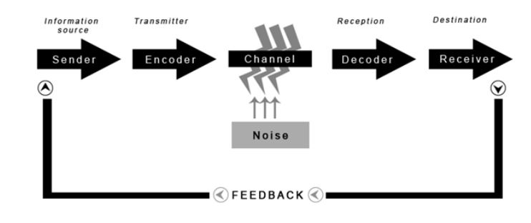
Image 1. The Shannon and Weaver model of communication. Image adapted by the student.
The sender is the information source that sends the message. The encoder is the way in which the message is transmitted or the device used for this purpose. The channel is the medium that is used for the message to be conveyed to the receiver. The decoder is the way, device or method used to interpret the message transmitted by the sender. The receiver is the final destination to which the message has been targeted.

For instance, during a call over a mobile phone between two people, the factors in the process are:
- Sender – the person who made the call;
- Encoder – the mobile phone;
- Channel – the mobile network;
- Reception - the mobile phone;
- Receiver – the person who picked up the call.
One of the most notable factors is the one called ‘noise’. According to the researchers, noise refers to any kind of disruptions, barriers, obstacles and interruptions, which spoil the original content of the message and which distort it throughout its way to the receiver. The ‘noise’ most commonly impacts the channel. For instance, if the network reception is bad, the quality of the sender and receiver’s voices is bad as well, resulting in words not being delivered properly and thus the whole content of the message is lost. Image 2 illustrates the five categories of noise – physical, psychological, physiological, semantic and cultural.
The advantage of this model is that it is not complicated and the communication process is explained in simple terms. It is best applied in person-to-person communication. However, although the adapted by the student Image 1 shows feedback arrow, the original model excludes this factor and does not take into consideration its importance, making the model a one-way system only, in which the sender plays a primary role while the receiver plays a secondary role. In reality, feedback and interaction between the sender and the receiver are what is important and what makes teamwork and communication the best tool for accomplishing targets and goals.
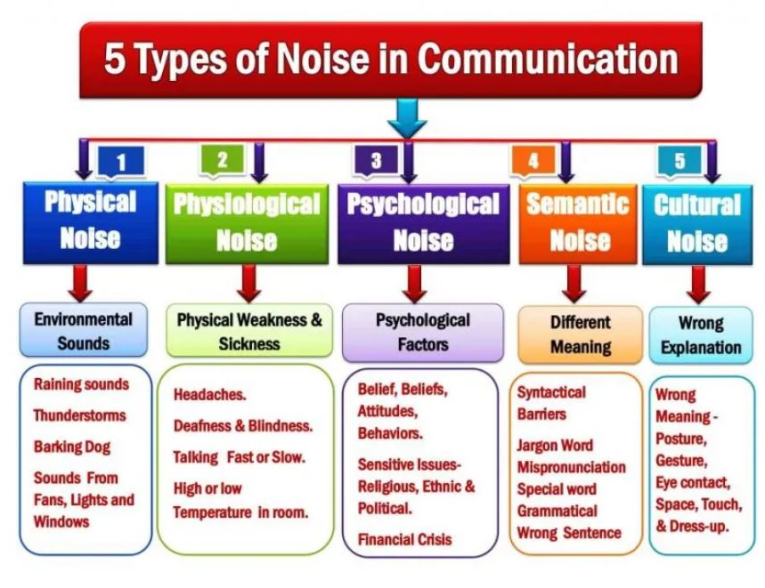
Image 2. Communication noise. Image adapted by the student.
Physical noise refers to the disturbance caused by external environmental factors. The physiological noise is commonly linked to illness or disabilities. Psychological noise refers to barriers created by behaviour or belief. Semantic noise arises when different meanings are mixed due to language barriers. Cultural noise is dominated by wrong interpretations caused by differences in customs and beliefs.

Schramm’s communication model

Wilbur Schramm developed the model in 1954 as an opposing view to Shannon and Weaver. He insisted that communication is a two-way process that involves interaction between the sender and the receiver. The process is illustrated in image 3.
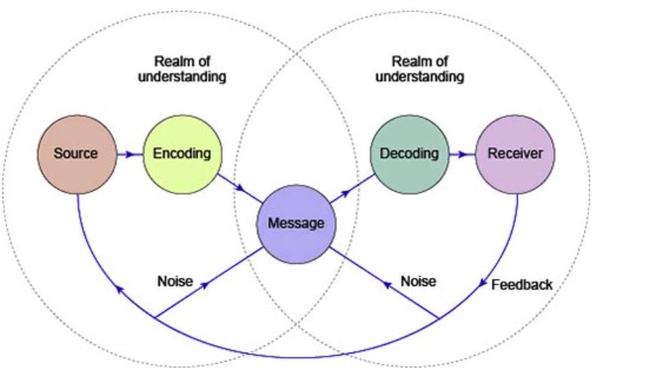
Image 3. Schramm’s communication model. Image adapted by the student.
The sender is the person who sends the message. The encoding process takes place when the message has been converted to the appropriate form so that it can be decoded by the receiver. The decoding process takes place when the receiver picks up the message and tries to interpret its meaning and intent. The receiver is the person for whom the message is intended. As discussed previously, ‘noise’ refers to any disruptions which obstruct the encoding and the decoding of the message. The channel used for transmitting the message is called ‘medium’. Unlike Shannon and Weaver’s model, Schramm’s model stresses out the presence and importance of feedback between the sender and the receiver. This feedback is the way in which the receiver acknowledges the message from the sender (McQuail and Windahl, 2015). This model is characterised as interactive, because it examines reciprocal communication, demonstrating how information must be encoded, decoded, and interpreted in real-time during a conversation. Throughout the process of exchanging messages, the sender becomes a receiver and vice versa. The advantages of this model are that feedback is a central feature and that communication dynamics is appreciated because it is circular in nature and not linear. The main disadvantage of the model is that it is not designed for mass communication and does not function properly when there is one sender and multiple receivers.

Berlo’s communication model
It was introduced in 1960 by David Berlo. It comprises similar elements as Shannon and Weaver’s – source, receiver, channel and message. According to Fouldger (2004), the model is linear in nature and to communicate effectively, the source and receiver must be on the same level. Only then will communication occur or will it occur correctly. As a result, the source and receiver should be comparable.

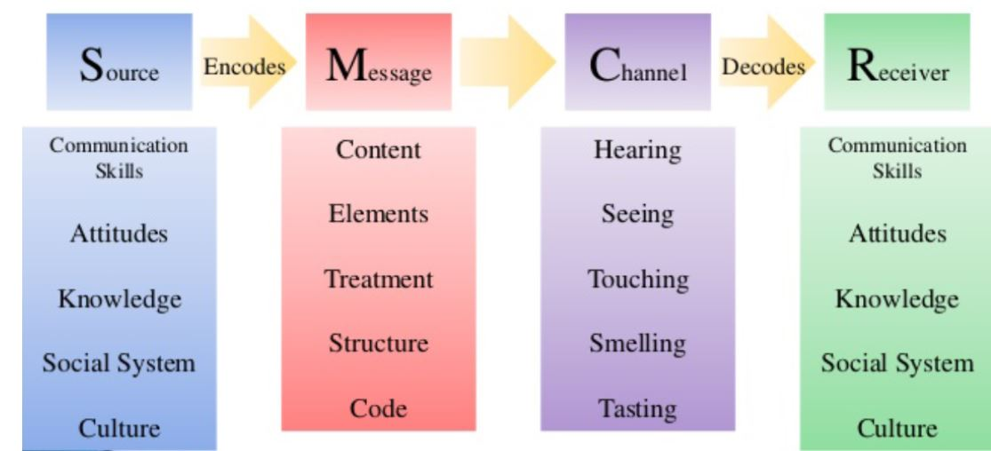
Image 4. Berlo’s communication model. Image adapted by the student.
The disadvantage of the model is that there is no feedback assessed as a factor. Noise and other barriers are also not considered. The model is regarded as complex and hard to apply.

Communication skills and teamwork
Communication skills enable people to understand and be understood by others (Hargie et al., 2017). For example, the ability to communicate ideas clearly to others, to express polite and confident behaviour, the ability to appreciate opposing points of view, the ability to speak in public and many other characteristics. Developing communication skills is proven to significantly aid people in their career advancement.
Throughout my training and work experience as a sales negotiator, I have been taught that there are ten traits that contribute to faster career advancement and also benefit the personal life of people. First of all, emotional intelligence is characterised as one of the most important traits which differentiate experienced leaders from bad ones. This is the capacity to comprehend and control one's emotions properly in order to communicate successfully, avoid stress, overcome obstacles, and sympathise with others.
Cohesion and clarity is the second most valued characteristic for efficient teamwork and positive communication. It saves time and avoids confusion. The personalised approach is the other important factor that is part of the communication skills arsenal of the skilled negotiator. The message sent to the receiver always has to have a personal note and lack the so-called ‘generic approach’. When communicating with others, the sender of the message has to demonstrate confidence, which makes the receivers feel that the speaker has faith in their abilities. Confidence is maintained and supported by appropriate eye contact when applicable.
Empathy is another trait that has to be considered when developing strong communication skills. This means respecting the views of others and trying to look at the world from their perspective. Empathy is supported by active listening, which means that the listener shows sincere interest, pays attention, avoids interruptions, gives support and feedback and evades criticism or judgement. This is also known as open-mindedness, which differentiates the professionals from the inexperienced.
The tone of voice of both the speaker and the listener are important because they set the ambience of the conversation. If the environment created by the participants is adverse, then the whole communication process can be negatively affected by it.
Duck and Mcmahan (2020) mention that verbal communication is the one in which words are used. These words can be spoken or written and used in a formal or informal way. It can take place in real-time or it can be delayed in time, such as exchanging letters or emails. It can also be recorded or non-recorded. Spoken communication is one of the most effective ways because it incorporates information from all aspects of the social communication norms. People encrypt their ideas in spoken language and rely on their audience to decode and interpret the message. The speaker may immediately ask for comments to ensure that their message was understood in the right way.
The authors emphasise the importance of non-verbal communication as well. It includes gestures, facial expressions, behaviour, eye contact, touch and proximity. It supports verbal communication because it enhances its reliability, clarity and effectiveness.

Conclusion
Nowadays people have lost their true sense of how real communication should look like. We are overwhelmed by social media and we tend to communicate using numerous apps, emojis and other fancy inventions. Instead, people should focus on practising real-time professional communication, learn all the best practices, rely more on their skills and abilities and try to engage in more meaningful projects and conversations, rather than playing games and watching viral videos. Adopting literacy in communication and efficiency in teamwork will allow us to become more productive, more confident and more satisfied with what we do.

References

Duck, S. and Mcmahan, D.T. (2020). Communication in everyday life: a survey of communication. 4th ed. Thousand Oaks, Calif: Sage Publications, Inc.
Foulger, D., 2004. Models of the communication process. Brooklyn, New Jersey, pp.1-13.
Griffith, B.A & Dunham, E.B (2015). Working in Teams.
Hargie, O., Dickson, D. and Tourish, D., 2017. Communication skills for effective management. Macmillan International Higher Education.
McKay, M., Davis, M. and Fanning, P., 2009. Messages: The communication skills book. New Harbinger Publications.
McQuail, D. and Windahl, S., 2015. Communication models: For the study of mass communications. Routledge.

Appendix
Email 1.
12 December 2021,
Hello Kathy,
I hope you are well. I am looking forward to seeing you for Christmas.
I decided to drop you a line rather than discuss the menu over the phone. I will attach some links with recipes and ideas. Please have a look and let me know what you think.
Hugs,
Joanna

Email 2.
17 Cromwell Road,
SG2 7DB
12 December 2021
Dear Ms Forbes,

I hope my email finds you well.
I am writing this email to let you know that we experienced a minor accident during your absence on 12th December 2021.
Our colleague Carren accidentally burnt her hand while operating the industrial oven. I gave her first aid and I took her immediately to the nearest urgent care centre as per our protocol. She is fine now, she had a slight burn only which will be healed in the next few days. She did not take any days off as the accident was only minor.
Regards,
Joanna Zaleska

