Managing Projects in the Organisation
Blogs

Title: Project for Supporting Children with Cancer

Student Name: Mariana-Adela Sugar
Student ID:2244011
Date:09/07/2025
Table of Contents
Blog 1: The Power of Setting Clear Project Objectives 3
Blog 2: Stakeholder Analysis—A Key to Project Success 4
Blog 3: Embracing Risk Management in Projects 5
Blog 4: The Value of Communication in Project Management 6
Blog 5: My Project Management Journey 7
References 8

Blog 1: The Power of Setting Clear Project Objectives

The provision of clear objectives of the project undertaken defines the primary precondition of the successful management of any project. Through this aim formulation, there exists a common sense of direction that can help each player to adjust his or her efforts to targeted outputs. This kind of clarity is essential for making informed decisions, monitoring progress, and maintaining group motivation. Goals are therefore systematically defined periods in which the overall goal is broken down into compartments to be measured (Joslin and Müller, 2020). With well-defined objectives, decisions on what to do, how to allocate the resources and the flexibility with which teams respond to unanticipated situations come easier.
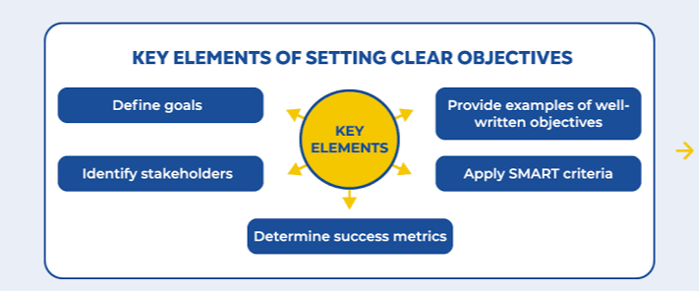
Figure 1: Elements of Setting Clear Objectives in Project (PMI, 2021)
However, the interconnective requirement of flexibility implies that the objectives must be flexible, as otherwise, their rigidity may make employees stagnant in addressing emerging issues. As a result, the project managers are well known to engage in objective revision that seeks relevance and applicability of the objectives over time as the project carries on (PMI, 2021). The result through this iterative feedback loop is that the project team tends to perform with better performance indicators and satisfy the stakeholders.

Blog 2: Stakeholder Analysis—A Key to Project Success
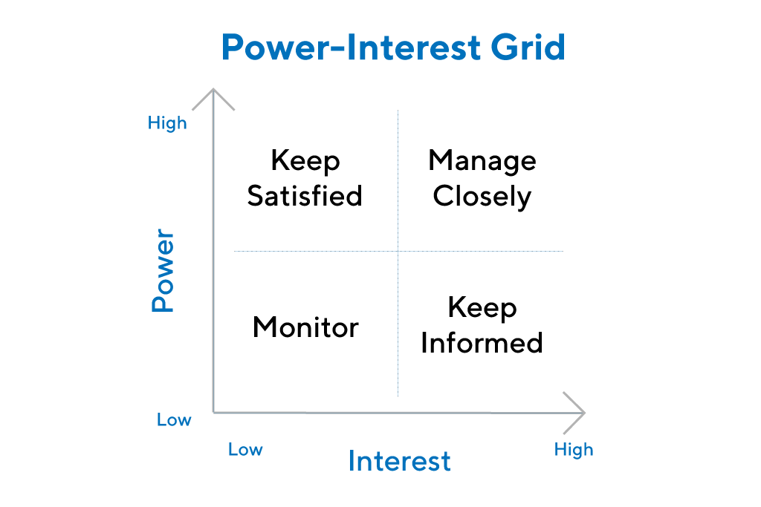
The formal undertaking of stakeholder identification will be especially important in projects which have a widespread effect upon society. The different typologies of stakeholders, e.g., a sponsor or end user, have a different set of influences and interests. The ability to identify the expectations of the stakeholders at the right time allows strategic communication that touches every need and concern. The hierarchical rankings based on the influence would bring into focus the actors that might become crucial to the effort, diminishing the potential to have objections and make cooperation happen (Serrador and Turner, 2022).

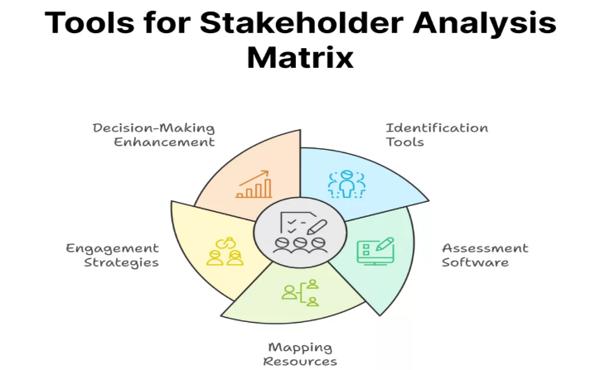
Figure 2: Stakeholder Matrix (Serrador and Turner, 2022)
Figure 3: Tools for stakeholder analysis matrix (Meredith, Shafer and Mantel, 2021)
Due to the dynamically changing nature of the interests of stakeholders, continuous participation is paramount, and thus managers are required to review and reassess their strategies every now and then. Structural tools like power-interest grids and stakeholder maps facilitate visualising these relationships and allow adjusting the strategies to the particular types of stakeholders; the approaches to which are particularly acute in the cases of complex initiatives with vulnerable populations, when the delicacy of relations is also increased (Meredith, Shafer and Mantel, 2021). Inability to interact with the stakeholders on a sufficient level may lead to a misalignment, time slip, or project failure, and the consistent, deliberate communication development will result in building the trust, transparency, and commitment of the parties to the goals of the project and provide long-term value to the parties involved.

Blog 3: Embracing Risk Management in Projects

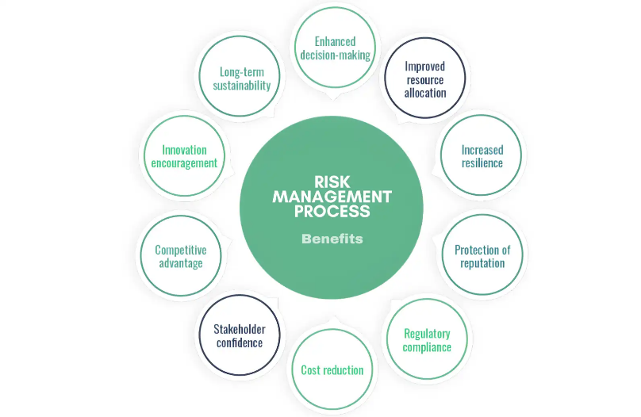
Risk management is among the structural blocks of efficient project governance regardless of its size. Risk anticipation, preplanning, evaluation and control often distinguish between success and catastrophe. The field entails the orderly evaluation of the risks, such as runaway budgets, prolonged schedules or scarcity of resources, and the description of backup plans (Flyvbjerg, 2021). A high-performing team uses risk analysis in the process of planning and keeps risk registers iteratively updated. Risk dialogue should be encouraged by establishing a permissive climate that helps develop problem-solving acuity and accelerates reactions to negative developments.

Figure 4: Risk management process (Schaufelberger and Holm, 2024)
However, the planning process may fail to recognise unexpected external events. When there is a sensitive population (e.g., children with cancer), it is important to have high standards when applying risk assessment to protect safety and ethical integrity (Schaufelberger and Holm, 2024). Effective risk management therefore transforms the uncertainty to learning, which ultimately builds resilience at the organisational level. To prevent the risks of jeopardizing the organizational goals, proactive risk management will help the project teams manage future uncertainties, build confidence and keep the project on track even in the event of unexpected circumstances.

Blog 4: The Value of Communication in Project Management
Communication forms the framework skeleton of a well undertaken project. It closes intention and action: communication is meant to bring everyone in the team and the people who have a stake in the project up to date with developments and projections. To suit personal communication style, digital means, the usage of email, planned meetings, instant messaging, and social media networks, can be utilised. Communication is useful to ease misunderstanding, to clear expectations and to bring shared belief (Kerzner, 2022). Community participation requires special communication efforts designed to maintain the support of projects involving multi-stakeholders, especially community participation.
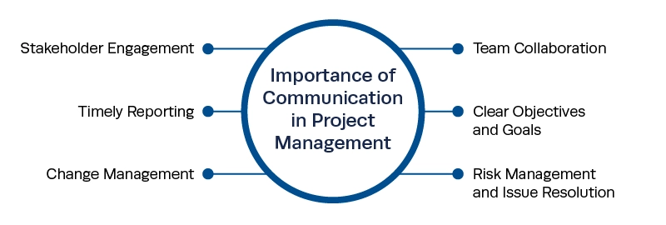
Figure 5: Value of Communication in Project Management (Burke, 2019)
But excessive dependence on electronic communication may also alienate individuals, who like direct contact with each other. Therefore, communication practices must be sensitive to the situation and include routine updates, responsive processes, and two-way communication. Regular evaluation of the effectiveness of communication determines the gaps and works as motivation to continually improve (Burke, 2019). Concisely, strategic communication keeps projects on track as well as nurturing cooperation and stakeholder satisfaction. Effective communication acts like a catalyst, since it brings together the stakeholders, harmonizes objectives and grants mutual trust, as the foundation of project success and stakeholder satisfaction.

Blog 5: My Project Management Journey
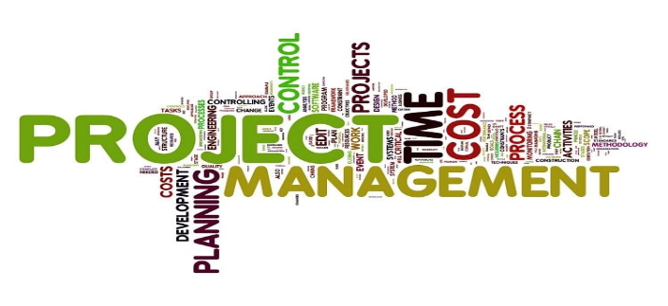
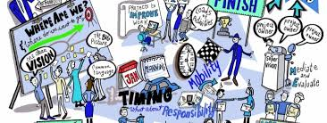
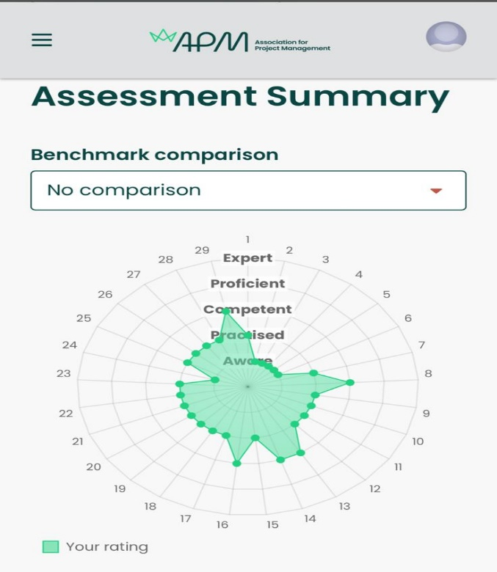
In my own case, I have gained a lot through the case project work on hand, as I am studying project management. My current competencies are outlined according to the APM assessment summary. Based on the radar chart, we can see that my strongest domains proved to be stakeholder engagement and planning, which I already am competent and well-trained in. Leadership and risk management are some of the areas to be developed. In our group project that helped children with cancer, I made sure that we had clearly written goals, a systematic analysis of stakeholders and that the risks were address ed and solved.

Figure 6: APM Assessment (Source: Author)
Flexibility and collaboration became significant forces toward organising solutions to overcome challenges and achieve objectives. The standards explained by the assessment provide support for further development and encourage me to undertake more challenging positions. Every single project is the source of new learning opportunities, and I will use them to my great advantage so that I can increase my capabilities and be able to make a difference. In every project, I will further develop managerial competence and will become stronger and more adaptable at transcending progressively more difficult problems.

References
Burke, R. (2019) Project Management: Planning and Control Techniques. 6th edn. Chichester: Wiley.
Flyvbjerg, B. (2021) ‘Top Ten Behavioral Biases in Project Management: An Overview’, Project Management Journal, 52(6), pp. 531–546.
Joslin, R. and Müller, R. (2020) ‘Evaluating project methodologies: Success and maturity’, International Journal of Project Management, 38(8), pp. 549–559.
Kerzner, H. (2022) Project Management: A Systems Approach to Planning, Scheduling, and Controlling. 13th edn. Hoboken, NJ: Wiley.
Meredith, J.R., Shafer, S.M. and Mantel, S.J. (2021) Project Management: A Managerial Approach. 10th edn. Hoboken, NJ: Wiley.
PMI (2021) A Guide to the Project Management Body of Knowledge (PMBOK® Guide) and The Standard for Project Management. 7th edn. Newtown Square, PA: PMI.
Schaufelberger, J. and Holm, L. (2024) Management of Construction Projects: A Constructor's Perspective. 2nd edn. New York: Routledge.
Serrador, P. and Turner, R. (2022) ‘The relationship between project success and project efficiency’, Project Management Journal, 53(1), pp. 1–13.

