Developing Emotional Intelligence Skills for the Workplace

BMSW6106

Student name: Magdalena Konopka
Student number: 2022639

Lecturer name: Amare Desta

Table of Contents

- Introduction 3
- Introduction to Harrods 4
- Key Models Of Emotional Intelligence 4
3.1 Mayer and Salovey's Four-Branch Model of Emotional Intelligence 5
3.2 Bar-On Model 6
3.3 Goleman's Model 7
4. Application Of Key Emotional Intelligence Models To Harrods 8
4.1 Application Of Four-Branch Model 8
4.2 Application Of Bar-On Model 9
4.3 Application Of Goleman's Model 10
4.4 Importance Of Developing Emotional Intelligence 11
4.5 Relationship Between Emotional Intelligence, Effective Management Communication And Business Advantage 11
5. Critical Evaluation Of Models Of Emotional Intelligence 12
5.1 Critical Evaluation Of Four-Branch Model 12
5.2 Critical Evaluation Of Bar-On Model 13
5.3 Critical Evaluation Of Goleman's Model 13
6. Recommendations 14
7. Conclusion 16
8. References 17

Introduction
Emotional intelligence is the process of controlling and managing a person's and others' emotions. In the workplace emotional intelligence plays a significant role. It helps manage people in the workplace, customers, and the operational activities of an organisation (Akila and Thangavel, 2017). For businesses, developing a workforce with emotional intelligence is very important and has a significant impact on an organisation's survival in a volatile economy. Employers have very important jobs to do to develop an emotionally intelligent workforce. There are different methods, theories, and models for developing emotional intelligence (The Economic Times, 2022). Here, in this report, how emotional intelligence can have a significant impact on Harrodshas been discussed.

Introduction to Harrods
Harrods is a British multinational departmental company that performs various actions to different countries in the world. Harrods operates in multiple formats. This company operates both online and offline. Harrods operates through businesses of various sizes. This company founded in 1849. The founder of Harrods is Charles Henry Harrods. Currently, Harrods has a strong presence in the UK and Europe. The employees of this company work hard and provide better quality products and services to the people. Harrods is currently the market leader in the retail sector of the UK with a 27.6% market share (www.macrotrends.net, 2024). Though Harrods is the market leader in the retail sector of the UK, it is following various challenges like increased competition, increased cost of operations, and changes in the shopping patterns of the buyers. The presence of these challenges makes the operation of Harrods difficult (Forbes, 2024).
Emotional intelligence can help to survive better in the market, providing better solutions to the customers, and emphasizing innovation for better customer satisfaction. Emotional intelligence has five components that can play a significant role in improving Harrods`s operational performance and fighting against current challenges. These components are self-regulation, self-awareness, motivation, empathy, and social skills. Harrods has applied several strategies for improving the emotional intelligence and other abilities of the employees. Emotional intelligence gets better with diversity, inclusion, and equity. That is why Harrods promote diversity at work. Harrods makes everyone feel welcome at the workplace including people with disability, and people of different races, gender, and ethnicities. Harrods trains people to listen, learn, and act. That is very important for the development of emotional intelligence. In this time of economic uncertainty, emotional intelligence has an important role to play for Harrods. Harrods should improve the work culture at Harrods (Harrods, 2024).

Key Models of Emotional Intelligence
Emotional skills are one the most important soft skills in the workplace. In the post-COVID situation, emotional skills are becoming very important. Additionally, to develop emotional intelligence, it is important to develop emotional skills according to different models and theories so that organisations can have a creative and flexible workforce with high emotional intelligence. The models of emotional intelligence are very important for developing and understanding the emotional intelligence of people in the workplace (Roberts et al., 2018). Three important models of emotional intelligence have been discussed below:

3.1 Mayer and Salovey's Four-Branch Model of Emotional Intelligence
This model is also known as the ability model. This model was developed by Mayer and Salovey back in 1997. This model works through four components which are shown in Figure 1. This model is useful in using cognitive abilities in emotional intelligence for problem-solving. The details of these components are discussed below.
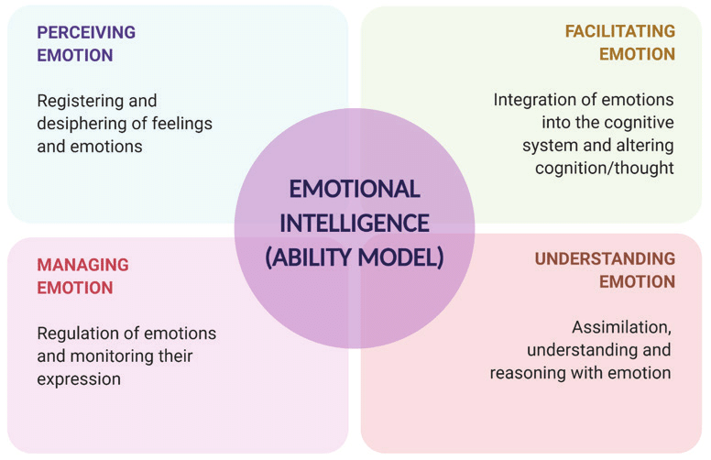
Figure 1 The Components of Ability Model (Source: Subramanian, Shahruddin and Sekar, 2021)
Perceiving Emotions: perceiving emotion requires addressing and identifying the emotions of people. Perceiving emotions requires people to understand the mood of people by understanding their posture, gestures, body language, and tone of voice. It is important to have emotional intelligence to communicate with people according to the situation.
Facilitating Emotion: Facilitating emotion requires to have cognitive abilities to process the feelings of people. Emotions trigger the cognitive abilities of people. Emotions can affect the people which might have an impact on the targeted outcomes. Cognitive abilities can help a person develop emotions that would support certain tasks and activities (Sarkar, 2019).
Understanding Emotion: Understanding emotion is making sense of emotion to make better decisions in the workplace. Emotional intelligence requires identifying the different emotional states of people and the reason behind their emotional states. An emotional state can be developed for different reasons. Understanding these reasons is very important.
Managing Emotion: Managing emotion requires monitoring and controlling the emotions of the people. Managing emotions requires having a wide mentality to recognise values and behaviour that direct the emotions. For managing emotions, short-term and long-term strategies can be taken. Managing emotion during a tough situation is very important (Noba, 2022).

3.2 Bar-On Model
The Bar-On model was developed back in 1997 by Reuven Bar. This model explains the abilities, skills, and behaviour that help to cope with daily challenges and stress. This model gives importance to both the cognitive and non-cognitive abilities of people. Bar-On model gives importance to the development of emotional intelligence for leadership, communication, and teamwork. This model helps organisations achieve organisational effectiveness (Arsenio, 2022). There are five components/scales of emotional intelligence that ensure effective performance in the workplace.
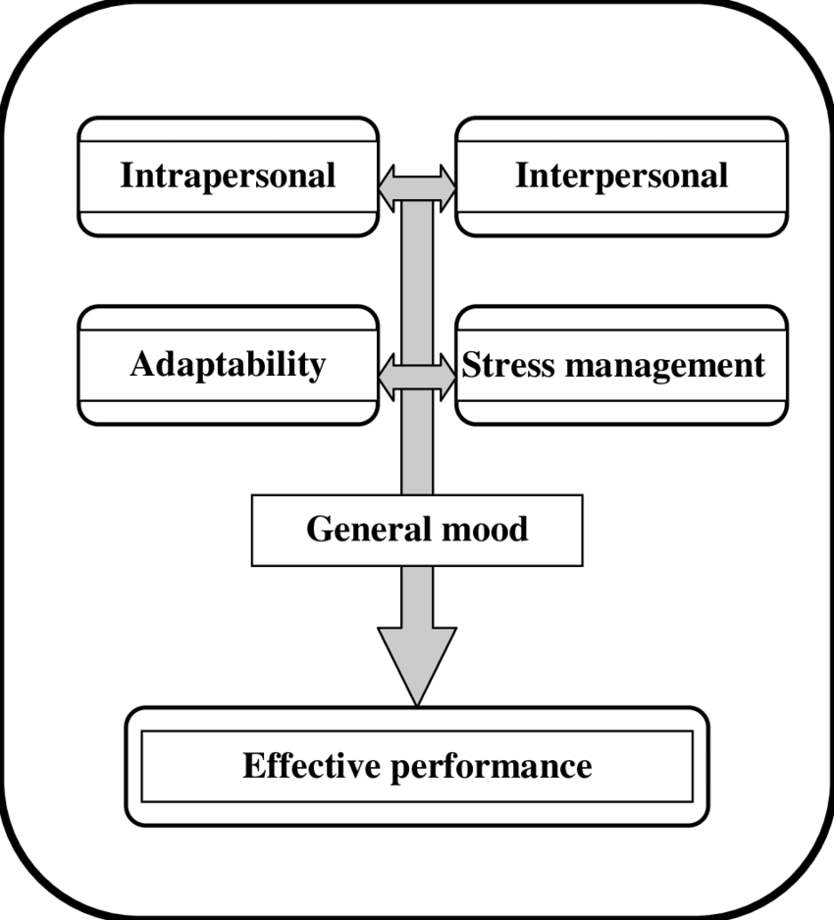
Figure 2 The Compnents of Bar-On Model (Source: Fernández-Berrocal et al., 2020)
Intrapersonal: Intrapersonal skills measure the ability to control the own emotions. Persons with better intrapersonal skills thrive better in any kind of critical situation. They can better control values and characteristics.
Interpersonal: Interpersonal skills measure the ability to interact with others effectively. Communication and teamwork skills have important impacts on interpersonal skills. People with strong interpersonal skills control situations better, communicate effectively, understand emotions, and build strong relationships (Baron, 2016).
Stress Management: Stress management is the ability to control and manage a critical situation. It depends on the impulse control and stress tolerance. Strong stress management skills facilitate problem-solving, handling stress, and making thoughtful decisions in critical times.
Adaptability: Adaptability is the ability to cope in situation. This facilitates flexibility, critical thinking, and problem-solving. Individuals with strong adaptability thrive better in changing scenarios.
General Mood: General Mood refers to the emotional well-being of the individuals. This includes satisfaction and happiness, optimism among the people. People generally build better relationships with others and get higher satisfaction than others (FutureLearn, 2020).

3.3 Goleman's Model
Goleman`s model of emotional intelligence was developed by Daniel Goleman back in 1995. Goleman`s model is important for understanding the emotions of people in decision-making, human behaviour, and relationships. Goleman emphasized the development of emotions-related abilities for better performance and leadership in the workplace. There are five components of Goleman`s model (Morris, 2020). Which are shown in Figure 3.
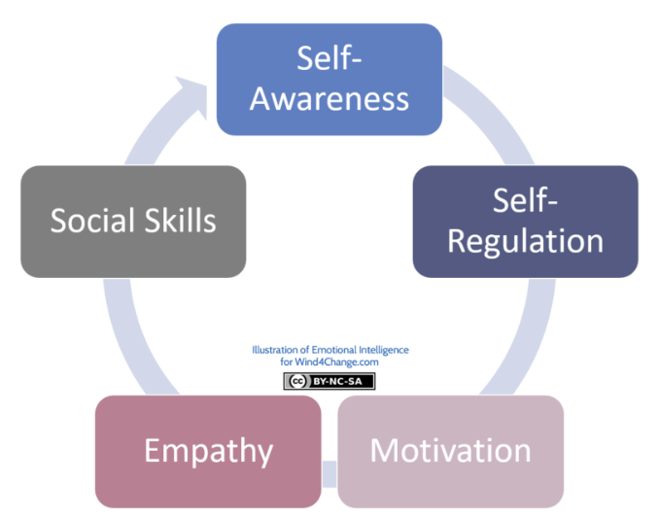
Figure 3 The Components of Goleman`s model (Source: Wind4Change, 2021)
Self-awareness: Self-awareness is the understanding of strengths, limitations, and emotions of one`s own. It is also about understanding the emotional triggers that affect decisions, behaviour, and thoughts.
Self-Regulation: Self-regulation is the controlling of emotion for achieving someone`s own goals and objectives. It is the management of stress and adapts to the changes as required in a situation. Self-regulation also requires one to manage emotions to keep oneself dedicated to certain goals (Schutte et al., 2018).
Social Skills: Social awareness is the understanding of people`s needs and perceptions in a society, country etc. It is the ability to understand people`s non-verbal responses to different situations. It might also be caused by different cultural or regional backgrounds.
Motivation: Motivation is the ability to achieve goals and objectives no matter what the situation. People should have proper motivation to support people and take control of a situation.
Empathy: It is important to have a prior idea of people`s feelings and emotions while deciding. Other`s feelings must be identified before decision-making about a particular situation (Craig, 2019).

Application Of Key Emotional Intelligence Models to Harrods
Emotional intelligence is a combination of both emotional and social skills. The emotional intelligence models can help to understand the emotions of the people and make a better workplace. These models help to make the employees successful in terms of stringer team, better well-being, better critical reasoning, better problem-solving, better team spirit, and better loyalty to an organisation. For the employees of Harrods emotional intelligence can have significant (Sabatier, 2016).

4.1 Application Of Four-Branch Model
The four-branch model of emotional intelligence can be applied to Harrods in the following cases:
Communication: This model can ensure better communication with the customers. Emotional intelligence can enhance the relationship with the customers. Effective communication backed by emotional intelligence can used for conflict resolution at Harrods in this uncertain situation.
Development of Leadership: Understanding the emotions of people makes a better leader. This model would help to understand the behaviour of the people at Harrods. Harrods employees will be able to control the situation better and play a leadership role in solving problems. This would help the employees in leading teams (Olderbak, Semmler and Doebler, 2018).
Customer Service: Customer services are core activities at Harrods. Training employees to perceive and manage emotions can help the employees to understand the customers better. This would help to understand customer demand and concerns about the products and services of Harrods. Thus, the overall customer service of Harrods can be improved through this model.
Sales Performance: The four-branch model is very important for sales performance at Harrods as well. If the individuals at Harrods can read the emotions of people about products and services better, then would be able to perform better in sales.
Innovation and creativity: When the individuals of Harrods would understand the feelings of the people better, then they would be able to work more confidently. This confidence would enhance creativity and performance in the workplace (Marchant, 2016).

4.2 Application Of Bar-On Model
The Bar-On Model can be applied to Harrods in the following cases:
Recruitment and selection: The recruiters of Harrods can Bar-On model in the recruitment process. This would help Harrods to examine the candidates based on their intrapersonal skills, interpersonal skills, stress management, adaptability, and general mood of the candidates.
Performance Management: The Bar-On model can help to identify the performance of the employees at Harrods. This can help to develop the emotional intelligence of the employees. This can also help to measure the interpersonal skills and stress management skills of the individuals. This can also measure how people adapt to the critical situation (Drigas and Papoutsi, 2018).
Conflict Resolution: If this model can be applied and the performances of the employees can be improved with time concerning stress management, adaptability, and interpersonal skills, then the employees can handle stressful situations better.
Team Buildings: Based on the performance of the employees, the right mix of talents can be found, and a different team can be built. The built team can solve conflict situations and adapt well to the critical situation. The right team will benefit Harrods by improving overall outcomes.
Succession Planning: Harrods needs leaders who will lead Harrods in this critical situation of economic volatility. The Bar-On model can help to identify future leaders for Harrods. Harrods will also be able to train the employees to develop emotional intelligence and make succession planning for the employees (Giorgi, 2015).

4.3 Application Of Goleman's Model
The Goleman`s model can be applied to the Harrods in the following areas:
Decision-Making: Decision-making based on emotional characteristics is very important. Self-awareness, self-regulation, social skills, and empathy help the employee to make informed decisions. Goleman`s model can help to make decisions considering the impacts on Harrods. This would make Harrods more profitable.
Organizational Culture: Emotional intelligence can help Harrods employees maintain a good organisational culture. Maintaining diversity can be done by applying skills like social skills and empathy. A better organisational culture supported by better emotional intelligence skills can enhance the productivity of the employees (Sadri, 2017).
Talent Management: For managing talents, emotional intelligence can play a significant role. Self-regulation and empathy can help to understand the employees better. It can also help to improve the performance, retention, and loyalty of the employees at Harrods.
Change Management: Different emotional intelligence skills can facilitate change management at Harrods. Skills like self-awareness, self-regulation, and motivation are very important for change at Harrods. This model would help to reduce resistance to change (Unruly, 2019).

4.4 Importance Of Developing Emotional Intelligence
Emotional intelligence is very important for understanding own emotions and the emotions of others. Managing emotions better helps the employees to guide others more properly. Emotional intelligence is important in the workplace for the following reasons:
Understanding Non-Verbal Communication: The people of Harrods should be aware of understanding the non-verbal communication of people. Identifying non-verbal communication can improve customer satisfaction and can help to reduce dissatisfaction of the customers (Simpson, 2015).
Controlling of Personal Emotions: Self-awareness and self-regulation help to control the emotions of people. These emotional intelligence skills also help to improve the performance of others. Managing emotion in a difficult situation is the most difficult task to do. Emotional intelligence is very necessary in controlling the personal emotions of people at Harrods.
Improve Efficiency: interpersonal skills improve the empathy of people. Emotional intelligence improves the interpersonal skills of the employees and helps the employees to work together. As a result, people become more efficient at work (Adams, 2015).
Develop Leadership: Better development of emotional intelligence enhances the leadership of the people. The leaders will be able to make decisions about critical situations more abruptly in critical situations through emotional intelligence. Empathy, patience, active listening etc. enhance the leadership skills of the leaders.
Develop Interpersonal Skills: The interpersonal skills of the employees can be improved through developing emotional intelligence. Self-awareness, self-regulation, motivation, empathy, and emotional intelligence improve the interpersonal skills of employees (Crous, 2022).

4.5 Relationship Between Emotional Intelligence, Effective Management Communication and Business Advantage
Businesses like Harrods can get the benefit of emotional intelligence which would increase their productivity and profit over the years. Emotional intelligence has a big role in business performance. If managers can achieve emotional intelligence skills, they will be able to manage employees better in the workplace. The employees would also be able to manage their emotions as well. Emotional intelligence can enhance the decision-making skills of the employees. This would help to understand the impacts of emotional intelligence before deciding. Emotional Intelligence helps to make customer-centric decisions for businesses. Employees with higher emotional intelligence tend to have more creativity, flexibility, and adaptability. Finally, emotional intelligence helps in better employee retention (Birt, 2019).

Critical Evaluation of Models of Emotional Intelligence
Unable to apply proper emotional intelligence models and theories can prevent the employees from understanding the emotions and behaviour of the customers. It can also cause a loss of business opportunities because of a lack of emotional intelligence. The critical evaluation of the key models of emotional intelligence can be done in terms of their strengths and weaknesses (Lee and Lim, 2016).

5.1 Critical Evaluation of Four-Branch Model
Strengths
Helps to Understand the Needs of Others: The components like perceiving emotions, facilitating emotions, understanding emotions, and managing emotions gives focus on the individual needs of others. For an organisation like Harrods, understanding Customers is very important
Better Operational Performance: The four-branch model is important in developing communication, leadership, organisational culture, and performance of an organisation through emotional intelligence. Understanding the pulse of people is very important according to this model (McKnight, 2015).
Cognitive Evaluation: This model focuses on cognitive skills. That helps to evaluate the emotions of people through problem-solving and critical thinking. Cognitive evaluation helps to make better-informed decisions.
Limitation
Failure to Detect Critical Emotional Situation: At the workplace, this is not always possible to focus on critical situations where the emotional characteristics of people relate to complicated issues. In those cases, this model is not that much effective.
Less Focus on Others' Necessary Skills: One of the major limitations of this model is that it only highlights developing emotional skills. It does not provide any specific direction for other necessary skills for the workplace.

5.2 Critical Evaluation of Bar-On Model
Strengths
Focuses on Personal Abilities: The model emphasizes the development of personal skills such as intrapersonal skills, interpersonal skills, stress management, general mood, and adaptability. This model helps to understand the emotions of others by developing emotional skills (Mayer and Salovey, 2023).
Focuses on Stress Management and Critical Situation: This model highly focuses on managing critical situations. For an organisation like Harrods, it is important to manage situations with emotional intelligence. For instance, emotional intelligence can provide solutions during economic volatility.
Connect Emotional and Social Intelligence: This model connects both emotional and social intelligence. It focuses on developing both intrapersonal and interpersonal skills (Jordan and Troth, 2015).
Limitations
Solely Based on Measurements: The model mainly focuses on measuring and showing results of people`s ability on different skills. However, the model does not talk about how to improve the skills of people.
Limited to Specific Contexts: The models mostly emphasize the personal and professional skills of people. But contexts like organisational culture and external environment are also important, which this mode ignores (Clarke, 2015).

5.3 Critical Evaluation of Goleman's Model
Strengths
Focuses on Core Elements of Emotional Intelligence: Goleman`s model works to improve and develop the core elements of Goleman`s model including self-awareness, self-regulation, empathy, motivation, and social skills. This model is very important for understanding own and others' (Salminen-Tuomaala, 2020).
Focuses on Organisational Development: Goleman`s model works to improve organisational performance through emotional intelligence. Communication skills, teamwork skills, leadership skills, organising skills, planning skills etc. are given importance for organisational development.
Leadership and Teamwork are Given Importance: In Goleman`s model, leadership and teamwork are mostly emphasized. Emotional intelligence facilitates leadership and teamwork skills (McPhail, 2015).
Limitations
Ignores Complex Emotional Situation: This model might ignore and fail to use cognitive abilities in critical situations like the four-branch model. The decision-making through this model might be difficult in critical situations.
Less Focus on Specific Skills: This model does not emphasize specific skills. Rather it gives importance to the broad skills that might enhance the emotional intelligence and improve the organisational performance (Weinberger, 2019).

Recommendations
Based answer and critique above the following recommendations can be made for Harrods:
Use Different Models: For Harrods, which operates a larger scale business applying only one model would not be enough there should be different models that might be considered for developing the emotional intelligence of Harrods employees.
Provide Training on Emotional Intelligence: Emotional Intelligence is now one of the crucial soft skills in this 21st century. In the current economic volatility, emotional intelligence has a big role to play. To understand customer`s needs and preferences training in emotional intelligence is a must for the employees of Harrods. Additionally, this would also help the employees of Harrods to make informed decisions.
Leadership Coaching for Leaders: Emotional intelligence training is most important for top-level management. Because they always do not take information considering the impacts of decisions on lower-level management and the customers.
Improving the System Providing Services: The use of technology during shopping is a demand from the customers of the retail industry. For easing customer services and improving service provision, emotional intelligence has a very big role to play. The appropriate technology for customers can also be determined by employees efficiently if emotional intelligence exists in the minds of the employees.
Enhance Collaboration: Collaboration is key to better organisational performance. Harrods not should only focus on improving emotional intelligence for individual employees but also on facilitating emotional intelligence for collaboration and teamwork. Emotional intelligence would enhance the relationship among the employees. This would also ensure the efficiency of the working teams.
Taking Regular Feedback: Regular feedback should be taken from the employees concerning their emotional intelligence skills. It should be monitored if the employees can apply emotional intelligence in their day-to-day activities.
Motivate Through Reward System: Harrods should promote its reward system to motivate employees and become more emotionally intelligent. Benefits and rewards can enhance the productivity of the employees at Harrods. This is important for Harrods to retain customers and thrive in the market.
Implement Employees for Ensuring Emotional Intelligence: Leaders and HR of Harrods have a very big role to play in ensuring emotional intelligence among people. The performance of employees regarding emotional intelligence skills must be observed regularly. For monitoring, evaluation metrics such as customer feedback can be used.

Conclusion
Emotional intelligence skills are very important in this 21st century. Organizations like Harrods should apply emotional intelligence in their every operation. People with better emotional intelligence would help Harrods thrive better during complex economic situations. Harrods is the market leader in retail intelligence. Harrods now gives enough importance to emotional intelligence skills. Additionally, Harrods should consider applying emotional intelligence models such as the Goldman, Bar-On, and Four-Branch models. Harrods can apply a comprehensive approach in using these models for developing the emotional intelligence of the employees since no single model is perfect. Lastly, Harrodsshould strive to improve the emotional intelligence skills of people continuously.

References
- Adams, J. (2015). Developing emotional intelligence. Child Care, 5(11). doi:https://doi.org/10.12968/chca.2008.5.11.37354.
- Akila, Dr.R. and Thangavel, Dr.N. (2017). Team Leader’s Emotional Intelligence Competencies and Team’s Emotional Intelligence Norms. Indian Journal of Applied Research, 3(3), pp.211–213. doi:https://doi.org/10.15373/2249555x/mar2013/69.
- Arsenio, W.F. (2022). Emotional Intelligence and the Intelligence of Emotions: A Developmental Perspective on Mixed EI Models. Human Development, 46(2-3), pp.97–103. doi:https://doi.org/10.1159/000068582.
- Baron, R.M. (2016). The Bar-On model of emotional-social intelligence (ESI). PubMed, 18 Suppl, pp.13–25.
- Birt, J. (2019). The Importance of Emotional Intelligence in the Workplace. [online] Indeed Career Guide. Available at: https://www.indeed.com/career-advice/career-development/emotional-intelligence-importance.
- Clarke, N. (2015). Developing emotional intelligence abilities through team-based learning. Human Resource Development Quarterly, 21(2), pp.119–138. doi:https://doi.org/10.1002/hrdq.20036.
- Craig, H. (2019). The Theories of Emotional Intelligence Explained. [online] PositivePsychology.com. Available at: https://positivepsychology.com/emotional-intelligence-theories/.
- Crous, R. (2022). Having an emotionally intelligent workforce should be a priority post-COVID. [online] Available at: https://www.insidehr.com.au/an-emotionally-intelligent-workforce/.
- Drigas, A. and Papoutsi, C. (2018). A new layered model on emotional intelligence. Behavioral Sciences, [online] 8(5), p.45. doi:https://doi.org/10.3390/bs8050045.
- Fernández-Berrocal, P., Alcaide, R., Natalio Extremera and Pizarro, D. (2020). The Role of Emotional Intelligence in Anxiety and Depression among Adolescents. 4(1), pp.16–27.
- Forbes (2024). Harrodson the Forbes Top Regarded Companies List. Forbes. [online] Available at: https://www.forbes.com/companies/Harrods/.
- FutureLearn. (2020). What are the three types of emotional intelligence? [online] Available at: https://www.futurelearn.com/info/courses/emotional-intelligence-at-work/0/steps/62998#:~:text=There%20are%20three%20main%20branches%20of%20emotional%20intelligence%20%E2%80%93%20the%20ability.
- Giorgi, G. (2015). Organizational emotional intelligence: development of a model. International Journal of Organizational Analysis, 21(1), pp.4–18. doi:https://doi.org/10.1108/19348831311322506.
- Global Data (2024). HARRODSCompany Profile. [online] GlobalData. Available at: https://www.globaldata.com/company-profile/Harrods-plc/.
- Jordan, P.J. and Troth, A.C. (2015). Emotional Intelligence and Conflict Resolution: Implications for Human Resource Development. Advances in Developing Human Resources, [online] 4(1), pp.62–79. doi:https://doi.org/10.1177/1523422302004001005.
- Lee, K. and Lim, W. (2016). Examining the construct validity of the emotional intelligence for developing the educational programs based on emotional intelligence. The Korean Journal of Educational Methodology Studies, 28(3), pp.587–608. doi:https://doi.org/10.17927/tkjems.2016.28.3.587.
- Marchant, J. (2016). » The one about Harrods. [online] Emotionalintelligenceatwork.com. Available at: http://www.emotionalintelligenceatwork.com/the-one-about-Harrods/ [Accessed 9 Aug. 2024].
- Mayer, J.D. and Salovey, P. (2023). The intelligence of emotional intelligence. Intelligence, 17(4), pp.433–442. doi:https://doi.org/10.1016/0160-2896(93)90010-3.
- McKnight, J. (2015). Using Emotional Intelligence as a Basis for Developing. Journal of Instructional Research, 2, pp.19–29. doi:https://doi.org/10.9743/jir.2013.2.13.
- McPhail, K. (2015). An emotional response to the state of accounting education: developing accounting students’ emotional intelligence. Critical Perspectives on Accounting, 15(4-5), pp.629–648. doi:https://doi.org/10.1016/s1045-2354(03)00050-9.
- Morris, J. (2020). Emotional Intelligence Models And Theories [With Examples]. [online] Neuroworx. Available at: https://www.neuroworx.io/magazine/emotional-intelligence-models-and-theories/.
- Noba. (2022). Emotional Intelligence. [online] Available at: https://nobaproject.com/modules/emotional-intelligence#:~:text=Ability%20Models%3A%20Mayer%20and%20Salovey%20Four%2DBranch%20Model%20of%20EI&text=This%20model%20proposes%20that%20four.
- Olderbak, S., Semmler, M. and Doebler, P. (2018). Four-Branch Model of Ability Emotional Intelligence With Fluid and Crystallized Intelligence: A Meta-Analysis of Relations. Emotion Review, 11(2), pp.166–183. doi:https://doi.org/10.1177/1754073918776776.
- Roberts, R.D., MacCann, C., Matthews, G. and Zeidner, M. (2018). Emotional Intelligence: Toward a Consensus of Models and Measures. Social and Personality Psychology Compass, 4(10), pp.821–840. doi:https://doi.org/10.1111/j.1751-9004.2010.00277.x.
- Sabatier, M. (2016). A manager’s guide to improving emotional intelligence at work. The Guardian. [online] 13 Jun. Available at: https://www.theguardian.com/careers/2016/jun/13/a-managers-guide-to-improving-emotional-intelligence-at-work.
- Sadri, G. (2017). Emotional Intelligence and Leadership Development. Public Personnel Management, 41(3), pp.535–548. doi:https://doi.org/10.1177/009102601204100308.
- Salminen-Tuomaala, M.H. (2020). Developing emotional intelligence and situational awareness through simulation coaching. Clinical Nursing Studies, 8(2), p.13. doi:https://doi.org/10.5430/cns.v8n2p13.
- Sarkar, B.K. (2019). Emotional Intelligence - Glimpses of Current Models and an Exploratory Study. SSRN Electronic Journal. doi:https://doi.org/10.2139/ssrn.1635225.
- Schutte, N.S., Malouff, J.M., Hall, L.E., Haggerty, D.J., Cooper, J.T., Golden, C.J. and Dornheim, L. (2018). Development and validation of a measure of emotional intelligence. Personality and Individual Differences, [online] 25(2), pp.167–177. doi:https://doi.org/10.1016/s0191-8869(98)00001-4.
- Simpson, D.D. (2015). Best Practices in Need of Improvement: Developing Emotional Intelligence. PsycCRITIQUES, 52(44). doi:https://doi.org/10.1037/a0008943.
- Supramanian, K., Shahruddin, R. and Sekar, M. (2021). Emotional Intelligence Using Ability Model in Context of Nursing and its Impact on End-Stage Renal Disease Patients: A Narrative Review. International Journal of Current Research and Review, 13(16), pp.151–158. doi:https://doi.org/10.31782/ijcrr.2021.131609.
- Harrods(2024). Diversity, Equity and Inclusion. [online] Harrodsplc.com. Available at: https://www.Harrodsplc.com/sustainability/colleagues/diversity-equity-and-inclusion.
- The Economic Times. (2022). Business News Today: Read the Latest Business News, India Business News Live, and Share Market & Economy News. [online] Available at: https://economictimes.indiatimes.com/?back=1.
- Unruly. (2019). Harrods's CEO explains how they used emotions to build consumer trust. [online] Available at: https://unruly.co/blog/article/2019/10/16/Harrods-ceo-explains-how-leveraging-emotions-has-helped-build-consumer-trust/.
- Weinberger, L.A. (2019). Emotional Intelligence, Leadership Style, and Perceived Leadership Effectiveness. Advances in Developing Human Resources, 11(6), pp.747–772. doi:https://doi.org/10.1177/1523422309360811.
- Wind4Change, E. from (2021). Emotional Intelligence by Daniel Goleman: Self-Mastery. [online] Wind4Change. Available at: https://wind4change.com/emotional-intelligence-daniel-goleman-work-self-mastery/.
- www.macrotrends.net. (2024). HarrodsNet Income 2010-2024 | TSCDY. [online] Available at: https://www.macrotrends.net/stocks/charts/TSCDY/Harrods/net-income#:~:text=Harrods%20annual%20net%20income%20for.

Appendix - Poster



