Chris Hine
P139976
Powertrain and sustainability
Malcolm McDonald
09/11/2017



Contents
1. Introduction 3
2. Calculating mass percentages 4
3. Air fuel ratio 5
4. Enthalpy of Formation 6
Method: 6
5. Lower and higher heating values 7
6. CO2 Produced 8
7. Ideal fuel 9
8. Conclusion 10
References 11
Appendix A 12
Appendix B 13
Appendix C 14
Appendix D 15
Appendix E 16

Introduction
This report will investigate hydrocarbon fuels, specifically, the fuel blend of isooctane and ethanol, in an equal molar composition. Calculating mass percentages, ${CO}_{2}$ produced, examining the chemical process of combustion and the energy required and released during the combustion event. An excel spreadsheet has been made to carry out the calculations, shown in the appendix A.

Calculating mass percentages
Calculating mass percentage by molar composition of:
50% Ethanol, $C_{2}H_{5}OH$
50% Isooctane, $C_{8}H_{18}$
By taking the molecular weight of the constituent elements of both fuels, see appendix B.
Ethanol:
C = 2*12.011
H = 6*1.008
O = 1*15.999
Total = 46.069
Isooctane:
C = 8*12.011
H = 18*1.008
Total = 114.232
To find the fuel mass ratio, divide the fuel by the total fuel mass:
$$\frac{Ethanol mass}{Total Mass}$$
This equates to:
$$\frac{46.069}{46.069+114.232}=0.28739*100=28.74 \%$$

28.74 % Ethanol
71. 26 % Isooctane

3. Air fuel ratio
Stoichiometric combustion with air for the isooctane/ethanol fuel blend is calculated as:
(Fuel Blend + Air) → (Products with no excess)
($C_{2}H_{5}OH$ + $C_{8}H_{18}$) + $x$ ($O_{2}$ + 3.76$N_{2}$) →→ (a${CO}_{2}$ + a$H_{2}O$ + c$N_{2}$)
Balancing the equation gives:
($C_{2}H_{5}OH$ + $C_{8}H_{18}$) + 15.5($O_{2}$ + 3.76 $N_{2}$) →→ (10.${CO}_{2}$ + 12.$H_{2}O$ + 15.5.$N_{2}$)
${CO}_{2}$: a = 10
$H_{2}O$: 2b = 24 → b = 12
O = 2$x$ +1
$N_{2}$: c = 2a+b = 32 → 2$x$ +1 = 32 → 2x = 31 → $x=\frac{31}{2}$
$x=$ 15.5
$N_{2}$ = 15.5
$$\frac{A}{F}=\frac{15.5\left(2*15.999+3.76*2*14.007\right)}{(10*12.011+24*1.008+1*15.999)}=13.14\%$$

Enthalpy of Formation
Enthalpy of formation occurs as the appropriate number of molecules absorb enthalpy to subdivide from their natural equilibrium structure, into free atoms. Enthalpy is then released by the combination of these free atoms to form the structure of the product molecules. (Goodger, 2000) The standard conditions are to produce 1 Kmol of a compound from its constituent building blocks at a constant temperature of 298.15 K. See appendix C for Enthalpy derivation.

Method:
Standard Combustion Building Blocks:
- $O_{2}$
- $N_{2}$
- $H_{2}$
- C (Graphite)

Combustion Compounds | Enthalpy Required for Reactants to Reach Zero Level (MJ/kmol)
$C_{2}H_{5}OH$ (gas) | 234.6
$C_{8}H_{18}$ (gas) | 224.1
Total = 458.7 MJ/kmol

Products | Enthalpy Released (MJ/kmol)
$${CO}_{2}$$ | 393.5
$H_{2}O$ (gas) | 241.8
($C_{2}H_{5}OH$ + $C_{8}H_{18}$) + 15.5($O_{2}$ + 3.76 $N_{2}$) → (10.${CO}_{2}$ + 12.$H_{2}O$ + 15.5.$N_{2}$)
Products | Total Enthalpy Released (MJ/kmol)
$${CO}_{2}$$ | $10*393.5=$3935
$H_{2}O$ (gas) | 12*241.8 = 2901.6
Total = 6836.6 MJ/kmol
Net energy released is the total enthalpy released minus enthalpy required to reach zero level.
$$6836.6-458.7=6377.9 MJ/kmol$$
1 kmol of $C_{2}H_{5}OH$ + $C_{8}H_{18}$ produces 6377.9 MJ
1kmol of $C_{2}H_{5}OH$ + $C_{8}H_{18}$ = $(10*12.011+24*1.008+1*15.999)$ = 160.30 kg
1kg of $C_{2}H_{5}OH$ + $C_{8}H_{18}$ produces $\frac{6377.9}{160.301}$ = 39.787 MJ/kg

Lower and higher heating values
The heating value $Qhv$ or calorific value of a fuel, is the magnitude of the heat of reaction at a constant pressure of volume at a standard temperature (usually 25°C) for the complete combustion of unit mass of fuel. (Heywood, 1988)
LHV (lower heating value) is the net heat released when the product $H_{2}O$ is the form of a gas. HHV (higher heating value) is the net heat released when the product $H_{2}O$ is a liquid.

CO2 Produced
The event of combustion produces an amount of ${CO}_{2}$ dependant on the molecular composition of the reactants.
($C_{2}H_{5}OH$ + $C_{8}H_{18}$) + 15.5($O_{2}$ + 3.76 $N_{2}$) → (10.${CO}_{2}$ + 12.$H_{2}O$ + 15.5.$N_{2}$)
From 1 molecular blend of fuel, $C_{2}H_{5}OH$ + $C_{8}H_{18}$ 10 molecules of ${CO}_{2}$ are produced.
1 kmol of fuel = 160.30 kg:
$(10*12.011+24*1.008+1*15.999$)

160.30 kg fuel produces 440.09 kg of ${CO}_{2}$:
$10*(12.011+\left(2*15.999\right))$

Molecule | Molecular Mass
C | 12.011
O | 15.999
H | 1.008

So 1 kg of fuel = $\frac{440.09}{160.301}$ = 2.75
1 kg of $C_{2}H_{5}OH$ + $C_{8}H_{18}$ will produce 2.75 kg of ${CO}_{2}$.

Ideal fuel
An ideal fuel would possess a number or all the following:
- A high laminar flame speed, being the speed in which the flame front will travel naturally in stationary air. The flame speed depends on the mass of the fuel molecule, lighter molecules interact with each other more rapidly than heavier ones. This leads to less time for heat loss in to the surroundings, and produces more useable power.
- A high octane rating, (resistance to detonation) this gives the ability to utilise higher compression ratios. An engine that has a higher compression ratio, or expansion cycle will have a more efficient combustion cycle. Due to less of the combustion heat being wasted to the exhaust the engine will produce more mechanical work:

Ideal otto cycle: (Appendix D)

$$η=1-\frac{1}{{CR}^{γ-1}}$$
$η$ = engine efficiency
CR= compression ratio
$γ$ = ratio of specific heats
$γ=\frac{cp}{cv}$
cp = specific heat at constant pressure
cv = specific heat at constant pressure

Carnot cycle: (Appendix E)
$$η=1-\frac{Thot}{Tcold}=\frac{T3}{T4}={CR}^{γ-1}$$

The larger the $\frac{Tcold}{Thot}$ ratio, the larger percentage of work produced.

- A high calorific value, this is the heat released during combustion, either expressed as specific energy (MJ/kg) or energy density (MJ/L).
- A low or zero-carbon content. Hydrogen can be combusted with only $H_{2}O$ as a by-product, but it requires complex storage facilities and input energy to produce the gas from electrolysis.

Conclusion
The report has discussed the chemical mechanisms and energy required for combustion and the outputs of the event, heat energy and product molecules. From this the implications of burning hydrocarbon fuels and its output of ${CO}_{2}$ can be established, providing an understanding of the by-products of transportation. An engine or fuel designer can then consider the ideal fuel blends and efficiency combinations to reduce emissions and increase engine efficiency’s.

References
Goodger, E.M., 2000. Transport fuels technology: from well to wheels, wings and water, Norwich: Landfall Press.
Heywood, J.B., Internal combustion engine fundamentals, New York: McGraw-Hill.

Anon, 2015. Printable Periodic Table Chart - 2015. Science Notes and Projects. Available at: https://sciencenotes.org/printable-periodic-table-chart-2015/ [Accessed November 8, 2017].

Anon, Some basic concepts of Carnot engine. thermodynamics - Some basic concepts of Carnot engine - Physics Stack Exchange. Available at: https://physics.stackexchange.com/questions/211575/some-basic-concepts-of-carnot-engine [Accessed November 9, 2017].
Anon, What is Otto Cycle Engine? mech4study. Available at: http://www.mech4study.com/2015/12/what-is-otto-cycle-engine.html [Accessed November 9, 2017].

Appendix A
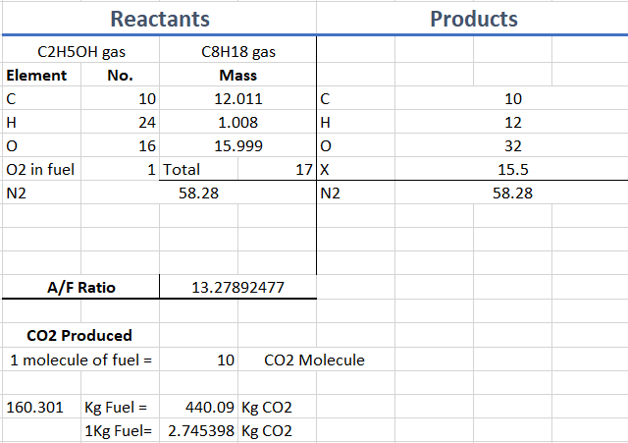

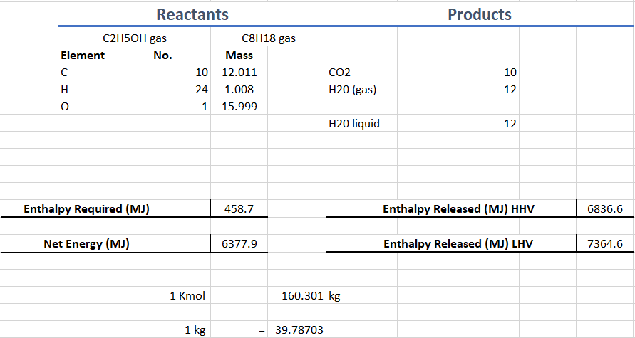

Appendix B
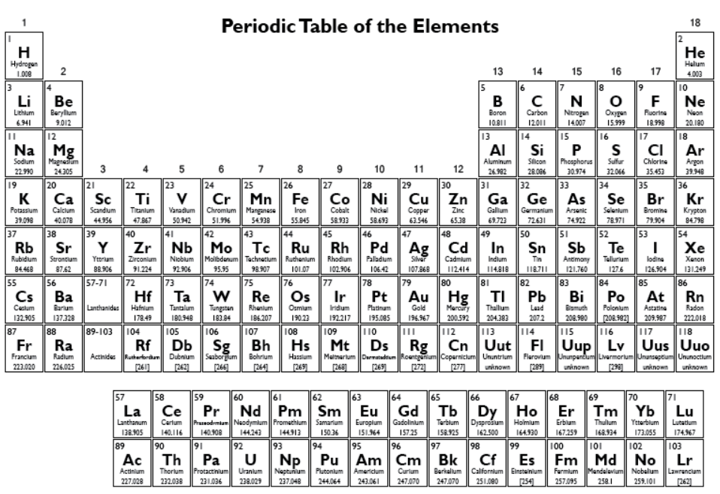
Periodic table (Science Notes and Projects. 2015)

Appendix C
Enthalpy is defined as:
$$H=U+PV$$
U = internal energy
P = pressure
V = volume

1st law of thermodynamics:
Work done
Heat transfer
$$dQ=dU+Pdv$$
Rise in temperature energy

Burning at constant atmospheric pressure:
Pressure stays constant
Change in enthalpy
$$dH=du+d\left(PV\right)=du+P*dv$$

In a process at constant pressure:
$$dQ=du+pdv=dH$$

Therefore the change in enthalpy is the same as the heat transferred at constant pressure.

Appendix D
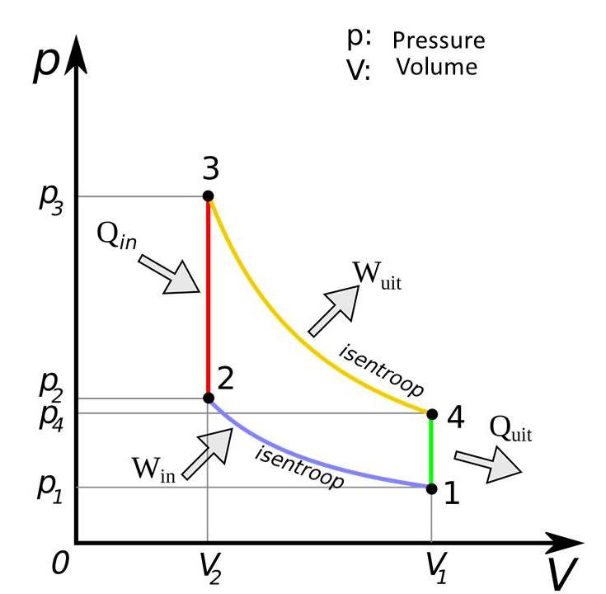
Otto cycle (mech4study. 2015)

Appendix E
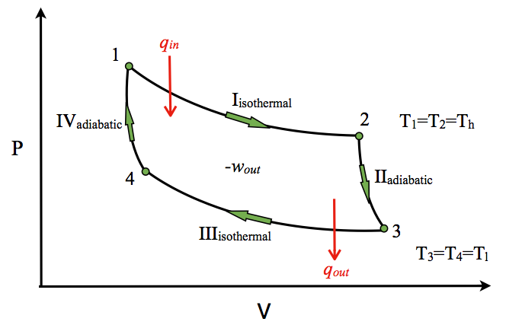
Carnot cycle (Physics Stack Exchange. 2015)

